***Grid-Connected PV Monitoring system (GCPV-MS)***

Mahmoud Dhimish, Student Member, IEEE, Violeta Holmes, Bruce Mehrdadi

Dept. Computing and Engineering

University of Huddersfield

Huddersfield, United Kingdom

[mahmoud.dhimish2@hud.ac.uk](mailto:mahmoud.dhimish2@hud.ac.uk); [V.holmes@hud.ac.uk](mailto:V.holmes@hud.ac.uk); [b.mehrdadi@hud.ac.uk](mailto:b.mehrdadi@hud.ac.uk)

*Abstract*—This paper presents the concept and operating principles of a flexible real-time long-term monitoring system for photovoltaic (PV) plants. Compared to traditional solutions which require dedicated hardware and/or specific data logging systems, the monitoring system we propose allows the user to monitor the grid-connected PV system using commercial of the shelf hardware devices and software programs such as LabVIEW and Weather Link software. The proposed system is built around wired/wireless devices and internet of things (IoT) concept. It provides customizable fast, reliable and secure monitoring tool suitable for deployment in PV systems management. The grid-connected PV monitoring system (GCPV-MS) is developed and installed at the University of Huddersfield, United Kingdom. The results obtained from this project indicate how IoT concept can be utilized in remote PV monitoring systems.

Keywords—Grid Connected Photovoltaic System; Internet of Things; Radio Frequency; Bluetooth; LabVIEW.

# Introduction

The cumulative global photovoltaic (PV) capacity has been growing exponentially in the last decade around the world, particularly due to the installation of grid connected PV systems. Grid-connected PV plants vary from a few kWp to hundreds of MWp. This growth indicates that PV energy production will have a significant role in the total generation of electricity of the future [1].

Most of PV monitoring systems require a number of parameters to be recorded such as: PV module temperature, solar irradiance, gird-connected PV voltage and current. These parameters are important to model and compare the PV measured data with theoretical curves. The monitoring units for PV systems are equally important because they enable monitoring the output performance of the PV system and that can help in detecting errors and faults before or after they occur. Recently, Wang, T., Chine, W. and Dhimish, M. [2 - 4] developed a fault detection technique to monitor and evaluate the output performance of the photovoltaic systems. The monitoring units are implemented using a web application based on cloud computing, MATLAB and LabVIEW Software.

From a review of PV monitoring systems, summarized in Table I, it is evident that a variety of platforms are used, such as LabVIEW, MATLAB/Simulink, Web application, and web pages in a cloud, as well as specialist systems such as spectrum analyzers.

LabVIEW is a graphical programming language by National Instruments that uses icons/blocks instead of lines of text to create applications. This programming environment has found its application in many scientific areas, hence in this work we propose a virtual instrumentation (VI) LabVIEW platform for monitoring grid-connected photovoltaic system and Davis weather station [16] and [17]. Additionally, Weather Link software allows the user to monitor the data of the weather station remotely. This software can generate a HTML code that allows the user to design a web page. Furthermore, historical weather data that is generated by the weather station console can be logged and viewed in charts.

It can be concluded that there are variety of solutions using both wired and wireless technology and different software platforms. Most of the systems considered in this review do not integrate environmental data as part of monitoring unit.

In this paper we present our efforts in designing and deploying a grid connected photovoltaic monitoring system (GCPV-MS) that utilizes IoT technology to integrate PV and environmental data monitoring. Fig. 1 describes the overall system design for the GCPV-MS. It consists of eight main monitoring units.

Fig. 2 presents the detailed architecture design of the GCPV-MS that is comprised of six monitoring subsystems: Arduino Ethernet shield with static IP-Address, Radio frequency (RF) with liquid crystal display (LCD), Bluetooth connection with Androids Application, Outback Mate 3 Monitoring unit, Felxmax80 Mate [18] and PC/Server.

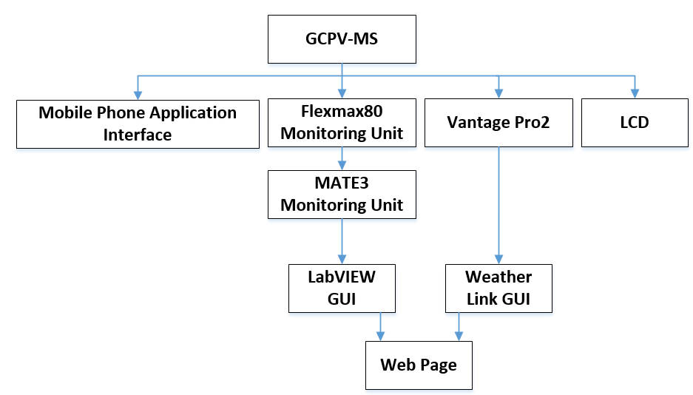

Fig. 1. Over-all Flowchart of GCPV-MS

TABLE I

Comparison of this work with other photovoltaic systems in the last 2 years

|  |  |  |  |  |
| --- | --- | --- | --- | --- |
| Word Done By | Remote or In-situ | Data Transfer Technology (Wired) | Data Transfer Technology (Wireless) | Monitoring System Used |
| Shariff et al, 2015 [5] | Remote | NOT INCLUDED | INCLUDED (XBee Pro) | LABVIEW |
| Guerriero et al, 2016 [6] | Remote | NOT INCLUDED | INCLUDED (Wireless Sensor based on Microchip MiWi) | Remote Station |
| Ngo et al, 2015 [7] | Remote | INCLUDED | INCLUDED (GSM) | WEB APP |
| Hu et al, 2015 [8] | Remote | NOT INCLUDED | INCLUDED (Wireless Network Sensor) | Cloud Storage With Web Page |
| Rezvani and Gandomkar, 2016 [9] | In-situ | INCLUDED | NOT INCLUDED | MATLAB/Simulink |
| Riccobono et al, 2015 [10] | In-situ | INCLUDED | NOT INCLUDED | LABVIEW |
| Kim et al, 2016 [11] | In-situ | INCLUDED | NOT INCLUDED | Zahner Elecktrik IM6ex Impedance Spectrum Analyzer |

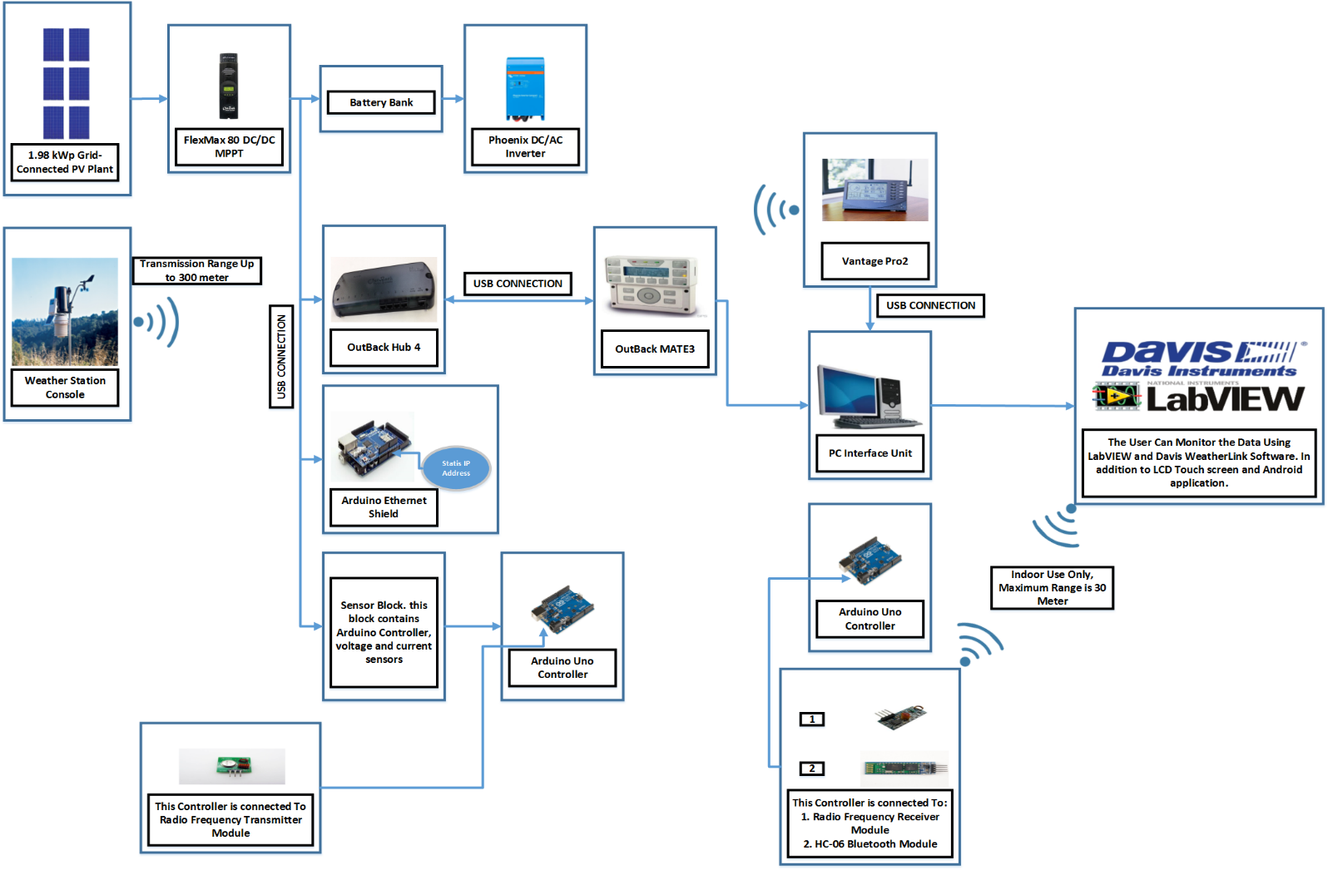

Fig. 2. GCPV-MS detailed architecture design

The same monitoring system provides three monitoring units for the weather station console which are Vantage Pro2 monitoring device [17], Web site created using Weather Link and LabVIEW Software.

# GCPV-MS System Desing

The GCPV-MS consists of three main units. The first unit is the grid-connected PV system which is producing a 1.98 kWp. The PV system consists of 9 polycrystalline silicon PV modules with a nominal power of 220 Wp. This system is connected to FLEXmax 80 maximum power point tracker (MPPT) manufactured by Outback Power. A battery storage is used to store the energy generated by the GCPV system where the Phoenix DC/AC inverter is installed to be connected to AC applications.

The weather station console is the second unit of GCPV-MS. This unit is manufactured by Davis instrumentation. The weather station console provides an important data such as the solar irradiance, humidity, temperature and wind speed. The data for the weather station console are needed to model and compare the measured data from the PV system with PV theoretical curves. The weather station console transmits the data wirelessly to Vantage Pro2 monitoring unit.

The last unit of the GCPV-MS consists of various monitoring tools which are classified as the following:

* Outback MATE 3
* Vantage Pro2
* Liquid Crystal Display (LCD)
* Android Application (App)
* LabVIEW software (Connected to a Web-site)
* WeatherLink software (Connected to a Web-site)

# Photovoltaic Monitoriing Units

## Local Monitoring Unit Using FLEXmax 80 Mate

The first monitoring unit for the Photovoltaic monitoring system is the MPPT FLEXmax 80 mate. This device allows the user to monitor the data such as the input voltage, input current, output voltage, output current and the battery status. FLEXmax 80 device is capable to log the data of the GCPV system up to 128 days.

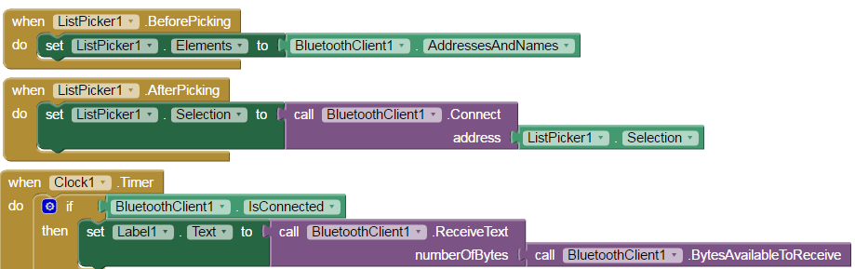

Fig. 4. MIT APP Inverter Bluetooth Connection Module

## Local Monitoring Unit Using OutBack MATE3

MATE 3 monitoring unit has the ability to display and control the data from the GCPV system. This device can monitor the DC input voltage and current, DC output voltage and current, Battery charging level and the DC/AC inverter statues.

As shown in Fig. 2, MAT3 device is connected to FLEXmax 80 MPPT through a HUB. This HUB is manufactured by Outback. Ethernet cable is used to connect the Hub with the MPPT and MATE3.

MATE3 communicates with the logging server (Computer Interface Unit) using USB cable. This allows the user to save the measured data into a 4GB SD memory card.

## Remote Monitoring Unit Using RF Technology

GCPV-MS measured data can be viewed remotely on LCD touch screen. The data is transmitted to the touch screen using RF modules. The Data includes voltage, current, temperature and the output power. The entire data is refreshed at a frequency of 1 Hertz. This unit also incorporates a password based access control feature.

## Remote Monitoring Unit Using Bluetooth Technology

Most mobile phones have integrated Bluetooth technology so it was decided to create a mobile phone application to allows users to view the real-time measured PV data. By using the MIT app inventor tool, an android mobile phone application was created. A Bluetooth module transmits measured data to the mobile device carrying the android app. Fig. 3 illustrates the logo and the output results of the mobile phone application, where the setup for the Bluetooth module in the MIT App inventor can be created as shown in Fig. 4.

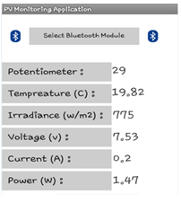

(a) (b)

Fig. 3. (a) Application output results. (b) Application logo

## Arduino Etherent Shield with Labview Software

The Arduino Ethernet shield connects Arduino controller to the internet using a static IP-address. It is based on the Wiznet W5100 Ethernet chip which provides a network stack capable of both TCP and UDP connection.

GCPV-MS uses Arduino Ethernet shield to send the data from the maximum power point tracker to PC/Server. The entire data is received by LabVIEW software. Fig. 5 Illustrates LabVIEW block diagram code which enables the connection between the Ethernet shield with LabVIEW interface unit.

## OutBack MATE3 Connected to LabVIEW Software

MATE3 monitoring device is connected to the LabVIEW software using USB cable. This device allows LabVIEW to read the data of the GCPV system.

Fig. 6 shows the front panel of the LabVIEW code. It consists of four main parts: A presents the status of the weather station, Outback Hub4 and MATE3 data stream status is the shown in part B. Where the third part C, is viewing the gird-connected photovoltaic system that includes the MPPT and the battery bank. At the bottom of the front panel the data stream can be monitored using Historical chart, this can be presented in D.

# Weather Station Monitoriing Units

## Weather Station console Connected to Vantage Pro2 Monitoring Device

Vantage Pro2 is a monitoring device that can communicate with the weather station console using radio frequency transmission (Wireless link). The device has some important features such as:

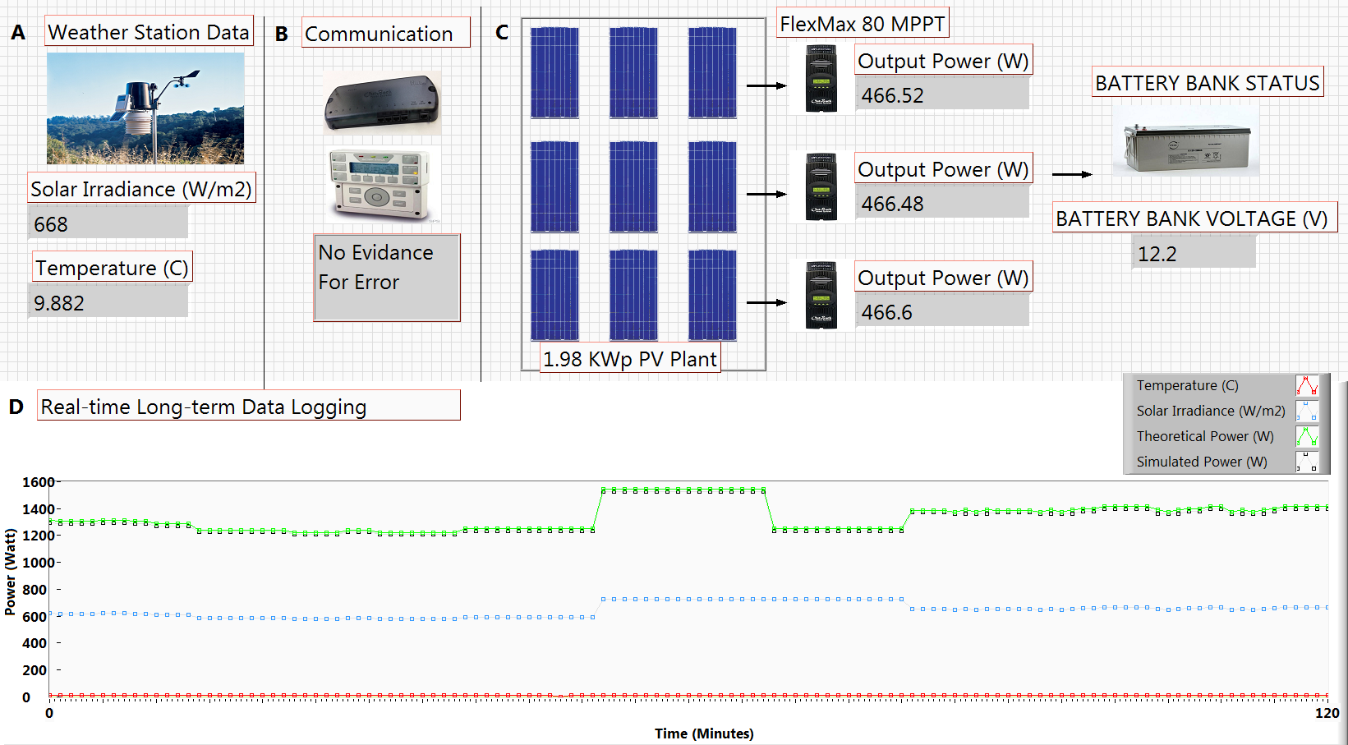

Fig. 6. GCPV Monitoring System using LabVIEW

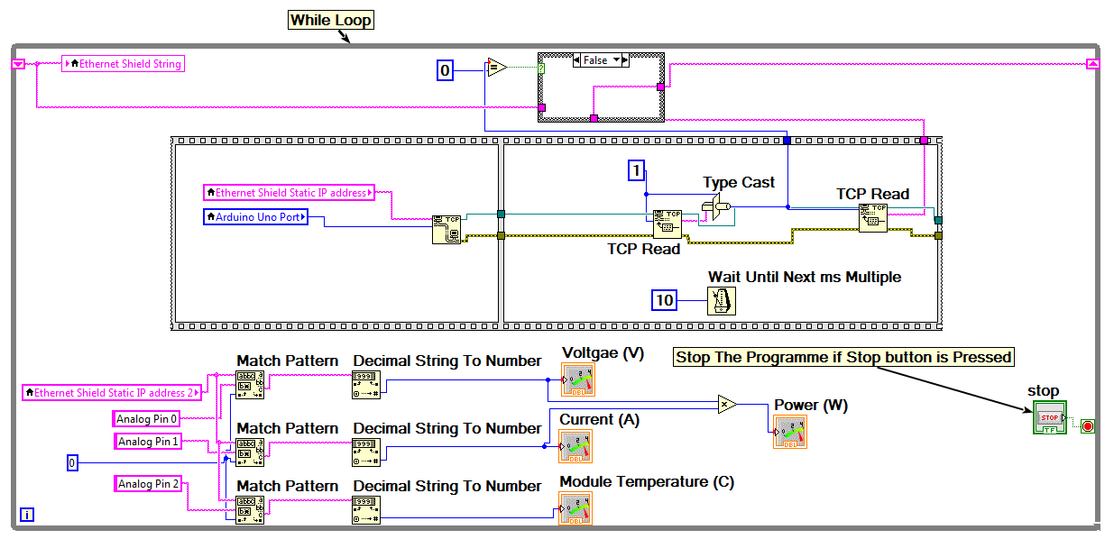

Fig. 5. LabVIEW connection code with Arduino Ethernet Shield

* Transmission distance up to 300 meters
* Logging data for any received information
* Easy to monitor the data from PC/Server

## Weather Station console Connected to WeatherLink Softawre

It is possible to view the data received from weather station console using Weather Link software. The data is sent to the device using radio frequency transmission. This monitoring unit can be connected to the PC/Server using USB cable to allow logging the measured data of the weather station.

Weather Link software allows the user to create a webpage using HTML code. The generated HTML code can be modified to fit the purpose of the user. In this project, web page has been created to monitor data

* Solar Irradiance
* Weather Temperature
* Humidity
* Wind Speed

## Weather Station console Connected to LabVIEW Software

This is the last monitoring unit of the GCPV monitoring system. LabVIEW software is used to communicate with the weather station which uses python script to read the data from the weather station. Not only the VI LabVIEW program shows the data of the weather station but also all measured data can be logged and monitored using a Web page. Fig. 7 illustrates the web page that is created by using LabVIEW web publishing tool. The web page can show a real-time data of the weather station console.

# GCPV Monitoring System Evaluation

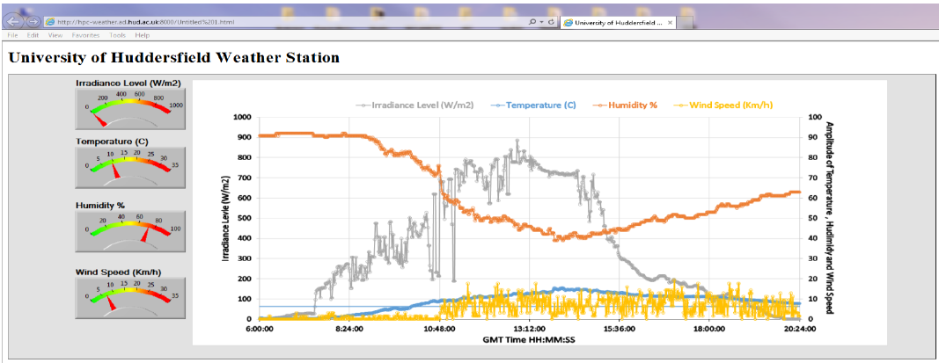

Fig. 7. Web Page Created by LabVIEW Software

## Transmission Technology

In this work, both wireless and wired transmission media were used. As summarized previously in Table I, the recent grid-connected photovoltaic monitoring systems are using different transmission technologies with their advantages and disadvantages. Table III shows a comparison between three different wireless transmission technologies.

## Graphical Unser Interface

Most of recent work related to GCPV monitoring systems are using LabVIEW and MATLAB/Simulink Software. Both programming software have a common features such as:

* Support programming of graphic UI
* Widely used, therefor easy to find publications and solutions for any coding problems
* Can be used to save/load data into a database
* Libraries Included for Renewable Energy applications such as Photovoltaic and Wind Turbines
* Easy to simulate and generate results

The recent Publications [5], [9] and [10] demonstrated suitable grid-connected monitoring systems that are using LabVIEW and MATLAB/Simulink software. Furthermore, there are some challenges for using such software described below:

* Cannot modify any toolkit or library that is created by the software
* MATLAB software doesn’t provide web publishing tool. However, LabVIEW is capable of creating a web page.
* LabVIEW software is not compatible with Ethernet, Wi-Fi and Zig-bee shields, MATLAB/Simulink has this option
* Some LabVIEW and MATLB/SIMULINK toolkits need additional licenses therefore, additional cost is required

## GCPV systems mircocontrollers

The main purpose of the microcontrollers used in photovoltaic systems is to interface the sensors readings with the graphical user interface software. In this project we used Arduino controller. However, some grid-connected photovoltaic systems use other microcontrollers such as 16F877A.

Arduino controller is usually used in GCPV systems because it has a very powerful features such as:

* Open-source Platform
* Easy programming language (Usually with C++)
* Provides different shields such as Ethernet, Bluetooth and Wi-Fi

## Weather Station

For any GCPV system, it is essential to collect the data for irradiance and temperature in order to generate I-V and P-V curves for the photovoltaic system. The Sun irradiance can be measured by the sensors in the weather station. However, module temperature should be measured using temperature sensor placed on the back of the PV panel. In this project, Davis weather station was used.

As outlined in section IV, the data of weather station is sent to a monitoring device called Vantage pro2 using wireless transmission. Additionally, if the distance between the weather station and the Vantage pro2 is beyond 300m, wireless repeaters should be used to amplify the transmitted signal. Each Repeater costs around $300. Table II shows a comparison between three different weather stations.

TABLE II

Three Different Weather Stations Comparison

|  |  |  |  |  |  |
| --- | --- | --- | --- | --- | --- |
| Weather Station | Wireless | Sun Irradiance | Temperature | Wind Speed | Cost |
| Davis | ✓ | ✓ | ✓ | ✓ | 700$ |
| PCE-FWS 20 | ✓ | 🗶 | ✓ | ✓ | 100$ |
| Maplin | ✓ | 🗶 | ✓ | ✓ | 200$ |

TABLE III

Comparison Between Three Different Transmission Technologies

|  |  |  |  |
| --- | --- | --- | --- |
| Word Done By | Bluetooth | Zig bee | Wi-Fi |
| Standard | IEEE 802.15.1 | 802.15.4 | 802.11a, b and g |
| Data Rate | 723 Kb/s | 250 Kb/s | 11 to 105 Mb/s |
| Frequency Used | 2.5 GHz | 868/915 MHz, 2.4 GHz | 2.4 GHz , 5.8 GHz |
| Range (m) | 10 | 10 to 300 | 10 to 100 |
| Power | Low | Very-Low | High |
| Cost To be used with GCPV systems | 3 – 25 $ | Depends on how big is the network (3 Zig bee Network : 50-90 $ ) | 20 – 150 $ |
| Recent Publications | [12] and [13] | [5] , [6] and [14] | [15] |

# CONCLUSION

In this paper a GCPV-MS system has been presented. It is a PV monitoring system comprising six different monitoring units and using three different transmission techniques. Most of the systems reviewed in this paper do not included environmental data as part of the monitoring unit. However, we offered a flexible, fast and secure system that utilises IoT concept to integrate photovoltaic and environmental data.

Different programming platforms were used in the GCPV-MS such as LabVIEW, Arduino and Weather Link software. Moreover, two communication links were used to monitor the entire data locally and remotely. RF modules, Bluetooth chip and Ethernet shield based on a static IP address are used to offer different monitoring frames.

The users of the GCPV-MS can monitor the data using a web page, LCD touch screen, mobile phone application, weather link and LabVIEW software. This variety of monitoring units make this system flexible, reliable and easy to use.

Further research and development of the tool will be focused on its implementation in a cloud, and use of parallel computing clusters in processing large amount of data gathered by the tool over a long period of time, In addition, a network of multiple monitoring systems will be designed to monitor and analyze the data using ‘Internet of Things’ technology and gain further insight into the PV systems’ performance.

##### References

1. Silvestre, S., Chouder, A., & Karatepe, E. (2013). Automatic fault detection in grid connected PV systems. Solar Energy, 94, 119-127.
2. Wang, T., Zhang, W., Ye, C., Wei, J., Zhong, H., & Huang, T. (2016). Fd4c: Automatic fault diagnosis framework for web applications in cloud computing. Systems, Man, and Cybernetics: Systems, IEEE Transactions on, 46(1), 61-75.
3. Chine, W., Mellit, A., Lughi, V., Malek, A., Sulligoi, G., & Pavan, A. M. (2016). A novel fault diagnosis technique for photovoltaic systems based on artificial neural networks.Renewable Energy,90, 501-512.
4. Dhimish, M., & Holmes, V. (2016). Fault detection algorithm for grid-connected photovoltaic plants. *Solar Energy, 137*, 236-245. doi: <http://dx.doi.org/10.1016/j.solener.2016.08.021>
5. Shariff, F., Rahim, N. A., & Hew, W. P. (2015). Zigbee-based data acquisition system for online monitoring of grid-connected photovoltaic system.Expert Systems with Applications,42(3), 1730-1742.
6. Guerriero, P., Di Napoli, F., Vallone, G., dAlessandro, V., & Daliento, S. (2016). Monitoring and Diagnostics of PV Plants by a Wireless Self-Powered Sensor for Individual Panels.Photovoltaics, IEEE Journal of,6(1), 286-294.
7. Ngo, G. C., Floriza, J. K. I., Creayla, C. M. C., Garcia, F. C. C., & Macabebe, E. Q. B. (2015, November). Real-time energy monitoring system for grid-tied Photovoltaic installations. InTENCON 2015-2015 IEEE Region 10 Conference(pp. 1-4). IEEE.
8. Hu, T., Zheng, M., Tan, J., Zhu, L., & Miao, W. (2015). Intelligent photovoltaic monitoring based on solar irradiance big data and wireless sensor networks.Ad Hoc Networks,35, 127-136.
9. Rezvani, A., & Gandomkar, M. (2016). Modeling and control of grid connected intelligent hybrid photovoltaic system using new hybrid fuzzy-neural method.Solar Energy,127, 1-18.
10. Riccobono, A., Naqvi, S. K. A., Monti, A., Caldognetto, T., Siegers, J., & Santi, E. (2015, June). Online wideband identification of single-phase AC power grid impedances using an existing grid-tied power electronic inverter. InPower Electronics for Distributed Generation Systems (PEDG), 2015 IEEE 6th International Symposium on(pp. 1-8). IEEE.
11. Kim, K. A., Seo, G. S., Cho, B. H., & Krein, P. T. (2016). Photovoltaic Hot-Spot Detection for Solar Panel Substrings Using AC Parameter Characterization.Power Electronics, IEEE Transactions on,31(2), 1121-1130.
12. Milosavljević, D. D., Pavlović, T. M., & Piršl, D. S. (2015). Performance analysis of A grid-connected solar PV plant in Niš, republic of Serbia. *Renewable and Sustainable Energy Reviews*, *44*, 423-435.
13. Collotta, M., & Pau, G. (2015). A Solution Based on Bluetooth Low Energy for Smart Home Energy Management. *Energies*, *8*(10), 11916-11938.
14. Moon, S., Yoon, S. G., & Park, J. H. (2015). A New Low-Cost Centralized MPPT Controller System for Multiply Distributed Photovoltaic Power Conditioning Modules. *Smart Grid, IEEE Transactions on*, *6*(6), 2649-2658.
15. Kabalci, E. (2015). A smart monitoring infrastructure design for distributed renewable energy systems. Energy Conversion and Management, 90, 336-346.
16. LabVIEW. (2016). *LabVIEW System Design Software*. Retrieved from <http://www.ni.com/labview/>.
17. DAVIS. (2016). *Your weather. Your web site.*. Retrieved from <http://www.weatherlink.com/>.
18. OutBack Power. (2016). *OutBack Power*. Retrieved from <http://www.outbackpower.com/>.