Perpendicular Anisotropy Controlled by Seed and Capping Layers of Heusler Alloy Films
William Frost, Marjan Samiepour and Atsufumi Hirohata, Senior Member, IEEE
Abstract—Half-metallic Heusler alloys typically have in-plane magnetic anisotropy, which can be converted to perpendicular by attaching MgO or heavy metal, e.g., Pt, layers as similarly applied for conventional ferromagnets. Recently we have found body-centred cubic (bcc) seed layers, e.g., V and W, to induce perpendicular anisotropy in Heusler alloy films above, however, they show small giant magnetoresistance (GMR) ratios in spin-valve structures to date. This is partially because of the large resistivity of the seed layer and the non-magnetic layer in the spin-valve. In this study we have systematically investigated non-magnetic overlayers and have found that a Ag layer best maintains the perpendicular anisotropy. The corresponding GMR devices have then been fabricated and characterised, achieving the GMR ratio of ~0.03% at room temperature. Such bcc seed layers can offer an alternative method for perpendicularly magnetised GMR junctions for applications.

Index Terms—Magnetoresistance, magnetoresistive devices, magnetic materials

Introduction
H
EUSLER alloys have been investigated intensively due to their half-metallicity at room temperature, which is ideal as an ideal spin source for spintronic devices [1],[2],[3]. The alloys can also exhibit other magnetism by controlling the number of valence band electrons in the alloys and the associated magnetic interactions, achieving antiferromagnetism [4], ferrimagnetism [5], topological insulator [6] and spin gapless semiconductor [7]. Such broad controllability of the Heusler alloys [8] allows us to develop spintronic devices consisting of Heusler alloys with different magnetic properties, e.g., giant magnetoresistive (GMR) [8] and tunnelling magnetoresistive (TMR) [9] junctions for a next generation hard disk read head and a magnetic random access memory cell [10].
For these device applications, a film form of Heusler alloys has some obstacles, including their large crystallisation energy, atomic disordering in the film and interfaces, and magnetic isotropy due to their cubic unit cells [11]. To date significant efforts have been made to induce perpendicular magnetic anisotropy in a Heusler alloy film by attaching a perpendicularly magnetised ferromagnet [13] or MgO layer [14]. Namely the latter structures can be useful for TMR junctions [15]. We have recently found a method to lower the crystallisation temperature of a ternary/quaternary Heusler alloy film by growing on the (110) plane [16]. Our latest study demonstrates that almost 85% of a Co₂FeAl_{0.5}Si_{0.5} (CFAS) Heusler-alloy film can be crystallised at 353K for 2 min. by growing on a body-centred cubic (bcc) seed layer, e.g., vanadium [17] or tungsten [18]. The CFAS(110) films are also found to exhibit perpendicular magnetic anisotropy (PMA) by growing the films even at 62ºC but with a small GMR ratio.
In this study, we systematically investigate the effect of seed and capping layers on Co-based Heusler-alloy films, which can be used as a non-magnetic layer in a GMR junction. We have found W shows strong PMA but with some magnetic dead layer at the interface against the Heusler-alloy films. Ag spacers in a GMR junction show consistent magnetisation reversal and small interfacial mixing, which is ideal for the device applications, achieving a GMR ratio of ~ 0.03% at room temperature.

Experimental Procedures
Heusler alloy films were grown on a thermally oxidised Si substrate in the form of Cr (0 and 3)/X (t)/CF(A)S (10)/Y (5)/Ru (3) (thickness in nm, X: V and W, Y: W, Ta, V and Pt, and 5 ≤ t ≤ 30 nm) using a high target utilisation sputtering system (PlasmaQuest, HiTUS) at room temperature. These films were annealed at 300 ~ 350ºC for 1 ~ 3 hours. The structural and magnetic properties of these films were characterised by X-ray diffraction (XRD, Rigaku, SmartLab) and vibrating sample magnetometry (VSM, Lakeshore, Series 8600). The magnetisation reversal process was also imaged using magnetic force microscope (MFM, Nanoscan, VLS-80).
A multilayer of W (10)/CFAS (12.5)/W (1.2)/CFAS (2.5)/Ru (3) (thickness in nm) was grown on a thermally oxidised Si substrate and patterned into a nanopillar junction using a combination of electron-beam lithography and Ar-ion milling using the same process as previously reported [19]. Here, a seed layer, Cr/W, was patterned into a bottom electrode with a width of 100-200 nm. Nanopillars with diameters between 80 and 200 nm were patterned to just above the bottom Heusler-alloy layer. The typical fluctuation in the diameter of the nanopillar fabricated was <10 nm, leading to a volume fluctuation of ± 4 ~ ± 27% for a 10 nm thick film. The nanofabrication process was carefully optimised by using a double-resist process with methyl methacrylate (MMA) and poly-methyl methacrylate (PMMA). A top electrode, Ag/Ta, was then patterned on the nanopillar in a similar manner. The fabricated nanopillars were measured using a non-magnetic probe station (HiSOL, HMP-400 SMS) with a conventional direct-current (dc) four-terminal method. A dc current between 1 µA and 10 mA was applied to the nanopillar with a constant current source (Keithley, 2400) to induce Joule heating for alloy crystallisation, while the voltage across the nanopillar was measured by a nanovoltmeter (Keithley, 2182A).
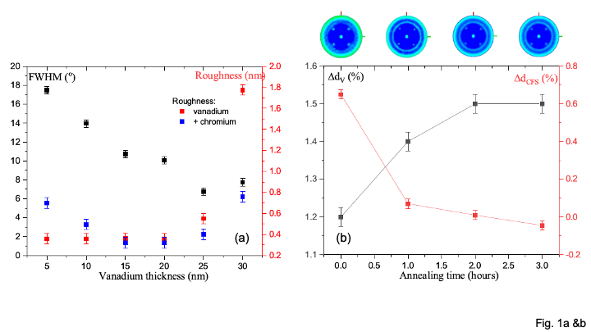
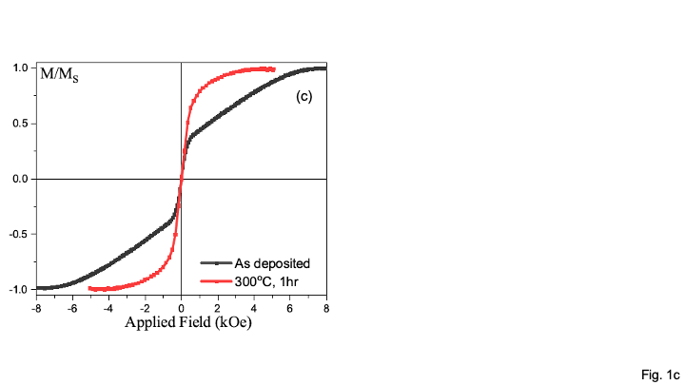
Fig. 1. (a) FWHM of the V(110) reflection measured by rocking curves with increasing V thickness without (black) a Cr layer and the roughness of V layers with (red) and without (blue) a Cr layer. (b) Estimated strain in V(110) (black) and CFS(110) (red) planes for samples with increasing annealing time at 300ºC. The corresponding pole figures of the CFS(220) and V(110) peaks are also shown. (c) Out-of-plane magnetisation curves for a 5 nm CFS layer with a 25 nm V seed layer before (black) and after (red) annealing at 300ºC for 1 hour.

Results and Discussion
The texture of vanadium films with and without a chromium seed layer is plotted as the full width half maximum (FWHM) of the rocking curve of the vanadium (110) peak as shown in Fig. 1(a). For the Co₂FeSi (CFS) Heusler-alloy films with a Cr layer, FWHM was found to be >20° for all thicknesses of vanadium. For those without Cr, FWHM shows much smaller values and takes the minimum at the V layer thickness of 25 nm, which is found to be optimal for inducing (110) texture in a Heusler-alloy layer. Figure 1(a) also shows the roughness of the V layer with and without the Cr layer as determined by X-ray reflectivity (XRR). The roughness of the films without Cr stays almost constant (< 0.4 nm) and increases at the V thickness between 25 nm and 30 nm, while that with Cr takes a dip of ~ 0.4 nm at 15 and 20 nm thick V layers. There is a clear threshold thickness around 20 ~ 25 nm where the sample properties are optimised. This is possibly due to the creation of islands at greater thicknesses which in turn create the increased roughness. This is the opposite of the case for silver seed layers where the film quality was improved by the presence of chromium [20]. This is likely due to intermixing being more prevalent between Cr and V than with Ag.
Figure 1(b) shows the change in the level of strain in the (110) planes of the V and CFS lattices calculated from θ-2θ scans by comparing with their bulk values for the films without the Cr seed layer. It is apparent that these two lattices have the opposite trends via the annealing process, which provides energy to improve the lattice match between them. As the V lattice is stretched with increasing lattice strain up to 1.5% after annealing at 300ºC for 3 hours, an opposite change is observed in the CFS layer down to almost no strain. The associated pole figure scans are performed around the CFS(220) reflection. For the as-deposited film, there is a diffuse ring at α = 29º. This confirms a dominant CFS{110} orientation in the films but the lack of intensity and sharpness are indicative of a low level of texture. Note that the spots are from the single crystal Si substrate. After annealing at 300ºC for 1 hour, the definition and intensity of the ring are improved significantly, confirming the increased crystallisation. Further improvement is observed with increasing annealing time, agreeing with the elimination of the film strain.
For the optimum 5 nm thick CFS layer, out-of-plane magnetisation curves normalised by the saturation magnetisation M_{S} are shown in Fig. 1(c). After the annealing at 300ºC for 1 hour, the films are found to show almost no coercivity. By reducing the CFS thickness to 4 nm, the coercivity is increased up to 15 Oe [13], which is not sufficient for device applications.
By replacing V with tungsten [14], significant improvement in the crystallinity of the Heusler-alloy films has been demonstrated, achieving smaller interfacial roughness of just 0.2 nm. Additionally significant increase in the crystallinity of the Heusler-alloy films is also confirmed by the increase in the relative XRD intensity despite the low temperature deposition below 62ºC. This increase is larger in the W layer at around five times, as compared to only twice in CFAS. This is accompanied by the relaxation of the W lattice toward the bulk value as shown in Fig. 2(a). This distortion of the lattice is not seen by in-plane 2θ_{χ} measurements, indicating that the W lattice is deposited with a tetragonal stretch out of plane.
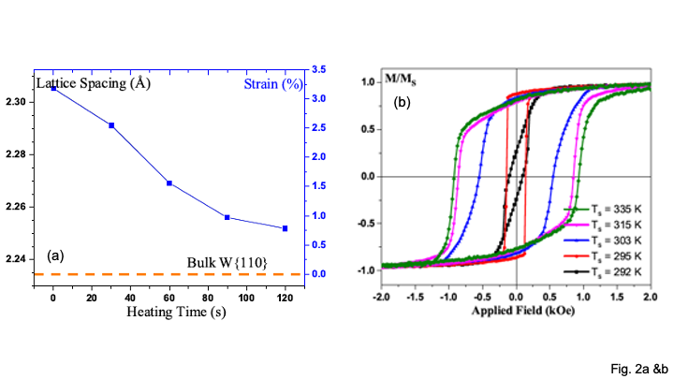
Fig. 2. (a) Lattice relaxation of the tungsten layer estimated by XRD spectra for a W (10)/CFAS (10) (thickness in nm) multilayer deposited at the substrate temperature of 62ºC for up to 2 min. (b) Out-of-plane magnetisation curves for a W/CFAS multilayer deposited at increasing substrate temperature.
The crystallite size is determined using the Scherrer analysis of the seed-layer and Heusler-alloy reflections. In W, there is an almost two-fold increase in the crystallite size from (5.4 ± 0.2) nm to (9.2 ± 0.1) nm associated with the increased crystallinity. CFAS without heating shows non-crystalline or nanocrystalline nature as expected [3]. In the samples grown at 62ºC, on the other hand, a crystallite size of (7.9 ± 0.1) nm is obtained. This has significant effects on the magnetisation reversal as previously reported [14]. The nanocrystalline samples grown below 22ºC have very strong intergranular coupling, leading to a low coercivity H_{C} with a squareness of 0.8 as shown in Fig. 2(b), which also contains some in-plane contributions as previously reported [19]. For samples deposited above 30ºC, the magnetisation reversal is dominated by domain rotation and strong pinning up to 1 kOe, followed by a nucleation process. H_{C} accordingly increases from 200 to 1000 Oe with increasing the growth temperature from 20 to 62ºC. Hence, the optimum structure is selected to be 10 nm thick bcc W seed layer for further study.
The magnetisation reversal process in a multilayer consisting of W (10)/CFAS (12.5)/W (1.2)/CFAS (2.5)/Ru (3) (thickness in nm) deposited at 62ºC is observed by MFM with a magnetic field applied perpendicular to the multilayer as shown in Fig. 3. At the remanence state without a field application after the positive saturation with the magnetic field applied from the substrate to the capping layer, the MFM image in Fig. 3 shows almost uniform magnetisation aligned perpendicular to the multilayer with minor ripple domains with the size of a few 100 nm. This agrees with the large remanence measured in the above films (M / M_{S} ~ 0.8). The magnetic domain configurations do not change up to 300 Oe, which agrees with the magnetisation measurement in Fig. 2(b). Above 400 Oe, reverse domain nucleation is observed with rapid rotation of these domains with increasing a magnetic field. Here the magnetisation reversal is dominated via nucleation as reported in Ref. [19]. There are several pinning sites observed up to ~ 600 Oe as seen for the MFM image taken under 600 Oe. The magnetisation reversal is completed under a large field, 3 kOe.
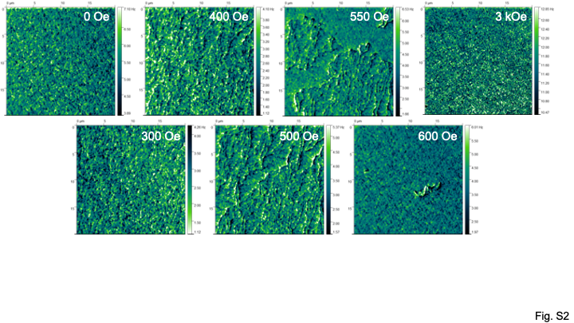
Fig. 3. Magnetisation process observed by MFM (20 µm × 20 µm area) on Si/SiO₂//W (10)/CFAS (12.5)/W (1.2)/CFAS (2.5)/Ru (3) (thickness in nm). Some minor distributions in the magnetic moments are visible under the remanent and saturation, which may be induced by the coexistence of in-plane contributions in the CFAS films.
For the investigation of the influence of a capping layer, the optimum 10 nm thick CFAS Heusler alloy films grown on the 10 nm thick W layer has been used. Figure 4(a) shows XRD θ-2θ signals on CFAS capped with a series of 5 nm thick layers Y (Y: W, Ta, V and Pt). All films show W crystallisation along the (110) surface orientation, which promotes the CFAS crystallisation as confirmed by the CFAS(220) peak as previously reported [14]. On CFAS, all the capping layers, Pt, β-W and (lesser extent) V, are found to crystallise. Among these capping layers, Ta and W encourage the crystallisation of Ru.
Figure 4(b) shows VSM data measured under the application of out-of-plane magnetic fields. All CFAS films exhibit perpendicular magnetic anisotropy as discussed above but with clear effects of top-interface variation, which induces some in-plane anisotropy possibly due to the poor crystallisation caused by the presence of the capping layer. The magnetisation curve of the W cap reveals the highest squareness, indicating a magnetisation reversal generated by effectively single nucleation due to strong intergranular coupling. This single reversal may be induced by the symmetric W/CFAS/W interfaces, showing square nucleation with H_{C} of ~ 300 Oe. The V cap, on the other hand, appears to have two switches with stepped loop, which suggests the nucleation occurs at the both top and bottom interfaces. Additional rotation-controlled reversal is added on top from the CFAS/V interface. The Pt cap also has two weak switches in the magnetisation curve but promotes the domain wall motion significantly. Here, the effect of CFAS/Pt interface dominates over the W/CFAS interface. This suggests that the nucleation is significantly reduced by the Pt cap due to the reduction in the intergranular coupling in CFAS and/or the pinning during the magnetisation reversal is increased at the CFAS/Pt interface. Since the CFAS crystallinity stays the same under the same growth condition, the latter scenario may govern the reversal process.
In-plane magnetisation measurements further support the formation of two distinctive interfaces for W/CFAS/V and W/CFAS/Pt samples as shown in Fig. 4(c). The stepped magnetisation curves again confirm the difference in the pinning strengths between the top and bottom CFAS interfaces, indicating the CFAS/Pt interface dominates the domain wall motion as discussed above for the out-of-plane measurements. On the other hand, the CFAS/W top interface again shows very different behaviour, indicating single-step magnetisation reversal. This sample shows the ideal magnetic properties for junction applications.
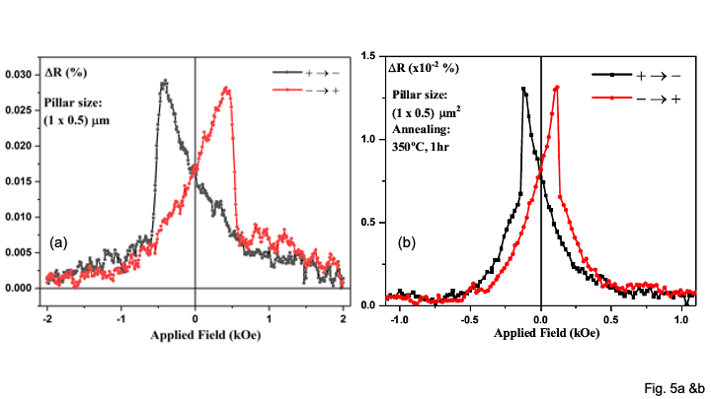
Fig. 5. GMR loops of a pillar with dimensions of 1 µm 0.5 µm, consisting of Si/SiO2//W (10)/CFAS (12.5)/W (1.2)/CFAS (2.5)/Ru (3) (thickness in nm), (a) before [16] and (b) after annealing at 350ºC for 1 hour measured at room temperature under the magnetic field applied perpendicular to the plane.
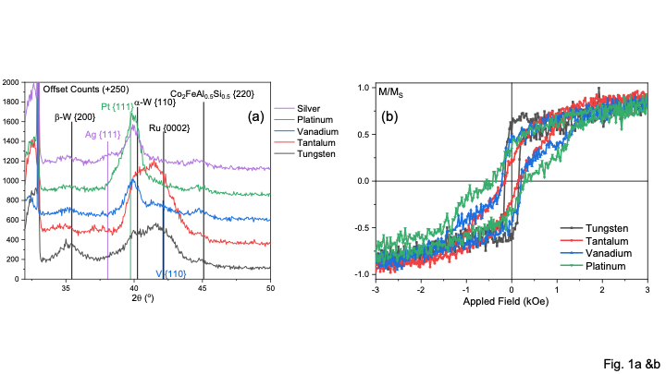
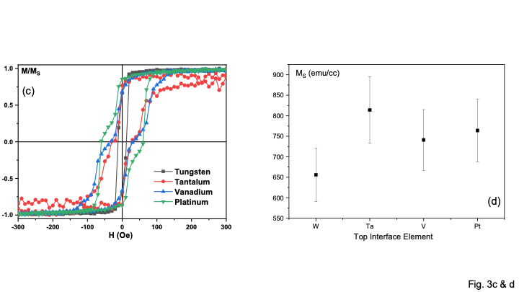
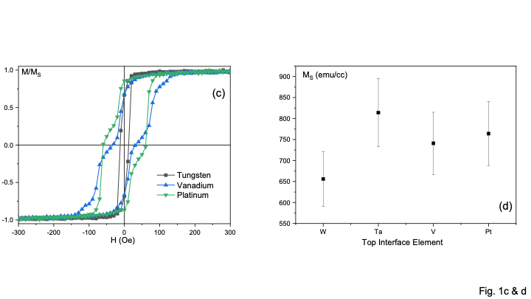
Fig. 4. (a) XRD θ-2θ scans and (b) out-of-plane and (c) in-plane magnetisation curves of Si/SiO₂//W (10)/CFAS (10)/Y (5)/Ru (3) (thickness in nm, Y: W, Ta, V and Pt). (d) Saturation magnetisation of these films calculated from (c).
The saturation magnetisation M_{S} of these CFAS films is calculated in Fig. 4(d) from the magnetisation curves. All films show 650 ~ 850 emu/cm³, which is almost 30% smaller than the bulk value of 1200 emu/cm³ [14]. This may be due to the interfacial mixing across the CFAS layer, especially at the CFAS/cap interfaces. Among these capping layers, W shows the largest reduction as reported earlier [14]. This leads to the GMR ratio of ~0.03% for an elliptical pillar with the long and short axes of 1 and 0.5 µm at room temperature. This is almost the same with the GMR pillar with the Ru capping layer as reported previously [14]. By annealing at 350ºC for 1 h, the GMR ratio is found to be reduced by half possibly due to the interfacial mixing. Although the interfacial roughness is reduced to ~ 0.2 nm at the bottom W/CFAS interface, further optimisation of the growth is required for the top CFAS/W interface for device implementation.

Conclusion
We used a bcc tungsten seed layer to promote the (110) surface to crystallise a Co-based Heusler-alloy films in a layer-by-layer mode at low energy and to induce perpendicular magnetic anisotropy. For the reduction in resistance in a GMR junction with the Heusler-alloy films, a series of non-magnetic layers have been studied to maintain high degrees of crystalline ordering and strong perpendicular anisotropy. Ag and Ta are found to satisfy these requirements with rotation-dominated magnetisation reversal. We have demonstrated the GMR ratio of ~0.03% at room temperature, which can be improved further by tuning the thickness of the Heusler-alloy and non-magnetic layers. These can be useful for all-metallic spintronic device applications.

Acknowledgment
This work was partially supported by EPSRC-JSPS Core-to-Core Programme (EP/M02458X/1) and JST CREST (No. JPMJCR17J5). The authors appreciate technical support on MFM imaging provided by Nanoscan.

References
- C. Felser and A. Hirohata (Eds.), “Heusler Alloys,” Berlin, Germany, Springer, 2016.
- I. Galanakis and P. H. Dederichs (Eds.), “Half-Metallic Alloys,” Berlin, Germany, Springer, 2005.
- K. Elphick, W. Frost, M. Samiepour, T. Kubota, K. Takanashi, H. Sukegawa, S. Mitani and A. Hirohata, “Heusler alloys for spintronic devices: Review on recent development and future perspectives,” Sci. Technol. Adv. Mater., vol. 22, no. 1, pp. 235-271, 2021, DOI:10.1080/14686996.2020.1812364.
- A. Hirohata, T. Huminiuc, J. Sinclair, H. Wu, M. Samiepour, G. Vallejo-Fernandez, K. O'Grady, J. Balluff, M. Meinert, G. Reiss, E. Simon, S. Khmelevskyi, L. Szunyogh, R. Yanes, U. Nowak, T. Tsuchiya, T. Sugiyama, T. Kubota, K. Takanashi, N. Inami and K. Ono, “Development of antiferromagnetic Heusler alloys for the replacement of critically raw iridium,” J. Phys. D: Appl. Phys., vol. 50, no. 44, pp. 443001, 2017, DOI: 10.1088/1361-6463/aa88f4.
- A. K. Nayak, M. Nicklas, S. Chadov, P. Khuntia, C. Shekhar, A. Kalache, M. Baenitz, Y. Skourski, V. K. Guduru, A. Puri, U. Zeitler, J. M. D. Coey and C. Felser, “Design of compensated ferrimagnetic Heusler alloys for giant tunable exchange bias,” Nat. Mater., vol. 14, pp. 679-684, 2015, DOI:10.1038/nmat4248.
- Z. K. Liu, L. X. Yang, S.-C. Wu, C. Shekhar, J. Jiang, H. F. Yang, Y. Zhang, S.-K. Mo, Z. Hussain, B. Yan, C. Felser and Y. L. Chen, “Observation of unusual topological surface states in half-Heusler compounds LnPtBi (Ln=Lu, Y),” Nat. Commun., vol. 7, 12924, 2016, DOI: 10.1038/ncomms12924.
- Y. Du, G. Z, Xu, X. M. Zhang, Z. Y. Liu, S. Y. Yu, E. K. Liu, W. H. Wang and G. H. Wu, “Crossover of magnetoresistance in the zero-gap half-metallic Heusler alloy Fe₂CoSi,” Europhys. Lett., vol. 103, no. 3, pp. 37011, 2013, DOI:10.1209/0295-5075/103/37011.
- I. Galanakis, P. H. Dederichs and N. Papanikolaou, “Orbital magnetism in the half-metallic Heusler alloys,” Phys. Rev. B, vol. 66, no. 1, pp. 174429, 2002, DOI: 10.1103/PhysRevB.71.012413.
- J. W. Jung, Y. Sakuraba, T. T. Sasaki, Y. Miura and K. Hono, “Enhancement of magnetoresistance by inserting thin NiAl layers at the interfaces in Co₂FeGa_{0.5}Ge_{0.5}/Ag/Co₂FeGa_{0.5}Ge_{0.5} current-perpendicular- to-plane pseudo spin valves,” Appl. Phys. Lett., vol. 108, no. 10, 102408, 2016, DOI:10.1063/1.4943640.
- H. Liu, T. Kawami, K. Moges, T. Uemura, M. Yamamoto, F. Shi and P. M. Voyles, “Influence of film composition in quaternary Heusler alloy Co₂(Mn,Fe)Si thin films on tunnelling magnetoresistance of Co₂(Mn,Fe)Si/MgO-based magnetic tunnel junctions,” J. Phys. D Appl. Phys., vol. 48, no. 16, pp. 164001, 2015, DOI:10.1088/0022-3727/48/16/164001.
- A. Hirohata, H. Sukegawa, H. Yanagihara, I. Žutić, T. Seki, S. Mizukami and R. Swaminathan, “Roadmap for emerging magnetic materials for spintronic device applications,” IEEE Trans. Magn., vol. 51, no. 10, pp. 0800511, 2015, DOI: 10.1109/TMAG.2015.2457393.
- A. Hirohata, W. Frost, M. Samiepour and J.-Y. Kim, “Perpendicular magnetic anisotropy in Heusler alloy films and their magnetoresistive junctions,” Materials, vol. 11, no. 1, 105, 2018, DOI: 10.3390/ma11010105.
- T. Hiratsuka, G. Kim, Y. Sakuraba, T. Kubota, K. Kodama, N. Inami, H. Naganuma, M. Oogane, T. Nakamura, K. Takanashi and Y. Ando, “Fabrication of perpendicularly magnetized magnetic tunnel junctions with L1₀-CoPt/Co₂MnSi hybrid electrode,” J. Appl. Phys. vol. 107, pp. 09C714, 2010; DOI: 10.1063/1.3358239.
- X. Li, S. Yin, Y. Liu, D. Zhang, X. Xu, J. Miao and Y. Jiang, “Perpendicular magnetic anisotropy of full-Heusler films in Pt/Co₂FeAl/MgO trilayers,” Appl. Phys. Exp. vol. 4, pp. 043006, 2011; DOI: 10.1143/APEX.4.043006.
- Z. Wen, H. Sukegawa, S. Kasai, M. Hayashi, S. Mitani and K. Inomata, “Magnetic tunnel junctions with perpendicular anisotropy using a Co₂FeAl full-Heusler alloy,” Appl. Phys. Exp. Vol. 5, pp. 063003, 2012; DOI: 10.1143/APEX.5.063003.
- J. Sagar, L. R. Fleet, M. Walsh, L. Lari, E. D. Boyes, O. Whear, T. Huminiuc, A. Vick and A. Hirohata, “Over 50% reduction in the formation energy of Co-based Heusler alloy films by two-dimensional crystallisation,” Appl. Phys. Lett., vol. 105, no. 3, pp. 032401, 2014, DOI: 10.1063/1.4886769.
- W. Frost and A. Hirohata, “Perpendicular anisotropy in Heusler alloy layers induced by a V seed layer,” IEEE Trans. Magn., vol. 52, no. 7, pp. 4400604, 2016, DOI:10.1109/TMAG.2016.2517738.
- W. Frost and A. Hirohata, “Heusler alloys with bcc tungsten seed layers for GMR junctions,” J. Magn. Magn. Mater., vol. 453, pp. 182-185, 2018, DOI: 10.1016/j.jmmm.2018.01.015.
- W. Frost and A. Hirohata, “Low-temperature deposition of Heusler alloys with perpendicular magnetic anisotropy,” J. Magn. Magn. Mater., vol. 484, pp. 100-104, 2019, DOI: https://doi.org/10.1016/j.jmmm.2019.04.008.
- J. Sagar, C. N. T. Yu, L. Lari and A. Hirohata, “Growth of polycrystalline Heusler alloys for spintronic devices,” J. Phys. D: Appl. Phys. vol. 47, pp. 265002, 2014; DOI: 10.1088/0022-3727/47/26/265002.

This paper is submitted on 25 May 2021 for review. This work was partially supported by EPSRC-JSPS Core-to-Core Programme (EP/M02458X/1) and JST CREST (No. JPMJCR17J5). The authors appreciate technical support on MFM imaging provided by Nanoscan. W. Frost is with the Department of Physics, University of York, York YO10 5DD, United Kingdom. Current address is Oxford Instruments Plasma Technology, Bristol BS49 4AP, United Kingdom. M. Samiepour was with Department of Electronic Engineering, University of York, York YO10 5DD, United Kingdom. Current address is Seagate Technology, Londonderry BT48 0LY, United Kingdom. A. Hirohata is with the Department of Electronic Engineering, University of York, York YO10 5DD, United Kingdom (e-mail: atsufumi.hirohata@york.ac.uk).

