**Airborne** **and indigenous microbiomes co-drive the rebound of antibiotic resistome during compost storage**

Hanpeng Liao1, Yudan Bai1, Chen Liu1, Chang Wen1, Qiue Yang1, Zhi Chen1, Samiran Banerjee2, Shungui Zhou1*, Ville-Petri Friman3*

**Affiliations**

**1**Fujian Provincial Key Laboratory of Soil Environmental Health and Regulation, College of Resources and Environment, Fujian Agriculture and Forestry University, Fuzhou 350002, China.

**2** Department of Microbiological Sciences,North Dakota State University, Fargo, North Dakota, USA

**3**Department of Biology, University of York, Wentworth Way, YO10 5DD, York, UK.

**\*Corresponding authors**

Correspondence to Shungui Zhou (sgzhou@fafu.edu.cn) and Ville-Petri Friman (ville.friman@york.ac.uk)

**Originality and significance statement**

Sewage sludge, livestock manure and solid waste contain high levels of antibiotics and antibiotic resistance genes (ARGs). While composting has been shown to be an effective way to turn these waste products into safe organic fertilizers with low levels of ARGs, the fate and abundance of residual ARGs during the compost storage remain unexplored. Here we experimentally tested the recovery of ARGs in conventional and hyperthermophilic compost under closed and open storage conditions. By using a combination of metagenomics and direct culturing methods, we show that residual ARGs left in the treated compost can rebound and exceed the initial levels within weeks of storage, irrespective of the used composting method. While this effect was constrained by the closed storage conditions, the recovery was primarily driven by the regrowth of surviving indigenous bacteria. As a result, better storage strategies are required to prevent ARG rebound after composting.

**Summary**

Composting is a widely used to reduce the abundance of antibiotic resistance genes (ARGs) in solid waste. While ARG dynamics have been extensively investigated during composting, the fate and abundance of residual ARGs during the storage remain unexplored. Here, we tested experimentally how ARG and mobile genetic element (MGE) abundances change during compost storage using metagenomics, quantitative PCR and direct culturing. We found that 43.8% of ARGs and 39.9% of MGEs quickly recovered already during the first week of storage. This rebound effect was mainly driven by the regrowth of indigenous, antibiotic resistant bacteria that survived the composting. Bacterial transmission from the surrounding air had a much smaller effect, being most evident as MGE rebound during the later stages of storage. While hyperthermophilic composting was more efficient at reducing the relative abundance of ARGs and MGEs, relatively greater ARG rebound was observed during the storage of hyperthermophilic compost, exceeding the initial levels of untreated sewage sludge. Our study reveals that residual ARGs and MGEs left in the treated compost can quickly rebound during the storage via airborne introduction and regrowth of surviving bacteria, highlighting the need to develop better storage strategies to prevent the rebound of ARGs and MGEs after composting.

**Keywords：**Composting, Resistome, Metagenomics, Rebound effect, Mobile genetic elements

**Abstract Art (for review)**

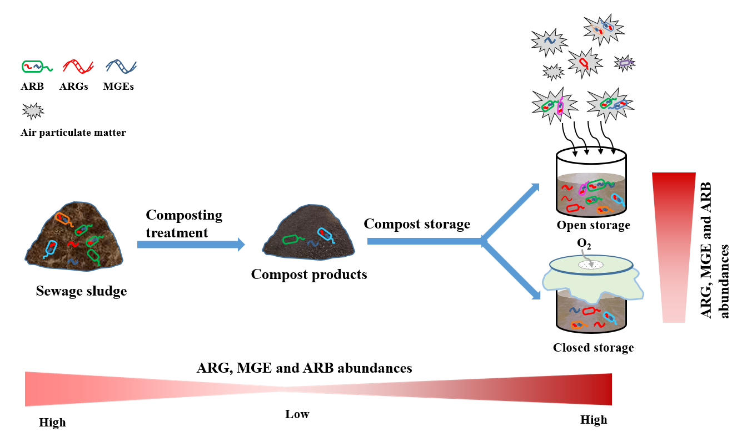

**Introduction**

Sewage sludge, livestock manure as well as solid waste can contain high levels of antibiotics and heavy metals, leading to positive selection for antimicrobial resistance genes (ARGs), which are often carried by pathogenic bacterial strains (Zhu et al., 2013; Munk et al., 2018). Annual production of such types of waste currently reaches nearly a billion metric tons globally, and sludge and manure are often recycled as a substitute for chemical fertilizers, especially in organic farming practices (Zhu et al., 2013; Udikovic-Kolic et al., 2014). As the ARGs from soil can re-enter the food chain directly via consumption of crops and vegetables, or though people working in farming industry (Udikovic-Kolic et al., 2014; Xie et al., 2016), it is important to reduce the amount of ARGs in sludge and manure before environmental release to constrain ARG transmission (Hernando-Amado et al., 2019).

Composting is a widely practiced, sustainable and low-cost strategy to turn solid waste into nutritious soil amendments for plants (Harrison et al., 2020). The thermophilic stage (sustained temperature above 50°C for five days) of composting is often able to kill most of the enteric pathogens, such as *Escherichia coli*, and is thus regarded as an efficient method to reduce the number of potential pathogens present in the animal gut and manure (Youngquist et al., 2016; Liao et al., 2018; Gao et al., 2019). Composting thus reduces the amount of ARGs in animal waste as these genes are often associated with pathogenic bacteria that are unable to survive high composting temperatures (Liao et al., 2019). Hyperthermophilic (HT) composting with relatively higher temperature (up to 90°C) has been shown to be more efficient at reducing ARGs and their associated host bacteria compared to conventional composting (CT) (Liao et al., 2018). While the efficiency of composting in reducing ARGs have been studied extensively (Zhang et al., 2016b; Wang et al., 2017; Liao et al., 2018; Gao et al., 2019; Liao et al., 2019), there exists much less information on how the subsequent storage and maturation of compost might affect the abundances and potential recovery of antibiotic resistant bacteria. The time required for the compost to reach maturity is determined by the properties of compost and storage conditions and ranges from several days to months (Butler et al., 2001). As the composting does not remove all ARGs, it is likely that residual ARGs could still increase during the storage stage via bacterial growth. For example, previous studies have found that *Escherichia coli* O157:H7 and *Salmonella* spp. could recover and increase their abundances after composting (Skanavis and Yanko, 1994; Kim et al., 2009), while certain ARGs that were reduced during the thermophilic phase of composting were found to rebound during the maturation stage (Zhang et al., 2016a; Liao et al., 2018; Cao et al., 2020). Similar recovery of ARGs has been observed with anaerobic and aerobic digestion of organic waste (Ma et al., 2011; Kanger et al., 2019) during the later stages of composting when ambient composting temperatures are reached. In addition to intrinsic recovery (regrowth) of surviving bacteria in the compost, ARGs could be reintroduced to the compost from external sources through air as particulate matter. Airborne transmission of ARGs via particulate matter has received increasing attention (Gao et al., 2018; Li et al., 2018; Xie et al., 2018b; Gaviria-Figueroa et al., 2019; Mao et al., 2019) and is thought to be an important pathway for ARG and MGE spread and transmission (Zhu et al., 2017; Xie et al., 2018b; Mahnert et al., 2019). While several studies have demonstrated that composting could increase the release of dust and particulate matter containing ARGs and antibiotic resistant bacteria (Hartmann et al., 2016; Gao et al., 2018; Li et al., 2020), the relative importance of airborne particulate matter for ARG recovery during compost storage is unclear.

The objectives of this study were to determine the effect of storage time on potential rebound of residual ARGs and MGEs after composting, and to explore to what extent this process is driven by the recovery of indigenous bacteria that survive composting compared to airborne reintroduction of ARGs. Specifically, we addressed following questions: (i) Does the storage time affect ARG and MGE rebound? (ii) Does the potential rebound of ARGs and MGEs depend on the composting method (conventional vs. hyperthermophilic)? (iii) What is the relative importance of indigenous versus airborne microbial transmission for ARG and MGE rebound?

To answer these questions, we used a small-scale composting system to treat sewage sludge simulating conventional (CT) and hyperthermophilic composting (HT) treatments (Fig. 1a). The final composts were stored aerobically in closed (caps with 0.22 μm filters for the exchange of gases) or open containers (no caps) for four weeks, allowing potential ARG and MGE recovery by indigenous or by both indigenous and airborne microbes, respectively. Changes in microbial community dynamics and ARG and MGE abundances were monitored by weekly sampling for a total of four weeks using a combination of metagenomics, amplicon sequencing, quantitative PCR (qPCR) and direct isolation and culturing of antibiotic resistant bacteria (ARBs). Moreover, the relative contribution of indigenous versus airborne microbes for the rebound was assessed using structural equation modelling. Our ﬁndings show that ARGs and MGEs can rapidly rebound already within a week of storage independent of the employed composting method. This rebound was mainly driven by regrowth of indigenous bacteria that were associated with ARGs and MGEs. Airborne transmission of ARGs and MGEs had a much smaller effect, which became visible at later stages of compost storage. Crucially, the ARG and MGE levels at the end of the storage exceeded those present in the initial raw sludge. Together our findings suggest that the rebound of ARGs and MGEs during the storage could outweigh the benefits of ARG and MGE reduction achieved during composting.

**Materials and Methods**

**Experiment 1: a simulated model composting setup**

The model system simulating large-scale composting was set up using the water-bath incubator according to previous studies (Qian et al., 2016) and described below. Composting materials (approximately 100 kg) consisted a mixture of sewage sludge (70% water content, provided by a local wastewater treatment plant) and composting end materials (15% water content included 5% rice husk) in a ratio of 4:1 (w/w). The mixtures of composting material were added into stainless boxes (50×20×30 cm), which where incubated in water-bath. An automatic temperature controller was set to control temperature changes of the water-bath simulating three main phases of the composting process: mesophilic phase (35-54°C), thermophilic phase (55-90°C), and maturing phases (30-45°C) based on a previous study (Liao et al., 2018). To explore the effect of composting temperature on the ARG rebound effects, conventional composting (CT, maximum 55°C) and hyperthermophilic composting (HT, maximum 90°C) temperatures were simulated during the water-bath composting experiment (N=3).

**Experiment 2: a simulated compost storage microcosm experiment**

After experiment 1, compost from two different treatments (HT and CT) were homogenized and mixed before dividing into replicate aliquots (500 g) in plastic sterilized bottles (9 cm high, inner diameter 6 cm, 500 ml volume). The compost microcosms were further divided into two additional treatments: exposure or no exposure to air (i.e., closed or open microcosms). Microcosms left open (no caps) were exposed to airborne dust and microbial transmission, while the closed microcosms were sealed with plastic caps equipped with 0.22 μm breathable filters, allowing aerobic composting conditions and exchange of gases. As a result, this experiment had four treatments: open-CT, closed-CT, open-HT and closed-HT, and each treatment was replicated for 30 times (5 sampling times × 6 replicates × 4 treatments, total of 120 microcosms). The open and closed treatment microcosms were stored aerobically at the same place, and only environmental difference was the exposure of open microcosms to the dust in the air.

The microcosms were then incubated in the open air at industrial composting facility in Fuzhou China for four weeks at room temperature, ranging from 26.1 ± 2.5 °C in September to 32.2 ± 2.7 °C in October 2019 (consistently high daytime humidity >70%). Microcosms were arranged randomly 10 cm apart from each other and the water contents were adjusted to 60% of the maximum water holding capacity with sterile deionized water every day during the storage (in aseptic conditions for closed treatment microcosms). The four treatments were sampled destructively by randomly removing six replicate microcosms per treatment at the beginning (S0) and then every week for total of four weeks (S1-S4). As a result, every sampling point consisted of 30 destructively sampled microcosms (6 independent replicates per every treatment). The four-week storage monitoring period was chosen as this is commonly used storage time in the commercial composting industry. All microcosm samples were stored at -80 °C to extract total DNA for bacterial community analyses as described below.

**Sampling of air particulate matter and DNA extraction**

To assess the effect of airborne transmission on ARG abundances during compost storage, particulate air matter was collected and extracted using air filters as described previously (Jiang et al., 2015) (More detailed description provided in Supplementary Text 1).

**Quantifying and analyzing bacterial communities based on 16S rRNA amplicon sequencing**

Total genomic DNA was extracted from composting samples using a Fast DNA spin kit (MP Biomedicals, Cleveland, OH, USA) according to the manufacturer’s instructions. Microvolume spectrophotometer (NanoDrop ND-2000, Thermo Fisher Scientific, Wilmington, USA) and gel electrophoresis were used to check DNA concentration and purity. To quantify bacterial communities in the compost samples, 16S rRNA amplicon sequencing was conducted using Illumina NovaSeq 6000 PE250 platform (Guangdong Magigene Biotechnology Co. Ltd, Guangzhou, China) according to previous studies (Liao et al., 2021). More detailed description of bacterial community analysis is provided in Supplementary Text 2.

**Source-Tracker analysis: tracking the origin of microbes**

To explore whether airborne transmission could affect the compost bacterial community composition, we tracked the most likely origin of microbial communities using the SourceTracker 0.9.5 software (Knights et al., 2011). SourceTracker uses a Bayesian approach to estimate the most probable proportion of user-defined “source” microbial communities in a given “sink” community. In this analysis, samples from compost were set as ‘sinks’, and samples from the raw sludge and airborne particulate matter as ‘sources’. SourceTracker analysis was performed using default settings with three independent replicate runs (average used to calculate the final plot).

**Quantitative PCR to determine 16S rRNA, ARG and MGE gene abundances**

Quantitative PCR was used to quantitate the abundance of 16S rRNA genes and a total of 27 ARG subtypes conferring resistance to four types of common antibiotics (tetracycline, sulfonamide, aminoglycoside and macrolide) and five MGEs including two integrases (*intI1*, *intI2*), two plasmids (*ISCR1*, *IncQ*), one transposon (*Tn916*/*1545*, abbreviated *Tn916*) and 16S rRNA gene across all samples (N=112). The quantification was carried out on a Light Cycler 96 system (Roche, Mannheim, Germany) as described previously(Liao et al., 2018), and all the details of the qPCR assay for all target genes (primers, annealing temperatures, reaction conditions and amplification cycles) are listed in Supplementary Table S1.

**Metagenomic sequencing and data analysis**

To further assess the dynamics of ARGs (resistome) and MGES (mobilome) during compost storage, raw sludge (N=6) and composting samples collected at S0, S1, S2, S3, S4 (N=6 for each time point) time points under open and closed condition were subjected to metagenomic sequencing. Briefly, approximately 1 μg DNA from each sample was used to construct library with a 300 bp insert size, followed by sequencing using Illumina HiSeq X ten platform (Guangdong Magigene Biotechnology Co. Ltd, Guangzhou, China) with PE150 (2×150 paired reads). The raw sequences with average quality scores or length less than 30 (Q30) or 50 bp, respectively, were removed using FastQC, resulting in 75.1 million clean reads with average 6.2 Gb clean reads for each sample. Changes in resistome were analyzed using local ARGs-OAP (v2.2) using the clean reads (Yin et al., 2018). ARG reads were identified against the SARG database at the cutoﬀ of 10-7 E-value, 80% identity and 75% hit length. SARG database contains 24 ARG types, 1208 ARG subtypes, and 12307 non-redundant reference sequences (Yin et al., 2018). Resistance ‘types’ represent the class of antibiotics to which ARGs confer resistance to, while ‘subtypes’ represent individual kinds of ARG, such as subtype *tetA* of tetracycline resistance gene. The reads were used to search the database of 30 essential single-copy gene families, which are found in nearly all bacteria and archaea, and are bacterial and archaeal PhyEco marker genes (Nayfach and Pollard, 2015). The average coverage of essential single-copy gene was used to calculate the cell numbers in each sample. Changes in mobilome were analyzed using the same pipeline except for using a recently published MGE database (Parnanen et al., 2018).

**Metagenome assembly and identification of ARG- and MGE-like open reading frames (ORFs) and bacterial hosts**

After quality control, the clean reads were assembled using SPAdes (v 3.13.1) with the parameters ‘-k 21, 33, 55, 77, 99 -meta (Bankevich et al., 2012) and the assembled contigs longer than 500 bp were analyzed further. In total, we obtained 12,567 million contigs with an average length of 1221.9 bp. The contig ORFs were predicted using Prodigal v2.6.3 with a meta model (Hyatt et al., 2010). The ARG- and MGE-like ORFs were identified against the SARG database (MGE database) using DIAMOND (v 0.9.29.130) with an E-value ≤10-10. An ORF was designated as an ARG- and MGE-like sequence if its best DIAMOND (Buchfink et al., 2015) alignment against database sequences had at least 80% similarity with a ≥ 70% query coverage (Ma et al., 2016). The co-occurrence of ARG- and MGEs-like was deemed as positive if they both located in the same contig. Bacterial hosts of ARGs or MGEs were predicted by taxonomically assigning metagenomic-assembled contigs in CAT (v 5.0.3) (Bastiaan von F. A. Meijenfeldt et al., 2019)

**Isolation of antibiotic resistant bacteria**

Culture-based methods were used to compare the number of antibiotic resistant bacteria in raw sludge (N=3) and compost samples at different time points (S0 to S4, N=3 per each point) during the storage. Isolation and identification of culturable antibiotic resistant bacteria from different treatments were performed as previously described by Liao *et. al* (Liao et al., 2019) (More detailed description provided in Supplementary Text 3).

**Correlating ARG abundance changes with experimental factors, recovering** **bacterial taxa and MGE abundances during the storage**

A correlation matrix was constructed to explore the potential correlations between ARG abundances and ARG host bacteria, by calculating all pairwise Spearman’s correlation coefficients (ρ) among ARG subtypes that occurred in at least 40% of the samples. A correlation between two nodes was regarded as statistically significant when ρ ≥ 0.8 and *p* value ≤ 0.01. The ρ and p values were generated using R-function “rcorr” (Hmisc package). To reduce the frequency of false-positives, the p values were adjusted using Benjamini-Hochberg method. The network analysis was performed in the R environment using vegan (Langfelder and Horvath, 2008) and Hmisc packages, and was visualized in Gephi (v0.9.2). Partial least squares path modeling (PLS-PM) was employed to explore the direct, indirect and interactive effects between all measured variables explaining changes in ARG abundances during compost storage (Tenenhaus et al., 2005). The final model included the following variables: storage time, storage condition (closed vs. open), composting method (CT vs. HT), bacterial community diversity and bacterial community composition (based on weighted UniFrac distances) and MGE abundances. Indirect effects were defined as multiplied path coefficients between predictor and response variables, including all possible paths excluding the direct effect. The final model was chosen of all constructed models based on the Goodness of Fit (GoF) statistic - a measure of the model’s overall predictive power.

**Calculation of the ARG rebound ratio during the compost storage**

To determine if ARG abundances rebounded during the storage, we compared the ARG abundances at the beginning and during the compost storage treatment. Briefly, if ARG abundances were higher during the storage phase (S1 to S4) compared to the initial starting point (S0), they were classified as rebounded genes.

Rebound ratio (Rr) was further used to reflect the degree of rebound effects under open (Rr-open) and closed (Rr-closed) storage treatments. To further analyze the relative contribution of airborne transmission (external effect) and regrowth of indigenous bacteria (internal effect) for ARG rebound effect, we used the following equations (2-5). For all equations:

1. Rr = log10 (ARG abundance at given storage sampling time point (S*i*) / ARG abundance at the initial sampling time point (S0)).

2. Contribution rate of external effect (Cr-e) = (Rr-open-Rr-closed) /(Rr-open + Rr-closed)

3. Contribution rate of internal effect (Cr-i) = Rr-closed / (Rr-open + Rr-closed)

4. Relative contribution rate of external effect (rCr-e)= Cr-e / (Cr-e + Cr-i) *100

5. Relative contribution rate of internal effect (rCr-i)= Cr-i / (Cr-e + Cr-i) *100

**Statistical analyses**

Most of the data was analyzed using the R platform (v 3.6.1). The overall mean differences between treatments were analyzed using ANOVA (Tukey HSD test) and Student’s t-tests where *p* values below 0.05 were considered statistically significant. Nonparametric PERMANOVA (Adonis function, 999 permutations) was used to determine the signiﬁcance of sampling time points and storage treatments on the microbiome and resistome composition. Signiﬁcant differences in taxonomic abundances between two treatment groups were determined using DESeq2 package (Love et al., 2014), using adjusted *p*-values (≤0.05) after Benjamini-Hochberg correction. Bacterial community composition and resistome structure were visualized using principal co-ordinates analysis (PCoA, based on Weighted-UniFrac distance) and non-metric multidimensional scaling (NMDS, Bray-Curtis distance) using the vegan package v2.4-3 and labdsv v1.8. Structural equation modelling was conducted using PLS-PM in R 3.6.1 using the plspm v 0.4.7.

**Results**

**The effect of composting method and storage time on residual ARG and MGE abundance dynamics**

Simulated, small-scale conventional (CT) and hyperthermophilic (HT) composting treatments were used to treat the same compost raw material, *i.e.*, sewage sludge (Fig.1a, for more detail, see methods). The composting removed nearly half of the ARGs (44.5% and 68.7% for CT and HT treatments, respectively) and MGEs (52.0% and 88.8% for CT and HT, respectively), with hyperthermophilic composting being around 60% more efficient. However, most of the detected genes clearly increased in abundance during the storage irrespective of composting treatment (based on the rebound ratio, which was calculated as the fold gene abundance change during storage stages (S1 to S4) relative to initial gene abundances (S0) based on logarithmic transformation, Fig. S1). Moreover, the gene richness (Fig. S2, *p*<0.01) and composition (Fig. S3, PERMANOVA; *p* < 0.05) of both ARGs and MGEs showed a significant increase during the storage, exceeding the initial ARG and MGE levels observed in the raw sludge (based on metagenomic data). Interestingly, this rebound effect was clearer in the HT treatment, where the reduction in ARGs and MGEs abundances was relatively higher (Fig. 1b).

The total abundance of residual ARGs significantly (*p*=0.0025) increased over time, and this increase was larger for the compost originating from the HT treatment (*p*<0.01, Fig. 1b). Moreover, the abundance of total ARGs increased significantly more during open storage in both composting treatments (Fig. S4): around 15.6% and 34.3% of detected ARGs and MGEs in CT and HT treatments exhibited more than 1.5-fold enrichment under open versus closed storage (after 2-weeks of storage; Fig. S5a). On average, 39.6% (118 of 298) and 48.7% (164 of 338) of detected ARGs showed a rebound trend (rebound ratio >1.0, based on subtype genes) in both CT and HT treatments (Fig. 2a). Specifically, the drastic rebound of resistance genes linked to kasugamycin, sulfonamide, trimethoprim, tetracycline, chloramphenicol, multidrug and beta-lactam antibiotic resistance (rebound ratio >1.0) was observed irrespective of the composting method. In contrast, no significant rebound of resistance genes associated with bleomycin, bacitracin and vancomycin resistances was observed (Fig. 2b-c). The abundance of chloramphenicol, sulfonamide, fosmidomycin and tetracycline genes increased over 2-fold under open compared to closed storage treatment in HT compost (Fig. S5b). The significance of airborne transmission on ARG and MGE rebound was further supported by quantitative PCR analysis showing that open storage treatment samples had higher rebound ratios compared to closed storage samples (Fig. S6). Similar to ARGs, the total abundance of MGEs increased during the storage (*p* <0.001), which was relatively higher in HT compost: 25.8 versus 2.8-fold increase in MGE abundances after 3 weeks of storage (Fig. 1b). Most of the detected MGEs (32.7% and 40.9% for CT and HT, respectively) included integrases, transposases, *IS91* and *tniB* genes, which all increased during the storage (Fig. 2d). HT treatment had the highest rebound effect (total rebound ratio =12.6) under open storage at S3 time point (Fig. 2f), and overall, a higher rebound ratio was observed under the open versus closed storage (*p*<0.01, Fig. 2e-f). Specifically, the abundances of MGEs including *IS91*, integrase and transposase genesshowed 2- to 3.5-fold enrichment during the open storage (Fig. S5b). The sequencing results were in line with increase in the abundance of culturable antibiotic resistant bacteria (for full description see Supplementary Text 4). Together, these results indicate that most ARGs, MGEs and antibiotic resistant bacteria can rebound during the storage via regrowth and airborne transmission, irrespective of the employed composting method.

**The recovery of indigenous core microbiota and airborne transmission co-drive the ARG and MGE rebound**

To further explore the relationship between the ARG and MGE rebound with compost bacterial communities, we performed 16S rRNA gene amplicon sequencing using all longitudinal compost microbiome samples (Fig. 1a), and compared the abundance, diversity and composition of bacterial communities in different treatments. We observed a clear reduction in cell densities during the composting (R vs. S0, *p*<0.05), which was followed by bacterial regrowth (S0-S1) that exceeded the initial bacterial densities present in the raw compost (*p*<0.01, Fig. S14). Another drop (S1-S3) and second recovery (S3-S4) was also observed later stages of storage, while composting or storage treatment had no significant effects (Fig. S14; bacterial abundances determined using qPCR of the 16S rRNA gene). We then compared the effect of composting method (CT vs. HT) for the compost microbiomes and found significant changes in microbial community composition during the storage in both composting treatments (based on weighted UniFrac distance; PERMANOVA test, *p* = 0.001, Fig. S7a, e). Bacterial species richness also increased in both composting treatments (*p* < 0.05, Fig. S7b, f), and overall, these changes were most drastic during the first week of storage. As a result, changes in bacterial community composition were significantly correlated with the structure of resistome (Procrustes analysis, *p* <0.001, Fig. S8). We next compared the effect of closed versus open storage treatment for bacterial communities. Similar to ARG and MGE results, airborne microbial transmission had a significant effect on microbiome composition (PCoA analysis and Adonis test, *p* = 0.001, Fig. S7c, g), which was relatively larger for HT compost (*p* < 0.001, Fig. S9). However, no difference in species richness was found between closed versus open storage treatments irrespective of employed composting method (Fig. S7d, h). Together, these results suggest that both the recovery of indigenous bacteria and airborne bacterial transmission shaped the microbiome assembly during the compost storage.

To investigate changes in the microbiome composition in more detail, a core microbiome was identified comprising of the taxa present in more than 75% of all samples (n=105 samples). A total of 74 core taxa (13.7%) could be detected, accounting for 57.1% of the total bacterial abundances (Table S2). Of these core taxa, around 48.6% (36 of 74) were enriched during the storage (S1 to S4 relative to S0; DESeq2, fold change >1.5, *p*-adj < 0.05, Table S2) and 94.4% of these taxa (34 of 36) were linked to ARGs or MGEs based on co-occurrence network analysis (Fig. 3a and Table S3). To confirm that these host taxa were resistant to antibiotics, we randomly isolated and 16S rRNA sequenced 1440 strains covering all experimental treatments using tetracycline, erythromycin, gentamicin and sulfamethoxazole antibiotic selective plates (Table S4). Approximately 48.9 % (22 of 46) of isolated antibiotic resistant bacterial taxa matched with predicted ARG-MGE hosts identified in the co-occurrence analysis (Table S5). We further compared the abundance differences of core taxa before (S0) and after the storage (S1 to S4) using DESeq2 based on ASV counts. Overall, the microbiome recovery was dominated by Firmicutes, Bacteroidetes and Proteobacteria phyla, and at the genera level, the most rapidly recovering taxa included *Bacillus*, *Fermentimonas*, *Moheibacter* and uncultured compost bacteria (fold change > 4, adjusted *p*-value < 0.05, Fig. S10-11, for full description see Supplementary Text 5). The enriched taxa associated with ARGs and MGEs included *Paracoccus*, *Lysinibacillus*, *Bacillus*, *Bhargavaea* and *Sporosarcina* which were also present in culturable antibiotic resistant isolates (Fig. 3b and Table S4). Specifically, the relative abundance of *Bacillus* withknown spore-forming capability drastically increased from 13.7% to 40.9% in the HT compost, while the relative abundance of *Fermentimonas* (*intI2*) increased more than 10-fold in HT compost after one week of storage (Fig. 4a). These results suggest that the rebound of ARGs was associated with regrowth of antibiotic resistant bacteria during the compost storage.

To determine the effect of airborne transmission on ARG and MGE abundances, we analyzed the airborne particulate matter samples collected at weeks 2 and 3 (Fig. 1). Airborne particulate matter samples contained high abundances of both ARGs (21 ARG type and 275 ARG subtypes including 1743 non-redundant ARG genes, Table S6) and MGEs (9 MGE types and 143 MGE subtype including 145 non-redundant MGE genes, Table S7). Overall, abundances of potential ARG and MGE hosts, such as Bacteroidetes, Planctomycetes, and Actinobacteria, increased more clearly during open versus closed storage conditions and this difference became greater along with the storage time (Fig. 4b-d); significant differences were only observed with Gemmatimonadetes and Bacterioidetes phyla during the first two sampling weeks, while multiple potential ARG taxa showed a higher recovery in the open treatment at sampling weeks 3 and 4, including Planctomycetes phyla (2.3 and 47.7 fold increases in CT and HT treatments in open compared to closed storage treatment, respectively, Fig. 4c-d). At the genera and species levels, open storage conditions significantly enriched *Paracoccus*, *Sporosarcina*, *Oceanobacillus*, *Novosphingobium*, *Brevundimonas*, *Sporosarcina*, *Moheibacter*, *Sphingobacterium*, *Lysobacter* and some uncultured bacteria (*p* < 0.05, Fig. S12). All these taxa were identified as potential ARG or MGE hosts in our network analysis, and most of them could be isolated using selective antibiotic plates (Table S4). Finally, we used source tracking approach to explore what proportion of recovered compost microbiome taxa could potentially be contributed to airborne microbial transmission. Our analysis showed that less than 10% of all observed compost microbiome taxa were derived from airborne particulate matter (Fig. S13). Most airborne taxa exclusively found in open storage compost microbiomes included 65 genera across 11 phyla (Table S8), and this sequence data matched taxonomically with culturable antibiotic resistant bacteria isolated from the compost microbiomes (for full description see Supplementary text 6). Together these results suggest that ARG and MGE recovery was associated with rebound of specific bacterial taxa, which was co-driven by airborne transmission and regrowth of indigenous bacteria containing ARGs and MGEs.

**Relative contribution of bacterial regrowth and airborne transmission for the ARG and MGE rebound during the storage**

Structural equation modelling was used to compare the relative importance of different factors for the ARG rebound during the storage. The storage time, storage condition (open vs. closed), composting method (CT vs. HT), bacterial diversity and abundance (based on top 100 taxa) and MGE abundances could together explain 61.48% of the total variation in ARG rebound. Based on partial least-squares path model (PLS-PM), the open storage condition, storage time and conventional composting method had strong direct effects on bacterial community composition (Fig. 5a). Community composition itself had a strong positive effect on both ARG and MGE abundances. Bacterial community diversity had a positive effect on ARG but negligible effect on MGE abundances. MGE abundances had the relatively strongest positive effect on ARG abundances (Fig. 5a). Based on the source tracking analysis, the importance of regrowth of indigenous bacteria on ARG rebound was relatively much larger compared to airborne bacterial transmission (Fig. S13). However, the significance of airborne transmission on ARG rebound became more significant at later stages of compost storage (Fig. 5b-c and Fig. S13). For example, in case of beta-lactam resistance, contribution by airborne transmission increased from 15.9% to 46.3% at the same time when the contribution by bacterial regrowth decreased from 84.0% to 53.7% between weeks 1 and 4 (Fig. 5b; similar trends were also observed with tetracycline resistance). These finding suggest that ARG recovery was primarily driven by the regrowth of indigenous bacteria and to a lesser degree by airborne transmission.

**Discussion**

Compost is a good fertilizer for agricultural farming. However if left untreated before application, it can inadvertently increase the levels of antibiotic-resistant bacteria and resistance genes in the soil (Udikovic-Kolic et al., 2014; Wang et al., 2018), potentially increasing health risks and the movement of ARGs from soils to plants and food systems (Udikovic-Kolic et al., 2014). Here we show that while composting efficiently reduces ARGs and MGEs, they can rapidly rebound during short-term storage via two likely mechanisms: regrowth of indigenous ARG host bacteria and reintroduction of ARG-carrying bacteria via airborne particulate matter. While the role of indigenous microbes was relatively more important for the ARG recovery, closed storage treatment could significantly constrain the rebound of ARGs and ARBs, especially towards the end of the storage period. Understanding the fate and recovery of residual ARGs during compost storage is thus of a great importance.

The employed composting approach (conventional vs. hyperthermophilic) considerably affected the rebound of ARGs and MGEs. Consistent with the previous findings, the high composting temperature of hyperthermophilic composting reduced the abundance of ARG and MGEs more efficiently compared to conventional composting (Qian et al., 2016; Liao et al., 2019). However, most of the ARGs and MGEs rebounded to much higher levels in HT treatment, exceeding the initial levels observed in the raw sludge. While such recovery has previously been observed already during the later stages of HT composting when the temperature drops closer to ambient temperature (Liao et al., 2018; Cui et al., 2020), it is unclear why such a high recovery was observed in this experiment already after a one week of storage. One reason for this could be that a higher proportion of non-hyperthermophilic bacteria was lost during the composting, which could have boosted the reassembly and recovery of surviving bacteria due to vacant niche space. In support of this, we observed a reduction in cell densities during the composting, which was followed by bacterial regrowth. Increase in ARGs and MGEs during the storage could have been driven by the increase in the abundance of antibiotic resistant bacteria that survived the composting. We also found that HT compost communities had a lower bacterial diversity and relative abundances but a higher number and variety of ARGs and MGEs. This raises a question if ARGs and MGEs were associated with some other auxiliary genes that help the associated bacteria to survive high temperatures during hyperthermophilic composting. Reduction in compost microbiome diversity could also make the composted communities more susceptible to microbial invasions from external environments via airborne dust and particulate matter (Wang et al., 2019). In support of this hypothesis, we observed that the rebound ratio of both ARGs and MGEs was higher during the open versus closed compost storage. Moreover, the MGE rebound was relatively higher in HT compost at open storage condition, which suggests that horizontal gene transfer played more important role in the ARG rebound in HT compost (Meredith et al., 2018). Together, these results indicate that more efficient removal of ARGs and MGEs during hyperthermophilic composting could be outweighed by faster ARG and MGE recovery during the storage, potentially outweighing the benefits of this composting method.

While airborne transmission had a significant effect on ARG and MGE rebound, this was considerably smaller compared to regrowth of indigenous microbes that survived the composting. The rebound of ARGs and MGEs was associated with enrichment of core microbial taxa that were found in more than 75% of compost samples and accounted for 57.1% of the total bacterial relative abundances (mainly Firmicutes). Several of these taxa could be linked to ARGs and MGEs using co-occurrence network analysis. Furthermore, we isolated over 1400 culturable antibiotic resistant bacteria during the experiment and confirmed that most of them could be assigned to predicted antibiotic resistant bacteria based on our network analysis, including *Bacillus*, *Pseudomonas*, *Fermentimonas*, *Moheibacter* and some uncultured bacterial taxa. Specifically, the relative abundances of *Moheibacter* bacterium in the HT compost and *Fermentimonas* in CT compost increased by 3 to 10 folds after a week of storage. This suggest that ARG rebound was partly driven by strong species identity effects, potentially due to the formation of heat-resistant endospores or physiological changes in metabolism that allowed increased tolerance to heat (Allison and Martiny, 2008; Chen et al., 2018; Dharmasena et al., 2021). Overall, our results are in line with previous studies, linking changes in ARG abundances with changes in microbial community composition in aquatic (Karkman et al., 2019), soil(Forsberg et al., 2014) and airborne microbiomes (Mahnert et al., 2019). However, it remains unclear why ARG and MGE containing bacteria enriched so strongly during the storage. One possibility is that potential antibiotics present in the raw sludge remained active after composting, creating a selective environment that favors antibiotic resistant bacteria. Alternatively, composting could have favored thermotolerant or spore-forming bacteria that could survive high temperature (Wang et al., 2015). In support of this, we found that spore-forming *Bacillus* genus, which was identified as one of the main ARGs hosts, showed a clear regrowth during the compost storage. Composting could thus be less effective in removing ARGs if they are carried by spore-forming Gram-positive species that have adapted to survive under stressful environmental conditions (Dharmasena et al., 2021).Another reason could be caused by few bacteria still survived with after composting due to they are thermotolerant or decrease the activity to produce spores (Wang et al., 2015). For example, the spore-forming *Bacillus* in Firmicutes identified as main ARGs hosts experienced sharply regrowth during storage. This phenomenon is not surprised due to some bacteria have versatile ability such as forming endospores for Gram-positive strain and change the form of cells to survive facing the environmental stress such as heat (Dharmasena et al., 2021). Moreover, antibiosis is an important ecological mechanism mediating bacterial competition, and potentially bacterial ability to produce and resist the antimicrobials was favored during compost microbiome reassembly. These effects could be enforced by MGEs that help ARGs to transmit throughout the bacterial population when MGE-free hosts become available. While these hypotheses remain to be tested in the future, our structural equation modelling demonstrates that ARG rebound effects were mainly driven by changes in bacterial community composition, diversity and MGE abundances, highlighting their importance for ARG rebound (Liao et al., 2018).

External airborne bacterial transmission also accelerated the ARG and MGE rebound especially towards the end of the storage, and air particulate matter contained around 0.5 ARG and MGE copies per cell in, which is close to the initial gene abundances of untreated raw sludge. As a result, the open compost microbiomes contained a higher number of culturable antibiotic resistant bacteria and potential Bacteroidetes and Planctomycetes ARG hosts, while certain taxa were exclusively found only in airborne particulate matter samples and open storage compost microbiomes. These results support previous findings demonstrating that airborne dust and particulate matter are important sources of ARGs and MGEs (Li et al., 2018; Xie et al., 2018a; Cui et al., 2020), partly explaining the observed ARG and MGE rebound under open storage condition. Several airborne MGEs were co-located with ARGs in the same contigs in open storage compost samples, which suggests that these ARGs were likely transferrable by horizontal gene transfer. Interestingly, the significance of airborne transmission became more important towards the end of the storage period likely due to increased exposure time to external microbes (Li et al., 2020). Together these results suggest that while closed compost storage can reduce the ARG recovery, it only has a relatively small role for the total ARG rebound. As a result, more research is required to develop more efficient methods to constrain ARG rebound during the compost storage. In order to reduce the rebound of antibiotic resistance genes after composting, more research is needed on the effect of compost storage conditions on ARG rebound. First, our results should be validated using large scale systems that are currently used for compost storage. Second, compost storage time could be extended to explore if ARG rebound is reduced along with longer storage time. Finally, the effect of other environmental parameters, such as temperature and moisture, could be explored to identify conditions that minimize ARG rebound during the compost storage, making the compost safe for agricultural use.

**Acknowledgements**

The authors would like to thank Dr. Zeyou Chen in Nankai University for the valuable suggestions. This work was supported by the National Natural Science Foundation of China (31972521), the Fujian Agriculture and Forestry University Program for Distinguished Young Scholar (No. XJQ2017001). Ville-Petri Friman is funded by the Royal Society (grant nos. RSG\R1\180213 and CHL\R1\180031) and jointly by a grant from UKRI, Defra, and the Scottish Government, under the Strategic Priorities Fund Plant Bacterial Diseases programme (BB/T010606/1) at the University of York.

**Supporting Information**: The SI contains additional methodological details and results about the rebound of the target genes and culturable antibiotic resistant isolates.

**Competing interests**

The authors declare no competing interests.

**References**

Allison, S.D., and Martiny, J.B.H. (2008) Resistance, resilience, and redundancy in microbial communities. *Proc Nat Acad Sci USA* **105 Suppl 1**: 11512-11519.

Bankevich, A., Nurk, S., Antipov, D., Gurevich, A.A., Dvorkin, M., Kulikov, A.S. et al. (2012) SPAdes: a new genome assembly algorithm and its applications to single-cell sequencing. *J Comput Biol* **19**: 455-477.

Bastiaan von F. A. Meijenfeldt, Arkhipova, K., Cambuy, D.D., Coutinho, F.H., and Dutilh, B.E. (2019) Robust taxonomic classification of uncharted microbial sequences and bins with CAT and BAT. *Genome Biol* **20**: 217.

Buchfink, B., Xie, C., and Huson, D.H. (2015) Fast and sensitive protein alignment using DIAMOND. *Nat Methods* **12**: 59-60.

Butler, T.A., Sikora, L.J., Steinhilber, P.M., and Douglass, L.W. (2001) Compost age and sample storage effects on maturity indicators of biosolids compost. **30**: 2141-2148.

Cao, R., Wang, J., Ben, W., and Qiang, Z. (2020) The profile of antibiotic resistance genes in pig manure composting shaped by composting stage: Mesophilic-thermophilic and cooling-maturation stages. *Chemosphere*: 126181.

Chen, Z., Kim, J., and Jiang, X. (2018) Survival of Escherichia coli O157:H7 and Salmonella enterica in animal waste-based composts as influenced by compost type, storage condition and inoculum level. *J Appl Microbiol* **124**: 1311-1323.

Cui, P., Bai, Y., Li, X., Peng, Z., Chen, D., Wu, Z. et al. (2020) Enhanced removal of antibiotic resistance genes and mobile genetic elements during sewage sludge composting covered with a semi-permeable membrane. *J Hazard Mater* **396**: 122738.

Dharmasena, M., Wang, H., Wei, T., Bridges Jr., W.C., and Jiang, X. (2021) Survival of Clostridioides difficile in finished dairy compost under controlled conditions. *J Appl Microbiol***.** https://doi.org/10.1111/jam.15001.

Forsberg, K.J., Patel, S., Gibson, M.K., Lauber, C.L., Knight, R., Fierer, N., and Dantas, G. (2014) Bacterial phylogeny structures soil resistomes across habitats. *Nature* **509**: 612.

Gao, M., Qiu, T., Sun, Y., and Wang, X. (2018) The abundance and diversity of antibiotic resistance genes in the atmospheric environment of composting plants. *Environ Int* **116**: 229-238.

Gao, Y., Lu, C., Shen, D., Liu, J., Ma, Z., Yang, B. et al. (2019) Elimination of the risks of colistin resistance gene (mcr-1) in livestock manure during composting. *Environ Int* **126**: 61-68.

Gaviria-Figueroa, A., Preisner, E.C., Hoque, S., Feigley, C.E., and Norman, R.S. (2019) Emission and dispersal of antibiotic resistance genes through bioaerosols generated during the treatment of municipal sewage. *Sci Total Environ* **686**: 402-412.

Harrison, B.P., Chopra, E., Ryals, R.A., and Campbell, J.E. (2020) Quantifying the farmland application of compost to help meet California's organic waste diversion law. *Environ Sci Technol* **54**: 4545-4553.

Hartmann, E.M., Hickey, R., Hsu, T., Betancourt Roman, C.M., Chen, J., Schwager, R. et al. (2016) Antimicrobial chemicals are associated with elevated antibiotic resistance genes in the indoor dust microbiome. *Environ Sci Technol* **50**: 9807-9815.

Hernando-Amado, S., Coque, T.M., Baquero, F., and Martínez, J.L. (2019) Defining and combating antibiotic resistance from One Health and Global Health perspectives. *Nat Microbiol* **4**: 1432-1442.

Hyatt, D., Chen, G.-L., LoCascio, P.F., Land, M.L., Larimer, F.W., and Hauser, L.J. (2010) Prodigal: prokaryotic gene recognition and translation initiation site identification. *BMC Bioinformatics* **11**: 119.

Jiang, W., Liang, P., Wang, B., Fang, J., Lang, J., Tian, G. et al. (2015) Optimized DNA extraction and metagenomic sequencing of airborne microbial communities. *Nat Protoc* **10**: 768-779.

Kanger, K., Guilford, N.G.H., Lee, H., Nesbø, C.L., Truu, J., and Edwards, E.A. (2019) Antibiotic resistome and microbial community structure during anaerobic co-digestion of food waste, paper and cardboard. *Fems Microbiol Ecol* **96**: 564823.

Karkman, A., Parnanen, K., and Larsson, D.G.J. (2019) Fecal pollution can explain antibiotic resistance gene abundances in anthropogenically impacted environments. *Nat Commun* **10**: 80.

Kim, J., Luo, F., and Jiang, X. (2009) Factors impacting the regrowth of Escherichia coli O157: H7 in dairy manure compost. *J Food Protect* **72**: 1576-1584.

Knights, D., Kuczynski, J., Charlson, E.S., Zaneveld, J., Mozer, M.C., Collman, R.G. et al. (2011) Bayesian community-wide culture-independent microbial source tracking. *Nat Methods* **8**: 761-763.

Langfelder, P., and Horvath, S. (2008) WGCNA: an R package for weighted correlation network analysis. *BMC Bioinformatics* **9**: 559.

Li, J., Cao, J., Zhu, Y.G., Chen, Q.L., Shen, F., Wu, Y. et al. (2018) Global survey of antibiotic resistance genes in air. *Environ Sci Technol* **52**: 10975-10984.

Li, L., Wang, Q., Bi, W., Hou, J., Xue, Y., Mao, D. et al. (2020) Municipal solid waste treatment system increases ambient airborne bacteria and antibiotic resistance genes. *Environ Sci Technol* **54**: 3900-3908.

Liao, H., Zhao, Q., Cui, P., Chen, Z., Yu, Z., Geisen, S. et al. (2019) Efficient reduction of antibiotic residues and associated resistance genes in tylosin antibiotic fermentation waste using hyperthermophilic composting. *Environ Int* **133**.

Liao, H., Lu, X., Rensing, C., Friman, V.P., Geisen, S., Chen, Z. et al. (2018) Hyperthermophilic composting accelerates the removal of antibiotic resistance genes and mobile genetic elements in sewage sludge. *Environ Sci Technol* **52**: 266-276.

Liao, H., Li, X., Yang, Q., Bai, Y., Cui, P., Wen, C. et al. (2021) Herbicide selection promotes antibiotic resistance in soil microbiomes. *Mol Biol Evol* **38**: 2337-2350.

Love, M.I., Huber, W., and Anders, S. (2014) Moderated estimation of fold change and dispersion for RNA-seq data with DESeq2. *Genome Biol* **15**: 550.

Ma, L., Xia, Y., Li, B., Yang, Y., Li, L.-G., Tiedje, J.M., and Zhang, T. (2016) Metagenomic assembly reveals hosts of antibiotic resistance genes and the shared resistome in pig, chicken, and human feces. *Environ Sci Technol* **50**: 420-427.

Ma, Y., Wilson, C.A., Novak, J.T., Riffat, R., Aynur, S., Murthy, S., and Pruden, A. (2011) Effect of various sludge digestion conditions on sulfonamide, macrolide, and tetracycline resistance genes and class I integrons. *Environ Sci Technol* **45**: 7855-7861.

Mahnert, A., Moissl-Eichinger, C., Zojer, M., Bogumil, D., Mizrahi, I., Rattei, T. et al. (2019) Man-made microbial resistances in built environments. *Nat Commun* **10**: 968.

Mao, Y., Ding, P., Wang, Y., Ding, C., Wu, L., Zheng, P. et al. (2019) Comparison of culturable antibiotic-resistant bacteria in polluted and non-polluted air in Beijing, China. *Environ Int* **131**: 104936.

Meredith, H.R., Andreani, V., Ma, H.R., Lopatkin, A.J., Lee, A.J., Anderson, D.J. et al. (2018) Applying ecological resistance and resilience to dissect bacterial antibiotic responses. *Science Advances* **4**: eaau1873.

Munk, P., Knudsen, B.E., Lukjancenko, O., Duarte, A.S.R., Van Gompel, L., Luiken, R.E.C. et al. (2018) Abundance and diversity of the faecal resistome in slaughter pigs and broilers in nine European countries. *Nat Microbiol* **3**: 898-908.

Nayfach, S., and Pollard, K.S. (2015) Average genome size estimation improves comparative metagenomics and sheds light on the functional ecology of the human microbiome. *Genome Biol* **16**: 51.

Parnanen, K., Karkman, A., Hultman, J., Lyra, C., Bengtsson-Palme, J., Larsson, D.G.J. et al. (2018) Maternal gut and breast milk microbiota affect infant gut antibiotic resistome and mobile genetic elements. *Nat Commun* **9**: 3891.

Qian, X., Sun, W., Gu, J., Wang, X.J., Zhang, Y.J., Duan, M.L. et al. (2016) Reducing antibiotic resistance genes, integrons, and pathogens in dairy manure by continuous thermophilic composting. *Bioresour Technol* **220**: 425-432.

Skanavis, C., and Yanko, W.A. (1994) Evaluation of Composted Sewage Sludge Based Soil Amendments for Potential Risks of Salmonellosis. *J Environ Health* **56**: 19-23.

Tenenhaus, M., Vinzi, V.E., Chatelin, Y.-M., and Lauro, C. (2005) PLS path modeling. *Comput Stat Data An* **48**: 159-205.

Udikovic-Kolic, N., Wichmann, F., Broderick, N.A., and Handelsman, J. (2014) Bloom of resident antibiotic-resistant bacteria in soil following manure fertilization. *Proc Natl Acad Sci USA* **111**: 15202-15207.

Wang, C., Dong, D., Strong, P.J., Zhu, W., Ma, Z., Qin, Y., and Wu, W. (2017) Microbial phylogeny determines transcriptional response of resistome to dynamic composting processes. *Microbiome* **5**: 103.

Wang, F., Xu, M., Stedtfeld, R.D., Sheng, H., Fan, J., Liu, M. et al. (2018) Long-term effect of different fertilization and cropping systems on the soil antibiotic resistome. *Environ Sci Technol* **52**: 13037-13046.

Wang, Q., Cen, Z., and Zhao, J. (2015) The survival mechanisms of thermophiles at high temperatures: an angle of omics. *Physiology* **30**: 97-106.

Wang, X., Wei, Z., Yang, K., Wang, J., Jousset, A., Xu, Y. et al. (2019) Phage combination therapies for bacterial wilt disease in tomato. *Nat Biotechnol* **37**: 1513-1520.

Xie, J., Jin, L., Luo, X., Zhao, Z., and Li, X. (2018a) Seasonal disparities in airborne bacteria and associated antibiotic resistance genes in PM2.5 between urban and rural sites. *Environmental Science & Technology Letters* **5**: 74-79.

Xie, J., Jin, L., He, T., Chen, B., Luo, X., Feng, B. et al. (2018b) Bacteria and antibiotic resistance genes (ARGS) in PM2.5 from China: implications for human exposure. *Environ Sci Technol* **53**: 963-972.

Xie, W.-Y., Mcgrath, S.P., Su, J., Hirsch, P.R., Clark, I.M., Shen, Q. et al. (2016) Long-term impact of field applications of sewage sludge on soil antibiotic resistome. *Environ Sci Technol* **50**: 12602-12611.

Yin, X., Jiang, X.-T., Chai, B., Li, L., Yang, Y., Cole, J.R. et al. (2018) ARGs-OAP v2.0 with an expanded SARG database and Hidden Markov Models for enhancement characterization and quantification of antibiotic resistance genes in environmental metagenomes. *Bioinformatics* **34**: 2263-2270.

Youngquist, C.P., Mitchell, S.M., and Cogger, C.G. (2016) Fate of antibiotics and antibiotic resistance during digestion and composting: A review. *J Environ Qual* **45**: 537-545.

Zhang, J., Sui, Q., Tong, J., Buhe, C., Wang, R., Chen, M., and Wei, Y. (2016a) Sludge bio-drying: Effective to reduce both antibiotic resistance genes and mobile genetic elements. *Water Res* **106**: 62-70.

Zhang, Y., Li, H., Gu, J., Qian, X., Yin, Y., Li, Y. et al. (2016b) Effects of adding different surfactants on antibiotic resistance genes and intI1 during chicken manure composting. *Bioresour Technol* **219**: 545-551.

Zhu, Y.-G., Gillings, M., Simonet, P., Stekel, D., Banwart, S., and Penuelas, J. (2017) Microbial mass movements. *Science* **357**: 1099-1100.

Zhu, Y.-G., Johnson, T.A., Su, J.-Q., Qiao, M., Guo, G.-X., Stedtfeld, R.D. et al. (2013) Diverse and abundant antibiotic resistance genes in Chinese swine farms. *Proc Natl Acad Sci USA* **110**: 3435-3440.

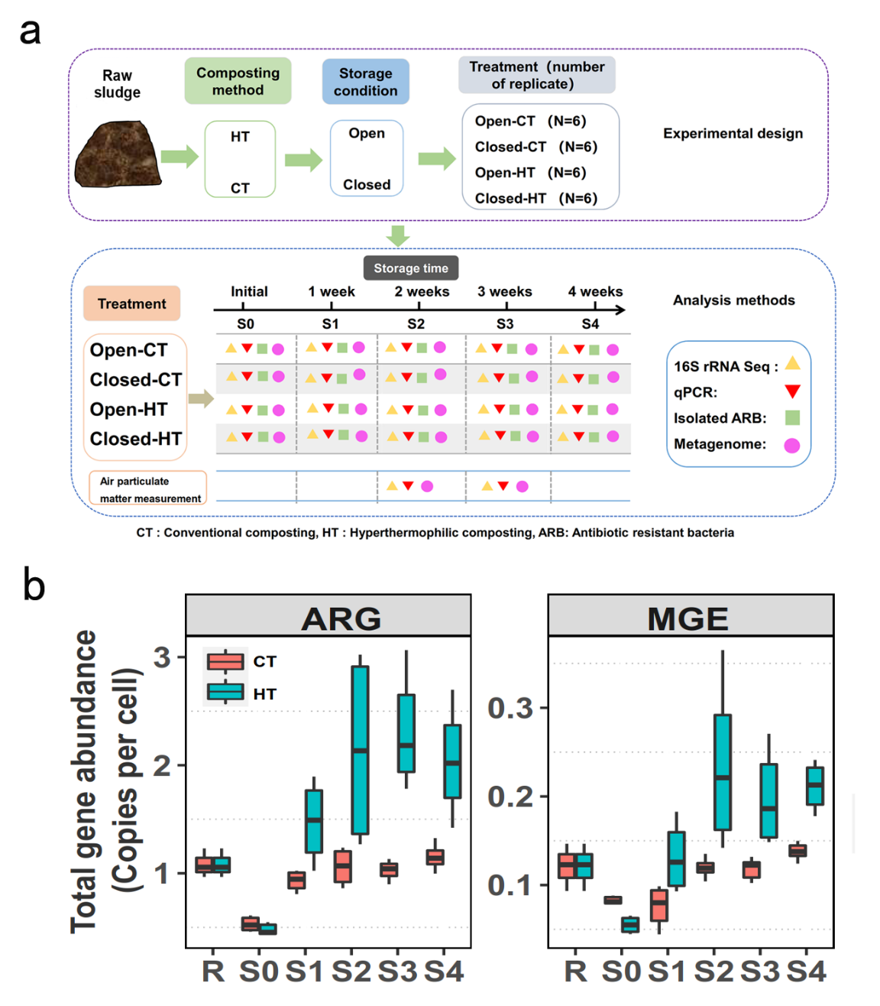

**Figure 1. Experimental overview and changes in antibiotic resistome and mobilome during the storage of compost treated with conventional (CT) and hyperthermophilic composting (HT) methods.** (**a**) Experimental treatments, timeline of sampling and types of analyses performed. (**b**) The dynamics of total ARG (right) and MGE (left) abundances before (R: initial raw sludge), after conventional (CT) or hyperthermophilic (HT) composting (S0) and during the compost storage (S1-S4). In (**b**), box plots encompass 25-75th percentiles, whiskers show the minimum and maximum values and the midline shows the median.



**Figure 2. The rebound of ARGs (a-c) and MGEs (d-f) in CT and HT composting treatments under open and closed storage treatments.** (**a**) The percentage of ARGs in CT and HT compost treatments that increased in abundance during closed and open storage (based on subtype genes, rebound ratio > 1). (**b-c**) Changes in the total (line plot) and individual ARG types (heatmap) based on rebound ratio in CT and HT compost treatments during closed and open storage. (**d**) The percentage of MGEs in CT and HT compost treatments that increased in abundance during closed and open storage (based on subtype genes, rebound ratio > 1). (**e-f**) Changes in the total (line plot) and individual MGE subtypes (heatmap) based on rebound ratio in CT and HT compost treatments during closed and open storage. In (**a** and **d)**, data show mean ± SD with of six biological replicates per treatment (n = 6), stars denote for significant differences (\**p* < 0.05, \*\**p* < 0.01).



**Figure 3. Taxonomic associations between bacterial ARG and MGE hosts in the compost**. (**a**) Co-occurrence network analysis showing associations between ARGs, MGEs and bacterial taxa (at genus level) based on metagenomic data. Nodes show different ARGs (orange triangles), MGEs (dark green triangles) and bacterial genera (circles) colored by their respective phyla; edges connecting nodes show significant associations based on contig co-occurrence. **(b)** Cladogram showing the phylogenetic relationship between 1440 antibiotic resistant bacterial taxa isolated from compost samples (based on the 16S rRNA gene sequence similarity). In (**b**), the colored outer ring shows phylum information for all isolates and the inner ring shows the type of antibiotic resistance.



**Figure 4. Changes in the relative abundance of core bacterial taxa linked with antibiotic resistance.** (**a**) Changes in the relative abundance of enriched core bacterial taxa associated with ARGs in raw sludge (R), after CT or HT composting (S0) and during the compost storage (S1-S4); colors refer to different time points and circle sizes are relative to relative taxa abundances. (**b**) Venn diagram representing unique and shared core bacterial taxa (at genus level) in CT and HT compost under closed and open storage; (**c-d**) The dynamics of differentially abundant core taxa (at phylum level) associated with ARGs under open and closed storage conditions in CT (**c**) and HT (**d**) composts. Stars show significant differences between open and closed treatments based on paired two-sided Student’s t-tests (\**p* < 0.05, \*\**p* < 0.01 and \*\*\**p* < 0.001).

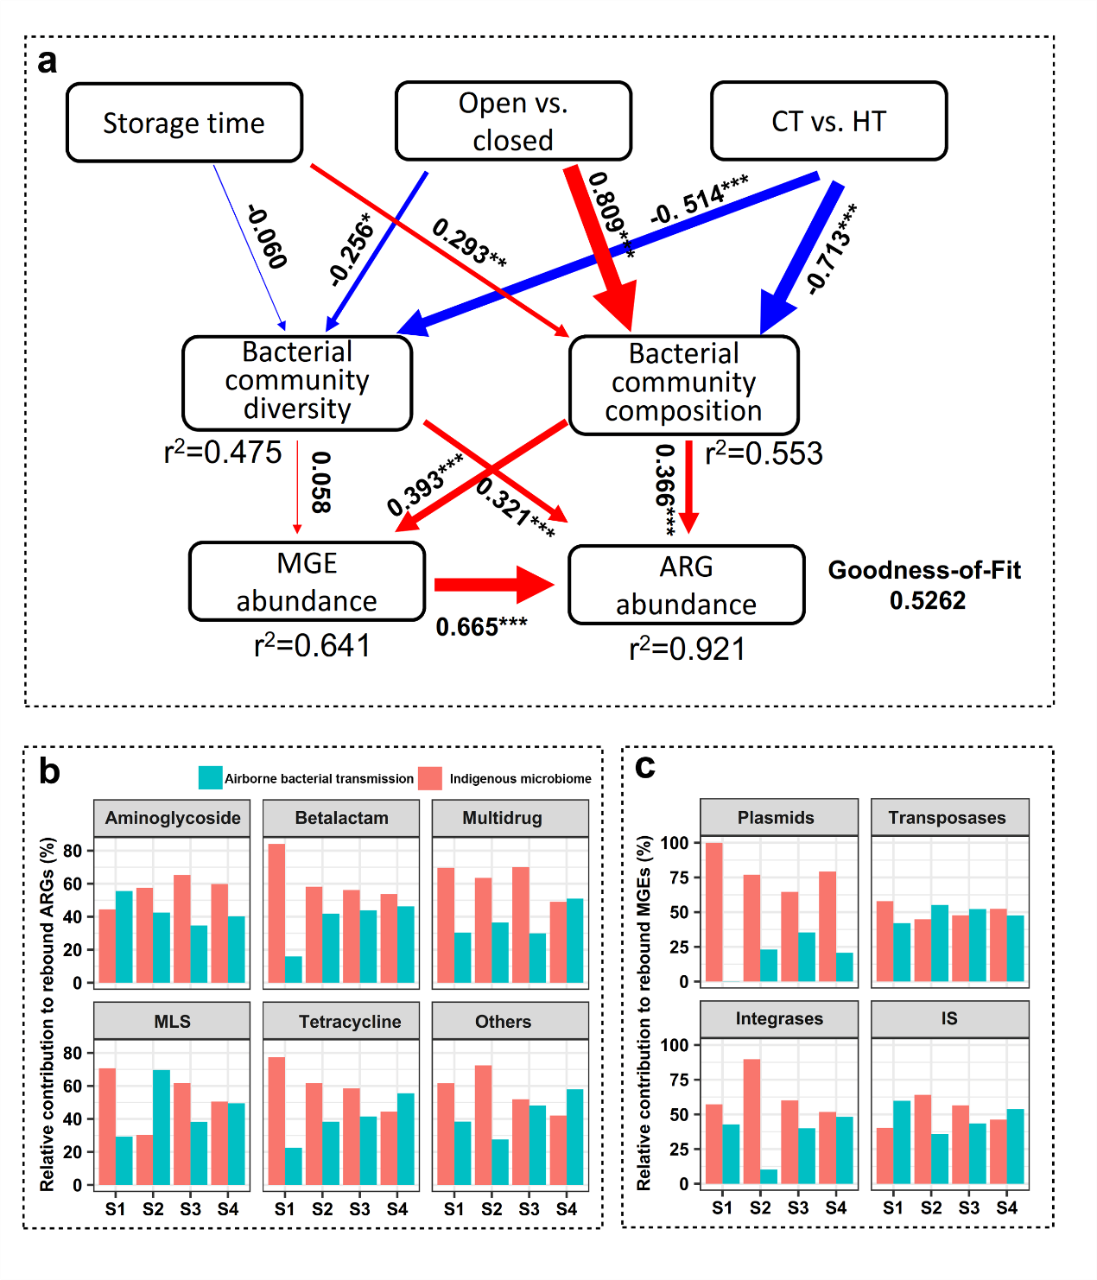

**Figure 5. Partial least squares path modelling (PLS-PM)** **comparing the relative importance of different factors explaining ARG and MGE rebound.** (**a**) PLS-PM describing the relationships between storage time, storage condition (open vs. closed), composting method (CT vs. HT), bacterial community diversity, bacterial community composition and MGE abundances on ARG rebound. Larger path coefﬁcients are shown as wider arrows and blue and red colors indicate negative and positive effects, respectively. Path coefficients and coefﬁcients of determination (r2) were calculated after 999 bootstraps and signiﬁcance levels are indicated by * (*p* < 0.05), ** (*p* < 0.01) and *** (*p* < 0.001). (**b-c**) The relative contribution of internal (regrowth of indigenous bacteria) and external factors (airborne transmission) on the ARG (**b**) and MGE (**c**) rebound. In (**b**) and (**c**), MLS and IS denote for macrolide-lincosamide-streptogramin and insertion sequences, respectively.