**Cultural History**

**Helen Cowie**

1. **Introduction and Overview**

Animals have long been central to human culture. From stone-age depictions of bison in the caves at Altamira to characters in Disney cartoons, animals have been a constant presence in human art, literature and belief systems. They have shaped how we live, how we work and how we think.

Cultural history is about recovering the mentalities and ideologies of past societies and exploring how their members interpreted and understood the world around them. Animals have often been fundamental to these analyses because of the rituals and taboos surrounding the human-animal relationship. Early cultural histories used animals as a prism through which to deconstruct human beliefs, unpicking the complex meanings attached to a range of human-animal relationships. Some more recent histories, influenced by the Animal Turn, focus more explicitly on the experiences of actual animals in the past (rather than purely their symbolic functions) and pose questions about emotions, agency, and even whether animals themselves can have a ‘culture’ – that is, a distinct set of ideas, customs or social behaviours that distinguishes one group of individuals from other members of the same species. This chapter explores how cultural historians have used animals to illuminate past beliefs and social practices and examines the methodological approaches they have taken. I draw on examples from the sixteenth to the nineteenth century, showing how animals functioned as symbols, victims and cultural actors in their own right.

1. **Methods and Approaches**

Cultural history is a broad and expanding field. In the nineteenth century, practitioners focused primarily on elite or ‘high’ culture. Since then increased emphasis has been placed upon mass or popular culture, and the different ways in which people understood the world around them.[1] Cultural history is primarily about meanings and interpretations. While social historians have traditionally concentrated on quantitative changes, tracing shifting class, race and gender relations [→Social History], cultural historians have tended to adopt a more qualitative approach, using detailed case studies to explore the layers of meaning individuals attached to particular experiences or events. What did people think when they took part in a carnival procession or participated in a food riot? What cultural beliefs shaped the perpetration of violence against other living beings – human or animal? What did it mean when someone baptised a pet dog, encountered a giraffe for the first time or fed gingerbread to an elephant in a travelling menagerie? Cultural historians seek to tease out the often multi-layered meanings of such events, and to go beyond the material causes of human behaviour.

Methodologically, cultural historians have been strongly influenced by developments in anthropology. In the 1960s and 70s, anthropologists conducted sustained observations of non-western societies in an effort to learn about the cultural beliefs that underpinned them. Clifford Geertz, for instance, drew upon observations of cockfighting in Bali to illuminate Balinese conceptions of power and masculinity, employing a technique called ‘thick description’ to build up layer upon layer of meaning onto the events he witnessed.[2] Cultural historians have imitated this technique, using archival sources to reconstruct past world views. In *The Cheese and the Worms*, Carlo Ginzburg draws upon surviving inquisition records to recover the somewhat eccentric religious views of a sixteenth-century miller named Menocchio – an approach described as microhistory.[3] In another cultural history classic, *Montaillou*, Emmanuel Le Roy Ladurie uses an earlier set of inquisitorial records to chart the beliefs and life ways of another group of heretics, the Cathars of twelfth-century France.[4] Literary theory has also impacted on the work of some cultural historians, prompting them to examine written texts more critically and to be more sensitive to language, silences, and the construction of narratives. Central indeed to many cultural histories, is the concept of close reading, or reading against the grain, in order to recover voices that had previously been absent or suppressed – including those of animals. The historian Inga Clendinnen has applied this technique to the records of Spanish missionaries in sixteenth-century Yucatán in an attempt to explore the impact of the Spanish conquest on Maya women.[5]

Today, cultural history remains a vibrant and evolving discipline. Cultural histories now exist of almost everything, from emotions to death, football to sex, and crime to chocolate. Cultural history has also informed the work of many social historians who increasingly incorporate cultural factors into their research. Indeed, the boundaries between the two disciplines are increasingly blurred, with many historians combining cultural and material approaches to the past; Kathleen Kete’s study of pet-keeping in nineteenth-century Paris, for instance, focuses on the cultural significance of dogs and cats within the bourgeois household, but sets this against the backdrop of shifting class relations.[6] The Animal Turn has brought animals further within the remit of cultural historians, posing new questions about human relationships with other species. This, however, represents a shift in emphasis rather than a complete innovation, as animals have been central to cultural history from its inception.

1. **Topics and Themes**

Cultural history, then, is about reconstructing the mental worlds of past societies. In what follows I focus specifically on the role of animals within cultural history and consider the important place they have assumed in helping us to interpret the attitudes and mentalities of cultures distant in time and place from our own. I address three key areas in which animals have been crucial in this regard: symbolism, religion and art; deviance and social subversion; and cross-cultural encounters.

*Symbolism, Religion and Art*

One prime area of analysis for cultural historians has been the symbolic function of animals in past societies. Because of their proximity to humans, and their crucial role as suppliers of meat, wool or transportation, animals have often featured prominently in a range of human belief systems; as the anthropologist Claude Lévi-Strauss famously expressed it, animals are ‘good to think’ with.[7]

If we start with the theme of religion, we find that animals have often been highly visible in the mythology, scripture and folklore of almost all societies. The Ancient Egyptians worshipped the cat goddess Bastet and mummified dead cats `in her honour.[8] The Aztecs and the Maya venerated the jaguar, often wearing jaguar skins into battle and sometimes ingesting the flesh of the animals to imbibe their feline courage.[9] The Incas sacrificed llamas and alpacas to mark key points of the agricultural cycle and the Ashanti of West Africa prayed to the spider god, Anansi.[10] Through analysing the multiple depictions of animals in spiritual contexts, historians have begun to disentangle the belief systems of past human societies, gradually reconstructing their mental worlds.

Animals have also been incorporated into secular rituals, which can likewise be highly revealing. Exploring how animals were perceived in Medieval Europe, for instance, Esther Cohen describes the phenomenon of the ‘backwards ride’ in which criminals were carried to the gallows ‘riding backwards upon a donkey, a ram (for licentious women), or a sick horse’. Sometimes the rider was ‘forced either to hold on to the animal’s tail or lower his face into its anal cleft’, deepening his sense of shame.[11] These kinds of shaming punishments played upon the permeability of the human-animal boundary and were inflicted as a deliberate inversion of social norms. In an interesting colonial adaptation of the ritual, Spanish officials in Peru punished disobedient Indians by making them ride naked on the back of a llama – a punishment considered more degrading if the animal selected was piebald in colour.[12] Jesuit-trained Andean chronicler Felipe Guaman Poma depicts a royal administrator subjecting a native Peruvian to this humiliation (fig.1).

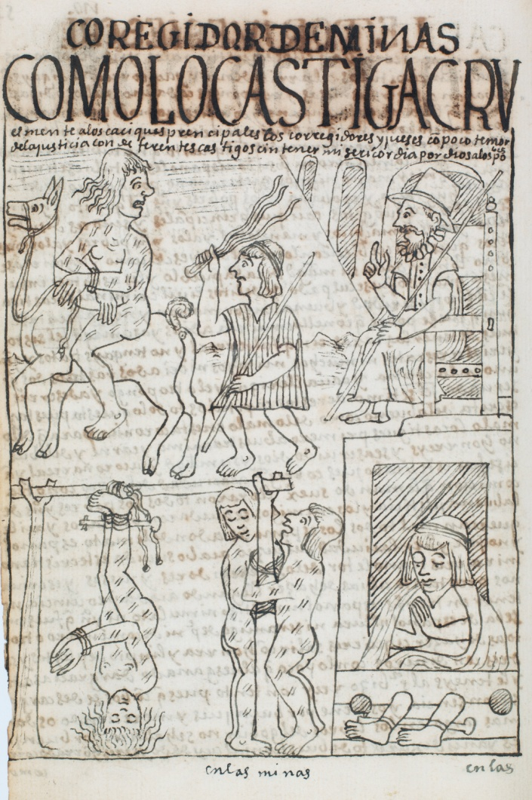

Figure 1: Drawing 211. ‘The administrator of royal mines punishes the native lords with great cruelty’. From Felipe Guaman Poma, *El Nuevo Corónica y Buen Gobierno* (1615), © Royal Library of Copenhagen, shelfmark GKS 2252 4.

As well as encoding spiritual and ritual meanings, animals have often taken on important symbolic functions as representatives of individuals, cities and nations. They appear on crests, coats of arm, flags, statues and coins and are increasingly seen as part of the national heritage. A bear, for instance, features on the crest of the Swiss city of Bern, commemorating the hunting exploits of a local lord, while a nineteenth-century sculpture by Luis Rochet uses native animals (an anteater, a tapir and a capybara) to represent the natural environment and (romanticised) indigenous heritage of Brazil (fig.2). Today, animals continue to act as shorthand for cities, regions and nations, standing in for countries in political discourse and sport.[13] Animals thus form part of personal and national iconographies, serving as visual representation of people and places.

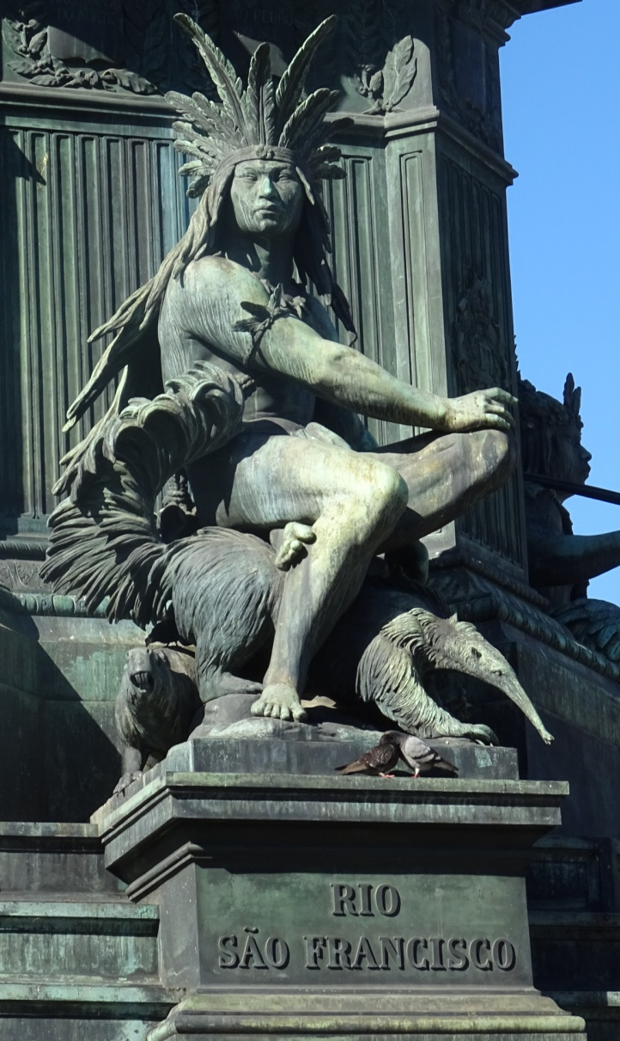

Figure 2: Luis Rochet, detail from ‘Equestrian Sculpture of Don Pedro I’, Praça de Tiradentes, Rio de Janeiro, 1862. Note the anteater and capybara alongside the idealised figure of a Native American.

Finally, animals have long made their presence felt in human art and literature, providing essential outlets for human artistic expression [→Visual and Art History]. Whether in fables, fairy tales, novels, poems or films, animals have been central to human story-telling. In some cases, such as George Orwell’s *Animal Farm* (1945), animals function largely as surrogate humans, offering a thinly-glossed critique of human actions and failings. In other cases, like Anna Sewell’s *Black Beauty* (1877), animals assume more individualised characters and become mouthpieces for other members of their own species. Whatever format they take, depictions of animals in books, paintings or films can be highly revealing of our changing relationship with other species and can tell us a lot about how past societies grappled with the human animal divide. As Lorraine Daston and Gregg Mitman observe, ‘When humans imagine animals, we necessarily re-imagine ourselves, so these episodes reveal a great deal about notions of the human – the “anthropos” of anthropomorphism’.[14]

*Deviance and Subversion*

One of the best ways to unpick the complex social codes adhered to by past societies is to examine instances in which those codes were transgressed. Precisely because animals have been so central to human power structures and belief systems they often feature in tales of subversion, sometimes as victims of extreme violence, in other cases as the objects of excessive human affection. By looking at instances in which animals have been treated inappropriately (according to the standards of the place and time), historians have gained a deeper insight into the social norms governing past societies and the (often unspoken) rules according to which they operated.

To understand how animals have become the subject of human taboos, let me turn first to one of the classic texts in cultural history, Robert Darnton’s essay, ‘The Great Cat Massacre’. In this engaging essay, Darnton relates a bizarre and disturbing incident that happened in Paris in 1730. Drawing on the sole written account of the episode – a narrative penned by one of the participants, Jerome, many years after the event – Darnton describes how a group of apprentices, tired of being kept awake at night by the sound of cats howling, rounded up the animals, subjected them to a mock trial and executed them by hanging. The boys apparently regarded the massacre as hilarious and re-enacted it many times over subsequent years as a form of entertainment. According to Jerome, they took particular pleasure in disposing of the mistress’s grey cat, ‘*la grise*’, which they knew to be a much-loved pet.

Killing cats doesn’t sound like the height of mirth to the modern reader, so Darnton naturally asks how something we would regard as supremely unfunny, even obscene, could prove so amusing to the apprentice Jerome and his colleagues. He argues that the very fact that we do not ‘get’ the joke in the cat massacre points to a disjuncture between a past society and our own, and that this disjuncture is precisely what merits investigation. Using the anthropological method of ‘thick description’, Darnton analyses the multiple layers of cultural meaning attached to the cat massacre, highlighting its function as a covert way of attacking the apprentices’ master and mistress, its invocation of the carnivalesque and the longstanding association between cats and witchcraft in early modern France. His detailed unpicking of a strange and violent incident thus illuminates the mental world of eighteenth-century French artisans, with the brutal death of the cats providing a vital entrée into these complex social dynamics.[15]

Another example of someone not ‘getting’ an animal-related joke features in Zeb Tortorici’s analysis of dog baptisms, marriages and funerals in eighteenth century Mexico. Making use, in this case, of Inquisition records from the Catholic Church, Tortorici relates how a party was held in Mexico City in 1770 to celebrate the marriage of two dogs. The animals, specially dressed up for the occasion, were attended by their owners, and later placed in a matrimonial bed. A real priest, Father Toribio Basterrechea, officiated the ceremony, pronouncing the animals man and wife ‘in the name of the Father and Mother of all Dogs’.[16] While the participants appear to have viewed that the canine nuptials were a joke – perhaps a reflection of the esteem in which the dogs were held, perhaps just a diversion for bored Mexican aristocrats to fritter away an afternoon – the Spanish Inquisition, not known for its sense of humour, perceived the incident as unfunny and potentially sacrilegious. As a consequence, Father Basterrechea found himself under arrest and threatened with torture, (though all parties were ultimately exonerated with a stiff reprimand).[17]

Attempting to explain the broader significance of this peculiar footnote in the inquisitorial archives, Tortorici traces the wider social and cultural meanings of canine marriages and shows how they subverted both the sanctity of the holy sacraments and the traditional relationship between humans and animals. The most subversive element of the performance, he contends, lay not in the words uttered by the priest, but in treating dogs as humans. As he explains:

In canine weddings and baptisms, carnivalesque religious rituals veered dangerously close to heresy, but the larger issue at stake was that, at least in the eyes of ecclesiastical authorities, these acts challenged the divinely ordained natural and social orders.[18]

Though very different in tone from the Great Cat Massacre, the marriage of two dogs served a similar purpose in undermining and mocking traditional social hierarchies. In stark contrast to the former incident, however, it may also have reflected genuine affection for the dogs involved, revealing a more complex emotional relationship between humans and animals.

In both of the above cases the perpetrators of animal mis-use were the jokers, deriving pleasure from their abnormal interactions with other species. In other instances, however, those who behaved unnaturally around animals became the butt of the joke for others, their inappropriate relationships exposed to ridicule in biting social satires. In eighteenth-century Britain, for instance, as Ingrid Tague has shown, women who lavished attention on parrots, cats and lapdogs were accused of perverting gender norms by pampering an animal rather than directing their attentions towards a member of the opposite sex, becoming the subjects of vicious cartoons.[19] Two centuries earlier, in sixteenth-century France, King Henri III’s passion for lapdogs became a symbol of his effeminacy and homosexuality, mirroring the king’s predilection for effeminate male favourites. As Juliana Schiesari observes: ‘The uncontrolled population of tiny dogs serves as a powerful synecdoche of the excess, sterility and general ruin of the kingdom under his rule’.[20] Misplaced affection for inappropriate animals could thus function as a vehicle for critiquing un-kingly – or indeed unmanly/unwomanly – conduct.

The case of George IV’s giraffe offers a revealing example of how culturally inappropriate relationships with animals could provide fodder for political opponents. A gift to George from the Pasha of Egypt, the giraffe arrived in 1827 and was installed in the king’s private menagerie at Sandpit Gate, near Windsor. Unfortunately the animal was in poor health after its long journey and suffering from a badly swollen knee. George, however, smitten with his new acquisition, devoted every attention to it, visiting the menagerie frequently, ordering that the giraffe be clothed in a blanket to protect it from the cold and arranging for its troublesome knee to be ‘constantly bathed in salt water’.[21] While such attentions might seem touching to the modern reader, contemporaries were less impressed, subjecting George to a barrage of ridicule. One critic, Sir Henry Halford, made a connection between the giraffe’s ailments and George’s own famed obesity, informing the Privy Council that ‘the indisposition of the Giraffe at Windsor has arisen from the animal’s loyal sympathy in his Majesty’s twinges in his toe, in his late fit of gout.[22] Another, a destitute merchant, wrote a highly sarcastic letter to the *Liverpool Mercury* in which he accused George of putting the care of his exotic pet above the suffering of his subjects:

I have perpetually before me the afflicting sight of a wife and six daughters almost heart-broken, not only deprived of the comforts of life to which they have hitherto been justly accustomed, but almost destitute of its necessaries, and that, too, without any prospect of amendment. But this is nothing compared with the misery I have undergone from solicitude for “that rare animal, the giraffe”, which at present appears very properly to occupy most of his Majesty’s attention.[23]

A series of satirical cartoons also circulated widely, showing the king riding on the giraffe’s back with his mistress, coddling it in his boudoir (Fig.3) and raising up the ailing animal with a specially designed pulley. Like Henry III’s lapdogs, George IV’s giraffe thus became the focus of opposition for the king’s many detractors, and a convenient vehicle through which to attack an already unpopular monarch.

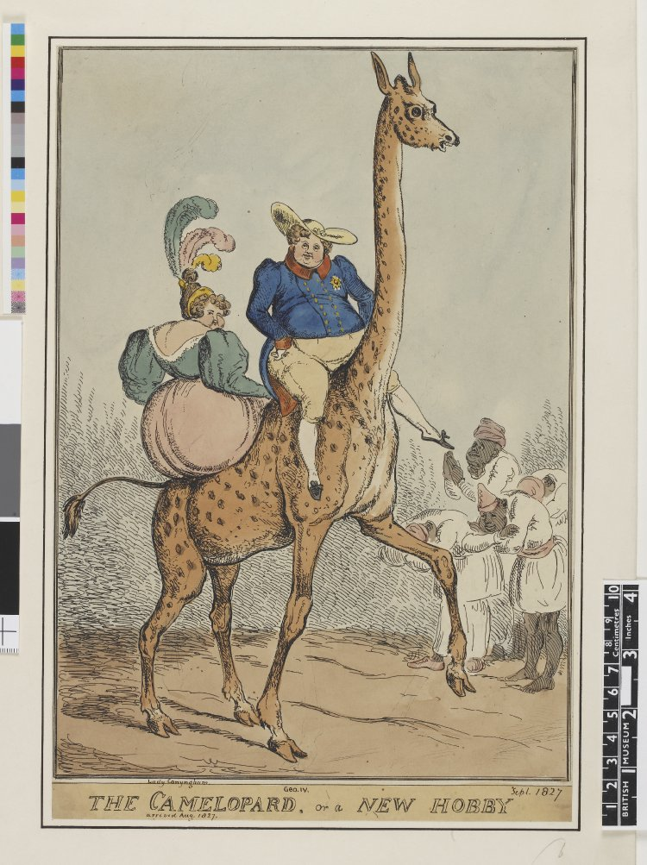

Figure 3: William Heath, ‘The Camelopard, or a New Hobby’, 1827 (colour engraving) courtesy of Bridgeman Images.

As the above examples show, animals often featured in cases of deviance, where social norms were subverted or challenged. For contemporaries, inappropriate behaviour towards animals gave the powerless a way of symbolically overturning social hierarchies or mocking social superiors. For historians, decoding these zoological ‘jokes’ can provide a window onto the sometimes elusive cultural practices of the past. Looking at animals can therefore offer an insight into alien traditions and customs, helping us to reconstruct past mentalities.

*Cross-Cultural Encounters*

A third area of cultural history in which animals have played a prominent role is in cross-cultural encounters [→(Post-)Colonial History; →Global History]. When different cultures meet, contrasting attitudes towards animals become particularly apparent. Focusing on these encounters can reveal some of the deepest practices and assumptions at the heart of different societies and bring to the fore key cultural distinctions.

An excellent example of how historians have used animals to chart cultural difference is Virginia DeJohn Anderson’s *Creatures of Empire* (2004), which examines animal encounters in colonial North America. Looking at the early years of British settlement in New England and the Chesapeake, Anderson shows how European settlers and Native Americans clashed in their perceptions of the newly-introduced European livestock, sometimes with tragic consequences. The Indians of north-eastern America ‘conceived of their relationship with animals in terms of balance and reciprocity’, while the Christian Europeans viewed animals as servants to be owned, farmed and domesticated.[24] When feral cattle and pigs strayed beyond European settlements and damaged Indian crops, these contrasting conceptions of animals were put to the test, generating conflict, litigation and, occasionally, physical violence. Loose cows and other introduced species thus function as important prisms through which historians can chart ideas about property rights, notions of agricultural improvement and conceptions of the natural world. Here, as Anderson demonstrates, animals were much more than just symbols: they were flesh and blood agents of the conquest – albeit unwitting ones.

In her article, ‘The Chicken and the *Iegue*’, Marcy Norton builds on DeJohn Anderson’s analysis to explore how cultural conceptions may explain the supposed ‘failure’ of Amerindian societies to domesticate more native species. Focusing on Caribbean and lowland South American Indians, Norton demonstrates that these groups frequently captured and tamed individual animals as pets (e.g. parrots, monkeys, tapirs), but that cultural taboos meant that these animals were never killed or eaten (although wild animals of the same species were). Norton argues that we should not apply European conceptions of pet-keeping and farming to non-European societies, and that other paradigms for relating to animals may exist. As she remarks:

For many Europeans, the human-animal and hunting/livestock binaries were organising principles, and those who confused or attempted to cross these boundaries were troubling. For Amerindians … the fundamental dividing line was between wild and tame beings. This divide bridged and superseded the human/non-human binary, grouping human kin and tamed animals on one side and human enemies and prey on the other.[25]

In this case, unravelling the cultural parameters that undergirded human-animal relations can help to explain why one society domesticated animals for food while another did not.

While DeJohn Anderson and Norton look at the encounters between whole societies with differing customs and values, other historians have explored how individual animals can act as cross-cultural ambassadors, moving between places and receiving differing reactions. In a thought-provoking article, Erik Ringmar assesses the differing receptions of three imported giraffes to explain why Europeans engaged in imperialist ventures in the sixteenth and nineteenth centuries. The first giraffe, presented to Lorenzo de’ Medici in 1486, reflected the curiosity of the Renaissance, and arrived in Europe just prior to the age of transatlantic exploration. The second giraffe, presented to Charles X of France in 1827, was by turns a commodity, Orientalist fantasy and scientific specimen, and pre-dated by a couple of decades the French colonisation of Algeria. The third giraffe reached China in 1414 from Melinda in East Africa, shortly before the Emperor prohibited all travel overseas by Chinese subjects. It was classified by contemporary scholars as a unicorn – a fantastical but already known being – and interpreted as a good omen. Ringmar concludes that these differing responses reflected broader cultural attitudes towards the exotic and can help to explain why Europeans chose to explore and conquer foreign lands while the Chinese became increasingly inward-looking. He suggests that the giraffe, ‘an emissary from the unknown’, acted as ‘an empty signifier that force[d] people to reveal their cultural predispositions’.[26]

The reception of two globetrotting anteaters in the eighteenth and nineteenth centuries likewise illustrates the cultural connotations of exotic animal acquisition. In this case, the first anteater, a royal gift, arrived in Madrid in 1776 as a present for King Charles III. It was donated by Don Manuel de Basavillazo, Administrator of Post in Buenos Aires, and housed in the Buen Retiro Menagerie, where it subsisted on ‘little pieces of bread, minced meat and flour dissolved in water’.[27] The second anteater, a commercial speculation, was brought to London from Rio de Janeiro by two German showmen in 1853 and exhibited in a dilapidated shop in Bloomsbury. The novelist Charles Dickens watched it consume ‘an egg, which it had heard cracked against the wall’, ‘licking the yolk’ out of the shell ‘with its long tongue’.[28] Like the two European giraffes, both anteaters became cultural icons, generating multiple textual and visual representations. The Madrid anteater was painted from life by the court painter Rafael Mengs (or possibly his apprentice, Franisco de Goya) and described in detail by the soldier naturalist Félix de Azara, who revealed that the species was called ‘*yurumí*’ (‘small mouth’) in its native Paraguay and that the locals in that country used anteater fat to ‘cure sores on horses’ [backs]’.[29] The London anteater was painted by the Austrian-born artist Joseph Wolf, examined by the comparative anatomist Richard Owen and fêted in an article by the satirical magazine, *Punch*, which compared its body to that of ‘a German pig’, its snout to ‘a cucumber’ and its long tongue to ‘some very fine surgical instrument that had shot out of its case upon a spring being touched’.[30] Dickens speculated that ‘should it live and get its rights, we shall have ant-bear quadrilles, ant-bear butter dishes, ant-bear paper weights, ant-bear pictures of all sorts, and perhaps a dash of ant-bear in the Christmas pantomime’.[31] The anteaters thus functioned by turns as scientific specimens and popular commodities, reflecting the differing outlooks and preoccupations of the people who encountered them. For the Paraguayans they were useful animals with medicinal properties; for the Spanish, they were reflections of royal power; for the British they were above all commercial attractions, as well as subjects for contemporary science. By looking at the reception of particular animals in different locations and social settings we can gain a better understanding of the priorities and world views of distinct (and often competing) cultural groups.

1. **Implication of the Animal Turn**

The Animal Turn has brought about a shift in the kinds of questions cultural historians ask when studying animals. From using animals primarily as a mirror onto human society, historians have begun to write the histories of animals in their own right, treating them not merely as symbols, but as historical subjects with distinctive and recoverable pasts. This has resulted in the opening up of new areas for investigation and the explicit inclusion of non-human animals within established historical contexts.

First, the Animal Turn has encouraged historians to write animals back into history. Sometimes using new sources, more often asking new questions of existing material, cultural historians have begun to highlight the crucial role that animals played in past societies and to trace changing conceptions of other species. A range of historical works now address such topics as the history of zoos and circuses [→History of the Zoo; →History of the Circus], the history of pet-keeping [→History of Pets] and the history of animal welfare organisations.[32] Many of these pose broader cultural questions, placing animals within the contexts of the Industrial Revolution, popular imperialism or Renaissance court culture and asking what role animals played within these wider human settings.[33] By putting animals at the centre of their analysis, rather than on the periphery, a new generation of cultural historians are highlighting the centrality of other species to human life and probing more deeply their role in shaping past societies.

Another group of works has emerged that puts either individual animals or species at the centre of analysis and explores their influence on human society. Drawing on the methodology of object histories, or the history of things [→Material Culture Studies], such studies focus on individual animals and trace their life histories, often, like Darnton, moving out from particular incidents to chart broader social trends. Susan Nance, for example, has examined the furore surrounding the sale of the African elephant Jumbo to American showman P.T. Barnum in 1882, describing how the famous pachyderm was celebrated, mourned and commodified on both sides of the Atlantic.[34] Samuel Alberti’s *The Afterlives of Animals* chronicles the posthumous histories of a range of well-known beasts, from the elephant Maharajah, who walked from Edinburgh to Manchester in 1872, to the lion, Wallace, who fought against six dogs at Warwick in 1825 (Fig.4). Alberti shows how these animals attained new meanings after death, appearing in new settings and reaching new audiences[→History of Taxonomy/Animal Collection].[35]

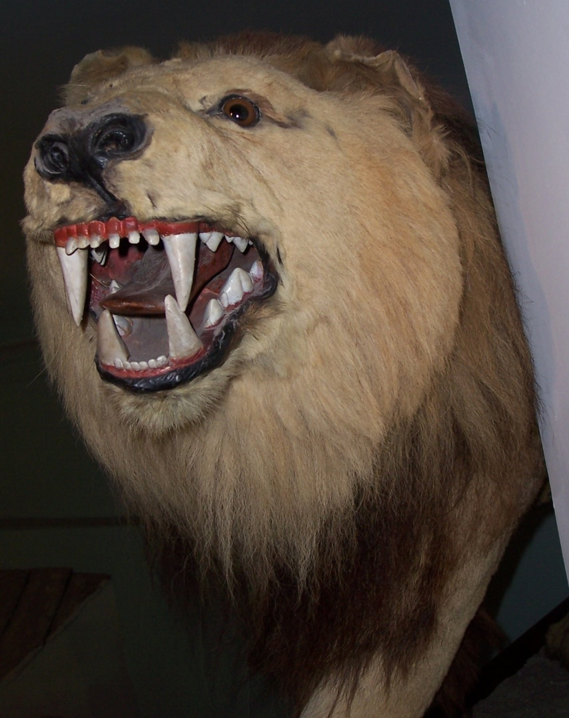

Figure 4: Wallace the lion, Saffron Walden Museum. Photo author.

Third, influenced by developments in the field of cultural geography [→Historical Animal Geography] and the history of science [→History of Science), cultural historians have started to pay more attention to the spatial dynamics of human-animal interactions. This means looking at animals in a range of different sites and contexts, from the royal palace to the scientific laboratory, the natural history museum to the travelling menagerie, and the city street to the bourgeois bedroom. In his book *At Home and Astray*, cultural geographer Philip Howell highlights the geographical dimensions of dog life in Victorian London, showing how different places and spaces conferred different meanings on its canine inhabitants. Dogs in the home formed part of the domestic idyll of the bourgeois world, owned, loved and cared for as part of the family; dogs on the streets represented disorder and disease and were increasingly perceived as a danger to be extirpated. Howell contends that these two processes operated in tandem, creating what he calls a ‘moral geography of dogs’.[36] The cultural history of animals has thus taken an important spatial turn, considering more explicitly how location influenced meaning.

Closely related to the geographies of human-animal relations, other historians have started to explore the sites, nature and meaning of human-animal interactions, asking what these tell us about cross-species connections in the present and in the past. Whether through milking a cow, cuddling a lap dog, riding a horse or stroking a hyena’s paw in a menagerie, humans have enjoyed multiple close connections with animals. By examining these interactions in detail, we can learn about the affection, mutual pleasure and violence inherent in our relationship with other species and recover intimate details of animal encounters in past societies. An early-twentieth-century *Animal Care Journal* for Manchester’s Bellevue Zoo, for instance, records how one keeper tickled a tapir in the ear, fed cakes to Daisy the elephant and massaged a giraffe’s stiff knee, ‘apparently to the Giraffe’s pleasure as he put his head down to caress me’.[37]

A fourth area in which historians have become increasingly interested is the history of the emotions [→History of Emotions]. Did people in the past experience the same range of feelings as we experience today and how did they express those feelings? When extended to animals, the history of the emotions becomes particularly contentious and often invites allegations of anthropomorphism. Do animals experience human-like emotions, and if they do, can we interpret them? In recent years, however, a number of cultural historians have taken the view that animals do exhibit emotions, and, drawing on scientific research in the field of cognitive ethology, they have begun to explore the behavioural and emotional worlds of animals in the past.[38] In a study that blends history with zoology, for instance, Nicola Foote and Charles W. Gunnels apply modern biological knowledge about sea lions, doves and tortoises to explain reported behaviours of animals on the Galapagos Islands.[39] In an in-depth exploration of one famous early-modern feline, Sarah Cockram documents that short life of a little cat, or *animalino* (little animal) owned by the Marquess of Mantua, Isabella d’Este, and wonders whether the creature liked being stroked and carried about in her sleeve. Cockram also explores what having this pet may have meant to its owner, Isabella, emphasising the sensory dimension of the encounter ‘There is,’ she suggests, ‘evidence for Renaissance Italy of the breeding of luxury animals specifically for strokability and of responses to such qualities’.[40]

Of course, in practice, it is often difficult to do more than speculate about what animals felt in the past. What we can sometimes do, however, is learn about what previous generations of humans *thought* animals were feeling, which can itself reveal changing cultural attitudes, values and relations – a central component of cultural history. Take, for instance, a 1908 court case, in which the RSPCA prosecuted circus keepers Schreida and Havadia for ‘cruelly abusing and terrifying an elephant’ by making it slide down a steep chute into a pool of water while performing at the White City in London. In stating the case for the prosecution, lawyer Stuart Bevan emphasised not only the physical pain suffered by the elephant, when Havadia ‘dug the pointed end of the elephant stick six times into the right cheek of the animal’, but also the mental pain it was thought to have experienced. One witness testified that the elephant ‘trumpeted loudly and gave vent to shrill cries of pain *and terror*’. Another stated that ‘From the movements of the beast it was suffering the utmost terror, and *evinced the greatest alarm* at the prospect of going down’. The magistrate, Mr Garret, convinced by this argument, concluded that the animal, ‘before it knew what was in front of it…could only think that it was plunging down into sheer space’ and ‘must [have been] *greatly frightened*’. In this instance, therefore, it mattered not just what happened to the elephant, but what it thought was going to happen to it. The fact that several witnesses assumed the animal was afraid may or may not have reflected the actual state of mind of the elephant, but it certainly reflected their interpretation of it and their judgement that inflicting fear on a fellow creature – particularly a highly intelligent mammal like an elephant – was unacceptable. The elephant’s sensory capacity was, indeed, referenced in the court proceedings, with one witness, elephant trainer Charles Miller, testifying that ‘An elephant was as sensitive as a human being’.[41] Here, then, we can see humans endowing animals with a repertoire of emotional responses, and modulating their treatment of the latter accordingly. By unpicking animal emotions in the past – and the human responses they elicited – cultural historians are expanding earlier work on the history of mentalities and making an important contribution to the burgeoning field of the history of emotions.

Finally, The Animal Turn is prompting scientists, and some historians, to ask a controversial but important question: can (non-human) animals have culture? When historians talk about culture, either high or low, they have almost exclusively focused on human beings – understandably, given the source material available. The work of several biologists, however, has begun to challenge the idea that culture is something confined to humans, showing that certain other species do indeed have what might be referred to as culture. Primatologists such as Jane Goodall have demonstrated that chimpanzee families possess distinct modes of existence, passing on particular skills or forms of tool use from generation to generation.[42] Recent research on sperm whales off the Galapagos Islands suggests, similarly, that different family groups, or clans, have developed their own distinct set of vocal clicks to communicate, a phenomenon that Professor Marucio Canto attributes to social learning rather than shared genetics.[43] Elephant expert Cynthia Moss, meanwhile, recounts how the elephants she observed for fourteen years in Amboseli National Park, Kenya, appeared to mourn their dead and to recognise the skulls and skeletons of their own species. She describes, in one case, how the calf of a dead elephant found the jaw of his mother near her camp and remained with it for a long time ‘repeatedly feeling and stroking the jaw and turning it with his foot and trunk’.[44] Whether such behaviours constitute culture remains open to debate, but they do raise important questions about how we perceive, study and represent other species, both in the present and the past, potentially raising the question whether animals themselves might have a cultural history.

***Selected Bibliography***

Alberti, Sam (ed.). *The Afterlives of Animals: A Museum Menagerie*. Charlottesville: University of Virginia Press, 2011

Cockram, Sarah, and Wells, Andrew (eds.). *Interspecies Interactions: Animals and Humans from the Middle Ages to Modernity*. London: Routledge, 2018

Cowie, Helen. *Exhibiting Animals in Nineteenth-Century Britain: Empathy, Education, Entertainment*. Basingstoke: Palgrave Macmillan, 2014

Darnton, Robert. *The Great Cat Massacre: And Other Episodes in French Cultural History.* London: Allen Lane, 1984

DeJohn Anderson, Virginia. *Creatures of Empire: How Domestic Animals Transformed Early America*. Oxford: Oxford University Press, 2004

Few, Martha, and Tortorici Zeb (eds.). *Centering Animals in Latin American History.* Durham: Duke University Press, 2013

Kaloff, Linda and Resl, Brigitte (eds.). *A Cultural History of Animals*. London: Bloomsbury, 2007

Norton, Marcy. ‘The Chicken and the *Iegue*: Human-Animal Relationships and the Columbian Exchange’. *American Historical Review*, February 2015, pp.28-60

Ringmar, Erik. ‘Audience for a Giraffe: European Expansionism and the Quest for the Exotic’. *Journal of World History* 17:4, pp.375-397

Tague, Ingrid. *Animal Companions: Pets and Social Change in Eighteenth Century Britain*. Philadelphia: Penn State U.P., 2015

1. Peter Burke. *What is Cultural History?*. London: Polity Press, 2008, p.29.
2. ‘Deep Play: Notes on the Balinese Cockfight’. In Clifford Geertz. *The Interpretation of Cultures*. New York: Basic Books, 1973, pp.412-153.
3. Carlo Ginzburg. *The Cheese and the Worms: The Cosmos of a Sixteenth-Century Miller*. London: Routledge, 1980.
4. Emmanuel Le Roy Ladurie. *Montailllou: Cathars and Catholics in a French Village, 1294-1324*. London: Penguin, 1980.
5. Inga Clendinnen, ‘Yucatec Maya Women and the Spanish Conquest: Role and Ritual in Historical Reconstruction’, *Journal of Social History* 15.3, Spring 1982, pp.427-442.
6. Kathleen Kete. *Petkeeping in Nineteenth-Century Paris*. Berkeley: University of California Press 1994.
7. Claude Lévi-Strauss. *Totemism*. trans. Rodney Needham. Boston: Beacon Press, 1963, p.89.
8. Jaromir Malek. *The Cat in Ancient Egypt.* London: British Museum, 1993.
9. Elizabeth P. Benson. ‘The Lord, the Ruler: Jaguar Symbolism in the Americas’. In Nicholas J. Saunders (ed.), *Icons of Power: Feline Symbolism in the Americas*.London: Routledge, 1998, pp.53-76.
10. Helen Cowie. *Llama*. London: Reaktion Books, 2017, pp.39-49; Barbara Allen. *Animals in Religion: Devotion, Symbol and Ritual*. London: Reaktion Books, 2016, p.33.
11. Esther Cohen. ‘Animals in Medieval Perceptions’. In Aubrey Manning and James Serpell. *Animals and Human Society: Changing Perspectives*. London: Routledge, 1994, p.69.
12. Bernabe Cobo. *Historia del Nuevo Mundo.* Seville: Imprenta de E. Rasco, 1891, Vol.2 p.321.
13. Sandra Swart, ‘The Other Citizens: Nationalism and Animals’, Philip Howell and Hilda Kean. *Handbook for Animal-Human History*. London: Routledge, 2018, pp.31-52.
14. Lorraine Daston and Gregg Mitman. ‘The How and Why of Thinking with Animals’. In Lorraine Daston and Gregg Mitman, *Thinking with Animals: New Perspectives on Anthropomorphism*. New York: Columbia University Press, 2005, p.6.
15. ‘Workers Revolt: The Great Cat Massacre of the Rue Saint Severin’. In Robert Darnton. *The Great Cat Massacre: And Other Episodes in French Cultural History.* London: Allen Lane, 1984, pp.75-104.
16. Zeb Tortorici.‘ “In the Name of the Father and the Mother of All Dogs”: Canine Baptisms, Weddings and Funerals in Bourbon Mexico’. In Martha Few and Zeb Tortorici (eds.). *Centering Animals in Latin American History*. Durham: Duke University Press, 2013, p.95.
17. Ibid., p.100.
18. Ibid., p102.
19. ‘Fashioning the Pet’. In Ingrid Tague, *Animal Companions: Pets and Social Change in Eighteenth-Century Britain*. Philadelphia: Penn State U.P., 2015, pp.91-137.
20. Juliana Schiesari. ‘ “Bitches and Queens”: Pets and Perversion at the Court of France’s Henri III’. In Erica Fudge, *Renaissance Beasts: Of Animals, Humans and Other Wonderful Creatures*. Urbana: University of Illinois Press, pp.37-49.
21. ‘Tuesday’s Post’, *Ipswich Journal*, 10 May 1828.
22. ‘The Mirror of Fashion’ *The Morning Chronicle* 15 July 1828.
23. ‘General Mourning’, *Liverpool Mercury*, 7 August 1829.
24. Virginia DeJohn Anderson. *Creatures of Empire: How Domestic Animals Transformed Early America*. Oxford: Oxford University Press, 2004, p.7.
25. Marcy Norton. ‘The Chicken and the *Iegue*: Human-Animal Relationships and the Columbian Exchange’. *American Historical Review*, February 2015, pp.28-60.
26. Erik Ringmar. ‘Audience for a Giraffe: European Expansionism and the Quest for the Exotic’. *Journal of World History* 17:4, pp.375-397. For a similar study of a cross-cultural animal, see Juan Pimentel’s recent book, *The Rhinoceros and the Megatherium*, which charts the reception of a rhinoceros in sixteenth-century Lisbon and a giant ground sloth in eighteenth-century Madrid. See Juan Pimentel. *The Rhinoceros and the Megatherium: An Essay in Natural History*. Cambridge: Harvard University Press, 2017.
27. MNCN, Fondo Museo, Sección A, Real Gabinete de Historia Natural, legajo 373; Félix de Azara. *Apuntamientos para la Historia Natural de los Quadrúpedos del Paraguay*. Madrid: Imprenta de la Viuda de Ibarra, 1802, Vol. I, p.16.
28. Charles Dickens. ‘A Brazilian in Bloomsbury’, *The Albion: A Journal of News, Politics and Literature*, 5 November 1853.
29. Ana Victoria Mazo Pérez. ‘El Oso Hormiguero de Su Majestad’. *Asclepio* Vol. LVIII, no.1 (2006), pp.286-8; <http://www.madridvillaycorte.es/museo-ciencias-naturales.php>; Félix de Azara. *Apuntamientos para la Historia Natural de los Quadrúpedos del Paraguay*, Madrid: Imprenta de la Viuda de Ibarra, 1802, Vol. I, pp.66-7.
30. ‘The Fashionable Zoological Star’, *Punch*, 24 December 1853.
31. Charles Dickens. ‘A Brazilian in Bloomsbury’, *The Albion: A Journal of News, Politics and Literature*, 5 November 1853.
32. See, for example, Katheleen Kete. *The Beast in the Boudoir: Petkeeping in Nineteenth-Century Paris*. Berkeley: University of California Press 1994; Helen Cowie. *Exhibiting Animals in Nineteenth-Century Britain: Empathy, Education, Entertainment*. Basingstoke: Palgrave Macmillan, 2014; Sarah Amato. *Beastly Possessions: Animals in Victorian Consumer Culture*, Toronto: University of Toronto Press, 2015; Janet Davis. *The Gospel of Kindness*. Oxford: Oxford University Press, 2016.
33. On race, zoo architecture and civic identity in the mid-twentieth-century USA, for example see L. Uddin. *Zoo Renewal: White Flight and the Animal Ghetto.* Minneapolis: University of Minnesota Press, 2015.
34. Susan Nance. *Animal Modernity: Jumbo the Elephant and the Human Dilemma*. New York: Palgrave Macmillan, 2015.
35. Samuel Alberti (ed.), *The Afterlives of Animals: A Museum Menagerie*. Charlottesville: University of Virginia Press, 2011.
36. Philip Howell. *At Home and Astray: The Domestic Dog in Victorian Britain*. Charlottesville and London: University of Virginia University Press, 2015, p.176.
37. *Animal Care Journal,* Belle Vue Gardens, Jennison Collection, Chetham's Library, Manchester, F.5.04, 1 January 1910; 12 July 1912; and 30 November 1909.
38. Important studies in the field of animal emotions from a scientific perspective include Jeffrey Masson and Susan McCarthy. *When Elephants Weep: The Emotional Lives of Animals*. London: Vintage, 1996; and Marc Bekoff. *The Emotional Lives of Animals*. Novato: New World Library, 2007.
39. Nicola Foote and Charles W. Gunnells IV. ‘Exploring Early Human-Animal Encounters in the Galapagos Islands Using a Historical Zoology Approach’. In Susan Nance (ed.). *The Historical Animal*. Syracuse: Syracuse University Press, 2015, pp.203-220.
40. Sarah Cockram. ‘Sleeve Cat and Lap Dog: Affection, aesthetics and proximity to companion animals in Renaissance Mantua’. In Sarah Cockram and Andrew Wells (eds.). *Interspecies Interactions: Animals and Humans from the Middle Ages to Modernity*. London: Routledge, 2018, pp.34-65.
41. ‘The Elephants at the Franco-British Exhibition’, *The Animal World*, November 1908, pp.246-7. My italics.
42. See, for instance, Jane Goodall. *In the Shadow of Man*. London: Weidenfeld and Nicholson, 1988.
43. When Sperm Whales Click, is it Culture?’ *Agence France Presse*, 8 September 2015. See also ‘Social and Cultural Evolution in the Ocean’ in Hal Whitehead, *Sperm Whales: Social Evolution in the Ocean* (Chicago: University of Chicago Press, 2003), pp.316-59.
44. Cynthia Moss. *Elephant Memories*. Chicago: University of Chicago Press, 2000, p.271.