**Compositional and functional succession of bacterial and fungal communities is associated with changes in abiotic properties during pig manure composting**

Xiaofang Wang1,#, Jinxin Wan1,#, Gaofei Jiang1, Tianjie Yang1, Samiran Banerjee2, Zhong Wei1, Xinlan Mei1, Ville-Petri Friman3, Yangchun Xu1,*, Qirong Shen1

1 Jiangsu Provincial Key Lab of Solid Organic Waste Utilization, Jiangsu Collaborative Innovation Center of Solid Organic Wastes, Educational Ministry Engineering Center of Resource-saving fertilizers, Nanjing Agricultural University, Nanjing 210095, Jiangsu, Peoples R China

2 Department of Microbiological Sciences,North Dakota State University, Fargo, North Dakota, USA

3Department of Biology, University of York, York, UK

# These authors contribute equally to this work.

**\*** Corresponding author: Prof. Yangchun Xu**;** Email: ycxu@njau.edu.cn;

Tel: +86-025-84396824

**Abstract**

While both bacteria and fungi are important for the degradation and humification of organic matter during composting, it is unclear to what extent their roles are associated with abiotic compost properties. This study evaluated changes in abiotic compost properties and the succession of bacterial and fungal communities during pig manure composting for 90 days. The compost rapidly reached thermophilic phase (>58 ℃), which lasted for 15 days. Both bacterial and fungal community compositions changed drastically during composting and while bacterial diversity increased, the fungal diversity decreased during the thermophilic phase of composting. Two taxa dominated both bacterial (*Bacillales* and *Clostridiales*) and fungal (*Eurotiales* and *Glomerellales*) communities and these showed alternating abundance fluctuations following different phases of composting. The abundance fluctuations of most dominant bacterial and fungal taxa could be further associated with decreases in the concentrations of fulvic acid, cellulose, hemicellulose and overall biodegradation potential in the compost. Moreover, bacterial predicted metabolic gene abundances dominated the first three phases of composting, while predicted fungal saprotrophic functional genes increased consistently, reaching highest abundances towards the end of composting. Finally, redundancy analysis (RDA) showed that changes in abiotic compost properties correlated with the bacterial community diversity and carbohydrate metabolism and fungal wood saprotrophic function. Together these results suggests that bacterial and fungal community succession was associated with temporal changes in abiotic compost properties, potentially explaining alternating taxa abundance patterns during pig manure composting.

**Keywords**: Composting, Microbial succession, Metabolic function, Saprotrophic function, Organic matter degradation

**1. Introduction**

With the development of China's breeding industry, huge amount of livestock manures is produced every year. If left untreated, livestock manures can cause environmental pollution, posing significant threat to human health (Fan et al., 2019; Wu et al., 2020). As an environmental and economic option, composting can be used to convert nutrient-rich livestock manure into organic fertilizers for agricultural application (Fan et al., 2019). Composting is a microbial process that drives degradation of organic waste into relatively more stable substances (Bernal et al., 2009). A comprehensive understanding of biochemical properties at different phases of composting is important for better management of composting process and optimization of the compost quality. Easily degradable substances such as sugars, lipids and amino acids are usually degraded by bacteria at initial phases of composting, leading to a rapid increase in temperature and so called thermophilic phase of composting (de Gannes et al., 2013). At the thermophilic phase, degradation of organic matter and composting efficiency reaches its maximum, and high composting temperature is also beneficial for eliminating parasites and pathogens (Steger et al., 2007). At the final cooling and maturation phase, persistent substances such as cellulose and lignin start to degrade (Yamamoto and Nakai, 2019). The thermal variation during composting process may also be reflected in the succession of microbial communities. Traditional composting studies suggest that bacteria dominate at the thermophilic phase, whereas fungi commonly proliferate at relatively colder, mesophilic phases of composting (Langarica-Fuentes et al., 2014). However, both bacteria and fungi include a plethora of groups that can tolerate a wide range of temperatures and their abundances vary across various stages of composting (Gu et al., 2017). Previous studies have described the successions of predominated bacterial and fungal groups (Akyol et al., 2019; Meng et al., 2019; Wang et al., 2018a). However, there are still gaps in the knowledge of dominant microbes during different phases of composting due to different raw composting materials used as well as varying composting conditions. While both bacteria and fungi play indispensable roles in the degradation and humification of organic matter, it is yet unclear to what extent microbial succession is influenced by abiotic compost properties, and how microbes might in turn change the physicochemical properties of the compost.

The effects of microbiome on composting process not only depend on the composition of microbial community but also its functional capacity (Qiao et al., 2020; Salles et al., 2009). The compositional dynamics of microbial communities have been explored extensively in various composting systems (Ding et al., 2020; Meng et al., 2019; Wang et al., 2018b). However, knowledge regarding the bacterial and fungal functions involved in composting is still relatively limited. The metabolic functions of microorganism directly affect the degradation of organic matter and bacteria play crucial roles in the biotransformation of organic matters due to their metabolic versatility (Lopez-Gonzalez et al., 2015). For example, Proteobacteria have been shown to have a vital role in compost degradation involving carbon and nitrogen cycles (Zhong et al., 2018). In contrast, Actinobacteria can degrade more recalcitrant substances such as lignin and chitin (Steger et al., 2003) and Actinobacterial members, such as *Cellulosimicrobium* and *Ochrobactrum*, have been reported to participate in the transformation of humic acid (Wei et al., 2018). Fungi are the key participants in the decomposition of non-degraded organic matter (Yamamoto and Nakai, 2019) and *Basidiomycotina*, *Ascomycotina*, *Thermoascus aurantiacus* and *Phanerochaete chrysosporium* fungal taxa are able to degrade lignin and cellulose (Tien and Kirk, 1983; Tuomela et al., 2000), while filamentous fungi have been reported to secrete cellulose and hemicellulose-degrading enzymes (Thygesen et al., 2003). While both bacteria and fungi have ability to participate transformation and degradation of different substances, it is not clear how compositional and functional succession of bacterial and fungal communities is affected by abiotic compost properties.

Here we explored the succession of bacterial and fungal communities in relation to abiotic properties during pig manure composting. Pig manure was chosen as composting material as it contains abundant nitrogen and organic matter and has become a major source of environmental pollution in China (Li et al., 2020b; Meng et al., 2018; Zhou et al., 2019b). Wood chips were added as auxiliary materials to conduct composting under natural conditions and compost replicates were sampled at the beginning, mesophilic, thermophilic and cooling phases. Changes in abiotic compost properties and degradation of organic matter was quantified and sequencing used to determine changes in bacterial and fungal community diversity and composition. Bacterial and fungal community functions were studied using predictive functional profiling pipelines, PICRUSt (Ding et al., 2020; Langille et al., 2013) and FUNGuild (Nguyen et al., 2016; Qiao et al., 2020), which rely on the sequencing of bacterial 16S rRNA gene and fungal ITS regions to predict the metabolic and saprotrophic functions of bacterial and fungal community. Finally, the relationships between abiotic compost properties and microbial community compositions and functioning were analyzed. This work enriches the knowledges in ecological functions of bacterial and fungal communities during livestock composting and demonstrates that microbial succession is associated with changes in abiotic compost properties.

**2. Materials and methods**

***2.1 Composting process and sampling***

The composting experiments were carried out using trough composting system at Senhe industry, Hangzhou, Zhejiang, China (120°18’E , 30°25’N). Experiment lasted for a total of 90 days from 17th May to 15th August in 2018. Pig manure (pH 7.04, TN 38.31g/Kg, TC 402.37 g/Kg, C/N 10.50) was used as the main composting materials and was mixed with sawdust (bulk density 0.29, total porosity 77.52 g/cm3, density 0.33 g/cm3, gas-water ratio 0.79, pH 4.78, electrical conductivity 0.73 ms/cm, C/N 50.81) to adjust the moisture content to approximately 65% (7:3 wet weight of pig manure/ sawdust). Composting was conducted in triplicate, the dimension of each composting pile was 0.9 m × 4 m ×1 m (length× width ×height) and the compost piles were turned and mixed once a week. The temperature of each composting pile was recorded at 10:00 am and 4:00 pm every day at the depth of 40 cm. The average daily temperatures were used to represent the temperature variation of each pile. Samples were obtained at the beginning (days 0: T1) and 3, 20, 60 and 90 days from the start of the composting representing different temperature phases of composting (T2-T5 representing the second, third, fourth and fifth phases). Samples were collected at the depth of 40 cm from 10 separated points within each replicate composting pile and mixed evenly to obtain a representative composite sample per replicate pile. Samples were then divided into two aliquots. One aliquot was crypreserved at - 80 ℃ for subsequent DNA extraction, and the other stored at 4 ℃ for analyzing physicochemical compost properties.

***2.2 Determination of abiotic properties***

pH and EC were determined by pH meter (E-201C, Shanghai, China) and conductometer (DJS-1C, Shanghai, China) after shaking samples for 2 h (mixed with deionized water at 1:10 wet weight of compost samples/ water ratio) (Tian et al., 2012). Total carbon (TC) and nitrogen (TN) contents were determined by dry burning method using an elemental analyzer (Vario EL, Germany) and the TC and TN contents were used to calculated C/N ratio (Cui et al., 2019). Total phosphorus (TP) content was determined using Agilent 710 ICP – OES following previously published standard methods (Zhang et al., 2012).

**Determination of fulvic and humic acid contents**: The different humus components of compost was determined. First, total humic substances (humic and fulvic acids) were extracted with 0.1 mol/L sodium pyrophosphate and NaOH mixture. Humic acid was then separated from the extract by acidification precipitation, and the content of fulvic acid was determined within the suspension (Francou et al., 2008). The contents of fulvic and humic acid was determined using SHIMADZU TOC-Vcph analyzer (Wu et al., 2020).

**Determination of cellulose, hemicellulose and lignin contents**: Based on the neutral washing fiber detection method, cellulose, hemicellulose and lignin were extracted after digestion with neutral detergent, sodium sulfite and sodium amylase. Cellulose and lignin were further digested with sulfuric acid and hexadecyl trimethyl ammonium bromide, while lignin was isolated by boiling with sulfuric acid and sodium hydroxide based on the crude fiber detection method (Hindrichsen et al., 2006). The biodegradation potential was then estimated by the (hemicellulose+ cellulose) / lignin ratio (Viaene et al., 2017).

**Enzymatic activity**: Cellulase and urease activities were measured with colorimetric determination at 540 nm and 578 nm wavelengths (Nannipieri et al., 1980; Schinner et al., 1990), respectively. Catalase activity was determined with the titration method (Eivazi and Tabatabai, 1977). Dehydrogenase activity was quantified based on spectrophotometric determination at 546 nm (Zhou et al., 2019a).

***2.3 DNA extraction and high-throughput sequencing***

Genomic DNA extraction was carried out by using the Power Soil DNA Isolation Kit (Mo Bio Laboratories, Solana Beach, CA, USA) following manufacturer’s instructions. DNA quality and concentration were determined with NanoDrop 1000 Spectrophotometer (Thermo Fisher Scientific, USA). Bacterial and fungal community compositions were characterized with multiplexed MiSeq sequencing at Shanghai Biozeron Biological Technology Co. Ltd (Shanghai, China). The primer pairs 563F and 802R were used to amplify the V4 region of bacterial 16S rRNA gene (563F, 5′-AYTGGGYDTAAAGV G-3′ and 802R, 5′-TACNVGGGTATCTAATCC-3′) (Cardenas et al., 2010), and ITS1 and ITS4 primers were used to amplify the fungal ITS region (ITS1F, 5’-CTTGGTCATTTAGAGGAAGTAA-3’ and ITS2, 5’- GCTGCGTTCTTCA TCGATGC-3’) (Gardes and Bruns, 1993; White et al., 1990).

Paired-end reads from the original DNA fragments were merged using FLASH which was designed to merge paired-end reads when at least some of the reads overlap the read generated from the opposite end of the same DNA fragment. Paired-end reads were assigned to each sample according to the unique barcodes. Sequencing reads were processed with the UPARSE pipeline (Macdonald et al., 2011). Chimeric sequences that were identified using both de-novo and reference-based chimera checking methods were removed from the data (Caporaso et al., 2010). High quality sequences were clustered into 3038 bacterial OTUs and 550 fungal OTUs based on 97% sequence similarity and assigned taxonomically based on Ribosomal Database Project (RDP) database (Margesin et al., 2011). The raw sequencing data used for this analysis were deposited into the NCBI Sequence Read Archive (SRA) database with accession number: PRJNA675156.

***2.4 Statistical analysis***

The abiotic properties were Z-score normalized by subtracting the mean value of each property, and dividing that result by the SD. After that complete hclust analysis was conducted with “Pheatmap” package in R. The bacterial and fungal abundance data were min-max normalized before analyses. Shannon diversity index and OTU richness were calculated using the *vegan* package in R v3.4.3 (https://www.r-project.org/). Microbial community structure was examined by principal coordinate analysis (PCoA) using unweighted UniFrac distance matrix (Lozupone and Knight, 2005). Shannon diversity index and OTU richness were used to compare bacterial and fungal α-diversity, and PCoA1 to compare β-diversity. Linear discriminant analysis effect size (LEfSe) was applied to search for statistically different biomarkers within each phase of composting (Segata et al., 2011). Potential metabolic functions of bacteria were predicted by PICRUSt pipeline after importing the normalizing bacterial OTUs table into PICRUSt (http://huttenhower.sph.harvard.edu/galaxy) based on KEGG database (Langille et al., 2013). Fungal functions were predicted using FUNGuild database (https://github.com/UMNFuN/FUNGuild) based on the ITS data (Nguyen et al., 2016). To explore if the bacterial and fungal community compositions and functions drove the abiotic compost properties, Spearman’s rank correlation and Redundancy analysis (RDA) were conducted. All the time-dependent data were analyzed with repeated-measures ANOVA by using time and factors as explanatory variables. *P* values < 0.05 were considered as be statistically significant differences.

**3. Results and discussion**

***3.1 Temporal changes in composting temperature***

Temperature rapidly increased and reached maximum temperature of approximately 65℃ 20 days after the start of composting (Fig. 1; T1-T2: mesophilic phase). This day was considered as the start of the thermophilic phase of composting, which lasted for 15 days retaining temperatures over 58℃ (Fig. 1; T3-T4). The high temperature can effectively eliminate pathogens and weed seeds in raw material making compost safer to use (Li et al., 2012). After the thermophilic phase, temperature declined gradually during the cooling phase, converging towards the ambient temperature (T4-T5). Five timepoints were selected for the subsequent analyses at different phases of temperature curve: T1 (day 0), initial phase; T2 (day 3), mesophilic phase; T3 (day 20), thermophilic phase; T4 (day 60), second thermophilic phase and T5 (day 90), cooling phase (Fig. 1).

***3.2 Temporal change in abiotic compost properties***

Clear changes in several abiotic properties of compost were observed during the composting (Fig.2). While the contents of TN, TC, fulvic acid, cellulose, hemicellulose and biodegradation potential decreased gradually throughout the composting process, the C/N, TP, humic acid and lignin contents showed the opposite patterns and increased during the composting. The pH increased rapidly during the first four sampling time points (T1-T4) before dropping again at the end of composting (Fig. S1a). The degradation of organic matter which leads to release of CO2 and organic acids could have possibly caused the decrease in pH at the cooling phase (Kaushik and Garg, 2004; Lazcano et al., 2008). EC showed an initial increase but decreased consistently from T2 sampling time point on (Fig. S1b). The reduction in EC may be due to the volatilization of ammonia as well as the leaching of mineral salts (Lazcano et al., 2008). Both TN and TC contents showed consistent decrease during the whole composting process, while C/N showed an opposite pattern and increased during the composting (Fig. S1c-e). The humification and mineralization of organic matter could potentially explain decreases in TC and TN contents (Wu et al., 2017). The increase in C/N could be potentially explained by relatively faster loss of nitrogen compared to organic matter, which has been found previously (Meng et al., 2018). TP content also increased slowly during the composting process (Fig. S1f), which in line with the previous results (Kulikowska, 2016).

Fulvic and humic acid are the main components of humus in composting materials which indicate the degree of maturity and stability of compost (Dias et al., 2010). Fulvic acid showed only a small decrease at the beginning (T1 vs. T2) but started to get decomposed much faster by microbes when composting temperature reached thermophilic phase (after T2; Fig. 2 and Fig. S2a). A strong decrease in fulvic acid indicates strong decomposition activity in the compost heap (Li et al., 2011; Liu et al., 2017; Wu et al., 2017) and as a simple fraction of humus, fulvic acid can be easily metabolized by compost microbiota (Dias et al., 2010). While the content of fulvic acid decreased during composting process, the humic acid contents increased throughout the composting ( Fig. 2 and Fig. S2 b) – a results, which is in line with previous reports (Wu et al., 2020; Wu et al., 2017). This could be potentially explained by utilization of readily available organic substances as the energy source (including the fulvic acid) to produce more stable compounds typical for mature composts, such as humic acid (Zhou et al., 2014).

Due to addition of sawdust in pig manure, the changes in (hemi-) cellulose, lignin and biodegradation potential were also evaluated. While the relative amounts of cellulose, hemicellulose and biodegradation potential declined, the lignin contents increased throughout the composting (Fig. 2 and Fig. S2c-f). Previous studies have showed that the stabilization of organic matter in composts was explained by the decrease in cellulose and hemicellulose and increase in the lignin contents (Lashermes et al., 2012; Viaene et al., 2017). The strong decrease in biodegradation potential indicates strong decomposition activity in the compost heap (Viaene et al., 2017). Changes in cellulase and urease contents were similar, showing consistent decline between T2-T4 followed by a clear increase at T5 sampling time point (Fig. S3). Cellulase and urease activities are associated with the cellulose decomposition (Du et al., 2019) and nitrogen metabolism (Castaldi et al., 2008) and were thus in line with reduction in cellulose, hemicellulose and TN contents. In contrast, dehydrogenase levels, which are linked with the production of ATP through oxidation of organic matter fluctuated during composting, showing a clear dip at T3 (Fig. S3c). The highest catalase activity was found at first thermophilic phase (T3, Fig. S3d), which indicates that compost microbiota accelerated the decomposition of hydrogen peroxide (Li et al., 2020a; Ukalska-Jaruga et al., 2019). Together these results indicate that pig manure compost properties showed both directional and fluctuating changes, which were linked with different thermophilic phases of composting.

***3.3 Taxonomic succession of microbial communities***

The Shannon diversity of bacterial communities increased and reached highest values at the fourth sampling time point, *i.e.*, the second thermophilic phase (T4, Fig. 3a). In contrast, variation in fungal Shannon diversity was more complex and showed the highest value at the third sampling time point, *i.e.*, the first thermophilic phase (T3) and the lowest diversity at the fourth sampling time point (second thermophilic phase, Fig. 3b). In terms of OTU richness, both bacterial and fungal communities showed the highest richness at third sampling time point (T3, Fig. S4). These results are in contrast with previous studies that have showed decrease in richness and diversity of both bacterial and fungal communities during composting (Li et al., 2019; Wang et al., 2018a). One potential explanation for this discrepancy is that the availability of easily degradable organic substances were high in our experiment, which could have supported high diversity of microorganism at the thermophilic phase (Meng et al., 2019). This is supported by the high dehydrogenase activity observed at T3 sampling time point, which is indicative of high microbial activity potentially linked with high community diversity. Principal coordinate analysis (PCoA) was conducted to explore the changes in bacterial and fungal community composition during composting. In case of bacterial communities, PCoA1 and PCoA2 explained 44.0% and 28.6% of the total variance, respectively (Fig. 3c). In case of fungal communities, PCoA1 and PCoA2 explained 48.2% and 25.6% of the total variance, respectively (Fig. 3d). The composition of bacterial and fungal communities showed significant temporal changes between different phases of composting (Adonis test, bacteria: *R2*= 0.983, *P*= 0.001; fungi: *R2*= 0.994, *P*= 0.001), indicative of succession of microbial composition during composting.

To explore temporal changes in community composition in more detail, relative bacterial and fungal taxa abundances were compared at the order level. In case of bacteria, *Bacillales* dominated the mesophilic (T2, 70.12%), second thermophilic (T4, 76.29%) and cooling (T5, 75.00%) phases (Fig. 3e). The wide distribution of *Bacillales* throughout composting process has been reported previously (Robledo-Mahon et al., 2018; Robledo et al., 2019) and this pattern could be explained by their ability to form thermoresistant endospores (Bello et al., 2020; Hartmann et al., 2014; Zhang et al., 2016). The order *Clostridiales* showed high abundances at the first thermophilic phase (T3, 58.36%), while *Pseudonocardiales* belonging to Actinobacteria phyla showed high abundances during the cooling phase (T5, 7.81%). *Clostridiales* have been reported to degraded cellulosic compounds (Robledo et al., 2019), and increase in their relative abundance could be explained by the rapid decrease in cellulose content (Fig. S2d). Members of *Pseudonocardiales* have high metabolic diversity being able to grow on hydrocarbons and recalcitrant compounds (Franco and Labeda, 2014) and could have been favored at later stages of composting after easily degradable compounds had been depleted. In case of fungal communities, *Eurotiales* dominated the T1 (62.23%) and T5 (63.56%) phases (Fig. 3f). Some species belonging to the order *Eurotiales* can degrade recalcitrant substances, such as aliphatic compounds, chlorophenol and polycyclic aromatic hydrocarbons (PAHs) (Robledo et al., 2019) , which could explain their dominance at the beginning (low microbial activity) and the end of the composting (recalcitrant compounds left). Fungi belonging to order *Dothideales* dominated the T2 phase (36.70%) and *Glomerellales* showed higher abundance at the T4 phase (84.50%). Members of *Dothideales* have been shown to decompose needles (Žifčáková et al., 2011), but the role of these taxa for composting is yet unclear.

To identify potential bacterial and fungal indicator groups, linear discriminant analysis (LEfSe) was used to compare significant differences between taxa at different phases of composting and results were visualized using cladogram (Fig. S5a). While *Fermentimonas* of Bacteroidetes was identified as a bacterial indicator taxon at T1 sampling time point, *Ureibacillus*, *Caldicoprobacter* and *Bacillus* bacteria belonging to Firmicutes were identified as the dominant indicator taxa at the T2, T3 and T4 sampling time point, respectively (Fig. S5a). *Ureibacillus spp.* is known as a degrader of organic matter (Nakasaki et al., 2009) and has been shown to increase humification levels during composting (Vargas-Garcia et al., 2006). *Caldicoprobacteria* are thermophilic bacteria known for xylanase activity (Liu et al., 2018) and could have been involved in hemicellulose degradation. *Bacillus spp*. is often detected in lignocellulosic composting systems as thermotolerant bacteria (de Gannes et al., 2013; Wei et al., 2018), contributing to lignin degradation during the composting. The dominance of these bacteria thus reflected well the changes in the abiotic properties of compost. In case of fungi, *Aspergillus*, *Candida*, *Nectriaceae*, *Acremonium* and *Talaromyces* belonging to Ascomycota were identified as the fungal indicators at the T1, T2, T3, T4 and T5 sampling time points, respectively (Fig. S5b). *Acremonium alcalophilum* is known cellulolytic fungus that thrives in alkaline conditions, while *Talaromyces* has been shown to have high cellulase activity (Trollope and Volschenk, 2018). These both taxa could thus have been highly successful during later stages of composting. Together, these findings suggest that dominant bacterial and fungal taxa changed along with abiotic compost properties indicative of potential ecological succession during pig manure composting.

***3.4 Functional changes in microbial communities during composting***

To explore if changes in bacterial and fungal community composition could have affected their functioning, PICRUSt and FUNGuild pipelines were used to predict functional gene differences based on 16s rRNA and ITS sequence data (Fig. S6a). In case of bacteria, most of the predicted protein sequences annotated by KEGG pathways were divided into cellular processes and signaling (22.02%), information storage and processing (21.08%), and metabolism (37.89%); gene abundances linked with metabolic functions are shown in Fig. S7. The variation in carbohydrate metabolism, lipid metabolism, glycan biosynthesis and metabolism genes all showed similar temporal patterns, having high relative abundances during the first three sampling time points (T1-T3), and sharply decreasing during the second thermophilic phase of composting (T4, Fig. 4a). Variation in these gene abundances was likely driven by relatively high abundance of *Ureibacillus* at T2 phase associated with the rapid degradation of fulvic acid (Fig. S2a) and rapid formation of humic acid (Fig. S2b). The dominance of *Caldicoprobacter* taxon at the thermophilic phase (T3)could have been associated with degradation of carbohydrates (Che et al., 2021). Interestingly, the lowest abundance of predicted metabolic genes was observed at T4 sampling time point when bacterial diversity was the highest. One explanation for this is that bacterial activity was slowed down towards the end of thermophilic phase, resulting in high diversity communities with low metabolic activity. Alternatively, increase in bacterial community diversity could have been associated with the recovery of non-thermophilic bacteria that were not involved in metabolism of organic matter.

Functional fungal gene abundances identified using FUNGuild pipeline were divided into three broad groups reflecting fungal trophic modes: pathotrophism, symbiotrophism and saprotrophism. The relative abundance of saprotrophic genes increased during the composting and dominated the fungal communities for the last three composting phases (T3-T5, 55.37% average abundances, Fig. S6b). Our results are in line with previous studies, which have shown that the saprotrophism is a key fungal trophic mode during composting (Dang et al., 2021; Zhang et al., 2020). Furthermore, wood saprotroph and dung saprotroph functional guilds showed the relatively highest abundances at the second thermophilic phase (T4, Fig. 4b, S8), when the bacterial metabolic functions were the lowest. As a result, fungi may have performed the main degradation functions towards the end of thermophilic composting. For example, the *Acremonium alcalophilum* belonging to *Glomerellales* dominated at T4 sampling time point and have been reported to be able degrade cellulose and xylan (Hayashi et al., 1997). T4 sampling time point could have represented a shift in the compost microbiota functioning as indicated by clear taxonomic changes in both bacterial and fungal communities, potentially triggered by changes in composting temperature and availability of degradable compounds. Collectively, these results show that taxonomic and functional composition of bacterial and fungal communities vary temporally in asynchrony, probably along with temporal variation in abiotic properties of compost.

***3.5 The relationship between microbial community and abiotic compost properties***

To further investigate how bacterial and fungal communities were associated with abiotic compos properties, a redundancy analysis (RDA) was conducted. It was found that the first two axes could explain 78.95% and 15.72% of total variation in the abiotic compost properties (Fig. 5a). RDA1 was highly negatively correlated with bacterial glycan metabolism and the Shannon diversity index of fungal communities, but positively correlated with fungal community plant and dung saprotroph functions (Table S1). The changes in abiotic compost properties were positively correlated with the bacterial carbohydrate metabolism, bacterial community Shannon diversity index and fungal wood saprotrophic function at the initial (T1), thermophilic (T3) and second thermophilic (T4) phases, respectively (Fig. 5a). Spearman correlation analysis revealed that the relative abundance of fungal saprotrophic functions (wood, dung and plant) correlated negatively with TN, TC, fluvic, cellulose, hemicellulose contents and degradation potential, but positively with C/N, TP and humic acid contents (Fig. 5b). These results indicate that fungi likely played important roles in the degradation of organic matter and the formation of humus-like substances. The abundances of bacterial glycan metabolism genes were inversely correlated with the same abiotic properties: positively correlated with TN, TC, fluvic, cellulose, hemicellulose contents and degradation potential, but negatively with C/N, TP and humic acid contents (Fig. 5b). This suggests that bacteria were relatively more important in the breakdown of cellulose and hemicellulose compared to fungi. The dominant bacterial and fungal genera (> 0.1% of relative abundance) also closely correlated with the changes in abiotic factors (Fig. S9-10), indicating that their abundances followed temporal changes in compost properties and the degradation and humification of organic matter. Previous studies have shown that compost microbiota shows ecological succession during composting where bacteria and fungi dominate at different phases of composting, being directly or indirectly involved in the composting process (Akyol et al., 2019; Steger et al., 2007). Here, our study extends this knowledge by identifying distinct bacterial and fungal groups that are associated with degradation and humification of organic matter at different phases of composting. The synergistic effects of bacteria and fungi may depend on their cooperation and exchange of metabolites during composting (Deveau et al., 2018). Bacteria are the main decomposers of proteins, fats, cellulose and hemicellulose. In contrast, fungi are responsible for the decomposition of various complex plant polymers and tough debris, enabling bacteria to continue the decomposition process further. Here, the succession of bacteria and fungi are similar to copiotrophs and oligotrophs. Copiotrophs (r strategists) typically dominate the early stages by utilizing the easily degradable C-compounds, whereas oligotrophs (k strategists) tend to dominate at later stages when only recalcitrant C-compounds (e.g. lignin) are available (Bastian et al., 2009; Fanin and Bertrand, 2016). Together our results show that the diversity, abundance and metabolic and saprotrophic functioning of bacterial and fungal communities vary temporally along with the abiotic compost properties.

**4. Conclusion**

In this study, changes in biotic and abiotic properties related to organic matter degradation and humification during pig manure composting were explored. We found that both bacterial and fungal diversity and community composition varied temporally following patterns in composting temperature and abiotic compost properties. The dominant bacteria and fungi at the order level were *Bacillales* and *Clostridiales*, *Eurotiales* and *Glomerellales*, respectively. Functional gene abundances related to composting activity varied temporally during the composting, and bacterial and fungal communities were associated with different phases of composting, reflecting the degradation and availability of simple and more complex substrates and composting temperature. Specifically, bacterial metabolic functions were more abundant during the early phases of composting, while fungal saprotrophic functions played a relatively more important role towards the end of composting. The compositional and functional properties of bacterial and fungal communities were strongly associated with changes in abiotic compost properties, where cellulose degrading bacteria dominated early on, followed by saprophytic fungi specialized in recalcitrant substrates. This study extends the understanding of microbial community dynamics and succession in relation to changes in abiotic compost properties during livestock manure composting.

**Author Contributions**

Y.C. Xu designed the experiments, J.X. Wan conducted the experiment, X.F. Wang conducted the data analysis and wrote the manuscript. S. Banerjee, Z. Wei, G.F. Jiang, T.J. Yang, V-P. Friman and Q.R. Shen revised the manuscript. All authors read and approved the final manuscript.

**Acknowledgments**

This work was supported by the National Key Technologies R&D Program of China (2017YFD0800200), the Fundamental Research Funds for the Central Universities (KJQN202116 and KJQN202117), Natural Science Foundation of Jiangsu Province (BK20200533) and the Bioinformatics Center of Nanjing Agricultural University. V.-P.F. is funded by the Royal Society (RSG\R1\180213 and CHL\R1\180031) and jointly by a grant from UKRI, Defra, and the Scottish Government, under the Strategic Priorities Fund Plant Bacterial Diseases programme (BB/T010606/1) at the University of York.

**Reference**

Akyol, C., Ince, O., Ince, B., 2019. Crop-based composting of lignocellulosic digestates: Focus on bacterial and fungal diversity. Bioresour. Technol. 288.

Bastian, F., Bouziri, L., Nicolardot, B., Ranjard, L., 2009. Impact of wheat straw decomposition on successional patterns of soil microbial community structure. Soil Biology & Biochemistry 41, 262-275.

Bello, A., Han, Y., Zhu, H., Deng, L., Yang, W., Meng, Q., Sun, Y., Egbeagu, U.U., Sheng, S., Wu, X., Jiang, X., Xu, X., 2020. Microbial community composition, co-occurrence network pattern and nitrogen transformation genera response to biochar addition in cattle manure-maize straw composting. Sci. Total Environ. 721, 137759.

Bernal, M.P., Alburquerque, J.A., Moral, R., 2009. Composting of animal manures and chemical criteria for compost maturity assessment. A review. Bioresour. Technol. 100, 5444-5453.

Caporaso, J.G., Kuczynski, J., Stombaugh, J., Bittinger, K., Bushman, F.D., Costello, E.K., Fierer, N., Pena, A.G., Goodrich, J.K., Gordon, J.I., Huttley, G.A., Kelley, S.T., Knights, D., Koenig, J.E., Ley, R.E., Lozupone, C.A., McDonald, D., Muegge, B.D., Pirrung, M., Reeder, J., Sevinsky, J.R., Tumbaugh, P.J., Walters, W.A., Widmann, J., Yatsunenko, T., Zaneveld, J., Knight, R., 2010. QIIME allows analysis of high-throughput community sequencing data. Nat. Methods 7, 335-336.

Cardenas, E., Wu, W.M., Leigh, M.B., Carley, J., Carroll, S., Gentry, T., Luo, J., Watson, D., Gu, B.H., Ginder-Vogel, M., Kitanidis, P.K., Jardine, P.M., Zhou, J.Z., Criddle, C.S., Marsh, T.L., Tiedje, J.M., 2010. Significant association between sulfate-reducing bacteria and uranium-reducing microbial communities as revealed by a combined massively parallel sequencing-indicator species approach. Appl. Environ. Microbiol. 76, 6778-6786.

Castaldi, P., Garau, G., Melis, P., 2008. Maturity assessment of compost from municipal solid waste through the study of enzyme activities and water-soluble fractions. Waste Manage. (Oxford) 28, 534-540.

Che, J., Bai, Y., Li, X., Ye, J., Liao, H., Cui, P., Yu, Z., Zhou, S., 2021. Linking microbial community structure with molecular composition of dissolved organic matter during an industrial-scale composting. J. Hazard. Mater. 405, 124281.

Cui, P., Chen, Z., Zhao, Q., Yu, Z., Yi, Z.G., Liao, H.P., Zhou, S.G., 2019. Hyperthermophilic composting significantly decreases N2O emissions by regulating N2O-related functional genes. Bioresour. Technol. 272, 433-441.

Dang, Q., Wang, Y., Xiong, S., Yu, H., Zhao, X., Tan, W., Cui, D., Xi, B., 2021. Untangling the response of fungal community structure, composition and function in soil aggregate fractions to food waste compost addition. Sci. Total Environ., 145-248.

de Gannes, V., Eudoxie, G., Hickey, W.J., 2013. Prokaryotic successions and diversity in composts as revealed by 454-pyrosequencing. Bioresour. Technol. 133, 573-580.

Deveau, A., Bonito, G., Uehling, J., Paoletti, M., Becker, M., Bindschedler, S., Hacquard, S., Hervé, V., Labbé, J., Lastovetsky, O.A., 2018. Bacterial–fungal interactions: ecology, mechanisms and challenges. FEMS microbiology reviews 42, 335-352.

Dias, B.O., Silva, C.A., Higashikawa, F.S., Roig, A., Sanchez-Monedero, M.A., 2010. Use of biochar as bulking agent for the composting of poultry manure: Effect on organic matter degradation and humification. Bioresour. Technol. 101, 1239-1246.

Ding, J.L., Wei, D., An, Z.Z., Zhang, C.J., Jin, L., Wang, L., Li, Y., Li, Q., 2020. Succession of the bacterial community structure and functional prediction in two composting systems viewed through metatranscriptomics. Bioresour. Technol. 313.

Du, J.J., Zhang, Y.Y., Qu, M.X., Yin, Y.T., Fan, K., Hu, B., Zhang, H.Z., Wei, M.B., Ma, C., 2019. Effects of biochar on the microbial activity and community structure during sewage sludge composting. Bioresour. Technol. 272, 171-179.

Eivazi, F., Tabatabai, M., 1977. Phosphatases in soils. Soil Biol. Biochem. 9, 167-172.

Fan, H.Y., Liao, J., Abass, O.K., Liu, L., Huang, X., Wei, L.L., Li, J., Xie, W., Liu, C.X., 2019. Effects of compost characteristics on nutrient retention and simultaneous pollutant immobilization and degradation during co-composting process. Bioresour. Technol. 275, 61-69.

Fanin, N., Bertrand, I., 2016. Aboveground litter quality is a better predictor than belowground microbial communities when estimating carbon mineralization along a land-use gradient. Soil Biology & Biochemistry 94, 48-60.

Franco, C.M., Labeda, D.P., 2014. Order Pseudonocardiales. The prokaryotes.

Francou, C., Lineres, M., Derenne, S., Le Villio-Poitrenaud, M., Houot, S., 2008. Influence of green waste, biowaste and paper-cardboard initial ratios on organic matter transformations during composting. Bioresour. Technol. 99, 8926-8934.

Gardes, M., Bruns, T.D., 1993. Its primers with enhanced specificity for Basidiomycetes - application to the identification of mycorrhizae and rusts. Mol Ecol 2, 113-118.

Gu, W.J., Lu, Y.S., Tan, Z.Y., Xu, P.Z., Xie, K.Z., Li, X., Sun, L.L., 2017. Fungi diversity from different depths and times in chicken manure waste static aerobic composting. Bioresour. Technol. 239, 447-453.

Hartmann, M., Niklaus, P.A., Zimmermann, S., Schmutz, S., Kremer, J., Abarenkov, K., Luscher, P., Widmer, F., Frey, B., 2014. Resistance and resilience of the forest soil microbiome to logging-associated compaction. ISME J. 8, 226-244.

Hayashi, K., Nimura, Y., Miyaji, T., Ohara, N., Uchimura, T., Suzuki, H., Komagata, K., Kozaki, M., Bioengineering, 1997. Purification and properties of a low-temperature-active enzyme degrading both cellulose and xylan from Acremonium alcalophilum JCM 7366. Seibutsu-Kogaku Kaishi-Journal of the Society for Fermentation 75, 9-14.

Hindrichsen, I.K., Kreuzer, M., Madsen, J., Knudsen, K.E.B., 2006. Fiber and lignin analysis in concentrate, forage, and feces: Detergent versus enzymatic-chemical method. J. Dairy Sci. 89, 2168-2176.

Kaushik, P., Garg, V.K., 2004. Dynamics of biological and chemical parameters during vermicomposting of solid textile mill sludge mixed with cow dung and agricultural residues. Bioresour. Technol. 94, 203-209.

Kulikowska, D., 2016. Kinetics of organic matter removal and humification progress during sewage sludge composting. Waste Manage. (Oxford) 49, 196-203.

Langarica-Fuentes, A., Zafar, U., Heyworth, A., Brown, T., Fox, G., Robson, G.D., 2014. Fungal succession in an in-vessel composting system characterized using 454 pyrosequencing. FEMS Microbiol. Ecol. 88, 296-308.

Langille, M.G.I., Zaneveld, J., Caporaso, J.G., McDonald, D., Knights, D., Reyes, J.A., Clemente, J.C., Burkepile, D.E., Thurber, R.L.V., Knight, R., Beiko, R.G., Huttenhower, C., 2013. Predictive functional profiling of microbial communities using 16S rRNA marker gene sequences. Nat. Biotechnol. 31, 814-+.

Lashermes, G., Barriuso, E., Le Villio-Poitrenaud, M., Houot, S., 2012. Composting in small laboratory pilots: Performance and reproducibility. Waste Manage. (Oxford) 32, 271-277.

Lazcano, C., Gomez-Brandon, M., Dominguez, J., 2008. Comparison of the effectiveness of composting and vermicomposting for the biological stabilization of cattle manure. Chemosphere 72, 1013-1019.

Li, C., Li, H., Yao, T., Su, M., Li, J., Liu, Z., Xin, Y., Wang, L., Chen, J., Gun, S., 2020a. Effects of microbial inoculation on enzyme activity, available nitrogen content, and bacterial succession during pig manure composting. Bioresour. Technol. 306, 123167.

Li, C., Li, H., Yao, T., Su, M., Ran, F., Han, B., Li, J., Lan, X., Zhang, Y., Yang, X., Gun, S., 2019. Microbial inoculation influences bacterial community succession and physicochemical characteristics during pig manure composting with corn straw. Bioresour. Technol. 289, 121653.

Li, H., Li, J., Yang, Z., Xu, Q., Hou, C., Peng, J., Hu, X., 2011. Simultaneous determination of ultratrace lead and cadmium by square wave stripping voltammetry with in situ depositing bismuth at Nafion-medical stone doped disposable electrode. J. Hazard. Mater. 191, 26-31.

Li, J., Bao, H.Y., Xing, W.J., Yang, J., Liu, R.F., Wang, X., Lv, L.H., Tong, X.G., Wu, F.Y., 2020b. Succession of fungal dynamics and their influence on physicochemical parameters during pig manure composting employing with pine leaf biochar. Bioresour. Technol. 297.

Li, R.H., Wang, J.J., Zhang, Z.Q., Shen, F., Zhang, G.J., Qin, R., Li, X.L., Xiao, R., 2012. Nutrient transformations during composting of pig manure with bentonite. Bioresour. Technol. 121, 362-368.

Liu, N., Zhou, J., Han, L., Huang, G., 2017. Characterization of lignocellulosic compositions' degradation during chicken manure composting with added biochar by phospholipid fatty acid (PLFA) and correlation analysis. Sci. Total Environ. 586, 1003-1011.

Liu, Y., Feng, Y., Cheng, D., Xue, J., Wakelin, S., Li, Z., 2018. Dynamics of bacterial composition and the fate of antibiotic resistance genes and mobile genetic elements during the co-composting with gentamicin fermentation residue and lovastatin fermentation residue. Bioresource technology 261, 249-256.

Lopez-Gonzalez, J.A., Suarez-Estrella, F., Vargas-Garcia, M.C., Lopez, M.J., Jurado, M.M., Moreno, J., 2015. Dynamics of bacterial microbiota during lignocellulosic waste composting: Studies upon its structure, functionality and biodiversity. Bioresour. Technol. 175, 406-416.

Lozupone, C., Knight, R., 2005. UniFrac: a new phylogenetic method for comparing microbial communities. Appl. Environ. Microbiol. 71, 8228-8235.

Macdonald, C.A., Clark, I.M., Zhao, F.-J., Hirsch, P.R., Singh, B.K., McGrath, S.P., 2011. Long-term impacts of zinc and copper enriched sewage sludge additions on bacterial, archaeal and fungal communities in arable and grassland soils. Soil Biol. Biochem. 43, 932-941.

Margesin, R., Płaza, G.A., Kasenbacher, S., 2011. Characterization of bacterial communities at heavy-metal-contaminated sites. Chemosphere 82, 1583-1588.

Meng, Q.X., Yang, W., Men, M.Q., Bello, A., Xu, X.H., Xu, B.S., Deng, L.T., Jiang, X., Sheng, S.Y., Wu, X.T., Han, Y., Zhu, H.F., 2019. Microbial community succession and response to environmental variables during cow manure and corn straw composting. Front. Microbiol. 10.

Meng, X.Y., Liu, B., Xi, C., Luo, X.S., Yuan, X.F., Wang, X.F., Zhu, W.B., Wang, H.L., Cui, Z.J., 2018. Effect of pig manure on the chemical composition and microbial diversity during co-composting with spent mushroom substrate and rice husks. Bioresour. Technol. 251, 22-30.

Nakasaki, K., Idemoto, Y., Abe, M., Rollon, A.P., 2009. Comparison of organic matter degradation and microbial community during thermophilic composting of two different types of anaerobic sludge. Bioresour. Technol. 100, 676-682.

Nannipieri, P., Ceccanti, B., Cervelli, S., Matarese, E., 1980. Extraction of Phosphatase, Urease, Proteases, Organic Carbon, and Nitrogen from Soil. 44, 1011-1016.

Nguyen, N.H., Song, Z.W., Bates, S.T., Branco, S., Tedersoo, L., Menke, J., Schilling, J.S., Kennedy, P.G., 2016. FUNGuild: An open annotation tool for parsing fungal community datasets by ecological guild. Fungal Ecol 20, 241-248.

Qiao, C., Penton, C.R., Liu, C., Tao, C., Deng, X., Ou, Y., Liu, H., Li, R., 2020. Patterns of fungal community succession triggered by C/N ratios during composting. J. Hazard. Mater. 401, 123344.

Robledo-Mahon, T., Aranda, E., Pesciaroli, C., Rodriguez-Calvo, A., Silva-Castro, G.A., Gonzalez-Lopez, J., Calvo, C., 2018. Effect of semi-permeable cover system on the bacterial diversity during sewage sludge composting. J. Environ. Manage. 215, 57-67.

Robledo, M., Gomez-Silvan, C., Andersen, G.L., Calvo, C., Aranda, E., 2019. Assessment of bacterial and fungal communities in a full-scale thermophilic sewage sludge composting pile under a semipermeable cover. Bioresour. Technol. 298, 122550.

Salles, J.F., Poly, F., Schmid, B., Le Roux, X., 2009. Community niche predicts the functioning of denitrifying bacterial assemblages. Ecology 90, 3324-3332.

Schinner, F., Von Mersi, W., Biochemistry, 1990. Xylanase-, CM-cellulase-and invertase activity in soil: an improved method. Soil Biol. Biochem. 22, 511-515.

Segata, N., Izard, J., Waldron, L., Gevers, D., Miropolsky, L., Garrett, W.S., Huttenhower, C., 2011. Metagenomic biomarker discovery and explanation. Genome Biol. 12.

Steger, K., Jarvis, A., Smars, S., Sundh, I., 2003. Comparison of signature lipid methods to determine microbial community structure in compost. J. Microbiol. Methods 55, 371-382.

Steger, K., Jarvis, A., Vasara, T., Romantschuk, M., Sundh, I., 2007. Effects of differing temperature management on development of Actinobacteria populations during composting. Res. Microbiol. 158, 617-624.

Thygesen, A., Thomsen, A.B., Schmidt, A.S., Jorgensen, H., Ahring, B.K., Olsson, L., 2003. Production of cellulose and hemicellulose-degrading enzymes by filamentous fungi cultivated on wet-oxidised wheat straw. Enzyme Microb. Technol. 32, 606-615.

Tien, M., Kirk, T.K., 1983. Lignin-Degrading Enzyme from the Hymenomycete Phanerochaete chrysosporium Burds. Science 221, 661-663.

Trollope, K., Volschenk, H., 2018. The heterologous expression potential of an acid-tolerant Talaromyces pinophilus β-glucosidase in Saccharomyces cerevisiae. Folia microbiologica 63, 725-734.

Tuomela, M., Vikman, M., Hatakka, A., Itavaara, M., 2000. Biodegradation of lignin in a compost environment: a review. Bioresour. Technol. 72, 169-183.

Ukalska-Jaruga, A., Smreczak, B., Klimkowicz-Pawlas, A., 2019. Soil organic matter composition as a factor affecting the accumulation of polycyclic aromatic hydrocarbons. Journal of Soils Sediments 19, 1890-1900.

Vargas-Garcia, M., Suárez-Estrella, F.F., López, M.J., Moreno, J., 2006. Influence of microbial inoculation and co-composting material on the evolution of humic-like substances during composting of horticultural wastes. Process Biochem. 41, 1438-1443.

Viaene, J., Nelissen, V., Reubens, B., Willekens, K., Driehuis, F., De Neve, S., Vandecasteele, B., 2017. Improving the product stability and fertilizer value of cattle slurry solid fraction through co-composting or co-ensiling. Waste Manage. (Oxford) 61, 494-505.

Wang, K., Mao, H.L., Wang, Z., Tian, Y., 2018a. Succession of organics metabolic function of bacterial community in swine manure composting. J. Hazard. Mater. 360, 471-480.

Wang, K., Yin, X.B., Mao, H.L., Chu, C., Tian, Y., 2018b. Changes in structure and function of fungal community in cow manure composting. Bioresour. Technol. 255, 123-130.

Wei, H.W., Wang, L.H., Hassan, M., Xie, B., 2018. Succession of the functional microbial communities and the metabolic functions in maize straw composting process. Bioresour. Technol. 256, 333-341.

White, T.J., Bruns, T., Lee, S., Taylor, J., applications, 1990. Amplification and direct sequencing of fungal ribosomal RNA genes for phylogenetics. PCR protocols: a guide to methods 18, 315-322.

Wu, J.Q., Zhao, Y., Wang, F., Zhao, X.Y., Dang, Q.L., Tong, T.J., Wei, Z.M., 2020. Identifying the action ways of function materials in catalyzing organic waste transformation into humus during chicken manure composting. Bioresour. Technol. 303.

Wu, J.Q., Zhao, Y., Zhao, W., Yang, T.X., Zhang, X., Xie, X.Y., Cui, H.Y., Wei, Z.M., 2017. Effect of precursors combined with bacteria communities on the formation of humic substances during different materials composting. Bioresour. Technol. 226, 191-199.

Yamamoto, N., Nakai, Y., 2019. Microbial community dynamics during the composting process of animal manure as analyzed by molecular biological methods, Understanding Terrestrial Microbial Communities. Springer, pp. 151-172.

Zhang, C., Gao, Z., Shi, W.C., Li, L.C., Tian, R.M., Huang, J., Lin, R.S., Wang, B., Zhou, B., 2020. Material conversion, microbial community composition and metabolic functional succession during green soybean hull composting. Bioresour. Technol. 316.

Zhang, L.L., Zhang, H.Q., Wang, Z.H., Chen, G.J., Wang, L.S., 2016. Dynamic changes of the dominant functioning microbial community in the compost of a 90-m(3) aerobic solid state fermentor revealed by integrated meta-omics. Bioresour. Technol. 203, 1-10.

Zhang, Z.J., Wang, H., Zhu, J., Suneethi, S., Zheng, J.G., 2012. Swine manure vermicomposting via housefly larvae (Musca domestica): The dynamics of biochemical and microbial features. Bioresour. Technol. 118, 563-571.

Zhong, X.Z., Ma, S.C., Wang, S.P., Wang, T.T., Sun, Z.Y., Tang, Y.Q., Deng, Y., Kida, K.J., 2018. A comparative study of composting the solid fraction of dairy manure with or without bulking material: Performance and microbial community dynamics. Bioresour. Technol. 247, 443-452.

Zhou, G., Qiu, X., Zhang, J., Tao, C., 2019a. Effects of seaweed fertilizer on enzyme activities, metabolic characteristics, and bacterial communities during maize straw composting. Bioresour. Technol. 286, 121375.

Zhou, G.X., Xu, X.F., Qiu, X.W., Zhang, J.B., 2019b. Biochar influences the succession of microbial communities and the metabolic functions during rice straw composting with pig manure. Bioresour. Technol. 272, 10-18.

Zhou, Y., Selvam, A., Wong, J.W., 2014. Evaluation of humic substances during co-composting of food waste, sawdust and Chinese medicinal herbal residues. Bioresour. Technol. 168, 229-234.

Žifčáková, L., Dobiášová, P., Kolářová, Z., Koukol, O., Baldrian, P., 2011. Enzyme activities of fungi associated with Picea abies needles. Fungal Ecol 4, 427-436.

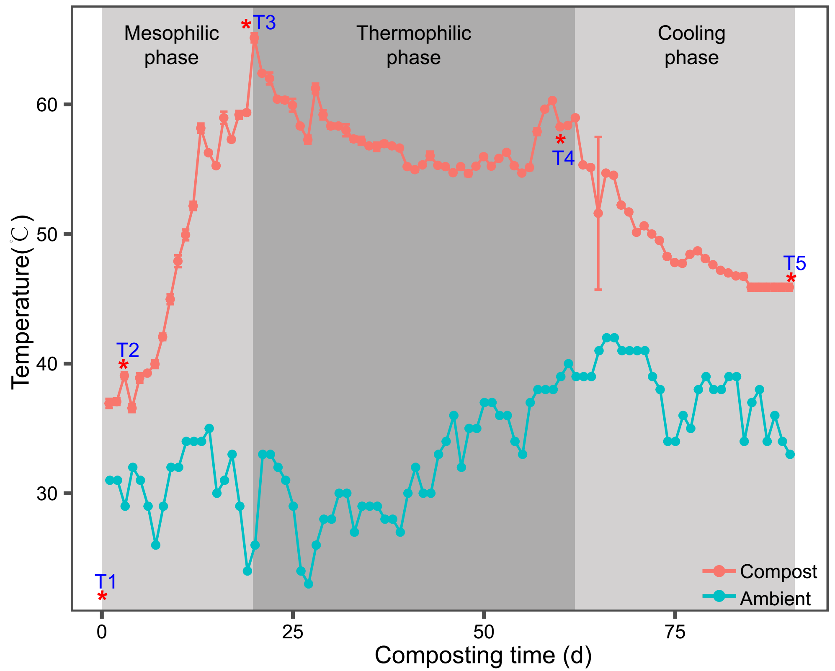

**Figure 1.** Changes in composting and ambient temperature during pig manure composting process. Letters T1-T5 and stars indicated the selected sampling timepoints that were used for subsequent analyses. Light gray backgrounds represent the mesophilic, thermophilic and cooling phases of composting. N=3 for each composting sampling time point.

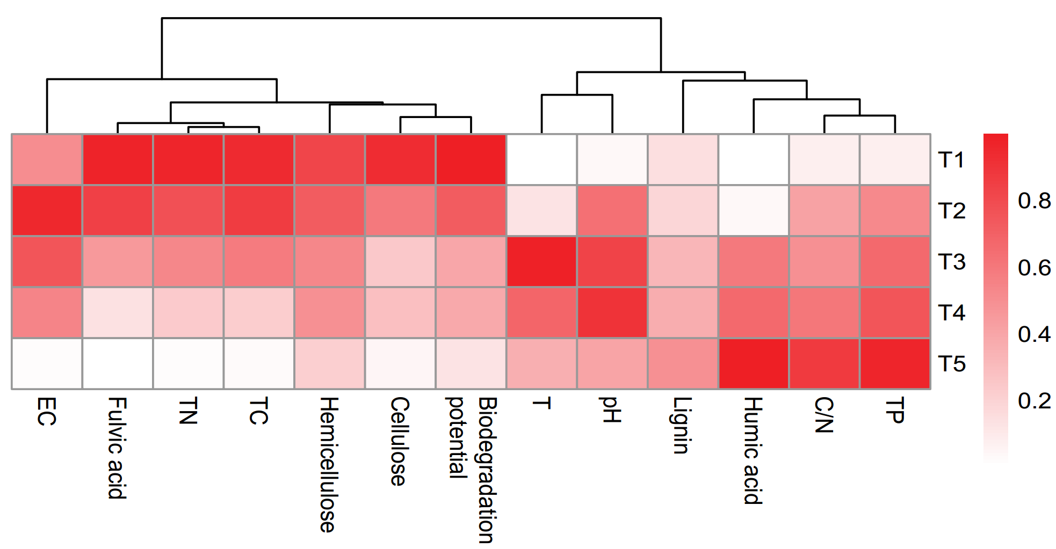

**Figure 2.** Heatmap showing the changes in abiotic compost properties during pig manure composting. The color range indicates the normalized mean values for each property (increasing from white to red). N=3 for each composting sampling time point.

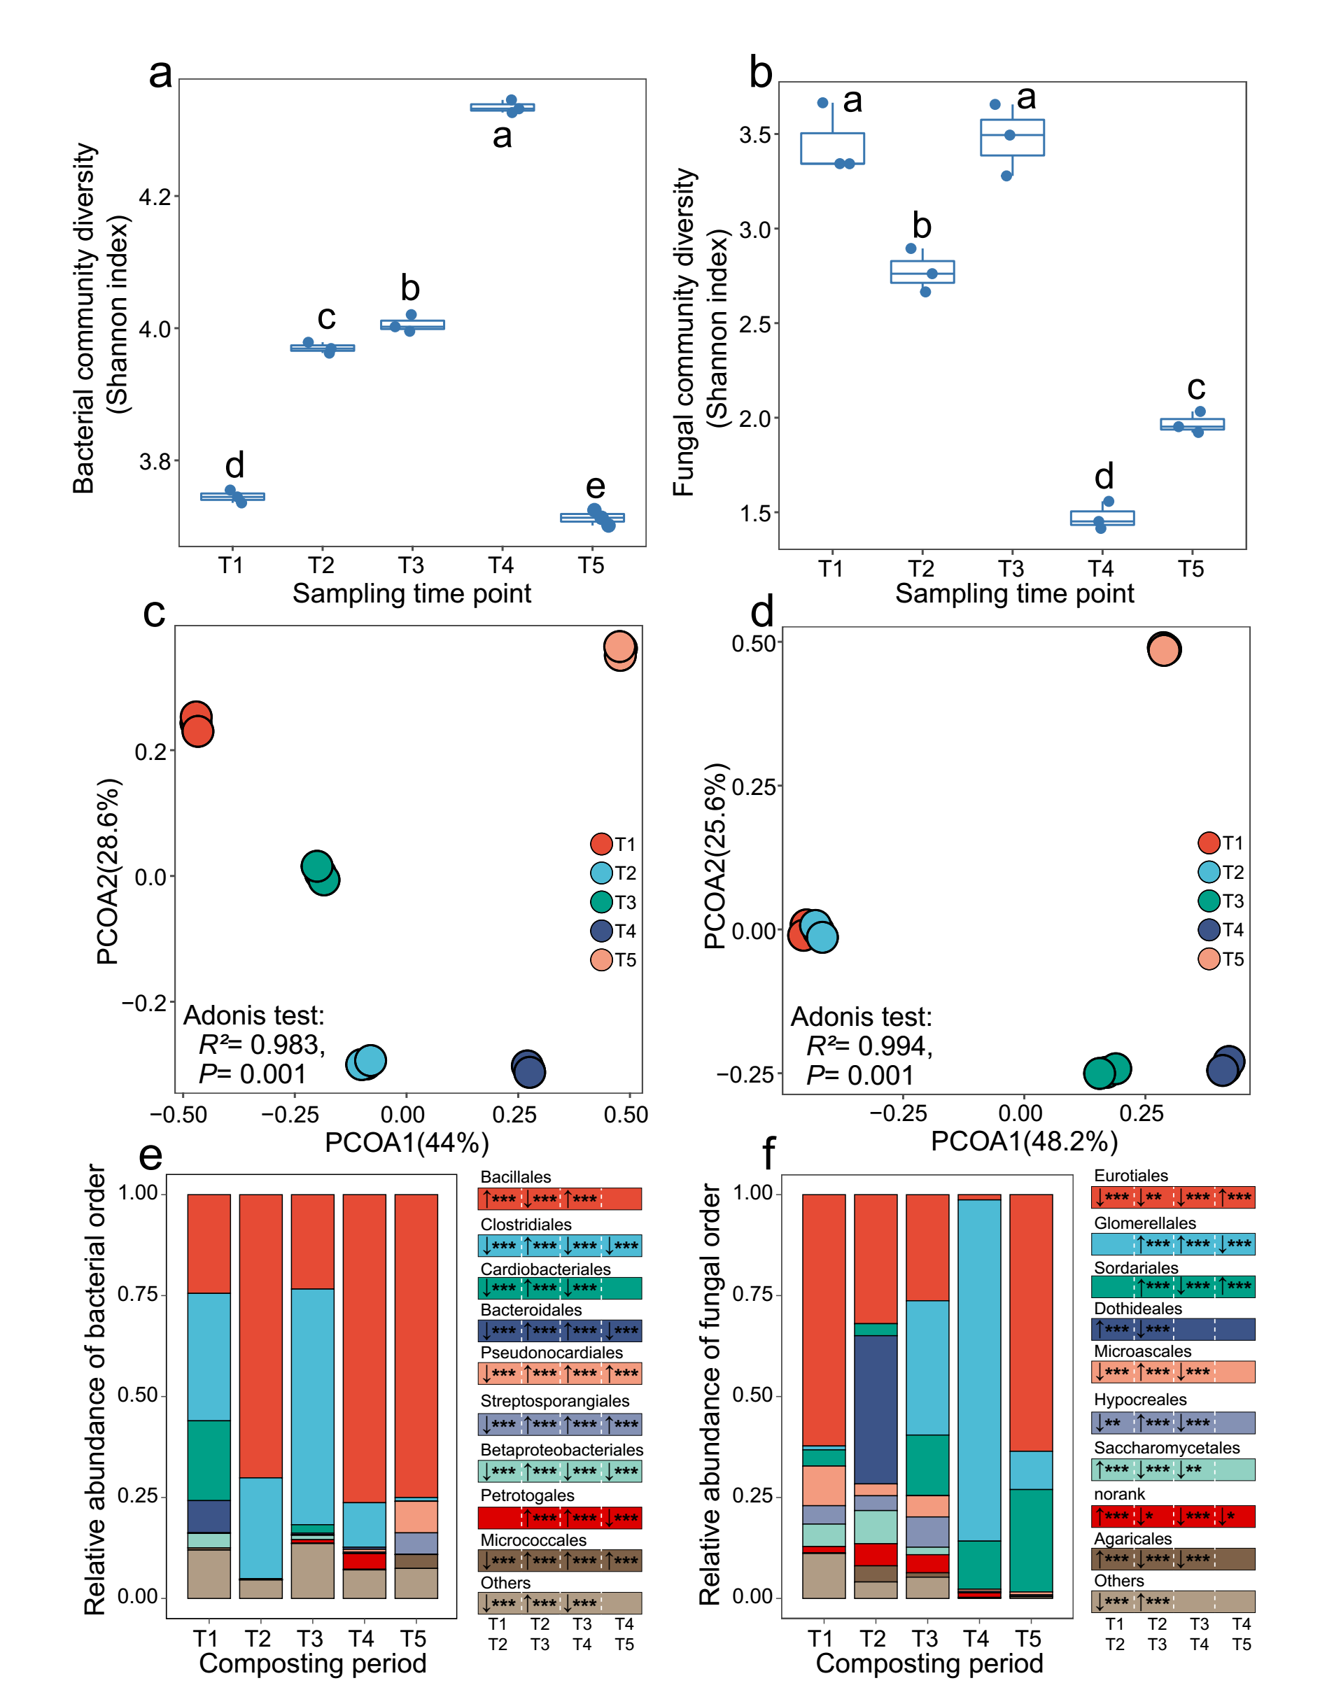

**Figure 3.** Temporal changes in compost microbiome diversity and composition during pig manure composting. Shannon diversity of bacterial (a) and fungal (b) communities. Lowercase letters within panel a and b denote for statistical differences at the level of *p*< 0.05. Bacterial (c) and fungal (d) community compositions based on principal coordinate analysis of unweighted UniFrac distance matrix. Relative abundance of the dominant bacterial (e) and fungal (f) taxa at the order level during pig manure composting (based on OTUs of top 9 orders). In (e) and (f), right small panels show differences in order abundances between two subsequent sampling time points. The upward and downward arrows denote for an increase and decrease in the relative abundance of the first group relative to the second group, respectively. The *, ** and *** represent significances at *p*<0.05, *p*<0.01 and *p*<0.001 levels, respectively. N=3 for each composting sampling time point.

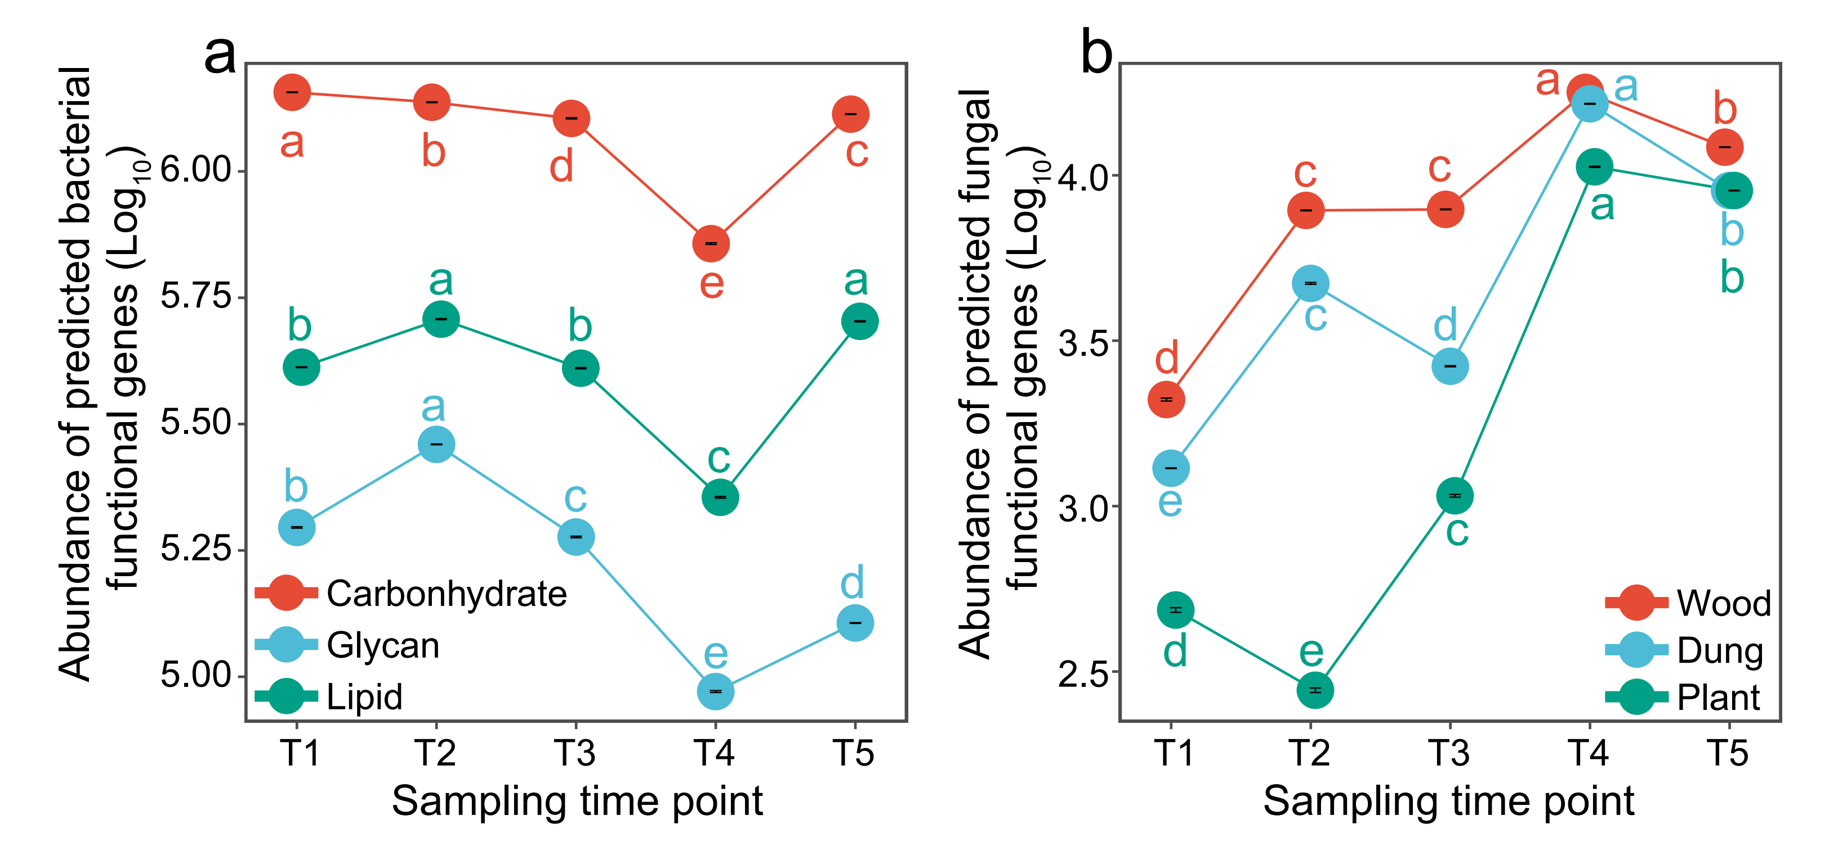

**Figure 4.** Changes in predicted bacterial (a) and fungal (b) functional gene abundances during pig manure composting. Panel (a) shows predicted gene abundances for three bacterial metabolic functions linked to carbohydrate metabolism (red), glycan biosynthesis and metabolism (blue), and lipid metabolism (green). Panel (b) shows predicted gene abundances for three fungal saprotrophic functions linked to wood saprotrophism (red), dung saprotrophism (blue), and plant saprotrophism (green). Lowercase letters denote for statistical difference at the level of *p*< 0.05, respectively. N=3 for each composting sampling time point.

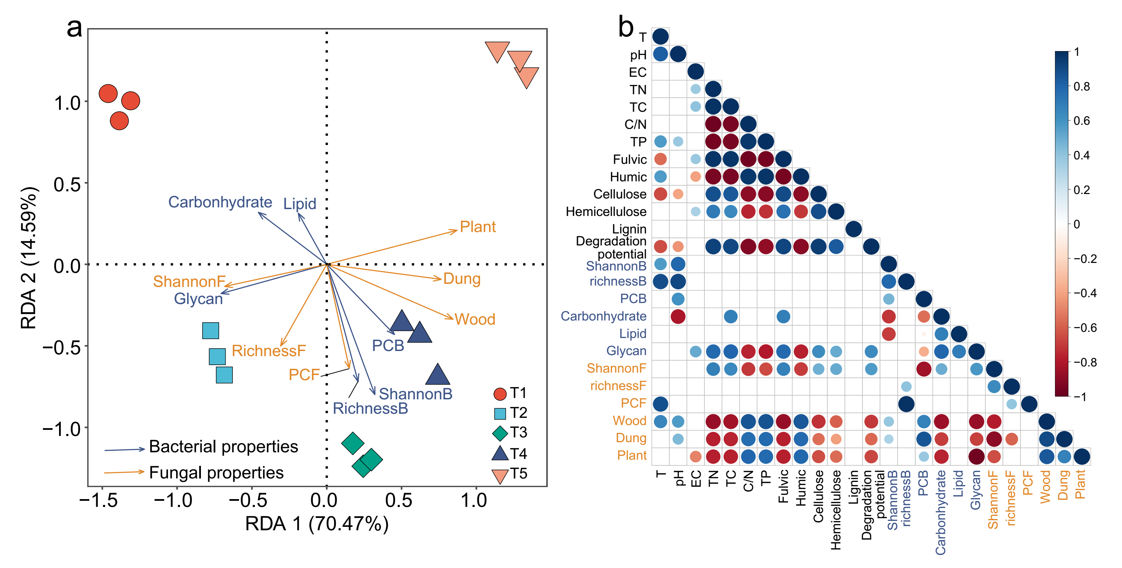

**Figure 5.** Comparison of relative importance of the bacterial and fungal community properties (composition and predicted functional genes) in explaining variation in the abiotic pig manure compost properties (T, pH, EC, TN, TC, C/N, TP, fulvic acid, humic acid, cellulose, hemicellulose, lignin and biodegradation potential). Panel (a) shows Redundancy analysis (RDA) explaining the abiotic compost properties based on bacterial properties (**Composition**: RichnessB, ShannonB, PCB; **Functioning**: carbonhydrate, lipid and glycan gene abundances) on dark blue vectors and fungal properties (**Composition**: RichnessF, ShannonF, PCF; **Functioning**: wood, dung and plant saprotrophism) on orange vectors. Panel (b) shows the Spearman correlations between bacterial (dark blue) and fungal (orange) community properties with abiotic compost properties (only significant correlations shown when *P*<0.05). The color (blue for positive and red for negative) and size of the circles indicate the magnitude of correlation coefficients (*R* value). N=3 for each composting sampling time point.