**Age and sex influence social interactions, but not associations, within a killer whale pod**

Michael N. Weiss1,2*, Daniel W. Franks3, Deborah A. Giles4, Sadie Youngstrom4, Samuel K. Wasser4, Kenneth C. Balcomb2, David K. Ellifrit2, Paolo Domenici5, Michael A. Cant6, Samuel Ellis1, Mia L. K. Nielsen1, Charli Grimes1, & Darren P. Croft1

1. Centre for Research in Animal Behaviour, University of Exeter, Exeter, UK
2. Center for Whale Research, Friday Harbour, WA, USA
3. Department of Biology and Department of Computer Science, University of York, York, UK
4. Center for Conservation Biology, Department of Biology, University of Washington, Seattle, WA, USA
5. IBF-CNR, Institute of Biophysics, Pisa, Italy
6. Centre for Ecology and Conservation, University of Exeter, Penryn, UK

* Corresponding author

Email: m.weiss@exeter.ac.uk

**Keywords:** centrality, homophily, *Orcinus orca*, social network, social life history, UAS

# Abstract

Social structure is a fundamental aspect of animal populations. In order to understand the function and evolution of animal societies, it is important to quantify how individual attributes, such as age and sex, shape social relationships. Detecting these influences in wild populations under natural conditions can be challenging, especially when social interactions are difficult to observe and broad-scale measures of association are used as a proxy. In this study, we use unoccupied aerial systems to observe association, synchronous surfacing, and physical contact within a pod of southern resident killer whales (*Orcinus orca*)*.* We show that interactions do not occur randomly between associated individuals, and that interaction types are not interchangeable. While age and sex did not detectably influence association network structure, both interaction networks showed significant social homophily by age and sex, and centrality within the contact network was higher among females and young individuals. These results suggest killer whales exhibit interesting parallels in social bond formation and social life histories with primates and other terrestrial social mammals, and demonstrate how important patterns can be missed when using associations as a proxy for interactions in animal social network studies.

# Introduction

Individual characterstics such as and sex and age often influence social relationships and underly variation in social position in animal societies. Understanding how these characteristics shape social structure under natural conditions can shed light on numerous aspects of behavioural ecology, including social life history evolution (e.g. Machanda & Rosati 2020) and the mechanisms underlying social bond formation (e.g. Gerber et al. 2020), while also providing potentially vital information about population-level processes such as gene flow and disease transmission (Kurvers et al. 2014).

Social network analysis has become an important tool for understanding these processes over the last two decades (Brent et al. 2011; Webber & Vander Wal 2019), however uncovering the drivers of social network structure is challenging. Studies of animal social networks require data on the rates of relevant social behaviours between identified individuals (Whitehead 2008a; Croft et al. 2008, Farine & Whitehead 2015), which often require a great deal of sampling to measure precisely (Whitehead 2008b). Furthermore, the structure of observed social networks is dependent on the behavioural definition of edges (Castles et al. 2014).

While social structure fundamentally arises from the patterns of repeated interactions between individuals (Hinde 1976), social interactions are often difficult to observe in free-ranging animals, as interactions may be subtle, rare, or not visible from traditional observation platforms. Therefore, many studies of social structure in free-ranging animal populations utilize association indices, measuring the probability that individuals are found within the same group or a particular spatial proximity during a sampling period (reviewed by Webber & Vander Wal 2019). As association provides the opportunity for interaction, these associations are typically assumed to generally reflect patterns of interactions between individuals (Whitehead & Dufault 1999), however there is still debate over the degree to which associations can reflect true interactions (e.g. Farine 2015). Using behavioural proxies of relationships that are too broad or do not represent the relationships of interest may mask the influences of individual characteristics on social network structure.

In this study, we quantify the influence of age and sex on social relationships in a pod of resident killer whales (*Orcinus orca*). Previous studies of killer whale societies have suggested that individuals do not show social homophily by age or sex (Tavares et al. 2017; Esteban et al. 2015; Williams & Lusseau 2006), and analyses of individual network centrality with respect to age and sex in this species have produced mixed results (Baird & Whitehead 2000; Williams & Lusseau 2006; Tavares et al. 2017). The apparent lack of age and sex structure in killer whale social networks is somewhat surprising in the context of other well-studied dolphin species, where social networks are commonly structured by age and sex (e.g. Hawkins et al. 2019; Hartman et al. 2008; Elliser & Herzing 2014; Leu et al. 2020; Webster et al. 2009). This discrepancy may be due to the definitions used to construct killer whale social networks. Because killer whales live and move in stable social units, the position of individuals and the patterns of edges within association networks are likely to primarily reflect attributes and relationships at the level of the unit, rather than the individual (e.g. Ivkovich et al. 2009; Williams & Lusseau 2006). This system therefore provides an opportunity to test the degree to which the use of broad-scale association patterns can mask important effects of individual characteristics in animal societies.

Here, we utilize unoccupied aerial systems (UAS) to quantify association (defined as individuals detected simultaneously, and therefore with the opportunity to be observed interacting), synchronous surfacing, and physical contact among individually identified killer whales. In delphinids, synchrony may be directly beneficial during cooperative behaviours (Myers et al. 2017) and may be important for maintaining and establishing social relationships (Connor et al. 2006; McCue et al. 2020). Similarly, physical contact may signal social affiliation and bonding (Connor et al. 2005; Dudzinski et al. 2017) and may be important for reconciliation after aggressive interactions (Weaver 2003). We hypothesized that both of these interactions would occur non-randomly between associated individuals, and that any influence of age and sex on social structure, both in terms of social homophily and individual centrality within the social network, would be more clear when analysing these interactions than when analysing associations.

# Methods

#### Study population

The southern resident killer whales are a small (< 80 individuals), closed population inhabiting the coastal waters of the northeastern Pacific, with their core habitat being the inland waters of Washington, USA and British Columbia, Canada. This population has been subject to a complete annual census carried out by the Center for Whale Research since 1976. All individuals can be visually identified using unique markings, body shapes and sizes, and scarring.

The southern residents exhibit lifelong bisexual philopatry to maternal social groups. The basic social unit is the matriline, composed of close relatives with a recent common maternal ancestor. Closely related matrilines form pods, larger semi-stable social groups with a shared vocal dialect (Bigg, et al., 1990; Parsons et al. 2009). This population contains three pods, designated J, K, and L pod, which at the time of the study contained 22, 18 and 32 individuals, respectively.

#### Field observations

During the summer of 2019, we collected video observations using a small UAS (DJI Phantom 4 Pro V2) launched from a small motorized vessel (21 ft. Grady White), or using a larger aircraft (DJI Matrice 600) launched from shore. Focal subgroups (sets of whales in close physical proximity to each other which could be captured simultaneously on video) were located by observers prior to launching the aircraft. Subgroups were primarily chosen for follows based on logistical factors, such as distance from the launch point and the presence of whale watch and research vessels. Preference was typically given to larger subgroups to maximize the possible number of interactions observed over a given observation period. We correct for potential biases introduced by this preference in our permutation analysis (see below). During on-water operations, the vessel maintained a low speed (< 7 kts) when within 1 km of whales. The vessel was usually positioned behind groups of whales, at a distance of 200-400 m (see Ayers et al., (2012) for details on vessel maneuvering).

When in the air, one crew member piloted the aircraft, while another served as a visual observer to aid in maintaining visual line-of-sight and situational awareness. A third team member was designated as a general observer, tasked with monitoring whale behaviour during research flights and assisting with operations. The aircraft maintained an altitude between 30 and 120 meters while above whales, and was typically positioned to the side of or behind the animals. The angle of the camera and position of the aircraft were adjusted to ensure a clear view of the full subgroup.

Operations were limited to conditions conducive to the safe operation of the UAS and clear observation of animals below the water (no rain, wind below 10 kts, sea state less than Beaufort 3). We collected footage of southern residents over 13 days. For most of these days (10/13), only members of J pod were present. To avoid spurious inferences about relationships involving K or L pod, we chose to restrict our analysis to days in which only J pod was present.

#### Video analysis

We analyse all video in BORIS software (Friard & Gamba, 2016). Analysis of each video clip proceeded by first identifying all whales that were visible at any point during the video by their unique markings, body shapes and size, and scarring. Then, in random order, each whale was followed for the entirety of the video. We coded a state variable for individual visibility, indicating when each individual was on screen and identifiable. We considered individuals to be associated when they were simultaneously visible in the video (Figure 1).

We code physical contact as an undirected point event, recorded when individuals initially come into contact. As we were interested in patterns of affiliative social relationships, we excluded aggressive interactions such as fluke strikes and biting. We also exclude observations of nursing. Potential sexual contacts were not excluded, as affiliative socialization often includes sexual behaviour in this population (Noren & Hauser, 2016; Osborne, 1986).

Synchronous surfacing was also coded as an undirected point event. Individuals were considered to have breathed in synchrony if they surfaced within one adult female body length (approx. 6 m) and at some point during their surfacing both individuals’ blowholes were simultaneously above the water’s surface. Individuals could be recorded synchronously surfacing with multiple partners in a single surfacing, however we did not use a chain-rule, and therefore synchronous surfacings were not transitive. As both interactions were coded as point events, they did not preclude one another.

Our sequential follow protocol generates two records of each interaction, potentially at slightly different time points. We ensured all interactions were recorded for both individuals and that all individuals were coded as visible during all of their interactions, with errors corrected by re-analyzing the video. We set the interaction time as the midpoint between the two records. The median difference in time between the two records was 0.203 seconds (IQR = 0.23) for synchronous surfacing and 0.439 seconds (IQR = 0.656) for contact.

*Determining age, sex, and kinship*

In 2019, all surviving members of J pod were born after the study began in 1976, and thus their ages (in years) are known with certainty. The sexes of all individuals in this pod were determined based on obvious sexual dimorphism in mature individuals and from genital coloration in young individuals.

Maternal kinship was estimated based on behaviourally defined mother-calf dyads. These relationships have been universally supported by subsequent genetic sampling (Ford et al. 2018). From known mother-calf relationships, we constructed a maternal pedigree and estimated a maternal relatedness matrix using the kinship2 R package (Sinnwel & Therneu 2020).

#### Social network construction

We constructed interaction networks by dividing each dyad’s total interaction by their total observation time. Initial analysis suggested interactions did not occur in bouts (see supplementary materials), so each interactions was treated as independent. Each dyad’s observation time was summarized as the total amount of time that one or both of the individuals was visible.

${rate}_{ij}= \frac{x_{ij}}{t_{i}+ t_{j}- t_{ij}}$ (1)

Here, *xij* is the number of interactions observed between individuals *i* and *j*, *ti* and *tj* are the total time (in seconds) *i* and *j* were visible, respectively, and *tij* is the amount of time both *i* and *j* were visible simultaneously. We calculate interaction rates separately for synchronous surfacings and contacts. We quantify the reliability of our interaction networks by estimating the correlation between true and observed interaction rates following Whitehead (2008b) (see supplementary materials for details).

We construct an association network representing the proportion of sampling time in which individuals co-occurred in our observations:

${association}_{ij}= \frac{t_{ij}}{t_{i}+ t_{j}- t_{ij}}$ (2)

where the variable definitions are the same as in equation 1. This index is comparable to the “simple ratio index” commonly used in animal social network analysis (Cairns & Schwager, 1987). Like other association indices, the edges in this network range from 0 (never co-occurred) to 1 (always observed together). This index represents the proportion of time that individuals were detected together, not the amount of time they truly spent together; Individuals could fail to be detected while in association if they were outside of the camera’s field of view, or if they submerged to a depth where they were no longer visible. During data collection, the camera captured an area with a median maximum distance between any two recorded points of 85 m (IQR = 30; see supplementary materials for methods). This distance is comparable to previous killer whale studies where a cutoff of 10 body lengths (roughly 70 m) has been used (e.g. Williams & Lusseau 2006). Social networks construction and all further analysis was carried out in R (R Core Team 2020).

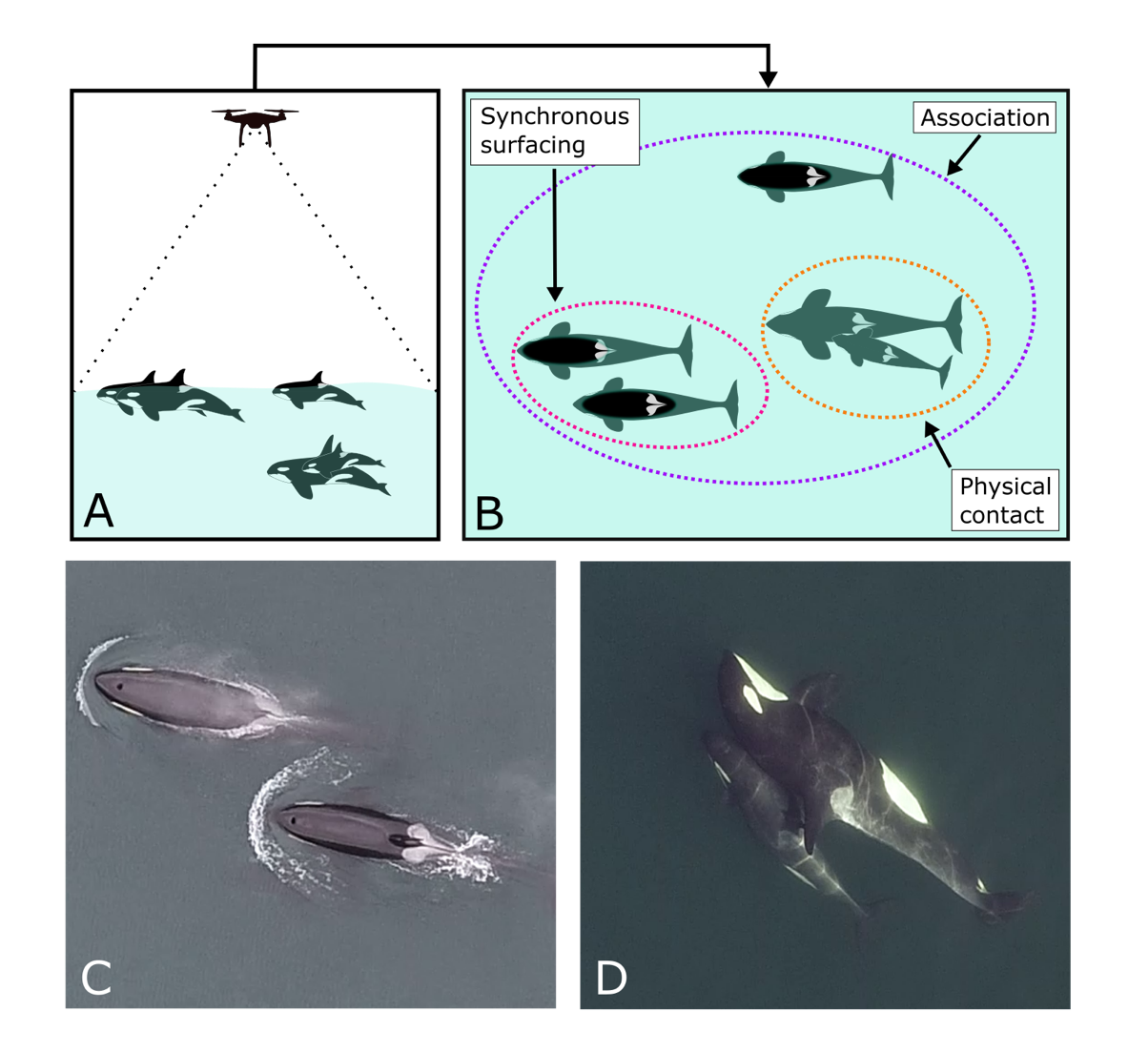

**Figure 1*.*** Observing killer whale social interactions using UAS. A-B: The aircraft is flown over focal killer whale sub-groups (A). All individuals detected simultaneously were considered to be associated, and both synchronous surfacing and physical contact interactions were recorded between identified individuals (B). C-D: Example video stills of synchronous surfacing between individuals J36 and J47 (C) and physical contact between individuals J44 and J53 (D).

#### Comparing associations and interaction rates

We first tested whether the structure of the two interaction networks could be explained solely by dyadic association and sampling. We construct a null model for our interaction networks that maintains both individual detection history and temporal variation in the observed overall rate of interactions. For each observed interaction, we randomly sample two individuals coded as visible at the time of the interaction as the new interaction partners. We repeat this procedure 10,000 times, re-calculating interaction rates for each randomisation to generate 10,000 randomised networks.

We first test whether interaction rates are more variable than expected given associations. We do this by using the coefficient of variation (CV) as a test statistic. The CV is a measure of the variation in interaction rates. When individuals have strongly preferred and avoided interaction partners, the CV of interaction rates will be higher than when individuals interact at random (Whitehead 2008a). We reject the null hypothesis that interactions occurred randomly between associates if the observed CV is greater than the upper 95% confidence interval of CVs from the randomised networks.

We additionally test whether the correlations between associations and interactions are different from expected if interactions occurred randomly by calculating Spearman’s rank correlation (*rs*) between interaction rates and association indices in both the observed and randomised interaction networks. If *rs* in the observed data lies within the 95% CI of *rs* values from the randomised networks, we do not reject the null hypothesis that interaction patterns match those expected given random interactions between associates. If the observed *rs* is lower than the lower 95% CI of the randomised values, the rates of social interaction between individuals cannot be directly inferred from patterns of association. We additionally compare these correlations to the null hypothesis of no correlation between the networks using Mantel tests, using the vegan package in R (Oksanen et al. 2019). Note that the Mantel test has a different null hypothesis than the randomization of the raw data. While our randomization of the raw data represents the null hypothesis that interactions occur randomly between associated individually (and thus associations reflect interactions), the Mantel test proposes the null hypothesis that association and interaction rates are independent.

#### Comparing surfacing and contact networks

Next, we investigated whether there were structural differences in the two interaction networks. We again use randomizations to test the null hypothesis that interaction types are interchangeable, using the procedure proposed by Franz & Alberts (2015). Each observed interaction is labelled according to which type of interaction it represented in the original data. Over 10,000 permutations, these labels are shuffled and the two resulting networks are calculated. We determine whether there are differences in the CV between the networks by comparing the observed difference in CV to the distribution of differences from the randomised networks as above. We test whether the networks are less correlated than expected if interaction types were interchangeable by comparing the *rs* between the observed networks to a distribution of *rs* values generated from the randomised networks, as above. We also test the correlation between these two networks against the null hypothesis of no relationship using a Mantel test.

#### Effects of age, sex, and kinship on edge strength

We next test the role of kinship, age, and sex in the structuring of edges in the association, contact, and synchronous surfacing networks. To quantify the relationship between both synchronous surfacing and contact rates and our predictors, we use generalised linear models (GLMs), with a negative binomial error structure. These models can be expressed as:

$x_{ij} \sim NB(λ_{ij},θ)$ (3)

${log⁡(λ}_{ij}) = β_{0}+β_{1}R_{ij}+β_{2}(-\left|a_{i}-a_{j}\right|)+β_{3}(1-\left|s_{i}-s_{j}\right|)+log⁡(t_{i}+t_{j}-t_{ij})$

where $λ_{i,j}$ and $θ$ are the mean and dispersion parameters for the negative binomial distribution, respectively, *Rij* is the estimated maternal kinship between *i* and *j*, *ai* is individual *i*’s age in years, *si* is the sex of individual *i* (0 = female, 1= male), and the $β$ are estimated regression parameters and the term log(*ti* + *tj* - *tij*) is an exposure term.

Similarly, we quantify the relationship between our predictors and association patterns with a beta regression model:

${association}_{ij} \sim Beta(μ_{ij},ϕ)$ (4)

${logit(μ}_{ij}) = β_{0}+β_{1}R_{ij}+β_{2}(-\left|a_{i}-a_{j}\right|)+β_{3}(1-\left|s_{i}-s_{j}\right|)$

where $μ_{ij}$ and $ϕ$ are the mean and precision parameter of the beta distribution. In this model, dyadic sampling effort was included as a proportional weight in the fitting process. As there were zeros in the association data, we transformed these values following Smithson & Verkuilen (2006):

$y' = \frac{y(N-1)+0.5}{N}$ (5)

Here, *y* are the original values, *y’* are the transformed values, and *N* is the sample size (here, the number of dyads). We fit these models in R, using the MASS package for negative binomial regression (Venables & Ripley 2002) and the betareg package for beta regression (Cribari-Neto & Zeileis, 2010).

We use a permutation procedure to determine the statistical significance of regression coefficients. We use the double-semi-partialling method developed by Dekker et al., (2007) with 10,000 randomizations, using the Wald’s *Z* as our test statistics. Our method is equivalent to multiple regression quadratic assignment procedure (MRQAP), but fitting GLMs instead of least squares regression. We therefore refer to this procedure as a generalised linear model quadratic assignment procedure (GLMQAP).

#### Effects of age and sex on network centrality

Finally, we determine the influence of age and sex on network centrality in our three networks. As using a large number of centrality measures can lead to false positives in statistical analyses (Webber et al. 2020), we choose just one index: eigenvector centrality. Eigenvector centrality depends on direct and indirect connectivity in the network; individuals with high eigenvector centrality have numerous, strong connections to individuals that are also well connected. In the remainder of the manuscript, we refer to eigenvector centrality scores simply as individuals’ “centrality”.

We fit linear mixed effects models to identify the relationship between centrality and individual attributes. These models had the form:

$\log\left({centrality}_{i}\right)\sim N(μ_{i}, σ_{residual})$ (6)

$μ_{i}= β_{0}+ β_{1}s_{i}+ β_{2}a_{i}+β_{3}log⁡(t_{i})+ ε_{m_{i}}$

$ε \sim N(0, σ_{matriline})$

Here *ε* is a matriline-level random effect (with *mi* indicating matriline membership), controlling for correlations in social network positions between matriline members (Williams & Lusseau 2006), and the terms *a, s,* and *t* are as in equation 3. The term for log(*ti*) is used here to correct for the effect of sa­mpling intensity on centrality measures (Franks & Weiss et al. 2020). Using the logarithm of centrality improved the data’s adherence to the model’s assumptions of normally distributed residuals and linearity, and initial visual examination suggested a log-log relationships between centrality and sampling intensity was an appropriate fit across all three networks. These models were fit using the lme4 R package (Bates et al. 2015).

We test our regression coefficients using a double-semi-partialling permutation procedure (Dekker et al. 2007), with permutation constrained within matrilines. We compare the observed *t-*values to 10,000 permutations to derive *p*-values. We do not test for interactions between age and sex, as double semi-partialling cannot test interaction effects.

#### Data accessibility

The processed contact, surfacing, and association networks, measures of dyadic sampling effort, estimated maternal kinship, individual attributes, and functions to conduct GLMQAP and general double-semi-partialling are included in the “aninet” R package on GitHub (<https://github.com/MNWeiss/aninet>). The raw time-series of detections and interactions, and R code necessary to reproduce all analyses, are available in the online supplementary material.

# Results

#### Data description

Over 10 days of sampling, we collected a total of 651 minutes of video. During this footage, a median of 4 individuals were visible at any given time (interquartile range = 3). All individuals were observed on at least 3 different days, and each individual whale was videoed for a mean of 125.96 minutes (SD = 57.65). Each pair of animals was observed for an average of 213.68 minutes total (SD = 58.17). While a relatively short period, this is an increase in sampling relative to the only other study using UAS to construct cetacean social networks (Hartman et al. 2020). We estimate that the observed interaction rates were strongly correlated with the true interaction rates (contact *rest* = 0.98; surfacing *rest* = 0.98). During our observations, we recorded 831 instances of physical contact between individuals, and 1617 synchronous surfacing interactions (Table S1). Contact and synchronous surfacing behaviours did not tend to occur simultaneously; 1.5% of contacts occurred within one second of the same pair synchronously surfacing. Pairs of whales were visible simultaneously for an average of 38.24 minutes (SD = 30.61).

#### Comparing interactions to association patterns

Rates of both interaction types were significantly more varied than expected given random interactions between associates (surfacing: Observed = 2.31, 95% CI Random = [1.09, 1.23], *p* < 0.001; contact: Observed = 2.46, 95% CI Random = [1.27, 1.47], *p* < 0.001). Both interaction networks were significantly positively correlated with the association network under the null hypothesis of no relationship (surfacing: *rs* = 0.79, *p* < 0.001; contact: *rs* = 0.59, *p* < 0.001). The interaction networks were, however, significantly less strongly correlated with the association network than expected if interactions occurred randomly between associates (surfacing: 95% CI random *rs* = [0.85, 0.90], *p* < 0.001; contact: 95% CI random *rs* = [0.70, 0.78], *p* < 0.001).

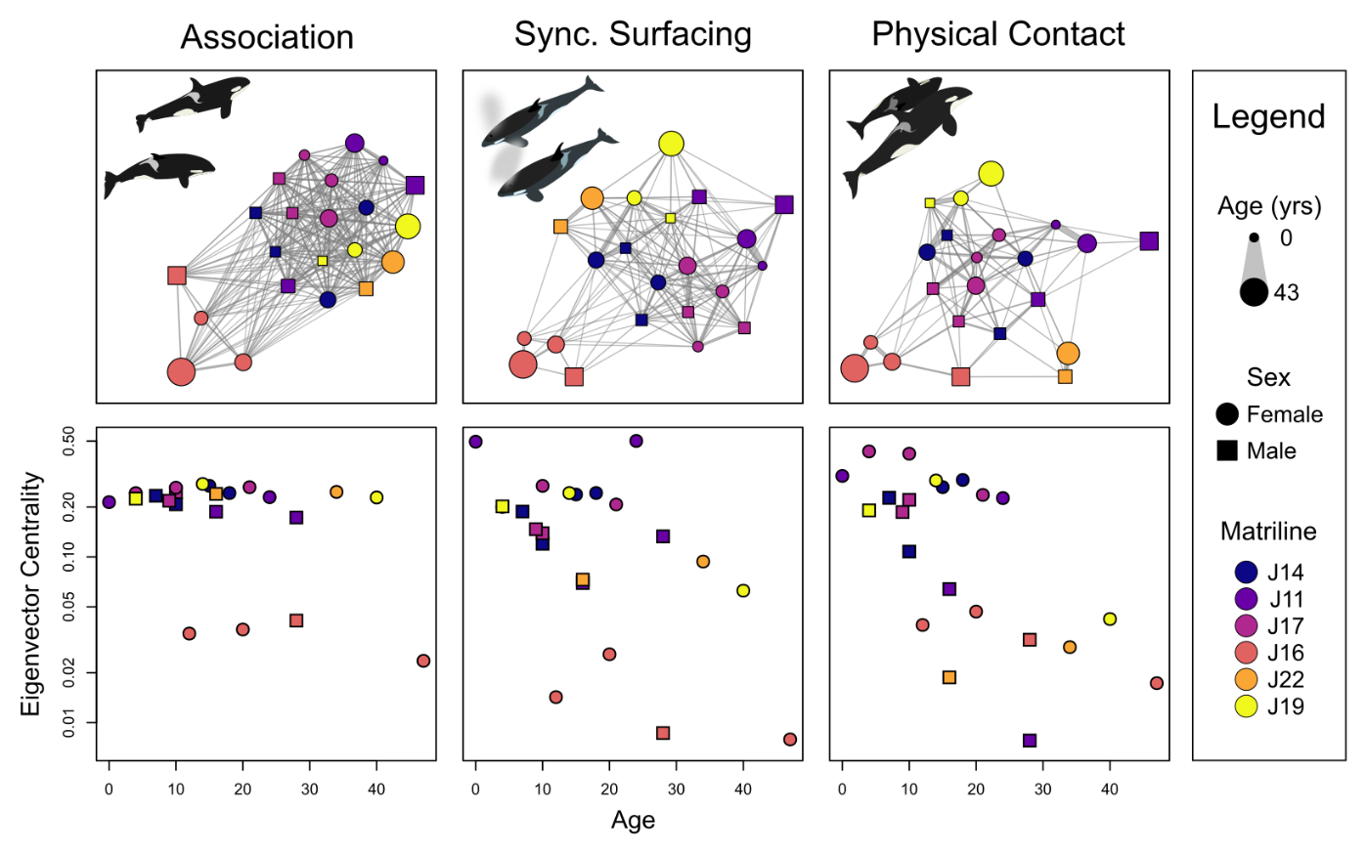

**Figure 2*.*** Network structure and social centrality in a resident killer whale pod. Panels show sociograms (top) and eigenvector centrality measures (bottom) for (from left to right) association, synchronous surfacing, and physical contact networks. Edge thicknesses in the sociograms are proportional to association or interaction rate, and nodes are placed according to the ForceAtlas2 algorithm (Jacomy et al. 2014). Across all plots, node shape indicates sex and node color indicates matriline membership, and node size in the sociograms indicates individual age (as shown in the legend). Note the log scale for the y-axis in the lower plots.

#### Comparison of interaction types

Rates of the two interaction types did not have statistically significant differences in their coefficients of variation. (Observed difference in CV = 0.23, 95% CI Random = [-0.17, 0.24], *p* = 0.07). The two networks were more correlated than expected under the null hypothesis of no relationship between contact and surfacing rates (*rs* = 0.72, *p* < 0.001), but significantly less correlated than expected if the two interaction types were interchangeable (95% CI Random = [0.80, 0.87], *p* < 0.001).

#### Influence of age, sex, and kinship on edge strength

As expected, maternal kinship was an important predictor of association and interaction rates across all three networks (all *p* < 0.001; Table S3). In the association network, neither age similarity nor sex similarity predicted edge weights. In both interaction networks, however, interaction rates were significantly related to age similarity (surfacing: *β* = 0.06 ± 0.01, *Z* = 5.32, *p* = 0.005; contact: *β* = 0.12 ± 0.02, *Z* = 6.82, *p* < 0.001) and sex similarity (surfacing: *β* = 0.60 ± 0.20, *Z* = 2.98, *p* = 0.02; contact: *β* = 1.27 ± 0.28, *Z* = 4.58, *p* = 0.002).

#### Influence of age and sex on social centrality

Across all three networks, increased sampling intensity was related to greater observed centrality (all *p* < 0.04, Table S4). In the synchronous surfacing and association network, we found no evidence that age or sex influenced centrality (all *p* > 0.05; Table S4). However, in the contact network, we found statistically significant effects of age and sex on centrality. Older individuals were significantly less central (*β* = -0.03 ± 0.01, *t* = -3.30, *p* = 0.006), and males were less central than females (*β* = -0.58 ± 0.16, *t* = -3.59, *p* = 0.004).

# Discussion

In this study, we observed direct social interactions in a killer whale pod to better understand the role of age and sex in structuring social relationships. Associations were not strongly organized by age or sex, but were primarily structured by matrilineal kinship. In contrast, both synchronous surfacing rates and physical contact rates showed significant assortment by age and sex. In addition, we found evidence that younger individuals and females were particularly central in the contact network, suggesting age and sex related variation in social strategies, a pattern that was not clear in the association or synchronous surfacing networks.

The potential issues with using association to quantify social structure have been extensively debated in the methodological literature (Whitehead & Dufault 1999; Castles et al. 2014; Farine 2015; Carter et al. 2015), however they have rarely been addressed in cetaceans and other aquatic species (but see Leu et al. 2020 and Lusseau 2007) or in the context of detecting the influence of individual attributes on network structure. Our results demonstrate how inferences about network structure in relation to individual characteristics can be missed when using association indices as a proxy for interaction rates. The effects of age and sex on the strength of network edges were only clear when analysing interaction rates, rather than associations, supporting previous studies which found no assortment by age or sex in killer whale association networks across multiple populations (Williams & Lusseau 2006; Esteban et al. 2015; Tavares et al. 2017). This suggests that while age and sex are important determinants of social interactions, these effects are difficult or impossible to detect from association patterns. While physical contact and synchronous surfacing were highly correlated, they were not interchangeable, and age and sex effects on social centrality were only found in the contact network. This suggests that physical contacts, which can only be consistently observed from the air in this system, may provide greater power for analysing individual social affiliations. This result adds to a growing body of work demonstrating the power of UAS for studying cetacean sociality (Hartman et al. 2020; Nielsen et al. 2019; Ramos et al. 2020).

There are several mechanisms that could drive the observed correlations between age, sex, and social structure. One hypothesis relates to energetics and behavioural budget, a factor that has frequently been proposed to explain sexual segregation in terrestrial ungulates (Ruckstuhl 2007). Adult male killer whales are considerably larger than females, and thus have greater energetic requirements (Noren 2011) and spend more time foraging (Tennessen et al. 2019), which may drive males’ lower social centrality. This may also lead to decoupled behavioural states between the sexes, contributing to assortment by sex in the interaction networks. Similarly, young individuals have a large portion of their energetic needs met by nursing (Newsome et al. 2009) or from prey sharing (Wright et al. 2016), which may lead to greater time spent socializing, primarily with other young individuals. Further work may shed light on how killer whale groups, which are composed of individuals with highly heterogenous energetic requirements, maintain cohesion.

The finding that killer whales become less social as they age aligns with social life histories found in other social mammals. In humans and non-human primates, individuals become less social and maintain fewer relationships as they age, potentially due to adaptive social selectivity or senescence (Machanda & Rosati 2020; Wrzus et al. 2013). Our results suggest that decreased sociality with age may be more widespread among social mammals, including killer whales. This apparent simiarlity between primate and killer whale social life history is particularly interesting given the convergent reproductive life histories in killer whales and humans (Johnstone & Cant 2010). Individuals may also actively form important relationships and social skills at a young age, as in other matrilineal societies (Chiyo et al. 2010; Goldenberg et al. 2016). While further work is needed to explore these and other possible mechanisms, our results demonstrate that killer whales may be a powerful system for testing hypotheses about the evolution of sex differences in sociality and social life histories in mammals.

These results may also have conservation implications for this population. Previous studies have highlighted the potential role of infectious disease risk in killer whale population dynamics (Gaydos et al. 2004; Raverty et al. 2017), and both contact and synchronous surfacing have been identified as disease transmission pathways in cetaceans (Leu et al. 2020). Our results suggest that young, female individuals may be at greater risk of exposure to skin-borne pathogens, such as cetacean poxvirus (Van Bressem et al. 1999). The assortment of both synchronous surfacing and physical contact by age and sex suggests that the impacts of any given disease outbreak may be spread unevenly between demographic classes, spreading to individuals of similar age and sex of the initially infected whale.

A limitation of the current study and method is that social interactions can only be observed by UAS when they occur relatively close to the surface. In addition, only a single social group was studied. Further studies using animal-borne devices may provide additional data on interactions that occur deeper in the water column, and analysing the full population may reveal further patterns.

Our results demonstrate how inferences about social structure are dependent on the behavioural definition of social relationships, and how potentially important patterns may only emerge at very fine scales. As association-based social network studies are ubiquitous in studies of numerous terrestrial and aquatic systems, our results strongly suggest that, where possible, association data should be combined with analyses of relevant social interactions. In particular, when individual movement patterns are primarily governed by membership in stable units, analysing direct interactions may be crucial for uncovering individual level drivers of social structure.

# Acknowledgements

We thank Tom Cogan and Chris Teren for their help designing the data collection protocols for this project. Discussions with many members of the Centre for Research in Animal Behaviour, particularly the members of the Croft and Darden labs and the Social Network Club, helped shape this manuscript. We would also like to thank the many volunteers who helped carry out fieldwork, including Lodie Budwill Gilbert, Alan Budwill, Mia Reynolds, Connor Whalen, Cindy Hansen, and Katie Jones.

# Funding

Support for this research was provided by research grants from the UK Natural Environmental Research Council [NE/S010327/1], the National Fish and Wildlife Foundation, the Paul G Allen Family Foundation, and the UW Center for Conservation Biology, as well as private donations to the Center for Whale Research.

# Ethics statmement

All research was conducted under permits issued by the National Marine Fisheries Service (NMFS permits 21238 and 22141) and was approved by the University of Exeter College of Life and Environmental Sciences ethics committee. We monitored focal whales to determine if clear behavioural responses occurred as the UAS approached, however no behavioural responses were observed during the study.

# Author Contributions

MNW, DPC, MAC, DWF, SE, and KCB conceived of the project. MNW, DAG, SY, PD, and SKW performed fieldwork. MNW conducted video analysis with assistance from DKE. MNW performed statistical analysis, with input from DWF, DPC, CG, MLKN, SE, and PD. MNW drafted the manuscript with input from all authors.

# References

Ayers K. L., Booth, R. B., Hempelmann, J. A., Koski, K. L., Emmons, C. K., Baird, R. W., Balcomb-Bartok, K., Hanson, M. B., Ford, M. J., & Wasser, S. K. (2012) Distinguishing the impacts of inadequate prey and vessel traffic on an endangered killer whale (*Orcinus orca*) population. *PLOS One*, *7*(6). E36842

Baird, R. W., & Whitehead, H. (2000) Social organization of mammal-eating killer whales: Group stability and dispersal patterns. *Canadian Journal of Zoology, 78*(12). pp. 2096-2105.

Bates, D. Maechler, M., Bolker, B. & Walker, S. (2015) Fitting linear mixed-effects models using lme4. *Journal of Statistical Software, 67*(1). pp. 1 – 48.

Bigg, M. A., Olesiuk, P. Ellis, G. M., & Ford, J. K. B. (1990) Organization and geneology of resident killer whales (*Orcinus orca*) in the coastal waters of British Columbia and Washington State. *Report - International Whaling Commission, 12*(12). pp. 383 – 405.

Brent, L. J. N., Lehmann, J., & Ramos-Fernandez, G. (2011) Social network analysis in the study of nonhuman primates: A historical perspective. *American Journal of Primatology, 73*(8). pp. 720 – 730.

Cairs, S. J. & Schwager, S. J. (1987) A comparison of association indices. *Animal Behaviour, 35*(5). pp. 1454 – 1469.

Carter, A. J., Lee, A. E. G, & Marshall, H. H. (2015) Research questions should drive edge definitions in social network studies. *Animal Behaviour, 104*. e7 – e11.

Castles, M. Heinsohn, R., Marshall, H. H., & Lee, A. E. G. (2014) Social networks created with different techniques are not comparable. *Animal Behaviour, 96*. pp. 56 – 67.

Chiyo, P. I, Archie, E. A., Hollister-Smith, J. A., Lee, P. C., Poole, J. H., Moss, C. J., & Alberts, S. C.(2011). Association patterns of African elephant all-male groups: the role of age and genetic relatedness. *Animal Behaviour, 81*(6). pp. 1093 – 1099.

Connor, R. C., Smolker, R., & Bejder, L. (2006) Synchrony, social behaviour, and alliance affiliation in Indian Ocean bottlenose dolphins, *Tursiops aduncus*. *Animal Behaviour, 72*(6). pp. 1371 – 1378.

Connor, R. C., Mann, J., & Watson-Capps, J. (2005) A sex-specific affiliative contact behaviour in Indian Ocean bottlenose dolphins, *Tursiops* sp. *Ethology, 112*, pp. 631 – 638.

Cribrari-Neto, F., & Zeileis, A. (2010). Beta regression in R. *Journal of Statistical Software, 34*(2). pp. 1-24.

Croft, D. P., James, R., & Krause, J. (2008) *Exploring animal social networks.* Princeton University Press, Princeton, N. J.

Dekker, D., Krackhardt, D., & Snijders, T. A. B. (2007). Sensitivity of MRQAP tests to collinearity and autocorrelation conditions. *Psychometrika, 72.* pp. 563 – 581.

Dudzinski, K. M. & Ribic, C. A. (2017) Pectoral fin contact as a mechanism for social bonding among dolphins. *Animal Behavior and Cognition, 4*(1), pp. 30 – 48.

Elliser, C. R., & Herzing, D. L. (2014). Long-term social structure of a resident community of Atlantic spotted dolphins, *Stenella frontalis*, in the Bahamas 1991-2002. *Marine Mammal Science, 30*(1). pp. 308 – 328.

Esteban, R., Verborgh, P., Gauffier, P., & Gimenez, J. (2016) Maternal kinship and fisheries interaction influence killer whale social structure. *Behavioural Ecology and Sociobiology, 7*(1). pp. 111-122.

Farine, D. R., & Whitehead H. (2015) Constructing, conducting, and interpreting animal social network analysis. *Journal of Animal Ecology, 84*(5). pp. 1144 – 1163.

Farine, D. R. (2015) Proximity as a proxy for interactions: issues of scale in social network analysis. *Animal Behaviour, 104*. e1-e5.

Ford, M. J., Parsons, K. M., Ward, E. J., Hempelmann, J. A., Emmons, C. K., Hanson, M. B., Balcomb, K. C., & Park, L. K. (2018) Inbreeding in an endangered killer whale population. *Animal Conservation, 21*(5). pp. 423 – 432.

Franks, D. W., Weiss, M. N., Silk, M. J., Perrynman, R. J., & Croft, D. P. (2020) Calculating effect sizes in animal social network analysis. *Methods in Ecology and Evolution, 12*(1). pp. 33 – 41.

Franz, M., & Alberts, S. (2015) Social network dynamics: the importance of distinguishing between heterogeneous and homogeneous changes. *Behavioural Ecology and Sociobiology, 69*(12). pp. 2059 – 2069.

Friard, O., & Gamba, M. (2016) BORIS: a free, versatile open-source event-logging software for video/audio coding and live observations. *Methods in Ecology and Evolution, 7*(11). pp. 1324 – 1330.

Gaydos, J. K., Balcomb, K. C., Osborne, R. W., & Dierauf, L. (2004) Evaluating potential infectious disease threats for southern resident killer whales, *Orcinus orca*: a model for endangered species. *Biological Conservation, 117*. pp. 253 – 262.

Gerber, L., Connor, R. C., King, S. L., Allen, S. J., Wittwer, S., Bizzozzero, M. R., Friedman, W. R., Kalberer, S., Sherwin, W. B., Wild, S., Willems, E. P, & Krutzen, M. (2019) Affiiation history and age similarity predict alliance formation in adult male bottlenose dolphins. *Behavioral Ecology, 31*(2), pp. 361 – 370.

Goldenberg, S. Z., Douglas-Hamilton, I., & Wittemyer, G. (2016) Vertical transmission of social roles drives resilience to poaching in elephant networks. *Current Biology, 26*(11). pp. 75 – 79.

Hartman, K., van der Harst, P., & Vilela, R. (2020) Continuous focal group follows operated by a drone enable analysis of the relation between sociality and position in a group of male Risso’s dolphins (*Grampus griseus*). *Frontiers in Marine Science, 7*. pp. 283.

Hartman, K. L., Visser, F., & Hendriks, A. J. E. (2008) Social structure of Risso’s dolphins (*Grampus griseus*) at the Azores: a stratified community based on highly associated units. *Canadian Journal of Zoology, 86*(4). pp. 294 – 306.

Hawkins, E. R., Pogson-Manning, L., Jaehnichen, C., & Meager, J. J. (2019). Social dynamics and sexual segregation of Australian humpback dolphins (*Sousa sahulensis*) in Moreton Bay, Queensland. *Marine Mammal Science, 36*(2). pp. 500 – 521.

Hinde, R. A. (1976) Interactions, relationships, and social structure. *Man, 11*(1). pp. 1 – 17.

Ivkovich, T., Filatova, O., Burdin, A. M., Sato, H., & Hoyt, E. (2010). The social organization of resident-type killer whales (*Orcinus orca*) in Avacha Gulf, Northwest Pacific, as revealed through association patterns and acoustic similarity. *Mammalian Zoologoy – Zeitschrift fur Saugetierkunde, 75*(3). pp. 198 – 210.

Jacomy, M., Venturini, T., Heymann, S., & Bastian, M. (2014) ForceAtlas2, a continuous graph layout algorithm for handy network visualization designed for the Gephi software. *PLoS ONE, 9*(6). e98679.

Johnstone, R. A., & Cant, M. A. (2010) The evolution of menopause in cetaceans and humans: the role of demography. *Proceedings of the Royal Society B: Biological Sciences, 277*, 3765 – 3771.

Kurvers, R. H. J. M., Krause, J., Croft, D. P., Wilson, A. D. M., & Wolf, M. (2014). The evolutionary and ecological consequences of animal social networks: emerging issues. *Trends in Ecology and Evolution, 29*(6). pp. 326 – 335.

Leu, S. T., Sah, P., Krzyszczyk, E., Jacoby, A., Mann, J., & Bansal, S. (2020) Sex, synchrony, and skin contact: integrating multiple behaviors to assess pathogen transmission risk. *Behavioral Ecology, 31*(3). pp. 651 – 660.

Lusseau, D. (2007) Why are male social relationships complex in the Doubtful Sound bottlenose dolphin population? *PLOS One, 2*(4). E348.

Machanda, Z. P. & Rosati, A. G. (2020) Shifting sociality during primate ageing. *Philosophical Transatctions of the Royal Society B, 375*, 20190620.

McCue, L. M., Cioffi, W. R., Heithaus, M. R., Barre, L., & Connor, R. C. (2020) Synchrony, leadership, and association in male Indo-pacific bottlenose dolphins (*Tursiops aduncus*). *Ethology, 126*(7), pp. 7741 – 750.

Myers, A. J., Herzing, D. L., & Bjorklund, D. F. (2017) Sychrony during aggression in adult male Atlantic spotted dolphins (*Stenella frontalis*). *acta ethologica, 20*, pp. 175 – 185.

Newsome, S. D, Etnier, M. A., Monson, D. H., & Fogel, M. L. (2009). Retrospective characterization of ontogenetic shifts in killer whale diets via δ13C and δ15N analysis of teeth. *Marine Ecology Progress Series, 374.* pp. 229 – 242.

Noren, D. P. (2011) Estimated field metabolic rates and prey requirements of resident killer whales. *Marine Mammal Science, 27*(1). pp. 60 – 77.

Noren, D. P., & Hauser, D. D. W. (2016) Surface-based observations can be used to assess behaviour and fine-scale habitat use by an endangered killer whale (*Orcinus orca*) population. *Aquatic Mammals, 42*(2). pp. 168 – 183.

Nowacek, D. P., Christiansen, F., Bejder, L., Goldbogen, J. A., & Friedlaender, A. S. (2016). Studying cetacean behaviour: new technological approaches and conservation applications. *Animal Behaviour, 120*. pp. 235 – 244.

Oksanen, J., Blanchet, F. G., Friendly, M., Kindt, R., Legendre, P., McGlinn, D., Minchin, P. R., O’Hara, R. B., Simpson, G. L., Solymos, P., Stevens, M. H. H., Szoecs, E., & Wagner, H. (2019) vegan: Community ecology package. R package version 2.5-8. <https://CRAN.R-project.org/package=vegan>.

Osborne, R. W. (1986) A behavioural budget of Puget Sound killer whales. In: Kirkevold, B. C., & Lockard, J. S (eds) *Behavioural Biology of Killer Whales. Zoo Biology Monographs vol. 1.* Alan R. Liss, Inc. New York, NY, USA.

Parsons, K. M., Balcomb, K. C., Ford, J. K. B., & Durban, J. W. (2009) The social dynamics of southern resident killer whales and conservation implications for this endangered population. *Animal Behaviour, 77*(4). pp. 963 – 971.

R Core Team (2020) R: A language and environment for statistical computing. R Foundation for Statistical Compution, Vienna, Austria. <https://www.R-project.org>

Raverty, S. A., Rhodes, L. D., Zabek, E., Eshghi, A., Cameron, C. E., Hanson, M. B., & Schroeder, J. P. (2017) Respiratory microbiome of endangered southern resident killer whales and microbiota of sourrounding sea surface microlayer in the eastern north Pacific. *Scientific Reports, 7,* 394.

Ruckstuhl, K. E. (2007) Sexual segregation in vertebrates: proximate and ultimate causes. *Integrative and Comparative Biology, 47*(2). pp. 245 – 257

Sinnwell, J., & Therneau, T. (2020) kinship2: Pedigree functions. R package version 1.8.5. <https://CRAN.R-project.org/package=kinship2>.

Smithson, M. & Verkuilen, J., 2006. A better lemon squeezer? Maximum-likelihood regression with beta-distributed dependent variables. *Psychological Methods,* 11(1), pp. 54-71.

Snyder-Mackler, N., Burger, J. R., Gaydosh, L, Nopper, G. A., Campos, F. A., Bartolomucci, A., Yang, Y. C., Aiello, A. E., O’Rand, A., Harris, K. M., Shively, C. A., Alberts, S. C., & Tung, J. (2020) Social determinants of health and survival in humans and other animals. *Science, 368*(6493). eaax9553

Sosa, S., Sueur, C., & Puga-Gonzales, I. (2020) Network measures in animal social network analysis: Their strengths, limits, interpretations and uses. *Methods in Ecology and Evolution, 12*(1). pp. 10 – 21.

Tavares, S. B., Samarra, F. I. P., & Miller, P. J. O. (2017) A multilevel society of herring-eating killer whales indicates adaptation to prey characteristics. *Behavioral Ecology, 28*(2). pp. 500 – 514.

Tennessen, J. B., Holt, M. M., Hanson, M. B., Emmons, C. K., Giles, D. A., & Hogan, J. T. (2019) Kinematic signatures of prey capture from archival tags reveal sex differences in killer whale foraging activity. *Journal of Experimental Biology, 222.* jeb191874.

Torres, L. G., Nieukirk, S. L. Lemos, L., & Chandler, T. E. (2018) Drone Up! Quantifying whale behavior from a new perspective improves observational capacity. *Frontiers in Marine Science, 5.* pp. 319.

Van Bressem, M., Van Waerebeek, K., & Raga, J. A. (1999) A review of virus infections of cetaceans and the potential impact of morbilliviruses, poxviruses, and papillomaviruses on host population dynamics. *Diseases of Aquatic Organisms, 38*(1). pp. 53 -65.

Venables, W. N., & Ripley, B. D. (2002) *Modern Applied Statistics with S.* Fourth edition. Springer, New York, NY, USA.

Weaver, A. (2003) Conflict and reconciliation in captive bottlenose dolphins, *Tursiops truncatus. Marine Mammal Science, 19*(4), pp. 836 – 846.

Webber, Q. M. R., & Vander Wal, E. (2019) Trends and perspectives on the use of animal social network analysis in behavioural ecology: a bibliometric approach. *Animal Behaviour, 149.* pp 77 – 87.

Webber, Q. M. R., Schneider, D. C., & Vander Wal, E. (2020) Is less more? A commentary on the practice of “metric hacking” in animal social network analysis. *Animal Behaviour, 168*. pp. 109 – 120.

Webster, T. A., Dawson, S. M., & Slooten, E. (2009) Evidence of sex segregation in Hector’s dolphin (*Cephalorhynchus hectori*). *Aquatic Mammals, 25*(2). pp. 212 – 219.

Whitehead, H., & Dufault, S. (1999) Techniques for analyzting vertebrate social structure using identified individuals: Review and recommendation. In: Slater, P., Rosenblatt, J. Roper, T, & Snowdon C. (eds) *Advances in the Study of Behaviour, vol 28.* Academic Press, San Diego, CA, USA.

Whitehead, H. (2008a) *Analyzing Animal Societies: Quantitative Methods for Vertebrate Social Analysis.* Univrsity of Chicago Press, Chicago, IL, USA.

Whitehead, H. (2008b) Precision and power in the analysis of social structure using associations. *Animal Behaviour, 75*. pp. 1093 – 1099.

Williams, R., & Lusseau, D. (2006) A killer whale social network is vulnerable to targeted removals. *Biology Letters, 2*(4). pp. 497 – 500.

Wright, B. M., Stredulinsky, E. H., Ellis, G. M., & Ford, J. K. B. (2016) Kin-directed food sharing promotes lifetime natal philopatry of both sexes in a population of fish-eating killer whales, *Orcinus orca*. *Animal Behaviour, 115*. pp. 81 – 95.

Wrzus, C., Hanel, M., Wagner, J., & Neyer, F. J (2013) Social network changes and life events across the life span: A meta-analysis. *Psychological Bulletin, 139*(1), pp. 53 – 80.