**Arable fields as potential reservoirs of biodiversity: earthworm populations increase in new leys**

Miranda T. Prendergast-Miller1,2*, David T. Jones3, Despina Berdeni4,5, Susannah Bird6, Pippa J. Chapman7,Leslie Firbank8, Richard Grayson7, Thorunn Helgason6, Joseph Holden7, Martin Lappage8, Jonathan Leake4, Mark E. Hodson1

1Department of Environment and Geography, University of York, Wentworth Way, York YO10 5NG, UK

2Department of Geography and Environmental Sciences, Northumbria University, Newcastle upon Tyne, NE1 8ST, UK (current address)

3Life Sciences Department, Natural History Museum, London, SW7 5BD, UK

4The University of Sheffield, Department of Animal and Plant Sciences, Sheffield, S10 2TN, UK

5Crop Physiology, ADAS Gleadthorpe, Meden Vale, Mansfield, Nottinghamshire, NG20 9PD, UK (current address)

6Department of Biology, University of York, Wentworth Way, YO10 5DD, UK

7water@leeds, School of Geography, University of Leeds, Leeds, LS2 9JT, UK

8water@leeds, School of Biology, University of Leeds, Leeds, LS2 9JT

*Corresponding author, Contact email: [miranda.prendergast-miller@northumbria.ac.uk](mailto:miranda.prendergast-miller@northumbria.ac.uk)

**Supplementary Information**

Table S1. Cropping history of study fields at Leeds University Farm, Tadcaster, UK.

Field crop codes: B = beans, BEET = sugar beet, L = Ley, MZ = maize, OSR = oilseed rape, P = pasture, POT = potatoes, SB = spring barley, VPEA = vining peas, WB = winter beans, WW = winter wheat. Ley strips were established within arable fields during spring 2015.



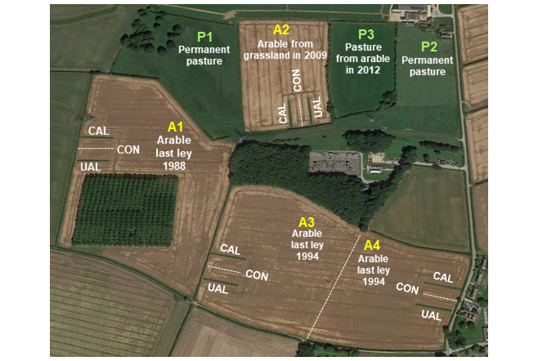

Fig. S1. Location of study fields at Leeds University Farm, Tadcaster, UK. Field management: A1-A4 = arable, P1-P3 = pasture. Treatment codes: CAL = connected ley strip, UAL = unconnected ley strip, CON = arable control (within arable fields). Connected and unconnected ley strips are 70 m long. Source of photo: Google Earth Pro 7.3.2 image© 2019 Google Earth. http://earth.google.com.

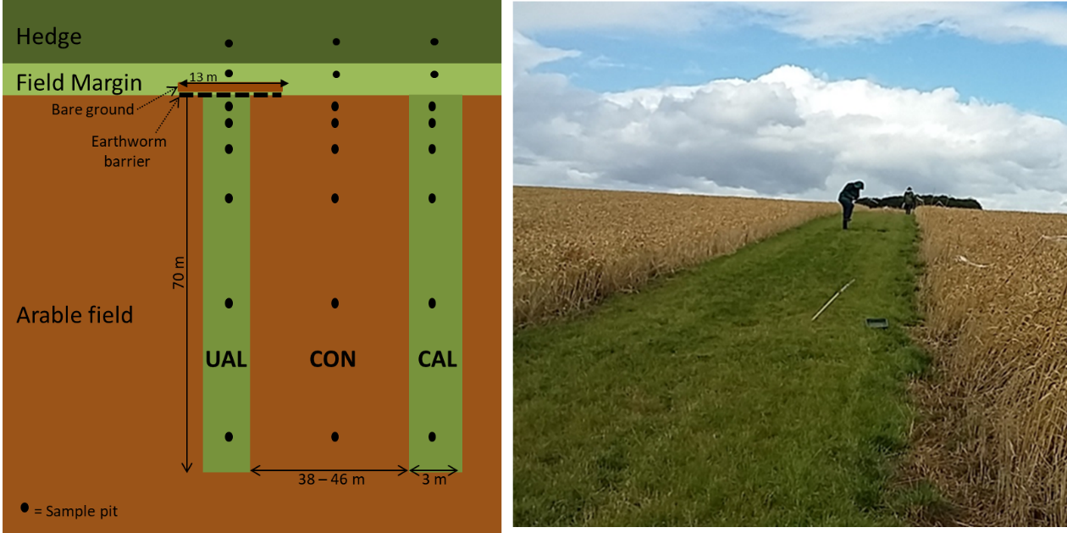

Fig. S2. Schematic of the paired ley strips in an arable field. Ley strips were either unconnected (UAL) by an earthworm barrier or connected (CAL) to the field margin and hedgerow. The area of arable field between the ley strips was the arable control (CON). Sample pits were under hedgerow, within grassy margin and 2, 4, 8, 16, 32 and 64 m from the margin. Not drawn to scale.

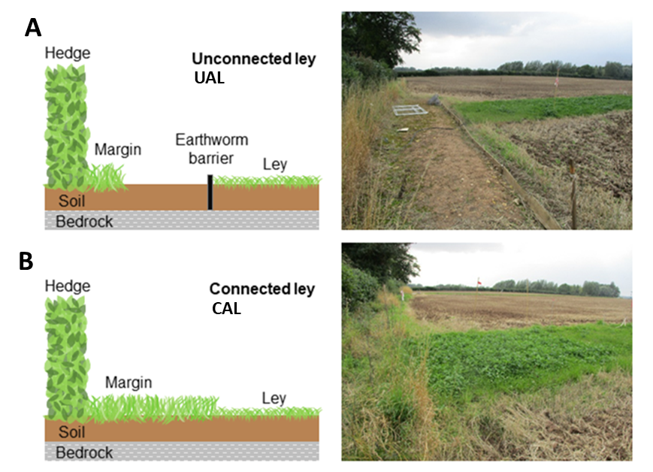

Fig. S3. Schematic of (A) earthworm exclusion barrier within an unconnected ley (UAL) (left) and photo of unconnected ley at field location (right); (B) schematic of connected ley strip (left) and photo of connected ley at field location (right).

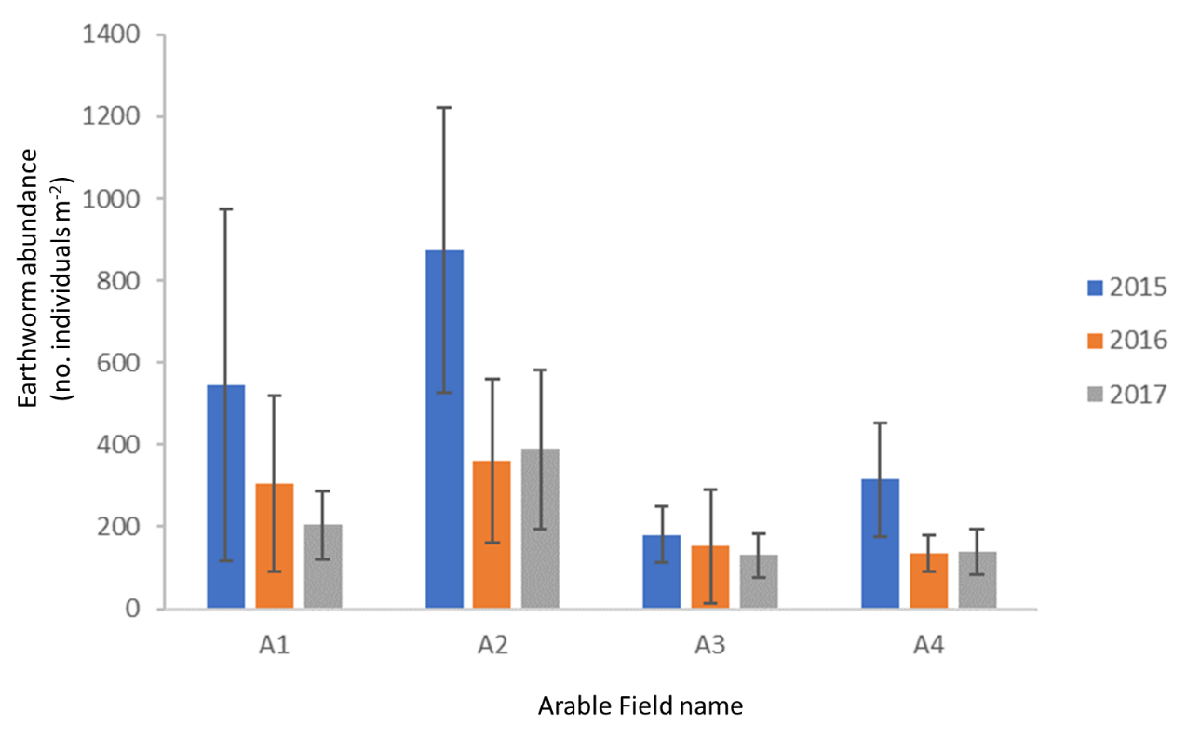

Fig. S4. Earthworm abundance in each arable field (CON strip only) over the sampling period of the study (2015-2017). For Field history and location refer to Table S1 and Fig. S1 respectively. Error bars show ± 1 standard deviation, n = 6.

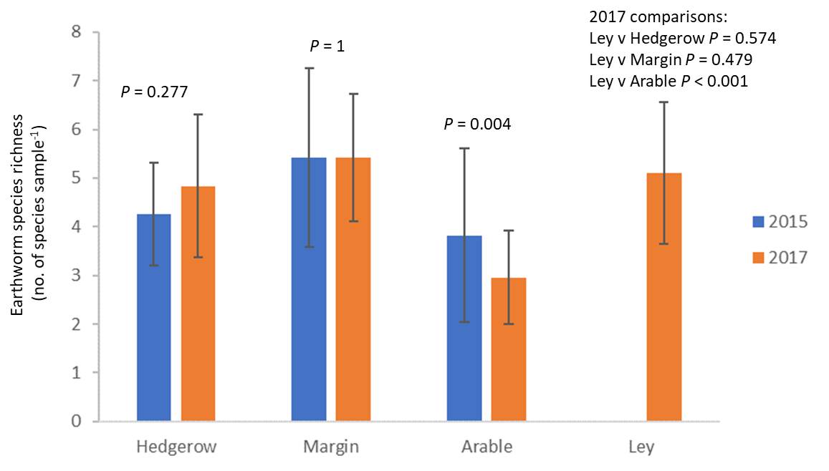

Fig. S5. Earthworm species richness in April 2015 (baseline) and April 2017 (2 yrs after arable-to-ley conversion) in hedgerow, field margin, arable and new ley soils. *P* values show results from t-test comparisons. Error bars show ±1 standard deviation.

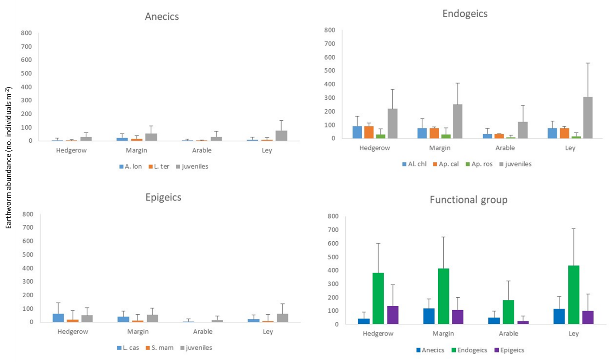

Fig. S6. Earthworm species and functional group mean abundance in each land use. Data show average abundance for annual surveys in April 2016 and 2017. Error bars show +1 standard deviation, where hedgerow, margin n = 12; arable n = 24; ley n = 48 in each year. *A. longa* (Ap.lon); *L. terrestris* (L.ter); *A. chlorotica* (Al.chl); *A. caliginosa* (Ap.Cal); *A. rosea* (Ap.Ros); *L. castaneus* (L.cas); *S. mammalis* (S.mam).





Fig S7. Mean earthworm biomass by species (A) and functional group (B) from hedgerow, margin, arable and ley soils sampled in April 2017. Anecic juveniles (ANE-juv; shaded blue); endogeic juveniles (END-juv; shaded green); epigeic juveniles (EPI-juv; shaded purple); *A. longa* (Ap-lon; dark blue); *L. terrestris* (L-ter; light blue); *A. chlorotica* (Al-chl; light green); *A. caliginosa* (Ap-cal; dark green); *A. rosea* (Ap-ros; pale green); *L. castaneus* (L-cas; dark pink); *S. mammalis* (S-mam; pink). Error bars show standard deviation.

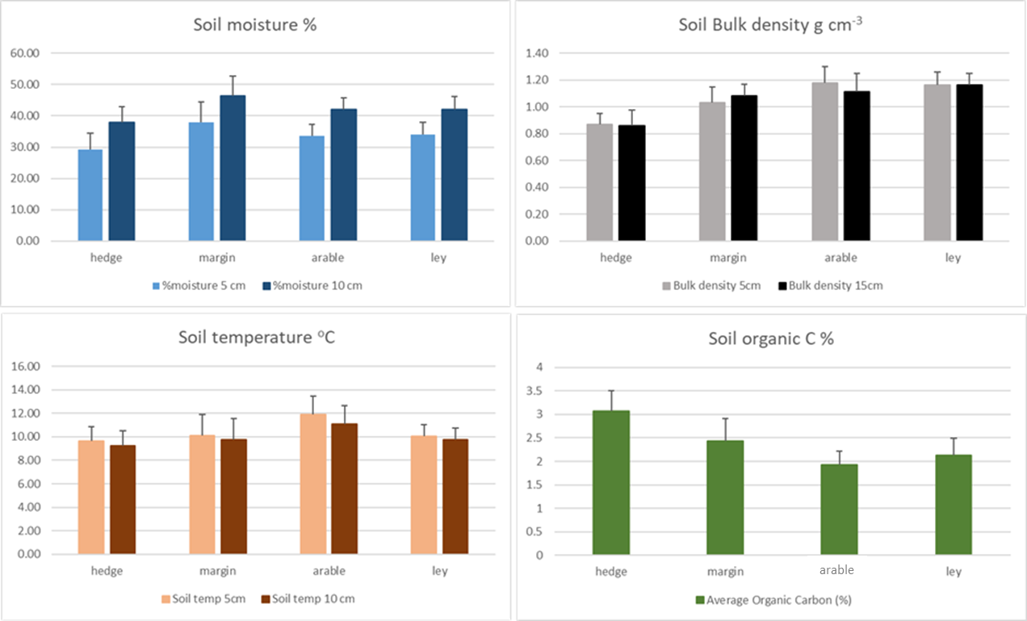

Fig. S8. Mean soil moisture, bulk density, temperature and organic C sampled under hedgerow, field margin, arable and new leys. Samples were collected in April 2017 (for moisture, density, temperature) and April 2018 (for SOC). n = 12, 12, 24 and 48 in hedgerow, margin, arable and ley soils. Soil moisture, bulk density and temperature were taken from samples collected at 5 and 10 (or 15 cm) depths, while SOC represents samples taken at 2-7 cm depth.

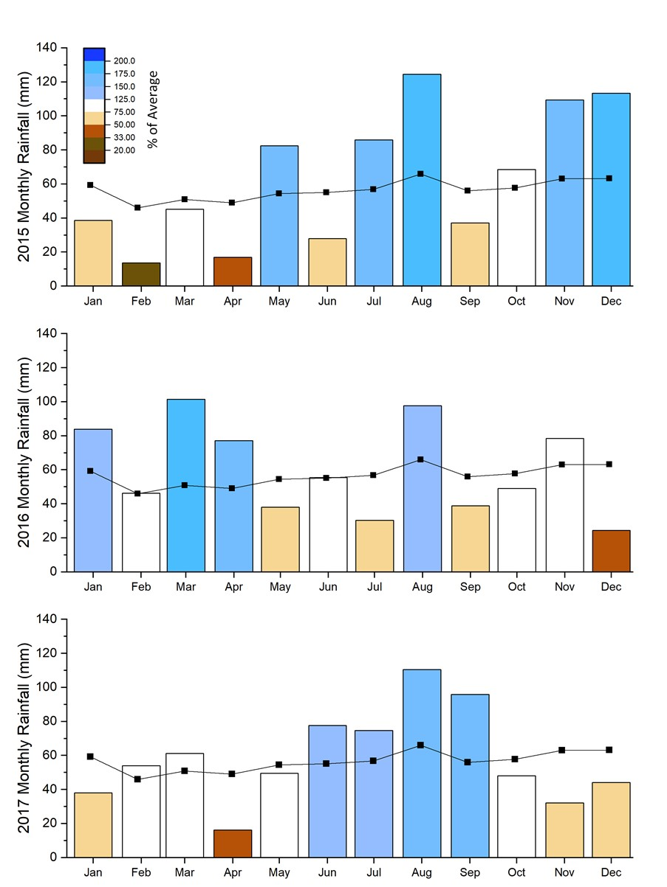

Fig. S9. Monthly rainfall measured at the Leeds Farm site over the study period (2015-2017). The black line indicates the long-term monthly average from 2001-2018 with the shading showing the monthly total as a percentage of the long-term average (blues >115%, white 75-125%, browns <75%). The annual precipitation was 764 mm, 720 mm and 701 mm in 2015, 2016 and 2017 respectively. Data are sourced from the Bramham UK Met Office climate station.

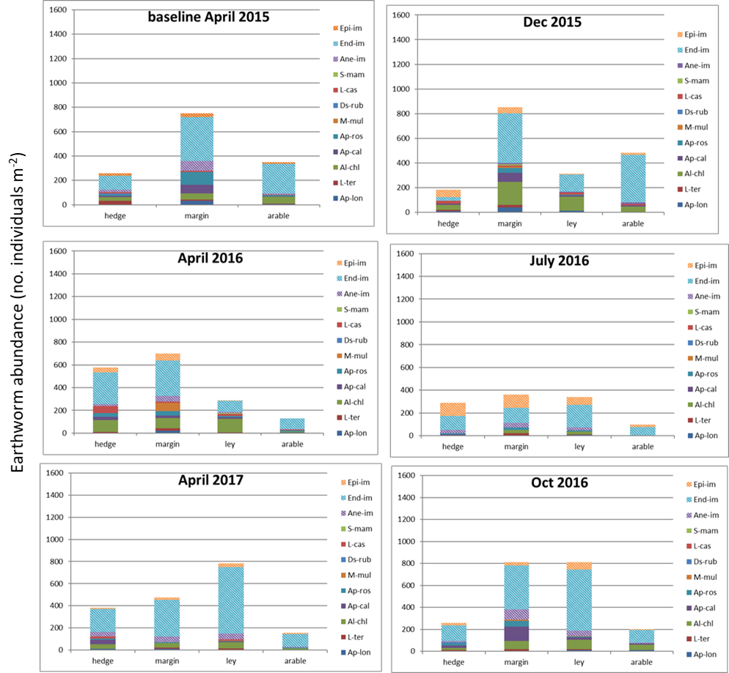

Fig. S10: Mean seasonal abundance of earthworm species and functional groups at one arable field (A4). The annual surveys are on the left panels, with additional seasonal surveys on the right. Hatched colours show juveniles for each functional group. ANECICS: Anecic juveniles (ANE-juv); *A. longa* (Ap-lon); *L. terrestris* (L-ter); ENDOGEICS: endogeic juveniles (END-juv); *A. chlorotica* (Al-chl); *A. caliginosa* (Ap.Cal); *A. rosea* (Ap-ros); *M. muldali* (M-mul); EPIGEICS: epigeic juveniles (EPI-juv); *L. castaneus* (L-cas); *S. mammalis* (S-mam); *D. rubidus* (Ds-rub).