**Arable fields as potential reservoirs of biodiversity: earthworm populations increase in new leys**

Miranda T. Prendergast-Miller1,2*, David T. Jones3, Despina Berdeni4,5, Susannah Bird6, Pippa J. Chapman7,Leslie Firbank8, Richard Grayson7, Thorunn Helgason6, Joseph Holden7, Martin Lappage8, Jonathan Leake4, Mark E. Hodson1

1Department of Environment and Geography, University of York, Wentworth Way, York YO10 5NG, UK

2Department of Geography and Environmental Sciences, Northumbria University, Newcastle upon Tyne, NE1 8ST, UK (current address)

3Life Sciences Department, Natural History Museum, London, SW7 5BD, UK

4The University of Sheffield, Department of Animal and Plant Sciences, Sheffield, S10 2TN, UK

5Crop Physiology, ADAS Gleadthorpe, Meden Vale, Mansfield, Nottinghamshire, NG20 9PD, UK (current address)

6Department of Biology, University of York, Wentworth Way, YO10 5DD, UK

7water@leeds, School of Geography, University of Leeds, Leeds, LS2 9JT, UK

8water@leeds, School of Biology, University of Leeds, Leeds, LS2 9JT, UK

*Corresponding author, Contact email: [miranda.prendergast-miller@northumbria.ac.uk](mailto:miranda.prendergast-miller@northumbria.ac.uk)

**Abstract**

Managing soil to support biodiversity is important to sustain the ecosystem services provided by soils upon which society depends. There is increasing evidence that functional diversity of soil biota is important for ecosystem services, and has been degraded by intensive agriculture. Importantly, the spatial distribution of reservoirs of soil biota in and surrounding arable fields is poorly understood. In a field experiment, grass-clover ley strips were introduced into four arable fields which had been under continuous intensive/conventional arable rotation for more than 10 years. Earthworm communities in arable fields and newly established grass-clover leys, as well as field boundary land uses (hedgerows and grassy field margins), were monitored over 2 years after arable-to-ley conversions. Within 2 years, earthworm abundance in new leys was 732 ± 244 earthworms m-2, similar to that in field margin soils (619 ± 355 earthworms m-2 yr-1) and four times higher than in adjacent arable soil (185 ± 132 earthworms m-2). Relative to the arable soils, earthworm abundance under the new leys showed changes in community composition, structure and functional group, which were particularly associated with an increase in anecic earthworms; thus new leys became more similar to grassy field margins. Earthworm abundance was similar in new leys that were either connected to biodiversity reservoirs i.e. field margins and hedgerows, or not (installed earthworm barriers). This suggests that, for earthworm communities in typical arable fields, biodiversity reservoirs in adjacent field margins and hedgerows may not be critical for earthworm populations to increase. We conclude that the increase in earthworm abundance in the new leys observed over 2 years was driven by recruitment from the existing residual population in arable soils. Therefore, arable soils are also potential reservoirs of biodiversity.

**1. Introduction**

Soil security is an important global issue (McBratney et al., 2014; Amundson et al., 2015). The need to maintain healthy soils and increase soil organic matter (SOM) content has been proposed as central to achieving some of the UN’s Sustainable Development Goals (SDGs) (Keesstra et al., 2016; Lal, 2019) such as zero hunger (SDG2); good health and well-being (SDG 3); climate action (SDG13); and restoring degraded land (SDG 15), which either directly or indirectly rely on soil as a key resource. Continuous conventional tillage in arable systems relies on intensive agricultural management practices which depletes SOM, can destroy soil structure and can lower soil biodiversity, including key ecosystem engineers such as earthworms (Beylich et al., 2010; Chan, 2000; Stroud et al., 2016; Briones and Schmidt, 2017; Pelosi et al., 2014). Intensive soil management practices, such as annual inversion ploughing, lower earthworm abundance, biomass and species diversity. For example, Holden et al., (2019) reported low earthworm abundance, biomass and diversity in intensively managed arable fields over a 3-year period (2015-2017) compared to soils under long-term permanent pasture. The burrowing and feeding activities of earthworms are related to their functional group (Edwards and Bohlen, 1996). Anecic earthworms form deep vertical, permanent burrows; these species are important for pulling plant litter into their burrows. Endogeic earthworms feed on soil and soil-associated organic matter and form transient horizontal burrows. Epigeic earthworms live within and feed on the surface litter layer (Edwards and Bohlen, 1996). The distribution of these functional groups has important consequences for soil ecosystem functions and soil health and there is good evidence showing that increased earthworm abundance and diversity benefits soil ecosystem services (Spurgeon et al., 2013; Blouin et al., 2013). For example, the permanent burrows formed by anecics like *Lumbricus terrestris* generate important classes of large pores that control water infiltration rates and facilitate root growth to access groundwater. In turn, these contribute to reducing overland flow and soil erosion. Endogeic species promote soil aggregation and soil organic carbon (SOC) stabilisation and sequestration (Zhang et al., 2013) and also contribute to increased hydraulic conductivity (Hallam et al., 2021), while epigeics are important for surface litter processing; all of which increase soil carbon and improve soil fertility via nitrogen mineralisation (Blouin et al., 2013). Meta-analyses suggest that the presence of earthworms in agroecosystems can lead to 25% increases in plant growth (Van Groenigen et al., 2014), however, agricultural intensification, especially high soil disturbance (Briones and Schmidt, 2017) and low organic matter inputs due to annual cropping, are detrimental to soil biodiversity and earthworm communities. Continuing with current intensive agricultural management practices will not deliver soil security. Soil management changes are therefore required which promote soil biodiversity and sustainable agro-ecosystems, but it remains unclear at what rate, or even if, earthworm populations can increase after depletion by many decades of intensive arable management.

It is generally accepted that pasture soils with permanent plant cover have higher SOM contents, better soil structure and support a higher biodiversity including earthworm communities (Spurgeon et al., 2013) compared to soils under continuous conventional arable cultivation. In arable systems, continuous cultivation destroys soil aggregates and soil structure and the increased disturbance reduces earthworm abundance and diversity, especially for the larger anecic species (Gerard and Hay, 1979; Stroud et al., 2016; Chan, 2000; Crittenden et al., 2015). Annual tillage promotes decomposition of organic matter, decreases food resources and their availability to earthworms and increases earthworm predation (Edwards and Lofty, 1982; Boström, 1995; Briones and Schmidt, 2017). Previous research has indicated improvements to soil biology and soil functioning that changes to land management can bring. For example, the use of rotational grass leys can lead to increases in SOM and earthworms (Evans and Guild, 1948; Gerard and Hay, 1979). However, the potential and timescale required for earthworm communities to increase in long-term intensively managed soils following a change in soil management is poorly understood. Increasing demand for agricultural productivity has led to a reduction in the use of leys. Therefore, confirming the timescales involved in the restoration of earthworm communities and soil function by leys may help decision-making with respect to the duration of leys needed. This is important especially where leys are being used as part of a transition to less intensive cultivation approaches such as no-tillage crop production.

While earthworms are generally considered to be ecosystem engineers (Blouin et al., 2013), we still do not fully understand their distribution across farming landscapes and how this varies on different temporal and spatial scales (White et al., 2020). Moreover, while earthworm distributions have generally been compared between broad land uses, e.g. between pasture, arable and woodland (e.g. Decaëns et al., 2008; Smith et al., 2008; Spurgeon et al., 2013), earthworm abundance and diversity vary at more local spatial scales within field boundary soils e.g. between the interior of fields and their grassy margins. Studies by Crittenden et al., (2015), Roarty and Schmidt (2013), Nuutinen et al., (2011) and Smith et al., (2008) have looked at annual changes in earthworms comparing arable fields and different field margins including newly established margins. Earthworm abundance tends to be higher in field margin soils and lower in adjacent arable soils. Smith et al., (2008) sampled soil biodiversity, including *Lumbricidae*, from different habitats, including hedgerows, margins, and 9 and 27 m into arable fields planted with beans or wheat. Hedgerows were shown to be distinct in their soil communities and margins were proposed as acting as corridors to enhance species dispersal within the arable fields. While arable fields with margins seem to have higher soil biota densities than fields without margins, there is still debate around the importance of field margins as biodiversity refugia and whether they are key in facilitating migration, of for example earthworms, between arable fields and the relatively higher quality soils in field margins. Studies have shown gradients in earthworm abundance, with abundance in arable fields declining with increasing distance from the field margin (e.g. Nuutinen et al., 2011; Nieminen et al., 2011), suggesting that migration and refugia in the margins are important. Dispersal time is important, as migration rates for earthworm species vary from 1.5 to 14 m yr-1 (Eijsackers, 2011). In contrast to the refugia-migration hypothesis, Roarty and Schmidt (2013) and Frazao et al., (2017) propose that margins do not contribute to earthworm species found in cultivated adjacent fields. By comparing old and new margins 3 years post-establishment, Roarty and Schmidt (2013) showed rapid increases in earthworm populations in new margins extending onto previously cultivated land, and showed no evidence that earthworm populations were affected by spill-over or migration into the remaining permanent arable part of the field. However, the study design did not resolve whether the increase in earthworm populations in the new margins was facilitated by migrations from the existing permanent margins. Frazao et al., (2017) showed that while the presence of field margins increased earthworm biodiversity in arable fields, the margins had limited effect on earthworms within arable fields, as biodiversity did not change. Therefore, further work is required to test the effect of landscape connectivity in controlling earthworm abundance in agro-ecosystems, especially under arable-to-ley conversions.

Given that soil health and biodiversity are generally lower under continuous arable cultivation and that viable soil management practices are required to improve soil function in agro-ecosystems, a field experiment was established with two main objectives: (1) to determine the rate of change in soil function in new grass-clover leys; and (2) to determine the importance of field boundary soils (hedgerows and grassy margins) as biodiversity reservoirs for soil ecosystem engineers like earthworms to colonise new leys. While several measures of soil biodiversity and soil function were taken in this field experiment (see Holden et al., 2019; Hallam et al., 2020), this paper focuses on the earthworm communities *in situ*. We monitored earthworm abundance, biomass, species composition and population structure over a 3-year period. The experiment used spatial sampling (samples were taken from set distances from the hedgerow), an earthworm migration barrier at the margin-field boundary, and temporal sampling (repeated annual and seasonal time points over 3 years) to test the following hypotheses:

H1: Agro-ecosystem land uses with a permanent plant cover e.g. hedgerows, grassy field margins and leys, support higher earthworm abundance, biomass and species composition than that found in continuous conventional arable cultivation with typical annual crops (cereals and oilseeds);

H2: Earthworm abundance in newly established leys declines with increasing distance away from the field boundary soils i.e. from hedgerow and grassy margins;

H3: Field boundary soils are important reservoirs of earthworm diversity: belowground connectivity between high quality soils in hedgerow and grassy field margins and newly-established leys facilitates colonisation via migration;

**2. Material and methods**

2.1 Study site

The field experiment was established in April 2015 at the University of Leeds Farm, North Yorkshire, northern England, UK (53°52'06.0"N; 1°19'36.8"W). It is a commercial mixed arable and pasture farm, on loamy, calcareous brown earth soils 50 - 90 cm deep, underlain by dolomitic limestone, in the Aberford series of Calcaric Endoleptic Cambisols (Holden et al., 2019). Four arable fields were studied (A1-A4, see Fig. S1), each with mature hedgerow boundaries and grassy field margins. Field margins were c. 1 m in width and were mown sporadically but were otherwise left unmanaged. Three of the four fields have been under conventional management since 1995. One field (A2) was under permanent pasture between 1998 and 2008 when it was returned to the same conventional cropping rotation as the other fields (see Supporting information Table S1). The main crop was winter wheat. Oilseed rape, barley, potatoes and vining peas were used as break crops. Arable fields received 150 kg N ha-1 and 70 kg K ha-1 in spring 2016, 23 kg P ha-1 in autumn 2016, 140 kg N ha-1, 86 kg K ha-1 and 22 kg S ha-1 in spring 2017, and 8 t ha-1 of pig manure in autumn 2017 (Holden et al., 2019). Further site details on climate, farm management and hedgerow species composition are given in Holden et al., (2019).

2.2 Experimental design

Paired grass-clover ley strips (70 m long, 3 m wide) were established in each arable field (see Supporting Information Figs. S1 and S2) for the field experiment described below. The strips ran perpendicular to one edge of each arable field and were approximately 40 m apart. Strips were prepared by subsoiling and were sown in May 2015 with a grass-clover seed mixture (Broadsword Hi-Pro), comprising tetraploid *Lolium* x *boucheanum* (12% and 16%), diploid and tetraploid *Lolium perenne* (20% and 16% respectively), *Festulolium* spp., 16%, *Trifolium repens* 5%, and *Trifolium pratense* 15%, at an application rate of 4.2 g m-2. The grass-clover ley strips received no fertiliser or agricultural chemical treatments over the course of the experiment.

In order to test the effect of hedgerow-to-field connectivity, one of each pair of ley strips was disconnected from the hedge-margin field boundary by installing a vertical steel mesh (104 µm pore size) barrier to 1 m depth to reach the bedrock (see Supporting Information Figs. S2 and S3). The barrier was inserted at the head of the Unconnected Arable-Ley strip (UAL), at the field-margin boundary. The first 2 m of the margin adjacent to the barrier was dug up during barrier insertion and subsequently kept fallow by regular glyphosate treatment to further discourage development of large populations of earthworms on plant litter and root carbon inputs, and movement of earthworms from the remaining margin to the new ley strip. Both the barrier and the fallow soil extended for 5 m either side of the ley strip giving a total length of 13 m centred on the ley strip. The height of the barrier was c.15 cm above the soil surface, supported with a wooden frame to keep the barrier vertical. The second strip, Connected Arable-Ley strip (CAL), was not modified at the field-margin boundary and was contiguous with the grassy field margin, giving continuous vegetation cover from the hedgerow to the end of the ley strip, 70 m into the arable field. The area of field lying between the two strips was managed in the same way as the rest of the arable field and served as the arable control (CON). Within the arable fields and CON area, winter wheat was grown in 2015. In 2016, spring barley was sown in three fields; one field had winter wheat (A2). In 2017, all fields were sown with winter barley. The ley strips were mown four times a year: in April and May 2016, clippings were retained within the leys. From June 2016 onwards, grass clippings were removed from the ley strips to promote clover *versus* grass biomass.

2.3 Earthworm and soil sampling

Hedgerow and Margin samples were taken under the hedgerow and from the middle of the margin at the head of each CON, CAL and UAL strip. Within each of these strips, further samples were taken at distances 2, 4, 8, 16, 32 and 64 m from the field margin edge (see Supporting Information Fig. S2). This sampling scheme was designed to test the effect of distance from the field boundary soils on earthworm communities and soil properties, providing ‘hedgerow to field’ transects when all sample points were taken into account, or ‘in-field’ transects when the hedgerow and margin samples were not included.

CON, CAL and UAL strips were sampled in April 2015 (spring) before the grass-clover ley strips were established (Baseline study), and then sampled again in April 2016 and April 2017 (Annual study). Additional sampling occurred in one arable field (A4, Fig. S1) in December 2015 (winter), July 2016 (summer) and October (autumn) 2016, providing a seasonal sampling period from the April 2015 baseline, before the leys were established, through to April 2017 (Seasonal study).

For earthworm sampling, a soil block (18 x 18 cm at the surface and 15 cm deep) was removed at each location and earthworms were collected by hand-sorting. Dilute allyl isothiocyanate (1.5 L; 0.1 g L-1) (Zaborski, 2003; Pelosi et al., 2009) was poured into each soil pit and left to drain into the soil to facilitate collection of deeper-dwelling species. Earthworm appearance in the pit was monitored over a 30-min period. Earthworms were stored in 80% ethanol and adults (with a clitellum) were identified to species using keys in Sims and Gerard (2013). Juvenile earthworms were identified to functional groups (epigeic, endogeic or anecic) based on pigmentation and size (Bouché, 1977). Earthworm biomass (the weight of individual earthworms) was also determined for samples collected from December 2015 onwards. After removal of earthworms, soils were returned to their respective pits and sample position was recorded to avoid re-sampling the same position on subsequent surveys.

Soil moisture and temperature measurements were taken at three positions (within 10 cm) around the excavated soil pit, at 5 and 10 cm depths. Soil moisture was measured using a ML3 ThetaProbe Soil Moisture Sensor (Delta-T Devices) and soil temperature using a Checktemp®1 probe (Hanna Instruments). Soil bulk density samples were taken from the side of the sample pit wall at 5 and 10 cm soil depth using steel bulk density rings (118 cm3); bulk density was calculated on an oven dry weight basis (dried for 24 hr at 105 ᵒC).

2.3.1 Soil organic carbon and nitrogen analyses

SOC and total nitrogen were measured from 100 cm3 bulk density samples collected at 2-7 cm depth at each sampling distance across the 4 fields in April 2018 (an additional sampling event for soil properties only). Samples were oven dried (105°C, 48 hours), weighed and then sieved (1 mm sieve size) to remove roots and large stones before being re-dried (105°C, 48 hours) and weighed. Dried soil was crushed to a fine powder using a Fristch Pulverisette agate ball mill. Inorganic C was removed by reaction with acid as detailed in Holden et al., (2019). Duplicate 25 - 30 mg samples of acid-treated soil were analysed using an Elementar vario MICRO cube for total nitrogen and SOC.

2.3.2 Soil sensors

Moisture and temperature sensors (Decagon 5TM) were installed at four distances along each strip (under hedgerow and 5, 20 and 50 m from margin) and at three depths for each distance (5, 20 and 50 cm). Data were recorded at 15 min intervals using Arduino Uno data loggers. Soil-specific calibrations were derived for each field based on a gravimetric method.

2.4 Statistical analyses

Data were transformed where required to reduce the variance. Unless otherwise stated, analyses were performed using SPSS (IBM v25). All data relating to the earthworm study described here have been archived in the Natural Environment Research Centre (NERC) Environmental Information Data Centre (Prendergast-Miller et al., 2019).

2.4.1 Effect of distance, field, year and land use on earthworm abundance

Earthworm abundance data were first natural log transformed to reduce the variance. For the 2015 baseline data, the effect of distance across the arable fields was tested using one-way ANOVAs on hedgerow-to-field (i.e. hedgerow to 64 m) or in-field distances (i.e. 2 – 64 m). Differences between field and land use were tested using a 2-way ANOVA with field (A1-A4) and land use (arable, hedgerow, margin) as factors.

The impact of arable-to-ley conversion was determined using data collected in April 2016 and April 2017. Analyses of variance for repeated measures with sampling year (2016, 2017) as the within-subject factor were conducted to test the effects of (1) field (A1-A4), land use (hedgerow, margin, arable, ley) and distance (hedge-to-field or in-field); and (2) connectivity (CAL vs UAL) and distance (hedge-to-field or in-field). Post-hoc pair-wise comparisons were performed using Bonferroni tests.

2.4.2 Effects of field, distance and land use on abundance of earthworm species and functional groups

Only species making up > 1% of total abundance were included in the analyses. The effects of field, distance, year and land use on abundance of earthworm species, juvenile functional groups and total functional groups were determined using the mvabund package in R (Wang et al., 2012), using a negative binomial distribution. Plots of residuals *versus* fitted were visually inspected to confirm model assumptions and model best fit (Wang et al., 2012). Population structure was calculated as the juvenile:adult ratio, based on earthworm abundance in each land use for 2015, 2016 and 2017. For each year, a one-way ANOVA on ranks was performed to compare population structure for each land use.

2.4.3 Soil properties and relationship with earthworm abundance

Soil moisture, temperature and bulk density were analysed by ANOVA with repeated measures, using year as the within-subjects factor (2016, 2017), and field, distance, land use and depth as the between-subjects factors. Post-hoc pair-wise comparisons were performed using Bonferroni tests. Differences in average SOC between land uses were tested using a Kruskal-Wallis test. Earthworm species abundance data were square-root transformed and a Bray-Curtis resemblance matrix was created. A distance-based redundancy analysis (dbRDA) plot was used to visualise the relative contribution of soil properties to earthworm abundance in each land use using data collected in April 2017 (April 2018 for SOC and N). Multivariate analyses were conducted using PRIMER-E (Clarke and Gorley, 2006).

2.4.4 Seasonal effects on earthworm communities and soil properties

One field (A4) was sampled over six time points between April 2015 and April 2017. As with the annual data, initial analyses confirmed that effects of distance and connectivity on earthworm abundance were not significant. The seasonal earthworm abundance and biomass data, as well as soil properties (soil moisture, temperature and bulk density data) were analysed over 6 seasonal time points: April 2015, December 2015, April 2016, July 2016, October 2016 and April 2017 using ANOVA with repeated measures. Month was the within-subject factor, with land use and depth (for soil properties) as the between-subjects factors. This is a pseudo-replicated sampling design which may constrain interpretation of the results. However, because the overall land use trends in field A4 were representative of changes in the other three fields, and earthworms are known to be sensitive to seasonality and soil moisture and temperature, we can assume that the temporal changes observed in one field also occurred in the adjacent fields used in this study. Data generated from the soil sensors installed at A4 field were used to calculate the number of antecedent dry days (ADD; 0 mm of precipitation), mean soil moisture and mean soil temperature 7, 14, 21, 30, 50, 80 and 100 days before each seasonal sampling date.

**3. Results**

3.1 Earthworm species

The earthworm species and their respective functional groups identified over the study period are listed in Table 1.

**Table 1: Earthworm species and the proportion of individuals (%) recorded in the annual surveys, 2015-2017. Species/juveniles groups highlighted in bold accounted for > 1% of the total abundance (total number of individuals) and were used in subsequent data analyses.**

|  |  |  |  |
| --- | --- | --- | --- |
| Species name | Functional group | % abundance  (Total abundance = 4704 individuals) |  |
| ***Aporrectodea longa*** (Ude, 1885) | Anecic | 2.0 |  |
| ***Lumbricus terrestris*** (Linnaeus, 1758) |  | 1.2 |  |
| **Juveniles** |  | 10.8 |  |
|  |  |  |  |
| ***Allolobophora chlorotica*** (Savigny, 1826) | Endogeic | 14.4 |  |
| *Aporrectodea caliginosa* (Savigny, 1826) |  | 0.5 |  |
| ***Aporrectodea rosea*** (Savigny, 1826) |  | 3.8 |  |
| *Murchieona muldali* (Omodeo, 1956) |  | 0.2 |  |
| *Octolasion cyaneum* (Savigny, 1826) |  | 0.1 |  |
| **Juveniles** |  | 50.1 |  |
|  |  |  |  |
| *Dendrodrilus rubidus* (Savigny, 1826) | Epigeic | 0.04 |  |
| ***Lumbricus castaneus*** (Savigny, 1826) |  | 4.8 |  |
| *Eisenia fetida* (Savigny, 1826) |  | 0.02 |  |
| ***Satchellius mammalis*** (Savigny, 1826) |  | 1.2 |  |
| **Juveniles** |  | 10.7 |  |

3.2 Baseline study (April 2015 survey)

3.2.1 Effect of field, land use and distance on earthworm communities in April 2015

The baseline study in 2015 compared earthworm abundance under hedgerow, margin and continuous arable in four fields. A 2-way ANOVA with field (4 levels) and land use (3 levels) as factors showed significant effects of field (*P* < 0.001) and land use (*P* < 0.05), but no significant interaction (*P* > 0.05). For reference, earthworm abundance in each field CON strip is shown in Fig. S4 (Supplementary information), indicating higher abundance in field A2 (see management history Table S1). Field differences are not considered further because the focus of this study is on land use impacts. In 2015, earthworm abundance was highest in the field margins (704 ± 534 earthworms m-2) compared to the hedgerow (473 ± 257 earthworms m-2) and arable (460 ± 359 earthworms m-2) soils (Fig. 1A). Earthworm abundance across the different fields was not affected by in-field sampling distances (i.e. 2 to 64 m) within the arable strips (*P* > 0.05).

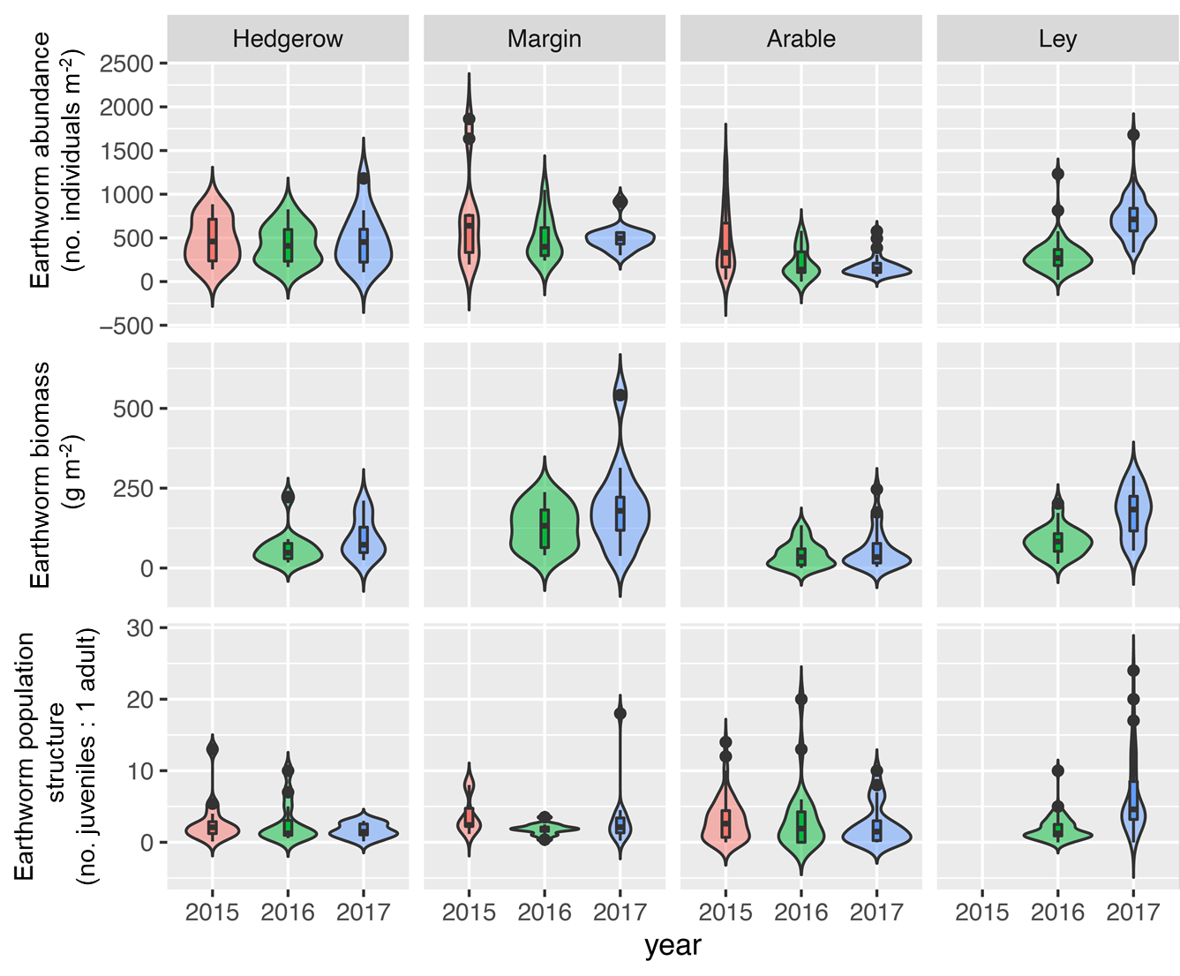**Fig. 1. Earthworm abundance (top panel), biomass (mid panel) and population structure (lower panel) in hedgerows, field margins, arable fields and new arable-to-ley strips. Samples were taken in April 2015 (before new leys were set up) and again in April 2016 and April 2017. For each year, n = 12 in hedgerow and margin soils; n = 24 in arable soils (for 2015, n = 72 in arable soils); n = 48 in ley soils. Biomass was not determined in 2015. The width of each violin plot indicates the frequency distribution of the data for each land use and year. Within each violin plot is a box and whisker plot. The central bar is the median (50th percentile), which divides the box into the interquartile range. The upper vertical line (whisker) extends to the largest value within 1.5 times the interquartile range above the 75th percentile, while the lower whisker extends to the smallest value within 1.5 times the interquartile range below the 25th percentile. The dots show outlier values beyond the interquartile range.**

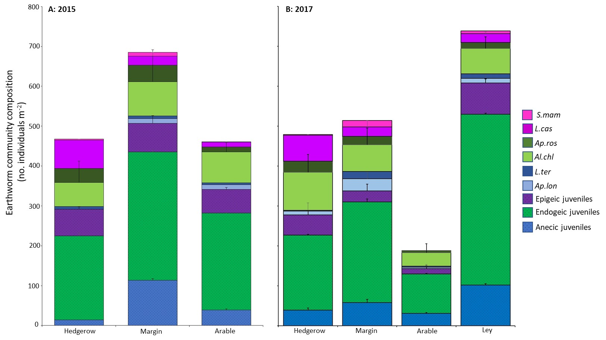**Fig. 2. Earthworm community mean abundance and composition by species and functional group in the hedgerow, field margin, arable in April 2015 (A) (baseline data, before ley strips were established) and in new ley soils in April 2017 (B). Colours indicate earthworm functional group (purple tones are epigeic species and juveniles; green tones are endogeic species and juveniles; blue tones are anecic species and juveniles). n = 12, 12, 24 and 48 in hedgerow, margin, arable and ley soils respectively. Error bars show +1 standard error.** **Key: *S. mammalis* (*S.mam; pink*); *L. castaneus* (*L.cas; dark pink*); *A. rosea* (*Ap.ros; dark green*); *A. chlorotica* (*Al.chl; light green*); *L. terrestris* (*L.ter; dark blue*); *A. longa* (*Ap.lon; light blue*); Epigeic juveniles (purple); Endogeic juveniles (green); Anecic juveniles (blue).**

3.2.2 Earthworm community structure and composition in April 2015

Baseline earthworm abundance and community composition are shown in Figs. 1 and 2A. Species abundance was affected by land use (*P* < 0.001) and field (*P* < 0.001) but not distance (*P* > 0.05). Specifically, the abundance of anecic juveniles (*P* < 0.001; lowest in hedgerow soils), *A. caliginosa* (*P* = 0.058; marginally significant and most abundant in margin soils) and *L. castaneus* (*P* < 0.01; most abundant under hedgerows) were affected by land use.

The three functional groups were represented in each land use (arable, hedgerow and margin), especially by juvenile earthworms. Margin soils tended to have the highest abundance of each species, except *L. castaneus* which was highest under hedgerows (Fig. 2A). Distribution of functional groups was also affected by land use (*P* < 0.01) and field (*P* < 0.001), but not distance from the margins (*P* > 0.05). Abundance of total anecic (*P* < 0.001; lowest under hedgerows) and epigeic species (*P* = 0.05) were affected by land use, whereas endogeics (*P* > 0.05) were not.

3.3 Annual study: the arable to ley conversion

3.3.1 Does connectivity facilitate earthworm migration into new leys?

Connectivity to hedgerows and grassy margins had no effect on earthworm abundance or biomass in the CAL (*P* > 0.05) or UAL (*P* > 0.05) ley soils. Earthworm abundance (*P* < 0.001) and biomass (*P* < 0.001) both increased in the CAL and UAL ley strips between 2016 and 2017. There was no effect of in-field distance on abundance (*P* > 0.05) or biomass (*P* > 0.05) within the ley strips and no significant interactions between year, strip or distance. Therefore, in all subsequent analyses, UAL and CAL samples were combined across fields and treated as ‘ley’ (whereby ley n = 48).

3.3.2. Impact of arable-ley conversion on earthworm abundance and biomass

Earthworm abundance increased significantly from a mean arable density of 472 ± 366 earthworms m-2 in 2015 (before ley conversion) to 732 ± 244 earthworms m-2 in 2017 in the new ley strips. There was also a significant increase in earthworm ley abundance between 2016 and 2017 (*P* < 0.001) (Fig. 1A). In contrast to this increase, between 2015 and 2017, mean earthworm abundance in arable soils appeared to decline from 470 ± 376 to 185 ± 132 earthworms m-2 but this change was not significant. Annual densities in field margins (619 ± 355 earthworms m-2 yr-1) and hedges (495 ± 277 earthworms m-2 yr-1) remained relatively stable over this period (2015, 2016 and 2017) (*P* > 0.05) and are therefore reported as mean values over the whole period. Total earthworm biomass (annual data available for 2016 and 2017 only; Fig. 1B) was also affected by land use (*P* < 0.001). In April 2016, earthworm biomass in margin soils (130 ± 67 g m-2) was significantly greater than biomass in arable soil (43 ± 39 g m-2) (*P* < 0.001). By April 2017, earthworm biomass in margin (195 ± 135 g m-2) and ley (171 ± 74 g m-2) soils was similar and both were significantly higher compared to biomass in arable soil (57 ± 62 g m-2) (*P* < 0.001).

3.3.3. Effects of land use, year and distance on abundance of earthworm species and functional groups

Species distributions in each land use before and after ley establishment are shown in Fig. 2. Abundance of individual species was significantly affected by land use (*P* < 0.001) and year (*P* < 0.001) but not distance (*P* > 0.05). Species richness in the new ley soils in 2017 was similar to that found in margin and hedgerow soils, but was significantly higher compared to arable soil (Fig. S5). While *A. chlorotica* and endogeic and epigeic juveniles were found in all land uses (*P* > 0.05), land use affected distribution of species such as *A. longa* and *L. terrestris* (low to no abundance in hedgerow or arable soils), *A. rosea* (lowest abundance in arable soils) and *L. castaneus* (low to no abundance in arable soils) (Fig. 2; S6). In particular, *A. chlorotica* and the three juvenile functional groups showed significant annual increases in abundance. Similar trends were found for the three earthworm functional groups (adults and juveniles), which were affected by land use (*P* < 0.001) and year (*P* < 0.001), but not distance (*P* > 0.05) (Fig. 2; S6). While anecic earthworms were found in all land uses, their abundance was lowest in arable and hedgerow soils.

In both 2015 and 2017, earthworm abundance was dominated by juvenile earthworms: juveniles made up at least 60% of the average earthworm abundance in each land use. In 2015, the proportion of juveniles:adults was generally highest in the arable soil (~76% juveniles). However, in 2017, the proportion of juveniles was greatest in the ley soil (~83% juveniles). Abundance of functional groups followed the order endogeic > epigeic > anecic earthworms. Juvenile earthworms made the largest contribution to abundance overall and within each functional group. Juvenile endogeic, anecic and epigeic earthworms made up 50.1%, 10.7% and 10.8% of total abundance.

In terms of biomass (Fig. S7), anecic juveniles and adults dominated earthworm biomass in margin, ley and arable soils. Endogeic earthworms were dominant in biomass in hedgerow soils. The biomass of the anecic adult earthworms, especially *L. terrestris* (which was not the dominant anecic earthworm in terms of abundance) was highest in the margin soil.

3.4 Population structure

In the baseline data (2015), population structure (Fig. 1C) was similar in hedgerow, margin and arable soils, nor did it change over time in these soils (*P* > 0.05). In the ley soils, population structure was similar to arable soils in 2016, but changed the following year (P < 0.001). In 2017, population structure in the ley soils had increased from an arable soil baseline (2015) mean juvenile:adult ratio of 3.1:1 and 3.3:1 in 2016, to a mean ratio of 6.5:1.

3.5 Soil physical properties (annual study)

Soil moisture, temperature and bulk density (Fig. S8) varied with sampling year: soils tended to be drier (0.43 ± 0.003 g g-1 (2016) vs. 0.38 ± 0.003 g g-1 (2017); *P* < 0.001), warmer (9.50 ± 0.107 oC (2016) vs. 10.55 ± 0.08 oC (2017); *P* < 0.001) and had a higher bulk density (1.02 ± 0.009 g cm-3 (2016) vs. 1.12 ± 0.007 g cm-3 (2017); *P* < 0.001) in 2017 compared to 2016. Overall, soil moisture was lower (~ 6% drier) and soil temperature higher (~1 oC) in April 2017 compared to April 2016. This complements the weather station monitoring data, which indicated that April 2017 was drier compared to the 20-year average for the farm (Fig. S9).

Soil properties varied with land use and depth, but were not affected by distance from the field margins. Interactions between year and land use (*P* < 0.001) or year and depth (*P* < 0.001) in soil moisture reflected the drier and warmer conditions during sampling in April 2017 compared to April 2016. Overall, mean soil moisture was significantly higher in margin soils compared to arable, hedgerow and ley soils (*P* < 0.001). Mean soil temperatures under hedgerows and margin soils were similar, and the highest mean soil temperatures were recorded in arable soils. Although soil bulk density tended to be low under hedgerows, there were no significant land use or depth effects in the soil bulk density data. SOC was highest under hedgerows (3.07 ± 0.43%) and lowest in arable and, to a lesser extent, ley soils (1.93 ± 0.29% and 2.13 ± 0.36% respectively) (*P* < 0.001; Fig. S8).

Earthworm abundance (2017 data) showed weak correlations with soil properties. For example, abundance and biomass were negatively correlated to soil temperature (r = -0.4, -0.2; *P* < 0.001; *P* = 0.017 respectively) and bulk density (r = -0.05, -0.2; *P* = 0.633, *P* = 0.043 respectively) (at 5 cm depth), but showed no correlation with soil moisture (r = 0.2, 0.2; *P* = 0.117, *P* = 0.117 respectively) (5 cm depth).

The relationship between earthworm species composition and soil properties in each land use was analysed using dbRDA (Fig. 3), using earthworm, soil temperature and density data collected in April 2017 and SOC, N and water holding capacity collected in April 2018. Here, soil temperature is a strong factor differentiating arable soils from ley, margin and hedgerow soils. Margin and hedgerow soils tend to separate along increasing SOC contents.

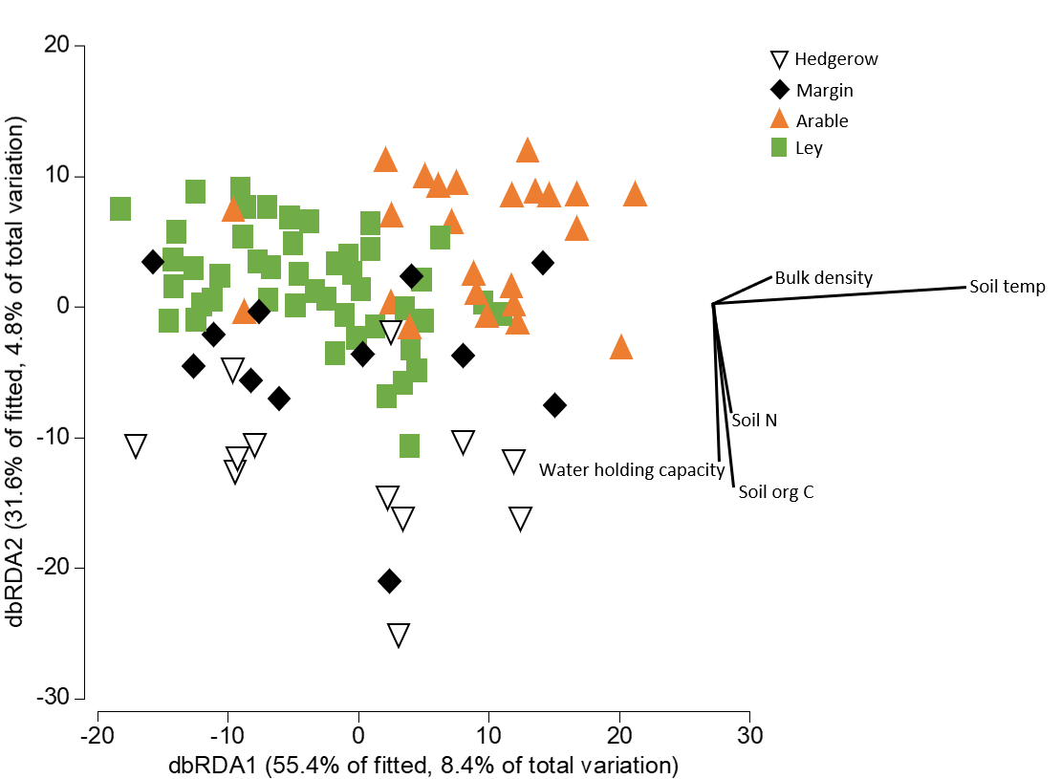

**Fig. 3. Distance based redundancy analysis (dbRDA) showing the relationship between earthworm species in hedgerow, margin, arable and ley soils and associated soil variables**

3.7. Seasonal study

3.7.1 Seasonal effects on earthworm abundance, biomass and species abundance and functional groups

The sampling periods over 2015-2017 had highly variable rainfall patterns, and some sampling periods coincided with when rainfall was lower (e.g. April 2015; April, July and October 2017), or higher (e.g. December 2015; April 2016) than the long-term average (2001-2018) (supplementary information, Fig. S9). In turn, variability in the weather was also reflected in soil temperature and moisture measured from the sampled earthworm pits (Fig. 4A&B). There were strong effects of month (*P* < 0.001) and land use (*P*< 0.001) on soil temperature and moisture (at both 5 and 10 cm depths). Land use also affected temperature: arable and ley soils tended to be warmer than hedgerow and margin soils. Moisture content indicated relatively drier soils under hedgerows compared to arable, ley and margin soils.

As expected, seasonal variability affected earthworm distributions, particularly in the annual spring surveys where for example, April 2017 which was relatively dry compared to previous spring samples, had a lower overall total abundance. There was a significant effect of month (*P* < 0.001) and land use (*P* < 0.001) and a significant month-land use interaction on earthworm abundance (*P* < 0.001) (Fig. 4C). Earthworm abundance across land uses tended to be higher in wetter and cooler months, with peak abundance coinciding with greater than average rainfall; and abundance was lower in drier and warmer months. Similar to abundance data, earthworm biomass showed similar significant effects of month (*P* < 0.001) and land use (*P* < 0.001) (Fig. 4D).

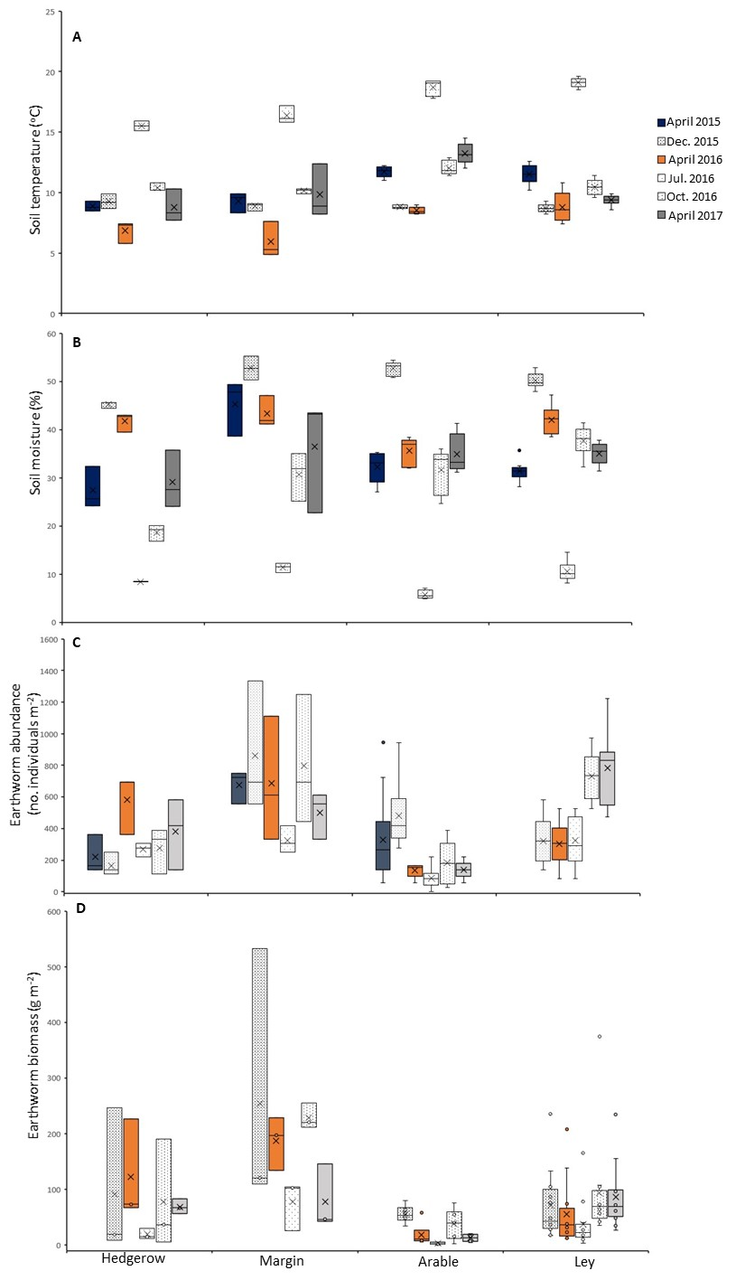

**Fig. 4. Seasonal variation in soil temperature (A), soil moisture (B), earthworm abundance (C) and biomass (D) in hedgerows, field margins, arable field and new arable-to-ley strips (in field A4). Samples were taken in April 2015 (before new leys were set up) and again in April 2016 and April 2017, with additional seasonal sampling in December 2015, July 2016 and October 2016. For each month, n = 3 in hedgerow and margin soils; n = 6 in arable soils (for April 2015, n = 18 in arable soils); n = 12 in ley soils). Biomass was not determined in April 2015. In the boxplots, X marks the mean, with the median line dividing the box into the interquartile range. Outliers are shown beyond the maximum and minimum vertical lines.**

Species abundance and functional groups (see Fig. S10) varied with land use (*P* < 0.001) and month (*P* < 0.001). Sampling month affected abundance of anecic (*P* < 0.01), endogeic (*P* < 0.001) and epigeic (*P* < 0.01) juveniles, as well as *A. chlorotica* (*P* < 0.001) and *L. castaneus* (*P* < 0.01). While total abundance of each functional group was affected by land use (*P* < 0.001), total abundance of anecic (*P* < 0.01) and endogeic (*P* < 0.001) groups were also affected by month, but total abundance of epigeic earthworms was not (*P* > 0.05).

3.7.2 Effect of seasonal antecedent weather and soil conditions on earthworms

Earthworm abundance and biomass did not correlate with antecedent soil moisture or temperature. However, earthworm biomass did negatively correlate with the number of dry days in the 14 days before sampling (ADD14; r = -0.876; *P* = 0.051). Antecedent dry day correlations were then calculated for each land use to see if land use had an effect. Earthworm abundance in arable soil negatively correlated with the number of dry days in the preceding 30- and 50-day periods before sampling (ADD30, r = -0.884, *P* < 0.05; ADD50, r = -0.897, *P* < 0.05). Earthworm biomass in arable soils also negatively correlated with the number of dry days in the preceding 30-day period (ADD30, r = -0.962, *P* < 0.01). Earthworm abundance in margin soils negatively correlated with each of the short-term antecedent periods, i.e. the number of dry days 7, 14, 21 or 30 days before sampling (r > -0.9, *P* < 0.05), but not the longer-term periods (50, 80 or 100 days). There were no correlations between ADD and earthworm abundance in ley soil or under hedgerows.

**4. Discussion**

This study set out to test three hypotheses relating to earthworm distributions in agro-ecosystems. We found that although earthworm communities were more diverse and distinct in hedgerow and margin soils compared to arable soils (H1), there was no effect of distance from high diversity field boundary soils (H2) or connectivity to the field margins (H3) on earthworm distributions in newly established leys. Earthworm distributions varied with annual and seasonal differences in soil moisture and temperature.

4.1 Earthworm communities in hedgerow and grassy field margins are distinct compared to those under continuous conventional arable (Baseline study)

In this study, soils under continuous conventional arable had a smaller and less diverse earthworm community, which was largely dominated by endogeic juvenile earthworms. In comparison, grassy field margins had the highest and most diverse earthworm communities. Earthworm abundance under hedgerows was similar to arable soils, but community composition was dominated by epigeic juveniles under hedgerows, where there is substantial deciduous litterfall. These findings agree with other studies showing that land use and cropping history in agricultural landscapes play a large role in determining earthworm abundance, biomass, species composition, age structure and functional group distribution (Blouin et al., 2013; Evans and Guild, 1948).

Continuous conventional arable cultivation with annual crops is detrimental to earthworms, due to soil disturbance during tillage, chemical inputs as fertilisers and pesticides, increased risk of predation after cultivation, and the removal of a permanent plant cover and crop residues, which reduce earthworm food resources (Briones and Schmidt, 2017; Stroud et al., 2016; Chan, 2000). In this study, arable soils had low SOC, high bulk density, and tended to be warmer and drier compared to margin soils. Additional related studies by Holden et al., (2019) and Hallam et al., (2020) at the same field sites confirm the hydrological functioning of these arable soils have lower infiltration rates and fewer macropores than for the hedgerow and margin soils. There are important links between earthworm communities and soil water (e.g. Spurgeon et al, 2013; Hallam and Hodson, 2020; Hallam et al., 2021).

In contrast, environmental stability in grassy field margins supported the highest and most diverse earthworm community in this study. Earthworm communities in field margins respond positively to environmental stability, the accrual of SOM and abundance of food resources for earthworms (Roarty and Schmidt, 2013; Frazão et al., 2017; Smith et al., 2008; Crittenden et al., 2015).

Despite the historical dominance of hedgerows and their potential loss in farming landscapes (Holden et al., 2019), few studies consider earthworm communities under hedgerows (e.g. Smith et al., 2008). Studies on field boundaries in agricultural landscapes tend to focus on grassy field margins. In this study, hedgerow soils had the highest abundance of epigeic earthworms. Soil pH was unlikely to be a strong factor in earthworm distributions between hedgerow and arable soils, because soil solution pH values were neutral and were not significantly different (see Holden et al., 2019). Hedgerow and arable soils had the greatest differences in bulk density and SOC contents which would affect earthworm abundance and community composition in these contrasting habitats (Fig. 2). Hedgerow soils also tended to be drier over the monitoring period of this study, reflecting the potentially large evapotranspiration of hedges and their interception of rainfall (Holden et al., 2019), which would tend to lower earthworm abundance compared to margin and ley soils.

4.2 New grass-clover leys boost earthworm abundance in arable soils (Annual study)

In this study, we showed that earthworm communities increased rapidly in new leys within 2 years of establishment, confirming the benefits of clover-rich ley rotations to earthworms (Riley et al., 2008; Scullion et al., 2007; Jarvis et al., 2017; van Eekeren et al., 2008; Schmidt et al., 2001). For example, van Eekeren et al., (2008) showed that earthworm abundance increased under a grass ley, and abundance was similar to the long-term grassland within 2 years. However, in their study, the biomass was still smaller than that observed in permanent grassland. In contrast, in our study, the abundance and biomass in the leys were similar to that observed in the field margins. Comparing our data to earthworm abundance in adjacent long-term pasture fields indicated that earthworm abundance in new leys was also similar to the 3-year average abundance in pasture soils (see Holden et al., 2019). Our results highlight that in these soils, 2 years under clover-rich grass ley is sufficient to increase earthworm populations. Availability of high quality food sources such as clover, as well as the reduction in ploughing disturbance have been linked to increased earthworm abundance (Schmidt et al., 2001; Yeates et al., 1998). In particular, Yeates et al., (1998) demonstrated the value of grass-clover mixtures in supporting higher earthworm abundance: earthworm biomass increased by only 13 g m-2 after 5 years in perennial ryegrass compared to 113 g m-2 under a ryegrass-clover mix.

The conversion of arable to ley demonstrated the rapid increase in earthworm abundance following cessation of disruptive ploughing. The positive effect on earthworms was not only in abundance, but also in species richness, biomass and population structure. In related studies (Hallam et al., 2020; Hallam and Hodson, 2020; Hallam et al., 2021) we have shown the positive effects earthworm increases have on soil properties; although it is possible that there might be a time-lag in the field between earthworm population change and changes in hydrological function. However, in this study, earthworms showed weak correlations to soil physical properties, and other variables such as soil texture, soil aggregation, plant biomass and organic matter may be important to consider. Nevertheless, it is plausible that the lack of soil disturbance and the presence of a permanent plant cover, continuous inputs of plant litter and plant C contributed to the positive effect on earthworms. Hallam et al., (2021) found a synergistic relationship between endogeic earthworms and plants in terms of improved soil hydraulic properties. Meta-analyses of data sets reporting earthworm abundance after converting arable to grassland showed that increases in earthworm abundance tended to occur in the short-term (0-3 yrs), with rapid increases due to the endogeic earthworms which tend to dominate in arable soils. As soil conditions improved and food resources became more available, so did the diversity in endogeic, epigeic and anecic earthworms over time; however longer periods since conversion did not add to the increase (Spurgeon et al., 2013).

4.3 Arable soils are important biological reservoirs (Annual study)

Our experimental design set out to determine the role of migration from biodiversity refugia into new ley strips. Our data show that the earthworm barrier at the margin-field boundary had no effect on earthworm distributions within the new leys. Although abundance was higher in margin soils, there was no gradient in earthworm distribution with distance from hedgerow and margin. The lack of a gradient in earthworm density has also been shown by Roarty and Schmidt (2013), Crittenden et al., (2015) and Smith et al., (2008). Where distance effects have been reported, these tend to reflect lower abundance at distances close to the margin, where vehicle traffic may have compacted soils, leading to lower earthworm numbers (e.g. Hof and Bright, 2010). The barriers were only installed at the head of each unconnected strip, so we cannot completely discount migration of earthworms from beyond the 13 m-long barrier at the margin-field boundary or from other parts of the arable field. Evidence from soil surface pitfall traps reveal that several earthworm species, particularly anecics, but also endogeics and some epigeics crawl over the soil surface at night (Eijsackers, 2011). Frazao et al., (2017) also noted that *L. terrestris* was likely to colonise plots in which they were not introduced, although there were ‘large’ buffer zones between the plots. Therefore, burrowing and soil surface dispersal from adjacent arable soils could also account for the population increase, as earthworms in lower quality arable soils are attracted into the new leys as conditions improved over time. Our study supports previous work by Smith et al., (2008), Roarty and Schmidt (2013), Crittenden et al., (2015) and Frazao et al., (2017) which demonstrate that although field margins have higher earthworm abundance, there is no ‘spill-over’ effect into adjacent arable fields. Roarty and Schmidt (2013) proposed that the survival of in-field populations supported the increase in earthworm abundance, rather than immigration from surrounding refugia (Marinissen and van den Bosch, 1992; Nuutinen et al., 2011). Our data support their idea of improved survival of in-field earthworm populations. However, we cannot rule out that the ley populations were also increased by immigation from the surrounding arable field as soil quality developed in the new leys. Our results demonstrate that despite low abundance and dominance by juvenile earthworms, intensively managed arable soils can still be considered as biodiversity reservoirs. Despite very limited abundance, this arable reservoir held juvenile representatives of the three functional groups. Our understanding of arable soil earthworm species diversity is incomplete because juveniles were identified to functional group only. However, arable earthworm diversity would still be relatively lower compared to the margins or new leys because of soil conditions and limited food resources. The new leys provided the stability and permanent plant cover which gave the juvenile earthworms the opportunity to mature and reach adulthood. Furthermore, the change in population structure suggests a shift from low survival and low abundance in arable soils to improved conditions in the new ley soils allowing adult earthworms to produce more offspring. Spurgeon et al., (2013) also suggested that the rapid accrual of earthworms following arable to grassland conversion was driven by improved survival of juvenile earthworms. They went on to highlight that endogeic species, which often dominate agroecosystems, may have an important role in initiating a positive feedback in soil conditions, thus facilitating the recruitment of epigeic and anecic species once plant surface litter became more available. Endogeic juveniles and species were the dominant group in our study. This highlights that arable soils may be potential reservoirs for all earthworm groups, but this is likely to depend on soil conditions and the historical legacy of land use management.

The increase in the number of adult earthworms in the leys could have been due to migration from the surrounding arable soils, resulting in an apparent decline in arable soil adult earthworms (Fig. 2). However, population structure remained the same in arable soils over the study period. Also, April 2017 was relatively drier than previous years, resulting in relatively lower earthworm abundance overall (the ley soils were the only land use to show an increase in abundance in 2017). It is likely that cocoon production and survival increased in the ley soils and also contributed to the increase in earthworm abundance. In addition, any adult earthworms that dispersed from the adjacent arable soil in the new leys are likely to reproduce and deposit cocoons. This may help account for the doubling in the juvenile:adult ratio in new leys compared to no change in arable, hedgerow or margin soils over the monitoring period.

4.4 Annual and seasonal changes in earthworm abundance

Temporal variation in soil moisture and temperature have strong effects on earthworm populations (Lowe and Butt, 2005; Schmidt et al., 2001; Whalen and Parmelee, 1999; Evans and Guild, 1947). As expected, earthworm abundance in our study correlated positively with soil moisture but negatively with temperature, and numbers declined during summer (July 2016) and the unusually dry spring (April 2017). In addition, our analyses show that earthworm data can be negatively affected by antecedent dry weather. Therefore, it is important to report weather conditions for the week before sampling in association with earthworm sampling data. Our data indicated that there were no correlations between number of antecedent dry days and earthworm abundance in soils from new leys or under hedgerows, suggesting that semi-permanent plant cover may help earthworm populations to be more resilient to fluctuations in soil conditions.

**5. Conclusions**

Results from our field experiments clearly show the positive impact on earthworm populations of converting arable soils, which are relatively low in earthworms, to grass-clover leys. This conversion increased earthworm abundance, biomass, and species diversity, while population structure shifted to relatively more adults. After 2 years, earthworm abundance had reached the average levels recorded in long-term pasture fields at the same site (see Holden et al., 2019), suggesting the maximum population level had been achieved. This rapid increase has important implications for soil management as arable farming practices seek to move towards sustainability and ecological intensification, as leys are also associated with other co-benefits to soil health, soil function, resilience and plant productivity. The policy mechanisms to encourage farmers to adopt rotational leys and the barriers to their use now need to be investigated.

Our data confirmed that although arable soils are depleted in earthworms, they can still be important reservoirs of biological diversity. Once converted to grass-clover ley, the earthworm community inhabiting former arable soils was able to survive under improved soil conditions, which supported the rapid increase in earthworm abundance. However, active dispersal from adjacent arable soils to the leys, due to greater food supply and improved conditions in the new leys, may also be contributing to the population increase. Our data show that sampling campaigns coinciding with periods of relatively high or low soil moisture strongly affect earthworm abundance assessments. This has implications for soil health metrics and long-term data collection is necessary to avoid misinterpreting changes in soil management practices.

**6. Acknowledgements**

We thank the anonymous reviewers for their constructive comments and feedback which improved this manuscript. This research was supported by Natural Environment Research Council (NERC) grant NE/M017095/1 (University of York) as part of the UK Soil Security Programme also funded by BBSRC, Defra and the Scottish Government. Thank you to J. Hallam, T. Kiss, S. Hunt, M. Nelson, S. Paramo Ortiz, H.L. Wong, O. Abdullah, R. Wade, K. High and P. Miranda for assistance during earthworm sampling campaigns. Thank you to Dr Y. Liu for Fig. 1 (Northumbria University). We also thank: University of Leeds Field Research Unit research managers, Dr Steven Pace and Dr George Sorensen and their staff chiefly Kevin White; Peter Burgis, Jake Wild and staff of NIAB /TAG Regional Centre at Headley Hall Farm; Velcourt Farm Managers Oliver Pilbeam, Josh Banks and Robert Yardley; and the Farm manager, Chantelle Astley and staff of Askham Bryan College farm.

**References**

AMUNDSON, R., BERHE, A. A., HOPMANS, J. W., OLSON, C., SZTEIN, A. E. & SPARKS, D. L. 2015. Soil and human security in the 21st century. *Science,* 348.

BEYLICH, A., OBERHOLZER, H. R., SCHRADER, S., HÖPER, H. & WILKE, B. M. 2010. Evaluation of soil compaction effects on soil biota and soil biological processes in soils. *Soil and Tillage Research,* 109, 133-143.

BLOUIN, M., HODSON, M. E., DELGADO, E. A., BAKER, G., BRUSSAARD, L., BUTT, K. R., DAI, J., DENDOOVEN, L., PERES, G., TONDOH, J. E., CLUZEAU, D. & BRUN, J. J. 2013. A review of earthworm impact on soil function and ecosystem services. *European Journal of Soil Science,* 64, 161-182.

BOSTRÖM, U. 1995. Earthworm populations (Lumbricidae) in ploughed and undisturbed leys. *Soil and Tillage Research,* 35, 125-133.

BOUCHE, M.B. 1977. Stratégies lombriciennes. In: Lohm, U., Persson T, editors, Soil organisms as components of ecosystems. Ecology Bulletin. Stockholm: NFR; pp122-132.

BRIONES, M. J. I. & SCHMIDT, O. 2017. Conventional tillage decreases the abundance and biomass of earthworms and alters their community structure in a global meta-analysis. *Global Change Biology,* 23, 4396-4419.

CHAN, K. Y. 2000. An overview of some tillage impacts on earthworm population abundance and diversity - Implications for functioning in soils. *Soil and Tillage Research,* 57, 179-191.

CLARKE, K.R. & GORLEY, R.N. 2006. PRIMER v6: User Manual/Tutorial (Plymouth Routines in Multivariate Ecological Research). PRIMER-E, Plymouth.

CRITTENDEN, S. J., HUERTA, E., DE GOEDE, R. G. M. & PULLEMAN, M. M. 2015. Earthworm assemblages as affected by field margin strips and tillage intensity: An on-farm approach. *European Journal of Soil Biology,* 66, 49-56.

DECAËNS, T., MARGERIE, P., AUBERT, M., HEDDE, M. & BUREAU, F. 2008. Assembly rules within earthworm communities in North-Western France-A regional analysis. *Applied Soil Ecology,* 39, 321-335.

EDWARDS, C. A. & BOHLEN, P. J. 1996. *Biology and Ecology of Earthworms*.

EDWARDS, C. A. & LOFTY, J. R. 1982. The effect of direct drilling and minimal cultivation on earthworm populations. *Journal of Applied Ecology,* 19, 723-734.

EIJSACKERS, H. 2011. Earthworms as colonizers of natural and cultivated soil environments. *Applied Soil Ecology*, 50, 1-13.

EVANS, A. C. & GUILD, W. J. M. 1947. STUDIES ON THE RELATIONSHIPS BETWEEN EARTHWORMS AND SOIL FERTILITY: I. BIOLOGICAL STUDIES IN THE FIELD. *Annals of Applied Biology,* 34, 307-330.

EVANS, A. C. & GUILD, W. J. M. 1948. Studies on the Relationships Between Earthworms and Soil Fertility: V. Field Populations. *Annals of Applied Biology,* 35, 485-493.

FRAZÃO, J., DE GOEDE, R. G. M., BRUSSAARD, L., FABER, J. H., GROOT, J. C. J. & PULLEMAN, M. M. 2017. Earthworm communities in arable fields and restored field margins, as related to management practices and surrounding landscape diversity. *Agriculture, Ecosystems and Environment,* 248, 1-8.

GERARD, B. M. & HAY, R. K. M. 1979. The effect on earthworms of ploughing, tined cultivation, direct drilling and nitrogen in a barley monoculture system. *The Journal of Agricultural Science,* 93, 147-155.

HALLAM, J., BERDENI, D., GRAYSON, R., GUEST, E. J., HOLDEN, J., LAPPAGE, M. G., PRENDERGAST-MILLER, M. T., ROBINSON, D. A., TURNER, A., LEAKE, J. R. & HODSON, M. E. 2020. Effect of earthworms on soil physico-hydraulic and chemical properties, herbage production, and wheat growth on arable land converted to ley. *Science of the Total Environment,* 713.

HALLAM, J., HODSON, M.E. Impact of different earthworm ecotypes on water stable aggregates and soil water holding capacity. *Biology and Fertility of Soils,* 56, 607–617 (2020)

HALLAM, J., HOLDEN, J., ROBNSON, D.A. & HODSON, M.E. 2021. Effects of winter wheat and endogeic earthworms on soil physical and hydraulic properties. *Geoderma* 400 115126.

HOF, A. R. & BRIGHT, P. W. 2010. The impact of grassy field margins on macro-invertebrate abundance in adjacent arable fields. *Agriculture, Ecosystems and Environment,* 139, 280-283.

HOLDEN, J., GRAYSON, R. P., BERDENI, D., BIRD, S., CHAPMAN, P. J., EDMONDSON, J. L., FIRBANK, L. G., HELGASON, T., HODSON, M. E., HUNT, S. F. P., JONES, D. T., LAPPAGE, M. G., MARSHALL-HARRIES, E., NELSON, M., PRENDERGAST-MILLER, M., SHAW, H., WADE, R. N. & LEAKE, J. R. 2019. The role of hedgerows in soil functioning within agricultural landscapes. *Agriculture, Ecosystems & Environment,* 273, 1-12.

JARVIS, N., FORKMAN, J., KOESTEL, J., KÄTTERER, T., LARSBO, M. & TAYLOR, A. 2017. Long-term effects of grass-clover leys on the structure of a silt loam soil in a cold climate. *Agriculture, Ecosystems and Environment,* 247, 319-328.

KEESSTRA, S. D., BOUMA, J., WALLINGA, J., TITTONELL, P., SMITH, P., CERDÀ, A., MONTANARELLA, L., QUINTON, J. N., PACHEPSKY, Y., VAN DER PUTTEN, W. H., BARDGETT, R. D., MOOLENAAR, S., MOL, G., JANSEN, B. & FRESCO, L. O. 2016. The significance of soils and soil science towards realization of the United Nations sustainable development goals. *SOIL,* 2, 111-128.

LAL, R. 2019. Eco-intensification through soil carbon sequestration: Harnessing ecosystem services and advancing sustainable development goals. *Journal of Soil and Water Conservation,* 74, 55A-61A.

LOWE, C. N. & BUTT, K. R. 2005. Culture techniques for soil dwelling earthworms: A review. *Pedobiologia,* 49, 401-413.

MARINISSEN, J.C.Y. & VAN DEN BOSCH, F. 1992. Colonization of new habitats by earthworms. *Oecologia* 91, 371–376.

MARTAY, B. & PEARCE-HIGGINS, J. W. 2018. Using data from schools to model variation in soil invertebrates across the UK: The importance of weather, climate, season and habitat. *Pedobiologia,* 67, 1-9.

MCBRATNEY, A., FIELD, D. J. & KOCH, A. 2014. The dimensions of soil security. *Geoderma,* 213, 203-213.

NIEMINEN, M., KETOJA, E., MIKOLA, J., TERHIVUO, J., SIRÉN, T. & NUUTINEN, V. 2011. Local land use effects and regional environmental limits on earthworm communities in Finnish arable landscapes. *Ecological Applications,* 21, 3162-3177.

NUUTINEN, V., BUTT, K. R. & JAUHIAINEN, L. 2011. Field margins and management affect settlement and spread of an introduced dew-worm (*Lumbricus terrestris* L.) population. *Pedobiologia,* 54, S167-S172.

PELOSI, C., BERTRAND, M., CAPOWIEZ, Y., BOIZARD, H. & ROGER-ESTRADE, J. 2009. Earthworm collection from agricultural fields: Comparisons of selected expellants in presence/absence of hand-sorting. *European Journal of Soil Biology,* 45, 176-183.

PELOSI, C., PEY, B., HEDDE, M., CARO, G., CAPOWIEZ, Y., GUERNION, M., PEIGNÉ, J., PIRON, D., BERTRAND, M. & CLUZEAU, D. 2014. Reducing tillage in cultivated fields increases earthworm functional diversity. *Applied Soil Ecology,* 83, 79-87.

[dataset]PRENDERGAST-MILLER, M.T., JONES, D.T., HODSON, M.E. 2019. Soil moisture, temperature and bulk density and earthworm abundance and biomass along transects from hedges into arable fields, pasture fields, ley strips established in arable fields and arable strips established in pasture fields at a farm in West Yorkshire (2015-2017). Data lodged with NERC Environmental Information Data Centre. <https://doi.org/10.5285/d3dcfd8a-918d-48a4-9511-ec832de34636>.

RILEY, H., POMMERESCHE, R., ELTUN, R., HANSEN, S. & KORSAETH, A. 2008. Soil structure, organic matter and earthworm activity in a comparison of cropping systems with contrasting tillage, rotations, fertilizer levels and manure use. *Agriculture, Ecosystems and Environment,* 124, 275-284.

ROARTY, S. & SCHMIDT, O. 2013. Permanent and new arable field margins support large earthworm communities but do not increase in-field populations. *Agriculture, Ecosystems and Environment,* 170, 45-55.

SCHMIDT, O., CURRY, J. P., HACKETT, R. A., PURVIS, G. & CLEMENTS, R. O. 2001. Earthworm communities in conventional wheat monocropping and low-input wheat-clover intercropping systems. *Annals of Applied Biology,* 138, 377-388.

SCULLION, J., NEALE, S. & PHILIPS, L. 2007. Earthworm casting and burrowing activity in conventional and organic grass-arable rotations. *European Journal of Soil Biology,* 43, S216-S221.

SMITH, J., POTTS, S. & EGGLETON, P. 2008. The value of sown grass margins for enhancing soil macrofaunal biodiversity in arable systems. *Agriculture, Ecosystems and Environment,* 127, 119-125.

SPURGEON, D. J., KEITH, A. M., SCHMIDT, O., LAMMERTSMA, D. R. & FABER, J. H. 2013. Land-use and land-management change: Relationships with earthworm and fungi communities and soil structural properties. *BMC Ecology,* 13.

STROUD, J. L., IRONS, D. E., WATTS, C. W., WHITE, R. P., MCGRATH, S. P. & WHITMORE, A. P. 2016. Population collapse of *Lumbricus terrestris* in conventional arable cultivations and response to straw applications. *Applied Soil Ecology,* 108, 72-75.

VAN EEKEREN, N., BOMMELÉ, L., BLOEM, J., SCHOUTEN, T., RUTGERS, M., DE GOEDE, R., REHEUL, D. & BRUSSAARD, L. 2008. Soil biological quality after 36 years of ley-arable cropping, permanent grassland and permanent arable cropping. *Applied Soil Ecology,* 40, 432-446.

VAN GROENIGEN, J. W., LUBBERS, I. M., VOS, H. M. J., BROWN, G. G., DE DEYN, G. B. & VAN GROENIGEN, K. J. 2014. Earthworms increase plant production: a meta-analysis. *Scientific Reports,* 4.

WHITE, H.J., LEON‐SANCHEZ, L, BURTON, V.J., et al. 2020. Methods and approaches to advance soil macroecology. *Global Ecology and Biogeography*. 00: 1– 17

WANG, Y., NAUMANN, U., WRIGHT, S. T. & WARTON, D. I. 2012. Mvabund- an R package for model-based analysis of multivariate abundance data. *Methods in Ecology and Evolution,* 3, 471-474.

WHALEN, J. K. & PARMELEE, R. W. 1999. Growth of *Aporrectodea tuberculata* (Eisen) and *Lumbricus terrestris* L. under laboratory and field conditions. *Pedobiologia,* 43, 1-10.

ZABORSKI, E. R. 2003. Allyl isothiocyanate: An alternative chemical expellant for sampling earthworms. *Applied Soil Ecology,* 22, 87-95.

ZHANG, W., HENDRIX, P.F., DAME, L.E., BURKE, R.A., WU, J., NEHER, D.A., LI, J., SHAO, Y., FU, S. 2013. Earthworms facilitate carbon sequestration through unequal amplification of carbon stabilization compared with mineralization. *Nature Communications* 4, 2576. Doi:10.1038/ncomms3576.