Time-response histogram based feature of magnetic Barkhausen noise for material characterization considering influences of grain and grain boundary under in-situ tensile test

Jia Liu ¹ Gui Yun Tian^{1, 2∗} Bin Gao ¹ Kun Zeng ¹ Yongbing Xu ³ Qian Hang Liu ¹
1 School of Automation Engineering, University of Electronic Science and Technology of China, Chengdu, Sichuan, 611731, China
2 School of Engineering, Newcastle University, Newcastle upon Tyne, NE1 7RU, UK.
3 Spintronics and Nanodevice Laboratory, Department of Electronics Engineering, University of York, York, YO10 5DD, UK

*Corresponding author: g.y.tian@ncl.ac.uk

Abstract- Stress is the crucial factor of ferromagnetic material failure origin. However, the nondestructive test methods to analyze the ferromagnetic material properties’ inhomogeneity at microstructure scale with stress have not been obtained so far. In this paper, magnetic Barkhausen noise (MBN) signals on different silicon steel sheet locations under in-situ tensile tests are detected by a high spatial resolution magnetic probe to evaluate material properties. Domain wall (DW) motion, grain, and grain boundary are detected by magneto-optical Kerr (MOKE) image. The time characteristic of MBN signals on different locations is characterized by using time-response histogram as proposed in this work, which shows different DW motions inside grain and around grain boundary under tensile test. In order to separate the variation of magnetic properties affected by grain and grain boundary under stress corresponding to MBN excitation, time-division is carried out to extract the root-mean-square (RMS), mean, and peak in the optimized time interval. The time-response histogram of MBN evaluates the silicon steel sheet’s inhomogeneous material properties, which provides a theoretical and experimental reference for inhomogeneous other ferromagnetic material properties under stress.
Index terms- Time-response histogram, Magnetic Barkhausen noise, Stress evaluation, Grain/Grain boundary, Domain wall motion

Introduction
Stress and residual stress in a service component are critical parameters that can lead to early fatigue failure and minor damage [1-3]. Jun et al. reported that component is vulnerable because of crack initiation caused by the generation of high tensile residual stresses and large thickness of heat affected zone [4]. Lee et al. assessed the fatigue life of welded repaired rail based on the welding process and contact stresses [5].
In most cases, the material is considered to be homogeneous in the macro-level analysis; however, mechanical research is necessary to connect with the microstructural properties to analyze material properties and stress state. Donegan et al. used a convolutional neural network to predict which regions of a microstructure are susceptible to forming stress/residual stress hot spots and serving areas of local damage accumulation [6]. Zarei et al. found that by considering the various orientations and shapes of the grains, the finite element model of DP steel microstructure causes a better prediction of stress-strain curve than the homogeneous models [7]. Zhao et al. proposed an automatic 3-D simulation to simulate metallic materials' microstructure and investigated each grain's stress for polycrystalline material [8]. Pagan et al. used ‘slip system strength curves’ to calculate each grain's average stress tensors over the applied deformation history [9]. Johnson et al. used high-resolution electron backscatter diffraction to show the intersection between material properties’ variation and grain boundaries for crack initiation process analysis [10]. Zhang et al. investigated the relationship between stress and carbon nanotubes' microstructure to quantify load partitioning using in-situ neutron diffraction [11]. Analysis of the inhomogeneous material properties and stress state affected by the grain and grain boundary is usually carried out in a simulation or destructive manner [12]. For this reason, it would be beneficial to propose a reliable nondestructive technique designed for the purpose above.
The variation of nondestructive test and evaluation method is used to characterize the macro electromagnetic properties for industrial materials state evaluation. Magnetic Barkhausen noise (MBN) is a microstructure sensitive technique for on-line inspection of structures to characterize both micro and macro stresses of ferromagnetic material in industrial applications [13-14]. The MBN signal is found in domain wall (DW) motion, detected by a pick-up coil wound around the ferromagnetic sample [15-16]. The microstructure and the stress affect the alignment of the DWs, whereas lattice defects drive the free path of DW motion [17-19]. MBN nondestructive determinate both micro-and macro-residual stresses in silicon steel, steel weldments, and lightly deformed AISI 1070 steel [20-23].
MBN signals are combined with microstructure observation methods performed by magneto-optical Kerr (MOKE), atomic force microscopy (AFM), scanning electron microscopy (SEM), etc. to analyze the relationship between the inhomogeneous material properties and mechanical properties [24-25]. The peak value of MBN signals is calibrated as a function of the microstructure expressed in dislocation density [28]. MBN distinguishes the variable character of the microstructure and stress state for tool steel X210Cr12 [26]. The smaller grain size leads to more MBN emissions under the same applied field conditions [27]. Due to the MBN phenomenon observation for grain-oriented steels, a division of MBN time-Frequency investigates the various factors affecting anisotropy distribution [29].
However, the quantitative analysis of material properties’ inhomogeneity on the grain and grain boundary is the key to the microscopic nondestructive characterization of stress for ferromagnetic material [30]. There is no reliable method for evaluating micro-magnetic properties affected by the grain and grain boundary with different average stress via MBN.
In this paper, the DW motion and MBN of silicon steel sheet under in-situ tensile test are detected by a MOKE and MBN detection device. By combining the time characteristic of DW motion and MBN signal on different location, the time-response histogram of MBN and its feature extraction are carried out to quantitatively analyze the effect of grain and grain boundary on the magnetic properties’ inhomogeneous. time-division is used to separate the variation of magnetic properties affected by grain and grain boundary. The proposed work will analyze the inhomogeneous material properties on the grain and grain boundary for other ferromagnetic material with stress via MBN in industrial applications.

Experimental procedure and methods
MOKE and MBN detection device with the high spatial resolution are used to observe DW motion and Barkhausen noise signal of a silicon steel sheet. Relating to DW motion and MBN signals, the time-response histogram method is carried out to evaluate the inhomogeneous material properties with different average stress on the grain and grain boundary.

Sample preparation

Table Ⅰ. Chemical composition of silicon steel sheets expressed as weight percentages
Fe | Si | C | Mn | P | S | Al
Balance | 3~5 | 0.06 | 0.15 | 0.03 | 0.25 | 5.1~8.5

The grain-oriented silicon steel sheet [31-32] is investigated to analyze the correlation of DW motion and time-response histogram on the grain and grain boundary with stress state. The average grain size of the selected silicon steel sheet is over 10 mm, which is visible for DW motion and MBN signal detection on grain and grain boundary. The sample with dimensions 300 mm × 30 mm × 0.2 mm (Length × Width × Thickness) is applied to a tensile load from 0 N to approximately 740 N. Grain-oriented silicon steel sheet has the characteristics of high magnetic induction and low iron loss [33-34]. The chemical composition of the silicon steel sheet is found in Table Ⅰ. The Sample is mechanically polished for microstructure and micromagnetic properties observation.

Experiment setup
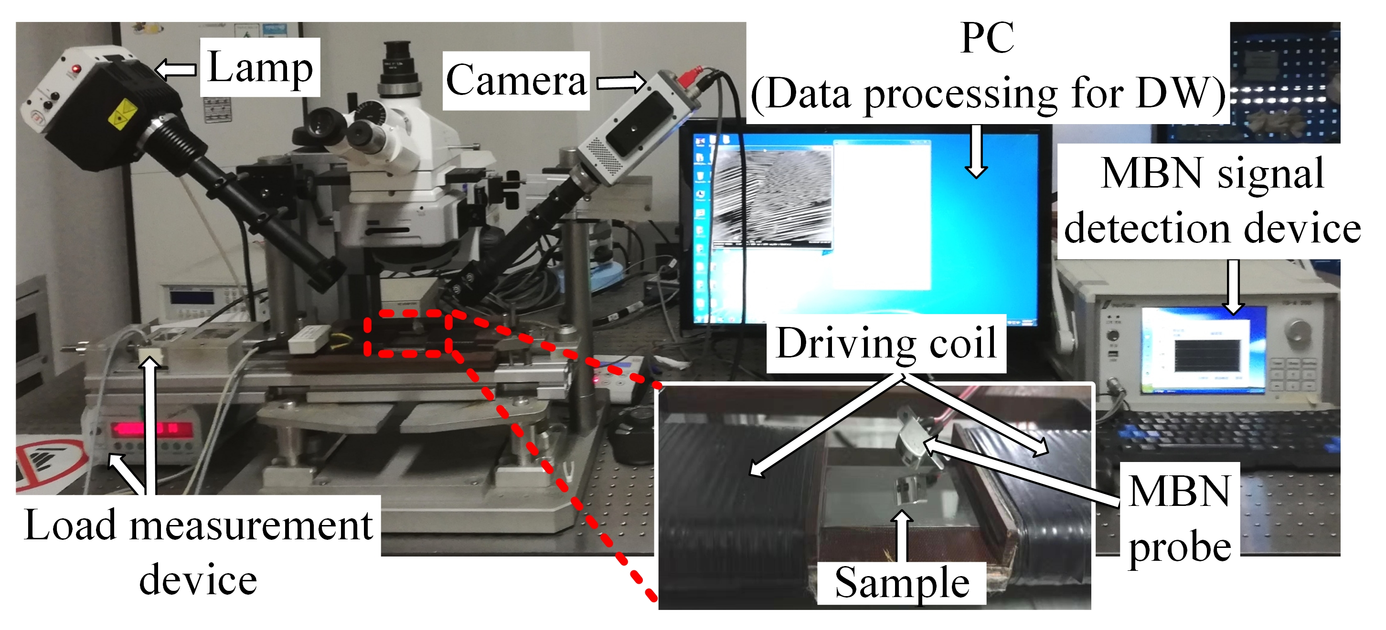
(a)
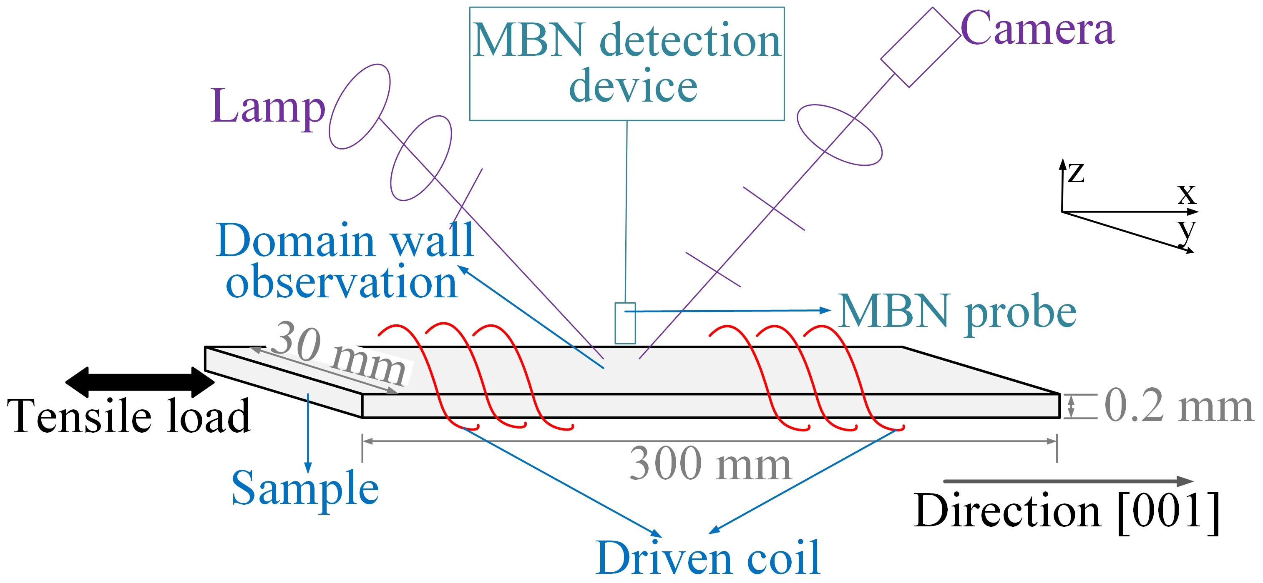
(b)
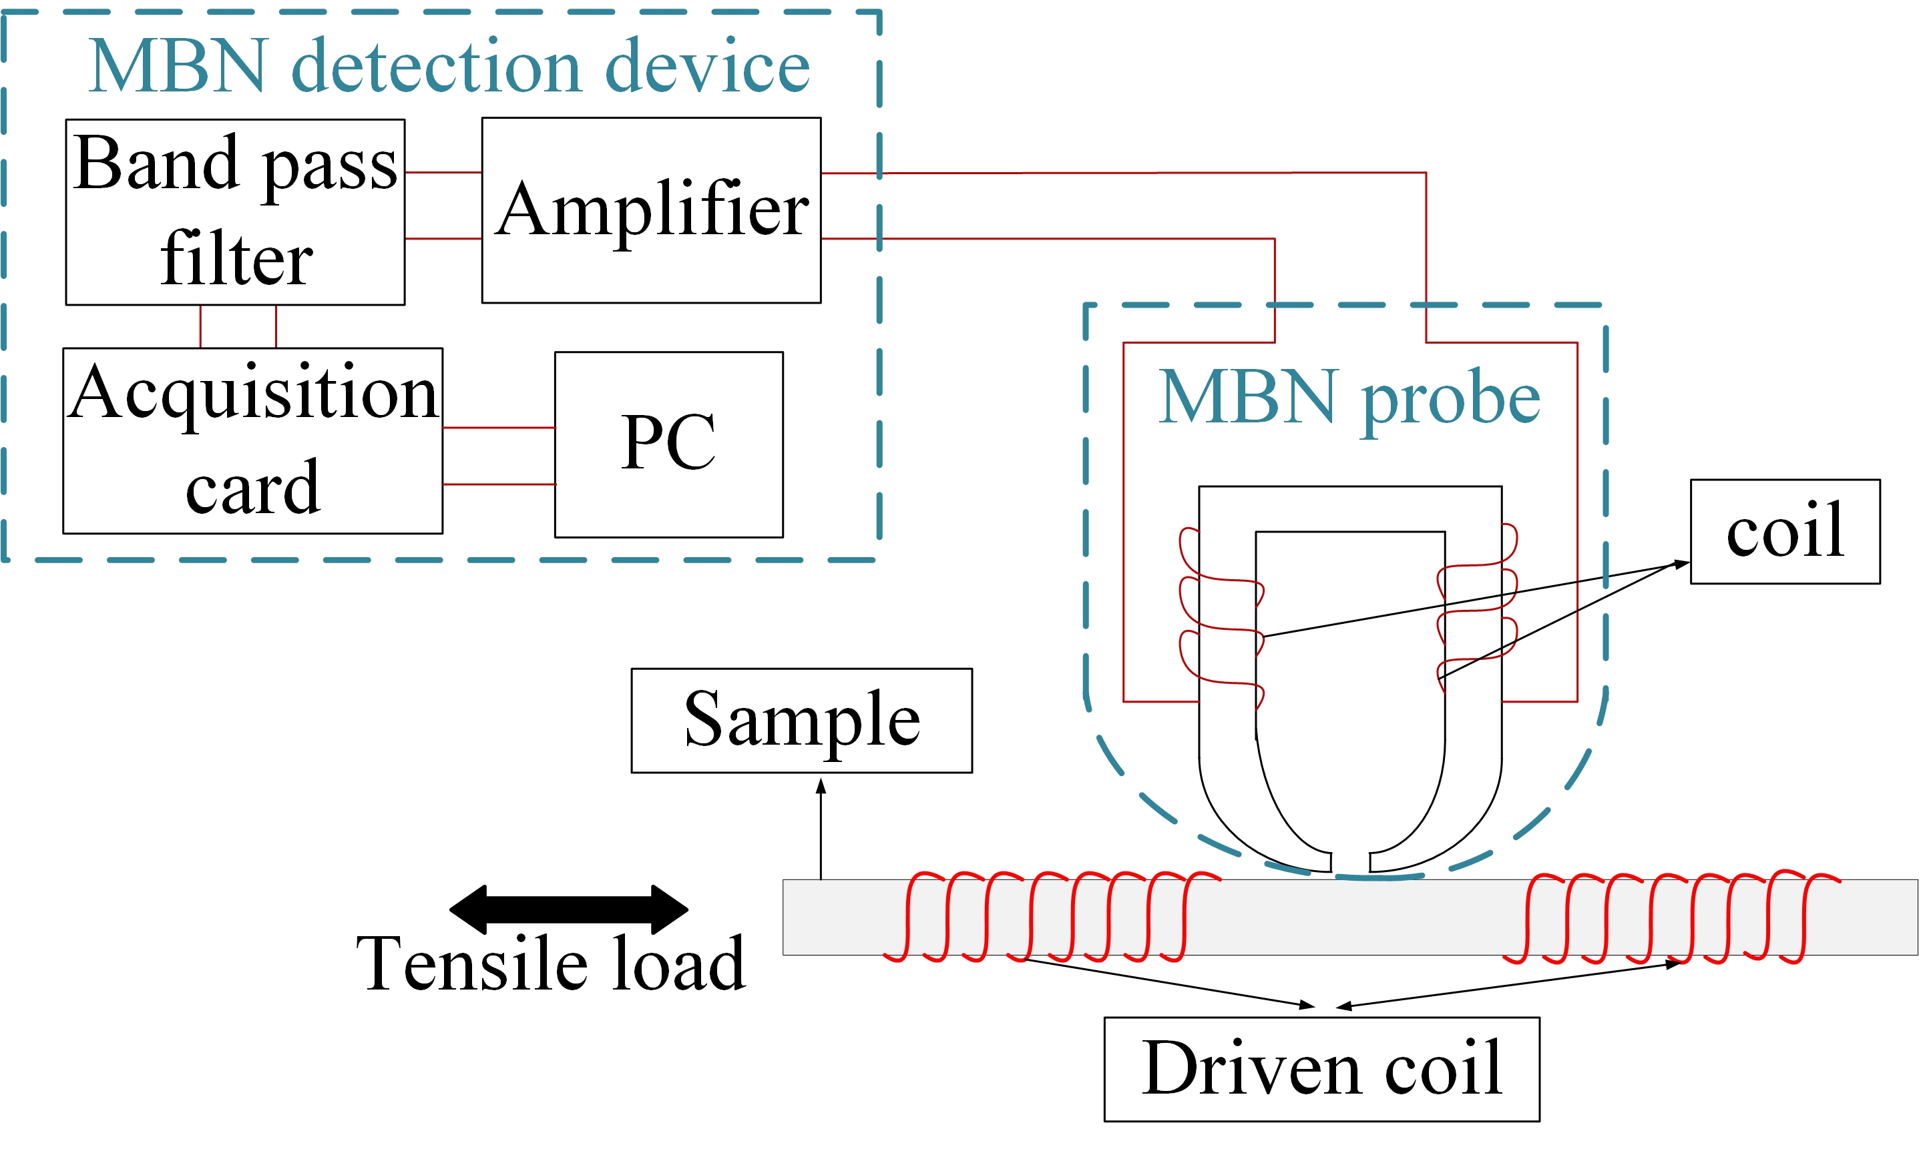
(c)
Fig. 1. (a) Experimental set-up for DW and MBN observation, (b) Schematic illustration of load, DW observation and MBN detection, (c) Schematic for high spatial resolution MBN probe (about 3 - 4 mm) and MBN detection device.
The experimental setup for MOKE and MBN observation for inhomogeneous material properties under the in-situ tensile test are shown in Fig. 1. MBN and longitudinal MOKE microscopy capture the MBN signal and DW motion of the silicon steel sheet. This system includes a high spatial resolution MBN probe, MBN detection device (including signal amplifiers, filter, acquisition card, MBN signal process), a digital CCD camera for DW observation, driving coils, and applied tensile load [35]. The applied excitation field is in the tensile load direction. The Driven coil with 355 turns wound around the sample can provide AC to magnetize the sample for periodicity. A digital CCD camera C8484-03G02 with a sampling rate of 16.3 Hz is used to observe the microstructure and DW motion directly. DW motion images and MBN signals are in the same setup, which can bridge the correlation of micro-macro magnetic parameters and stress on the grain and grain boundary. The excitation is a triangular wave, in which the magnetization frequency and amplitude are 0.5 Hz and 1 kA/m, respectively. This magnetic field strength was greater than the maximum sample material magnetic saturation level (about 0.9 kA/m). The magnetic domain image is about 16.2 mm × 13.6 mm with 450 × 360 pixels, showing the microstructure and DW motion directly. The tiny magnetic head with the high spatial resolution is enough to analyze the magnetic parameters’ variation on the grains and grain boundaries. The high spatial resolution MBN probe sensitively detect MBN signals on the grain and grain boundary, linking the micromagnetic properties observed by MOKE. This system analyzes the difference of the time-response histogram of MBN affected by grain and grain boundary, which interpret the effect of grain and grain boundary on the inhomogeneous material properties measurement with different average tensile stress.

The model of the time-response histogram
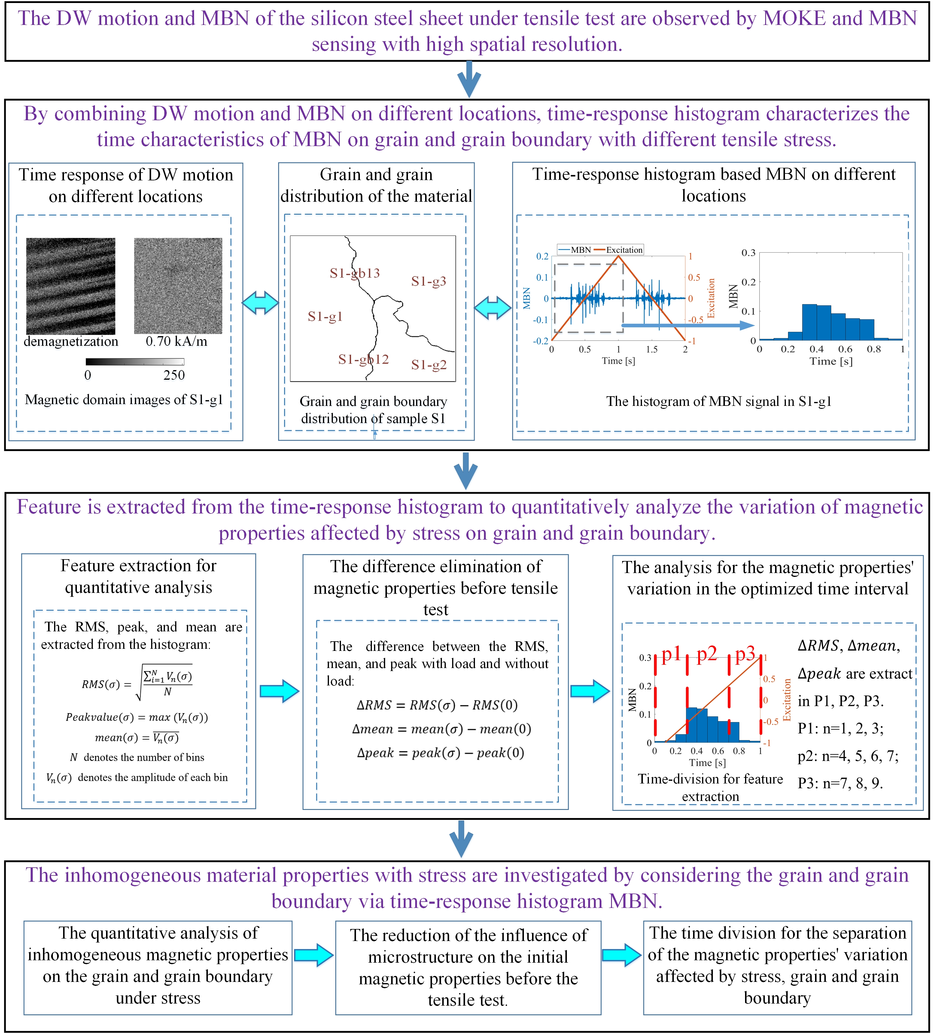
Fig. 2. The approach of the time-response histogram to evaluate the inhomogeneous material properties on grain and grain boundary.
The method for time-response histogram on grain and grain boundary with different stress state is outlined in Fig. 2 to analyze the effect of grain and grain boundary on inhomogeneous material properties.
The DW motion and MBN signal of the silicon steel sheet are observed by a MOKE and MBN detection device. Tape type probe is also designed as MBN sense to get the high spatial resolution of MBN signal on the grain and grain boundary. The combination of DW motion and MBN can analyze inhomogeneous material properties considering the influence of the grain and grain boundary.
Grain boundaries are important microstructural elements that can affect DW motion, leading to a change in the differential susceptibility at all field strengths, thereby changing the time characteristics of MBN [36-37]. Time-response histogram is proposed to divide the entire time range of MBN activities into a series of equal intervals, showing the micromagnetic properties’ variation along time. Thus, the time-response histogram is modeled to analyze the variation of magnetic properties affected by grain and grain boundary with different stress.
The mean, RMS, and peak are extracted from the time-response histogram to quantify the time characteristics of magnetic properties on different positions. Based on the correlation among applied field and magnetic time characteristics on the grain and grain boundary, time-division is carried out to analyze the time-response histogram features in the optimized time intervals. Besides, the difference between the RMS, mean, and peak with load and without load is carried out to reduce the slight difference of time-response histogram before tensile test. The feature extraction and time-division quantitatively analyze the inhomogeneous material properties affected by the grain, grain boundary, and stress.
When the load is applied to the material, the time-response histogram and its features quantitatively analyze the variation of magnetic properties, reflecting material properties’ variation affected by stress, grain, and grain boundary. Time-division is carried out to extract the histogram features in the optimized time interval to separate the variation of magnetic properties affected by grain and grain boundary under stress. The difference elimination of magnetic parameters without load is helpful to reduce the influence of material microstructure on the initial material properties before the tensile test, improving the results of time-division.

Experimental results
To analyze the influence of grain and grain boundary on the inhomogeneous material properties, the results of the time-response histogram are investigated to analyze the variation of magnetic properties.

The relationship between the time-response histogram and DW motion on grain and grain boundary
Based on the observation of DW motion and MBN of silicon steel, the time-response histogram is used to investigate the influence of grain and grain boundary on the micromagnetic properties. In Figs. 3 and 4, when the tensile load is 0 N and 740 N respectively, DW motion, hysteresis loops, and time-response histogram are analyzed on grain and grain boundary. The distribution of the grain and grain boundary is shown in Figs. 3 (a) and 4 (a), S1-g1 and S1-g3 denote two adjacent grains, S1-gb13 denotes the grain boundary between grains S1-g1 and S1-g3.
The microstructure and stress can affect the distribution of magnetic domain and the behavior of DW motion around the grain boundary [38]. When the tensile load is 0 N, DW motion is almost synchronous. When the tensile load is 740 N, the average value of the grain-oriented silicon steel’s tensile stress is 123 MPa. Tensile stress aligns the magnetic domains parallel to stress direction and makes the magnetization process easy when excitation is in stress direction [32]. The formation of ${180}^{°}$ DW increases. The stable state of the magnetic domain structure is that magnetic domain’s orientation makes the fewer free pole appear on grain interface to reduce the magneto-static energy [39-40]. The branch domain appears on the grain boundary S1-gb13 under 123 MPa to minimize the magnetic- static energy on the grain boundary affected by the load. Thus, the distribution of DW more complex on grain boundary S1-gb13 than these on grain S1-g1 and S1-g3. Since stress makes DW distribution more complex on the grain boundary, the DW motion becomes different on different locations with stress. The intensity value for every pixel in the magnetic domain image is calculated to analyze the hysteresis loops on the different location, as shown in Figs 3 (b) and 4 (b). When the tensile stress is 0 MPa, the hysteresis loops are almost the same in S1-g1 S1-g3, and S1-gb13. When the tensile stress is 123 MPa, the hysteresis loops are quite different in S1-g1, S1-g3, and S1-gb13.
The DW motion in magnetization occurring over a given time interval relates to MBN activity [41-42]. In particular, the change rate of magnetization occurring as Barkhausen emissions ${dM_{JS}}/{dt}$ is expected to be proportional to the change rate of magnetization occurring as magnetization changes ${dM}/{dt}$. The time-response histogram is modeled to divide the entire time range of MBN activities into a series of equal intervals. Each bin of the histogram is represented as the magnetization change with the dimensionless term $γ$ . The time characteristic of Barkhausen noise is distributed as:
$\frac{dM_{JS}}{dt}=γ\frac{dM}{dH}\frac{dH}{dt}$ (1)
where $H$ denotes the external magnetic field. In this paper, the histogram quantifies the Barkhausen activity by dividing the noise signal into an equal interval (the interval is 0.1 s). Each bin of time-response histogram identifies the amplitude of MBN activity per 0.1 s.
Grain boundary can affect the movement of DWs and lead to different magnetization processes under load in the previous research [43]. The magnetization intensity $M$ is calculated by adding the intensity value for every pixel in the magnetic domain image $I$， given as $M∝I$. The relationship among the difference of MBN activity ${∆M}_{JS}$, the difference of the magnetic domain images $∆I$, and the difference of magnetization intensity $∆M$ on different locations satisfies:

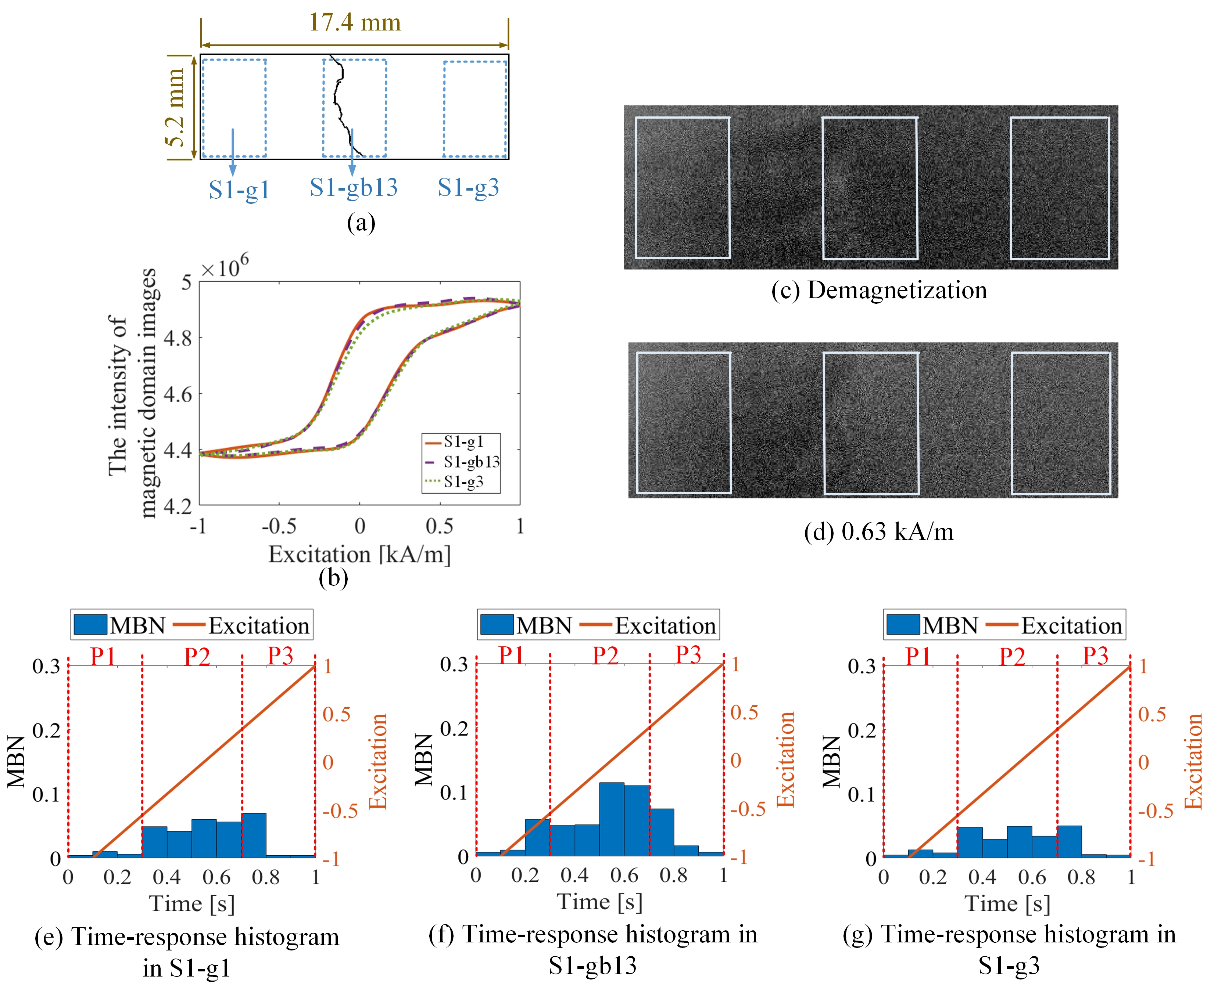
Fig. 3. Different time-response histogram of sample 1 in different locations when the tensile load is 0 N: (a) denotes the locations of S1-gb13, S1-g1 and S1-g3; (b) denotes the different hysteresis loops on different locations, (c) and (d) show the similar DW motion on the different locations; (e), (f) and (g) show the related similar time-response histogram of MBN.
$\frac{d{∆M}_{JS}}{dt}∝γ\frac{d∆M}{dH}\frac{dH}{dt}∝γ\frac{d∆I}{dH}\frac{dH}{dt}$ (2)
When the tensile load is 0 N, the difference of time-response histogram on S1-g1, S1-g3, and S1-gb13 is small. When the tensile load increases, MBN signals on these locations become much more extensive. The time-response histogram’s bins are quite different. When the tensile stress is 123 MPa, the histogram on S1-g3 is the smallest, and histogram bins are the largest under 123 MPa than these on grain S1-g1 and S1-g3. Based on time-response histograms on different locations, the time interval p1, p2, and p3 highlight the various activities of MBN along time, as shown in Figs. 3 and 4. When the tensile stress is 123 MPa, the magnetic saturation is reached earliest on the grain S1-g2 (from 0.3 s to 0.7 s, denoted as time interval P2), and magnetic saturation is reached latest on the grain boundary S1-gb12 under 123 MPa (from 0.1 s to 0.9 s). The different DW motion affects the time-response histogram on different locations. The variation of MBN activity on different locations is highlighted in the time interval p1 (0 – 0.3 s), p2 (0.3 s - 0.7 s), and p3 (0.7 s – 1 s).
Thus, the time-response histogram of MBN affected by stress on different locations is quite different, consistent with the phenomenon of DW motion and hysteresis loops. Each bin of the time-response histogram $V_{n}$ is proportional to DW motion velocity $v_{DW}$ [36-37], where $n$ denotes the number of histogram bins. The relationship between the DW motion and time-response histogram’s bin on different locations satisfies:
${∆V}_{n}(σ)∝∆v(σ)$ (3)
where ${∆V}_{n}(σ)$ and $∆v(σ)$ denote the difference of time- response histogram’s bin and difference of DW motion velocity under stress on the grain and grain boundary.
Based on studying the DW motion and magnetization process, the time-response histogram quantifies the micro-magnetic, reflecting the variation of material properties on the grain and grain boundary under stress. When load applied to the materials, due to the microstructure of grain and grain boundary, the micromagnetic parameters’ variation degree on the grain boundary is greater than these inside the grain.

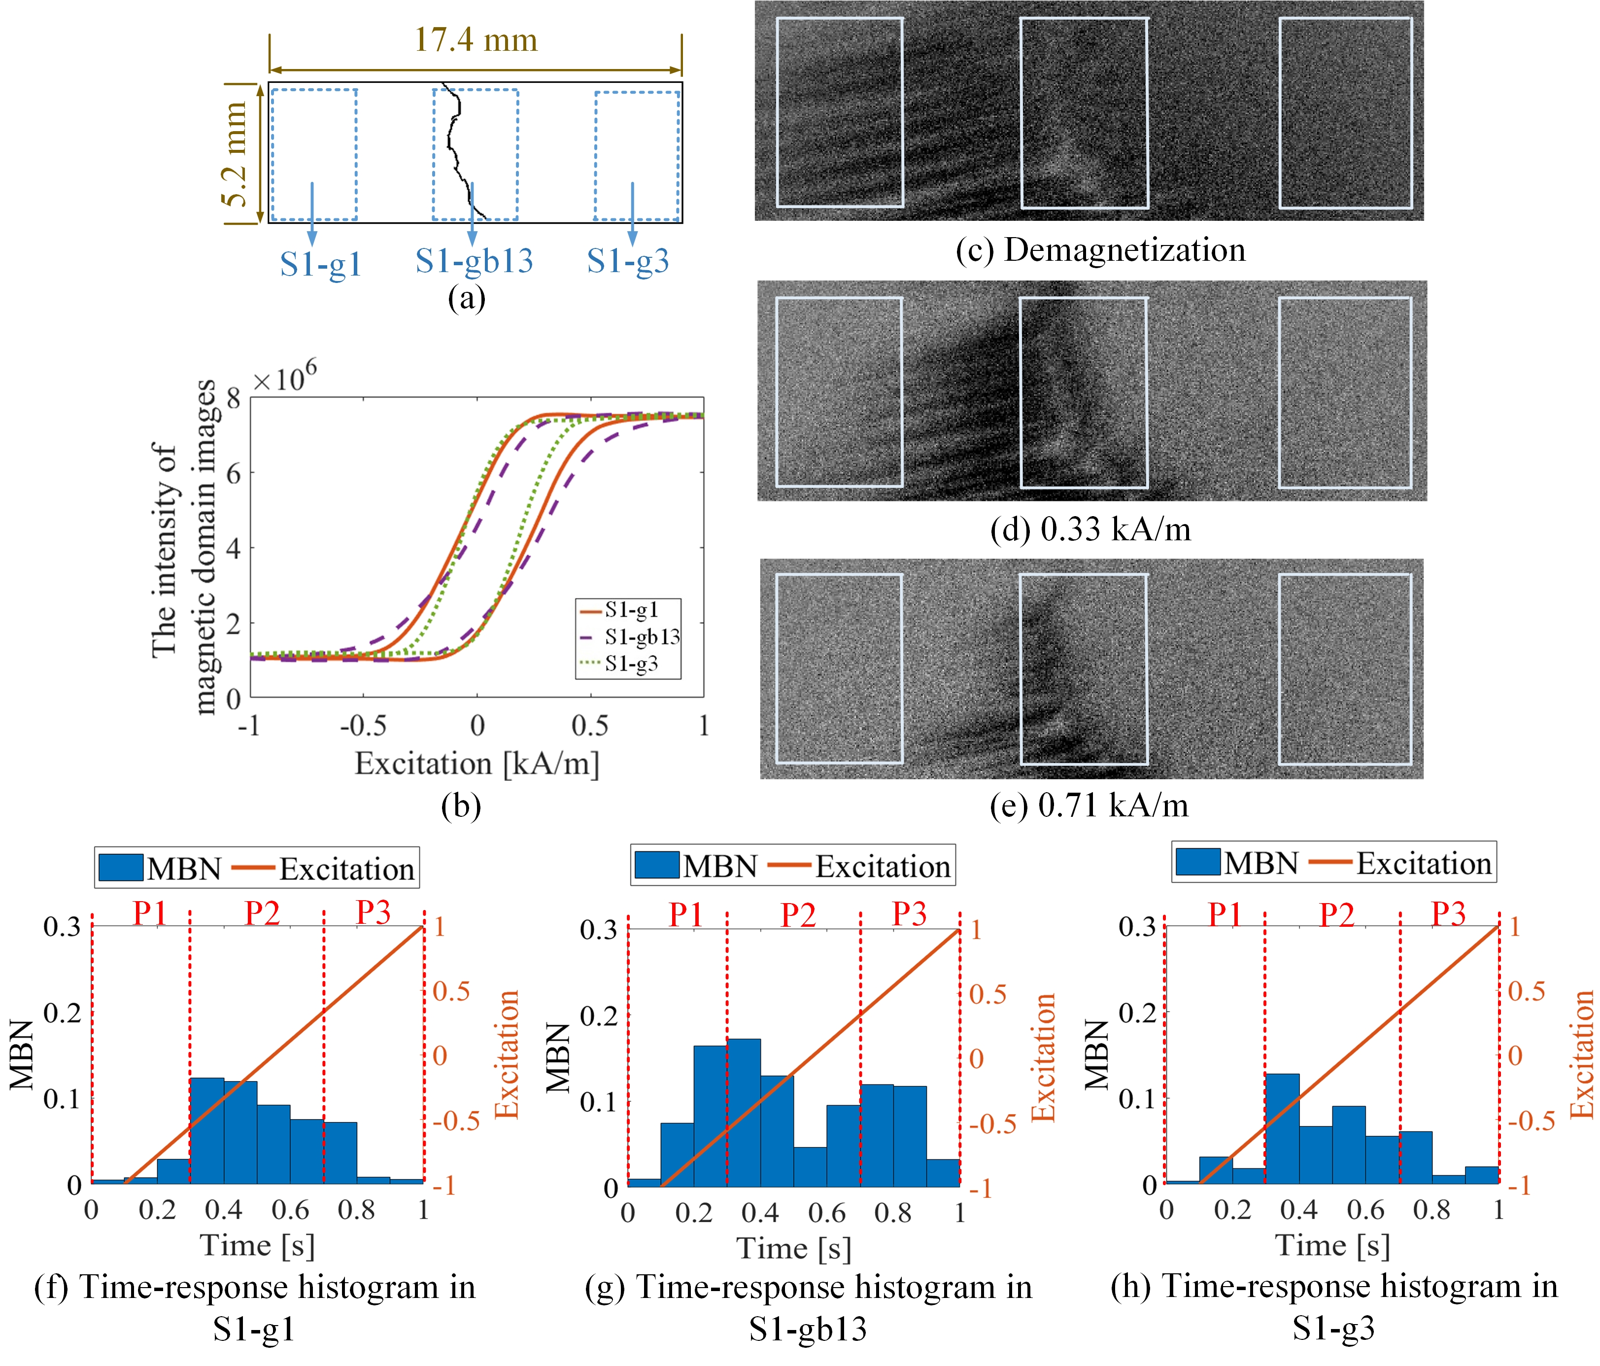
Fig. 4. Different time-response histogram of sample 1 in different locations when the tensile load is 740 N: (a) denotes the locations of S1-gb13, S1-g1 and S1-g3; (b) denotes the different hysteresis loops on different locations, (c), (d) and (e) show the different DW motion on the different locations; (f), (g) and (h) show the related quite different time-response histogram of MBN.

Time-response histogram for evaluation of magnetic properties on different grains and grain boundaries
To further analyze the influence of grain and grain boundary on material properties, the variation of the time-response histogram on different locations under tensile test is analyzed.
Fig. 5 shows the grain and the grain boundary distribution of the sample 1. The sample is divided into 15 parts ($5×3$) by a dotted grid. The area of each grid area is $3.33 mm×4.53 mm$. The X-coordinate and Y-coordinate define each part’s location, as shown in Fig. 5 (a). Due to the high spatial resolution magnetic probe, time-response histogram of MBN is detected on each part by scanning the sample, as shown in Fig. 5 (b). The magnetic domain and MBN are analyzed to investigate material properties on different locations.

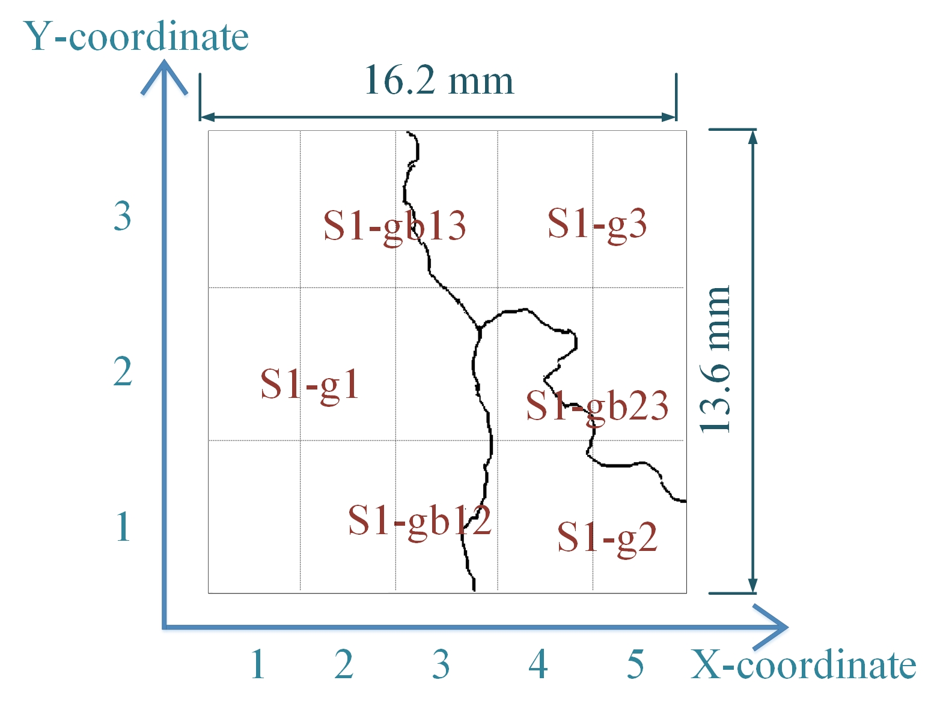
(a)
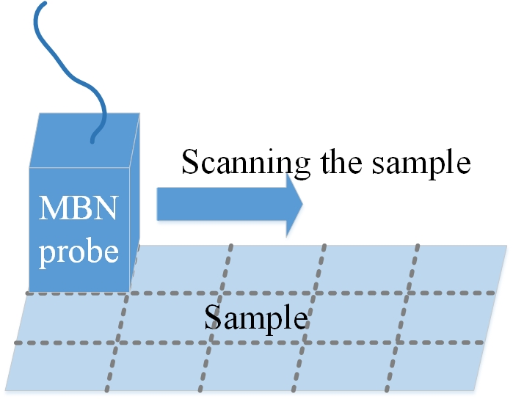
(b)
Fig. 5. The Sample is divided into 15 parts ($5×3$) by a dotted grid: (a) illustrates the grain distribution of the sample and the coordinate of each part; (b) shows MBN detection in each part by scanning the sample (Note: S1-g1, S1-g2, and S1-g3 denote three adjacent grains of the sample; S1-gb12 denotes grain boundary between grain S1-g1 and grain S1-g2; S1-gb13 denotes grain boundary between grain S1-g1 and grain S1-g3; S1-gb23 denotes grain boundary between grain S1-g2 and grain S1-g3)
DW motion varies with the increased load on different locations. From Fig. 6, there is no difference for the DW motion on the grain and the grain boundary under 0 N, while the DW motion becomes different with the increase of load. When the tensile load is 740 N, the average stress is 123 MPa, the DW distribution is more complicated on the grain boundary than this on the grain. The branch domain form around grain boundary S1-gb13 and S1-gb12 to reduce the increasing total energy caused by the tensile stress. Especially, on S1-gb12, magnetic field lines are mostly continuous across the grain boundary to reduce free poles on the grain interface under 123 MPa. Due to increasingly complex domain reorganization around S1-gb12, the energy loss is higher on this location [44]. Due to the different time-response of DW motion on different locations under the tensile test, the related time-response histograms of MBN are different. Figs. 7 and 9 show the time-response histogram on every part under the tensile test. From Fig. 9, when tensile stress is 0 MPa, since DW motion is the similar on the grain and grain boundary, time-response histogram on these locations is similar (such as Fig. 9 (a), (b), (d), (e), (f), (g), (i), (j), (k), (l), (n), (o)). However, due to residual stress and material manufacturing, time-response histograms on different locations exhibit a slight difference. When tensile the stress increases, the time-response histograms become much larger, the difference of the histogram on different locations becomes much larger. Besides, since the strength of the external magnetic field required to make material achieve saturation magnetization is much larger on the grain boundary (S1-gb12 and S1-gb13) than these on grain (S1-g1, S1-g2, and S1-g3), the amplitude of the time-response histogram become bigger on grain boundary (S1-gb12 and S1-gb13) than these on grain (S1- g1, S1- g2 and S1-g3).
The high spatial resolution MBN probe is sensitive for magnetic properties characterization, reflecting the grain and the grain boundary’s material properties. The time-response histogram on each part is consistent with DW motion results, proving the reliable repeat of correlation between DW motion and time-response histogram inside the grain and around the grain boundary. The material properties are inhomogeneous on different locations, the grain boundary and adjacent grains affect mechanical behavior [8, 45]. Figs. 7, 8, and 9 reflect that the magnetic properties and material properties on the grain boundary change greater than these on the grain under stress. The time-response histogram of MBN has enough sensitivity to characterize the grain and grain boundary effect on inhomogeneous material properties.

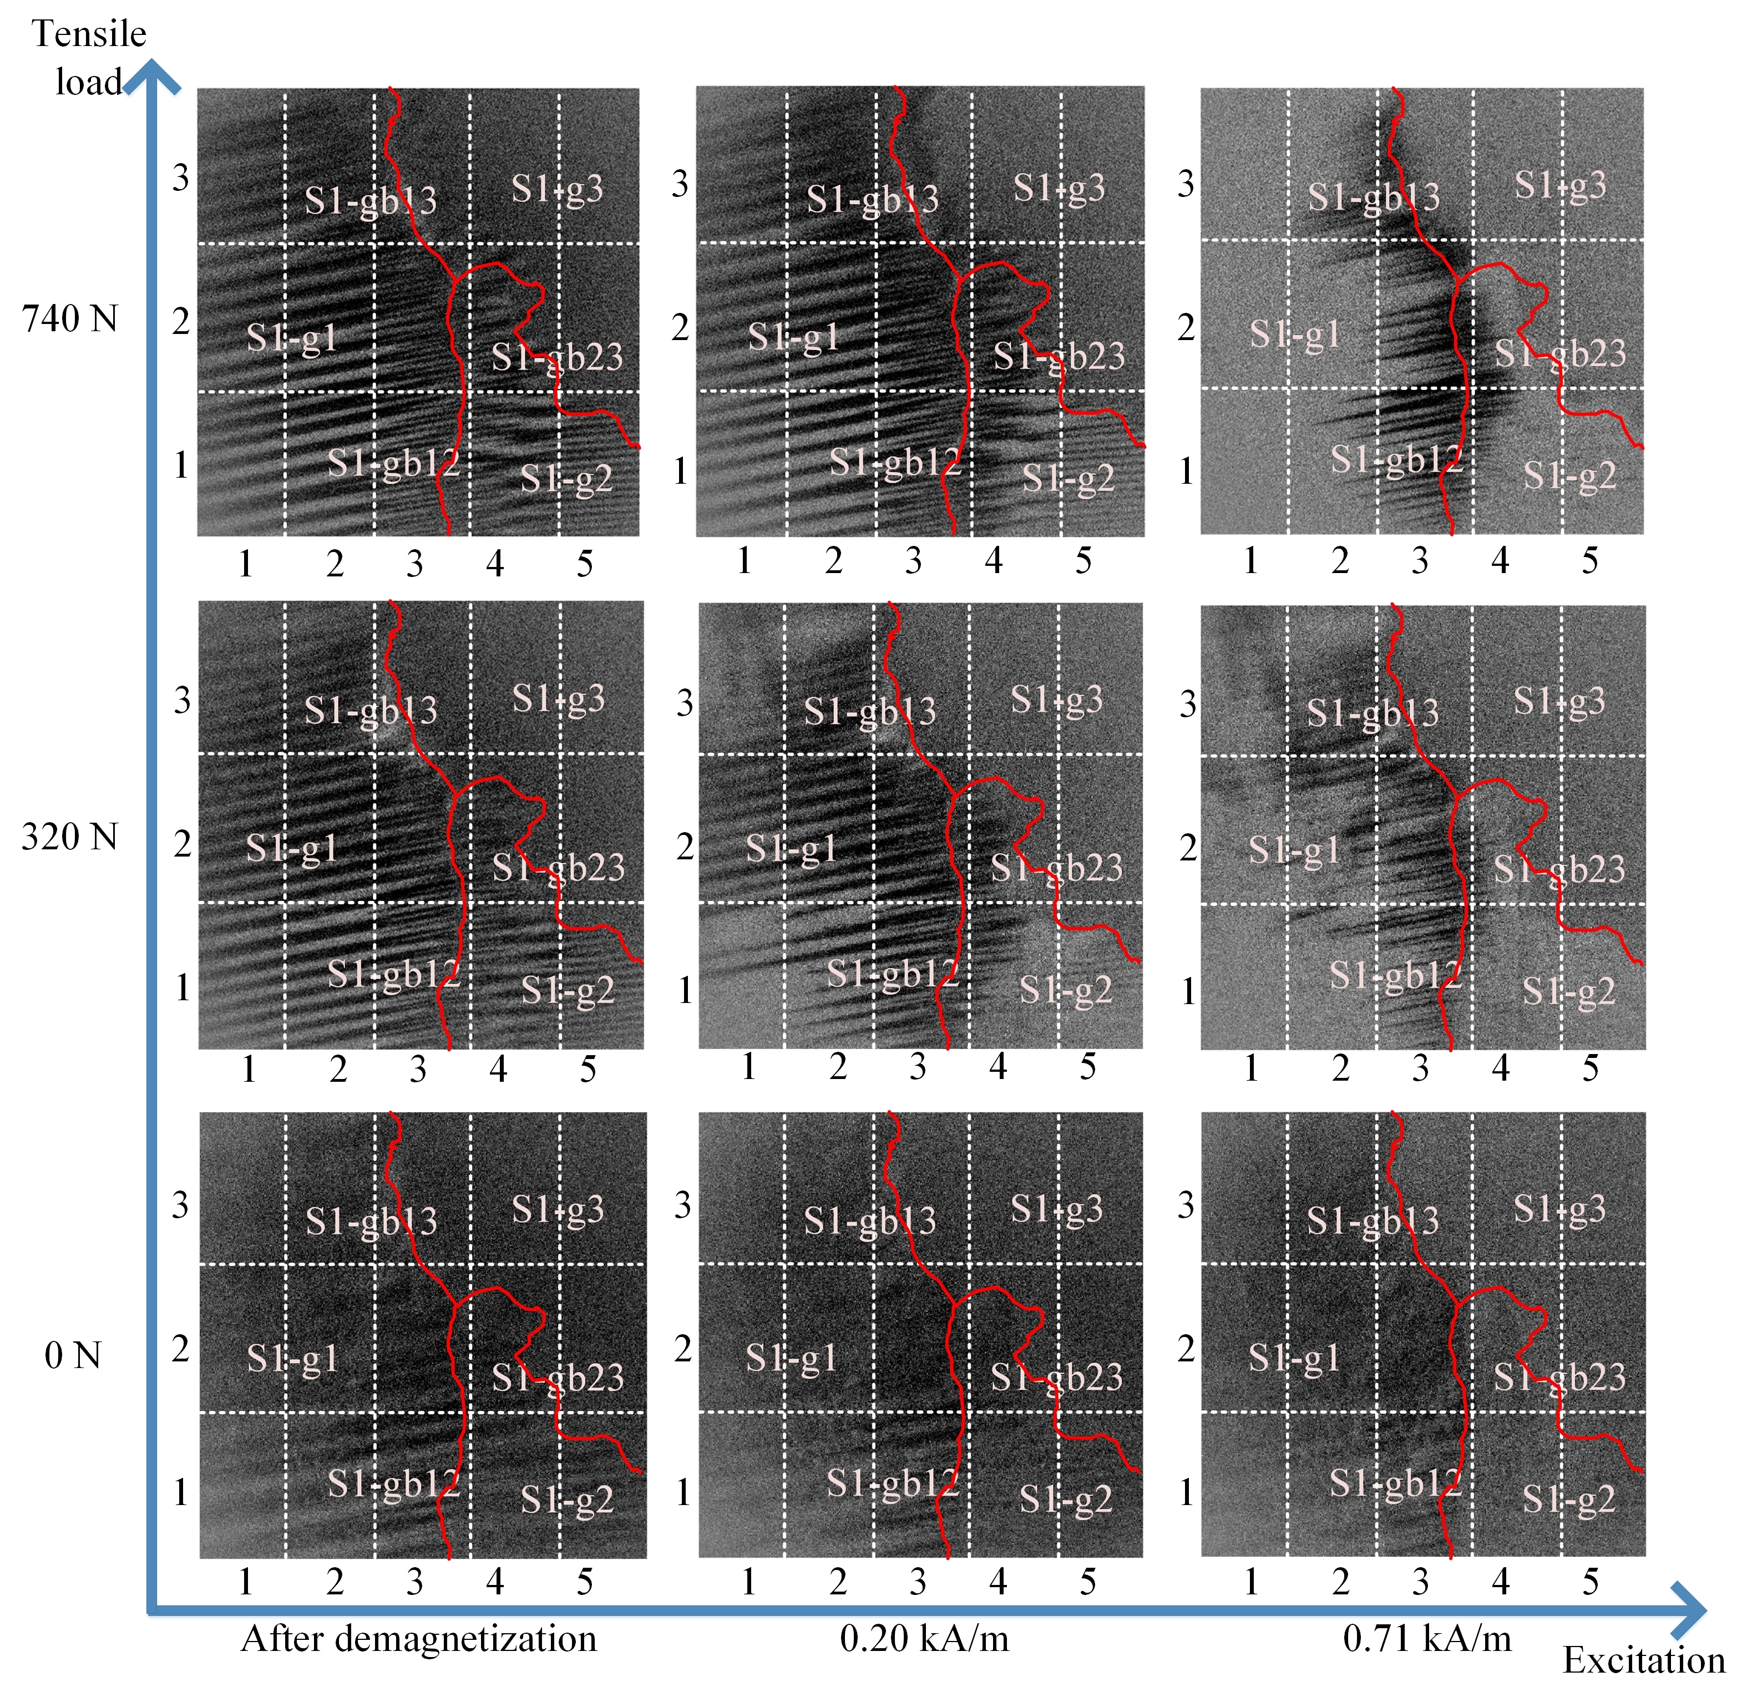
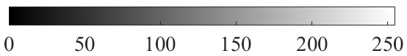
Fig. 6. The magnetic domain and DW motion on each part of the sample with the different tensile loads. The average stress is from 0 MPa increase to 123 MPa. When the tensile load increases, the difference of magnetic domain and DW motion increases on the grain and grain boundary.

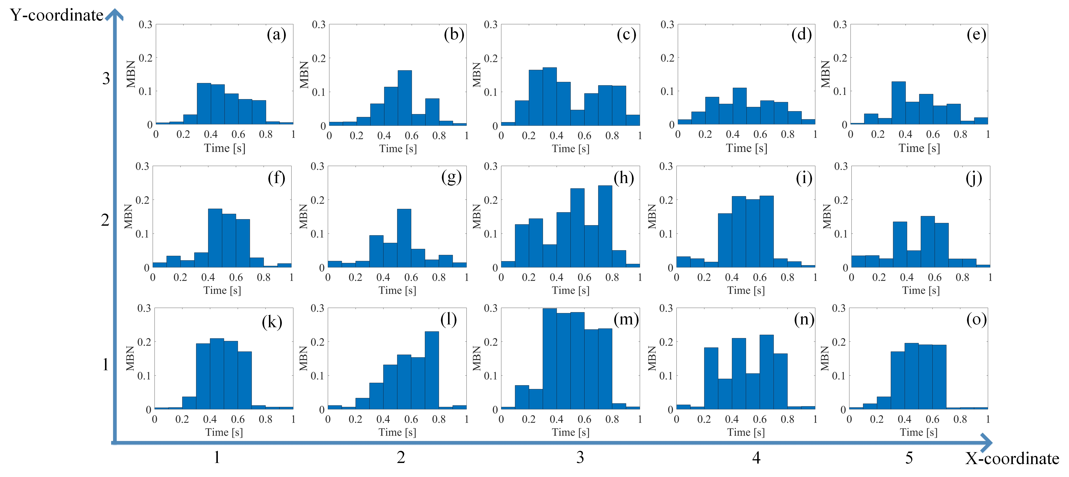
Fig. 7. Time-response histogram on different locations when the tensile load is 740 N. The time-response histogram increases with the increase of tensile load and the difference of MBN histogram on each part become much large.
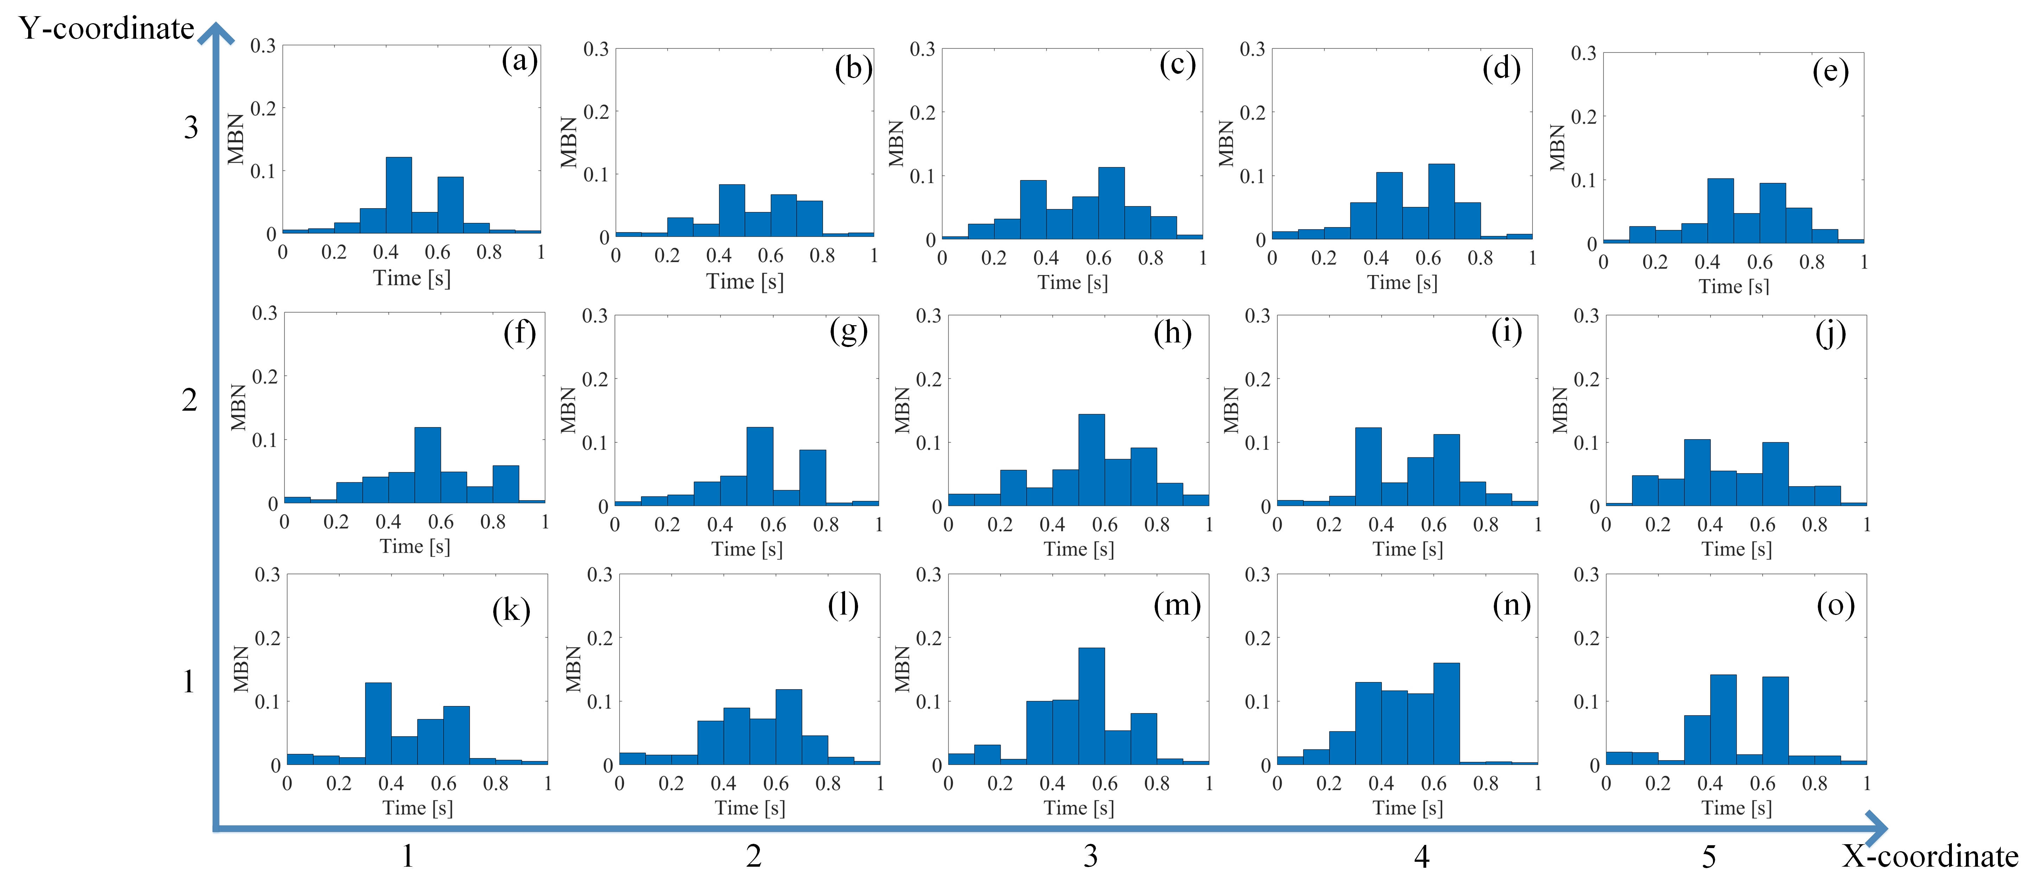
Fig. 8. Time-response histogram on the different locations when the tensile load is 320 N. The time-response histogram increases with tensile load.
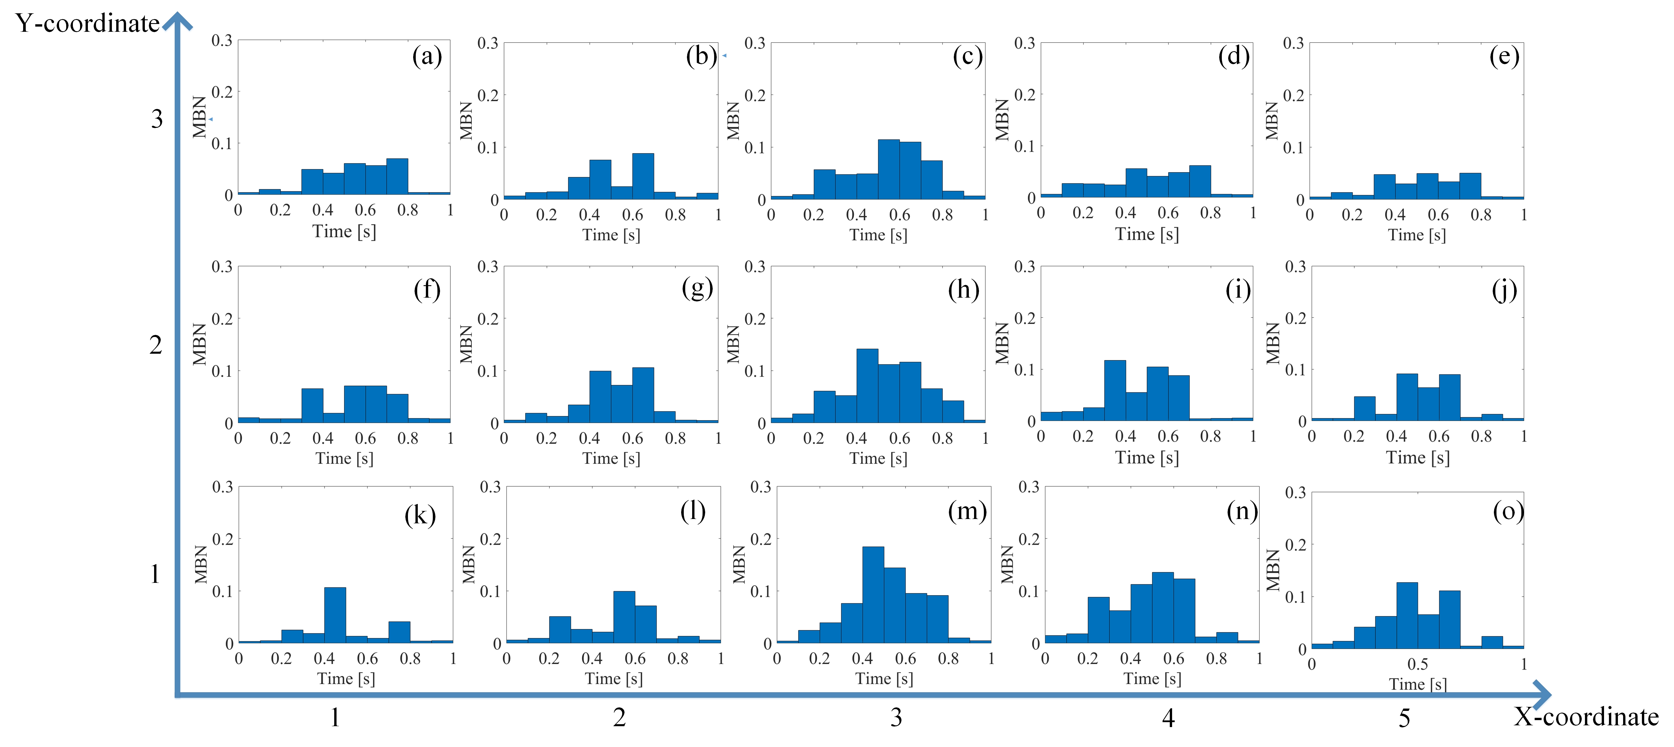
Fig. 9. Time-response histogram on different locations when the tensile load is 0 N. The Time-response histogram under 0 N exhibits a slight difference, including the slight difference of material properties affected by the residual stress, material manufacturing and etc. before the tensile test.

Discussion
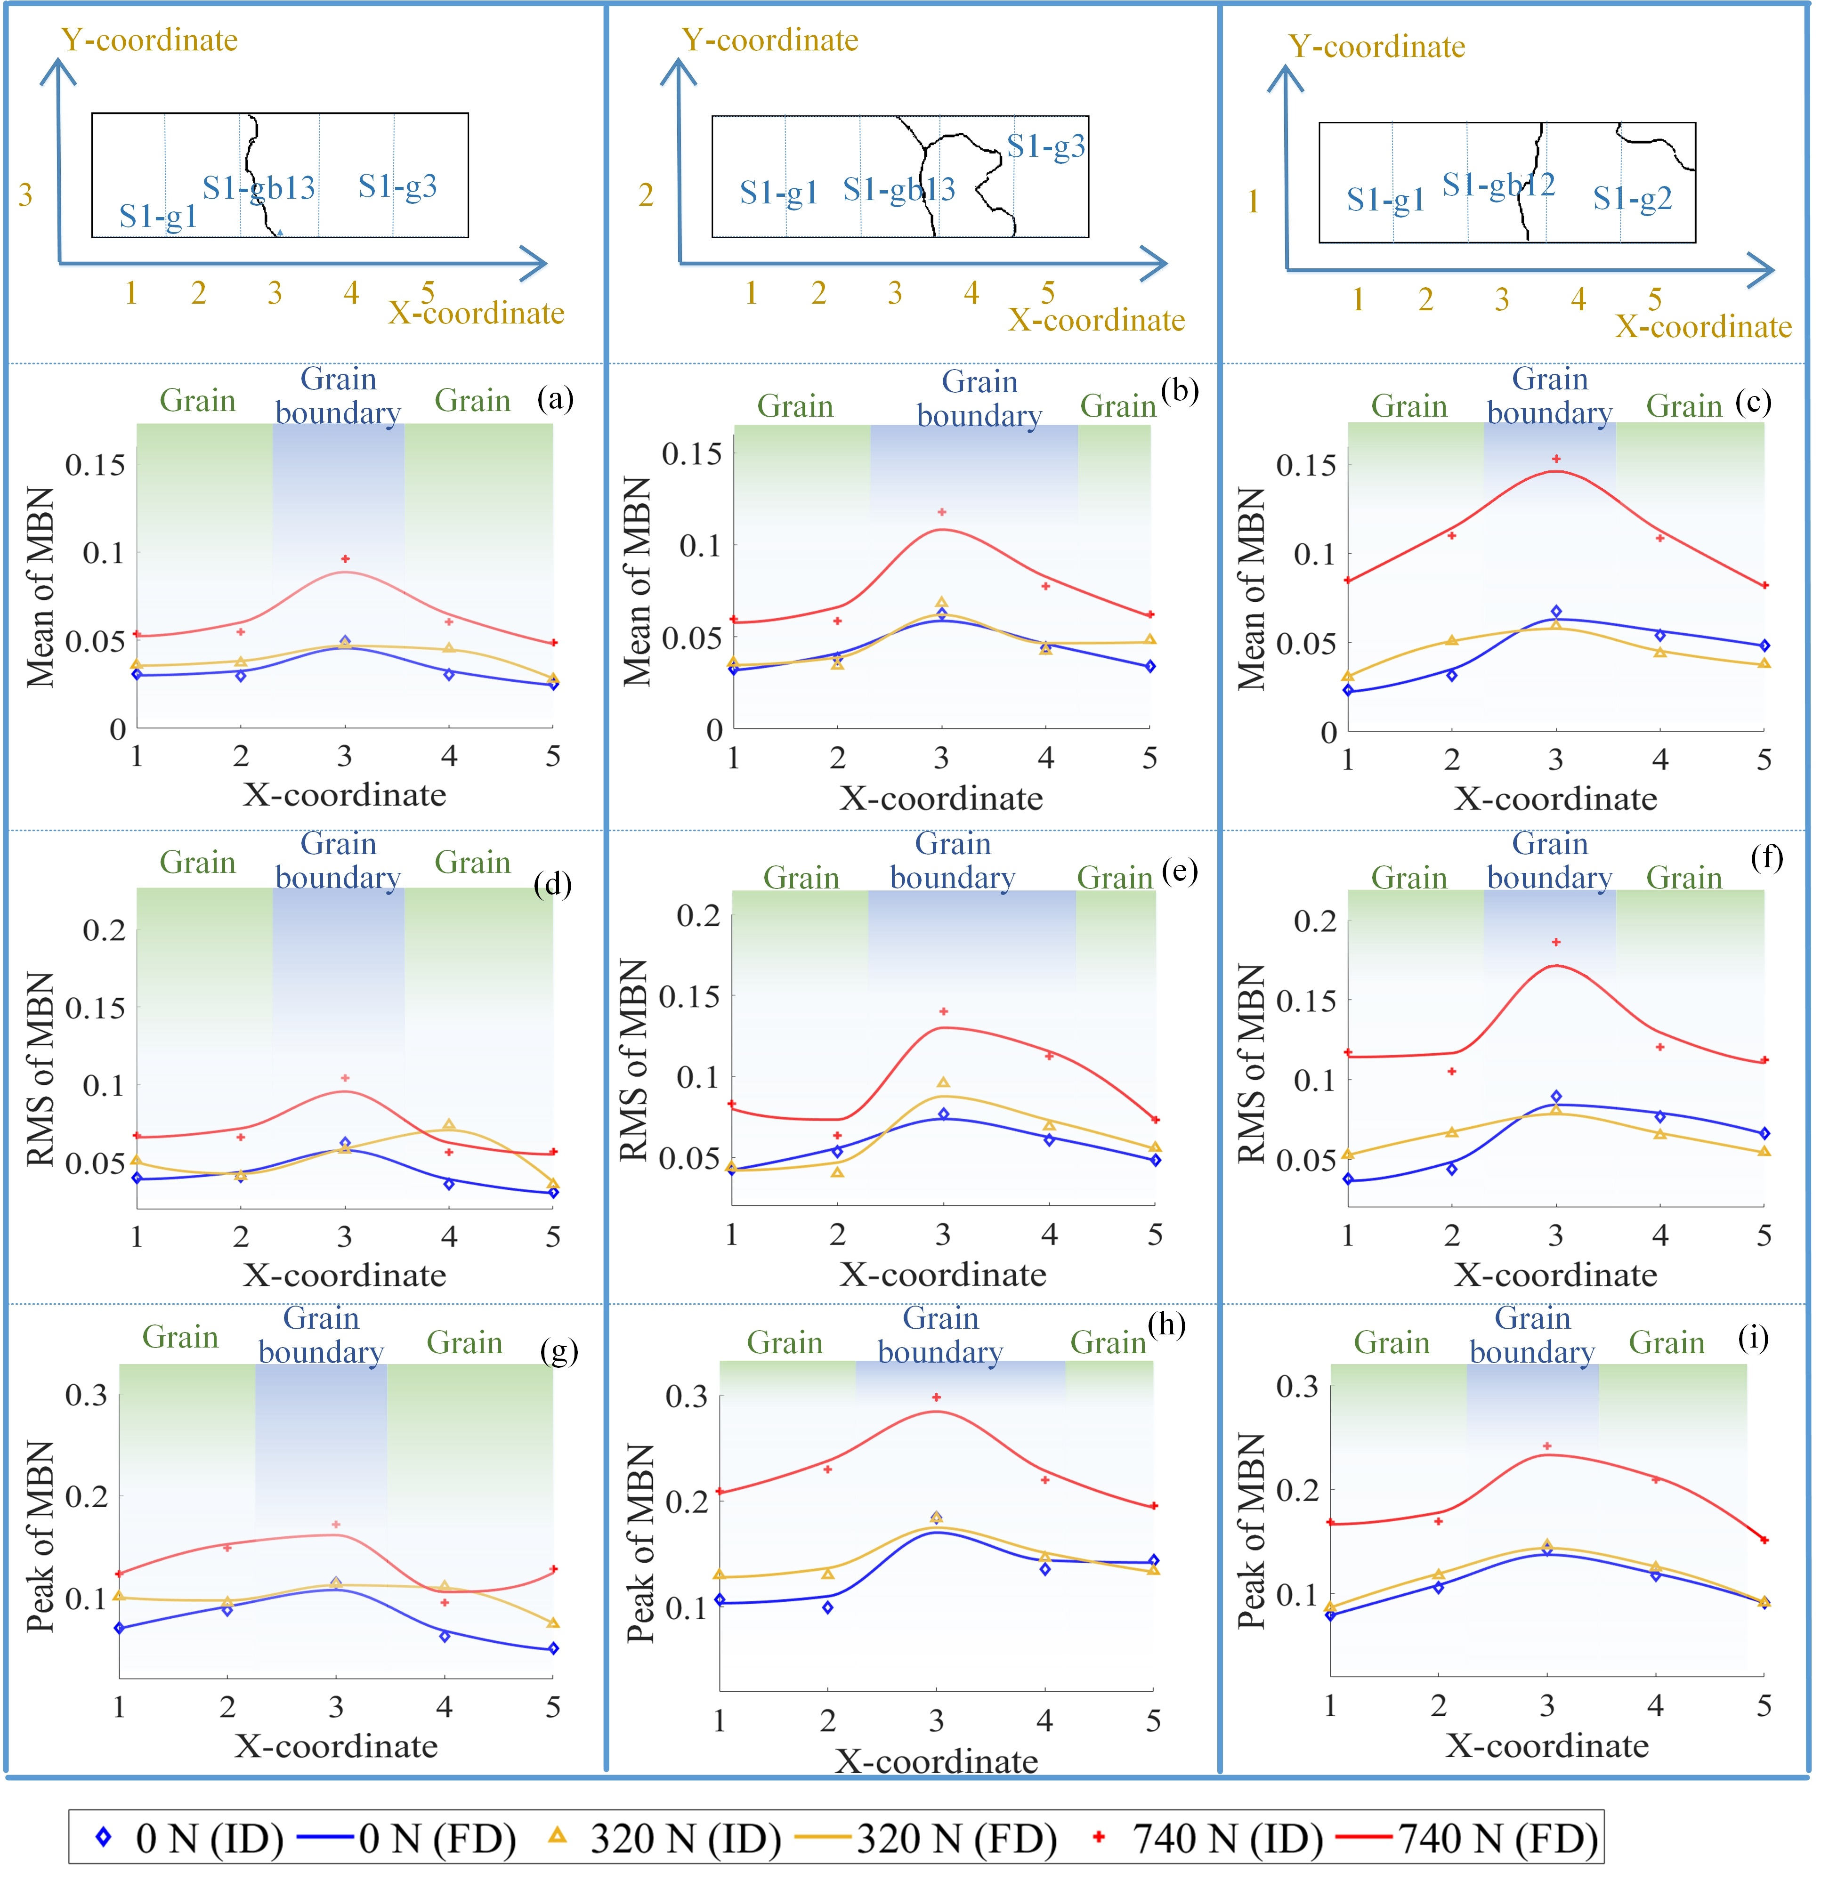
Fig. 10. The curves for the RMS, mean, and peak value of time-response histogram on different locations reflects the inhomogeneity of material properties on different locations. (Note: FD denotes the fitting data, ID denotes the original data.)
RMS, mean, and peak value are extracted from time-response histograms to quantify the inhomogeneity of material properties affected by microstructure under stress. In order to separate the variation of material properties affected by grain and grain boundary under stress, the time interval is adjusted to highlight the different time response of MBN signal affected by the stress or microstructure, respectively. Then, time-division is carried out to extract the root-mean-square (RMS), mean, and peak in the optimized time interval after the slight difference elimination without load.

Time-response histogram’s feature extraction for magnetic properties quantitative analysis with different stress
The time-response histogram of MBN reflects the variation of material state on different locations. MBN characteristic parameters such as RMS, mean value, and peak value have a high correlation with stress in the previous studies [29]. RMS, mean, and peak value on the grains and grain boundaries are extracted from the histogram on each part to investigate the time-response histogram’s statistical properties, which quantitatively analyzes the material properties. In this paper, the magnetization frequency is 0.5 Hz. The interval of the time-response histogram bin is 0.1 s. The number of histogram bins is 10. Thus, the feature exaction for the quantitative method can be defined as:
$RMS(σ)=\sqrt{\frac{\sum_{i=1}^{N}{V_{n}(σ})}{N}}$ (4)
$Peakvalue(σ)=max⁡(V_{n}(σ))$ (5)
$mean\left(σ\right)=\overline{V_{n}(σ)}$ (6)
where $N$ denotes the number of histogram bins and $V_{n}(σ)$ denotes the amplitude of each bin.
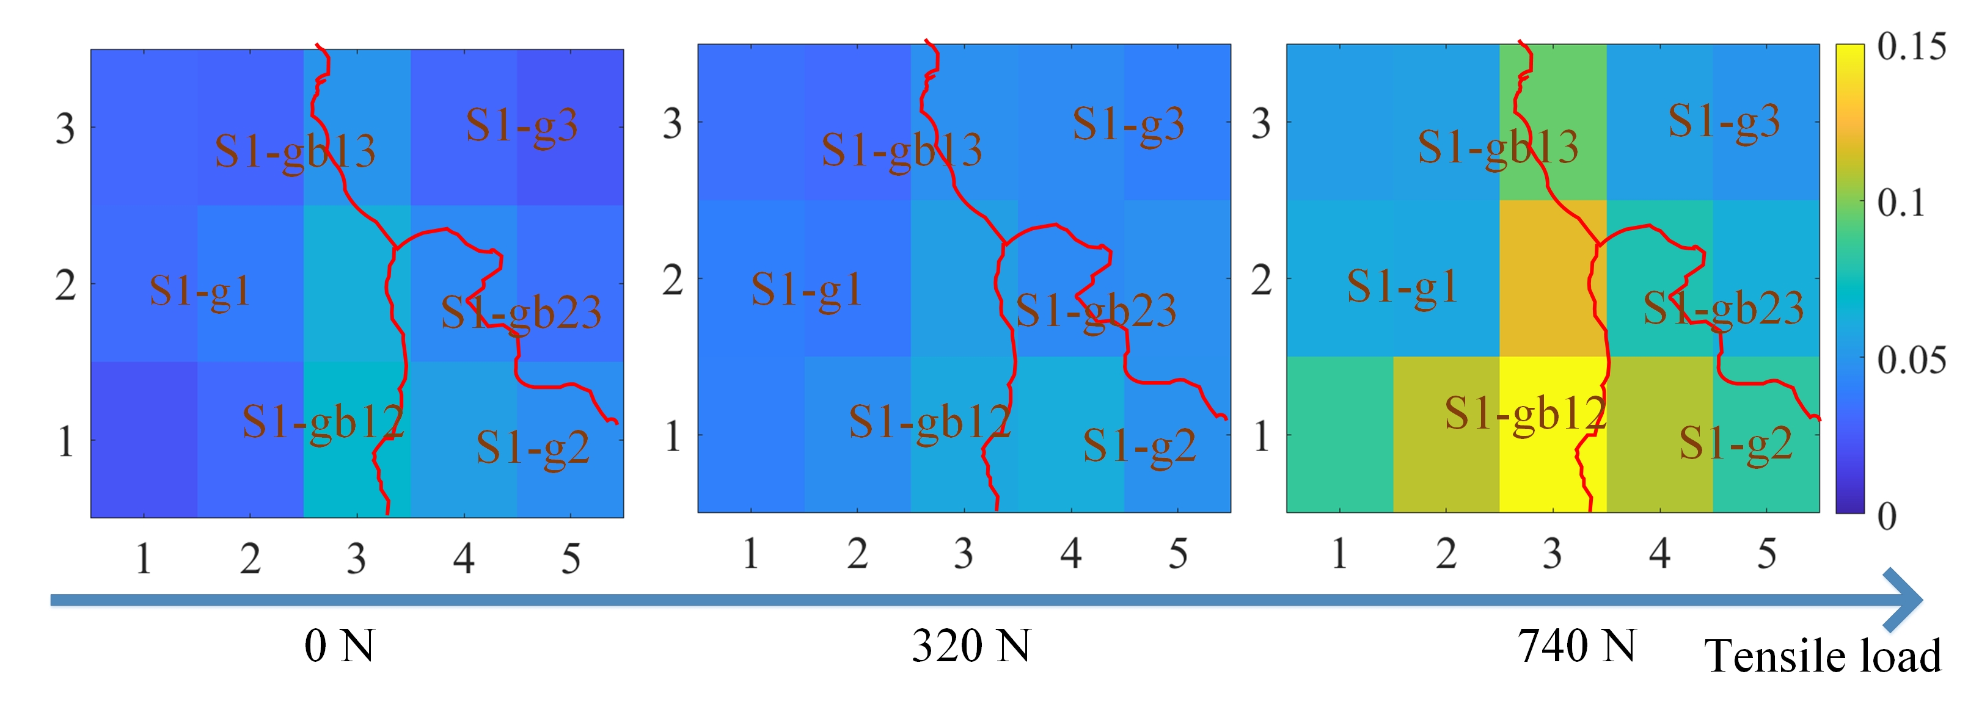
Fig. 11. The images for the mean of Time-response histogram on different location to reflect the inhomogeneous material properties on different locations. The size of images is 16.2 mm × 13.6 mm
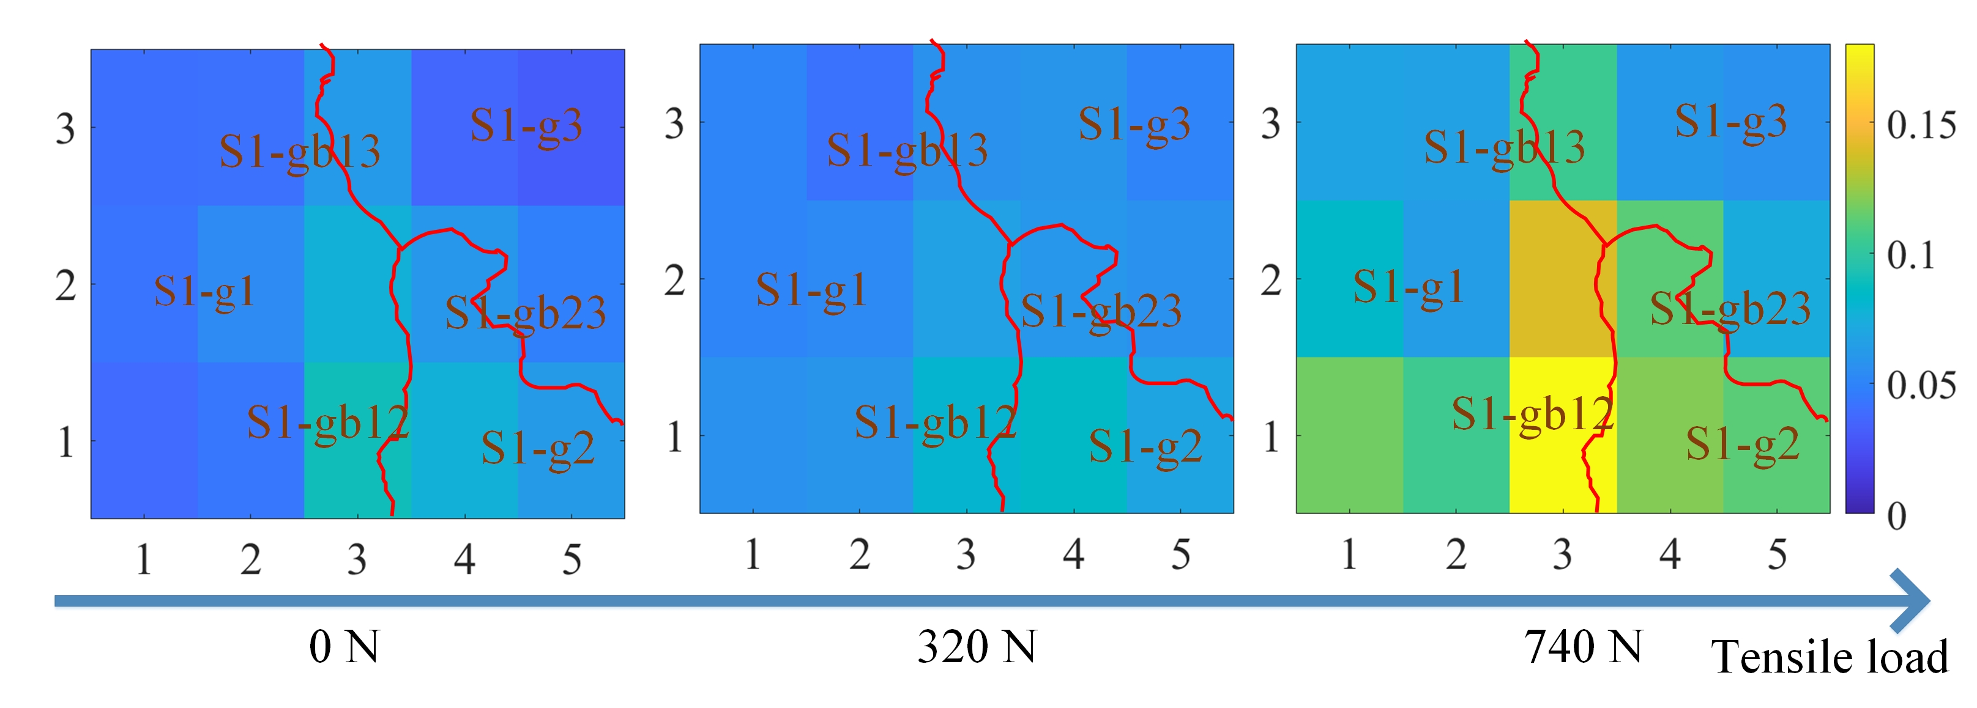
Fig. 12. The images for the RMS of Time-response histogram of on different location to reflect inhomogeneous material properties on different locations. The size of images is 16.2 mm × 13.6 mm
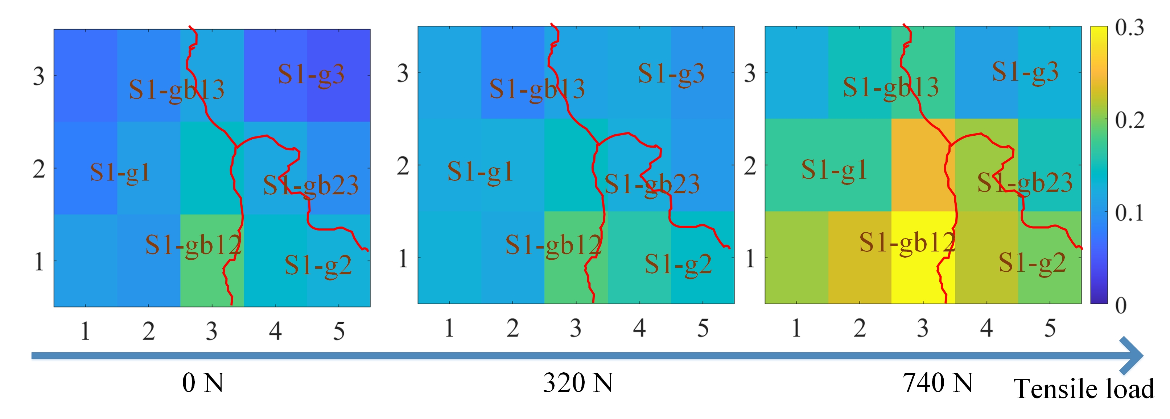
Fig. 13. The images for the peak value of Time-response histogram on different location to reflect inhomogeneous material properties on different locations. The size of images is 16.2 mm × 13.6 mm
When the tensile load is from 0 N to 740 N, the sample’s average tensile stress is from 0 MPa to 123 MPa. However, due to the grain and grain boundary, the material properties on different locations is not uniform. Fig. 10 shows the curve of the three features of the time-response histogram. Figs. 11, 12, and 13 show the two-dimension images for RSM, mean, and peak value of the time-response histogram on different locations. A clear positive correlation between measured tensile stress state and the corresponding MBN is verified in the previous study [36]. These features quantify the micromagnetic properties on different locations, quantifying the inhomogeneous material properties. The mean, RMS, and peak values have the same increase tendency with the increase of stress. However, these features are higher on the grain boundaries than these on grain. Due to the higher time-response histogram and its features on the grain boundary, grain boundaries are more susceptible to external tensile load. Especially since the time-response histogram is much higher on the grain boundary S1-gb12, material properties increase dramatically on S1-gb12. The minor failure is more likely to occur on the grain boundary S1-gb12 [10, 44].
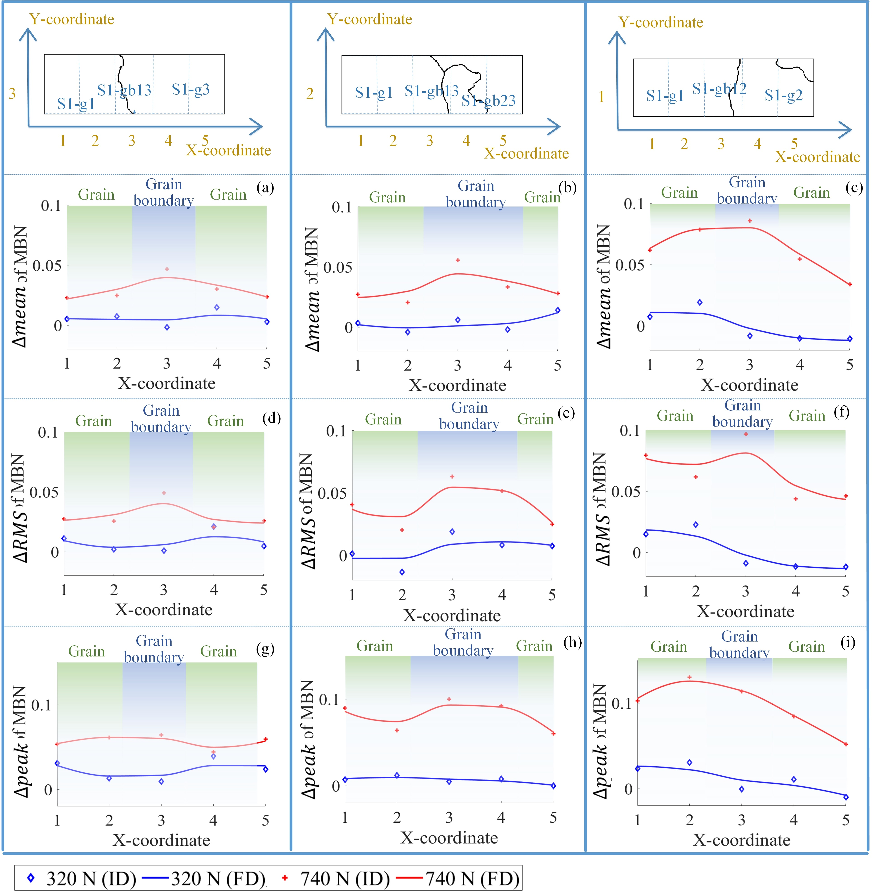
Fig. 14. The difference elimination of material properties before tensile test. (Note: FD denotes the fitting data, ID denotes the original data.)

MBN emission increases along with tensile stresses and decreases with compressive stresses, especially for uniaxial loading and elastic regime [12]. The time-response histogram and its features show that the material properties under tensile load are affected by grain and grain boundary. The varying degree of material properties is much higher on the grain boundary than other locations. The grain boundary is more unstable, and the material properties on the grain boundary are more susceptible to the influence of tensile load. The total tensile stress acting normal to the grain boundary during elastic deformation is a sum of the internal stress due to the applied load, resolved onto the grain boundary plane [10]. The domain walls motion in the case is a function of micro-stresses (the function of grain and grain boundary microstructure) [12]. The micro stress is higher on the grain boundary than grain, making grain boundary more prone to the early minor failure formation on the grain boundary [8]. The time-response histogram and its features characterize time characteristics of DW motion to quantitative analyze the inhomogeneous material properties affected by the stress, grain, and grain boundary.

The difference elimination of magnetic properties before tensile test
The magnetic properties under 0 N exhibit a slight difference as shown in Figs. 10, 11, 12, and 13. There are many factors contribute the difference before tensile test, including the residual stress, material manufacturing, etc. It is better to reduce the difference before the tensile test to further analyze and separate the inhomogeneous material properties affected by the grain, grain boundary and tensile stress, as shown in Fig. 14. The difference between these features with load and without load is carried out to remove slight difference of material properties before tensile test. The definition of the difference of histogram features is shown in following:
$∆RMS=RMS\left(σ\right)-RMS\left(0\right)$ (7)
$∆mean=mean\left(σ\right)-mean\left(0\right)$ (8)
$∆peak=peak\left(σ\right)-peak\left(0\right)$ (9)
where $RMS\left(σ\right), mean\left(σ\right)$, and$peak\left(σ\right)$ denote RMS, mean, and peak value with load, $RMS\left(0\right), mean\left(0\right)$, and$peak\left(0\right)$ denote RMS, mean, and peak value without load.
Compare with the results of Fig. 13, $∆RMS$, $∆mean$, and $∆peak$ are almost uniform on the different locations when the tensile stress increase from 0 MPa to 53 MPa. It means that the difference of histogram features removes the difference of magnetic properties before tensile test. When the tensile stress increase from 0 MPa to 123 MPa, $∆RMS$, $∆mean$ , and $∆peak$ on the grain boundaries are higher than these on the grains. As the time-response histogram on the grain boundary is more susceptible to the tensile load, $∆RMS$, $∆mean$, and $∆peak$ reflects the inhomogeneity of the material properties affected by stress, grain, and grain boundary. When the tensile stress increase 123 MPa, which makes the degree of material properties inhomogeneity much more significant on the grain boundary than this on the grain. The time-response histogram becomes quite different. The difference elimination of magnetic parameters without load is helpful to reduce the influence of material microstructure on the initial material state before the tensile test.

Time-division to separate the magnetic properties’ variation affected by grain and grain boundary
Due to load transfer on the grain and grain boundary, the magnetic properties and material properties are inhomogeneous [11]. The time-division is carried out to optimize the time interval to separate the material properties’ variation affected by the grain and the grain boundary.
The main factor of time-division is how to localize the time bands [46]. The time-division has high time resolution and less redundant information for material properties’ variation separation. In this paper, the optimal time-division is in line with the excitation and hysteresis loops, which is shown in Figs. 3 and 4. Based on the time-response histogram on different locations shown in Figs. 3 and 4, the time-division with three-time bands is enough to separate the material properties affected by stress, grain and grain boundary. The time bands p1 (0 – 0.3 s) and p3 (0.7 s – 1 s) identify the material properties’ variation affected by the tensile stress and microstructure. The time bands p2 is 0.3 - 0.7 s, which determines the material properties’ variation affected by the tensile stress.
As shown in Fig. 15, the time-division is used for the feature separation, analyzing on each part of the sample. For the time band p1 and p3, the difference of time-response histogram features ($∆RMS$, $∆mean$ , and $∆peak$) on the grain boundary increases much higher than these on the grain under 123 MPa. However, the variation of these features for time band p2 is almost uniform.
When the tensile stress is 53 MPa, the material properties on the grains and the grain boundaries is uniform. When the tensile stress increases to 123 MPa, due to the influence of stress and material microstructure, material properties on grain boundaries vary significantly, reflected by the time band p1 and p3. However, for time-band p2, the variation of time-response histogram features is almost uniform from 53 MPa to 123 MPa.
The optimal time-division is based on the correlation of applied field and magnetization processes on different locations. When the load increases, the distribution of DW on the grain boundary becomes more complicated. It takes more time on the grain boundary to reach magnetic saturation during the magnetization process. As a result, the MBN activities last longer, and the time-response histogram features are larger on the grain boundary. After the slight difference elimination of material properties without load, the time-division separate the material properties affected by the grain and the grain boundary. The time band p1 and p3 highlight the different variation of micro-macro magnetic properties affect by the microstructure and stress, while the time band p2 removes the variation of material properties affected by the microstructure. Based on the approach proposed in this paper, the standard sample of the other ferromagnetic material without external load will be used as a reference to reduce the slight difference of material properties without load to improve the results of on inhomogeneous material properties evaluation affected by the grain, grain boundary, and stress [47]. Besides, the time-division will be used to analyze inhomogeneity of material properties with other grain size for other ferromagnetic material.

Conclusion and future work
In this paper, based on the combination of DW motion and MBN, the time-response histogram of MBN is established with a high spatial resolution to nondestructively characterize silicon steel sheet’s inhomogeneous material properties affected by the grain and grain boundary with the stress. The main conclusions are summarized as follows:
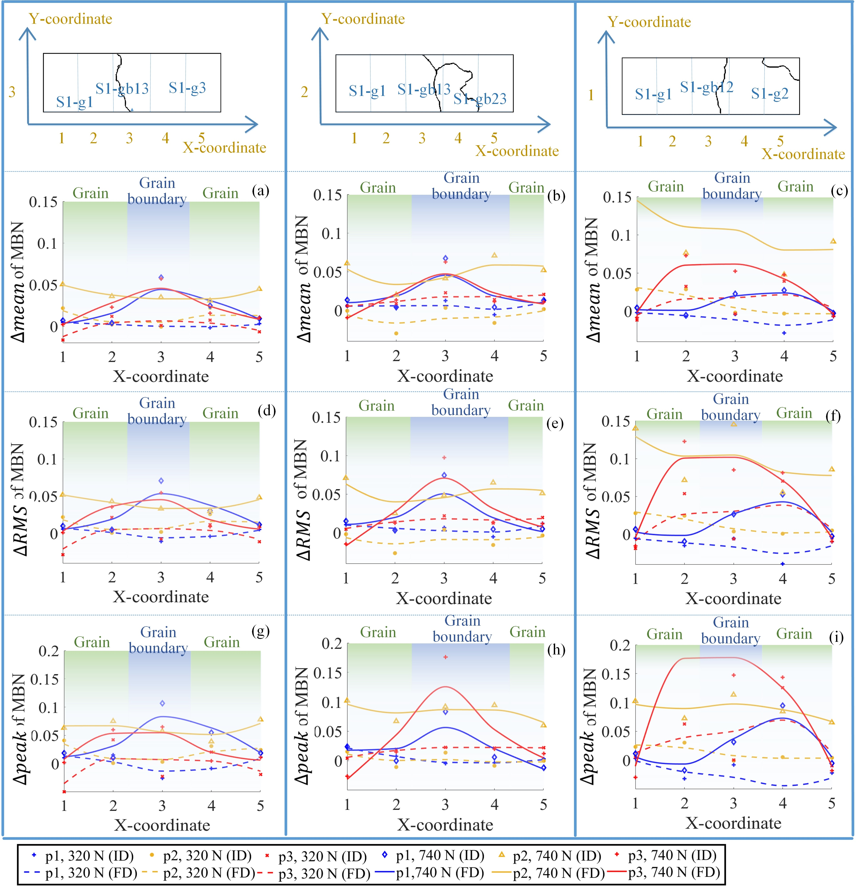
Fig. 15. The time-division to separate the material properties affected by grain and grain boundary. The histogram features in p1 (0 – 0.3 s) and p3 (0.7 s – 1 s) identify the variation affected by the tensile load; the histogram feature in p2 (0.3-0.7 s) identify the variation affected by the tensile load and microstructure. (Note: FD denotes the fitting data, ID denotes the original data.)
    - The time-response histogram characterizes DW motion in the same interval to investigate the time response of magnetic properties on different locations. The time-response histogram become different on different locations with stress, characterizing the inhomogeneous material properties on the grain and grain boundary.
    - The varying degrees of material properties are much higher on the grain boundary than the grain with the stress state. Especially, MBN signals on the grain boundary S1-gb12 are much higher than other locations, reflecting the fact that the grain boundaries are more susceptible to external tensile load.
    - The RMS, mean, and peak value are extracted from the time-response histogram to quantify the material properties’ variation on the grain and grain boundary. These three features have the same tendency on different locations under stress.
    - The time-division separates the variation of magnetic properties affected by grain and grain boundary after difference elimination of magnetic properties without load. The time intervals p1 and p3 highlight the different variation of magnetic properties affected by the microstructure and stress, while the time band p2 removes the variation of material properties affected by the microstructure.
The study provides a theoretical and experimental for a better understanding of the effect of grain, grain boundary on inhomogeneous material properties evaluation of other ferromagnetic material (especial Q235, steel. etc.) by using MBN [48-49]. Besides, the relationship between mechanical properties and magnetic properties during the elastic deformation and plastic deformation will be investigated to analyze the influence of inhomogeneity material properties on the mechanism of failure development [50].

Acknowledgement
This work is funded by the National Natural Science Foundation of China (Grants No. 61527803, No. 61960206010 and No. 61971093) and supported by the National Key R&D Program of China (Grants No. 2017YFF0209702).

References
[1] B Cao, T Iwamoto, P P Bhattacharjee. An experimental study on strain-induced martensitic transformation behavior in SUS304 austenitic stainless steel during higher strain rate deformation by continuous evaluation of relative magnetic permeability [J]. Materials Science and Engineering: A, 2020: 138927.
[2] K Habib, M Koyama, T Tsuchiyama, et al., Dislocation motion at a fatigue crack tip in a high-nitrogen steel clarified through in situ electron channeling contrast imaging [J]. Materials Characterization, 2019, 158: 109930.
[3] C Meng, W Hu, S Sandlöbes, et al. The effect of large plastic deformation on elevated temperature mechanical behavior of dynamic strain aging Al-Mg alloys [J]. Acta Materialia, 2019, 181: 67-77.

[4] H K Jun, J W Seo, I S Jeon, et al. Fracture and fatigue crack growth analyses on a weld-repaired railway rail [J]. Engineering failure analysis, 2016, 59: 478-492.
[5] S H Lee, S H Kim, Y S Chang, et al. Fatigue life assessment of railway rail subjected to welding residual and contact stresses [J]. Journal of Mechanical Science and Technology, 2014, 28(11): 4483-4491.
[6] S P Donegan, N Kumar, M A Groeber. Associating local microstructure with predicted thermally-induced stress hotspots using convolutional neural networks [J]. Materials Characterization, 2019, 158: 109960.
[7] S Zarei, R J Nedoushan, M Atapour. The sources of the micro stress and strain inhomogeneity in dual phase steels [J]. Materials Science and Engineering: A, 2016, 674: 384-396.
[8] Y Zhao,R Tryon. Automatic 3-D simulation and micro-stress distribution of polycrystalline metallic materials [J]. Computer Methods in Applied Mechanics and Engineering, 2004, 193(36-38): 3919-3934.
[9] D C Pagan, P A Shade, N R Barton, et al. Modeling slip system strength evolution in Ti-7Al informed by in-situ grain stress measurements [J]. Acta Materialia, 2017,128: 406-417.
[10] D C Johnson, B Kuhr, D Farkas, et al. Quantitative linkage between the stress at dislocation channel–Grain boundary interaction sites and irradiation assisted stress corrosion crack initiation [J]. Acta Materialia, 2019, 170： 166-175.
[11] X X Zhang, J F Zhang, Z Y Liu, et al. Microscopic stresses in carbon nanotube reinforced aluminum matrix composites determined by in-situ neutron diffraction [J]. Journal of Materials Science & Technology, 2020, 54(1): 58-68.
[12] M Neslušan, P Minárik, M Čilliková, et al., Barkhausen noise emission in tool steel X210Cr12 after semi-solid processing[J]. Materials Characterization, 2019, 157: 109891.
[13] Ryu K S, Akinaga H, Shin S C, Tunable scaling behaviour observed in Barkhausen criticality of a ferromagnetic film [J]. Nature Physics, 2007, 3(8): 547.
[14] J A J Burgess, A E Fraser, F F Sani, et al. Quantitative magneto-mechanical detection and control of the Barkhausen effect [J]. Science, 2013, 339(6123): 1051-1054.
[15] D C Jiles. Dynamics of domain magnetization and the Barkhausen effect [J]. Czechoslovak journal of physics, 2000, 50(8): 893-924.
[16] T Herranen, L Laurson. Barkhausen Noise from Precessional Domain Wall Motion [J]. Physical Review Letters, 2019, 122(11).
[17] F Colaiori. Exactly solvable model of avalanches dynamics for Barkhausen crackling noise[J]. Advances in Physics, 2008, 57(4): 287-359.
[18] A Vazquez, O Sotolongo-costa, Dynamics of a domain wall in soft-magnetic materials: Barkhausen effect and relation with sandpile models [J]. Physical review letters, 2000, 84(6): 1316.
[19] V Zhukova, J M Blanco, P Corte-Leon, et al. Grading the magnetic anisotropy and engineering the domain wall dynamics in Fe-rich microwires by stress-annealing [J]. Acta Materialia, 2018, 155: 279-285.
[20] J C Sánchez, M F De Campos, L R Padovese. Magnetic Barkhausen emission in lightly deformed AISI 1070 steel [J]. Journal of Magnetism and Magnetic Materials, 2012, 324(1): 11-14.
[21] H I Yelbay, I Cam, C H Gür. Non-destructive determination of residual stress state in steel weldments by Magnetic Barkhausen Noise technique [J]. NDT & E International, 2010, 43(1): 29-33.
[22] S Ghanei, A S Alam, M Kashefi, et al. Nondestructive characterization of microstructure and mechanical properties of intercritically annealed dual-phase steel by magnetic Barkhausen noise technique [J]. Materials Science and Engineering: A, 2014, 607: 253-260.
[23] M Maciusowicz, G Psuj. Use of Time-Dependent Multispectral Representation of Magnetic Barkhausen Noise Signals for the Needs of Non-Destructive Evaluation of Steel Materials [J]. Sensors, 2019, 19(6): 1443.
[24] L Lan, X Jin, S Gao, et al. Microstructural evolution and stress state related to mechanical properties of electron beam melted Ti-6Al-4V alloy modified by laser shock peening [J]. Journal of Materials Science & Technology, 2020, 50:153-161.
[25] P Wang, C S Lao, Z W Chen, Y. K. Liu, et al. Microstructure and mechanical properties of Al-12Si and Al-3.5 Cu-1.5 Mg-1Si bimetal fabricated by selective laser melting [J]. Journal of Materials Science & Technology, 2020, 36: 18-26.
[26] M Neslušan, P Minárik, M Čilliková, et al. Barkhausen noise emission in tool steel X210Cr12 after semi-solid processing [J]. Materials Characterization, 2019, 157: 109891.
[27] S Yamaura, Y Furuya, T Watanabe. The effect of grain boundary microstructure on Barkhausen noise in ferromagnetic materials [J]. Acta materialia, 2001, 49(15): 3019-3027.
[28] M Neslušan, J Čížek, K Kolařík, et al. Monitoring of grinding burn via Barkhausen noise emission in case-hardened steel in large-bearing production [J]. Journal of Materials Processing Technology, 2017, 240: 104-117.
[29] M Maciusowicz, G Psuj. Time-Frequency Analysis of Barkhausen Noise for the Needs of Anisotropy Evaluation of Grain-Oriented Steels [J]. Sensors. 2020, 20(3):768.
[30] S Ghanei, A S Alam, M Kashefi, et al. (2014). Nondestructive characterization of microstructure and mechanical properties of intercritically annealed dual-phase steel by magnetic Barkhausen noise technique [J]. Materials Science and Engineering: A, 2014, 607: 253-260.
[31] C M Bacaltchuk, G A Castello-Branco, M Ebrahimi, et al. Effect of magnetic field applied during secondary annealing on texture and grain size of silicon steel [J]. Scripta Materialia. 2003, 48(9): 1343-7.
[32] J Liu, G Y Tian, B Gao, et al., Domain wall characterization inside grain and around grain boundary under tensile stress [J]. Journal of Magnetism and Magnetic Materials, 2019, 471: 39-48.
[33] M Imafuku, H Suzuki, K Akita, et al., Effects of laser irradiation on iron loss reduction for Fe–3% Si grain-oriented silicon steel [J]. Acta materialia. 2005, 53(4):939-45.
[34] G Xiuhua, Q Kemin, Q Chunlin. Magnetic properties of grain oriented ultra-thin silicon steel sheets processed by conventional rolling and cross shear rolling [J]. Materials Science and Engineering: A, 2006, 430(1-2), 138-141.
[35] J Liu, G Y Tian, B Gao, et al. Micro-macro characteristics between domain wall motion and magnetic Barkhausen noise under tensile stress [J]. Journal of Magnetism and Magnetic Materials, 2020, 493: 165719.
[36] Jr C Aranas, Y He. M Podlesny, Magnetic Barkhausen noise characterization of two pipeline steels with unknown history [J]. Materials Characterization, 2018, 146: 243-257.
[37] G Bertotti, G Durin, A Magni. Scaling aspects of domain wall dynamics and Barkhausen effect in ferromagnetic materials [J]. Journal of Applied Physics, 1994, 75(10): 5490-5492.
[38] M Winning, G Gottstein, L S Shvindlerman. On the mechanisms of grain boundary migration [J]. Acta Materialia, 2002, 50(2): 353-363
[39] S Shin, R Schafer, B C D Cooman. Grain Boundary Penetration by Lancet Domains in Fe-3%Si Grain-Oriented Steel [J]. IEEE Transactions on Magnetics, 2010, 46(9): 3574-3581.
[40] F T Calkins, R C Smith, A B Flatau. Energy-based hysteresis model for magnetostrictive transducers [J]. IEEE Transactions on Magnetics, 2000, 36(2): 429-439.
[41] B Alessandro, C Beatrice, G Bertotti, et al. Domain‐wall dynamics and Barkhausen effect in metallic ferromagnetic materials. II. Experiments [J]. Journal of Applied Physics, 1990, 68(6): 2908-2915.
[42] Y Zhang, T T Zuo, Z Tang, et al. Microstructures and properties of high-entropy alloys[J]. Progress in Materials Science, 2014, 61: 1-93.
[43] S V Bobylev, I AOvid’Ko. Stress-driven migration of deformation-distorted grain boundaries in nanomaterials[J]. Acta Materialia, 2015, 88:260-270.
[444] H L Duan, J Wang, Z P Huang, et al. Stress concentration tensors of inhomogeneities with interface effects [J]. Mechanics of Materials, 2005, 37(7): 723-736.
[45] S Kumar, S K Kurtz, V K Agarwala. Micro-stress distribution within polycrystalline aggregate [J]. Acta mechanica, 1996, 114(1-4): 203-216.
[46] M Maciusowicz, G Psuj. Time-Frequency Analysis of Barkhausen Noise for the Needs of Anisotropy Evaluation of Grain-Oriented Steels [J]. Sensors 2020,20(3): 768.
[47] M Neslušan, J Čížek, K Zgútová, et al. Microstructural transformation of a rail surface induced by severe thermoplastic deformation and its non-destructive monitoring via Barkhausen noise [J]. Wear, 2018, 402: 38-48.
[48] J P Camarillo-Garcia, F Hernández-Navarro, Soto- D E Parra, et al. High sensitivity on caloric effects induced by stress or magnetic field in a polycrystalline Ni-Mn-In-Co-Cu shape-memory alloy [J]. Scripta Materialia, 2019, 166: 92-95.
[49] S Hier-Majumder, P H Leo, D L Kohlstedt. On grain boundary wetting during deformation [J]. Acta materialia, 2004, 52(12): 3425-3433.
[50] K Habib, M Koyama, T Tsuchiyama, et al. Dislocation motion at a fatigue crack tip in a high-nitrogen steel clarified through in situ electron channeling contrast imaging [J]. Materials Characterization, 2019, 158: 109930.

