Geometric interlace: a study of the rise, fall, and meaning of stereotomic strapwork in the architecture of Rum Seljuq Anatolia

Richard Piran McClary
History of Art Department/Centre for Medieval Studies, University of York

Abstract
This article examines the introduction of stereotomic ablaq marble geometric interlace into the architecture of Rum Seljuq Anatolia in the early 13th century CE. It is a study of the subsequent developments and changes to the constituent motifs in the following decades, before its eventual decline. Attention starts with the Zangid and Ayyubid origins of the technique, in the mihrabs of several madrasas in Aleppo, and moves on to examine the ways in which the pattern mutated and the style of execution shifted over time. A distinctively Anatolian architectural motif emerged throughout the course of the 13th century CE, primarily on monuments built in and around Konya. The possible meanings encoded within the geometric forms, and how they changed over time, are examined, as are the uses of dragon-like forms. Related figural secular examples in Iraq are studied, to demonstrate the overt use of the same symbols. The article concludes with an examination of the later uses of related forms, that look similar, but do not appear to be encoded with the same semiotic meanings. Ultimately it can be seen that it was the motifs rather than the techniques, first developed in Aleppo in the 12th century CE, that were more widely used in Anatolia in the 13th century CE.

Text
This article consists of an examination of the introduction of stereotomic (interlocking stones) ablaq (bi-chrome) marble geometric interlace into the architecture of Rum Seljuq (CE 1081-1307) Anatolia in the early 13th century CE, and a study of the subsequent developments and changes to the constituent motifs in the following decades and its eventual decline. This requires a brief look of the Zangid (CE 1127-1251) and Ayyubid (CE 1171-1260) Aleppine origins of the technique, in the mihrabs (prayer niche) of several madrasas (religious schools) in that city, and moves on to examine the ways in which the pattern mutated and the style of execution shifted over time. This process of metamorphosis resulted in a distinctively Anatolian architectural motif emerging throughout the course of the 13th century CE, primarily on monuments built in and around Konya. While the decorative elements under discussion are only one part of much larger and more complex structures, the focus here is specifically on the one particular type of motif. Alongside the development of the main patterns, some attention is given to an examination of the possible symbolic meanings encoded within the geometric forms and how they changed over time.

Origins in Zangid and Ayyubid Aleppo
The late-12th and early-13th century CE stereotomic marble interlace compositions on a number of mihrabs in the northern Syrian city of Aleppo are generally somewhat more complex than the ones produced in Anatolia. However, they are clearly the source of both the technique and the aesthetic, and there are several examples that are very closely related. The overall composition appears to be an original innovation of the hardstone masons in Aleppo, but the circular interlace motif at the apex of the arch can be seen to derive from the long tradition of Roman and Byzantine pavements, often as part of a quincunx (four circles in the corner and one in the middle) pattern. There are a number of related patterns on the pavement of the 12th-century CE Pantokrator Monastery in Istanbul (Bloom 2005: 67, fig. 4.4). An earlier, eighth-century CE example of the pattern, in mosaic, can be seen on the floor of the Church of the Virgin in Madaba, Jordan, laid in CE 767 (Evans, Ratcliff 2012: 35, fig. 12).
The courtyard iwan (vaulted space open on one end) of the Mashhad al-Husayn, located 2.6km west of Aleppo citadel and dated 579 AH/CE 1183 (Mulder 2014: 82-99), is thought to be the earliest example of stereotomic strapwork. An inscription panel that was in the back of the iwan gave the date and specified that the patron was a silk merchant named Abu’l-Ghanaʾim ibn Abi’l-Fadl Yahya (Tabbaa 1997: 112, 118-19), but there was no craftsman named. As it is external, and closer in scale to the later portals in Konya than the mihrabs in Aleppo, it is a relevant structure to examine. The portal was destroyed in an explosion in 1920 (Burns 1999: 43) and then rebuilt in a different way. A photograph by K. A. C. Creswell (fig. 4) is one of the few records of it in its original state, and shows a large number of ammunition crates stacked in the iwan (the image is in the Victoria & Albert Museum in London, accession number 2398-1921). However, the Mashhad al-Husayn portal is not ablaq, and, like the version of the motif located to the right of the Alaeddin Mosque portal discussed below, it relied on low relief instead of tonal contrast to make the pattern stand out. Perhaps most significantly, the iwan portal of the Mashhad al-Husayn does not have the semi-circular interlace on the extrados (face) of the arch, and thus does not represent the complete semiotic sign that the later Aleppine mihrabs, and the portals in Konya, do. In addition to the structural evidence, the architect whose signature is associated with the north portal of the Alaeddin Mosque in Konya has a Syrian nisba (attribution) of al-Dimashqi, albeit suggesting a Damascene rather than Aleppine origin. While a nisba in and of itself is not proof of a craftsman’s origin or place of training, it can provide useful secondary evidence when the stylistic elements suggest strong links with a certain region or city (Rogers 1972: 446).

The al-Shadbakhtiyya Madrasa is the oldest surviving Ayyubid madrasa in Aleppo (fig. 2). It is the earliest dated example of a building with a marble mihrab that has the interlace motif on the arch, and similar decoration in the spandrels (spaces between the curve of an arch and a rectangular frame), if somewhat more curvilinear in form than the later Konyan examples. The madrasa is dated 589 AH/CE 1193, and a roundel at the top of the mihrab gives the name of the two brothers responsible for creating it, Abi’l Raja and Abi ‘Abdullah, sons of Yahya (Tabbaa 1997: 134-35 and fig. 171). The al-Sultaniyya Madrasa, just south of the citadel in Aleppo, was under construction for a number of years, with a completion date of 620AH/CE 1223 (Tabbaa 1997: 138-41). Its mihrab has a magnificent stereotomic strapwork interlace composition (fig. 5), that is closely related to, but somewhat more complex than, the ones on the two portals in Konya, as well as being smaller in scale. Additional elements include a horizontal band that cuts through the central circle at the apex of the arch, and the use of three colours instead of two for the corner strapwork interlace. As a result, while the embedded Allah, Muhammad and ʿAli are still present, they are less discernible than they are in the two portals in Konya and the niches flanking the main portal of the Sultan Han Aksaray. Although the recess in the arched hood is different, with the continuous bands reminiscent of earlier Fatimid (CE 909-1171) stonework, the Aleppine source of the motif is clear. It subsequently mutated, and for a significant portion of the 13th century CE the constituent elements of the design were absorbed into the decorative vocabulary of the Anatolian relief-carved limestone tradition.

Alaeddin Mosque North Portal, Konya
While larger than the earlier Aleppine examples, both of the ablaq interlace strapwork patterns in Konya are somewhat simpler in terms of design. They are predominantly bi- rather than tri-chrome, and they lack the additional horizontal band that intersects with the central circular motif at the apex of the arch seen in the Aleppine mihrabs. Apart from the two portals in Konya, and the flanking niches of the Sultan Han Aksaray, the rest of the examples of architectural interlace are either not marble, or not stereotomic, instead being executed in monochrome relief.
The section of stereotomic strapwork interlace over the north portal of the Alaeddin Mosque (fig. 6) on the north end of the citadel hill in Konya is well known and published (Loytved 1907: 34; Redford 1991: 54-74; McClary 2017: 77-78), but it remains something of an enigma with regard to the meaning of its decoration. Despite its initial appearance it is not strictly bi-chrome, as there are small pie-slice shaped yellow sandstone inserts in between the overlapping semicircle pattern on the extrados of the arch, making it technically a tri-chrome composition (fig. 7). The eight-point star section in the recessed arch below also has small yellow limestone inserts set into the predominantly grey and white marble pattern in a similar manner to the main area of decoration. This technique is somewhat reminiscent of the more conspicuous use of larger sections of yellow marble, alongside black and white, in the mihrab of the al-Sultaniyya Madrasa in Aleppo. An inscription panel next to the portal bears the name of the Syrian craftsman responsible for the portal, Muhammad ibn Khawlan al-Dimashqi, (Loytved 1907: 33) and the location of the portal, part way up the citadel hill, made it a highly visible architectural motif, forming part of the royal complex of mosque, tomb tower and palace (fig. 3).

The ablaq marble composition over the portal is not the only example of geometric strapwork interlace on the north wall of the Alaeddin Mosque. There is another contemporaneous section just a few metres to the right (fig. 8), forming a tri-lobed arch around an inscription panel. The text, including the date CE 1219 and the name of ʿIzz al-Din Kay Kawus I (r. CE 1211-1220), has been published by Scott Redford (Redford 1991: 74, 56). The fact that the sophisticated stereotomic ablaq marble version and the rougher, monochrome intaglio (incised design) limestone variant were used at the same time suggests that the craftsmen were drawing on the mihrabs, and the earlier Mashhad al-Husayn in Aleppo, when looking for techniques as well as motifs. This also helps explain why the arch does not have the interconnected overlapping semicircles seen in the portal next to it. Given the technical difficulties in carving and fitting the complex marble blocks together, it is perhaps not surprising that it was the far easier to execute low-relief carving of the pattern into a monochrome limestone surface that became the dominant technique for the depiction of strapwork interlace over the following decades in Anatolia. The design features a number of inconsistencies, especially in the upper left corner, but it is unclear how much of this is the result of later restoration.

Büyük Karatay Madrasa Portal, Konya
There is one other portal with stereotomic ablaq strapwork interlace in Konya. It now forms the main access to the Büyük Karatay Madrasa in Konya (fig. 9), dated 649 AH/CE 1251-1252, but was most likely built around the same time as the nearby Alaeddin Mosque north portal, to which it is strikingly similar, and then subsequently incorporated into the later structure. Redford also suggests that the portal should be dated to CE 1219-1220, rather than the later date given in the inscription at the top, which has clearly been altered (Redford 1991: 69). Despite this overall similarity, there are a number of significant differences. Apart from the larger scale, the use of muqarnas (multiple modular vaulting units) over the doorway, and three high-relief ajouré (openwork) grey bosses, in the spandrels and at the apex of the arch, the main differences that are relevant to the discussion here concern the variations in the ablaq strapwork interlace. The differences between the various elements of the two portals have already been published in detail (McClary 2017: 77-83), but there are two main points of variance, the most obvious being in the sections of strapwork that curve over the top of the semi-circular interlace on the arch extrados. These follow the same curve on the Alaeddin Mosque north portal, but fail to do so on the Büyük Karatay portal, giving it a more awkward and less well-designed feel. The second point of difference is the space between the lower, inner portion of strapwork and the first grey band of semi-circular interlace on the extrados of the arch. The two almost touch on the Karatay portal, but there is a space equivalent to the width of the strapwork on the Alaeddin Mosque portal (fig. 10). As a result, the latter design has more room to breathe, and is less compressed into the space.

Sultan Han, Aksaray
Following the construction of the two closely related portals in Konya, both of which appear to date from the same period, the next example of the use of the spandrel pattern, if not the arch extrados interlace, is on a secular, but still sultanic, structure to the east of Konya. The Sultan Han Aksaray caravanserai features flanking niches, located at right angles to, and either side of, the main external entrance. The building is the largest of the surviving caravanserais of the period and is located 45km west of Aksaray on the road to Konya, at 38.248060, 33.547160. The building was designed by the same Muhammad ibn Khawlan al-Dimashqi as the mosque portal in Konya (Redford 2020: 39) and each niche has two sections of bi-chrome marble patterns. There is the upper section, with the strapwork interlace that is a significantly smaller version of the compositions on the Büyük Karatay Madrasa and the Alaeddin Mosque north portal in Konya, along with a lower section with bell-shaped joggled voussoirs (stone arch segments). The black ones have the point facing up, and the alternating white marble ones have the point facing down (fig. 11). Both compositions act like miniature portals and clearly reference the portal accessing the primary architectural complex of the whole Rum Seljuq lands, on the Konya citadel hill. Although the completion date is not known, construction of the building started in 626 AH/CE 1229, during the reign of ʿAlaʾ al-Din Kay Kubad I (r. CE 1220-1237) (Erdmann, Erdmann 1976: 62).
While the voussoirs are truly stereotomic, the strapwork interlace in the spandrels is in a technique more like stone mosaic, with the inlay formed of pieces of grey marble that are recessed as deep as the bands are wide on the visible face (fig. 12). There are several minor, but not insignificant, variations between the two niches. There is a difference from one side to the other on the spandrels of the right-hand niche. The fine tip at the bottom of the spandrel on the left extends 1.5cm down the side of the first black voussoir, but on the other side of the composition the same tip is 1.5cm above the corresponding voussoir. The difference is even more pronounced on the niche on the left-hand side of the main entrance portal. In that case, the lowermost tip of the strapwork on the left spandrel is 1cm above the voussoir, while on the right it is 2cm above. Such differences, while minor, are indicative or a more freeform and less rigid approach to the production of seemingly identical decorative inlay and stereotomic decoration on the part of the craftsmen responsible than initially appears to be the case. There are a number of variations across the various decorative elements of the two niches, in terms of both design and execution. The recent restoration (started after CE 2012) has resulted in some appallingly bad damage, including roughly smeared cement over the lower portion of the right-hand spandrel on the niche to the right of the entrance, and mismatched black for the replaced voussoirs and sections of the spandrel strapwork (fig. 12).
Although the Sultan Han Aksaray examples are closer in scale to the antecedent Aleppine mihrabs than the portals in Konya, almost all of them feature pseudo-Corinthian capitals, as well as a variety of types of fluted engaged columns, and the stereotomic ablaq marble pattern in the spandrels. Like the two earlier portals in Konya, but unlike the later relief monochrome examples, the spandrels of the two niches on the Sultan Han Aksaray retain the more clearly legible encoded names of Allah, Muhammad, and ʿAli.

Symbolism and Meaning
There are two main elements to the compositions seen on the initial examples in Konya, as well as the mihrabs in Aleppo. These are the interlaced semi-circular pattern on the extrados of the arch, and the largely rectilinear pattern, with some curvilinear elements, in the spandrels. The two elements are interconnected, and have been argued to be abstracted representations of the twin dragons seen on numerous city gates in the wider region, often with a dragon-slayer figure in each spandrel (McClary 2015: 84-85).
Although the closest direct parallels for the interlace patterns in Anatolia are to be found in the architecture of Aleppo, there are several monumental examples of monochrome relief interlace patterns on arches and spandrels of city gates in Mesopotamia. The pattern employed on the Konya portals and the Aleppine mihrabs has been described as the Syrian knot, although the motif rapidly became dispersed across a wider region (Gierlichs 1995: 202). Joachim Gierlichs argues that the decorative and morphological grammar employed in the Byzantine churches in the South Anatolian-North Mesopotamian art region provides a number of the foundations of the visual language employed by the designers of the Islamic structures in the region and beyond (Gierlichs 1995: 195). Another example can be seen in the 13th-century CE al-Khan gate in Sinjar (Sarre, Hertzfeld 1911a: 13, fig. 7) although in the Sinjar example there is a dragon and a dragon-slayer in each spandrel, and no interlaced semi-circle representation of the body of the dragon on the arch extrados. There was also the, now lost, Bab al-Tilism (Talisman Gate) in Baghdad (Sarre, Hertzfeld 1911b: 153-56).
The city of al-ʿAmadiyya is about 160km northeast of Mosul, and was within the domain of Badr al-Din Luʾluʾ (r. CE 1234-1259), to whom the surviving gate is attributed (Al Janabi 1982: 253). Although he was not ruling until CE 1234 it is possible that the gate was built prior to that date, as he was appointed regent from CE 1210 onwards. The Bab al-Mawsil (Mosul Gate) in al-ʿAmadiyya (circa early 13th century CE) features relief monochrome decoration, with the overlapping semi-circle pattern on the extrados of the arch forming the coiled bodies of two intertwined dragons. In addition, there is a dragon’s head and a dragon-slaying human figure wielding a sword in each spandrel (fig. 13). This secular example of a closely related composition illustrates the overt apotropaic and zoomorphic symbolism of the motif that becomes more stylised and non-figural in the context of the religious monuments in Konya and Aleppo. Sara Kuehn has written the most detailed study of the use and meaning of the dragon in the cultural context of the time, and addresses the multivalent symbolism of the dragon in medieval Islamic art (Kuehn 2011: 124). In addition, in a study of the use of figural reliefs in Anatolia and Iraq for political purposes, Gierlichs takes another approach to possible hidden meanings in monumental architectural decoration of the period. He argues that alongside the apotropaic function and the astrological meaning, such public pictures acted as imperial victory monuments (Gierlichs 2009: 56-57).

In Konya and Aleppo the aniconic rectilinear and curvilinear motifs act as abstracted symbols for the apotropaic depiction of victory over evil which is so clearly displayed in figural form in the contemporaneous city gate in al-ʿAmadiyya. The overt symbolism of the dragon body appears to have been retained in the examples in Konya, as well as in the ones in Malatya, discussed below, in an abstracted form. It is possible to interpret the motif as a cypher for the names of Allah, Muhammad and ʿAli in the upper corners (fig. 14), in place of the apotropaic dragon-slayer figures depicted on city gates.
The spandrel interlace seen on the two portals in Konya has the names of Allah, Muhammad and ‘Ali encoded within it, and all three names are shown in the rotated drawings of the right-hand spandrel of the Büyük Karatay Madrasa portal in fig. 14. This means that the portals in Konya integrate the entirely Islamic names of God, the rasul (messenger) and one of the rashidun (first four rightly-guided caliphs), with the far more ancient protective powers associated with serpent-bodied dragons, in an entirely abstract, innovative and syncretic symbolic composition. Another example of a square Kufic Muhammad, also featuring a similar shaped ha’ with vertical attenuation, can be seen in glaze tilework inside the Büyük Karatay Madrasa (Schneider 1980: pl. 1, fig. 18).
The depiction of dragons was fairly common across Anatolia and beyond in the 13th century CE, but in the context of the monumental strapwork decoration on spandrels the Karatay Han of 638 AH/CE 1240, near Kayseri, (Erdmann, Erdmann 1976: 148-52) is something of an outlier. It is the only zoomorphic example in the group of Anatolian examples addressed in detail here, but fits into the same wider category, and so is included in this study. There are numerous other surviving examples of carved stone, as well as stucco and metal, images of dragons from the 13th century CE in Anatolia, with the most detailed catalogue still being the one published by Gönül Öney (Öney 1969: 171-92).
Located on the rear wall of the main entrance portal of the Karatay Han near Kayseri, facing into the courtyard (fig. 15), are a pair of dragons with twisted interlace bodies. They are in the spandrels, rather than on the extrados of the arch, as is seen in al-ʿAmadiyya, and there is no dragon-slayer figure. The design is an unusual mix of naturalistic heads and highly abstracted bodies. Although it is the only example on the inside, rather than the outside, of an entrance portal, the same apotropaic meaning should still be assumed. Öney has studied the dragon slayer motif in detail, albeit in a rather formalist manner, with a focus mainly on establishing the corpus in Anatolia. However, she does note that the dragon appears to be the opposing force to the good figure slaying it, and that it also had an astrological meaning, representing the invisible eighth planet, Jauzahr (Öney 1969: 175-76, 191). Yasser Tabbaa has given some more general observations on the symbolic meaning of dragons in medieval Islam, and notes that all architectural examples are on gates or portals. He adds that the intertwined dragons were components of the iconography of power, impregnability and the good fortune of the structures they form part of, and that the knotting contributed a magical apotropaic symbolism (Tabbaa 1997: 77). More recently, Persis Berlekamp has conducted an extensive examination of the possible talismanic and apotropaic qualities attributed to dragons (and lions) in an architectural context in medieval Anatolia and Mesopotamia. She argues that dragons had multivalent meanings, and could be understood as having frightened away foes, offered protection, as well as acquired increased talismanic efficacy through their paired symmetry (Berlekamp 2016: 60, 66-67, 78, 85, 88-90).
The extrados of the arch of the two flanking niches at the Suzan Han, in Burdur Province, also each feature a pair of dragons, but these smaller examples have a different pattern for the body. They do however demonstrate the use of the motif on arches, as well as spandrels in the region in the early 13th century CE (Redford 2020: 47, fig. 48). A fragment of a stone frame with a series of low-relief interlinked circles, in a similar manner to the body of the dragons in the Karatay Han, but smaller, is in the İnce Minareli Madrasa Museum, but it is fragmentary and its origin is unknown. The later Obaköy Madrasa in Alanya, built in 775 AH/CE 1373, has a narrow vertical panel by the entrance that has an intertwined dragon body with two heads facing each other at the top (Sözen 1970: 312).
While the separation of the arch and spandrel decoration can be seen to occur throughout the 13th century CE in Anatolia, the use of just the arch to depict apotropaic dragons over an entrance can be seen on the doorway into the Aleppo citadel. In that example, datable to the early 13th century CE (Tabbaa 1997: 75-77, figs. 25, 26), the extrados of the arch has as a pair of intertwined dragons in relief, each with a head at either end of its body (fig. 16). The presence of the paired dragons, but no opposing figure slaying them, does indicate that in such cases the dragons were employed as a positive, protective motif.

Malatya Ulu Camii
Two clearly related versions of the motif used on the extrados of the arches in Konya and al-‘Amadiyya were used on both the east and the west portals of the Ulu Camii (Great Mosque) in Malatya (Eski Malatya, also referred to as Battalgazi). One is monochrome, and somewhat more refined in the quality of carving (fig. 17), and the other, which is both earlier and somewhat more crude, is on the west portal, in red and grey ablaq (fig. 15). The mosque was founded in 621 AH/CE 1224, with the west portal added in 645 AH/CE 1247, and the east one added in 672 AH/CE 1273-1274, and both portals bear the name of the same architect, Hüsrev (Arık 1969: 141, 144).
The east portal has been extensively rebuilt recently, but Gertrude Bell’s photograph of the portal that was taken in June 1909 (image N.167 in the Gertrude Bell archive at the University of Newcastle), provides evidence that the section of the arch extrados shown in fig. 17, while having been cleaned, is original. It is different to both the style of decoration seen on the arch of the west portal, and the earlier ablaq stereotomic marble portals in Konya. Instead of two overlapping semi-circular lines, as is seen in the two examples in Konya and on the west portal of the Malatya mosque, on the east portal the same line doubles back at the base of the semicircle and crossed over the mid-point of the previous part (fig. 17). This is the same style as was used for the dragon body on the arch extrados of the Mosul Gate in al-ʿAmadiyya, and adds credence to the argument that the motif retained its association with the dragon, and with it the same apotropaic effect, even when shorn of the overtly zoomorphic heads of the two intertwined dragons in the specifically religious context of a mosque portal.
The overlapping semi-circles on the extrados of the arch of the west portal (fig. 18) are different to the ones on the east portal. The ones on the west portal are closer, in terms of both the pattern and the ablaq effect created with a red background, to the antecedent design used in Konya rather than alternating colours for the bands themselves. The effect in Malatya is achieved by the insertion of thin segments of red stone, rather than the complex stereotomy seen in the earlier portals in Konya. Despite the differences between the two portals accessing the Malatya mosque, it should be assumed that the same symbolic apotropaic meaning was intended in both cases, with each individual pattern drawing on different antecedent structures in the wider region.
Some elements of the semiotic apotropaic meaning, especially in the context of an entrance, may be assumed to carry over from the zoomorphic design on the secular structures into the geometric forms on the mosques and madrasas. This apotropaic connection is supported by the otherwise entirely geometric interlace pattern at the Karatay Han with identifiable dragon heads, which make the largely non-figural pattern become inextricable associated with the twisting writhing bodies of two apotropaic beasts. In Anatolia it was primarily the spandrel interlace pattern that continued in use throughout the 13th century CE and beyond, rather than the interlaced semi-circles on the arch extrados. However, further south the process seemed to have worked the other way. There is an ablaq marble mihrab in the madrasa of Jaqmaq al-Argunshawi of 762 AH/CE 1361 in Damascus and a monochrome limestone mosque portal that accesses the mosque of Mankaliburgha ash-Shamsi in Aleppo, with construction having started in 769 AH/CE 1369 (Meinecke 1996: 93, 147, pls. 29 c-d). Both of these examples feature the same sort of decoration as seen on the Alaeddin Mosque and the Büyük Karatay Madrasa portals in Konya, and earlier structures in Aleppo, but without the interlace spandrel decoration.

The Use of the Motif on Mihrabs and Other Non-Portal Locations in Anatolia
A very similar motif to that seen on the two portals in Konya, but in monochrome relief limestone, can be seen over the west window of the kiosk in the centre of the courtyard of the Kayseri Sultan Han, dateable to CE 1232-1237 (Erdmann, Erdmann 1976: 62). A recent drawing and photograph of the section, on a lintel over the window (Bulut 2019: 69, fig. 60), shows an increased level of complexity of the corners of the pattern that is not reflected in an earlier drawing (Erdmann, Erdmann 1976: pl. 87). Despite the smaller scale, the upper corners are slightly more complex than that seen on the two ablaq marble portals in Konya, and they have the same design as the earlier Mashhad al-Husayn in Aleppo. This small-scale example appears to mark the final point of the development of the combined elements of two interconnected spandrel patterns and arch extrados motifs in the context of Anatolia. Subsequently, the elements of the composition became fragmented and applied individually, and each part of the design tended to become simplified and increasingly stripped of any discernible meaning over time.
An almost identical spandrel motif as seen on the two portals in Konya, as well as the two Sultan Han Aksaray niches, but in monochrome relief marble with a simple semi-circular profile to the relief moulding, was used to frame of an arch-shaped epigraphic panel bearing the date 642 AH/CE 1244 that was set high up into one of the towers of the city walls of Antalya (fig. 19). Unlike the earlier examples, there are cushion voussoirs instead of the dragon-body interlace on the arch extrados. The panel is now located in the Antalya Museum, and along with the date it gives the names and extensive titles of the Rum Seljuq sultan Ghiyath al-Din Kay Khusraw (r. CE 1237-1246). The other main difference in the spandrel design between the ones in Konya and the one in Antalya is the lack of a central intertwined circle at the apex of the arch. The Antalya example shows that the two main elements introduced from Aleppo, namely the dragon-body interlace on the arch and the strapwork in the spandrels, were soon separated, and in the process aspects of the overall meaning of the two elements together would have been lost.
Despite the geometric interlace motif having been used in the context of the spandrels of several mihrabs in Aleppo, there are only two surviving examples of the use of related motifs on Anatolian mihrabs. These are in the Hacı Kiliç Camii in Kayseri dated 647 AH/CE 1249 (Bakırer 1976: 165-67), and the Karatay Madrasa in Antalya built in 648 AH/CE 1250 (Bulut 2019: 68-69, figs 57, 59; Bakırer 1976: pl. XL, fig. 89). The Hacı Kiliç Camii mihrab features a simpler design, with a semi-circular profile moulding used for the relief pattern, and while the spandrel decoration is similar, the relief interlaced pattern on the extrados of the arch of the Karatay Madrasa mihrab is modified. It is not related to the pattern in the spandrels, which is incised intaglio, and has a different sort of surface treatment (figs. 20 and 21). The spandrel pattern, while similar to earlier iterations, is noticeably different even to the example added to the nearby Antalya city wall tower just six years previously. As with the diminution of the motif at the Sultan Han Aksaray, it is not the dominant element of the composition in the Karatay Madrasa mihrab, as can be seen in fig. 20. In addition, the design is not as well conceived as the earlier, larger examples. The interlace is narrower, with shallow carving, making it less pronounced, and there is a mistake in the execution of the design at the top of the right-hand spandrel (fig. 21).

Sahib Ata Mosque Portal, Konya
Following the total defeat of the Rum Seljuqs by the Mongols in the battle at Köse Dağ in CE 1243 there was, unlike so many parts of the Islamic world at this time, a proliferation in building, despite the dearth of sultanic patronage. Over the following decades, numerous influential figures vied for political supremacy and visibility through the patronage of religious monuments, a process which has been covered in considerable detail by Patricia Blessing (Blessing 2014).
Returning to Konya, the portal of the Sahib Ata Mosque, located a little to the south of the citadel mound (fig. 3), features a pair of relevant motifs on the upper section, near the base of each of the twin minarets. Only the lower half of the right-hand minaret survives, and the one on the left is lost entirely. In addition, there are another two pairs of relief strapwork motifs, in the spandrels of the main arch and the doorway within it, that also find their antecedents in the stereotomic marble mihrabs of Zangid and Ayyubid madrasas in Aleppo. The portal is the work of the architect Kaluk ibn ‘Abd Allah and is dated 656 AH/CE 1258 (Brend 1975: 165). Along with the two panels with clear decorative references to the earlier portal on the north wall of the Alaeddin Mosque, the Sahib Ata Mosque portal also includes a longer excerpt of the same sura (Qur’an 48) that is used around the door of the earlier portal (Brend 1975: 165-66). The upper pair of interlace motifs on the Sahib Ata portal are similar but not identical. The one on the left has an interlace circle at the apex of the arch, while the one on the right has no connection between the apex and the upper section of the design. In addition, the interlace pattern in the corners, which appears ostensibly the same in both cases, appear to underlap on one side, and overlap on the other (fig. 22).
These two panels are somewhat oversized in relation to the small windows that they surround, and seem more out of proportion and less visual harmonious than the earlier, and considerably larger, examples. The asymmetric nature of the two panels is quite unusual in Islamic architecture, and it has been suggested that the asymmetry is related to the possible Armenian origins of the architect (Brend 1975: 166-67).
Alternatively, it may have been a deliberate attempt to highlight the two different boustrophedonic (alternate reversed direction writing) square Kufic inscription panels above, with the panel on the base of the minaret on the right featuring repeats of Abu Bakr, while ʿAli is repeated on the one on the left.
There are two antecedent Aleppine mihrabs that have spandrel decoration closest to that seen in relief in the corners of the main arch of the Sahib Ata portal, as well as on a much smaller scale in the spandrels of the two lower muqarnas hood niches. They are the ones in the Zangid al-Muqaddamiyya Madrasa of 563 AH/CE 1168, and the later Ayyubid al-Kamiliyya Madrasa, built in circa CE 1230-1237 (fig. 2) (Tabbaa 1997: 145, 136, figs. 166, 168). The former is closest to the form used on the main arch around the muqarnas hood, while the latter is somewhat more angular, in the manner of the spandrels above the doorway in the lower part of the centre of the Sahib Ata Mosque portal (fig. 22). This desire to refer back to Aleppine antecedents was clearly not something limited to architects working for Rum Seljuq sultans. It is indicative of the syncretic and dynamic approach to architectural ornament, drawing on a wide range of sources and integrating them in new and innovative ways, that was underway in the Konya region throughout the 13th century CE.
Over the course of the century it can be seen that the application of the pattern shifts from flat, or very low relief, ablaq marble to somewhat higher relief stone in a single colour, and, in the case of the Sahib Ata mosque portal, with the addition of a background of turquoise glazed tiles.

İnce Minareli Madrasa Portal, Konya
The final stage of the development of the interlace pattern was the division of the previously interconnected spandrel motifs into two separate patterns. This can be seen with the relief sections either side of the two vertical bands of text on the upper section of the portal of the İnce Minareli Madrasa in Konya. The building does not have a foundation inscription giving a date, but is presumed to have been built after the Sahib Ata Mosque portal of CE 1258. Barbara Brend has argued for a date in the CE 1260s (Brend 1975: 171-72), and a waqfiyya (endowment charter) associated with the building bears the date 663 AH/CE 1264 which would make that the terminus ante quem (latest date) (Bayram, Karabacak 1981: 32, 38-40).
The portal is the work of the same architect as the Sahib Ata Mosque portal, Kaluk ibn ‘Abd Allah, with his signature placed in two roundels above the two interlace motifs (figs. 23 and 24). The two sections are the only examples of monumental rectilinear geometric relief decoration to be seen on the whole portal. They give it a distinctive aesthetic, amidst the wide array of different types of ornament, much of which is clearly drawn from the same well as the decoration seen on the earlier Mengucekid (before CE 1118-after CE 1252) mosque and hospital complex, built in Divriği in 626 AH/CE 1229. Kuban has published a detailed study of the two main portals at the Divriği complex (Kuban 1997: 105-44), and Brend has studied the specific elements that can be seen on both buildings, but these do not include the interlace motif. She suggests that Kaluk ibn ‘Abd Allah may have trained in Divriği, and that elements of the design of both structures may have been inspired by motifs found in Armenian manuscripts (Brend 1975: 172-73).
The two examples on the İnce Minareli Madrasa portal are the last monumental use of a motif clearly linked to, but much altered from, the flat marble examples built in the same city just 40 years or so before. They highlight the rapid rise and then fall of such a distinctive and recognisable motif in the architecture of Konya in the 13th century CE. While the pair of related motifs on the Sahib Ata Mosque portal are similar, they each retain a sense of completeness. In contrast, the ones on the İnce Minareli Madrasa mark the only instance of the two corner elements being separated and applied either side of a different type of central ornament.

Conclusion
As the 13th century CE progressed, the related arch and spandrel motifs appear to have moved away from their overtly Ayyubid Aleppine roots, and became integrated into the relief carved stonework aesthetic of the indigenous Anatolian architectural tradition. The two soon became separated, and in addition, in the case of the İnce Minareli Madrasa portal, the two corner elements of the spandrel motif, that had previously been interlinked, are also separated, and split by a pair of vertical bands of text in relief. In contrast, a very close copy of the spandrel pattern on the two earlier portals in Konya forms part of the Mamluk (CE 1250-1517) Qalawun complex façade in Cairo, built in 683 AH/CE 1284-5, but instead of the semi-circular interlace on the arch extrados there are alternating black and white joggled voussoirs (McClary 2017: 85, fig. 3.21). There is also a later and slightly more complex, but closely related, variant of the spandrel motif on the portal of the Khan al-Khalili bazaar built under the rule of Qaytbey (r. CE 1468-1496) (Behrens-Abouseif 2007: 88, fig. 33).
There was a degree of longevity in the use of the main element of the spandrel motif that had been introduced from Aleppo into the architecture of Konya in the early 13th century CE. One small-scale example is in the corners of the inscription panel, dated 812 AH/CE 1409-1410 (Önkal 1996: 423), over the door of the Sayyid Mahmud Hayrani Tomb in Akşehir (fig. 25). Önkal gives details of the tomb and a translation of the text in the inscription panel (Önkal 1996: 419-26, figs. 647-53). However, while this example shows that the form had truly entered the decorative vocabulary of the region, the monumentality had been lost and its diminutive scale is a far cry from the earlier, larger and far more sophisticated, examples. The last monumental use of a somewhat related pattern, in ablaq, but quite different in design and consisting of thin slabs of applied marble rather than true stereotomic construction, can be seen on the portal of the İsa Bey Mosque in Ephesus. It was built in CE 1374 by an architect from Damascus (Arık 1980: 117, 125, pl. 74). The İsa Bey Mosque also features a window in the courtyard that has the same arch extrados interlace and circle at the apex as seen earlier in Konya, but monochrome and without the corresponding spandrel interlace (Meinecke 1996: 93, 147, pl. 29b).
Furthermore, its use under the Qaramanids (CE 1256-1475), as well as with the earlier post-Köse Dağ uses of variants of the motif on the Sahib Ata Mosque and İnce Minareli Madrasa portals in Konya, shows that it was not a symbol that was necessarily associated specifically with the Rum Seljuq dynasty. There may have been an attempt by some patrons to connect themselves with the Rum Seljuq dynasty in the mind of the public, or other figures who may have viewed the building, but such a hypothesis is almost impossible to prove. After it was first introduced to the region from the south it was initially only used on monuments patronised by Rum Seljuq sultans, and despite its wider use in the following centuries, it is now generally used in most modern Turkish publications and signage as being synonymous with the Rum Seljuq dynasty.

Despite its striking aesthetic, the use of stereotomic ablaq marble strapwork never really became embedded into the architectural traditions of Anatolia in the way that it had in Syria. Apart from the first three examples (Alaeddin Mosque north portal, Büyük Karatay Madrasa portal, Sultan Han Aksaray), it was the motif, rather than the technique, that was adopted by the architects and stonemasons working in the region. The various constituent elements of the pattern that had been developed by the marble carvers of Aleppo in the late 12th century CE were used as a source of innovation and adaption in the context of relief carved limestone in the following decades, especially in and around Konya. In the first two iterations, on the Büyük Karatay Madrasa portal and the Alaeddin Mosque north portal, a distinctive style was created, but with the successive innovations and alterations the underlying meaning of the whole composition was soon lost.

Acknowledgements
The research for this article was made possible, in part, by the award of a research grant from the British Institute at Ankara (BIAA) that allowed me to survey several of the buildings in question, and to acquire a number of relevant Turkish publications. I would also like to credit Scott Redford with having helped develop elements of this article.

Bibliography
Al Janabi, T.J. 1982: Studies in Medieval Iraqi Architecture. Baghdad, Ministry of Culture and Information
Arık, O. 1969: ‘Malatya Ulu Camiinin Aslî Plânı ve Tarihi Hakkında’ Vakıflar Dergisi 8: 141-48
- 1980: ‘Turkish Architecture in Asia Minor in the Period of the Turkish Emirates’ in Akurgal. E. (ed.), The Art and Architecture of Turkey. Oxford, Oxford University Press: 111-70
Bakırer, Ö. 1976: Anadolu Mihrabları. Ankara, Türk Tarih Kurumu
Bayram, S., Karabacak, A.H. 1981: ‘Sahib Ata Fahrü’d-Din Ali’nin Konya İmaret ve Sivas Gökmedrese Vakfiyeleri’ Vakıflar Dergisi XIII: 21-69
Behrens-Abouseif, D. 2007: Cairo of the Mamluks. A History of the Architecture and its Culture. London, I.B. Tauris
Berlekamp, P. 2016: ‘Symmetry, Sympathy, and Sensation: Talismanic Efficacy and Slippery Iconographies in Early Thirteenth-Century Iraq, Syria, and Anatolia’ Representations 133: 59-109
Blessing, P. 2014: Rebuilding Anatolia after the Mongol Conquest. Islamic Architecture in the Lands of Rūm, 1240-1330. Farnham, Ashgate
Bloom, J.M. 2005: ‘Almoravid Geometric Designs in the Pavement of the Cappella Palatina in Palermo’ in O’Kane, B. (ed.), The Iconography of Islamic Art. Studies in Honor of Robert Hillenbrand. Cairo, The American University in Cairo Press: 61-80
Brend, B. 1975: ‘The Patronage of Faḫr ad-Dīn ‘Alī ibn al-Ḥusain and the Work of Kalūk ibn ‘Abd Allāh in the Development of the Decoration of Portals in Thirteenth Century Anatolia’ Kunst des Orients 10.1/2: 160-86
Bulut, M. 2019: Anadolu Selçuklu Geometrik Kompozisyonları. Istanbul, İnkılāb
Burns, R. 1999: Monuments of Syria. An Historical Guide. London, I.B. Tauris
Erdmann, K., Erdmann, H. 1976: Das Anatolische Karavanseray Des 13. Jarhunderts. Zwitter und Dritter Teil. Berlin, Gebr. Mann Verlag
Evans, H.C., Ratcliff, B. (eds.), 2012: Byzantium and Islam. Age of Transition 7th – 9th Century. New York, Metropolitan Museum of Art
Gierlichs, J. 1995: ‘Das Mosul-Tor von ‘Amadiya im Nordirak’ Baghdader Mitteilungen 26: 195-206
- 2009: ‘A Victory Monument in the Name of Sultan Malik-Shāh in Diyarbakir: Medieval Figural Reliefs Used for Political Propaganda?’ Islamic Art 6: 51-79
Kuban, D. 1997: The Miracle of Divriği. An Essay on the Art of Islamic Ornamentation in Seljuk Times. Istanbul, Yapı Kredi Yayınları
Kuehn, S. 2011: The Dragon in Medieval East Christian and Islamic Art, Leiden / Boston, Brill
Loytved, J.H. 1907: Konia Inschriften der Seldschukischen Bauten, Berlin: Julius Springer
McClary, R.P. 2015: The Rūm Saljūq Architecture of Anatolia 1170-1220. PhD thesis, The University of Edinburgh
- 2017: Rum Seljuq Architecture, 1170-1220. The Patronage of Sultans. Edinburgh, Edinburgh University Press
Meinecke, M. 1996: Patterns of Stylistic Changes in Islamic Architecture. Local Traditions versus Migrating Artists. New York, New York University Press
Mulder, S. 2014: The Shrines of the ‘Alids in Medieval Syria. Sunnis, Shi’is and the Architecture of Coexistence. Edinburgh, Edinburgh University Press
Öney, G. 1969: ‘Anadolu Selçuk Sanatında Ejder Figürleri’ Belleten XXXIII: 171-92
Önkal, H. 1996: Anadolu Selçuklu Türbeleri. Ankara, Atatürk Kültür Merkezi
Redford, S. 1991: ‘The Alaeddin Mosque in Konya Reconsidered’ Artibus Asiae 51.1/2: 54-74
- 1993: ‘The Seljuks of Rum and the Antique’ Muqarnas 10: 148-56
- 2020: ‘Rum Seljuq Caravanserais: Urbs in Rure’ in Canby, S.R., Beyazit, D., Rugiadi, M. (eds.), The Seljuqs and Their Successors. Art, Culture and History. Edinburgh, Edinburgh University Press: 35-52
Rogers, J.M. 1972: Patronage in Seljuk Architecture. DPhil. thesis, University of Oxford
- 1976: ‘Waqf and Patronage in Seljuk Anatolia and the Epigraphic Evidence’ Anatolian Studies XXVI: 69-103
Sarre, F., Hertzfeld, E. 1911a: Archäologische Reis in Euphrat- und Tigris-Gebit Vol. 1. Berlin, Verlag von Dietrich Reimer
- 1911b: Archäologische Reis in Euphrat- und Tigris-Gebit Vol. 2. Berlin, Verlag von Dietrich Reimer
Schneider, G. 1980: Geometrische Bauornamente der Seldschuken in Kleinasien. Wiesbaden, Ludwig Reichert Verlag
Sözen, M. 1970: Anadolu Medreseleri Vol. 1. Istanbul, İstanbul Teknik Universitesi
Tabbaa, Y. 1997: Constructions of Power and Piety in Medieval Aleppo. University Park, The Pennsylvania State University Press

Figures and Captions
Fig. 1: Anatolia and surrounding region, with approximate boundaries of the Rum Seljuq lands in the first half of the 13th century (map: Richard McClary)
Fig. 2: Medieval Aleppo, with locations of 1: al-Muqaddamiyya Madrasa, 2: al-Shadbakhtiyya Madrasa, 3: al-Sultaniyya Madrasa, 4: al-Kamiliyya Madrasa, as well as 5: Great Mosque, and 6: Citadel (map: US Army Map Service)

Fig. 3: Central Konya, with locations of 1: Alaeddin Mosque north portal, 2: Büyük Karatay Madrasa portal, 3: Sahib Ata Mosque portal, 4: İnce Minareli Madrasa portal

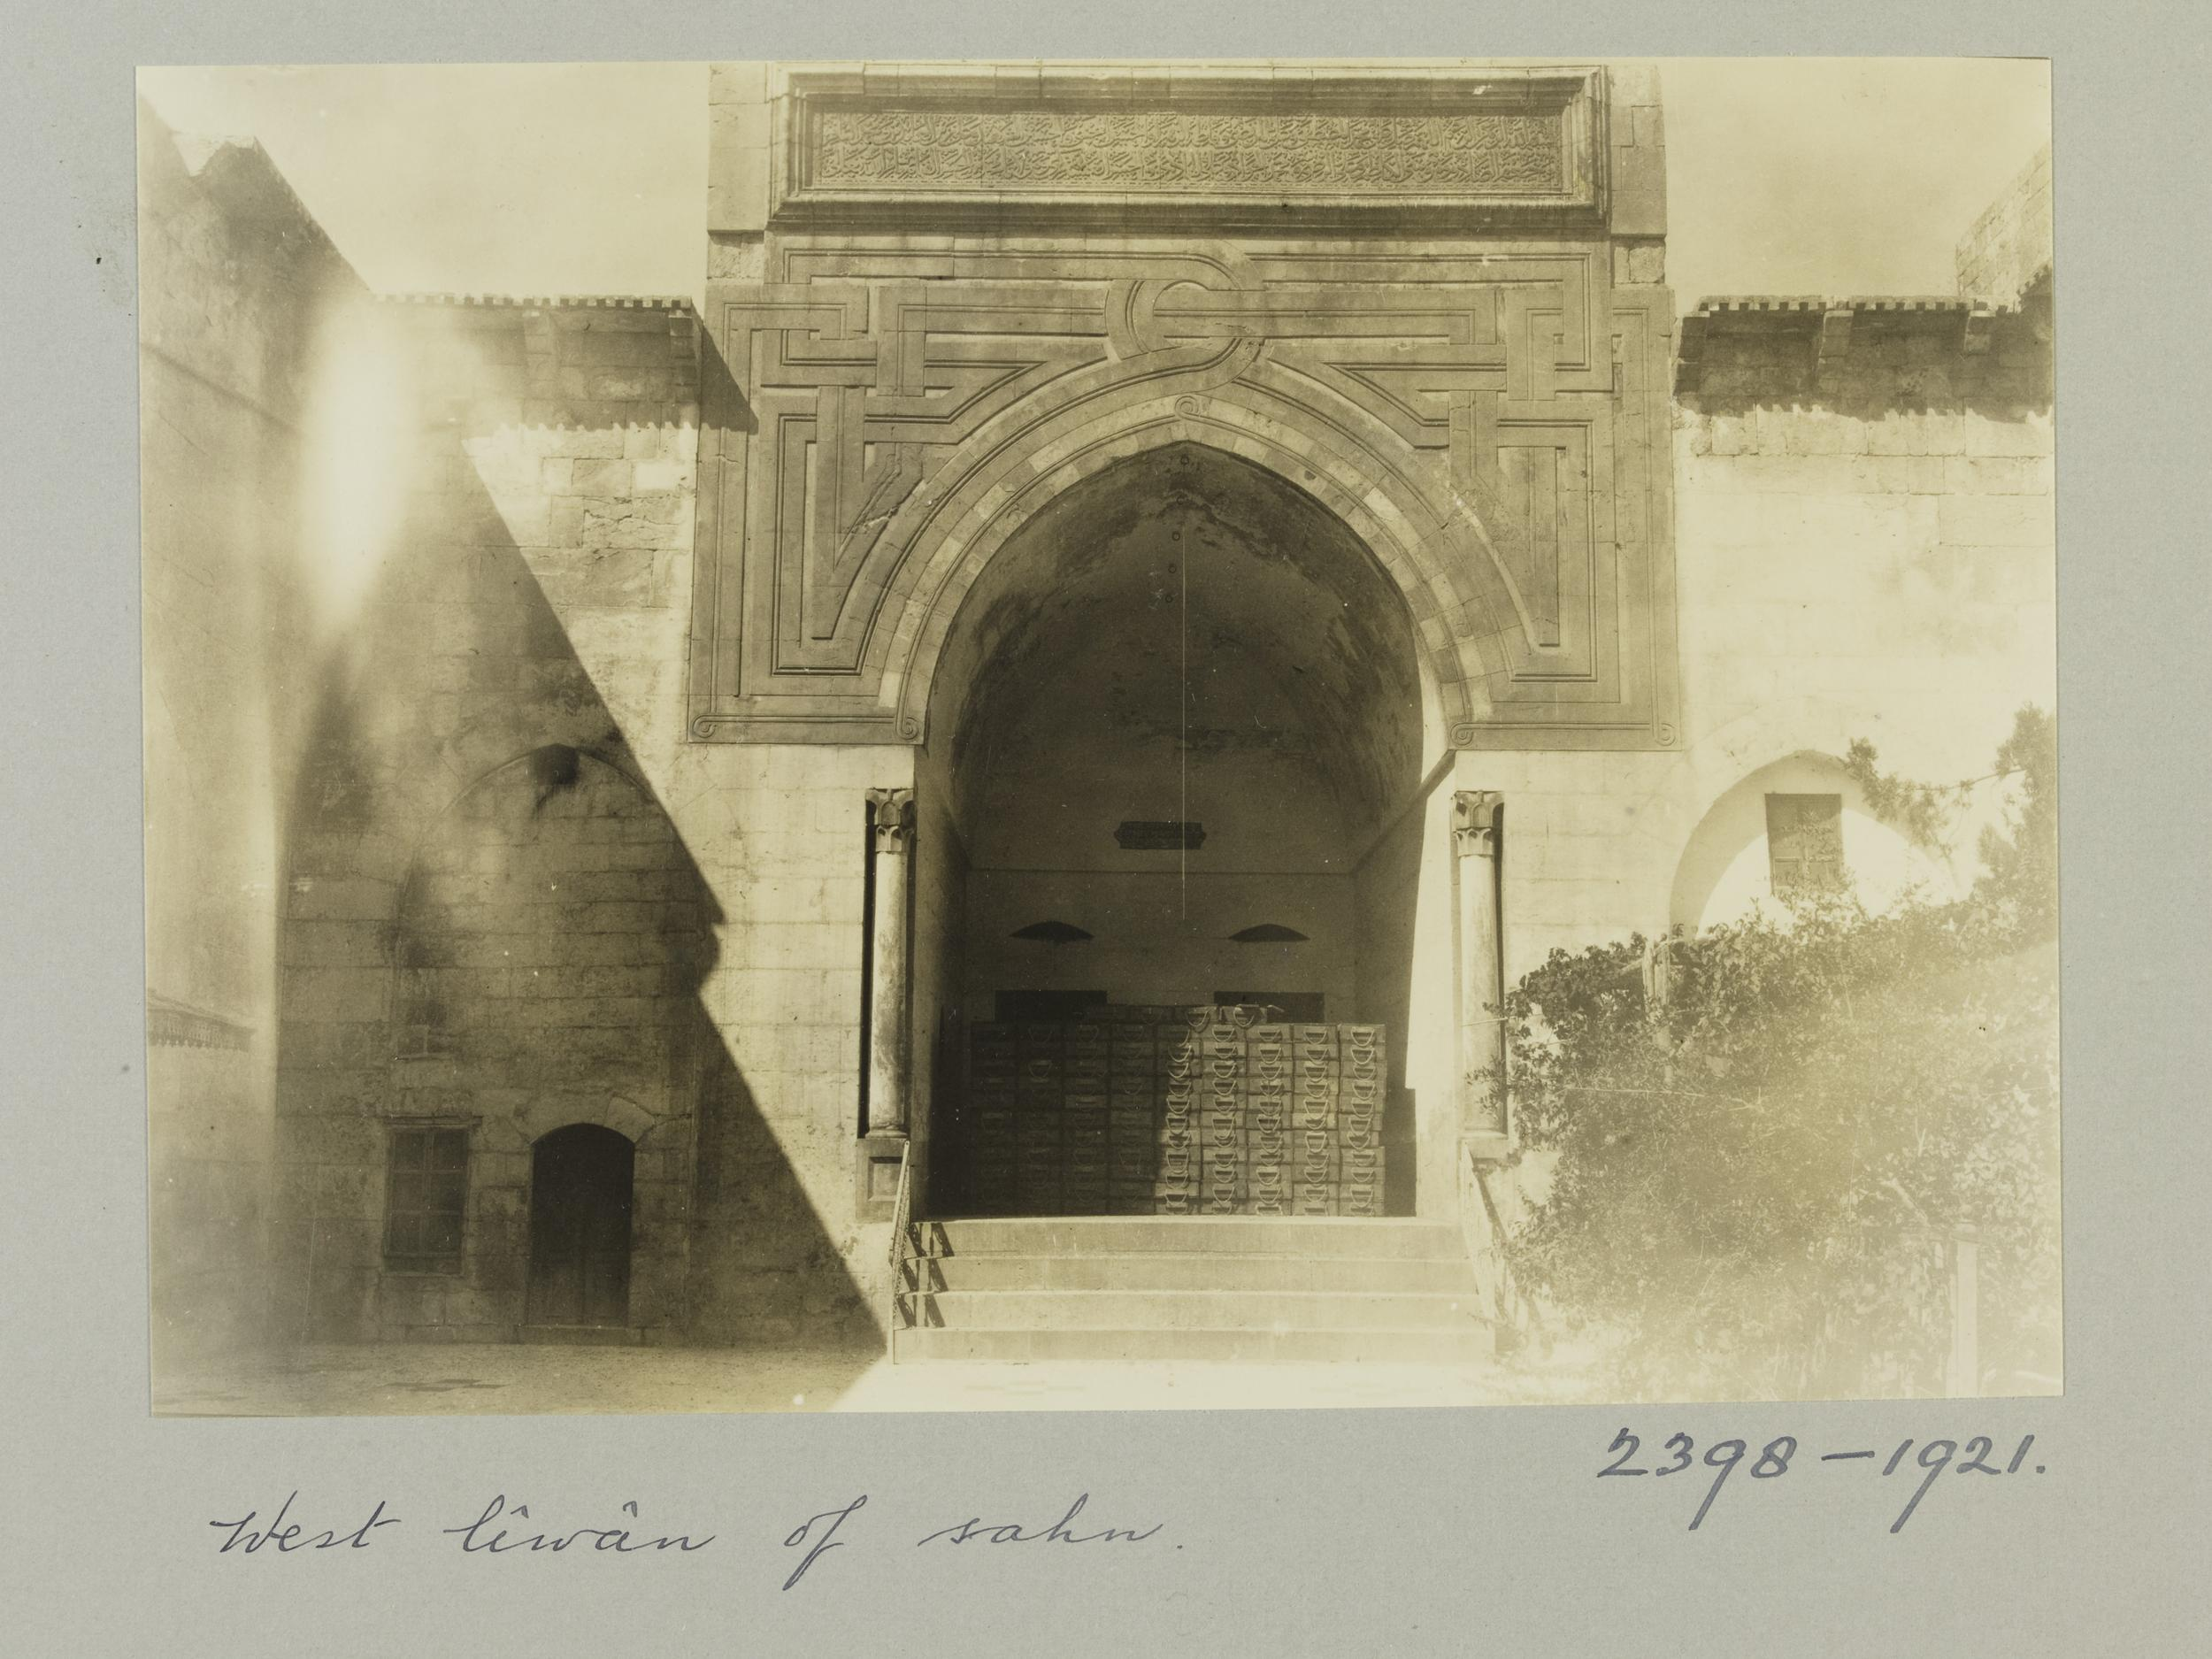
Fig. 4: Iwan portal of the Mashhad al-Husayn, Aleppo, CE 1183. Photographed by K. A. C. Creswell between CE 1919 and 1920. (Photo: Victoria and Albert Museum, London)
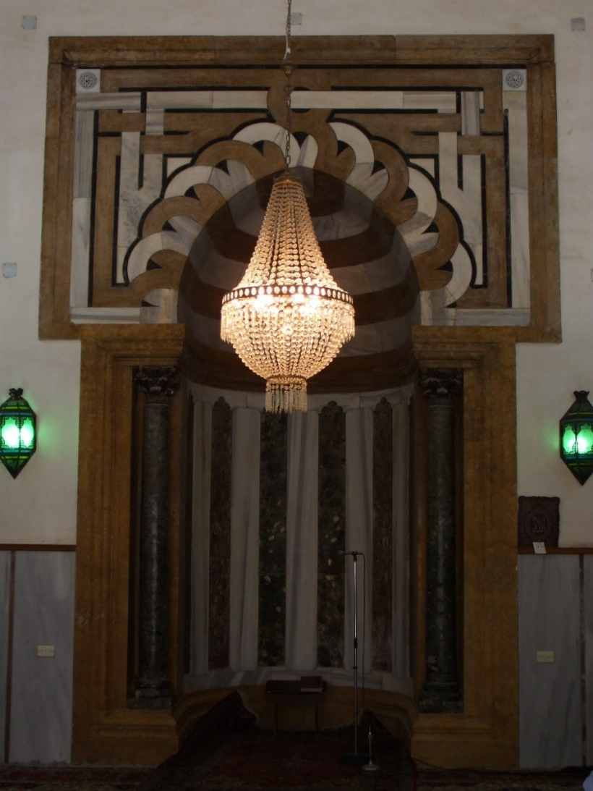
Fig. 5: Mihrab in the al-Sultaniyya Madrasa, Aleppo, 620 AH/CE 1223. (Photo: Richard McClary)
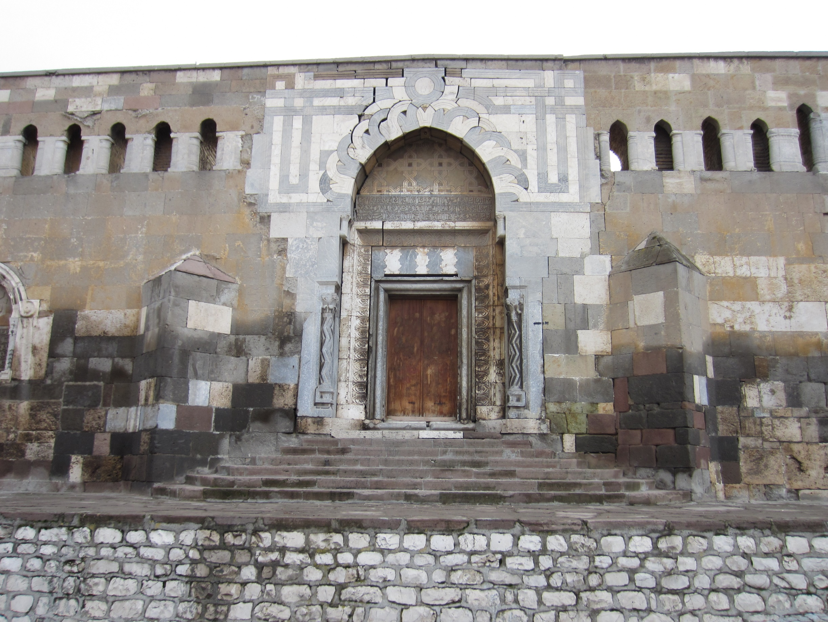
Fig. 6: Alaeddin Mosque north portal, Konya, 616 AH/CE 1219-1220. (Photo: Richard McClary)
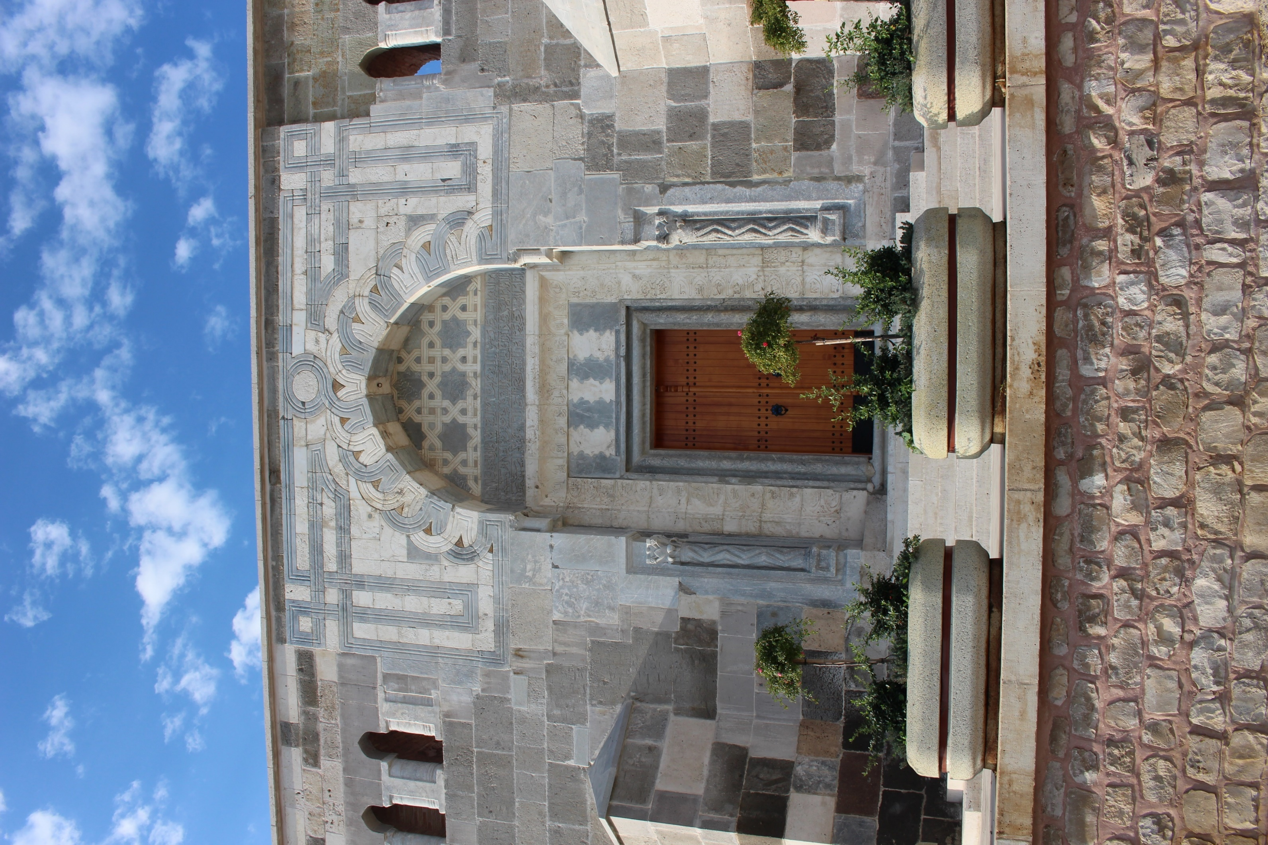
Fig. 7: Detail of arch extrados of the Alaeddin Mosque north portal, Konya. (Photo: Richard McClary)

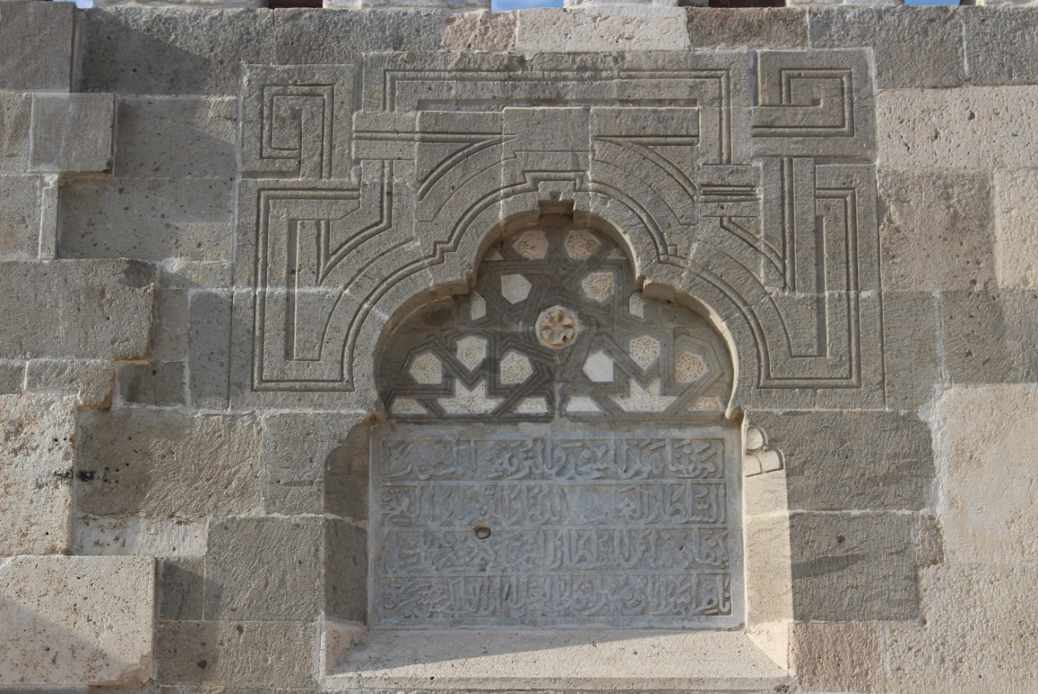
Fig. 8: Intaglio interlace pattern on the north wall, Alaeddin Mosque, Konya, 616 AH/CE 1219. (Photo: Richard McClary)
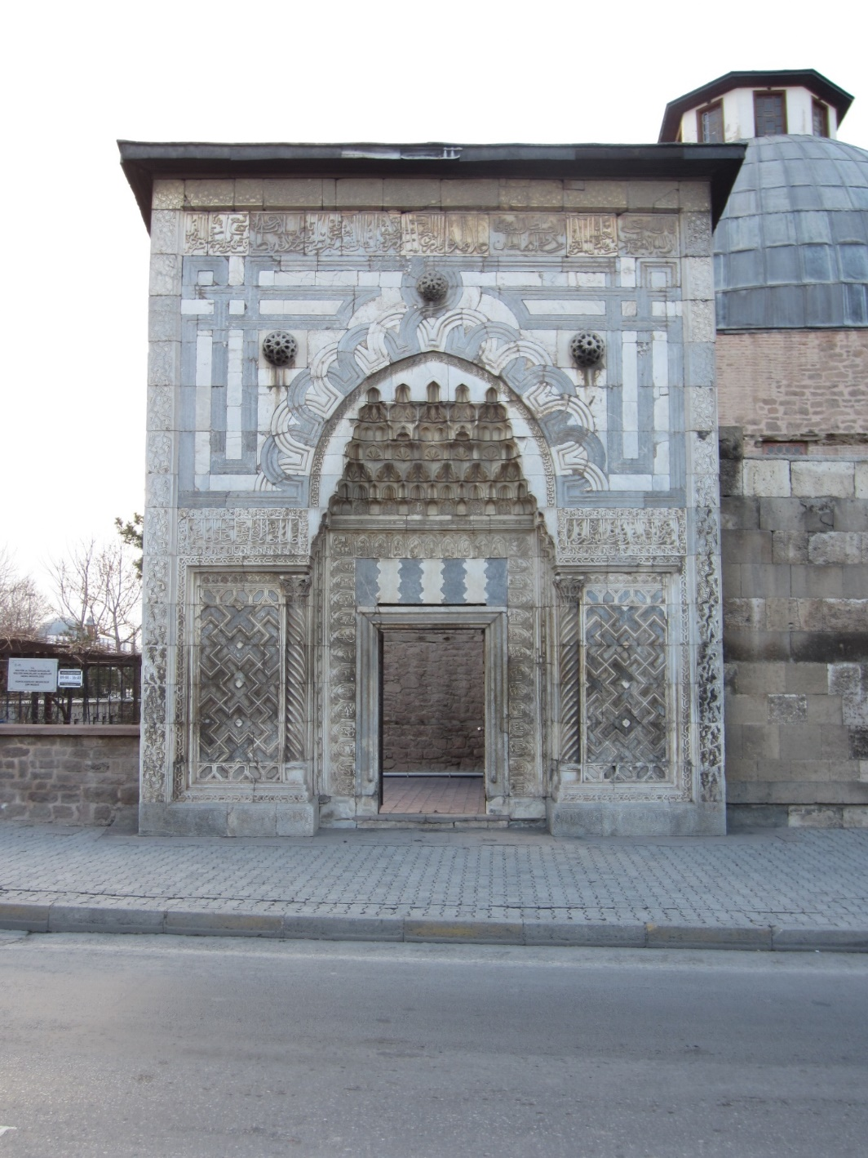
Fig. 9: Büyük Karatay Madrasa portal, Konya, circa CE 1219. (Photo: Richard McClary)

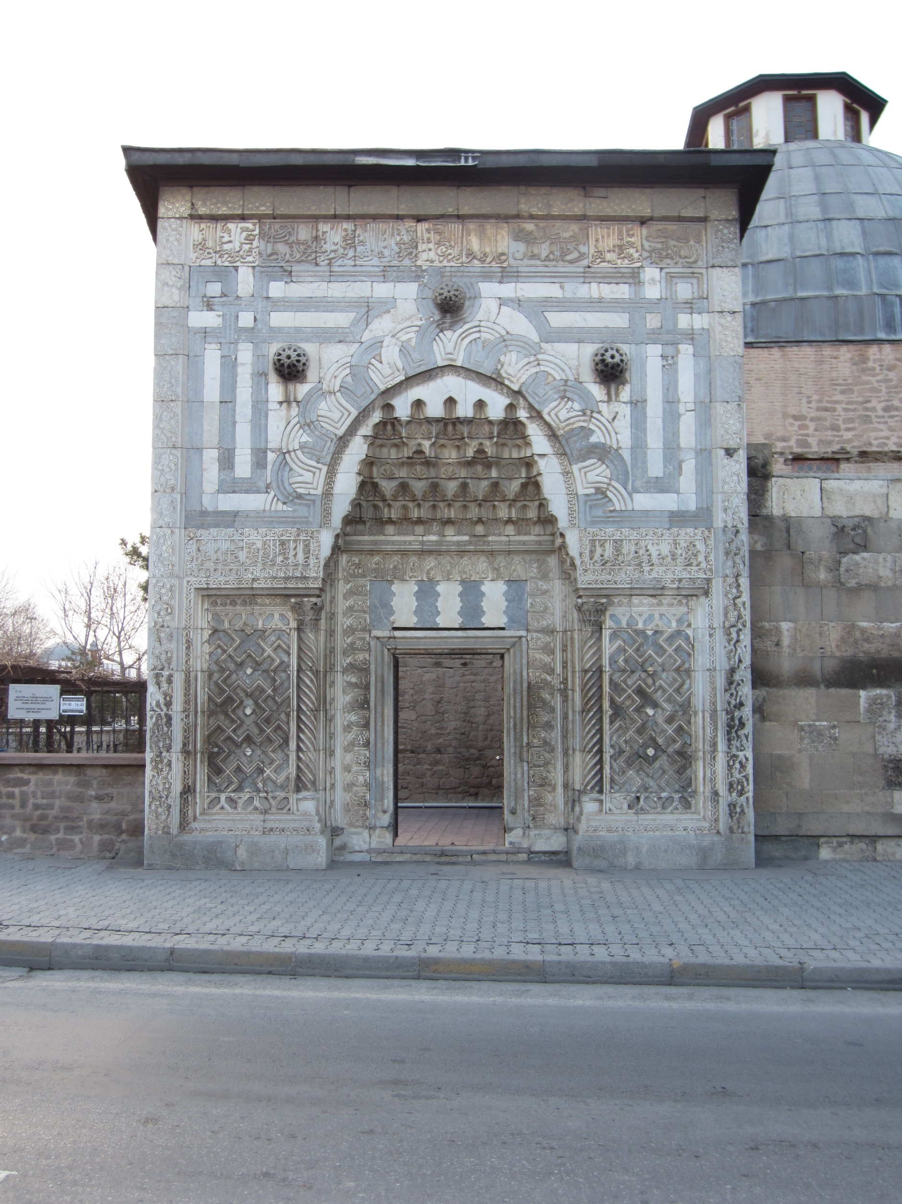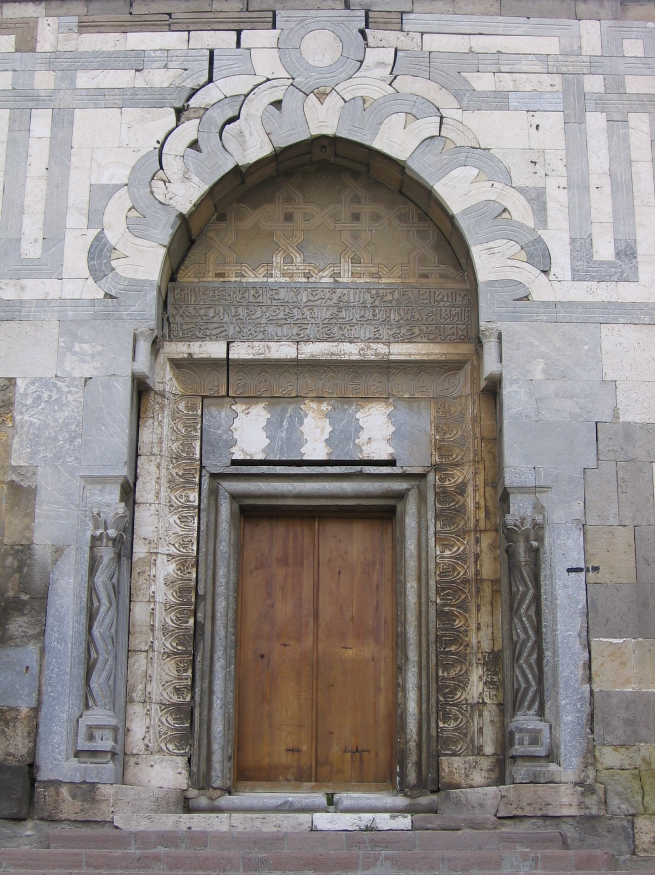
Fig. 10: Comparison showing the differences between the Büyük Karatay Madrasa portal (left) and Alaeddin Mosque north portal (right) stereotomic interlace strapwork spandrels. (Photo: Richard McClary)
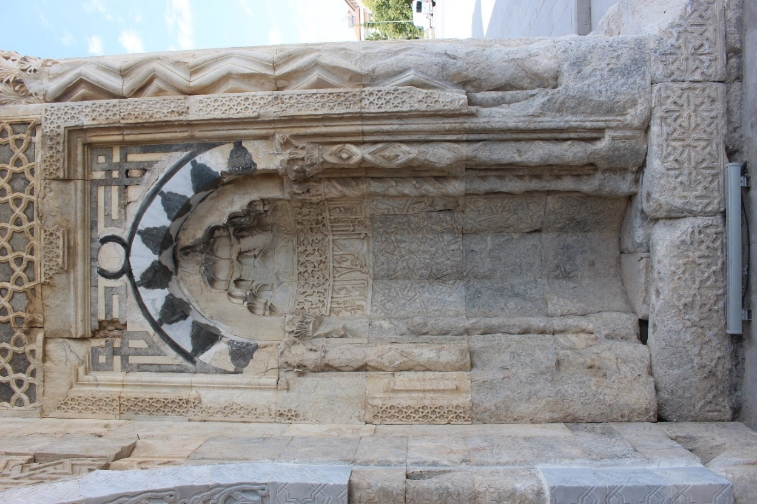
Fig. 11: Right-hand niche beside the main entrance of the Sultan Han Aksaray, 626 AH/CE 1229. (Photo: Richard McClary)
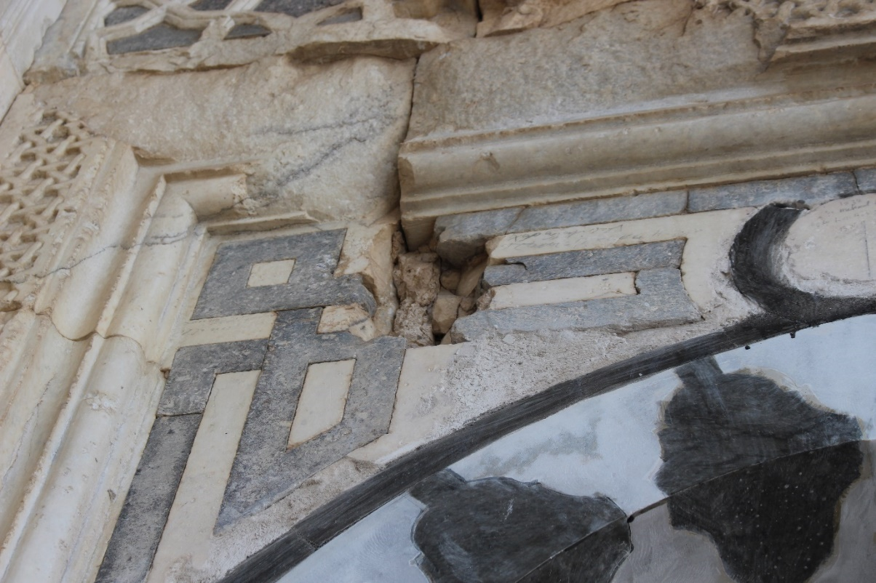
Fig. 12: Detail of the spandrel of the right-hand niche beside the main entrance of the Sultan Han Aksaray. (Photo: Richard McClary)
Fig. 13: Bab al-Mawsil, al-ʿAmadiyya, Iraq (circa early 13th century CE). (Photo: Tariq Al Janabi)
Fig. 14: Drawing of the right-hand spandrel of the Büyük Karatay Madrasa portal, with the embedded Allah (الله) highlighted on the right, Muhammad (محمد) in the middle, and ʿAli (علي) on the right. (Drawing: Richard McClary)

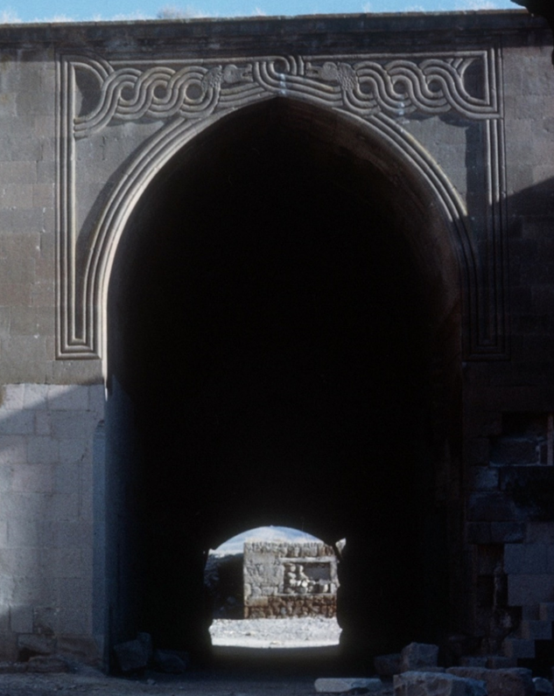
Fig. 15: Courtyard arch with paired dragons, Karatay Han, near Kayseri 638 AH/CE 1240. (Photo: John Ingham)
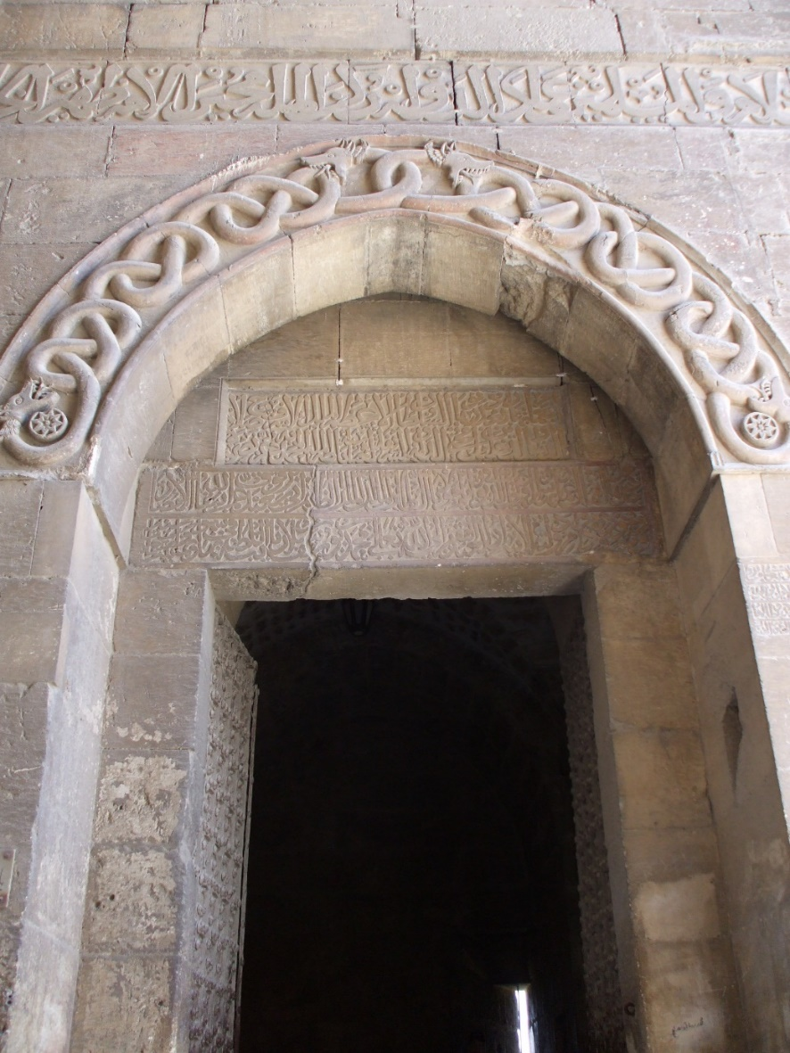
Fig. 16: Twin intertwined double-headed dragons on the arch of the entrance to the citadel, Aleppo (circa early 13th century CE). (Photo: Richard McClary)
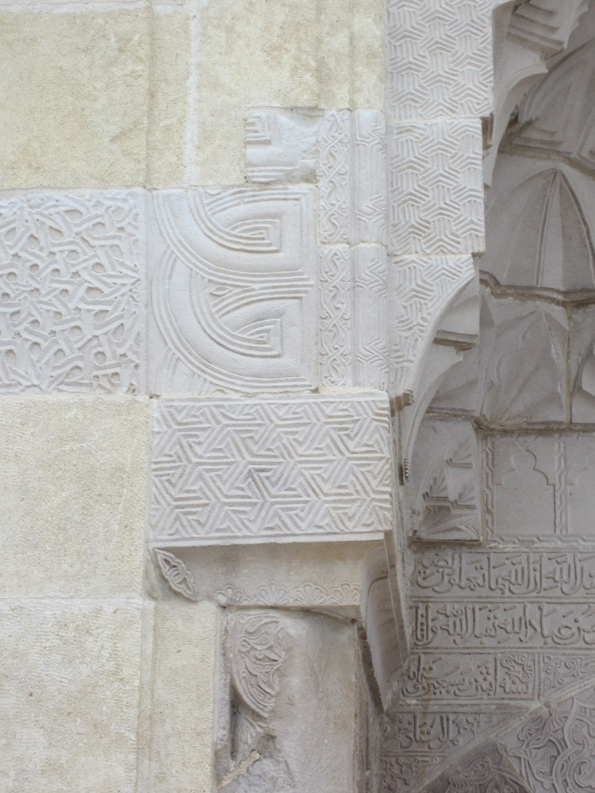
Fig. 17: Detail of arch extrados on the west portal of the Malatya Ulu Camii 672 AH/CE 1273-1274. (Photo: Richard McClary)
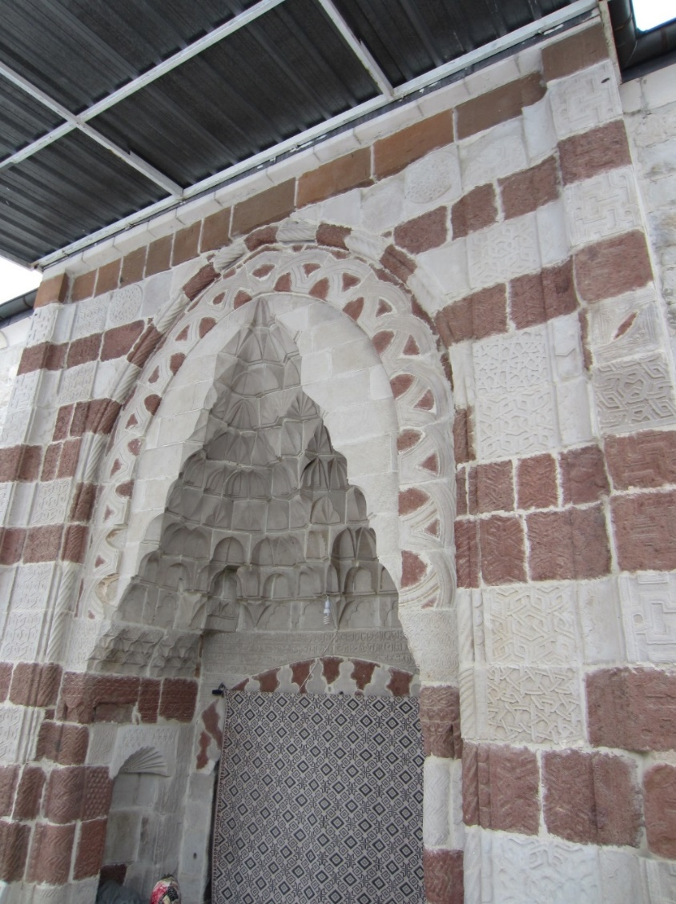
Fig. 18: West portal of the Malatya Ulu Camii, 645 AH/CE 1247. (Photo: Richard McClary)
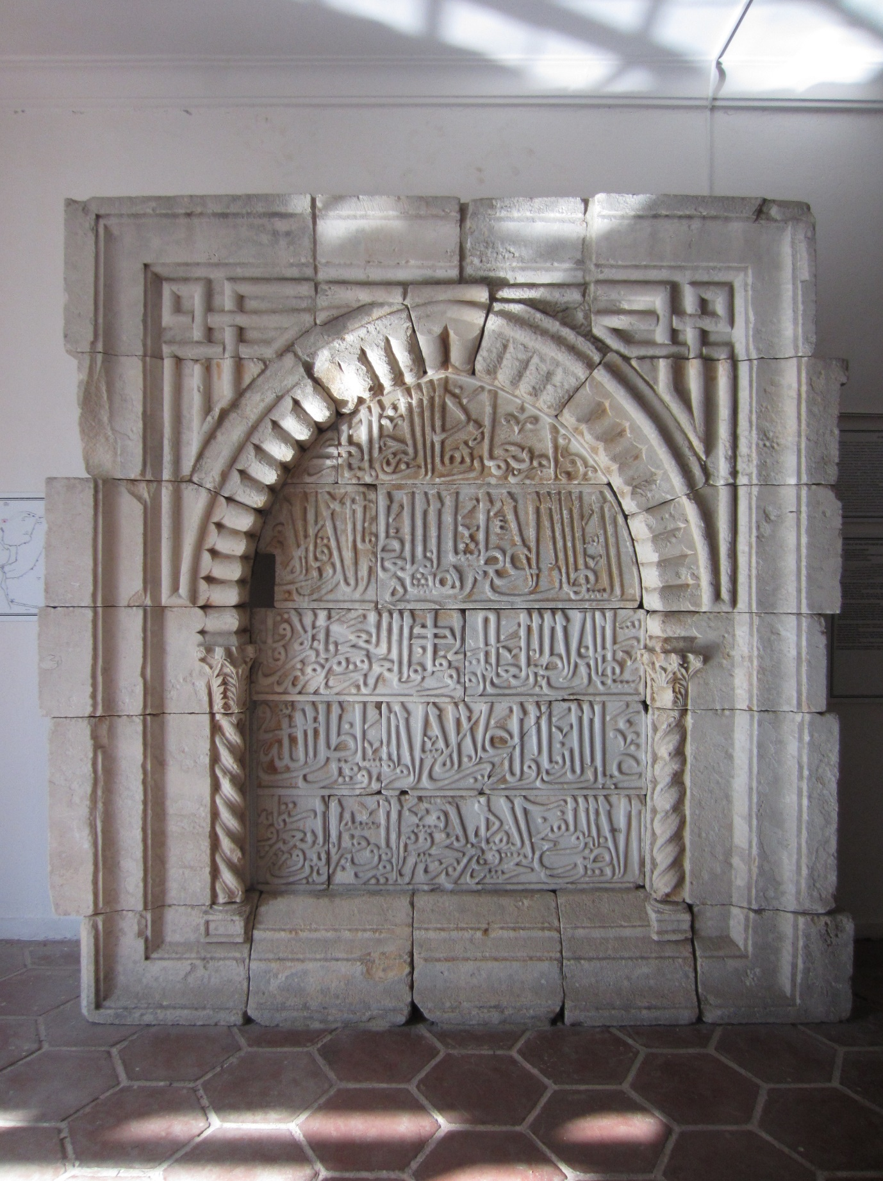
Fig. 19: Marble inscription panel with relief interlace decoration in the spandrels, dated 642 AH/CE 1244, formerly set into one of the towers of the Antalya city walls (now in the Antalya Museum). (Photo: Richard McClary)
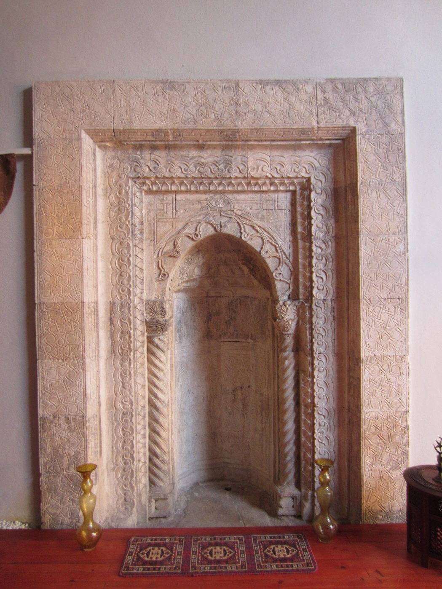
Fig. 20: Mihrab in the Karatay Madrasa, Antalya, 648 AH/CE 1250. (Photo: Richard McClary)
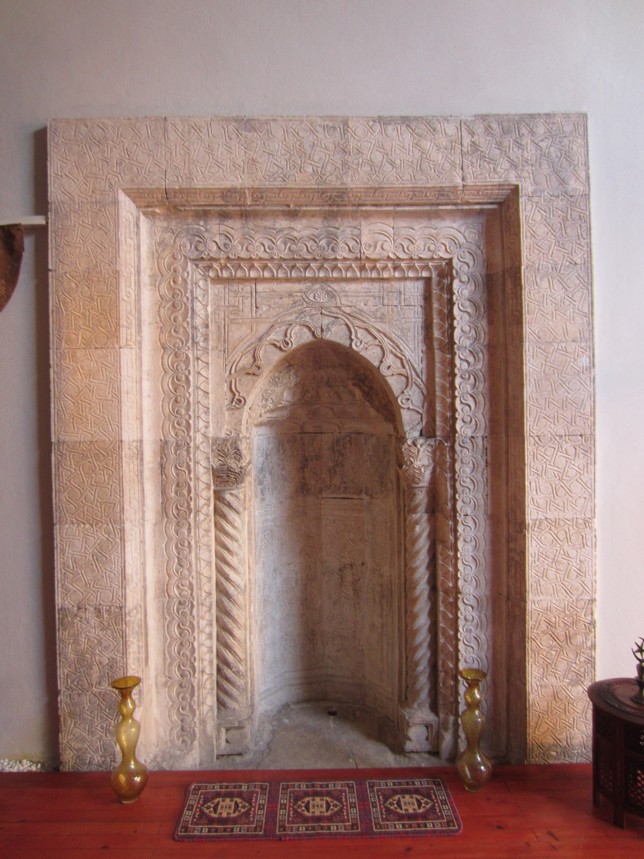
Fig. 21: Detail of the arch and spandrels of the mihrab in the Karatay Madrasa, Antalya. (Photo: Richard McClary)
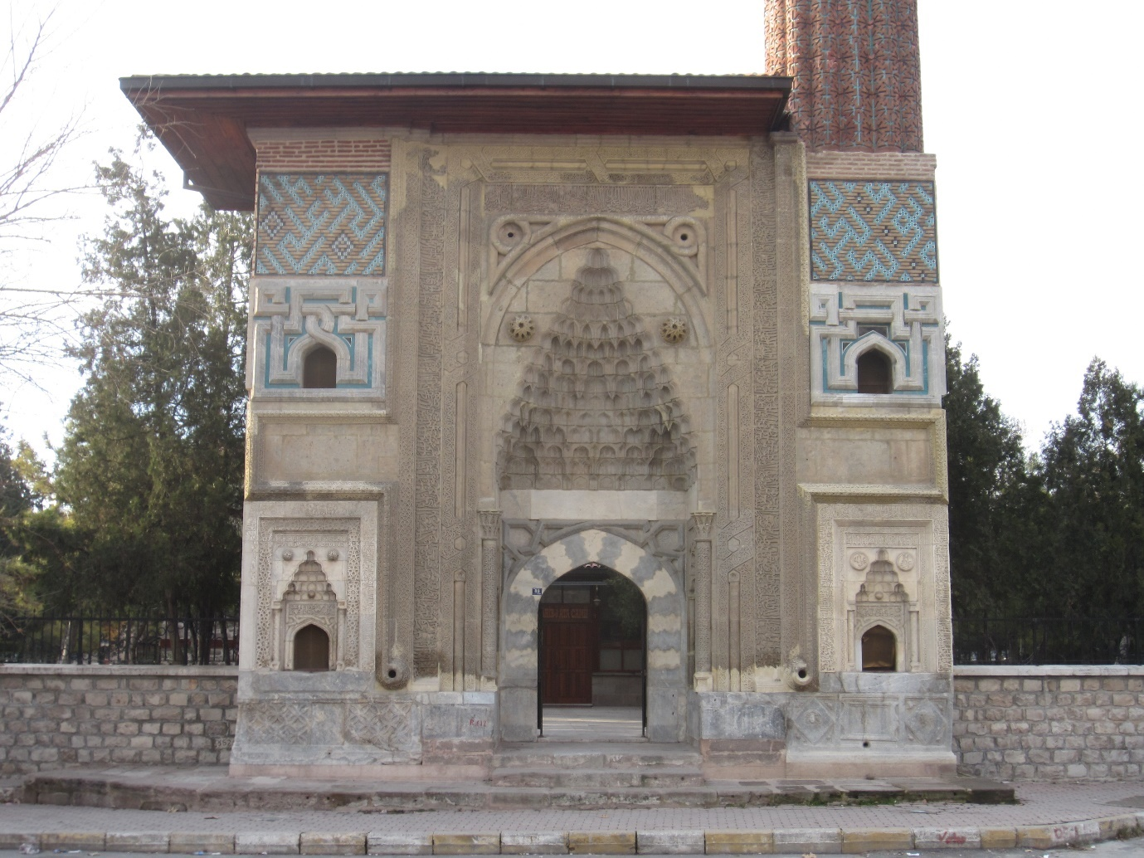
Fig. 22: Sahib Ata Mosque portal, Konya, 656 AH/CE 1258. (Photo: Richard McClary)
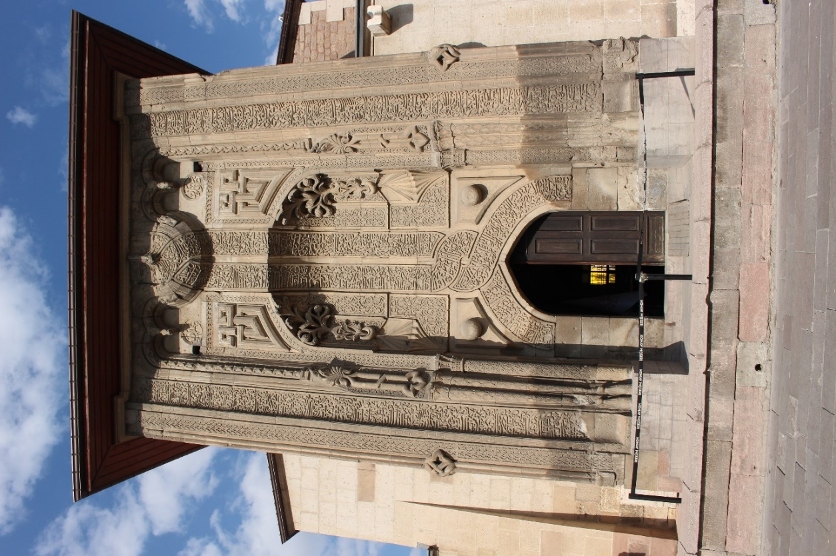
Fig. 23: İnce Minareli Madrasa portal, Konya (circa CE 1260-1265). (Photo: Richard McClary)

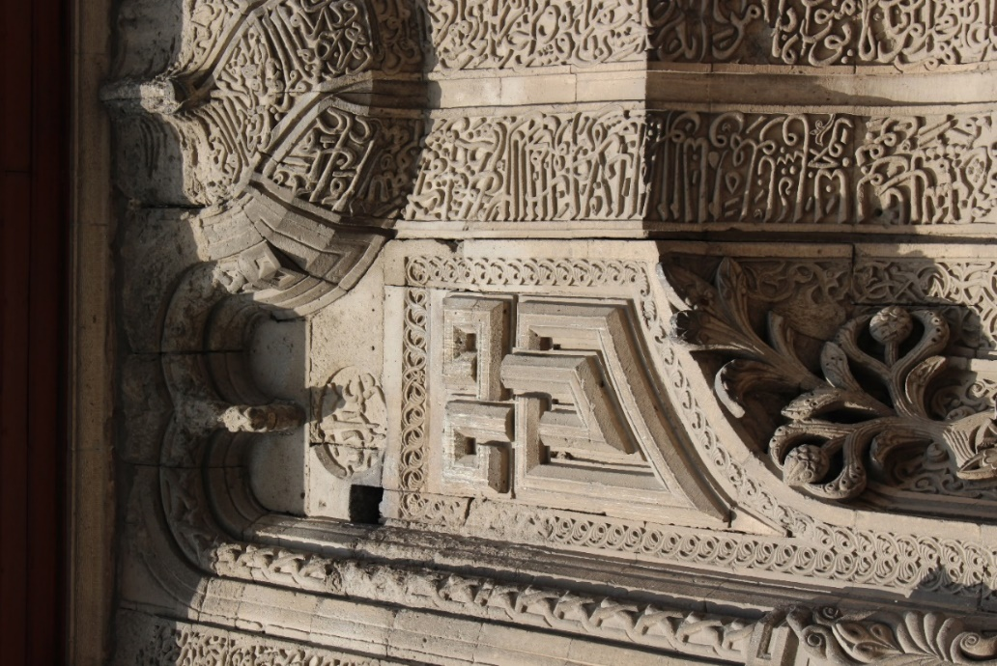
Fig. 24: Detail of the left-hand interlace motif, with a roundel with the second part of the architect’s signature above, on the İnce Minareli Madrasa portal, Konya. (Photo: Richard McClary)
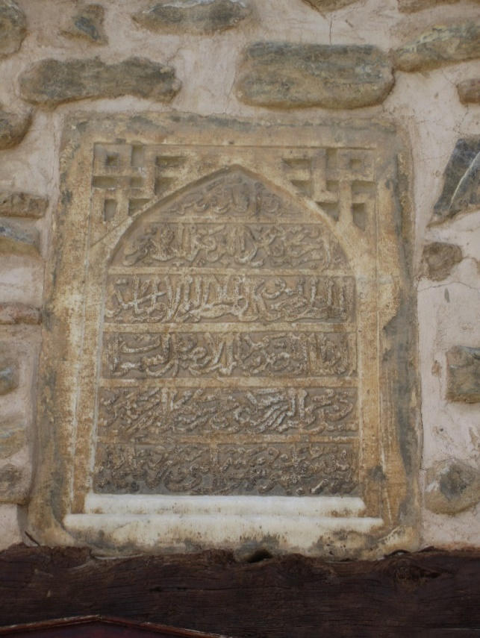
Fig. 25: Inscription panel over the door of the Sayyid Mahmud Hayrani Tomb, Akşehir, 812 AH/CE 1409-1410. (Photo: Richard McClary)

