**Second Language Learning Tunes the Language Control Network: A Longitudinal fMRI Study**

Cong Liua, b, Angela de Bruinc, Lu Jiaoa, Zilong Lib, Ruiming Wangb,*

*a Department of Psychology, Normal College & School of Teacher Education, Qingdao University, Qingdao, China*

*b Guangdong Provincial Key Laboratory of Mental Health and Cognitive Science, and Center for Studies of Psychological Application, School of Psychology, South China Normal University, China*

*c Department of Psychology, University of York, York, United Kingdom*

\***Address for correspondence:**

Ruiming Wang, PhD

School of Psychology

South China Normal University

510631 Guangzhou, P. R. China.

E-mail: wangrm@scnu.edu.cn

**Abstract**

The current longitudinal functional magnetic resonance imaging study investigated how classroom second language (L2) learning modulates the neural correlates of bilingual language control during language production. A group of Chinese college freshmen majoring in English undertook two test sessions (i.e., pre-learning and post-learning) over the course of one year. Specifically, while in the scanner, participants were instructed to name pictures in either their first or second language in response to cues. Behavioral results showed that switch costs in the post-learning session were reduced as compared to the pre-learning session. fMRI results showed that, compared to the pre-learning session, the connectivity strength between the dorsal anterior cingulate gyrus (dACC) and the left Caudate was increased in the post-learning session. Critically, this increased connectivity strength was correlated with the reduction in behavioral switch costs. These findings suggest that the language control network used during bilingual language production could be modulated by long-term L2 learning in a naturalistic classroom setting.

**Keywords:** Second language learning; Language production; Language control; Longitudinal design; fMRI

**Second Language Learning Tunes the Language Control Network: A Longitudinal fMRI Study**

**1. Introduction**

Bilinguals activate both of their languages in parallel during speech production (e.g., Declerck, 2020; Costa, Caramazza, & Sebastián-Gallés, 2000). Therefore, to speak in the intended language, language control processes are implemented to minimize cross-language interference (for a review, see Declerck & Philipp, 2015).

One of the most common experimental tasks used to investigate the mechanisms underlying language control is the language switching task (e.g., Liu, Timmer, Jiao, Yuan, & Wang, 2019; Meuter & Allport, 1999; Timmer, Grundy, & Bialystok, 2017), in which participants are instructed to name digits or pictures in either their first language (L1) or second language (L2) in response to cues. This task typically shows that switching from one language to another (i.e., a switch trial) yields longer reaction times than repeating the same language in two subsequent trials (i.e., a non-switch trial). This switch cost is often used as a measure of language control (e.g., Meuter & Allport, 1999). A prominent model of language control, the Inhibitory Control Model (ICM, Green, 1998), proposes that inhibitory control is involved in language control during bilingual language production. Switch costs might originate from inhibition over the non-target language and the need to overcome this inhibition when switching to a new target language. In the present study, we set out to investigate how language control mechanisms are shaped by long-term classroom L2 learning over the course of one year.

Previous fMRI studies have identified a number of key brain regions involved in bilingual language control processes (Abutalebi & Green, 2007; Calabria, Costa, Green, & Abutalebi, 2018). Abutalebi and Green’s (2007) Neurocognitive Language Control (NLC) model in particular highlighted that the language control network mainly includes neural regions such as (1) the dorsal anterior cingulate gyrus (dACC), (2) the left caudate nucleus (LCN), (3) the left inferior frontal gyrus (IFG), and (4) the left inferior parietal lobe (IPL). The dACC has been shown to be important in conflict monitoring and has been defined as the monitoring system for language control in bilinguals (Green & Abutalebi, 2013; Tu et al., 2015). Increased activation in the LCN has been found during language switching (de Bruin, Roelofs, Dijkstra, & Fitzpatrick, 2014; Zou, Ding, Abutalebi, Shu, & Peng, 2012) and has been associated with language selection in the face of cross-language competition (Abutalebi & Green, 2008). The left IFG has been associated with domain-general inhibitory control and activation in the left IFG might decrease after a short amount of language switching training (Kang et al., 2017). Finally, the left IPL has been shown to be involved in the attentional aspects of language control, including guiding language selection away from the language not in use (Abutalebi & Green, 2008; Calabria et al., 2018).

Notably, the Adaptive Control Hypothesis (ACH), proposed by Green and Abutalebi (2013), postulated that bilingual language control mechanisms used during language production are not fixed but adapt depending on the specific type of bilingual experience. Evidence supporting this argument mainly comes from studies using a cross-sectional design comparing different groups of bilinguals (e.g., Kousaie, Chai, Sander, & Klein, 2017) or comparing bilinguals to monolinguals (e.g., Li et al., 2015). Given that cross-sectional designs might be hindered by individual differences within groups and might not directly reveal the causal relationship between bilingualism/language learning and language control mechanisms, recent studies have started to conduct longitudinal training studies to test the adaptability of language control mechanisms (Hervais-Adelman, Moser-Mercer, & Golestani, 2015; Kang et al., 2017; Wu, Kang, Ma, Gao, & Guo, 2017; Tu et al., 2015). For example, in one behavioral study, Wu et al. (2017) trained a group of unbalanced Chinese–English bilinguals on a cued picture-naming task four times on two consecutive days (two times per day) in the lab, and they found that switch costs in the L1 decreased with training. This suggested that a short language-switching training program improved the efficiency of language control. Moreover, in one fMRI study, a group of unbalanced Chinese–English bilinguals completed an 8-day cued picture naming training in the lab. The results showed that the behavioral switch costs and activation of language control areas including the dACC and the LCN were reduced in the after-training session as compared to the before-training session (Kang et al., 2017). However, these training studies only tracked short-term training effects in a laboratory setting, which lacks ecological validity and might not reflect changes in language control mechanisms in daily life. In other words, it remains to be examined whether long-term extensive language training in a more naturalistic setting modulates language control mechanisms in bilinguals. The present study therefore examined if and how one year of L2 learning in a naturalistic classroom setting shapes language control mechanisms.

Following the Adaptive Control Hypothesis, the more recent Dynamic Restructuring Model (DRM) (Pliatsikas, 2020) proposed a time-course (i.e., initial exposure, consolidation and peak efficiency) for structural brain changes and suggested that these adaptations are dynamic and depend on the quantity and quality of the language learning and switching experience. For instance, Pliatsikas (2020) notes that during the early exposure to a new language grey matter changes seem to occur in brain regions related to language control (e.g., IFG, ACC and Caudate), and these changes are typically documented in non-immersed sequential bilinguals as well as in participants enrolled in intensive language training studies. Although the DRM mainly focused on structural neuroplasticity, it suggests that L2 learning experiences might modulate brain regions related to language control.

To date, research on the neural mechanisms underlying language control and the role of L2 language learning is still in its infancy (Abutalebi & Green, 2016; Liu, Jiao, Li, Timmer, & Wang, 2020). Only a few studies have attempted to investigate changes in brain plasticity over time in relation to classroom L2 learning, but they did not specifically explore how language control mechanisms adapt to classroom L2 learning (Grant, Fang, & Li, 2015; Legault, Grant, Fang, & Li, 2019). For instance, Grant et al., (2015) found that the connectivity between the caudate and the ACC in classroom L2 learners increased over the course of one academic year (i.e., 4-5 months). Moreover, another similar study found that English-Spanish language learners showed greater cortical thickness in the left ACC and right middle temporal gyrus (MTG) after four months of L2 learning as compared to controls (Legault et al., 2019). However, most of these studies have either looked at structural differences without using any behavioral measures of language control (DeLuca, Rothman, Bialystok, & Pliatsikas, 2019; DeLuca, Rothman, & Pliatsikas, 2019; for reviews, see Li, Legault, & Litcofsky, 2014; Pliatsikas, 2020) or focused on language comprehension (such as the Grant et al. (2015) study, which looked at lexical competition in a homonym task). It thus remains an open question how long-term classroom L2 learning shapes language control networks, in particular during bilingual language production. The current study aims to address this gap by examining a group of classrooms English L2 learners across a period of approximately one year.

In the present study, a group of Chinese college freshmen (i.e., unbalanced Chinese-English bilinguals) who were about to start a major in English were recruited and performed the same cued picture naming task in the MRI scanner before and after one year of classroom L2 learning. During this year, the participants took various English courses, including oral, writing, and intensive reading courses in an all-English teaching and learning environment. This L2 learning experience reflects how L2 learning often happens in a naturalistic and immersive classroom in real-life. Testing L2 classroom learners in this setting provides good ecological validity to investigate how these experiences influence language control mechanisms, focusing on the ability to switch between languages. According to the ACH, DRM and the findings from previous studies (Green & Abutalebi, 2013; Pliatsikas, 2020), we hypothesized that classroom L2 learning over the course of one year could modulate the neural mechanisms of language control in bilingual language production. We used language switching costs as a measurement of bilingual language control. Specifically, we predicted that the activation of brain areas related to language control would differ before and after the training, and that the functional connectivity between them would strengthen. Moreover, we assessed whether developmental changes in language switch costs correlated with neural changes in the bilingual language control network, which could indicate a direct link between language control and their corresponding neural bases while adapting to long-term classroom L2 learning experiences.

**2. Method**

*2.1 Participants*

Twenty-five Chinese-English bilinguals from South China Normal University took part in this study. Three participants were excluded due to not participating in the post-learning session, leaving 22 participants (20 females, mean age: 18.35 years, SD: 0.71) for the analysis. All of the participants were college freshmen majoring in English, and had started learning English on average at age 7.40 (SD = 2.81). They were all right-handed with normal or corrected-to-normal vision. All participants signed written informed consent before the experiment and got paid for their participation after the experiment. This research was approved by the Research Ethics Committee at South China Normal University.

In both the pre-learning and post-learning session, participants completed a language history questionnaire and rated their proficiency levels in both languages on a 7-point scale (1 = lowest level of proficiency, 7 = highest level of proficiency). Paired sample *t* tests showed that these participants were unbalanced bilinguals with a higher proficiency level in Chinese than English (*t* (21) = 9.740, *p* < 0.001 in the pre-leaning session; *t* (21) = 8.026, *p* < 0.001 in the post-learning session). Paired sample T-tests also showed that these participants’ self-rated proficiency scores in English improved significantly after one year of L2 learning in a classroom setting (see Table 1, *t* (21) = 2.856, *p* < 0.01). To confirm the reliability of these self-ratings, participants were asked to complete an Oxford Placement Test (OPT) in the post-learning session. The OPT contains 25 multiple choice questions and a cloze test, with a maximum score of 50, and higher scores indicated higher levels of English proficiency. This test has been widely used to measure language proficiency in previous language-production studies (e.g., Jiao et al., 2020; Liu et al., 2020; Yang, Ye, Wang, Zhou, & Wu, 2018). Pearson correlation analyses showed a correlation between the OPT score and the self-rated English proficiency score in the post-learning session (*r* = 0.355, *p* = 0.041), which (to some extent) confirmed the reliability of the self-rated proficiency data.

[Table 1 about here]

*2.2 Procedure*

In the present study, participants were tested in two sessions, once in October (i.e., pre-learning session) and once one year later (i.e., post-learning session). In both sessions, participants performed the same language switching task inside the MRI scanner.

For the language switching task, 16 black and white drawings were selected from the database of Zhang and Yang (2003), of which 4 pictures were used in the practice phase. According to the norming data from Zhang and Yang (2003) and Snodgrass and Vanderwart (1980), attributes such as familiarity, visual complexity, and image agreement are matched. Before the formal experiment, participants were familiarized with the pictures and their corresponding Chinese and English names until they correctly named all the pictures. Then they completed one practice session with 12 trials outside the scanner.

The language switching task included two runs. Each run contained 48 switch trials and 48 non-switch trials, which were presented in a pseudo-randomized manner within a rapid event-related design. Each trial began with a fixation cross together with a Chinese or American flag for 500 ms, followed by a picture for 1500 ms. Participants were instructed to name the picture in the language indicated by the Chinese or American flag as quickly and accurately as possible in a soft voice. The Chinese flag indicated that the picture had to be named in Chinese while the American flag indicated it had to be named in English. Then a fixation cross was presented during a jittered inter-stimulus-interval (ISI) lasting between 2000 ms and 5500 ms (in steps of 500 ms). The timing and order of trial presentation within each run was optimized for estimation efficiency using optseq2 (<http://surfer.nmr.mgh.harvard.edu/optseq/>). Each run lasted approximately 8 min (see Figure 1 for an example of a trial sequence). Because of technical limitations, we re-collected the verbal response data in a behavioral test after the scanning session.

In addition, participants completed a color-shape switching task to measure cognitive flexibility and a modified flanker task to measure inhibitory ability, in both the pre-learning and post-learning sessions. These tasks are reported in more detail in Liu et al., (in preparation). We include them in the current manuscript to assess whether behavioral changes between sessions are uniquely associated with the language switching task. The order of tasks was counterbalanced across participants. The color-shape switching task included one run with 128 trials (containing 64 switch trials and 64 non-switch trials). Each trial began with a fixation cross together with a rainbow or geometric figure for 500 ms, followed by a stimulus for 1500 ms. Participants were instructed to decide if the stimulus was red or yellow when the cue was a rainbow and to decide if the stimulus was a circle or triangle when the cue was a geometric figure. Participants indicated their responses via a left or right button press. Afterwards, a fixation cross was presented during a jittered ISI lasting between 2000 ms and 5500 ms (in steps of 500 ms). The modified flanker task included two runs and each run contained 24 neutral trials, 24 congruent trials, 24 incongruent trials and 24 no-go trials. On each trial, a fixation cross was first presented during a jittered ISI lasting between 2000 ms and 5500 ms (in steps of 500 ms). Then an array of five stimuli including a central arrow and two stimuli on either side of it (i.e., flankers) was present for 2000 ms. Participants were instructed to respond by pressing the left button when the central arrow pointed to the left and by pressing the right button when it pointed to the right. On neutral trials, the flankers were diamonds, which were not associated with any response. On congruent trials, the flankers were arrows pointing in the same direction as the target. On incongruent trials, the flankers were arrows pointing in the opposite direction of the target. On no-go trials, the flankers were Xs, which indicated that subjects should withhold their response.

[Figure 1 about here]

*2.3 MRI data acquisition*

MRI data were collected using a 3T Siemens Trio scanner with 12-channel phase array head coil at the MRI center of South China Normal University. Functional images were acquired using T2-weighted gradient-echo planner imaging (EPI) sequence with the following parameters: TR = 2000 ms, TE = 30 ms, flip angle = 90°, FOV = 204×204 mm2, matrix = 64×64, slice thickness = 3.5 mm, voxel size = 3 × 3 × 3.5 mm3). In addition, high-resolution T1-weighted anatomical images were acquired using the MPRAGE sequence with the following parameters: TR = 1900 ms, TE = 2.52 ms, flip angle = 9°, FOV = 256 × 256 mm2, matrix = 204 × 204, slice thickness = 1 mm, voxel size 1 × 1 × 1 mm3).

*2.4 Data analysis*

*2.4.1 Preprocessing*

MRI images were preprocessed using Statistical Parametric Mapping (SPM 12; [www.fil.ion.ucl.ac.uk](http://www.fil.ion.ucl.ac.uk)) implemented in Matlab R2015a (Mathworks Inc., Sherborn, MA). Imaging data were realigned, slice time corrected, normalized to Montreal Neurological Institute (MNI) space, resliced to a voxel size of 3 mm3, and smoothed with 8 mm Gaussian kernel. Artifact/outlier scans were excluded using the Artifact Detection Tools (ART, www.nitrc.org/ projects/artifact detect/). An image was defined as an outlier if the average intensity deviated 3 SDs from the mean intensity in the session or if the composite head movement exceeded 1mm from the previous image.

*2.4.2 Whole brain analyses*

Statistical analyses were performed by modeling different conditions on a voxel-by-voxel basis using the General Linear Model. In the first level analysis, two types of effects of interest were assessed by computing the following statistical contrasts: (a) Switch trials versus Non-switch trials in the pre-learning session; (b) Switch trials versus Non-switch trials in the post-learning session. Movement parameter estimates produced by the realignment procedure were entered as covariates of no interest in order to correct for potential movement artifacts. In the second level analysis, one-sample *t* tests were first performed for the two aforementioned contrasts. Then, to examine potential L2 learning effects on switch costs, the neural activation of the switch cost (i.e., the difference between Switch trials and Non-switch trials) was compared between the pre-learning and post-learning sessions using a paired t-test. Only activations containing at least 100 contiguous voxels within a cluster (*p* < 0.05, FDR corrected) were reported as significant.

*2.4.3 ROI analyses*

As indicated by the Neurocognitive Language Control (NLC) model (Abutalebi & Green, 2007), the language control network includes the dACC, LCN, left IFG and left IPL. We chose four seeds based on the NLC model and the ROI coordinates were derived from three previous studies: the LCN and left IFG from Luk, Green, Abutalebi, & Grady, (2012), a meta-analysis study on neural regions involved in bilingual language control; the dACC from Abutalebi et al. (2012); and the left IPL from Barbeau et al. (2017). These ROI coordinates were also chosen in a recent study by Gullifer et al. (2018), which suggested that both static components of language acquisition (e.g., age of acquisition) and the social diversity of language use contribute to adaptive changes in brain networks involved in bilingual language control, so we chose them as reference for our ROIs. In addition, two neural regions associated with language processing, namely the bilateral posterior superior temporal gyrus (pSTG), were selected as control regions in which no changes were expected (Friederici, 2011), and their ROI coordinates were derived from Sulpizio et al. (2020). All ROIs were 6mm spheres and their coordinates are represented in MNI Space (see Table 2 for seed coordinates). Beta values were obtained from the single-subject contrast images (non-switch trials vs. switch trials) and were exported for group-level analyses. For each ROI’s beta value, we performed a paired sample *t* test comparing switch costs between the pre-learning and post-learning session.

[Table 2 about here]

*2.4.4 Connectivity analysis*

ROI-to-ROI functional analysis was performed with the CONN toolbox (v. 18b: <https://www.nitrc.org/projects/conn/>; Whitfield-Gabrieli & Nieto-Castanon, 2012) with SPM12. The CONN toolbox has been used for functional connectivity analyses in event-related designs (see Beaty, Benedek, Barry Kaufman, & Silvia, 2015; Berger, Bitsch, Nagels, Straube, & Falkenberg, 2018), by conducting a generalized psycho-physiological interaction (gPPI) approach (see CONN manual; <https://web.conn-toolbox.org/resources/manuals#h.p_aiqzwnbuSuss>). To correct for confounds of physiological noise and motion (Chai, Castañón, Öngür, & Whitfield-Gabrieli, 2012), the CONN toolbox implemented the anatomical component-based noise correction method (CompCor; Behzadi, Restom, Liau, & Liu, 2007) identifying principal components associated with the segmented white matter and cerebrospinal fluid. These components were entered as confound regressors along with realignment parameters in the first-level analysis. In addition, in order to exclude simple task-related activation effects, the main effects of the task conditions (switch, non-switch) were included as confound regressors in our connectivity analysis. A temporal bandpass filter (0.01– inf. Hz) was applied to the time series. Within the gPPI approach, the mean time-series, averaged across all voxels within each seed was correlated with each other by bivariate correlations. The final results from group-level statistics provide Fisher-z transformed correlation coefficient values. Paired sample t-tests were used to examine whether network connectivity changed over the one-year period. FDR corrections for multiple comparisons were applied at an adjusted significance level of *p* < .05.

*2.4.5 Correlation analyses*

Correlation analyses were conducted to assess the correlation between changes in behavioral switch costs (i.e., RTs) and significant changes in brain connectivity (i.e., Fisher's z values reflecting functional connectivity across ROIs). We also carried out correlational analyses between significant brain connectivity changes and behavioral changes on the flanker and color-shape switching tasks.

**3 Results**

*3.1 Behavioral Results*

For the language switching task, RTs over 2.5 SDs from the mean in each condition were excluded from the behavioral analysis (cf. Liu et al., 2019). We only performed statistical analyses on RTs, as accuracy was generally high for all participants (> 95%).

[Figure 2 about here]

Analyses were conducted using linear mixed-effects models with crossed random effects for participants and items using the lme4 package (Bates, Maechler, Bolker, & Walker, 2014) and the lmerTest package (Kuznetsova, Brockhoff, & Christensen, 2014) in R (version 3.4.4). We used a mixed-effects model because it allows random effects of participants and items to be considered simultaneously, making the results generalizable to other subjects and items.

We fit a mixed-effect model for log RT data, with test session (pre-learning vs. post-learning), trial type (non-switch vs. switch), and their interaction as fixed effects. All variables were coded using mean-centered contrast coding (i.e., pre-learning = –0.5, post-learning = 0.5; non-switch = –0.5, switch = 0.5), and the results thus present main effects analogous to ANOVAs. The set of pictures was repeated frequently. To control for potential picture repetition effects, the model also included item repetition as a continuous variable, as well as the interactions with the other two variables. To reduce collinearity, the continuous fixed effect (i.e., item repetition) was z-scored. After removal of correlations between the random slopes and the random intercepts (‘no random correlations’, Barr, Levy, Scheepers, & Tily, 2013), the final converging model included intercepts with a maximal random effects structure (i.e., participant and item slopes for test session, trial type, item repetition and their interactions). The final model was checked for collinearity between variables through VIF.mer (Frank, 2011), and VIFs were below 2.5 (De Bruin, Samuel, & Dunabeitia, 2018).

As shown in Table 3, the effect of test session was not significant (*t* = -1.44, *p* = 0.165), suggesting that overall RTs were similar in the pre- and post-learning session. There was a significant effect of trial type (*t* = 3.31, *p* = 0.007), indicating that switch trials (757 ms) were named more slowly than non-switch trials (734 ms). Critically, the interaction between test session and trial type reached significance (*t* = -2.14, *p* = 0.033), suggesting that the switch cost in the post-learning session (11 ms) was smaller than in the pre-learning session (36 ms). However, there was no significant effect of item repetition (*t* = 1.53, *p* = 0.142) and no significant interactions between Trial type × Item repetition or between Test session × Trial type × Item repetition (*ps* > 0.05), indicating that item repetition did not affect overall RTs or the switch costs (which is of main interest here).

[Table 3 about here]

We also assessed whether there were behavioral changes in the color-shape switching and flanker tasks between sessions. Considering that it was not necessary to control the random effects of items in the color-shape switching task and flanker task, we conducted paired sample T-tests for both tasks. The results showed that the task switching costs (i.e., cognitive flexibility = switch trials – non-switch trials) in the color-shape switching task reduced significantly in the post-learning session as compared to the pre-learning session (82 ms vs. 50 ms; *t* (21) = 2.293, *p* = 0.032). However, the flanker effect (i.e., inhibitory ability = incongruent trials – congruent trials) remained the same across the pre- and post-learning sessions (110 ms vs. 111 ms; *t* (21) = -0.079, *p* = 0.938).

To explore the relationship between the language switching tasks and non-language tasks, we correlated the language switching costs with the task switching costs and the flanker effect in the pre- and post-learning sessions separately. The results showed no significant correlations between the language switching costs and task switching costs (*r* = -0.221, *p* = 0.324 in pre-learning session; *r* = 0.012, *p* = 0.958 in post-learning session), or between the language switching costs and flanker effect (*r* = 0.257, *p* = 0.248 in pre-learning session; *r* = 0.190, *p* = 0.397 in post-learning session). In addition, neither the correlation between the amount of change in the language switch costs and the amount of change in the task switching costs (*r* = 0.049, *p* = 0.828), nor the correlation between the amount of change in the language switch costs and the amount of change in the flanker effect reached significant (*r* = 0.173, *p* = 0.440).

*3.2 fMRI Results*

*3.2.1 Whole brain results*

One-sample t-tests showed that on language switch compared to non-switch trials, the left middle frontal gyrus (MNI = [-39, 45, 0], *t* = 6.10) and left IPL (MNI = [-48, -39, 42], *t* = 4.83) were activated in the pre-learning session. There were no significant differences between switch and non-switch trials in the post-learning session. Critically, the paired sample *t*-test did not indicate significant differences in any brain region when we contrasted the neural activity for switch costs in the post-learning with that in the pre-learning (see Figure 3).

[Figure 3 about here]

*3.2.2 ROI results*

The results of paired sample *t*-tests showed that, within the language control network, there was a significant decrease in switch costs between pre- and post-learning sessions in the beta values of the left IPL (*t* = 2.668, *p* = 0.014) but not the dACC (*t* = 1.903, *p* = 0.071), LCN (*t* = 0.572, *p* = 0.573) and left IFG (*t* = 1.045, *p* = 0.308). However, none of the regions survived FDR corrections (*ps* > 0.0125) (see top panel of Figure 4). In addition, we included ROIs related to language processing that are not part of the language control network. There was no significant decrease in the beta values of these control ROIs between pre- and post-learning sessions: left pSTG (*t* = 0.662, *p* = 0.515) and right pSTG (*t* = 1.045, *p* = 0.308) (see bottom panel of Figure 4).

[Figure 4 about here]

*3.2.3 Connectivity results*

As shown in Figure 5A, the results of the ROI-to-ROI connectivity analysis indicated that, for the language control network, only the connectivity strength between the dACC and LCN was significantly increased in the post-learning as compared to the pre-learning session (*t* = 3.4, *p* = 0.008, FDR corrected). There were no significant changes in connections between other areas of the language control network, nor between regions associated with language processing (*ps* > 0.05).

[Figure 5 about here]

*3.2.4 Correlation results*

In an additional correlational analysis, we found that the increase in connectivity between the dACC and LCN was significantly correlated with the reduction in the behavioral language switching costs (*r* = -0.502, *p* = 0.017). Specifically, the stronger the increase in connectivity between the dACC and LCN, the smaller the language switching cost was in the post-learning compared to the pre-learning session (see Figure 5B). No significant correlations were observed between the increase in dACC-LCN connectivity and behavioral changes in the non-verbal switching task (*r* = -0.060, *p* = 0.789) or the flanker task (*r* = -0.201, *p* = 0.370)

**4 Discussion**

In the present study, we investigated how long-term classroom L2 learning shapes the neural mechanisms of bilingual language control in language production. Chinese College freshmen majoring in English completed a language switching task in the MRI scanner before and after classroom L2 learning over the course of one year. Behavioral results showed that the switch cost in the post-learning session was significantly smaller than the cost in the pre-learning session. Furthermore, fMRI data revealed that the connectivity between the dACC and LCN significantly increased with classroom L2 learning, and this increase was significantly correlated with the improvements in the behavioral language switching cost. These results suggest that classroom L2 learning induces adaptive changes in brain networks involved in bilingual language control.

*4.1 Developmental changes in behavior*

The Adaptive Control Hypothesis (ACH) and Dynamic Restructuring Model (DRM) proposed that language control mechanisms during bilingual language production adapt to specific types of language experience (Green & Abutalebi, 2013; Pliatsikas, 2020). The present study explored the performance of Chinese College freshmen majoring in English (i.e., Chinese-English bilinguals) and observed that they showed decreased language switch costs after classroom L2 learning over the course of one year.

This finding is consistent with previous studies (Kang et al., 2017; Wu et al., 2017) that showed reduced language switch costs induced by short-term language-switching training, which was interpreted as indicating improved language control efficiency. While previous results have demonstrated short-term training effects on language control in laboratory settings, the current study reveals a long-term language training effect in a more naturalistic classroom setting. The current study showed that language switch costs decreased after classroom L2 learning over the course of one year, which may reflect improved language control efficiency.

Behavioral changes after L2 learning were not just observed on the language switching task but also on the color-shape switching task. This suggests that classroom L2 learning can affect switching in general, both in language and non-language switching tasks. However, the present study showed no significant correlation between the language switching and task switching costs. This could suggest that classroom L2 learning could affect language and task switching without a direct overlap between the two types of switching. The flanker effect in the modified flanker task remained the same across the two sessions, suggesting that non-verbal inhibition was not influenced by classroom L2 learning. This null effect could furthermore suggest that the observed changes in the language switching task and color-shape switching task were not purely the result of task practice or training effects.

*4.2 Changes in functional connectivity in the bilingual language control network*

The main finding from the neuroimaging data in the current study was that the connectivity strength between the dACC and LCN was significantly higher in the post-learning as compared to the pre-learning session. This finding is consistent with previous work indicating that the dACC and LCN are two key brain regions in the language control network (Garbin et al., 2011; Kang et al., 2017; Zou et al., 2012). The dACC has been reported to be responsible for domain-general conflict monitoring (Botvinick, Braver, Barch, Carter, & Cohen, 2001; Botvinick, Nystrom, Fissell, Carter, & Cohen, 1999), and the LCN might be responsible for inhibiting cross-language interference during language selection in bilinguals (Abutalebi et al., 2013; Abutalebi & Green, 2008; Branzi, Della Rosa, Canini, Costa, & Abutalebi, 2015). Both regions have been associated with language switching in bilinguals (Abutalebi & Green, 2007; Branzi et al., 2015; Guo, Liu, Misra, & Kroll, 2011; Hosoda, Hanakawa, Nariai, Ohno, & Honda, 2012; Zou et al., 2012). The links between these two regions may reflect that they work together to monitor the language environment and to resolve competition between the languages. Thus, in the present study, the increased connectivity strength between the dACC and LCN might suggest that the participants’ ability to monitor and resolve conflict (i.e., language control abilities) improved after long-term L2 learning in a classroom setting. It should be emphasized that this concerns an increase in *functional* connectivity. In contrast, previous studies focusing on *structural* connectivity have observed that language learning decreased isotropic diffusivity in white matter, which signified more efficient communication between frontal, parietal, and subcortical language-related regions (Pliatsikas, 2020). There were no significant changes in neural activation in brain regions associated with language processing outside the language control network. Moreover, these regions revealed no significant changes in functional connectivity. The observed changes thus appear to be associated with the language control network specifically.

Critically, a significant negative correlation between the behavioral improvements in the language switching task (i.e., reduced language switch cost) and neural changes in functional connectivity was observed, suggesting that the increased connectivity between the dACC and LCN was related to enhanced language switching performance.

These findings show how language control mechanisms can be shaped by long-term classroom L2 learning. This is in line with Grant et al., (2015), who showed increased connectivity between the caudate and the ACC after classroom L2 learning over the course of one academic year. While some previous studies have shown that L2 learning might be associated with functional changes during language comprehension (Grant et al., 2015; Legault et al., 2019), our study focuses on language production. By combining neural and behavioral data, our study indicates that language control used during language production is shaped by classroom L2 learning.

In our ROI analysis, the neural activation of some brain regions in the language control network (e.g., left IPL) significantly decreased from the pre-learning session to the post-learning session, which was in line with some previous studies showing decreased activation in language control brain regions such as the dACC and LCN with short-term language switching training (Kang et al., 2017; but see Grant et al., 2015). This pattern of decreased activation may thus reflect an optimization of the language control system within the L2 classroom learning environment. However, while there was a change in connectivity strength, no significant decrease in neural activation was observed in the dACC and LCN in the present study, although there was a trending decrease in both regions. This differs from the findings in Kang et al. (2017). We speculate that such difference might arise from the different training types in both studies. While the training in Kang et al., (2017) was an intensive short-term language switching training in a laboratory setting, the long-term L2 learning in the current study was in a more naturalistic classroom setting. These different training types may eventually lead to different neuroplastic changes in areas responsible for language control. In our whole brain analysis, no neural changes were observed between the pre-learning session and the post-learning sessions. One potential factor that might contribute to the non-significant results is the number of participants. Specifically, there were only 22 valid participants in our experiment, which might have been too small to detect small differences.

*4.3 Limitations*

Our fMRI study did not include a control group and it could be argued that the decrease in switch costs was related to task-related training. To address this limitation, we added a behavioral control group. Specifically, 25 college freshmen who were not majoring in foreign languages (22 females, mean age: 19.32 years, SD: 0.75; Self-rated Chinese proficiency = 5.94, Self-rated English proficiency = 4.09, *t* = 9.323, *p* < 0.001) were recruited to behaviorally complete the language switching task twice about one month apart. The results showed that the language switch cost remained the same between the pre- and post-learning sessions (12ms vs. 9ms, *t* = -0.54, *p* > 0.05). Together with the finding that changes in connectivity were only observed in language control regions, this suggests that the observed changes were specifically related to L2 learning affecting language control.

While our results indicate that classroom L2 learning can shape language control, they do not show *which aspects* of L2 learning are most important. The use of a naturalistic classroom setting is important for ecological validity (see Blanco-Elorrieta et al., 2018; DeLuca et al., 2019). Future studies should use these environments to assess which aspects of L2 learning contribute to changes in language control. In addition, our study mainly included female participants (i.e., 20/22 participants were female), which might constrain the generalization of the findings. Future studies should use more balanced designs with similar numbers of female and male participants.

**5 Conclusion**

The current study examined behavioral and neural changes in language control before and after one year of English classroom learning. Our results show that L2 learning may lead to increases in connectivity strength between the dACC and LCN, two key brain regions involved in language control that have been implicated in previous studies (Garbin et al., 2011; Kang et al., 2017). This increased connectivity strength was correlated with the reduction in behavioral RT switch costs. These findings provide considerable support to the idea that long periods of L2 classroom learning may induce significant neuroplastic changes in areas responsible for language control. These findings corroborate recent theoretical perspectives on the adaptive features of bilingual language control mechanisms, including the ACH (Green & Abutalebi, 2013) and DRM (Pliatsikas, 2020). As postulated in both theories, bilinguals’ cognitive and language control processes are shaped by language learning and switching experiences. Combining the findings from previous studies and the current findings, we show the flexibility and plasticity of bilingual language control mechanisms, which not only adapt to short-term language-switching training, but also as the result of long-term extensive language training in naturalistic classroom settings.

**Notes**

1. We did not include ‘language’ in the linear mixed-effects models analyses because there were no interactions between language and other variables.

**Acknowledgments**

This research was supported by the Chinese National Funding of Social Sciences (19AYY009).

**Disclosure statement**

No potential conflict of interest was reported by the authors.

**References**

Abutalebi, J., Della Rosa, P. A., Green, D. W., Hernandez, M., Scifo, P., Keim, R., … Costa, A. (2012). Bilingualism tunes the anterior cingulate cortex for conflict monitoring. *Cerebral Cortex*, *22*(9), 2076–2086.

Abutalebi, J., Della Rosa, P. A., Ding, G., Weekes, B., Costa, A., & Green, D. W. (2013). Language proficiency modulates the engagement of cognitive control areas in multilinguals. *Cortex*, *49*(3), 905–911.

Abutalebi, J., & Green, D. W. (2007). Bilingual language production: The neurocognition of language representation and control. *Journal of Neurolinguistics*, *20*(3), 242–275.

Abutalebi, J., & Green, D. W. (2016). Neuroimaging of language control in bilinguals: neural adaptation and reserve. *Bilingualism: Language and Cognition*, *19*(04), 689–698.

Abutalebi, J., & Green, D. W. (2008). Control mechanisms in bilingual language production: Neural evidence from language switching studies. *Language and Cognitive Processes*, *23*(4), 557–582.

Barbeau, E. B., Chai, X. J., Chen, J.-K., Soles, J., Jonathan Berken, L., Baum, S., … Klein, D. (2017). The role of the left inferior parietal lobule in second language learning: an intensive language training fMRI study. *Neuropsychologia* (*98)*, 169-176.

Barr, D. J., Levy, R., Scheepers, C., & Tily, H. J. (2013). Random effects structure for confirmatory hypothesis testing: Keep it maximal. *Journal of Memory and Language, 68*, 255–278.

Bates, D., Maechler, M., Bolker, B., & Walker, S. (2014). lme4: Linear mixed-effects models using Eigen and S4. R package version 1.1-7.

Beaty, R. E., Benedek, M., Barry Kaufman, S., & Silvia, P. J. (2015). Default and Executive Network Coupling Supports Creative Idea Production. *Scientific Reports*, *5*(1), 10964.

Behzadi, Y., Restom, K., Liau, J., & Liu, T. T. (2007). A component based noise correction method (CompCor) for BOLD and perfusion based fMRI. *NeuroImage*, *37*(1), 90–101.

Berger, P., Bitsch, F., Nagels, A., Straube, B., & Falkenberg, I. (2018). Frontal hypoactivation and alterations in the reward-system during humor processing in patients with schizophrenia spectrum disorders. *Schizophrenia Research*, *202*, 149–157.

Botvinick, M. M., Braver, T. S., Barch, D. M., Carter, C. S., & Cohen, J. D. (2001). Conflict monitoring and cognitive control. *Psychological Review*, *108*(3), 624–652.

Botvinick, M., Nystrom, L. E., Fissell, K., Carter, C. S., & Cohen, J. D. (1999). Conflict monitoring versus selection-for-action in anterior cingulate cortex. *Nature*, *402*(6758), 179–181.

Branzi, F. M., Della Rosa, P. A., Canini, M., Costa, A., & Abutalebi, J. (2015). Language Control in Bilinguals: Monitoring and Response Selection. *Cerebral Cortex*, *26*(6), 2367–2380.

Calabria, M., Costa, A., Green, D. W., & Abutalebi, J. (2018). Neural basis of bilingual language control. *Annals of the New York Academy of Sciences*, 221–235.

Chai, X. J., Castañón, A. N., Öngür, D., & Whitfield-Gabrieli, S. (2012). Anticorrelations in resting state networks without global signal regression. *Neuroimage*, *59*(2), 1420–1428.

Costa, A., Caramazza, A., & Sebastián-Gallés, N. (2000). The cognate facilitation effect: Implications for models oflexical access. *Journal of Experimental Psychology: Learning, Memory, and Cognition, 26*, 1283–1296.

De Bruin, A., Samuel, A. G., & Dunabeitia, J. A. (2018). Voluntary language switching: When and why do bilinguals switch between their languages?. *Journal of Memory and Language*, *103,* 28-43.

De Bruin, A., Roelofs, A., Dijkstra, T., & Fitzpatrick, I. (2014). Domain-general inhibition areas of the brain are involved in language switching: fMRI evidence from trilingual speakers. *Neuroimage*, *90*, 348–359.

Declerck, M, & Philipp, A. M. (2015). A review of control processes and their locus in language switching. *Psychonomic Bulletin & Review*, *22*(6), 1630–1645.

Declerck, M. (2020). What about proactive language control?. *Psychonomic bulletin & review, 27*(1), 24-35.

DeLuca, V., Rothman, J., Bialystok, E., & Pliatsikas, C. (2019). Redefining bilingualism as a spectrum of experiences that differentially affects brain structure and function. *Proceedings of the National Academy of Sciences, 116*(15), 7565-7574.

Deluca, V., Rothman, J., & Pliatsikas, C. (2019). Linguistic immersion and structural effects on the bilingual brain: a longitudinal study. *Bilingualism: Language and Cognition, 22*(5), 1160-1175.

Frank, A. F. (2011) R-hacks/mer-utils.R.<https://github.com/aufrank/R-hacks/blob/ master/mer-utils.R> . Accessed October 2017.

Friederici, A. D. (2011). The brain basis of language processing: From structure to function. *Physiological Reviews, 91*(4), 1357-1392.

Garbin, G., Costa, A., Sanjuan, A., Forn, C., Rodriguez-Pujadas, A., Ventura, N., … Ávila, C. (2011). Neural bases of language switching in high and early proficient bilinguals. *Brain and Language*, *119*(3), 129–135.

Golestani, N., & Zatorre, R. J. (2004). Learning new sounds of speech: reallocation of neural substrates. *Neuroimage*, *21*(2), 494–506.

Grant, A., Fang, S. Y., & Li, P. (2015). Second language lexical development and cognitive control: A longitudinal fMRI study. *Brain and Language*, *144*, 35–47.

Green, D. W., & Abutalebi, J. (2013). Language control in bilinguals: The adaptive control hypothesis. *J Cogn Psychol (Hove)*, *25*(5), 515–530.

Green, D. W. (1998). Mental control of the bilingual lexico-semantic system. *Bilingualism: Language and Cognition*, *1*(02), 67–81.

Gullifer, J. W., Chai, X. J., Whitford, V., Pivneva, I., Baum, S., Klein, D., & Titone, D. (2018). Bilingual experience and resting-state brain connectivity: Impacts of L2 age of acquisition and social diversity of language use on control networks. *Neuropsychologia*, *117*, 123-134.

Guo, T., Liu, H., Misra, M., & Kroll, J. F. (2011). Local and global inhibition in bilingual word production: fMRI evidence from Chinese-English bilinguals. *Neuroimage*, *56*(4), 2300–2309.

Hervais-Adelman, A., Moser-Mercer, B., & Golestani, N. (2015). Brain functional plasticity associated with the emergence of expertise in extreme language control. *NeuroImage*, *114*, 264-274.

Hosoda, C., Hanakawa, T., Nariai, T., Ohno, K., & Honda, M. (2012). Neural mechanisms of language switch. *Journal of Neurolinguistics*, *25*(1), 44–61.

Jiao, L., Liu, C., de Bruin, A., & Chen, B. (2020). Effects of language context on executive control in unbalanced bilinguals: An ERPs study. *Psychophysiology*, *57*(11), e13653.

Kang, C., Fu, Y., Wu, J., Ma, F., Lu, C., & Guo, T. (2017). Short-term language switching training tunes the neural correlates of cognitive control in bilingual language production. *Human Brain Mapping*, *38*(12), 5859–5870.

Kousaie, S., Chai, X. J., Sander, K. M., & Klein, D. (2017). Simultaneous learning of two languages from birth positively impacts intrinsic functional connectivity and cognitive control. *Brain and Cognition*, *117*, 49–56.

Kuznetsova, A., Brockhoff, P. B., & Christensen, R. H. B. (2014). lmerTest: Tests for random and fixed effects for linear mixed effect models. R package version 2.0-11.

Legault, J., Grant, A., Fang, S.-Y., & Li, P. (2019). A longitudinal investigation of structural brain changes during second language learning. *Brain and Language*, *197*, 104661.

Li, L., Abutalebi, J., Zou, L., Yan, X., Liu, L., Feng, X., … Ding, G. (2015). Bilingualism alters brain functional connectivity between “control” regions and “language” regions: Evidence from bimodal bilinguals. *Neuropsychologia*, *71*, 236–247.

Li, P., Legault, J., & Litcofsky, K. A. (2014). Neuroplasticity as a function of second language learning: anatomical changes in the human brain. *Cortex, 58*, 301-324.

Liu, C., Jiao, L., Li, Z., Timmer, K., & Wang, R. (2020). Language Control network adapts to Second Language Learning: A Longitudinal rs-fMRI Study. *Neuropsychologia*.

Liu, C., Jiao, L., Wang, Z., Wang, M., Wang, R., & Wu, Y. J. (2019). Symmetries of bilingual language switch costs in conflicting versus non-conflicting contexts. *Bilingualism: Language and Cognition*, *22*(3), 624–636.

Liu, C., Jiao, L., Schwieter, J. W., & Wang, R. (in preparation). The adaptation of cognitive control with classroom second language learning.

Liu, C., Timmer, K., Jiao, L., Yuan, Y., & Wang, R. (2019). The influence of contextual faces on bilingual language control. *Quarterly Journal of Experimental Psychology*, *72*(9), 2313-2327.

Liu, H., Tong, J., de Bruin, A., Li, W., He, Y., & Li, B. (2020). Is inhibition involved in voluntary language switching? Evidence from transcranial direct current stimulation over the right dorsolateral prefrontal cortex. *International Journal of Psychophysiology*, *147*, 184-192.

Luk, G., Green, D. W., Abutalebi, J., & Grady, C. (2012). Cognitive control for language switching in bilinguals: A quantitative meta-analysis of functional neuroimaging studies. *Language Cognitive Process*, *27*(10), 1479–1488.

Mestres-Missé, A., Münte, T. F., & Rodriguez-Fornells, A. (2009). Functional neuroanatomy of contextual acquisition of concrete and abstract words. *Journal of Cognitive Neuroscience*, *21*(11), 2154–2171.

Meuter, R. F. I., & Allport, A. (1999). Bilingual language switching in naming: Asymmetrical costs of language selection. *Journal of Memory and Language*, *40*(1), 25–40.

Pliatsikas, C. (2020). Understanding structural plasticity in the bilingual brain: The Dynamic Restructuring Model. *Bilingualism: Language and Cognition*, *23*(2), 459-471.

Snodgrass, J. G., & Vanderwart, M. (1980). A standardized set of 260 pictures: norms for name agreement, image agreement, familiarity, and visual complexity. *Journal of Experimental Psychology: Human Learning and Memory*, *6*(2), 174–215.

Sulpizio, S., Del Maschio, N., Del Mauro, G., Fedeli, D., & Abutalebi, J. (2020). Bilingualism as a gradient measure modulates functional connectivity of language and control networks. *NeuroImage, 205,* 116306.

Timmer, K., Grundy, J. G., & Bialystok, E. (2017). Earlier and more distributed neural networks for bilinguals than monolinguals during switching. *Neuropsychologia*, *106*, 245–260.

Tu, L., Wang, J., Abutalebi, J., Jiang, B., Pan, X., Li, M., … Huang, R. (2015). Language exposure induced neuroplasticity in the bilingual brain: A follow-up fMRI study. *Cortex*, *64*, 8–19.

Wu, L., Kang, C., Ma, F., Gao, X., & Guo, T. (2017). The influence of short-term language switching training on the plasticity of the cognitive control mechanism in bilingual word production. *Quarterly Journal of Experimental Psychology,* *71*(10), 2115-2128.

Yang, J., Ye, J., Wang, R., Zhou, K., & Wu, Y. J. (2018). Bilingual contexts modulate the inhibitory control network. *Frontiers in psychology*, *9*, 395.

Zhang, Q., & Yang, Y. (2003). The deferminers of picture-naming latency. *Acta Psychologica Sinica*, *35*, 447-454.

Zou, L., Ding, G., Abutalebi, J., Shu, H., & Peng, D. (2012). Structural plasticity of the left caudate in bimodal bilinguals. *Cortex*, *48*(9), 1197–1206.

Table 1 Means (and SDs) of the language proficiency self-ratings for both Chinese and English.

|  |  |  |
| --- | --- | --- |
|  | Pre-learning | Post-learning |
| Chinesea | 6.05 (0.87) | 5.93 (0.60) |
| Englisha, ** | 4.25 (0.77) | 4.76 (0.53) |
| OPT score |  | 41.5 (2.93) |

a Self-rated proficiency score from 1 (lowest) to 7 (highest).

** *p* < 0.01.

Table 2 Regions of interest (ROI).

|  |  |  |  |
| --- | --- | --- | --- |
| **ROI** | **x** | **y** | **z** |
| *Language control network* |  |  |  |
| dACC (BA24) | 0 | 6 | 44 |
| LCN | -8 | 4 | 2 |
| L_IFG (BA47) | -32 | 20 | -8 |
| L_IPL (BA40) | -54 | -34 | 36 |
| *Language processing network* |  |  |  |
| L_pSTG (BA39) | -57 | -47 | 15 |
| R_pSTG (BA22) | 59 | -42 | 13 |

Table 3 Results for mixed-effects model on log RTs.

|  |  |  |  |  |
| --- | --- | --- | --- | --- |
| Fixed effects | Estimate | SE | *t* | *p* |
| Intercept | 6.58 | 0.02 | 272.39 | < 0.001 |
| Test session | -0.04 | 0.03 | -1.44 | 0.165 |
| Trial type | 0.03 | 0.01 | 3.31 | **0.007** |
| Item repetition | 0.01 | 0.01 | 1.53 | 0.142 |
| Test session × Trial type | -0.02 | 0.01 | -2.14 | **0.033** |
| Test session × Item repetition | 0.01 | 0.01 | 0.87 | 0.394 |
| Trial type × Item repetition | 0.00 | 0.01 | 0.21 | 0.832 |
| Test session × Trial type × Item repetition | 0.00 | 0.01 | -0.06 | 0.951 |

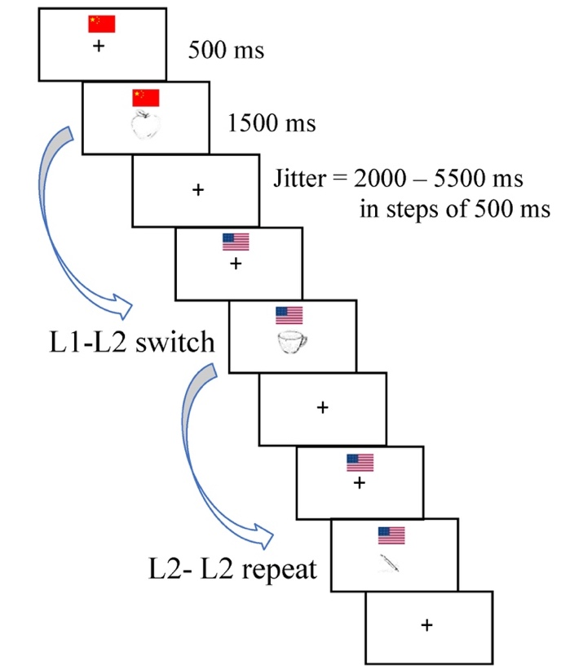

Figure 1. Procedure of the language switching task conducted during fMRI scanning.

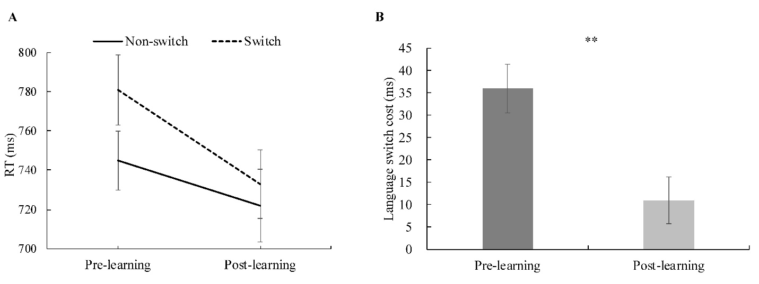

Figure 2. The mean RTs for (A) non-switch trials, switch trials and (B) switch costs (switch trials - non-switch trials) in the pre-learning and post-learning session. Error bars show one standard error.

** *p* < 0.01

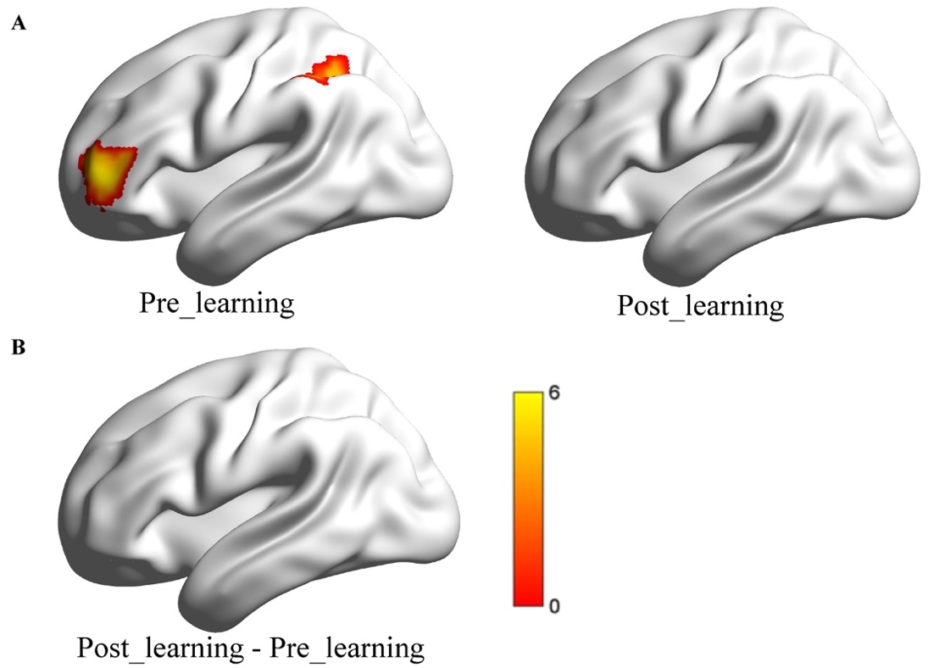

Figure 3. The neural activity of switch costs in the pre-learning and post-learning session.

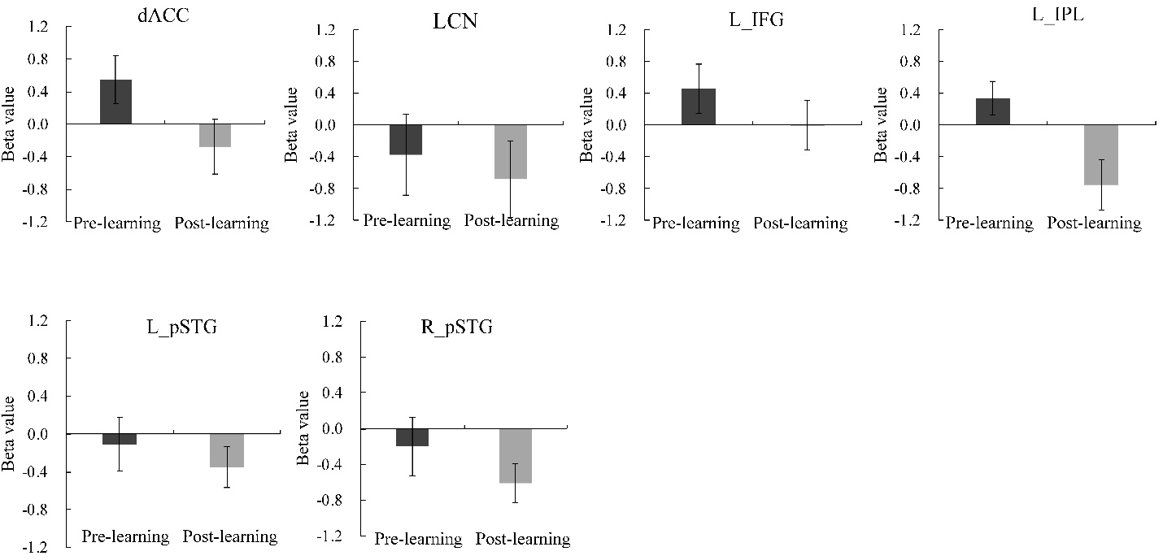

Figure 4. The $?=$ beta values reflecting the switch cost in the pre-learning and post-learning session in ROIs from the language control network (top panel) and ROIs from the language processing network (bottom panel).

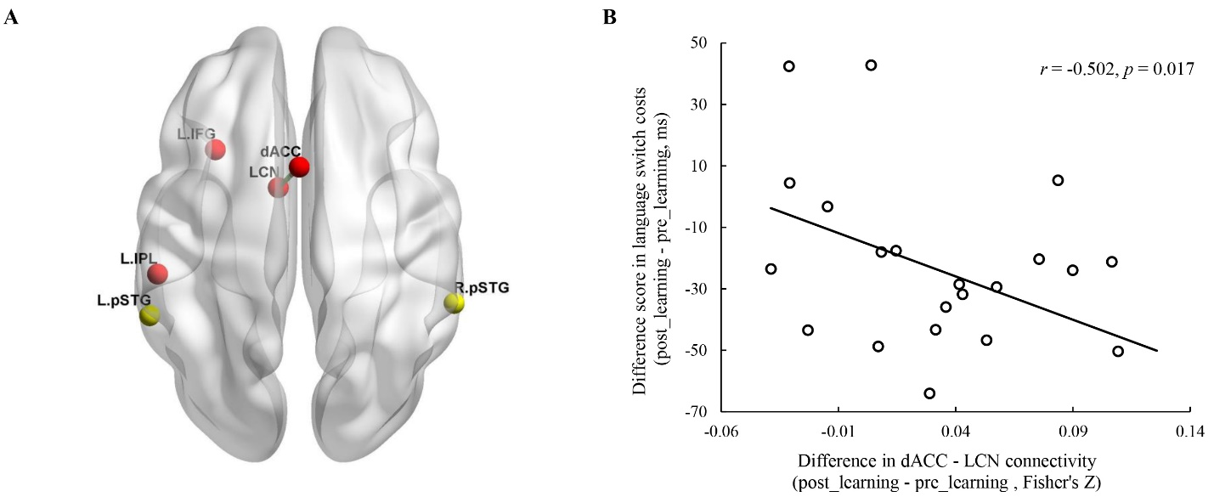

Figure 5. Connectivity between the dACC and LCN correlated with language switching costs. (A) Left panel indicating that the connectivity strength between the dACC and LCN was significantly increased in the post-learning as compared to the pre-learning session. (B) Association between connectivity (Fisher’s z) and behavioral performance on the language switching task.