**Table 1: Other EPDS shortened forms**

|  |  |  |  |  |  |  |  |  |  |  |  |  |  |  |  |
| --- | --- | --- | --- | --- | --- | --- | --- | --- | --- | --- | --- | --- | --- | --- | --- |
| **EPDS Items** | **1** | **2** | **3** | **4** | **5** | **6** | **7** | **8** | **9** | **10** | **Participants** | **Method for Item Selection** | **Validation Compared to Major Depression Classification** | | |
| **EPDS Version** | **funny** | **enjoy** | **blame** | **anxious** | **scared** | **overwhelmed** | **sleep** | **sad** | **cry** | **harm** | **Diagnostic Standard** | **N total** | **N**  **Major Depression** |
| EPDS-2 (a) |  | X |  |  |  |  |  | X |  |  | Primiparous adolescent mothers | Expert-based analysis of item content was used to select items resembling the PHQ-2. | KID-SCID major depressive disorder | 106 | 19 |
| EPDS-2 (b) |  |  |  |  | X |  |  | X |  |  | Pregnant women in 3rd trimester | Pearson correlation and multiple linear regression were used to select items. Authors examined R2 and AUC for individual items, and some unspecified sets of items to choose the final simplified scale. | --a | -- | -- |
| EPDS-3 (a) |  |  | X | X | X |  |  |  |  |  | Primiparous adolescent mothers | Expert-based analysis of item content was used to select items that measure symptoms of anxiety. | KID-SCID major depressive disorder | 106 | 19 |
| EPDS-3 (b) |  | X |  |  | X |  | X |  |  |  | Postpartum women | Univariate assessment of relationship between the diagnosis via the MINI and EPDS items without item 10, followed by penalized regression to assess predictive value of each item. | MINI depression | 298 | 63 |
| EPDS-5 |  | X | X | X |  |  | X | X |  |  | Women of reproductive age (not necessarily pregnant or postpartum) | Stepwise multiple linear regression, using the full EPDS as the outcome and adjusted R2 as the selection criteria, considering all items except for item 6, was used to create a 5-item tool. This was done among all women and among the postpartum women. Cronbach’s alpha used to assess internal consistency. | PRIME-MD major depressionb | 56 | 9 |
| EPDS-7 | X | X |  |  |  | X | X | X | X | X | Primiparous adolescent mothers | Expert-based analysis of item content was used to select items that measure symptoms of depression. | KID-SCID major depressive disorder | 106 | 19 |
| EPDS-7 | Postnatal women | Exploratory and confirmatory factor analyses were used to create a depression factor. | --c | -- | -- |
| EPDS-8 | X | X | X | X | X | X |  |  | X | X | Primiparous women | Rasch analysis was used to remove items based on misfit. Then, differential item functioning was assessed among the remaining items and principal components analysis was used to assess local independence and unidimensionality. | --d | -- | -- |

Abbreviations: AUC: area under the curve; EPDS: Edinburgh Postnatal Depression Scale; KID-SCID: Structured Clinical Interview for DSM-IV Childhood Diagnoses; MINI: Mini International Neuropsychiatric Interview; N/A: not applicable; PHQ: Patient Health Questionnaire; PRIME-MD: Primary Care Evaluation of Mental Disorders; SCID: Structured Clinical Interview for DSM-IV

a Compared shortened form to EPDS ≥ 12 classification.

b In addition, correlated shortened form with EPDS total scores and with SCL-25 (Hopkins Symptom Check List 25-items version) total scores

c Compared EPDS-7 scores to EPDS ≥ 10 classification and to Structured Interview Guide for the Hamilton Depression Rating Scale with Atypical Depression Supplement (SIGH-ADS) > 18 classification. EPDS-3 not evaluated.

d Compared shortened form to EPDS ≥ 10 but < 13 classification and to EPDS ≥ 13 classification.

**Table 2. Patient demographic and diagnostic characteristics (N = 5157)**

|  |  |
| --- | --- |
| Sociodemographic variables | Summary |
| Age, years, *mean [median] $±$ SD (range)* | 29.1 [29] $±$ 5.9 (18, 47) |
| EPDS-10 score, *mean [median] $±$ SD (range)* | 7.1 [6] $±$ 5.9 (0, 30) |
| Country, *n (%)* |  |
| Australia | 158 (3.1) |
| Brazil | 241 (4.7) |
| Croatia | 272 (5.3) |
| Denmark | 320 (6.2) |
| Finland | 134 (2.6) |
| Germany | 224 (4.3) |
| Greece | 81 (1.6) |
| Hungary | 484 (9.4) |
| Italy | 29 (0.6) |
| Kenya | 161 (3.1) |
| Malawi | 186 (3.6) |
| Peru | 306 (5.9) |
| Portugal | 141 (2.7) |
| South Africa | 104 (2.0) |
| Thailand | 625 (12.1) |
| United Kingdom | 1093 (21.2) |
| United States of America | 239 (4.6) |
| Vietnam | 359 (7.0) |
| Pregnancy status, *n (%)* |  |
| Pregnant | 1455 (28.2) |
| Postpartum | 3702 (71.8) |
| Classification system, *n (%)* |  |
| DSM-III-R | 428 (8.3) |
| DSM-IV | 3947 (76.5) |
| DSM-IV-TR | 301 (5.8) |
| DSM-V | 481 (9.3) |

**Table 3. EPDS items and discrimination parameters from the generalized partial credit model**

|  |  |  |
| --- | --- | --- |
| Item Number | Description | Discrimination Parameter |
| 1 | I have been able to laugh and see the funny side of things | 1.69 |
| 2 | I have looked forward with enjoyment to things | 1.51 |
| 3 | I have blamed myself unnecessarily when things went wrong | 1.04 |
| 4 | I have been anxious or worried for no good reason | 1.13 |
| 5 | I have felt scared or panicky for no very good reason | 1.16 |
| 6 | Things have been getting on top of me | 1.11 |
| 7 | I have been so unhappy that I have had difficulty sleeping | 1.39 |
| 8 | I have felt sad or miserable | 3.00 |
| 9 | I have been so unhappy that I have been crying | 2.57 |
| 10 | The thought of harming myself has occurred to me | 1.29 |

**Table 4. Items included in optimal short forms of each length**

|  |  |  |  |  |  |  |  |  |  |  |
| --- | --- | --- | --- | --- | --- | --- | --- | --- | --- | --- |
| **Item Number (X indicates inclusion)** | | | | | | | | | |  |
| **Short Form Length** | **1**  **Funny Side** | **2**  **Enjoyment** | **3**  **Blame** | **4**  **Anxious** | **5**  **Scared** | **6**  **Overwhelmed** | **7**  **Difficulty Sleeping** | **8**  **Sad** | **9**  **Crying** | **10**  **Self-Harm** |
| 1 |  |  |  |  |  |  |  | X |  |  |
| 2 |  |  |  |  |  |  |  | X | X |  |
| 3 | X |  |  |  |  |  |  | X | X |  |
| 4 | X | X |  |  |  |  |  | X | X |  |
| 5 | X | X |  |  |  |  |  | X | X | X |
| 6 | X | X |  |  |  |  | X | X | X | X |
| 7 | X | X |  | X |  |  | X | X | X | X |
| 8 | X | X |  | X |  | X | X | X | X | X |
| 9 | X | X |  | X | X | X | X | X | X | X |

**Table 5. Reliability and validity results of the candidate short forms**

|  |  |  |  |
| --- | --- | --- | --- |
| **Form Length** | **Cronbach’s alpha (95% CI)** | **Correlation of summed scores (95% CI)** | **Correlation of factor scores (95% CI)** |
| 1 | NA | 0.816 (0.807, 0.825) | NA |
| 2 | 0.811 (0.797, 0.823) | 0.867 (0.860, 0.874) | 0.913 (0.841, 0.953) |
| 3 | 0.805 (0.794, 0.815) | 0.891 (0.885, 0.897) | 0.932 (0.875, 0.963) |
| 4 | 0.833 (0.823, 0.841) | 0.899 (0.894, 0.904) | 0.945 (0.898, 0.970) |
| **5** | **0.818 (0.808, 0.827)** | **0.910 (0.906, 0.915)** | **0.949 (0.906, 0.973)** |
| 6 | 0.840 (0.832, 0.848) | 0.932 (0.928, 0.935) | 0.962 (0.930, 0.980) |
| 7 | 0.844 (0.837, 0.851) | 0.965 (0.963, 0.967) | 0.975 (0.953, 0.987) |
| 8 | 0.856 (0.850, 0.862) | 0.980 (0.979, 0.981) | 0.988 (0.977, 0.993) |
| 9 | 0.868 (0.862, 0.874) | 0.991 (0.990, 0.991) | 0.997 (0.993, 0.998) |
| 10 | 0.877 (0.872, 0.883) | 1.000 (1.000, 1.000) | 1.000 (1.000, 1.000) |

Bold values represent those of the final selected form.

**Table 6. Screening accuracy results of the candidate short forms and their non-inferiority test results**

|  |  |  |  |  |  |
| --- | --- | --- | --- | --- | --- |
| **Form Length** | Optimal Cutoff | Sensitivity (95% CI) | P-value | Specificity (95% CI) | P-value |
| 1 | 2 | 0.612 (0.525, 0.693) | 1.000 | 0.917 (0.884, 0.941) | 0.000 |
| 2 | 3 | 0.654 (0.563, 0.735) | 1.000 | 0.919 (0.887, 0.943) | 0.000 |
| 3 | 3 | 0.801 (0.707, 0.870) | 0.001 | 0.823 (0.762, 0.871) | 0.822 |
| 4 | 4 | 0.782 (0.670, 0.863) | 0.022 | 0.872 (0.819, 0.912) | 0.000 |
| **5** | **4** | **0.825 (0.731, 0.892)** | **0.000** | **0.859 (0.801, 0.902)** | **0.000** |
| 6 | 5 | 0.803 (0.720, 0.866) | 0.000 | 0.870 (0.811, 0.913) | 0.000 |
| 7 | 7 | 0.799 (0.705, 0.869) | 0.005 | 0.892 (0.833, 0.931) | 0.000 |
| 8 | 8 | 0.834 (0.751, 0.893) | 0.000 | 0.863 (0.799, 0.909) | 0.000 |
| 9 | 9 | 0.822 (0.739, 0.882) | 0.000 | 0.857 (0.793, 0.904) | 0.000 |
| 10 | 11 | 0.797 (0.710, 0.863) | NA | 0.880 (0.826, 0.919) | NA |

Bold values represent those of the final selected form

**FIGURES**

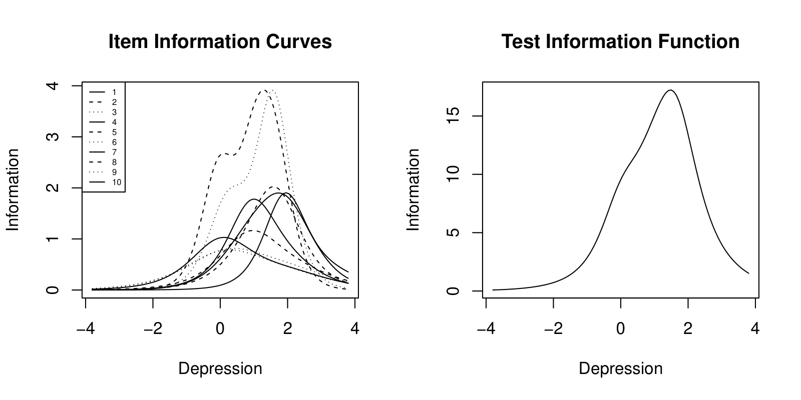

**Figure 1.** The left-hand plot shows the item information functions for each of the 10 items. The right-hand plot shows the test information function of the EPDS.