# ISPOR Poster – text figures and tables

## Introduction

BMI is known to be associated with mortality and comorbidity. In addition, weight loss has been associated with increased mortality and poorer health. On average, BMI increases during adulthood but some older individuals see their BMI significantly reduce over time potentially due to muscle loss rather than a reduction in fatty tissue. This would result in a decrease in BMI despite an increase in body fat percentage. Individuals could remain at the higher risk of mortality and comorbidities associated with obesity despite being classified as having a 'normal' BMI. This study investigates different BMI trajectories in older adults to determine whether BMI trajectory can predict mortality and comorbidities.

## English Longitudinal Study of Aging

The English Longitudinal Study of Ageing (ELSA) recruited over 18,000 participants from the 1998-2000 samples of the Health Survey for England (HSE) if they were 50 years or older in 2002. This study uses data from the main baseline HSE (wave 0) and waves 1 to 7 of the ELSA questionnaires and from nurse visits. At waves 2, 4 and 6, nurse visits included measures of height, weight and BMI with approximately four years between measurements. Response rates were consistently higher than 70%.

ELSA was linked with the NHS central register official mortality data providing accurate mortality data for participants from waves 1 to 6.

Information on self-reported comorbidities (type II diabetes, cancer, arthritis, asthma, heart problems, stroke) was available in ELSA waves 1 to 7.

## Methods

**Growth Mixture Modelling:** GMM allows the identification of distinct subpopulations (c) of individuals with similar BMI trajectories within a wider heterogeneous population; it tells us the characteristics (X) of individuals likely to experience similar BMI trajectories. Model choice is determined by criteria used in existing literature, including Bayesian Information Criteria.

**Discrete-time Survival Analysis:** DTSA is used to estimate hazard ratios (h) for mortality and comorbidities. Proportional odds are assumed. Residual variance of each survival model is unrestricted creating a random effect for unobserved heterogeneity in the propensity to experience each hazard. Fig 1 displays only one of many DTSAs.

The GMM and DTSAs are linked using the BCH approach (see methods framework). This estimates the influence of BMI trajectory on each outcome simultaneously. Previous research has focused on independent outcomes.

Parameters are estimated by maximum likelihood using an accelerated expectation maximisation (EMA) algorithm with Fisher Scoring and Quasi-Newton optimization as required.

## Results

Four distinct BMI trajectories were identified and shown in Fig 2; ‘stable overweight’, ‘persistently obese’, ‘increasingly obese’ and ‘decreasing BMI’.

Individuals had 3.1% probability of following the ‘decreasing BMI’ trajectory and compared to the ‘stable overweight’ trajectory had a higher risk of mortality and the onset of diabetes, arthritis, asthma, stroke and heart problems. Following the ‘consistently obese’ trajectory increased the risk of diabetes considerably compared to the ‘stable overweight’ trajectory. There was little evidence that BMI trajectory influence the onset of cancer.

## Methods Framework

Previous studies have jointly estimating a GMM and DTSA. Joint estimation means that any distal outcome can influence BMI trajectory, creating a counter-intuitive circularity. Joint estimation also means that each distal outcome has to be estimated in a separate model, meaning that the estimated trajectories inevitably differ when estimating different outcomes, due to the counter-intuitive circularity discussed above.

The 2-step BCH approach overcomes these problems. **Step 1:** Estimate the GMM independent of the distal outcomes where distal outcomes are included as auxiliary variables. **Step 2:** Estimate the distal outcomes, in this case DTSAs. The second step does not influence the first, avoiding the problem of counterintuitive circularity and allowing multiple DTSAs to be estimated jointly.

## Discussions and Conclusions

* Using the BCH approach allows multiple distal outcomes to be estimated simultaneously.
* Jointly estimating BMI trajectory and distal outcomes could overestimate the influence of BMI trajectories on the outcomes.
* Most recent BMI is not a sufficient indicator of obesity related risk of mortality or comorbidity.
* In older adults, a slowly decreasing BMI is the least desirable trajectory in terms of the outcomes from this study.
* Older individuals who experience a slow reduction in BMI should be considered at higher risk of mortality, arthritis, asthma, heart problems and stroke.

**Figure 1:** Path diagram for GMM and DTSA

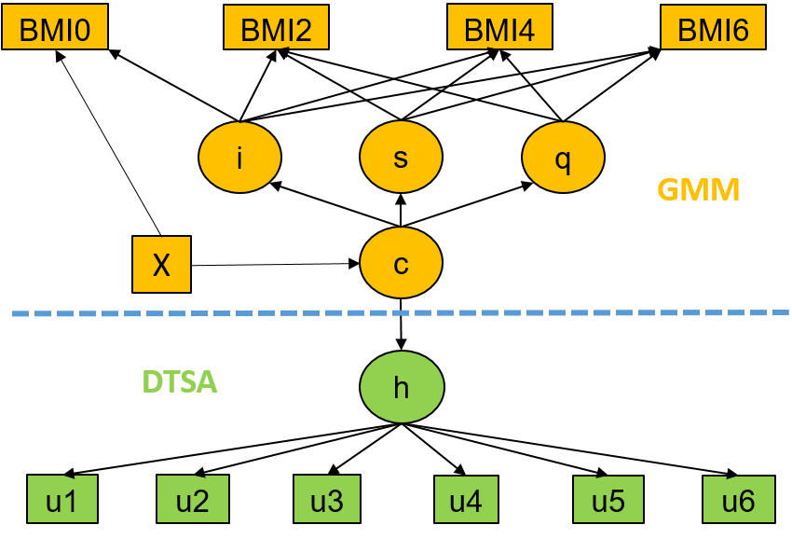

**Figure 2:** Estimated BMI trajectories

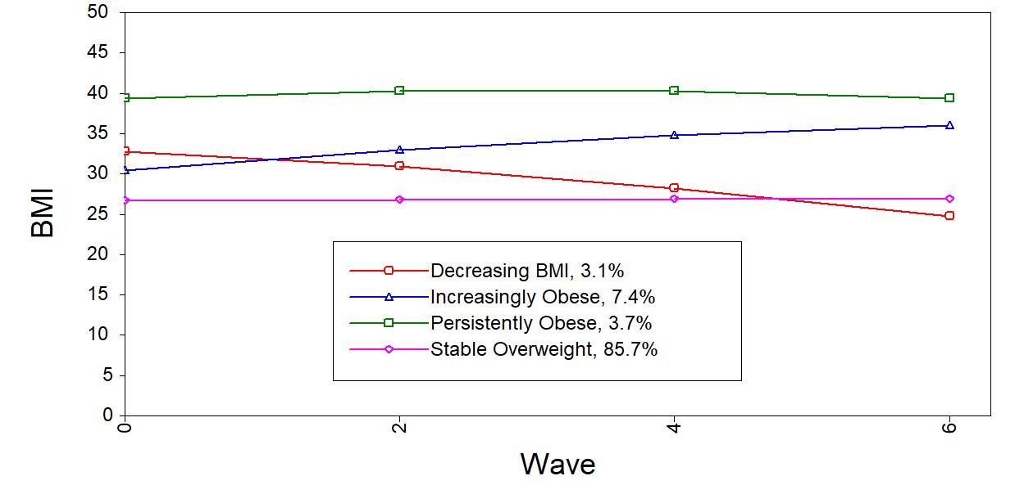

**Table 1:** Hazard ratios for mortality and comorbidities by BMI trajectory component

