**Prevailing Conditions of Flow in Particulate Systems**

M. Alizadeh Behjani a, M. Pashab, Haifeng Luc, C. Hared, A. Hassanpour a*

a School of Chemical and Process Engineering, University of Leeds, Leeds, UK

b The Chemours Company, Wilmington, Delaware, USA

c Institute of Clean Coal Technology, East China University of Science and Technology, China

d Department of Chemical and Process Engineering, University of Surrey, Guildford, UK

*Corresponding contributor. E-mail: [a.hassanpour@leeds.ac.uk](mailto:a.hassanpour@leeds.ac.uk%20)

**Abstract**

This chapter reviews the main prevailing features of the flow in particulate systems. The flow behaviour of a powder is a function of different parameters and conditions, such as the particles properties, applied stresses, flow regime, environmental conditions, and time. The differences and similarities of bulk materials and liquids in terms of stress distribution are discussed, and the main mathematical models for estimation of these stresses are mentioned briefly. This chapter also discusses the relation between stress and strain rate in different powder flow regimes, such as the static, quasi-static, intermediate, and rapid granular regimes. Flow behaviour of powder alters by the change in environmental conditions, such as the temperature, relative humidity, and electrostatic charging, all of which are discussed here.

## Introduction

In chapter 2 the macroscopic response of bulk powders to the external forces and the role of microscopic attributes, such as forces on particles, have been reviewed. Such response could lead to the yielding of bulk materials and initiate flow depending on the interparticle properties, state of their packing and loading conditions. Packing and loading conditions depend on the external factors and geometry of the system and will be reviewed in this chapter. Here, the state of stress prevailing in a powder bed, including how this varies as compared to stress in a liquid is discussed and methods for its determination using a number of theoretical approaches are presented. It should be note that the stress level is also affected by boundary conditions and environmental factors. The influence of velocity profiles within the bed (strain rate) on the stress conditions in form of flowing regimes are outlined and discussed. In addition, effect of continuous applied load and resulting time consolidation and caking behaviour as well as the influence of temperature, humidity and electrostatic interactions on the powder flow behaviour are reviewed and discussed.

## Stresses in containers

### Bulk solid stress versus the liquid hydrostatic pressure

Fluid systems can exist in static conditions when they are completely stationary, e.g. stored inside a tank, or can be in dynamic conditions when they are in motion due to the external forces. In this context, the *hydrostatic condition* is a specific term given to the fluids with zero velocity. In such condition, the pressure variation within the fluid is only because of the fluid’s weight. Some well-known applications of the hydrostatic pressure are 1) pressure distribution in oceans and weather forecasting, 2) pressure measurement by a manometer, 3) design of floating objects like ships and boats, and 4) design of submerged bodies like submarines. Considering a certain fluid in a known gravitational field, the hydrostatic pressure increases in proportion to the depth measured from the free surface, and it acts equally in all directions at a given point. **Error! Reference source not found.** shows the hydrostatic pressure in a container filled with a fluid which increases linearly downwards.1

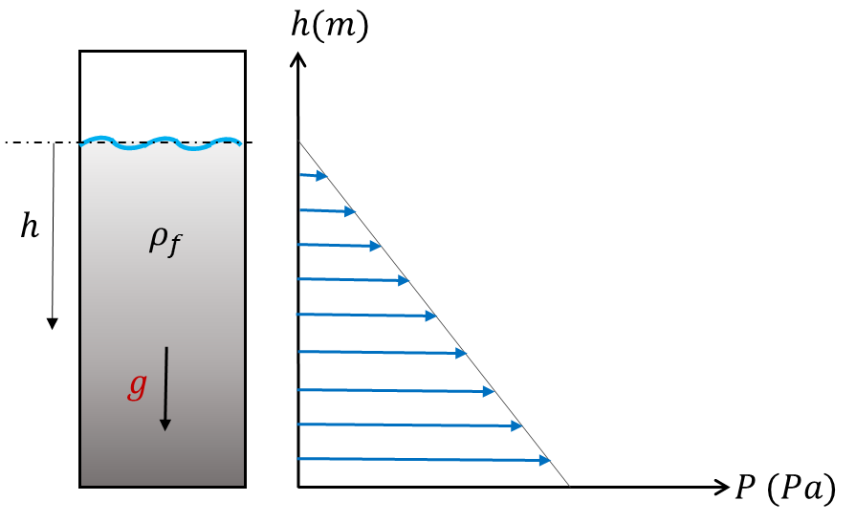

Figure ‎3.1: Pressure in an arbitrary container filled with a fluid.

The liquid hydrostatic pressure also depends on the density of the liquid. For an incompressible fluid, the governing equation for hydrostatic pressure is given by,

$P=ρ_{f}gh$ (3.1)

where $ρ_{f}$ is the density of the fluid, *g* is the gravitational acceleration and *h* is the depth measured from the free surface. Interestingly, as it can be concluded from Equation (3.1), the liquid hydrostatic pressure at a given point in a container varies only due to the depth and density, and does not depend upon the total mass, surface area, or the geometry of the container. This is illustrated schematically in Figure 3.2, where the hydrostatic pressure of a certain fluid is shown as a function of depth.

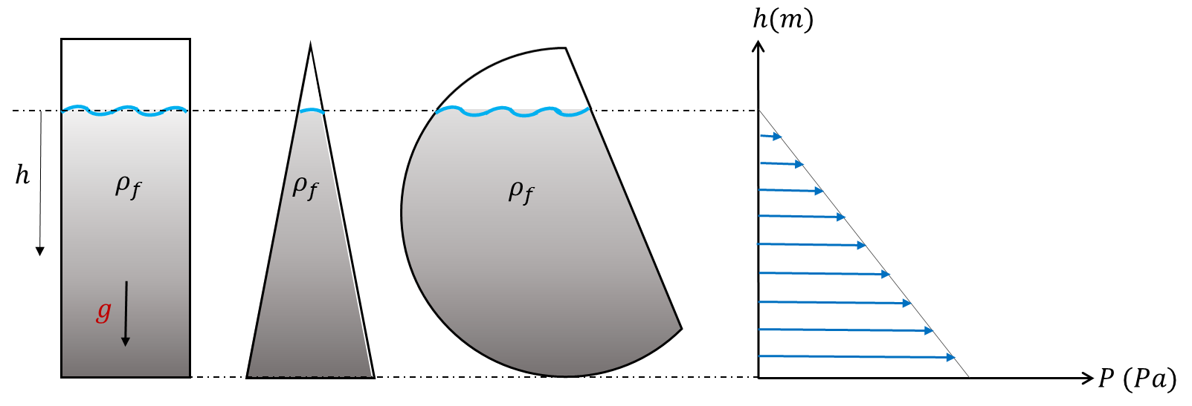

Figure ‎3.2: Liquid hydrostatic pressure in different containers

Using fluid analogy and theories to describe the state of stresses within bulk solids material is highly questionable due to the significant differences in the nature of the two materials. Different attributes within bulk solids that distinguishes their behaviour from fluids are given below.

#### Internal Structure

A powder bed structure is formed as particles fall inside a container. Due to the weight of the particles, the powder bed is subjected to the normal stress as more particles fall on top, leading to a denser structure. This is a phenomenon that can be observed visually, where a gradient in the voidage (or solids fraction) is seen across the powder bed, especially near the top side of the bed2. Fluids, on the other hand, tend to have a uniform structure across the volume, where the state of the stress can be represented by a single scalar value of density. For particulate systems, however, bulk density alone does not fully describe the structure of the bed for evaluation of stresses. The internal structure of the packed beds, e.g. when a container is filled with powder via a pouring process, strongly depends on various single and bulk powder properties. The packing behaviour of fine particles is different from that of coarse particles, as described in Section 2.7.1, in systems with a small particle size (e.g. < 100 μm), inter-particle interactions (cohesive contacts) become the dominant forces compared to the particle weight. As a consequence, fine particles tend to form tree- or chain-like structures, leading to a non-uniform structure with higher porosity compared to coarser particles3. The relationship between initial bulk porosity and particle size is shown in Figure ‎3.3, where Yu *et al.3* compared the data from a number of studies in the literature for spherical particles of various sizes.

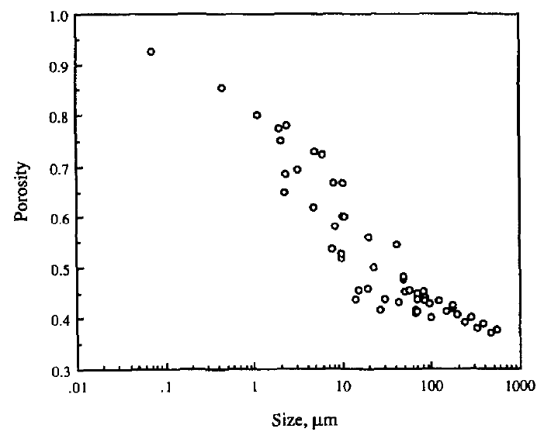

Figure ‎3.3: Initial bulk porosity as a function of particle size. (Reprinted with permission from 3)

A wide particle size distribution increases the likelihood of fine particles migrating into the voids that are formed between larger particles. Therefore, a system with a wider particle size distribution would form a structure that is less porous.2 It is also known that irregularly-shaped particles (e.g. needle-like crystals – see Section 2.7.1 for particle shape description) form dilated powder beds with larger void fraction.2

The internal structure of a powder bed formed by pouring a powder into a container is not only a function of the single particle properties, but also depends on the procedure by which the powder is introduced into the container.4 This was investigated by Zafar *et al.*,4 where they compared the uniaxial unconfined compression (Sections 2.3 and 4.4.2.1) of 45 – 63 μm silanised (cohesive) glass beads that were prepared by two different filling method; (a) the sample was simply poured into a cylindrical die, and (b) the sample was fed into the die through a sieve with a mesh opening of ~ 5 times the mean particle diameter. As can be observed in Figure 3.4, the sieved filling method led to a more uniform apparent bed structure, due to the breakdown of large, loose agglomerates by the sieve. The unconfined yield stress of the sieved sample was an order of magnitude larger than that of the poured sample.

|  |  |
| --- | --- |
| https://ars.els-cdn.com/content/image/1-s2.0-S0032591017300670-gr3_lrg.jpg  (a) | https://ars.els-cdn.com/content/image/1-s2.0-S0032591017300670-gr4_lrg.jpg  (b) |

Figure ‎3.4: Load-displacement data and exposed surface of 45–63 μm silanised glass beads during the unconfined uniaxial compression at (a) 5-kPa consolidated sample with the poured filling method and (b) 5-kPa consolidated sample with the sieved filling method.4

The powder structure is sensitive to vibration and tapping, unlike fluids whose density does not change upon slight vibration or agitation. As described in Section 2.8, fine and cohesive powder tend to show a greater level of densification upon tapping.

#### Powder compressibility

Unlike most fluids, bulk solid materials exhibit high degrees of compressibility.5 Compressibility is the change in the relationship between relative density, porosity or volume and applied pressure, and it is known that systems with, wide size distributions or fine, cohesive or soft particles tend to be more compressible. The Carr index and Hausner ratio (HR) are the most common measures for quantifying the compressibility of powders. A detailed description of the compressibility response of bulk solids is provided in Section 2.2.

#### Friction

Bulk solids materials have significant shear strength, which is defined as the internal angle of friction (see Section 2.5.2 for more details).6 A more notable difference between fluids and bulk solids is the frictional interaction between the material and the confining walls. Once a container is filled, bulk solids materials exhibit significant levels of static friction with the walls of the container. Additionally, upon application of a normal force to a confined bulk solids material, part of the force is converted to shear stress and transmitted to the walls as such, whilst in fluids, the shear stress at walls, albeit less comparable to particles, remains independent of the applied normal force.7 (See Sections 2.5.3 and 4.4.4 for a description of wall friction and its measurements, respectively).

#### Anisotropy

Unlike the hydrostatic pressure in fluids that acts uniformly in all directions, the stress in bulk solids is an anisotropic property, i.e. at a certain point of a powder bed, the stress may vary in different directions, due to the discrete nature of the particles. For instance, it has been shown that the unconfined yield stress of bulk solids strongly depends on the direction at which the material is consolidated8 - see Section 4.4.2.4 for more information.

### Estimation of stress in a straight section

While the hydrostatic pressure would increase linearly downwards in a silo if it had been filled with a fluid, the course of the vertical stress in a silo filled with a bulk solid is rather different. In the latter case, in the vertical (cylindrical) section of the silo the vertical stress increases in a digressive way, as shown later in Figure ‎3.6. Due to the shear stresses between the powders and the walls, the silo walls carry part of the weight of the bulk solid; which is obviously not the case for the liquids. The stresses in a vertical section of silo can be calculated according to a derivation by Janssen9, as outlined in the following section.

#### Janssen Theory for Estimation of Stresses within Bulk Solids

Janssen9 derived an equation for the vertical pressure that a loose bulk material exerts on the bottom of a container by considering the forces acting on an increment across the height of the powder bed, as shown schematically in Figure 3.5. The forces shown in Figure 3.5 are based on the assumptions that across the powder bed increment, the bulk density is constant, and vertical and horizontal stresses are uniform over the cross-sectional area and perimeter, respectively.

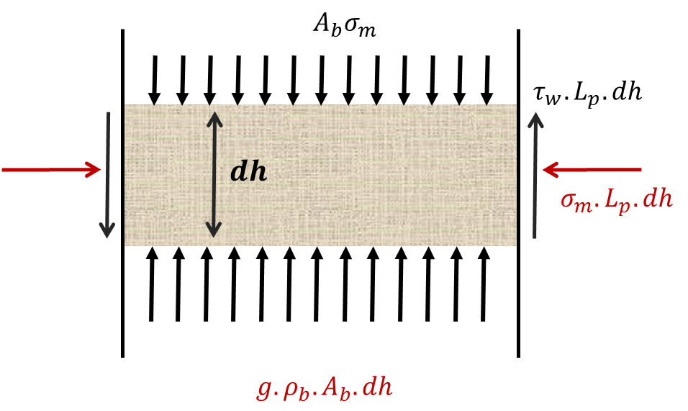

Figure ‎3.5: Schematic representation of forces acting on an increment of a powder bed inside a container

The forces shown in Figure 3.5 are balanced as follows,

$A_{b}σ_{m}+gρ_{b}A_{b}dh=A_{b}\left(σ_{m}+dσ_{m}\right)+τ_{w}L_{p}dh$ (3.2)

where $σ_{m}$ is the normal stress acting on the top of the bed increment, $dh$ is the height of the powder bed increment, *g* is the gravitational constant, $ρ_{b}$ is the bulk density of the powder bed increment, $τ_{w}$ is the normal stress acting on the wall, and *Ab* and *Lp* are the area and perimeter of the cross section of the powder bed increment, respectively. Rearranging Equation (3.2) yields,

|  |  |
| --- | --- |
| $$\frac{dσ_{m}}{dh}=gρ_{b}-τ_{w}\frac{L_{p}}{A_{b}}$$ | (3.3) |

Janssen9 assumed that the full frictional force is mobilised at the container walls, hence tan(*φwi*) = *τw*/ *σm*. Considering *λσ* is the horizontal to vertical stress ratio, Equation (3.3) can be re-written to obtain a first order differential equation for the vertical stress as,

|  |  |
| --- | --- |
|  | (3.4) |

Assuming constant values of $ρ_{b}$, $λ_{σ}$, and $tan⁡(ϕ_{wi})$, Equation (3.4) can be solved by using an integrating factor to get,

|  |  |
| --- | --- |
| $$σ_{m}=\frac{gρ_{b}A_{b}}{λ_{σ}L_{p}tan⁡(ϕ_{wi})}+\left(σ_{m0}-\frac{gρ_{b}A_{b}}{λ_{σ}L_{p}tan⁡(ϕ_{wi})}\right)e^{-λ_{σ}\frac{L_{p}}{A_{b}}tan⁡(ϕ_{wi})h}$$ | (3.5) |

where $σ_{m0}$ is the vertical stress at the top increment of the powder bed, i.e. at *h* = 0. Janssen assumed the free surface of the powder to be flat and subject to atmospheric pressure (i.e. $σ_{m0}$ = 0). This yields the Janssen equation of stress equilibrium,

|  |  |
| --- | --- |
| $$σ_{m}=\frac{gρ_{b}A_{b}}{λ_{σ}L_{p}tan⁡(ϕ_{wi})}\left(1-e^{-λ_{σ}\frac{L_{p}}{A_{b}}tan⁡(ϕ_{wi})h}\right)$$ | (3.6) |

Equation (3.6) can be used to evaluate the stress distribution across the height of a powder column. An example is provided in Figure 3.6, where the normal stress is plotted as a function of bed height using liquid hydrostatic and Janssen equations (Equations (3.1) and (3.6), respectively). Assumptions in this example are as follows: 1) constant bulk density ($ρ_{b}$) of 1000 ${kg}/{m^{3}}$, 2) constant angle of wall friction ($ϕ_{wi}$) of 20 degrees, 3) constant horizontal to vertical stress ratio ($λ_{σ}$) of 0.4, 4) a cylindrical container of 15 cm diameter, and 5) an initial bed height of 30 cm.

Figure ‎3.6: Comparison of Janssen theory and fluid hydrostatic pressure for estimation of stress distribution inside a container

Since the establishment of Janssen theory in 1895, there has been extensive research to improve upon this theory. Examples include; accounting for (i) compressibility of powder beds (see 10-12), (ii) variable horizontal to vertical stress ratio (see 11, 13-16), and (iii) distribution of the vertical stress in the radial direction across the powder bed increment (see 12, 13, 17).

### The Rankine states

Rankine's theory, also known as the maximum stress theory, was derived for soil mechanics applications and provides a solution for the lateral earth pressure. It assumes that failure in the soil occurs when the maximum principal stress reaches the tensile stress for the failure. In application of this theory it is assumed that: the soil is cohesionless and isotropic, the wall has no friction, the soil-wall interface vertical, the surface on which the soil slides is planar, and the overall force is parallel to the surface of the backfill. In Rankine’s theory, the pressure exerted on the wall by the soil is called the “active pressure” and the resistance of the soil against external objects is termed "passive pressure". Based on this, the Rankine states can be described by a simple experiment shown in Figure ‎3.7, where a sample bulk material is confined between two infinitely-extended vertical planes. If the planes are moved slowly apart, the powder will flow outwards, as shown in Figure ‎3.7 (a). This stress state represents the “active stress”. Alternatively, if the planes are pushed slowly together, the powder will move inwards, as shown in Figure ‎3.7 (b), representing the “Passive Stress”.12

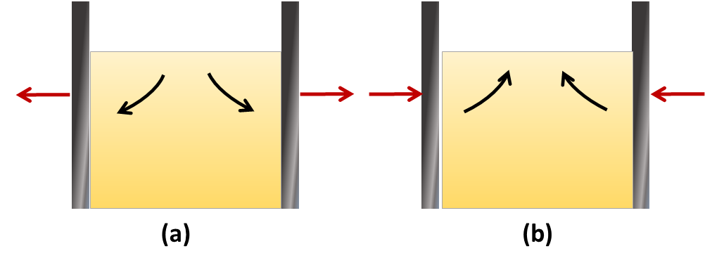

Figure ‎3.7: Schematic diagram of the (a) active and (b) passive Rankine failure states.

Rankine's theory is suitable for incompressible soils. The equations of the active and passive earth pressures are expressed, respectively, as:

|  |  |  |
| --- | --- | --- |
|  | $$P_{a}=K_{a}ρ_{b}gh$$ | (3.7) |

|  |  |  |
| --- | --- | --- |
|  |  | (3.8) |

where $K_{a}$ and $K_{p}$ show the coefficients of the active and passive pressures, respectively,

|  |  |  |
| --- | --- | --- |
|  | $$K_{a}=\frac{cosβ-{\left(\cos^{2}β-\cos^{2}ϕ_{i}\right)}^{1/2}}{cosβ+{\left(\cos^{2}β-\cos^{2}ϕ_{i}\right)}^{1/2}}×cosβ$$ | (3.9) |

|  |  |  |
| --- | --- | --- |
|  |  | (3.10) |

where $β$ is the angle between the powder surface and the horizontal line and $ϕ_{i}$ refers to the angle of internal friction. In case of a bulk material with a horizontal surface (i.e. $β=0$), the coefficients of active and passive pressures become inversely proportional, i.e. $K_{a}=1/{K_{p}}$.

### Walter’s switch stress analysis

Silos and containers which are designed by the available methods, such as the Janssen theory, are normally manufactured using a moderate safety factor. These bunkers must tolerate the static, dynamic and transition from static to dynamic conditions. However, in some cases, bunkers may fail upon powder discharge. This phenomenon is investigated by Walters18, where he suggests that large lateral and shear stresses are observed, just before the transition from static to dynamic conditions. An approximation for analysing the stress variation in such cases is proposed by Walters where the predicted stress level is much larger than the Janssen’s prediction. In Walters’ predictions, only the angles of internal friction and the wall friction are required, both of which can be determined easily in the laboratory (see section 4.4). Further details of their analysis are found in 18.

## Strain Rate Dependency

Rheology is one of the classical characterisation methods for material properties or functions of matter. It focuses on linking stress applied on a sample and the resulting deformation. A flowing powder can exist in various rheological states based on the way the particles interact with each other. Information of the flow field in the powder and forces acting on different objects in the flow and on the boundaries can be obtained using the equations of equilibrium of stress in the powder together with a yield condition and a rule for powder flow. Tardos19 provides a schematic representation of different regimes in powder flow as shown in Figure ‎3.8. He has illustrated the flow regime as a function of a dimensionless shear rate, defined as $γ^{o*}=\dot{γ}{\left[d/g\right]}^{1/2}$, where $d$ represents the particle diameter. As the dimensionless shear rate varies, the powder flow falls in different flow regimes, which influence the stress-strain rate relationship.

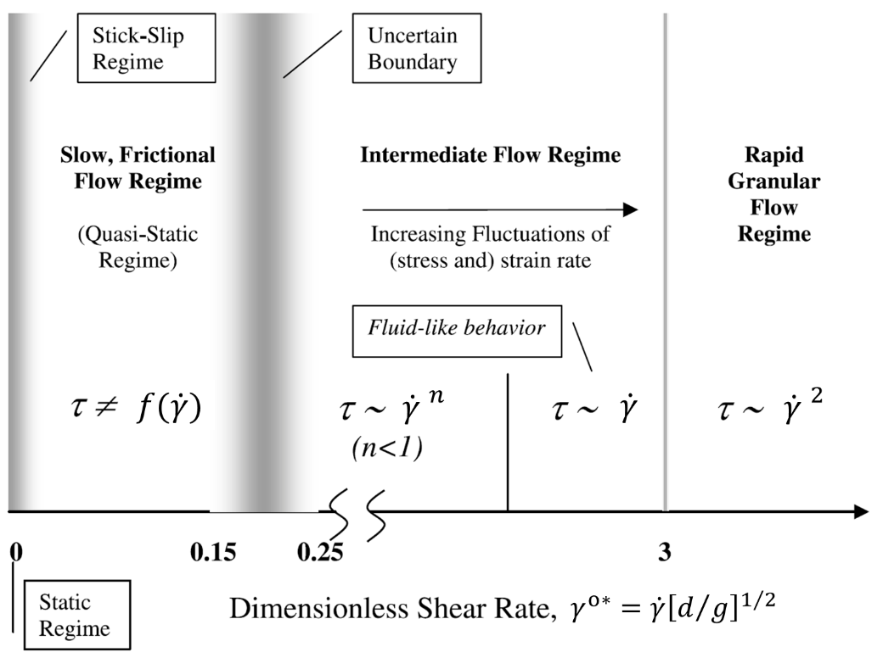

Figure ‎3.8: Powder flow regimes based on the dimensionless shear rate. (Reprinted with permission from 19)

### Static regime

The static regime is the condition at which the powder has no movement and is in static equilibrium. This condition is associated with no shear within the powder bed. The powder, however, may deform in presence of large stresses, where the yield point is defined as the onset of this deformation. Using the yield condition and the static equilibrium equations, one can calculate the stresses within the powder bed. There are various types of analytical (e.g. Equation 3.6) and numerical techniques available for analysing the stress distribution within a powder bed, which are discussed in Chapter 5.

### Quasi-static regime

The quasi-static regime applies to shear rates up to around 0.15 – 0.25; the upper boundary of this regime is uncertain19. Particles movement is very slow and governed by friction in this regime. In this regime, the slow-flowing particles lose most of their energy through sliding but with very few collisions. This is because particles are packed closely together and hence collisions occur at negligible relative velocities; instead, the particles are overwhelmed by contact frictional sliding. Slow flows occur during discharge from industrial storage hoppers and bins and are therefore of great industrial relevance.

For analysing the quasi-static regime (also known as the slow flow regime), it is assumed that the flow has an uninterrupted character and the shear field is continuous. In this regime, the powder is considered to be an incompressible continuous medium. In all states, the powder obeys the principles of the conservation of mass and momentum together with a yield condition, which specifies the onset of deformation. To define the behaviour of the powder after yielding, i.e. after powder starts to move, a “flow rule” is also required.

To determine the flow field and stress distribution of the powder during flow, a constitutive equation, which defines the relation of the stress and strain rate in the powder, is required. Schaeffer proposed an equation for the quasi-static powder flows which obeys the von-Mises yield condition20 and Levy’s flow rule21 as follows:

|  |  |  |
| --- | --- | --- |
|  |  | (3.11) |

where ${\dot{γ}}_{ij}$ is the strain rate, $δ_{ij}$ is the Kronecker delta, $τ_{ij}$ is the deviatoric stress, $P={\left(σ_{ii}+σ_{jj}+σ_{kk}\right)}/3$ shows the mean normal stress (pressure), and $ϕ_{i}$ denotes the angle of internal friction. The strain rate is:

|  |  |  |
| --- | --- | --- |
|  | $${\dot{γ}}_{ij}=\frac{1}{2}\left(\frac{{∂v}_{i}}{{∂x}_{j}}+\frac{{∂v}_{j}}{{∂x}_{i}}\right)$$ | (3.12) |

where its magnitude for a 2D case is given by:

|  |  |  |
| --- | --- | --- |
|  |  | (3.13) |

Based on Levy’s flow rule, the deviatoric stress and strain rate remain proportional during flow. In the case of an incompressible powder (${\dot{γ}}_{ii}+{\dot{γ}}_{jj}+{\dot{γ}}_{kk}=0$), the flow rule is mathematically expressed as $τ_{ij}=β_{1}{\dot{γ}}_{ij}$*,* where $β_{1}$ denotes a coefficient. The coefficient $β_{1}$ is obtained using the Levy’s flow rule together with the yield condition of von Mises $\sqrt{\sum_{ij}{τ_{ij}^{2}}}=\sqrt{2}Psinϕ_{i}$ to yield Equation (3.11). Combining Equation (3.11) and the momentum equation, the general form of the equation of motion for an incompressible powder will be:

|  |  |  |
| --- | --- | --- |
|  |  | (3.14) |

The velocity and pressure distribution in the flow field is obtained by solving the above equations together with the continuity equation, $∇v=0$. It should be noted that in deriving and solving these equations, it is assumed that the powder is incompressible and not cohesive, with the powder being characterised only by the bulk density, $ρ_{B},$ and angle of internal friction, $ϕ_{i}$. Obtaining an analytical solution for these equations is normally difficult, yet, solutions for simple cases, like a 2D-plane hopper and powder shearing in a Couette device (see Figure ‎3.9), are published in the literature22, 23. The stress distribution is predicted well by these equations, while the velocity profile is over-estimated due to the incompressibility assumption. To enhance the predictability of the theory, Tardos introduced the powder compressibility. However, in the case of a unidimensional powder flow, e.g. shear flow in the Couette device, no values for the velocity distribution are produced by the equation. This drawback stems from implementing the yield condition; allowing the shear bands to form a discontinuous pattern in the powder.19

### Intermediate flow regime

The intermediate regime is defined as a flow regime between the slow, quasi-static regime and the rapid granular flow regime. In this regime, the particle interactions are both frictional and collisional, and the flow is characterised by fluctuations in stress and strain rate. It should be noted that the boundaries between the quasi-static, intermediate, and rapid granular flow regimes are not as clear as presented in Figure ‎3.8, and more work is required to define these boundaries.

Experiments show that stresses and deformations constantly fluctuate during powder flow in the intermediate regime. Based on this, it is assumed that the strain rate fluctuates around a mean value,

|  |  |  |
| --- | --- | --- |
|  | $${\dot{γ}}_{ij}=〈{\dot{γ}}_{ij}〉+{\dot{γ}}_{ij}^{'}$$ | (3.15) |

where $〈{\dot{γ}}_{ij}〉$ is the mean value of the strain rate and ${\dot{γ}}_{ij}^{'}$ shows the fluctuations around the mean (i.e. $〈{\dot{γ}}_{ij}^{'} 〉=0$). Here, the fluctuations are distributed based on the Gaussian distribution function $\left[f({\dot{γ}}_{ij})\right]$ having a standard deviation, *𝜉*. Alternatively, other distribution functions can be used; however, it may only add to the complexity of the formulation without improving the results. The standard deviation (𝜉) is defined to be a function of the granular temperature (see24) as *𝜉*, where $β_{2}$ is a coefficient which is approximately ${≈1}/4$ for randomly packed discs. Average stresses, are obtained from Equation (3.16):

|  |  |  |
| --- | --- | --- |
|  | $$〈σ_{ij}〉=\int{f({\dot{γ}}_{ij})}(σ_{ij})({\dot{γ}}_{ij})d{\dot{γ}}_{ij}$$ | (3.16) |

In case of powder flow in the Couette device, Tardos proposed equations for the intermediate regime that spanned shear rates from the slow frictional regime to the rapid granular flow regime using the constitutive Equation (3.11). The flow is considered as 2-dimensional (on the *y*-*x* plane) with *z* as the axis of rotation. In such a case, the conditions on parallel horizontal planes merely vary by the hydrostatic pressure, as illustrated in Figure ‎3.9.



Figure ‎3.9: The 2D schematic of the shearing gap in a Couette device. (Reprinted with permission from 19)

For this simple flow in the Couette device, Equation (3.11) reduces to:

|  |  |  |
| --- | --- | --- |
|  | $$τ_{xy}=±Psinϕ_{i}, σ_{xx}=σ_{yy}=σ_{zz}=P$$ | (3.17) |

It is assumed that the powder deformations occur only in the tangential direction; thus, $〈{\dot{γ}}_{xx}〉=〈{\dot{γ}}_{yy}〉=0$, and fluctuations are assumed to occur in all directions but *z*. To find an analytical solution for this problem, we take ${\dot{γ}}_{xx}=-{\dot{γ}}_{yy},$ therefore, the equation of the mean shear stress becomes:

|  |  |
| --- | --- |
| $$〈τ_{xy}〉=\frac{Psinϕ_{i}}{2πξ^{2}}\int_{-∞}^{∞}{exp\left[\frac{{\dot{γ}}_{xx}^{2}+{\left({\dot{γ}}_{xy}-〈{\dot{γ}}_{xy}〉\right)}^{2}}{2ξ^{2}}\right]} ×\frac{{\dot{γ}}_{xy}}{\sqrt{\left({2\dot{γ}}_{xx}^{2}+{2\dot{γ}}_{xy}^{2}\right)}}d{\dot{γ}}_{xy}d{\dot{γ}}_{xx}$$ | (3.18) |

By defining $a_{ξ}={〈{\dot{γ}}_{xy}〉}/{\left(\dot{ξ}\sqrt{2}\right)}$ and integrating, we will have:

|  |  |
| --- | --- |
| $$〈τ_{xy}〉=\sqrt{\frac{π}{2}}\frac{Psin∅}{2ξ}〈{\dot{γ}}_{xy}〉\left\{I_{A}\left(\frac{{a_{ξ}}^{2}}{2}\right)+I_{B}\left(\frac{{a_{ξ}}^{2}}{2}\right)\right\} ×exp\left[-\frac{{a_{ξ}}^{2}}{2}\right]$$ | (3.19) |

$I_{A}$ and $I_{B}$ represent the “modified Bessel functions of the first kind”19. Equation (3.19) is the right equation for modelling the flow in the Couette device. In the case of zero fluctuations (i.e. $a_{ξ}→∞$), this equation reduces to Equation (3.17), which represents the Coulomb powder behaviour in the slow-flow regime. On the other hand, when the fluctuations approach infinity (i.e. $a_{ξ}→0$), the powder adopts the behaviour of a fluid, with an equivalent viscosity of:

|  |  |
| --- | --- |
| $$2η=\lim_{a→0}{\frac{d〈σ_{xy}〉}{d〈{\dot{γ}}_{xy}〉}=}\frac{\sqrt{π}Psinϕ_{i}}{2\sqrt{2}ξ}\left[I_{A}\left(0\right)+I_{B}\left(0\right)\right]=\frac{2β_{3}P}{ξ}$$ | (3.20) |

where ${β_{3}=\left(\frac{π}{2}\right)}^{0.5}sin\frac{∅_{i}}{4}$. For this limit, Equation (3.20) can be alternatively written as:

|  |  |
| --- | --- |
| $$〈τ_{xy}〉=η〈\frac{dv}{dy}〉=\left[\sqrt{\frac{π}{2}}\frac{Psinϕ_{i}}{4ξ}\right]〈\frac{dv}{dy}〉$$ | (3.21) |

with the shear stress being defined as the multiplication of the velocity gradient and viscosity. Equations (3.20) and (3.21) are suitable only for the fast flows in areas with large fluctuations. Although the powder adopts fluids behaviour, defining it as a fluid is still not easy, as the quantity *𝜉* is a function of the granular temperature, $T_{gran}$. One great advantage of Equation (3.19) is that it comprises the intermediate regime between the slow-frictional and the rapid granular flows by applying the aforementioned limits for strain rates, with very tiny and large fluctuations, respectively. Direct application of the average stress in Equation (3.21) is somehow difficult; however, one can use simpler expressions, given in Table 3.1, with no compromise in the accuracy of the results.19

Table ‎3.1: Mathematical expressions for the energy dissipation functional and the average stress.

|  |  |  |  |
| --- | --- | --- | --- |
| Average stress, $〈τ_{xy}〉$ | | Dissipation function, $ζ$ | |
| (a1) | $$Psinϕ_{i} erf\left(\frac{a_{ξ}\sqrt{π}}{2}\right)$$ | (a2) | $$\sqrt{\frac{π}{2}}Pξsinϕ_{i}\left\{1/{sinϕ_{i}+exp\left[-{\left(\frac{a_{ξ}π}{2}\right)}^{2}\right]}\right\}$$ |
| (b1) | $$Psinϕ_{i}erf\left(\frac{a_{ξ}π}{4}\right)$$ | (b2) | $$\sqrt{\frac{π}{2}}Pξsinϕ_{i}\left\{1/{sinϕ_{i}+{sech}^{2}\left[\frac{a_{ξ}\sqrt{π}}{2}\right]}\right\}$$ |

The predictability of the stress expressions (a1) and (b1), given in Table 3.1, is compared with that of the exact solution (Equation (3.19)) in Figure ‎3.10. As presented in Figure ‎3.10, they all show similar slopes at $a_{ξ}=0$ and plateau to the same asymptote as $a_{ξ}$ approaches $∞$. The simplicity of these expressions is their main advantage. The linear fit shows that Equation (3.21) is valid for $0≤a_{ξ}≤0.8$. The expressions given in Table 3.1 can be used for $0.8≤a_{ξ}≤3$, which represents the intermediate regime. For $a_{ξ}≥3$, stress has a simple dependence, as expressed in Equation (3.17).

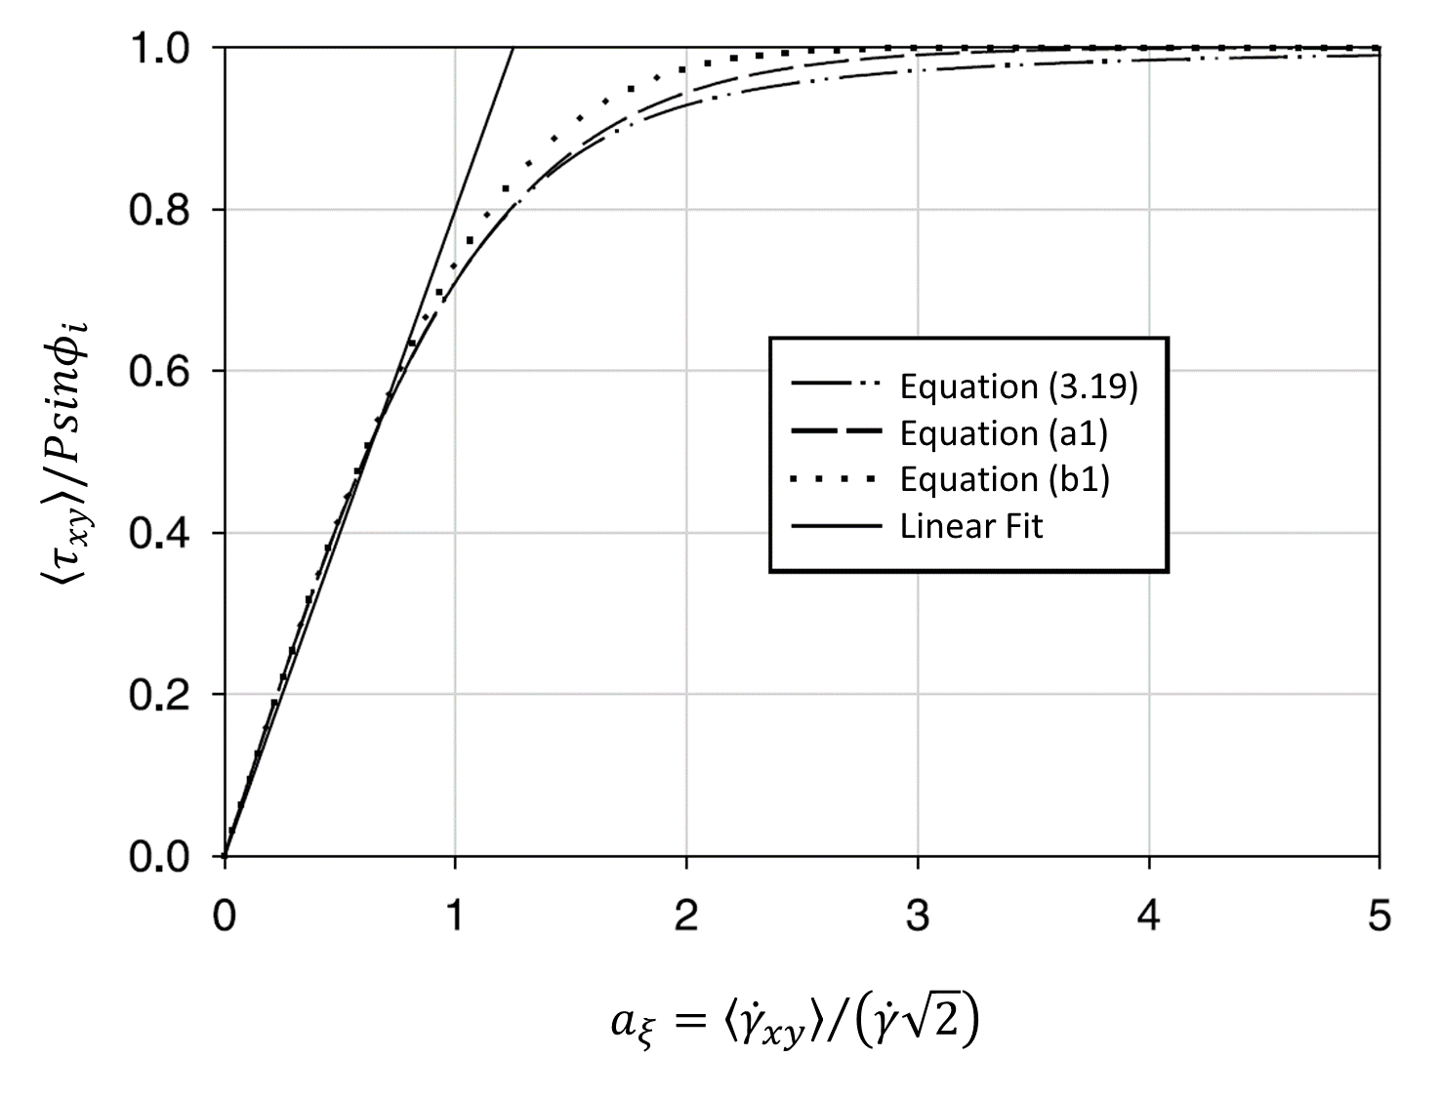

Figure ‎3.10: The variation of the shear stress versus the strain rate fluctuation using different stress expressions. (Reprinted with permission from 19)

### Rapid granular flow regime

In the rapid granular flow regime particles move at high velocity, to the extent that the frictional forces between particles are neglected and only the effects of collision are taken into account. In such a regime, particles mostly experience short collisions and lose their energy because of the inelasticity of the material. Due to their high energy and stochastic motion, particles in the rapid flow regime can be modelled in a similar manner to gas molecules. Hence the kinetic theory of gases is used along with the constitutive equations for the conservation of mass, momentum, and energy. The analysis of particles in the rapid flow regime is, therefore, similar to the classic continuum modelling of fluid dynamics. The difference between granular and fluid flows, however, lies in considering the inelasticity for the inter-particle and particle-wall collisions in the granular flow.

One of the simplest approaches to model the particles collision is to use the hard sphere model, where particle collisions are assumed to be instantaneous.25 For a particle with a perfectly smooth surface, the energy dissipation can be defined only by one parameter, termed the effective coefficient of restitution, $e_{eff}$. For a more realistic model, other factors, including (1) the particles roughness, (2) particle deformations (3) particle shape, (4) particle size distribution, and (5) particles density, should be considered. This approach is known as the soft-sphere model, which is described in detail in Section 5.3. However, implementing all of the aforementioned factors in modelling of the rapid granular flow is troublesome. Here, the constitutive equations for a simple 2D case of a rapid granular flow, with monodisperse frictionless discs of slight inelasticity, are given. The equation for the conservation of mass is as follows,26

|  |  |
| --- | --- |
|  | (3.22) |

where *χ* denotes the local concentration (solid fraction) and *vx* and *vy* show the average velocity components in the *x* and *y* directions, respectively. The equations for conservation of linear momentum are:

|  |  |
| --- | --- |
| $$ρ_{p}χ\left(\frac{∂v_{x}}{∂t}+u\frac{∂v_{x}}{∂x}+v\frac{∂v_{x}}{∂y}\right)=\frac{∂τ_{xx}}{∂x}+\frac{∂τ_{yx}}{∂y}$$ | (3.23) |

|  |  |
| --- | --- |
|  | (3.24) |

where $ρ_{p}$ denotes the particle density and $τ_{ij}$ is the stress tensor in direction *i* on face *j*. The equation for conservation of fluctuation energy is:

|  |  |
| --- | --- |
| $${2ρ}_{p}χv_{fl}\left(\frac{∂v_{fl}}{∂t}+v_{x}\frac{∂v_{fl}}{∂x}+v_{y}\frac{∂v_{fl}}{∂y}\right)=-\frac{∂q_{x}}{∂x}-\frac{∂q_{y}}{∂y}+τ_{xx}\frac{∂v_{x}}{∂x}+τ_{yx}\frac{∂v_{x}}{∂y}+τ_{xy}\frac{∂v_{y}}{∂x}+τ_{yy}\frac{∂v_{y}}{∂y}-Γ$$ | (3.25) |

where $v_{fl}=\sqrt{T_{gran}}$ is the average fluctuation speed, $q_{i}$ denotes the components of the “fluctuation energy flux vector”, and *Γ* is the energy dissipation rate per unit volume in inelastic collisions. The constitutive equations of the components of the stress tensor are:

|  |  |
| --- | --- |
| $${τ_{xx}=-2ρ}_{p}χG_{1}G_{2}{v_{fl}}^{2}+\frac{2}{\sqrt{π}}ρ_{p}χG_{1}dv_{fl}\left(\left(1+\frac{G_{3}}{2}\right)\frac{∂v_{x}}{∂x}+\left(1-\frac{G_{3}}{2}\right)\frac{∂v_{y}}{∂y}\right)$$ | (3.26) |

|  |  |
| --- | --- |
|  | (3.27) |

|  |  |
| --- | --- |
|  | (3.28) |

The equations of the energy dissipation ($Γ$) and energy flux ($q$) are also expressed as:

|  |  |
| --- | --- |
| $$q=-\frac{4}{\sqrt{π}}ρ_{p}χG_{1}G_{4}dv_{fl}^{2}∇v_{fl}$$ | (3.29) |

|  |  |
| --- | --- |
|  | (3.30) |

where the parameters *G1*, *G2*, and *G3* are functions of $χ$ and expressed as $G_{1}(χ)=χg_{0}$, $G_{2}(χ)=1+1/{2G_{1}}$, $G_{3}(χ)=1+\left(π/8\right){\left(1+1/{G_{1}}\right)}^{2}$, and $g_{0}(χ)={\left(1-{7χ}/{16}\right)}/{{\left(1-χ\right)}^{2}}1+\left(π/4\right){\left(3/2+1/{G_{1}}\right)}^{2}$. $g_{0}$ is the radial distribution function, which is calculated at the contact point and given as $G_{4}(χ)=1+\left(π/4\right){\left(3/2+1/{G_{1}}\right)}^{2}$. The approximation for the function $g_{0}$ was first proposed by Verlet and Levesque27 and shows a very close match with the numerical simulation, conducted by Hoover and Alder,28 of systems of hard and elastic disks.

## Effects of Environmental Conditions on Powder Flow

### Temperature

Temperature has a significant impact on the flow behaviour of bulk solids. It alters the flowability of particles by changing their mechanical and physical properties. One of the most important examples is observed in the freezing of the moisture content of powders, where the ice on particle surfaces drastically changes the surface properties of the particles depending on the amount of moisture and the conditions under which the ice crystals are formed. For instance, if liquid bridges exist between particles, undergoing sub-zero temperature results in ice bonds which reduce the powder flowability.29, 30 Temperature variation also has a considerable impact on the crystallinity of materials, especially the surface structure. A change in the crystal structure of the surface of a particle has a direct influence on its surface energy, which is an important factor in flow behaviour of particles. In such cases, powder caking due to change in crystallography of particles is highly possible.29 For many bulk solid materials though, the variation of temperature between 0 – 40oC is not coupled with a change in flowability, as long as no melting or glass transition occur in this temperature range.

The flowability of amorphous materials can dramatically change near their glass-transition temperature. By increasing temperature of an amorphous powder to above its glass-transition temperature, the particles experience a gradual transition from a hard, glassy state to a softer, rubbery state.31 This also decreases the elastic modulus and changes other properties of the particles. The main consequence of going above the glass-transition temperature is the substantial increase in particle stickiness and caking tendency.32

### Relative Humidity

The relative humidity (RH) of the air is one of the key factors affecting the flow properties of granular materials. Depending on the internal structure of particles and their chemical composition, RH alters their flow behaviour via changing their physical, mechanical, and/or surface properties.29 For example, the majority of the organic materials are known to be hygroscopic, i.e. tend to absorb or lose moisture depending on the RH of the ambient air. In such cases, the internal structure of the material may be affected as well.33

Moisture sorption can cause the formation of inter-particle liquid bridges (as discussed in Section 2.7.3), which increases the attractive force between particles.34 The increase in cohesivity of particles is manifested in an increase in the angle of repose and reduction of the flow factor of the bulk powder.35 Karde *et al.*36 investigated the effect of RH on shear stress and flowability of corn starch powder under different consolidation stresses. As presented in Figure ‎3.11, at low consolidation stress, increasing the RH results in a higher angle of internal friction (*ϕi*), i.e. deteriorated flowability, whereas, for the high consolidation stresses, a decreasing trend for *ϕi* is observed. Nevertheless, for almost all the consolidation stresses, there is an optimum level of RH at which *ϕi* is the minimum and, as a result, the powder flowability is maximised.

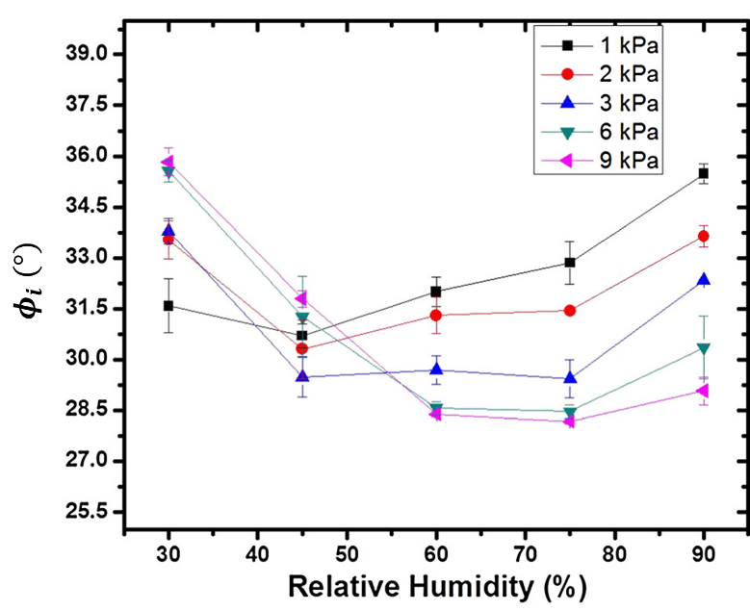

Figure ‎3.11: The relation between the angle of internal friction (*ϕi*) and RH at various consolidation stresses for corn starch powder. (Reprinted with permission from 36)

A high level of moisture on the surface may cause microbial growth, which can easily modify the surface condition of the particle.29 Moreover, in some cases, variation in the relative humidity can alter the structure of the surface of the particles from the crystalline phase to amorphous and vice versa.37 This alteration may significantly change the surface energy of the particles, which is a key element in flowability of powders.35 In the case of dealing with amorphous powders, an increase in the moisture content can function as a plasticiser and lower the glass-transition temperature of the material, and raise the caking tendency of the powder substantially.31, 38

### Electrostatics

Electrostatic charging is one of the most baffling aspects of granular materials, where individual particles transfer electric charge during their contacts and collisions with the neighbouring elements, including other particles and/or walls. As a source of external forces on particles, electrostatic charge can immensely affect the flow behaviour of the bulk solids. It may cause powders to stick to the walls of containers if they have a dissimilar charge to that of the wall. The pertinent examples would be powders sticking to the walls of silos and hoppers during powder discharge, or to the walls of mixers and granulators as a result of the high level of particle-wall contact. Electrostatic charging can cause coagulation in pharmaceutical powders,39 and result in poor flowability.

Having said that, the extent of electrostatic charging can be controlled, and therefore, by charging powders with the same or opposite charges, it is possible to control their flowability and particle dispersion. For example, having a powder with like-charged particles can improve the flowability by neutralising the effect of attractive forces, such as the surface adhesion.39 Wirth and Linsenbühler40 showed that the process of mixing of fine particles can be supported by clever use of the electrostatic charging effect.

Electrostatic charging is influenced by the relative humidity, as the moisture content affects the conductivity of the powder. An increase in the RH of a powder reduces its electrostatic charge39, 41, 42 , due to the enhanced conductivity of the bulk material and charge leakage.39 Of course, an excessively high RH may result in reduced flowability due to moisture pick-up, and as a consequence there is usually and optimum humidity range to maximise flowability, e.g. ~ 45% RH for millimetre-sized glass beads.43 The effect of electrostatic charging is more substantial for fine powders, since it is a surface phenomenon and the fine powders have a higher surface to volume ratio.

## Time consolidation and creep effect

### Time consolidation

For many powders their state of packing under a given loading condition (compressibility response – see section 2.2) may evolve over time under continuous application of this load, due to the gradual creep effect of the bulk powder. This effect is often referred to as *time consolidation* or *caking*, and is frequently experienced in process industries, typically when large quantities of powders are stored. In addition to the load applied, the environmental conditions are influential in driving the time consolidation effect, with elevated temperature and humidity typically increasing the rate and extent of creep. Many powders, particularly organic powders, are hygroscopic, with a subset being deliquescent; dissolving in moisture acquired from the atmosphere.

### Mechanisms of creep

The most commonly encountered mechanisms of creep in powders are *sintering* and *dissolution-crystallisation*:

*Sintering* – occurs when particles coalesce and increase their contact area by minimisation of the surface free energy.44 While sintering may occur in elastically deforming specimens, it is much more common, and the effects more extreme, for plastically deforming materials. Though elastic and plastic deformation occur almost instantaneously, the extent of plastic deformation may increase over time due to viscous flow, as described by Frenkel45:

|  |  |  |
| --- | --- | --- |
|  |  | (3.31) |

where *dc* is the diameter of the contact, *t* is the contact time, *Δγ* is the work of adhesion and *η* is the viscosity of the contact. For water soluble (deliquescent) amorphous materials, an increase in humidity results in an increased moisture content and therefore decreases the viscosity. This leads to a more rapid progression of the contact area, though results in a reduced tensile strength of the sintering material due to the increased moisture content.46

*Dissolution-crystallisation* – occurs by evaporation of surface moisture in crystalline materials. Water may already be present in the form of liquid bridges, or may emerge by partial dissolution when the critical humidity of the crystalline powder is exceeded.31 This partial dissolution leads to an increased contact area, of relatively low strength whilst in the liquid phase,46 however subsequent evaporation leads to re-crystallisation and therefore formation of continuous solid bonds between contacting particles.

### Macroscopic creep effects

As creep occurs at individual contact points, the particles become more intimately located and the packing density of the powder increases. This increased packing density in itself is a cause of increased flow resistance, though is compounded by the increased strength of each contact, which can lead to substantial increases in flow resistance for caked powders. The matter is complicated by the fact that moisture is usually unevenly distributed within a powder bed, with moisture absorbed from the atmosphere typically progressing inwards from the bed surface. Brockbank *et al.*47 observed that in such a case the increased flow resistance may be limited to a small caked portion of the bed, the size of which extends with time as further moisture is retained within the bed, and propagates further within the bed. Calvert *et al.*48 devised an apparatus for assessing unconfined yield strength (section 2.3) under controlled temperature and humidity conditions, finding that for a highly hygroscopic and deliquescent powder the increased cake strength under elevated temperature and humidity corresponded directly with the increased strain experienced by the bed. This is likely driven by an increased strain arising due to increased particle deformations and subsequently greater interfacial contact area. In contrast, Hartmann and Palzer46 point out that for some particles, such as dehydrated vegetables, the presence of an insoluble matrix (e.g. cellulose) prevents macroscopic deformation of the bed, despite the increasing strength of the contacts. It has been observed for ceramic powders under high temperature49, and glass beads under high humidity conditions50, that the increased flow resistance caused by caking is due to an increase in bulk cohesion, driven by the increased cohesion of the contacts without significant change in the contact area (these powders are not prone to plastic deformation), yet no significant alteration of the internal angle of friction occurs. A different behaviour has been observed for food powders: tea, whey permeate and flour, whereby an increase in relative humidity from 22 to 66% led to an increase in wall friction, and therefore an increase in hopper angle required to ensure mass flow.51

Most studies of environmental effects of powder flowability expose samples to fixed conditions of temperature and humidity, which is often not the experience in powder processing and storage facilities. Where temperature and humidity cycling occur the caking behaviour is complicated, and usually exacerbated, particularly when dissolution crystallisation occurs. Johanson and Paul52 observed an increase in cake strength for both salt and sucrose powders stored under fixed, elevated temperature conditions, with salt displaying a linear increase in strength with the number of cycles between ambient and elevated conditions, whilst for sucrose the cake strength did not increase beyond the first cycle. Due to the evolving temperature and moisture profiles present in a powder bed, consideration of heat and mass transfer rates, which are highly powder dependent, may enable a more accurate prediction of caking effects under known processing conditions. A number of these such models, which have been developed for powders experiencing dissolution-crystallisation, are reviewed by Zafar *et al.31*

### Preventing creep

Creep is increased with load, humidity, temperature and exposure time, therefore minimisation of any of these factors can mitigate the extent of creep. The mechanism causing creep is important, since in some cases the cycling between low and elevated conditions of temperature and humidity may exacerbate creep effects. As with non-creeping powders, minimisation of the interfacial contact area leads to better flowability, and so reduction of the width of the size distribution and the quantity of fine particles reduces the influence of creep. For powder mixtures creep may arise predominantly due to one component, in which case determination and replacement or reduction of this material in the powder will minimise the effects of creep.

## Concluding remarks

The main prevailing features of flowing granular materials are discussed in this chapter. Bulk solid materials may exhibit some similarities with the behaviour of continuum solids or liquids in some conditions, yet show complete dissimilarity in other conditions. As an example, the stress variation of powders in containers is compared with liquid hydrostatic pressure. The comparison shows that, unlike the hydrostatic pressure in liquids, which varies only by the depth of the liquid, the stress in granular materials depends also on the particle packing, wall friction, shape of the container, and shape of particles. Additionally, granular materials show anisotropy in their stress distribution and compressibility during the flow; while liquids have none of these attributes.

Granular material systems can generally exist in four regimes, namely the static, quasi-static, intermediate, and rapid granular flow regimes, which are classified based on shear rate. For each flow regime specific constitutive equations are derived to describe the flow behaviour of particles and predict the stress condition within the powder.

Time consolidation or caking is another important feature of many powders, where their state of packing under a given loading condition evolves over time under continuous load application. This change occurs mainly due to the gradual creep effect of the bulk powder and is frequently experienced in process industries, typically when large quantities of powders are stored. In addition to the load applied, the environmental conditions are influential in driving the time consolidation, with elevated temperature and humidity typically increasing the rate and extent of creep. Many powders, particularly organic powders, are hygroscopic, thus take in water from the atmosphere by either absorption or adsorption. Furthermore, deliquescent materials dissolve in this newly acquired moisture; both phenomena tend to exacerbate caking.

In addition to the effect of environmental conditions on caking, they can change the particle properties, such as the surface adhesion and the material stiffness, and consequently, alter the flow behaviour of the powder. These effects are especially observed in alteration of the crystal structure of particles at their surface and in glass transition phenomenon. The electrostatic charging may also have a significant impact on the flow behaviour of powders, where depending on the material, nature and frequency of collisions, relative humidity, and pattern of the electric charging (i.e. like- or unlike-charged), it can enhance or deteriorate the flowability.

## References

1. F. M. White, *Fluid Mechanics*, McGraw Hill, 2011.

2. A. C. Hoffmann and H. J. Finkers, *Powder Technology*, 1995, **82**, 197-203.

3. A. B. Yu, J. Bridgwater and A. Burbidge, *Powder Technology*, 1997, **92**, 185-194.

4. U. Zafar, C. Hare, A. Hassanpour and M. Ghadiri, *Powder Technology*, 2017, **310**, 300-306.

5. A. W. Jenike, *Powder Technology*, 1987, **50**, 229-236.

6. S. K. Shukla, J. G. Loughran and N. Sivakugan, *Powder Technology*, 2009, **192**, 389-393.

7. S. Koynov, B. Glasser and F. Muzzio, *Powder Technology*, 2015, **283**, 103-112.

8. T. Ittershagen, H. Zetzener, J. Schwedes and A. Kwade, *Powder Technology*, 2013, **247**, 260-264.

9. H. A. Janssen, in *3rd European symposium; PARTEC congress, Storage and flow of particulate solids*, Nurnberg Messe GmbH, Nuremberg, Editon edn., 1995, pp. 1-6.

10. N. P. Kruyt, *Journal of Applied Mechanics*, 1990, **57**, 1032-1035.

11. S. C. Cowin, *Journal of Applied Mechanics*, 1979, **46**, 524-528.

12. A. Takami and S. Oka, *Powder Technology*, 1974, **10**, 295-301.

13. J. B. Lvin, *Powder Technology*, 1971, **4**, 280-285.

14. D. Singh and E. B Moysey, *GRAIN BIN WALL PRESSURES: THEORETICAL AND EXPERIMENTAL*, 1985.

15. J. Y. Ooi and J. M. Rotter, *Computers & Structures*, 1990, **37**, 361-374.

16. J. Y. Ooi, J. F. Chen, R. A. Lohnes and J. M. Rotter, *Construction and Building Materials*, 1996, **10**, 109-116.

17. D. M. Walker, *Chemical Engineering Science*, 1966, **21**, 975-997.

18. J. K. Walters, *Chemical Engineering Science*, 1973, **28**, 13-21.

19. G. I. Tardos, S. McNamara and I. Talu, *Powder Technology*, 2003, **131**, 23-39.

20. R. V. Mises, *ZAMM - Journal of Applied Mathematics and Mechanics / Zeitschrift für Angewandte Mathematik und Mechanik*, 1928, **8**, 161-185.

21. G. I. Taylor and H. Quinney, *Philosophical Transactions of the Royal Society of London. Series A, Containing Papers of a Mathematical or Physical Character*, 1931, **230**, 323-362.

22. G. I. Tardos, M. I. Khan and D. G. Schaeffer, *Physics of Fluids*, 1998, **10**, 335-341.

23. G. I. Tardos, *Powder Technology*, 1997, **92**, 61-74.

24. I. Goldhirsch, *Powder Technology*, 2008, **182**, 130-136.

25. A. Hassanpour, M. Pasha and M. Alizadeh Behjani, in *Introduction to Software for Chemical Engineers*, ed. M. Martin, CRC Press, Editon edn., 2019.

26. M. Babić, *Mechanics of Materials*, 1993, **16**, 163-171.

27. D. Levesque, *Molecular Physics*, 1982, **46**, 969-980.

28. W. G. Hoover and B. J. Alder, *The Journal of Chemical Physics*, 1967, **46**, 686-691.

29. V. Ganesan, K. A. Rosentrater and K. Muthukumarappan, *Biosystems Engineering*, 2008, **101**, 425-435.

30. J. J. Fitzpatrick, T. Iqbal, C. Delaney, T. Twomey and M. K. Keogh, *Journal of Food Engineering*, 2004, **64**, 435-444.

31. U. Zafar, V. Vivacqua, G. Calvert, M. Ghadiri and J. A. S. Cleaver, *Powder Technology*, 2017, **313**, 389-401.

32. T. Howes, B. R. Bhandari and V. Truong, *International Journal of Food Properties*, 2001, **4**, 1-33.

33. N. Hardas, S. Danvirivakul, J. L. Foley, W. W. Nawar and P. Chinachoti, *Journal of the American Oil Chemists' Society*, 2002, **79**, 151-158.

34. R. Jones, H. M. Pollock, J. A. S. Cleaver and C. S. Hodges, *Langmuir*, 2002, **18**, 8045-8055.

35. M. Alizadeh, M. Asachi, M. Ghadiri, A. Bayly and A. Hassanpour, *Powder Technology*, 2018, **339**, 789-800.

36. V. Karde, D. Dixit and C. Ghoroi, *Advanced Powder Technology*, 2017, **28**, 346-355.

37. D. Mahlin, J. Berggren, G. Alderborn and S. Engström, *Journal of Pharmaceutical Sciences*, 2004, **93**, 29-37.

38. J. Aguilera, J. del Valle and M. Karel, *Trends in Food Science & Technology*, 1995, **6**, 149-155.

39. S. Karner and N. Anne Urbanetz, *Journal of Aerosol Science*, 2011, **42**, 428-445.

40. K.-E. Wirth and M. Linsenbühler, *China PARTICUOLOGY*, 2005, **03**, 94-98.

41. G. Rowley and L. A. Mackin, *Powder Technology*, 2003, **135-136**, 50-58.

42. A. Elajnaf, P. Carter and G. Rowley, *European Journal of Pharmaceutical Sciences*, 2006, **29**, 375-384.

43. N. Vandewalle, G. Lumay, F. Ludewig and J. E. Fiscina, *Physical Review E*, 2012, **85**, 031309.

44. K. Kendall, *Molecular Adhesion and Its Applications*, Springer, 2014.

45. J. Frenkel, *J. Phys. USSR*, 1945, **9**, 301–303.

46. M. Hartmann and S. Palzer, *Powder Technology*, 2011, **206**, 112-121.

47. B. Armstrong, Y. Chandorkar and T. Freeman, *Particulate Science and Technology*, 2015, **33**, 102-108.

48. G. Calvert, N. Curcic, C. Redhead, H. Ahmadian, C. Owen, D. Beckett and M. Ghadiri, *Powder Technology*, 2013, **249**, 323-329.

49. R. Chirone, D. Barletta, P. Lettieri and M. Poletto, *Powder Technology*, 2016, **288**, 379-387.

50. G. Landi, D. Barletta and M. Poletto, *Powder Technology*, 2011, **207**, 437-443.

51. T. Iqbal and J. J. Fitzpatrick, *Journal of Food Engineering*, 2006, **72**, 273-280.

52. J. R. Johanson and B. O. Paul, *Chemical Processing*, 1996, **59**, 71-75.