Hybrid Hydrogels Loaded with Palladium Nanoparticles – Catalysts for Environmentally-Friendly Sonogashira and Heck Cross-Coupling Reactions

Petr Slavíkand David K. Smith*

Department of Chemistry, University of York, Heslington, York, YO10 5DD, United Kingdom

E-mail: [david.smith@york.ac.uk](mailto:david.smith@york.ac.uk)

1 Characterization data of the products

2 1H and 13C NMR spectra

3 References

**1. Characterization data of the products**

**1-Nitro-4-(phenylethynyl)benzene (2a)**

Yellow solid. 1H NMR(CDCl3, 400 MHz, 293 K): δ = 8.24-8.19 (m, 2H), 7.68-7.64 (m, 2H), 7.58-7.53 (m, 2H), 7.41-7.34 (m, 3H) ppm. 13C NMR (CDCl3, 101 MHz, 293 K): δ = 147.1, 132.4, 132.0, 130.4, 129.4, 128.7, 123.8, 122.2, 94.8, 87.7 ppm. The recorded spectroscopic data correlate with those reported in literature.1

**1-Methyl-4-(phenylethynyl)benzene (2b)**

White solid. 1H NMR(CDCl3, 400 MHz, 293 K): δ = 7.58-7.50 (m, 2H), 7.44 (d, *J* = 7.9 Hz, 2H), 7.35 (dd, *J* = 8.0, 3.7 Hz, 3H), 7.16 (d, *J* = 8.1 Hz, 2H), 2.37 (s, 3H).13C NMR (CDCl3, 101 MHz, 293 K): δ = 138.5, 131.7, 131.6, 129.2, 128.4, 128.2, 123.6, 120.3, 89.7, 89.8, 21.6 ppm. The recorded spectroscopic data correlate with those reported in literature.1

**1-Methoxy-4-(phenylethynyl)benzene (2c)**

Yellow solid. 1H NMR(CDCl3, 400 MHz, 293 K): δ = 7.55-7.44 (m, 4H), 7.37-7.28 (m, 3H), 6.92-6.84 (m, 2H), 3.82 (s, 3H) ppm. 13C NMR (CDCl3, 101 MHz, 293 K): δ = 159.7, 133.2, 131.6, 128.4, 128.1, 123.7, 115.5, 114.1, 89.5, 88.2, 55.4 ppm. The recorded spectroscopic data correlate with those reported in literature.1

**1-Fluoro-4-(phenylethynyl)benzene (2d)**

White solid. 1H NMR(CDCl3, 400 MHz, 293 K): δ = 7.56-7.47 (m, 4H), 7.39-7.30 (m, 3H), 7.08-7.00 (m, 2H) ppm. 13C NMR (CDCl3, 101 MHz, 293 K): δ = 162.5 (d, *JC-F* = 250.2 Hz), 133.6 (d, *JC-F* = 8.6 Hz), 131.7, 128.5, 128.4, 123.2, 119.4 (d, *JC-F* = 3.8 Hz), 115.8 (d, *JC-F* = 22.1 Hz), 89.1, 88.4 ppm. The recorded spectroscopic data correlate with those reported in literature.2

**4-(Phenylethynyl)benzoic acid (2e)**

White-yellow solid. 1H NMR(DMSO-*d*6, 400 MHz, 293 K): δ = 13.15 (bs, 1H), 7.97-7.90 (m, 2H), 7.66-7.60 (m, 2H), 7.59-7.52 (m, 2H), 7.44-7.39 (m, 3H) ppm. 13C NMR (DMSO-*d*6, 101 MHz, 293 K): δ = 167.2, 132.1 (2x), 131.1, 130.1, 129.8, 129.4, 127.1, 122.3, 92.5, 89.1 ppm. The recorded spectroscopic data correlate with those reported in literature.3

**2-(Phenylethynyl)thiophene (2f)**

White solid. Product was partly contaminated by thiophene as a side product. Even after thorough column chromatography, we were not able to remove it completely due to very similar *R*f values. 1H NMR(CDCl3, 400 MHz, 293 K): δ = 7.56-7.47 (m, 2H), 7.39-7.31 (m, 3H), 7.30-7.27 (m, 2H), 7.03-6.97 (m, 1H) ppm. 13C NMR (CDCl3, 101 MHz, 293 K): δ = 132.0, 131.5, 128.5 (2x), 127.4, 127.2, 123.4, 123.0, 93.1, 82.7 ppm. The recorded spectroscopic data correlate with those reported in literature.4

**1,2-Dimethoxy-4-(phenylethynyl)benzene (2g)**

White-yellow-brown solid. Product was partly contaminated (ca. 10%) by 1,2-dimethoxybenzene as a side product. Even after thorough column chromatography, we were not able to remove it completely due to very similar *R*f values.1H NMR(CDCl3, 400 MHz, 293 K): δ = 7.54-7.49 (m, 2H), 7.37-7.27 (m, 3H), 7.13 (dd, *J* = 8.3, 1.9 Hz, 1H), 7.04 (d, *J* = 1.9 Hz, 1H), 6.83 (d, *J* = 8.3 Hz, 1H), 3.90 (s, 3H), 3.89 (s, 3H). The recorded spectroscopic data correlate with those reported in literature.5

**4-Phenylethynyl-benzaldehyde (2h)**

Reaction was performed using 4-bromo-benzaldehyde and the reaction followed by NMR. Product NMR spectrum is: 1H NMR (CDCl3, 400 MHz): δ 10.00 (s, 1H), 7.85 (d, J = 8.4 Hz, 2H), 7.68-7.64 (m, 2H), 7.57-7.51 (m, 2H), 7.39-7.32 (m, 3H) ppm.

The reaction only went to 20% completion – product was contaminated with starting material 4-bromobenzaldehyde, the NMR spectrum of which is: 1H NMR (CDCl3, 400 MHz): 9.96 (s, 1H), 7.74-7.70 (m, 2H), 7.69-7.63 (m, 2H) ppm.

**1,4-Diphenyl-1,3-butadiyne (3)**

This homocoupled product was determined by 1H NMR in crude form only. 1H NMR (CDCl3, 400 MHz): 7.55-7.45 (m, 4H), 7.39-7.30 (m, 6H) ppm.

**Ethyl (*E*)-3-(4-methoxyphenyl)acrylate (4a)**

1H NMR(CDCl3, 400 MHz, 293 K): δ = 7.63 (d, *J* = 16.0 Hz, 1H), 7.51-7.43 (m, 2H), 6.95-6.81 (m, 2H), 6.30 (d, *J* = 16.0 Hz, 1H), 4.24 (q, *J* = 7.1 Hz, 2H), 3.83 (s, 3H), 1.32 (t, *J* = 7.1 Hz, 3H). The recorded spectroscopic data correlate with those reported in literature.6

**Methyl (*E*)-3-(4-methoxyphenyl)acrylate (4b)**

1H NMR(CDCl3, 400 MHz, 293 K): δ = 7.65 (d, *J* = 16.0 Hz, 1H), 7.47 (d, *J* = 8.8 Hz, 2H), 6.89 (d, *J* = 8.8 Hz, 2H), 6.31 (d, *J* = 16.0 Hz, 1H), 3.83 (s, 3H), 3.79 (s, 3H). The recorded spectroscopic data correlate with those reported in literature.6

**Ethyl (E)-3-(4-nitrophenyl)acrylate (4d)**

White solid. 1H NMR(CDCl3, 400 MHz, 293 K): δ = 8.24 (d, *J* = 8.8 Hz, 2H), 7.82-7.55 (m, 3H), 6.55 (d, *J* = 16.0 Hz, 1H), 4.28 (q, *J* = 7.1 Hz, 2H), 1.34 (t, *J* = 7.1 Hz, 3H). The recorded spectroscopic data correlate with those reported in literature.7

**2. 1H and 13C NMR spectra**



**Figure S1.** 1H NMR of compound **2a** (CDCl3, 400 MHz).

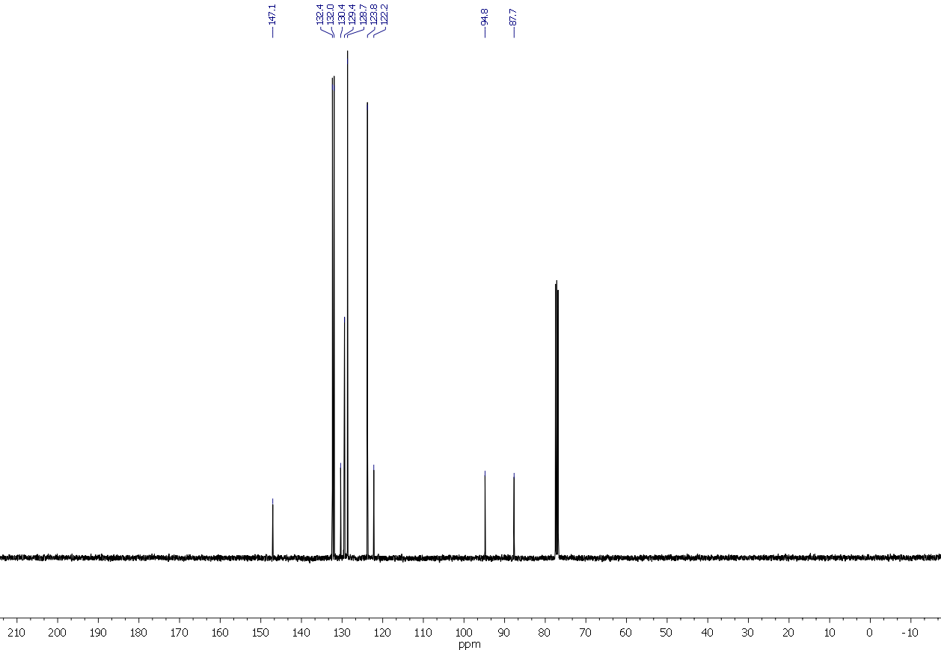 **Figure S2.** 13C NMR of compound **2a** (CDCl3, 101 MHz).



**Figure S3.** 1H NMR of compound **2b** (CDCl3, 400 MHz).

 **Figure S4.** 13C NMR of compound **2b** (CDCl3, 101 MHz).



**Figure S5.** 1H NMR of compound **2c** (CDCl3, 400 MHz).



**Figure S6.** 13C NMR of compound **2c** (CDCl3, 101 MHz).



**Figure S7.** 1H NMR of compound **2d** (CDCl3, 400 MHz).



**Figure S8.** 13C NMR of compound **2d** (CDCl3, 101 MHz).

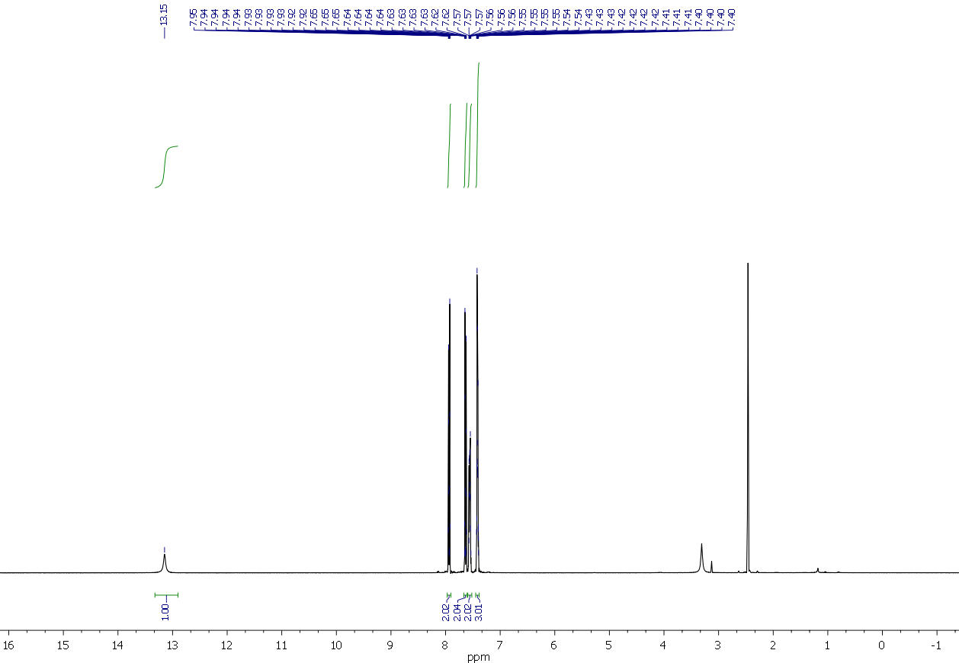

**Figure S9.** 13C NMR of compound **2e** (DMSO-*d6*, 101 MHz).

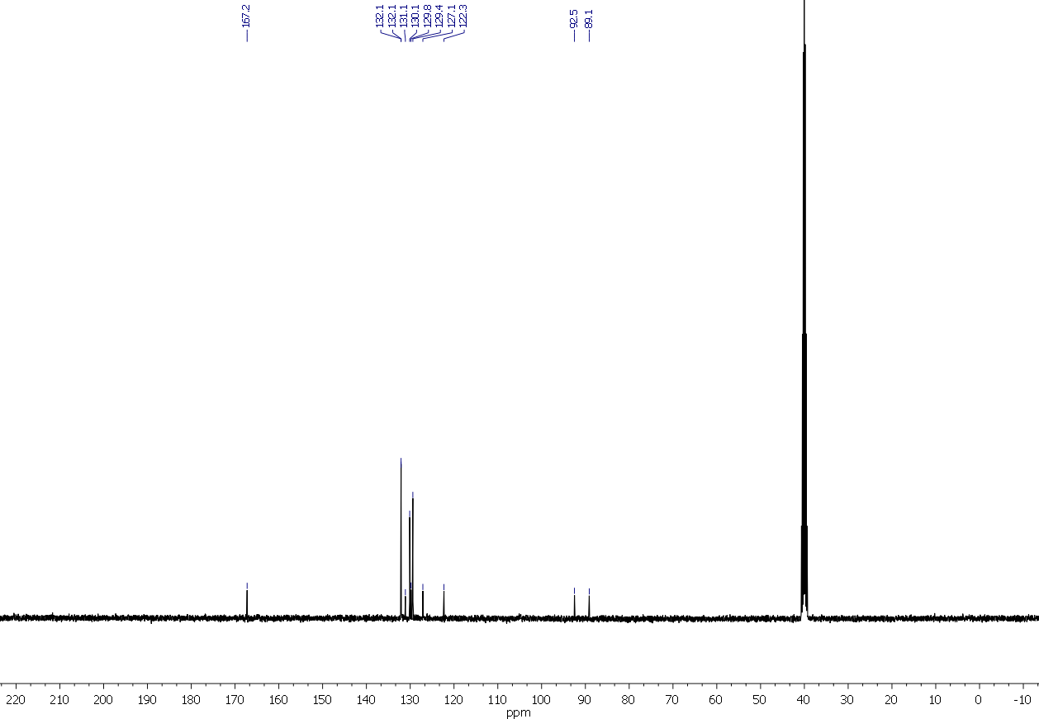

**Figure S10.** 13C NMR of compound **2e** (DMSO-*d6*, 101 MHz).



**Figure S11.** 1H NMR of compound **2f** (CDCl3, 400 MHz).



**Figure S12.** 13C NMR of compound **2f** (CDCl3, 101 MHz).



**Figure S13.** 1H NMR of compound **2g** (CDCl3, 400 MHz).

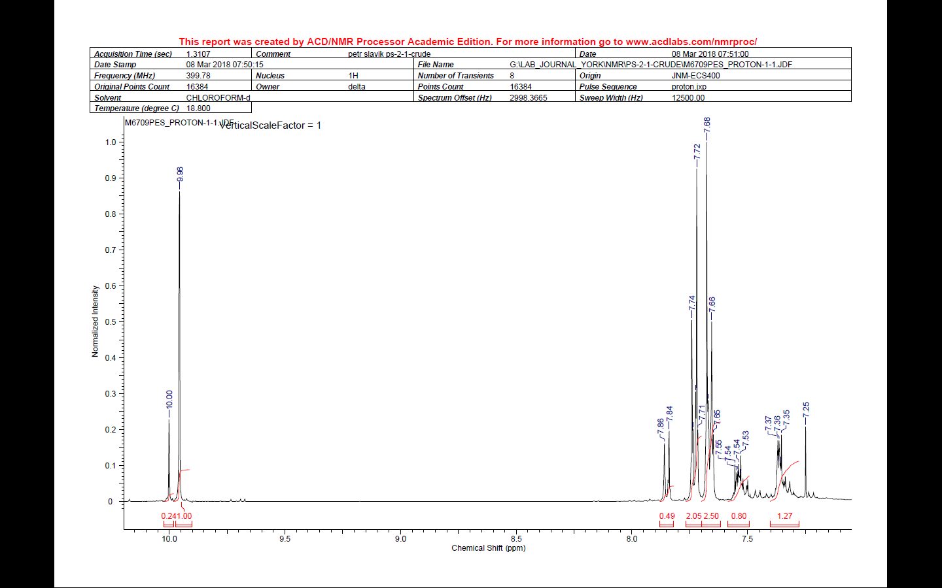

**Figure S14.** 1H NMR of compound **2h** (CDCl3, 400 MHz), contaminated with starting material 4-bromo-benzaldehyde.

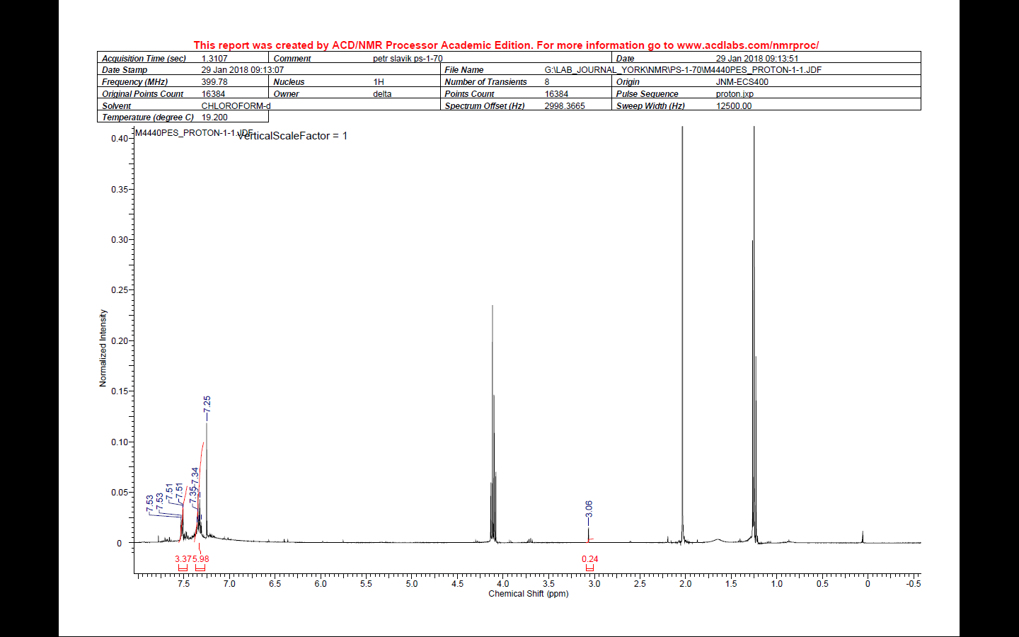

**Figure S15.** 1H NMR of crude compound **3** (CDCl3, 400 MHz), contaminated with solvent (EtOAc).



**Figure S16.** 1H NMR of a crude reaction mixture containing compound **4a** together with starting compound(CDCl3, 400 MHz).Table 4, Entry 1.



**Figure S17.** 1H NMR of a crude reaction mixture containing compound **4a** together with starting compound(CDCl3, 400 MHz). Table 4, Entry 2.



**Figure S18.** 1H NMR of a crude reaction mixture containing compound **4b** together with starting compound(CDCl3, 400 MHz). Table 4, Entry 4.



**Figure S19.** 1H NMR of a crude reaction mixture containing compound **4b** together with starting compound(CDCl3, 400 MHz). Table 4, Entry 5.



**Figure S20.** 1H NMR of a crude reaction mixture, Table 4, Entry 6 (CDCl3, 400 MHz).



**Figure S21.** 1H NMR of a crude reaction mixture containing **4c**, Table 4, Entry 8 (CDCl3, 400 MHz).



**Figure S22.** 1H NMR of crude **4d** (CDCl3, 400 MHz).

**3. References**

1. Liang, B.; Dai, M.; Chen, J.; Yang, Z. *J. Org. Chem.*, **2005**, *70*, 391-393.

2. Jin, G.; Zhang, X.; Cao, S. *Org. Lett.*, **2013**, *15*, 3114-3117.

3. Zhang, X.; Zhang, W.-Z.; Shi, L.-L.; Guo, C.-X.; Zhang, L.-L.; Lu, X.-B. *Chem. Commun.*, **2012**, *48*, 6292-6294.

4. Fu, S.; Chen, N.-Y.; Liu, X.; Shao, Z.; Luo, S.-P.; Liu, Q. *J. Am. Chem. Soc.*, **2016**, *138*, 8588-8594.

5. Kusy, R.; Grela, K. *Org. Lett.*, **2016**, *18*, 6196-6199.

6. Hota, P. K.; Vijaykumar, G.; Pariyar, A.; Sau, S. C.; Sen, T. K.; Mandal, S. K. *Adv. Synth. Catal.*, **2015**, *357*, 3162-3170.

7. Su, Y.-H.; Wu, Z.; Tian, S.-K. *Chem. Commun.*, **2013**, *49*, 6528-6530.