Art with marginalised communities: Participatory video as a tool of empowerment and resistance for migrant domestic workers in London

Zhe Jiang, University of York, UK
Tassia Kobylinska, Goldsmiths, University of London
The Voice of Domestic Workers, London

Abstract
In contrast to the dominant masculinised discourses on global cities, this project explores the feminised and private spheres of global cities - ‘domestic work’ in London. Domestic work is of particular concern for London, given the concentration of domestic workers in the capital and the large numbers of migrants employed in the sector. In the polarised London labour market, migrant domestic workers are concentrated at the bottom end of the labour market and suffer from high levels of exploitation, but often face difficulties to articulate their social and political will and to intervene in public forums. Our participatory video project with twelve migrant domestic workers from The Voice of Domestic Workers, a grassroots campaigning and advocacy organisation in London, suggests that participatory art can play a significant role in supporting the voice of marginalised communities. It reveals the power of art as a voice of dissent and as a tool for advancing social justice. Our project also highlights the importance of shifting the attention from the object of art and art as end product, to the subject of art and art as a social process in which social relationships may be restructured, in order to better understand the potential role of art in helping oppressed groups to achieve social changes. The latter approach implies a stronger sense of agency regarding the ability of marginalised communities to participate directly in structural changes.
Keywords: migrant domestic workers; domestic work; global cities; London; participatory art; marginalised communities

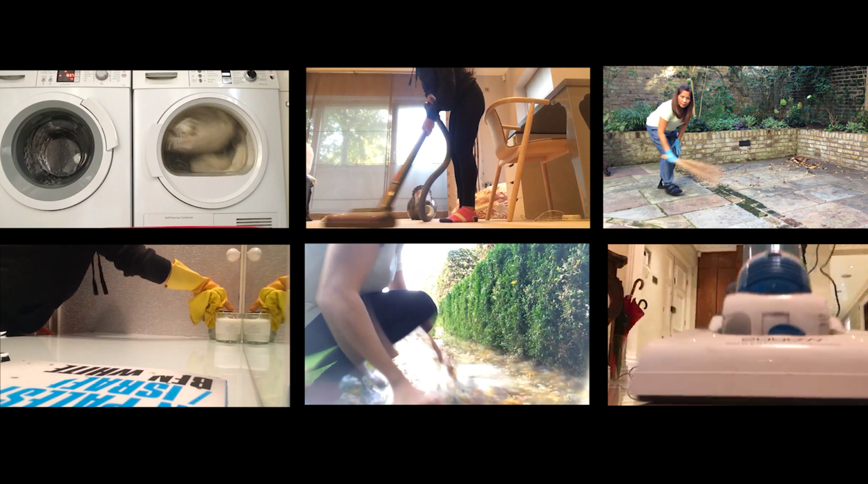
Figure 1 Still from our participatory film ‘Our Journey’, 2019. Source: The Voice of Domestic Workers, Zhe Jiang and Tassia Kobylinska.

‘Participatory video … makes possible the opening of a sideward flow of communication; a channel for … exchange within communities, between communities. And beyond this it allows people to talk back and up the ladder of communication – to leaders, to policy makers.’ (Shaw and Robertson, 1997, 20)

Art, marginalised communities and political power
The relationship between art and politics has been widely discussed by social scientists in the field of art history and theory（Bishop 2006), sociology（Shepard 2011) and anthropology (Haugerud 2013). The debate about the aesthetic and social values of art has remained active. On the one hand, some argue that art must maintain neutral and adulterated aloofness from the strategies of political power (Denisoff 1983). They believed that the fictions of aesthetic creativity are radically incompatible to the facts of brute experiences. On the other hand, it is argued that art has political power and can potentially affect social changes and address social justice (Martinez 2007; Jones 2011). The power of art, in the latter sense, is regarded as “a voice of dissent, as a tool for advancing social justice and democracy, as the core of a revolutionary strategy, and as a source of memory and future ways of thinking” (David and McCaughan 2006, 1).

The topic of empowerment of the marginalised, the oppressed and the under-represented through art is not new. The theatre of the oppressed, created by Brazilian play-writer and philosopher Augusto Boal (1979) in the 1950s and 1960s, and building on the liberation discourses of the time which saw the publication of Paulo Freire’s Pedagogy of the Oppressed (1968), uses applied theatre with the explicit purpose of addressing inequality and injustice and promoting social change. The relationship between music and political engagement has also been explored. Roy’s research (2010) explores how folk music effectively wielded solidarity and stirred public imagination among participants in civil rights movements in 1950s and 1960s in the US. The political power of art has also been highlighted in the field of feminist activist art scholarship. Since 1970s, feminist artists have pursued activism around a wide range of issues pertaining to gender, sexuality, race and their intersection with other forms of social, economic and political forms of oppressions by using a wide variety of artistic approaches including video, poster art, public performance, drama and other creative uses of public space (Aagerstoun and Auther 2007). For example, Suzanne Lacy's activist project Three Weeks in May (1977) - a collaborative public performance that took place in Los Angeles - created the anti-rape discourse and prompted the city government and policy to address violence against women (Fryd 20007). Miller’s (2007) study of the Philani project, a women’s textile cooperative in South Africa, showed that training projects aimed at unemployed mothers, trained to become artists, could generate income while making the exploitative and discriminative conditions faced by the black South African women visible. These feminist art forms stressed group reception and foregrounded the values of collaboration, participation, empowerment, consciousness-raising, and the belief in art's ability to create social change. Recent studies on the intersection of art and politics also suggest that art has an important role in contemporary activism, such as environmental movements and Occupy Wall Street (Serafini, Holtaway and Cossu 2018).

Several factors contribute to art’s role in aiding the resistance of marginalised communities. First, marginalised populations, such as females, workers, ethnic minorities and people in oppressive political contexts, often face difficulties in articulating their social and political will due to the lack of formal education and limited capacity to intervene in public forums. Compared with rhetorical means, drama, music, image and video offer more spontaneous and immediate forums in which they can learn to effectively express themselves regardless of their educational and social backgrounds. As Mills (2009, 553) commented:

People who are quiet in a group might put forward strong ideas through image. Theatre is levelling. It is not working from the intellectual basis, but is a spontaneous and immediate forum. Sometimes it is easier for someone to express themselves physically rather than verbally.

Moreover, the expressive capacity of art can be stronger than verbal means. Art can stir up emotions such as anger, sympathy and pleasure, which are useful in facilitating movements, but can seldom be fully expressed or stimulated through language (Adam 2000). The notion of ‘emotional energy’ echoes Durkheim’s (1964) argument that rituals, such as ceremonies and public parades, can create emotional effervescence and revitalize the ritual group.

Furthermore, unlike verbal means, such as newsletters and speeches, in which the visible wall between the subject and audiences exists, art can potentially maximise the participation from both actors and audiences. Participatory art, in particular, focuses on active engagement and moves away from hierarchy. The bottom-up participation within participatory art practices emphasises ‘relational aesthetics’ (Bourriaud et al. 2002) and ‘the poetics of open work’ (Eco 2006). These can potentially provide a safe space or autonomous zone where participants challenge the sensible in a given social order.

In spite of the increasing academic interest in activist art and political art aimed at encouraging political engagement and empowering marginalised communities, it is important to differentiate between types of political art: art made by professional artists and art made by the marginalised communities; art that is about politics and art that functions as a political context (Schwarzman 1993). The former view often treats political art as an end product which represents a political event for others to observe and criticize existing structures from a distance, while the latter focuses on art-marking as a social process which implies a stronger sense of agency regarding the ability of marginalised communities to participate directly in structural changes. These two perspectives also imply the different objects of study, with the former emphasizing art as object and the latter focusing on the subject of art.

Roy (2010) called for a shift of academic attention from the content of art to art-making processes in which social relationships might be restructured. Consistent with this call to shift the academic focus from the object to the subject of art, there are an increasing number of studies of community-based art which are defined as “a form of cultural practice in which art is produced and used by local people within their communities as an instrument for social change” (Madyaningrum and Sonn 2011, 358). Instead of viewing art as end-products or elite activities, the scholarship of community-based art focuses on art-making processes which serve as a ritualistic setting for social interactions and solidarity development within the community (Fromm 1955; Becker1982).

Drawing from these frameworks of community-based and participatory art studies, we treat art as a social construction process. Our participatory video project with migrant domestic workers (MDWs) focuses on providing a political context to develop social bonding and solidarity among migrant domestic workers and promote social change that can address exploitation in the domestic work sector.

Setting the scene : migrant domestic workers in London
International migration has become one of the most prominent and controversial issues in the 21st century. Much of its prominence is attributed to the wave of economic migrants in the past few decades. In 1991, Sassen already noted that there was a rapid growth of migrant jobs at both the top and bottom end of the labour market in global cities. Wills et al. (2009) describe the polarity of London’s labour market as ‘London’s Migrant Division of Labour’ - expressing London’s high demand for both the most qualified and high-paid professionals and for a large number of low-wage workers in service employment. They argue that London, more than ever, is dependent on migrant labour in low-waged employment, including in key sectors central to the capital’s economic sustainability such as the service industries. Construction, hospitality, retail, contract cleaning and residential care are all identified as the main migrant labour sectors in London (Buchan et al. 2006; Cangiano et al. 2009). Migrant workers at the bottom of this division of labour face high levels of exploitation and vulnerability (Davies 2019). Domestic work is of particular concern for London, given the concentration of domestic workers in the capital and the large numbers of migrants employed in the sector (Gordolan and Lalani 2009).
Yoeh and Saco (2014) have also criticised the dominant masculinised discourses on global cities which often focus on creativity and public civility as accompanying conditions for developing productive relations in business enterprises. They call for more attention to feminised and private spheres of global cities, including those of ‘carework’ and ‘domestic work’. Each year the Home Office issues approximately 19,000 visas under its ‘domestic workers in private households’ scheme, which allows foreign families to bring domestic workers to the UK. These employers include business executives, diplomats, actors, solicitors, doctors and wealthy British residents returning from abroad with their domestic staff. The workers’ decisions to migrate to the UK were seldom made autonomously but were driven by their employers’ mobility. This could explain MDWs’ lack of knowledge about British society and lack of social networks in the UK (Jiang and Korczynski 2016).
Being enmeshed in class relations integrated with gendered and racialized structures of oppression, MDWs experience greater exploitation than do workers in most occupations. They are not only subject to non-compliance of the National Minimum Wage and long working hours, but also to verbal, physical and sexual abuses (See Figure 2 for an example). Jiang’s (2019) recent survey of 39 MDWs shows their average monthly salary to be £1541; that they worked for 268 hours on average per month, with an hourly rate of £5.75, which is far below the National Minimum Wage. A survey of 539 MDWs conducted by The Voice of Domestic Workers (VoDW) in 2018 reveals that 69% of MDWs did not have their own room in employers’ houses and only 49.4% had enough food to eat. The abuse is prevailing in this sector as 76.5% of respondents had experienced abuse at work, including verbal (54.4%) physical (18.9%) and sexual (7%) abuse. Many reported not being allowed to go out without company and supervision of their employers.

Figure 2 Portrait of MDW Still from our participatory film ‘Our Journey’ 2019. Source: The Voice of Domestic Workers, Zhe Jiang and Tassia Kobylinska.



‘Your employers are not going to follow the rules. They just follow whatever they want. You are going to work 24/7 actually. You are going to sleep four or five hours a day. Downstairs there is a big dining room they are using. You need to sleep there. It’s not a proper room. You lie on a table.’

The visa change introduced by the UK government in 2012 has further reinforced the vulnerability of MDWs. Before 2012, MDWs were allowed to change employers provided that they would be continuously hired as full-time domestic workers. Then, after five years, they could apply for indefinite leave to remain and eventually UK citizenship. But since the government introduced restrictions, which removed the rights of holders of the Overseas Domestic Worker (ODW) visa to renew the visa, MDWs are now tied to a non-renewable six-month ODW visa. Only when MDWs are identified as victims of human trafficking through the National Referral Mechanism (NRM) can they apply to extend their ODW visa. Otherwise they have to leave the UK or become undocumented workers after their visa expires. Jiang’s (2019) study shows that undocumented MDWs all tend to work more, but earn less compared to ODW visa holders. The majority of the undocumented MDWs also have reported they have experienced more abuses at work without the ODW visa.

MDWs constitute one of the most vulnerable and invisible group of workers in the UK. However, there are important barriers to organising MDWs due to the peculiar nature of domestic work. As Hondagneu-Sotelo and Riegos (1997, 56) argue: “the peculiar exceptionalism of paid domestic work centers on the spatial isolation and atomisation of individual employers, employees, and workplaces”. There is often a lack of group setting in which MDWs can share their grievances with their fellow workers and seek collective solutions. Moreover, domestic workers are not only expected to perform specific work tasks but also emotional labour and social relations. Workers are often positioned as ‘labourers of love’ rather than ‘real workers’ in the material sense; thus the employer-employee relationship is often characterized by maternalistic and/or servile ideologies (Gutierrez Garza 2019; Lan 2003). Furthermore, undocumented MDWs often face the risk of being removed from the UK if they engage with public platforms.

The peculiar nature of domestic work requires a creative way of organising workers (Jiang and Korczynski 2016). In this context, VoDW in London, a charity organisation self-led by MDWs themselves beyond the workplace, has been offering a supportive group setting in which members can share their working experiences, make links between personal problems and broader economic and social injustices, and build collective power. It was established by eight MDWs in March 2009. VoDW is affiliated to the hotel and restaurant branch of Unite the Union and organises a wide range of activities, such as English classes, union organising courses, legal surgeries from qualified solicitors, emergency support for those running away from employers, employment advice, parliamentary lobbying and campaign organising. There are over 1500 members registered with the organization, with about 50-70 active members present in their weekly classes and monthly meetings. Participative democracy and collective leadership development constitutes an important part of the organizational processes in VoDW. The leader of VoDW was a Filipino domestic worker. The major decisions affecting MDWs are collectively discussed at their monthly self-regulated meetings. There is also a policy to rotate the representation of VoDW at public events. What is particularly innovative about VoDW is that it organises art workshops every month to engage MDWs in art-making processes, such as the making of videos, drawing, drama, and songs, through which MDWs are encouraged to reflect on their exploitative employment relationships, enhance their self-esteem and develop social bonding. The art workshops are conducted in a safe venue provided by Unite the Union or Cubitt gallery in North London.
Participatory video workshops: An empowering methodology
The women from VoDW are no strangers to the participatory arts, having worked collectively over the years on creative writing projects, artworks, photography projects and performance workshops (Jiang and Korczynski 2019). Thus the concept of a series of participatory video workshops was not unknown to a group already operating along collective, horizontal organisational lines and with a history and experience of the processes required to create collective art.

Participatory video is in itself a radical act. The aim of the participatory film process is to bring participants together, to facilitate a sense of agency in articulating their experiences and offer audiences a new critical perspective (Lunch and Lunch 2006; Robertson and Shaw 2007; Roberts and Muñiz 2018). In utilising the power of such a dominant cultural force that is film and television, and in dictating the terms of self-representation in this medium, is to turn upon its head the usual exploitation of migrant workers’ stories, which are often edited and truncated to fit reductive forms in mainstream media. Participatory video seeks to take the typically elitist and hegemonic form of mainstream media with its expensive tools, its hierarchical broadcast structures, its othering of marginalised groups (Atton 2015, 2; Taylor et al. in Coover 2009, 238) and hand these over to marginalised groups so that they might take charge of their representation and the telling of stories themselves.
The twelve participants of our video workshop series were Filipinos and entered the UK on both pre- and post-2012 ODW visas. The workshops (see Figure 3), covered a 12-week period between April and December 2018 with editing finalised in January 2019. We began with a discussion on how and why we should produce a film, and what shape it might take. At this stage it was important to let the group set the agenda for the film’s topics and purpose. Through mind-mapping ideas and group discussions, the group was able to identify themes and decide which subjects they would speak about in the film, themes such as distant family relationships, domestic work, exploitation, community and campaigning.

Figure 3 Participatory film workshop with participants from VoDW, 2019. Source: The Voice of Domestic Workers, Zhe Jiang and Tassia Kobylinska.
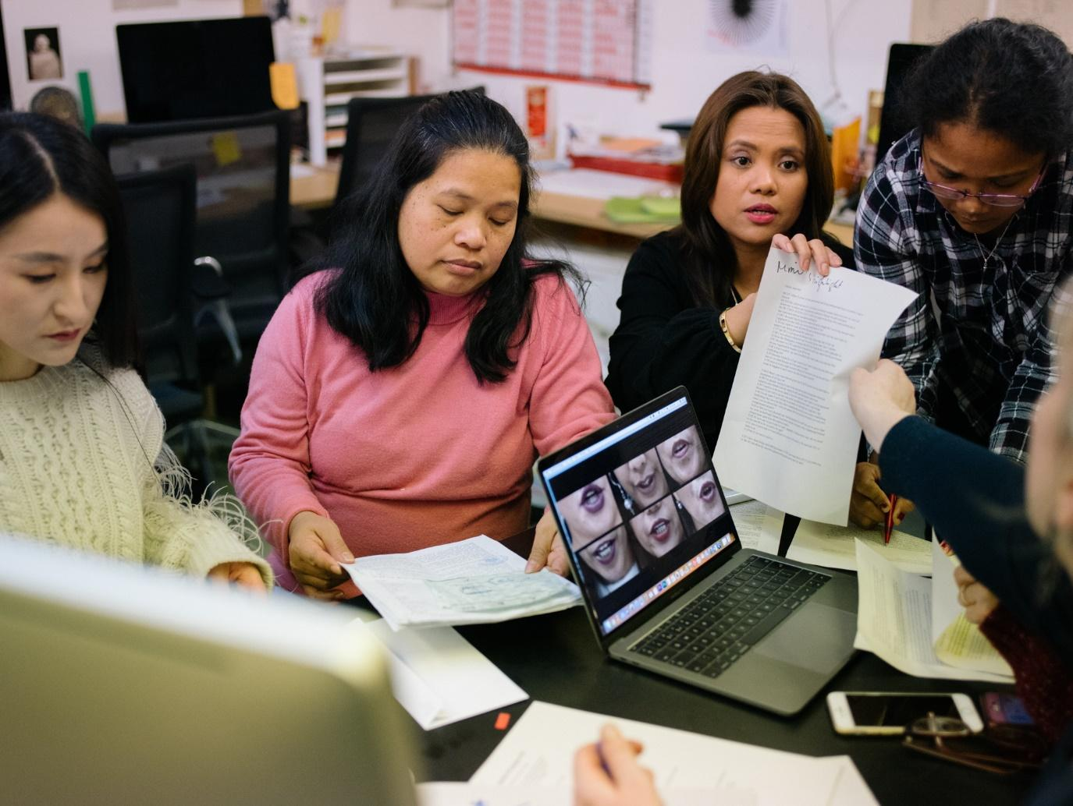
‘It is possible for those who are not part of formal media structures to participate in media, to become reporters of their own reality, to become experts in their own social settings (Atton 2015, 2).’
Acquiring the skills and understanding of the tools required for production became the focus for the group in the next sessions. A professional standard camera and microphones and portable lights were introduced and the codes and conventions of shooting for the screen explored, including shot size and its meaning and composition for an effective screen aesthetic. As well as building familiarity and confidence in using professional equipment, we also looked at the issue of accessibility for the women: how might we achieve these results through shooting on the camera that they each already had in their pocket – their mobile phones. The mobile phone, as a ‘mundane’ rather than ‘spectacular’ piece of equipment (Schleser in Milne et al. 2012, 403) offered a counterpoint to the complexities of the high end camera kit. The women, already regularly using their mobile phone cameras to send video clips home to the Philippines, easily embraced this tool. Here was a small and portable medium in which the women could easily make a record of, and invite an audience into, their domestic world of work: the private domains they inhabit individually and yet collectively, their homes and yet not their homes, making the invisible visible.

Their familiarity with their mobile phone cameras and its accessibility meant that they were able to choose what aspects of their work they wanted to show in the film, at a time convenient to them, and bring the footage to the group for discussion and decisions on what to include in, or exclude from, the film. These editorial decisions were shaped not just by their content, but by the women’s ability to gain permissions for their use by their employers, since each scene took place in a private home. Although some scenes were composed to be non-identifiable, some of the shots clearly were. It was also decided to exclude all shots of childcare, bar one scene of a MDW feeding her own grandchild.
As the workshops continued, a familiarity and relationship of trust and respect grew between we, the facilitators, and the group members. With growing confidence in their production skills, we were able to step back from the process and facilitate the women to take charge of the creative production. Setting up the camera and microphones and conducting the interviews with each other, each participant filmed and interviewed each other from behind the camera in turn (see Figure 4). The set-up and aesthetic design was simple. The women chose their own colour backdrop from a selection of large brightly coloured cards, and dressed in colours to complement their chosen backdrop. In interviewing each other from behind the camera, the women’s gaze was directed straight to the lens, resulting in direct address to the audience. In contrast to the conventional formality of the mainstream media news and documentary that the women were familiar with, this approach, when hugely projected onto a wall, became an experience full of emotional impact for the viewer (see Figure 2).

Figure 4 Participatory film workshop with participants from VoDW, 2019. Source: Tassia Kobylinska
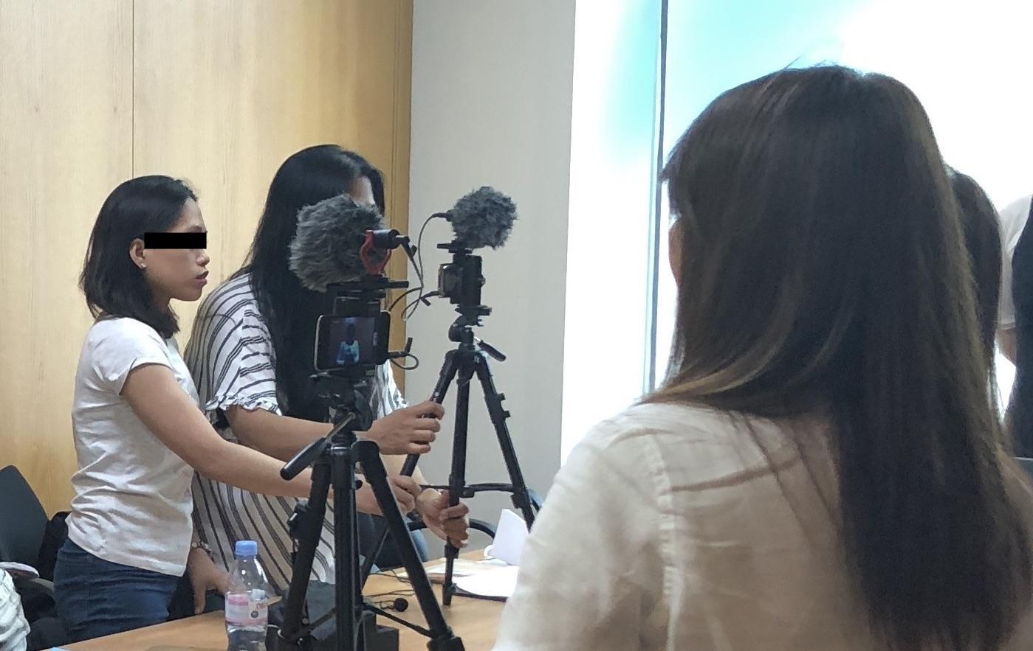

Each interview was fully transcribed for the editing phase and each participant determined what they would include and exclude from their filmed contribution for the final film. The finished film, their personal testimonies with their striking close ups and direct address to camera were described by the curator of the Stephen Lawrence Gallery exhibit, Connie Gallagher, as “[b]y turns beautiful, heroic, shocking, comforting, unsettling.” The participants speak movingly of exploitation and abuse, of the precarity and isolation of their position as domestic workers in private households. They spoke openly, confident that the person behind the camera had experienced the same as them, and so were able to share their experiences with directness and intimacy, in some cases revealing trauma for the first time. The collective performance of the poem ‘Our Journey’ (see Figure 5) starts with the poverty, unemployment and hunger faced by their families, their children and elders, which drove the women to seek work through dubious agencies who sent them abroad to work in private homes in Hong Kong, Kuwait, Saudi Arabia and UAE, before arriving in London, UK, with their employers. The sequences the women filmed on their mobile phones of themselves at work portray the repetitive nature and isolation of their positioning within the domestic realm. Yet, by placing these clips side by side on the screen to form a matrix of six such scenes, they are able to portray their experience as part of a shared reality - a shared history, a shared understanding and a shared awakening about their rights as workers in the UK (see Figure 1).

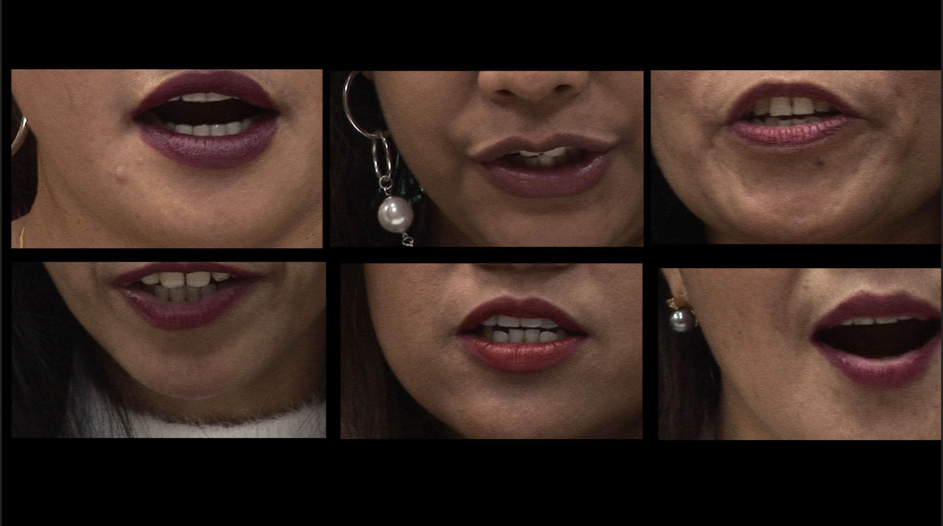
Figure 5 Still from our participatory film ‘Our Journey’, 2019. Source: The Voice of Domestic Workers, Zhe Jiang and Tassia Kobylinska

By participating in the film project the women were able to find commonality in their individual experiences as precarious and exploited workers, finding solidarity and a rallying call to action around a political campaign that both collectivised and empowered. The filmmaking process offered a creative outlet through which the expression of individual traumas could safely be cathected (Banks 2001, 5; Zoettl in Brickell 2013, 213). As one of the participants, Nerisa, says “I am full of tears watching this video again […] we learned a lot, it is priceless. Knowledge and the bonding every week, it’s memorable.”
The women from the group have produced something personal that has been rendered political through art and creative modes of self-representation. The women feel that they have been through a transformative experience, best described in the words of Grace Nine, a participant in the project:
I got to express my feelings, my views, and now I treat the [women] as my family. The experience is hard, it’s a long process. I’m not really a person who is used to expressing my sadness, but we had times of crying together and laughing together, we became close… And then when I saw my face there on the big screen – oh! I felt like an actress! Oh my god! What a fulfilment! (Resonance FM 2019).

Participatory video as a tool of external communication and campaign
Our co-produced film, ‘Our Journey’, has been screened alongside a self-curated exhibition of the artefacts from their lives as migrant domestic workers, such as family photographs, letters from children back home, employment contracts and work uniforms (see Figure 6), in a number of galleries including L’etrangere (see Figure 7), Stephen Lawrence gallery and Cubitt in London and Norman Rea gallery in York. The exhibitions gave a unique and intimate insight into a hidden world of exploitation, abuse and ultimately strength in solidarity and community. Through exhibitions, MDWs communicated a collective narrative in the public sphere, articulating who they were, what they stood for and what they stood against.

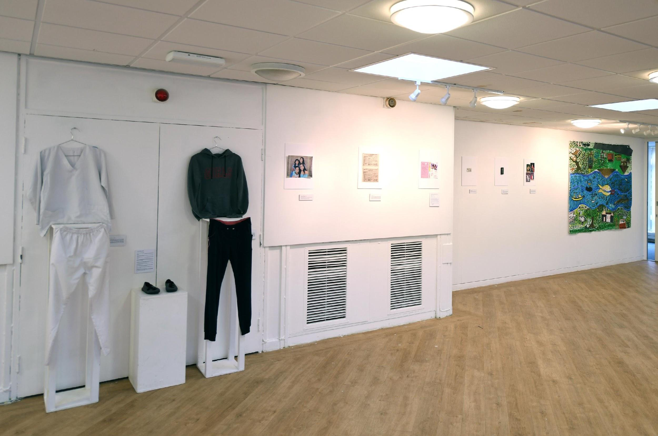
Figure 6 MDW’s artefacts exhibited in Norman Rea Gallery, York, 5-12 November 2019. Source: Paul Shields
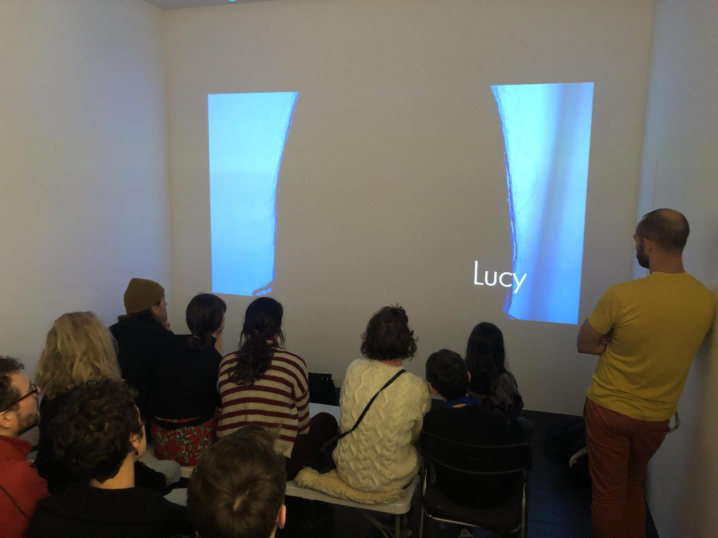
Figure 7 ‘My Home Is Not My Home’ exhibition in L’etrangere, 16-26 January 2019. Source: Zhe Jiang.

The exhibitions were well received by visitors, who consisted of media representatives, trade unionists, NGO staff, community activists, politicians and a public audience. Many responding to our exhibition survey reported that it had changed their way of thinking and made them more aware of the situations of MDWs who are often invisible in public space (see Figure 8). As one visitor commented,

It is an astonishing, heart-warming and shocking exhibition… a very emotional experience. What I came out feeling most of all is respect for these women: for what they have suffered, and how they are coming through it in ways that are truly inspiring. (email to Tassia Kobylinska from Professor Kate Nash, Goldsmiths, November 7, 2019)

Figure 8 Responses from visitors to the ‘My Home Is Not My Home’ exhibition in L’etrangere,16-26 Jan 2019, after watching the film indicating new awareness of the issues raised by the group, 2019. Source: Zhe Jiang.

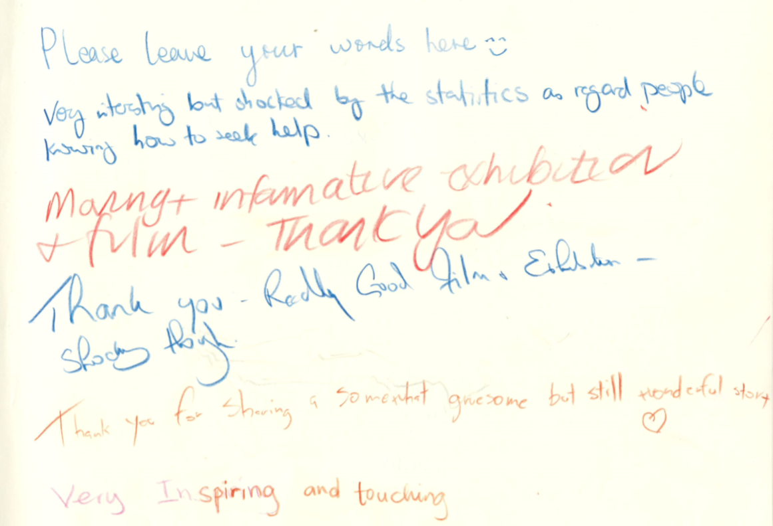

The hosting galleries have also offered positive feedback on how our participatory project has helped them to enhance connections with grassroots communities and develop solidarity to promote positive social changes. As a Cubitt Curatorial fellow put it,

It is a perfect example of how art can be used to inform and support social movements related to labour and visibility – intending also to build new alliances that can propose strategies for continued collective working. The film brought new audiences and conversations to Cubitt and is a great example of how art can work across and with different communities, individuals and issues and strive to have a real affect in the world.

The Guardian published an article on the exhibition and the stories of migrant domestic workers in the UK (Karpf 2019). The video has also been screened in a Parliament event and lobbying meetings to inform politicians of the main difficulties facing MDWs in the UK. Additionally, the video interviews conducted in our participatory video workshop series informed the campaign led by VoDW that recommends the government to reinstate the pre-2012 ODW visa system. Overall, the participatory video has functioned as an effective tool of resistance for MDWs to articulate their interests in the public space challenging the oppressive political context.

Conclusion
In contrast to the dominant masculinised discourses on global cities, this study echoes Yoeh and Saco’s (2014) call to pay more attention to feminised and private spheres of global cities including those of ‘carework’ and ‘domestic work’. In the polarised London labour market (Wills et al. 2009), MDWs are concentrated at the bottom end of the labour market and suffer from high levels of exploitations and social isolation. Our project explores the role of participatory art in supporting and organising MDWs in London who often face difficulties to articulate their social and political wills and to intervene in public forums due to the lack of formal education and precarious visa status in the hosting society.
The participatory video project suggests that participatory art can play a significant role in supporting the voice of marginalised communities. Through participating in the video workshop series, MDWs found the commonality in their individual experiences as precarious and exploited workers, and developed solidarity and critical awareness. The participatory video workshops thus provided a political context in which MDWs were able to share grievances and enhance self-efficacy. Consistent with the notion of ‘relational aesthetics’ (Bourriaud et al. 2002), participatory video workshops have provided a safe space and autonomous zone where MDWs share their common issues and seek collective solutions. The co-produced film, ‘Our journey’, and the associated exhibitions have also helped MDWs to articulate their interests to politicians and public audiences about the oppressive political context. The project indicates the power of participatory art as a tool of empowerment and resistance for migrant workers and other marginalised populations who suffer from precarious visa status and face difficulties to articulate their social and political wills. It reveals the power of art as ‘a voice of dissent, as a tool for advancing social justice’ (David and McCaughan 2006).
Our project also highlights the importance of shifting the attention from the object of art and art as end product, to the subject of art and art as a social process, in order to better understand the potential role of art in helping oppressed groups to achieve social changes (Schwarzman 1993; Roy 2010). Here, the social meaning of art is interpreted as art making, a social construction process which involves domestic workers’ perceptions, identities and preferences and implies a stronger sense of agency regarding the ability of domestic workers to participate directly in structural changes.
Finally, we propose that there are likely to be real opportunities for participatory art practices to play an important role in supporting marginalized, and relatively powerless workers, such as migrant workers in low-wage, informal sectors. These workers often lack the cultural resources to challenge dominant framings supportive of the existing social order, and so these are the participants for whom knowing, questioning and empowerment through art are likely to speak most loudly. Our study also suggests that the flourishing of participative art practices are more likely to be found in flat organisations such as VoDW. The flat, non-hierarchical, sharing culture of VoDW facilitated the simultaneous creation of friendships, collaboration and participation, grassroots empowerment and consciousness-raising which are also core values of participatory art practices.

References:
Aagerstoun, M., and E. Auther. 2007. Considering Feminist Activist Art . NWSA Journal 19 (1):vii-xiv.
Adam, J. 2000. “Movement Socialization in Art Workshops: A Case from Pinochet's Chile.” The Sociological Quarterly 41 (4): 615-638.

Banks, M. 2001.Visual methods in social research (pp. 110-137). London: Sage

Becker. H.S. 1982. Art Worlds. Berkeley: University of California Press.

Bishop, C (ed.) 2006. Participation. Whitechapel: Documents of Contemporary Art.

Boal, A.1979. Theatre of the Oppressed. London: Pluto Press.

Bourriaud, N., S. Pleasance., F. Woods., and M. Copeland. 2002. Relational aesthetics . Dijon: Les presses du réel.

Brickell,K. 2015. Participatory video drama research in transitional Vietnam: post-production narratives on marriage, parenting and social evils, Gender, Place & Culture, 22 (4), 510-525

Buchan, J., R. Jobanputra, P. Gough, and R. Hutt. 2006. “Internationally Recruited Nurses in London: A Survey of Career Paths and Plans.” Human Resources for Health 4 (14). doi: 10.1186/1478-4491-4-14

Cangiano, A., I. Shutes., S. Spencer., and G. Leeson. 2009. “Migrant Care Workers in Ageing Societies: Research Findings in the United Kingdom.” Centre on Migration, Policy and Society, University of Oxford. Accessed 17 December 2019. https://www.compas.ox.ac.uk/wp-content/uploads/PR-2009-Care_Workers_Ageing_UK.pdf.

Coover, R (2009) “On Vérité to Virtual: Conversations on the Frontier of
Film and Anthropology”, Visual Studies, 24(3): 235-249

David, E.A. and E.J. McCaughan. 2006. “Art, Power, and Social Change." Social Justice 33( 2):1-4.

Davies, J.2019. Form severe to routine labour exploitation: The case of migrant workers in the UK food industry. Criminology & Criminal Justice 19 (3): 294-310.

Denisoff, R.S. 1983. Sing a Song of Social Significance. Bowling Green, OH: Bowling Green State University Popular Press.

Durkheim, E. 1964. The Rules of Sociological Method. New York: The Free Press.

Eco, U. 2006. “The poetics of the open work.” In Participation. edited by C. Bishop, 20-40. Whitechapel: Documents of Contemporary Art.

Fromm, E. 1995. The Sane Society, Routledge.

Fryd, V. 2007. Suzanne Lacy's Three Weeks in May: Feminist Activist Performance Art as "Expanded Public Pedagogy”. NWSA Journal 19 (1): 23-38.

Gordolan, L. and M. Lalani. 2009. “Care and Immigration: Migrant Care Workers in Private Households.” Kalayaan, London. Accessed 17 December 2019. http://www.kalayaan.org.uk/documents/Kalayaan%20Care%20and%20Immigration%20Report%20280909%20e-version.pdf.

Gutierrez Garza, A.P. 2019. Care for sale: An ethnography of Latin American domestic and sex workers in London. New York: Oxford University Press.

Haugerud, A. 2013. No Billionaire left Behind: Satirical Activism in America. Stanford University Press.

Hondagneu-Sotelo, P., and C. Riegos. 1997. “Sin organizacion, no hay solucion: Latina domestic workers and non-traditional labour organising.” Latino Studies Journal 8: 54–81.
Jiang, J. 2019. A Special Vulnerability: Migrant Domestic Workers Enslaved by The Non-renewable Overseas Domestic Worker Visa in the UK. Policy report for The Voice of Domestic Workers.
Jiang, Z., and M. Korczynski. 2016. ‘When the ‘unorganizable’ organize: The collective mobilization of migrant domestic workers in London.” Human Relations 69 (3):813-838.
Jiang, Z .,and M. Korczynski. 2019. ‘‘The Art of Labour Organising: Participatory Art and Migrant Domestic Workers’ Self-Organising in London.” Human Relations. https://doi.org/10.1177/0018726719890664.
Jones, G. 2011. “Slumming about: Aesthetics, art and politics.” City 15(6): 696-708.
Karpf, A.2019. “When escaping an abusive employer is a crime: the trap Britain sets for Filipino domestic workers.” The Guardian, January 15. https://www.theguardian.com/lifeandstyle/2019/jan/15/when-escaping-an-abusive-employer-is-a-the-trap-britain-sets-for-filipino-domestic-workers.
Lan, P.C. 2003. Maid or madam? Filipina migrant workers and the continuity of Domestic labor. Gender and Society 17 (2): 187-208.
Lunch, C., and N. Lunch. 2006. “Insights into Participatory Video: a handbook for the field.” Accessed 17 December 2019. https://www.participatorymethods.org/resource/insights-participatory-video-handbook-field.

Madyaningrum, M. E., and C. Sonn. 2011. “Exploring the meaning of participation in a community art project: A case study on the Seeming project." Journal of Community and Applied Social Psychology 21(4): 358-370.
Martinez, M.X. 2007. “The Art of Social Justice." Social Justice 34(1): 5-11.

Miller, K. 2003. “The Philani Printing Project: Women's Art and Activism in Crossroads.” Feminist Studies 29(3): 618-637.

Mills, S. 2009. “Theatre for Transformation and Empowerment: A Case Study of Jana Sanskriti Theatre of the Oppressed.” Development in Practice 19(4/5): 550-559.

Milne, E-J et al. 2012. Handbook of Participatory Video. Lanham: Rowman & Littlefield

Rienzo, C. 2014. “Migrants in the UK labour market: An overview. “Accessed 20 September 2014. http://www.migra- tionobservatory.ox.ac.uk/sites/files/migobs/Briefing%20-%20Migrants%20in%20the% 20UK%20Labour%20Market_0.pdf.
Roberts T., and S. Muñiz. 2018. “Fifty Years of Practice and Innovation Participatory Video (PV).” In Handbook of Communication for Development and Social Change, edited by J. Servaes. Springer.

Robertson, C. and J. Shaw. 1997. Participatory Video: A Practical Approach to Using Video Creatively in Group Developmental Work. Routledge.

Serafini, S., J. Holtaway, and A. Cossu. 2018. artWORK: Art, Labour and Activism. Rowman & Littlefield Publishers.

Shepard, B. 2011. Play, Creativity, and Social Movements: If I Can’t Dance, It’s Not My Revolution. New York: Routledge.

Resonance FM. 2019. The Workplace. Broadcast 22nd January 2019. Available at: https://www.mixcloud.com/Resonance/workplace-22-january-2019/?fbclid=IwAR1CwmCwSrwbMfDn_u6jXNcMOvwROQnx_spLtzc9vlnOrC32ZcLqBl35j3s

White, Shirley A. 2003. Participatory Video : Images That Transform and Empower. New Delhi: Sage

Wills, J., J. May, K. Datta, Y. Evans, J. Herbert, and C. McIlwaine. 2009. “London’s Migrant Division of Labour.” European Urban and Regional Studies 16(3):257–271.

Yeoh, B and M. Saco. 2014. “The cosmopolis and the migrant domestic worker." Cultural Geographies 21(2):171-187.

Acknowledgements
This participatory video project would have been impossible without migrant domestic workers taking time out of their busy work and life to share their migrant stories and life experiences in the UK. We would like to thank all migrant domestic workers who were involved in this participatory video project and the organisational support from The Voice of Domestic Workers. We are very grateful to Unite the Union and Cubitt gallery which offered free venues for our video workshops. We also wish to say thank you to L’etrangere, Stephen Lawrence gallery, Cubitt Gallery, Norman Rea Gallery and People’s History Museum who have kindly hosted our exhibitions.

The Voice of Domestic Workers is a London-based charity organisation protecting the rights of migrant domestic workers in the UK. It provides educational and community activities for domestic workers – including English lessons, drama and art classes, and employment advice, and provides support for domestic workers who exit from abusive employers.
website: https://www.thevoiceofdomesticworkers.com/
Email: info@thevoiceofdomesticworkers.com

Dr Zhe Jiang (Joyce Jiang) is a Lecturer in Human Resource Management and Sociology of Work at The York Management School, University of York, UK. She is also a trustee of a charity organisation - The Voice of Domestic Workers in London. Her research areas include migration and globalisation, social movement, politicised art, as well as art-based research methods. Her research takes an ethnographic approach that involves the use of photography and video. She is on the editorial board of the journal Work, Employment and Society
The York Management School, University of York, UK. Email: joyce.jiang@york.ac.uk

Tassia Kobylinska is a Lecturer in Digital Media Production at Goldsmiths, University of London, and a filmmaker who has produced and directed documentaries, public and charity sector films, international policy and human rights productions for a range of NGOs and INGOs globally. She has a particular interest in Nepal based projects. She also specialises in the processes and production of participatory, community and social action films. Email: t.kobylinska@gold.ac.uk

