Received 00th January 20xx,

Accepted 00th January 20xx

DOI: 10.1039/x0xx00000x

**Si–C(sp3) Bond Activation Through Oxidative Addition at a Rh(I) centre**

S. Azpeitia,a A. J. Martinez-Martinez,b  M. A. Garralda,a A. S. Wellerc, * and M. A. Huertosa, d, *

An easy, direct and room temperature silicon-carbon bond activation is reported. The reaction of [RhCl(coe)2]2 with the silane [Si(Me)2(*o*-C6H4SMe)2] in the presence of an halide extractor provokes a Si–CH3 bond cleavage yielding a cationic silyl-methyl-Rh(III). In contrast, if the reaction is performed using the Rh(I) bis-alkene dimers [RhCl(cod)]2 or [RhCl(nbd)]2, the Si–CH3 bond activation does not occur.

There is current interest in the study of non-polar Si–C bond activation by transition metal complexes as Si–C bond cleavage plays an important role in the mechanism of organosilicon based cross-coupling reactions (e.g. Hiyama reactions).1-3 Moreover, the Si–C bond activation has gained attention in the chemical community because it is a powerful method to synthesise new organosilanes such as, for example, siloles.4-10 Reports on transition-metal-catalysed reactions involving cleavage of Si–C(sp3) bond are scarce6-10 due to the high bond dissociation energy and low polarity of Si–C(sp3) bond when compared to Si–C(sp2) or Si–C(allyl) bonds.11, 12 There are a number of examples that demonstrate that a Si–C(sp3) bond cleavage can be induced by a chelate effect of PSiP and NSiN frameworks (Scheme 1).13-17 Puddephatt and co-workers reported the oxidation of a Pt(II) complex containing a 2SiMe2(2-C5H4*N*)2 ligand allowed the transfer of a methyl group from silicon to platinum (Scheme 1a).15 The isolation of a neutral methyl-silyl-Pt(II) compound, was achieved by oxidative addition of a Si–CH3 bond on a Pt(0) centre (Scheme 1b),16 while Si–CH3 addition occurs at [Rh(H)(CO)(PPh3)3], with concomitant loss of methane (Scheme 1c).17

1. Department of Applied Chemistry, University of Basque Country (UPV/EHU), 20080 San Sebastián, SPAIN.
2. CIQSO-Centre for Research in Sustainable Chemistry and Department of Chemistry, University of Huelva, Campus el Carmen, 21007, Huelva, SPAIN.
3. Department of Chemistry, University of York, York, YO10 5DD, UK

Email: [andrew.weller@york.ac.uk](mailto:andrew.weller@york.ac.uk)

1. IKERBASQUE. Basque Foundation for Science, 48013, Bilbao, SPAIN.

Email: [miguelangel.huertos@ehu.es](mailto:miguelangel.huertos@ehu.es)

**†**Electronic Supplementary Information (ESI) available: see DOI: 10.1039/x0xx00000x



**Scheme 1** Selected examples of Si–C(sp3) bond activations previously reported and showed in this work.

We now report a fast and quantitative Si–CH3 bond activation using a rhodium(I) alkene complex and a bidentate thioether pro-ligand that contains a bridging {SiMe2} unit. The identity of the alkene is important: monodentate coe (cyclooctene) leads to Si–CH3 activation, while for more strongly bound cod (1,5-cyclooctadiene) and nbd (2,5-norbornadiene) ligands no bond activation is observed.

The ligand employed in this work, SiMe2(*o*-C6H4SMe)2 (**1**), was synthesised by reaction of the aryl bromide 2-MeS(C6H4Br) with n-buthyllithium at 0°C in diethyl ether, and subsequent addition of half equivalent of dimethyldichlorosilane (Figure 1).

**Fig. 1** Synthesis of **1** and its solid-state structure. Displacement ellipsoids are shown at the 50 % probability level. Selected bond lengths [Å] and angles [°]: Si1-C1, 1.893(1); Si1-C8, 1.887(1); Si1-C14, 1.868(1); Si1-C15, 1-875(1); C1-Si1-C8, 110.45(5).

The 1H NMR spectrum of **1** indicates the presence of the two equivalent SiMe groups by a relative integral 6 H singlet signal at 0.65 ppm (29Si satellites, *2J*Si-H = 6.7 Hz). The thioether groups are observed as a 6 H singlet signal at 2.18 ppm. Slow evaporation of a concentrated Et2O solution leads to the formation of colourless single crystals that allowed the characterisation of the ligand by single crystal X-ray diffraction. The structure of **1** (Figure 1) consistent with that deduced from the NMR data in solution.

****The addition of pro-ligand **1** to [RhCl(diolefin)]2 (diolefin = cod, nbd) in dichloromethane at room temperature in the presence of Na[BArF4] leads to the formation of the cationic 16-electron Rh(I) compounds [Rh(cod){2SiMe2(*o*-C6H4*S*Me)2}][BArF4] (**2**) and [Rh(nbd){2SiMe2(*o*-C6H4*S*Me)2}][BArF4] (**3**) respectively (Scheme 2).18 Complexes **2** and **3** were characterised in solution by NMR spectroscopy and ESI-MS (Electrospray Ionisation Mass Spectrometry), and in solid state by X-ray diffraction and elemental analysis. Changing the solvent to CH2Cl2/MeCN (vide infra) did not result in a different product.

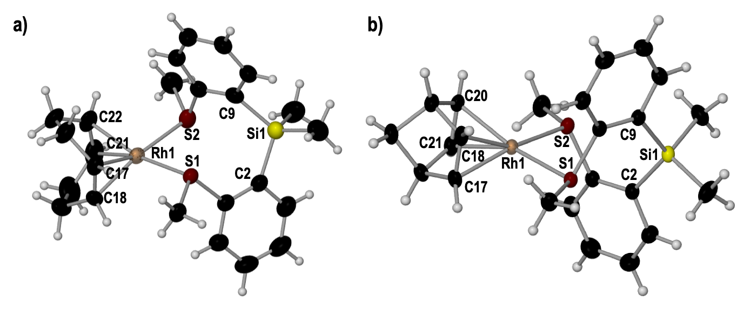For complex **2** NMR data show that the ligand (**1**) binds to give overall C2 symmetry (Figures S2-S4, ESI). The presence of a 6H relative integral singlet at 2.31 ppm corresponds to the two SMe groups, while a singlet at 0.47 ppm (29Si satellites, *2J*Si-H = 6.4 Hz), with a relative integral of 6H, corresponds to the two methyl groups bonded to the silicon atom. The 13C–1H HSQC NMR spectrum of **2** shows the correlation between the signals assigned to the double bonds in the cyclooctadiene ligand, which are observed as two multiplets at 4.75 and 4.23 ppm, with the doublet signals at 86.8 ppm (*J*Rh-C = 11.0 Hz) and 91.0 ppm (*J*Rh-C = 11.0 Hz) in the 13C{1H} NMR spectrum (Figures S2-S4, ESI).

For compound **3**,the 1H NMR spectrum (Figure S6, ESI) shows a singlet at 2.16 ppm for the two SMe fragments in the chelate ligand and a singlet at 0.44 ppm (29Si satellites, *2J*Si-H = 6.5 Hz) corresponding to the equivalent methyl groups on the silicon. A very broad signal at 4.19 ppm (fwhm = 39.5 Hz) with a 4H relative integral corresponds to two overlapped signals of the alkene protons of the norbornadiene fragment. This signal correlates with two broad signals at 64.3 and 53.1 ppm in the 13C{1H} NMR spectrum (Figure S7 and S8, ESI). C2 symmetry, as for complex **2**, is signalled by 2H relative integral signals at 3.92 ppm (CH), and 1.44 ppm (bridge CH2) in the 1H NMR spectrum.

Determination of the solid-state structures of **2** and **3** was also possible using X-ray diffraction. The resulting structures agree with those deduced from the spectroscopic data in solution (Figure 2). In **2**, in which there is non–crystallographic C2 symmetry imposed by the twist of the thioether ligands. The Rh(I) centre sits in a distorted square planar geometry. **1** is coordinated as bidentate *via* the two SMe moieties (Rh1–S1 2.3967(7) Å and Rh1–S2 2.41(1) Å) to form an eight-membered ring chelate, having a S1–Rh1–S2 bite angle of 83.3(2)°. All bond distances between rhodium and the diolefin carbon atoms are very similar (Rh1–C17 2.141(4) Å, Rh1–C18 2.173(4) Å, Rh1–C21 2.148(3) Å, Rh1–C22 2.160(3) Å). As in compound **2**, **3** shows a slightly distorted square-planar geometry around the rhodium(I) centre. The ligand **1** forms an eight-membered chelate-ring. The bite angle, S1–Rh1–S2, is slightly larger 87.87(1)° and the bond distances between rhodium and the norbornadiene carbon atoms are similar (Rh1–C17 2.145(2) Å, Rh1–C18 2.145(2) Å, Rh1–C20 2.139(2) Å, Rh1–C21 2.138(2) Å).

The S-Rh-S bite angles in **2** and **3** are smaller than previously reported {bis[(2-diphenylphosphan-yl)phenyl] ether} (DPEPhos) Rh(I) complexes: [Rh(cod)(DPEPhos)][BF4], P–Rh–P = 96.39(3)°; [Rh(nbd)(DPEPhos)][BF4], P–Rh–P = 99.77 (3)°.19 This fact could be explained by the difference in the structural arrangement of the eight-membered metallacycle that allows for a more compact arrangement. Coordination of the ligand **1** opens up the C-Si-C angles in compounds **2** and **3** (C2-Si1-C9 117.2(8) and C2-Si1-C9 118.42(8) respectively) compared with free ligand **1** (C1-Si1-C8 110.45(5)).

**Scheme 2** Synthesis of **2** and **3**.

**Fig. 2** Solid-state structure of complexes **2** and **3**. The anion is omitted for clarity. Displacement ellipsoids are shown at the 50 % probability level. **a) 2:** Selected bond lengths [Å] and angles [°]: Rh1-S1 2.3967(7), Rh1-S2 2.41(1), Rh1-C17 2.141(4), Rh1-C18 2.173(4), Rh1-C21 2.148(3), Rh1-C22 2.160(3), C21-C22 1.379(6), C17-C18 1.373(5), S1-Rh1-S2 83.3(2), C2-Si1-C9 117.2(8). **b) 3.** Selected bond lengths [Å] and angles [°]: Rh1-S1 2.3687(7), Rh1-S2 2.367(1), Rh1-C17 2.145(2), Rh1-C18 2.145(2), Rh1-C20 2.139(2), Rh1-C21 2.138(2), C21-C20 1.392(3), C17-C18 1.392(3), S1-Rh1-S2 87.87(1), C2-Si1-C9 118.42(8).

At variance with the reactivity shown by the dithiosilane ligand **1** toward diolefinic complexes, when using the rhodium(I)cyclooctene (coe) dimer [RhCl(coe)2]2, Si–CH3 bond activation of **1** and oxidative addition on the Rh(I) centre to afford a Rh(III) complex occurred. The reaction of **1** with [Rh(coe)2Cl]2 in the presence of Na[BArF4]in dichloromethane at room temperature leads to a complex mixture of uncharacterized products. However, by adding acetonitrile to the reaction mixture a single organometallic product is isolated which has undergone aSi-CH3 bond activation and loss of the mono-dentate alkene. The resulting cationic complex [Rh(Me){3*Si*Me(*o*-C6H4*S*Me)2})(MeCN)2][BArF4](**4**), Scheme 3, was characterised using NMR spectroscopy and single–crystal x-ray diffraction.

****Single crystals of complex **4** were obtained from a dichloromethane solution layered with pentane at room temperature. The structure in the solid state (Figure 3) consists of a Rh(III) centre in a pseudo-octahedral geometry. The, now, tridentate dithiosilyl ligand occupies one of the faces of the octahedron, and is bound to the metal through a silyl fragment (Rh1–Si1 2.2676(10) Å) and the SMe moieties (Rh1–S 2.2783(9), 2.4357(14) Å). The Rh–CH3 group that originates from Si-C activation sits *cis* to the silyl ligand (Rh1–C16 2.088(4) Å). Two acetonitrile molecules complete the coordination sphere, and are located *trans* to Si (Rh1–N2 2.225(3) Å) and one of the sulphur atoms (Rh1–N1 2.099(3) Å). The Rh-N bond distance for the MeCN group *trans* to the silyl fragment is significantly longer than that of the NCMe *trans* to the thioether moiety, consistent with the *trans* influence of the silyl fragment

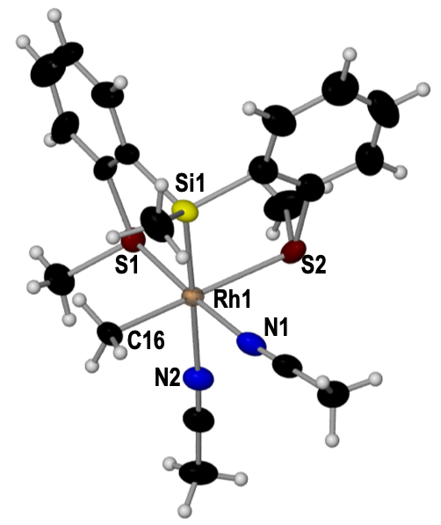**Scheme 3** Synthesis of **4**.

**Fig. 3** Solid-state structure of complex4. The anion is omitted for clarity. Displacement ellipsoids are shown at the 50 % probability level. Selected bond lengths [Å] and angles [°]: Rh1-Si1 2.2676(10), Rh1–S1 2.2783(9), Rh1–S2 2.4357(14), Rh1–N2 2.225(3), Rh1–N1 2.099(3), Rh1–C16 2.088(4); Si1-Rh1-N2 178.03(10), S1-Rh1-N1 176.59(9), C16-Rh1-S2 172.52(13), S1-Rh1-S2 94.46(5), C16-Rh1-N1 91.76(15), C16-Rh1-S1 90.91(12), S2-Rh1-N1 82.69(10).

1H, 13C{1H} and 13C–1H HSQC NMR experiments revealed that the methyl group bound to the rhodium(III) centre is observed as a broad signal at 0.83 ppm in the 1H NMR spectrum and as a signal at -2.1 ppm in the 13C{1H}NMR spectrum, which is consistent with previous RhIII–CH3 complexes reported.20-22 The tridentate ligand exhibits a singlet signal at 0.67 ppm (3 H, 29Si satellites, *2J*Si-H = 7.1 Hz) for the methyl bound to the silicon atom, and two 3H relative integral singlets at 2.68 and 2.36 ppm for the non-equivalent SMe groups. Two signals with a relative integral of 3H at 2.27 ppm and 2.22 ppm are assigned to the coordinated acetonitrile molecules.

Overall, these results suggest that olefin displacement is easier for cyclooctene than for chelating diolefinic ligands, and thus enables the overall formal Si-CH3 oxidative addition. Most likely, a coordinating solvent such as acetonitrile plays a stabilising role of the Rh(III) species formed. It is interesting that while other stochiometric Si–C(sp3) activations require reactive organometallic precursors, such as Rh(I) hydrides;17 strong oxidizing agent/external nucleophiles15 or long reaction times,16 the Si–CH3 activation reported in this work occurs at room temperature in 20 minutes. We suggest a mechanism for overall Si–C addition to the Rh(I) centre as one that invokes initial d🡪Si–C σ* interactions followed by methyl transfer, as proposed previously in other Rh(I) systems that undergo Si–C cleavage (Fig. 1c)17 and also reminiscent of the overall nucleophile assisted methyl migration reported by Puddephatt (Fig. 1a).15

In summary, we have studied the reactivity of the silane proligand [Si(Me)2(*o*-C6H4SMe)2] (**1**) with the Rh(I) precursors [RhCl(nbd)]2, [RhCl(cod)]2 and [RhCl(coe)2]2 in the presence of Na[BArF4]. When the rhodium diolefin compounds were used, the cationic complexes [Rh(cod){2SiMe2(*o*-C6H4*S*Me)2}][BArF4] (**2**) and [Rh(nbd){2SiMe2(*o*-C6H4*S*Me)2}][BArF4] (**3**) were obtained. However, the reaction of **1** with [Rh(coe)2Cl]2 led to the formation of the silyl-methyl-Rh(III) complex, [Rh(Me){3*Si*Me(*o*-C6H4*S*Me)2})(MeCN)2][BArF4](**4**) *via* a straightforward and fast CH3–Si activation. We have described here a suitable combination of transition metal precursor and ligand able to promote an easy Si–CH3 activation, which is a reaction of interest for the synthesis of alkyl containing organosilanes. Since several mechanism for the rhodium-catalysed C–Si bond cleavage have been proposed, 5, 8, 23 our resulting isolated methyl-silyl-Rh(III) species, could be a model for intermediates proposed in the activation of C–Si bonds.

Conflicts of interest

There are no conflicts to declare.

Acknowledgements

The authors acknowledge Ministerio de Economía y Competitividad (MAH, CTQ2015-65268-C2), Gobierno Vasco (MAH, IT1880-19) and the EPSRC (ASW, EP/M024210/1) for funding. MAH acknowledge support from IKERBASQUE.

Notes and references

1. T. Hiyama, *J. Organomet. Chem.,*2002, **653**, 58-61.
2. H. Zhou, Y. H. Xu, W. J. Chung and T. P. Loh, *Angew. Chem. Int. Ed.,* 2009, 5355−5357.
3. S. E. Denmark, *J. Org. Chem.,* 2009, **74**, 2915-2927.
4. L. Li, Y. Zhang, L. Gao and Z. Song, *Tetrahedron Lett.,* 2015, **56**, 1466-1473.
5. J. F. Hartwig, Organotransition Metal Chemistry, From Bonding to Catalysis, University Science Brooks, Sausalito, CA, 2010.
6. I. Ojima, D. A. Fracchiolla, R. J. Donovan and P. Banerji, *J. Org. Chem*., 1994, **59**, 7594-7595.
7. C. M.  Ong, T. J. Burchell and R. J. Puddephatt, *Organometallics*, 2004, **23**, 1493-1495.
8. M. Tobisu, M. Onoe, Y. Kita and N. Chatani, *J. Am. Chem. Soc*., 2009, **131**, 7506-7507.
9. Y. Liang, S. G. Zhang and Z. F. Xi, *J. Am. Chem. Soc*., 2011, **133**, 9204-9207.
10. Q. W. Zhang, K. An and W. He, *Angew. Chem. Int. Ed*., 2014, **53**, 5667-5671.
11. *for Si–C(sp2) activation see for example*: S. E. Denmark and R. F. Sweis, *J. Am. Chem. Soc.,* 2001, **123**, 6439-6440.
12. *for Si–C(allyl) activation see for example:* S. E. Denmark and M. H. Ober, *Org. Lett.,* 2003, **5**, 1357-1360.
13. S. J. Mitton, R. McDonald and L. Turculet, *Angew. Chem. Int. Ed.,* 2009, **48***,* 8568-8571.
14. J. Takaya and N. Iwasawa, *Organometallics,* 2009, **28**, 6636-6638.
15. M. Safa, M. C. Jennings and R. J. Puddephatt, *Chem. Commun.,* 2010, **46***,* 2811-2813.
16. S. J. Mitton, R. McDonald and L. Turculet, *Polyhedron,* 2013, **52**, 750-754.
17. H. Kameo, S. Ishii and H. Nakazawa, *Dalton Trans.,* 2013, **42**, 4663-4669.
18. For cod and coe complexes there was no reaction in the absence of Na[BArF4]. For the coe complex an insoluble (MeCN) precipitate formed that we suggest is a halide-bridge oligomer/polymer.
19. S. Möller, H-J, Drexler and D. Heller, *Acta Cryst. C,* 2019, **75**, 1434-1438.
20. E. L. Dias, M. Brookhart and P. S. White, *Organometallics*, 2000, **19**, 4995-5004.
21. M. Feller, M. A. Iron, L. J. W. Shimon, Y, Diskin-Posner, G. Leitus and David Milstein, *J. Am. Chem. Soc*., 2008, **130**, 14374-14375.
22. T. E. Stevens, K. A. Smoll and K. I. Goldberg, *J. Am. Chem. Soc*., 2017, **139**, 7725-7728.
23. Z. Yu and Y. Lan, *Organometallics*, 2013, **78**, 11501-11507.