Supplementary Table 1. UK sample characteristics

|  |  |  |
| --- | --- | --- |
|  |  |  |
| **UK sample** | **Australian sample** |
|  |  |
| *Patients (n)* | n=13 | n=11 |
| **Disease duration (years), n (%)**  ≤ 1  1-2  3-5  6-10  10 + | - (0)  1 (8)  - (0)  7 (54)  5 (38) | 3 (27)  1 (9)  3 (27)  4 (36)  - |
| **Age** **(years)**, median, range | 45, 20-70 | 35, 24-68 |
| **Sex, female, n (%)** | 6 (46%) | 7 (64%) |
| **Employment n (%)**  Employed  Unemployed  Pensioner  Student | 6 (46)  2 (15)  4 (31)  1 (8) | 9 (82)  1 (9)  1 (9)  - |
| **Disease subtype n (%)**  CD  UC  IBDU | 9 (69)  4 (31)  0 (0) | 5 (45)  5 (45)  1 (9) |
| **Hospital sector n (%)**  Public  Private | 13 (100)  - | 7 (64)  4 (36) |
| Anxiety (HADS)  Mild  Moderate  Depression (HADS)  Mild  Moderate | N/A | 4 (36%)  3 (27%)  5 (45%)  1 (9%) |
| *Health Professionals n (%)* | n=12 | n=8 |
| Gastroenterologist  IBD nurse  Dietitian  Psychologist  Nurse other | 5 (42)  4 (33)  1 (8)  1 (8)  1 (8) | 4 (49)  2 (25)  -  2 (25)  - |
| **Sex, n (%)**  Male  Female | 4 (33%)  8 (67%) | 3 (37%)  5 (62%) |

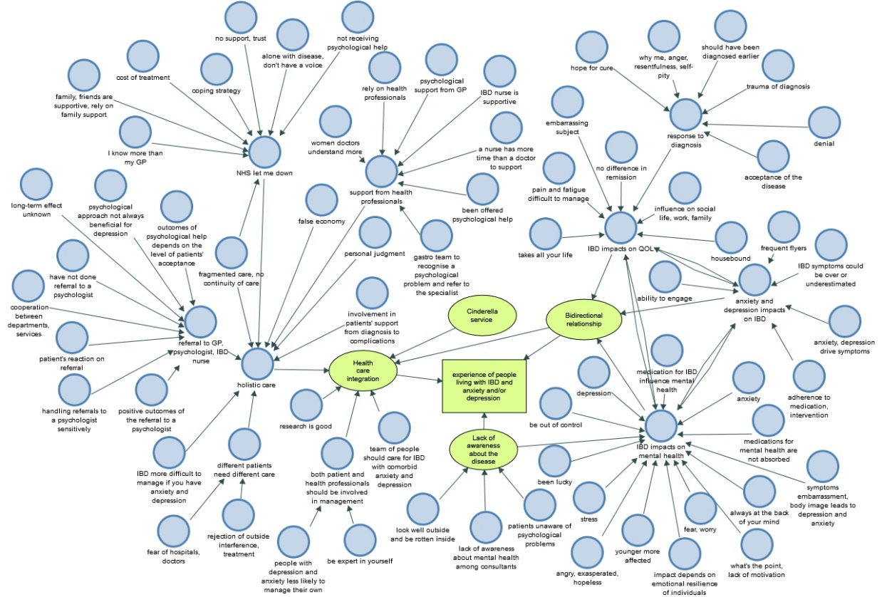

Supplementary Figure 1. Thematic map of British patients’ and health professionals’ perspectives on the experience of IBD with comorbid anxiety and/or depressive symptoms

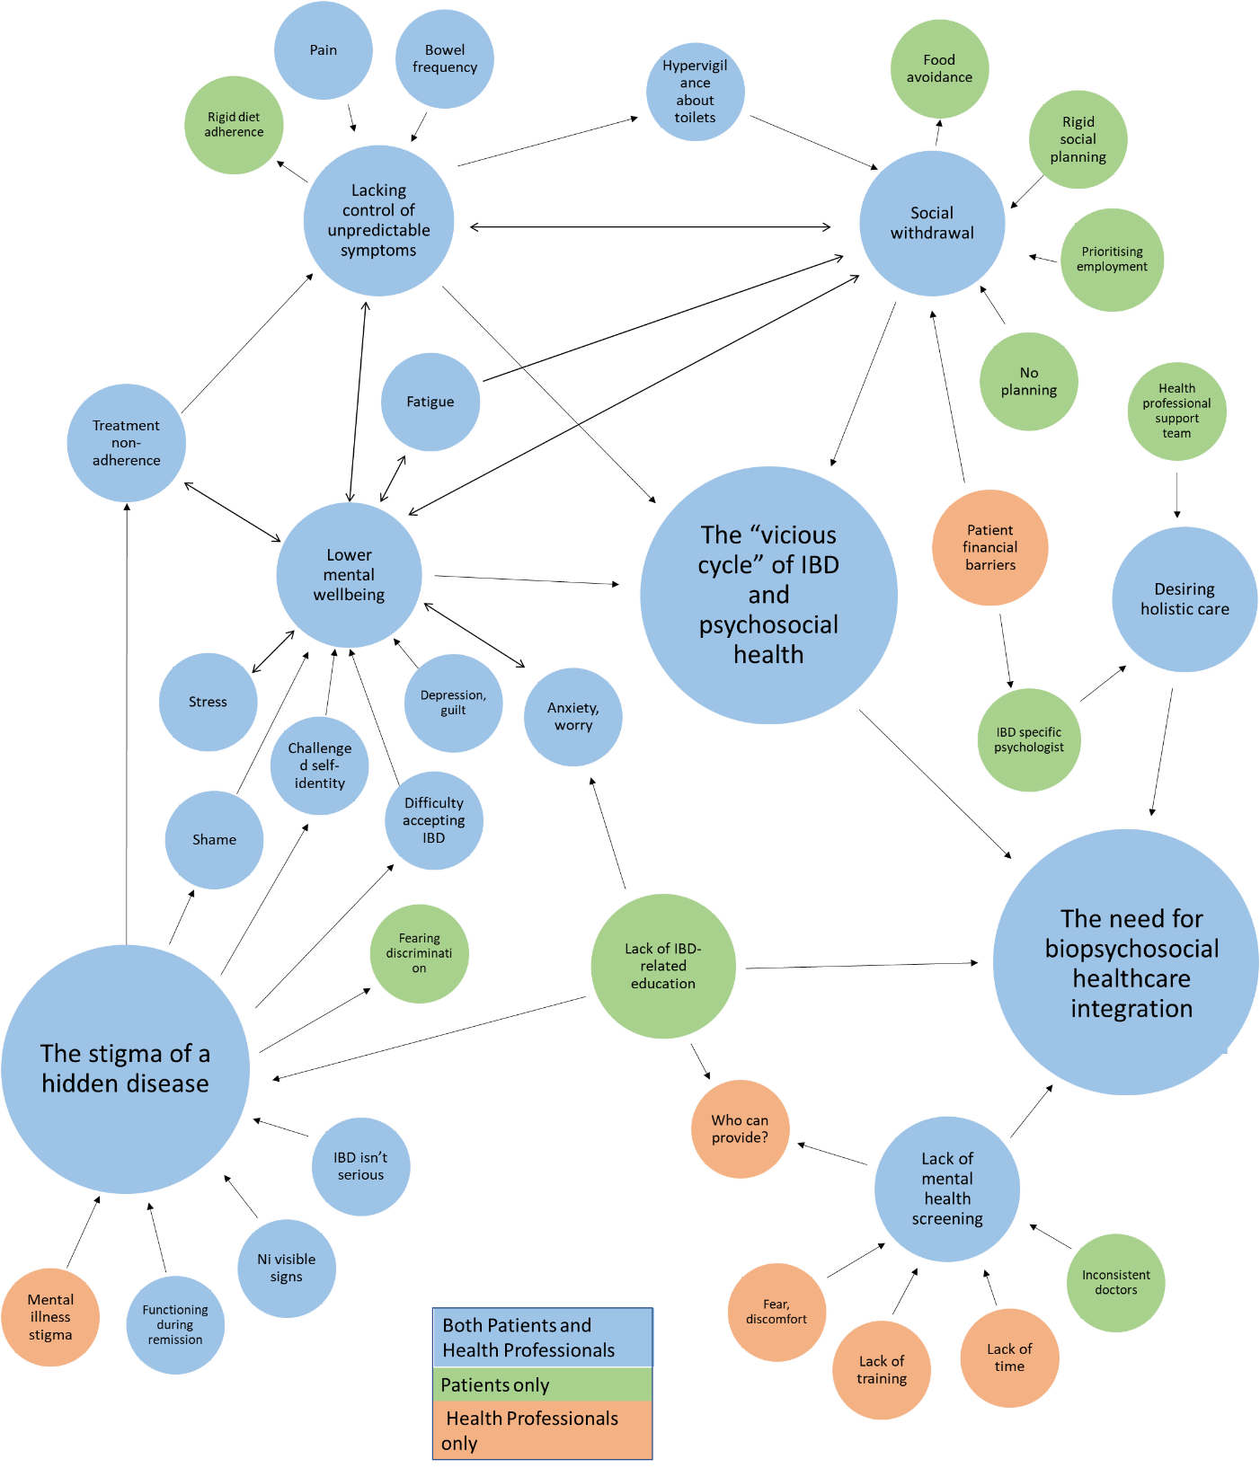

Supplementary Figure 2. Thematic map of Australian patients’ and health professionals’ perspectives on the experience of IBD with comorbid anxiety and/or depressive symptoms