Microbial oil produced from the fermentation of microwave- depolymerised rapeseed meal

Fabio Santomauro ª, Jiajun Fan ^{b*}, Vitaliy Budarin ^{b}, Sophie Parsonsª, James Clark ^{b}, Timothy Miller ^{c} and Christopher J. Chuck ª.*
ª Department of Chemical Engineering, University of Bath, Bath, BA2 7AY, UK
^{b} Green Chemistry Centre of Excellence, Department of Chemistry, University of York, Heslington, York, YO10 5DD, UK
^{c} Croda Europe Ltd, Foundry Lane, Ditton, Widnes, Cheshire, WA8 8UB, UK

Corresponding author; c.chuck@bath.ac.uk, alice.fan@york.ac.uk

Abstract
Rapeseed meal is high in protein and carbohydrate and is a promising feedstock for microbial valorisation, however, the fibrous structure is difficult to breakdown and involves multiple chemical and enzymatic steps to release a fermentable hydrolysate. In this investigation an innovative pre-treatment of rapeseed meal was demonstrated, involving a one-step process using microwave heating and no additional chemicals or enzymes. 57% of the biomass was solubilized over just a few minutes with minimal energy input. The hydrolysate contained a mixture of monosaccharides, oligosaccharides and micronutrients. To ferment this material the oleaginous yeast Metschnikowia pulcherrima was selected and was able to metabolise the material including some of the oligosaccharides of approximately DP8 and below, producing a lipid that was highly monounsaturated. On the laboratory scale 11% lipid could be achieved from the rapeseed meal alone, with a lipid profile akin to palm oil. On the addition of glycerol to increase the C:N ratio, over 16 g/L of yeast was achieved with lipid content of 38% w/w. To demonstrate the scalability of the microbial process, the fermentation was demonstrated on depolymerised rapeseed meal with glycerol, in a 30 L pilot scale fermenter, yielding 12 g/L of yeast with 22% w/w lipid over 120 hours. While the lipid production needs to be further optimised on this scale, the use of rapeseed meal as a feedstock, coupled with a one-step microwave process that does not need additional pre- and post-processing stages, is an exciting route to potential commercially viable microbial oils.
Keywords: lignocellulose; yeast; lipid; biodiesel; depolymerisation

1. Introduction
Triglyceride oils are becoming an increasingly important feedstock for biofuels, further chemical products and polymer precursors. However, traditional terrestrial oil sources such as palm, rapeseed and soybean compete with arable land. For example, the rapid increase in palm and soybean plantations in South East Asia and Latin America is leading to widespread deforestation, increased localised and global pollution and a severe reduction in biodiversity in these areas (Abrams, 2016; Aini, 2015). As such, a key scientific goal is the development of a more sustainable sources of triglyceride oils. One such source are single cell oils (SCO) derived from oleaginous yeasts cultivated on lignocellulose hydrolysates. The fatty acid profile of most oleaginous yeasts typically contain elevated levels of palmitic, oleic and linoleic acid. The majority of yeast produce oils akin to rapeseed oil, high in oleic acid, and a number have been demonstrated to produce an oil with a similar fatty acid profile to palm oil, with high lipid co-efficients and productivity being observed (Whiffin, 2016). The technology for the large scale production of yeasts is well established though the preparation of a suitable, inexpensive, feedstock remains a key issue (Papanikolaou, 2011a, 2011b).
A number of studies have demonstrated the need for effective pre-treatments in bioethanol production (Da Silva, 2018), including the need to reduce inhibitor production (Prasad, 2018). However, like a lot of oleaginous yeasts Metschnikowia pulcherrima is well known to have elevated inhibitor tolerance (Whiffin, 2016; Zhou, 2017). Recently, we demonstrated that this yeast species was a suitable candidate for SCO production, due to high lipid levels obtainable, the ability to grow on both hexose and pentose sugars and that the yeast could be cultured in non-sterile conditions due to the low pH and ability to produce antimicrobials agents like pulcherriminic acid and 2-phenylethanol (Santomauro, 2014). There is also some evidence to suggest that the yeast can produce cellulases (Strauss, 2001), and could potentially metabolise oligosaccharide making it suitable for its exploitation in consolidated bioprocessing (CBP) as well. Due to its ability to combat microbial invasions, the main use of M. pulcherrima to date has been as a biocide agent and in the wine industry (Belda, 2016; Oro, 2014; Turkel, 2014).
For sustainable oil production by M. pulcherrima on a large scale, lignocellulose wastes sourced from agriculture must be used as substrate. One promising substrate is rapeseed meal (RSM), a by-product from the extraction of oil from rapeseed. After soybean and cotton, rapeseeds produce the largest amount of waste on an annual basis, with an estimated EU-28 production of 14 million tonnes of RSM in 2015 (USDA, 2016). RSM tends to have a protein content of around 40%, a range of essential micronutrients and a fiber content of approximately 15% (Invanova et al, 2016). In addition RSM is produced from the extraction process for pure rapeseed oil. An SCO production process using RSM as a feedstock could then fit into this distribution structure, without need for further infrastructure investment.
Rapeseed meal has been demonstrated to be a suitable feedstock for a number of biotechnological processes such as the production of xylanases from T. reseii and the production of succinic acid, in a titre of 23 g/L, from Actinobacillus succinogenes (Lomascolo, 2012). However, to date the processing of rapeseed meal is dependent on enzymes and multiple stages for processing which severely hamper the economics of the process. One of the most energy and cost inefficient stages of this process is the chemical hydrolysis of the meal, which releases the digestible components for enzymatic degradation.
It is well-known that microwaves (MW) have the potential to be a very energy efficient method of heating, especially aqueous solutions, due to the high polarity of water. Furthermore, MWs have a number of other advantages such as selectivity, higher reaction rate and controllability (Ganzler, 1986; Lanigan, 2010). Recently, a method for the hydrothermal microwave depolymerisation of lignocellulosic materials, that produce substantial quantities of sugar, without the need for additional celluloses and additives, was reported (Fan, 2013). The temperature that was optimally used was significantly below conventional heating technologies previously reported for the depolymerisation (Fan, 2013). For example, the MW process was demonstrated to produce over 20% of glucose at 220°C from microcrystalline cellulose under additive free conditions. This process only produced trace levels of HMF and furfural (Chen, 2015). Potentially this method for depolymerisation could be more commercially viable, due to minimum pre-and post- enzymatic treatment. However, due to complexity of real biomass, the process can make the ratio between sugars and inhibitors production unpredictable. Therefore, it is important to find a balance between the MW pre-treatment and a fermentation process, enabling the industrial application of combined technologies for SCO production.
There are a few reports of rapeseed meal being demonstrated as a promising feedstock for industrial biotechnology. For example, as a major source of microbial amino nitrogen for general fermentations (Wang 2010), a consolidated bioprocess for the production of succinic acid (Chen 2011) and as a source of free amino nitrogen, and some monosaccharide, for microbial oil production (Kiran 2012). Each of these studies notes the need for additional carbon sources. And in all of these studies the rapeseed meal was depolymerised using multiple steps including a conventional chemical pre-treatment and enzymatic process to release monosaccharides and free amino nitrogen. The aim of this study was to demonstrate the use of an efficient one-step microwave heating for the depolymerisation process and coupling that to an oleaginous yeast that can effectively use the carbon released. To that end M. pulcherrima has been recently reported to convert a range of feedstocks, hydrolysed with a one-step MW process with Y_{M/M} from the solubilised hydrolysate of up to 50% (Fan, 2018). The aim of this investigation was to fully characterize the resulting rapeseed meal hydrolysate from the microwave process, optimize the fermentation on this hydrolysate, and assess whether a suitable yeast oil substitute could be produced in a scaled up 30 L fermentation in a suitable timeframe. A simplified flow chart of the process is given in Figure 1.
2. Materials and Methods
2.1 Reagents
All the chemical reagents were purchased from Sigma Aldrich (UK) and used without further purification. The rapeseed meal and the waste glycerol were provided by Croda International (Widnes, UK). The rapeseed meal was ground after the lipid extraction process, and sieved prior to microwave hydrolysis this yielded particle between 250-500 µm.
2.2 Strain and culture conditions
The strain of Metschnikowia pulcherrima used was purchased from the National Collection of Yeast Cultures (Institute of Food Research, Norwich, UK). The strain was periodically refreshed on YPD agar plates (yeast extract 10 g/L; peptone 20 g/L; dextrose 20 g/L) and incubated at 20 °C for 48 h. For the inoculation of cultures of depolymerized rapeseed meal, 1% (v/v) of cultures of M. pulcherrima were grown in 10 ml YMS (yeast extract 30 g/L; D-mannitol 5 g/L; L-sorbose 5 g/L) and incubated at 20 °C for 48 h, 180 rpm.
For the lab scale cultures of M. pulcherrima in depolymerized rapeseed meal without supplementations, the cultures were incubated at 20 °C for 96 h with an agitation of 180 rpm. Cultures were supplemented with glucose and glycerol were incubated at 20 °C, 180 rpm for 288 h. All fermentations were completed in triplicate and the standard error presented in the figures as error bars.
For the culture on 30 L scale, M. pulcherrima was inoculated in 50 ml YMS and incubated at 20 °C, 180 rpm, for 48 h. The 50 ml inoculum was used to inoculate 1 L of YMS and incubated under the same conditions. After 48 h, the biomass was centrifuged, re-suspended in 1 L of fresh YMS media and incubated for 12 h in the same conditions. 600 ml were used to inoculate the 30 L reactor. None of the media or the fermenter were sterilized prior to use. The experiment was carried out for 7 days with an agitation of 300 rpm, a constant aeration of 30 L/min at a temperature of 25 °C.
2.3 Depolymerization of rapeseed meal
The depolymerisation of rapeseed meal was undertaken using an Anton Parr Monowave 300 microwave reactor (Anton Parr GmbH, Austria). For this, 1 g ± 0.1 g of rapeseed meal was weighed into a 25 ml glass vial (provided by Anton Parr) and 20 ml of distilled water added in order to make a sample to water ratio of 1:20. To this mixture, a PTFE magnetic stirrer bar was added. Upon inserting the glass vial into the Anton Parr, the stirring rotation was set to 1000rpm on the microwave. Experiments were subsequently performed to ascertain the optimum condition for the production of fermentable sugars from the fixture by systematically testing differing ratios of rapeseed meal to water and sodium chloride concentration. All experiments were performed at temperature range between 140-190 °C with varying holding time under dynamic microwave conditions; with a maximum of 850 W microwave power applied.
Once conditions had been optimised, further experiments were performed in which additional carbon sources were added to the microwave mixture; these being either glucose, glycerol or rapeseed straw. For this set of experiments samples were heated to 190 ºC under microwave irradiation, with no holding time once the temperature had been achieved.
2.4 Media preparation for 30L scale culture
600 g of rapeseed meal were depolymerized using a CEM MARS6 microwave (CEM UK, Birmingham) at 190 °C, with no holding time, in water containing NaCl 6 g/L. Before use, the media was stored at 4 °C. Prior to the inoculation, the depolymerized RSM was added with crude glycerol and diluted with deionised water to a final concentration of RSM 20 g/L, NaCl 2 g/L and crude glycerol 100 g/L.
2.5 Lipid extraction and analysis
A modified version of the ‘Bligh and Dyer’ method was used to extract oils. In brief: 0.1 g of freeze-dried biomass was added to 10 ml HCl 4M at 60 ⁰C under agitation for 2 h. The sample was then left to cool down and 20 ml of a solution of chloroform/methanol 1:1 was added. The samples was let agitating for at least 24 h before recovering the chloroform phase. The oil content was determined gravimetrically after removing the solvent.
30 mg of freeze-dried biomass were added to 3 ml of a solution of methanol and sulfuric acid 1%. The samples were then incubated at 90 ⁰C for 3 h, cooled to room temperature before hexane (3 ml) was added. 1 ml for the upper layer of the hexane phase was recovered and analyzed through GC-MS. GC-MS analysis was carried out using an Agilent 7890A Gas Chromatograph (Agilent Technologies, UK) equipped with a capillary column (60 m × 0.250 mm internal diameter) coated with DB-23 ([50%-cyanpropyl]-methylpolysiloxne) stationary phase (0.25 μm film thickness) and a He mobile phase (flow rate: 1.2 ml/min) coupled with an Agilent 5975C inert MSD with Triple Axis Detector. 1 μl of the solution was loaded onto the column, pre-heated to 150 °C. This temperature was held for 5 mins and then heated to 250 °C at a rate of 4 °C/min and then held for 2 mins.
2.6 HPLC analysis
The mono- and oligo- saccharides were analyzed using an Agilent 1260 Inﬁnity HPLC instrument equipped with an Agilent Hi-PlexH (300×7.7mm, 8μm particle size) column. The mobile phase used was 0.005 M H₂S0₄ which was isocratic (no gradient), with a ﬂow-rate of 0.4 mLmin⁻¹, column temperature of 60 °C, refractive index detector at 55 °C, total run time of 35 mins, and injection volume of 5 μL were used. External standards were prepared at ﬁve different concentrations (0.5, 0.75, 1.0, 1.5, 2.0 mgmL⁻¹).

3. Results and Discussion
3.1 Lab scale production
By using a microwave hydrothermal process, at 190 °C with a sample to water ratio of 1:20, it was possible to solubilise approximately 57% of the RSM raw material. The hydrolysate demonstrated excellent retention of natural nutrients, such as K and P, needed for growth as well as the production of sugars and inhibitors (table 2).
To understand the temperature range of the microwave activation of RSM, the heating rate profile of this biomass was investigated (Fig. 2). The four major activation points of RSM occurred at 120, 140, 170 and 190 °C, with the most abundant at 170 °C with rate of heating of around 200 °C /min. It has been previously reported that approximately 180 °C is the activation point of amorphous cellulose (Fan, 2013), where temperatures of around 140 °C are associated with hemi-cellulose decomposition. Therefore, to optimize the microwave process, RSM was depolymerized at different temperatures in the range 120-190 °C, and the yeast cultured on the hydrolysate (Fig. 3a). The experiments were carried out using different holding times, from 0 to 15 min. The solids were removed and M. pulcherrima was cultured on the liquid fraction.
At lower temperatures (between 120 to 160 °C) the conditions are suitable for the extraction of proteins and the depolymerisation of hemicellulose, however, at higher temperatures increased breakage of the 1-6 glucosidic bonds in amorphous cellulose takes place, resulting in higher sugar yields [Fan, 2013]. Correspondingly, M. pulcherrima, grew poorly on the hydrolysate depolymerised at the low temperatures, but by 190 °C approximately 2.5x more yeast biomass was observed. This is in good agreement with the efficiency of interaction of MW irradiation with RSM. In addition, longer holding times tended to result in higher yeast biomass, until the RSM was depolymerized above 180 °C where a reduction in the yeast biomass content was observed. This is likely due to the breakdown of sugars into inhibitory compounds at the longer reaction times. The same result was achieved at 190 °C with no holding time as opposed to five minutes, the optimal conditions for the preparation of RSM was therefore chosen to be 190 °C, with no holding time from this point on.
The carbohydrate profile of the supernatant of cultures of M. pulcherrima was analysed (fig 3b). The monosaccharides were used quickly with little left after fermentation. The oligosaccharides in the DP2-DP5 range are metabolised slower, though none of these components were observed in the broth after 144 h. The large oligosaccharides in DP6-DP8 range appear to be reduced after 72 h, though the oligosaccharides in the DP9+ range remain relatively constant. After 144 h, there are more oligosaccharides in the DP6-8 range again, potentially produced from the partial hydrolysis of the DP9+ compounds, which are reduced slightly compared with the start of the fermentation. This clearly demonstrates the ability of this yeast to metabolize oligosaccharides, though the larger saccharides are metabolised slower than the small compounds. This effect confirms previous literature findings on the cellulazes produced (Strauss, 2001). As a consequence, there is no need for a complete depolymerisation of cellulosic waste into simple sugars for M.pulcherrima to grow, as even a less energetically demanding and incomplete process can be metabolised. However, for an effective production of cellulases by this species, the presence of simple sugars are still seemingly required.
Previous studies have shown that optimal M. pulcherrima cultures have elevated levels of NaCl (Santomauro, 2014). In addition, NaCl is also known to improve the extraction of globulin proteins from oilseeds due to the higher ionic strength of the medium. A higher ionic strength is beneficial in the redisposition of the protein chains that, in order to pass into solution, must rearrange their structure to expose hydrophilic groups on the outside and hydrophobic on the inside, creating an emulsion as a consequence (Gerzhova, 2016). Using the optimized conditions for depolymerisation (190 °C, 0 min holding time), the use of NaCl during microwave-assisted depolymerisation was studied and concentrations ranging from 1 to 10 g/L were added to the RSM prior to depolymerisation (fig. 4a). The addition of salt was beneficial to M. pulcherrima up to a concentration of 6 g/L, after which the growth started to decline again to reach the same values without salt addition. The value of 6 g/L is similar to the one previously reported to be effective in breaking the bonding between proteins and phenolics in rapeseed meal (Purkayastha, 2015). With additions beyond 6 g/L, a salting-out effect on proteins could occur as well as a toxic effect on M.pulcherrima. This suggests that it is important to optimize the NaCl in the additional starting material.
Increasing levels of RSM also afford higher yeast biomass, with a linear increase observed over a 20 g/L – 70 g/L range (fig. 4b). By increasing the RSM by 10 g/ L, a 0.75 g /L increase in yeast biomass was achieved, finishing with over 6 g/L of yeast from 70 g/L of RSM. This suggests that there is nothing particularly inhibitory in the RSM and rather that the cultures are limited by a lack of accessible carbon.
To increase the yeast biomass, three alternative carbon sources were considered; glucose, glycerol and depolymerized rapeseed straw (RSS). In particular, glycerol and RSS were chosen for being the main by-product from the production of rapeseed oil and, as a consequence, readily available within the supply chain where RSM is also produced.
When supplemented with RSS the yeast biomass is not increased substantially, with only 2 g/L of yeast being achieved though the yeast did produce approximately 60% w/w lipid (fig. 5). However, supplementing with glycerol or glucose gave yeast biomass concentrations of up to 15 g/L. The yeast grew better on glycerol than glucose, with 60 g/L for both glycerol and glucose being the optimal loading. The increase in biomass production was also accompanied by an increase in lipid production that reached 40% of the biomass. This is a similar value to reported in literature of M. pulcherrima grown in optimized synthetic media (Santomauro, 2014). This demonstrates that while RSM is lacking in accessible carbohydrate and needs to be supplemented for an effective fermentation, the macro and micronutrients needed for growth are present. The elemental analysis of rapeseed meal for example showed a nitrogen content of 4.95 ±0.05%, with a C:N ratio of around 8.8, far from the optimal value for growth and lipid accumulation previously reported in literature for Metschnikowia pulcherrima (Santomauro, 2014)
The fatty acid profile of the lipid from the cultures was also assessed by GC-MS (table 3). Interestingly, on rapeseed meal alone the lipid produced is high in polyunsaturated lipids, giving a lipid closer to soybean oil. However, with additional carbon supplementation more monounsaturated esters are produced, and when glycerol is used the lipid profile is akin to rapeseed oil. It is possible that the metabolic pathways involving the desaturation of fatty acids could be induced or repressed according to the carbon source being metabolized.
3.2 30L Batch Fermentation
Due to the high yeast biomass obtained as well as the production of a suitable lipid substitute, the fermentation of RSM with glycerol was scaled to a 30 L stirred tank fermenter. RSM was depolymerized using a microwave reactor, with additional NaCl (2 g/L). The RSM was then used at 20 g/L with industrially sourced waste glycerol, a byproduct from the production of fatty acids. The fermentation was held at 25 °C, a constant airflow (30 L/min) and stirred using an impeller at 300 rpm (fig. 6). M. pulcherrima thrived under these conditions and reached stationary phase after only 60 h, producing a final maximum biomass concentration of over 11 g/L after 6 days (fig. 5).
The lipid content increased throughout the exponential phase and the initial stationary phase until 120h, where a maximum of 22% was reached. After that point, the oil content remained constant for 24h before being consumed by the yeast. The kinetics of lipid accumulation were quite similar to that observed for Y. lipolytica where the majority of the content is produced at the end of the exponential phase (Papanikolaou 2001, 2003). In this case, the lipid accumulation appears to be a basal metabolic activity of the cells that is strictly connected to the growth rate. However, this behavior is quite different from what already reported in literature about lipid accumulation in M. pulcherrima, where the majority of the production is thought to occur in advanced stationary phase (Santomauro, 2014). It is possible that the different culture conditions (higher temperature, a complex media) triggered this trend.
While the lipid content was reduced compared to the smaller scale, the fatty acid profile demonstrated a similar level of monounsaturation, producing a suitable rapeseed oil substitute (fig. 6b). This suggests that while the lipid content must be increased to deliver a cost effective process, the industrial conditions the fermentation was held under deliver a suitable rapeseed oil type substitute using the feedstocks investigated, and has significant potential for further scale up.
As previously shown, M. pulcherrima can be grown in minimal sterile conditions, due to the production of a range of anti-microbial compounds. This makes the yeast highly suitable for bioprocessing (Fan, 2018). As such, the 30 L fermentation was undertaken in non-sterile conditions, yet no contamination was observed. One possible antimicrobial compound the M. pulcherrima is capable of producing is 2-phenylethanol, and the fermentation broth was analysed for the production of this metabolite. The increase in biomass was accompanied by a related production of 2-phenylethanol, up to a maximum concentration of 190 mg/L, a magnitude higher than that seen generally in wine fermentations (Clemente-Jimenez, 2004). One possibility is that the complex media in the RSM could induce a higher production of this compound due to the presence of phenylalanine. The concentration of nitrogen also plays an important role in 2-phenylethanol production, with 0.25% yeast extract reported in literature as optimal for 2PE production in Pichia fermentans (Huang, 2000). As such, not only is RSM hydrolysate a suitable media for fermentation but allows the production of excessive 2-phenylethanol in the broth, aiding in the axenic growth of M. pulcherrima.
3.3 Practical implications of this study
Only a handful of reports have demonstrated the use of rapeseed meal as a suitable feedstock for microbial fermentation. For example, Wang et al demonstrated that hydrolytic enzymes from Aspergillus oryzae could release amino nitrogen and a range of other non-carbon nutrients, suitable for fermentation (Wang 2010). While promising the proposed system, to produce ethanol from S. cerevisiae, still needed a source of glucose and the production of the original enzymes to break the RSM down in the first place. Similar processes, with additional enzymes for the breakdown of rapeseed meal and additional carbon sources, have been demonstrated for the production of succinic acid (Chen 2011) and microbial oil production (Kiran 2012). In However, by using the microwave processing stage, the production of enzymes become unnecessary to produce the nutrients needed for fermentation, and by using M. pulcherrima, more of the carbon (in the form of oligosaccharides) was accessed than the previous literature.
Various cost estimates have been attempted for oleaginous yeasts,REF including M. pulcherrima from sucrose or lignocellulosic hydrolysate (Parsons 2018). These place the cost of lipid of approximately between $2,000-$5,000 tonne⁻¹. Microwave generation has huge potential to be a more efficient method of heating when compared with conventional heating,REFREF and could be used to efficiently break down the biomass, reducing costs of the overall lipid product. However, more work is needed to understand the energy demand and techno-economics associated with microwave hydrothermal treatment of biomass at the per tonne rather than per kilogram scale. Significant biomass and lipid yield using RSM hydrolysate with the addition of glycerol was demonstrated via batch fermentation; however, economic viability at commercial scale means that the process must also be demonstrated in at least a semi-continuous mode. This adds additional challenges in terms of maintaining sterility, but with high levels of antimicrobial 2PE produced this indicates that M. pulcherrima is a promising yeast to scale up lipid production from waste biomass. The fact that M. pulcherrima has been shown to utilize oligosaccharides during fermentation is also highly promising, meaning that expensive enzymatic breakdown of biomass is not required. This makes this particular yeast highly appropriate to couple together with a low-energy microwave step for biomass hydrolysis.
4. Conclusions
RSM was pre-treated through a low-energy microwave step replacing the classical thermal and enzymatic depolymerisation. The microwave process was coupled with a suitable yeast, M. pulcherrima, which was able to metabolise a wide range of the solubilised carbohydrate, produce lipid under non-sterile conditions. As RSM is relatively carbon poor, high yeast biomass could only be accessed through increased loadings of RSM or through supplementation with glycerol. Using this yeast, a culture with a high biomass concentration on a 30 L scale was obtained, and significant amount of lipids and 2PE were produced over 120 hours.
5. Acknowledgements
We would like to thank the BBSRC, EPSRC and Innovate UK for funding this work through the IB Catalyst Programme (EP/N013522/1), the BBSRC Plants to Products NIBB (BB/L013819/1), and to Roger and Sue Whorrod for their generous funding of the Whorrod Fellowship held by the corresponding author.
6. References
Abrams, J.F., Hohn, S., Rixen, T., Baum, A., Merico, A. 2016. The impact of Indonesian peatland degradation on downstream marine ecosystems and the global carbon cycle. Glob. Change Biol., 22(1), 325-337.
Aini, F.K., Hergoualc’h, K., Smith, J.U., Verchot, L. 2015. Nitrous oxide emissions along a gradient of tropical forest disturbance on mineral soils in Sumatra. Agric. Ecosysts. Environ. 214, 107-117.
Belda, I., Conchillo, L.B., Ruiz, J., Navascués, E., Marquina, D., Santos, A. 2016. Selection and use of pectinolytic yeasts for improving clarification and phenolic extraction in winemaking. Int. J. Food Microbiol. 223, 1-8.
Chen, K., Zhang, H., Miao, Y., Wei, P., Chen, J. 2011. Simultaneous saccharification and fermentation of acid-pretreated rapeseed meal for succinic acid production using Actinobacillus succinogenes. Enzyme and microbial technology, 48(4-5), 339-344.
Clemente-Jimenez, J.M.a., Mingorance-Cazorla, L., Martı́nez-Rodrı́guez, S., Las Heras-Vázquez, F.J., Rodrı́guez-Vico, F. 2004. Molecular characterization and oenological properties of wine yeasts isolated during spontaneous fermentation of six varieties of grape must. Food Microbiol. 21(2), 149-155.
Da Silva, A.R.G., Errico, M., Rong, B.-G. 2018. Systematic procedure and framework for synthesis and evaluation of bioethanol production processes from lignocellulosic biomass. Bioresource Technology Reports. 4, 29-39
Das Purkayastha, M., Barthakur, A., Mahanta, C.L. 2015. Production of Vegetable Protein from Rapeseed Press-Cake Using Response Surface Methodology, Weighted Multivariate Index, and Desirability Function: A Way to Handle Correlated Multiple Responses. Int. J. Food Props., 18(6), 1248-1271.
Fan, J., De Bruyn, M., Budarin, V.L., Gronnow, M.J., Shuttleworth, P.S., Breeden, S., Macquarrie, D.J., Clark, J.H. 2013. Direct microwave-assisted hydrothermal depolymerization of cellulose. J. Am. Chem. Soc., 135(32), 11728-11731.
Fan, J., Santomauro, F., Budarin, V.L., Whiffin, F., Abeln, F., Chantasuban, T., Gore-Lloyd, D., Henk, D., Scott, R.J., Clark, J., Chuck, C.J. 2018. The Additive Free Microwave Hydrolysis of Lignocellulosic Biomass for Fermentation to High Value Products. J. Clean. Prod. in press.
Ganzler, K., Salgó, A., Valkó, K. 1986. Microwave extraction: A novel sample preparation method for chromatography. J. Chromatogr. A. 371, 299-306.
Gerzhova, A., Mondor, M., Benali, M., Aider, M. 2016. Study of total dry matter and protein extraction from canola meal as affected by the pH, salt addition and use of zeta-potential/turbidimetry analysis to optimize the extraction conditions. Food Chem. 201, 243-252.
Huang, C.J., Lee, S.L., Chou, C.C. 2000. Production and molar yield of 2-phenylethanol by Pichia fermentans L-5 as affected by some medium components. J. Biosci Bioeng. 90(2), 142-147.
Ivanova, P., Chalova, V., Uzunova, G., Koleva, L., Manolov, I. 2016. Biochemical Characterization of Industrially Produced Rapeseed Meal as a Protein Source in Food Industry. Agriculture and Agricultural Science Procedia, 10, 55-62.
Uçkun Kiran, E., Salakkam, A., Trzcinski, A.P., Bakir, U., Webb, C. 2012. Enhancing the value of nitrogen from rapeseed meal for microbial oil production. Enzyme and Microbial Technology, 50(6), 337-342.
Lanigan, B, 2010 Microwave processing of lignocellulosic biomass for production of fuels. PhD thesis, University of York.
Li, H., Chen, X., Ren, J., Deng, H., Peng, F., Sun, R. 2015. Functional relationship of furfural yields and the hemicellulose-derived sugars in the hydrolysates from corncob by microwave-assisted hydrothermal pretreatment. Biotechnol. Biofuels, 8(1), 127.
Lomascolo, A., Uzan-Boukhris, E., Sigoillot, J.-C., Fine, F. 2012. Rapeseed and sunflower meal: a review on biotechnology status and challenges. Appl. Microbiol. Biot. 95(5), 1105-1114.
Oro, L., Ciani, M., Comitini, F. 2014. Antimicrobial activity of M etschnikowia pulcherrima on wine yeasts. J. Appl. Microbiol., 116(5), 1209-1217.
Papanikolaou, S., Chevalot, I., Komaitis, M., Aggelis, G., Marc, I. 2001. Kinetic profile of the cellular lipid composition in an oleaginous Yarrowia lipolytica capable of producing a cocoa-butter substitute from industrial fats. Anton. Leeuw. Int. J. G. 80(3), 215-224.
Papanikolaou, S., Aggelis, G. 2003. Modeling lipid accumulation and degradation in Yarrowia lipolytica cultivated on industrial fats. Curr. Microbiol. 46(6), 0398-0402.
Papanikolaou, S., Aggelis, G. 2011. Lipids of oleaginous yeasts. Part I: Biochemistry of single cell oil production. Eur. J. Lipid Sci. Tech., 113(8), 1031-1051.
Papanikolaou, S., Aggelis, G. 2011. Lipids of oleaginous yeasts. Part II: Technology and potential applications. Eur. J. Lipid Sci. Tech., 113(8), 1052-1073.
Parsons S., Abeln, F., McManus M., Chuck C. 2018 Techno‐economic analysis (TEA) of microbial oil production from waste resources as part of a bio‐refinery concept: assessment at multiple scales under uncertainty J. Chem. Tech. Biot. In press https://doi.org/10.1002/jctb.5811
Prasad, S., Malav, M.K., Kumar, S., Singh, A., Pant, D., Radhakrishnan, S. 2018. Enhancement of bio-ethanol production potential of wheat straw by reducing furfural and 5-hydroxymethylfurfural (HMF). Bioresource Technology Reports. 4, 50-56
Santomauro, F., Whiffin, F., Scott, R.J., Chuck, C.J. 2014. Low-cost lipid production by oleaginous yeast cultured in non-sterile conditions using waste resources. Biotechnol. Biofuels, 7(1), 34-44.
Strauss, M., Jolly, N., Lambrechts, M., Van Rensburg, P. 2001. Screening for the production of extracellular hydrolytic enzymes by non‐Saccharomyces wine yeasts. J. Appl. Microbiol., 91(1), 182-190.
Türkel, S., Korukluoğlu, M., Yavuz, M. 2014. Biocontrol activity of the local strain of Metschnikowia pulcherrima on different postharvest pathogens. Biotechnol. Res. Int., 2014.
USDA ,2016, EU-28 Oilseeds and Products Annual. Available at: http://gain.fas.usda.gov/Recent%20GAIN%20Publications/Oilseeds%20and%20Products%20Annual_Vienna_EU-28_4-1-2016.pdf
Wang, R., Shaarani, S.M., Godoy, L.C., Melikoglu, M., Vergara, C.S., Koutinas, A., Webb, C. 2010. Bioconversion of rapeseed meal for the production of a generic microbial feedstock. Enzyme and Microbial Technology, 47(3), 77-83.
Whiffin, F., Santomauro, F., Chuck, C.J. 2016. Toward a microbial palm oil substitute: oleaginous yeasts cultured on lignocellulose. Biofuels Bioprod. Bior. 10 3, 316-334
Zhou, L., Santomauro, F., Fan, J., Macquarrie, D., Clark, J., Chuck, C.J., Budarin, V. 2017. Fast microwave-assisted acidolysis: a new biorefinery approach for the zero-waste utilisation of lignocellulosic biomass to produce high quality lignin and fermentable saccharides. Faraday discussions, 202, 351-370.
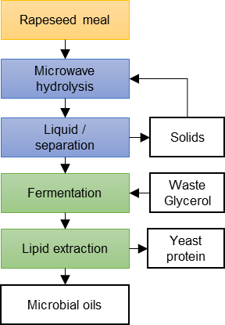
Figure 1. Schematic detailing the unit operations for the proposed rapeseed meal SCO process

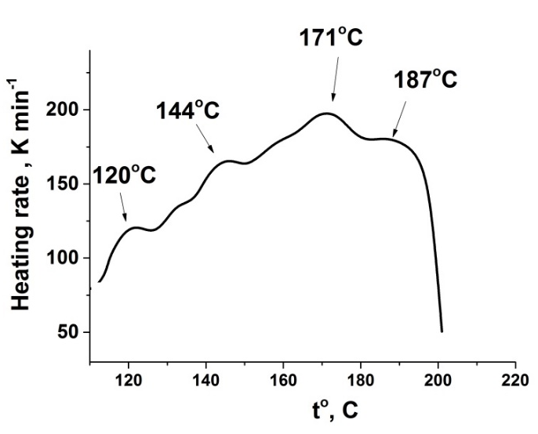
a)
b)
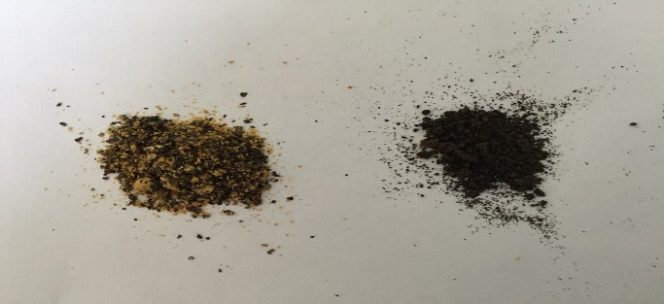
Figure 2. a) Heating rate profile of RSM under MW irradiation b) the RSM before and after MW treatment (sample to water ratio of 1:20, 190 ºC with no holding)

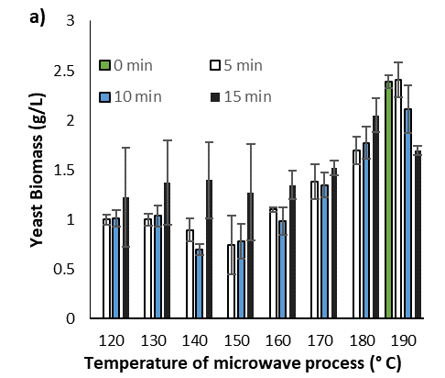
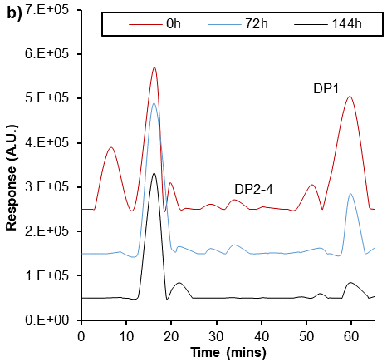
DP9+
Protein based macro-molecules
DP5
DP6-8
Figure 3 a) Final M. pulcherrima biomass cultured on the liquid fraction from depolymerised RSM in a microwave reactor with holding times between 0-15 minutes and temperatures between 120 °C – 190 °C; b) HPLC chromatograph of the depolymerised RSM (20 g/L, 190 °C, 0 hold) at 0, 72 and 144 h of fermentation (20°C, 180 rpm)

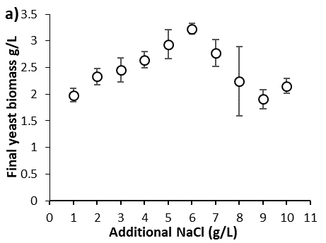
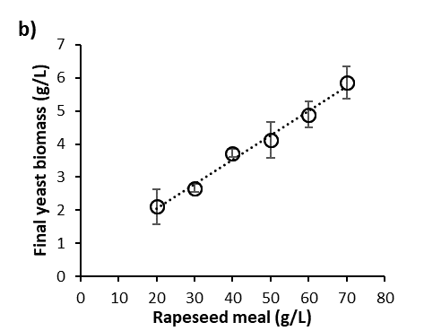
Figure 4 a) Final biomass of M. pulcherrima in RSM 20g/L depolymerized at 190°C with additional amounts of NaCl, grown at 20°C, 180 rpm, over 96h; b) Final biomass of M. pulcherrima in RSM depolymerized at 190°C, at concentrations between 20 and 70 g/L, over 96h. Standard deviation (n=3) is given as error bars

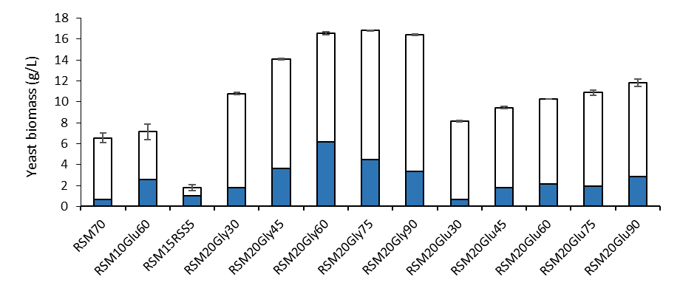Figure 5 The effect of supplementary glucose (Glu), glycerol (Gly) and rapeseed straw (RSS) to the RSM hydrolysate on the yeast biomass and lipid production using MW heating (190 °C with 0 hold time) over 12 days, numbers in the axis title indicate the concentration of initial feedstock source in g/L. Shaded area indicates the lipid content (% w/w dry cell). Standard deviation (n=3) is given as error bars

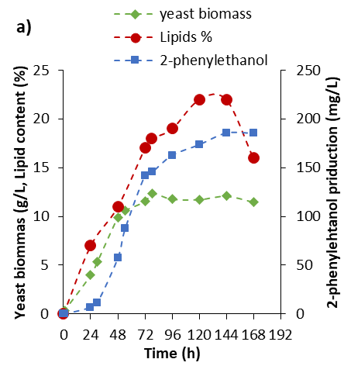
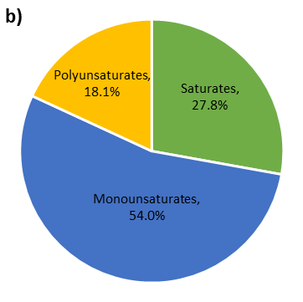
Figure 6: a) The growth, lipids (% w/w dry cell) and 2-phenylethanol production from M. pulcherrima in a controlled 30L bioreactor held at 25 °C, 300 rpm on crude glycerol (100 g / L) and microwave depolymerised RSM with an additional 2 g / L NaCl b) Fatty acid profile of the resulting lipid after 144 hours

Table 1 – Average composition of rapeseed meal, adapted from (13)
Main analysis | Average amount | Coefficient of variation
Dry matter | 89.78 | 0.61
Crude protein | 42.00 | 3.51
Ether extract | 1.50 | 20.88
Crude fibre | 14.37 | 9.03
Neutral Detergent Fiber | 39.36 | 12.41
Acid Detergent Fiber | 23.80 | 11.88
Ash | 8.46 | 9.31
Phosphorus (g/kg DM) | 0.92 | 12.05
Calcium (g/kg DM) | 0.88 | 6.33
Gross energy, kcal/kg | 4589 | 1.28
Total glucosinolates, μmol/g | 10.07 | 60.37

Table 2: Analysis of the RSM raw material and the hydrolysate after microwaving at 190 °C with 0 hold time
Element | RSM raw material | Hydrolysate (190 °C, 0 min hold)
Carbon % | 41.5 | 39.3
Hydrogen % | 6.3 | 4.4
Nitrogen % | 6.3 | 4.5
Rest % | 45.9 | 51.8
Ca (ppm) | 4316 | 3876
K (ppm) | 2626 | 5375
Mg (ppm) | 1726 | 2730
Na (ppm) | 96 | 773
P (ppm) | 10670 | 10479
HMF (mg/ml) |  | 0.055
Furfural (mg/ml) |  | 0.016

Table 3: FAME profile of cultures of M. pulcherrima grown in depolymerized rapeseed meal (20g/L) with additional glycerol (Gly) or glucose (Glu) (60g/L).
Compound | RSM 70 g/L | RSM 20g/L, Glu 60g/L | RSM 20g/L, Gly 60g/L
Total lipid (% cell dry weight) | 10.7% | 20.8% | 37.3%
C16:0 | 16.5 | 10.6 | 18.1
C16:1 | 2.5 | 4.7 | 5.0
C17:1 | 0 | 2.6 | 1.9
C18:0 | 4.0 | 1.0 | 2.9
C18:1 | 41.6 | 68.8 | 60.7
C18:2 | 29.8 | 11.3 | 10.4
C18:3 | 5.6 | 1.0 | 1.2
Saturates | 20.5 | 11.6 | 21.0
Monounsaturates | 44.1 | 76.0 | 67.5
Polyunsaturates | 35.4 | 12.4 | 11.6

