## Abstract

Effects of earthworms on soil physico-hydraulic properties, herbage production and wheat growth in long-term arable soils following conversion to ley were investigated. Seven intact soil monoliths were collected from each of four arable fields. One monolith per field served as a control. The other six were defaunated by deep-freezing; three were left defaunated (DeF) and three (DeF+E) were repopulated with earthworms to mimic pasture field density and diversity. The monoliths were planted with a grass-clover ley and inserted into pre-established ley strips in their original fields for 12 months. Hydraulic conductivity measurements at -0.5 cm tension (*K0.5*) were taken five times over the year. *K0.5* significantly increased in summer 2017 and spring 2018 and decreased in winter 2017-18. *K0.5* was significantly greater (47%) for DeF+E than DeF monoliths. By the end of the experiment, pores >1 mm diameter made a significantly greater contribution to water flow in DeF+E (98%) than DeF (95%) monoliths. After only a year of arable to ley conversion, soil bulk density significantly decreased (by 6%), and organic matter (OM) content increased (by 29%) in the DeF treatments relative to the arable soil. Earthworms improved soil quality further. Compared to DeF monoliths, DeF+E monoliths had significantly increased water-holding capacity (by 9%), plant-available water (by 21%), OM content (by 9%), grass-clover shoot dry biomass (by 58%), water-stable aggregates > 250 µm (by 15%) and total N (by 3.5%). In a wheat bioassay following the field experiment, significantly more biomass (20%) was produced on DeF+E than DeF monolith soil, likely due to the changed soil physico-hydraulic properties. Our results show that earthworms play a significant role in improvements to soil quality and functions brought about by arable to ley conversion, and that augmenting depleted earthworm populations can help the restoration of soil qualities adversely impacted by intensive agriculture.

**Keywords:** Soil fauna, hydraulic conductivity, soil water release curves, water-holding capacity, plant available water, wheat bioassay.

## Introduction

Soil degradation affects about 33% of land worldwide and is a major threat to future food security, increasing human vulnerability to extreme events resulting from climate change (FAO and ITPS, 2015). Estimates of the costs to the global economy of soil degradation range widely from US$231 billion per year (Nkonya et al., 2016) to US$10 trillion per year (The Economics of Land Degradation, 2015), which is equivalent to 160% of the global spend on healthcare (World Health Organisation, 2012). Soil degradation involves both loss of soil functions, such as depleted organic matter content which reduces carbon, water and nutrient storage, and loss of soil volume caused by erosion and compaction. The degradation of soil quality and quantity are interlinked, as reduced water-holding capacity and infiltration rates and poorer crop establishment leave soil more vulnerable to wind and water erosion (Durán Zuazo and Rodríguez Pleguezuelo, 2008; Turner et al., 2018; United Nations Convention to Combat Desertification, 2017). Intensive arable cultivation by growing annual crops on soils that are ploughed and harrowed each year is a major cause of soil degradation, yet as recently as 2016, 60% of arable land in England was cultivated in this way (Townsend et al., 2016). Arable farming accounts for 29% of the land use of England and Wales and is responsible for 31% of the total costs associated with soil degradation, in terms of the loss of capacity of soils to deliver ecosystem services (Graves et al., 2015). These costs have been estimated at US$1.4 - 1.9 billion per year without considering the cost of diffuse pollution, soil biota loss and sealing (Graves et al., 2015); the core contributions to these costs are estimated to be loss of soil organic matter (47%), compaction (39%) and erosion (12%).

Increasing awareness of the economic and environmental impacts of soil degradation, for example highlighted in the UK by a parliamentary inquiry into soil health (House of Commons, 2016), has led to policies around the world to protect soil, for example, the policy goal in the UKs 25 year Environment Plan (House of Commons, 2018) to sustainably manage all of England’s soils by 2030. Central to achieving this aspiration is the need to increase soil organic matter content, create a better soil structure, enhance the hydrological function of the soil (e.g. enhanced infiltration and water storage) and to protect the soil surface from erosion (Blanco-Canqui and Lal, 2008). This could be achieved in a number of ways, including through the use of arable-ley rotations and minimum- or no-till methods (van Capelle et al., 2012; van Eekeren et al., 2008). These are less damaging to earthworms (Edwards and Lofty, 1982) and mycorrhizal fungal symbionts of plant roots, that together assist in soil aggregate stabilization and soil carbon sequestration (Asmelash et al., 2016; Wilson et al., 2009; Zhang et al., 2013). While these management approaches favour the development of earthworm populations (Chan, 2001; van Capelle et al., 2012) it is unclear as to the extent to which the action of the earthworms, as distinct from other effects of these management methods, such as reduced soil disturbance, greater aggregation of soil by perennial plant roots and mycorrhizal fungal hyphae, and increased organic matter inputs, give rise to observed improvements in soil properties.

Earthworms increase soil organic matter content by incorporating organic material into soil (Fahey et al., 2013), enhance soil aggregation in which organic carbon is protected (Sharma et al., 2017), and generate macropores that increase soil water flow (Francis and Fraser, 1998), which in turn protects the soil surface against erosion (Jouquet et al., 2012). Adding earthworms to improve soil properties (Sinha, 2009; Sinha et al., 2010), especially in combination with land-management changes that are more favourable to them such as introduction of leys into arable rotations, has the potential to be economically affordable, environmentally sustainable and socially acceptable. Earthworms can process up to 250 tonnes ha-1 of soil each year (Birkas et al., 2010; Zaller et al., 2013) and reproduce rapidly under optimal soil conditions when sufficient food is provided (≈ 27-82 earthworms per year from a single adult earthworm) (Butt and Lowe, 2011; Johnston et al., 2014; Lowe and Butt, 2005), which could lead to rapid changes in soil properties. The effect of earthworms depends both on which earthworm species are present and the soil conditions (Clause et al., 2014; Hallam, 2018; Hedde et al., 2013). Typically, in field conditions, earthworms are present in mixed communities comprising several species, belonging to the three main ecological groups - epigeic, endogeic and anecic (Kooch and Jalilvand, 2008) - that interact with other soil biota and plant roots. Under laboratory conditions, individual earthworm species interactions with plant roots have resulted in significantly greater improvements in soil physico-hydraulic properties by endogeic compared to anecic earthworm species (Hallam, 2018).

This study forms part of the larger NERC Soil Security Programme SoilBioHedge project which tested the hypothesis that grass-clover leys sown into arable fields and connected to hedgerows and unploughed grassy margins enable key ecosystem-engineers (earthworms, mycorrhizal fungi) to recolonize fields, restoring and improving soil quality compared to leys unconnected to field margins. The aim of the experiment detailed here was to isolate the effects of earthworm communities on soil physico-hydraulic properties and plant growth from the effects due to the change in cultivation and vegetation when arable soils are converted to grass-clover leys. To achieve this aim we conducted experiments using intact soil monoliths (Allaire and Bochove, 2006) in arable fields. We set out to test the hypothesis that earthworm populations make a substantial contribution to improvements in soil properties and functions in addition to improvements resulting from converting arable land that has been intensively cultivated for many decades into grass-clover leys. These improvements are expected to include increased soil carbon sequestration, increased aggregate stability, and changes to hydrological functions such as increased infiltration rates and water storage (Blouin et al., 2013).

Using soil monoliths taken from arable fields, grass-clover leys were established, and earthworm populations manipulated (see Methods for details). We monitored soil hydraulic conductivity at five time points and plant shoot biomass twice over 12 months. At the end of the experiment, we measured soil water release curves, soil water-holding capacity, bulk density, percentage soil mass in water-stable aggregates > 250 µm, organic matter content, total nitrogen content, and earthworm diversity. Soil from each monolith was then used in a 6-week wheat growth bioassay. These studies enabled us to test the effects of earthworms on a set of key measures of soil quality and functions that deliver important ecosystem services such as carbon sequestration, water infiltration and storage, flood risk reduction and crop production.

## Materials and methods

### Site and experimental design

Seven intact monoliths were extracted from each of four arable fields (approximately 70 m from the field margin) in March 2017 at the University of Leeds Farm (northern England; 53° 52' 25.2'' N, 1° 19' 47.0" W; Figure 1). The fields had been cultivated and used to grow annual arable crops every year since they were last converted from ley in 1988 (Copse); 1994 (Big Substation East (BSE) and Big Substation West (BSW)), and 2009 (Hillside (HS)). The monoliths were extracted from the permanent arable area between a pair of ley strips (3 m wide and 70 m long, and 48 m apart), which extended into each of the fields from the hedges, having been sown in May 2015 as part of the NERC Soil Security Programme research project SoilBioHedge (Figure 1). The soil in each field was a Cambisol (WRB, 2006) and basic properties are summarized in Table 1.

The seven monoliths from each field were used to produce three treatments: i) unfrozen control, (*n* = 1 per field) ii) frozen (defaunated) monoliths not inoculated with earthworms, abbreviated to DeF (*n* = 3), iii) frozen monoliths inoculated with earthworms, abbreviated to DeF+E (*n* = 3). The monoliths were planted with a grass-clover ley (see below) and were returned to their fields of origin in late March 2017 towards the ends of the 2-year-old ley strips furthest from the field edge. The monolith experiment ran until mid-April 2018.

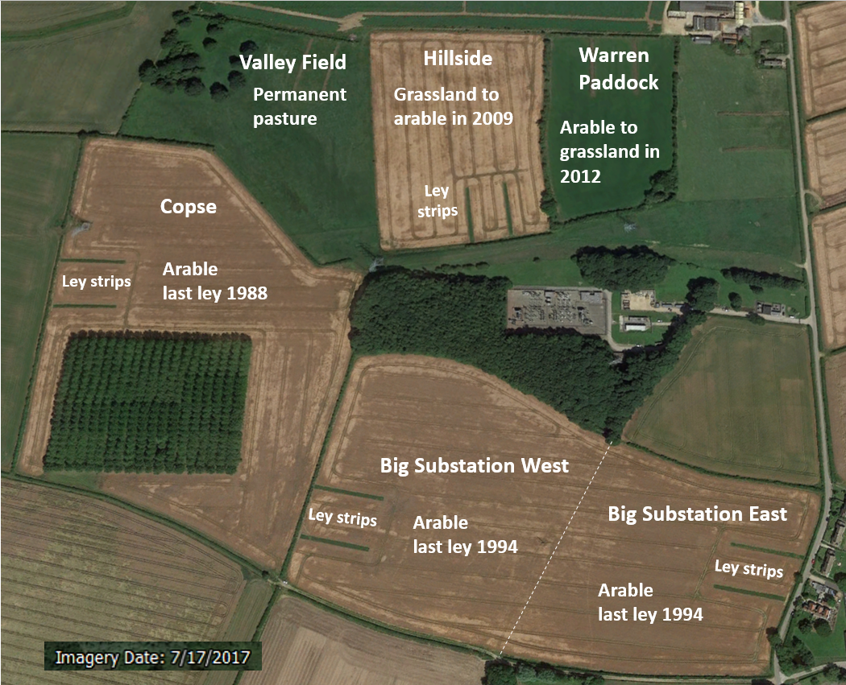

Figure 1. The location of the four arable fields, Big Substation East (BSE), Big Substation West (BSW), Copse and Hillside (HS) in which the experiment was carried out and the two pasture fields (Valley field and Warren Paddock) from which earthworms were collected to repopulate the monoliths. The paired green strips within each arable field are the 70 m long ley strips between which the monoliths were sampled from, and near the end of which the monoliths were installed following defaunation by freezing.

### Monolith preparation and grass-clover planting

Seven undisturbed monoliths (22 cm deep, 36 cm long x 27cm wide) were carefully extracted from the arable portion of each field following procedures similar to Allaire and Bochove (2006) and placed into plastic boxes. Each box had drainage holes of 10 mm diameter in the bottom and 8 mm diameter in the sides which were covered in nylon mesh on both the inside and outside (see Figure S1). A mesh size of 0.5 mm was used to try to prevent the entry and exit of earthworms or other soil macrofauna over the duration of the experiment. The control monolith (*n* = 1) from each field was immediately placed in an excavated hole in the ley strip of the field from which the monolith was taken.

To maintain soil structural integrity, we needed a non-invasive way of manipulating earthworm populations. Previous studies that have used mustard solution and electro-shocking were found to have an incomplete effect on earthworm extraction (Eisenhauer et al., 2008). Deep freezing (-20 °C) has been reported to be totally effective for eliminating earthworms and a range of other soil macro- and meso-fauna such as oribatid mites and collembola though it appears to have little effect on soil micro-fauna such as ciliates, nematodes, rotifers and tardigrades and soil microbiota (Barley, 1961; Bruckner et al., 1995; Kandeler et al., 1994). The remaining 24 monoliths were therefore defaunated by deep-freezing at -20 °C for three weeks. After defaunation, all 28 monoliths were planted with the grass-clover ley.

Because clover establishment is slow, established plants were collected from the 2-year ley strips in the fields (Figure 1); their roots were thoroughly washed to remove any earthworms and their cocoons. Six white clover plants with extensive lateral root systems, and 3 red clover plants with strong taproots, were carefully transplanted into each monolith. The monoliths were kept indoors for one day and then 2 g of hybrid and Italian ryegrass, using the same mixture of clover-grass seeds “Broadsword Hi Pro” (Oliver Seeds, Lincoln UK) as planted in the leys, were scattered on the surface of each monolith. The monoliths were kept indoors for another 24 hours and then, on the third day, watered to stimulate grass seed germination and moved outdoors. Blocks of soil were excavated from the ley strips of the fields from which the monoliths had been extracted and the monoliths placed in the holes so that they were level with the surrounding soil. Mesh fences of 15 cm height and supported by a bamboo frame were placed around the monoliths to prevent earthworms coming in and out over the surface.

### Earthworm collection and culturing

Three defaunated monoliths per replicate field were repopulated with earthworms. Although earthworm populations will not instantaneously return to pasture levels when arable soils are put into ley, our data from the main SoilBioHedge experiment (unpublished) indicate that earthworm populations within the ley strips reach levels equivalent to the nearby pasture within two years. Therefore, we repopulated the monoliths to give a population diversity and density based on that measured previously by ourselves in nearby pasture fields (Valley Field and Warren Paddock, Figure 1) on the same farm in December 2016 (Table 2). Earthworms were collected from pasture fields by excavating the soil to a depth of 20 cm and hand sorting. The earthworms were classified using the OPAL earthworm identification key (Jones and Lowe, 2009), rinsed with deionized water and placed in containers of soil from each field from which the monoliths had been extracted and maintained at 15 °C in darkness (Butt, 1991) to ensure that individuals were viable prior to the experiment. After 3 days acclimatization, the viable adult earthworms were rinsed again with deionized water, dried with tissue paper, weighed and put in containers ready for inoculation at the surface of the DeF+E monoliths. Earthworms were placed on the surface of the monoliths and watched until they had completely entered the soil to avoid losses to birds or other earthworm predators.

To ensure earthworm inoculation success and survival of the more vulnerable species during the experiment we followed the recommendations of (Butt, 2008) in repeating additions after the summer. Our main concern was earthworm survival during high summer temperatures (see Table S3) and low soil moisture conditions, as the depth of the boxes limits the depth to which earthworms can retreat from surface conditions. Earthworms were therefore added to the DeF+E monoliths twice, on 31st of March 2017 at the start of the experiment, and again on the 15th of November 2017, at approximately the same density and species composition (we were unable to collect sufficient *Allolobophora longa* in March 2017 and sufficient *Lumbricus castaneus* and *Aporrectodea rosea* for the November 2017 restock, Table 2, and Table S2 for further details). To reduce the abundance of earthworms, that despite the barriers had managed to recolonize the DeF monoliths, we applied up to 3 L of allyl isothiocyanate at 0.1g L-1 per monolith (Zaborski, 2003) in November 2017, when the soil moisture content was approaching field capacity and earthworms were very active, to expel any earthworms. We found 0 – 8 adults and 1 – 14 juveniles in each monolith, (see Table S4 for details).

### Measurements made during the experiment

* + 1. *Hydraulic conductivity (K)*

*K* was measured five times, once per season, over the duration of the experiment (spring 2017, 23-26th May; summer 2017, 21-25th August; autumn 2017, 3rd-10th November; winter 2017-18, 26th January to 2nd February; and spring 2018, 3rd-6th April 2018). The measurements were made using a Decagon Mini Disk Portable Tension Infiltrometer (Decagon Devices Inc, 2016) with an infiltrometer placed on a thin sand layer to ensure good contact between the tension disc and monolith surface (Köhne et al., 2011; Reynolds and Elrick, 1991). Measurements were made at potentials of -6, -3, -1 cm and -0.5 cm until steady-state flow was reached, corresponding to water flow through pores less than 0.5, 1, 3 and 6 mm in diameter respectively. To avoid hysteresis effects, *K* measurements were made in an ascending tension sequence (Baird, 1997). *K* for three dimensional infiltration was computed using the Van-Genuchten Zhang method (Zhang, 1997). The contribution of different pore size classes (< 0.5, 0.5-1, 1-3 and > 3 mm in diameter) to water flow for each set of measurements was calculated after Watson and Luxmoore (1986). In this study the hydraulic conductivity at a tension of -0.5 cm, close to zero, was assumed to be a good approximation for saturated hydraulic conductivity *Ks* (Yolcubal et al., 2004).

* + 1. *Grass-clover shoot biomass*

Grass-clover above ground biomass was measured halfway through the experiment (23rd September 2017) and just before the end of the experiment (16th April 2018). At each sampling point all plant shoots were cut at the soil surface. The fresh shoot biomass was weighed and then oven dried at 70 °C to constant weight.

### Measurements made after monolith removal

At the end of the experiment all of the monoliths were removed and weighed. Earthworms were first extracted using up to 3 L of non-toxic allyl isothiocyanate at 0.1 g L-1 per monolith, (Zaborski, 2003). Emerging earthworms were collected for approximately 20 minutes after application. Soil core samples were then collected from the monoliths for the measurement of soil water release curves, soil water-holding capacity, bulk density, percentage soil mass in water-stable aggregates, organic matter content and total nitrogen content. These values are all reported on an oven-dried weight basis.

After the soil core samples had been removed, any remaining earthworms in the monoliths were recovered by hand-sorting. Stones > 1 cm diameter were removed, and subsamples of this sorted soil were collected for the wheat bioassay. In the laboratory, the recovered earthworms were rinsed with deionized water, dried with tissue paper, identified using the Opal identification key if clitellate (adult) (Jones and Lowe, 2009) and weighed. Juveniles were classed as either *A. chlorotica* or *A. caliginosa* based on the Opal identification key (other than the lack of a saddle), anecic (if > 1 g in mass and > 2 cm in length), epigeic (if < 1 g in mass and 1 – 2 cm in length) or “unknown”.

* + 1. *Soil water release curves and water holding capacity (WHC)*

Intact soil cores 8 cm diameter x 5 cm high were taken from the surface of the monoliths. The cores were analyzed for water retention at different potentials following the simplified evaporation method (Peters et al., 2015; Schindler et al., 2010) using a HYPROP device (UMS, Munchen, Germany). The measured hydraulic conductivities using the minidisk infiltrometer and the HYPROP measurement campaigns were modeled using the HYPROP-FIT software. The hydraulic function parameters were generated using the bimodal Van Genuchten (1980) model (Durner, 1994). Soil water content at saturation, at field capacity and at wilting point, and plant-available water were calculated from the generated curves.

The WHC was determined on 0-5 cm depth x 3.5 cm diameter intact soil cores that were saturated in the laboratory for 48 hours. The cores were then allowed to drain freely, until water was no longer draining out, at which point the cores were weighed and oven dried at 105 °C to a constant weight to establish the water content (ISO 11268-2:1998).

* + 1. *Bulk density (BD) and percentage water stable aggregates (%WSA)*

BD was determined in the monoliths at 0-5, 5-10 and 10-15 cm depth using a bulk density corer with rings of 100 cm3 (Eijkelkamp, Agrisearch Equipment). BD measurements were corrected for the mass and volume of stones >2 mm, were averaged across the three depths for each monolith and are expressed on an oven dried weight basis.

Four grams of air dried soil that had been sieved through a 2 mm sieve and retained on a 1 mm sieve were placed on 250 µm sieves, pre-moistened and wet-sieved for 3 minutes in deionized water at a rate of 34 times per minute using wet sieving equipment (Eijkelkamp, Agrisearch Equipment). The %WSA was determined as the weight of the stable aggregates remaining on the sieve relative to the total weight of aggregates adjusting for the mass of primary sand particles > 250 µm present in the samples (Kodešová et al., 2009; Milleret et al., 2009).

* + 1. *Percentage organic matter (%OM) and total nitrogen (%N) contents*

Organic matter was determined by loss on ignition; as the soil contained carbonates an ignition temperature of 350 °C was used to avoid their decomposition (Ayub and Boyd, 1994; CEAE, 2003). Total N was measured using a Vario MACRO C/N Analyser (Elementar Analysis System, Germany). The soil samples were first dried at 105 ºC, sieved to < 2 mm then homogenized to a fine powder with a laboratory ball mill (Retsch, Germany). The samples were then weighed into a tin-foil cups and sealed for dry combustion.

* + 1. *Wheat bioassay experiment*

Moist homogenized soil from each monolith equivalent to an oven dry mass of 200 g was added to plastic pots of approximately 7 cm diameter and 13 cm height and stored at 15 °C for four days until planted with pre-germinated winter wheat seedlings (*Triticum aestivum*, Skyfall variety). Winter wheat seeds were germinated on moist filter paper in Petri dishes kept at room temperature in natural light. Three days after germination, seedlings with approximately 2 cm long radicles were transplanted into the pots and allowed to grow for five days under natural light. The pots were then placed under 50 W LED lights (Massa et al., 2008; Schroer and Hölker, 2016) operating on a 12-hour photoperiod in a controlled temperature room set at 15 °C. Photosynthetically Active Radiation (PAR) measured at the surface of pots was up to 580 µmoles m-2 s-1. The plants were watered three times a week with distilled water. After 6 weeks, shoots and roots were harvested with roots washed free of soil, weighed and oven dried at 70 °C to a constant weight.

### Statistical analysis

Data from monoliths were analyzed using a general linear model analysis of variance (ANOVA). Three-way mixed ANOVA with two main factors (treatment and field) and one repeated factor (seasonal measurements) was used to analyze *K* at different tensions. Ordinary two-way ANOVA was used to analyze data of the other measured parameters at the end of the experiment with treatment and field name as factors. Ideally, we would have had four unfrozen control monoliths per field. However, due to logistic limitations, we only had one unfrozen control monolith per field. Consequently, an ANOVA analysis including control treatments was performed to look at the main effects of treatments (4 control vs 12 DeF vs 12 FeF+E monoliths) and fields (7 monoliths per field) or seasons (all 28 monoliths per season) but not at their interactions, since the design is an unbalanced ANOVA. The unbalanced design resulted in uneven variances for some parameters, we therefore repeated our ANOVA analysis excluding control monoliths; the statistically significant trends were the same. Therefore, here we report the results of the ANOVA analysis including control treatments. However, the ANOVA analysis excluding the controls was used to investigate interactions between the main factors in the DeF+E and DeF monoliths.

As part of the regular management of the fields where the monoliths were located, a selective herbicide (ASTROKerb®, MAPP 16184, Dow AgroSciences, Cambridge UK) was applied in late November 2017. The herbicide spray drifted onto the edges of the ley strips in HS field, killing the grass in one replicate of the DeF+E (Replicate 3) and DeF (Replicate 3) treatments; this appears to have had a negative effect on the earthworm populations (see Table S5). For this reason, the infiltration measurements in January and April 2018, in addition to the collected data at the end of the experiment for these two monoliths, were excluded from the statistical analysis. SPSS (IBM Corp. Released 2016, version 24) was used to estimate the statistical significance of mean differences between treatments. *P* values of < 0.05 were used as the threshold for significance.

## Results

### Recovered earthworms

Figure 2a shows the mean number of each earthworm species recovered from all the treatments and across all the fields in April 2018 and Figure 2b the mean weights of these earthworms. Detailed data for each replicate mesocosm are given in Table S5 and Figure S2. In the DeF+E treatment the number of adults recovered at the end of the experiment (26.42 ± 1.47; *n* = 11) was significantly greater than the numbers added either in April 2017 (23 per monolith, *p* = 0.025) or November 2017 (20 per monolith, *p* = 0.01) though the mass of adults was not significantly different. Juveniles were also present in the monoliths at the end of the experiment. Importantly, for testing our hypotheses, at the end of the experiment, the DeF+E monoliths showed significantly higher total earthworm numbers and weights than the DeF treatments (*p* < 0.001) (Figure 2a, b). Total earthworm numbers and weights of the control treatment were significantly higher (*p* = 0.013 and *p* = 0.001 respectively) than in the DeF treatment but not significantly different from the DeF+E treatment, although the mass of juveniles in the control treatment appeared to be more than double that in the other two treatments. At the end of the experiment no significant differences were observed between fields for recovered earthworm numbers, but BSE contained a lower total weight of earthworms than BSW field (*p* =0.049). There were no significant interactions between fields and treatments. The earthworm population in DeF+E treatments was dominated by endogeic individuals (*p* < 0.001 when compared to numbers of individuals of other earthworm types) while epigeics were the dominant earthworm type in the DeF treatments at the end of the experiment (*p* = 0.02, *p* = 0.003 and *p* = 0.008 when compared to numbers of anecic, endogeic and unknown individuals respectively).

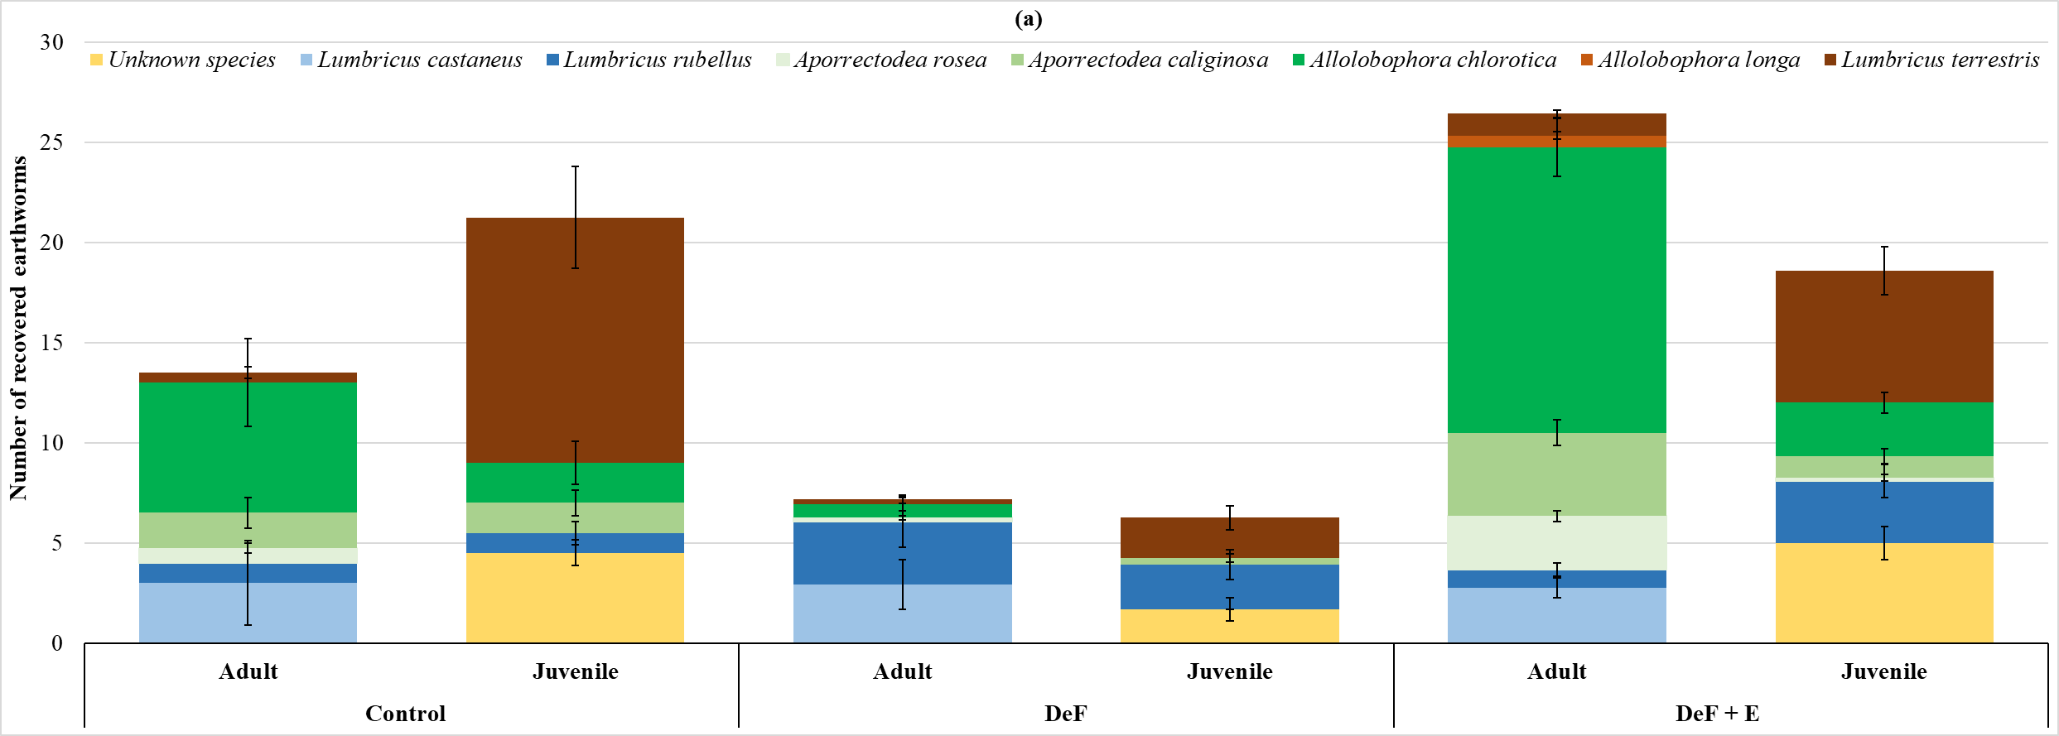

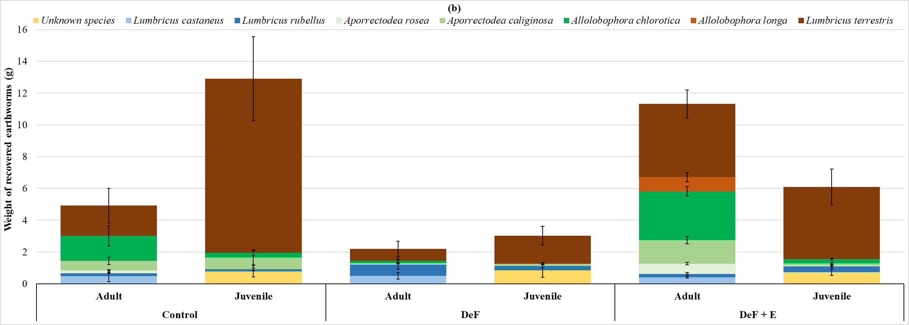

Figure 2. Mean of the recovered earthworm (a) numbers per monolith and (b) weight (g) per monolith for adults and juveniles across all fields. The figures represent the three treatments; Control = unfrozen monoliths (*n* = 4); DeF = frozen monoliths without earthworm addition (*n* = 11), DeF+E = frozen monoliths with earthworm addition (*n* = 11); error bars = standard error. The chart stack colour and its shades represent the ecological group of earthworm; Brown : anecic, green : endogeic and blue : epigeic species. *L. terretris* and *L. rebellus* species for juveniles represent anecic and epigiec ecological group respectively, and not species, for the purpose of this graph only. Recovered earthworm numbers and weight for each treatment on a field by field basis is presented in Figure S2.

### Seasonal differences in hydraulic conductivity (K)

Figure 3 presents the seasonal variation in *K* at -0.5 cm tension (*K0.*5) for all treatments and across all the fields (for *K* data at different tensions and details of each field see Figure S3). A three-way mixed ANOVA with season, treatment and fields as factors indicated that *K0.5* increased from spring to summer 2017 (*p* < 0.001), that there were no significant differences between summer and autumn 2017, that there was a significant decrease from autumn 2017 to winter 2017-18 (*p* = 0.003), when the values were similar to those in spring 2017, and that subsequently values increased significantly in spring 2018 (*p* < 0.001) to attain values similar to those in summer and autumn 2017. Across treatments *K0.5* was significantly greater in DeF+E relative to DeF (47%) and control (64%) treatments (*p* < 0.001). There was no significant difference between DeF and control treatments. Only seasons and treatments showed a significant interaction (*p* = 0.023), with *K0.5* significantly greater in DeF+E compared to DeF treatments only in winter 2017-18 and spring 2018 (*p* < 0.001). Across fields *K0.5* was higher in HS field compared to BSE (*p* = 0.006) and BSW (*p* < 0.001) fields and also higher in Copse compared to BSW (*p* = 0.006).

Apart from a significantly lower *K* at -1 cm tension (*K1*) in winter 2017-18 compared to summer 2017 (*p* = 0.05), autumn 2017 (*p* = 0.022) and spring 2018 (*p* = 0.019), no significant differences were observed in *K1* between seasons. Across all seasons *K1* was not significantly different between fields (*p* = 0.06) and was greater in DeF+E compared to DeF and control treatments (*p* = 0.05). There was no significant difference between DeF and control treatments and no significant interaction effect between main factors.

At a tension of – 3 cm, *K3* was significantly different between seasons and fields (*p* < 0.001) but not significantly different between treatments. *K3* increased from spring to summer 2017 (*p* = 0.001) and from winter to spring 2018 (*p* = 0.05) but decreased from summer to autumn 2017 (*p* < 0.001) and from autumn 2017 to winter 2017-18 (*p* = 0.01). *K3* was significantly lower in BSE compared to the other fields and higher in HS compared to Copse (*p* = 0.002) and BSE fields (*p* < 0.001). There was no significant interaction between fields and treatments. Interactions between seasons and treatments or fields are reported in the Supporting information section.

*K6* was not significantly different between treatments. No differences in *K6* were observed between BSE and Copse or between BSW and HS fields through all the seasons. The highest values were reported for BSW and HS fields compared to BSE and Copse fields (*p* < 0.001). All the fields showed a significant decrease in *K6* from summer to autumn 2017 (*p* = 0.037, *p* < 0.001, *p* = 0.002, *p* < 0.001 for BSE, BSW, Copse and HS fields respectively) with no significant differences between the other seasons.

The relative flow of water through different pore sizes varied between treatments through the experiment period, but there were no significant differences, so the data are not reported in the main text of this paper (see Figure S4). However, at the end of the experiment (Figure 4) the proportion of water flow through pores wider than 1 mm was significantly greater in the DeF+E treatments (98%) compared to the DeF treatments (95%) (*p* = 0.045). Flow through pores wider than 1 mm in the control treatment was not significantly different from the other two treatments and had a value that lay between them (97%). However, flow through pores 1 – 3 mm was significantly greater in the DeF+E and DeF treatments and through pores > 3mm was significantly greater in the controls. No significant differences were observed between fields at the end of the experiment for these hydrological properties.

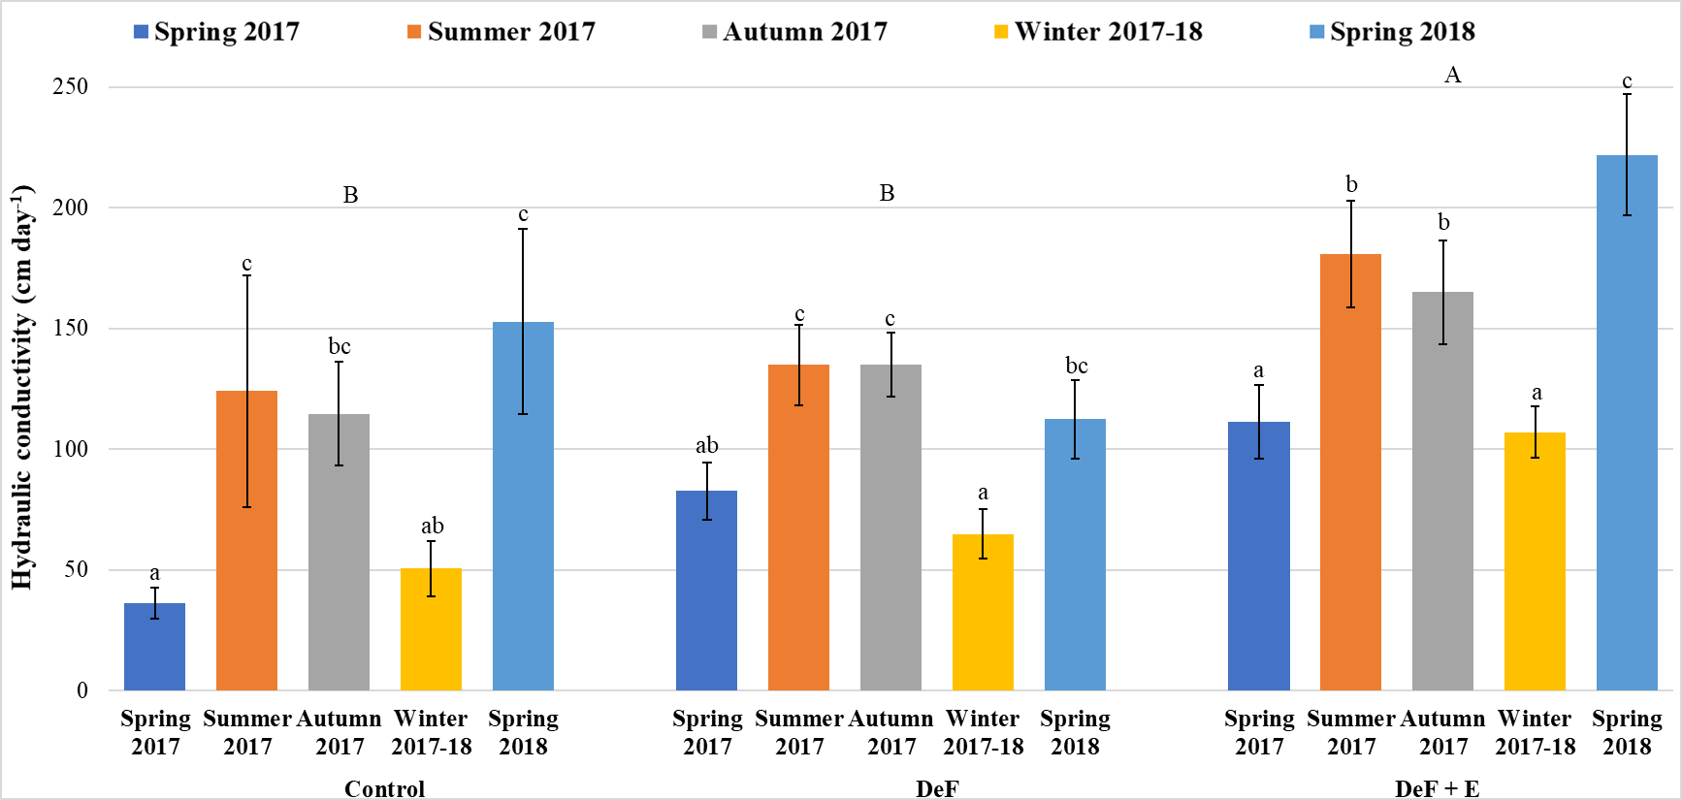

Figure 3. Mean hydraulic conductivity at -0.5 cm tension across seasons and all the fields (*n* = 4) at field temperature. Control = unfrozen monoliths (n = 4); DeF = frozen monoliths without earthworm addition (*n* = 11), DeF+E = frozen monoliths with earthworm addition (*n* = 11); error bars = standard error. Columns with the same letter over them are not significantly different (p > 0.05, Bonferroni test); lower-case show differences between seasons within each treatment and upper-case show differences between treatments. Hydraulic conductivity data at different tensions across seasons for each treatment and on a field by field basis are presented in Figure S3.

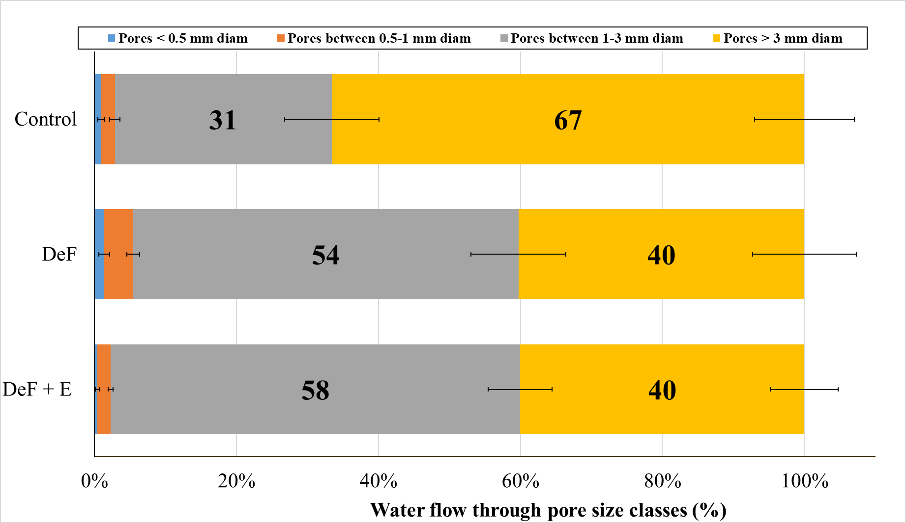

Figure 4. Mean pore size class contribution to water flow at the end of the experiment across all the fields. Control unfrozen monoliths (*n* = 4); DeF = frozen monoliths without earthworm addition (*n* = 11), DeF+E = frozen monoliths with earthworm addition (*n* = 11), error bars = standard error. Pore size class contribution to water flow across seasons for each treatment on a field by field basis is presented in Figure S4.

### Soil water release curves (SWRC) and water-holding capacity (WHC)

The SWRC data from the individual cores from each monolith were combined to produce a single SWRC for the DeF and DeF+E treatments from each field and fitted using Hyprop-Fit models. SWRC for the controls were from single cores (Figure 5, Figure S5). The generated SWRC were used to derive the soil water content at saturation (WCS) and at field capacity (FC) (at 33KPa; Kirkham (2005)), and also the plant available water (PAW) (Table 3). All these values were significantly greater in the DeF+E treatments relative to DeF (by 11%, 24% and 21% for WCS (*p* = 0.001), FC (*p* < 0.001) and PAW (*p* < 0.001) respectively) and relative to the unfrozen controls (by 9%, 16% and 19% for WCS (*p* = 0.027), FC (*p* = 0.006) and PAW (*p* = 0.011) respectively). No significant differences were observed between DeF and control treatments. The three parameters showed significant differences between fields (*p* = 0.021, *p* = 0.001, *p* = 0.05 for WCS, FC and PAW respectively). HS field had the highest values, but these were only significantly greater than those for Copse field. There was no significant interaction between treatments and fields.

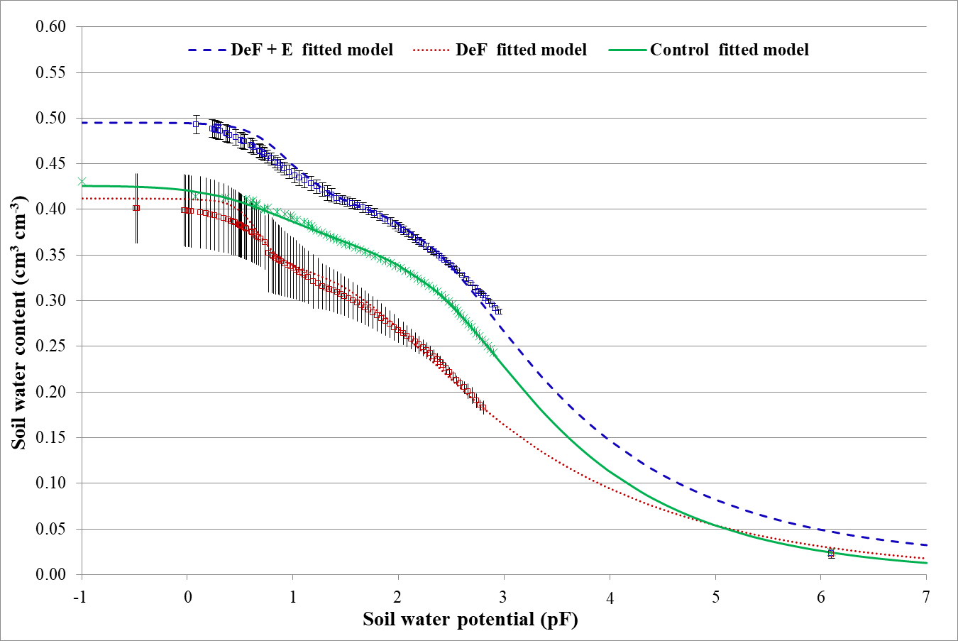

Figure 5. Soil water release curves (SWRC) of Copse field fitted to the measured data using the bimodal constrained Van Genuchten (1980) model (Durner, 1994). The curves represent the control, DeF = frozen monoliths without earthworm addition and DeF+E = frozen monoliths with earthworm addition; Three replicates were combined each for the DeF and DeF+E treatments and fitted using Hyprop-Fit models (error bars = Standard deviation). Only one replicate was fitted for the Control. SWRC for BSE, BSW and HS fields are presented in Figure S5.

WHC varied significantly between treatments (*p* = 0.011; Table 4). The WHC of the DeF+E monoliths was nearly 9% greater than the DeF monoliths (*p* = 0.05). There was no significant difference between controls and the other treatments. WHC was significantly higher in HS compared to BSE (*p* < 0.001) and BSW (*p* = 0.007) fields and significantly lower in BSE compared to Copse (*p* = 0.002) and HS fields (*p* < 0.001). There was no significant interaction between treatments and fields.

### Soil bulk density (BD)

BD significantly decreased by 6% in the DeF and DeF+E treatments at the end of the experiment compared to the initial soil conditions (*p* = 0.01), suggesting that the growth of the ley for one year increased soil pore space, but there was no effect of adding earthworms. There was no significant difference in BD between the DeF+E and DeF treatments and the control monoliths at the end of the experiment (*p* > 0.05) (Table 4). BD was significantly higher in BSE field compared to the other fields (*p* = 0.005, *p* = 0.011, *p* = 0.05 for BSW, Copse and HS fields respectively). There was no significant interaction between treatments and fields on BD.

### Percentage water stable aggregates (%WSA)

%WSA (> 250 μm) in the DeF+E monoliths was significantly greater than that in the DeF monoliths (70 ± 3% vs 60 ± 3%, *p* = 0.014). %WSA of the control treatments was between the DeF+E and the DeF treatments with no significant differences (Table 4). %WSA also varied significantly with field (*p* = 0.003); %WSA was highest in the HS field. There was no significant interaction between treatments and fields.

### Percentage organic matter (%OM)

Comparison of the DeF treatments at the end of the experiment (Table 4) with the initial soil conditions (Table 1) indicate that the conversion of arable soil to ley led to a significantly greater %OM in the DeF monoliths in just one year (3.66 ± 0.23% vs 4.72 ± 0.15%, *p* < 0.001). In addition, %OM in DeF+E was significantly greater than that in the DeF monoliths (5.12 ± 0.19% vs 4.72 ± 015%, *p* < 0.001). The %OM of the control treatments was between the DeF+E and the DeF treatments with no significant differences. The %OM was highest in HS field and lowest in BSW field (*p* < 0.0001). For %OM there was no significant interaction between treatments and fields.

### Total nitrogen content (%N)

The addition of the earthworms to the defaunated monoliths resulted in a significant greater %N compared to the DeF treatment (0.31 ± 0.01% vs 0.30 ± 0.01%, *p* < 0.027). %N in the control treatments was between the DeF+E and the DeF treatments with no significant differences (Table 4). %N was significantly lower in the HS field compared to the other fields (*p* < 0.001).

### Plant dry biomass

* + 1. *Grass and clover shoot dry biomass of the monoliths*

No significant differences between treatments were observed at the midpoint of the experiment, due to relatively high variance between treatments, but the DeF+E monoliths did produce 34% more shoot biomass than the DeF monoliths. At the end of the experiment, this trend was much stronger with 58% more biomass produced in the DeF+E monoliths compared to the DeF monoliths and had become significant (*p* = 0.004). Plant shoot biomass in the control treatment had an intermediate value and was not significantly different from the DeF+E and DeF treatments. More biomass was collected in September 2017 than in April 2018 (Table 4). Over both periods, the BSE and HS field produced the least dry shoot biomass (*p* = 0.001 and *p* = 0.005 in September 2017 and April 2018 respectively). At the end of the experiment only grass was present in HS field monoliths. The low shoot dry biomass in the BSE field and HS field in September 2017 (Table 4) was likely due to voles grazing the grass-clover; plant stems at the soil surface of the monoliths showed evidence of grazing, vole galleries were present around the monoliths and the mesh fences had been pierced at surface level. This impacted the weight of the collected plant material in those fields in spring 2018. Voles have a preference for clover over grass (DeJaco and Batzli (2013), perhaps explaining why only grass was collected in the HS soil at the end of the experiment (see Figure S6 and Figure S7 for details).

* + 1. *Wheat bioassay experiment*

Wheat grown in the soil from the DeF+E treatments achieved significantly greater biomass compared to the DeF (20% increase) and control treatments (30% increase) (Table 4, *p* = 0.006 for both DeF and control). This was due to an increase in root biomass in DeF+E compared to DeF and control treatments (*p* < 0.001); shoot biomasses were not different (*p* > 0.05). Root and total dry biomass varied significantly between fields (*p* < 0.001) with the highest values recorded for Copse field and the lowest for BSE field. Shoot biomass was not significantly different between fields. There was no significant interaction between treatments and fields.

## Discussion

This study examined the effects of earthworm communities on soil physico-hydraulic and chemical properties and plant growth in arable soil on conversion to grass-clover leys under realistic conditions. Here we focus on differences between treatments. Where relevant, differences between fields are discussed in the Supplementary Information where field specific data are presented.

### Earthworm populations

The earthworm diversity that we introduced into the DeF+E treatments was maintained for the duration of the experiment. Endogeics dominated the earthworm populations in the DeF+E treatments at the end of the experiment as typically found in pasture fields of the farm (Figure 2; Holden et al.(2019)). Although a greater number of adult earthworm numbers were recovered at the end of the experiment (26.42 per Def+E monolith) than were added to the monoliths in April (23 per monolith) or November (20 per monolith) the numbers were similar, indicating that the second set of additions was necessary. The greater number of adult earthworms can be attributed either to survival of some of the original additions or entry of earthworms into the monoliths over the course of the experiment. The juveniles recovered from the DeF+E treatments represent either entrant earthworms, the hatching of cocoons that survived the defaunation (for example the cocoons of the epigeic *L. rubellus* and *L. castaneus*, two dominant epigeic species found in the monoliths, have been reported to tolerate temperatures as low as -35 °C and -50 °C respectively; (Meshcheryakova and Berman, 2014), or the offspring of some of the added earthworms.

Small numbers of earthworms were recovered from the DeF treatments despite the use of mesh on the outside and inside of the plastic containers that contained the monoliths and the use of mesh fences around the monoliths and must represent either hatched cocoons (see above) or entrant earthworms. The earthworms were dominated by epigeics but with some anecic juveniles also present (Tables S4 S5). Epigeics are reported as having high dispersion rates relative to anecic and endogeic earthworms which results in more rapid colonization of new habitats (Bouché, 1977; Chatelain and Mathieu, 2017; Margerie et al., 2001; Migge-Kleian et al., 2006).

### Soil water flow

* + 1. *Earthworm effects on water flow*

The significant increase in *K0.5* in the DeF+E compared to the DeF and control treatments (Figure 3) is consistent with previous studies reporting a positive effect of earthworms on water flow (Blouin et al., 2013; Bouché and AlAddan, 1997; Edwards and Bohlen, 1996; Francis and Fraser, 1998; Lamandé et al., 2003). The impact of earthworms was significant in winter 2017-18 and spring 2018 after the second addition of earthworms to the DeF+E monoliths in mid-November 2017. The lack of significant differences between treatments in spring 2017, less than 2 months after the first addition of earthworms, is probably due to earthworms having had insufficient time to work the soil. Qualitative observations made whilst measuring *K* indicate that although earthworm casts were found on the surface of the DeF+E monoliths in summer and autumn 2017 these were at a relatively low density compared to spring 2018. Earthworm activity typically reduces in the summer months (Birkas et al., 2010) and the higher than average temperatures during the summer of 2017 may have reduced earthworm populations in the DeF+E monoliths further, which may explain the non-significant differences between the DeF+E and DeF treatments.

In spring 2018, DeF+E treatments showed significantly higher *K0.5* compared to the other seasons. In this period, pores > 1 mm contributed more significantly to water flow in the DeF+E than the DeF treatments (Figure 4). These pores will have been created by earthworms or produced as a result of improved soil structure through aggregation (Table 4). Earthworms facilitate soil aggregation and the incorporation of organic matter within the soil aggregates, which may explain the high %OM content in the DeF+E treatments at the end of the experiment (Fonte et al., 2007).

The mean values of *K0.5* across all seasons were 39 ± 28, 44 ± 22 and 66 ± 32 mm h-1 for the Control, DeF and DeF+E, treatments respectively. Heavy rainstorms in the UK rarely exceed 200 mm day-1, with the greatest rainfall in 2015 being recorded as 341.1 mm day-1 (Friederike et al., 2018), though with the rainfall being concentrated in a shorter time period than 24 hours. The experimental results suggest that the presence of earthworms in the soil will largely reduce infiltration-excess overland flow and flooding which would help to alleviate negative effects of such events. Differences between fields as opposed to treatments are discussed in the text accompanying Figure S3.

* + 1. *Water flow changes between the seasons*

*K* is a dynamic property influenced by, amongst other things, climate, management practices and biological activity (Amer et al., 2014; Elhakeem et al., 2018). As in previous studies (Alletto and Coquet, 2009; Deb and Shukla, 2012; Strudley et al., 2008), *K* measured at different tensions varied significantly across the seasons. In this study we largely used measures of *K1*, *K3* and *K6* to determine the proportion of water flow through different pore sizes, therefore in this section we focus on *K0.*5 as this is close to hydraulic conductivity at saturation and allows comparison with other studies.

Our initial hypotheses were that *K* would increase with earthworm activity and in line with the seasonal activity of earthworms. By the end of our experiment our data supported our first hypothesis, but it failed to fully support the second part of our hypothesis. *K0.5* increased significantly in summer 2017 when soils were dry and earthworm activity would be expected to decrease compared to spring 2017 (Spurgeon and Hopkin, 1999) and was unchanged during autumn 2017 when typically earthworms that aestivated over the summer start working the soil again as conditions become more moist and grass and clover litter accumulates on the soil surface (Dar et al., 2006; Michiels et al., 2001). *K0.5* then decreased considerably in winter 2017-18 (January 2018) when soils are wet, facilitating earthworm movement and the hatching activity of some species starts to increase (Potvin and Lilleskov, 2017; Spurgeon and Hopkin, 1999).

The high monthly precipitation and temperatures during the summer of 2017 compared to the other seasons (see Table S3) would have induced multiple soil wetting-drying cycles, perhaps resulting in shrink-swell processes increasing aggregation and improving soil structure (Tang et al., 2016). Soil mineralogy data are not available for the soils, so we are not able to say whether the clays present were those which demonstrate shrink-swell behaviours. However, the study site is underlain by limestone and the soils are from the Aberford series of Calcaric Endoleptic Cambisols (Cranfield University, 2019), which are characterized by calcareous clay enrichment, and therefore may be only slightly prone to shrink-swell behavior when compared to non-calcareous equivalents (Avery and Bullock, 1977). Although high rainfall can lead to the disintegration of aggregates and the consequent blocking of pores resulting in reduced *K* for coarse textured soils with an organic matter content of less than 1% (Hu et al., 2012, 2009), in fine textured soils the formation of small cracks can lead to an increase in *K* of several order of magnitude (Albrecht and Benson, 2001). These contrasting effects are dependent on soil texture and organic matter content and, in the case of the soils used in this experiment, the formation of small cracks rather than the breakdown of soil aggregates may have dominated and resulted in the increased *K0.5* in summer 2017. In addition, grass and clover reached maximum growth (see Figure S9) in summer 2017 (with abundant rainfall and suitable temperatures for plant growth in summer) and the cracks and pores associated with well-developed root systems (Angers and Caron, 1998) may have also increased *K0.5*.

We expected an increase in earthworm activity and *K* from summer (21 – 25th August sampling) to autumn 2017 (3 – 10th November sampling) (Hu et al., 2012, 2009) but did not detect a significant change in *K0.5*. There are two possible factors that can explain this:

1. The numbers of earthworms recovered at the end of the experiment (Figure 2) suggests that earthworms in the DeF+E treatment died over the summer, reducing the populations in the monoliths and therefore earthworm impacts on *K*. We restocked the monoliths with earthworms on 15th November just after measuring *K*.
2. The shoot harvest taken in late September 2017 likely reduced the food supply for any earthworms that had survived over the summer, particularly for vertical burrowing anecics that produce water transmitting vertical pores which may have reduced their activity. Further the harvesting of shoots may have resulted in grass and clover switching from root development that can aid pore formation, to shoot development.

By winter 2017-18 (26 January – 2nd February), although *K* was significantly higher in the DeF+E treatment relative to the DeF treatment indicating a positive impact of earthworms, *K* had reduced significantly relative to the autumn period. This was counter to our expectation; we expected earthworm activity to have increased due to cocoons continuing to hatch, autumn hatchlings growing in size and the increase in rainfall leading to moister soils. However, relative to autumn 2017, the low air temperatures in winter 2017-18 (down to -5.9 °C) may have reduced earthworm activity at the surface. Additionally, the heavier rainfall in the winter period (see Table S3), combined with the reduced plant cover may have led to some surface soil disaggregation and blocking of soil pores. Although the average air temperature during the infiltration measurement campaign was 3 °C, on the mornings of the measurements there was often a thin sheet of ice on the soil surface so it seems likely that at least near-surface pores could also have been blocked by ice which would reduce measures of *K*. In addition the viscosity of water decreases with decreasing temperature (e.g. by a factor of 1.6 between temperatures of 3 °C (Figure 3) and 20 °C (see Figure S3e)) (Aleksandrov and Trakhtengerts, 1974; Haridasan and Jensen, 1972) which would reduce rates of flow and calculated values of *K*. However, although correcting *K* values to 20 °C increases the calculated *K 0.5* values for winter 2017-18 (see Figure S3e) they still remain lower than the other seasons with the change in water viscosity only accounting for 6 % of the decrease in *K* from autumn 2017 to winter 2017-18. Finally, low temperatures and solar radiation in winter reduce water evaporation after frequent rainfall and the increased water content may have led to increasing periods of water saturation and expansion of clays in the soil (Hesseltine, 2016) which can lead to a reduction in pore size and thus a decrease of *K* (Dexter, 1988; Jabro, 1996; Messing and Jarvis, 1990).

In some soils *K* can decrease in spring after winter freeze-thaw cycles due to reconsolidation causing an increase in soil density (Hu et al., 2012, 2009). However, in our experiments *K0.5*increased significantly in spring 2018 (3rd – 6th April) relative to winter 2017-18. Earthworm activity and plant growth during the spring may contribute to an increase in connected soil pores that can conduct more water. At a coarser scale of observation than the hydraulic conductivity measurements we recorded, a decrease in the bulk density and an increase in the %OM content of the soils between the start and end of the experiment, would improve soil structure and also be expected to increase the amount of water movement within the soil (Hillel, 2008).

### Soil water release curves and water holding capacity

Soil water release curves for the DeF+E treatments shifted to the right relative to the DeF and control treatments resulting in increased predicted water contents at saturation, field capacity and at wilting point for all the fields (Table 3, Figure 5, Figure S5). The DeF+E treatments also had higher water holding capacities (Table 4) and plant available water. This is consistent with an improved soil structure (Huntington, 2006). Earthworms impact soil structure directly by creating pores of different sizes, branching and sinuosity which impact on soil water storage capacity (Bastardie et al., 2005). According to the capillary rise equation, pore radius is proportional to the potential value at which that pore drains (Hillel, 1980). Therefore, at very low potential, water drains through both rapidly and slowly draining pores (Amer, 2012) such as those created by adult earthworms (2 – 9 mm diameter (Pérès et al., 1998)). The wide pores have more impact on soil water content at saturation than at lower water contents. Pores created by juveniles of diameter less than 1 mm would affect capillary water and therefore water content at field capacity, plant available water and water holding capacity (Amer, 2012). Earthworms also impact soil structure by fragmenting organic matter content and mixing it into the soil (Lavelle et al., 1998). This would improve soil aggregation (Table 4) and porosity which in turn increases soil water retention (Smagin and Prusak, 2008; Tisdall and Oades, 1982).

Plants roots and associated mycorrhizal fungi also improve soil structure by stabilizing macro-aggregates (Tisdall and Oades, 1982) and creating pores of different sizes. Plant species with dense and fine roots such as grass (Deru et al., 2016) and highly mycorrhizal fibrous lateral root systems such as clover (Wyngaarden et al., 2015) both produce a range of soil pore sizes and increase micropore volume (Bodner et al., 2014; Jarvis et al., 2017). This can increase the water available to plants (Zangiabadi et al., 2017). As is commonly observed (van Groenigen et al., 2014) plant growth was greater in the presence of earthworms (Table 4, Figure S10). This suggests a potential synergistic effect whereby improvements in soil structure may be greater in the presence of earthworms and plants than expected based on improvements in soil structure in the presence of plants or earthworms alone.

### Plant dry biomass and soil organic matter

Plant shoot dry biomass of grass-clover was greater in the DeF+E compared to the DeF treatments, which is consistent with the majority of studies that report the impact of earthworms on plant growth (Scheu, 2003). In a meta-analysis van Groenigen et al. (2014) reported that the presence of earthworms in agroecosystems increased the aboveground biomass by 23% on average and attributed the majority of this effect to the release of nitrogen from organic matter by earthworms. Consistent with this, in our experiment, the DeF+E treatment of the monoliths increased total soil N content and increased shoot dry biomass by 37 ± 10% (Table 4). Although no significant increase in shoot biomass was observed in the DeF+E treatments in the bioassay, root biomass did increase significantly, resulting in a significant increase in total dry biomass in the DeF+E treatments. Our data suggest escape or death of at least some of the earthworms added over the duration of the experiment so it is possible that earthworm necromass contributed to this increase in total soil N. However, given a typical earthworm moisture content of 80% (Roots, 1956), and assuming that earthworms have a protein content of 20% comprising 20% N (Currie et al., 2005) even if all the earthworms added to each monolith had died, and all the N present in the earthworms had remained in the soil, the resultant increase in total soil N would be over an order of magnitude less than the increase seen in the DeF+E treatment soils.

The significantly higher water holding capacity and available water to plants in the DeF+E treatments (Table 4, Table 3) would also support improved plant growth leading to significant increases in shoot dry biomass in the monoliths and the total dry biomass of the bioassay experiment (Denmead and Shaw, 1962; Veihmeyer and Hendrickson, 1950). These results show the important role of earthworms in supporting food production and security.

The increases in the %OM in the DeF and DeF+E treatments relative to the initial arable soil conditions are most likely due to organic exudates from plant roots (Wiesmeier et al., 2019) and increased amounts of plant litter. The precise role that earthworms have on the soil C cycle remain debated (e.g. Lubbers et al. (2013); Zhang et al. (2013)). However, in our experiments, which represent a long-term field trial in the presence of plants, there was an increase in %OM in the DeF+E treatment relative to the DeF treatment. Earthworms play an important role in aggregate formation (e.g. Six et al. (2004)) and %WSA were significantly greater in the DeF+E treatments than in the DeF treatments. Aggregates are thought to protect soil C (e.g. Six et al. (2004)) . Thus, whilst our experiments do not allow us to comment on the contribution of earthworms to greenhouse gas fluxes from soils they do indicate that earthworm activity increases carbon storage in soils.

### Research limitations

Despite studies that show that freezing has an impact on soil structure (e.g. Hinman and Bisal (1968); Chamberlain and Gow (1979)) there were no significant differences between the control (unfrozen) and DeF monoliths in terms of hydraulic conductivity, SWRC, WHC, %WSA, BD, %OM, %N and plant biomass at the end of the experiment. Prior to repopulating with earthworms our DeF and DeF+E treatments were treated identically. This gives us confidence that freezing our monoliths to defaunate them did not significantly impact on the physical soil properties that we measured or the conclusions we reached regarding the mechanisms behind the differences in these measurements between the DeF and DeF+E monoliths. However, freezing also removes other soil macro- and meso-invertebrates whilst having little impact on soil micro-invertebrates and the micro-biota (Barley, 1961; Bruckner et al., 1995; Kampichler et al., 1999). We did not compare the inverbrate populations of the monoliths other than the earthworms. Whilst it remains unlikely that these populations would respond differently between the DeF and DeF+E monoliths we can not strictly rule out such differences and consequent impacts on soil properties. Perhaps more significantly, allyl isocyanate has negative effects on at least some types of fungi (e.g. Nazareth et al. (2020); Nazareth et al.(2018)) but was only applied to the DeF+E monoliths. Fungi in particular play an important role in aggregate formation (e.g. Six et al. (2004)). As an assessment of microbial diversity was beyond the scope of this study we can not rule out differences between the DeF and DeF+E monolith soil properties being due, at least in part, to microbial differences rather than the direct actions of earthworms.

At the start of our experiment we introduced an earthworm population equivalent to that found in adjacent pasture fields. Therefore, it could be argued that the changes we saw in soil properties over c. 1 year between the DeF and DeF+E treatments would not be observed to occur so rapidly in a natural system as earthworm populations would recover more gradually. However observations in our main experiments indicate that earthworm populations recover very rapidly to pasture levels in our ley strips (within two years, unpublished data) and our experiment does serve to isolate out the important contribution that earthworms, as opposed to changes in vegetation or land management methods, make to soil properties in ley / pasture systems. Further, the data also demonstrate the benefits that could be achieved in a short period of time if arable soils are moved to either pasture or minimum / no till cultivation and are inoculated with earthworms.

For logistical reasons our experimental design was unbalanced with only one unfrozen control monolith used for each field. The lack of within-field replication of these controls is not a severely unbalanced design for ANOVA since the experiment is replicated across 4 fields. However, one could be more cautious in interpreting significant differences if *p*-values are anywhere near the threshold for significance of 0.05. ANOVA analysis was performed to examine the main effects of each factor level (consistent with the experimental design of the fields being the main unit of replication) but not their interactions (which consider observations per field per treatment). We repeated the ANOVA tests excluding the unfrozen control monoliths and the variables with statistical differences between DeF and DeF+E treatments were the same, giving confidence in our statistical analyses that included the controls.

Finally, our experiment ran for only one year and we saw improvements in soil properties relative to the arable soil even in our control monoliths. It would be instructive to run earthworm exclusion experiments for longer periods of time to see whether the levels of improvements obtained in the presence of earthworms are greater than those achievable in their absence or whether the achievement of such improvements is simply accelerated.

## Conclusion

This experiment examined how the soil properties of long-term arable fields develop when converted into ley and in response to enrichment and depletion of earthworm populations. Within one-year, the conversion led to significant improvements in soil qualities and functions that are widely degraded by intensive cultivation, including reducing compaction (6% decrease in bulk density) and increasing soil organic matter (by 29%). The effects of soil freezing and earthworm enrichment compared to freezing without enrichment, demonstrated significant beneficial effects of earthworms in respect of WHC (9% increase), PAW (21% increase), soil organic matter (9% increase), %WSA > 250 µm (by 15%), and total N (by 3.5%), but no significant effects on bulk density, even though the leys reduced BD. Overall, our study indicates that increases in earthworm populations previously seen in arable land converted to grassland (Roarty and Schmidt, 2013) and in arable rotations that include leys, will make important contributions to the improvements in soil qualities and functions seen in leys. We found organic carbon sequestration, improved soil structure (Jarvis et al., 2017; Johnston et al., 2017) improved herbage (58% increase) and wheat growth (20% increase) all attributable to earthworms.

Although earthworms increased *K* (47% increase in *K0.5*), their impact changed in magnitude through the seasons. This suggests that when modelling the impact of earthworms on water drainage, for example for flood runoff modelling, large estimation errors could occur if the wrong hydraulic conductivity values are used for the wrong season. Seasonal weather conditions influence soil properties and biological activity which in turn impact *K*, but the presence of earthworms led to an increase in hydraulic conductivity. Given the effect of earthworms, there is a need to better understand whether those effects are only temporary and how they change in the long term. The changed soil proprieties of a converted ley due to the presence of earthworms may be more resilient than the smaller improvements that occur in their absence when exposed to extreme drought or flooding events.

## Acknowledgements

This study was part of the NERC Soil Security Programme funded project SoilBioHedge (NE/M017044/1, NE/M017095/1) carried out by the White Rose Sustainable Agriculture consortium. Jamal Hallam’s PhD was funded by the Islamic Development Bank and National Institute of Agricultural Research of Morocco. We gratefully acknowledge Tamsyn Kiss, Kirsty Elliott, Susannah Bird and Philip Brailey for their help with field work. We thank Dr. Inma Robinson and Rebecca Sutton for their assistance in the laboratory. We acknowledge helpful comments from two anonymous reviewers that helped us clarify the manuscript and the assistance of the Co-Editor in Chief, Damià Barceló.

## References

Albrecht, B.A., Benson, C.H., 2001. Effect of Desiccation on Compacted Natural Clays. J. Geotech. Geoenvironmental Eng. 127, 67–75. https://doi.org/doi:10.1061/(ASCE)1090-0241(2001)127:1(67)

Aleksandrov, A.A., Trakhtengerts, M.S., 1974. Viscosity of water at temperatures of −20 to 150°C. J. Eng. Phys. 27, 1235–1239. https://doi.org/10.1007/bf00864022

Allaire, S.A., Bochove, E. van, 2006. Collecting large soil monoliths. Can. J. Soil Sci. 86, 885–896. https://doi.org/10.4141/s05-062

Alletto, L., Coquet, Y., 2009. Temporal and spatial variability of soil bulk density and near-saturated hydraulic conductivity under two contrasted tillage management systems. Geoderma 152, 85–94. https://doi.org/https://doi.org/10.1016/j.geoderma.2009.05.023

Amer, A.M., 2012. Water flow and conductivity into capillary and non-capillary pores of soils. J. soil Sci. plant Nutr. 12, 99–112. https://doi.org/10.4067/s0718-95162012000100009

Amer, A.M., Suarez, C., Valverde, F., Carranza, R., Matute, L., Delfini, G., 2014. Saturated Hydraulic Conductivity Changes with Time and Its Prediction at SAR and Salinity in Quevedo Region Soils. J. Water Resour. Prot. Vol.06No.1, 13. https://doi.org/10.4236/jwarp.2014.617143

Angers, D.A., Caron, J., 1998. Plant-induced Changes in Soil Structure: Processes and Feedbacks. Biogeochemistry 42, 55–72. https://doi.org/10.1023/a:1005944025343

Asmelash, F., Bekele, T., Birhane, E., 2016. The Potential Role of Arbuscular Mycorrhizal Fungi in the Restoration of Degraded Lands. Front. Microbiol. 7, 15. https://doi.org/10.3389/fmicb.2016.01095

Avery, B.W., Bullock, P., 1977. Mineralogy of clayey soils in relation to soil classification. Soil Survey, Technical Monograph No. 10, Soil Survey of England and Wales. Harpenden, Rothamsted.

Ayub, M., Boyd, C.E., 1994. Comparison of different methods for measuring organic carbon concentrations in pond bottom soils. J. World Aquac. Soc. 25, 322–325. https://doi.org/10.1111/j.1749-7345.1994.tb00198.x

Baird, A.J., 1997. Field estimation of macropore functioning and surface hydraulic conductivity in a fen peat. Hydrol. Process. 11, 287–295. https://doi.org/10.1002/(sici)1099-1085(19970315)11:3<287::aid-hyp443>3.0.co;2-l

Barley, K.P., 1961. The Abundance of Earthworms in Agricultural Land and Their Possible Significance in Agriculture, in: Norman, A.G. (Ed.), Advances in Agronomy. Academic Press, pp. 249–268. https://doi.org/https://doi.org/10.1016/S0065-2113(08)60961-X

Bastardie, F., Capowiez, Y., Cluzeau, D., 2005. 3D characterisation of earthworm burrow systems in natural soil cores collected from a 12-year-old pasture. Appl. Soil Ecol. 30, 34–46. https://doi.org/10.1016/j.apsoil.2005.01.001

Birkas, M., Bottlik, L., Stingli, A., Gyuricza, C., Jol, #225, nkai, M., #225, rton, 2010. Effect of Soil Physical State on the Earthworms in Hungary. Appl. Environ. Soil Sci. 2010. https://doi.org/10.1155/2010/830853

Blanco-Canqui, H., Lal, R., 2008. Restoration of Eroded and Degraded Soils, in: Blanco-Canqui, H., Lal, R. (Eds.), Principles of Soil Conservation and Management. Springer Netherlands, Dordrecht, pp. 399–423. https://doi.org/10.1007/978-1-4020-8709-7_15

Blouin, M., Hodson, M.E., Delgado, E.A., Baker, G., Brussaard, L., Butt, K.R., Dai, J., Dendooven, L., Peres, G., Tondoh, J.E., Cluzeau, D., Brun, J.J., 2013. A review of earthworm impact on soil function and ecosystem services. Eur. J. Soil Sci. 64, 161–182. https://doi.org/10.1111/ejss.12025

Bodner, G., Leitner, D., Kaul, H.-P., 2014. Coarse and fine root plants affect pore size distributions differently. Plant Soil 380, 133–151. https://doi.org/10.1007/s11104-014-2079-8

Bouché, M.B., 1977. Strategies lombriciennes, in: Lohm, U., Persson, T. (Eds.), Soil Organisms as Components of Ecosystems. Ecol. Bul, Stockholm, Sweden, pp. 122–133.

Bouché, M.B., AlAddan, F., 1997. Earthworms, water infiltration and soil stability: Some new assessments. Soil Biol. Biochem. 29, 441–452. https://doi.org/Doi 10.1016/S0038-0717(96)00272-6

Bruckner, A., Wright, J., Kampichler, C., Bauer, R., Kandeler, E., 1995. A method of preparing mesocosms for assessing complex biotic processes in soils. Biol. Fertil. Soils 19, 257–262. https://doi.org/10.1007/bf00336169

Butt, K.R., 2008. Earthworms in Soil Restoration: Lessons Learned from United Kingdom Case Studies of Land Reclamation. Restor. Ecol. 16, 637–641. https://doi.org/doi:10.1111/j.1526-100X.2008.00483.x

Butt, K.R., 1991. The effects of temperature on the intensive production of lumbricus-terrestris (Oligochaeta, Lumbricidae). Pedobiologia (Jena). 35, 257–264.

Butt, K.R., Lowe, C.N., 2011. Controlled cultivation of endogeic and anecic earthworms, in: Karaca, A. (Ed.), Biology of Earthworms. Springer Berlin Heidelberg, Berlin, pp. 107–121. https://doi.org/10.1007/978-3-642-14636-7_7

CEAE, 2003. Determination de la matiere organique par incineration: Methode de perte de feu (PAF). Centre d’expertise en analyse environnementale du Québec, Quebec, Canada.

Chamberlain, E.J., Gow, A.J., 1979. Effect of freezing and thawing on the permeability and structure of soils. Eng. Geol. 13, 73–92. https://doi.org/https://doi.org/10.1016/0013-7952(79)90022-X

Chan, K.Y., 2001. An overview of some tillage impacts on earthworm population abundance and diversity - implications for functioning in soils. Soil Tillage Res. 57, 179–191. https://doi.org/Doi 10.1016/S0167-1987(00)00173-2

Chatelain, M., Mathieu, J., 2017. How good are epigeic earthworms at dispersing? An investigation to compare epigeic to endogeic and anecic groups. Soil Biol. Biochem. 111, 115–123. https://doi.org/https://doi.org/10.1016/j.soilbio.2017.04.004

Clause, J., Barot, S., Richard, B., Decaens, T., Forey, E., 2014. The interactions between soil type and earthworm species determine the properties of earthworm casts. Appl. Soil Ecol. 83, 149–158. https://doi.org/10.1016/j.apsoil.2013.12.006

Cranfield University, 2019. The Soils Guide [WWW Document]. URL http://www.landis.org.uk

Currie, M., Hodson, M.E., Arnold, R.E., Langdon, C.J., 2005. Single versus multiple occupancy—effects on toxcityp parameters measured on Eisenia fetida in lead nitrate–treated soil. Environ. Toxicol. Chem. 24, 110–116. https://doi.org/10.1897/03-686.1

Dar, xed, o, J.D., xed, az, C., Mar, xed, a Pilar, R., Marta, R., xf, nica, G., xe, rrez, 2006. Is the aestivation of the earthworm hormogaster elisae a paradiapause? Invertebr. Biol. 125, 250–255.

Deb, S.K., Shukla, M.K., 2012. Variability of hydraulic conductivity due to multiple factors. Am. J. Environ. Sci. 8, 489–502. https://doi.org/10.3844/ajessp.2012.489.502

Decagon Devices Inc, 2016. Decagon biophysical instruments: Minidisk infiltrometers.

DeJaco, C.E., Batzli, G.O., 2013. Palatability of plants to small mammals in nonnative grasslands of east-central Illinois. J. Mammal. 94, 427–435. https://doi.org/10.1644/12-MAMM-A-157.1

Denmead, O.T., Shaw, R.H., 1962. Availability of Soil Water to Plants as Affected by Soil Moisture Content and Meteorological Conditions1. Agron. J. 54, 385–390. https://doi.org/10.2134/agronj1962.00021962005400050005x

Deru, J., Schilder, H., Van der Schoot, J.R., Van Eekeren, N., Roldán-Ruiz, I., Baert, J., Reheul, D., 2016. No Trade-off Between Root Biomass and Aboveground Production in Lolium perenne. Springer International Publishing, Cham, pp. 289–292.

Dexter, A.R., 1988. Advances in characterization of soil structure. Soil Tillage Res. 11, 199–238. https://doi.org/https://doi.org/10.1016/0167-1987(88)90002-5

Durán Zuazo, V.H., Rodríguez Pleguezuelo, C.R., 2008. Soil-erosion and runoff prevention by plant covers. A review. Agron. Sustain. Dev. 28, 65–86. https://doi.org/10.1051/agro:2007062

Durner, W., 1994. Hydraulic conductivity estimation for soils with heterogeneous pore structure. Water Resour. Res. 30, 211–223. https://doi.org/doi:10.1029/93WR02676

Edwards, C.A., Bohlen, P.J., 1996. Biology and Ecology of Earthworms. Springer.

Edwards, C.A., Lofty, J.R., 1982. The effect of direct drilling and minimal cultivation on earthworm populations. J. Appl. Ecol. 19, 723–734. https://doi.org/10.2307/2403277

Eisenhauer, N., Straube, D., Scheu, S., 2008. Efficiency of two widespread non-destructive extraction methods under dry soil conditions for different ecological earthworm groups. Eur. J. Soil Biol. 44, 141–145. https://doi.org/https://doi.org/10.1016/j.ejsobi.2007.10.002

Elhakeem, M., Papanicolaou, A.N.T., Wilson, C.G., Chang, Y.-J., Burras, L., Abban, B., Wysocki, D.A., Wills, S., 2018. Understanding saturated hydraulic conductivity under seasonal changes in climate and land use. Geoderma 315, 75–87. https://doi.org/https://doi.org/10.1016/j.geoderma.2017.11.011

Fahey, T.J., Yavitt, J.B., Sherman, R.E., Maerz, J.C., Groffman, P.M., Fisk, M.C., Bohlen, P.J., 2013. Earthworm effects on the incorporation of litter C and N into soil organic matter in a sugar maple forest. Ecol. Appl. 23, 1185–1201. https://doi.org/10.1890/12-1760.1

FAO, ITPS, 2015. Status of the World’s Soil Resources (SWSR) – Main Report. Rome, Italy.

Fonte, S.J., Kong, A.Y.Y., van Kessel, C., Hendrix, P.F., Six, J., 2007. Influence of earthworm activity on aggregate-associated carbon and nitrogen dynamics differs with agroecosystem management. Soil Biol. Biochem. 39, 1014–1022. https://doi.org/10.1016/j.soilbio.2006.11.011

Francis, G.S., Fraser, P.M., 1998. The effects of three earthworm species on soil macroporosity and hydraulic conductivity. Appl. Soil Ecol. 10, 11–19. https://doi.org/Doi 10.1016/S0929-1393(98)00045-6

Friederike, E.L.O., Karin van der, W., Geert Jan van, O., Sjoukje, P., Sarah, F.K., Peter, U., Heidi, C., 2018. Climate change increases the probability of heavy rains in Northern England/Southern Scotland like those of storm Desmond—a real-time event attribution revisited. Environ. Res. Lett. 13, 24006.

Graves, A.R., Morris, J., Deeks, L.K., Rickson, R.J., Kibblewhite, M.G., Harris, J.A., Farewell, T.S., Truckle, I., 2015. The total costs of soil degradation in England and Wales. Ecol. Econ. 119, 399–413. https://doi.org/https://doi.org/10.1016/j.ecolecon.2015.07.026

Hallam, J., 2018. Soil hydraulic function: Earthworm-plant root interactions. Unpublished PhD Thesis. Environ. Geogr. University of York, York, UK.

Haridasan, M., Jensen, R.D., 1972. Effect of temperature on pressure head-water content relationship and conductivity of two soils1. Soil Sci. Soc. Am. J. 36, 703–708. https://doi.org/10.2136/sssaj1972.03615995003600050011x

Hedde, M., Bureau, F., Delporte, P., Cécillon, L., Decaëns, T., 2013. The effects of earthworm species on soil behaviour depend on land use. Soil Biol. Biochem. 65, 264–273. https://doi.org/https://doi.org/10.1016/j.soilbio.2013.06.005

Hesseltine, J., 2016. Change in Hydraulic Conductivity of Expansive Soils. Oregon State University. https://doi.org/http://localhost/files/h702q8180

Hillel, D., 2008. 7. - SOIL-WATER DYNAMICS, in: Hillel, D. (Ed.), Soil in the Environment. Academic Press, San Diego, pp. 91–101. https://doi.org/https://doi.org/10.1016/B978-0-12-348536-6.50012-5

Hillel, D., 1980. 7 - Soil Water: Content and Potential, in: Hillel, D. (Ed.), Fundamentals of Soil Physics. Academic Press, San Diego, pp. 123–165. https://doi.org/https://doi.org/10.1016/B978-0-08-091870-9.50012-1

Hinman, W.C., Bisal, F., 1968. ALTERATIONS OF SOIL STRUCTURE UPON FREEZING AND THAWING AND SUBSEQUENT DRYING. Can. J. Soil Sci. 48, 193–197. https://doi.org/10.4141/cjss68-023

Holden, J., Grayson, R.P., Berdeni, D., Bird, S., Chapman, P.J., Edmondson, J.L., Firbank, L.G., Helgason, T., Hodson, M.E., Hunt, S.F.P., Jones, D.T., Lappage, M.G., Marshall-Harries, E., Nelson, M., Prendergast-Miller, M., Shaw, H., Wade, R.N., Leake, J.R., 2019. The role of hedgerows in soil functioning within agricultural landscapes. Agric. Ecosyst. Environ. 273, 1–12. https://doi.org/https://doi.org/10.1016/j.agee.2018.11.027

House of Commons, 2018. The Government’s 25 Year Plan for the Environment, Eighth Report of Session 2017–19.

House of Commons, 2016. Soil health, First Report of Session 2016–17.

Hu, W., Shao, M., Wang, Q., Fan, J., Horton, R., 2009. Temporal changes of soil hydraulic properties under different land uses. Geoderma 149, 355–366. https://doi.org/https://doi.org/10.1016/j.geoderma.2008.12.016

Hu, W., Shao, M.A., Si, B.C., 2012. Seasonal changes in surface bulk density and saturated hydraulic conductivity of natural landscapes. Eur. J. Soil Sci. 63, 820–830. https://doi.org/doi:10.1111/j.1365-2389.2012.01479.x

Huntington, T.G., 2006. Available water capacity and soil organic matter, in: Encyclopedia of Soil Science. Taylor and Francis, New York, pp. 139–143. https://doi.org/http://dx.doi.org/10.1081/E-ESS-120018496

Jabro, J.D., 1996. Variability of field-saturated hydraulic conductivity in Hagerstown soil as affected by initial water content. Soil Sci. 161, 735–739.

Jarvis, N., Forkman, J., Koestel, J., Kätterer, T., Larsbo, M., Taylor, A., 2017. Long-term effects of grass-clover leys on the structure of a silt loam soil in a cold climate. Agric. Ecosyst. Environ. 247, 319–328. https://doi.org/https://doi.org/10.1016/j.agee.2017.06.042

Johnston, A.E., Poulton, P.R., Coleman, K., Macdonald, A.J., White, R.P., 2017. Changes in soil organic matter over 70 years in continuous arable and ley–arable rotations on a sandy loam soil in England. Eur. J. Soil Sci. 68, 305–316. https://doi.org/10.1111/ejss.12415

Johnston, A.S.A., Holmstrup, M., Hodson, M.E., Thorbek, P., Alvarez, T., Sibly, R.M., 2014. Earthworm distribution and abundance predicted by a process-based model. Appl. Soil Ecol. 84, 112–123. https://doi.org/10.1016/j.apsoil.2014.06.001

Jones, D.T., Lowe, C.N., 2009. Key to common british earthworms.

Jouquet, P., Janeau, J.L., Pisano, A., Sy, H.T., Orange, D., Luu, T.N.M., Valentin, C., 2012. Influence of earthworms and termites on runoff and erosion in a tropical steep slope fallow in Vietnam: A rainfall simulation experiment. Appl. Soil Ecol. 61, 161–168. https://doi.org/10.1016/j.apsoil.2012.04.004

Kampichler, C., Bruckner, A., Baumgarten, A., Berthold, A., Zechmeister-Boltenstern, S., 1999. Field mesocosms for assessing biotic processes in soils: How to avoid side effects. Eur. J. Soil Biol. 35, 135–143. https://doi.org/https://doi.org/10.1016/S1164-5563(00)00113-8

Kandeler, E., Winter, B., Kampichler, C., Bruckner, A., 1994. Effects of mesofaunal exclusion on microbial biomass and enzymatic activities in field mesocosms, in: Ritz, K., Dighton, J., Giller, K.E. (Eds.), Beyond the Biomass: Compositional and Functional Analysis of Soil Microbial Communities. John Wiley & Sons, Chichester, pp. 181 – 189.

Kirkham, M.B., 2005. 8 - Field capacity, wilting point, available water, and the non-limiting water range, in: Kirkham, M.B. (Ed.), Principles of Soil and Plant Water Relations. Academic Press, Burlington, pp. 101–115. https://doi.org/https://doi.org/10.1016/B978-012409751-3/50008-6

Kodešová, R., Vignozzi, N., Rohošková, M., Hájková, T., Kočárek, M., Pagliai, M., Kozák, J., Šimůnek, J., 2009. Impact of varying soil structure on transport processes in different diagnostic horizons of three soil types. J. Contam. Hydrol. 104, 107–125. https://doi.org/https://doi.org/10.1016/j.jconhyd.2008.10.008

Köhne, J.M., Alves Júnior, J., Köhne, S., Tiemeyer, B., Lennartz, B., Kruse, J., 2011. Double-ring and tension infiltrometer measurements of hydraulic conductivity and mobile soil regions. Pesqui. Agropecuária Trop. 41, 336–347.

Kooch, Y., Jalilvand, H., 2008. Earthworms as ecosystem engineers and the most important detritivors in forest soils. Pak J Biol Sci 11, 819–825.

Lamandé, M., Hallaire, V., Curmi, P., Pérès, G., Cluzeau, D., 2003. Changes of pore morphology, infiltration and earthworm community in a loamy soil under different agricultural managements. Catena 54, 637–649. https://doi.org/https://doi.org/10.1016/S0341-8162(03)00114-0

Lavelle, P., Pashanasi, B., Charpentier, F., Gilot, C., Rossi, J.-P., Derouard, L., André, J., Ponge, J.-F., Bernier, N., 1998. Large-scale effects of earthworms on soil organic matter and nutrient dynamics, in: Edwards, C.A. (Ed.), Earthworm Ecology. St. Lucie Press, pp. 103–122.

Lowe, C.N., Butt, K.R., 2005. Culture techniques for soil dwelling earthworms: A review. Pedobiologia (Jena). 49, 401–413. https://doi.org/10.1016/j.pedobi.2005.04.005

Lubbers, I.M., van Groenigen, K.J., Fonte, S.J., Six, J., Brussaard, L., van Groenigen, J.W., 2013. Greenhouse-gas emissions from soils increased by earthworms. Nat. Clim. Chang. 3, 187–194. https://doi.org/10.1038/nclimate1692

Margerie, P., Decaëns, T., Bureau, F., Alard, D., 2001. Spatial distribution of earthworm species assemblages in a chalky slope of the Seine Valley (Normandy, France). Eur. J. Soil Biol. 37, 291–296. https://doi.org/10.1016/S1164-5563(01)01100-1

Massa, G.D., Kim, H.-H., Wheeler, R.M., Mitchell, C.A., 2008. Plant productivity in response to LED lighting. HortScience 43, 1951–1956.

Meshcheryakova, E.N., Berman, D.I., 2014. Cold hardiness and geographic distribution of earthworms (Oligochaeta, Lumbricidae, Moniligastridae). Entomol. Rev. 94, 486–497. https://doi.org/10.1134/s0013873814040046

Messing, I., Jarvis, N.J., 1990. Seasonal variation in field-saturated hydraulic conductivity in two swelling clay soils in Sweden. J. Soil Sci. 41, 229–237. https://doi.org/doi:10.1111/j.1365-2389.1990.tb00059.x

Michiels, N.K., Hohner, A., Vorndran, I.C., 2001. Precopulatory mate assessment in relation to body size in the earthworm Lumbricus terrestris: avoidance of dangerous liaisons? Behav. Ecol. 12, 612–618. https://doi.org/10.1093/beheco/12.5.612

Migge-Kleian, S., McLean, M.A., Maerz, J.C., Heneghan, L., 2006. The influence of invasive earthworms on indigenous fauna in ecosystems previously uninhabited by earthworms. Biol. Invasions 8, 1275–1285. https://doi.org/10.1007/s10530-006-9021-9

Milleret, R., Le Bayon, R.-C., Gobat, J.-M., 2009. Root, mycorrhiza and earthworm interactions: their effects on soil structuring processes, plant and soil nutrient concentration and plant biomass. Plant Soil 316, 1–12. https://doi.org/10.1007/s11104-008-9753-7

Nazareth, T. de M., Alonso-Garrido, M., Stanciu, O., Mañes, J., Manyes, L., Meca, G., 2020. Effect of allyl isothiocyanate on transcriptional profile, aflatoxin synthesis, and Aspergillus flavus growth. Food Res. Int. 128, 108786. https://doi.org/https://doi.org/10.1016/j.foodres.2019.108786

Nazareth, T.M., Correa, J.A.F., Pinto, A., Palma, J.B., Meca, G., Bordin, K., Luciano, F.B., 2018. Evaluation of gaseous allyl isothiocyanate against the growth of mycotoxigenic fungi and mycotoxin production in corn stored for 6 months. J Sci Food Agric 98, 5235–5241. https://doi.org/10.1002/jsfa.9061

Nkonya, E., Anderson, W., Kato, E., Koo, J., Mirzabaev, A., von Braun, J., Meyer, S., 2016. Global Cost of Land Degradation, in: Nkonya, E., Mirzabaev, A., von Braun, J. (Eds.), Economics of Land Degradation and Improvement – A Global Assessment for Sustainable Development. Springer International Publishing, Cham, pp. 117–165. https://doi.org/10.1007/978-3-319-19168-3_6

Pérès, G., Cluzeau, D., Curmi, P., Hallaire, V., 1998. Earthworm activity and soil structure changes due to organic enrichments in vineyard systems. Biol. Fertil. Soils 27, 417–424. https://doi.org/10.1007/s003740050452

Peters, A., Iden, S.C., Durner, W., 2015. Revisiting the simplified evaporation method: Identification of hydraulic functions considering vapor, film and corner flow. J. Hydrol. 527, 531–542. https://doi.org/http://dx.doi.org/10.1016/j.jhydrol.2015.05.020

Potvin, L.R., Lilleskov, E.A., 2017. Introduced earthworm species exhibited unique patterns of seasonal activity and vertical distribution, and Lumbricus terrestris burrows remained usable for at least 7 years in hardwood and pine stands. Biol. Fertil. Soils 53, 187–198. https://doi.org/10.1007/s00374-016-1173-x

Reynolds, W.D., Elrick, D.E., 1991. Determination of hydraulic conductivity using a tension infiltrometer. Soil Sci. Soc. Am. J. 55, 633–639.

Roarty, S., Schmidt, O., 2013. Permanent and new arable field margins support large earthworm communities but do not increase in-field populations. Agric. Ecosyst. Environ. 170, 45–55. https://doi.org/https://doi.org/10.1016/j.agee.2013.02.011

Roots, B.I., 1956. The water relations of earthworms: II. Resistance to desiccation and immersion, and behaviour when submerged and when allowed a choice of environment. J. Exp. Biol. 33, 29–44.

Scheu, S., 2003. Effects of earthworms on plant growth: patterns and perspectives: The 7th international symposium on earthworm ecology Cardiff Wales 2002. Pedobiologia (Jena). 47, 846–856. https://doi.org/https://doi.org/10.1078/0031-4056-00270

Schindler, U., Durner, W., von Unold, G., Mueller, L., Wieland, R., 2010. The evaporation method: Extending the measurement range of soil hydraulic properties using the air-entry pressure of the ceramic cup. J. Plant Nutr. Soil Sci. 173, 563–572. https://doi.org/10.1002/jpln.200900201

Schroer, S., Hölker, F., 2016. Impact of lighting on flora and fauna, in: Karlicek, R., Sun, C.-C., Zissis, G., Ma, R. (Eds.), Handbook of Advanced Lighting Technology. Springer International Publishing, Cham, pp. 1–33. https://doi.org/10.1007/978-3-319-00295-8_42-1

Sharma, D.K., Tomar, S., Chakraborty, D., 2017. Role of earthworm in improving soil structure and functioning. Curr. Sci. 113, 1064–1071. https://doi.org/10.18520/cs/v113/i06/1064-1071

Sinha, R.K., 2009. Earthworms: the miracle of nature (Charles Darwin’s ‘unheralded soldiers of mankind & farmer’s friends’). Environmentalist 29, 339. https://doi.org/10.1007/s10669-009-9242-4

Sinha, R.K., Agarwal, S., Chauhan, K., Chandran, V., Soni, B.K., 2010. Vermiculture Technology: Reviving the Dreams of Sir Charles Darwin for Scientific Use of Earthworms in Sustainable Development Programs. Technol. Invest. Vol.01No.0, 19. https://doi.org/10.4236/ti.2010.13019

Six, J., Bossuyt, H., Degryze, S., Denef, K., 2004. A history of research on the link between (micro)aggregates, soil biota, and soil organic matter dynamics. Soil Tillage Res. 79, 7–31. https://doi.org/https://doi.org/10.1016/j.still.2004.03.008

Smagin, A. V, Prusak, A. V, 2008. The effect of earthworm coprolites on the soil water retention curve. Eurasian Soil Sci. 41, 618–622. https://doi.org/10.1134/S1064229308060069

Spurgeon, D.J., Hopkin, S.P., 1999. Seasonal variation in the abundance, biomass and biodiversity of earthworms in soils contaminated with metal emissions from a primary smelting works. J. Appl. Ecol. 36, 173–183. https://doi.org/doi:10.1046/j.1365-2664.1999.00389.x

Strudley, M.W., Green, T.R., Ascough, J.C., 2008. Tillage effects on soil hydraulic properties in space and time: State of the science. Soil Tillage Res. 99, 4–48. https://doi.org/https://doi.org/10.1016/j.still.2008.01.007

Tang, C.-S., Cui, Y.-J., Shi, B., Tang, A.-M., An, N., 2016. Effect of wetting-drying cycles on soil desiccation cracking behaviour. E3S Web Conf. 9, 12003.

The Economics of Land Degradation, 2015. The Value of Land: Prosperous lands and positive rewards through sustainable land management. www.eld-initiative.org.

Tisdall, J.M., Oades, J.M., 1982. Organic matter and water-stable aggregates in soils. J. Soil Sci. 33, 141–163. https://doi.org/10.1111/j.1365-2389.1982.tb01755.x

Townsend, T.J., Ramsden, S.J., Wilson, P., 2016. How do we cultivate in England? Tillage practices in crop production systems. Soil Use Manag. 32, 106–117. https://doi.org/10.1111/sum.12241

Turner, B.L., Fuhrer, J., Wuellner, M., Menendez, H.M., Dunn, B.H., Gates, R., 2018. Scientific case studies in land-use driven soil erosion in the central United States: Why soil potential and risk concepts should be included in the principles of soil health. Int. Soil Water Conserv. Res. 6, 63–78. https://doi.org/https://doi.org/10.1016/j.iswcr.2017.12.004

United Nations Convention to Combat Desertification, 2017. Global Land Outlook. Bonn, Germany.

van Capelle, C., Schrader, S., Brunotte, J., 2012. Tillage-induced changes in the functional diversity of soil biota – A review with a focus on German data. Eur. J. Soil Biol. 50, 165–181. https://doi.org/https://doi.org/10.1016/j.ejsobi.2012.02.005

van Eekeren, N., Bommelé, L., Bloem, J., Schouten, T., Rutgers, M., de Goede, R., Reheul, D., Brussaard, L., 2008. Soil biological quality after 36 years of ley-arable cropping, permanent grassland and permanent arable cropping. Appl. Soil Ecol. 40, 432–446. https://doi.org/https://doi.org/10.1016/j.apsoil.2008.06.010

Van Genuchten, M.T., 1980. A closed-form equation for predicting the hydraulic conductivity of unsaturated soils. Soil Sci. Soc. Am. J. 44, 892–898.

van Groenigen, J.W., Lubbers, I.M., Vos, H.M.J., Brown, G.G., De Deyn, G.B., van Groenigen, K.J., 2014. Earthworms increase plant production: a meta-analysis. Sci. Rep. 4, 6365. https://doi.org/10.1038/srep06365

Veihmeyer, F.J., Hendrickson, A.H., 1950. Soil Moisture in Relation to Plant Growth. Annu. Rev. Plant Physiol. 1, 285–304. https://doi.org/10.1146/annurev.pp.01.060150.001441

Watson, K.W., Luxmoore, R.J., 1986. Estimating macroporosity in a forest watershed by use of a tension infiltrometer1. Soil Sci. Soc. Am. J. 50, 578–582. https://doi.org/10.2136/sssaj1986.03615995005000030007x

Wiesmeier, M., Urbanski, L., Hobley, E., Lang, B., von Lützow, M., Marin-Spiotta, E., van Wesemael, B., Rabot, E., Ließ, M., Garcia-Franco, N., Wollschläger, U., Vogel, H.-J., Kögel-Knabner, I., 2019. Soil organic carbon storage as a key function of soils - A review of drivers and indicators at various scales. Geoderma 333, 149–162. https://doi.org/https://doi.org/10.1016/j.geoderma.2018.07.026

Wilson, G.W.T., Rice, C.W., Rillig, M.C., Springer, A., Hartnett, D.C., 2009. Soil aggregation and carbon sequestration are tightly correlated with the abundance of arbuscular mycorrhizal fungi: results from long-term field experiments. Ecol. Lett. 12, 452–461. https://doi.org/doi:10.1111/j.1461-0248.2009.01303.x

World Health Organisation, 2012. Spending on health: A global overview [WWW Document].

WRB, 2006. World reference base for soil resources, 2nd ed. ISRIC-FAO, Rome.

Wyngaarden, S., Gaudin, A., Deen, W., Martin, R., 2015. Expanding Red Clover (Trifolium pratense) Usage in the Corn–Soy–Wheat Rotation. Sustainability 7, 15487.

Yolcubal, I., Brusseau, M L, Artiola, J F, Wierenga, P., Wilson, L.G., 2004. 12 - ENVIRONMENTAL PHYSICAL PROPERTIES AND PROCESSES, in: Artiola, Janick F, Pepper, I.L., Brusseau, Mark L (Eds.), Environmental Monitoring and Characterization. Academic Press, Burlington, pp. 207–239. https://doi.org/https://doi.org/10.1016/B978-012064477-3/50014-X

Zaborski, E.R., 2003. Allyl isothiocyanate: an alternative chemical expellant for sampling earthworms. Appl. Soil Ecol. 22, 87–95. https://doi.org/https://doi.org/10.1016/S0929-1393(02)00106-3

Zaller, J.G., Wechselberger, K.F., Gorfer, M., Hann, P., Frank, T., Wanek, W., Drapela, T., 2013. Subsurface earthworm casts can be important soil microsites specifically influencing the growth of grassland plants. Biol. Fertil. Soils 49, 1097–1107. https://doi.org/10.1007/s00374-013-0808-4

Zangiabadi, M., Gorji, M., Shorafa, M., Khavari Khorasani, S., Saadat, S., 2017. Effects of Soil Pore Size Distribution on Plant Available Water and Least Limiting Water Range as Soil Physical Quality Indicators. Pedosphere. https://doi.org/https://doi.org/10.1016/S1002-0160(17)60473-9

Zhang, R., 1997. Determination of soil sorptivity and hydraulic conductivity from the disk infiltrometer. Soil Sci. Soc. Am. J. 61, 1024–1030. https://doi.org/10.2136/sssaj1997.03615995006100040005x

Zhang, W., Hendrix, P.F., Dame, L.E., Burke, R.A., Wu, J., Neher, D.A., Li, J., Shao, Y., Fu, S., 2013. Earthworms facilitate carbon sequestration through unequal amplification of carbon stabilization compared with mineralization. Nat. Commun. 4, 2576. https://doi.org/10.1038/ncomms3576https://www.nature.com/articles/ncomms3576#supplementary-information