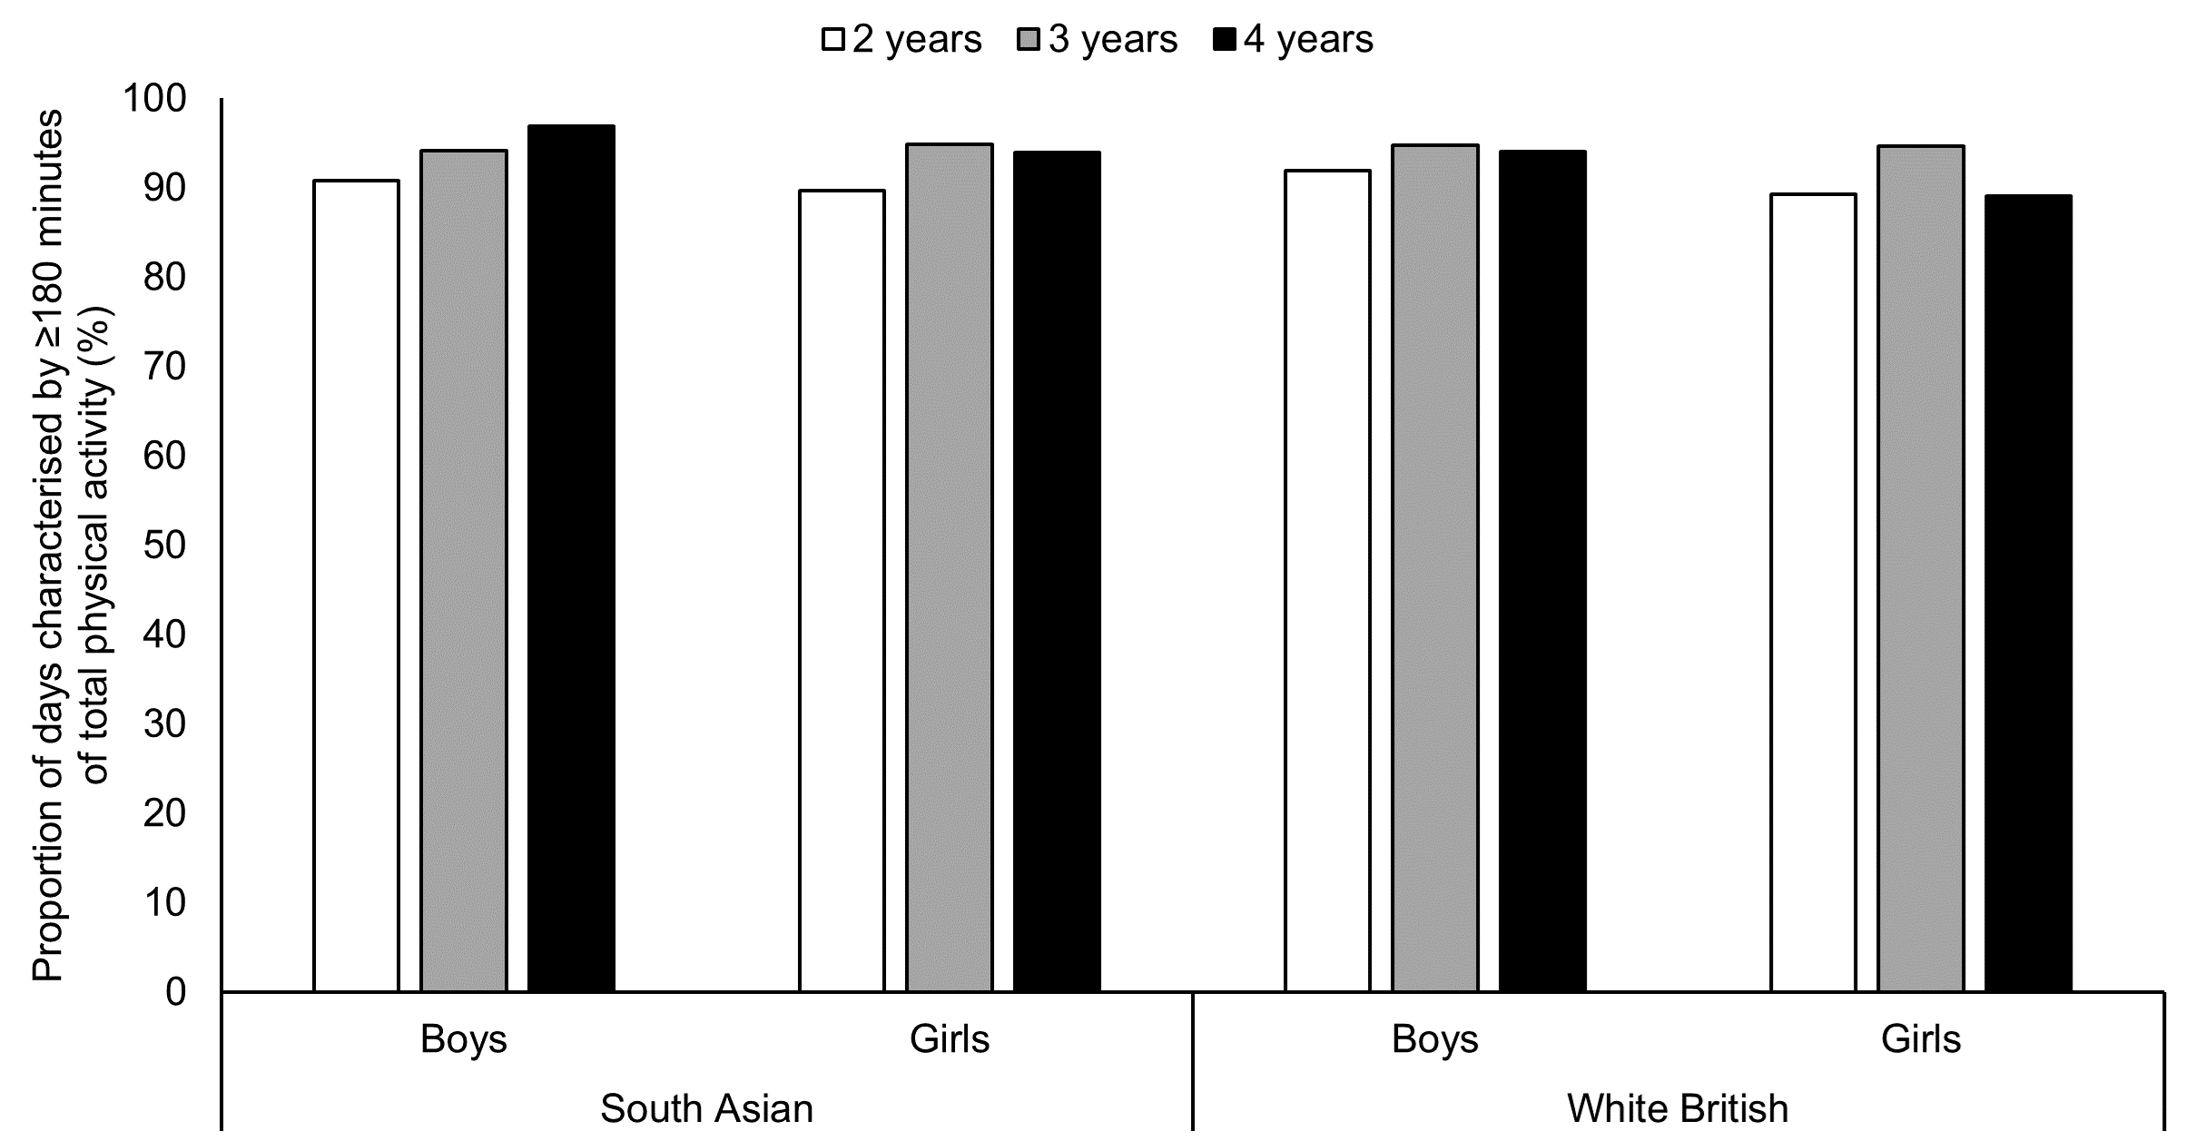

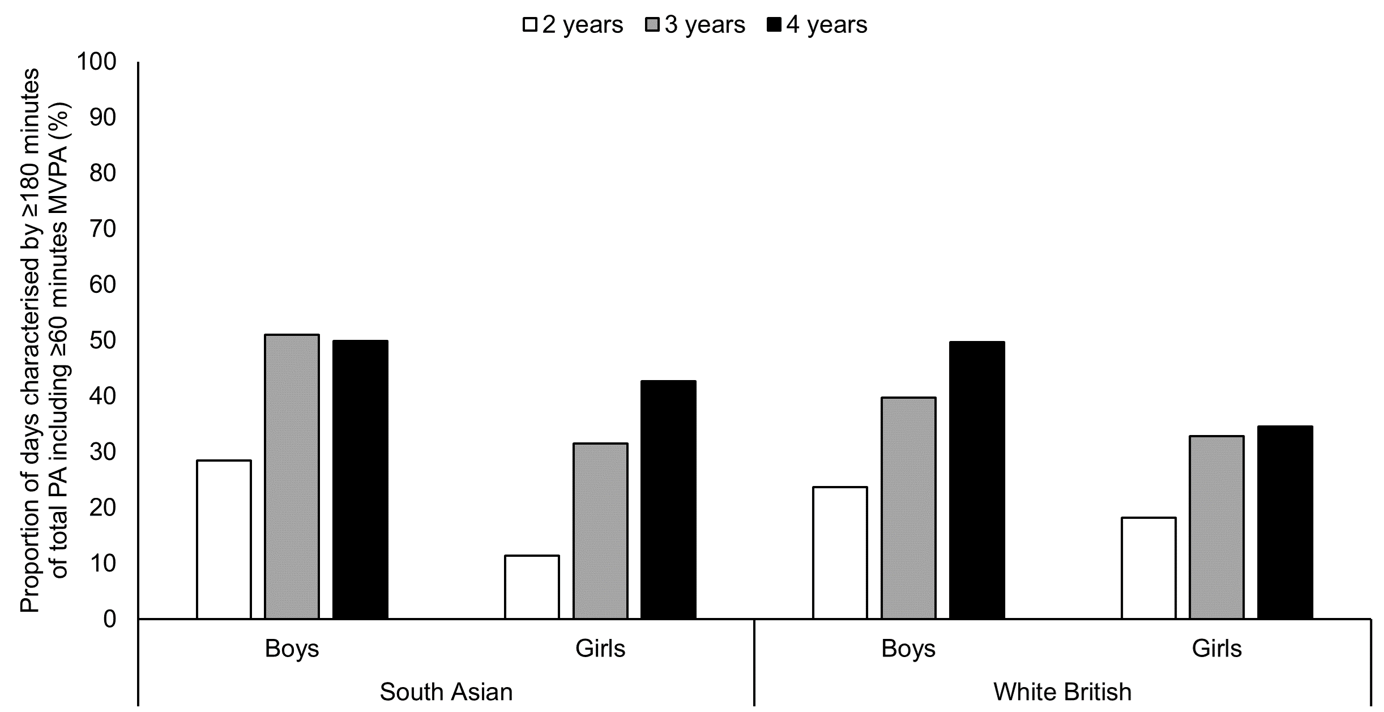

**Figure 1. Proportion of days characterised by meeting the former guideline daily amount of physical activity for all children aged younger than 5 years (≥180 minutes of total physical activity) and the new international guideline daily amount of physical activity for children aged 3 to 4 years (≥180 minutes of total physical activity including ≥60 minutes MVPA), stratified by ethnicity, gender and age.** The top tile relates to meeting the guideline daily amount of physical activity for all children aged younger than 5 years who are capable of walking. The bottom tile relates to meeting the new international guideline daily amount of physical activity for children aged 3 to 4 years. Sample sizes: South Asian boys aged 2 years: 27 children; 64 time-points; 260 days; South Asian boys aged 3 years: 43 children; 72 time-points; 339 days; South Asian boys aged 4 years: 30 children; 42 time-points; 323 days; South Asian girls aged 2 years: 36 children; 93 time-points; 300 days; South Asian girls aged 3 years: 37 children; 74 time-points; 461 days; South Asian girls aged 4 years: 29 children; 35 time-points; 328 days; white British boys aged 2 years: 26 children; 45 time-points; 186 days; white British boys aged 3 years: 41 children; 68 time-points; 320 days; white British boys aged 4 years: 8 children; 8 time-points; 133 days; white British girls aged 2 years: 27 children; 48 time-points; 214 days; white British girls aged 3 years: 32 children; 45 time-points; 262 days; white British girls aged 4 years: 6 children; 6 time-points; 55 days. Due to small numbers, for 7 children aged 1.6 to 1.9 years (contributing 12 time-points and 139 days), age was rounded to 2 years. For another 7 children aged 5.0 to 5.1 years (contributing 7 time-points and 67 days) age was rounded to 4 years. PA, physical activity. MVPA, moderate-to-vigorous physical activity.

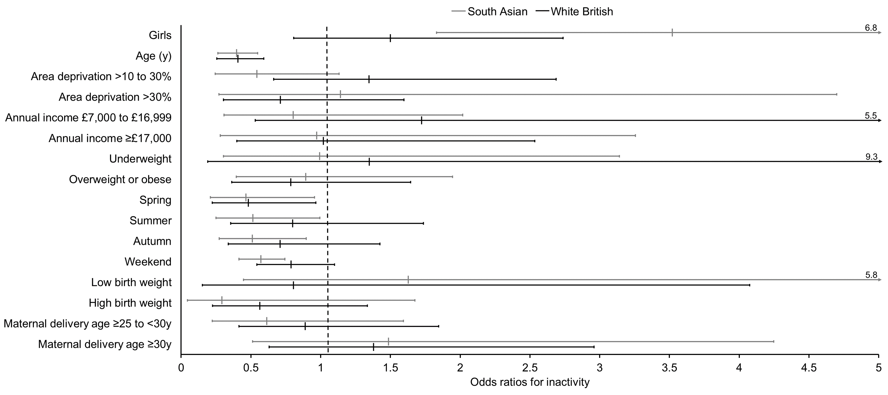

**Figure 2. Odds ratios for failing to meet the new international guideline daily amount of physical activity for children aged 3 to 4 years (≥180 minutes of total physical activity including ≥60 minutes MVPA).** Statistical analyses performed on multiple (*n*=60) imputed datasets using multilevel logistic regression to account for clustering of days within time-points and children. Analyses were stratified by South Asian (202 children; 380 time-points; 2011 days) and white British (140 children; 220 time-points; 1170 days) ethnicities. All factors were mutually adjusted for one another except area deprivation and annual income which occupied separate models from each other. Reference categories are boys, area deprivation ≤10%, annual income <£6,999, healthy weight, winter, weekday, normal birth weight, and maternal delivery age <25y, respectively. Age was modelled continuously. South Asian ethnicity includes Pakistani (*n*=154), Bangladeshi (*n*=21), Indian (*n*=4), and ‘Other South Asian’ including country of origin unknown (*n*=23). MVPA, moderate-to-vigorous physical activity.