**A Simple and Cost-efficient Technique to Generate Hyperpolarized Long-lived 15N-15N Nuclear Spin Order in a Diazine by Signal Amplification by Reversible Exchange**

Soumya S. Roy,1,2 Peter J Rayner,1 Michael J. Burns1 and Simon B. Duckett 1, a)

1 Centre for Hyperpolarisation in Magnetic Resonance (CHyM), Department of Chemistry, University of York, Heslington, York, YO10 5DD, UK.

2 Department of Inorganic and Physical Chemistry, Indian Institute of Science, Bangalore 560012, India

a) Author to whom correspondence should be addressed: [simon.duckett@york.ac.uk](mailto:simon.duckett@york.ac.uk)

**ABSTRACT**

Signal Amplification by Reversible Exchange (SABRE) is an inexpensive and simple hyperpolarization technique and is capable of boosting Nuclear Magnetic Resonance (NMR) sensitivity by several orders of magnitude. It utilizes the reversible binding of *para*-hydrogen as hydride ligands and a substrate of interest to a metal catalyst to allow polarization transfer from *para*-hydrogen to the substrate nuclear spins. The nuclear spin lifetime of the created magnetization sets a strict upper limit on experimental timeframe. Short nuclear spin lifetimes are therefore a challenge for hyperpolarized metabolic imaging prospects. In this report we demonstrate how hyperpolarization and long nuclear spin lifetime can simultaneously be achieved in nitrogen-15 containing pyridazine and phthalazine derivatives by SABRE. These reflect two distinct classes of 15N2-coupled species with respect to their chemical symmetry and thus show different nuclear spin lifetime with the pyridazine derivative having a singlet state lifetime of ca. 2.5 minutes, produced with a signal enhancement of *ca*. 2,700. In contrast the phthalazine derivative yields a superior 15,000-fold enhancement at 11.7 T but has a much shorter singlet lifetime.

**I. INTRODUCTION**

Despite the many significant advances that have taken place since its inception, the poor sensitivity of Nuclear Magnetic Resonance (NMR) still limits its full utility. This low sensitivity arises because NMR relies on the Boltzmann distribution to create population imbalances between the nuclear spin orientations it probes.[1] Whilst 1H detection offers maximum sensitivity, the signal amplitude still originates from a difference of just 1 in each 32,000 1H spins at room temperature within a 9.4 T magnet.[1] This problem is even more pronounced for low-γ nuclei such as 13C and 15N, where in the latter case just 1 in every 300,000 15N nuclear spins contribute positively at this field.[1, 2]

Recent developments in hyperpolarization techniques have allowed the development of magnetic resonance applications that were previously thought to be beyond the techniques reach.[3] This builds from the fact that techniques such as Dynamic Nuclear Polarization (DNP)[4] and Spin Exchange Optical Pumping (SEOP)[5] provide unprecedented levels of signal enhancement for carbon-13, nitrogen-15 and xenon-129 spin detection. These developments have been applied to *in vivo* study,[6-8] however, they often involve high-cost instrumentation[4] which acts to restrict their utilization.

An alternative approach involving *para*-hydrogen (*p*-H2) as a source of polarization is gaining popularity due to its speed and simplicity.[9, 10] Methods involving *p*-H2 are are referred to as *Para*-Hydrogen Induced Polarization (PHIP) and classically uses a metal catalyst to add *p*-H2 to an unsaturated substrate *via* a hydrogenation step. However, a variant of PHIP called Signal Amplification by Reversible Exchange (SABRE) has greatly expanded the remit of the PHIP method as it does not induce chemical change in the substrate.[11] SABRE instead employs reversible substrate and *p*-H2 binding to a catalyst to transfer polarization from the *p*-H2 derived hydride ligands to a selected substrate under appropriate resonance conditions (Scheme 1).[12] Since its inception, SABRE has become successful at hyperpolarizing a growing range of important materials such as nicotinamide, methyl nicotinate, imidazole, diazirines, metronidazole, amines and pyruvate.[13-20]

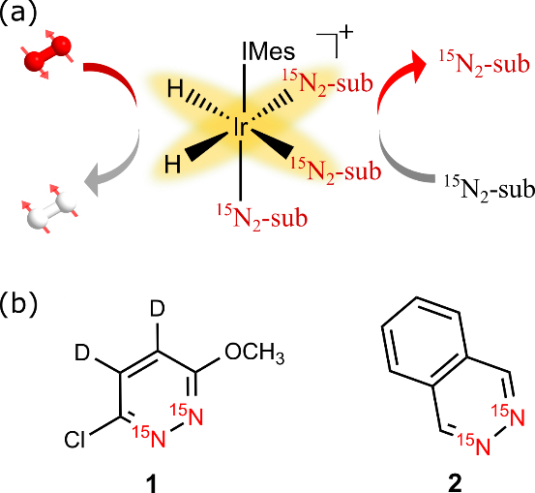

SCHEME 1: (a) Schematic depiction of the SABRE hyperpolarization method; *p*-H2 and substrate (sub) bind reversibly to an iridium catalyst to induce polarization transfer. (b) Structures of the substrates used in this study—3-chloro-6-methoxy-4,5-*d*2-pyridazine-15N2 (**1**) and phthlazine-15N2 (**2**).

The hyperpolarization of heteronuclei provides two crucial advantages over normal 1H magnetic resonance imaging (MRI) – (a) an essentially background-free signal and (b) potentially long magnetic state lifetimes. The greatest success of DNP has been the hyperpolarization of 13C nuclei in isotopically labelled pyruvate for the study of metabolic pathways linked to cancer.[6, 21-23] Hyperpolarized 15N offers similar advantages to 13C and the feasibility of its *in vivo* detection has been studied previously for 15N-choline.[24] As the relative molar receptivity of 15N is just and 13C with respect to 1H, the use of hyperpolarization is critical for heteronuclei detection.[1] Warren and co-workers have demonstrated that 15N targets can be produced with high levels of hyperpolarization together with long magnetic state lifetimes using a variation of SABRE they termed SABRE-SHEATH.[25-29] It simply uses a mu-metal shield to enable efficient and direct polarization transfer from the hydride ligands of the catalyst to heteronuclei. A significant breakthrough was reflected in their studies of diazirines which were found to display both longitudinal magnetization and long lived singlet states after polarization transfer.[16] 15N polarization levels of ca. 5% were reported and the associated singlet state had a lifetime of 23 min. This singlet state was revealed by the use of chemical asymmetry. This built from work by Levitt and co-workers who illustrated how long-lived singlet states (LLS) sustain nuclear spin lifetimes beyond those of the normal *T*1 timescale through storage in disconnected Eigen states[30, 31] due to the fact they are immune to the major mechanisms of relaxation.[32] Examples of such systems have been found where their long-lived states have lifetimes that exceed 1 hour, or 50 times the more usual *T*1 timescale, in room temperature solution.[33, 34]

In this work, we use the SABRE variant SABRE-SHEATH to hyperpolarize two 15N2-based diazines and rationalize the basis of a simple route to their detection over long-time-scales. To broaden applicability, these agents were selected to represent two different kinds of substrate that differ according to whether their coupled 15N-spins are chemically or magnetically different.

**II. EXPERIMENTAL METHODS AND RESULTS**

The *p*-H2 for this SABRE hyperpolarization study was created with in more than 92% purity using an in-house *para-*hydrogen generator.[35] Samples were prepared by mixing 5 mM of [IrCl(COD)(IMes)] (IMes = 1,3-bis(2,4,6-trimethylphenyl)imidazol-2-ylidene) with 30 mM of the substrate (**1** or **2** ofScheme 1) in 0.6 mL of methanol-*d*4 in a 5 mm NMR tube fitted with a J. Young’s Tap. After degassing using a freeze-pump-thaw method, the samples were activated by the introduction of H2 at a pressure of 3 bar. SABRE hyperpolarization experiments were then completed by filling the NMR tubes with *p*-H2 (3 bar) and subsequently shaking them vigorously in the specified magnetic field before detecting the resulting signal inside a high field NMR spectrometer (11.75 T). In these experiments, a mu-metal shield was used to reduce the background magnetic field to around 1000 times its normal value so that a mG top-up field can be applied to the sample through the application of a solenoid.[17] The SABRE/SABRE-SHEATH hyperpolarization and sample transfer steps take place over 10 to 20 seconds. [36, 37] Since SABRE is reversible, sample re-hyperpolarisation can be achieved within just a few seconds by repeating this procedure with fresh *p*-H2. In this way, accuracy and relaxation effects can readily be probed. The NMR measurements that feature in the final observation step were carried out at 298 K on an 11.75 T Bruker Avance III spectrometer using a TBI probe.

Pyridazine **1** contains a pair of coupled 15N spins that are chemically different. Earlier studies of several related pyridazine based substrates confirmed they can provide access to good 1H-SABRE hyperpolarization levels, thereby indicating the suitability of these systems.[28, 29, 38] The hyperpolarization of 3,6-dichloropyridazine-15N2 has also previously been reported.[39] The pyridazine motif is prevalent in a range of pharmacologically active agents and hence screening their NMR detection and magnetic state lifetimes is sensible.[40]

The chemical shift between the two inequivalent 15N sites in **1** was quantified to be 29.3 ppm, with a mutual spin-spin coupling of 23 Hz connecting them. During the SABRE process, **1** and a pair of *p*-H2 derived hydride ligands bind to the iridium catalyst to temporarily create an AA’BC type 4-spin system at low-magnetic field. Consequently, the SABRE transfer mechanism for diazines, that relate directly to the type **1** and **2** substratesof this study,will apply andlead here to direct transfer into the corresponding 15N2-spin system singlet state.[16, 18, 27, 38, 41]

Once SABRE hyperpolarization experiments were performed according to the aforementioned protocol, in the case of **1**, the observation of two 15N NMR signals results, as detailed in Figure 1a, after a 90˚ hard observation pulse. These signals possess what is now known to be a characteristic ‘up-up-down-down’ pattern that confirms the creation of 15N-singlet spin character in **1** after SABRE.[17, 42, 43] When the same process was repeated, but a 9˚ flip angle used, the resulting NMR spectrum yields detectable outer-line transitions as shown in Figure 1b which further confirm the presence of initial singlet spin character. These observations also show that whilst the zero quantum-x (ZQx) coherence associated with this singlet will evolve cyclically at high field under the chemical shift difference into ZQy, it does not decohere rapidly which confirms the presence of the methyl substituent has minimal effect.[44, 45] This is in agreement with the failure to observe any scalar coupling between the methyl groups protons and the 15N centres. For comparison purposes, Figure 1c shows the corresponding thermally polarized 15N NMR spectrum that was acquired in conjunction with signal averaging over 1000 scans where the delay between measurements is 120 sec. Consequently, this control measurement took over 33 hours to make. On the basis of these data, a signal enhancement factor of 1250 could be determined at 11.75 T, relative to the thermally polarized NMR spectrum. These measurements were repeated using different polarization transfer field values in the range 1 to 10 mG and little intensity variation was observed which is expected for a direct singlet transfer pathway.

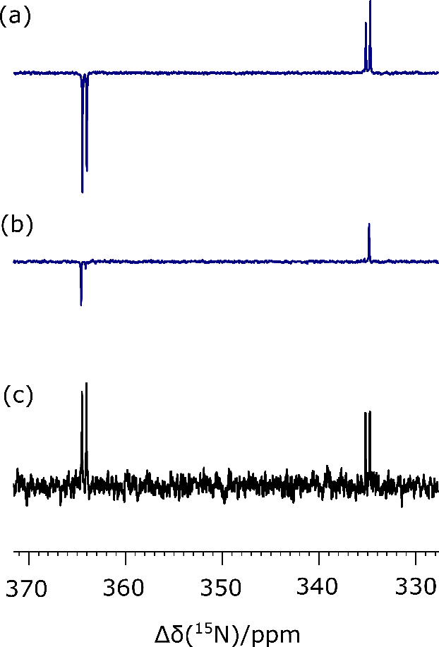

FIGURE 1: 15N NMR spectra associated with **1**: (a) single-shot hyperpolarized SABRE-SHEATH experiment detected at 11.75 T by a 90˚ pulse, (b) detected by a 9˚ pulse and (c) the corresponding 15N NMR spectrum after 1000 averages.

Since the SABRE signal that is created in these experiments originates in the corresponding singlet state, it’s lifetime should be much longer than that associated with more usual *T*1 decay. Furthermore, since chemical shift anisotropy (CSA) is the major source of singlet order relaxation, this period should be extended significantly with lower magnetic field storage.[46] We therefore measured the LLS lifetime of this state after storage in three magnetic fields. For the high magnetic field value, we used the 11.75 T field of the NMR system and determined the LLS lifetime to be 35.8 ± 5.8 s. Next, the sample was examined after storage at 0.3 T and a lifetime of 56.5 ± 12.6 s determined. The 0.3 T field was selected because of the work of Shchepin *et* al. where they found it proved suitable for hyperpolarized *T*1 extension.[47] Upon storage in the mu-metal shield, the lifetime became 118.3 ± 20.4 s. The normalized signal intensities used in obtaining these values alongside the corresponding exponential fits are shown in Figure 2 and the results are detailed in Table 1. These LLS lifetimes are each measured in the presence of the active SABRE catalyst. Therefore, the lifetimes are compressed due to the reversible interaction of **1** with the catalyst during the measurement which further breaks the symmetry of the magnetic state during the ligation event. When these measurements are repeated with a 50-fold excess of **1** based on iridium, rather than the 6-fold excess previously employed, these lifetimes are extended. Now, the TLLS lifetimes were 48.8 ± 7.1 s at 11.75 T whilst at zero field (mu-metal shield) it became 155.5 ± 15.4 s. Hence, we can conclude that the LLS lifetimes can be substantially improved in the presence of a larger excess of substrate which reduces the propensity for magnetization decay. However, a significant drop in signal enhancement factor to *ca*. 200-fold is also observed at this higher substrate loading and therefore a balance between signal size and lifetime needs to be considered based on the desired application.

Due to the long lifetime of the created hyperpolarized 15N signal of **1**, we could further improve the signal enhancement achieved with the sample containing 5 mM [IrCl(COD)(IMes)] and 30 mM of **1** by extending the polarization transfer times. When a 25 second polarization time was employed the visible signal gain increased significantly to 2700-fold. This represents the detection of a signal that is twice as large as that achieved with a 10 second transfer time. However, when the polarization time was increased above 30 seconds, the 15N signal gain decreased to 2500-fold which reflects the finite volume of *p*-H2 that is present in the sealed NMR tubes used in this study.

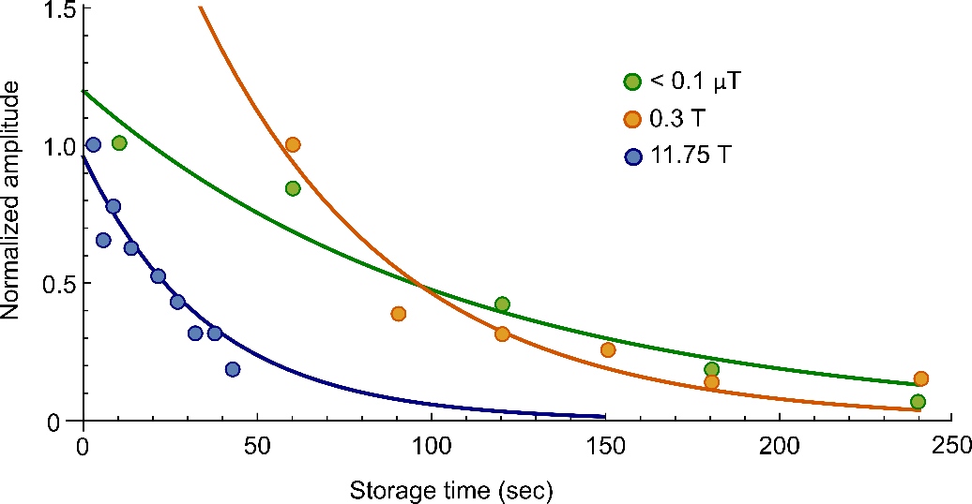

FIGURE 2: Normalized signal amplitudes of the 15N hyperpolarised NMR signals seen for **1** (circles) after SABRE-SHEATH as a function of sample storage time. Data points are fitted to an exponential (solid curves) which yields the lifetimes reported in Table 1 for a precatalyst to **1** loading of 1:6. Sample storage took place at 11.75 T (blue), 0.3 T (orange) and 0 T (green).

TABLE 1: 15N polarization levels (enhancement factor and %), and singlet lifetimes for **1** and **2** at the specified storage fields achieved with the precatalyst [IrCl(COD)(IMes)]. All measurements were made at 11.75 T and 298 K.

|  |  |  |  |  |
| --- | --- | --- | --- | --- |
| Agent | Enhancement factor () and net polarization (P%) | Hyperpolarised lifetime at 11.75 T | Hyperpolarised lifetime at 0.3 T | Hyperpolarised lifetime at 0 T |
| **1** |  1250  P: 0.5% | TLLS: 35. 8 ± 5.8 s | TLLS: 56.5 ± 12.6 s | TLLS: 118.3 ± 20.4 s |
| **2** |  4800  P: 2% | T1: 5. 8 ± 0.2 s | T1: 56.0 ± 2.5 s | T1: 21.0 ± 6.3 s |

Phthalazine **2** has a chemically equivalent, but in view of the associated 1H couplings, magnetically distinct 15N2-spin system. It was probed under SABRE-SHEATH inside a mu-metal shield.[17, 48] The presence of -proton substituents on the ring system, and their visible couplings to 15N, will enable decoherence of any ZQx term that is created through SABRE and thereby make the resulting states visible to NMR.[46] However, we further note that the transient binding of **2** to a metal complex will break both the chemical and magnetic symmetry of this 15N pair, thereby providing not only a route to see both bound and free material, but also a route to decohere the singlet state, in a process whose effect will be concentration dependent.

For these measurements we initially employed a solution containing 5 mM of [IrCl(COD)(IMes)] and 30 mM of **2**. Figure 3 shows the resulting series of hyperpolarized 15N NMR signals for **2** that were observed after the application of a 90 degree observation pulse as a function of the polarization transfer field strength and we see the signal reaches maximum amplitude at 4.5 mG.

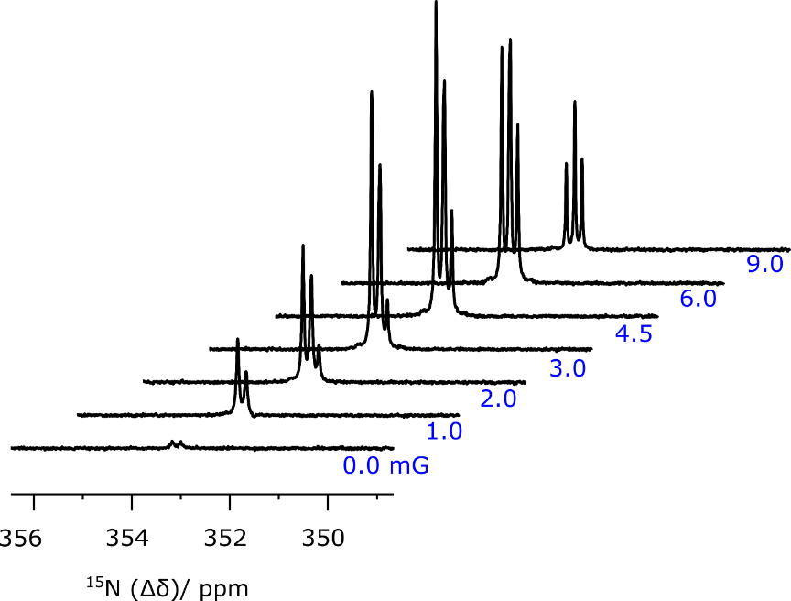

FIGURE 3: Hyperpolarized 15N NMR spectra of **2** as a function of the mixing field (0-9 mG) experienced during polarization transfer. The NMR tube was mixed with *p*-H2 inside a voltage-controlled coil that was placed inside a mu-metal shielded chamber for these measurements.

The polarization of **2** is achieved through the creation of an initially identical AA'BC spin network on the catalyst as with **1**, however, upon dissociation the singlet state that is created can only evolve under the weak symmetry breaking proton-nitrogen spin-spin couplings. Figure 4 shows all of the detected 15N resonances after SABRE transfer at 4.5 mG where additional peaks due to bound **2** within this catalyst are clearly present. Consequently, a similar ‘up-up-down-down’ 15N NMR pattern is seen for the two coupled spins when the ligand is located in an equatorial manner ( 362.8 and 278.8)**.** Peaks with significantly reduced amplitude correspond to the much slower exchanging axial-ligand ( 302.6 and 299.7). Confirmation of singlet character is again provided by small tip-angle pulse examination which leads to the detection of the two outer transitions in all cases (Figure 5). This process of substrate dissociation from the iridium catalyst will break the symmetric 15N2-environment of **2** in these measurements, as proposed earlier, and thereby promote further singlet statedecoherence. The signal enhancements for the less sterically demanding **2** were significantly higher than **1** under these SABRE conditions and a 15N control signal (Figure 4b) confirmed the enhancement factor was now 4800 at 11.75 T (*ca*. 2%). Changing the SABRE catalyst to a *tert*-butyl-substituted catalyst[49] raised this level to 14,500-fold (~ 6%) under similar conditions.

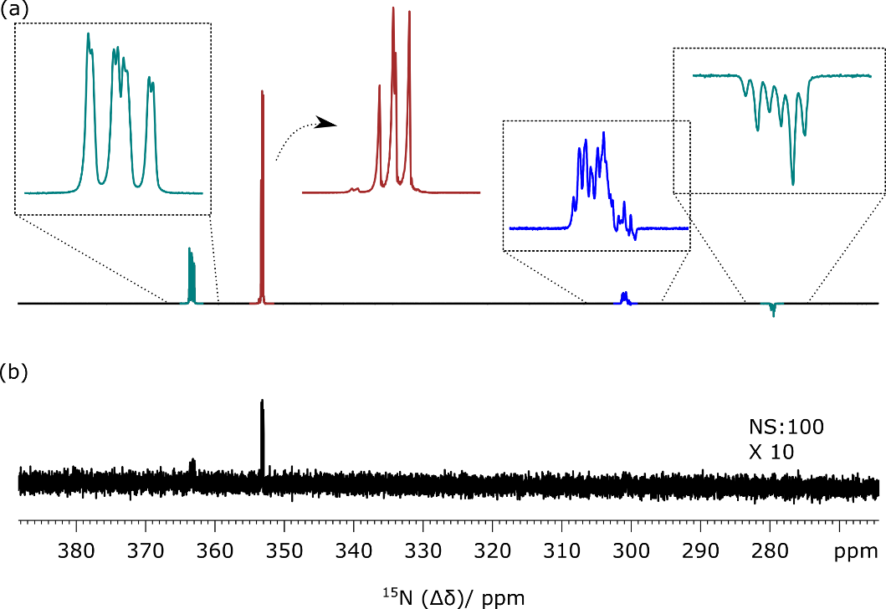

FIGURE 4: (a) High field single shot 15N NMR SABRE-SHEATH spectrum of **2** after polarization transfer at 4.5 mG. Expansions show the ‘free-**2**’ peak at 353 ppm (red) and ‘bound’ equatorial ligand peaks (green and blue) with characteristic singlet features. (b) 15N thermal polarized NMR spectrum using 100 transients that is vertically scaled by 10 compared to (a).

The lifetime over which the ‘bound’ singlet state remained visible was less than 10 s in accordance with a rapid ligand loss rate of *ca*. 0.4 s−1 which leads to rapid cycling of this material.[38]

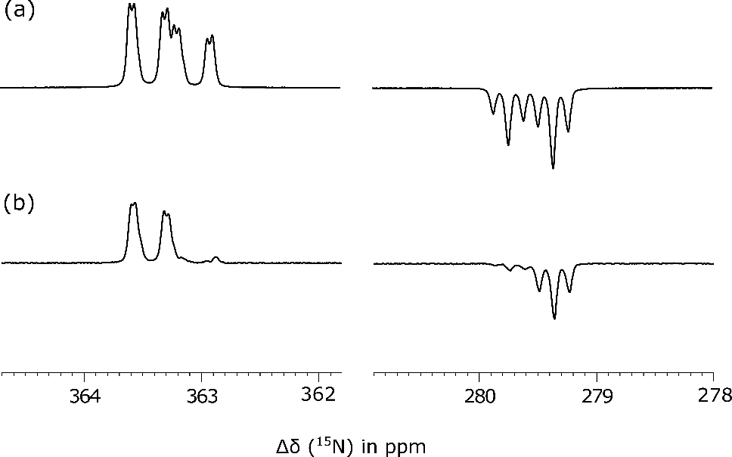

FIGURE 5: 15N NMR spectra showing the equatorially-bound ligand peaks of **2** [Ir(H)2(IMes)(**2**)3]Cl that are visible after SABRE-SHEATH and through (a) a 90˚ pulse and (b) a 9˚ pulse.

The lifetime of the magnetism responsible for the signal of hyperpolarized **2** wasthen studied in more detail. Its high-field relaxation time proved to be 5.8 ± 0.2 s. A lifetime of 21.0 ± 6.3 s was determined in the mu-metal shield while at 0.3 T it became 56.0 ± 2.5 s. Figure 6 shows the normalized hyperpolarized signal amplitude observed for **2** in these three storage fields. Table 1 details the enhancement factor and lifetimes of **2**. These results are again affected by the catalyst and substrate concentration and when a 50-fold excess of **2** when compared to catalyst was utilized, these lifetimes were increased by ~40%. This scale of change is similar to that of previous reports and is a consequence of the catalysts contribution to the singlet sate decoherence being reduced.[28, 44]

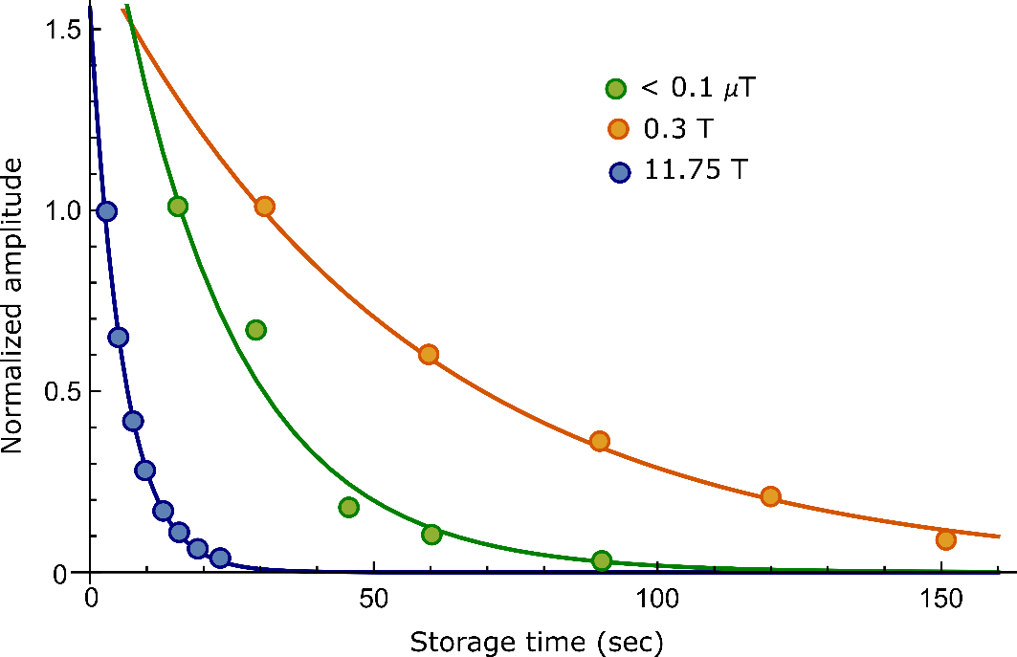

FIGURE 6: Normalized signal amplitude of 15N hyperpolarized NMR signals of **2** (circles) observed from after SABRE SHEATH as a function of sample storage time. Data points were fitted to exponentials (solid curves) and results are detailed in Table 1. Three different magnetic storage fields were used: 11.75 T (blue), 0.3 T (orange), and 0 T (green).

**III. CONCLUSION**

In summary, we have reported how SABRE hyperpolarization can improve the 15N detectability of **1** and **2**. These molecules were synthesized as representative examples of pyridazine derivatives that possess a strong 15N-15N coupling. Consequently, we expected to be able to prepare them in a singlet state through low-field polarization transfer. In the case of **1**,the steric bulk of the agentlimits the efficiency of SABRE transfer such that a 0.5% polarization level is achieved, however, the isolated spin system exhibits an impressive LLS lifetime of 155 s when stored inside a mu metal shield. In the case of **2** it is easier to achieve high levels of hyperpolarization due to the reduced steric bulk of this agent. Consequently, when a *tert*-butyl-substituted precatalyst is employed 6% 15N polarization is achieved. This hyperpolarization is readily read out by breaking the system of **2** through binding to the catalyst with the result that two inequivalent signals are detected for the associated 15N NMR responses. In this case, rapid exchange with the SABRE catalyst reduced the apparent LLS lifetime of this state to 75 s for a 50-fold excess of reagent at a 0.3 T storage field.[47] We expect further catalyst optimizations to increase the levels of 15N-signal gain and perhaps facilitate the *in vivo* detection of these agents through 15N detection.

**METHODS**

**15N2-*d*2-maleic hydrazide**. 15N2-Hydrazine sulfate (500 mg, 3.79 mmol, 1.0 eq) was added to a stirred solution of *d*2-maleic anhydride (500 mg, 5.0 mmol, 1.32 eq) in water (7 mL). The resulting solution was heated to 100 °C for 3 h before being allowed to cool to rt. The reaction was filtered, the precipitate was collected and dried under reduced pressure to give15N2-*d*2-maleic hydrazide as a white solid which was used in the next step without further purification.

**15N2-3,6-dichloro-4,5-*d*2-pyridazine**.15N2-*d*2-Maleic hydrazide (325 mg, 2.80 mmol, 1.0 eq.) in POCl3 (3.0 mL) was heated to 95 °C for 3 h. Then the reaction was cooled to rt and added dropwise to an ice cold solution of NaHCO3 to neutralise. EtOAc (15 mL) was added and the two layers were separated. The aqueous layer was extracted with EtOAc (3 x 15 mL) and the combined organic layers were dried (MgSO4) and concentrated under reduced pressure to give the crude product. Purification by flash column chromatography with 8:2 hexane-EtOAc as eluent gave 15N2-3,6-dichloro-4,5-*d*2-pyridazine (321 mg, 75%) as a white solid, *R*F (8:2 hexane-EtOAc) 0.3; **13C NMR** (126 MHz, CDCl3) *δ* (ppm) 156.0 (t, *J =* 7.24 Hz), 130.0(t, *J =* 26.6 Hz); **15N NMR** (51 MHz, CDCl3) *δ* (ppm) 390.2 (s); **MS** (ESI) *m/z* 175 [(M + Na)+, 40] 153 [(M + H)+, 100]; **HRMS** (ESI) *m/z* [M + Na]+ calculated for C4­Cl2D215N2 174.9553, found 174.9559 (−3.0 ppm error).

**15N2-3-chloro- 4,5-*d*2-6-methoxypyridazine (1).** Sodium methoxide (60 mg, 1.1 mmol, 1.1 eq.) was added to a stirred solution of 15N2-3,6-dichloro-4,5-*d*2-pyridazine (153 mg, 1.0 mmol, 1.0 eq) in MeOH (10 mL) and the resulting solution was stirred at rt for 48 h. The reaction was concentrated under reduced pressure to give the crude product. Purification by flash column chromatography with 95:5-85:15 CH2Cl2-EtOAc as eluent gave **1** (143 mg, 97%) as a white solid, *R*F (85:15 CH2Cl2-EtOAc) 0.3; **1H NMR** (500 MHz, CDCl3)4.12 (s, 3H); **13C NMR** (126 MHz, CDCl3) *δ* (ppm) 164.4 (d, *J =* 5.3 Hz), 151.0 (m), 130.3(app. t, *J =* 24.3 Hz), 119.7 (dd, *J* = 23.4, 3.8 Hz), 55.2 (d, *J* = 4.0 Hz); **15N NMR** (41 MHz, CDCl3) *δ* (ppm) 372.3 (d, *J =* 23.7 Hz), 339.9 (d, *J =* 23.7 Hz); **MS** (ESI) *m/z* 171 [(M + Na)+, 80] 149 [(M + H)+, 100]; **HRMS** (ESI) *m/z* [M + Na]+ calculated for C5H3ClD215N2O 171.0049, found 171.0053 (−1.7 ppm error).

**15N2-phthalazine(2).** A solution of 15N2H4.H2SO4 (1.21 g, 9.31 mmol) in 1 M NaOH (15 mL) was added to a solution of phthaldialdehyde (1.25 g, 9.33 mmol) and EtOH (30 mL) at room temperature, and stirred for 3 hours. The resulting solution was extracted with DCM (3 × 100 mL) and the combined extracts concentrated *in vacuo*. Purification by column chromatography (EtOAc) afforded **2** (815 mg, 66%) as an orange solid. **1H NMR** (400 MHz, CDCl3) δ (ppm) 9.43 (app t, *J* = 8.2 Hz, 2H) 7.87-7.81 (m, 4H); **13C NMR** (101 MHz, CDCl3) δ (ppm) 151.1 (t, *J* = 4.4 Hz), 132.7, 126.4 (t, *J* =1.8 Hz), 126.2; **15N NMR** (51 MHz, CDCl3) δ (ppm) 365.3; **MS** (ESI) *m/z* 155 [(M + Na)+, 100], 133 [(M + H)+, 80]; **HRMS** (ESI) *m/z* [M + H]+ calculated for C8H715N2 133.0544, found 133.0548 (−2.5 ppm error).

**ACKNOWLEDGEMENTS**

This work was supported by The Wellcome Trust (Grants 092506 and 098335), the EPSRC (EP/R51181X/1) and the University of York.

**REFERENCES**

[1] M.H. Levitt, Spin dynamics : basics of nuclear magnetic resonance, 2008.

[2] O.W. Sorensen, G.W. Eich, M.H. Levitt, G. Bodenhausen, R.R. Ernst, Product Operator-Formalism for the Description of Nmr Pulse Experiments, Prog Nucl Mag Res Sp 16 (1983) 163-192.

[3] J.H. Lee, Y. Okuno, S. Cavagnero, Sensitivity enhancement in solution NMR: Emerging ideas and new frontiers, Journal of Magnetic Resonance 241 (2014) 18-31.

[4] J.H. Ardenkjaer-Larsen, On the present and future of dissolution-DNP, Journal of Magnetic Resonance 264 (2016) 3-12.

[5] G.W. Thad, Fundamentals of Spin-Exchange Optical Pumping, Journal of Physics: Conference Series 294 (2011) 012001.

[6] J. Kurhanewicz, D.B. Vigneron, K. Brindle, E.Y. Chekmenev, A. Comment, C.H. Cunningham, R.J. DeBerardinis, G.G. Green, M.O. Leach, S.S. Rajan, R.R. Rizi, B.D. Ross, W.S. Warren, C.R. Malloy, Analysis of Cancer Metabolism by Imaging Hyperpolarized Nuclei: Prospects for Translation to Clinical Research, Neoplasia 13 (2011) 81-97.

[7] K. Golman, R. in't Zandt, M. Lerche, R. Pehrson, J.H. Ardenkjaer-Larsen, Metabolic imaging by hyperpolarized C-13 magnetic resonance imaging for in vivo tumor diagnosis, Cancer Res 66 (2006) 10855-10860.

[8] S.J. Nelson, J. Kurhanewicz, D.B. Vigneron, P.E.Z. Larson, A.L. Harzstark, M. Ferrone, M. van Criekinge, J.W. Chang, R. Bok, I. Park, G. Reed, L. Carvajal, E.J. Small, P. Munster, V.K. Weinberg, J.H. Ardenkjaer-Larsen, A.P. Chen, R.E. Hurd, L.-I. Odegardstuen, F.J. Robb, J. Tropp, J.A. Murray, Metabolic Imaging of Patients with Prostate Cancer Using Hyperpolarized 1-C-13 Pyruvate, Science Translational Medicine 5 (2013) 198ra108.

[9] C.R. Bowers, D.P. Weitekamp, Para-hydrogen and Synthesis Allow Dramatically Enhanced Nuclear Alingment, Journal of the American Chemical Society 109 (1987) 5541-5542.

[10] T.C. Eisenschmid, R.U. Kirss, P.P. Deutsch, S.I. Hommeltoft, R. Eisenberg, J. Bargon, R.G. Lawler, A.L. Balch, Para Hydrogen Induced Polarization in Hydrogenation Reactions, Journal of the American Chemical Society 109 (1987) 8089-8091.

[11] R.W. Adams, J.A. Aguilar, K.D. Atkinson, M.J. Cowley, P.I.P. Elliott, S.B. Duckett, G.G.R. Green, I.G. Khazal, J. Lopez-Serrano, D.C. Williamson, Reversible Interactions with para-Hydrogen Enhance NMR Sensitivity by Polarization Transfer, Science 323 (2009) 1708-1711.

[12] R.W. Adams, S.B. Duckett, R.A. Green, D.C. Williamson, G.G.R. Green, A theoretical basis for spontaneous polarization transfer in non-hydrogenative parahydrogen-induced polarization, Journal of Chemical Physics 131 (2009).

[13] P.J. Rayner, M.J. Burns, A.M. Olaru, P. Norcott, M. Fekete, G.G.R. Green, L.A.R. Highton, R.E. Mewis, S.B. Duckett, Delivering strong H-1 nuclear hyperpolarization levels and long magnetic lifetimes through signal amplification by reversible exchange, P Natl Acad Sci USA 114 (2017) E3188-E3194.

[14] D.A. Barskiy, R.V. Shchepin, A.M. Coffey, T. Theis, W.S. Warren, B.M. Goodson, E.Y. Chekmenev, Over 20% N-15 Hyperpolarization in Under One Minute for Metronidazole, an Antibiotic and Hypoxia Probe, Journal of the American Chemical Society 138 (2016) 8080-8083.

[15] R.V. Shchepin, D.A. Barskiy, A.M. Coffey, T. Theis, F. Shi, W.S. Warren, B.M. Goodson, E.Y. Chekmenev, N-15 Hyperpolarization of Imidazole-N-15(2) for Magnetic Resonance pH Sensing via SABRE-SHEATH, Acs Sensors 1 (2016) 640-644.

[16] T. Theis, G.X. Ortiz, A.W.J. Logan, K.E. Claytor, Y. Feng, W.P. Huhn, V. Blum, S.J. Malcolmson, E.Y. Chekmenev, Q. Wang, W.S. Warren, Direct and cost-efficient hyperpolarization of long-lived nuclear spin states on universal N-15(2)-diazirine molecular tags, Sci Adv 2 (2016).

[17] W. Iali, S.S. Roy, B. Tickner, F. Ahwal, A.J. Kennerley, S.B. Duckett, Hyperpolarising Pyruvate through Signal Amplification by Reversible Exchange (SABRE), Angewandte Chemie-International Edition 58 (2019) 10271-10275.

[18] B.J. Tickner, W. Iali, S.S. Roy, A.C. Whitwood, S.B. Duckett, Iridium alpha-Carboxyimine Complexes Hyperpolarized with para-Hydrogen Exist in Nuclear Singlet States before Conversion into Iridium Carbonates, Chemphyschem 20 (2019) 241-245.

[19] B.J. Tickner, R.O. John, S.S. Roy, S.J. Hart, A.C. Whitwood, S.B. Duckett, Using coligands to gain mechanistic insight into iridium complexes hyperpolarized with para-hydrogen, Chemical Science 10 (2019) 5235-5245.

[20] W. Iali, P.J. Rayner, A. Alshehri, A.J. Holmes, A.J. Ruddlesden, S.B. Duckett, Direct and indirect hyperpolarisation of amines using parahydrogen, Chemical Science 9 (2018) 3677-3684.

[21] S.E. Day, M.I. Kettunen, F.A. Gallagher, D.-E. Hu, M. Lerche, J. Wolber, K. Golman, J.H. Ardenkjaer-Larsen, K.M. Brindle, Detecting tumor response to treatment using hyperpolarized C-13 magnetic resonance imaging and spectroscopy, Nature Medicine 13 (2007) 1382-1387.

[22] K. Golman, R. in't Zandt, M. Thaning, Real-time metabolic imaging, P Natl Acad Sci USA 103 (2006) 11270-11275.

[23] E.M. Serrao, K.M. Brindle, Potential Clinical Roles for Metabolic Imaging with Hyperpolarized [1-C-13]Pyruvate, Front Oncol 6 (2016).

[24] C. Cudalbu, A. Comment, F. Kurdzesau, R.B. van Heeswijk, K. Uffmann, S. Jannin, V. Denisov, D. Kirik, R. Gruetter, Feasibility of in vivo15N MRS detection of hyperpolarized 15N labeled choline in rats, Physical Chemistry Chemical Physics 12 (2010) 5818-5823.

[25] T. Theis, G.X. Ortiz, A.W. Logan, K.E. Claytor, Y. Feng, W.P. Huhn, V. Blum, S.J. Malcolmson, E.Y. Chekmenev, Q. Wang, W. Warren, Direct and cost-efficient hyperpolarization of long-lived nuclear spin states on universal 15N2-diazirine molecular tags, Sci Adv 2 (2016) e1501438.

[26] Z. Zhou, J. Yu, J.F. Colell, R. Laasner, A.W. Logan, D.A. Barskiy, R.V. Shchepin, E.Y. Chekmenev, V. Blum, W.S. Warren, Long-Lived 13C2 Nuclear Spin States Hyperpolarized by Parahydrogen in Reversible Exchange at Micro-Tesla Fields, The Journal of Physical Chemistry Letters (2017).

[27] S.S. Roy, P. Norcott, P.J. Rayner, G.G.R. Green, S.B. Duckett, A Hyperpolarizable H-1 Magnetic Resonance Probe for Signal Detection 15 Minutes after Spin Polarization Storage, Angewandte Chemie-International Edition 55 (2016) 15642-15645.

[28] S.S. Roy, P.J. Rayner, P. Norcott, G.G.R. Green, S.B. Duckett, Long-lived states to sustain SABRE hyperpolarised magnetisation, Phys. Chem. Chem. Phys. 18 (2016) 24905-24911.

[29] S.S. Roy, P. Norcott, P.J. Rayner, G.G.R. Green, S.B. Duckett, A Simple Route to Strong Carbon-13 NMR Signals Detectable for Several Minutes, Chem.- Eur. J. 23 (2017) 10496-10500.

[30] M.H. Levitt, Short perspective on "NMR population inversion using a composite pulse" by M.H. Levitt and R. Freeman J. Magn. Reson. 33 (1979) 473-476, Journal of magnetic resonance (San Diego, Calif. : 1997) 213 (2011) 274-275.

[31] M. Carravetta, O.G. Johannessen, M.H. Levitt, Beyond the T-1 limit: Singlet nuclear spin states in low magnetic fields, Physical Review Letters 92 (2004) 153003.

[32] G. Pileio, Singlet NMR methodology in two-spin-1/2 systems, Prog Nucl Mag Res Sp 98-99 (2017) 1-19.

[33] G. Stevanato, J.T. Hill-Cousins, P. Hakansson, S.S. Roy, L.J. Brown, R.C.D. Brown, G. Pileio, M.H. Levitt, A Nuclear Singlet Lifetime of More than One Hour in Room-Temperature Solution, Angewandte Chemie-International Edition 54 (2015) 3740-3743.

[34] G. Pileio, M. Carravetta, E. Hughes, M.H. Levitt, The long-lived nuclear singlet state of N-15-nitrous oxide in solution, Journal of the American Chemical Society 130 (2008) 12582-+.

[35] P.M. Richardson, R.O. John, A.J. Parrott, P.J. Rayner, W. Iali, A. Nordon, M.E. Halse, S.B. Duckett, Quantification of hyperpolarisation efficiency in SABRE and SABRE-Relay enhanced NMR spectroscopy, Physical Chemistry Chemical Physics 20 (2018) 26362-26371.

[36] T. Theis, M.L. Truong, A.M. Coffey, R.V. Shchepin, K.W. Waddell, F. Shi, B.M. Goodson, W.S. Warren, E.Y. Chekmenev, Microtesla SABRE Enables 10% Nitrogen-15 Nuclear Spin Polarization, Journal of the American Chemical Society 137 (2015) 1404-1407.

[37] R.E. Mewis, K.D. Atkinson, M.J. Cowley, S.B. Duckett, G.G.R. Green, R.A. Green, L.A.R. Highton, D. Kilgour, L.S. Lloyd, J.A.B. Lohman, D.C. Williamson, Probing signal amplification by reversible exchange using an NMR flow system, Magnetic Resonance in Chemistry 52 (2014) 358-369.

[38] K.M. Appleby, R.E. Mewis, A.M. Olaru, G.G.R. Green, I.J.S. Fairlamb, S.B. Duckett, Investigating pyridazine and phthalazine exchange in a series of iridium complexes in order to define their role in the catalytic transfer of magnetisation from para-hydrogen, Chemical Science 6 (2015) 3981-3993.

[39] M.L. Truong, T. Theis, A.M. Coffey, R.V. Shchepin, K.W. Waddell, F. Shi, B.M. Goodson, W.S. Warren, E.Y. Chekmenev, 15N Hyperpolarization by Reversible Exchange Using SABRE-SHEATH, The Journal of Physical Chemistry C 119 (2015) 8786-8797.

[40] M. Asif, Some Recent Approaches of Biologically Active Substituted Pyridazine and Phthalazine Drugs, Curr Med Chem 19 (2012) 2984-2991.

[41] K. Shen, A.W.J. Logan, J.F.P. Colell, J. Bae, G.X. Ortiz, T. Theis, W.S. Warren, S.J. Malcolmson, Q. Wang, Diazirines as Potential Molecular Imaging Tags: Probing the Requirements for Efficient and Long-Lived SABRE-Induced Hyperpolarization, Angewandte Chemie-International Edition 56 (2017) 12112-12116.

[42] B. Procacci, S.S. Roy, P. Norcott, N. Turner, S.B. Duckett, Unlocking a Diazirine Long-Lived Nuclear Singlet State via Photochemistry: NMR Detection and Lifetime of an Unstabilized Diazo-Compound, J. Am. Chem. Soc. 140 (2018) 16855-16864.

[43] M.C.D. Tayler, I. Marco-Rius, M.I. Kettunen, K.M. Brindle, M.H. Levitt, G. Pileio, Direct Enhancement of Nuclear Singlet Order by Dynamic Nuclear Polarization, Journal of the American Chemical Society 134 (2012) 7668-7671.

[44] O. Torres, B. Procacci, M.E. Halse, R.W. Adams, D. Blazina, S.B. Duckett, B. Eguillor, R.A. Green, R.N. Perutz, D.C. Williamson, Photochemical Pump and NMR Probe: Chemically Created NMR Coherence on a Microsecond Time Scale, Journal of the American Chemical Society 136 (2014) 10124-10131.

[45] M.H. Levitt, Long live the singlet state!, Journal of Magnetic Resonance 306 (2019) 69-74.

[46] G. Pileio, Relaxation theory of nuclear singlet states in two spin-1/2 systems, Prog Nucl Mag Res Sp 56 (2010) 217-231.

[47] R.V. Shchepin, L. Jaigirdar, E.Y. Chekmenev, Spin-Lattice Relaxation of Hyperpolarized Metronidazole in Signal Amplification by Reversible Exchange in Micro-Tesla Fields, The journal of physical chemistry. C, Nanomaterials and interfaces 122 (2018) 4984-4996.

[48] M.L. Truong, T. Theis, A.M. Coffey, R.V. Shchepin, K.W. Waddell, F. Shi, B.M. Goodson, W.S. Warren, E.Y. Chekmenev, N-15 Hyperpolarization by Reversible Exchange Using SABRE-SHEATH, J. Phys. Chem. C 119 (2015) 8786-8797.

[49] P.J. Rayner, P. Norcott, K.M. Appleby, W. Iali, R.O. John, S.J. Hart, A.C. Whitwood, S.B. Duckett, Fine-tuning the efficiency of para-hydrogen-induced hyperpolarization by rational N-heterocyclic carbene design, Nat Commun 9 (2018) 4251.