**Loss in Space: Deconstructing Urban Rephotography**

Author:

**MICHAEL SCHOFIELD**

Affiliation:

THE UNIVERSITY OF LEEDS, UNITED KINGDOM

**INTRODUCTION**

Cities are in a state of constant flux[1]. The seemingly static spaces of the built environment are only experienced as immobile until they are modified or demolished to make way for something new. While this change is happening continually, it is common to perceive the city as a series of inert spaces, the extent of the transformation taking place going largely unnoticed. It is only when that upheaval directly affects personal space, sense of place, or memory of somewhere crucial to the individual or community, that people usually take notice. Recorded images of the city – whether still or moving – allow observation and contemplation of the scale of urban change over time. Looking at archival images or footage of places well known to the observer, can be truly revelatory. However, these spatiotemporal mediations of the city – intrinsically a series of static spaces themselves (or photographic frames of some sort) – embody some surprising limitations and distortions. Acknowledgement of this is essential in understanding how the modern city is viewed, as contemporary media and the digital archive have led to the past becoming “part of the present in ways simply unimaginable in earlier centuries.”[2] These temporal mediations also undoubtedly play a role in “how real and imaginary spaces commingle in the mind to shape our notions of specific cities”[3], our view always “mediated by other people’s representations [...] necessary for ‘cover[ing] the gaps in our remembrances’.”[4]

The photographic practice and moving image work examined in this chapter, attempted to document and visually represent changing urban space over time. It was part of a doctoral research project entitled Aura and Trace[5], which sought to forge connections between these lens-based investigations of the city and various theories of media and the imaginary; between issues of representation of the ‘man-altered landscape’[6] and the changing ontology of the photographic image itself. Close examination of the practice of rephotography[7] (or repeat photography), and of how photographic traces of the past can potentially “haunt” the contemporary city with echoes of prior change, lead the theoretical work to Jacques Derrida’s notion of “hauntology”[8], and a thorough consideration of the photograph as a strange form of material ghost. This Derridean view of medium[9] sees images as disembodied traces of reality; fragments of the past which perpetually haunt and affect the present, but which can never be fully reconciled with it. Through this ‘lens’ it becomes possible to see how such partial traces might profoundly mediate the perception of the city, and how photographs function as crucial prosthetics to cultural memory, even as they distort the view of both past and present.

A belief in the supernatural is certainly not required to reconnoitre with such ‘technological’ phantoms[10]. Since the ‘spectral turn’[11] in many subjects and disciplines including literary criticism and cultural geography, the spectre has been rehabilitated as a legitimate academic consideration. The spectre can function as an aspect of memory, as a metaphor, as a material and technological phenomenon (such as the photograph) and also as a tool: a catalyst for the deconstruction of previously established ‘truths’, or the deconstruction of a simple linear view of progress. Cultural geographer Tim Edensor has written extensively on such reconsidered ghosts and the ‘haunting’ of derelict buildings: specifically those in the post-industrial ruins and voids of northern England. For Edensor, these sites are an important link to a rapidly disappearing past, an endangered cultural memory, but these remaining traces are, by their very nature, partial objects, elusive and often illusory. “By virtue of their partiality – they are not whole bodies or coherent, solid entities – ghosts are echoes which refuse reconstruction”[12] The archival photograph certainly possesses some of these same spectral qualities: a presence that marks an absence, a fragment of time from another time, which is also a fragmentary view of a very narrow spatial configuration[13]. Old photographs are fading echoes of past space, which often constitute the last ‘reliable’ view of it, however limited that may be.

**STATIC IMAGES OF MOVING SPACES**

Architecture is usually seen as stationary – fixed, motionless and even permanent – but while certain buildings and spaces may survive unchanged for many centuries, the vast majority do not. The notion of static space, or even a static landscape[14], is just an illusion of (time) scale. Sometimes the built environment can be placed into an accelerated state of flux, such as during rapid urbanisation (as seen to a vast extent in China in recent decades[15]), deindustrialisation and re-wilding (as in late 20th Century northern England), regeneration projects and mass demolition such as slum clearance.

This chapter primarily tries to reveal how these static images (archival photographs) represent and misrepresent *moving* spaces (or the changing cityscape), or how static representations of place give rise to a false temporality, a deceptive sense of movement or its absence. The iterative photography discussed here attempts to represent change; echoes of the city’s past and echoes of its future, charting the disintegration of social space, of former structures, the obsolescence of space and its by-product: the voids and derelict ‘non-places’[16] that are left behind in every contemporary city. There are places where there are visible traces of an earlier structure, like material ghosts themselves, poignant reminders of that site’s former social utility – and sometimes there are spaces which have been effaced, the photographic archive then becoming the only surviving source of visual evidence of its former state.

**Nothing disappears completely…**

In his seminal definition of social space, Henri Lefebvre describes its uncanny ability to persist, to outlive such changes, in a way that is problematized when we contrast it with mass urban effacement, and the evident displacement of entire communities that has taken place.

Nothing disappears completely, however; nor can what subsists be defined solely in terms of traces, memories or relics. In space, what came earlier continues to underpin what follows. The preconditions of social space have their own particular way of enduring and remaining actual within that space.[17]

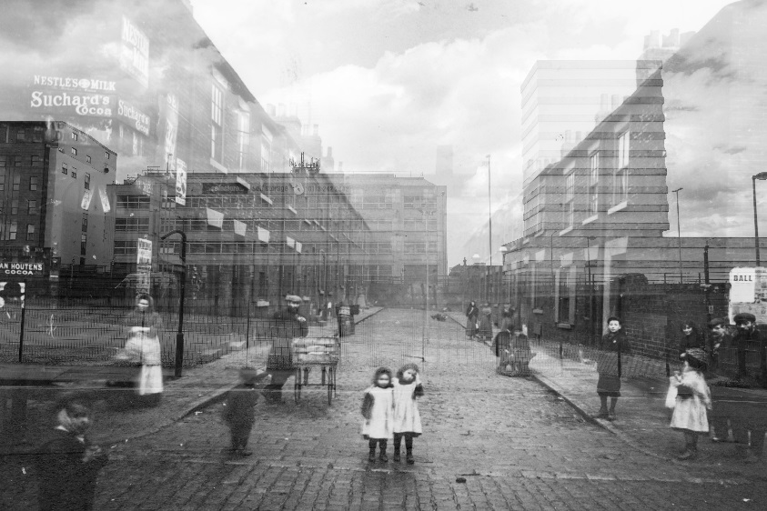

*Fig 1. Michael C Coldwell, Cross Templar Street 1901-2017. Courtesy of the author.*

Spaces change over time and can certainly be haunted by what came before – however, there is an allusion to permanence in Lefebvre’s portrayal of space, “enduring and remaining”, which conflicts with photography of urban spaces which have changed beyond all recognition. Sometimes all that is left are those very “traces, memories or relics” to which Lefebvre refers, the very last of which may well be photographic. While space can be socially produced it must also be possible that it can be socially destroyed, with that destruction being driven by capital and class in the ways Lefebvre[18] himself identified.

In Figure 1, just such a trace is used rephotographically – a prosthetic ‘memory’ of a space which now only exists on paper (and its spectral copy flickering across screens). The original image used in this montage represents a space which did not endure, a street which no longer exists, in a district which has all but disappeared – from the city’s social space and increasingly from lived-memory too. This haunting archival photograph is from Quarry Hill[19], an inner-city borough of Leeds in the UK. Otherwise known as Leeds’ East End, this area has seen multiple waves of slum clearance since the late 19th Century. Each major demolition event has constituted a comprehensive erasure of what came before – Quarry Hill no longer fulfils its historical social function as a residential area for extremely low-income families, no traces of these buildings or even the original road layout, remain today. While a small number of historic buildings do survive in this corner of the city, which is approximately 100 acres in size, the space has been radically transformed over the last century. The Victorian slum was cleared in its entirety and a whole new housing estate constructed in the late 1930s, the largest social housing complex in the UK: the infamous Quarry Hill flats[20].

**REPRESENTING DISAPPEARANCE**

This later ‘slum’ was demolished too, in 1978. The disappearance of Quarry Hill flats was documented beautifully in a book entitled Memento Mori by photographer Peter Mitchell[21]. Mitchell’s images of the 1978 clearance were interspersed with archival photographs of the complex, as a new and celebrated architectural work, with blueprints and advertisements, and with vernacular photographs and accounts by the residents themselves, interviewed just before eviction. Quarry Hill’s intriguing photographic documentation does not end with Mitchell. A body of photographs of the previous slum have survived and have been used to great critical effect in a canonical book on representation by John Tagg[22]. In a chapter entitled God’s Sanitary Law, Tagg examined these archival photographs of Quarry Hill, taken before the wave of slum clearance which began at the turn of the last century. These photographic artefacts, held by Special Collections[23] at the University of Leeds, were of particular interest to Tagg, because Leeds Corporation commissioned them for the sole purpose of making the political case for demolition. The entire district had been branded “unhealthy” by the authorities, and these images were taken to evidence that position, effectively demonising the area prior to its wholesale destruction.

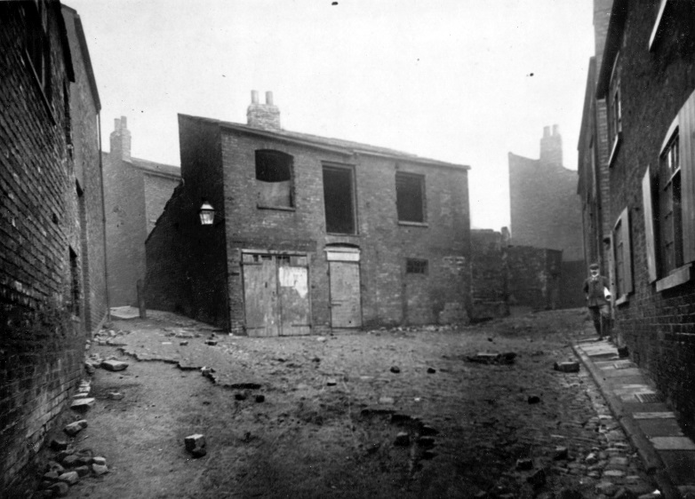

*Fig 2. Photographer unknown, Cornhill, East End, 1901. Reproduced with the permission of Special Collections, Leeds University Library.*

For Tagg, the photographs were evidence of something else: the lack of a truly objective evidential power to the photograph, but equally, the power the photograph does wield in the hands of authority, its “contentious legal realism” [24], and its potent political and rhetorical uses, which are often far from forensic. The photographs themselves are often hauntingly empty (see Figure 2), the slum-dwellers were unrepresented in this photographic ‘evidence’ of residential space – barring the occasional blurred face at a window, the only fleeting indication that these streets weren’t already abandoned at the time that they were taken.

This research follows in Mitchell’s footsteps and returns to Quarry Hill in 2017, but this time armed with Tagg’s archival views of the long-lost slum, intending to reveal the vast changes that had taken place to this ostensibly ‘static’ space. This became a rephotography project in which rephotography in the usual mode was practically impossible. The artefacts were taken back to the area as it stands today, an unrecognisable space, haunting it with views of its prior self – views that seem to be from a different world entirely.

**The problem with rephotography**

As a method of recording change in cities, and of experiencing past spaces, rephotography has some surprising inadequacies. The photographer and author of this chapter has been using the technique to document the changing urban environment in Leeds for some years, with somewhat inconsistent results. Rephotography initially seemed like the obvious medium to use for mapping areas of the city under some form of erasure: the gradual disappearance of the city’s industrial and working class past. Quarry Hill is undergoing rapid modification once again, set for mass redevelopment for the fourth time in a hundred years; the area is now being rebranded SOYO[25], a new “cultural” sector in the city. This new wave of regeneration has elicited allegations of gentrification, the adjoining areas being some of the most deprived in the county, and neighbouring Mabgate, a former industrial zone, now being home to many artists and small enterprises, making use of cheap rent and large spaces in the crumbling Victorian warehouses that have survived. Earlier photographic research addressing these spaces entitled The Disappearing City[26], did not involve archival images, but instead used iterative rephotographic methods to reveal changes as they were happening.

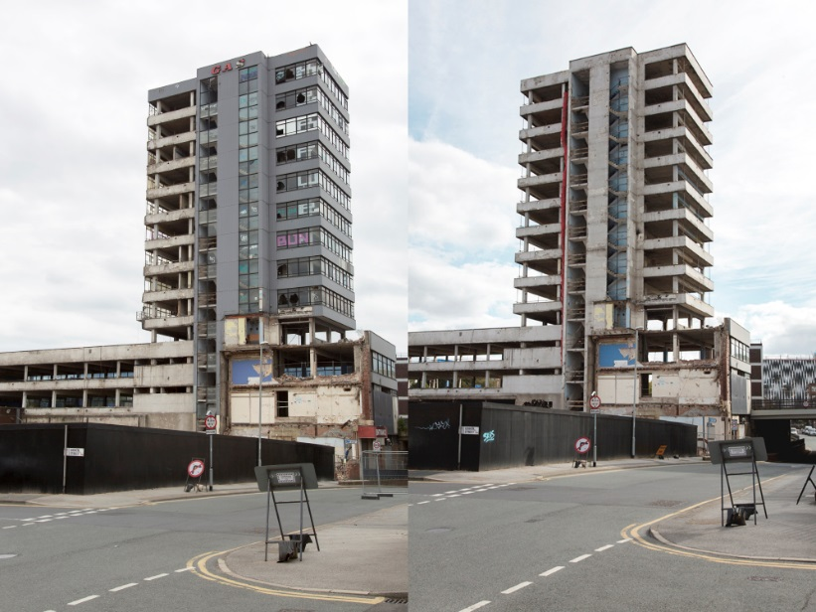

*Fig 3. Michael C Coldwell, Deconstruction, Gower Street, Leeds, 2016 from The Disappearing City. Courtesy of the author.*

In such rephotography one slice of time is shown and then the next. They are presented together as a sort of narrative diptych, but little about these montages informs us of the nature or reasons for the spatial changes depicted. Under closer inspection rephotography can be seen as something of a gimmick, a spatial trick picture and a game of spot the difference, rather than an insightful engagement with urban change and the social issues surrounding it. Focussing on the period of transformation itself (Figure 3 – in this case demolition) something temporal and dynamic was indeed captured in the work, but the final results still seemed limited in what they could communicate. They are certainly formally gratifying – the repetition performs a strong aesthetic function – but they are spatially composed and framed around what has stayed the same, rather than concentrating on what has actually changed – or the effects (or indeed social affects) of that change. It is the repetition of persisting spatial features that actually draws the eye. All of the various practices of rephotography share these traits. It is essential for the two photographs used to both contain the same persisting features of the landscape or built environment – crucial spatial reference points[27] which allow recognition that the same scene is presented twice, to establish a continuing sense of place. These enduring features maintain the false sense of permanence or stasis mentioned earlier with regards to Lefebvre, and this form fails to communicate any profound change, formally wedded as it is to its opposite.

In much ‘professional’ rephotography this diptych form dominates. In the cartographic explorations of Mark Klett[28], exploring the changing landscapes of the American mid-west, or the precise recreation of historically significant photographs seen in Douglas Levere’s rephotography of Berenice Abbott’s New York[29] and Eugene Atget’s Paris[30]. Here there is a determination to keep yet more variables under precise control, all features of the image unerringly the same. In these latter examples, even the same historical cameras, lenses and film stocks were used, in a concerted effort to take the same photograph again. Even in what could be termed “vernacular” rephotography – the contemporary social practice[31] in which old printed photographs are physically held up in front of the camera – the form is still dictated by an ability to register the two views presented, and subsequently, understand them as the same view. This limits the rephotographic form and its various practices to spaces which have remained largely the same. The rephotographic motivation to overcome the temporal limitation of the static photograph, and reveal change through a pairing, or even sequence of stills, is nonetheless encumbered by that same photographic stasis, and its unavoidable fragmentation of space as well as time. In Jason Kalin’s words:

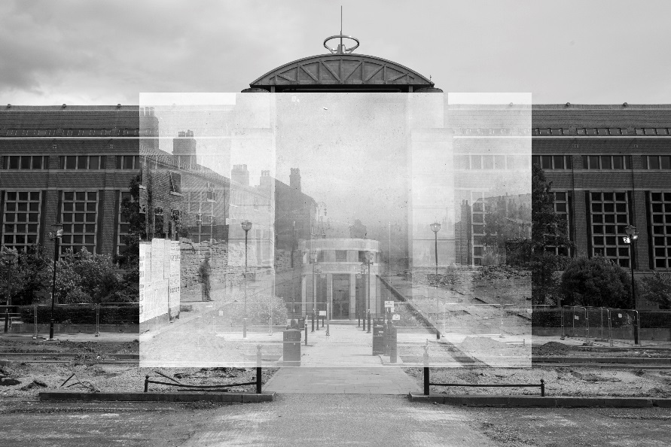

*Fig 4. Michael C Coldwell, Unhealthy Area, Quarry Hill 1905-2017. Courtesy of the author.*

Rephotography is best understood as hauntography to emphasise how any perspective upon the present is haunted by its own past. Hauntography – hauntological montage – retemporalizes memory by inventing memory images and places that mobilize perspectives and bodies to perform acts of personal and public remembering[32]

**HAUNTING AS AN INTERVENTION**

Despite some profound formal weaknesses, there is merit in continuing to push rephotography’s limits – using its fragmentation and uncanny stasis to reveal the city as a moving target. By taking ‘impossible’ rephotographs of urban landscapes that have changed beyond all recognition, the form deconstructs itself, and also challenges the photographic impression of the city as a static space. In this revised form of the medium the archival photograph floats unmoored in the landscape, unable to form a synthesis with the contemporary view, revealing itself as a spectral and disembodied trace of what came before – a ghost (or “hauntograph” [33]) of some prior spatial configuration that no longer makes sense in a wholly transformed, and continually transforming, environment. In this ‘deconstructed rephotography’, the idea is not to attempt an illusion of continuity between past and present, or to create a sense of place where this is no longer possible, but to highlight that very haunting disjuncture[34]. It renders rephotography a method of approaching the forgotten for what it is, rather than “inventing memory images”[35]. The deconstructed rephotograph might communicate a sense of loss and absence, where rephotography in the normal mode attempts to construct a disingenuous presence, an illusion of a recreated past or something actually remembered. In deconstructed rephotography the contemporary city is haunted by the unknown and by the lost, overwhelmingly affected by the enormity of the change that has taken place. Conventional rephotography papers over the temporal cracks, impressing with its technical accomplishment under the misapprehension of successful time travel.

Using the same archival photographs as John Tagg, this project began the deconstructed rephotography of Quarry Hill, carefully studying maps and methodically rephotographing the streets that no longer exist. For some of the archival images it was possible to get very close to the original locations, although this was certainly not obvious from the final outcomes. In others the positioning was necessarily very approximate. Even so, in each case, the archival image was returned to haunt the right area of Quarry Hill, and as the two views could no longer be registered anyway, great precision in that regard seemed of limited importance. Being in roughly the right location was crucial though, and necessary for these images to work as an intervention in the contemporary space; to work as a comment on what should be valued in cities and their histories; to mean something indexically, even if they could no longer work as functioning icons of place.

**Reanimating the dead**

In a video installation entitled The Remote Viewer[36], these deconstructed rephotographs of Quarry Hill were then projected over one another to create new media art. In this project movement is reintroduced to the static spaces represented. The two views wander about, tracking, unable to gain purchase, they slowly float apart, echoing the impossible search for streets which have disappeared and the unfeasible act of rephotography in truly changing spaces. This draws attention to the equally impossible and uncanny stillness of the photographs themselves, unnaturally frozen points in time, the added motion highlighting the implausibility of any real stasis in a relentlessly mutable world. The result is a restless, shifting palimpsest of ‘static’ images, a haunting metaphor for the changing city itself. As they await new development these voids in Leeds certainly echo the sentiments of Andreas Huyssen, of the city as some “fast changing palimpsest”[37] in which traces are restored and erasures documented. The role of photography here seems vital – without such lens-based interventions in the space, can there be any assurance that memories of these lost slums will remain part of this re-written city text? The urban palimpsest “implies voids, illegibilities and erasures”[38], but must also somehow preserve coherent traces to function as prosthetic memories in its structure, in order to keep these stories alive at all.

In The Remote Viewer the photographs are made to return and literally haunt the spaces from which they came – intervening and problematizing the contemporary urban landscape. This seems in-keeping with Derrida’s own ideas on the politics of haunting – that haunting can be an intervention[39] and potentially a radical act. The idea that the ghosts of history cannot be fully silenced, that they will somehow return, that we can intervene and wake the dead in the name of justice[40]. Spectropolitics[41] is also congruent with the original problematic use of these images, very selectively taken to make the case for slum clearance (which for some meant dispossession, the break-up of communities and the destruction of working class space) but which failed to represent, let alone consult, those that would be most affected by it. They are the real ghosts in this work – the conspicuous silence felt – the absent presence of those that once inhabited these now voiceless spaces.

Alongside this haunting narrative of displacement and dispossession, there is also a more universal spectrality at work in these shifting images – what Roland Barthes called “time as punctum”[42] – the still photograph as the most affective haunting reminder of transience. The punctum of photography is not limited to human mortality. People can be equally haunted by the impermanence of the traces left behind – homes and cities are also mortal. The photograph of urban space becomes a memento mori – a visual reminder of entropy itself. Shelley Hornstein invokes Derrida in her exploration of these themes in *Losing Site* (2013). The idea that buildings and homes are always in a process of ruin is certainly an evocative one, as is the notion that permanence is an idealisation of architectural form. The hidden truth, revealed in both that work and this, is that homes and cities are temporary structures, “always dissolving before our eyes, transforming” [43] and falling out of memory entirely. The deceptive sense of stillness in both photography and architecture, belies and hides this fact.

**CONCLUSION**

our attempts to reflect the world – to record and mark it orthographically – have built into them our failure to do so.[44]

Notwithstanding its temporal limitations, and the many changes to both the technology and social practices of the medium, photography still provides a vital tool for the detailed study and contemplation of urban change, presenting tantalizing glimpses back in time – views of another world that once stood in place of this one. The very stillness of the photographic image makes careful examination of previous spatial configurations possible, giving access to space in a way prohibited in moving images. The photographic archive allows people to remember the forgotten and keep haunting traces of the dead alive. There are certainly limits to what the photograph can capture and communicate – it isn’t as reliable a source of evidence as people would like it be. The common faith in its evidential force is routinely exploited (as seen with Tagg’s investigation of slum clearance mentioned here, and in so many other rhetorical uses of the image) and so reminders of this fallibility are vital, as are reminders that the archive preserves only fragmentary traces of what came before. New practices such as deconstructed rephotography have the potential to help illuminate these mediations, limitations and failures, as well as helping to highlight the significant changes happening in all urban space – the disappearance of entire neighbourhoods and the hidden and forgotten trauma of this loss. In deconstructed rephotography these things are seen through their erasure and their invisibility, through an intentional frustration of our usual attempts to orientate ourselves spatially, and apprehend or simplify the vast changes that have taken place.

Projecting ghosts into sites of redevelopment and regeneration is a gesture towards preserving the urban palimpsest in the face of its potential effacement. Layering times and traces that hauntingly no longer fit – ghosts of the past that struggle “on the same terrain without prospects for reconciliation” [45], can be a political act, countering those that would erase uncomfortable narratives and inconvenient memories. In these urban voids, “saturated with invisible history”[46], it is their palimpsestic quality that haunts. When this is erased in large-scale demolition and regeneration projects, we lose both a fragile link to the past and any palpable sense that change is occurring at all.

**bibliography**

Augé, Marc. *Non-Places: Introduction to an Anthropology of Supermodernity*. London: Verso, 1995.

Barthes, Roland. *Camera Lucida: Reflections on Photography*. London: Vintage, 1993.

Bird, Lawrence. "Territories of Image: Disposition and Disorientation in Google Earth." In *Imaging the City: Art, Creative Practices and Media Speculations*, edited by Steve Hawley, Edward Montgomery Clift and Kevin O'Brien. Bristol;Chicago, IL;: Intellect Ltd, 2016.

Blanco, M., and Esther Peeren. *The Spectralities Reader: Ghosts and Haunting in Contemporary Cultural Theory*. London: Bloomsbury Academic, 2013.

Brogden, Jim. *Photography and the Non-Place: The Cultural Erasure of the City*. Palgrave Macmillan, 2019.

Derrida, Jacques. *Right of Inspection*. New York, N.Y: Monacelli Press, 1998.

Derrida, Jacques. "Specters of Marx: The State of the Debt, the Work of Mourning and the New International." New York;London;: Routledge, 2006.

Edensor, Tim. "Haunting in the Ruins: Matter and Immateriality." *Space and Culture* 11, no. 12 (2001): 42-51.

Fisher, Mark. "Phonograph Blues." *K-Punk* (2006). <http://k-punk.abstractdynamics.org/archives/008535.html>.

Fox, William L. *View Finder: Mark Klett, Photography, and the Reinvention of Landscape*. UNM Press, 2001.

Graham, Stephen. "Introduction: Cities and Infrastructure." *International Journal of Urban and Regional Research* 24, no. 1 (2000): 114-19.

Heholt, Ruth. "Unstable Landscapes: Affect, Representation and a Multiplicity of Hauntings." In *Haunted Landscapes*, edited by Ruth Heholt and Niamh Downing. Place, Memory, Affect: Rowman and Littlefield International, 2016.

"History of Quarry Hill." Leeds Play House, https://leedsplayhouse.org.uk/about-us/playhouse-redevelopment/history-of-quarry-hill/.

Hornstein, Shelley. *Losing Site: Architecture, Memory and Place*. Ashgate Publishing, Ltd., 2013.

Huyssen, Andreas. *Present Pasts: Urban Palimpsests and the Politics of Memory*. Stanford, Calif: Stanford University Press, 2003.

Jenkins, William. "New Topographics: Photographs of a Man-Altered Landscape." *Rochester, NY: The International Museum of Photography at George Eastman House*  (1975).

Kalin, Jason. "Remembering with Rephotography: A Social Practice for the Inventions of Memories." *Visual Communication Quarterly* 20, no. 3 (2013): 168-79.

Klett, Mark. "Repeat Photography in Landscape Research." *The Sage handbook of visual research methods*  (2011): 114-30.

Kracauer, Siegfried, and Thomas Y. Levin. *The Mass Ornament: Weimar Essays*. Cambridge, Mass: Harvard University Press, 1995.

Lefebvre, Henri, and Donald Nicholson-Smith. *The Production of Space*. Oxford: Blackwell, 1991.

Levere, D. *New York Changing: Revisiting Berenice Abbott's New York*. Princeton Architectural Press, 2005.

Liu, Yuting, Shenjing He, Fulong Wu, and Chris Webster. "Urban Villages under China's Rapid Urbanization: Unregulated Assets and Transitional Neighbourhoods." *Habitat International* 34, no. 2 (2010): 135-44.

Mitchell, Peter. *Memento Mori: The Flats at Quarry Hill, Leeds*. 2nd Edition ed.: RRB Photobooks, 2016.

Munteán, László. "Double Exposure: Rephotography and the Life of Place ". In *Spectral Spaces and Hauntings: The Affects of Absence*, edited by Christina Lee: Taylor & Francis, 2017.

"Print Item: Photographs of Properties Situated in the Quarry Hill Unhealthy Area. Taken Dec. 1900 & Jan. 1901." Special Collections: University of Leeds.

Rauschenberg, Christopher, Eugène Atget, Clark Worswick, Alison Devine Nordström, and Rosamond Bernier. *Paris Changing: Revisiting Eugene Atget's Paris*. New York: Princeton Architectural Press, 2007.

Schofield, Michael Peter. "Aura and Trace: The Hauntology of the Rephotographic Image." University of Leeds, 2018.

Simpson, Mavis. "The History of Quarry Hill." <http://www.bbc.co.uk/leeds/citylife/quarry_hill/history.shtml>.

"Soyo Leeds." https://soyoleeds.com/.

Stankovic, Jelena. "Mapping the City as Remembered and the City as Imaged." In *Imaging the City: Art, Creative Practices and Media Speculations*, edited by Steve Hawley, Edward Montgomery Clift and Kevin O'Brien. Bristol;Chicago, IL;: Intellect Ltd, 2016.

Tagg, John. *The Burden of Representation: Essays on Photographies and Histories*. Basingstoke: Macmillan Education, 1988.

"Tracks in Time: The Leeds Tithe Map Project." Leeds City Council <http://tithemaps.leeds.gov.uk/>.

**END NOTEs**

1. While this may seem something of an obvious observation, surprisingly little research focuses on the mutability of the city as experienced. “The constant flux of this urban process is constituted through many superimposed, contested and interconnecting infrastructural ‘landscapes’ which provide the mediators between ‘nature’ and the production of the ‘city’.” Stephen Graham, "Introduction: Cities and Infrastructure," *International Journal of Urban and Regional Research* 24, no. 1 (2000). P. 114
2. Andreas Huyssen, *Present Pasts: Urban Palimpsests and the Politics of Memory* (Stanford, Calif: Stanford University Press, 2003). 1
3. Ibid. 49
4. Jelena Stankovic, "Mapping the City as Remembered and the City as Imaged," in *Imaging the City: Art, Creative Practices and Media Speculations*, ed. Steve Hawley, Edward Montgomery Clift, and Kevin O'Brien (Bristol;Chicago, IL;: Intellect Ltd, 2016). 78
5. Michael Peter Schofield, "Aura and Trace: The Hauntology of the Rephotographic Image" (University of Leeds, 2018).
6. William Jenkins, "New Topographics: Photographs of a Man-Altered Landscape," *Rochester, NY: The International Museum of Photography at George Eastman House* (1975).
7. Mark Klett is one of the leading exponents of the rephotographic genre, he defines it thus: “A repeat photograph, or ‘rephotograph’ is a photograph made to duplicate selected aspects of another… The new image typically repeats the spatial location of the original” Mark Klett, "Repeat Photography in Landscape Research," *The Sage handbook of visual research methods* (2011).
8. “Hauntology” is a philosophical neologism coined by Jacques Derrida, Jacques Derrida, "Specters of Marx: The State of the Debt, the Work of Mourning and the New International," (New York;London;: Routledge, 2006).
9. Many theorists have alluded to photography’s spectral nature, but none more so than Derrida. “I like the word “medium” here. It speaks to me of specters, of ghosts and phantoms, like these images themselves. From the first 'apparition’, it’s all about the return of the departed… The spectral is the essence of photography” *Right of Inspection* (New York, N.Y: Monacelli Press, 1998). 34
10. “Hauntology isn't about hoky [sic] atmospherics or 'spookiness' but a technological uncanny” Mark Fisher, "Phonograph Blues," *K-Punk* (2006), http://k-punk.abstractdynamics.org/archives/008535.html.
11. M. Blanco and Esther Peeren, *The Spectralities Reader: Ghosts and Haunting in Contemporary Cultural Theory* (London: Bloomsbury Academic, 2013). 31
12. Tim Edensor, "Haunting in the Ruins: Matter and Immateriality," *Space and Culture* 11, no. 12 (2001). P. 48
13. “A shudder runs through the viewer of old photographs. For they make visible not the knowledge of the original, but the spatial configuration of a moment” Siegfried Kracauer and Thomas Y. Levin, *The Mass Ornament: Weimar Essays* (Cambridge, Mass: Harvard University Press, 1995). 56
14. “Landscapes shift and move, ‘collapse and cohere’, as we traverse them. This makes the static representation of place, catching the essence of the landscape, impossible” Ruth Heholt, "Unstable Landscapes: Affect, Representation and a Multiplicity of Hauntings," in Ruth Heholt, "Unstable Landscapes: Affect, Representation and a Multiplicity of Hauntings," in *Haunted Landscapes*, ed. Ruth Heholt and Niamh Downing, Place, Memory, Affect (Rowman and Littlefield International, 2016). 4
15. Yuting Liu et al., "Urban Villages under China's Rapid Urbanization: Unregulated Assets and Transitional Neighbourhoods," *Habitat International* 34, no. 2 (2010).
16. The term ‘non-place’ originates in Marc Augé, *Non-Places: Introduction to an Anthropology of Supermodernity* (London: Verso, 1995). It takes on new signification in Jim Brogden’s photographic exploration of post-industrial dereliction and liminal areas of the city: Jim Brogden, *Photography and the Non-Place: The Cultural Erasure of the City* (Palgrave Macmillan, 2019).
17. Henri Lefebvre and Donald Nicholson-Smith, *The Production of Space* (Oxford: Blackwell, 1991). 229
18. Ibid. 418
19. A very potted history of the area can be found here for context: Mavis Simpson, "The History of Quarry Hill," http://www.bbc.co.uk/leeds/citylife/quarry_hill/history.shtml.
20. "History of Quarry Hill," Leeds Play House, https://leedsplayhouse.org.uk/about-us/playhouse-redevelopment/history-of-quarry-hill/.
21. Peter Mitchell, *Memento Mori: The Flats at Quarry Hill, Leeds*, 2nd Edition ed. (RRB Photobooks, 2016).
22. John Tagg, *The Burden of Representation: Essays on Photographies and Histories* (Basingstoke: Macmillan Education, 1988). 117
23. "Print Item: Photographs of Properties Situated in the Quarry Hill Unhealthy Area. Taken Dec. 1900 & Jan. 1901," (Special Collections: University of Leeds).
24. Ibid., 144.
25. "Soyo Leeds," https://soyoleeds.com/.
26. http://www.michaelcoldwell.co.uk/disappearingcity.html
27. “Things that are recognisable in the photograph and surroundings play a crucial role as reference points – landscapes, streets, buildings and certain household fixtures and furnishings tend to remain stationary and may have out-lasted human lives. Their identification is key to the experience of place” László Munteán, "Double Exposure: Rephotography and the Life of Place " in *Spectral Spaces and Hauntings: The Affects of Absence*, ed. Christina Lee (Taylor & Francis, 2017).136.
28. William L Fox, *View Finder: Mark Klett, Photography, and the Reinvention of Landscape* (UNM Press, 2001).
29. D. Levere, *New York Changing: Revisiting Berenice Abbott's New York* (Princeton Architectural Press, 2005).
30. Christopher Rauschenberg et al., *Paris Changing: Revisiting Eugene Atget's Paris* (New York: Princeton Architectural Press, 2007).
31. Jason Kalin, "Remembering with Rephotography: A Social Practice for the Inventions of Memories," *Visual Communication Quarterly* 20, no. 3 (2013).
32. Ibid. 176.
33. Ibid. 176.
34. “It is this sense of temporal disjuncture that is crucial to hauntology. Hauntology isn't about the return of the past, but about the fact that the origin was already spectral. We live in a time when the past is present, and the present is saturated with the past. Hauntology emerges as a crucial - cultural and political - alternative both to linear history and to postmodernism's permanent revival.” Fisher, "Phonograph Blues".
35. Kalin, "Remembering with Rephotography: A Social Practice for the Inventions of Memories." 176
36. http://www.michaelcoldwell.co.uk/auratrace.html
37. Andreas Huyssen, *Present Pasts: Urban Palimpsests and the Politics of Memory* (Stanford, Calif: Stanford University Press, 2003). 83
38. Ibid. 84
39. “I suggest that a haunting needs an outside, interpretive presence: a haunting is an intervention, an encounter” Heholt, "Unstable Landscapes: Affect, Representation and a Multiplicity of Hauntings.", 5.
40. “If I am getting ready to speak at length about ghosts, inheritance, and generations, generations of ghosts, which is to say about certain others who are not present, nor presently living, either to us, in us, or outside us, it is in the name of justice” Derrida, "Specters of Marx: The State of the Debt, the Work of Mourning and the New International." xviii.
41. Blanco and Peeren, *The Spectralities Reader: Ghosts and Haunting in Contemporary Cultural Theory*. 91
42. Roland Barthes, *Camera Lucida: Reflections on Photography* (London: Vintage, 1993). 94
43. Shelley Hornstein, *Losing Site: Architecture, Memory and Place* (Ashgate Publishing, Ltd., 2013). 83.
44. Lawrence Bird, "Territories of Image: Disposition and Disorientation in Google Earth," in *Imaging the City: Art, Creative Practices and Media Speculations*, ed. Steve Hawley, Edward Montgomery Clift, and Kevin O'Brien (Bristol;Chicago, IL;: Intellect Ltd, 2016). 21
45. Andreas Huyssen, *Present Pasts: Urban Palimpsests and the Politics of Memory* (Stanford, Calif: Stanford University Press, 2003). 77
46. Ibid. 58