Touch and Talk: Detailing Embodied Experience in the Music Masterclass
Darren J Reed
Sociology Department, University of York, York, UK
Correspondence: Darren.reed@york.ac.uk
Darren Reed is a social scientist and Senior Lecturer specialising in embodied, online and device-based interaction. His background is in ethnomethodology and conversation analysis, as well as technology development and design. He teaches on the Social Psychology pathway in the Sociology department.

Touch and Talk: detailing embodied experience in the music masterclass
This paper analyses talk and touch in interaction in a musical masterclass setting. It shows how sequences of touch and talk enable the public evaluation and instruction of internal body experience through a focus on three forms of touch: 'demonstrative touch', 'diagnostic touch,' and 'manipulative touch'. As a consequence, it highlights the mechanisms of semiotic power in the instructional relationship as the province of private reflection (the embodied sense) is made public and available for the embodied instruction of a group of students.
Keywords: touch; talk-in-interaction; conversation analysis; body instruction; masterclass.

Introduction
Knowing how one's body feels - our 'inner experiences' - are private matters. Yet, in various social situations, such as performance education, therapeutic interaction, and medical diagnosis, the 'felt life' of the body is topicalised and constituted by ordered practices of social interaction. In this sense, this is a paper about 'body instruction' or 'body pedagogics' (Shilling 2017). It is about attaining appropriate "techniques of the body" ("techiques du corps", Mauss 1973) - how to use it; but it is also about appropriate ways to feel with and through the body - how to experience it. I take the position that the ability to show, diagnose, and define particular embodied 'experiences' inheres in sequences of talk-in-interaction and pedagogic performance (Cekaite 2015). This paper, therefore, undertakes an analysis of touch and talk in a performance masterclass.
Experience of the body links to a range of interests in the sociology of the body and the philosophy of body perception (Williams and Bendelow 1998; Howson and Inglis 2001; Shusterman 2012, 2008). In sociology, the debate as to whether the body was absent in research, or implicitly contained in research into "behaviour, action, interaction, practice, praxis" (Crossley 2007, 84) is ongoing. Such concerns rest on a broader critical approach to the body, and more specifically touch, in sociology. Shilling (2007, 2017) identifies 'body pedagogics' as an essential topic,
Body pedagogies may be defined as referring to the central pedagogic means through which a culture seeks to transmit its main corporeal techniques, skills and dispositions, the embodied experiences associated with acquiring or failing to acquire these attributes, and the actual embodied changes resulting from this process. (Shilling 2007, 13)

Body pedagogy implicates interactional settings in which the body undergoes instruction and learning (Aalten 2007; Crossley 2007; Lande 2007; O'Connor 2007). These interactions involve forms of body knowledge and experience, sanctioned, in broad terms, by claims to expertise in the unfolding embodied 'transactions' between actors. Embodied instruction implicates such transaction that, in turn, involve forms of power in interaction. As Shilling points out,
the fact occupational body pedagogics can be designed explicitly to structure the tacit – even in terms of how people stand or move – illustrates that it can be translated into prompts/exercises designed to teach others specific ways of knowing and acting. The power relationships implicated in who is able to direct consciously the pre-conscious cultural learning of others is an important sociological issue. (Shilling 2017, 1216)

Such pedagogic 'prompts' include the use of touch. However, while Shilling's earlier writing enriches an understanding of body pedagogics, and points to critical sociological issues of power, it does so through theoretical means. Arguably such a strategy precisely escapes the embodied instantiation of knowledge in ongoing and practical instances of learning.
This paper draws on Garfinkel's understanding of the phenomenology of everyday practices. Here Garfinkel transforms the philosophical approach into a matter of mundane 'constitutive practices' by saying that 'every philosophy, every theory, every attitude toward the world has its relevant phenomenology' (Garfinkel and Rawls 2015, 116). These 'phenomenologies' rest on a distinction made between the 'theoretical sense' and the 'data sense' of any interaction, i.e. what is understood as data, or evidence and what is understood as conception and argument.
By pursuing an understanding of experience as a practical matter of the 'theoretic' and 'data sense' of the body in everyday practices, and hence as a sequence of constitutive practices, I contribute to an appreciation of body instruction from an interactional perspective. At the same time, by taking an ethnomethodological approach to the phenomenology of experience, the gaze is lifted from individual experiences to social practices of sense-making.

Touch and feel
There is a long history of academic interest in touch that occurs in disciplines such as neuroscience, psychology, and cultural geography (Gallace and Spence 2010; Hetherington 2003). While these approaches often incorporate social aspects (based on gender, sexuality, setting, interpersonal communication and influence, for example), they rarely extend to study of social action and interaction. The work which does approach such mundane practices does so by counting and categorising forms of touch in situations such as greetings (e.g. Greenbaum and Rosenfeld 1980).
Touch is rightly positioned as an intimate form of social behaviour. It is also a social action, an interactional resource for embodied display. M. H. Goodwin and Cekaite (2014) show the interactional use of touch in the "choreographing of directive response sequences" (185). They show "how the timing and coordination of haptics (communicative acts of touch), speech, and contextual factors produce communicative meanings" (Cekaite 2015, 152). Their work sits within a broader concern with adult-child interactions that exemplify a "multifunctional interactional resource for control, affection, and instruction" (ibid. 153). These studies show the close interweaving of directive talk and touch (Cekaite 2010, 2015).
Similarly, Kääntä and Piiraninen-Marsh (2013) show what they call the "manual guiding" of objects and bodies between peers in the classroom, as a means to accomplish group tasks. Nishizaka, & Sunaga (2015) analyse embodied contact through the hands in massage interaction and view these activities as manifesting "asymmetries" in embodied interaction and see the talk as reflective conversations on those asymmetries. Such interactions, then, are supportive of forms of power relations.
There is relatively little social research into the Alexander Technique (AT). However, the work of Tarr (2008, 2011) provides a useful insight into a critical sociological approach that rests on the work of Csordas (2002) and Foucault (2012) with AT situated as a form of 'somatic mode of attention' and as a 'technique of the self' respectively. The Technique's focus on inhibiting the embodied habits of the body also extends from the work of Bourdieu (1988) and the 'somaesthetics' line in the philosophy of Shusterman (2008, 2012). A primary feature of the AT interaction is that the individual's 'feelings' about their body and experiences are positioned in the process as untrustworthy to set up the intervention by the practitioner (Tarr 2011; Alexander [1932]1985):
[S]essions include activities to make pupils aware that they suffer from what the Technique calls 'faulty sensory awareness' and to enable them to differentiate aspects of their movement and thereby develop more precise awareness of their bodily use. (Tarr 2011, 254)
An essential aspect of the above description is the distinction it makes between individual — and potentially 'internal' kinaesthetic experience — and the externalisation of that experience to make it available for interaction, intervention and instruction. In this way, the phenomenology of the perceived body and the sense a person has of their movements (or kinaesthesis), is made interactionally available to both the practitioner and, in the case of the master class, the audience members (see Streeck 2015 for a discussion of kinesthetics in interaction).
This paper contributes to an interest in touch as an ordering practice within social interaction by introducing the notion of a sequence of 'pedagogic touch'. Here touch is not only a matter of interactional practice between two or more individuals, but it is also produced to be seen by others in a public context, specifically an asymmetrical 'instructional' context. While applied to a particular performance-pedagogic setting (and extendable to other areas such as dance tuition, e.g. Keevallik 2010), pedagogic touch can be identified in a range of social situations, and hence there is potential for extending such analysis to everyday activities beyond the performance domain.
The argument proposed is that making sense of the body through sequentially-ordered practices of touch-in-interaction provides a means to address the embodied instruction of the 'inner experience' of the body and in so doing reveals the way that the semiotic resource of touch perpetuates an imbalance in power relations between (in this case) an instructor and an instructed person.

The Masterclass Setting
Master classes play a central role in the music curricula of conservatoires and universities. The format consists of a series of public one-on-one coaching sessions in front of an audience of peers and the general public (Hanken 2008). Masterclasses are a form of institutional interaction (Heritage and Greatbatch 1991) and differ in a variety of ways from natural talk. A typical goal is the participants' collaborative pursuit of performance-oriented 'learnables' (Koschmann and Zemel 2011; Szczepek Reed, Reed, and Haddon 2013). These learnables are oriented not only to the performed piece, but also the manner of performance; that is, the general attitude and embodied approach to playing, singing, and performing. This instruction involves making comments about the body of the performer and focusing the attention of the student through active body commentary and manipulation. These manipulations occur through intimate physical interactions between master and student, yet require that they be available to onlooking participants for them to figure as collective instruction and learning.
Classical performance is embodied. The body is most apparent and prominent in voice training, when it takes the place of the musical instrument, but is also present in the discussion of the embodied character of the instrument-based performance. Some masterclasses include a specialist in embodiment who focusses on how the body, and its use, provides a foundation for performance. In the instances in this paper, a teacher of the Alexander Technique— a therapeutic approach to performance embodiment — undertakes the role of an instructor in the masterclass.
The Alexander Technique takes its name from its creator Frederick Matthias Alexander (Alexander [1932]1985). It is a form of educational interaction between a student and teacher in which the habitual patterns of movement and posture are 'retrained'. Alexander was an actor, and the approach extends from his reflective examination of (his own) embodied performances. It is popular in performance tuition (Valentine 2004; Valentine et al. 1995) but was almost immediately extended to more general body therapy and became popular amongst a wide range of American intellectuals and public figures in the early nineteen hundreds (Jain, Janssen, and DeCelle 2004).
The paper shows three forms of touch concerning body sensitisation, diagnosis and manipulation; student acknowledgement in question-answer sequences oriented to body perception; and the transformation of the interaction between student and master into a matter for onlooking participants, as a form of collective embodied experience and learning.

Data and Analysis
The data for this analysis comes from two two-day masterclass event organised by the music charity Live Music Now (http://www.livemusicnow.org.uk). The recordings form part of a corpus of fifty hours of recorded masterclasses. The recording entailed multiple video cameras, positioned to capture activity from multiple angles. They were transcribed with an adapted Jeffersonian notation (ten Have, 1999) and analysed as sequences of verbal and embodied interactions. A subset of these data involves three masters (a singer, an instrumentalist, and an AT practitioner) each bringing different perspectives to bear on the instructional interaction. The analysis focuses on the Alexander Technique master who intervened at particular points in the masterclass to instruct the performers about the use of their body in performance.

Spatial orientation, visibility and touch
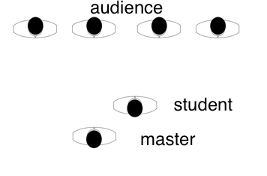
Figure 1: Spatial Positions of master, student and audience

A central aspect of the AT master interaction with the student is the spatial orientation of the actors. As with all master class interactions, the teaching occurs in front of an audience. This audience is made up of other students in the particular instances under investigation. The master provides 'informings' and 'learnables' (Reed and Szczepek Reed 2014, 452) for the student in the first instance; but the instructional interaction is visible to the accumulated onlookers. Also, elements of the instructional interaction are explicitly made relevant to the audience through lecture-like asides, which extend the points made. The onlooker orientation is engineered through the positioning of the bodies of the master and student (see Figure 1). Those aspects of the interaction between master and student that are unseen, because they occur behind the student's back, or are so subtle as to be imperceptible, are topicalised and drawn out through the verbal and embodied actions of the master. A key characteristic is the need to make available the embodied aspects of the interaction. The subtle changes introduced by the AT practitioner - sensitisations, observations, and manipulations - are shared through strategic positioning of the bodies, verbal acknowledgements by the student, and explication directed to the onlooking participants.
The following sections show three forms of touch: 'demonstrative touch; 'diagnostic touch'; and 'manipulative touch'. These are situated within ordered patterns or projects (It is the case this order is disrupted, with 'demonstrative' forms of touch repositioned as a 'reminder', but in general the forms of touch in interaction occur in the order presented). Each works in combination with sequences of talk. A key element of this talk-in-interaction is the pursuit by the master of an acknowledgement and agreement on the part of the student.

Analysis: Forms of touch and talk

Demonstrative touch
This form of touch is deployed in various ways. Typically, it is used to sensitise the student to parts of the body. It occurs early in the teaching interaction and functions as a preparatory teaching strategy. The most common body area is the spine; in particular, the two ends of the spine. The following is a simple example. Embodied activities are indicated temporally, with the tilde symbol used to show moving touch and an underscore (see instance 2) showing held touch. The images capture particular moments positioned through numbered bullet points.

Instance 1 – Demomstrative Touch

Transcript 1: LMNAT140 3:20-3:25
The student is facing the audience with her hands to her side, the AT practitioner is to her left side.

01 M: |I’m gonna re|mind you
|~~~~~~~~~~~~| ((RH to neck))
~~~~~~~~~~~~~| ((LH on forehead moves head))
|~~~~~~~~ ((LH moves hair))
02 M: that you’ve got your |spi:ne ●1
~~~~~~~~~| ((LH to forehead))
03 M: |it |goes all the way from here to here ●2
|~~~~~~~~~~~~~~~~~~~~~~~~~~~~~~~~~~~~~~ ((RH to base of spine))
|~~~~| ((LH to back head))
04 (------|-----) ●3
~~~~~~| ((RH to base of spine))
|~~~~~ ((RH to middle of back))
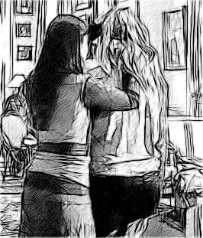  Image 1 | 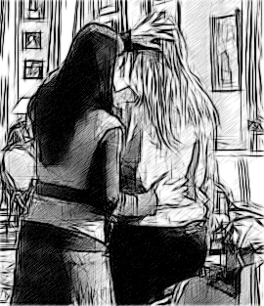  Image 2 | 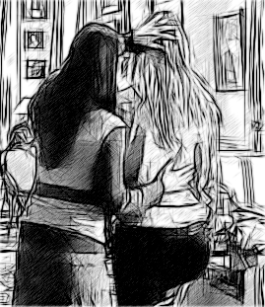  Image 3
Figure 2: Rear view of master and student (relating to bullet points in the transcript).

Instance 1 is a simple version of what I am calling the 'demonstrative' form of touch. In lines 01 and 02, as the master utters 'I'm gonna remind you that you've got your spi::ne', she first places her right hand on the student's neck, and with her left-hand moves the student's head slightly backwards. During 'mind you' she uses her left hand to move the student's hair over her shoulder and puts her hand back to the student's forehead on 'got your' (not shown in Figure 2). The first image in Figure 2 shows the position of the hands at the end of line 02. As the master utters 'it goes all the way from here to here' in line 03, she brushes her right hand down the spine of the student and moves her left hand to the back of the student's head on 'goes'. The second image in figure 2 shows this position. During the first 0.6 seconds of a verbal pause in line 04, she continues the brushing movement down the spine with the right hand and then reverses the hand movement for the remaining 0.5 of a second to reach the middle back as shown in the third image in figure 2.
The combination of verbal utterance and hand movements work together to make relevant the body of the student. Note, much of the touching occurs out of sight of the onlooking participants who are in front of the student. Therefore, the utterance simultaneously makes relevant to the audience the unseen aspects of the body contact, and hence includes them in the embodied instruction. That the student is actively compliant in this one-sided form of touch interaction should not be forgotten.

Instance 2 – Demonstrative Touch
Being sensitised to the spine is extendable to other aspects of the student's body. In the following example, the spine touching as one move occurs (lines 03 to 06), but then there are further actions related to the pelvis (line 08), followed by the legs (line 09), and finally an action directed toward the spine once again (lines 09 to 11). This continues with comments about the posture muscles (line 12), the rib cage and the abdominals (line 14, line 17). Here touch functions as preparation and projection of vocal topicalisation. In each instance, the master's hands move to the upcoming named body part (pelvis, legs, spine). Note, in the case of the projection of the spine, while the hand moves to the middle back in line 09, and an initial downward movement along the spine is seen in line 10, the upward stroke accompanies the utterance 'mazing strong spine'. So, while projecting the next body element with talk, touch and talk become aligned - an echo perhaps of the earlier touch-talk combination (04-06).
In this instance, the sensitising action of the master precedes a summary statement about the total body, 'so your skeleton offers this springy flexible structure' (lines 19-21) for performance (line 22). This is a student-oriented learnable formulation, with the use of 'your'. However, it is spoken in front of the accumulated audience, and hence available to them as part of a learnable instruction. This is framed in line 02 with the explicit mention of the audience and the repositioning of the student. More importantly in lines 19-22 the master disengages from the student, stands to her side, and forms a mimetic representation of the 'spring flexible structure' to the watching audience through a gestural formation of the hands into a 'v' shape and then a 'fist' shape (Figure 3). The gestures continue in a functional manner to emphasise the remaining utterance 'from which you are going to play'. The sequence of talk and touch (and gesture) transitions from student to audience and translates moments of intimate touch and talk into body instruction for the onlooking students.

Transcript 2: LMNAT100, LMNAT110 0:00-26:00

01 M: |so I wanna remind| you
M:|~~~~~~~~~~~~~~~~~|____ ((RH to middle back))
02 M: you just fa|ce this way so they can all see
M: |~~~____________________________ ((LH on L forearm))
S: |~~~~~~~~~~~~~~~~~~~~~~~~~~~~~~~ ((body to audience))
03 (|------)
M: |~~~~~~ ((RH from middle back to head))
04 M: you have a sp|i:ne
M:~~~~~~~~~~~~~|____ ((RH to head))
05 S: yeah
M:____
06 M: it |goes from here to h|e:re
M:___|~~~~~~~~~~~~~~~~~~~|____ ((RH moves to lower back))
07 S: ↑uh huh
M:_______
08 M: |you have a |pelvis that wraps round he:re
M:|~~~~~~~~~~~| ((RH LH to hips front))
M: |~~~~~~~~~~~~~~_______________((RH LH to hips back))
09 M: |then you have| your leg|s: .hhhh
M:|~~~~~~~~~~~~~|_________ ((RH LH to top legs))
M: |~~~~~~~~_________ ((RH to middle back))
M: |~~~~~~~~_________. ((to L forearm))
10 M: |an this a|mazing strong spine|
M:|~~~~~~~~~| ((RH stroke downwards))
M: |~~~~~~~~~~~~~~~~~~~| ((RH stroke to spine top))
M:______________________________
S:|~~~~~~~~~| ((turns head to M))
11 M: which is held up
M:________________ ((RH spine top))
M:________________ ((LH forearm))
12 M: with your posture muscles
M:_________________________
S:~~~~~~~~~~~~~~~~~~~~~~~~~ ((nodding))
13 (---)
14 M: tut |(.) off that |hangs your rib cage
M:~~~~|_____________ ((RH to L shoulder blade))
M: |~~~~~~~~~~ ((RH to back L))
M: |~~~~~~~~~~~~~ ((LH between upper arm and body))
15 M: (.) |.hh and| you::r
M: |~~~~~~~|_______ ((RH to middle of back))
M: |~~~~~~~| ((LH to front of stomach))
16 (----------)
M: __________ ((RH middle back))
M: __________ ((LH stomach))
17 M: suportses all your abdominals
18 (0.5) ●1
19 M: |So-| your| skelet|on offers:
M:|~~~| ●2 ((release RH, raises to form v-shape))
M:|~~~~~~~~~| ●3 ((release LH, raises to form v-shape))
M: |~~~~~~~~~~~~~| ●4 ((steps to left to face audience))
20 M: this:| (.)| sp|ringy |fl|exible
M:~~~~~| ((hands towards each other))
M: |~~~~| ((RH LH makes fist))
M: |~~| |~~| ((RH LH emphasis gestures))
21 M: |str|ucture
M:|~~~| ((RH LH emphasis gesture))
22 M: |from which you are going to play
M:|~~~~~~~~~~~~~~~~~~~~~~~~~~~~~ ((RH LH emphasis gestures))

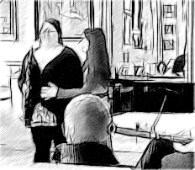  Image 1 | 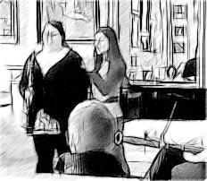  Image 2 | 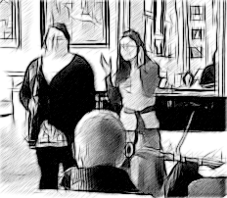  Image 3 | 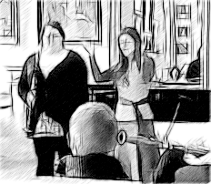  Image 4
Figure 3: Front view of student and master (relating to bullet points in the transcript)

A vital element of this interaction is the acknowledgement utterance of the student. At line 05 the student responds 'yeah' to a touch/talk action oriented to the spine, and in line 07 to the master describing the extent of the spine 'from here to he:re' she says, 'uh huh'. It is noticeable, however, that such acknowledgements do not follow the other sensitising actions of the master.

Summary
The two instances of the 'demonstrative' form of touch shown above are indicative of a temporally positioned activity of sensitising the student to the body. This activity is most typically carried out before the other forms of touch and forms part of the early stages of the AT master and student interaction. The second instance is more detailed and elaborate, but it has the same components of verbal description and accompanying body directed touch. The talk and touch movements combine, in a similar way to other forms of embodied movements (Nishizaka 2011; Cekaite 2015; Tulbert and Goodwin 2011) and form a talk-body ensemble or multiactivity setting (Goodwin and Goodwin 1996; Nishizaka and Sunaga 2015) in which touch accompanies or precedes the talk.
The argument is that this activity forms a foundation for those forms of touch to follow. In good part, this relates to the interaction between AT master and student, but at the same time, it forms a preparatory orientation for the gathered audience through the verbal description which is hearable by the onlooking participants. While the actual details of the touch are visibly hidden (occurring literally 'behind the back' of the student), the verbal description and the acknowledgement by the student through verbal acknowledgement make available the activity, and more specifically the detail of the touch, to the other persons present. Utterance-gesture formations that extend the interaction and turn them into teaching matters for the remaining students are also seen. This last activity-set is a common feature of the master-student interaction.
To this point, there have been few acknowledgements by the student. There are two examples in instance 2 at line 05 and 07, however, as the analysis moves from these forms of orientation or sensitisation to the body towards diagnostic and manipulative forms of touch, more instances of verbal acknowledgement by the student recipient can be seen.

Diagnostic Touch
In the following series of instances, touch is utilised as a part of an instructional diagnostic interaction. In relation to the teaching strategy or ‘project’, diagnostic touch follows earlier demonstrative forms of touch, and precedes later manipulative forms. As such it provides an integrative function, a pivot between private individual sensation and their public manifestation as a learning matter. In Instance 3, the student is asked to carry out an action by putting a woodwind instrument to her mouth, and the master feels the movements in the skeletal structure and muscles and makes an evaluative comment. This comment is first addressed to the student, attaining an agreement response, and then made available to the onlooking participants through an extended explanation.

Instance 3 - diagnostic touch

Transcript 3: LMNAT140 0:40-1:13
01 M: t'so your gonna bring
M:_____________________ ((RH on neck))
02 M: bring your flute | to|in your |normal way (which is)
M:~~~~~~~~~~~~~~~~~| ((RH stroke down back))
M: ~~~| ((RH up)
M: |~~ ((RH to middle back))
S: |~~~. ((small movement of R arm))
03 M: ●1 ˚i just wanna check something ●2
S: ~~~~~~~~~~~~~~~~~~~~~~~~~~~~~ ((puts flute to mouth))
04 (------|--------●3|----|----------●4)
M: |~~~~~~~~~~|_________________ ((LH to L shoulder))
M: |~~~~~~~~~~~~ ((RH stroke down back))
05 M: ˚ukay|
M:~~~~~| ((RH small movement))
06 (1.0)
07 M: m .hh so:: (0.3) do you fee:::l th't(0.6) you::ve lost
08 M: a bit of the softness and flexibil[ity in your spine
09 S: [hmm::
10 S: mm::[::
11 M: [.hhh
12 (0.3)
13 M: now I think what what thats to do with is that
14 (2.0)
15 M: ˚(name)
16 S: sarah
17 (0.5)
18 M: t’sarah (0.2) ha:s (0.4) got to bring erm (0.5)
19 M: her arms (.) and a flute (0.4) in front of her body:

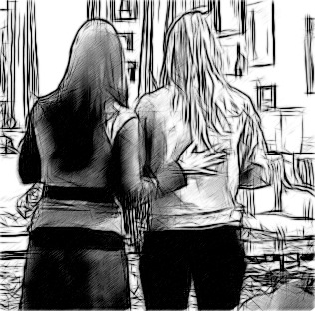  Image 1 | 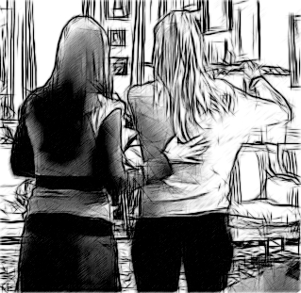  Image 2 | 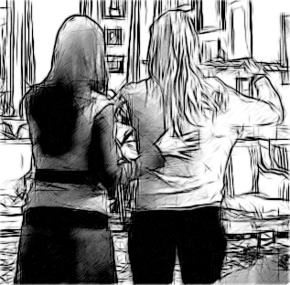  Image 3 | 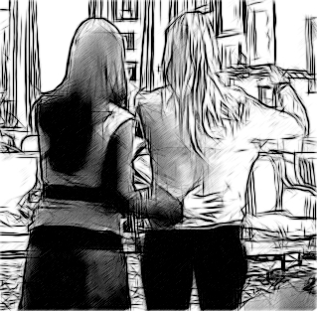  Image 4
Figure 4: Rear view of master and student (relating to bullet points in the transcript)

In line 01 and 02 the AT master issues a 'local' (Szczepek Reed, Reed, and Haddon 2013) embodied-action directive (Cekaite 2010) 't'so your gonna bring bring your flute to in your normal way (which is)'. This directive is accompanied by touch by the master, with the right hand beginning on the back of the neck of the student on line 01 and then moving down to the base of the spine as the master says 'bring your flute', a change of direction on 'to' and a movement to the middle of the back on 'in' (line 02). A small movement of the student's right arm in line with 'normal' is seen, but then she produces the larger movement of both arms to bring the flute to the mouth as the master utters 'i just wana check something' in line 03 (Images 1 and 2 in Figure 4). In the verbal pause that follows, the master puts her left hand to the student's right shoulder 0.6 seconds into the pause (Image 3) and then moves her right hand down the student's back 2.0 seconds into the pause (Image 4). As the master utters 'ukay' in a quiet voice in line 05, she continues this 'stroke' of the right hand down the back. In line 07 the utterance'm .hh so::' is followed by a question 'do you fee:::l th't'. The statement in lines 7 and 8 issues a diagnostic verdict formulated as a question of 'you've lost a bit of the softness and flexibility in your spine'. Given that flexibility is simultaneously an internal and external affair (and could potentially be judged by the master's diagnostic touch movement), the 'feeling' of the student (which again could be heard as both internal and experiential, and external and assessable) is placed in an ambiguous position of being a matter of collective agreement.
After an overlapping 'hmm' (9) and an agreement token, 'mm::::' (10) by the student, the master contextualises and explains this lack of flexibility to the onlooking audience in lines 13 to 19. This is accomplished through a request for the student's name in lines 15 and the use of this name at the beginning of a summary statement, 't' sarah (0.2) has (0.4) got to bring erm (0.5) her arms (.) and a flute (0.4) in front of her body directed to the audience members. The master uses the person reference to position the student as the object of the instructional learning.
The utterance 'do you feel' turns the student's embodied experience, as both a matter of perception and body expertise, into a matter of embodied epistemics; 'knowledge of' and 'knowledge through' are placed in opposition, with a prioritisation of the former as a social and accountable matter. The preference for a positive second pair-part is underpinned and promoted by the potential that a negative second pair-part merely provides evidence for the greater insight of the master. This sets the scene for the pronouncement in line 13, which begins 'now I think', which begins the diagnostic account. The pursuit of acknowledgement (7 and8) precedes the pronouncement and summation directed at the audience and is arguably a crucial aspect of the pivot-like move by the master to transform a one-to-one interaction into a group learning interaction. There are a similar set of moves and epistemic negotiations in the following instance.

Instance 4 - diagnostic touch

Transcript 4: LMNAT160 1:42-2:14
01 M: so |take a breath for me::
M: ~~~|______________________ ((RH to middle of back R))
M: ~~~|______________________ ((LH to middle of back L))

02 M: so I can feel what what it means for you to take a breath
03 (----------------------------)
S: ~~~~~~~~~~~~~~~~~~~~~~~~~~~~ ((breathes in and out))
04 M: one more when you're ready
05 (---------------)
S: ~~~~~~~~~~~~~~~ ((breathes in and out))
06 M: now do:- one with the trumpet up
07 (-----|-------)
S: ~~~~~| ((puts trumpet to mouth))
S: |~~~~~~~ ((breathes in and out))
08 M: do you feel what you did to your back
M: ~~~~~~~~~~~~~~~~~~~~~~~~ ((moves to side to look at S))
09 (------)
10 M: you did [exactly what I was |talking about earlier
11 S: [yeah
12 (---)
13 M: so see if you can remember the old pivot
14 M: (.) the ankle pivot
15 (--)
16 M: what he did so that you kno:w
M: ~~~~~~~~~~~~~~~~~~~~~~~~~~~~~ ((walks in front of S))
17 (----)
18 M: is::
19 ●1(-------------) ●2
20 M: tha::t
21 (0.3)
22 M: I've exag(ated) it .hhhhhh t'so:: (--)
23 M: this part of his back came in:
24 M: .hhh t’so exactly the bit that you want
25 M: to be (.) able to mo:ve (---) he squashed .hh

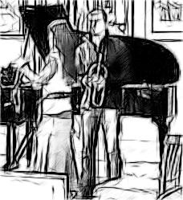  Image 1 | 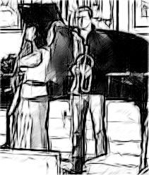  Image 2
Figure 5: Front view of master and student (relating to bullet points in the transcript)

In transcript 4, there are embodied action-directives in lines 01, 04 and 06 in a 'cluster' of directives (see Szczepek Reed, Reed, and Haddon 2013, 26). In line 01 'so take a breath for me::' is accompanied by a touch action of putting both the right hand and left hand to the middle of the back of the student. Unlike the previous instance, here the hands remain in the same place as the master first clarifies the purpose of the activity with 'so I can feel what what it means for you to take a breath' in line 02 and the student breathes in and out during the verbal pause in line 03. Extending the earlier analysis, there is an orientation to the epistemic transference of rights to speak to embodied experience here. The utterance is a way of positioning the upcoming action (and the person's experience of it) as a particular kind of object of knowledge: it displays to the student that whatever they do next is an assessable event.
As with the previous instances, these directive/movement pairs lead to a question directed to the student about their perception of the action: 'do you feel what you did to your back' in line 08, followed by a diagnostic account 'you did exactly what I was talking about earlier' in line 10. The question, however, does not meet with an immediate response during the pause in line 09. Instead, there is a delayed acknowledgement in overlap in line 11. Once achieved the master delivers a learnable beginning 'so' in line 13, then proceeds to extend this to the attendant audience with an embodied display (or mime) in lines 16-25 (Figure 5).
In lines 16 to 20 the AT master moves in front of the student as she utters 'what he did so that you kno:w' (0.4) is:: (1.3) tha::t (0.3)', enacting an embodied mime in the 1.3 second pause (Figure 4, image 1 and 2). This mime is similar to the activities of dance teachers who use embodied mimicry to contrast correct and incorrect body movements through "decomposition, highlighting, and exaggeration" (Keevalik 2010, 401).
The mime action is an additional resource for conveying the intimate, and often invisible, features of the touch interaction in relation to what the master 'sees' with their hands. By mimicking and exaggerating the student's movement, the master's action does a number of things: firstly it conveys the student's movement or lack of movement and embodied stance; secondly it qualifies and makes available the immediately preceding interaction between master and student for the onlooking participants; thirdly it underlines the therapeutic interaction as having relevant embodied content; fourthly it acts as an action of knowledgeable teaching, in that it conveys 'good' or 'bad' embodied movements to the onlooking students.

Summary
The two diagnostic forms of touch show the construction of assessable embodied movements. The assessment is first offered to the individual for acknowledgement. Once this is achieved, the movement and agreed 'feeling' are made available through explicit description and mime to the attendant audience. Touch, here, then, provides an anchor for assessment and agreement, but also - as seen in the second instance - sets up upcoming embodied acts as matters of assessment and knowledge.

Manipulative touch
The following instances involve a development of the diagnostic form of touch through the additional manipulation of the body of the student by the master. This form of touch occurs as a culmination of earlier demonstrative and diagnostic forms. It functions as the most ‘public’ teaching strategy and hence completes the transformation from private to public matters. Student perception of their body is then oriented to the changes brought about by this body manipulation. Acknowledgement by the student in these instances confirms and makes available these manipulations to the onlooking participants (Figure 6, image 1). The acknowledgements combine with forms of diagnostic question-answer pairs that confirm the positive outcomes of the manipulation and learning.
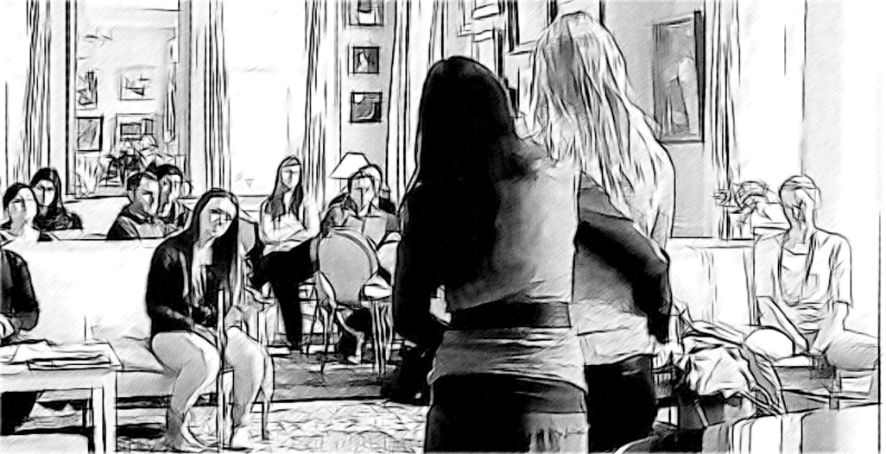
Image 1
Figure 6: rear view of student and master (relating to bullet points in the transcript)

Instance 5 – Manipulative Touch

Transcript 5: LMNAT140 LMNAT130 4:02-4:37
01 M: so|what I just want to (.)| invite you to do::
M: |~~~~~~~~~~~~~~~~~~~~~~~|___________________((RHLH to hips))
02 (0.2)
03 M: ve:ry slowly:::
04 (0.4)
05 M: you're goin to take your ar:ms
06 M: forward |in the way you just did
S: |~~~~~~~~~~~~~~~~~~~~~ ((moves arms forward))
07 M: an i'm gonna rebalance you from your ankle joints
08 (--------)●1
S: ~~~~~~~~ ((moves arms forward))
09 M: you feel that
10 S: mm:::
11 M: |.hhh therefore |you do not
M: |~~~~~~~~~~~~~~~|__________ ((RH to middle of S back))
12 M: have to grab anything |do you |feel the difference
M: ~~~~~~~~~~~~~~~~~~~~~~ ((RH up spine))
|~~~~~~~~~~~~~~~~~~~~~~~~~((down spine))
S: |~~ ~~~ ~~~ ~~~ ~~~ ((nod))
13 M: .hh tSo:
14 M: (-----)
15 M: all that |it was::
M: ~~~~~~~~~| ((moves to side of S))
M: ~~~~~~~~~| ((looks at audience))
|~~~~~~~~ ((looks at S))
16 (0.4)
17 M: half an inch↑
18 S: yeah ●2

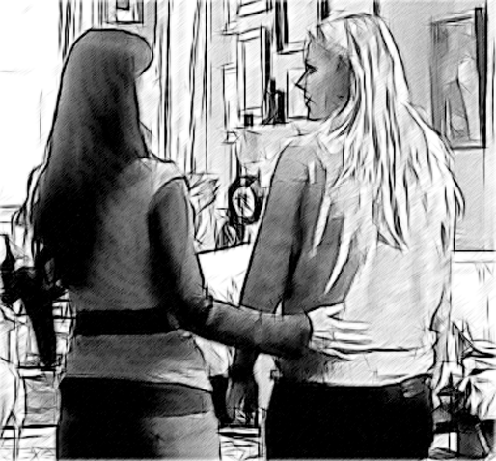

Image 2
Figure 7: rear view student and master (relating to bullet points in the transcript)

19 M: |tso I |helped her move half an inch| backwards
M: |~~~ |●3 |●4 ((looks at audience))
20 M: from the from the ankle joint
21 M: |.hh so that |she did not
M: |~~~~~~~~~~~ |~~~~~~~~~~~ ((looks at S; looks at A))
22 M: |have to grab hold of her spi::ne| in order to balance
M: |~~~~~~~~~~~~~~~~~~~~~~~~~~~~~~~~ ((RH up spine))
M: |~~~~~~~~~~~~~~((down spine))
23 M: because |the weight of the arms| plus the flu:te
M: |~~~ ((steps to side of S))
M: |~~~~~~~~~~~~~~~~ ((MIME))
24 (1.0)
25 M: she was bal|anced
M: ___________|~~~~~ ((turns head to look at S))
26 M: did you get that
27 S: yeah

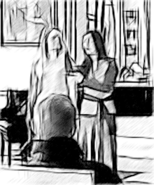  Image 3 | 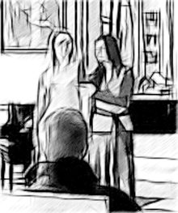  Image 4
Figure 8: front view of student and master (relating to bullet points in the transcript)

This instance follows a very similar pattern as the last as the master issues and action-directive for the student to raise her arms in lines 01 to 06. In line 07, she announces the body manipulation. This is followed by the movement by student and manipulation by the master in line 08. The adjacency pair of directive/movement is extended to include an active form of touch (rather than a diagnostic touch that moves with the body in section 2.2), in that the master manipulates the position of the student's hips. However, this is not necessarily perceivable by the onlooking participants. Hence in lines 09 and 10, there is a question/answer adjacency pair oriented to the embodied perception of the student 'do you feel that' 'mm:::'. In lines 11 and 12 there is a learnable issued by the master, '.hhh therefore you do not have to grab anything' followed by a question first pair part, 'do you feel the difference'. Here the student produces an acknowledgement action through head nodding in overlap with 'feel the difference'. This is then followed by a descriptive characterisation of the movement in lines 13 to 17 by the master accompanied by orientation to the onlookers through gaze alignment in line 15 and an agreement token by the student at line 18. Orientation to the audience and student in line fifteen is accompanied by a finely detailed grammatically appropriate verbalisation formed as an embodied verbal pivot — with 'all that' produced with gaze orientation to the audience, and 'it was::' oriented to the student. There is an extended explanation and description by the master in lines 19 to 25, which grammatically turns the student into a referenced object through the use of ‘her’ in ‘so I helped her move’ (19) and the pronoun 'she' in 'so that she did not have to grab hold' in lines 21 and 22. Finally, there is a question/answer pair in which the master asks 'did you get that' and the student replies 'yeah' in lines 26 and 27.
The movement of the body is turned into a diagrammatic gesture with the master using an pivoting arm movement to make visible the ‘half an inch’ of movement in line 19 during the utterance ‘so I helped her move half and inch backwards’ (Figure 7).
This is a more complex, and nuanced sequence, punctuated by verbal and embodied acknowledgement by the student and finely detailed gaze alignment design by the master. Lines 01-10 contain a form of manipulative touch. The detailing of the embodied change in lines 13 - 18, and the making of this movement relevant to the onlooking participants in lines 19 - 27. Again, each element is begun with the 'so' discourse marker (lines 01, 13 and 19) and ends with student acknowledgement.
Embedded in this sequence is a question formulated grammatically as an imperative 'you feel that' (line 09) that prefers a positive acknowledgement, which is produced by the student. A summation follows this premised upon 'therefore' in line 11, which contains a simple question 'do you feel the difference'. This sequence neatly encapsulates the control of the master over the personal and 'internal' embodied experience of the student. By formulating the first 'checking' as an imperative, the 'correct' experience is anticipated and pursued.
An alternative means of acknowledging the master's utterances, then, is to carry out an embodied action as seen with the head nodding in line 12. This then makes relevant a master evaluation in line with the well-known IRE (Instruction-Response-Evaluation) sequential structure (in this instance: body directive — body movement — evaluation of body moves) (Mehan 1979).

Discussion
Garfinkel's take on phenomenology leads us to look for the constitutive practices of body experience. By undertaking a conversation analytic investigation of the interactions between a music master and performance student forms of touch were identified that - in combination with talk - constructed a focus on the body of the performer and the inner experiences of body movement. Formulated to be available to the attendant masterclass students (and observers) these forms of touch were made available to social understanding and accountability.
Touch produced conterminously with talk acts as a form of haptic deixis. The replacement of 'there' with 'here' further cementing the intimate focus of the descriptive utterance. At the same time, such intimacies are made public by the same combination - the dynamic descriptive 'from here to here' narrating the travelling hand and making the invisible available to the imagination. In Garfinkel's terms, the data sense of master and student is transformed and transferred into the theory sense of the audience members.
The progression from invisible and private touch to invisible and private inner experience is accomplished through the diagnostic framing of the physical connecting. It is not without peril. Attaining student acknowledgement and agreement anchors the epistemic authority of the master, expressing it both as a truthful and public matter.
The different forms of touch (demonstrative, diagnostic, and manipulative) performed by the master are relevant primarily to the student, and in that touch is an intimate and often invisible aspect to onlookers, these forms of touch are made apparent, visible, and relevant to the onlookers through different strategies. A first strategy is to have the student acknowledge the touch in some way. Here the master pursues acknowledgement and uses this as a pivotal moment to introduce a broader instructional interaction with onlooking participants. A second sequential possibility is a form of IRE (instruction-response-evaluation), in that 'what is happening now' in the inner experience of the student is made a matter of instruction, response, and evaluation, and hence an accountable process. It is here that the 'correct' feeling or data sense is introduced and pursued. A third strategy is for the master to mime the embodied elements of the touch interaction to the onlooking participants, and in this way utilise embodied mimicry to enact an embodied metaphor or body performance and link collective engagement with inner experience.
The three forms of touch inform a progressive socialisation of somatic and kinesthetic experience, which might be called a transition from intimate body relations and individual experience to public perception and embodied instruction. The orientation to particular aspects of the body through the show-form of touch, is then a move away from the phenomenology of individual body experience through social interaction with the master, which makes perceptually available the details of the student's body to onlookers and interlopers (Goffman, 1963) through the on- and with-forms of touch. Accompanying summary and reorientation to the audience provide for broader learnables to be revealed (and pursued in subsequent interactions) to onlooking students. The three forms of touch can be detailed as:
- Demonstrative orientation to the body through targeted touch (spine, legs, etc.);
- Diagnostic touch and talk, oriented to student acknowledgement (work towards this based on non-uptake of adjacency question-answer pairs);
- Manipulative touch, oriented to onlooker comprehension and acknowledgement.

The sequences in which these forms of touch are embedded complement the general processual rationale of the Alexander therapeutic technique,

[F]irst, initial responses to a stimulus must be inhibited; second, the directions for 'primary control' of the head-neck-back relationship should be projected until sufficiently well absorbed to respond to the stimulus; third, while still projecting these directions for new use, a fresh decision should be made about whether or not to respond to the stimulus; and finally some kind of response to it should be undertaken. (Alexander [1932]1985, 33-4, as cited in Tarr 2011, 256)

However, an interactional analysis reveals how this set of institutional objectives and practices become practical and 'visible' matters for both the recipient of the therapy and the onlookers in the masterclass. Far from taken for granted, the incorporation of this process into the learning of the individual and collected participants is a matter of instructional interaction, and it is in the details of this interaction that the progression from intimate matters of touch to collective understandings of the 'proper' functioning of bodies in performance practice can be recognised. Importantly, this progression includes the 'mastery' of student's subjective experience, perception and expression'. True to the Alexander Technique handbook, these interactions externalise the internal experiences of the recipient and make them public and accountable matters, within an epistemically asynchronous interaction.

Conclusion
This paper has revealed various forms of sequentially situated touch in the musical masterclass. In that it shows how essentially individual embodied and experiential elements become social and available for interaction and instruction, it connects with an appreciation of social phenomenology (Langsdorf 1995). More specifically, the paper provides a foundation for an appreciation of the instructional uses of various types of talk and talk, as a part of a specific teaching practices. The paper shows how an integrated description of touch, verbalisations is made possible by using an interactional approach to the study of embodiment, haptic acts, and talk. While beyond the purview of this article, it links with recent work by Jurgen Streeck that examines kinesthetics in interaction (Streeck 2015), kinesthetic learning (Lengel and Kuczala 2010) and kinesthetic empathy (Reynolds and Reason 2012; Wood 2016) in performance. Such forms of embodied mutuality champion touch in the social interactional realm, and support and stimulate extended interactional accounts. In the context of the masterclass, a next step would be to combine the AT practitioner's interactions with students with the teaching practices of the more traditional performance 'master' (see Reed and Szczepek Reed 2014; Szczepek Reed, Reed, and Haddon 2013), so as to understand the musical masterclass as instructional 'project' (Reed and Szczepek Reed 2013) that combines touch, talk and other forms of social action. More broadly, the epistemic ‘rights’ to speak to and control the body of another, as they occur in detailed moments of embodied interaction, would situate such studies within the context of body pedagogics and the enculturation of the body.

References
Aalten, Anna. 2007. “Listening to The Dancer's Body.” The Sociological Review 55 (1): 109–125. https://doi.org/10.1111/j.1467-954X.2007.00696.x.
Alexander, Frederick, Matthias. [1932]1985 The Use of the Self: Its Conscious Direction in Relation to Diagnosis, Functioning and the Control of Reaction. London: Victor Gollancz.
Bourdieu, Pierre. 1988. “Program for a Sociology of Sport.” Sociology of Sport Journal 5 (2): 153–161. https://doi.org/10.1123/ssj.5.2.153.
Cekaite, Asta. 2010. “Shepherding the Child: Embodied Directive Sequences in Parent-Child Interactions.” Text & Talk-An Interdisciplinary Journal of Language, Discourse & Communication Studies 30(1): 1-25. https://doi.org/10.1515/text.2010.001.
Cekaite, Asta. 2015. “The Coordination of Talk and Touch in Adults Directives to Children: Touch and Social Control.” Research on Language and Social Interaction 48(2): 152-175. https://doi.org/10.1080/08351813.2015.1025501
Crossley, Nick. 2007. “Researching Embodiment by Way of Body Techniques.” The Sociological Review 55(s1): 80-94. https://doi.org/10.1111/j.1467-954X.2007.00694.x.
Csordas, Thomas J. 2002 Body, Meaning, Healing. New York: Palgrave Macmillan, US.
Foucault, Michel. (2012) The History of Sexuality, Vol. 3. New York: Vintage Books.
Gallace, Alberto, and Charles Spence. 2010. “The Science of Interpersonal Touch: An Overview.” Neuroscience & Biobehavioral Reviews 34(2): 246-259. DOI:10.1016/j.neubiorev.2008.10.004
Garfinkel, Harold, and Anne Rawls. 2015. Toward a Sociological Theory of Information. Abingdon: Routledge.
Goffman, Erving. 1963. Behaviour in Public Places. Illinois: Free Press.
Goodwin, Charles, and Marjorie Goodwin. 1996. “Seeing as Situated Activity: Formulating Planes.” in Cognition and Communication at Work, edited by Yrjö Engeström and David Middleton, 61-95. New York: Cambridge University Press.
Goodwin, Marjorie, and Asta Cekaite. 2014. “Orchestrating Directive Trajectories in Communicative Projects in Family Interaction.” In Requesting in Social Interaction, edited by Paul Drew and Elizabeth Couper-Kuhlen, 185-214. Amsterdam: John Benjamins.
Greenbaum, Paul, and Howard Rosenfeld. 1980. “Varieties of Touching in Greetings: Sequential Structure and Sex-Related Differences.” Journal of Nonverbal Behavior 5(1): 13–25.
Hanken, Ingrid Maria 2008. “Teaching and Learning Music Performance: The Master Class.” The Finnish Journal of Music Education (FJME) 11(1-2): 26- 36.
Heritage, John, and David Greatbatch. 1991. “On the Institutional Character of Institutional Talk: The Case of News Interviews.” In Talk and Social Structure, edited by David Boden and Donald Zimmerman, 93-137. Cambridge: Polity Press.
Howson, Alexandra and David Inglis. 2001. “The Body in Sociology: Tensions Inside and Outside Sociological Thought.” Sociological Research Online 49(3): 297–317. https://doi.org/10.1111/1467-954X.00333.
Jain, Sanjiv, Kristy Janssen, and Sharon DeCelle. 2004. “Alexander Technique and Feldenkrais Method: A Critical Overview.” Physical Medicine and Rehabilitation Clinics of North America 15 (4): 811–825. doi:10.1016/j.pmr.2004.04.005.
Kääntä, Leila, and Arja Piirainen-Marsh. 2013. “Manual Guiding in Peer Group Interaction: A Resource for Organizing a Practical Classroom Task.” Research on Language and Social Interaction 46(4), 322-343. DOI: 10.1080/08351813.2013.839094
Keevallik, Leelo. 2010. “Bodily Quoting in Dance Correction.” Research on Language & Social Interaction 43(4): 401-426. DOI: 10.1080/08351813.2010.518065
Koschmann, Timothy, and Alan Zemel. 2011. Discovering the Learnable. Paper Presented at 10th Conference of the International Institute for Ethnomethodology and Conversation Analysis, Fribourg, Switzerland 10-14 July 2011.
Lande, Brian. 2007. “Breathing Like a Soldier: Culture Incarnate.” Sociological Review 55 (s1): 95–108. DOI: 10.1111/j.1467-954X.2007.00695.x.
Langsdorf, Lenore. 1995. “Treating Method and Form as Phenomena: An Appreciation of Garfinkel's Phenomenology of Social Action.” Human Studies 18(2): 177-188.
Lengel, Traci, and Mike Kuczala. 2010. The Kinesthetic Classroom. Thousand Oaks, CA: Corwin Press.
Mauss, Marcel. 1973. Techniques of the Body*. Economy and Society 2(1): 70–88.
Mehan, Hugh. 1979. “What time is it, Denise?: Asking Known Information Questions in Classroom Discourse.” Theory into Practice 18(4): 285–294. DOI: 10.1080/00405847909542846.
Nishizaka, Aug. 2011. “Touch Without Vision: Referential Practice in a Non-Technological Environment.” Journal of Pragmatics 43(2): 504-520.
Nishizaka, Aug and Masafumi Sunaga. 2015. “Conversing While Massaging: Multidimensional Asymmetries of Multiple Activities in Interaction.” Research on Language and Social Interaction 48(2): 200-229. DOI: 10.1080/08351813.2015.1025506
O’Connor, E. (2007) Embodied Knowledge in Glassblowing: The Experience of Meaning and the Struggle Towards Proficiency. Sociological Review 55 (s1): 126–141.
Reed, Darren J. and Beatrice Szczepek Reed. 2013. “Building an Interactional Project: Actions as Components of Music Masterclasses.” In Units Of Talk — Units Of Action, edited by Beatrice Szczepek Reed and Geof Raymond, 313-42. Amsterdam: John Benjamins.
Reed, Darren J. and Beatrice Szczepek Reed. 2014. “The Emergence of Learnables in Music Masterclasses.” Social Semiotics 24(4): 446-467.
Reynolds, Dee and Matthew Reason. 2012. Kinesthetic Empathy in Creative and Cultural Practices. Bristol: Intellect Books.
Shilling, Chris. 2007. “Sociology and the Body: Classical Traditions and New Agendas.” The Sociological Review 55 (1), pp. 1–18. DOI: 10.1111/j.1467-954X.2007.00689.x
Shilling, Chris. 2017. “Body Pedagogics: Embodiment, Cognition and Cultural Transmission.” Sociology 51 (6): 1205–1221. DOI: 10.1177/0038038516641868
Shusterman, Richard. 2008. Body Consciousness: A Philosophy of Mindfulness and Somaesthetics. Cambridge: Cambridge University Press.
Shusterman, Richard. 2012. Thinking Through the Body. Cambridge: Cambridge University Press.
Streeck, Jurgen. 2015. Perceiving Gesture, Sensing Action.” Paper presented at Revisiting Participation. University of Basel, 24th-27th June.
Szczepek Reed, Beatrice, Darren, J. Reed, and Liz Haddon. 2013. “NOW or NOT NOW: Coordinating Restarts in Vocal Masterclasses.” Research on Language & Social Interaction 46(1): 22-46.
Tarr, Jennifer. 2008. “Habit and Conscious Control: Ethnography and Embodiment in the Alexander Technique.” Ethnography 9 (4): 477–497. https://www.jstor.org/stable/24047911
Tarr, Jennifer. 2011. “Educating With The Hands: Working on The Body/Self in Alexander Technique.” Sociology of Health & Illness 33(2): 252-65. DOI: 10.1111/j.1467-9566.2010.01283.x
ten Have, Paul. 1999. Doing Conversation Analysis: a practical guide. London: Sage.
Tulbert, Eve and Margorie Goodwin. 2011. “Choreographies of Attention: Multimodality.” In Embodied interaction: Language and Body in the Material World, edited by Jurgen Streeck, Charles Goodwin, and Curtis LeBaron, 79-92. Cambridge: Cambridge University Press.
Valentine, Elizabeth. 2004. “Alexander Technique.” In Musical Excellence Strategies and Techniques to Enhance Performance, edited by Aaron Williamson, 179–196. Oxford: Oxford University Press.
Valentine, Elizabeth, David Fitzgerald, Tessa Gorton, Jennifer Hudson, and Elizabeth Symonds. 1995. “The Effect of Lessons in the Alexander Technique on Music Performance in High and Low Stress Situations.” Psychology of Music 23: 129–141. DOI: 10.1177/0305735695232002
Williams, Simon, and Gillian Bendelow. 1998. The Lived Body: Sociological Themes, Embodied Issues. London: Routledge.
Wood, Karen. 2016. “Kinesthetic Empathy: Conditions for Viewing.” In The Oxford Handbook of Screendance Studies. vol.1, edited by Douglas Rosenberg. Oxford University Press. DOI: 10.1093/oxfordhb/9780199981601.013.12

Appendix

Transcription notation
The transcription notation and system used is adapted from Jefferson and Heath. It replaces numerical pauses lengths with a graphical representation so as to allow for clear description of the actions that occur simultaneously with verbal pauses. Graphical notation of an action (as opposed to descriptive notation) is positioned in line with the verbal utterance line, while a descriptive gloss is offered in the right-justified double parentheses relating to that notation. Embodied actions are indicated by the indentation of identifiers by one space, and line numbers are attributed to the verbal utterances only, so as to underline the simultaneous nature of the verbal and embodied actions.

~~~ action, aligned with vocal utterance
_____ ‘held’ action (such as touch)
| timing point, relating to aligned point in verbal and action line
[ verbal overlap
(-----) pause, length indicated in tenths of a second
- image capture point
↑ raising intonation

The data consist of video and audio recordings. No other forms of data were collected (such as questionnaire data). This is consistent with a Conversation Analytic approach that focusses on behaviour and interaction.
More broadly, the epistemic ‘rights’ to speak to and control the body of another, as they occur in detailed moments of embodied interaction, would situate such studies within the context of body pedagogics and the enculturation of the body.

