**Patterns of on-task thought in older age are associated with changes in functional connectivity between temporal and prefrontal regions.**

Léa M. Martinon1, Leigh M. Riby1, Giulia Poerio2,3, Hao-Ting Wang2, Elizabeth Jefferies2, Jonathan Smallwood2 *

1 Psychology department, Northumbria University, Newcastle-upon-Tyne, UK

2 Psychology department, University of York, York, UK

3 Psychology department, University of Sheffield, Sheffield, UK

* Corresponding author

[Jonny.smallwood@york.ac.uk](mailto:Jonny.smallwood@york.ac.uk)

Declarations of interest: none

Acknowledgments. This project was supported by European Research Council Consolidator awarded to JS (WANDERINGMINDS – 646927) and an award from The Dunhill Medical Trust to JS, LMR and EJ. [R422/0515].

**Abstract**

Humans spend a large proportion of their time engaged in thoughts unrelated to the task being performed, a tendency that declines with age. However, a clear neuro-cognitive account of what underlies this decrease is lacking. This study addresses the possibility that age-related changes in off-task thinking are correlated with changes in the intrinsic organisation of the brain. Laboratory measures of ongoing thought were recorded in young and older individuals, who also participated in a resting state fMRI experiment. Older individuals showed reduced connectivity between the left anterior temporal lobe with prefrontal aspects of the DMN. We found that off-task thinking did not increase when task demands were lower for older adults, which is a pattern repeatedly seen in younger individuals. Finally, we demonstrated that these neural and thought patterns were linked – for younger participants only, reductions in the strength of connectivity were related to a greater shift towards off-task thoughts when task demands decreased. Importantly, in the older individuals, lower connectivity between the same regions was linked to preserved performance on a creativity task. These data suggest that the age-related reduction of off-task thought may be related to reduced communication between temporal and prefrontal DMN regions in ageing.

**Keywords**: fMRI, Ageing, mind-wandering, connectivity, self-generated thoughts

1. Introduction

The ability to self-generate thoughts in imagination is a central aspect of human cognition. Between a third to half of our waking life is spent engaged in experiences that are unrelated to events in the here and now (Kane et al., 2007). Given their ubiquity, it is hardly surprising that self-generated thoughts are linked to useful features of human cognition including: planning (Baird, Smallwood, & Schooler, 2011), temporal decision making (Smallwood, Ruby, & Singer, 2013), memory (Poerio et al., 2017) and creative problem solving (Baird et al., 2012; Smeekens & Kane, 2016; Wang, Poerio, et al., 2018). States or patterns of off-task thought have also been linked to lapses in performance during working memory tasks (McVay & Kane, 2009; Mrazek, Smallwood, & Schooler, 2012), an association that is argued to emerge partly because attention is directed away from events in the immediate environment (a phenomenon known as ‘decoupling’; Smallwood, 2013). Hence, it is argued that self-generated thoughts can be beneficial in everyday life, despite costs on task performance, especially if they occur in a context in which deficits in performance are unlikely (Smallwood & Andrews-Hanna, 2013). One well documented and robust characteristic of off-task thought is its reduction with increasing age (Giambra, 1989; Jackson & Balota, 2012; Jackson, Weinstein, & Balota, 2013; McVay, Meier, Touron, & Kane, 2013; Martinon, Smallwood, Hamilton, & Riby, In press). Although the association between ageing and reduced off-task thought is well documented in the literature, we currently lack a clear neuro-cognitive account of this age-related decline.

Component process accounts of off-task thought emphasise the dual importance of processes involved in: (1) the production of mental content that is not related to the external environment, and (2) the control processes that are important for the regulation of these experiences (Christoff, Irving, Fox, Spreng & Andrews-Hanna, 2016; Smallwood, 2013; Smallwood & Schooler, 2015). Broadly, these accounts propose that the generation and representation of off-task thoughts are subserved by memory representation processes whereas the control of off-task thought occurrence is subserved by executive control processes (McVay & Kane, 2009; Smallwood & Andrews-Hanna, 2013). From a theoretical perspective, age-related declines in off-task thought may emerge from declines in the integrity of neurocognitive processes either related to memory, control, or both. To investigate these possibilities, our study combines laboratory measures of ongoing thought patterns in young and older individuals, with measures of intrinsic neural organisation provided by resting state functional magnetic resonance imaging. In our study we aimed to characterise the underlying neural changes linked to ageing and examine whether these are associated with age-related changes in patterns of ongoing thought. While the literature often focuses on the relationship between off-task thought and ageing, we explored the effects of age on a range of aspects of ongoing thought using Multi Dimensional Experience Sampling (MDES). In this way we hoped to provide valuable information with regards to the potential neural correlates of age-related changes in patterns of ongoing thought.

According to contemporary theory, memory processes provide representational information upon which the content of self-generated experiences are based (Baird et al., 2011; Christoff et al., 2016; Poerio et al., 2017; Tulving, 2002), and it is well known that changes in conceptual and episodic knowledge occur with age (Addis, Musicaro, Pan, & Schacter, 2010; Addis, Wong, & Schacter, 2008; Schmitter-Edgecombe, Vesneski, & Jones, 2000). Evidence from cognitive neuroscience suggests memory processes are linked to temporal lobe structures, including both anterior regions of the lateral temporal cortex, and regions on the medial surface such as the hippocampus (Davey et al., 2016; Ellamil et al., 2016; Ralph, Jefferies, Patterson, & Rogers, 2017). At rest, these regions show increased functional connectivity with medial and lateral regions in the posterior and anterior cortical regions, and collectively form what is known as the Default Mode Network (DMN) (Andrews-Hanna, 2012; Buckner, Andrews-Hanna, & Schacter, 2008; Raichle, 2015; Spreng, Mar, & Kim, 2008). In older age, reduction of both activity and connectivity of the DMN have been reported (Biswal et al., 2010; Damoiseaux et al., 2008; Damoiseaux, 2017). Regions closely allied to the core DMN also change with age, including regions of temporal cortex (Fjell et al., 2009; Raz, Rodrigue, Head, Kennedy, & Acker, 2004) and hippocampus (Allen, Bruss, Brown, & Damasio, 2005; Du et al., 2006; Raz, Ghisletta, Rodrigue, Kennedy, & Lindenberger, 2010). In healthy young adults, connectivity of the hippocampus is related to changes in spatial, episodic and semantic memory (Persson, Stening, Nordin, & Söderlund, 2018; Sormaz et al., 2017) and age-related changes in this domain can mediate cognitive abilities such as episodic memory (Fjell & Walhovd, 2010).

As well as processes important for generating off-task experience, contemporary accounts emphasise the need to understand how they are regulated (Andrews‐Hanna, Smallwood, & Spreng, 2014; McVay & Kane, 2010). It is generally assumed that the regulation of task-unrelated states depends in part upon executive control processes (Kane & McVay, 2012; Levinson, Smallwood, & Davidson, 2012; Rummel & Boywitt, 2014). As such, individuals with high working memory capacity flexibly (Rummel & Boywitt, 2014), who make patient economic choices (Smallwood et al., 2013), or who score high on measures of intelligence (Turnbull et al., 2019) adjust their off-task experience to demands of the environment. Neural studies suggest that important aspects of executive control are linked to processes in regions of lateral frontal and parietal cortex that show elevated activity across a wide range of task domains (Duncan & Owen, 2000; Fedorenko, Duncan, & Kanwisher, 2013).In younger adults, the connectivity between regions important for executive control predicts working memory performance and intelligence (Finn et al., 2015), cognitive features highly related to off-task thoughts (Kane & McVay, 2012; Mrazek et al., 2012). Critically, older adults display altered connectivity patterns between frontal and parietal areas (Meunier, Achard, Morcom, & Bullmore, 2009; Wu et al., 2012), as well as poorer working memory capacity (Braver & West, 2008), suggesting off-task thoughts regulation may prove difficult in ageing.

Accumulating evidence in younger adults supports a role of both the default mode and frontoparietal networks in off-task states. Experience sampling studies, in conjunction with fMRI, have shown that both networks are active during periods of off-task thought (Allen et al., 2013; Christoff, Gordon, Smallwood, Smith, & Schooler, 2009; Stawarczyk, Majerus, Maquet, & D’Argembeau, 2011). Studies have also examined individual variation in off-task experience and how they relate to the organisation of neural functioning. Smallwood et al. (2016) found that variation in regions of both the temporal pole and the hippocampus were related to variations in ongoing experience patterns including episodic quality, detail, and relationship to an ongoing task. Regions of the frontal-parietal cortex are also important in the off-task state: studies suggest that the connectivity of the DMN and frontoparietal network is stronger for individuals who spend more time off-task (Mooneyham et al., 2016), especially when off-task thinking is deliberate (Golchert et al., 2017).

In our study, we used a combination of experience sampling and resting state fMRI to explore whether age-related neural changes are associated with changes in patterns of ongoing thought. To this aim, young and older participants performed a working memory task with varying difficulty, during which patterns of thoughts were measured using a set number of questions targeting thought content, this method is referred as Multi-Dimensional Experience Sampling (MDES). For a complete consideration of the cognitive functions relating to ongoing experiences, measures of fluid intelligence, creativity and working memory were taken. Participants also underwent a resting state functional connectivity scan allowing us to describe each individual in terms of their intrinsic architecture at rest. For our connectivity analyses three sets of seed regions targeting different theories for the age-related decrease of off-task thoughts were selected. To consider the implications of systems important for mental representation, seed regions from the temporal lobe linked to memory were used: the left and right hippocampus and left and right anterior temporal lobe (Patterson, Nestor & Rogers, 2007; Tulving, 2002). We also selected regions in the left and right pre-frontal cortex which are linked to processes of cognitive control within the memory domain. Specifically, we selected the left and right inferior frontal gyrus to explore the involvement of systems important for semantic control (Noonan, Jefferies, Visser, & Lambon Ralph, 2013).

1. Method
   1. Participants

|  |  |  |
| --- | --- | --- |
| **Table 1.** Means (Standard Deviations) of participants’ characteristics. | | |
| Measures | Young (SD) | Old (SD) |
| N | 41 | 39 |
| N Probes | 924 | 981 |
| M age | 19.73 (1.34) | 66.08 (6.65) |
| Female % | 78 | 56.4 |
| NART (errors) | 20.23 (6.38) | 8.84 (6.20) |
| MMSE | - | 29.03 (1.24) |

The older adults’ group was composed of 22 women and 17 men (*Mage* = 66.08 years, *range* = 55–87) recruited using opportunity sampling. The younger adult group consisted of 32 women and 9 men (*Mage*= 19.73 years, *range*= 18–23) who were undergraduate students in psychology at the University of York. All participants were remunerated for their time and travel. Participants were required to be native English speakers, right-handed, and to have a normal or corrected vision and hearing. Exclusion criteria were: presence or history of neurological or psychiatric disorder. Older participants completed the Mini-Mental State Examination (MMSE; Folstein, Folstein, & McHugh, 1975) to ensure that they did not have dementia or mild cognitive impairment (threshold: score ≥26/30) (see **Table 1**.). The University of York Neuroimaging Centre ethics committee approved this study, and it was conducted according to the principles expressed in the Declaration of Helsinki.

* 1. Procedure

Participants attended two two-hourly sessions on consecutive days. Upon the first session, all participants completed demographic information and older adults were assessed with the MMSE. Participants first completed the N-back task with MDES. This was followed by six other cognitive tasks which will be investigated elsewhere but included the backward digit span (the task stopped after two consecutive erroneous trails, the number of trials varied between 2 and 14 and the proportion of trials that they got correct was measured; Wechsler, 1997) and the DSST (Digit Symbol Substitution Test; Wechsler, 1997). During the second session, all participants carried out the N-back task for the second time. Following this, participants completed another five tasks including the NART (National Adult Reading Task; Nelson, 1982), the Raven’s Matrices (Raven, 1983), and the Unusual Uses Test (UUT, Guilford, Merrifield, & Wilson, 1958).

Prior studies have found associations between patterns of ongoing thought and poor performance on tasks of intelligence and working memory (e.g., McVay & Kane, 2009; Mrazek, Franklin, Phillips, Baird, & Schooler, 2013; Wang, Bzdok, et al., 2018) and better performance on tasks that measure creativity and problem solving (Baird et al., 2012; Smeekens & Kane, 2016; Wang, Poerio, et al., 2018). In this study, we therefore also measured working memory capacity (i.e. backward digit span), fluid intelligence (i.e. Raven’s Matrices), and creativity (i.e. Unusual Uses Test). We also took measures to control for basic differences in psychomotor speed (i.e. DSST) and premorbid IQ (i.e. NART). The tasks were always performed after the measures of ongoing thought. Data from fMRI resting state scanning were gathered on a different day.

* 1. N-back task

The task was developed using PsychoPy (Pierce, 2007) and featured a 0-Back and a 1-Back condition that continuously switched from one another throughout the experimental session. In both conditions participants saw different pairs of shapes (Non-Targets) appearing on the screen divided by a vertical line; the pairs could be: a circle and a square, a circle and a triangle, or a square and a triangle for a total of 6 possible pairs (two different left/right configurations for each). The pairs never had shapes of the same kind (e.g. a square and a square). In both tasks, a block of Non-Targets was followed by a Target requiring participants to make a manual response. The target was a small stimulus presented in the centre of the line, in blue if in the *0-Back* condition and in red if in the *1-Back* condition. In the *0-Back* condition, the target was flanked by two shapes and participants had to indicate, by pressing the left or right arrow key, on which side was the same shape as the target shape. In the *1-Back* condition, the target was flanked by two question marks and participants had to respond depending on which side the target shape was on the prior trial (see **Figure 1**.).

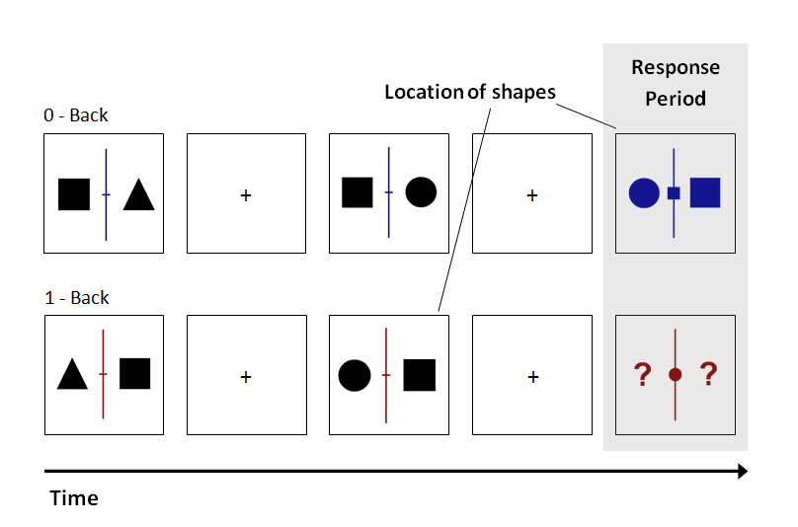

1 s

1.5 s

1.5 s

1 s

2 s

**Figure 1.** Illustration of both 0-Back and 1-Back conditions included in the working memory task.

Each block lasted between 40 to 120 seconds before switching to the other condition; the change of condition was signalled by a message (“SWITCH”) that remained on screen for 5 seconds. On each trial, the number of Non-Targets preceding the Targets varied between 2 and 6, the number of trials per block varied between 2 and 5 and the total number of blocks was 8 for each condition. The whole task lasted approximately 30 minutes. The total number of targets varied between 10 and 21 per condition. In order to sample ongoing experience, we used Multi-Dimensional Experience Sampling(Smallwood et al., 2016). Participants were presented with an average of 6.07 (*SD* = 1.68) probes in the 0-Back condition and 6.22 (*SD* = 1.85) in the 1-Back condition. The thought probe consisted of a screen prompting the participants to rate their focus level (‘*My thoughts were focused on the task I was performing.*’) on a four-point Likert scale from 1 (*Not at all*’) to 4 (*Completely*). This prompt was always followed by 12 questions regarding thought characteristics (**Table 2**.); the order of presentation was randomised. Every presentation of non-targets, targets, probes and SWITCH screens were separated by a fixation cross. The fixation crosses, non-targets and targets were respectively presented 1.5, 1 and 2 seconds and a response from participants did not end the target presentation.

|  |  |  |
| --- | --- | --- |
| **Table 2.** Probe questions and scales used in the Multiple Dimension Sampling Experience. | | |
| Measures | Probe questions | Scale (1 🡪 4) |
| Task | My thoughts were focused on the task I was performing. | Not at all 🡪 Completely |
| Future | My thoughts involved future events. | Not at all 🡪 Completely |
| Past | My thoughts involved past events. | Not at all 🡪 Completely |
| Self | My thoughts involved myself. | Not at all 🡪 Completely |
| Other | My thoughts involved other people. | Not at all 🡪 Completely |
| Emotion | The content of my thoughts was: | Negative 🡪 Positive |
| Images | My thoughts were in the form of images. | Not at all 🡪 Completely |
| Words | My thoughts were in the form of words. | Not at all 🡪 Completely |
| Vivid | My thoughts were vivid as if I was there. | Not at all 🡪 Completely |
| Detailed | My thoughts were detailed and specific. | Not at all 🡪 Completely |
| Habit | This thought has recurrent themes similar to those I have had before. | Not at all 🡪 Completely |
| Evolving | My thoughts tended to evolve in a series of steps. | Not at all 🡪 Completely |
| Deliberate | My thoughts were: | Spontaneous 🡪 Deliberate |

* 1. Neuroimaging
     1. MRI acquisition

MRI functional and structural parameters for the resting state fMRI scans were acquired using a 3T GE HDx Excite MRI scanner utilising an eight-channel phased array head coil (GE) tuned to 127.4 MHz, at the York Neuroimaging Centre, University of York. Structural MRI acquisition in all participants was based on a T1-weighted 3D fast spoiled gradient echo sequence (TR = 7.8 s, TE = minimum full, flip angle= 20°, matrix size = 256 x 256, 176 slices, voxel size = 1.13 x 1.13 x 1 mm). Resting-state functional MRI activity was recorded from the whole brain using single-shot 2D gradient-echo-planar imaging (TR = 3 s, TE = minimum full, flip angle = 90°, matrix size = 64 x 64, 60 slices, voxel size = 3 x 3 x 3 mm3, 180 volumes). A FLAIR scan, with the same orientation as the functional scans, was collected to improve co-registration between subject-specific structural and functional scans.

* + 1. MRI pre-processing

Functional and structural data were pre-processed and analysed using FMRIB’s Software Library (FSL version 4.1, http://fsl.fmrib.ox.ac.uk/fsl/fslwiki/FEAT/). Individual FLAIR and T1 weighted structural brain images were extracted using BET (Brain Extraction Tool). Structural images were linearly registered to the MNI-152 template using FMRIB's Linear Image Registration Tool (FLIRT). Functional data were pre-processed and analysed using the FMRI Expert Analysis Tool (FEAT). The individual subject analysis involved: motion correction using MCFLIRT; slice-timing correction using Fourier space time-series phase-shifting; spatial smoothing using a Gaussian kernel of FWHM 6mm; grand-mean intensity normalisation of the entire 4D dataset by a single multiplicative factor; highpass temporal filtering (Gaussian-weighted least-squares straight line fitting, with sigma = 100 s); Gaussian lowpass temporal filtering, with sigma = 2.8s

* + 1. Region of Interest (ROI) Mask Creation

For the purpose of our study we selected the following regions of interests. The hippocampus masks were obtained from previously published study (Sormaz et al., 2017). The inferior frontal gyrus (IFG) were extracted from bilateral frontal regions in the 12th network from Yeo’s 17 parcellation (Yeo et al., 2011). The overlaps between the extracted clusters and the anatomical frontal pole in Harvard-Oxford Cortical Structural Atlas were excluded to create the final ROI mask (Desikan et al., 2006; Frazier et al., 2005; Goldstein et al., 2007; Makris et al., 2006). Left and right anterior temporal lobe (ATL) were assembled from visually selected clusters in Craddock 2011 parcellations (K=12) (Craddock, James, Holtzheimer, Hu, & Mayberg, 2012). The assembled masks were upsampled from 1mm to 2mm space. The interim 2mm masks were smoothed with a gauss kernel of 1 mm and then binarized. The overlap between the hippocampus ROI masks and the anatomical temporal lobe in Harvard-Oxford Cortical Structural Atlas were excluded. The spatial distribution of these ROIs are presented in **Figure 2**. The ROI masks are available in the associated NeuroVault collection (https://neurovault.org/collections/VDHQWAYF/).

* + 1. MRI first level analysis

After calculating the average activity within each ROI along the time series, we performed a functional connectivity analysis separately for each subject. The resulting maps were compared at the group level using FMRIB’s Local Analysis of Mixed Effects. These maps were thresholded at a Z = 3.1 to define contiguous clusters and then significant clusters of voxels were extracted at P<0.05 with family-wise error correction. The resulting connectivity maps for both age groups are presented in **Figure 2**., the individual maps for both groups were used to investigate age differences in connectivity and how that relates to thoughts occurrence (see Results).



**Figure 2.** Thresholded spatial maps displaying functional connectivity of the seed region separately for younger and older participants.

The upper grey panel shows the spatial distribution of the regions used as seeds in the functional connectivity analyses. Different columns present the data for each seed region. Maps were thresholded at Z = 3.1 and were corrected for the family wise error in terms of the number of voxels in the brain, the two tailed nature of our tests and the number of seed regions. Regions of overlap across age groups are indicated in yellow.

1. Results
   1. Behavioural performance

We examined differences in performance according to age (young vs. older) for relevant behavioural measures. These comparisons used a Multivariate Analysis of Variance (MANOVA) and revealed group differences for all measures except the Unusual Uses Test (Digit symbol substitution test, *F* (1, 65) = 29.54, *p* < .001, *ηp2* = .31; National Adult Reading Test, *F* (1, 65) = 54.75, *p* < .001, *ηp2* = .46, Ravens Progressive Matrices, *F* (1, 65) = 35.38, *p* < .001, *ηp2* = .35, Unusual Uses Test, *F* (1, 65) = .375, *p* = .542, *ηp2* = .01, Backwards Digit Span, *F* (1, 65) = 4.07, *p* = .048, *ηp2* = .06). Overall, older adults were slower, had better premorbid IQ, poorer fluid intelligence and working memory capacity than younger adults, see **Table 3**. for descriptive data for these comparisons.

Subsequently, differences in participants’ efficiency at the task were investigated according to age (young vs. older) and task difficulty (0-Back vs. 1-Back). An inverse efficiency score (IES), representing the average energy consumed by a system over time, was computed following Townsend & Ashby (1983) recommendations: reaction time (RT) divided by the proportion of correct answers (PC): IES = $\frac{RT}{PC}$. Results of the mixed ANOVA showed a main effect of age [*F* (1, 76) = 95.31, *p* < .001, *ηp2* = .56], a main effect of task difficulty [*F* (1, 76) = 19.79, *p* < .001, *ηp2* = .21], and an interaction effect between age and task difficulty [*F* (1, 76) = 41.52, *p* < .001, *ηp2* = .35]. Further analyses displayed higher costs for young adults in the 1-Back task compared to the 0-Back task, *F* (1, 39) = 37.09, *p* < .001, *ηp2* = .49. The opposite pattern was found for older adults, evidencing higher energy costs in the 0-Back compared to the 1-Back task, *F* (1, 37) = 28.98, *p* < .001, *ηp2* = .44 (see **Table 3**. for descriptive data for these comparisons).

|  |  |  |  |  |
| --- | --- | --- | --- | --- |
| **Table 3.** Descriptive statistics, means (standard deviations), of young and older adults on cognitive measures. | | | | |
|  | Young (*N* = 35) | | Old (*N* = 32) | |
| DSST *** | 50.23 (12.45) | | 35.13 (10.03) | |
| NART (errors) *** | 20.23 (6.38) | | 8.84 (6.20) | |
| Ravens Matrices *** | 10.40 (2.90) | | 6.56 (2.31) | |
| UUT – Total uniqueness score | 11.31 (6.22) | | 12.13 (4.35) | |
| Backwards Digit Span (proportion of correct) * | .74 (.09) | | .70 (.09) | |
| **N-Back task** | 0-Back | 1-Back | 0-Back | 1-Back |
| Accuracy | .95 (.07) | .92 (.15) | .46 (.16) | .83 (.14) |
| Reaction Time | .85 (.23) | 1.04 (.21) | 1.40 (.31) | 1.55 (.26) |
| IES *** | .86 (.21) | 1.14 (.36) | 3.41 (1.84) | 1.88 (.56) |
| *Note*. * *p* < .05, *** *p* < .001 | | | | |

* 1. Multi-Dimensional Experience Sampling

To analyse the MDES data, we decomposed the set of questions using principal component analysis (PCA) applying varimax rotation (for prior examples of this approach see Konishi, Brown, Battaglini, & Smallwood, 2017; Poerio et al., 2017; Ruby, Smallwood, Engen, & Singer, 2013; Ruby, Smallwood, Sackur, & Singer, 2013). This allowed the core patterns of variance within the self-reported data to be characterised by a smaller set of underlying dimensions. Three-factor solutions were selected with eigenvalues >1 and the loadings that describe these dimensions are presented by the heat map in **Figure 3**. Component One – *Deliberate on-task* – described deliberate, detailed and positive thoughts and accounted for 27.20% of the variance; Component Two – *Mental time travelling* (MTT) – described episodic thoughts (past and future) with high loadings on the self and other, and accounted for 17.76% of the variance; Component Three – *Thought modality* (Images or words) – described thoughts that varied in their modality between representations in images or words and accounted for 9.56% of the variance. These patterns of on-going thought revealed by the current decomposition are consistent with prior studies. For example, prior PCA decompositions have emphasised the distinction between task focus and episodic mental time travel (i.e. Karapanagiotidis, Bernhardt, Jefferies, & Smallwood, 2017; Smallwood et al., 2016). For completeness, means and standard deviations for each question can be found in supplementary material (Table S1.)

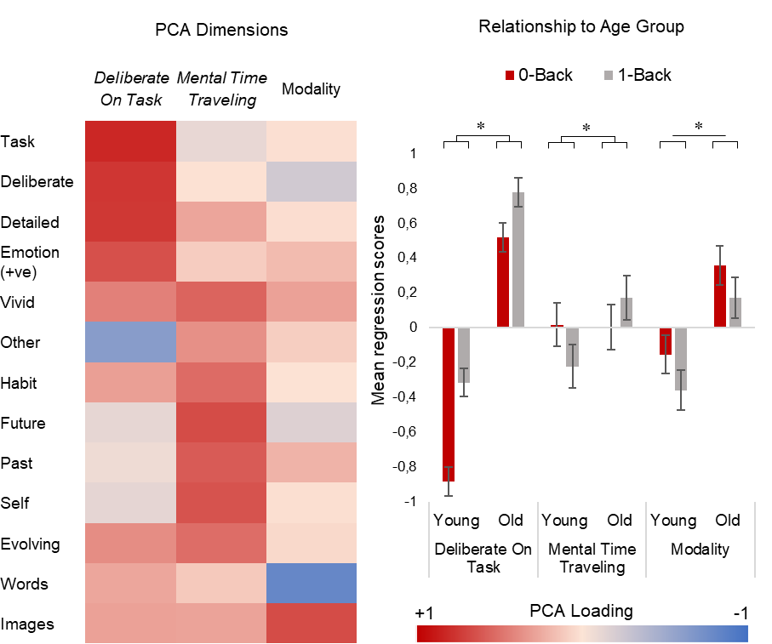

**Figure 3.** Determining patterns of ongoing thought and their relationship to ongoing task and age group.

(*Left*) Heat map illustrating the loading of the different questions on the three factors resulting from the principal component analyses (PCA). (*Right*) The interaction between Age (*Young, Old*) and Task difficulty (*0-Back, 1-Back*) for the mean regression weights for On Task and MTT types of thoughts, along with the main effects of Age (*Young, Old*) and Task difficulty (*0-Back, 1-Back*) on mean regression scores for Modality type of thoughts. Higher scores represent more thoughts representative of the component. *Note*. *** *p* <.001; Error bars are Standard Errors.

In order to identify how these patterns of thoughts varied across the two task conditions and age groups, 2 (Age; *Young, Old*) x 2 (Task; *0-Back, 1-Back*) mixed ANOVAs were conducted on participants’ mean regression scores for each of the three PCA components. For the ***Deliberate*** ***On-Task*** component we found a main effect of Task indicating lower scores in the *0-Back* condition than in the *1-Back* condition, *F* (1, 78) = 83.58, *p* < .001, *ηp2* = .52. The main effect of Age indicated that young adults had less thoughts deliberately directed toward the task than older adults, *F* (1, 78) = 133.89, *p* < .001, *ηp2* = .63. The interaction between Task and Age was also significant, *F* (1, 78) = 11.62, *p* < .001, *ηp2* = .13 (see **Figure 3**.). Decomposition of this interaction showed less *Deliberate On-Task* thought for younger adults compared to older adults in both the *0-Bback*, *F* (1, 78) = 139.77, *p* < .001, *ηp2* = .64, and the *1-Back*, *F* (1, 78) = 89.82, *p* < .001, *ηp2* = .54. To formally compare these differences, we calculated the difference in Deliberate On-Task loadings across the *0-Back* and *1-Back* tasks and conducted a univariate ANOVA with Age Group as a single categorical variable. This revealed a significant effect of Age Group, *F* (1, 79) = 11.6, *p* < .001, *ηp2* = .13 such that younger individuals tended to decrease the amount of Deliberate Task Focus in the *0-Back* relative to the *1-Back* task to a greater degree than older individuals. Analysis of the ***Mental Time Travelling*** component revealed a significant interaction between Task and Age, *F* (1, 78) = 16.77, *p* < .001, *ηp2* = .18 (see **Figure 3**.). Decomposition of this interaction showed no effect of Age in the *0-Back* condition, *F* (1, 78) = .006, *p* = .937, *ηp2* = .00, but a significant effect of Age in the *1-Back* condition, *F* (1, 78) = 4.95, *p* = .029, *ηp2* = .06, indicating less MTT for younger adults compared to older adults in the more demanding task context. Finally, analysis of the ***Modality*** of thoughts revealed a main effect of Task indicating more visual experiences in the *0-Back* condition (*M* = .09; *SD* = .74) and more verbal experiences in the *1-Back* condition (*M* = -.10; *SD* = .78), *F* (1, 78) = 12.40, *p* < .001, *ηp2* = .14. The main effect of Age indicated that young adults (*M* = -.26; *SD* = .59) had less thoughts in the form of images than older adults (*M* = .26; *SD* = .76), *F* (1, 78) = 11.84, *p* < .001, *ηp2* = .13.

* 1. Brain connectivity in ageing and relation to the task

Our first neural analysis identified regions whose patterns of functional connectivity from the selected regions of interest showed age-related changes. We conducted a series of group level multiple regressions in which spatial maps describing the functional connectivity of these seeds were the dependent variables and Age group was included as an explanatory variable. These analyses generally found regions of decreased functional connectivity with age (see **Figure 4**.). For both the Left and Right ATL younger individuals had stronger connectivity with a region of dorsomedial prefrontal cortex. These patterns were generally limited to the same hemisphere as the seed region; however, a small area of overlap was apparent in the right hemisphere. The Left ATL also had stronger connectivity to a cluster of Left ventrolateral dorsomedial prefrontal cortex in younger individuals. Examination of both patterns of connectivity showed that both the seed regions and the subsequent destination regions fall within the DMN (see **Figure 5**.). The connectivity of the left Inferior Frontal Gyrus seed with a region of left anterior Insula was stronger for younger relative to older individuals. This pattern of connectivity was associated with increased changes between the frontoparietal network and the ventral attention network (see **Figure 5**.). No differences were found in the connectivity of the Hippocampus across age groups. Previous research has reported conflicting findings with the posterior but not the anterior hippocampus showing less functional connectivity in ageing (Damoiseaux, Viviano, Yuan, & Raz, 2016). The unthresholded maps for all analyses are available in the associated Neurovault collection (<https://neurovault.org/collections/XDUJYLFH/>).

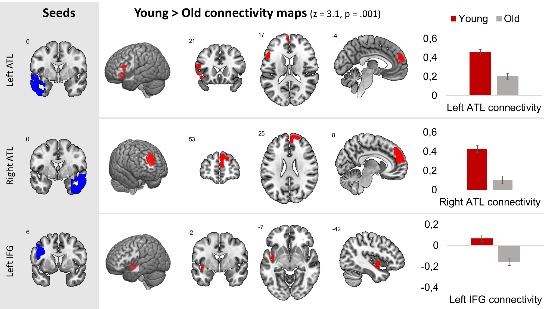

**Figure 4.** Significant effects of Age (*Young, Old*) on brain connectivity from the left ATL, the right ATL and the left IFG.

The left hand grey panel shows the regions used as seed regions in each analysis. Each row corresponds to the results of a whole brain analysis on each seed. Brain areas indicated as red in the centre panel showed greater connectivity with the seed region for Younger than Older Adults. The bar graphs in the right hand panel summarise the beta weights of the effects as generated by the model for Younger and Older participants. Abbreviations: ATL = Anterior Temporal Lobe; IFG = Inferior Frontal Gyrus. Maps were thresholded at Z = 3.1 and were corrected for the family wise error in terms of the number of voxels in the brain, the two tailed nature of our tests and the number of seed regions.

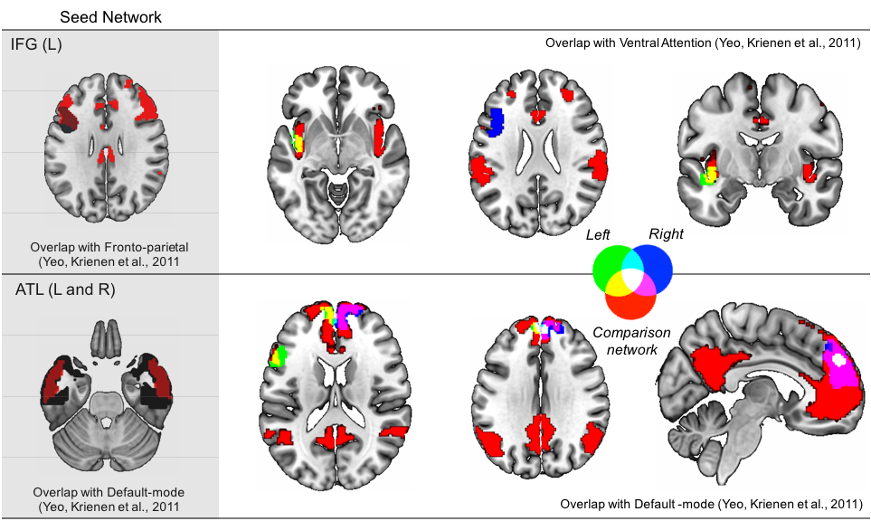

**Figure 5.** Relationship between age-related changes in functional connectivity and large scale networks.

The main panel describes the correspondence between regions showing age related changes and the relevant large scale network as described by Yeo, Krienen and colleagues (2011). In the main panel, green indicates regions showing age related changes in connectivity from the left hemisphere, while blue shows the same data originating from the same region in the right hemisphere. Regions in red show the comparison network (upper panel – ventral attention, lower panel – the default mode network). The sub panel (coloured grey) shows the overlap between the seed regions (indicated in black) and the relevant network (in red).

Next, we explored correspondences between age-related changes in the patterns of ongoing thought and changes in intrinsic neural function identified in our prior analyses. Three outliers were identified based on the visualisation of boxplot generated in SPSS 24.0, and removed in the following analyses; two older adults (connectivity measures) and one younger adult (behavioural measures). Prior to performing these analyses all data was z-scored separately for young and older individuals. This step assured that gross differences in intercepts across conditions and age group were minimised, allowing relationships between the variables to be visualised more transparently. These data were analysed using a mixed ANOVA. Our model had two within-participant factors: Task (*0–Back, 1-Back*), and Component (*Detailed On Task, Mental Time Travel, Modality*). We included age group (*Young, Old*) as a between participant variable. We also included the normalised connectivity scores for all of the significant effects (Left ATL, Right ATL and Left IFG) and controlled for differences in movement across the two groups by including mean FD (frame displacement, see Power, Barnes, Snyder, Schlaggar, & Petersen, 2012). We modelled the main effects of all variables as well as both two-way and three-way interactions between task, age group and each PCA component. We did not include interaction terms describing the relationship between each PCA component.

This analysis revealed a significant four-way interaction Task X Age Group X Component X Left ATL Connectivity, *F* (2, 126) = 9.019, *p* < .001, *ηp2* = .15. The effect was found for variation in patterns of Deliberate On-Task thought only: Task X Age Group X Left ATL Connectivity, *F* (1, 63) = 11.204, *p* = .001, *ηp2* = .15. To visualise this interaction, we plotted the relationship between left ATL connectivity and change in how Deliberate On-Task thought changed across task separately in each age group (**Figure 6**.). In younger individuals, lower connectivity is linked to more off-task, spontaneous thought in the 0-Back task and a more deliberate on-task state in the 1-Back task. No such pattern of variation was apparent in the older individuals. There were no significant associations with any other pattern of experience, nor were there any significant Task by Age Group interactions for any task.

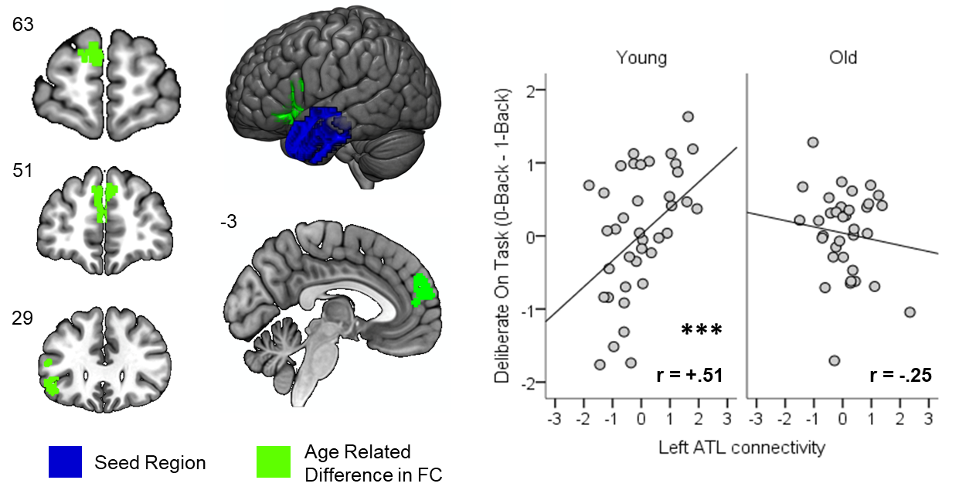

**Figure 6.** Association between patterns of age-related difference in functional connectivity and patterns of ongoing thought.

The left-hand panel illustrates the regions with age-related differences (green) in functional connectivity from the left ATL (blue). The right-hand panel illustrates the significant relationship between left ATL connectivity and the variation in Deliberate On Task states across tasks in the younger but not the older participants. *Note*. *** *p* <.001

* 1. Relationship to control tasks

Our final analysis examined the relationship between age-related changes in performance on the behavioural tasks. This will enable a more general understanding of the consequences underlying neurocognitive changes in ageing. We performed a series of univariate analyses on the measures of creativity, fluid intelligence and working memory. We included Age as between-subject variable, included the normalised connectivity from each of the significant analyses and again controlled for the mean FD. We modelled the main effects of each factor and as well as the two-way interactions between Age group and each of the connectivity patterns. These revealed an Age by Left ATL connectivity interaction related to performance on the UUT, *F* (1, 63) = 5.355, *p* = .024, *ηp2* = .08. Comparing the association between UUT performance and connectivity with left ATL separately for each age group showed a significant negative association for older individuals, *r* = -.50, *p* <.01, but showed no association for younger participants, *r* = .05, *p* = .756. Thus, weaker connectivity was related to more creativity in older adults only.

1. Discussion

Our study set out to understand whether different patterns of ongoing thought in older individuals could be linked to age-related changes in the underlying functional architecture. We selected three regions, each linked to different processes based on prior research: the hippocampus given its role in episodic memory, the anterior temporal lobe given their role in semantic memory and the inferior frontal gyrus given its role in control of memory in both domains (Stampacchia et al., 2018). Our group level analysis showed decreased connectivity between DMN regions in the anterior temporal cortex with regions of the same network in ventrolateral and dorsomedial prefrontal cortex. We also found that left inferior frontal gyrus had decreased connectivity with the left anterior insula, suggesting age-related changes in how regions of the frontoparietal network communicate with the ventral attention network. We confirmed prior studies showing more deliberate on-task thoughts in older individuals, especially in the easier 0-Back condition, and found that they tended to think more in images than words. They also reported experiences with more episodic features in the more demanding 1-Back task relative to the younger participants.

We found evidence that regions showing different patterns of ATL connectivity with the prefrontal regions of the DMN in older adults, were linked to changes in the ability to increase off-task thoughts when task demands decline. In the younger individuals, lower connectivity between these sets of regions was associated with more flexible adjustment of off-task thoughts, increasing them in the undemanding 0-Back task relative to the harder 1-Back task. This association was absent in older individuals who reduced their focus on the task less when demands were reduced compared to younger participants. Our data, therefore, show age-related changes in connectivity within the DMN target regions that in younger participants are related to flexible increases in off-task thought when task demands are low. Titrating task focus in line with the demands of the task is a well-documented feature of cognition in younger individuals (Konishi et al., 2017; Seli, Risko, Smilek, & Schacter, 2016; Smallwood, Nind, & O’Connor, 2009) and is assumed to reflect the ability to regulate the contents of ongoing thought in line with the demands of the environment (Smallwood & Andrews-Hanna, 2013). Our prior work using this paradigm shows that individuals who do this the best score higher on measures of fluid intelligence (Turnbull et al., 2019). Our study therefore suggests that reductions in off-task thinking as we age may be linked to neural changes that may disrupt the ability to flexibly alter patterns of ongoing thought when external task demands change.

Importantly, our study found that older individuals with lower patterns of connectivity between the same set of temporal and prefrontal regions, tended to perform better on creativity measure. Associations in older adults between performance on the Unusual Uses Task (UUT) and reduced connectivity from the left ATL, rules out simple interpretations of this age-related connectivity change as reflecting generally impaired cognitive processing. Instead, it seems that older adults who have a pattern of connectivity associated with preserved cognitive function on UUT are making more cognitive effort even when it is not needed (i.e. undemanding task). Prior studies in younger individuals have found correlations between better divergent creativity and patterns of off-task experience (Baird et al., 2012; Smeekens & Kane, 2016; Wang, Poerio, et al., 2018). If creativity and the off-task state share some underlying cognitive features, it is possible that association between performance on the unusual uses task and connectivity in older individuals is evidence of a certain degree of preservation of this latent factor. In support of this account, our prior work shows an association between more spontaneous off-task thoughts, greater creativity and lower within DMN connectivity (Wang, Poerio, et al., 2018). In that study, using independent data, but a similar experimental setup, we used canonical correlation to identify a pattern of spontaneous off-task thought that was linked to reduced connectivity across regions of the DMN. This pattern was independently linked to better performance on tasks tapping a process of generation, such as the unusual uses task, self-reference and measures of verbal fluency. The conceptual similarity between the results of the current study with those Wang and colleagues (2018), therefore, provides independent support for the close association between creativity, spontaneous off-task thoughts and reduced connectivity within the DMN. Further corroborating evidence comes from a recent study, using the same task paradigm, in which we combined online experience sampling with fMRI. Using representational similarity analysis, we demonstrated that neural signals within certain regions of the DMN are important for momentary states of detailed focus on the task (Sormaz et al., 2018). This result is consistent with our past (i.e. Wang, Poerio, et al., 2018) and current data, which show that in younger individuals, stronger coupling between regions of the DMN are linked to a preference for detailed on-task thinking. Based on this emerging literature, we speculate that understanding the intersection between creativity and off-task thought in ageing, could be an important question for future work exploring the functions that the DMN plays in cognition. It is worse noting that our creativity measure was based on divergent thinking and did not consider convergent measures of creativity. This second approach is likely to involve different connectivity patterns and should be investigated in the future.

While our study implicates the DMN in age-related changes in off-task thought, many questions remain unanswered. First, our use of a cross-sectional design to examine age differences in cognition and brain function, while practical, confounds many factors that could have been addressed using a more complex longitudinal design. Studies suggest that declines in the tendency for off-task thought are consistent whether a cross-sectional or longitudinal design is used (Giambra, 1989; Shaw & Giambra, 1993) as are age-related changes in functional connectivity (Damoiseaux, 2017). Building on our findings, future studies could benefit from a longitudinal design in which individuals with a range of ages are measured on multiple occasions, a design that may help provide a more comprehensive understanding of the underlying relationships between neural function and patterns of ongoing thought. Additionally, longitudinal designs would prevent some of the limitation observed in this study, namely the large age range within the older adults’ group and the impact of age-related difference in task motivation on off-task thought (Frank, Nara, Zavagnin, Touron, & Kane, 2015; Krawietz, Tamplin, & Radvansky, 2012). Second, our study used an individual difference approach to examine patterns of ongoing thought, and thus adopted a trait level perspective on a state. While a between participant approach is efficient in helping understand variation in the neuro-cognitive architecture linked to patterns of ongoing thought (Golchert et al., 2017; Smallwood et al., 2016; Wang, Bzdok, et al., 2018; Wang, Poerio, et al., 2018) it lacks the precision that momentary experience sampling can provide (Allen et al., 2013; Christoff et al., 2009; Hasenkamp, Wilson-Mendenhall, Duncan, & Barsalou, 2012; Stawarczyk et al., 2011). Our recent work has shown that MDES data can be successfully combined with measures of online neural function to identify links between experience and brain activity (Sormaz et al., 2018). Building on the success of this work it may be possible to compare measures of online neural activity across older and younger individuals. This would help determine neural patterns of activity during task performance and so could usefully constrain the interpretations that should be placed on these data. Third, while showing important neural associations underlying age-related changes in older individuals’ capacity to generate patterns of off-task thought, our data do not directly constrain the underlying mechanism that explains both the reductions in functional connectivity, as well as the changes in ongoing thought seen in older individuals. It is possible that the reductions in the increase in off-task thought in older individuals when tasks demands are lower reflect the process of neuro-dedifferentiation whereby age related changes in older individuals cognition forces them to engage more general purpose processes (Reuter-Lorenz & Cappell, 2008). In particular, since the production of off-task thought can be conceived of as an example of dual-tasking (e.g. Teasdale, Proctor, Lloyd, & Baddeley, 1993), older individuals may lack the resources with which to consciously engage with other concerns. However, it is important to note that our study did not directly assess neural functioning when older individuals performed the task, and so this interpretation must remain speculative in lieu of further evidence. Fourth, in the current study we made no attempt to tailor task demands to the resources of a specific individual. Surprisingly, older adults performed worse at the 0-Back than in the 1-Back condition, perhaps because in the absence of the requirement to continually maintain task relevant information, they lost track of what condition they were in. It is possible that a design in which task parameters where staircased to ensure equivalence of task demands (e.g. Baird, Smallwood, Gorgolewski, & Margulies, 2013) would be useful in identifying a more nuanced relationship between aging and patterns of off-task thought. Finally, our study focused on functional differences across age groups. It remains possible that age differences in brain structure (e.g. Bartzokis et al., 2001) could underlie these differences, an important question for a future study with a larger sample to address.

To conclude, our study set out to understand whether age-related changes in ongoing thought are linked to changes in the functional architecture that occur as we grow older. We found that connectivity between the left ATL and ventrolateral/dorsomedial prefrontal cortex within the DMN was reduced in older individuals. In younger participants this pattern of connectivity was related to the flexibility with which ongoing thought is modulated. Importantly, in the older individuals, lower connectivity between the same two regions was linked to preserved creativity performance, suggesting that age-related changes in this area are not linked to impairments in cognition across domains. Together these data provide converging evidence that one reason why ongoing thought becomes more focused on tasks as we age is related to changes in the connectivity of the DMN. In the future, understanding the role of the DMN in creativity and off-task thought may shine a light on an important aspect of how cognition changes as we age.

**References**

Addis, D. R., Musicaro, R., Pan, L., & Schacter, D. L. (2010). Episodic simulation of past and future events in older adults: Evidence from an experimental recombination task. *Psychology and Aging*, *25*(2), 369–376. https://doi.org/10.1037/a0017280

Addis, D. R., Wong, A. T., & Schacter, D. L. (2008). Age-related changes in the episodic simulation of future events. *Psychological Science*, *19*(1), 33–41.

Allen, J. S., Bruss, J., Brown, C. K., & Damasio, H. (2005). Normal neuroanatomical variation due to age: The major lobes and a parcellation of the temporal region. *Neurobiology of Aging*, *26*(9), 1245–1260. https://doi.org/10.1016/j.neurobiolaging.2005.05.023

Allen, M., Smallwood, J., Christensen, J., Gramm, D., Rasmussen, B., Gaden Jensen, C., … Lutz, A. (2013). The balanced mind: the variability of task-unrelated thoughts predicts error-monitoring. *Frontiers in Human Neuroscience*, *7*. https://doi.org/10.3389/fnhum.2013.00743

Andrews-Hanna, J. R. (2012). The Brain’s Default Network and Its Adaptive Role in Internal Mentation. *The Neuroscientist*, *18*(3), 251–270. https://doi.org/10.1177/1073858411403316

Andrews‐Hanna, J. R., Smallwood, J., & Spreng, R. N. (2014). The default network and self‐generated thought: component processes, dynamic control, and clinical relevance. *Annals of the New York Academy of Sciences*, *1316*(1), 29–52. https://doi.org/10.1111/nyas.12360

Baird, Benjamin, Smallwood, J., Gorgolewski, K. J., & Margulies, D. S. (2013). Medial and Lateral Networks in Anterior Prefrontal Cortex Support Metacognitive Ability for Memory and Perception. *Journal of Neuroscience*, *33*(42), 16657–16665. https://doi.org/10.1523/JNEUROSCI.0786-13.2013

Baird, Benjamin, Smallwood, J., Mrazek, M. D., Kam, J. W. Y., Franklin, M. S., & Schooler, J. W. (2012). Inspired by Distraction: Mind Wandering Facilitates Creative Incubation. *Psychological Science*, *23*(10), 1117–1122. https://doi.org/10.1177/0956797612446024

Baird, Benjamin, Smallwood, J., & Schooler, J. W. (2011). Back to the future: Autobiographical planning and the functionality of mind-wandering. *Consciousness and Cognition*, *20*(4), 1604–1611. https://doi.org/10.1016/j.concog.2011.08.007

Bartzokis, G., Beckson, M., Lu, P. H., Nuechterlein, K. H., Edwards, N., & Mintz, J. (2001). Age-Related Changes in Frontal and Temporal Lobe Volumes in Men: A Magnetic Resonance Imaging Study. *Archives of General Psychiatry*, *58*(5), 461–465. https://doi.org/10.1001/archpsyc.58.5.461

Biswal, B. B., Mennes, M., Zuo, X.-N., Gohel, S., Kelly, C., Smith, S. M., … Milham, M. P. (2010). Toward discovery science of human brain function. *Proceedings of the National Academy of Sciences*, *107*(10), 4734–4739. https://doi.org/10.1073/pnas.0911855107

Braver, T. S., & West, R. (2008). Working memory, executive control, and aging. *The handbook of aging and cognition, 3*, 311-372.

Buckner, R. L., Andrews-Hanna, J. R., & Schacter, D. L. (2008). The Brain’s Default Network: Anatomy, Function, and Relevance to Disease. *Annals of the New York Academy of Sciences*, *1124*(1), 1–38. https://doi.org/10.1196/annals.1440.011

Christoff, K., Gordon, A. M., Smallwood, J., Smith, R., & Schooler, J. W. (2009). Experience sampling during fMRI reveals default network and executive system contributions to mind wandering. *Proceedings of the National Academy of Sciences*, *106*(21), 8719–8724. https://doi.org/10.1073/pnas.0900234106

Craddock, R. C., James, G. A., Holtzheimer, P. E., Hu, X. P., & Mayberg, H. S. (2012). A whole brain fMRI atlas generated via spatially constrained spectral clustering. *Human Brain Mapping*, *33*(8), 1914–1928. https://doi.org/10.1002/hbm.21333

Damoiseaux, J. S. (2017). Effects of aging on functional and structural brain connectivity. *NeuroImage*, *160*, 32–40. https://doi.org/10.1016/j.neuroimage.2017.01.077

Damoiseaux, J. S., Beckmann, C. F., Arigita, E. J. S., Barkhof, F., Scheltens, P., Stam, C. J., … Rombouts, S. a. R. B. (2008). Reduced resting-state brain activity in the “default network” in normal aging. *Cerebral Cortex*, *18*(8), 1856–1864. https://doi.org/10.1093/cercor/bhm207

Damoiseaux, J. S., Viviano, R. P., Yuan, P., & Raz, N. (2016). Differential effect of age on posterior and anterior hippocampal functional connectivity. *NeuroImage*, *133*, 468–476. https://doi.org/10.1016/j.neuroimage.2016.03.047

Davey, J., Thompson, H. E., Hallam, G., Karapanagiotidis, T., Murphy, C., De Caso, I., … Jefferies, E. (2016). Exploring the role of the posterior middle temporal gyrus in semantic cognition: Integration of anterior temporal lobe with executive processes. *NeuroImage*, *137*, 165–177. https://doi.org/10.1016/j.neuroimage.2016.05.051

Desikan, R. S., Ségonne, F., Fischl, B., Quinn, B. T., Dickerson, B. C., Blacker, D., … Killiany, R. J. (2006). An automated labeling system for subdividing the human cerebral cortex on MRI scans into gyral based regions of interest. *NeuroImage*, *31*(3), 968–980. https://doi.org/10.1016/j.neuroimage.2006.01.021

Du, A.-T., Schuff, N., Chao, L. L., Kornak, J., Jagust, W. J., Kramer, J. H., … Weiner, M. W. (2006). Age effects on atrophy rates of entorhinal cortex and hippocampus. *Neurobiology of Aging*, *27*(5), 733–740. https://doi.org/10.1016/j.neurobiolaging.2005.03.021

Duncan, J., & Owen, A. M. (2000). Common regions of the human frontal lobe recruited by diverse cognitive demands. *Trends in Neurosciences*, *23*(10), 475–483. https://doi.org/10.1016/S0166-2236(00)01633-7

Ellamil, M., Fox, K. C. R., Dixon, M. L., Pritchard, S., Todd, R. M., Thompson, E., & Christoff, K. (2016). Dynamics of neural recruitment surrounding the spontaneous arising of thoughts in experienced mindfulness practitioners. *NeuroImage*, *136*, 186–196. https://doi.org/10.1016/j.neuroimage.2016.04.034

Fedorenko, E., Duncan, J., & Kanwisher, N. (2013). Broad domain generality in focal regions of frontal and parietal cortex. *Proceedings of the National Academy of Sciences*, *110*(41), 16616–16621. https://doi.org/10.1073/pnas.1315235110

Finn, E. S., Shen, X., Scheinost, D., Rosenberg, M. D., Huang, J., Chun, M. M., … Constable, R. T. (2015). Functional connectome fingerprinting: identifying individuals using patterns of brain connectivity. *Nature Neuroscience*, *18*(11), 1664–1671. https://doi.org/10.1038/nn.4135

Fjell, A. M., & Walhovd, K. B. (2010). Structural Brain Changes in Aging: Courses, Causes and Cognitive Consequences. *Reviews in the Neurosciences*, *21*(3). https://doi.org/10.1515/REVNEURO.2010.21.3.187

Fjell, A. M., Walhovd, K. B., Fennema-Notestine, C., McEvoy, L. K., Hagler, D. J., Holland, D., … Dale, A. M. (2009). One-Year Brain Atrophy Evident in Healthy Aging. *Journal of Neuroscience*, *29*(48), 15223–15231. https://doi.org/10.1523/JNEUROSCI.3252-09.2009

Folstein, M. F., Folstein, S. E., & McHugh, P. R. (1975). “Mini-mental state”. *Journal of Psychiatric Research*, *12*(3), 189–198. https://doi.org/10.1016/0022-3956(75)90026-6

Frank, D. J., Nara, B., Zavagnin, M., Touron, D. R., & Kane, M. J. (2015). Validating older adults’ reports of less mind-wandering: An examination of eye movements and dispositional influences. *Psychology and Aging*, *30*(2), 266–278. https://doi.org/10.1037/pag0000031

Frazier, J. A., Chiu, S., Breeze, J. L., Makris, N., Lange, N., Kennedy, D. N., … Biederman, J. (2005). Structural Brain Magnetic Resonance Imaging of Limbic and Thalamic Volumes in Pediatric Bipolar Disorder. *American Journal of Psychiatry*, *162*(7), 1256–1265. https://doi.org/10.1176/appi.ajp.162.7.1256

Giambra, L. M. (1989). Task-unrelated thought frequency as a function of age: A laboratory study. *Psychology and Aging*, *4*(2), 136–143. https://doi.org/10.1037/0882-7974.4.2.136

Golchert, J., Smallwood, J., Jefferies, E., Seli, P., Huntenburg, J. M., Liem, F., … Margulies, D. S. (2017). Individual variation in intentionality in the mind-wandering state is reflected in the integration of the default-mode, fronto-parietal, and limbic networks. *NeuroImage*, *146*, 226–235. https://doi.org/10.1016/j.neuroimage.2016.11.025

Goldstein, J. M., Seidman, L. J., Makris, N., Ahern, T., O’Brien, L. M., Caviness, V. S., … Tsuang, M. T. (2007). Hypothalamic Abnormalities in Schizophrenia: Sex Effects and Genetic Vulnerability. *Biological Psychiatry*, *61*(8), 935–945. https://doi.org/10.1016/j.biopsych.2006.06.027

Guilford, J. P., Merrifield, P. R., & Wilson, R. C. (1958). Unusual uses test. *Orange, CA: Sheridan Psychological Services.*

Hasenkamp, W., Wilson-Mendenhall, C. D., Duncan, E., & Barsalou, L. W. (2012). Mind wandering and attention during focused meditation: A fine-grained temporal analysis of fluctuating cognitive states. *NeuroImage*, *59*(1), 750–760. https://doi.org/10.1016/j.neuroimage.2011.07.008

Jackson, J. D., & Balota, D. A. (2012). Mind-wandering in Younger and Older Adults: Converging Evidence from the Sustained Attention to Response Task and Reading for Comprehension. *Psychology and Aging*, *27*(1), 106–119. https://doi.org/10.1037/a0023933

Jackson, J. D., Weinstein, Y., & Balota, D. A. (2013). Can mind-wandering be timeless? Atemporal focus and aging in mind-wandering paradigms. *Frontiers in Psychology*, *4*. https://doi.org/10.3389/fpsyg.2013.00742

Kane, M. J., Brown, L. H., McVay, J. C., Silvia, P. J., Myin-Germeys, I., & Kwapil, T. R. (2007). For Whom the Mind Wanders, and When An Experience-Sampling Study of Working Memory and Executive Control in Daily Life. *Psychological Science*, *18*(7), 614–621. https://doi.org/10.1111/j.1467-9280.2007.01948.x

Kane, M. J., & McVay, J. C. (2012). What Mind Wandering Reveals About Executive-Control Abilities and Failures. *Current Directions in Psychological Science*, *21*(5), 348–354. https://doi.org/10.1177/0963721412454875

Karapanagiotidis, T., Bernhardt, B. C., Jefferies, E., & Smallwood, J. (2017). Tracking thoughts: Exploring the neural architecture of mental time travel during mind-wandering. *NeuroImage*, *147*, 272–281. https://doi.org/10.1016/j.neuroimage.2016.12.031

Konishi, M., Brown, K., Battaglini, L., & Smallwood, J. (2017). When attention wanders: Pupillometric signatures of fluctuations in external attention. *Cognition*, *168*, 16–26. https://doi.org/10.1016/j.cognition.2017.06.006

Krawietz, S. A., Tamplin, A. K., & Radvansky, G. A. (2012). Aging and mind wandering during text comprehension. *Psychology and Aging*, *27*(4), 951–958. https://doi.org/10.1037/a0028831

Levinson, D. B., Smallwood, J., & Davidson, R. J. (2012). The Persistence of Thought: Evidence for a Role of Working Memory in the Maintenance of Task-Unrelated Thinking. *Psychological Science*, *23*(4), 375–380. https://doi.org/10.1177/0956797611431465

Makris, N., Goldstein, J. M., Kennedy, D., Hodge, S. M., Caviness, V. S., Faraone, S. V., … Seidman, L. J. (2006). Decreased volume of left and total anterior insular lobule in schizophrenia. *Schizophrenia Research*, *83*(2), 155–171. https://doi.org/10.1016/j.schres.2005.11.020

Martinon, L. M., Smallwood, J., Hamilton, C., Riby, L. M. (In press). Frogs’ Legs versus Roast Beefs: How Culture can Influence Mind-Wandering Episodes across the Lifespan. *Europe’s Journal of Psychology.*

McVay, J. C., & Kane, M. J. (2009). Conducting the Train of Thought: Working Memory Capacity, Goal Neglect, and Mind Wandering in an Executive-Control Task. *Journal of Experimental Psychology. Learning, Memory, and Cognition*, *35*(1), 196–204. https://doi.org/10.1037/a0014104

McVay, J. C., & Kane, M. J. (2010). Does mind wandering reflect executive function or executive failure? Comment on Smallwood and Schooler (2006) and Watkins (2008). *Psychological Bulletin*, *136*(2), 188–197. https://doi.org/10.1037/a0018298

McVay, J. C., Meier, M. E., Touron, D. R., & Kane, M. J. (2013). Aging ebbs the flow of thought: Adult age differences in mind wandering, executive control, and self-evaluation. *Acta Psychologica*, *142*(1), 136–147. https://doi.org/10.1016/j.actpsy.2012.11.006

Meunier, D., Achard, S., Morcom, A., & Bullmore, E. (2009). Age-related changes in modular organization of human brain functional networks. *NeuroImage*, *44*(3), 715–723. https://doi.org/10.1016/j.neuroimage.2008.09.062

Mooneyham, B. W., Mrazek, M. D., Mrazek, A. J., Mrazek, K. L., Phillips, D. T., & Schooler, J. W. (2016). States of Mind: Characterizing the Neural Bases of Focus and Mind-wandering through Dynamic Functional Connectivity. *Journal of Cognitive Neuroscience*, *29*(3), 495–506. https://doi.org/10.1162/jocn_a_01066

Mrazek, M. D., Franklin, M. S., Phillips, D. T., Baird, B., & Schooler, J. W. (2013). Mindfulness Training Improves Working Memory Capacity and GRE Performance While Reducing Mind Wandering. *Psychological Science*, *24*(5), 776–781. https://doi.org/10.1177/0956797612459659

Mrazek, Michael D., Smallwood, J., & Schooler, J. W. (2012). Mindfulness and mind-wandering: Finding convergence through opposing constructs. *Emotion*, *12*(3), 442–448. https://doi.org/10.1037/a0026678

Nelson, H. E. (1982). *National Adult Reading Test (NART): For the assessment of premorbid intelligence in patients with dementia: Test manual.* NFER-Nelson.

Noonan, K. A., Jefferies, E., Visser, M., & Lambon Ralph, M. A. (2013). Going beyond Inferior Prefrontal Involvement in Semantic Control: Evidence for the Additional Contribution of Dorsal Angular Gyrus and Posterior Middle Temporal Cortex. *Journal of Cognitive Neuroscience*, *25*(11), 1824–1850. https://doi.org/10.1162/jocn_a_00442

Peirce, JW (2007) PsychoPy - Psychophysics software in Python. *J Neurosci Methods, 162*(1-2):8-13

Persson, J., Stening, E., Nordin, K., & Söderlund, H. (2018). Predicting episodic and spatial memory performance from hippocampal resting-state functional connectivity: Evidence for an anterior-posterior division of function. *Hippocampus*, *28*(1), 53–66. https://doi.org/10.1002/hipo.22807

Poerio, G. L., Sormaz, M., Wang, H.-T., Margulies, D., Jefferies, E., & Smallwood, J. (2017). The role of the default mode network in component processes underlying the wandering mind. *Social Cognitive and Affective Neuroscience*, *12*(7), 1047–1062. https://doi.org/10.1093/scan/nsx041

Power, J. D., Barnes, K. A., Snyder, A. Z., Schlaggar, B. L., & Petersen, S. E. (2012). Spurious but systematic correlations in functional connectivity MRI networks arise from subject motion. *Neuroimage*, *59*(3), 2142–2154. https://doi.org/10.1016/j.neuroimage.2011.10.018

Raichle, M. E. (2015). The Brain’s Default Mode Network. *Annual Review of Neuroscience*, *38*(1), 433–447. https://doi.org/10.1146/annurev-neuro-071013-014030

Ralph, M. A. L., Jefferies, E., Patterson, K., & Rogers, T. T. (2017). The neural and computational bases of semantic cognition. *Nature Reviews Neuroscience*, *18*(1), 42–55. https://doi.org/10.1038/nrn.2016.150

Raven, J. C. (1983). Manual for Raven's progressive matrices and vocabulary scales. *Standard Progressive Matrices*.

Raz, N., Rodrigue, K. M., Head, D., Kennedy, K. M., & Acker, J. D. (2004). Differential aging of the medial temporal lobe: A study of a five-year change. *Neurology*, *62*(3), 433–438. https://doi.org/10.1212/01.WNL.0000106466.09835.46

Raz, Naftali, Ghisletta, P., Rodrigue, K. M., Kennedy, K. M., & Lindenberger, U. (2010). Trajectories of brain aging in middle-aged and older adults: Regional and individual differences. *NeuroImage*, *51*(2), 501–511. https://doi.org/10.1016/j.neuroimage.2010.03.020

Reuter-Lorenz, P. A., & Cappell, K. A. (2008). Neurocognitive Aging and the Compensation Hypothesis. *Current Directions in Psychological Science*, *17*(3), 177–182. https://doi.org/10.1111/j.1467-8721.2008.00570.x

Ruby, F. J. M., Smallwood, J., Engen, H., & Singer, T. (2013). How Self-Generated Thought Shapes Moodâ€”The Relation between Mind-Wandering and Mood Depends on the Socio-Temporal Content of Thoughts. *PLoS ONE*, *8*(10), e77554. https://doi.org/10.1371/journal.pone.0077554

Ruby, F. J. M., Smallwood, J., Sackur, J., & Singer, T. (2013). Is self-generated thought a means of social problem solving? *Frontiers in Psychology*, *4*. https://doi.org/10.3389/fpsyg.2013.00962

Rummel, J., & Boywitt, C. D. (2014). Controlling the stream of thought: Working memory capacity predicts adjustment of mind-wandering to situational demands. *Psychonomic Bulletin & Review*, *21*(5), 1309–1315. https://doi.org/10.3758/s13423-013-0580-3

Schmitter-Edgecombe, M., Vesneski, M., & Jones, D. W. R. (2000). Aging and Word-Finding: A Comparison of Spontaneous and Constrained Naming Tests. *Archives of Clinical Neuropsychology*, *15*(6), 479–493. https://doi.org/10.1016/S0887-6177(99)00039-6

Seli, P., Risko, E. F., Smilek, D., & Schacter, D. L. (2016). Mind-Wandering With and Without Intention. *Trends in Cognitive Sciences*, *20*(8), 605–617. https://doi.org/10.1016/j.tics.2016.05.010

Shaw, G. A., & Giambra, L. (1993). Task‐unrelated thoughts of college students diagnosed as hyperactive in childhood. *Developmental Neuropsychology*, *9*(1), 17–30. https://doi.org/10.1080/87565649309540541

Smallwood, J. (2013). Distinguishing how from why the mind wanders: A process–occurrence framework for self-generated mental activity. *Psychological Bulletin*, *139*(3), 519–535. https://doi.org/10.1037/a0030010

Smallwood, J., & Andrews-Hanna, J. (2013). Not all minds that wander are lost: the importance of a balanced perspective on the mind-wandering state. *Frontiers in Psychology*, *4*. https://doi.org/10.3389/fpsyg.2013.00441

Smallwood, J., Karapanagiotidis, T., Ruby, F., Medea, B., Caso, I. de, Konishi, M., … Jefferies, E. (2016). Representing Representation: Integration between the Temporal Lobe and the Posterior Cingulate Influences the Content and Form of Spontaneous Thought. *PLOS ONE*, *11*(4), e0152272. https://doi.org/10.1371/journal.pone.0152272

Smallwood, J., Nind, L., & O’Connor, R. C. (2009). When is your head at? An exploration of the factors associated with the temporal focus of the wandering mind. *Consciousness and Cognition*, *18*(1), 118–125. https://doi.org/10.1016/j.concog.2008.11.004

Smallwood, J., Ruby, F. J. M., & Singer, T. (2013). Letting go of the present: Mind-wandering is associated with reduced delay discounting. *Consciousness and Cognition*, *22*(1), 1–7. https://doi.org/10.1016/j.concog.2012.10.007

Smallwood, J., & Schooler, J. W. (2015). The Science of Mind Wandering: Empirically Navigating the Stream of Consciousness. *Annual Review of Psychology*, *66*(1), 487–518. https://doi.org/10.1146/annurev-psych-010814-015331

Smeekens, B. A., & Kane, M. J. (2016). Working memory capacity, mind wandering, and creative cognition: An individual-differences investigation into the benefits of controlled versus spontaneous thought. *Psychology of Aesthetics, Creativity, and the Arts*, *10*(4), 389–415. https://doi.org/10.1037/aca0000046

Sormaz, M., Jefferies, E., Bernhardt, B. C., Karapanagiotidis, T., Mollo, G., Bernasconi, N., … Smallwood, J. (2017). Knowing what from where: Hippocampal connectivity with temporoparietal cortex at rest is linked to individual differences in semantic and topographic memory. *NeuroImage*, *152*, 400–410. https://doi.org/10.1016/j.neuroimage.2017.02.071

Sormaz, M., Murphy, C., Wang, H., Hymers, M., Karapanagiotidis, T., Poerio, G., … Smallwood, J. (2018). Default mode network can support the level of detail in experience during active task states. *Proceedings of the National Academy of Sciences*, *115*(37), 9318–9323. https://doi.org/10.1073/pnas.1721259115

Spreng, R. N., Mar, R. A., & Kim, A. S. N. (2008). The Common Neural Basis of Autobiographical Memory, Prospection, Navigation, Theory of Mind, and the Default Mode: A Quantitative Meta-analysis. *Journal of Cognitive Neuroscience*, *21*(3), 489–510. https://doi.org/10.1162/jocn.2008.21029

Stampacchia, S., Thompson, H. E., Ball, E., Nathaniel, U., Hallam, G., Smallwood, J., … Jefferies, E. (2018). Shared processes resolve competition within and between episodic and semantic memory: Evidence from patients with LIFG lesions. *Cortex*, *108*, 127–143. https://doi.org/10.1016/j.cortex.2018.07.007

Stawarczyk, D., Majerus, S., Maquet, P., & D’Argembeau, A. (2011). Neural Correlates of Ongoing Conscious Experience: Both Task-Unrelatedness and Stimulus-Independence Are Related to Default Network Activity. *PLoS ONE*, *6*(2), e16997. https://doi.org/10.1371/journal.pone.0016997

Teasdale, J. D., Proctor, L., Lloyd, C. A., & Baddeley, A. D. (1993). Working memory and stimulus-independent thought: Effects of memory load and presentation rate. *European Journal of Cognitive Psychology*, *5*(4), 417–433. https://doi.org/10.1080/09541449308520128

Tulving, E. (2002). Episodic Memory: From Mind to Brain. *Annual Review of Psychology*, *53*(1), 1–25. https://doi.org/10.1146/annurev.psych.53.100901.135114

Turnbull, A., Wang, H.-T., Schooler, J. W., Jefferies, E., Margulies, D. S., & Smallwood, J. (2019). The ebb and flow of attention: Between-subject variation in intrinsic connectivity and cognition associated with the dynamics of ongoing experience. *NeuroImage*, *185*, 286–299. https://doi.org/10.1016/j.neuroimage.2018.09.069

Wang, H.-T., Bzdok, D., Margulies, D., Craddock, C., Milham, M., Jefferies, E., & Smallwood, J. (2018). Patterns of thought: Population variation in the associations between large-scale network organisation and self-reported experiences at rest. *NeuroImage*, *176*, 518–527. https://doi.org/10.1016/j.neuroimage.2018.04.064

Wang, H.-T., Poerio, G., Murphy, C., Bzdok, D., Jefferies, E., & Smallwood, J. (2018). Dimensions of Experience: Exploring the Heterogeneity of the Wandering Mind. *Psychological Science*, *29*(1), 56–71. https://doi.org/10.1177/0956797617728727

Wechsler, D. (1997). Wechsler Adult Intelligence Scale – Third edition San Antonio. TX: The Psychological Corporation

Wu, K., Taki, Y., Sato, K., Kinomura, S., Goto, R., Okada, K., … Fukuda, H. (2012). Age-related changes in topological organization of structural brain networks in healthy individuals. *Human Brain Mapping*, *33*(3), 552–568. https://doi.org/10.1002/hbm.21232

Yeo, B. T., Krienen, F. M., Sepulcre, J., Sabuncu, M. R., Lashkari, D., Hollinshead, M., … Buckner, R. L. (2011). The organization of the human cerebral cortex estimated by intrinsic functional connectivity. *Journal of Neurophysiology*, *106*(3), 1125–1165. https://doi.org/10.1152/jn.00338.2011