**Supporting information**

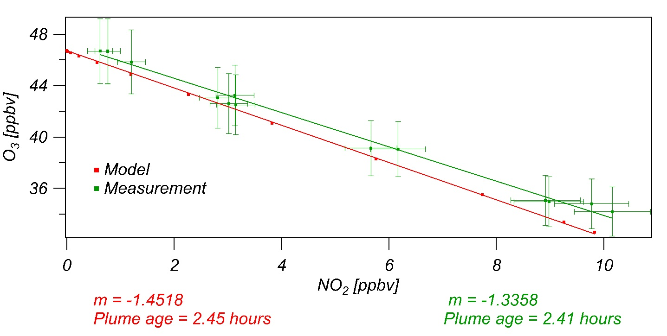

Figure S1: Plot of ozone concentration vs. NO2 concentration for Plume 2. The green line is a fit to measurements (green symbols). The red line represents the fit to the model results. The plume age is calculated from the slope, the rate coefficient for reaction of NO2 with ozone and the average O3 mixing ratio in the second plume.

Table S1: Absolute concentration at plume center of the SA produced from three pathways, primary emission, SSA from CI and SSA from OH, in the three scenarios, “Welz”, “Decay” and “No CI”.

|  |  |  |  |  |
| --- | --- | --- | --- | --- |
| [µg/Sm3] | | source | plume age (2.5 hours) | 10 hours |
| “Welz” | primary | 2.38 | 0.38 | 0.10 |
| CI | 0 | 0.15 | 0.30 |
| OH | 0 | 0.05 | 0.34 |
| “Decay” | primary | 2.94 | 0.40 | 0.20 |
| CI | 0.00 | 0.02 | 0.03 |
| OH | 0.00 | 0.07 | 0.34 |
| “No CI” | primary | 3.32 | 0.45 | 0.22 |
| CI | 0.00 | 0.00 | 0.00 |
| OH | 0.00 | 0.05 | 0.30 |

Table S2: Percentage of the concentration at plume center of SA produced from three pathways, primary emission, SSA from CI and SSA from OH, in the three scenarios, “Welz”, “Decay” and “No CI”.

|  |  |  |  |  |
| --- | --- | --- | --- | --- |
| [%] | | source | plume age (2.5 hours) | 10 hours |
| welz | primary | 100 | 66 | 14 |
| CI | 0 | 26 | 41 |
| OH | 0 | 8 | 46 |
| decay | primary | 100 | 81 | 35 |
| CI | 0 | 5 | 6 |
| OH | 0 | 14 | 60 |
| No CI | primary | 100 | 90 | 43 |
| CI | 0 | 0 | 0 |
| OH | 0 | 10 | 57 |

**Zero-NOx conditions simulation**

Table S3: Absolute concentration at plume center of the SA produced from three pathways, primary emission, SSA from CI and SSA from OH, in the three scenarios, “Welz”, “Decay” and “No CI”.

|  |  |  |  |  |
| --- | --- | --- | --- | --- |
| [µg /Sm3] | | source | plume age (2.5 hours) | 10 hours |
| welz | primary | 2.38 | 0.32 | 0.16 |
| CI | 0.00 | 0.30 | 0.78 |
| OH | 0.00 | 0.05 | 0.12 |
| decay | primary | 2.94 | 0.40 | 0.20 |
| CI | 0.00 | 0.05 | 0.08 |
| OH | 0.00 | 0.11 | 0.26 |
| No CI | primary | 3.32 | 0.50 | 0.34 |
| CI | 0.00 | 0.00 | 0.00 |
| OH | 0.00 | 0.05 | 0.12 |

Table S4: Percentage of the concentration at plume center of SA produced from three pathways, primary emission, SSA from CI and SSA from OH, in the three scenarios, “Welz”, “Decay” and “No CI”.

|  |  |  |  |  |
| --- | --- | --- | --- | --- |
| [%] | | source | plume age | 10 hours |
| welz | primary | 100 | 48 | 15 |
| CI | 0 | 44 | 74 |
| OH | 0 | 8 | 11 |
| decay | primary | 100 | 71 | 37 |
| CI | 0 | 9 | 15 |
| OH | 0 | 20 | 48 |
| No CI | primary | 100 | 91 | 74 |
| CI | 0 | 0 | 0 |
| OH | 0 | 9 | 26 |

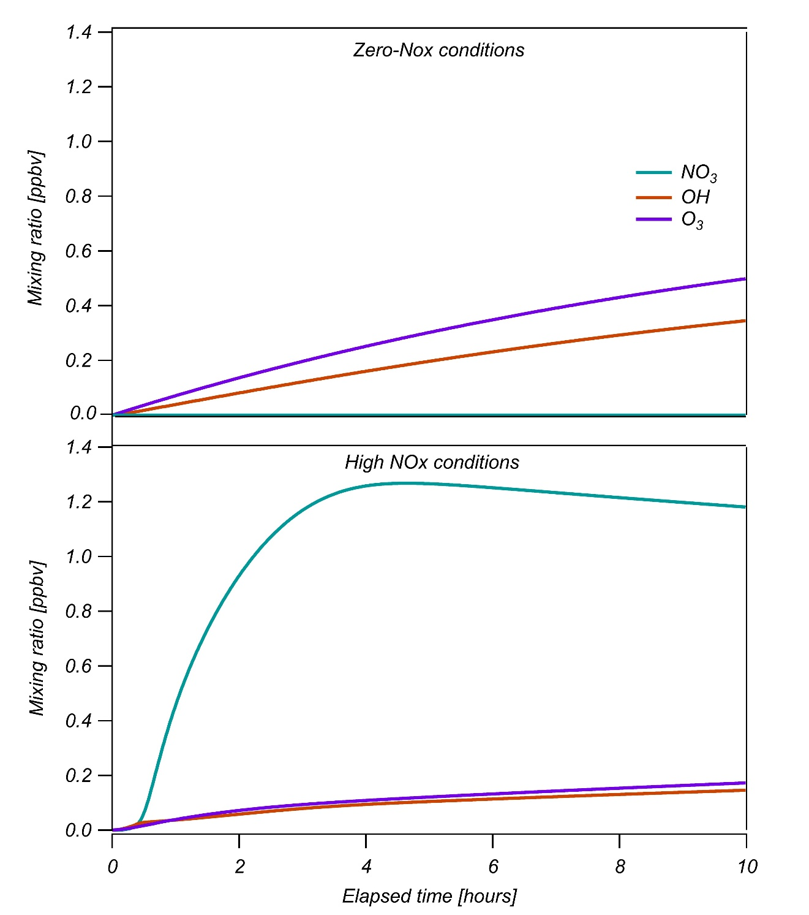

Figure S2: Isoprene consumption with the three oxidants, OH, ozone and NO3 at plume center. The top plot shows the results from the zero-NOx conditions and the bottom plot from the concentrated plume. The concentrated NOx conditions consume a larger amount of isoprene compared to the zero-NOx conditions.

Figure S2 shows the isoprene consumption at plume center with the three oxidants. In the zero-NOx conditions more isoprene is consumed through reaction with ozone, therefore more first generation CIs are produced. Additionally, there is no NO3 reaction with isoprene, leading to zero production of second generation CIs. On the other hand, at the concentrated NOx plume isoprene is consumed in larger amounts, but mainly through NO3 reaction. This results in smaller amounts of first generation CIs and higher amounts of second generation CIs.

**Constraining the Dispersion coefficient**

The dispersion coefficient is set to fit the width of the power plant plumes at the place of interception by the aircraft. Three plumes were examined and plume-specific dispersion coefficients were fitted for each plume (Figure S3).

|  |  |  |
| --- | --- | --- |
|  | Plume age | 10 hours |
| Plume 1 |  | |
| Plume 2 |
| Plume 3 |

Figure S3: SA production pathways at plume age (left column) and after 10 hours of simulations (right column). All the results are from the “Welz” scenario, plumes from top to bottom: fresh (1.4 hours at time of intersect), medium (2.5 hours at time of intersect) and aged (4.8 hours at time of intersect).

Figure S4 shows three simulations of the same plume with different dispersion coefficients. At plume age, i.e. 2.5 hours after emission, although the plumes look different, the integrated concentration through the plume is similar for all the dispersion coefficients. At the end of the simulations the dispersion is more dominant and the integrated concentration across the plume highly differs between the three different dispersion coefficients.

|  |  |  |
| --- | --- | --- |
|  | Plume age | 10 hours |
| 3*d |  | |
| d |
| d/3 |

Figure S4: SA production pathways at plume age on the left and after 10 hours of simulations on the right. All the results are from the Welz scenario, simulations differ in dispersion coefficient from top to bottom: 7.5x10-6, 2.5x10-6 and 8.33x10-7 km2 s-1.