Received 00th January 20xx,

1. Institute of Physical Chemistry, University of Stuttgart, Pfaffenwaldring 55, 70569 Stuttgart, Germany; e-mail: cosima.stubenrauch@ipc.uni-stuttgart.de; Tel.: +49-711-685-64470
2. Department of Chemical Engineering, Faculty of Applied Sciences, Delft University of Technology, Julianalaan 136, 2628BL Delft, The Netherlands; j.h.vanesch@tudelft.nl
3. Department of Chemistry, University of York, Heslington, York, YO10 5DD, UK; david.smith@york.ac.uk.

† Footnotes relating to the title and/or authors should appear here.

Electronic Supplementary Information (ESI) available: [details of any supplementary information available should be included here]. See DOI: 10.1039/x0xx00000x

Accepted 00th January 20xx

DOI: 10.1039/x0xx00000x

www.rsc.org/

Tuning gelled lyotropic liquid crystals (LLCs) – probing the influence of different low molecular weight gelators on the phase diagram of the system H2O/NaCl – Genapol LA070

Katja Stecka, Jan H. van Eschb, David K. Smithc, Cosima Stubenrauch*,a

Gelled lyotropic liquid crystals (LLCs) are highly tunable multi-component materials. By studying a selection of low molecular weight gelators (LMWGs), we find gelators that form self-assembled gels in LLCs without influencing their phase boundaries. We studied the system H2O/NaCl – Genapol LA070 in the presence of (a) the organogelators 12-hydroxyoctadecanoic acid (12-HOA) and 1,3:2,4-dibenzylidene-D-sorbitol (DBS) and (b) the hydrogelators *N*, *N*’-dibenzoyl-L-cystine (DBC) and a tris-amido-cyclohexane derivative (HG1). Visual phase studies and oscillation shear frequency sweeps confirmed that 12-HOA acts as co-surfactant (stabilizing the lamellar Lα phase and destabilizing the hexagonal H1 phase), thus preventing gelation. Conversely, DBS was a potent gelator for LLCs, with the phase boundaries un-influenced by the presence of DBS; gelled lamellar Lα, and softly-gelled hexagonal H1 phases are formed. For the hydrogelator DBC, the LLC phase boundaries were only slightly altered, but no gelled LLCs were formed. For the hydrogelator HG1, however, the phase boundaries were unaffected while gelled lamellar Lα and softly-gelled hexagonal H1 phases were formed. Temperature-dependent rheology measurements demonstrated that by changing the DBS concentration, the sol-gel transition temperature of the gelled lamellar Lα phase can be adjusted such that (a) *T*sol-gel is below the Lα-isotropic phase transition (DBS mass fraction η = 0.0075) and (b) *T*sol-gel is above the gelled Lα-isotropic phase transition (DBS η = 0.015). This opens the possibility of temporal materials control by addressing phase transitions in different orders. As this system contains oil and water, both the organogelator DBS and the hydrogelator HG1 can gel these LLCs, but this clearly does not apply to all organogelators/hydrogelators. The study indicates that careful optimization of LMWGs is required to avoid interaction with the surfactant layer and to optimize the *T*sol-gel value, which is important for the application of LMWGs in gelled LLCs.

Introduction

Gelled lyotropic liquid crystals (gelled LLCs) are one example of gelled complex fluids [1]. They combine the mechanical stability of a gel with the microstructure of a lyotropic liquid crystalline phase, which makes them interesting new materials in tissue healing applications and (trans-)dermal drug delivery systems.1,2 If the two structures, i.e. the lyotropic liquid crystal and the gel network, form simultaneously but independently, gelled LLCs can be called orthogonal self-assembled systems.1 Introduced by Laibinis *et al*. for alkanethiols on gold and alkane carboxylic acids on alumina3, the term orthogonal self-assembly was first used for gelled complex fluids by the group of van Esch, who gelled micellar solutions by adding a low molecular weight gelator (LMWG) to aqueous surfactant solutions.4-8 Kato *et al*. reported on thermotropic liquid-crystalline physical gels and showed that the anisotropic environment leads to controlled self-aggregation of the gelator molecules.9-12 For the special case of gelled LLCs, the cell is the most prominent example of an orthogonal self-assembled system.13 The liquid crystalline phospholipid membrane coexists independently with the protein filaments that give the cell mechanical stability. Smith and co-workers explored cationic micelles in several hydrogels, showing that depending on the chemical functionality of the hydrogelator, the self-assembled systems can either be orthogonal or non-orthogonal, depending on the absence or presence of non-covalent interactions between the two components.14,15 Lamellar biogels, described by Warriner *et al*., are an example of a non-orthogonal self-assembled gelled LLC.16 The gel character of the latter is provided by the random orientation of lamellar bilayers, resulting from defects in high curvature regions which are stabilized by short poly(ethylene glycol)-based amphiphilic block copolymers attached to the lamellar bilayers. Gelled LLCs, more specifically gelled lamellar phases, formed by adding a LMWG to a lamellar phase were studied focussing on the concept of orthogonal self-assembly.17,18 Koitani *et* *al*.found that the gelled lamellar phase of the system H2O – 2C12DAB (didodecyldimethylammonium bromide) – 12-HOA (12-hydroxyoctadecanoic acid) is an orthogonal self-assembled system17, whereas Xu *et* *al.* found for the very same gelator that the gelled lamellar phase of the system H2O – *n*-decane/12-HOA – C10E4 (tetraethylene glycol monodecyl ether) is not compatible with the concept of orthogonal self-assembly since the gel network and the lamellar phase influence each other.18 Thus, the question under which conditions gelled lamellar phases, or more generally gelled LLC, are truly orthogonal self-assembled systems still has to be fully understood.

In order to answer this question, the system H2O – C12E7 (heptaethylene glycol monododecyl ether) is our system of choice since it forms three lyotropic liquid crystalline phases, namely the hexagonal H1 phase, the bicontinuous cubic V1 phase and the lamellar Lα phase, with moderate melting points (*T* ≈ 50 °C) which ensures easy handling.19 In our previous study20, we investigated the influence of the organogelator 12-HOA on the phase boundaries of the LLC phases of the system H2O – C12E7 since 12-HOA has turned out to be a potent gelator for complex fluids.21,22 However, we made an unexpected observation. We found that 12-HOA has two roles, namely as co-surfactant and as gelator with the former being more pronounced. In its role as co-surfactant, 12-HOA influences the LLC phases such that the hexagonal phase is destabilized and the lamellar phase is stabilized. The “loss” of gelator, i.e. the incorporation of 12-HOA in the surfactant layer, is directly reflected in a reduced gelation capacity20, i.e. that the system H2O – C12E7 – 12-HOA is not appropriate to answer the question.

Since 12-HOA turned out not to be a suitable gelator for gelling the LLCs of the system H2O – C12E7 in an orthogonal self-assembled way, a gelator has to be found, which gels the lyotropic liquid crystals of the system H2O – C12E7 without influencing the phase boundaries. For economic reasons, we chose the system H2O/NaCl – Genapol LA070 as “scouting” system for further investigations. Genapol LA070 is the technical analogue to C12E7 with an alkyl chain length varying between C12-C14. We first determined the phase diagram of the system H2O/NaCl – Genapol LA070 and subsequently the influence of the organogelators 12-HOA (as reference) and DBS (Dibenzylidene-D-sorbitol)24 as well as of the hydrogelators DBC (*N, N’*-dibenzoyl-L-cystine)25 and HG14-7 on its phase boundaries by means of visual observations of birefringence. At the same time, we qualitatively determined the capability of the gelators to gel the LLCs. The molecular structures of the gelators are shown in Figure 1. Note that all gelators are low molecular weight gelators (LMWG), with sol-gel transition temperatures that can be adjusted via the concentration of the gelator in a suitable solvent26. In addition to the visual phase studies, we performed oscillation shear frequency sweeps in order to clarify whether gelled lyotropic liquid crystalline phases are formed. In case a gelled LLC was formed we carried out oscillation shear temperature sweeps in order to detect the sol-gel transition temperatures.

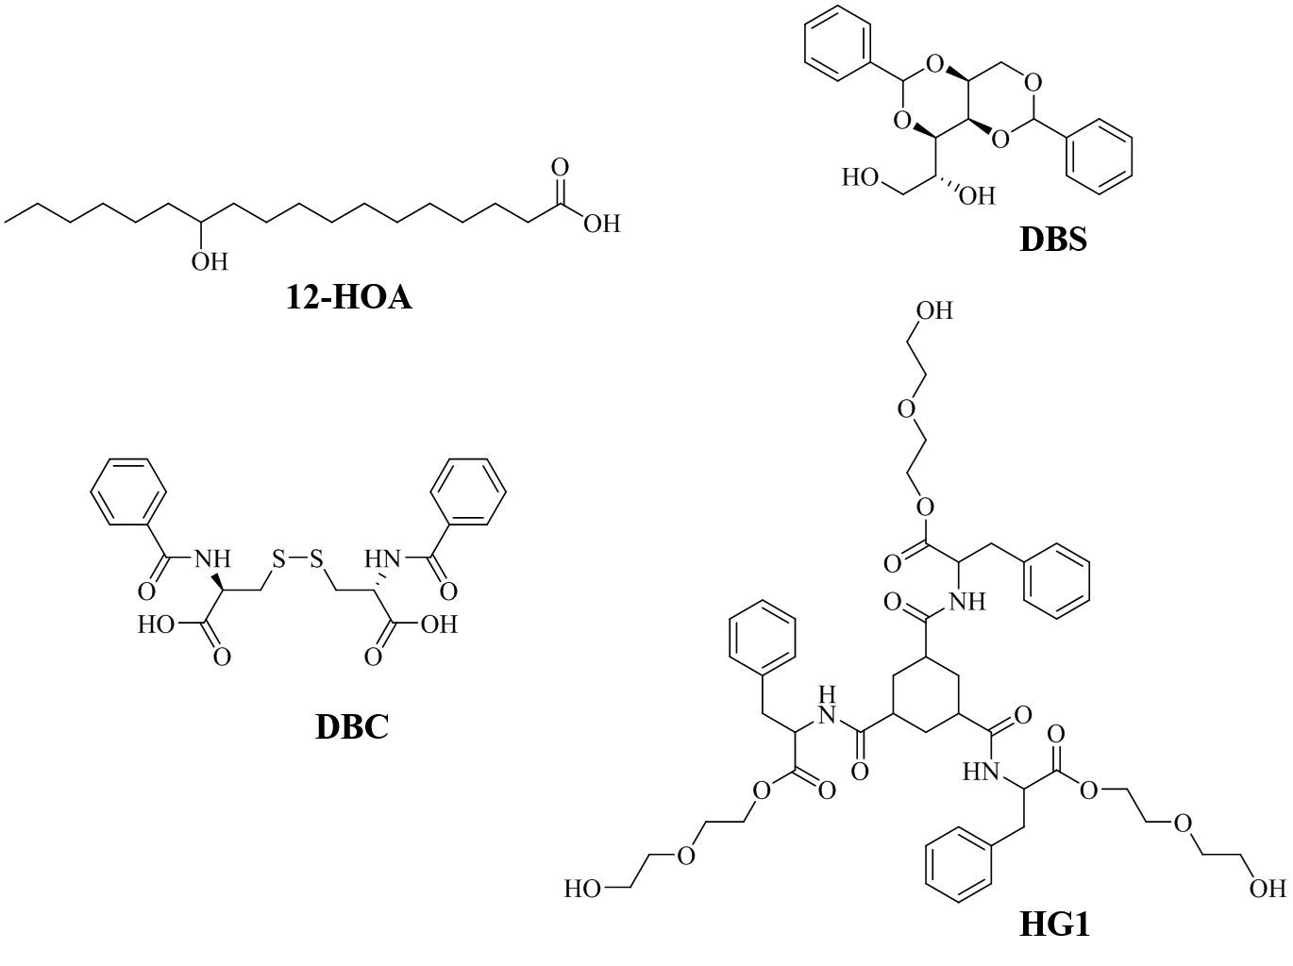

Figure 1: Molecular structures of the organogelators 12-hydroxyoctadecanoic acid (12-HOA), 1,3:2,4-Dibenzylidene-D-sorbitol (DBS) and of the hydrogelators *N*, *N*’-dibenzoyl-L-cystine (DBC) and HG1.

Experimental

Materials and Sample Preparation

We purchased Genapol LA070 from Clariant, 12-hydroxyoctadecanoic acid (12-HOA, *R*-enantiomer) from Alfa Aesar (95%), *N, N’* – dibenzoyl – L – cystine (DBC) from Santa Cruz and DBS as ‘Geniset D’ from NJC Europe. HG1 was synthesized as described before27. The chemicals were used without further purification.

The samples were prepared by using bi-distilled water with the salt mass fraction

|  |  |
| --- | --- |
| $$\text{ε = }\frac{{\text{m}}_{NaCl}}{{\text{m}}_{\text{NaCl}}\text{+ }{\text{m}}_{{\text{H}}_{\text{2}}\text{O}}}$$ | (1) |

and the surfactant mass fraction

|  |  |
| --- | --- |
| $${\text{γ}}_{\text{a}}\text{= }\frac{{\text{m}}_{\text{Genapol LA070}}}{{\text{m}}_{\text{Genapol LA070}}\text{+ }{\text{m}}_{{\text{H}}_{\text{2}}\text{O/NaCl}}}.$$ | (2) |

Gelator mass fractions were calculated by

|  |  |
| --- | --- |
| $$\text{η = }\frac{{\text{m}}_{\text{gelator}}}{{\text{m}}_{\text{Genapol LA070} }\text{+ }{\text{m}}_{{\text{H}}_{\text{2}}\text{O/NaCl}}\text{+ }{\text{m}}_{\text{gelator}} }.$$ | (3) |

We used ε = 0.001 for all samples and η = 0.0075 and η = 0.015 for gelator-containing samples. All components were weighed in glass tubes and sealed with plugs. The samples were heated up to *T* = 95 °C in a water bath as the gelators had to be molten. To ensure homogeneity, the samples were stirred at *T =* 95 °C for at least 10 min. Subsequently, the samples were cooled to room temperature for gelation. In the case of the lamellar phase, changes in viscosity indicated the process of gelation since no other phase transition occurred in this temperature range. The change of turbidity was used as indication for gelation in the case of the otherwise clear hexagonal phase.

Visual Phase Studies

The *T* - γa – phase diagram of the system H2O/NaCl – Genapol LA070 as well as the influence of various low molecular weight gelators on the phase boundaries of the lyotropic liquid crystalline phases were determined by visual observation of birefringence in water basins. The water basins are equipped with a thermostat (Thermo Scientific DC30), a thermometer, a sample holder, a lamp behind the samples and two crossed polarizers, one in front of and one behind the samples. First, we determined eventual LLC to isotropic phase transitions in intervals of Δ*T* = 5 K, followed by a second temperature scan changing the temperature increment to Δ*T* = 0.1 K at about 2 K below the roughly determined phase transitions. A waiting time of 3 min was kept for each increment. The phase boundaries of the lyotropic liquid crystalline phases were determined by anisotropy, viscosity and turbidity. The transparent hexagonal H1 phase is highly viscous as compared to the slightly turbid and less viscous lamellar Lα phase. Accordingly, the upper miscibility gap at high temperatures was identified by turbidity.

Rheometry

The rheological properties of the samples were determined by oscillation shear rheometry using a Physica MCR 501 rheometer from Anton Paar. We used a cone-plate geometry with an upper moving cone of 2.5 cm diameter and a cone angle of 1°. After the samples were transferred with a spatula to the lower plate, the upper cone was lowered to the measuring position (gap width *z* = 1 mm). In order to reach equilibrium, the samples were kept at *T* = 22 °C for 30 min, before starting the measurements. In preliminary oscillation strain sweeps at constant frequency ω = 10 s-1 and constant temperature *T* = 22 °C the linear viscoelastic (LVE) region of each sample was determined. The constant strain amplitude was set such that all tests were within the strain limit of the LVE region for each sample. The storage modulus *G*’ and the loss modulus *G*’’were then determined by frequency (ω) sweeps at a constant strain amplitude γ = 1 % and a constant temperature *T =* 22 °C. We calculated the average *G*’ and *G*’’ values and their standard deviations of three ω-sweeps (Table 1).

Table 1: Standard deviations of the storage modulus *G*’ and the loss modulus *G*’’ averaged over three frequency sweep measurements for the pure lamellar Lα and the pure hexagonal H1 phase as well as for both phases in the presence of the gelators 12-HOA, DBS, DBC and HG1 at gelator mass fractions η.

|  |  |  |  |  |  |
| --- | --- | --- | --- | --- | --- |
|  |  | Lα phase | | H1 phase | |
| gelator | η | Standard deviation of | | | |
| *G*’ / % | *G*’’ / % | *G*’ / % | *G*’’ / % |
|  | 0 | 61 | 52 | 66 | 67 |
| 12-HOA | 0.0075 | 34 | 20 | 42 | 37 |
| 0.015 | 59 | 51 | 56 | 53 |
| DBS | 0.0075 | 33 | 35 | 59 | 53 |
| 0.015 | 35 | 32 | 15 | 12 |
| DBC | 0.0075 | 85 | 74 | 47 | 40 |
| 0.015 | 51 | 48 | 25 | 22 |
| HG1 | 0.0075 | 49 | 48 | 60 | 70 |
| 0.015 | 76 | 73 | 36 | 30 |

Additional *T* – sweeps enabled us to monitor the sol-gel transition temperatures as well as the lyotropic liquid crystal to isotropic phase transitions of the gelator containing samples. Therefore, the samples were heated from *T* = 22 °C up to *T* = 100 °C in temperature steps of 2 K ∙ min-1 at a constant strain amplitude γ = 1 % and at a constant frequency ω = 10 s-1. The average sol-gel transition temperatures of two *T*-sweeps were calculated.

Results & Discussion

Visual Phase Studies

Visual observations of birefringence as function of the temperature *T* and the surfactant mass fraction γa enabled us to determine the *T* – γa phase diagram of the system H2O/NaCl – Genapol LA070 (Figure 2, black symbols). The system forms two lyotropic liquid crystalline phases, namely the hexagonal H1 phase and the lamellar Lα phase, in specific ranges of temperature and surfactant mass fraction.

The highly viscous and transparent hexagonal H1 phase occurs at surfactant mass fractions γa ≈ 0.30-0.60 and melts at temperatures between *T* ≈ 25-41 °C. The less viscous and slightly turbid lamellar Lα phase is formed at higher surfactant mass fractions (γa ≈ 0.60-0.84) but extends to the upper miscibility gap (2φ) at low surfactant mass fractions γa and high temperatures *T*. Note that an extended lamellar Lα phase does not occur in the system H2O – C12E7. Its formation in the system H2O/NaCl – Genapol LA070 is caused by the technical grade surfactant Genapol LA070 whose alkyl chain length varies from C12-C14. Due to the presence of longer alkyl chains in Genapol LA070, the packing parameter, i.e. the ratio of hydrophobic area to effective hydrophilic head group area, is reduced which leads to a lower curvature of the surfactant layer, and hence to an extended lamellar phase.28-33

Having measured the phase diagram of the binary base system, we investigated the influence of the organogelators 12-HOA and DBS as well as of the hydrogelators DBC and HG1 at gelator mass fractions of η = 0.0075 and η = 0.015 on the phase boundary of the hexagonal H1 phase at surfactant mass fractions γa = 0.40 and 0.50 as well as on the phase boundary of the lamellar Lα phase at γa = 0.60, 0.70 and 0.80. (Figure 2, open symbols). Looking at the *T* – γa phase diagram of H2O/NaCl – Genapol LA070 in the presence of the organogelator 12-HOA at η = 0.0075 and η = 0.015 (Figure 2, top left), the role of 12-HOA as co-surfactant becomes obvious. Whereas it has no influence on the phase boundary of the lamellar Lα phase, the influence on the hexagonal H1 phase is enormous, i.e. its melting point is shifted towards lower temperatures by Δ*T* = 5-6 °C at both 12-HOA mass fractions. Adding 12-HOA at a mass fraction of η = 0.075, one sees that the initially transparent hexagonal H1 phase does not change its appearance and that the slightly turbid lamellar Lα phase maintained its flow ability, i.e. no gelled LLCs are formed. At a 12-HOA mass fraction of η = 0.015, still no gelled lamellar Lα phase was formed. However, the hexagonal H1 phase at γa = 0.40 became turbid which is taken as hint for the beginning of a gel formation. A detailed discussion of the latter observation can be found in our previous work.20

Contrary to 12-HOA, the organogelator DBS does not influence the phase boundaries of the hexagonal H1 phase at the surfactant mass fractions γa = 0.40 and 0.50 as well as of the lamellar Lα phase at γa = 0.60, 0.70 and 0.80 (Figure 2, top right). However, the lamellar Lα phase lost its flow ability and the transparent hexagonal H1 phase became turbid at both DBS mass fractions. We ascribed this to gel formation as will be discussed further below (Section Rheometry). In the presence of the hydrogelator DBC (Figure 2, bottom left) the phase boundaries were also not influenced at a DBC mass fraction of η = 0.0075, but were marginally decreased (Δ*T* = 2-4 °C) at η = 0.015. No gelled lyotropic liquid crystalline phases were formed though. The lamellar Lα phase maintained its slight turbidity and its flow ability, while the hexagonal H1 phase maintained its optical transparence. Thus, DBC is only solubilized but does not act as gelator for the system H2O/NaCl – Genapol LA070. Finally, we found that the hydrogelator HG1 also does not influence the LLC phase boundaries of the system H2O/NaCl – Genapol LA070 but forms gelled lyotropic liquid crystalline phases at both gelator mass fractions similar to the organogelator DBS.

Figure : *T* – γa phase diagram of the system H2O/NaCl – Genapol LA070 (black symbols) and the influence of the organogelators 12-HOA, DBS (top) and of the hydrogelators DBC and HG1 (bottom) on the phase boundaries of the lyotropic liquid crystalline phases at the surfactant mass fractions of γa = 0.40, 0.50, 0.60, 0.70 and 0.80 determined by visual observations of birefringence in water basins. The open triangles indicate the influence of the gelators at a gelator mass fraction η = 0.0075 and the open squares the influence at η = 0.015. The gelators capable of gelling lyotropic liquid crystals are highlighted in grey. The error of the phase boundaries is within the size of the symbols.

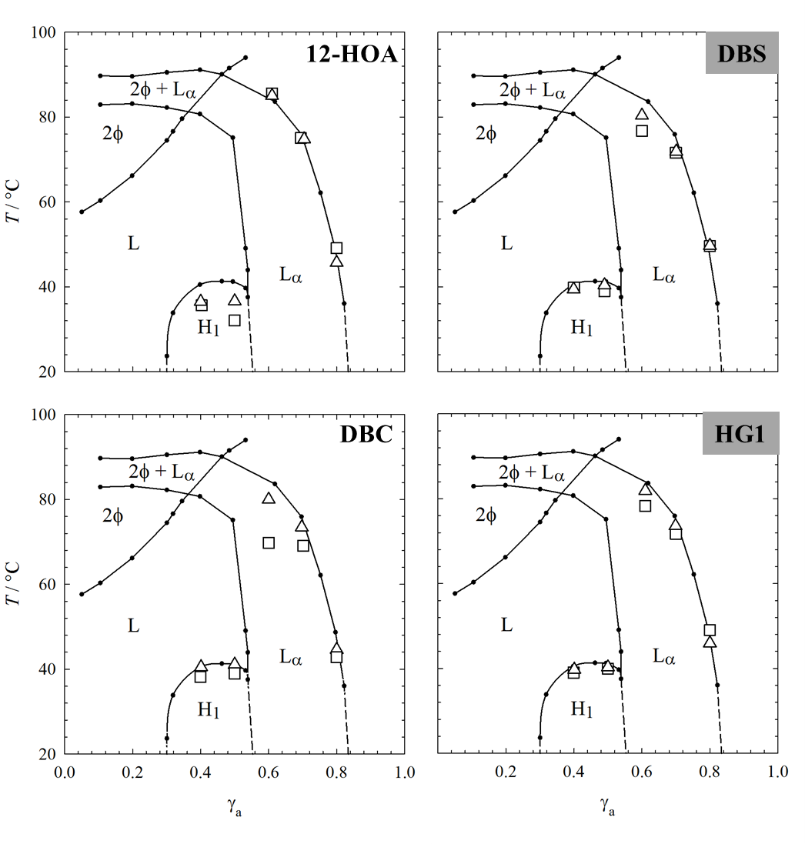

Based on the results obtained so far, one can conclude that the organogelator DBS and the hydrogelator HG1 are suitable gelators for gelling the lyotropic liquid crystals of the system H2O/NaCl – Genapol LA070. Both gelled hexagonal H1 phases and gelled lamellar Lα phases were formed in their presence. In the following section our focus is the gelling capacity of DBS and HG1. Since the visual phase studies allowed us to only qualitatively determine whether a gelled LLC was formed, we performed oscillation shear rheometry experiments, more precisely frequency (ω) sweeps at constant strain amplitude and constant temperature to investigate whether indeed gelled lamellar Lα phases and gelled hexagonal H1 phases are formed in the presence of DBS and HG1. For comparison, we also performed ω-sweeps of the pure lamellar Lα phase, the pure hexagonal H1 phase and in the presence of the gelators 12-HOA and DBC.

Rheometry

Frequency Sweeps The ω-sweeps of the pure lamellar Lα phase at a surfactant mass fraction of γa = 0.70 and those of the lamellar Lα phase in the presence of the organogelators 12-HOA and DBS as well as in the presence of the hydrogelators DBC and HG1 at gelator mass fractions of η = 0.0075 and η = 0.015 are shown in Figure 3. For all systems, the storage modulus *G*’ is higher than the loss modulus *G*”, i.e. all systems show solid-like, elastic behaviour in the frequency range ω = 0.01-100 s-1 [34]. The absolute *G*’and *G*”values of the pure Lα phase (Figure 3, left) are low, due to the parallel lamellar bilayers which can easily slide over each other.35,36 *G*’and *G*” are not significantly altered in the presence of the organogelator 12-HOA (Figure 3, top middle) or of the hydrogelator DBC (Figure 3, bottom middle) at the mass fractions η = 0.0075 and η = 0.015, which confirms that no gelled Lα phases were formed, irrespective of the 12-HOA and of the DBC mass fraction. However, adding the organogelator DBS or the hydrogelator HG1 at mass fractions of η = 0.0075 and η = 0.015, one clearly sees that that *G*’and *G*” are significantly higher compared to the values of the pure Lα phase. However, the storage modulus *G*’is still frequency dependent in the presence of DBS and HG1, which is characteristic for soft solids and soft gels.34 These observations prove, in accordance to the visual phase studies, that gelled Lα phases are formed in the presence of DBS and HG1 at both gelator mass fractions. Note that the sol-gel transition temperature of LMWGs depends on the gelator concentration, i.e. that it increases with increasing gelator concentration up until a plateau is reached. Although we studied only two gelator concentrations we can conclude from the data shown in Figure 3 that this plateau is reached in case of HG1 (no concentration dependence of *G*’, *G*’’), while this is not the case for DBS (higher *G*’ and *G*’’ values at η = 0.015 as compared to η = 0.0075). These observations are in line with previous studies. For DBS it was found that *G*’ and *G*’’ of liquid paraffin gelled with DBS increases significantly between η = 0.002 and η = 0.01.24 On the other hand, the sol-gel transition temperature of H2O gelled with HG1 stays constant at concentrations as low as ~ 6 mM, which corresponds to η = 0.006.7

Figure : Storage modulus *G*’(filled symbols)and loss modulus*G*” (open symbols) of the pure lamellar phase at a surfactant mass fraction of γa = 0.70 (left) and in the presence of the organogelators 12-HOA, DBS (top) and of the hydrogelators DBC, HG1 (bottom) at two gelator mass fractions η = 0.0075 (triangles) and η = 0.015 (squares) determined by frequency (ω) – sweeps at constant temperature *T* = 22 °C and constant strain amplitude γ = 1%. The grey highlighted gelators are capable of gelling the Lα phase.

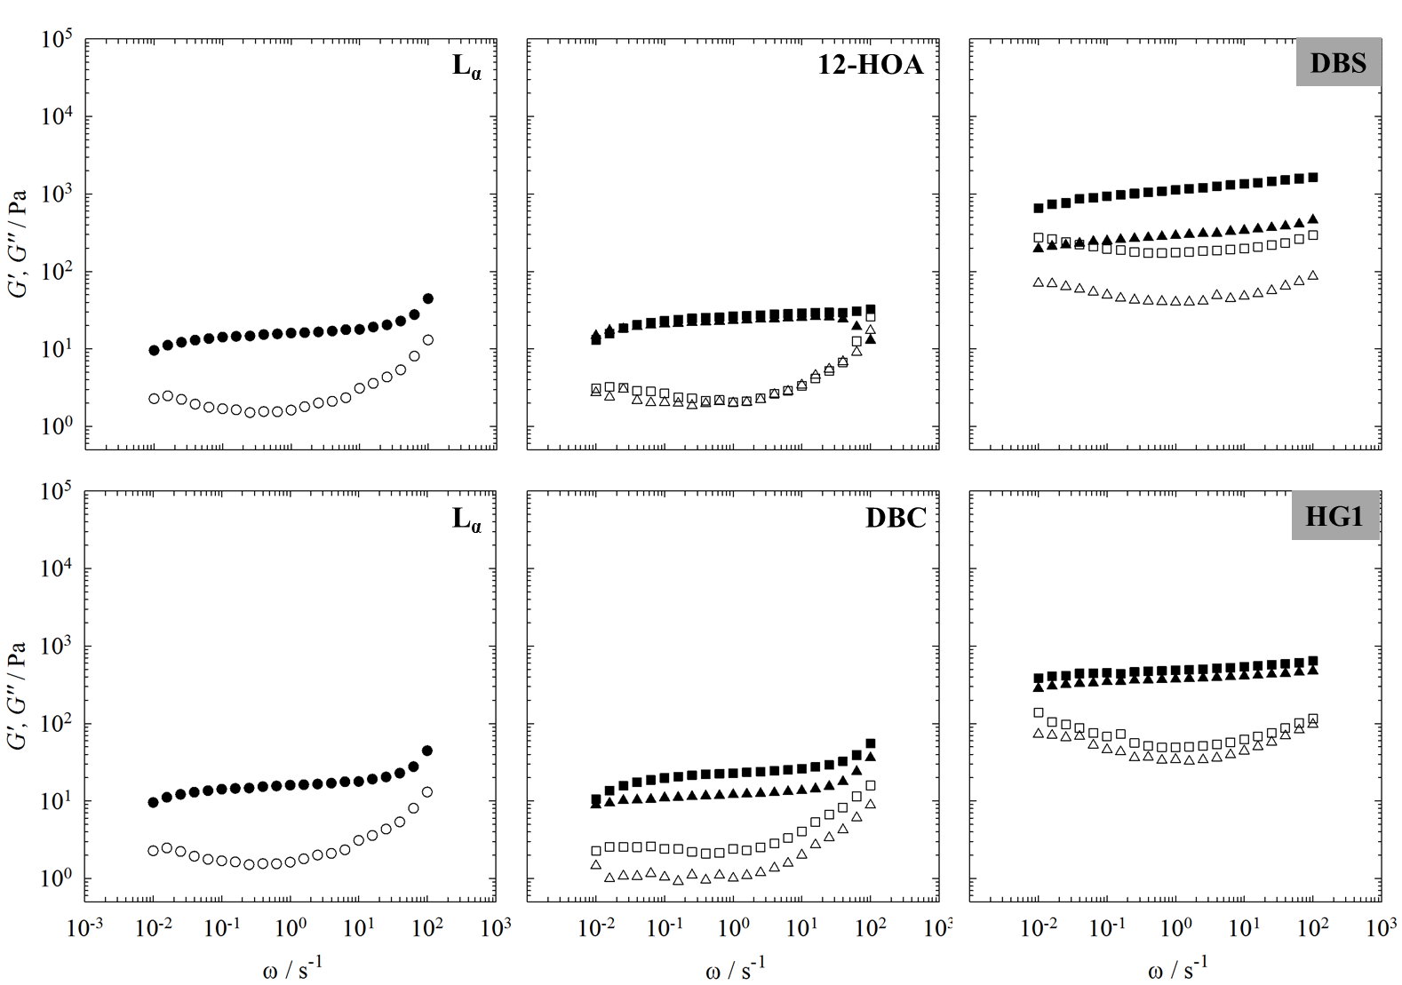

Looking at the ω-sweeps of the pure hexagonal H1 phase (Figure 4, left), one can see higher values of *G*’and *G*”than for the less viscous lamellar Lα phase, due to densely packed cylinders.35 In addition, there is a crossover point of the storage modulus *G*’ and the loss modulus *G*”at low frequencies. At this crossover point, the rheological behaviour of the hexagonal H1 phase changes from liquid-like, viscous behaviour (*G*” > *G*’) at lower frequencies to solid-like, elastic behaviour (*G*’ > *G*”) at higher frequencies.36

For a gelled hexagonal H1 phase one would expect that *G*’ > *G*” in the measured frequency range. In the presence of the organogelator 12-HOA at both 12-HOA mass fractions η = 0.0075 and η = 0.015, the crossover of *G*’ and *G*’’ does not occur

anymore in the measured frequency range, but seems to be shifted to lower frequencies, since *G*’ and *G*’’ approach each other at low frequencies (Figure 4, top middle). Furthermore, the *G*’ value is slightly enhanced by the presence of the organogelator. Taken together, these observations would suggest that the hexagonal H1 phase forms a soft gel in the presence of 12-HOA. Contrary to the hexagonal H1 phase in the presence of 12-HOA, the crossover of *G*’and *G*”still occurs at low frequencies in the presence of DBC at both gelator mass fractions, and furthermore, the absolute value of *G*’ is near identical in the presence of absence of the gelator. These observations confirm that no gelled hexagonal H1 phase was formed in the presence of DBC. The hexagonal H1 phase in the presence of the organogelator DBS (Figure 4, top right) and the hydrogelator HG1 (Figure 4, bottom right) show the same viscoelastic behaviour as the H1 phase in the presence of 12-HOA. The storage moduli *G*’are higher than the loss moduli *G*” in the measured frequency range, but *G*’ still is strongly frequency dependent and approaches *G*” at low frequencies in the presence of DBS and HG1. The presence of the gelator slightly enhances the absolute values of *G*’. The results of the ω-sweeps of the hexagonal H1 phase in the presence of the organogelators 12-HOA, DBS and of the hydrogelator HG1 therefore suggest that gelled hexagonal H1 phases are formed. However, the strong frequency dependence of *G*’ indicates that

Figure : Storage modulus *G*’(filled symbols)and loss modulus*G*’’ (open symbols) of the pure hexagonal phase at a surfactant mass fraction of γa = 0.40 (left) and in the presence of the organogelators 12-HOA, DBS (top) and of the hydrogelators DBC, HG1 (bottom) at two gelator mass fractions η = 0.0075 (triangles) and η = 0.015 (squares) determined by frequency (ω) – sweeps at constant temperature *T* = 22 °C and constant strain amplitude γ = 1%. The grey highlighted gelators are capable of gelling both the hexagonal H1 phase and the lamellar Lα phase.

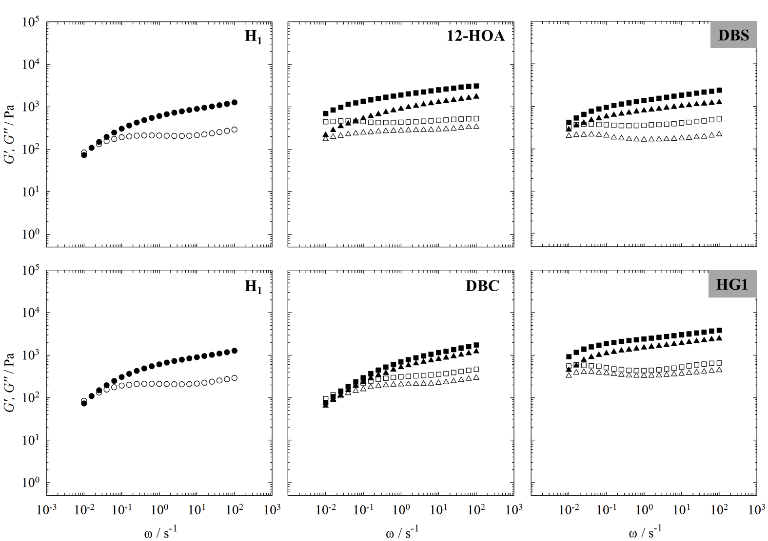

the gel is very soft and that the viscoelastic behaviour dominates.

To summarize, the oscillation shear ω-sweeps confirm the visual observations and show that the organogelator 12-HOA is not suitable for gelling liquid crystals, since no gelled lamellar Lα phase and only a softly gelled hexagonal H1 phase are formed. In the presence of the hydrogelator DBC no gelled lyotropic liquid crystals are formed either. In contrast to 12-HOA and DBC, gelled lamellar Lα phases and softly gelled hexagonal H1 phases are formed in the presence of the organogelator DBS and of the hydrogelator HG1 at both mass fractions. Interestingly, since the system H2O/NaCl – Genapol LA070 is partly oil and partly water, both the organogelator and the hydrogelator are capable of gelling the lyotropic liquid crystals.

Note that due to the large standard deviations (see Table 1 in the Experimental Section), we do not discuss the actual *G*’ and *G*’’ values but only the qualitative trends which were always the same: (a) increasing *G*’ and *G*’’ values in the case of the gelled lamellar Lα phases and (b) *G*’ > *G*’’ in the whole frequency range for the gelled hexagonal phases.

Temperature Sweeps We decided to additionally perform *T*-sweeps of the gelled lamellar Lα phase and the gelled hexagonal H1 phase in the presence of the organogelator DBS and of the hydrogelator HG1 in order to determine the sol-gel transition temperatures. The *T*-sweeps of the pure lamellar Lα phase and of the Lα phase in the presence of DBS and HG1 at mass fractions of η = 0.0075 and η = 0.015 are shown in Figure 5. In the case of the pure lamellar Lα phase (Figure 5, left), the storage modulus *G*’ is higher than the loss modulus *G*”at the initial temperature

*T* = 22 °C in accordance with the frequency sweeps. On increasing the temperature, *G*’and *G*”slightly decrease until *G*’ drops below *G*’’ at *T* ≈ 70 °C, which can be assigned to the lamellar to isotropic phase transition.36 Looking at the *T*-sweeps of the gelled lamellar Lα phase in the presence of DBS at η = 0.0075 (Figure 5, top middle), one can see that, in accordance to the frequency sweeps, *G*’ and *G*” have considerably higher values than *G*’ and *G*” of the pure Lα phase. *G*’and *G*” decrease with increasing temperature until the sol-gel boundary is approached. Due to the loss of interconnectivity of the gelator fibers, a sharp drop of *G*’ and *G*’’ as well as *G*’ < *G*’’ indicate the sol-gel transition temperature.37 Due to the fact that the lamellar to isotropic and sol-gel transitions occur at about the same temperature (ca. 70 °C), the lamellar to isotropic phase transition cannot be isolated and is “hidden” in the sol-gel transition. In the case of the gelled lamellar Lα phase in the presence of DBS at η= 0.015 (Figure 5, top right) the same temperature-dependent viscoelastic behaviour is observed with slightly larger absolute values of *G*’and *G*’’. Both moduliagain decrease with increasing temperature, however, in this case, there is a small drop at *T* ≈ 68 °C. According to the optical phase studies, we assigned this drop to the lamellarto isotropic phase transition. After crossing this phase boundary, the values of *G*’ and *G*”remain high with *G*’> *G*’’ until the sol-gel boundary is reached at *T* ≈ 82 °C, indicated by the sharp drop of the moduli. As such, doubling the concentration of gelator increases the *T*sol-gel value by ca. 10 °C, and consequently allows the lamellar-to-isotropic and gel-to-sol transitions to be thermally separated from one another.

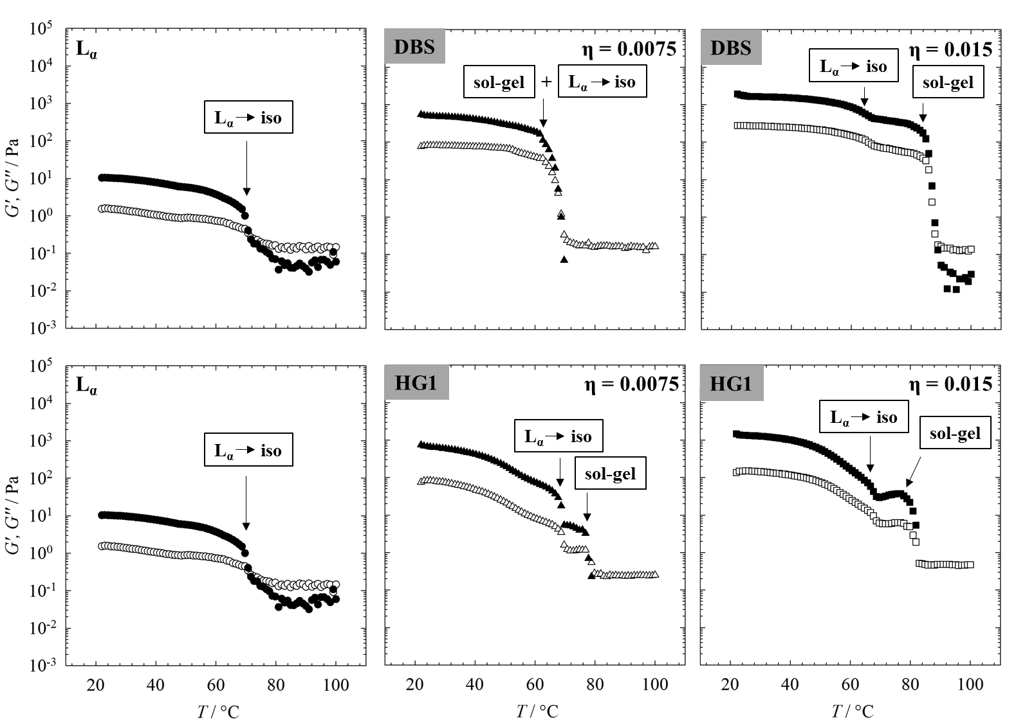

Figure : Storage modulus *G*’(filled symbols)and loss modulus*G*’’ (open symbols) of the pure lamellar phase at a surfactant mass fraction of γa = 0.70 (left) and in the presence of the organogelator DBS (top) and of the hydrogelator HG1 (bottom) at gelator mass fractions of η = 0.0075 (triangles) and η = 0.015 (squares) determined by temperature sweeps (heating rate 2 K ∙ min-1) at constant frequency ω = 10 s-1 and constant strain amplitude γ = 1%.

For the gelled lamellar Lα phase in the presence of the hydrogelator HG1 at η = 0.0075 (Figure 5, bottom middle), the collapse of *G*’ and *G*” is not as sharp as for the gelled lamellar phases Lα in the presence of DBS. Instead, *G*’and *G*”decrease continuously with increasing temperature. However, one can see two small drops of the storage modulus *G*’and the loss modulus *G*’’ at *T ≈* 68 °Cand *T* ≈ 77 °C, which indicate phase transitions*.* According to the visual observations, the first drop at *T* ≈ 68 °C can be identified as the lamellar to isotropic phase transition, whereas the second drop indicates the sol-gel transition temperature. In the presence of HG1 at η = 0.015 (Figure 5, bottom right), the same temperature-dependent viscoelastic behaviour can be observed. The drop at *T* ≈ 66 °C is due the lamellar to isotropic phase transition and the one at *T* ≈ 85 °C is due to sol-gel transition temperature.

The *T*-sweeps of the pure hexagonal H1 phase and those of the softly gelled H1 phases in the presence of the organogelator DBS and of the hydrogelator HG1 can be interpreted in the same way (Figure 6). For the pure hexagonal H1 phase, the sharp collapse of *G*’and *G*’’ at *T* ≈ 40 °C can be assigned to the hexagonal to isotropic phase transition.

The hexagonal to isotropic phase transition is also visible in the temperature-dependent viscoelastic behaviour of the weakly gelled hexagonal H1 phases. In case of the gelled H1 phase in the presence of DBS at η = 0.0075 (Figure 6, top middle), the first drop of *G*’ and *G*” indicates the hexagonal to isotropic phase transition after which the values of *G*’ and *G*” again increase until a second drop occurs at *T* ≈ 79 °C, which can be assigned to the sol-gel transition temperature. However, in the presence of DBS at η = 0.015 (Figure 6, top right) the hexagonal to isotropic phase transition can be detected at *T* ≈ 40 °C, after which *G’* and *G”* first remain constant before they increase with increasing temperature. The increase of *G*’ and *G*’’, i.e. the observed thermo-thickening, may be due to the fact that the gel network is able to reorganize and thus strengthen itself in the isotropic phase once the hexagonal phase is molten. We would like to emphasize that this observation is not in contradiction to orthogonal self-assembly: orthogonal self-assembly refers to a self-assembly on a molecular level, while the observed thermo-thickening happens on a supramolecular level. In the latter case we are talking about the rearrangement of already formed fibers (formed via self-assembly) in a solvent in which the self-assembly of surfactants leads to an anisotropic and an isotropic surrounding, respectively.The sharp drop of *G*’and *G*” at high temperatures (*T* ≈ 92 °C) can be assigned to the sol-gel transition temperature in accordance with the visual observations.

Figure : Storage modulus *G*’(filled symbols)and loss modulus*G*’’ (open symbols) of the pure hexagonal H1 phase at a surfactant mass fraction γa = 0.40 (left) and in the presence of the organogelator DBS (top) and of the hydrogelator HG1 (bottom) at gelator mass fractions of η = 0.0075 (triangles) and η = 0.015 (squares) determined by temperature sweeps (heating rate 2 K ∙ min-1) at constant frequency ω = 10 s-1 and constant strain amplitude γ = 1%.

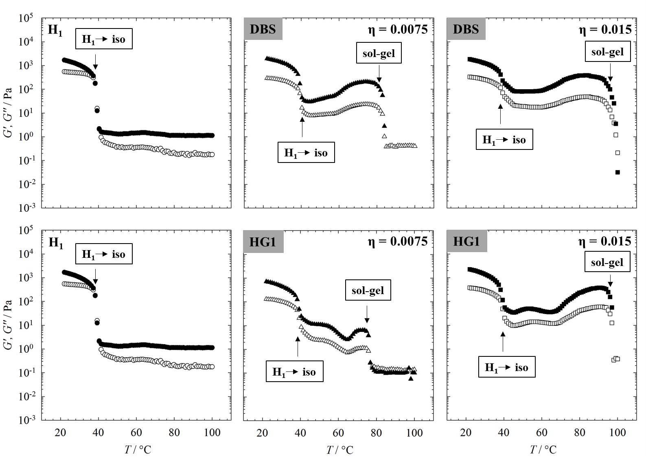

The temperature dependent viscoelastic behaviour of the gelled hexagonal H1 phase in the presence of the hydrogelator HG1 at η = 0.0075 is dominated by the viscoelastic behaviour of the hexagonal H1 phase (Figure 6, bottom middle). Comparing the visual observations with the *T*-sweep, the first drop in *G*’and *G*’’can be assigned to the hexagonal to isotropic phase transition. Similar to the gelled H1 phase in the presence of DBS at η = 0.0075, the drop of *G*’and *G*’’at *T* ≈ 74 °C can be assigned to the sol-gel transition temperature. For the weakly gelled H1 phase in the presence of HG1 at η = 0.015 the same temperature-dependent viscoelastic behaviour can be observed. The hexagonal to isotropic phase transition is assigned to the first drop of *G*’and *G*’’*.* With increasing temperature, *G*’ and *G*”increase again until the sharp drop at *T* ≈ 94 °C, which is assigned to the sol-gel transition temperature.

To conclude, the *T*-sweeps enabled us to detect the lyotropic liquid crystal to isotropic phase transitions as well as the sol-gel phase transitions of the gelled lamellar Lα phase and the gelled hexagonal H1 phase in the presence of the organogelator DBS and the hydrogelator HG1. In Figure 7, we added the sol-gel transition temperatures to the *T* – γa phase diagram of the system H2O/NaCl – Genapol LA070. For the gelled LLC phases in the presence of DBS (Figure 7, left), we were able to detect the sol-gel transition temperatures of the gelled Lα phases and the gelled hexagonal H1 phases at both gelator mass fractions η = 0.0075 and η = 0.015. In the case of the lamellar Lα phase, the sol-gel transition temperature is below the melting point of the lamellar Lα phase (*T*sol-gel < *T*LLC-iso) at the DBS mass fraction η = 0.0075, whereas it is above the melting point of the Lα phase (*T*sol-gel > *T*LLC-iso) at η = 0.015. In analogy to Kato *et al.*10, we name the former situation Type II LLC gel and the latter Type I LLC gel. In the case of the gelled H1 phase the sol-gel transition temperatures are above the melting point of the hexagonal H1 phase at both DBS mass fraction. For the gelled LLCs in the presence of HG1 (Figure 7, right), the same situation can be observed. We could also detect the sol-gel transition temperatures of the gelled H1 phases and of the gelled Lα phases at both mass fractions, i.e. η = 0.0075 and η = 0.015. The sol-gel phase transition temperature of the gelled lamellar Lα phases at η = 0.0075 is below the lamellar to isotropic phase transition (Type II LLC gel) and it is above the melting point of the lamellar Lα phase for η = 0.015 (Type I LLC gel). The sol-gel transition temperatures of the gelled hexagonal H1 phase in the presence of HG1 are above the melting point of the hexagonal H1 phase at both HG1 mass fractions with a higher sol-gel transition temperature at η = 0.015. The decrease of the sol-gel transition temperatures with increasing surfactant concentration for DBS and HG1 is due to the fact that both gelators are soluble in the pure surfactant. In other words, the binary water-surfactant mixture becomes a better solvent for the gelators with increasing surfactant mass fraction.

Figure : *T* – γa phase diagram of the system H2O/NaCl – Genapol LA070 (black circles) with added sol-gel transition temperatures *T*sol-gel of the gelled H1 phase at γa = 0.40 and the gelled Lα phase γa = 0.70 in the presence of the organogelator DBS (left) and of the hydrogelator HG1 (right) at gelator mass fractions of η = 0.0075 (black stars) and η = 0.015 (open stars) determined by oscillation shear temperature sweeps. The error of the sol-gel transition temperature is Δ*T*sol-gel = ± 1-5 °C. Since the phase boundaries of the LLCs did not change in the presence of DBS and HG1 (see Figure 2), they are not added to the phase diagrams.

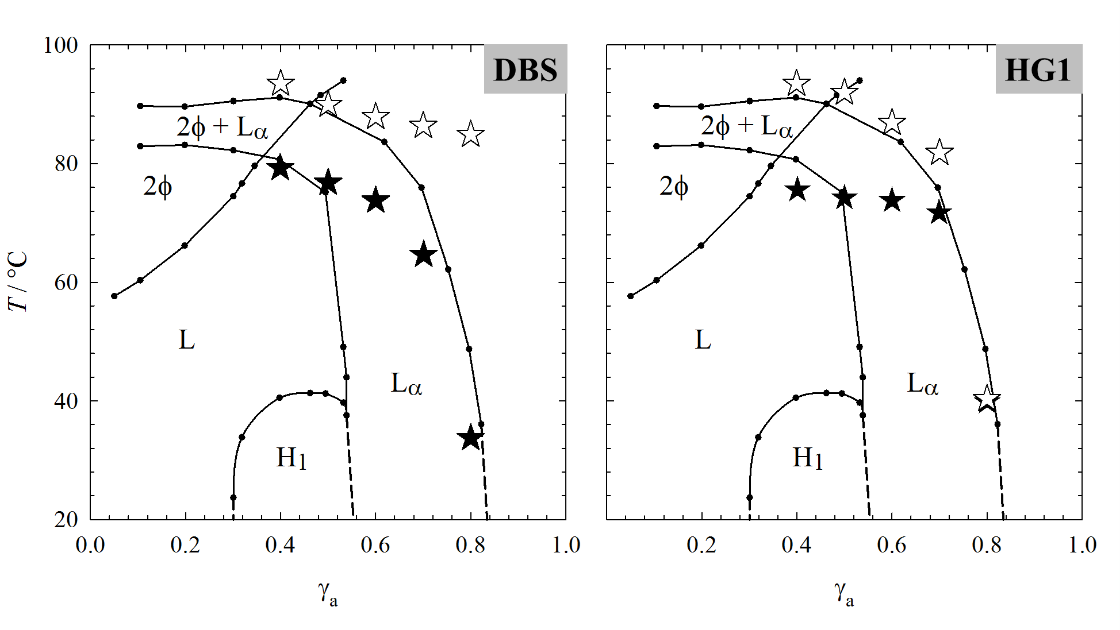

Conclusions

In order to find a gelator which forms self-assembled gels in LLCs without influencing their phase boundaries, we studied the LLCs of the system H2O/NaCl – Genapol LA070 in the presence of organogelators 12-HOA and DBS as well as in the presence of hydrogelators DBC and HG1 at gelator mass fractions η = 0.0075 and η = 0.015. 12-HOA is partly incorporated in the surfactant layer and acts as co-surfactant such that the lamellar Lα phase is stabilized and the hexagonal H1 phase is destabilized, which results in a reduced gelation capacity, i.e. no gelled LLCs are formed. The organogelator DBS is a potent gelator for LLCs. The LLC phase boundaries are not influenced by the presence of DBS and softly gelled hexagonal H1 phases as well as gelled lamellar Lα phases are formed at both DBS mass fractions. In the case of hydrogelator DBC, the LLC phase boundaries are only slightly altered by its presence but since no gelled LLCs are formed, DBC was not studied further. For hydrogelator HG1, similar to DBS, the LLC phase boundaries are not influenced by its presence and softly gelled hexagonal H1 phases as well as lamellar Lα phases are formed at both HG1 mass fractions. Since we studied the phase behaviour at surfactant mass fractions γa = 0.40 and γa = 0.70, respectively, the system contains both oil and water, and thus organogelator DBS and hydrogelator HG1 are capable of gelling the LLCs.

For both gelators, DBS and HG1, the sol-gel transition temperatures of the gelled lamellar Lα phases could be adjusted such that (a) *T*sol-gel isbelow the melting point of the gelled lamellar Lα phase at the gelator mass fractions η = 0.0075 and (b) *T*sol-gel isabove the melting point of the gelled Lα phase at η = 0.015. In the case of the gelled hexagonal H1 phase however, the sol-gel transition temperatures are above the melting point of the H1 phase at both DBS and HG1 mass fractions. Since DBS and HG1 are soluble in the pure Genapol LA070, the *T*sol-gel value increases with increasing surfactant mass fraction for both gelators.

Orthogonal self-assembly requires simultaneous but independent formation of two self-assembled structures. The observation that DBS and HG1 gel LLCs without altering the phase boundaries and that the gelators indeed self-assemble into gel fibers prove that the gelled LLCs of this study are indeed orthogonal self-assembled systems from a molecular point of view. In a follow-up study we will characterize the two coexisting structures. Another focus will be on the chronology of lyotropic liquid crystal and gel formation, i.e. we want to study if (a) the LLC can serve as template for the gel network leading to aligned gelator fibers and (b) if the gel network has influence on the LLC structure. If both answers were yes, we would have an orthogonal self-assembled system in which the two coexisting self-assembled supramolecular structures interact with each other. The study published here has allowed us to identify two gelators, DBS and HG1, with which it is possible two adjust the sol-gel transition temperatures of the gelled lamellar Lα phases via the gelator mass fraction as required, in order to answer the question whether the chronology of gel and LLC formation does play a role regarding orthogonal self-assembly. For the simple reason of commercial availability, we choose DBS for further investigations.

Conflicts of interest

The authors declare no conflict of interest.

Acknowledgements

We thank David Moser for carrying out parts of the visual and rheological phase studies. Financial Support by the Deutsche Forschungsgemeinschaft (grant number: STU287/6-1) is gratefully acknowledged.

Notes and references

1. C. Stubenrauch, F. Gießelmann, *Angew. Chem. Int. Ed.*,2016, **55***,* 3268.
2. D.-H. Kim, A. Jahn, S.-J. Cho, J.S. Kim, M.-H. Ki, D.-D. Kim, *J. Pharm. Invest.*,2015, **45**, 1.
3. P. E. Laibinis, J. J. Hickman, M. S. Wrighton, G. M. Whitesides, *Science*,1989, **245**, 845.
4. A. Heeres, C. van der Pol, M. Stuart, A. Friggeri, B. L. Feringa, J.van Esch, *J. Am. Chem. Soc.*,2003, **125**, 14252.
5. A. Brizard, M. Stuart, K. Van Bommel, A. Friggeri, M. De Jong, J. van Esch, *Angew. Chem. Int. Ed.*,2008, **47**, 2063.
6. A. M. Brizard, J. H. van Esch *Soft Matter* 2009, **5**, 1320.
7. A. M. Brizard, M. C. A. Stuart, J.H. van Esch, *Faraday Discuss.*,2009, **143**, 345.
8. J. Boekhoven, A. M. Brizard, M. C. A. Stuart, L. Florusse, G. Raffy, A. Del Guerzo, J. H. van Esch, *Chem. Sci.* 2016, **00**, 1.
9. N.Mizoshita, T. Kutsuna, K. Hanabusa, T. Kato, *Chem. Commun.*,1999, **0**, 781.
10. T. Kato, T. Kutsuna; K. Yabuuchi, N. Mizoshita, *Langmuir*, 2002, **18**, 7086.
11. K. Mizoshita, K. Hanabusa, T. Kato, *Adv. Funct. Mater.*, 2003, **13**, 313.
12. T. Kato, N. Mizoshita, K. Kishimoto, *Angew. Chem. Int. Ed.*,2006, **45**, 38.
13. C.V.-D. Kelly, Perturbations of cellular membranes with synthetic polymers and ultrafast lasers. PhD Thesis, University of Michigan, Michigan, 2009.
14. V. M. P. Vieira, L. L. Hay, D. K. Smith, *Chem. Sci.*, 2017, **8**, 6981.
15. V. M. P. Vieira, A. C. Lima, M. de Jong, D. K. Smith, *Chem. Eur. J.*, 2018, **24**, 15112.
16. H. E. Warriner, S. H. J. Idziak, N. L. Slack, P. Davidson, C. R. Safinya *Science*, 1996, **271**, 969.
17. S. Koitani, S. Dieterich, N. Preisig, K. Aramaki, C. Stubenrauch, *Langmuir*, 2017, **33**, 12171.
18. Y. Xu, M. Laupheimer, N. Preisig, T. Sottmann, C. Schmidt, C. Stubenrauch, *Langmuir*,2015, **31**, 8589.
19. T. Inoue, M. Matsuda, Y. Nibu, Y. Misono, M. Suzuki, *Langmuir*, 2001, **17**, 1883.
20. K. Steck, C. Schmidt, C. Stubenrauch, *Gels*, 2018, **4**, 78.
21. M. Laupheimer, Gelled Bicontinuous Micoremulsions: A New Type of Orthogonal Self-Assembled Systems. PhD Thesis, University of Stuttgart, Stuttgart, 2013.
22. M. Laupheimer, K. Jovic, F. E. Antunes, M. da Graça Martins Miguel, C. Stubenrauch, *Soft Matter*, 2013, **9**, 3661.
23. M. Laupheimer, T. Sottman, R. Schweins, C. Stubenrauch, *Soft Matter*,2014, **10**, 8744.
24. B. O. Okesola, V. M. P. Vieira, D. J. Cornwell, N. K. Whitelaw, D. K. Smith, *Soft Matter*, 2015, **11**, 4768.
25. A. Friggeri, B. L. Feringa, J. van Esch, *J. Control. Release*, 2004, **97**, 241.
26. R. G. Weiss, Terech P. Molecular Gels: Materials with Self-Assembled Fibrillar Networks; Springer: The Netherlands, 2005.
27. K. J. van Bommel, C. van der Pol, I. Muizebelt, A. Friggeri, A. Heeres, A. Meetsma, B. L. Feringa, J. van Esch, *Angew. Chem. Int. Ed. Engl.* 2004, **43**, 1663.
28. K. Selber, S. Müller, H. Gieren, J. Thömmes, T. Sottmann, R. Strey, M.-R. Kula, *Bioseparation*, 2002, **10**, 243.
29. J. N. Israelachvili, D. J. Mitchell, B. W. Ninham, *J. Chem. Soc., Faraday Trans. 2*,1976, **72**, 1525.
30. C. Stubenrauch, C. Frank, R. Strey, D. Burgmeister, C. Schmidt, *Langmuir*, 2002, **18** , 5027.
31. D. Varade, H. Kunieda, R. Strey, C. Stubenrauch, *J. Colloid Interface Sci.*,2006, **300**, 338.
32. K. Kratzat, H. Finkelmann, *Liquid Crystals*, 1993*,* **13**, 691.
33. K. Kratzat, C. Stubenrauch, H. Finkelmann, *Colloid Polym. Sci.*,1995, **273**, 257.
34. K. Nishinari, *Progr. Colloid Polym. Sci.*,2009, **136**, 87.
35. P. J. Collings, M. Hird, *Introduction to Liquid Crystals: Chemistry and Physics*; Taylor & Francis Ltd.: United Kingdom, 1997.
36. R. Mezzenga, C. Meyer, C. Servais, A. I. Romoscanu, L. Sagalowicz, R. C. Hayward, *Langmuir*,2005, **21**, 3322.
37. P. Terech, C. Rossat, F. Volino, *J. Colloid Interface Sci.*,2000, **227**, 363.
38. T. Kato, Y. Hirai, S. Nakaso, M. Moriyama, *Chem. Soc. Rev.*,2007, **36**, 1857.