**Thiol-ene Reaction Based Polymer Dispersed Liquid Crystal Composite Films with Low Driving Voltage and High Contrast Ratio**

Tingjun Zhonga Richard J. Mandleb, John W. Goodbyb & Huai Yanga

a*Department of Materials Science and Engineering, College of Engineering, Peking University, Beijing 100871, People’s Republic of China*

*bDepartment of Chemistry, University of York, York YO10 5DD, United Kingdom*

Tingjun Zhong, Huai Yang; Department of Materials Science and Engineering, College of Engineering, Peking University, Beijing, People’s Republic of China; [tingjun.zhong@pku.edu.cn](mailto:tingjun.zhong@pku.edu.cn), [yanghuai@pku.edu.cn](mailto:yanghuai@pku.edu.cn).

Richard J. Mandle, John W. Goodby; Department of Chemistry, University of York, York YO10 5DD, United Kingdom; [richard.mandle@york.ac.uk](mailto:richard.mandle@york.ac.uk), john.goodby@york.ac.uk.

Thiol-ene Reaction Based Polymer Dispersed Liquid Crystal Composite Films with Low Driving Voltage and High Contrast Ratio

**Abstract:** In this study, polymer dispersed liquid crystal composite films are obtained via a one-step fabrication technique based on photo-initiated polymerization-induced phase separation of the thiol-vinyl ether reaction. The effects of the compositions of two vinyl monomers, curing light intensity, curing light time, liquid crystal content and thiol content on the electrical-optical properties of the polymer dispersed liquid crystal films have been systematically investigated. It is demonstrated that a composite film with the low driving voltage (33.7 V), the high contrast ratio (228.1) and the short response time (4.8 ms) has been achieved, which is of great significance for the potential applications of polymer dispersed liquid crystal composite films.

**Keywords:** thiol-ene reaction, polymer dispersed liquid crystal, liquid crystal, driving voltage, contrast ratio

1. **Introduction**

Polymer dispersed liquid crystal (PDLC) films are widely studied for their potential application in smart windows[1, 2], display devices[3-5], optical sensors[6] and other electro-optical devices[7-10]. PDLC films both offer the mechanical and environmental advantages of polymers (such as …) and possess the optical and electrical properties of liquid crystals,[11-13] where the micro-sized or nano-sized liquid crystal (LC) droplets are dispersed in a continuous isotropic polymer matrix.[4] Generally, a PDLC film shows a light-scattering opaque state (off-state) in a normal mode due to the randomly oriented LC droplets dispersed in the polymer matrix.[14] Application of a sufficiently large electric field can be switch PDLC films to a transparent state (on-state) due to electrically controlled refractive index matching.[15] Methods to prepare PDLC films include encapsulation [16], thermal-induced phase separation (TIPS)[17], solvent-induced phase separation (SIPS)[18] and polymerization-induced phase separation (PIPS)[19]. The phase separation of PIPS is usually induced by photo-initiated polymerization[20], thermal-initiated polymerization[21] or electron beam-initiated polymerization[22]. The PIPS method is relatively simple processible, clean and solvent-free, however, it is highly sensitive to the experimental conditions such as composition, curing time and intensity, and so on.[23-26] The electro-optical properties of PDLC films fabricated by photo-initiated polymerization have been extensively studied, where the thiol-ene based PDLC films have drawn great attention and developed for the benefits of the exceptional utility of thiol-ene reaction in polymer synthesis such as easy access to starting materials and good synthesis strategies for both linear and cross-linked polymer networks.[27, 28] The nucleophile-initiated thiol-ene click reaction demonstrated in PDLC system has been investigated by Shi et al, they have illustrated that with the increase of thiol functionality, the threshold voltage and saturation voltage of the thiol-ene based PDLC films increases and the off-state transmittance decreases.[29, 30] Except for changing polymerization conditions, Shi et al. have reported a dye-doped thiol-ene based PDLC system with low threshold voltage.[31] Without UV irradiation, they have also added Nitrogen-centred catalysts such as 4-dimethylaminopyridine for fabricating thiol-ene based PDLCs.[32] Zhang et al. studied the effects of crosslinking agent/diluents/thiol on the electro-optical properties of thiol-ene based PDLC films.[33] Sun et al. studied a thiol-acrylate system for photo-initiated polymerization, of which the effects of thiol functionality and thiol monomer content on polymer morphologies and electro-optical properties of the PDLC films have been investigated.[34] Moreover, when adding poly-mercaptan curing agent with appropriate concentration into the polymer dispersed cholesteric liquid crystals system, lower voltage and high contrast ratio can be achieved.[35, 36]

Thiol monomer can copolymerize with vinyl ether, allyl, acrylate, methacrylate and vinyl benzene monomers, and the reaction between thiol monomer and vinyl ether monomer is fast because of the vinyl ether group.[37] Comparing with the acrylate systems, the thiol-vinyl ether system has significant advantages, such as requiring a lower photoinitiator loading, excellent thermal insulation, high refractive index, inertia to oxidation and water resistance.[38] Herein, we have prepared the PDLC films by the photo-initiated polymerization of two different vinyl ether monomers and thiols in this work, where the effects of the ratio of two vinyl monomers, the curing light intensity and time, the LC content and the ratio of vinyl monomers and thiol on the electro-optical properties of PDLCs have been investigated systematically. By optimizing the composition of PDLCs and the curing conditions, PDLC films with low driving voltage and high contrast have been achieved.

**2. Experimental**

***2.1 Materials***

The -ene monomer C4V with rigid structure was synthesized in our lab. *Bis* (2-vinyloxyethyl ether) (M1) was obtained from Aladdin Industrial Inc., China. Pentaerythritol tetrakis (3-mercaptoacetate) (M2) and Iragcure 651 weer purchased from Heowns Biochem Technologies. The nematic LC mixture SLC1717 (TNI = 365.00 K, Δ*n* = 0.201, *n*o = 1.519, *n*e = 1.720) was provided by Shijiazhuang Chengzhi Yonghua Display Materials Co. Ltd. All materials were used as received, without any further purification. The chemical structures of C4V, M1, M2 and Iragcure 651 are shown in Figure 1.

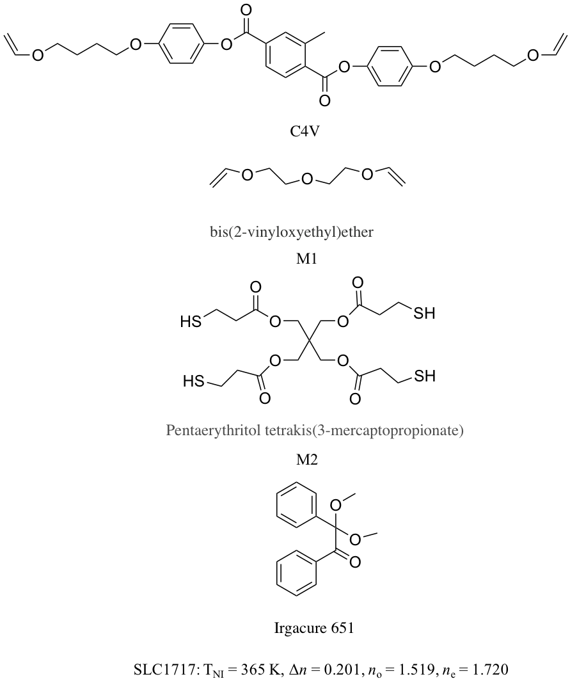

Figure 1. All the chemicals used in this work.

***2.2 Preparation***

PDLC films were prepared by the PIPS method. The mixtures of C4V, M1, M2, SLC1717 and Iragcure 651 were prepared in the weight ratios listed in Table 1, and filled into the LC cells between two glass slides coated with a thin transparent layer of conducting indium tin oxide (ITO) in the inner surfaces. The film thickness is controlled by 20.0 ± 1.0 μm polyethylene terephthalate (PET) spacer. Then the samples are irradiated for the polymerization by a UV lamp (365.0 nm, 35 W Hg lamp, PS135, UV Flood, Stockholm, Sweden) at room temperature. The curing time and curing intensity at the cell surface are set as shown in Table 1.

Table.1 The compositions(g) and the reaction conditions (curing time(s) and curing intensity(mw/m2)) of the PDLC films.

|  |  |  |  |  |  |  |  |
| --- | --- | --- | --- | --- | --- | --- | --- |
| Sample  ID | Compositions (g) | | | | | Reaction Conditions | |
| C4V | M1 | M2 | SLC1717 | Iragcure 651 | Curing Time  (s) | Curing Intensity  (mw/cm2) |
| Group A | | | | | | | |
| A1 | 0.0000 | 0.1000 | 0.1000 | 0.2000 | 0.0040 | 800.0 | 5.0 |
| A2 | 0.0050 | 0.0950 | 0.1000 | 0.2000 | 0.0040 | 800.0 | 5.0 |
| A3 | 0.0100 | 0.0900 | 0.1000 | 0.2000 | 0.0040 | 800.0 | 5.0 |
| A4 | 0.0150 | 0.0850 | 0.1000 | 0.2000 | 0.0040 | 800.0 | 5.0 |
| A5 | 0.0200 | 0.0800 | 0.1000 | 0.2000 | 0.0040 | 800.0 | 5.0 |
| Group B | | | | | | | |
| B1 | 0.0050 | 0.0950 | 0.1000 | 0.2000 | 0.0040 | 800.0 | 1.0 |
| B2 | 0.0050 | 0.0950 | 0.1000 | 0.2000 | 0.0040 | 800.0 | 3.0 |
| B3 | 0.0050 | 0.0950 | 0.1000 | 0.2000 | 0.0040 | 800.0 | 5.0 |
| B4 | 0.0050 | 0.0950 | 0.1000 | 0.2000 | 0.0040 | 800.0 | 7.0 |
| B5 | 0.0050 | 0.0950 | 0.1000 | 0.2000 | 0.0040 | 800.0 | 9.0 |
| Group C | | | | | | | |
| C1 | 0.0050 | 0.0950 | 0.1000 | 0.2000 | 0.0040 | 200.0 | 5.0 |
| C2 | 0.0050 | 0.0950 | 0.1000 | 0.2000 | 0.0040 | 400.0 | 5.0 |
| C3 | 0.0050 | 0.0950 | 0.1000 | 0.2000 | 0.0040 | 600.0 | 5.0 |
| C4 | 0.0050 | 0.0950 | 0.1000 | 0.2000 | 0.0040 | 800.0 | 5.0 |
| C5 | 0.0050 | 0.0950 | 0.1000 | 0.2000 | 0.0040 | 1000.0 | 5.0 |
| Group D | | | | | | | |
| D1 | 0.0060 | 0.1140 | 0.1200 | 0.1600 | 0.0040 | 800.0 | 5.0 |
| D2 | 0.0055 | 0.1045 | 0.1100 | 0.1800 | 0.0040 | 800.0 | 5.0 |
| D3 | 0.0050 | 0.0950 | 0.1000 | 0.2000 | 0.0040 | 800.0 | 5.0 |
| D4 | 0.0045 | 0.0855 | 0.0900 | 0.2200 | 0.0040 | 800.0 | 5.0 |
| D5 | 0.0040 | 0.0760 | 0.0800 | 0.2400 | 0.0040 | 800.0 | 5.0 |
| Group E | | | | | | | |
| E1 | 0.0025 | 0.0475 | 0.1500 | 0.2000 | 0.0040 | 800.0 | 5.0 |
| E2 | 0.0033 | 0.0634 | 0.1100 | 0.2000 | 0.0040 | 800.0 | 5.0 |
| E3 | 0.0050 | 0.0950 | 0.1000 | 0.2000 | 0.0040 | 800.0 | 5.0 |
| E4 | 0.0066 | 0.1267 | 0.0667 | 0.2000 | 0.0040 | 800.0 | 5.0 |
| E5 | 0.0075 | 0.1425 | 0.0500 | 0.2000 | 0.0020 | 800.0 | 5.0 |

***2.3 Measurements***

Scanning electron microscopy (SEM, S-4800, Hitachi, Tokyo, Japan) was used to observe the polymer morphologies of all 25 PDLC films. All the samples are firstly soaked in cyclohexane for one week at room temperature for extracting the LCs from the polymer matrix, then dried for 24 h at 353.15 K under vacuum. After this, the surfaces of the treated films are sputtered with gold and the polymer morphologies are observed by SEM.

The electro-optical properties of all the PDLC samples at room temperature are measured by a liquid crystal device parameter tester (LCT-5016C, Changchun Liancheng Instrument Co. Ltd., Changchun, China). A halogen laser (λ = 560.0 nm) is used as the incident light source, and the transmittance of the samples is recorded by a photodiode, monitored by an oscilloscope. The distance between the samples and photodiode is 300.0 mm. An electric field square wave (100 Hz) is applied and the collection angle of the transmitted intensity is about ±1° so that the forward scattering is detected. The transmittance of air is normalised as 100 %.

**3. Results and Discussion**

***3.1 Analysis of the polymer morphologies of PDLC films***

The droplet size of LCs dispersed in a polymer networks is controlled by the photo-polymerizable monomers and LCs, the rate of polymerization, physical parameters such as viscosity, rate of diffusion, and the solubility of the LCs in the polymer matrix.[39-41] Figure 2 shows the polymer morphologies of PDLC films A1-A5 by SEM. Generally, the size of LC droplets increases due to the slower reaction rate of rigid ene with the increased content of rigid ene. As shown in Figure 2, the LC droplets dispersed in films A4 and A5 are larger than those in films A1-A3. In film A4, the average diameter size of larger LC droplets is 6.05 μm and the average diameter size of smaller LC droplets is 1.20 μm, while in film A5, the average diameter size of larger LC droplets is 10.80 μm and the average diameter size of smaller LC droplets is 3.60 μm. The LC droplets dispersed in the film is uniform and small without adding rigid ene (see A1), where the average diameter size of LC droplets is 1.20 μm. When adding relatively low rigid ene, the average diameter size of LC droplets dispersed in film A2 (about 1.90 μm) is larger than that in film A1. Accompanying with a little more rigid ene, the average diameter size of LCs in film A3 is 0.90 μm.

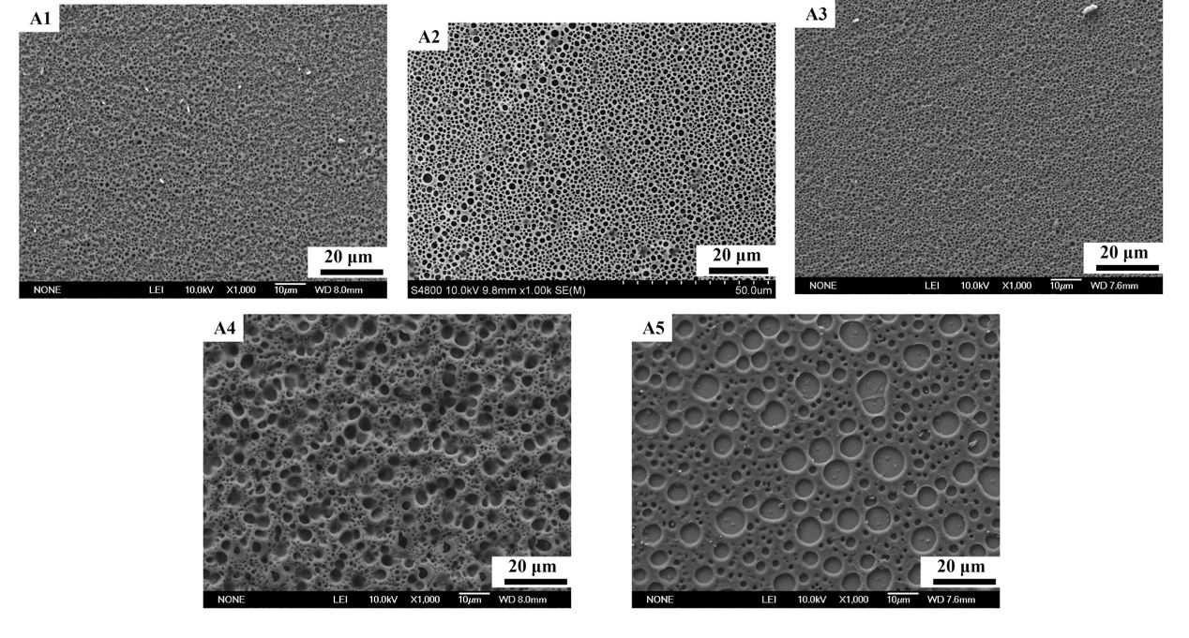

Figure 2. SEM Photomicrographs of the polymer morphologies in sample A1-A5.

For a definite system, the curing light intensity has a great effect on the electro-optical properties of PDLC films.

Figure 3 shows with the increasing curing intensity of PDLC films in group B, the size of LC domains increases firstly. When the curing intensity is 1.0 mW/cm2, LC droplets are uniformly dispersed in the film (see B1). As the curing intensity increases to 3.0 mW/cm2, some of the LC droplets are gathering together before the phase separation of LCs and monomers, thus both large and small LC droplets are present in film B2. In addition, the average size of LC droplets in film B2 is larger than that in film B1. When the curing intensity reaches 5.0 mW/cm2, with a faster polymerization rate, LC droplets separate readily from the polymer network, thus small droplets are formed in the film B3. Continually increasing the curing light intensity, the average size of LC droplets decreases in film B4. By strong curing intensity, the difference between the reaction rate of the rigid ene and the soft ene is larger, thus there are larger LC droplets and smaller LC droplets in film B5. The average size of LC domains is respectively obtained for 3.80 µm, 35.44 µm, 1.90 µm, 1.27 µm and 8.23 µm in films B1-B5.

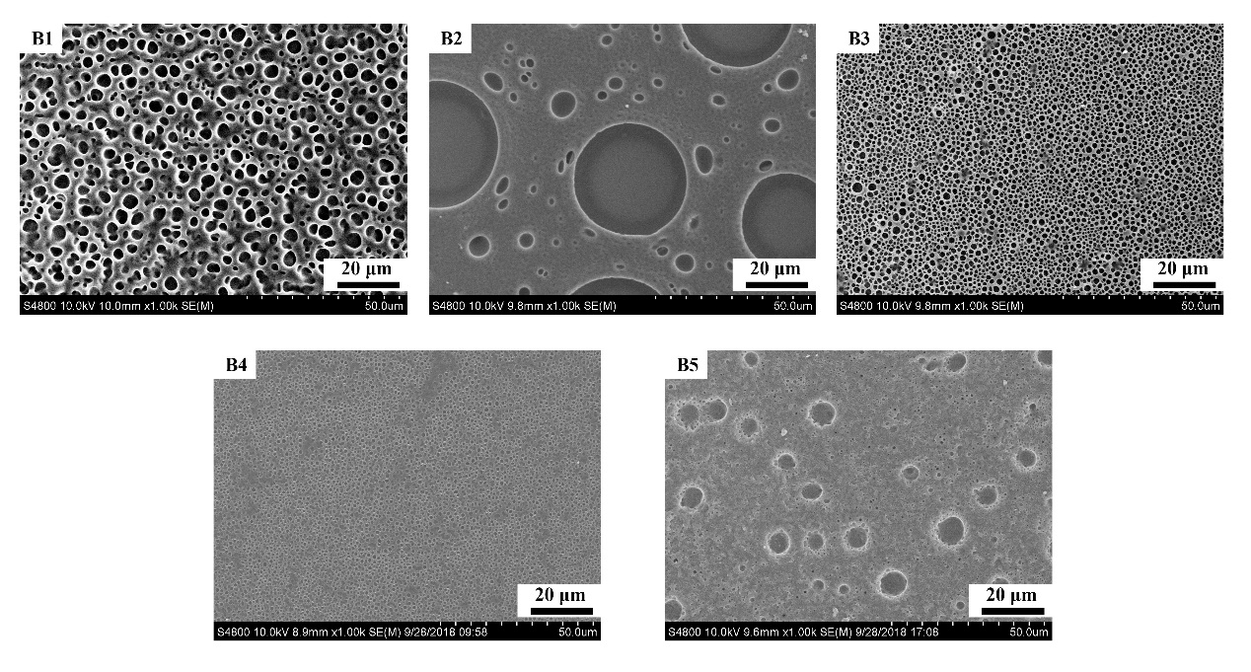

Figure 3. SEM Photomicrographs of the polymer morphologies in sample B1-B5.

Figure 4 shows the morphologies of polymer networks of PDLC films C1-C5. Primarily, the average size of the LC droplets dispersed in polymer networks is 1.27 µm, 0.95 µm, 0.82 µm, 1.90 µm and 1.14 µm, respectively. Due to the strong curing light intensity, curing time has slightly affected the size of LC droplets that dispersed in the polymer networks. At first, with the increase of curing time, the polymerization gradually completed, and the size of the LC droplets decreased. Additionally, as the thiol-ene reaction and the polymerization is fast and the phase separation of LCs and polymers is complete, during the free radical polymerization process, the thiol radical does not polymerize with other thiol monomers, LC droplets are more gathering in film C4 and C5 so that the size of the LC droplets turns larger.

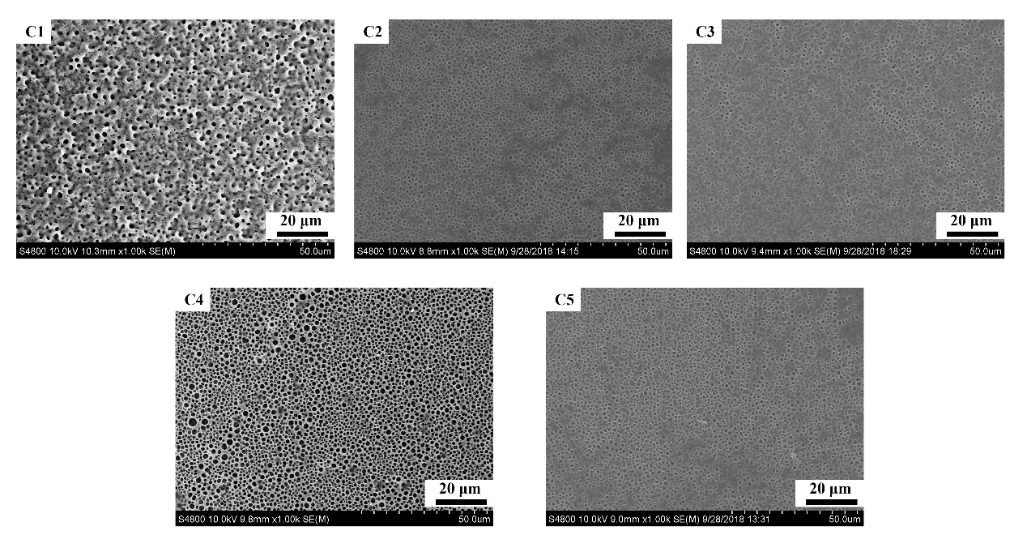

Figure 4. SEM Photomicrographs of the polymer morphologies in sample C1-C5.

As shown in Figure 5, the average size of the LC droplets dispersed in polymer networks is respectively 1.27 µm, 0.63 µm, 1.90 µm, 1.39 µm and 5.06 µm. As the concentration of the LC increased, the size of the LC droplets has no regularity, but the tendency of the average size of the LC droplets increases generally. As the LCs are a diluent for the thiol-ene system, the increasing LC content reduces the rate of the polymerization and leads to phase separation, thus the size of the LC droplets increases.

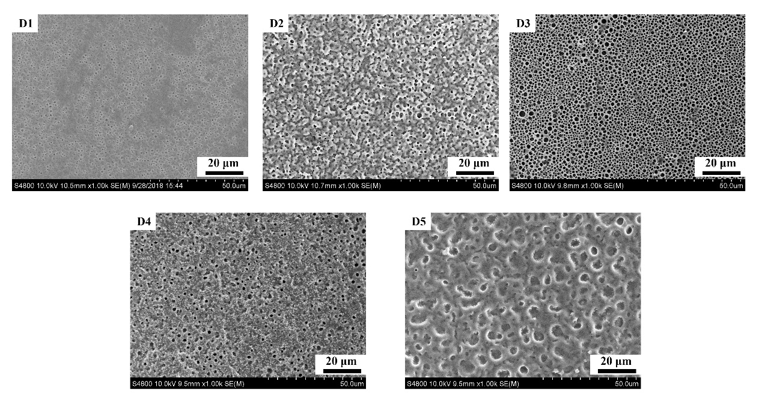

Figure 5. SEM Photomicrographs of the polymer morphologies in sample D1-D5.

Figure 6 presents the morphologies of the polymer networks of PDLC films E1-E5. The average size of LC droplets dispersed in polymer networks of films E1-E3 is respectively 6.96 µm, 0.32 µm and 1.90 µm. With the decreasing content of the thiol, the LC droplets dispersed in the polymer networks is smaller. As ene monomer and thiol monomer are closer to the stoichiometric ratio (1:1), theoretically the polymer matrix will have higher crosslinking density. To keep decreasing the thiol content, polymer networks cannot form due to the incomplete reaction between ene and thiol monomers, after extracting the LC droplets, there are no polymer networks in film E4 and E5.

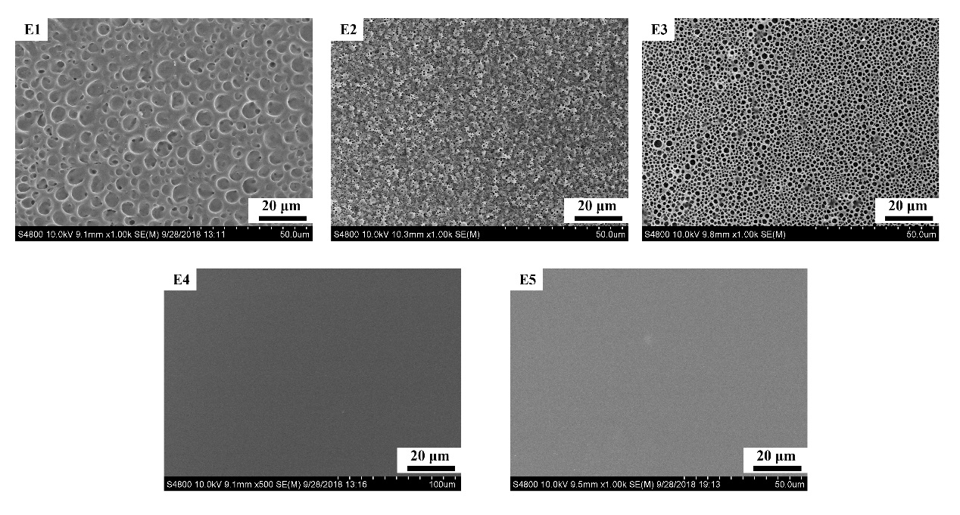

Figure 6. SEM Photomicrographs of the polymer morphologies in sample E1-E5.

***3.2 Analysis of the electro-optical properties of PDLC films***

For the evaluation of the PDLC films, the electro-optical performances including threshold voltage, saturation voltage, response time and contrast ratio are the significant physical properties, which are affected by the ratio of two different types of vinyl ethers, the curing intensity and the curing time during the polymerization induced phase separation, the content of LCs, and the ratio of ene monomer and thiol as well.

The threshold voltage (Vth) and the saturation voltage (Vsat) are defined as the electrical voltage that required for the transmittance to reach 10.0 % and 90.0 % of the maximum transmittance, respectively. The contrast ratio (CR) is known as the switching contrast ratio, the ratio of the ultimate on-state transmittance and the initial off-state transmittance. Turn-on response time (Ton) is the time required from 10.0 % to 90.0 % of the maximum transmittance when the electrical field is turned on, and turn-off response time (Toff) is the time required from 90.0 % to 10.0 % of the maximum transmittance when the electrical field is turned off.

With respect to group A, a serious of PDLC films A1-A5 with the different ratios of C4V and M1 have been prepared and their electro-optical properties are investigated. As Figure 7(A) illustrates, when the content of C4V is low and increases, the transmittance at no electric field slightly decreases and the transmittance at no electric field is respectively 0.57 % and 0.32 % in films A1 and A2; and the transmittance at the maximum electric field keeps stable, where the transmittance at the maximum electric fieldis respectively 74.03 % and 74.10 % in films A1 and A2. With more rigid structure in the vinyl monomers in the films A3, A4 and A5, their electro-optical properties are not good where the transmittance at no electric field are respectively 0.67 %, 1.02 % and 0.64 % in films A3, A4 and A5, and the transmittance at the maximum electric field are respectively 49.09 %, 66.56 % and 63.32 % in films A3, A4 and A5. As shown in Figure 7 (B), Vth of films A1-A5 is respectively 23.95 V, 33.67 V, 33.42 V, 44.31 V and 65.58 V, it is presented that Vth of films A1-A5 are increasing with the increased content of C4V, but with the exception of the Vth of A3, which is the lowest and close to that of A2). In addition, Vsat of films A1-A5 are respectively 41.16 V, 54.11 V, 70.81 V, 69.56 V and 90.87 V, it can be seen that Vsat of films A1-A5 has the similar tendency with the Vth as the content of C4V is increasing, but Vsat of A4 is slightly lower than which of A3. In Figure 7(C), the CR of films A1-A5 is respectively 131.55, 228.11, 72.28, 65.11 and 98.76, of which film A2 owns the highest CR. As for the responding time that presented in Figure 7 (D), Ton of films A1-A5 is respectively 0.504 ms, 0.816 ms, 1.576 ms, 1.354 ms and 3.002 ms, and Toff of films A1-A5 is respectively 4.660 ms, 3.998 ms, 3.760 ms, 2.308 ms and 1.216 ms. When adding more C4V that has rigid structure into PDLC films, the driving voltage increases a lot, but CR of films A1-A5 first increases and then decreases with more C4V. This is due to the more C4V monomer make the composition and structure of polymer network change greatly. Considering the electro-optical properties of films A1-A5 in group A, the composition of film A2 is selected to the following investigation due to both its low driving voltage and high contrast ratio.

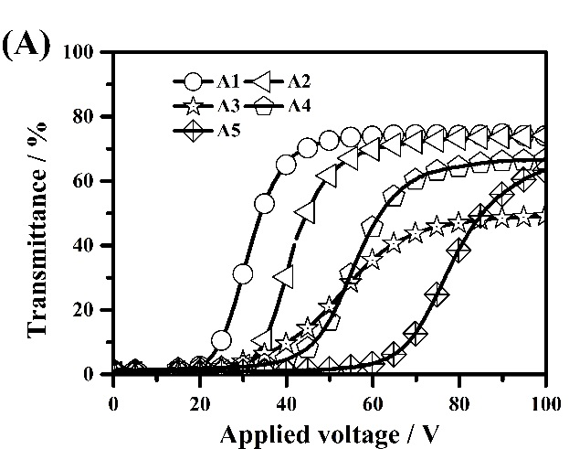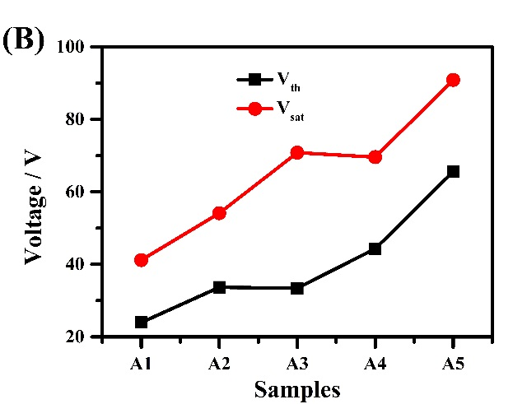

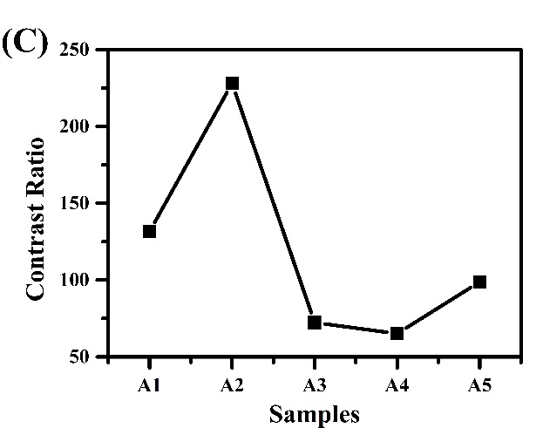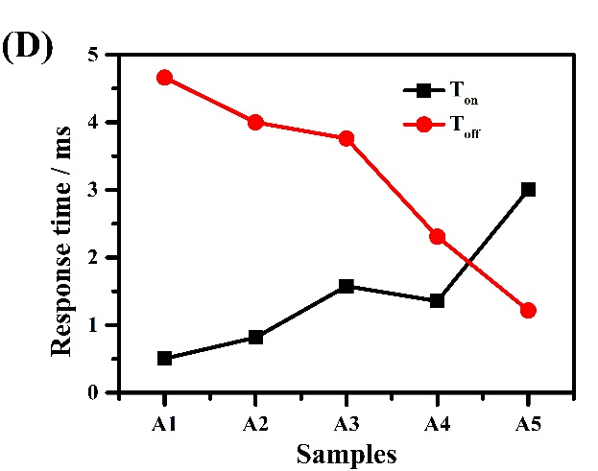

Figure 7. The electrical optical properties of PDLC films A1-A5. (A) The voltage-dependent transmittance of samples A1-A5. (B) Threshold voltage (Vth) and saturation voltage (Vsat) of samples A1-A5. (C) The contrast ratio (CR) of samples A1-A5. (D) The turn-on response time (Ton) and turn-off response time (Toff) of samples A1-A5.

As is shown in Figure 8, a serious of PDLC films B1-B5 with the same composition, where the weight ratio between C4V and M1 is fixed, the content of LC is fixed and the content of ene monomer and thiol monomer is fixed, the same curing time but different curing light intensity have been investigated. The curing UV light intensity is set from 1.0 to 9.0 mW/cm2 at the interval of 2.0 mW/cm2. At off-state, film B2 shows the highest transmittance due to the weak phase separation. The transmittance of film B2 at no electric field is 14.63 % due to the large size of the LC domain, while the transmittance of film B2 at the maximum electric field is 76.68 %, which is the highest in the films B1-B5. Although the transmittance of film B1 at no electric field (1.92 %) is smaller, the transmittance of film B1 at the maximum electric field (42.49 %) is not enough to get a good contrast. By utilizing the stronger curing light intensity, good CR can be obtained in films B3-B5, the transmittance of films B3-B5 at no electric field are respectively 0.32 %, 0.48 %, 0.39 %, while the transmittance of films B1-B5 at the maximum voltage are respectively 74.10 %, 73.13 % and 72.02 %. Vth of films B1-B5 is respectively 12.243 V, 6.509 V, 33.673 V, 39.156 V and 40.952 V, as is described in Figure 8 (B). Vth of films B1-B5 firstly decreases, when the curing intensity is much stronger, Vth increases. Owning to the relationship between electro-optical properties and morphology, the Vth of PDLC films is inversely proportional to the radius of LC droplets, due to the largest LC droplets in film B2, thus threshold voltage of film B2 is the smallest. Moreover, Vsat of films B1-B5 is respectively 26.197 V, 57.352 V, 54.113 V, 67.322 V and 70.577 V. Generally, Vsat increases with the increased curing intensity. Additionally, CR value of films B1-B5 is respectively 26.31, 5.23, 228.11, 150.49 and 185.19. CR of film B3 are the highest because of both the low transmittance at the off-state and the high transmittance at the on-state. Due to the large LC droplets dispersed in film B2 the CR is the lowest of the five PDLC films. The Ton of films B1-B5 is respectively 0.462 ms, 0.66 ms, 0.816 ms, 1.41 ms and 1.508 ms, and Toff of films B1-B5 is respectively 5.182 ms, 5.836 ms, 3.998 ms, 3.8 ms and 3.674 ms. As is depicted in Figure 8 (C), Ton increases slightly with the increase of curing intensity while Toff decreases in general. With the comparison of the driving voltages, contrast ratio and response time of films in group B, the optimal curing intensity for this PDLC system is set as 5.0 mW/cm2.

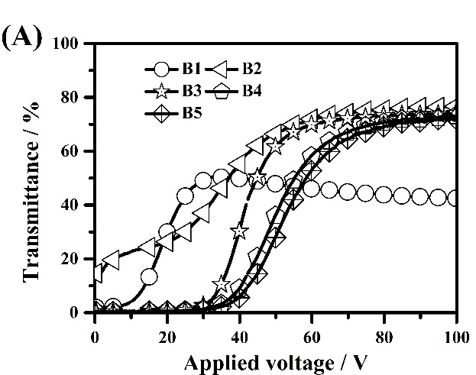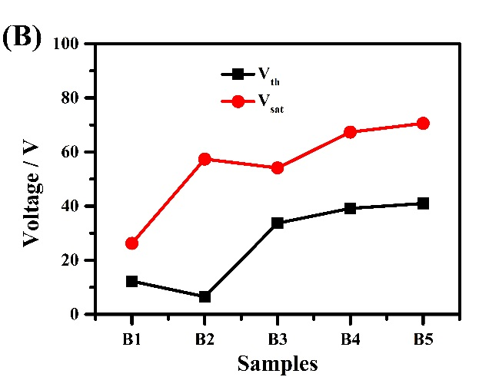

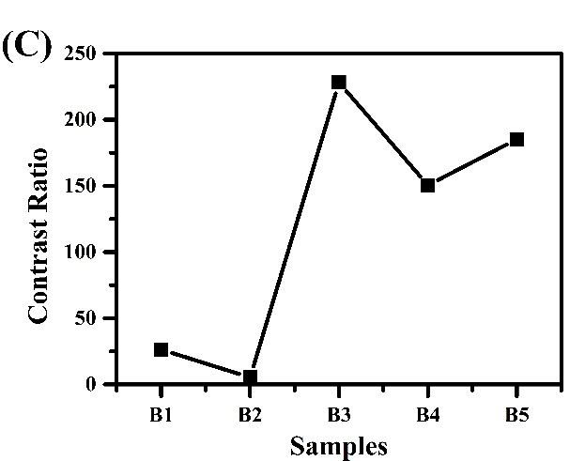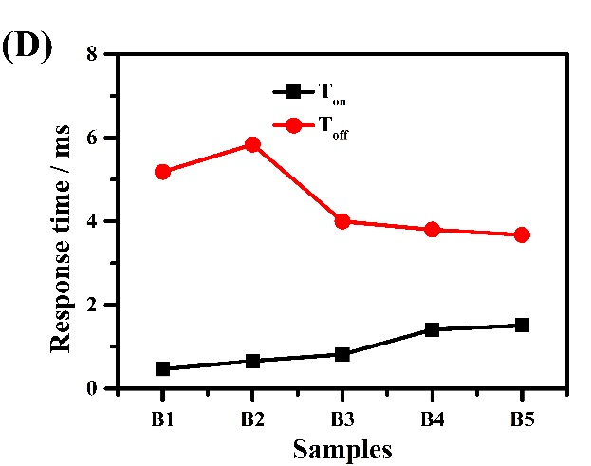

Figure 8. The electrical optical properties of PDLC films B1-B5. (A) The voltage-dependent transmittance of samples B1-B5. (B) Threshold voltage (Vth) and saturation voltage (Vsat) of samples B1-B5. (C) The contrast ratio (CR) of samples B1-B5. (D) The turn-on response time (Ton) and turn-off response time (Toff) of samples B1-B5.

Films C1-C5 were been prepared to probe the influence of the curing time, which was varied from 200.0 s to 1000.0 s at the interval of 200.0 s. As Figure 9(A) illustrates, all transmittance at off state in films C1-C5 are small, which are respectively 0.41 %, 0.48 %, 0.29 %, 0.32 % and 0.31 %. The transmittance of films C1-C5 at the maximum voltage has little differences, but when the curing time is the shortest or the longest, transmittancesdecrease slightly. The transmittances of films C1-C5 at the maximum voltage are respectively 69.92 %, 73.07 %, 70.38 %, 74.10 % and 65.32 %. In Figure 9(B), it demonstrates that both the threshold voltage and saturation voltage vary slightly, and Vth of films C1-C5 is respectively 26.197 V, 32.178 V, 32.428 V, 33.673 V and 33.424 V while Vsat of films C1-C5 is respectively 45.387 V, 54.362 V, 55.608 V, 54.113 V and 56.355 V. As is seen from Figure 4, the average sizes of LC droplets are between 0.5 µm and 2.0 µm, thus Vth is lower than 35.0 V and Vsat is lower than 60.0 V. As for the CR, CR value of films C1-C5 is respectively 170.43, 152.17, 239.90, 228.11 and 209.89. All the contrast ratio value of films C1-C5 are higher than 150.00 because of the synergistic effect of low off-state transmittance and the high on-state transmittance. As is described in Figure 9 (C), CR value of film C3 is the highest and slightly higher than which of film C4. Additionally, Ton and Toff of PDLC films are the critical parameters of their electrical-optical properties. Ton of films C1-C5 is respectively 0.922 ms, 0.954 ms, 5.7 ms, 0.816 ms and 6.65 ms, while Toff of films C1-C5 is respectively 5.46 ms, 4.432 ms, 6.75 ms, 3.998 ms and 6.65 ms. Both the turn-on and turn-off response time of film C3 is much higher than that of film C4. Herein, the optimal curing time has been selected to 800.0 s for this PDLC system.

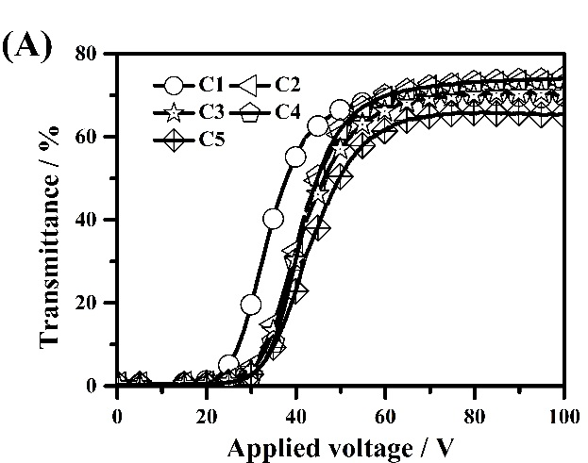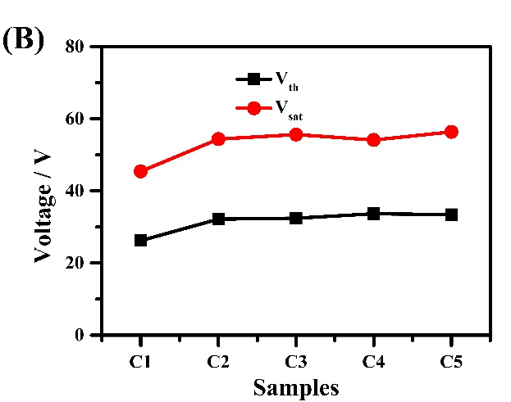

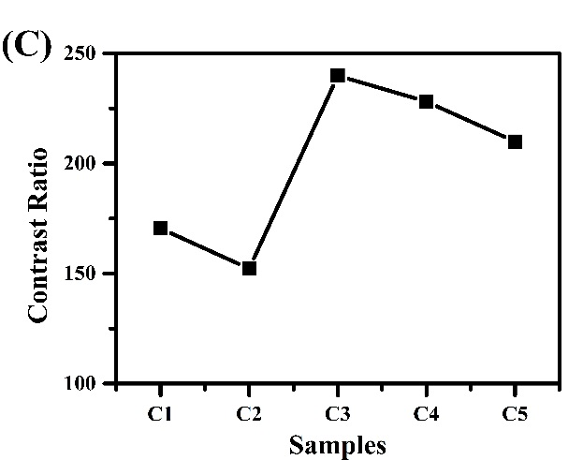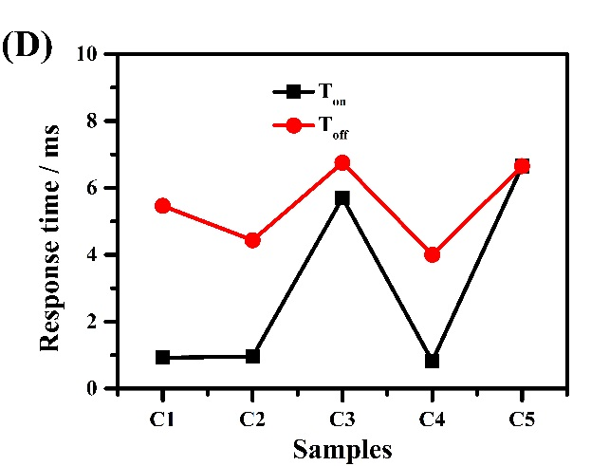

Figure 9. The electrical optical properties of PDLC films C1-C5. (A) The voltage-dependent transmittance of samples C1-C5. (B) Threshold voltage (Vth) and saturation voltage (Vsat) of samples C1-C5. (C) The contrast ratio (CR) of samples C1-C5. (D) The turn-on response time (Ton) and turn-off response time (Toff) of samples C1-C5.

In the composition of films D1-D5, the content ratio of the LCs is influential on the electro-optical properties of PDLC films. In Figure 10, the transmittance of films D1-D5 at off state are respectively 0.57 %, 0.72 %, 0.32 %, 0.60 % and 5.41 % while the transmittance of films D1-D5 at the maximum voltage are respectively 74.03 %, 63.83 %, 74.10 %, 58.37 % and 38.87 %. Additionally, Vth of films D1-D5 is respectively 31.680 V, 57.102 V, 33.673 V, 4.171 V and 3.769 V, and Vsat of films D1-D5 is respectively 60.095 V, 91.375 V, 54.113 V, 18.471 V and 12.493 V. Consequently, Vth of films D1-D5 decreases due to the increasing tendency of the average size of LC droplets dispersed in films D1-D5 with the exception of film D2.But as Figure 10 illustrates, with the increase of LC content, the CR value of films D1-D5 firstly increases then decreases., Films D3, D4 and D5 all achieve high CR, whose value are 88.19, 228.11, and 102.20 respectively, while CR value of films D1 and D2 is relatively low, which are 25.20 and 8.28 respectively. As shown in Figure 10(D), Ton of films D1-D5 is respectively 1.192 ms, 6.18 ms, 0.816 ms, 0.377 ms and 0.346 ms while Toff of films D1-D5 is respectively 5.422 ms, 4.378 ms, 3.998 ms, 5.462 ms and 3.706 ms. As considering high CR and low driving voltage, the composition 1:1 of the content ratio of the total monomers and the LCs is the optimization.

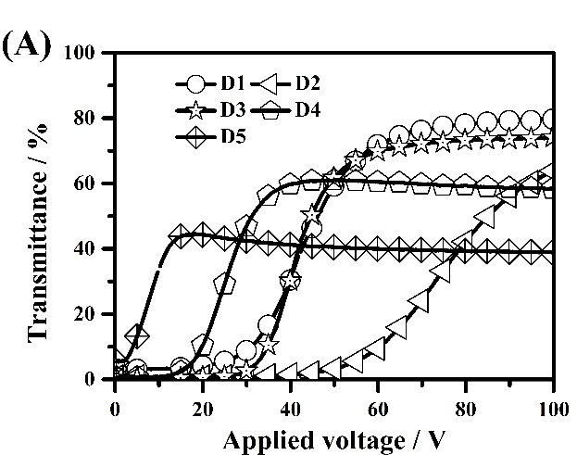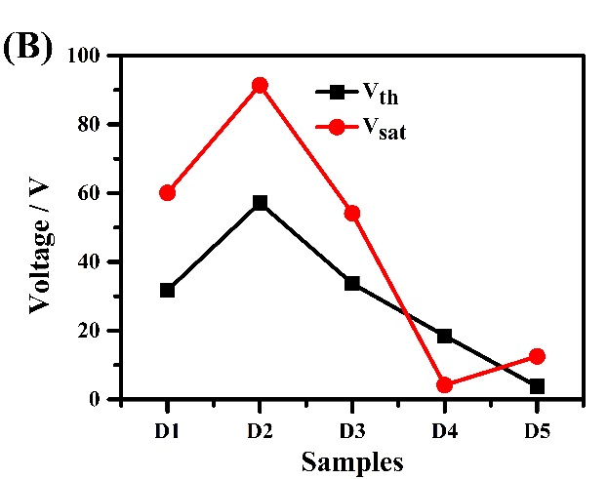

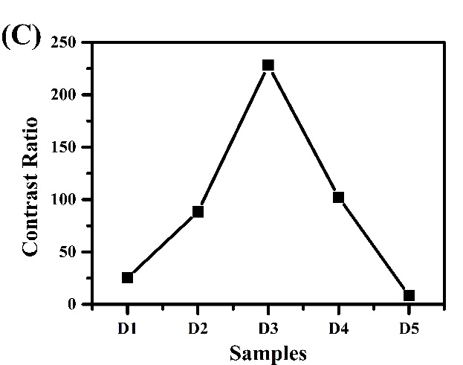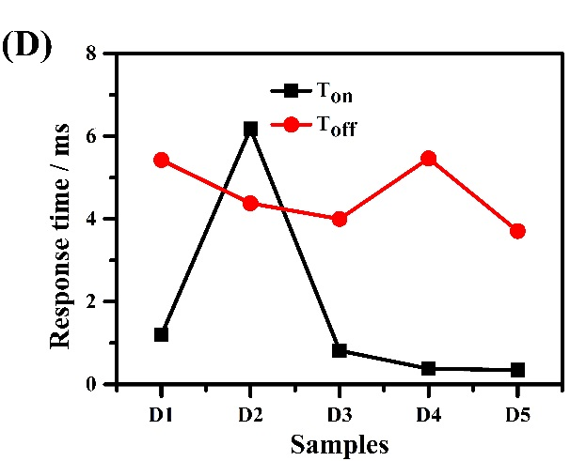

Figure 10. The electrical optical properties of PDLC films D1-D5. (A) The voltage-dependent transmittance of sample D1-D5. (B) Threshold voltage (Vth) and saturation voltage (Vsat) of sample D1-D5. (C) The contrast ratio (CR) of sample D1-D5. (D) The turn-on response time (Ton) and turn-off response time (Toff) of samples D1-D5.

As Figure 11 illustrates, the content of thiol has a great effect on the electro-optical performance of films E1-E5. Firstly, the thiol content is greatly influential on the transmittances of films E1-E5 at off state, which are respectively 0.95 %, 1.82 %, 0.32 %, 76.95 % and 86.97 %. While the transmittances of films E1-E5 at the maximum voltage increases due to the decreased thiol content, which are respectively 44.20 %, 65.97 %, 74.10 %, 84.27 % and 87.19 %. With the decrease of the content of thiol, Vth of films E1-E5 is respectively 30.433 V, 51.869 V, 33.673 V, 0.729 V and 31.929 V while Vsat of films E1-E5 is respectively 61.59 V, 84.089 V, 54.113 V, 20.465 V and 40.324 V, as is depicted in Figure 11 (B). Because of the average size of LC droplets dispersed in films E1-E3 in Figure 6, Vth of films E1-E3 presents the related trend. Actually, films E4 and E5 are not active because the maximum voltage (100.0 V) is not enough to switch the films to transparent state as described in Figure 11 (A). In addition, CR values of films E1-E5 are respectively 46.51, 36.29, 228.11, 1.09 and 1.00, of which film E3 owns the highest CR value due to the weight ratio of 1:1 of ene and thiol monomers. Generally, Ton of films E1-E5 is small, which is respectively 1.056 ms, 1.254 ms, 0.816 ms, 1.49 ms and 4.198 ms. However, Toff of films has no regularity, which is respectively 3.807 ms, 1.284 ms, 3.998 ms, 4.918 ms and 2.056 ms.

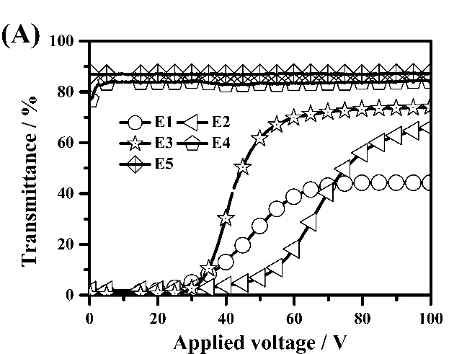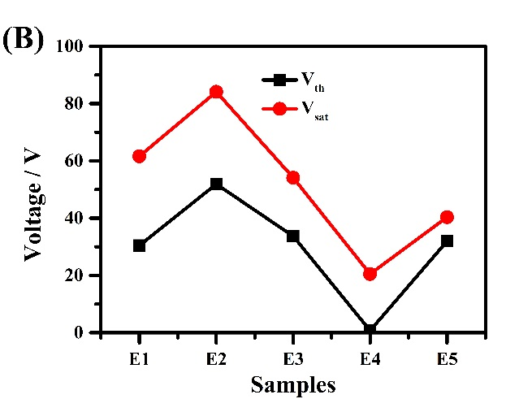

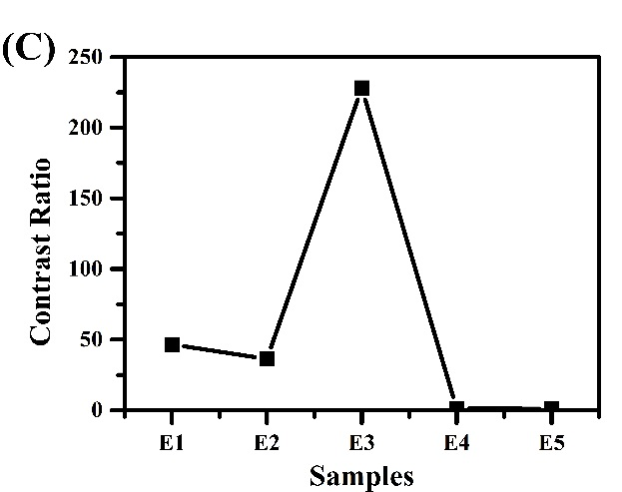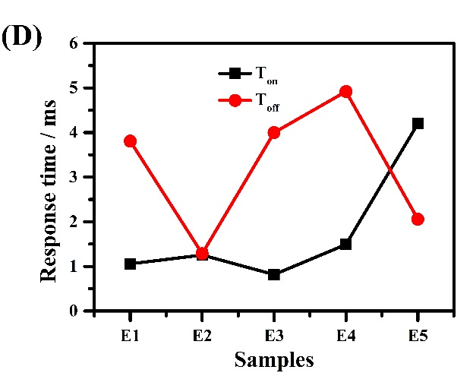

Figure 11. The electrical optical properties of PDLC films E1-E5. (A) The voltage-dependent transmittance of samples E1-E5. (B) Threshold voltage (Vth) and saturation voltage (Vsat) of samples E1-E5. (C) The contrast ratio (CR) of samples E1-E5. (D) The turn-on response time (Ton) and turn-off response time (Toff) of samples E1-E5.

**4. Conclusions**

In this work, the effects of the content of vinyl ether C4V with rigid structure, curing intensity, curing time, LC content and the thiol content on the electro-optical properties of PDLC films prepared by the thiol-ene click reaction have been investigated. Consequently, with the increasing curing intensity, the average size of LC droplets that dispersed in the polymer networks firstly increases and then decreases, Vth of PDLC films correspondingly increases and decreases, with a curing intensity of 5.0 mWS/cm2, a PDLC film with relatively low driving voltage (33.67 V) and high CR (228.11) is prepared. Additionally, curing time has no great influence on the electrical-optical properties of PDLC films. As is known to us, the composition of PDLC films has significant effects on the properties of PDLC films. As the concentration of C4V with a rigid structure goes up, Vth of PDLC films increases and CR of PDLC films decreases, thus the optimum weight ratio of C4V and M1 is 1:19. The LC content is also much influential on the properties of PDLC films, with the lowest LC concentration and the highest LC concentration, CR is very low. In addition, the thiol content has greatly affected the electro-optical properties of PDLC films, by adding more thiol, ene monomer cannot polymerize completely, and with relative lower thiol content, CR is lower, thus the optimum weight ratio of ene and thiol monomers is 1:1.

Table 1. The compositions (g) and the reaction conditions (curing time(s) and curing intensity(mw/m2)) of the PDLC films.

Figure 1. All the chemicals used in this work.

Figure 2. SEM Photomicrographs of the polymer morphologies in PDLC films A1-A5.

Figure 3. SEM Photomicrographs of the polymer morphologies in PDLC films B1-B5.

Figure 4. SEM Photomicrographs of the polymer morphologies in PDLC films C1-C5.

Figure 5. SEM Photomicrographs of the polymer morphologies in PDLC films D1-D5.

Figure 6. SEM Photomicrographs of the polymer morphologies in PDLC films E1-E5.

Figure 7. The electrical optical properties of PDLC films A1-A5. (A) The voltage-dependent transmittance of samples A1-A5. (B) Threshold voltage (Vth) and saturation voltage (Vsat) of samples A1-A5. (C) The contrast ratio (CR) of samples A1-A5. (D) The turn-on response time (Ton) and turn-off response time (Toff) of samples A1-A5.

Figure 8. The electrical optical properties of PDLC films B1-B5. (A) The voltage-dependent transmittance of samples B1-B5. (B) Threshold voltage (Vth) and saturation voltage (Vsat) of samples B1-B5. (C) The contrast ratio (CR) of samples B1-B5. (D) The turn-on response time (Ton) and turn-off response time (Toff) of samples B1-B5.

Figure 9. The electrical optical properties of PDLC films C1-C5. (A) The voltage-dependent transmittance of samples C1-C5. (B) Threshold voltage (Vth) and saturation voltage (Vsat) of samples C1-C5. (C) The contrast ratio (CR) of samples C1-C5. (D) The turn-on response time (Ton) and turn-off response time (Toff) of samples C1-C5.

Figure 10. The electrical optical properties of PDLC films D1-D5. (A) The voltage-dependent transmittance of sample D1-D5. (B) Threshold voltage (Vth) and saturation voltage (Vsat) of sample D1-D5. (C) The contrast ratio (CR) of sample D1-D5. (D) The turn-on response time (Ton) and turn-off response time (Toff) of samples D1-D5.

Figure 11. The electrical optical properties of PDLC films E1-E5. (A) The voltage-dependent transmittance of samples E1-E5. (B) Threshold voltage (Vth) and saturation voltage (Vsat) of samples E1-E5. (C) The contrast ratio (CR) of samples E1-E5. (D) The turn-on response time (Ton) and turn-off response time (Toff) of samples E1-E5.

**Disclosure Statement**

No potential conflict of interest was reported by the authors.

**Funding**

**References**

1. Kumano N., Seki T., Ishii M., Nakamura H., Umemura T. & Takeoka Y., Multicolor polymer-dispersed liquid crystal, Adv. Mater. 2011, 23:884-888

2. Park S. & Hong J. W., Polymer dispersed liquid crystal film for variable transparency glazing, Thin Solid Films 2009, 517: 3183-3186.

3. Vorflusev V. & Kumar S., Phase-separated composite films for liquid crystal displays, Science 1999, 283; 1903-1905.

4. Doane J. W., Golemme A., West J. L., Whitehead Jr. J. B. & Wu B.-G., Polymer Dispersed Liquid Crystals for Display Application, Molecular Crystals and Liquid Crystals 1988, 165(1): 511-532.

5. Ahmad F., Jamil M., Lee J. W., Kim S. R. & Jeon Y. J., The Effect of UV Intensities and Curing Time on Polymer Dispersed Liquid Crystal (PDLC) Display: A Detailed Analysis Study, Electron. Mater. Lett. 2016, 12(5): 685-692.

6. Ramanitra H., Chanclou P., Dupont L. & Vinouze B., Polymer-dispersed liquid crystal structure for variable optical attenuator application, Opt. Eng. 2004, 43 (6):1445-1453.

7. Kim J. & Han J. I., Effect of Liquid Crystal Concentration on Electro-Optical Properties of Polymer Dispersed Liquid Crystal Lens for Smart Electronic Glasses with Auto-Shading and Auto-Focusing Function, Electron. Mater. Lett. 2014, 10(3): 607-610.

8. Kim J. & Han J. I., Effect of Cell Gap on Electro-Optical Properties of Polymer Dispersed Liquid Crystal Lens for Smart Electronic Glasses, Electron. Mater. Lett. 2014, 10(4): 857-861.

9. Broer D. J., Lub J. & Mol G. N., Wide-band reflective polarizers from cholesteric polymer networks with a pitch gradient, Nature 1995, 378: 467-469.

10. Fuh A. Y. G. & Lin T. H., Electrically switchable spatial filter based on polymer-dispersed liquid crystal film, J. Appl. Phys. 2004, 96 (10): 5402-5404.

11. Ailincai D., Farcau C., Paslaru E. & Marin L., PDLC composites based on polyvinyl boric acid matrix-a promising pathway towards biomedical engineering, Liquid Crystals 2016, 43: 1973-1985.

12. Qin A., Zhang Y. & Wang Y., Electro-optical properties of polymer-dispersed liquid crystal prepared by controlled graft living radical polymerization, J Appl Polym Sci. 2012, 124: 2200-2208.

13. Schulte M. D., Clarson S. J., Natarajan L. V., Tomlin D. W. & Bunning T. J., The effect of fluorine-substituted acrylate monomers on the electro-optical and morphological properties of polymer dispersed liquid crystals, Liquid Crystals 2000, 27(4): 467-475.

14. Drzaic P. S., Liquid crystal dispersions, Singapore: World Scientific; 1995.

15. Chidichimo G., Arabia G., Golemme A. & J. W. Doane, Electrooptic properties of polymer dispersed liquid crystals, Liquid Crystals 1989, 5(5): 1443-1452.

16. Fergason J. L., Encapsulated liquid crystal and method, US Patent, 4435047, 1984-03-06.

17. Wang D., Zhang L., Xing Y., Gao H., Wang K. W., Yang Z., Hai M. T., Cao H., He W. L. & Yang H., Study on the electro-optical properties of polyimide-based polymer-dispersed liquid crystal films, Liquid Crystals 2015, 42(12): 1689-1697.

18. Jain S. C., Rout D. K. & Chandra S., Electro-optic studies on polymer dispersed liquid crystal films prepared by solvent-induced phase separation technique, Molecular Crystals and Liquid Crystals Incorporating Nonlinear Optics 1990, 188(1): 251-259.

19. Penterman R., Klink S. I., De K. H., Nisato G. & Broer D. J., Single-substrate liquid-crystal displays by photo-enforced stratification, Nature 2002, 417: 55-58.

20. Zhang H., Zhong T., Chen M., Zhang L., Liu X., Cao H., Yang H. & Zhu S., The physical properties of alkene-terminated liquid crystal molecules/E8 mixture and the electro-optical properties as they doped in polymer-dispersed liquid crystal systems, Liquid Crystals 2018, 45(8): 1118-1128.

21. Russell G. M., Paterson B. J. A. & Imrie C. T., Thermal Characterization of Polymer-Dispersed Liquid Crystals by Differential Scanning Calorimetry, Chem. Mater. 1995, 7(11): 2185-2189.

22. Maschke U., Traisnel A., Turgis J.-D. & Coqueret X., Influence of Liquid Crystal Concentration on the Electro-Optical Behavior of Polymer Dispersed Liquid Crystal Films Prepared by Electron Beam Processing, Molecular Crystals and Liquid Crystals Science and Technology. Section A. Molecular Crystals and Liquid Crystals 1997, 299(1): 371-378.

23. Liu J., Liu X. & Zhen Z., Effects of chiral additives on the electro-optical properties of polymer dispersed liquid crystal, Materials Letters 2016, 163: 142-145.

24. Abdoune F. Z., Benkhaled L., Coqueret X., Maschke U. & Mechernene L., Effects of Ultraviolet-curing conditions on the electro-optical behavior of polymer dispersed liquid crystal films, Molecular Crystals and Liquid Crystals 2004, 422(1): 163-172.

25. Elouali F. Z., Yaroshchuk O. & Maschke U., A Wide-Range Controlling of Optical and Morphological Parameters of PDLC Samples via the Intensity of Curing Light, Molecular Crystals and Liquid Crystals 2010, 526(1): 1-9.

26. He J., Yan B., Yu B., Wang S., Zeng Y. & Wang Y., The effect of molecular weight of polymer matrix on properties of polymer-dispersed liquid crystals, European Polymer Journal 2007, 43: 2745-2749.

27. Dondoni A., The emergence of thiol-ene coupling as a click process for materials and bioorganic chemistry. Angew Chem Int Ed. 2008, 47: 8995–8997.

28. Rachet V., Feneyrou P., Loiseaux B., Barny P., Huignard J.-P. & Maschke U., Electro-optical response of thiol-ene based PDLC, Molecular Crystals and Liquid Crystals 2004, 421(1): 165-174.

29. Shi Z., Wang Y. & Wang Y., Effects of thiol monomers on the electro-optical properties of polymer-dispersed liquid crystal films prepared by nucleophile-initiated thiol-ene click reaction, Liquid Crystals 2018, DOI: 10.1080/ 02678292. 2018.1483037.

30. Shi Z., Shao L., Zhang Y., Guan Y., Wang F., Deng F., Liu Yawei & Wang Y., Fabrication of polymer-dispersed liquid crystals with low driving voltage based on the thiol-ene click reaction, Polym Int 2017, 66: 1094-1098.

31. Shi Z., Shao L., Wang F., Deng F., Liu Y. & Wang Y., Fabrication of dye-doped polymer-dispersed liquid crystals with low driving voltage based on nucleophile-initiated thiol-ene click reaction, Liquid Crystals 2018, 45(4): 579-585.

32. Shi Z., Guan Y., Wang F., Zhang Y., Deng F., Liu Y. & Wang Y., Facile fabrication of polymer-dispersed liquid crystal films via nucleophile-initiated thiol-ene click reaction, Liquid Crystals 2017, 44(11), 1695-1700.

33. Zhang Y., Zhou L., Yang J., Zhang J., Hai M., Zhang L., Li F., Zhang C., Yang Z., Yang H. & Zhu S., Effects of crosslinking agent/diluents/thiol on morphology of the polymer matrix and electro-optical properties of polymer dispersed liquid crystal, Liquid Crystals 2018, 45(5): 728-735.

34. Sun Y., Zhang C., Cao H., Xiao J., Ding H., Li F., Yu H., Yang Z. & Yang H., Effects of functionality of thiol monomer on electro-optical properties of polymer-dispersed liquid crystal films, Liquid Crystals, 2017, 44(7): 1086-1092.

35. Sun Y., Zhang C., Zhou L., Fang H., Huang J., Ma H., Zhang Y., Yang J., Zhang L., Song P., Gao Y., Xiao J., Li F. & Li K., Effect of a Polymercaptan Material on the Electro-Optical Properties of Polymer-Dispersed Liquid Crystal Films, Molecules 2017, 22(1): 43-55.

36. Sun Y., Gao Y., Zhou L., Huang J., Fang H., Ma H., Zhang Y., Yang J., Song P., Zhang C., Zhang L., Li F., Zhao Y. & Li K., A Study on the Electro-Optical Properties of Thiol-Ene Polymer Dispersed Cholesteric Liquid Crystal (PDChLC) Films, Molecules 2017, 22(2): 317-329.

37. Hoyle C. E., Lee T. Y. & Roper. T., Thiol–enes: Chemistry of the past with promise for the future, J. Polym. Sci. A Polym. Chem. 2004, 42: 5301-5338.

38. Lee J. W., Kim J. K., Ahmad F., Jamil M. & J. J. Young, Properties of thiol-vinyl PDLC films without additional photoinitiator, Liquid Crystals 2014, 41(8): 1109-1115.

39. Malik P. & Raina K. K., Droplet orientation and optical properties of polymer dispersed liquid crystal composite films, Opt. Mater. 2004, 27: 613-617.

40. Kim B. K., Kim S. H. & Choi C. H., Effect of Copolymer Composition on the Domain Morphology and Electrooptic Properties of Polymer Dispersed Liquid Crystals, Molecular Crystals and Liquid Crystals 1995, 261(1): 605-616.

41. Smith G. W., Study of Formation, Phase Behavior, and Microdroplet Size of a Polyurethane-based Polymer-dispersed Liquid Crystal, Molecular Crystals and Liquid Crystals 1990, 180(2): 201-222.