|  |  |
| --- | --- |
|  | FULL PAPER |

DOI: 10.1002/adsc.201((will be filled in by the editorial staff))

Influence of mesoporous silica properties on cyclic carbonate synthesis catalysed by supported aluminium(salen) complexes

Patricia A. Carvalho,a James W. Comerford,b Katie J. Lamb,b Michael North*b and Paul S. Reissb

a SINTEF Materials and Chemistry, P. O. Box 124, Blindern, 0314 Oslo, Norway.

b Green Chemistry Centre of Excellence, Department of Chemistry, University of York , Heslington, York, YO10 5DD, UK. Tel +44 1904 324545. E-mail: michael.north@york.ac.uk.

Received: ((will be filled in by the editorial staff))

Supporting information for this article is available on the WWW under http://dx.doi.org/10.1002/adsc.201######.



|  |  |
| --- | --- |
| **Abstract.** By modification of pore size and morphology, pore-expanded variants of SBA-15 and KIT-6 have been utilised as mesoporous silica supports for the immobilisation of a bimetallic aluminium-salen complex. The performance of the resulting heterogeneous catalysts in the synthesis of cyclic carbonates from carbon dioxide and terminal epoxides was assessed. Support materials which retained higher pore volume and surface areas after catalyst immobilisation | demonstrated enhanced conversions to the desired cyclic carbonates. This was rationalised to be a consequence of the promotion of reactant mass transport through a less-inhibited pore structure.  **Keywords:** Cyclic carbonate; Epoxide; Carbon dioxide fixation; Aluminium(salen); Mesoporous silica; Heterogeneous catalysis |

Introduction

Carbon dioxide is an abundant, cheap, and non-toxic C1 building block whose direct chemical fixation into value-added products has received much attention in recent years.[1] In particular, the 100% atom economical reaction of carbon dioxide with epoxides **1** to produce cyclic carbonates **2** has been performed commercially for over 50 years (Scheme 1).[2] Cyclic carbonates have important applications including as electrolytes in lithium ion batteries,[3] polar aprotic solvents,[4] and as intermediates in organic synthesis.[5] However, current commercial processes use quaternary ammonium or phosphonium salts as catalysts and these require the use of elevated temperatures and pressures.[6] As a result, the commercial synthesis of cyclic carbonates is a net generator of carbon dioxide. To address this issue, various catalytic systems have been developed over the last decade which promote cyclic carbonate synthesis under ambient conditions.[7-9] For example, our group reported that bimetallic aluminium(salen) complex **3** would catalyse cyclic carbonate synthesis at room temperature and pressure in conjunction with a tetrabutylammonium bromide co-catalyst.[10]

We have also previously reported the use of immobilised versions of complex **3** as heterogeneous catalysts for cyclic carbonate synthesis (Figure 1). Of the various support materials investigated, amorphous silica was found to give the most active heterogeneous catalyst (**4**) which could convert propylene oxide **1a** into propylene carbonate **2a** with



**Scheme 1.** Synthesis of cyclic carbonates from epoxides and CO2.



**Figure 1.** Catalysts **3-5**.

86% conversion after 24 hours at 25 ˚C and 1 bar carbon dioxide pressure using 2.5 mol% of catalyst.[11] This system has also been demonstrated to work effectively in a gas-phase flow reactor[12] and with flue gas.[13] The influence of different amorphous silica supports and of the linker length on catalyst activity and lifetime were subsequently investigated.[14] While the pore size of these amorphous systems had little effect on catalytic activity, smaller particle sizes were found to be beneficial for cyclic carbonate synthesis, indicating that the catalyst was supported on the surface of the silica particles. By changing from a three-carbon linker in catalyst **4** to an eleven-carbon linker in catalyst **5**, higher catalyst loadings could be obtained, but the catalytic activity and stability were reduced.

Amorphous silicas are cheap, commercially available and highly stable, but their disordered pore structures cause an inherent lack of control with respect to catalyst loading and the mass transport of reactants. Therefore, we decided to investigate the use of structured mesoporous silica materials as supports for catalyst immobilisation. Mesoporous silicas are attractive supports as they possess high surface areas, large pore volumes and diameters, and are extremely stable. In addition, their porosity can be tuned through modification of the synthetic conditions, and the abundance of silanol groups on the silica surface promotes enhanced catalyst loading. In particular, mesoporous silica SBA-15 has been investigated in a host of applications.[15-19] Its popularity is derived from its honeycomb-like porous structure; consisting of uniform, tubular channels. By altering the synthesis conditions, the dimensions of these channels can be enlarged through the use of micelle expanders, such as trimethylbenzene (TMB) or trisisopropylbenzene (TIPB).[20] For cyclic carbonate synthesis, SBA-15 has previously been functionalised *via* the introduction of metals,[21] sulfonic acids[22] or ionic liquids[23] to generate heterogeneous catalysts. However, these systems require either an additional co-catalyst or high temperatures in order to promote the reaction between epoxides and carbon dioxide. Other solid supports have also been used to immobilise catalysts for cyclic carbonate synthesis.[7-9,24-32]

Due to the small size of the tethered functionality in these systems relative to the size of the mesopores in SBA-15 (6 nm), there has previously been no need to investigate the use of pore-expanded variants of SBA-15 for cyclic carbonate synthesis. However, in view of the relatively large size of the bimetallic aluminium(salen) complexes (1.7 nm longest dimension for **3**), immobilisation onto mesoporous silica supports possessing larger pores could improve access of the reactants to the catalytically active sites, and aid their mass transport through the pore structure. In addition to SBA-15 type materials, the mesoporous silicaKIT-6 is also an excellent candidate for catalyst immobilisation and has not been previously investigated for cyclic carbonate synthesis. In contrast to the 2D pore structure in SBA-15, KIT-6 possesses an interconnected 3D cubic pore structure[33] and so allows the influence of pore morphology on catalysis to be investigated.

Herein, we report the use of mesoporous silica materials as supports for the immobilisation of a bimetallic aluminium(salen) complex, and their influence on catalyst loading and activity.

Results and Discussion

SBA-15 was prepared following the procedure of Kundu *et al*.,[34] using Pluronic P123 triblock copolymer as a structure directing agent and tetraethyl orthosilicate (TEOS) as a silicon source under mildly acidic conditions. The pore-expanded SBA-15 variants were obtained following the complementary procedure of Dacquin   
*et al*.,[35] whereby TMB was introduced as a micelle expander. Subsequently ageing the reaction mixture at 80 or 120 °C for 3 days resulted in the isolation of two pore-expanded SBA-15 materials (SBA-15-7 and SBA-15-10 respectively). KIT-6 was prepared following the procedure of Sun *et al*.,[36] with   
*n*-butanol introduced as a co-solvent along with Pluronic P123 and TEOS. After isolation of the silica, the structure directing agent was removed from each material by calcination at 550 °C for 6 hours under an air flow. The successful preparation of each mesoporous silica material was confirmed by porosimetry, powder X-ray diffraction (PXRD), and transmission electron microscopy (TEM).

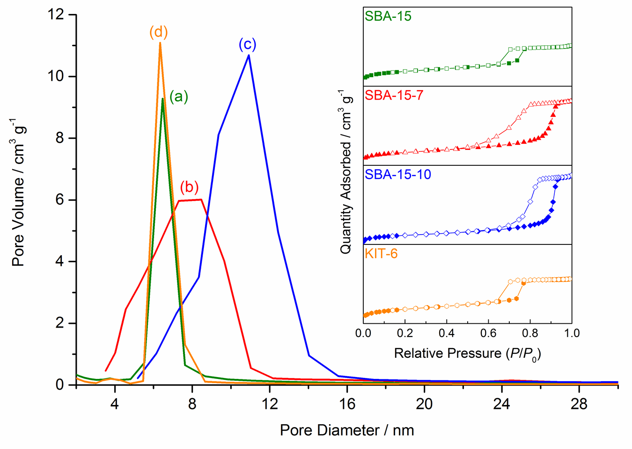

**Figure 2.** Pore-size distributions and (inset) N2 adsorption isotherms for (a) SBA-15; (b) SBA-15-7; (c) SBA-15-10 and (d) KIT-6. Adsorption and desorption isotherms are represented by closed and open symbols respectively.

The nitrogen adsorption-desorption isotherms shown in Figure 2 (and Supporting Information Figures S1-S2) reveal that all the silica support materials exhibit Type IV isotherms with H1 hysteresis loops, which is characteristic of open cylindrical pores.[37] For the pore-expanded SBA-15 silicas, the hysteresis loop shifts to higher relative

**Table 1.** Structural properties of the mesoporous silica materials before and after immobilisation of complex **6**.a)

|  |  |  |  |  |  |
| --- | --- | --- | --- | --- | --- |
| Entry | Support | Surface areab) (m2 g-1) | Pore volume  (cm3 g-1) | Pore diameterc)  (nm) | Catalyst loading  (mmol g-1) |
| 1 | SBA-15 | 1004 | 1.18 | 6.00 | - |
| 2 | SBA-15-**7** | 5 | 0.01 | (N/A) | 0.42 |
| 3 | SBA-15-7 | 878 | 1.87 | 6.90 | - |
| 4 | SBA-15-7-**7** | 67 | 0.23 | 6.31 | 0.35 |
| 5 | SBA-15-10 | 580 | 1.99 | 10.0 | - |
| 6 | SBA-15-10-**7** | 277 | 0.86 | 7.36 | 0.33 |
| 7 | KIT-6 | 977 | 1.30 | 6.09 | - |
| 8 | KIT-6-**7** | 255 | 0.30 | 4.33 | 0.39 |
| 9 | SA-**7**d) | 275 | 0.37 | 4.43 | 0.13 |

a) Entries ending in -**7** are after immobilisation of complex **6**. b)Calculated using the BET method. c) Determined from the desorption branch of the isotherm. d)SA: synthesised using amorphous 3-chloropropyl functionalised silica purchased from Sigma Aldrich.

pressures as the ageing temperature increases which is indicative of an increase in pore size.[35] Barrett-Joyner-Halenda (BJH) analysis on the desorption branch of the respective isotherms confirmed the successful fabrication of mesoporosity in these materials. Both SBA-15 and KIT-6 possess narrow pore size distributions (PSDs) and an average pore diameter of around 6 nm. The introduction of the TMB micelle expander during the synthesis of SBA-15 results in an increase in the average pore diameter, with SBA-15-7 and SBA-15-10 possessing average pore diameters of 7 nm and 10 nm respectively (Table 1), though the PSD is also noticeably broader. Expansion of the pores also results in an increase in pore volume (from 1.18 cm3 g-1 to 1.99 cm3 g-1), as well as a decrease in the apparent Brunauer-Emmett-Teller (BET) surface area (from 1004 m2 g-1 to 580 m2 g-1) on going from SBA-15 to SBA-15-10.

SBA-15 displays characteristic (100), (110), and (200) diffraction peaks typical of the expected 2D *p6mm* hexagonal structure (Supporting information Figure S5). The (100) diffraction peak would be expected to shift to a lower angle as a result of an increase in pore diameter, and hence an increase in the unit cell parameter. However, for SBA-15-7 and SBA-15-10, the PXRD patterns are relatively ill-defined. This indicates that these materials possess a lower degree of order and correlates with their broad PSDs. The low angle PXRD pattern of KIT-6 shows a characteristic (211) diffraction peak which confirms that the material possesses the desired cubic *Ia3d* symmetry (Supporting information Figure S5).[33]

TEM imaging confirmed the observations from PXRD analysis. SBA-15 showed uniform, ordered mesopores arranged in a hexagonal array (Supporting information Figure S6). However, SBA-15-7 and SBA-15-10 were found to consist of pores of different size, which is in line with their broader PSDs, as determined by porosimetry, and consistent with their lack of order in PXRD analysis. KIT-6, on the other hand, exhibits the desired 3D pore structure. The loss of periodicity in the pore-expanded mesoporous silicas was not problematic with respect to determining structure-property relationships, as the



**Scheme 2.** Preparation of mesoporous silica-supported catalysts.

PSDs were still statistically larger than that of standard SBA-15 and retained a degree of order in comparison to amorphous silica.

To covalently attach a bimetallic aluminium(salen) complex onto the silica surface, the mesoporous silica materials were functionalised with 3-chloropropyl chains. This was achieved by refluxing a suspension of the mesoporous silica and (3-chloropropyl)triethoxysilane (CPTES) in toluene (Scheme 2). The immobilised one-component mesoporous silica-supported catalysts were then prepared by first stirring complex **6**[38]and the 3-chloropropyl functionalised silica under reflux in acetonitrile. Once immobilisation was achieved, the complex was quaternised using benzyl bromide and tetrabutylammonium bromide (TBAB) to produce the desired immobilised one-component catalysts (**7**).[11]

Immobilisation of the bimetallic aluminium(salen) complex onto the mesoporous silicas resulted in a significant change in the properties of these materials. The nitrogen adsorption-desorption isotherm of catalyst-loaded SBA-15 (SBA-15-**7**) demonstrates that it loses essentially all of its initial porosity as a consequence of the pores becoming blocked by the large bimetallic complex (Table 1, entry 2). In contrast, the pore-expanded mesoporous silica materials retain porosity following catalyst loading (Table 1, entries 4, 6 and 8) where the loss of some pore volume and surface area suggests that the complex is not only immobilised onto the external silica surface, but is also present within the pores. Interestingly, KIT-6 possesses a similar average pore diameter to SBA-15 (6.0-6.1 nm), however it retained a significant amount of pore volume (0.30 cm3 g-1) and surface area (255 m2 g-1) after catalyst loading. This can be rationalised on the basis that KIT-6 has 3D pore morphology which allows retention of porosity even with deposition of **6** within the porous structure, as opposed to SBA-15’s 2D structure. SEM and TEM imaging of the mesoporous silica-supported catalysts demonstrated that the mesostructure of each material was preserved after catalyst loading (Figure 3 and Supporting information Figures S7-8).

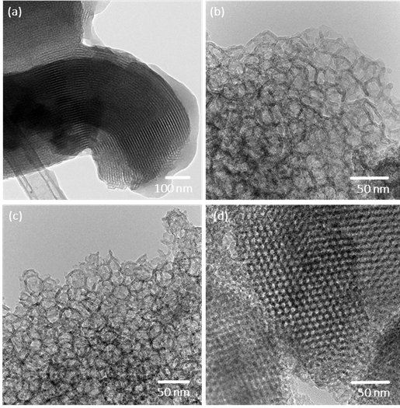

**Figure 3.** TEM images of catalyst-loaded (a) SBA-15-**7**; (b) SBA-15-7-**7**; (c) SBA-15-10-**7** and (d) KIT-6-**7**.

Diffuse reflectance infrared Fourier transform spectroscopy (DRIFTS) was performed on all silica materials before and after covalent attachment of the 3-chloropropyl chains and after catalyst immobilisation (Figure 4 and Supporting information Figures S9-S12). All unfunctionalised silicas contained characteristic Si-O-Si stretching vibrations at 1212–1088 cm-1 and 793 cm-1, in addition to bending and stretching vibrations of the Si-OH bond at 948 cm‑1.[39] There are also prominent bands at 3800–2800 cm-1 and 1632 cm-1, which are indicative of residual water. Upon attachment of the 3-chloropropyl chains, these bands obscure any evidence of functionalisation. However, after catalyst immobilisation, prominent C-H stretching and bending vibrations at 2958–2876 cm-1 and 1446 cm-1 respectively are observable, which confirms the successful attachment of the organic species.[40]

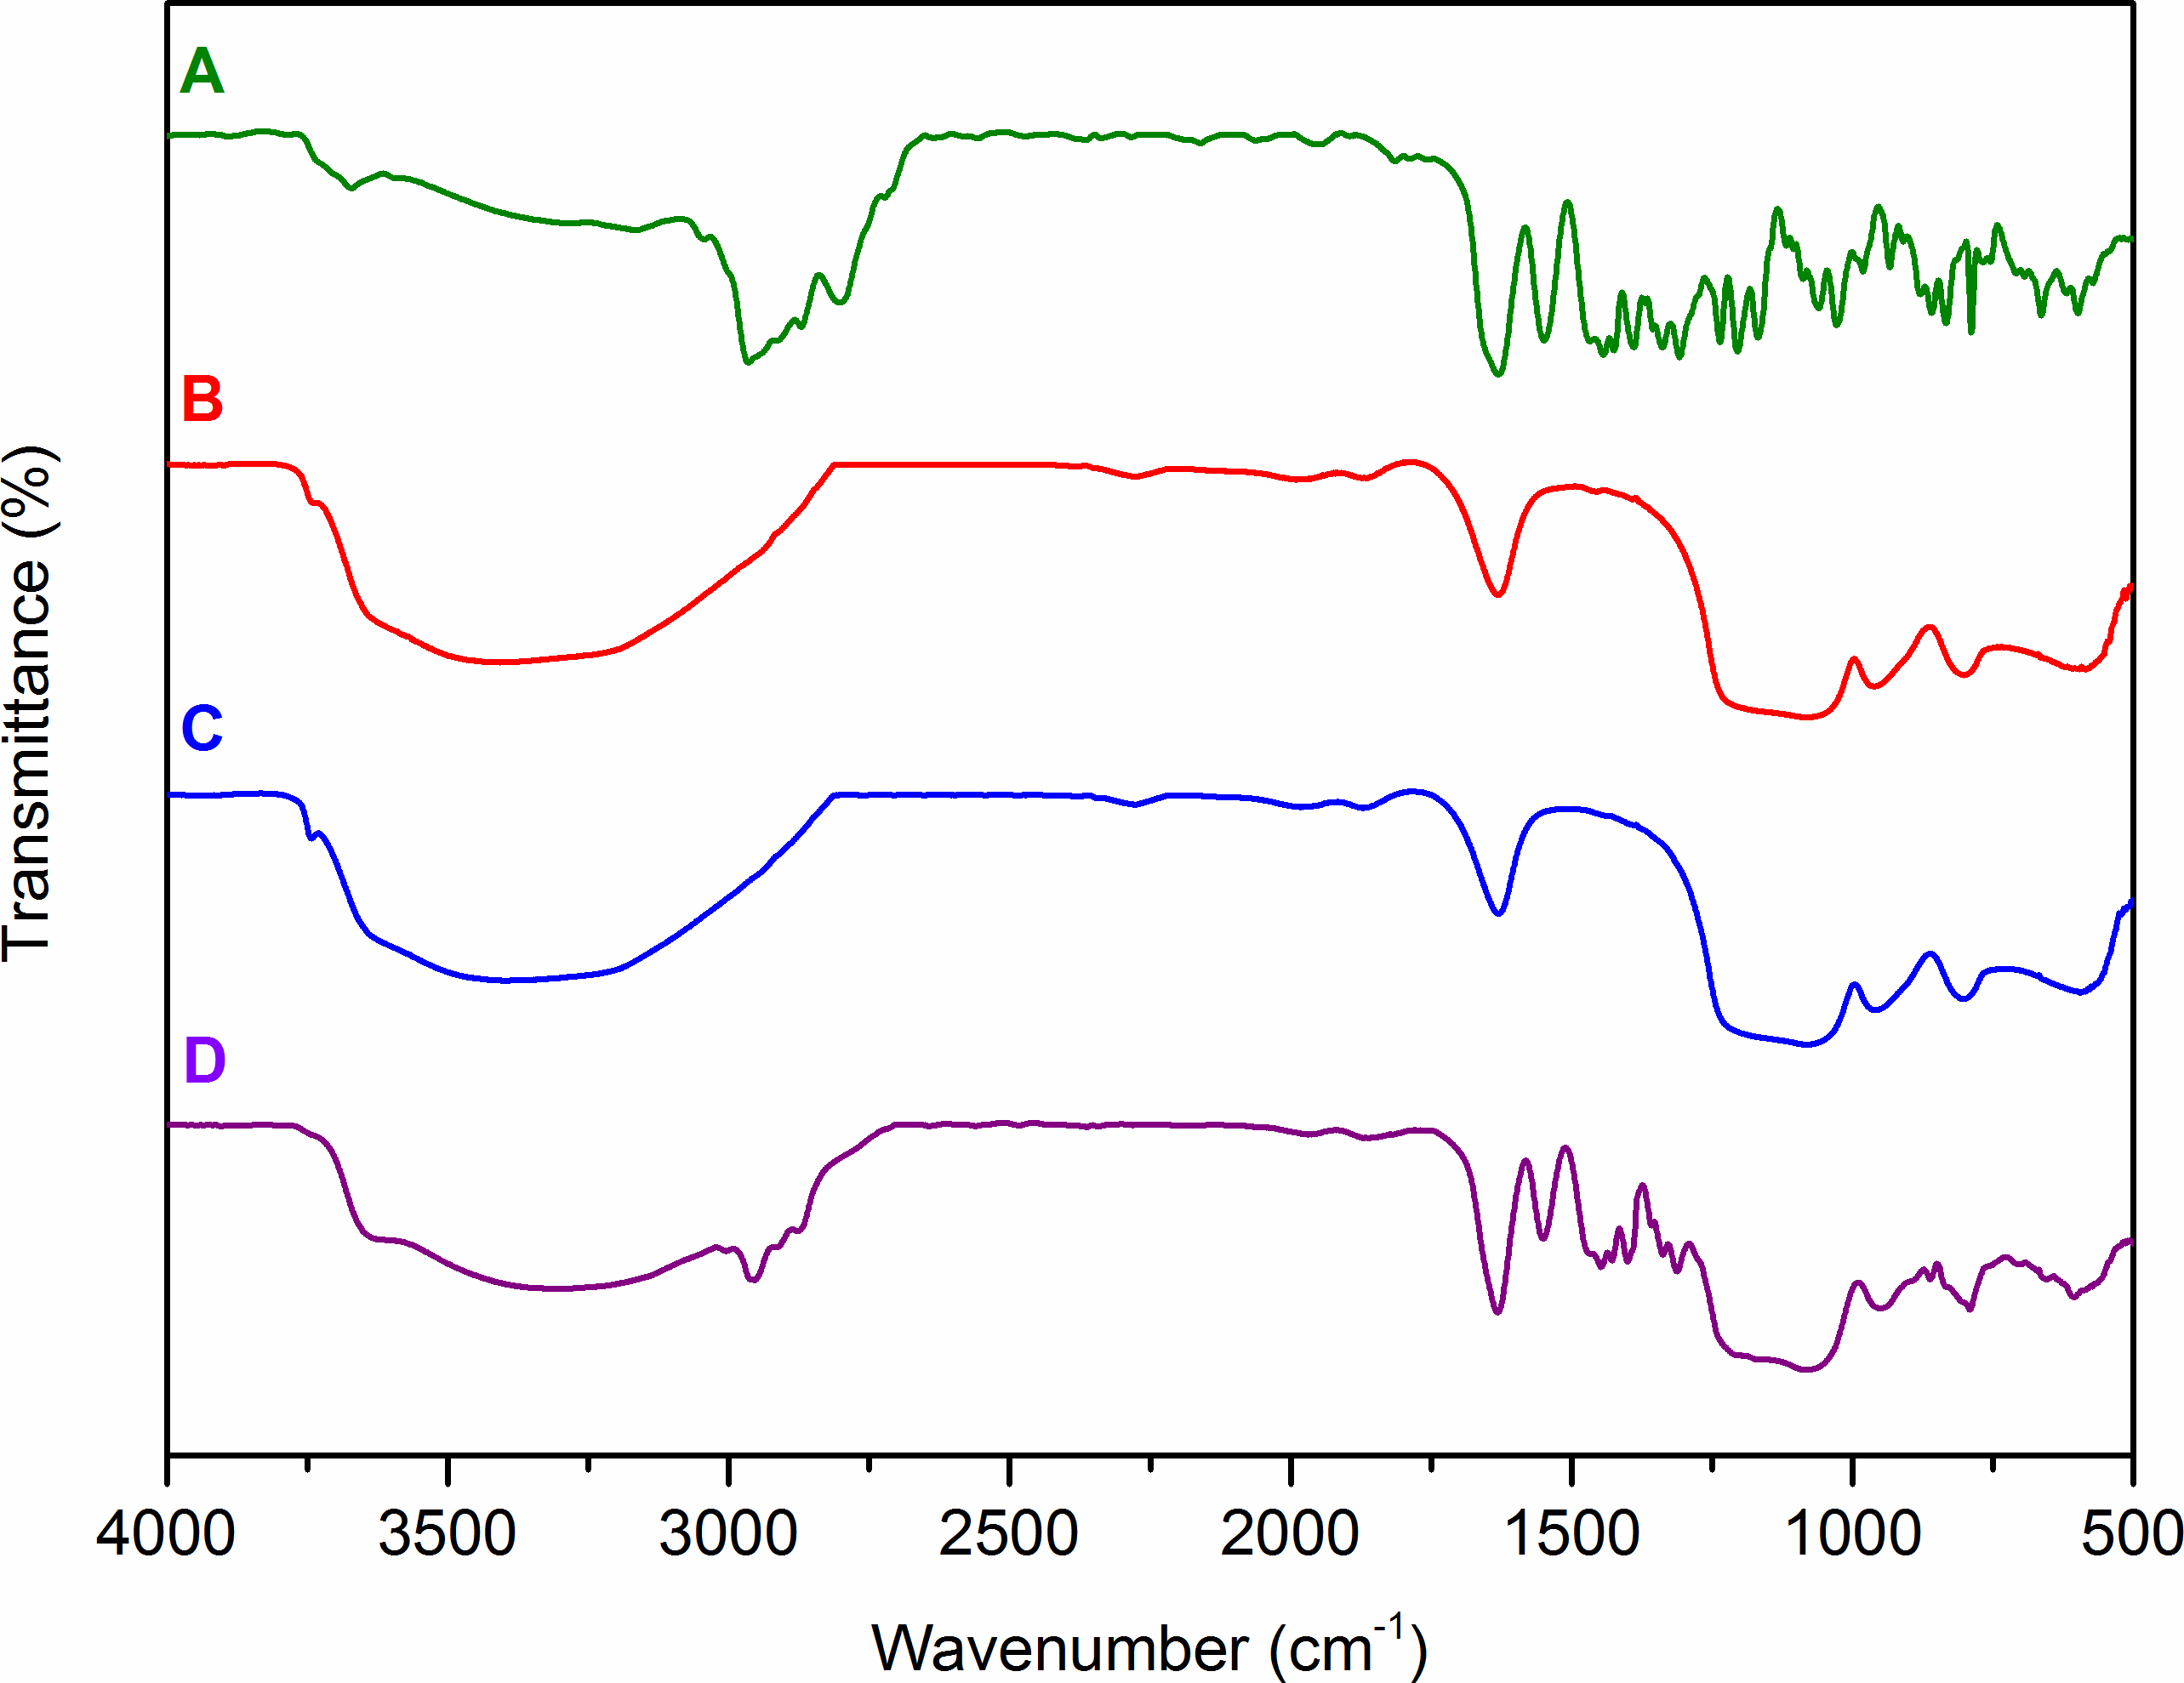

**Figure 4.** DRIFTS spectra of (a) bimetallic catalyst **6**; (b) SBA-15; (c) 3-chloropropyl functionalised SBA-15 and (d) catalyst-loaded SBA-15**-7**.

The aluminium content of the mesoporous silica-supported catalysts was determined by inductively coupled plasma mass spectrometry (ICP-MS) analysis (Supporting information Table S1). It can be seen from the data in Table 1 and Table S1 that the degree of aluminium loading correlates with the surface area initially possessed by the mesoporous silica materials, with SBA-15 possessing the highest aluminium loading (0.42 mmol g-1) and SBA-15-10 the lowest (0.33 mmol g-1). A commercial, amorphous 3-chloropropyl functionalised silica support (SA) with a similar pore size to non-expanded SBA-15 (entry 9, Table 1) was also included for comparison. SA possessed an average pore diameter of 6 nm before functionalisation with **6** (Supporting Information Figures S3-S4). Following the covalent attachment of the bimetallic complex, porosity was retained, but the catalyst loading (0.13 mmol g-1) was only one third that of the highest loading achieved for the structured mesoporous silica materials (Supporting information Table S1). The lower loading capacity is most likely a result of the disordered nature of the amorphous pores in SA.

SBA-15-10 and SBA-15-10-**7** were also analysed by solid-state 29Si NMR and, for SBA-15-10-**7**, solid-state 13C NMR spectroscopy. The 29Si spectrum of SBA-15-10 (Supporting information Figure S13) showed the expected peaks corresponding to **Si**(OSi)4 units at -110 ppm, **Si**(OH)(OSi)3 units at -100 ppm and **Si**(OH)2(OSi)2 units at -90 ppm.[41] After attachment of the aluminium(salen) complex to give SBA-15-10-**7**, the spectrum underwent substantial changes (Supporting information Figure S14). The peak at -90 ppm corresponding to **Si**(OH)2(OSi)2 units completely disappeared and the peak at -110 ppm corresponding to **Si**(OSi)4 units substantially increased in intensity relative to the peak at -100 ppm. In addition, two new peaks appeared at -65 ppm and -57 ppm which can be assigned to C**Si**(OSi)3 and C**Si**(O2Si)(OSi) units respectively.[42] This data clearly indicates the successful attachment of the linker to the silicon support.

Based on the amounts of mesoporous silicon and CPTES used (see experimental section), the maximum catalyst loading achievable corresponds to one in every ten silicon atoms of the mesoporous support supporting a catalyst unit. This corresponds to an average 20 atom gap between functionalised silicon atoms. The 29Si peak intensities in Figure S14 are consistent with this analysis. In structure **6**, the shortest distance between two amino groups is 15 atoms and taking the propylsilyl linkers into account this gives a minimum of 23 atoms available to bridge between two functionalised sites on the mesoporous support. Thus, it is possible for catalyst units **6** to be multiply attached to the silica support (Scheme 2).

To obtain more information on the nature of immobilised catalyst **7**, SBA-15-10-**7** was analysed by solid-state 13C NMR spectroscopy (Supporting information Figure S15). This spectrum showed that the catalyst structure was intact with peaks corresponding to carbon atoms with aromatic rings, in tertiary butyl groups, in ethyl groups and adjacent to nitrogen atoms all clearly present. No peaks assignable to the linker units were visible however.



**Scheme 3.** Conversion of glycidol and its derivatives (**1b**-**f**) into the corresponding cyclic carbonates (**2b**-**f**).

Each mesoporous silica-supported complex was tested as a catalyst for the conversion of various epoxides into their corresponding cyclic carbonates. Initially, glycidol and its derivatives **1b-f** were used as substrates (Scheme 3). Using 0.25 mol% (of supported bimetallic aluminium-complex) of each catalyst under mild conditions (50 ˚C and 1 bar carbon dioxide pressure) for 24 h was found to give good conversions of epoxides **1b-f** into cyclic carbonates **2b-f** (Table 2) and enabled the catalytic performance of the silica supported complexes to be compared. These conditions ensured that the theoretical number of potentially available active sites within each reaction system would be the same and hence any variation in catalytic performance between the different supports would be a function of their pore morphologies, rather than their catalyst loadings.

**Table 2.** Conversion of glycidol and its derivatives **1b-f** into cyclic carbonates **2b-f** using mesoporous silica-supported catalysts.

|  |  |  |  |  |  |
| --- | --- | --- | --- | --- | --- |
| Substrate | Conversion (%)a) | | | | |
| SBA-15**-7** | SBA-15-7**-7** | SBA-15-10**-7** | KIT-6**-7** | SA**-7** |
| **1b** | 42 | 43 | 53 | 46 | 43 |
| **1c** | 47 | 45 | 49 | 54 | 45 |
| **1d** | 62 | 63 | 80 | 76 | 65 |
| **1e** | 57 | 63 | 76 | 71 | 58 |
| **1f** | 10 | 25 | 34 (51)b) | 19 | 15 |

a) Determined using 1H NMR spectroscopy. b) At 100 oC.

When comparing the two-dimensional SBA-15 supports, catalysts SBA-15-7-**7** and SBA-15-10-**7** show a small pore-size effect which lead to enhanced conversions with the larger substrates **1d–f**. Non-template expanded SBA-15 lost virtually all of its porosity after the immobilisation of **6** and as a result had no defined pore size (Table 1, entry 2). This suggests that the large majority of active sites responsible for the observed catalytic activity of SBA-15-**7** are situated on the external surface of the support. In contrast, SBA-15-7-**7** retained a small surface area and pore volume (Table 1, entry 4) and generally exhibited a slight increase in conversion of **1b-f** to **2b-f** compared to SBA-15-**7**. This may be attributed to substrates being able to penetrate into the remaining porous network post-immobilisation and interact with catalyst supported within the pores, though it is likely that with such a low surface area and pore volume, diffusion though these pores will be somewhat limiting. SBA-15-10-**7** retains almost half of its original surface area and pore volume, implying that a reasonable quantity of immobilised complex **6** is distributed within the pore channels, though these retain good pore diameters of 7 nm (Table 1, entry 6). As a consequence, substrates may diffuse in and out of the porous network with minimal hindrance and have increased accessibility to internal active sites allowing increased conversions to **2b-f** compared with SBA-15-**7**. Epoxide **1c**, the smallest of the aprotic epoxides, showed the least difference in conversion to **2c** across the catalyst series. The small size of this epoxide may facilitate its access to even hindered active sites within almost filled pores. Glycidol **1b**, for which individual molecules are of a similar size to epoxide **1c** will be extensively intermolecularly hydrogen bonded (reactions were carried out under solvent free conditions) giving it a much greater apparent size. Hence there is an 11% increase in conversion for this substrate between SBA-17-**7** and SBA-15-10-**7** (Table 2).

Conversions achieved by KIT-6-**7** were found to be similar to those obtained using SBA-15-10-**7** despite this supported catalyst having less than half of the pore volume and a smaller pore diameter of 4.3 nm (albeit with an overall similar surface area). This can be attributed to its three dimensional cubic pore structure, where substrates are able to enter the internal structure of the catalyst via multiple surfaces, rather than being limited to access through one plane as in the two dimensional SBA type supports.

Substrate **1f**, the largest of the glycidol derivatives gave the lowest conversions with all the silica supported catalysts (Table 2). This may suggest that the internal structure of the two- or three-dimensional pores has a negative impact on mass transport of large species within the channels. However, cyclic carbonate **2f** has a melting point of 94 oC and this may lead to pore blockage at even low conversions. Consistent with this, the conversion of epoxide **1f** into cyclic carbonate **2f** increased to 51% when the reaction was carried out at 100 oC.

To further explore the effect of substrate size on conversion, the substrate scope was extended to epoxides **1g-m** (Scheme 4). SBA-15-10-**7** was found to be the best catalyst for each of substrates **1g-l** (Table 3). For the halomethyl epoxides **1g-i**, the conversion increased from catalysts SBA-15-**7** to SBA-15-7-**7** to SBA-15-10-**7**, but the conversion also increased as the size of the epoxide increased from **1g** to **1h** to **1i**. This suggests that for these small epoxides, size related access to active sites within the pores is not the dominant factor and the observed effects may be due to hydrophobicity increasing from **1/2g** to **1/2h** to **1/2i** resulting in product being more effectively repelled away from the silanol surface and thus clearing the catalytically active sites.



**Scheme 4.** Conversion of epoxides **1g**-**m** into cyclic carbonates **2g**-**m**.

**Table 3.** Conversion of epoxides **1g-m** into cyclic carbonates **2g-m** using mesoporous silica-supported catalysts.

|  |  |  |  |  |  |
| --- | --- | --- | --- | --- | --- |
| Substrate | Conversion (%)a) | | | | |
| SBA-15**-7** | SBA-15-7**-7** | SBA-15-10**-7** | KIT-6**-7** | SA**-7** |
| **1g** | 23 | 29 | 37 | 31 | 24 |
| **1h** | 31 | 50 | 63 | 51 | 39 |
| **1i** | 52 | 60 | 80 | 67 | 65 |
| **1j** | 22 | 24 | 29 (31)b) | 25 | 21 |
| **1k** | 9 | 13 | 19 (58)b) | 10 | 12 |
| **1l** | 5 | 10 | 18 | 7 | 11 |
| **1m** | <1 | 1 | 1 | 3 | 1 |

a) Determined using 1H NMR spectroscopy. b) At 100 oC.

Aromatic epoxides **1j/k** give cyclic carbonates **2j/k** which have melting points at or above the reaction temperature (49-51 oC for **2j** and 67-69 oC for **2k**). The conversion of styrene oxide **1j** into styrene carbonate **1k** barely changed on increasing the reaction temperature to 100 oC, whilst the conversion of epoxide **1k** into **2k** increased three-fold. Long chain aliphatic epoxides **1l/m** gave the lowest conversions which may be attributed to the size of the epoxide preventing access to catalyst within pores along with the non-polar aliphatic chain being repelled by the polar, silica-supported catalysts.

A catalyst reusability study was conducted using the best-performing mesoporous silica-supported catalyst (SBA-15-10-**7**) and one of the most reactive epoxides (**1d**: butyl glycidyl ether). Performing each run using 1 mol% of catalyst at 25 °C and 1 bar carbon dioxide pressure for 24 h demonstrated the ability of SBA-15-10-**7** to catalyse the formation of cyclic carbonates over successive runs, even at ambient conditions (Figure 5). After each reaction, the catalyst was isolated by centrifugation in order to minimise any loss of material. SBA-15-10-**7** was found to slowly deactivate and lose its activity over successive catalytic cycles, which is in line with the use of other silica-supported catalysts previously prepared and used within the group.[6] This deactivation has previously been demonstrated to be a result of dequaternisation of the ammonium groups within the supported catalyst.[11,12,14] In line with this, after use 5, SBA-15-10-**7** was reactivated by treatment with benzyl bromide and its catalytic activity was fully restored.



**Figure 5.** Reusablity study of SBA-15-10**-7**. Conditions: **1d** (3.30 mmol), SBA-15-10-**7** (1 mol%), 25 °C, 1 bar, 24 h. Use 6 was after the catalyst had been reactivated.

Conclusion

Pore-expanded variants of SBA-15 and KIT-6 have been used to prepare four novel heterogeneous bimetallic aluminium(salen) complexes. Each material was analysed for to its ability to catalyse cyclic carbonate synthesis from the reaction of carbon dioxide with epoxides. Over a broad substrate range, it was found that the structured mesoporous silica supports which retained a greater degree of porosity and wider pore openings upon catalyst immobilisation, resulted in better conversions to the desired cyclic carbonates and also outperformed an analogous amorphous silica support. The enhanced activity was rationalised to be a consequence of increased reactant accessibility to active sites immobilised within the pores. This study also demonstrated that KIT-6 can be used as a mesoporous silica support. Interest in its utilisation has grown over recent years, and it has been investigated in a variety of applications.[34-36] Therefore, future studies could involve the use of pore-expanded variants of KIT-6 to further investigate the effect of porosity retention on catalytic activity.

Experimental Section

All reagents were commercially available (Alfa Aesar, Sigma Aldrich, TCI) and were used as received. Carbon dioxide and nitrogen gases were purchased from BOC gases.

Porosimetry of both unloaded and loaded mesoporous silica materials was performed on a Micromeritics ASAP 2020 volumetric adsorption analyser. The unloaded silica materials and loaded silica materials were degassed offline at 413 K and 353 K respectively for 10 h under dynamic vacuum (20 mmHg) before analysis. Nitrogen adsorption isotherms were performed at 77 K and 1 bar. Surface areas were calculated using the BET method over the range *P*/*P*0 = 0.06–0.20. PSDs were calculated using the BJH model applied to the desorption branch of the isotherm. Total pore volumes were evaluated at *P*/*P*0 = 0.98.

PXRD patterns were collected on a Rigaku Intelligent X-ray Diffraction system with Ge-monochromated Cu-*Kα* (1.54 Å) radiation. Unloaded mesoporous silica materials were loaded onto a glass slide equipped with a sample well of 0.5 mm depth. Low angle XRD scans were scanned over the 2*θ* range of 0.2–3° with a step size of 0.01° and scan speed of 0.002° s-1.

TEM imaging was performed using an FEI Titan G2 60-300 microscope equipped with a DCOR probe Cs-aberration corrector operating at 300 kV. The samples were suspended in iso-propanol and deposited on Cu grids with Lacey carbon membranes prior to observation. SEM imaging was performed using an FEI NOVA NanoSEM 650 microscope using secondary electron detectors. The samples were deposited on carbon tape and coated with carbon prior to observation.

The aluminium metal concentration of the loaded mesoporous silica materials was determined using ICP-MS on an Agilent 7700x Series instrument fitted with standard Ni sample and skimmer cones and coupled to a mass spectrometer. The samples were run in He mode. The sample introduction line was rinsed for 60 seconds between samples using 5% HCl and 2% HNO3, and for   
30 seconds for each sample. The sample uptake was set for   
60 seconds and left to stabilise for 40 seconds. Prior to analysis, each mesoporous silica-supported catalyst (0.01 g) was added to a glass vial containing HNO3 (≥69.0%, *Trace*SELECT®, 5 mL) and subsequently stirred at 373 K for 3 h. After cooling to room temperature, the mixture was diluted to 100 mL using ultrapure water.

DRIFTS analysis of both unloaded and loaded mesoporous silica materials was performed using a Bruker Equinox 55 using a resolution of 2 cm−1 and a KBr dilution of 10:1.

Solution state 1H and 13C NMR spectra were recorded at 400 and 100 MHz respectively using a Jeol Oxford 400 Spectrometer. Chemical shifts are reported in ppm (*δ*) referenced to CHCl3 (7.26 ppm) and CDCl3 (77.16 ppm)for 1H and 13C spectra respectively. Solid-state NMR spectra were recorded on a Bruker Avance 400 spectrometer operating at 400, 100 and 79.5 MHz for 1H, 13C, and 29Si, respectively. Cross-polarization MAS spectra were recorded at 296 K and a spin-rate of 9 kHz. 13C spectra were externally referenced to adamantine whilst 29Si spectra were externally referenced to octakis(trimethylsiloxy)silsesquioxane (Q8M8).

**Synthesis of SBA-15.** A 250 mL round-bottom flask was charged with Pluronic P-123 (2.00 g) and a mixture of distilled water (15 mL) and 2 M HCl (60 mL). After stirring at 40 °C for 4 h to ensure complete dissolution, TEOS (4.25 g) was added dropwise and the resulting reaction mixture was left to stir at 40 °C for 24 h. After this time, the white suspension was left to stand at 100 °C for 24 h. The solid product was collected by Büchner filtration, washed with distilled water (100 mL) and dried under vacuum for 6 h. The isolated solid was calcined statically in ambient air at 550 °C (heating ramp rate of 2 °C/min) for 5 h to yield SBA-15 as a powdery white solid.

**Synthesis of SBA-15-7 and SBA-15-10.** A 250 mL round-bottom flask was charged with Pluronic P-123 (2.00 g) and a mixture of distilled water (52 mL) and 37% HCl (10 mL). After stirring at 25 °C for 2 h to ensure complete dissolution, TMB (2.00 g) was added in one portion and the stirring continued for 2 h. TEOS (4.30 g) was added dropwise and the resulting reaction mixture was left to stir at 35 °C for 24 h. After this time, the white suspension was left to stand at 80–120 °C for 72 h. The solid product was collected by Büchner filtration, washed with distilled water (100 mL) and dried under vacuum for 6 h. The isolated solid was calcined statically in ambient air at 550 °C (heating ramp rate of 2 °C/min) for 5 h to yield   
SBA-15-7 or SBA-15-10 as a powdery white solid.

**Synthesis of KIT-6.** A 250 mL round-bottom flask was charged with Pluronic P-123 (3.00 g) and a mixture of distilled water (108 mL) and 37% HCl (4.90 mL). After stirring at 35 °C for 4 h to ensure complete dissolution, *n*-butanol (3.00 g) was added in one portion and the stirring continued for 1 h. TEOS (6.40 g) was added dropwise and the resulting reaction mixture was left to stir at 35 °C for 24 h. After this time, the white suspension was left to stand at 100 °C for 24 h. The solid product was collected by Büchner filtration and dried under high vacuum at 60 °C for 12 h. The isolated solid was calcined statically in ambient air at 550 °C (heating ramp rate of 2 °C/min) for 6 h to yield KIT-6 as a powdery white solid.

**General synthesis of 3-chloropropyl functionalised silica**. In a 50 mL round-bottom flask, calcined mesoporous silica (0.50 g) was suspended in anhydrous toluene (30 mL). With stirring, CPTES (0.29 g, 1.20 mmol) was directly added to the reaction mixture, which was heated under reflux (115 °C) for 16 h under a nitrogen atmosphere. After this time, the reaction mixture was allowed to cool to rt. The solid product was isolated *via* sintered funnel and washed successively with toluene (10 mL), CH2Cl2 (10 mL), and Et2O (10 mL). The isolated solid was dried under high vacuum at rt for 12 h to yield the 3-chloropropyl functionalised silica as a powdery white solid.

**General preparation of bimetallic aluminium-salen catalyst functionalised silica.** A 50 mL round-bottom flask was charged with 3-chloropropyl functionalised silica (0.25 g), **3** (0.24 g) and MeCN (20 mL). With stirring, the reaction mixture was heated under reflux (86 °C) for 16 h. After this time, the reaction mixture was allowed to cool to rt. The solid product was isolated *via* sintered funnel and washed with EtOAc (2 × 10 mL). The isolated solid was transferred to a 50 mL round-bottom flask and BnBr (0.28 g), TBAB (0.36 g) and MeCN (20 mL) were added. The reaction mixture was heated under reflux (86 °C) with stirring for 16 h. After this time, the reaction mixture was allowed to cool to rt. The solid product was isolated *via* sintered funnel filtration and washed with EtOAc (2×10 mL) to yield the bimetallic aluminium-salen catalyst functionalised silica as a powdery orange solid.

**General procedure for catalyst screening.** A glass vial was charged with mesoporous silica-supported catalyst (0.25 mol%) and an epoxide (3.30 mmol), sealed and purged with CO2, and then placed in a pre-heated DrySyn® heating block. A balloon filled with CO2 was attached and the reaction mixture was gently stirred at 50 or 100 ˚C for 24 h. After this time, the reaction mixture was allowed to cool to rt. Conversions were determined by 1H NMR spectroscopy of the reaction mixture. When good conversions were obtained using SBA-15-10**-7** catalyst, the reaction mixture was purified by column chromatography on silica gel, eluting first with hexane:EtOAc 5:1, then hexane:EtOAc 1:1 and finally with just EtOAc to give the pure cyclic carbonates **2b-m**.[42-49] Characterising data and copies of spectra for compounds **2b-m** are given in the supporting information.

**General procedure for reusability study.** A glass vial was charged with catalyst-loaded SBA-15-10-**7** (1 mol%) and butyl glycidyl ether **1d** (3.30 mmol), sealed and purged with CO2, and then placed in a pre-heated DrySyn® heating block. A balloon filled with CO2 was attached and the reaction mixture was gently stirred at 25 ˚C for 24 h. After this time, the reaction mixture was diluted with EtOAc (3 mL) and the washings were isolated and separated by centrifugation, and then concentrated to dryness under vacuum. Conversions were determined by 1H NMR spectroscopy of the residue. The isolated catalyst was dried under vacuum and then re-used directly in the next run. After 5 uses, the catalyst (200 mg), benzyl bromide (144 mg) and TBAB (50 mg) were added to MeCN (5 mL) and heated under reflux (86 °C) with stirring for 2 days. After this time, the reaction mixture was allowed to cool to rt. The solid product was isolated *via* sintered funnel filtration, washed with EtOAc (2×10 mL) to give the reactivated catalyst as a beige solid.

Acknowledgements

We gratefully acknowledge financial support from the European Union Seventh Framework Programme FP7–NMP–2012 under grant agreement number 309497. We thank Jon Sinclair (University of York) for help with powder X-ray diffraction and Heather Fish (University of York) for help with solid state NMR.

References

[1] Carbon Dioxide as Chemical Feedstock (Ed.: M. Aresta), Wiley-VCH, Weinheim, **2010**, 1–375.

[2] W. J. Peppel, *Ind. Eng. Chem.* **1958**, *50*, 767–770.

[3] K. Xu, *Chem. Rev*. **2004**, *104*, 4303–4417.

[4] B. Schaffner, F. Schaffner, S. P. Verevkin, A. Borner, *Chem. Rev*. **2010**, *110*, 4554–4581.

[5] A. A. G. Shaikh, S. Sivaram, *Chem. Rev*. **1996**, *96*, 951–976.

[6] S. Fukuoka, M. Kawamura, K. Komiya, M. Tojo, H. Hachiya, K. Hasegawa, M. Aminaka, H. Okamoto, I. Fukawa, S. Konno, *Green Chem*. **2003**, *5*, 497–507.

[7] J. W. Comerford, I. D. V. Ingram, M. North, X. Wu, *Green Chem.* **2015**, *17*, 1966–1987.

[8] C. Martín, G. Fiorani, A. W. Kleij, *ACS Catal.* **2015**, *5*, 1353–1370.

[9] G. Fiorani, W. Guo, A. W. Kleij, *Green Chem.* **2015**, *17*, 1375–1389.

[10] M. North, R. Pasquale, *Angew. Chem. Int. Ed.* **2009**, *48*, 2946–2948.

[11] J. Melendez, M. North, P. Villuendas, C. Young, *Dalton Trans.* **2011**, *40*, 3885–3902.

[12] M. North, P. Villuendas, C. Young, *Chem. Eur. J.* **2009**, *15*, 11454–11457.

[13] M. North, B. Wang, C. Young, *Energy Env. Sci.* **2011**, *4*, 4163–4170.

[14] M. North, P. Villuendas, *ChemCatChem* **2012**, *4*, 789–794.

[15] N. Hiyoshi, K. Yogo, T. Yashima, *Micro. Meso. Mater.* **2005**, *84*, 357–365.

[16] R. K. Zeidan, S.-J. Hwang and M. E. Davis, *Angew. Chem. Int. Ed.* **2006**, *45*, 6332–6335.

[17] Z. Zhou, M. Hartmann, *Chem. Soc. Rev.* **2013**, *42*, 3894–3912.

[18] V. Fathi Vavsari, G. Mohammadi Ziarani, A. Badiei, *RSC Advances* **2015**, *5*, 91686–91707.

[19] J. W. Comerford, T. J. Farmer, D. J. Macquarrie, S. W. Breeden, J. H. Clark, *Arkivoc* **2012**, *7*, 282–293.

[20] M. Kruk, *Acc. Chem. Res.* **2012**, *45*, 1678–1687.

[21] M. Liu, B. Liu, L. Liang, F. Wang, L. Shi, J. Sun, *J. Mol. Cat. A: Chem.* **2016**, 418–419, 78–85.

[22] S. Ravi, R. Roshan, J. Tharun, A. C. Kathalikkattil, D. W. Park, *J. CO2 Utilization* **2015**, *10*, 88–94.

[23] L. Han, S.-W. Park, D.-W. Park, *Energy Env. Sci.* **2009**, *2*, 1286–1292.

[24] T. Takahashi, T. Watahiki, S. Kitazume, H. Yasuda, T. Sakakura, *Chem. Commun.* **2006**, 1664–1666.

[25] Y. Xie, K. Ding, Z. Liu, J. Li, G. An, R. Tao, Z. Sun, Z. Yang, *Chem. Eur. J.* **2010**, *16*, 6687–6692.

[26] T. Ema, Y. Miyazaki, T. Taniguchi, J. Takada, *Green Chem.* **2013**, *15*, 2485–2492.

[27] U. R. Seo, Y. K. Chung, *Adv. Synth. Catal.* **2014**, *356*, 1955–1961.

[28] W. Zhang, Q. Wang, H. Wu, P. Wu, M. He, *Green Chem.* **2014**, *16*, 4767–4774.

[29] B. Chatelet, L. Joucla, J.-P. Dutasta, A. Martinez, V. Dufaud, *J. Mater. Chem. A* **2014**, *2*, 14164–14172.

[30] S. Verma, R. I. Kureshy, T. Roy, M. Kumar, A. Das, N.-ul H. Khan, S. H.R. Abdi, H. C. Bajaj, *Catal. Commun.* **2015**, *61*, 78–82.

[31] J. Steinbauer, L. Longwitz, M. Frank, J. Epping, U. Kragl, T. Werner, *Green Chem.* **2017**, *19*, 4435–4445.

[32] M. H. Kim, T. Song, U. R. Seo, J. E. Park, K. Cho, S. M. Lee, H. J. Kim, Y.-J. Ko, Y. K. Chung, S. U. Son, *J. Mater. Chem. A* **2017**, *5*, 23612–23619.

[33] A. Vinu, N. Gokulakrishnan, V. V. Balasubramanian, S. Alam, M. P. Kapoor, K. Ariga, T. Mori, *Chem. Eur. J.* **2008**, *14*, 11529–11538.

[34] S. K. Kundu, J. Mondal, A. Bhaumik, *Dalton Trans.* **2013**, *42*, 10515–10524.

[35] J. P. Dacquin, A. F. Lee, C. Pirez, K. Wilson, *Chem. Commun.* **2012**, *48*, 212–214.

[36] J. Sun, Q. Kan, Z. Li, G. Yu, H. Liu, X. Yang, Q. Huo, J. Guan, *RSC Advances* **2014**, *4*, 2310–2317.

[37] M. Thommes, K. Kaneko, A. V. Neimark, J. P. Oliver, F. Rodriguez-Reinoso, J. Rouquerol, K. S. W. Sing, *Pure Appl. Chem*. **2015**, *87*, 1051–1069.

[38] J. Melendez, M. North, P. Villuendas, *Chem. Commun*. **2009**, 2577–2579.

[39] X. Chen, J. Jiang, F. Yan, S. Tian, K. Li, *RSC Advances* **2014**, *4*, 8703–8710.

[40] S. Roy, P. Bhanja, S. Safikul Islam, A. Bhaumik, S. Manirul Islam, *Chem. Commun.* **2016**, *52*, 1871–1874.

[41] D. W. Sindorf, G. E. Maciel, *J. Am. Chem. Soc.* **1983**, *105*, 3767–3776.

[42] J. A. Castro-Osma, M. North, X. Wu, *Chem. Eur. J.* **2014**, *20*, 15005–15008.

[43] C. J. Whiteoak, E. Martin, M. M. Belmonte, J. Benet-Buchholz, A. W. Kleij, *Adv. Synth. Catal.* **2012**, *354*, 469–476.

[44] L. Zhou, Y. Liu, Z. He, Y. Luo, F. Zhou, E. Yu, Z. Hou, W. Eli, *J. Chem. Res.* **2013**, *37*, 102–104.

[45] D. Zhao, X.-H. Liu, J.-H. Guo, H.-J. Xu, Y. Zhao, Y. Lu, W.-Y. Sun, *Inorg. Chem.* **2018**, *57*, 2695−2704.

[46] J. A. Castro-Osma, M. North, X. Wu, *Chem. Eur. J.* **2016**, *22*, 2100–2107.

[47] M. K. Nielsen, C. R. Ugaz, W. Li, A. G. Doyle, *J. Am. Chem. Soc.* **2015**, *137*, 9571−9574.

[48] J. A. Castro-Osma, K. J. Lamb, M. North, *ACS Catal.* **2016**, *6*, 5012−5025.

[49] Y. A. Rulev, Z. T. Gugkaeva, A. V. Lokutova, V. I. Maleev, A. S. Peregudov, X. Wu, M. North, Y. N. Belokon, *ChemSusChem* **2017**, *10*, 1152–1159.

|  |  |  |  |
| --- | --- | --- | --- |
| FULL PAPER |  |  |  |
| Influence of mesoporous silica properties on cyclic carbonate synthesis catalysed by supported aluminium(salen) complexes | |  |  |
| *Adv. Synth. Catal.* **Year**, *Volume*, Page – Page | |
| Patricia A. Carvalho, James W. Comerford, Katie J. Lamb, Michael North*and Paul S. Reiss | |