Supplementary Material 1: Summary of Health policies assessed

|  |  |  |
| --- | --- | --- |
| **Policy** | **Time of Introduction** | **Key Features** |
| 1st SIGN Head Injury Guideline | August 2000 | Indication for CT imaging (referenced directly from 2000 SIGN guideline):  (1) GCS<13  (2) A deteriorating level of consciousness or progressive focal neurological signs  (3) Confusion or drowsiness (CGS 13 or 14/15) followed by failure to improve within at most  four hours of clinical observation  (4) Radiological/clinical evidence of a fracture, whatever the level of consciousness  (5) New focal neurological signs which are not getting worse  (6) Full consciousness (GCS 15/15) with no fracture but other features, including:  – severe and persistent headache  – nausea and vomiting  – irritability or altered behaviour  – a seizure.    Skull films should be carried out if any of the following apply and if CT is not being performed:  If the patient is alert and orientated and obeying commands (GCS 15/15) but:  – the mechanism of injury has not been trivial; or  – consciousness has been lost; or  – the patient has loss of memory or has vomited; or  – the scalp has a full thickness laceration or a boggy haematoma; or  – the history is inadequate. |
| 4-Hour ED performance target | 2004 | 98% of patients attending the ED to be assessed, treated and either discharged or admitted to hospital within 4 hours of arrival. Financial incentives associated with meeting the target. |
| 2nd Sign Head Injury Guideline | May 2009 | Referenced directly from 2nd SIGN Guidelines  Indications Immediate CT scanning (adult):  - GCS<13/15  - GCS 13/15 or 14/15 followed by failure to improve within one hour of clinical observation  - base of skull or depressed skull fracture and/or suspected penetrating injuries  - a deteriorating level of consciousness or new focal neurological signs  - GCS 15/15 with severe and persistent headache or two episodes of vomiting  - coagulopathy (eg warfarin use) and loss of consciousness or amnesia  Indications CT scanning within eight (adult):  - age>65 (with loss of consciousness or amnesia)  - clinical evidence of a skull fracture but no clinical features indicative of an immediate CT scan  - any seizure activity  - significant retrograde amnesia (>30 minutes)  - dangerous mechanism of injury  Indications Immediate CT scanning (<16 years):  - GCS≤13 on assessment in ED  - witnessed loss of consciousness >5 minutes  - suspicion of open or depressed skull injury or tense fontanelle  - focal neurological deficit  - any sign of basal skull fracture.  Indications CT scanning within 8 hours (<16 years):  - presence of any bruise/swelling/laceration >5 cm on the head  - post-traumatic seizure  - amnesia (anterograde or retrograde) lasting >5 minutes  - clinical suspicion of non-accidental head injury  - a significant fall  - age under one year: GCS<15 in emergency department  - three or more discrete episodes of vomiting  - abnormal drowsiness. |

Supplementary Material 2: Changes to Scotland’s population structure

1. Mid-year Estimate Scottish Population 0-15



1. Mid-year Estimate Scottish population 16-64



1. Mid-year Estimate Scottish population 65+

Supplementary Material 3: Increase in admissions related to the introduction of the 4-hour target in the 16-64 age group



Supplementary Material 4: Estimate of Impact of the SIGN guidelines and introduction of 4-Hour Target admissions for head injury with 12-month time lag

|  |  |  |  |  |  |  |
| --- | --- | --- | --- | --- | --- | --- |
| **Age Band** | **Winter** | **Initial Trend** | **1st SIGN Guideline** | **4-hour Target**  **Introduced** | **2nd SIGN Guideline** | **Durbin-Watson**  **Statistic** |
| **All ages** | -3.00 (95% CI: -3.75 to -2.26) P<0.01 | 0.04 (95% CI: -0.07 to 0.14) P=0.48 | **Change level:**  2.66 (95% CI:0.27 to 5.04) P=0.03 | **Change level:**  -2.73 (95% CI:-4.85 to -0.61) P<0.01 | **Change level:**  -2.07 (95% CI:-3.74 to -0.40) P=0.02 | Untransformed 1.77  Prais-Winsten 2.00 |
|  |  |  | **Change trend:**  -0.23 (95% CI:-0.38 to -0.08) P<0.01 | **Change trend:**  0.25 (95% CI: 0.14 to 0.36) P<0.01 | **Change trend:**  -0.13 (95% CI: -0.18 to -0.08) P<0.01 |  |
| **0-15** | -9.31 (95% CI: -11.05 to -7.59) P<0.01 | -0.18 (95% CI:-4.89 to 0.13) P=0.26 | **Change level:**  8.53 (95% CI:1.93 to 15.13) P=0.01 | **Change level:**  1.61 (95% CI:-4.39 to 7.61) P=0.60 | **Change level:**  -1.71 (95% CI:-6.61 to 3.20) P=0.49 | Untransformed 1.37  Prais-Winsten 1.85 |
|  |  |  | **Change trend:** -0.17 (95% CI:-0.61 to 0.28) P=0.47 | **Change trend:**  0.15 (95% CI: -0.17 to 0.48) P=0.36 | **Change trend:**  0.10 (95% CI:-0.50 to 0.26) P=0.18 |  |
| **16-64** | -1.80 (95% CI:-2.56 to -1.04) P<0.01 | 0.06 (95% CI:-0.06 to 0.17) P=0.34 | **Change level:**  1.29 (95% CI:-1.28 to 3.85) P=0.32 | **Change level:**  -4.19 (95% CI:-6.48 to -1.89) P<0.01 | **Change level:**  -3.06 (95% CI:-4.88 to -1.24) P<0.01 | Untransformed 1.57  Prais-Winsten 2.05 |
|  |  |  | **Change trend:**  -0.25 (95% CI:-0.41 to -0.09) P<0.01 | **Change trend:**  0.29 (95% CI: -0.17 to 0.40) P<0.01 | **Change trend:**  -0.25 (95% CI:-0.30 to -0.19) P<0.01 |  |
| **65+** | 1.69 (95% CI: 0.22 to 3.17) P=0.03 | 0.17 (95% CI:-0.04 to 0.38) P= 0.10 | **Change level:**  3.64 (95% CI:-1.08 to 8.36) P= 0.13 | **Change level:**  -1.64 (95% CI:-5.83 to 2.55) P=0.44 | **Change level:**  2.30 (95% CI:-1.00 to 5.60) P=0.17 | Untransformed 1.78  Prais-Winsten 2.00 |
|  |  |  | **Change trend:**  -0.22 (95% CI:-0.51 to 0.07) P=0.14 | **Change trend** 0.26 (95% CI: 0.04 to 0.48) P=0.02 | **Change trend:** 0.003 (95% CI:-0.10 to 0.10) P=0.95 |  |

Supplementary Material 5: Increase in admissions related to the introduction of the 2nd SIGN guideline



Supplementary Material 6: The impact of the SIGN guidelines on the percentage of admissions for TBI that resulted in neurosurgery

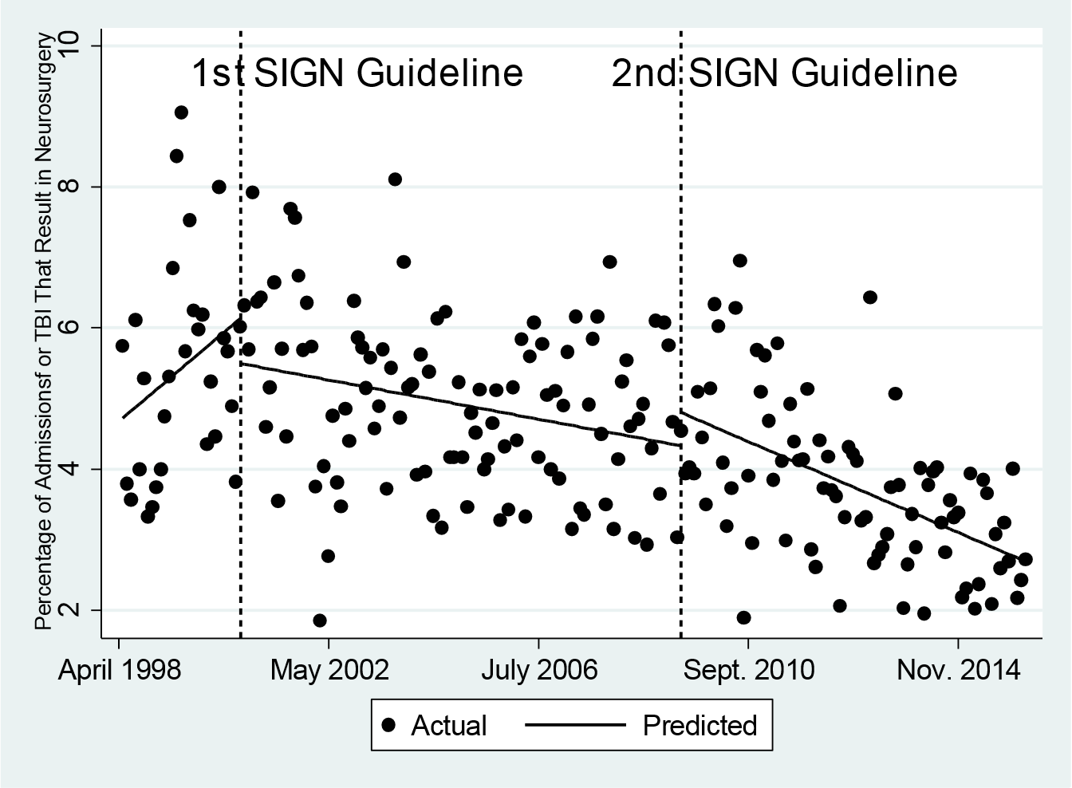

Supplementary Material 7: Estimate of impact of the SIGN guidelines and 4-Hour Target on admissions for Traumatic Brain Injury with 12-month time lag

|  |  |  |  |  |  |
| --- | --- | --- | --- | --- | --- |
| **Outcome** | **Initial Trend** | **1st SIGN Guideline** | **4-hour Target**  **Introduced** | **2nd SIGN Guideline** | **Durbin-Watson**  **Statistic** |
| **Admissions for TBI/ 100 000** | -0.05 (95% CI: -0.10 to 0.003) P=0.07 | **Change level:**  0.75 (95% CI:-0.34 to 1.84) P=0.18 | **Change level:**  0.35 (95% CI:-0.63 to 1.33) P=0.48 | **Change level:**  -0.16 (95% CI: -0.92 to 0.60) P=0.69 | Untransformed 1.44  Prais-Winsten 2.03 |
|  |  | **Change trend:**  0.05 (95% CI:-0.02 to 0.12) P=0.16 | **Change trend:**  -0.01 (95% CI:-0.06 to 0.04) P=0.66 | **Change trend:**  0.05 (95% CI:3 to 0.08) P<0.01 |  |
| **Percentage TBI admissions neurosurgical** | 0.05 (95% CI: -0.01 to 0.11) P=0.10 | **Change level:**  -0.96 (95% CI:-2.19 to 0.28) P=0.13 |  | **Change level:**  0.17 (95% CI:-0.59 to 0.93) P=0.66 | Untransformed 1.85 |
|  |  | **Change trend:**  -0.06 (95% CI:-0.12 to 0.003) P=0.06 |  | **Change trend:**  -0.02 (95% CI:-0.04 to-0.004) P=0.01 |  |

Supplementary Material 8: The impact of the SIGN guidelines on deaths per 100 000 population within 30 days of admission with traumatic brain injury

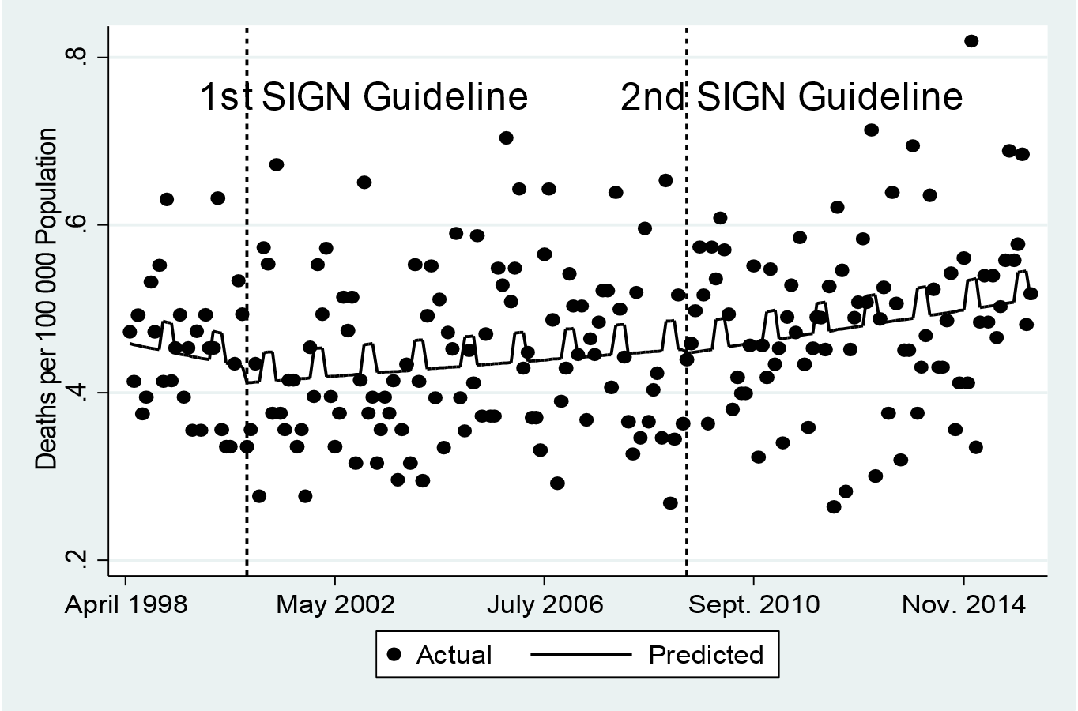

Supplementary Material 9: The impact of the SIGN guidelines on the percentage of patients admitted with TBI who died within 30 days of admission

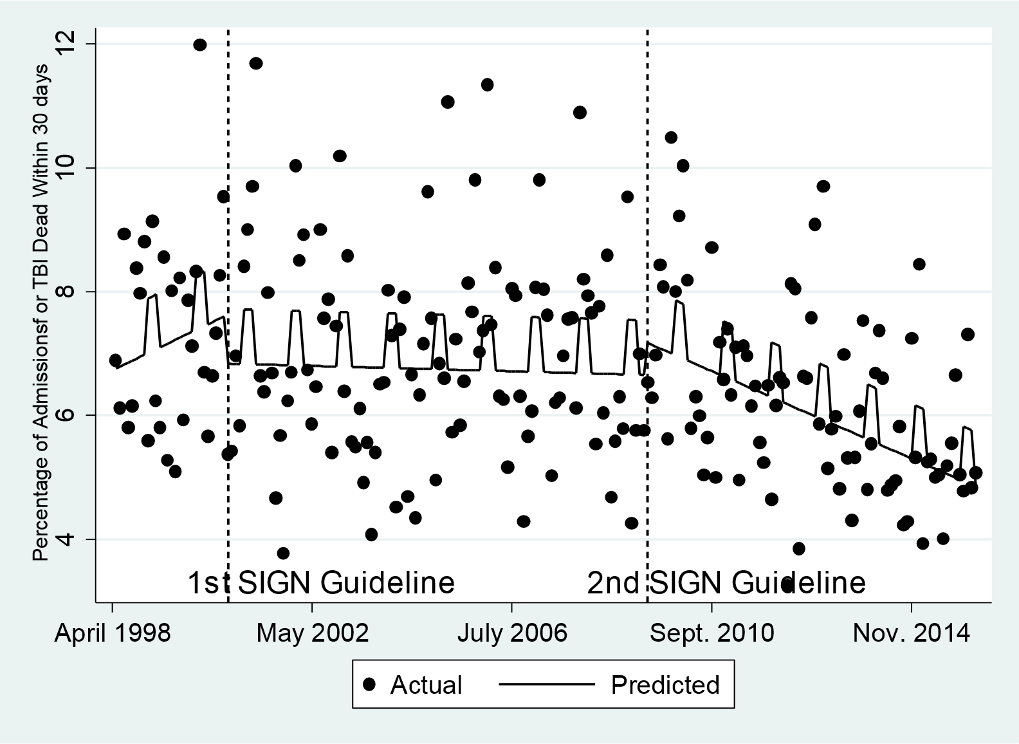

Supplementary Material 10: Estimate of impact of the SIGN guidelines on deaths following admission for Traumatic Brain Injury with 12 month time lag

|  |  |  |  |  |  |
| --- | --- | --- | --- | --- | --- |
| **Outcome** | **Winter** | **Initial Trend** | **1st SIGN Guideline** | **2nd SIGN Guideline** | **Durbin-Watson Statistic** |
| Deaths/100 000 | 0.03 (95% CI:-0.01 to 0.06) P=0.15 | -0.001 (95% CI:-0.004 to 0.003) P=0.59 | **Change level:**  -0.02 (95% CI:- 0.09 to 0.06) P=0.66 | **Change level:**  -0.03 (95% CI:-0.08 to 0.03) P=0.32 | Untransformed 2.29 |
|  |  |  | **Change trend:**  0.001 (95% CI:-0.002 to 0.005) P=0.44 | **Change trend:**  0.001 (95% CI:-0.0002 to 0.002) P=0.10 |  |
| Percentage TBI admissions death | 0.74 (95% CI: 0.18 to 1.30) P=0.10 | 0.03 (95% CI:-0.03 to 0.10) P=0.34 | **Change level:**  -1.06 (95% CI: -2.40 to 0.29) P=0.12 | **Change level:**  -0.37 (95% CI:-1.20 to 0.47) P=0.39 | Untransformed 2.17 |
|  |  |  | **Change trend:**  -0.03 (95% CI:-0.10 to 0.04) P=0.38 | **Change trend:**  -0.02 (95% CI:-0.04 to -0.004) P=0.02 |  |