Oxidoreductase-Catalyzed Synthesis of Chiral Amines

Mahesh D. Patil,ª Gideon Grogan,^{b} Andreas Bommarius,^{c} and Hyungdon Yun ª*

ª Department of Systems Biotechnology, Konkuk University, 120 Neungdong-ro, Gwangjin-gu, Seoul 05029, Korea
^{b} Department of Chemistry, University of York, Heslington, York, YO10 5DD, UK.
^{c} School of Chemical & Biomolecular Engineering, Georgia Institute of Technology, 950 Atlantic Drive, Atlanta, GA 30332-2000

Email addresses
Mahesh D. Patil- mahi1709@gmail.com
Gideon Grogan- gideon.grogan@york.ac.uk
Andreas Bommarius - andreas.bommarius@chbe.gatech.edu
Hyungdon Yun – hyungdon@konkuk.ac.kr

*Corresponding author: Hyungdon Yun, E-mail: hyungdon@konkuk.ac.kr

Abstract
Chiral amines are valuable constituents of many important pharmaceutical compounds and their intermediates. It is estimated that nearly 40-45% small molecule pharmaceuticals contain chiral amine scaffolds in their structures. The major challenges encountered in the chemical synthesis of enantiopure amines are the use of toxic chemicals, formation of a large number of by-products, and multi-step syntheses. To address these limitations, cost-effective biocatalytic methods are maturing and proving to be credible alternatives for the synthesis of chiral amines in enantiomerically pure forms. Herein, we report the recent progress achieved and current perspectives in the enzymatic synthesis of chiral amines using four important enzymes i.e. imine reductases, amine dehydrogenases, monoamine oxidases and cytochrome P450s. Applications to the industrial synthesis of chiral amines are highlighted. Protein engineering approaches, which play a critical role in improving or altering enzyme activity and substrate scope, are also addressed along with the discovery of pioneering enzymatic activities from nature. This survey of recent work demonstrates that enzymatic approaches to the synthesis of chiral amines will continue to be a major focus of research in biocatalytic chemistry in the years to come.

Keywords: Biocatalysis; chiral amines; amine dehydrogenase; imine reductase; monoamine oxidases; cytochrome P450s
- Introduction
In recent years, biocatalysis has emerged as a competent and superior alternative to traditional organo-catalysis for the production of fine chemicals, pharmaceuticals and agricultural products.¹⁻⁸ Enzyme-mediated processes are well-recognized for asymmetric transformations because they can be conducted under mild conditions, and as part of short synthetic routes.⁹⁻¹¹ The use of biocatalysts also does not require the activation of functional groups; thus, the protection and deprotection steps that are generally required in conventional synthesis are avoided.¹²⁻¹⁴ Also, the generation of fewer by-product while avoiding the use of toxic reagents, and the excellent chemo-, regio- and stereo-selectivities exhibited by enzymes can give biocatalytic routes considerable advantage over traditional abiotic catalysis.^{15,16}
Chiral amines play an important role as the building blocks of many life-saving drugs and other industrially important chemicals such as agrochemicals¹⁷⁻¹⁹ [Figure 1]. It has been estimated that nearly 40% of the currently used pharmaceuticals contain chiral amine functional groups in their structure.^{20,21} In this regard, the ACS Green Chemistry Institute, Pharmaceutical Roundtable has also acknowledged that the asymmetric synthesis of amines from prochiral ketones and ammonia is one of the top aspirational reactions challenging the pharmaceutical industry.²² Consequently, various enzymatic methods have been developed that provide sustainable synthetic alternatives towards a range of chiral amines.²³⁻²⁵
Enzymes such as ω-transaminases (ω-TAs), monoamine oxidases (MAOs), amine dehydrogenases (AmDHs), phenylalanine ammonia lyases (PALs), imine reductases (IREDs), lipases, P450 monooxygenases (P450s), Pictet-Spenglerases and berberine bridge enzymes (BBEs) can be useful for the biocatalytic synthesis of various chiral amines [Figure 1]. Many of these enzymes have already been optimized by protein engineering and currently serve as alternatives to chemical syntheses of chiral amines.²⁶⁻³³
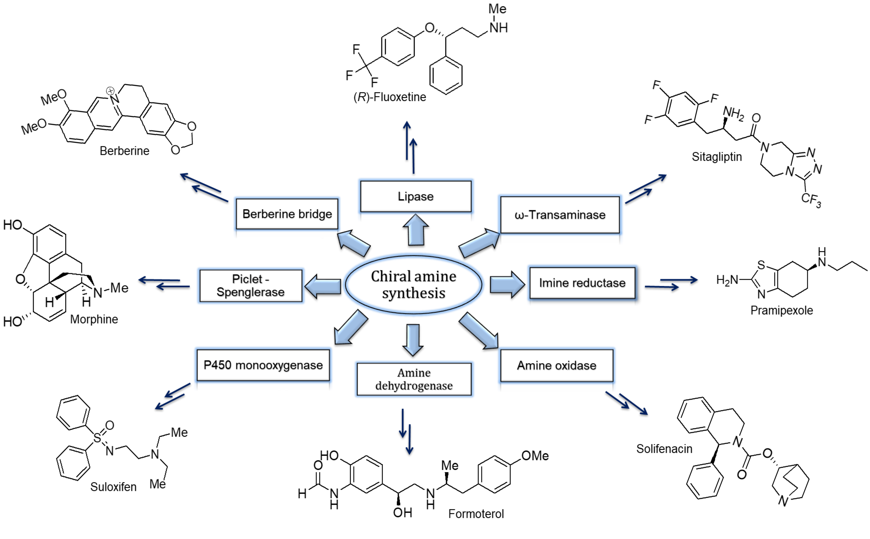
Figure 1. Enzymatic synthesis of chiral amines and important pharmaceuticals containing chiral amine scaffolds
Owing to their importance in various industries, progress in the field of the enzymatic synthesis of chiral amines, especially using transaminases, has been reviewed in the past few years.^{20,26-36} The current review endeavors to describe advances in the discovery, recent developments and current perspectives in the applications of four important enzymes: imine reductases, amine dehydrogenases, monoamine oxidases and cytochrome P450s, for the synthesis of chiral amines. The pivotal role played by protein engineering approaches in the improvement of these biocatalysts is emphasized along with the discovery of new enzymatic activities from nature.

- Imine Reductases (IREDs)
Owing to their high structural diversity and propensity for hydrogen bond formation, chiral amines are involved in a variety of biological activities.^{37,38} The majority of the enzymes used for amine biocatalysis generate primary amines. However, secondary and tertiary amines constitute the motifs of many important pharmaceuticals and industrially important chemicals. One of the efficient approaches for the generation of these structural motifs is the reductive amination of carbonyl compounds with amines.³⁹ This reaction enables the formation of a stereogenic center by directly coupling two smaller fragments. For example, Huang et al. have recently reported a highly efficient direct asymmetric reductive amination of arylacetones that uses diphenylmethylamine as the nitrogen source.⁴⁰ Notwithstanding the significant advances achieved in the chemically-catalyzed asymmetric reductive amination, it suffers considerable challenges, such as disfavoured equilibrium of imine formation in an aqueous medium, and chemoselectivity of the catalyst.⁴¹ The benefits offered by biocatalytic reductive amination processes would make them a desirable alternative to the abiotic examples.
Imine reductases (IREDs) are NADPH-dependent oxidoreductases that catalyze the asymmetric reduction of cyclic prochiral imines to amines. Also, IREDs can enable the reductive amination of carbonyl compounds with amines and thereby give access to the synthesis of secondary and tertiary amines.^{42,43} Therefore, depending on the structures of substrates and the reactions catalyzed by them, IREDs scan be categorized into two classes: A) Enzymes that catalyze only the reduction of pre-formed cyclic imines [Figure 2A], and B) Enzymes that catalyze reductive amination [Figure 2B] and reduction of pre-formed cyclic imines.⁴⁴
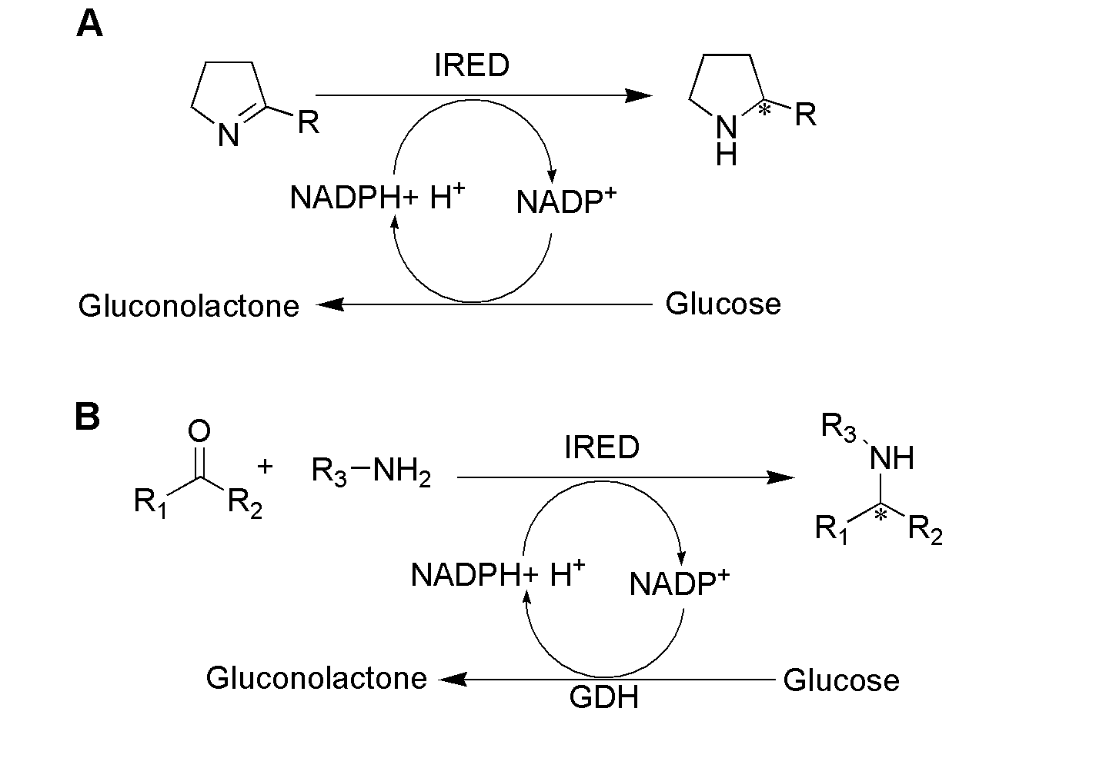
Figure 2. A) Reduction of cyclic imines by IREDs and B) Reductive amination of carbonyl compounds catalysed by IRED
2.1 Imine reductase for the reduction of cyclic imines
The electrophilic character and lower bond energy of C=N bonds makes them susceptible to attack by nucleophiles. Thus, noncyclic imines are hydrolytically labile in aqueous media.⁴⁴ On the other hand, cyclic imines are known to be stable in an aqueous environment and therefore serve as substrates for the enzyme-mediated reduction.^{44,45} A cyclic imine, 2-methyl-1-pyrroline, has been widely used for the screening of novel enzymes for the reduction of cyclic imines to generate the chiral amine building blocks. Mitsukura et al.⁴⁶ screened a large number of microorganisms and found two novel IREDs from Streptomyces sp. GF 3587 and Streptomyces sp. GF 3546 with (R)- and (S)- selectivity, respectively towards 2-methyl-1-pyrroline for the production of 2-methylpyrrolidine [Figure 3], a building block for H3 histamine receptor antagonist ABT-239.
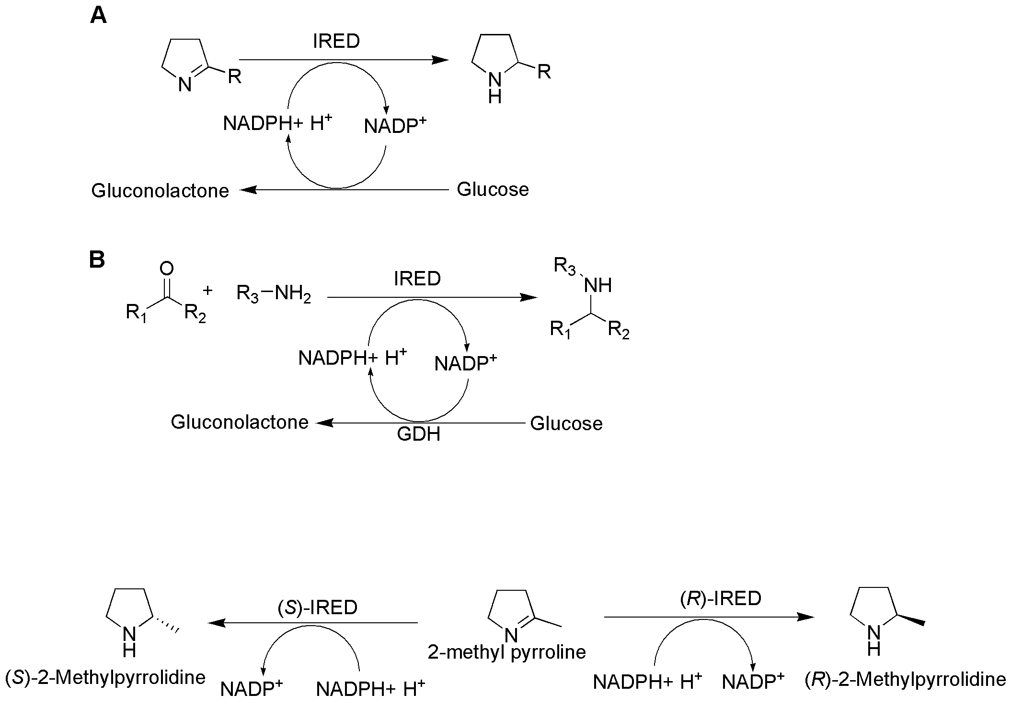
Figure 3. Asymmetric reduction of 2-methyl-1-pyrroline to 2-methylpyrorolidine by (S)- and (R)-IRED
Mitsukura et al. purified and characterized the (R)-selective IRED from Streptomyces sp. GF 3587 (R-IRED-Ss)⁴⁷ and the (S)-selective IRED from Streptomyces sp. GF 3546 (S-IRED-Ss).⁴⁸ Furthermore, Rodriguez-Mata et al. solved the crystal structure of the (R)-selective IRED from Streptomyces kanamyceticus (R-IRED-Sk) and its complex with the cofactor NADPH.⁴⁹ This structure was found to contain four monomers (A–D), arranged as two pairs of dimers (A–B and C–D). These studies demonstrated the potential of R-IRED-Sk in the reduction of cyclic imines, such as 2-methyl-1-pyrroline, 3,4-dihydroisoquinoline and 2-methyl-3,4-dihydroisoquinolin-2-ium triflate.
The synthetic gene approach, in combination with bioinformatic tools, can play an important role in discovering novel biocatalysts with desired functions. To further explore the scope of imine reductases, Scheller et al. established the ‘Imine Reductase Engineering Database’ with more than 350 protein entries.³⁷ Two novel (R)-type proteins [R-IRED-Sr and R-IRED-St; from Streptosporangium roseum and Streptomyces turgidiscabies, respectively], and one (S)-IRED from Paenibacillus elgii (S-IRED-Pe) from this database were characterized, and used in whole cell biocatalysis for the reduction of 2-methylpyrroline. Though the catalytic efficiencies of these (R)-IREDs were higher by over two orders of magnitude compared to that of the previously reported R-IRED-Sk, the efficiency of S-IRED-Pe was lower than that of S-IRED-Ss. Owing to the low catalytic efficiencies of these IREDs, the authors concluded that 2-methylpyrroline might not be a natural substrate for these IREDs. Similarly, the Grogan and Turner groups demonstrated that cyclic imines, such as 2-methylpyrroline, 3,4-dihydroisoquinoline and 2-methyl-3,4-dihydroisoquinolin-2-ium triflate were unnatural substrates for R-IRED-Sk.⁴⁹ Recently, Aleku et al.⁵⁰ have demonstrated the potential of an IRED from Amycolatopsis orientalis [S-IRED-Ao] for the reduction of 2-substituted pyrrolines, piperidines and azepines. S-IRED-Ao exhibited the formation of corresponding (S)-amine products from the cyclic imine substrates with excellent enantioselectivities. Similarly, Li et al. have demonstrated the efficiency of IRED from Paenibacillus lactis [S-IRED-Pl] for the enantioselective reduction of 3H-indoles as well as 3H-indole iodides, for the synthesis of chiral indolines with good stereospecificity.^{51,52}
Tetrahydroisoquinolines (THIQs) are known as important scaffolds in numerous biologically active molecules.⁵³ Though the synthesis of THIQs from their corresponding dihydroisoquinolines using imine reductases is a very attractive approach, it is limited by the strong steric hindrance imposed by the aryl substitution at C1, thereby affecting the enzyme activity.^{54,55} In this light, Zhu et al. recently screened 88 IREDs and found a group of hindrance-tolerant enzymes, which was then successfully employed for the reduction of methyl-, chloro-, and methoxy-substituted 1-phenyl-dihydroisoquinolines to generate the corresponding aryl-THIQs.⁵³ However, many of the reported IREDs exhibit substrate inhibition by higher quantities of dihydroisoquinoline substrates, and therefore a substrate feeding strategy needed to be applied to avoid possible substrate inhibition.⁵⁶ Nevertheless, the recently identified (S)-IRED from Stackebrandtia nassauensis (S-IRED-Sn) displayed high catalytic efficiency and enantioselectivity towards dihydroisoquinoline substituents.⁵⁷ This enzyme could completely reduce 100 mM of 1-methyl dihydroisoquinoline in only 4 h, but more importantly, without a substrate feeding strategy. Moreover, many of the bulky dihydroisoquinolines were efficiently converted to their corresponding THIQs with good yields (up to 81%), and moderate to excellent enantioselectivities (up to 99% ee).⁵⁷ The studies demonstrating the IRED-catalyzed reduction of cyclic imines are summarized in Table 1.

Table 1. Use of IREDs in the Reduction of Cyclic Imines
Entry | Imine substrate | Product |  | Genbank identifier |  | Source |  | Enzyme characteristics [K_{M} (mM); kcat/K_{M} (mM⁻¹min⁻¹)] |  | Conversion (%); ee (%)$ |  | Reference
1 |  |  |  |  | WP_015347361.1 |  | Myxococcus stipitatus |  | 1; 134 |  | >98; >98 (R) |  | 42
2 |  |  |  |  | WP_015347361.1ª |  | Myxococcus stipitatus |  | 12; 0.7 |  | 46; >98 (R) |  | 42
3 |  |  |  |  | WP_015347361.1 ^{b} |  | Myxococcus stipitatus |  | 6.8; 0.2 |  | 11; >98 (R) |  | 42
4 |  |  |  |  | WP_015347361.1 |  | Myxococcus stipitatus |  | 23; 0.2# |  | 14; >98 (R) |  | 42
5 |  |  |  |  | WP_015347361.1 ª |  | Myxococcus stipitatus |  | 9.8; 24# |  | >98; >98 (R) |  | 42
6 |  |  |  |  | WP_015347361.1 ^{b} |  | Myxococcus stipitatus |  | 11; 7.9# |  | 94; >98 (R) |  | 42
7 |  |  |  |  | BAM99301.1 |  | Streptomyces sp. GF 3546 |  | 7.15; N.D. |  | 100; 92.3 (S) |  | 46,47
8 |  |  |  |  | WP_107099103.1 |  | Streptomyces kanamyceticus |  | 8.21; 0.132 |  | 23; 99.6 (R) |  | 49
9 |  |  |  |  | WP_009330409 |  | Streptomyces ipomoeae 91-03 |  | N.D. |  | 99; 99 (R) |  | 65
10 |  |  |  |  | WP_010953707.1 |  | Pseudomonas putida |  | N.D. |  | 97; 99 (R) |  | 65
11 |  |  |  |  | YP_003336672.1 |  | Streptosporangium roseum sp. DSM 43021 |  | 1.085; 53.13 |  | 100; 98.3 (R) |  | 37
12 |  |  |  |  | WP_006374254.1 |  | Streptomyces turgidiscabies |  | 1.815; 14.729 |  | 100; 99 (R) |  | 37
13 |  |  |  |  | WP_010497949.1 |  | Paenibacillus elgii |  | 1.29; 1.224 |  | 96.8; 94.9 (S) |  | 37
14 |  |  |  |  | WP_008741284.1 |  | Streptomyces sp. Mg1 |  | N.D. |  | 70; 99 (S) |  | 56
15 |  |  |  |  | WP_003931250.1 |  | Mycobacterium vaccae |  | N.D. |  | 99; 98 (S) |  | 56
16 |  |  |  |  | BAM99302.1 |  | Streptomyces sp. GF3587 |  | 1.88; 11.22 |  | >98; >98 (R) |  | 54
17 |  |  |  |  | WP_016644884 |  | Streptomyces aurantiacus |  | N.D. |  | >95; 99 (S) |  | 73
18 |  |  |  |  | YP_008010673 |  | Amycolatopsis orientalis |  | 0.72; 61.8 |  | 100; 81 (S) |  | 50
19 |  |  |  |  | WP_009737838.1 |  | Frankia sp. QA3 |  | N.D. |  | 98; 99 (R) |  | 56
20 |  |  |  |  | WP_003931250.1 |  | Mycobacterium vaccae |  | N.D. |  | 93; 97 (S) |  | 56
21 |  |  |  |  | BAM99301.1 |  | Streptomyces sp. GF3546 |  | 1.05; 2.28 |  | >98; 98 (S) |  | 45
22 |  |  |  |  | WP_013019548.1 |  | Stackebrandtia nassauensis |  | 0.056; 3240 |  | >99; >99 (S) |  | 57
23 |  |  |  |  | BAM99301.1 |  | Streptomyces sp. GF 3546 |  | N.D. |  | 92; >98 (S) |  | 45
24 |  |  |  |  | WP_009737838.1 |  | Frankia sp. QA3 |  | N.D. |  | 99; 98 (R) |  | 56
25 |  |  |  |  | WP_013733165.1 |  | Verrucosispora maris |  | N.D. |  | 97; 88 (R) |  | 56
26 |  |  |  |  | WP_026403156.1 |  | Actinomadura rifamycini |  | N.D. |  | 96; 17 (S) |  | 56
27 |  |  |  |  | WP_015611605.1 |  | Streptomyces fulvissimus |  | N.D. |  | 60; 69 (S) |  | 56
28 |  |  |  | BAM99301.1 |  | Streptomyces sp. GF 3546 |  | N.D. |  | 34; 27 (R) |  | 48
29 |  |  |  |  | BAM99301.1 |  | Streptomyces sp. GF3546 |  | 0.63; 42.48 |  | >98; N.A. |  | 45
30 |  |  |  |  | WP_107099103.1 |  | Streptomyces kanamyceticus |  | 1.16; 0.0444 |  | N.D; N.A. |  | 49
31 |  |  |  |  | WP_107099103.1 |  | Streptomyces. kanamyceticus |  | 0.724; 0.312 |  | N.D; N.A. |  | 49
32 |  |  |  |  | YP_008010673 |  | Amycolatopsis orientalis |  | 0.96; 48 |  | 90; N.A. |  | 50
33 |  |  |  |  | BAM99301.1 |  | Streptomyces sp. GF3546 |  | 0.60; 48.06 |  | >90; N.A. |  | 45
34 |  |  |  |  | WP_009330409 |  | Streptomyces ipomoeae |  | N.D. |  | 57; 99 (R) |  | 65
35 |  |  |  |  | WP_010953707.1 |  | Pseudomonas putida |  | N.D. |  | 72; 99 (R) |  | 65
36 |  |  |  |  | WP_010497949.1 |  | Paenibacillus elgii |  | N.D. |  | 68; 99 (R) |  | 65
37 |  |  |  |  | YP_008010673 |  | Amycolatopsis orientalis |  | 0.65; 31.8 |  | >99; 98 (S) |  | 65
38 |  |  |  |  | WP_018958796.1 |  | Streptomyces sp. CNB091 |  | N.D. |  | 99; 81 (R) |  | 56
39 |  |  |  |  | WP_008741284.1 |  | Streptomyces sp. Mg1 |  | N.D. |  | 99; 98 (S) |  | 56
40 |  |  |  |  | WP_015611605.1 |  | Streptomyces fulvissimus |  | N.D. |  | 9; 99 (S) |  | 56
41 |  |  |  |  | BAM99302.1 |  | Streptomyces sp. GF3587 |  | 0.371; 684 |  | >98; >98 (R) |  | 54
42 |  |  |  | YP_008010673 |  | Amycolatopsis orientalis |  | 0.22; 22.8 |  | >99; 40 (S) |  | 50
43 |  |  |  | YP_008010673 |  | Amycolatopsis orientalis |  | 0.51; 16.2 |  | >99; 60 (R) |  | 50
44 |  |  |  |  | WP_012921542.1 |  | Kribbella flavida sp. DSM 17836 |  | N.D. |  | 91; 97 (S) |  | 56
45 |  |  |  |  | YP_005263141.1 |  | Nocardia cyriacigeorgica GUH-2 |  | N.D. |  | 90; 96 (R) |  | 56
46 |  |  |  |  | WP_008741284.1 |  | Streptomyces sp. Mg1 |  | N.D. |  | 94; 99 (S) |  | 56
47 |  |  |  |  | BAM99302.1 |  | Streptomyces sp. GF3587 |  | 5.22; 41.88 |  | >98; >98 (R) |  | 54
48 |  |  |  |  | MF540777 |  | Actinomadura madurae |  | 0.026; 3554 |  | 100; 96 (R) |  | 53
49 |  |  |  |  | MF540792 |  | Frankia sp. EAN1pec |  | 0.19; 163.8 |  | 99; >99 (R) |  | 53
50 |  |  |  |  | MF540819 |  | Streptomyces aurantiacus |  | 0.17; 112.8 |  | 99; >99 (S) |  | 53
51 |  |  |  |  | MF540777 |  | Actinomadura madurae |  | 0.024; 23925 |  | 100; 99 (R) |  | 53
52 |  |  |  |  | MF540792 |  | Frankia sp. EAN1pec |  | 0.019; 6600 |  | 99; >99 (R) |  | 53
53 |  |  |  |  | MF540819 |  | Streptomyces aurantiacus |  | 0.031; 79.2 |  | 99; 91 (S) |  | 53
54 |  |  |  |  | MF540777 |  | Actinomadura madurae |  | 0.029; 3186 |  | 100; >99 (R) |  | 53
55 |  |  |  |  | MF540792 |  | Frankia sp. EAN1pec |  | 0.12; 354.6 |  | 99; >99 (R) |  | 53
56 |  |  |  |  | MF540819 |  | Streptomyces aurantiacus |  | 0.034; 18.6 |  | 99; >99 (S) |  | 53
57 |  |  |  |  | BAM99301.1 |  | Streptomyces sp. GF3546 |  | N.D. |  | >95; 98 (S) |  | 73
58 |  |  |  |  | MF540819 |  | Streptomyces aurantiacus |  | N.D. |  | >91; 99 (S) |  | 73
59 |  |  |  | BAM99302.1 |  | Streptomyces sp. GF3587 |  | N.D. |  | >98; 8 (S) |  | 54
60 |  |  |  | BAM99302.1 |  | Streptomyces sp. GF3587 |  | N.D. |  | 20; >98 (S) |  | 54
61 |  |  |  | BAM99302.1 |  | Streptomyces sp. GF3587 |  | N.D. |  | 86; 26 (S) |  | 54
62 |  |  |  | BAM99302.1 |  | Streptomyces sp. GF3587 |  | N.D. |  | >98; 66 (S) |  | 54
63 |  |  |  | BAM99302.1 |  | Streptomyces sp. GF3587 |  | 1.05; 15 |  | >98; >98 (S) |  | 54
64 |  |  |  | WP_013019548.1 |  | Stackebrandtia nassauensis |  | N.D. |  | >99; >99 (S) |  | 57
65 |  |  |  | MF540833 |  | Paenibacillus lactis |  | 0.48; 1404 |  | 75; 99 (S) |  | 52
$Absolute configuration of the product is mentioned in parenthesis
ª mutant N32E/R33Y/T34E/K37R/L67I/T71V
^{b} mutant N32E/R33Y/T34E/K37A/L67I/T71V
# NADH was used as cofactor
N.D. -Not determined
N.A.- Not applicable

Until recently, transition-metal-mediated homogenous catalysis and organo-catalytic methods were the main chemical strategies for the enantioselective reductions.^{37,58-62} However, the application of expensive and toxic metals and the requirement of several deprotection steps are the major challenges faced by chemical methods.^{63,64} Also, chemically catalyzed imine hydrogenation methods require the starting ketone to react with the activated groups of nitrogen sources.⁶⁵
IRED-mediated approaches have provided a proficient alternative for the preparation of chiral amine intermediates.^{37,63,66} However, the stereospecific reduction of imine to the corresponding amines by IREDs was confined to the few naturally occurring imines such as dihydrofolate and D-1-pyrroline-2-carboxylate.^{67,68} The major issue related to the reduction of imines is their rapid degradation to aldehyde or ketone and ammonia and amines.⁴⁶ It is worth emphasizing that the recent advances achieved for the identification, purification, and characterization of novel IREDs from various microbial sources^{57,69,70} permit the biocatalytic synthesis of chiral amines from preformed imine substrates.

  - Reductive amination of carbonyl compounds with amine nucleophiles
One of the most stunning discoveries of recent years in imine reduction reactions is the exploration of reductive aminases. Reductive aminases, a subclass of imine reductases, functionally differ from imine reductases in that later enzymes catalyze only the reduction of pre-formed cyclic imines. On the other hand, reductive aminases catalyze the reductive amination between carbonyl substrates and amine nucleophiles in addition to the reduction of pre-formed cyclic imines.⁷¹ As amines are derived from a diverse range of metabolic pathways, very few enzymes were explored until recently for their potential for direct reductive amination of ketone substrates to their amine counterparts. The important potential of the utility of this method lies in the in-situ production of the imine, thereby omitting the need for the chemical synthesis of a substrate prior to the reduction step.⁵⁶ The selective reduction of imines, which are formed during the condensation of amine and ketone in an aqueous environment, is feasible due to the excellent enantioselectivity of IREDs towards imines and not towards the excess ketone present.⁷²
Huber et al. in 2014 demonstrated the first direct reductive amination potential of two native enzymes, from Streptomyces sp. GF 3546 (S-IRED-Ss) and Streptomyces aurantiacus (S-IRED-Sa).⁷³ Furthermore, these enzymes were crystallized, and their three-dimensional structures were solved by the molecular replacement method. These studies further proposed the catalytic mechanism for the binding of the cofactor NADPH and subsequent catalysis performed by IREDs [Explained in the later Section]. Scheller and group have demonstrated the enzyme-mediated reductive amination of various aldehydes and ketone substrates with different amine nucleophiles.⁷⁴ It has been reported that increasing the nucleophilicity of the amines can significantly affect the production of amination products by favoring the equilibrium of the reaction intermediate towards imine formation. Therefore, in these cases, the higher generation of imines in solution leads to the higher interaction of the enzyme molecules with their substrate.
Aromatic unsaturated ketones are known as challenging substrates for various IREDs. Nevertheless, R-IRED-Sr successfully converted unsaturated ketones, such as 1-cyclohexylethanone and the aromatic acetophenone to their corresponding amination products.⁷⁴ Recently, France et al. have investigated the biocatalytic potential of 45 IREDs for the reductive amination of stoichiometric ratios of ketones and amine substrates.³⁹ Moreover, IRED from Rhizobium sullae (S-IRED-Rs) also afforded high conversion with the N-protected pyrrolidinone and secondary amine pyrrolidine substrates, which were previously reported as challenging substrates for reductive amination by IREDs. A notable difference between the studies by Huber et al.⁷³ and France et al.³⁹ was the ratio of ketone:amine substrates. While France et al. could demonstrate the reductive amination at very low amine:ketone ratio (2.5:1), significantly higher amount of amine partner was used in the studies by Huber et al.⁷³ [Table 2].
Ketone reduction to alcohol has also been reported as a promiscuous behavior of IREDs. It has been principally established that depending on the substrate and the reaction conditions, IRED-mediated reduction of ketones to alcohols is catalytically achievable.⁷⁰ Lenz et al. have recently demonstrated the electronic effects of substituents on IRED-mediated asymmetric hydrogenation of 2,2,2-trifluoroacetophenone, benzoyl cyanide, and acetophenone as substrates.⁷⁵ However, R-IRED-Sr could transform only trifluoroacetophenone substrate to its corresponding alcohol with 57.4 % conversion and excellent enantioselectivity (ee 96%) [Figure 4]. No product was detected for benzoyl cyanide, and acetophenone substrates.
No product formation was detected with 1b or 1c as
substrate
No product formation was detected with 1b or 1c as
substrate
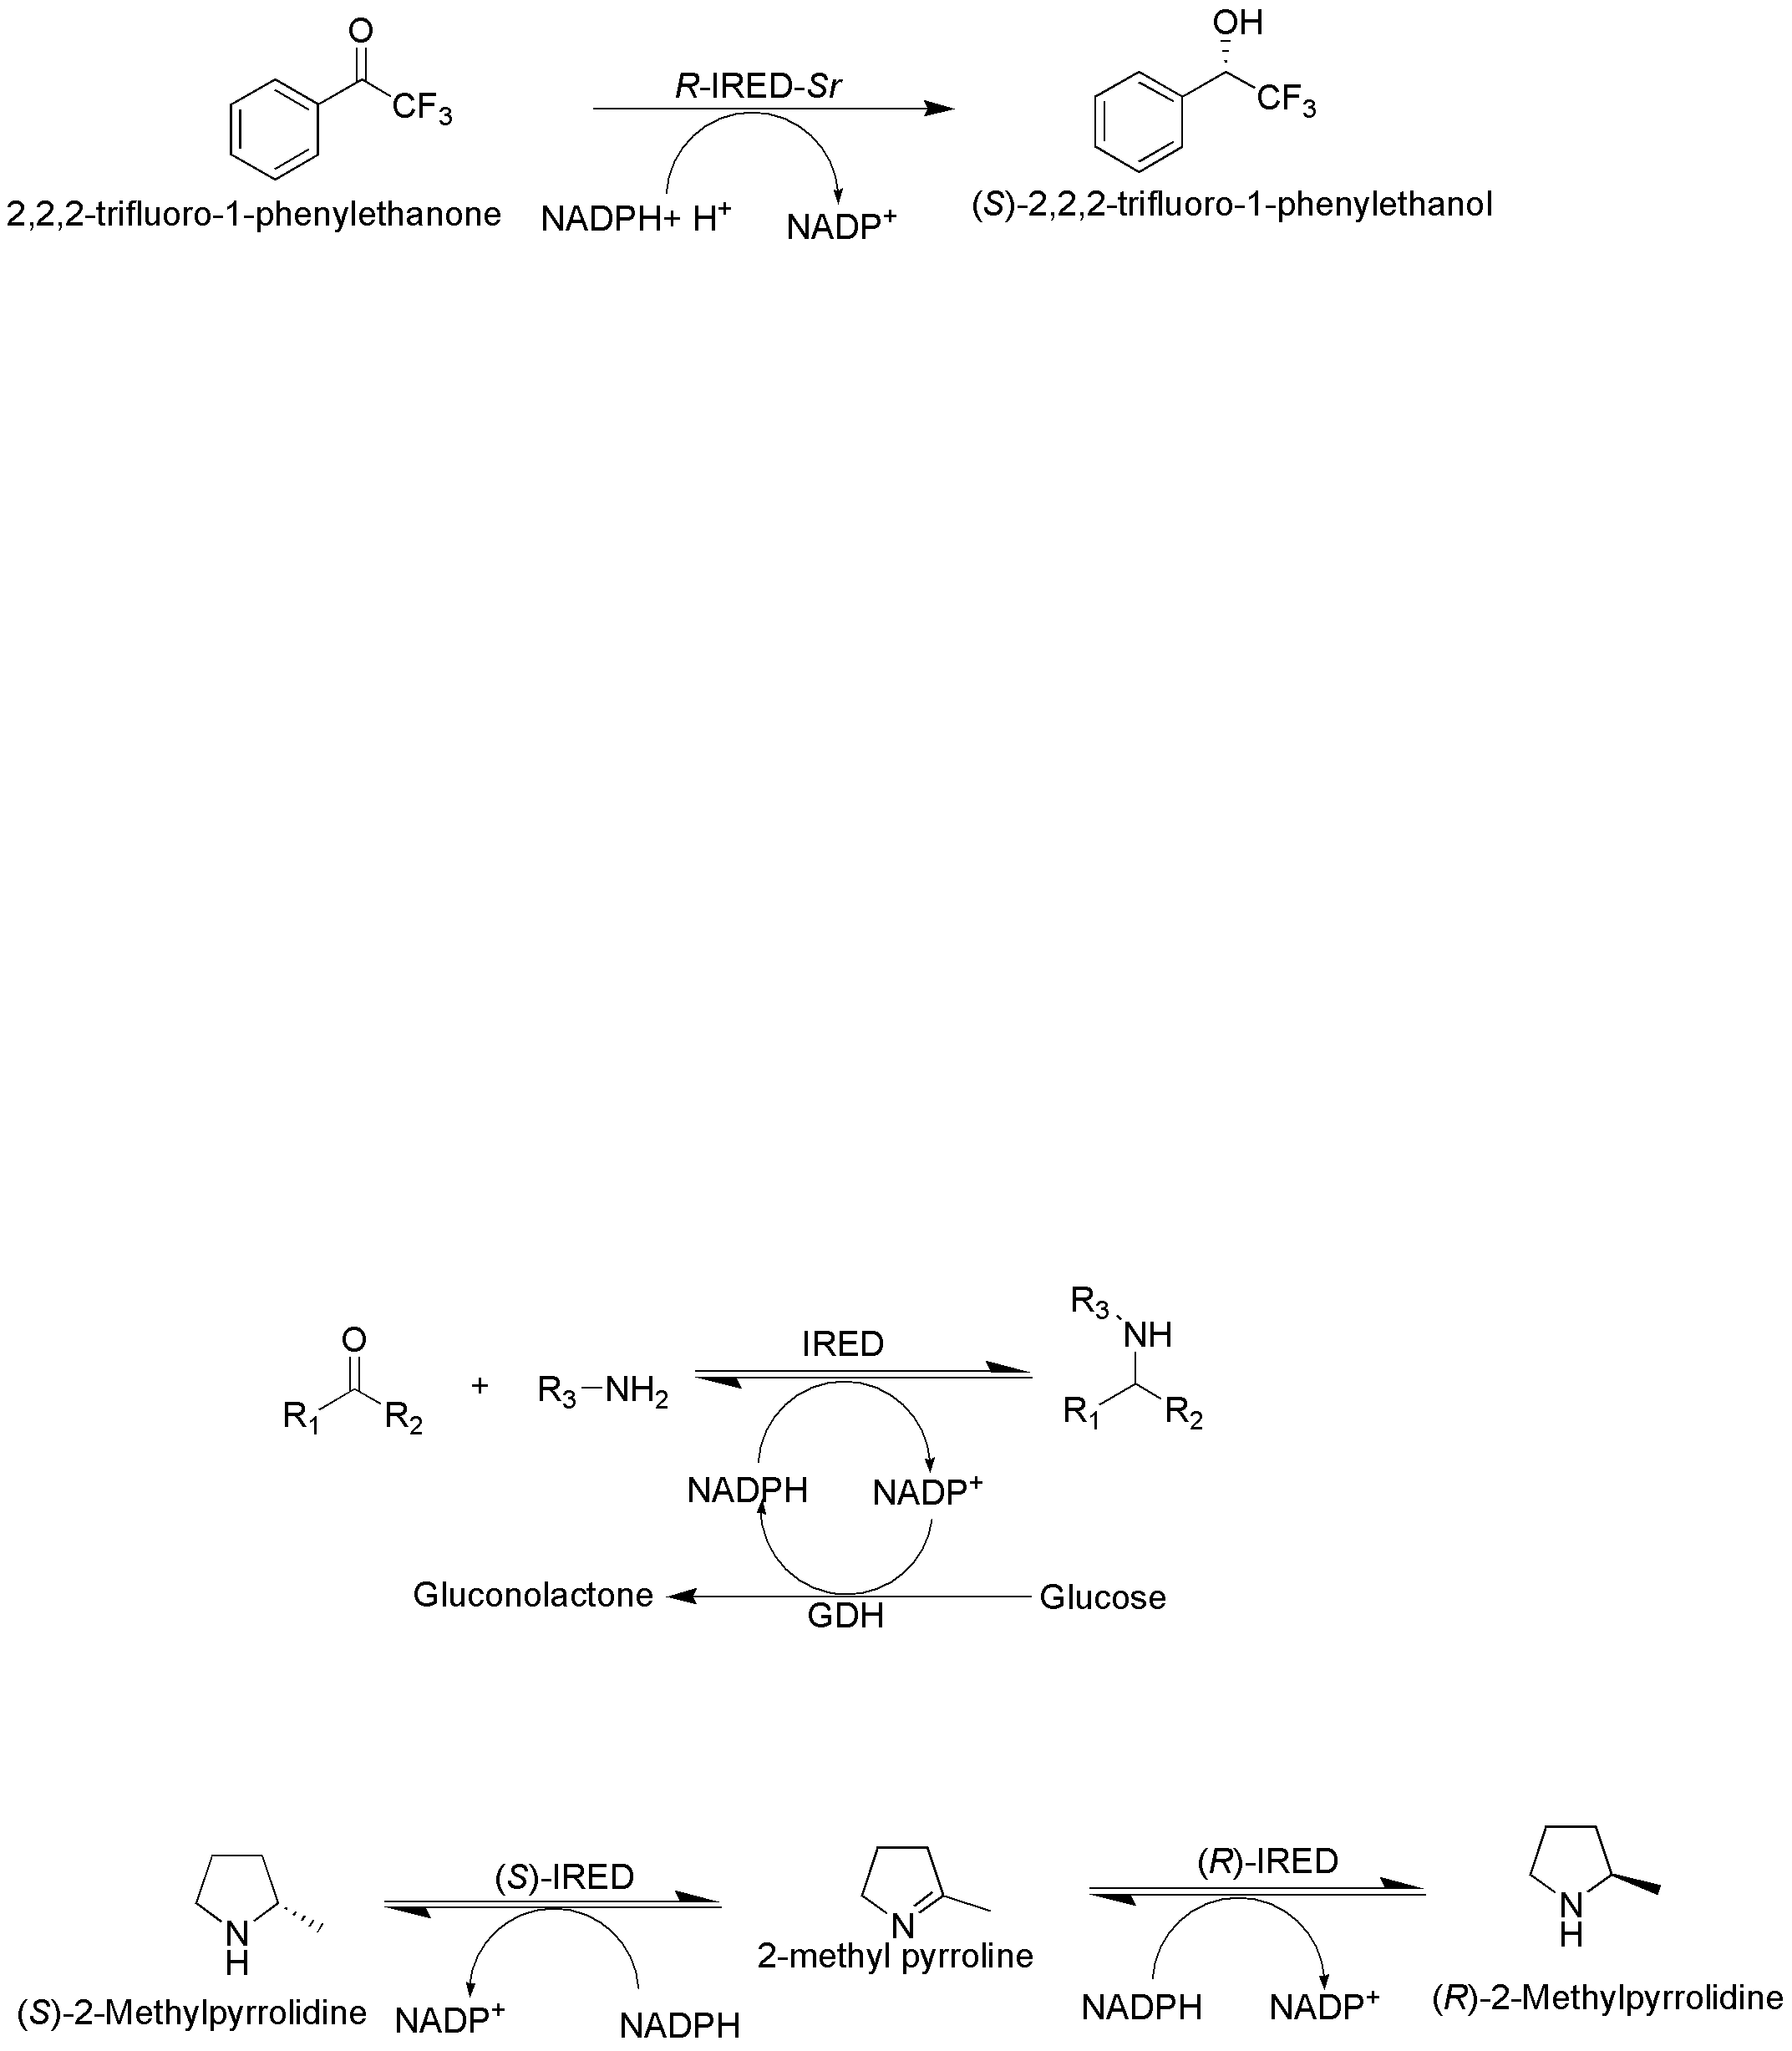
Figure 4. IRED-mediated asymmetric hydrogenation of 2,2,2-trifluoroacetophenone to the corresponding alcohol.⁷⁵
These studies utilized the approach of calculating energy barriers for the hydride transfer from the nicotinamide subunit to various substrates. It has been reported that ammonium salts undergo faster reduction compared to their imine counterparts.^{52,54} Lenz and group have also reported that energy barriers for selected ketones are higher than for iminium ions, but lower than for imine compounds.⁷⁵
Table 2. Imine Reductase-mediated Reductive Amination Between Ketone Substrates and Amine Nucleophiles
Entry No. | Carbonyl substrate | Amine nucleophile | Genbank identifier | Source | Amine:ketone ratio | Conversion (%); ee (%)$ | Reference
1 |  |  | WP_023809753.1 | Mesorhizobium sp. L2C084A000 | 2.5:1 | 45; >98 (S) | 39
2 |  |  | WP_026324618.1 | Salinispora pacifica | 2.5:1 | 19; >78 (S) | 39
3 |  |  | WP_027512056.1 | Rhizobium sullae | 2.5:1 | 41; >98 (S) | 39
4 |  |  | WP_029347354.1 | Mesorhizobium ciceri | 2.5:1 | 46; >98 (S) | 39
5 |  |  | WP_034788492.1 | Ensifer sp. | 2.5:1 | 43; >98 (S) | 39
6 |  |  | AKU97888.1 | Labilithrix luteola | 2.5:1 | 43; >98 (S) | 39
7 |  |  | WP_053252429.1 | Ensifera dhaerens | 2.5:1 | 43; >98 (S) | 39
8 |  |  | WP_013733165.1 | Verrucosispora maris | 12.5:1 | 63; 76 (R) | 80
9 |  |  | WP_006347397.1 | Streptomyces tsukubaensis | 12.5:1 | 88; 96 (R) | 80
10 |  |  | WP_025846174.1 | Paenibacillus himensis | 12.5:1 | 88; 84 (R) | 80
11 |  | NH₃ | WP_006347397.1 | Streptomyces tsukubaensis | 12.5:1 | 40; 23 (R) | 80
12 |  |  | WP_023809753.1 | Mesorhizobium sp. L2C084A000 | 50:1 | 99; >98 (S) | 39
13 |  |  | WP_026324618.1 | Salinispora pacifica | 50:1 | 99; 26 (R) | 39
14 |  |  | WP_027512056.1 | Rhizobium sullae | 50:1 | 99; >98 (S) | 39
15 |  |  | WP_029347354.1 | Mesorhizobium ciceri | 50:1 | 99; >98 (S) | 39
16 |  |  | WP_037099331.1 | Rhizobium sp. OK665 | 50:1 | 56; >98 (S) | 39
17 |  |  | WP_038576230.1 | Ensifer adhaerens | 50:1 | 99; >98 (S) | 39
18 |  |  | WP_012921542.1 | Kribbella flavida | 50:1 | 30; 76 (S) | 39
19 |  |  | BAM99301.1 | Streptomyces sp. GF3546 | 12.5:1 | 8.8; N.D. (N.D.) | 73
20 |  |  | WP_016644884 | S. aurantiacus | 12.5:1 | 1.7; N.D. (N.D.) | 73
21 |  |  | XP_001827659 ª | Aspergillus oryzae | 20:1 | >97; >97 (R) | 71
22 |  |  | XP_001827659 ^{b} | Aspergillus oryzae | 20:1 | >97; 94 (S) | 71
23 |  |  | XP_001827659 ª | Aspergillus oryzae | 20:1 | 97; >98 (R) | 71
24 |  |  | WP_023809753.1 | Mesorhizobium sp. L2C084A000 | 50:1 | 19; >98 (S) | 39
25 |  |  | WP_026165099.1 | Streptomyces sp. CNS615 | 50:1 | 53; >98 (R) | 39
26 |  |  | WP_027512056.1 | Rhizobium sullae | 50:1 | 22; >98 (S) | 39
27 |  |  | WP_030930447.1 | Streptomyces violaceoruber | 50:1 | 44; >98 (R) | 39
28 |  |  | WP_034788492.1 | Ensifer sp. | 50:1 | >99; >98 (S) | 39
29 |  |  | WP_036267253.1 | Mesorhizobium ciceri sp. | 50:1 | 51; >98 (S) | 39
30 |  |  | WP_048649179.1 | Nitratireductor soli | 50:1 | 50; 51 (S) | 39
31 |  |  | WP_051300844.1 | Actinomadura sp. | 50:1 | 10; >98 (S) | 39
32 |  |  | WP_051455530.1 | Microvirga lupini | 50:1 | 10; >98 (S) | 39
33 |  |  | WP_012921542.1 | Kribbella flavida | 50:1 | 74; >98 (S) | 39
34 |  |  | XP_001827659 ª | Aspergillus oryzae | 20:1 | >97; >97 (R) | 71
35 |  |  | WP_026324618.1 | Salinispora pacifica | 50:1 | 58; 89 (S) | 39
36 |  |  | WP_027512056.1 | Rhizobium sullae | 50:1 | 89; >96 (S) | 39
37 |  |  | BAM99301.1 | Streptomyces sp. GF3546 | 12.5:1 | 0.1; N.D. (N.D.) | 73
38 |  |  | WP_016644884 | S. aurantiacus | 12.5:1 | 2.3; N.D. (N.D.) | 73
39 |  | NH₃ | YP_003336672.1 | Streptosporangium roseum | 10:1 | 51; N.D. (R) | 74
40 |  |  |  |  | 50:1 | 61; N.D. (R) | 74
41 |  |  | YP_003336672.1 | Streptosporangium roseum | 10:1 | 72; N.D. (R) | 74
42 |  |  |  |  | 50:1 | 73; N.D. (R) | 74
43 |  | NH₃ | YP_003336672.1 | Streptosporangium roseum | 50:1 | 16; 97 (R) | 74
44 |  | NH₃ | WP_023264430.1 | Cupriavidus sp. HPC (L) | 12.5:1 | 10; 98 (S) | 80
45 |  |  | YP_003336672.1 | Streptosporangium roseum | 50:1 | 39; 87 (R) | 74
46 |  | NH₃ | YP_003336672.1 | Streptosporangium roseum | 50:1 | 53; 78 (R) | 74
47 |  |  | WP_008741284.1 | Streptomyces sp. Mg1 | 12.5:1 | 39; 78 (S) | 80
48 |  |  | WP_012921542.1 | Kribbella flavida sp. DSM 17836 | 12.5:1 | 41; 67 (S) | 80
49 |  |  | WP_011731218.1 | Mycobacterium smegmatis | 12.5:1 | 85; 96 (S) | 80
50 |  |  | WP_013733165.1 | Verrucosispora maris | 12.5:1 | 94; 98 (S) | 80
51 |  |  | WP_025846174.1 | Paenibacillus himensis | 12.5:1 | 35; 58 (R) | 80
52 |  | NH₃ | WP_008741284.1 | Streptomyces sp. Mg1 | 12.5:1 | 15; 80 (S) | 80
53 |  | NH₃ | WP_016644884 | Streptomyces aurantiacus | 12.5:1 | 30; 98 (S) | 80
54 |  | NH₃ | WP_011731218.1 | Mycobacterium smegmatis | 12.5:1 | 62; 99 (S) | 80
55 |  | NH₃ | WP_013733165.1 | Verrucosispora maris | 12.5:1 | 14; 94 (S) | 80
56 |  |  | WP_009330409.1 | Streptomyces ipomoeae | 40:1 | 81; 90 (R) | 72
57 |  |  | XP_001827659 ª | Aspergillus oryzae | 50:1 | >97; >98 (R) | 71
58 |  |  | F2TIQ4 | Ajellomyces dermatitidis | 1.1:1 | 62; 98 (R) | 76
59 |  |  | WP_014059042.1 | Streptomyces sp. PRh5. | 1.1:1 | 47; 95 (R) | 76
60 |  |  | XP_001827659 | Aspergillus oryzae | 1.1:1 | 40; 99 (R) | 76
61 |  |  | WP_004000144.1 | Streptomyces viridochromogenes | 1.1:1 | 15; 99 (S) | 76

$Absolute configuration of the product is mentioned in parenthesis
N.D.- Not determined
ª mutant Q240A
^{b} mutant W210A

More recently, Roiban et al. from GlaxoSmithKline have reported the use of 96 various IREDs, operating at 1:1 stoichiometry for a variety of amines and carbonyls.^{37,76} These studies exhibited the extended scope of substrates for the IREDs, as high conversion rates were reported for various IREDs towards the combination of arylamines and cyclohexanone and for aniline either with phenylacetaldehyde or acetaldehyde. In these studies, among the large number of screened IREDs, two IREDs catalyzed the formation of tertiary amines using equimolar quantities of the reactants. These pioneering findings established the fact that tertiary amine synthesis can be achieved using IRED-catalyzed biotransformations. A further successful example of the acceptance of secondary amine as a nucleophile by IREDs and the synthesis of the corresponding tertiary amine was achieved by Matzel et al.⁷² This group demonstrated an interesting one-step synthesis alternative to multistep synthesis [Figure 5A] which relies on the preparation of enantiopure precursors for the synthesis of important pharmaceuticals, such as Rasagiline⁷⁷ [Figure 5B], Selegiline, and Pramipexole, used for the treatment of Parkinson’s disease.⁷² However, the ratio of amine nucleophile:ketone substrates used in these studies was very high i.e. 40:1 and 50: 1 for the small and preparative scale reactions, respectively.

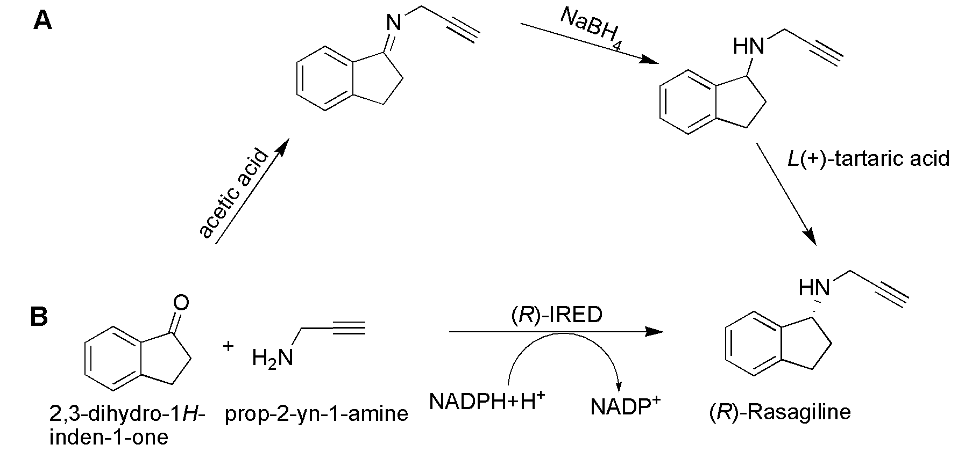
Figure 5. Rasagiline synthesis by A) Traditional multistep synthesis; and B) One-step synthesis by IRED.^{72,77}
There has been increasing use of IREDs in recent years for the reduction of numerous cyclic imines and the reductive amination of carbonyl substrates. However, IRED-mediated catalysis still suffers various challenges such as a low activity of available enzymes, thus requiring large enzyme loads.⁴⁷ Also, many of the enzymes have exhibited limited substrate specificity, and the ‘true’ natural substrates are still largely unidentified.^{49,65} The specific activities and enantioselectivities of the reported IREDs vary widely^{28,72,78} [Table 2]. Moreover, one of the major problems associated with IRED-mediated catalysis is their exclusive dependence on NADPH.⁶⁵ Accordingly, the product formation in biocatalytic reactions employing NADH is many times lower than that in reactions using NADPH as a cofactor.⁷⁵ An accessibility of cofactor regeneration enzymes for NADH is inadequate in contrast to that of NADPH. Overall, the biocatalytic approaches that employ imine reductases as prospective enzymes for stereospecific conversion of cyclic imine and ketone substrates to corresponding amines clearly warrant further evaluation to overcome these challenges.

2.3 Enzyme structure, catalytic mechanism and protein engineering aspects for IRED-mediated amine synthesis
The development of bioinformatics and molecular biology tools has been shown to be useful for finding the structural and molecular insights in IRED-mediated reactions. The early findings by Scheller and coworkers identified the catalytically important amino acids by systematically comparing the conserved amino acid residues of various (R)- and (S)-IREDs.³⁷ Among the amino acid residues conserved at 53 different positions across all IREDs, aspartic acid and tyrosine have been reported to be highly conserved in the superfamilies of (R)- and (S)-IREDs, respectively.^{37,49} These findings were further supported by the presence of tyrosine at 187th position in (S)-selective IREDs from Streptomyces,⁷³ Bacillus, and Nocardiopsis.⁷⁹ However, in recent studies with the ternary complex of S-IRED-Ao, NADPH and a substrate molecule, mutation of Asn 171 (corresponding to Asp and Tyr residues of previously reported IREDs) did not improve the activity, implicating that certain IREDs possess the ability to catalyze the imine reduction in the absence of the protic residues.⁵⁰ Furthermore, Scheller et al. observed the diminished conversion rates catalyzed by R-IRED-Sr and R-IRED-St following the mutation of Asp to Ala. Nevertheless, the retention of some catalytic activity suggested the presence of other proton-donating amino acids in the active site of (R)-IREDs or the coordinating function of Asp187 with water as a proton donor. Notably, the loss of activity following the mutation of Tyr187 in (S)-IRED, (equivalent to Asp187 in (R)-IREDs) also implied that the conserved tyrosine serves as a proton donor in (S)-specific IRED.³⁷
The X-ray crystal structure of R-IRED-Sk was solved by Rodríguez Mata et al.⁴⁹ This enzyme was shown to consist of an intimate dimer, each monomer of which contained a two-domain structure: C-terminal bundle and N-terminal Rossman fold.⁴⁹ A long helix connects these domains in each monomer. A residue Asp187 protrudes into the active site, and the distance of its side chain from the C4 atom of the nicotinamide ring of NADPH, which delivers and accepts hydride, is approximately 8 Å.⁵⁰ The mutational studies carried out to further gain structural insights demonstrated that the replacement of Asp187 with asparagine or alanine resulted in the inactive enzyme. Consequently, the imine reduction reaction has been proposed to be initiated by the protonation of the imine to iminium ion by a catalytic Asp residue.⁴⁹ This is followed by the stabilization and subsequent reduction of iminium ion by hydride transfer from NADPH.
The catalytic mechanism for the binding of NADPH and subsequent reduction of imine substrates was further studied by Huber et al. who determined the crystal structures of S-IRED-Ss in complex with the cofactor NADPH and S-IRED-Sa in a native form.⁷³ The binding of the Si-face of the cofactor NADPH to these IREDs faces the active site cleft, suggesting a sequential mechanism in which binding of NADPH causes conformational changes and subsequently binding of substrate occurs for the catalysis. Furthermore, it was reported that the catalytic cleft remaining after the binding of NADPH was still spacious, suggesting the potential of site-directed mutagenesis for the application of extended substrate scope of imine reductase-mediated biocatalysis. Also, the C-terminal of the IREDs and not the N-terminal domain, to which NADPH co-factor binds, has been proposed to more significantly influence the substrate specificities and enantioselectivity of these enzymes.⁵⁶ To gain deeper insights, Wetzl et al. built a Hidden Markov model (HMM) of reported IREDs to identify the important positions that control the stereochemistry of the IRED-mediated biocatalytic reaction.⁵⁶ Similarly, the comparison of the amino acid sequence of S-IRED-Ss with oxidoreductases and imine-reducing enzymes from various microbial sources suggested the likely location of amino acid residues responsible for substrate specificity might be in the domain from the central to the C-terminal.
The higher homology of IREDs with dehydrogenases suggests that IREDs might be able to exhibit promiscuous activity.⁴⁸ The recent studies carried out by Aleku et al.^{50,71} reported that even smaller changes in the structure of substrate 2-phenylpiperidine derivatives cause dramatic changes in the enantioselectivity of the products, suggesting the alternative binding site or mode for varying substrates. Moreover, IRED-mediated catalysis prefers anilines with electron-donating substituents over that of electron-withdrawing substituents as substrates. The preferential utilization of these substrates by IREDs suggests that the nucleophilicity of the amine and imine formation might thereby be contributing as a rate-determining step in the imine reductase-catalyzed biotransformations.^{76,80} Furthermore, Aleku et al. demonstrated that the movement of the tyrosine loop in the N-terminal domain and the relative closeness of the two participatory domains of the active site in IRED-Ao reduce the volume of the active site pocket in such a manner that exerts a control over the exhibition of the prochiral face of the imine presented to the hydride.^{50,71}
To date, more than 1000 putative IREDs have been reported in the imine reductase engineering database^{37,81,82} and crystal structures for seven IREDs have been solved.^{50,65,73,79,81} However, the exclusive dependence of IREDs on NADPH, rather than on NADH, limits their industrial use.⁸² As NADH is much cheaper than its phosphorylated counterpart, the protein engineering approach has been attributed as a method of choice to tackle this important challenge of altering the cofactor specificity of IREDs.²⁹ The charge and polarity of the binding pocket of the enzyme dictate its specificity towards NADH/NADPH.⁸³ Recently, the rational design approach has been demonstrated to generate a single mutant variant (K40A) of R-IRED-Ss with a 3-fold increased activity for NADH.⁸¹ More recently, the specificity of the R-selective IRED from Myxococcus stipiatus (R-IRED-Ms) towards cofactors was altered using the semi-rational structure-guided approach of ‘Cofactor Specificity Reversal-Structural Analysis and Library Design’ (CSR-SALAD).^{42,83} CSR-SALAD includes the simultaneous mutagenesis of phosphate coordinating residues, which are determinants of the cofactor specificity. In the case of R-IRED-Ms, Borlinghaus et al.⁴² identified seven positions for mutations based on its identity with R-IRED-Sk. In the first round of mutagenesis, the double variant, R33Y/T34E (termed as V1), with improved specificity towards NADH was identified from the mutant library generated by changing phosphate coordinating residues. Further rounds of mutagenesis, performed using V1 as a template, generated V8 mutant (N32E/R33Y/T34E/K37R/L67I/T71V) exhibiting 47-fold increased NADH activity and a 900-times improved specificity compared to that of wild-type. The replacement of arginine to alanine at position 37 resulted in improved variant (V10; N32E/R33Y/T34E/K37A/L67I/T71V) with 2900-times higher specificity compared to wild-type, albeit with reduced activity with NADH.⁴²
Accumulating pieces of evidence suggest that the enantioselectivity of the products in a biocatalytic process is complex and the prediction of selectivity needs to be studied on a case-by-case basis.⁵⁰ Though significant progress has been made to understand the IRED-catalyzed reactions, their exact molecular mechanism is still elusive. Moreover, the enantioselectivity and the natural preference of imine reductase towards specific substrates is a complex phenomenon.⁵² The recently explored IREDs tolerant to steric hindrance open a new window for the biocatalytic transformation of sterically hindered substrates, and the possible application of hindrance-tolerant IREDs with protein engineering.^{50,84}

- Amine dehydrogenases (AmDHs)
Amine dehydrogenases (AmDHs) catalyze the NAD(P)H-dependent asymmetric reductive amination of aldehyde and ketone substrates using ammonia as an amine donor [Figure 6]. Owing to their high atom efficiency and enantioselectivity, AmDH-mediated synthesis of chiral amines is very attractive and a potential biosynthetic approach. Also, the amine donor used. i.e ammonia is a cheaper substrate and only water is formed as a byproduct of AmDH-catalyzed reductive amination reactions.⁸⁵
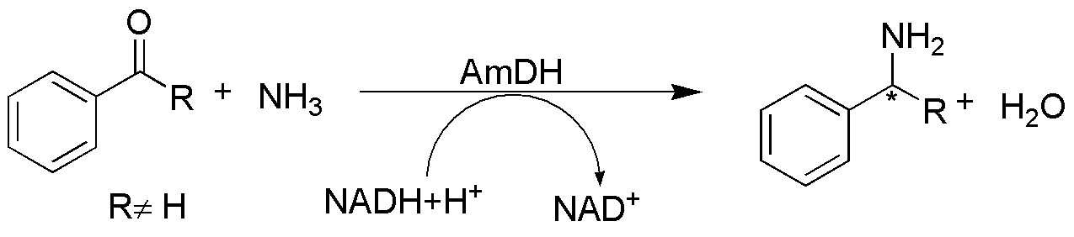
Figure 6. AmDH-mediated synthesis of chiral amines
Owing to electrophilic nature of C=N double bonds, imines and iminium ions are very susceptible to attack by various nucleophiles.⁴⁴ Consequently, most imines are unstable in the aqueous environment and biological systems. As many of the primary and secondary metabolic pathways involve reduction of imines as a constituent reaction, enzymes involved in these pathways such as amino acid dehydrogenases (AADHs) are ubiquitous in nature.⁴⁴ However, AmDHs are rare in nature. AADHs such as alanine dehydrogenase and leucine dehydrogenase catalyze reductive amination reactions however, only with 2-keto acid substrates.^{86,87}
In the course of searching for biocatalysts that can reduce ketones accompanying amination with ammonium ions, Itoh et al. first reported the purification and characterization of a novel AmDH from S. virginiae IFO 12827 strain.⁸⁸ This enzyme exhibited the maximum reductive amination at pH 6.5-7.0 and temperature of 25 °C. Also, this NADH-dependent AmDH could directly produce various amino alcohols and amine derivatives from a broad range of substrates which included various aldehydes, ketones, keto acids and keto alcohols.⁸⁸ However, this work was not followed up, possibly owing to a lack of reproducibility, and amine dehydrogenases remained unexploited for nearly a decade. Recently, the pool of natural AmDHs was further extended with the discovery of the only (S)-specific enzyme available to date.⁸⁹ A thermostable AmDH from Petrotoga mobilis sp. DSM 10674, which catalyzed the reductive amination of ketones without carboxylic function in α or β position, was identified using a genome-mining approach. This enzyme efficiently converted 4-ketopentanoic acid to (4S)-4-aminopentanoic acid with high stereoselectivity (ee ≥99.5%) and 88% yield.

3.1 Protein engineering approaches for the development of amine dehydrogenase from l-amino acid dehydrogenases
The scarcity of natural AmDHs was addressed through the generation of new AmDHs from wild-type amino acid dehydrogenases as a scaffold by using protein engineering approaches. The reversible and NADH-dependent reductive amination of α-keto isocaproate catalyzed by leucine dehydrogenase served as a vehicle for the discovery of the first protein engineering guided generation of AmDHs.⁹⁰ In their series of publications, Bommarius et al. pioneered the generation of highly efficient AmDHs; the group achieved this feat by application of data-driven protein engineering from the available amino acid dehydrogenase scaffolds.
Leucine dehydrogenase (LeuDH) from Bacillus stearothermophilus was used as the initial protein scaffold to alter the substrate specificity using several rounds of mutations. Amino acid residues important for the catalytic mechanism (K80 and D115) were excluded from the mutational studies; however, those residues playing a critical role in the recognition of carboxylate were targeted for the mutational studies. K68 served as the initial point of mutation and saturation mutation at this position yielded a beneficial variant, K68M, which exhibited low but inimitable activity (0.2 mU/mg) towards the reductive amination of methyl isobutyl ketone (MIBK). Furthermore, the mutational library was generated by changing other amino acid residues influential in substrate specificity. The most active variant (L-AmDH; K68S/E114V/N261L/V291C) converted MIBK to (R)-1,3-dimethylbutylamine (1,3-DMBA) with 92.5% conversion and 99.8% ee [Figure 7].
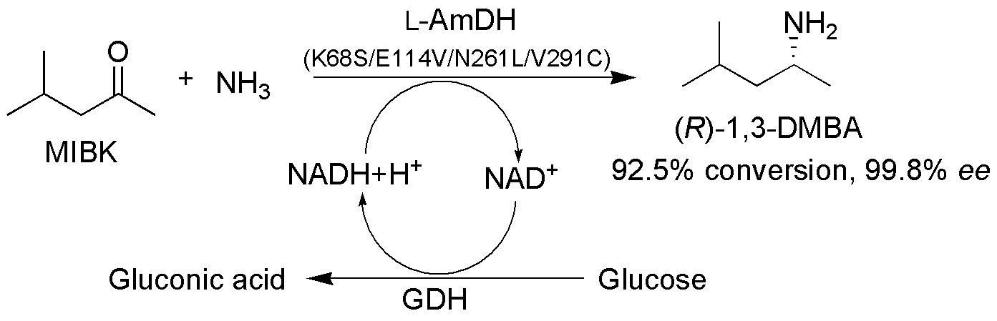
Figure 7. AmDH-mediated conversion of MIBK to 1,3-DMBA.⁹⁰
In addition, this active mutant exhibited amination activity for various ketones, concomitant with a complete loss of activity towards its native substrate, i.e. leucine.⁹⁰
Subsequently, the group of Bommarius developed another AmDH based on the scaffold of phenylalanine dehydrogenase (PheDH) from Bacillus badius.⁹¹ As the PheDH and LeuDH share reasonable sequence similarity, the analogous substitutions in PheDH were identified using sequence alignment. The PheDH double variant K77M/N276V interacted with wild-type substrate at the carboxyl moiety and this double variant rendered a synergistic effect on the amination of MIBK compared to their respective single variants. Also, this double variant was catalytically efficient in the amination of aromatic ketone substrate p-fluorophenylacetone (PFPA) to 1-(4-fluorophenyl)-propyl-2-amine (FPPAm) [Figure 8] with a k_{cat} and K_{M} of 0.128 s⁻¹ and 4.61 mM, respectively.
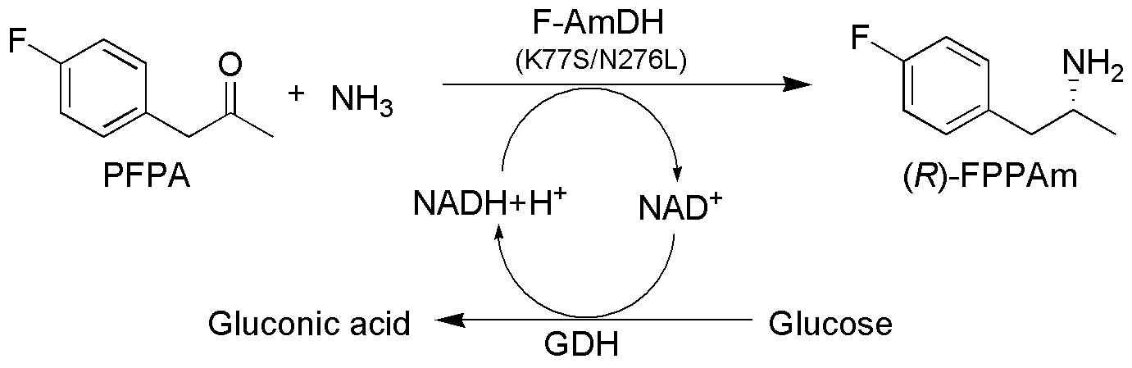
Figure 8. AmDH-mediated conversion of PFPA to FPPAm.⁹¹
Further improvement in this variant was achieved using a focused mutagenesis strategy to generate an improved variant K77S/N276L (F-AmDH), which exhibited improvement of the k_{cat} value by 15-fold to 2.8 s⁻¹ and after saturation with ammonia to 6.85 s⁻¹. In addition, the improved variants feature a reductive amination activity towards a range of ketones including phenoxy-2-propanone, 2-hexanone, and 3-methyl-2-butanone.^{29,91} However, both AmDHs (L-AmDH and F-AmDH) exhibited poor catalytic activity towards benzylic ketone substrates.
Bommarius et al. further generated a chimeric AmDH by domain shuffling of the two previously generated AmDHs (F-AmDH and L-AmDH) as parental enzymes.⁹² This chimeric AmDH (cFL1-AmDH) was generated by combining the residues 1–149 from F-AmDH and 140-366 from the L-AmDH. The substrate binding pocket in cFL1-AmDH was constituted from F-AmDH, and the cofactor binding domain was contributed from L-AmDH. This chimeric AmDH was catalytically active towards various ketones and efficiently converted sterically more hindered substrates, such as acetophenone and adamantyl methyl ketone to their corresponding (R)-amine products with excellent enantioselectivities. The further improvements in cFL1-AmDH were achieved by the generation of a variant (cFL2-AmDH) in which two adjacent asparagine residues were each mutated to leucine (N270L/N271L). The new variant containing N270L displayed an improvement in k_{cat} value towards p-fluoroacetophenone to 2.52 s⁻¹. Moreover, the chimeric AmDH displayed improved substrate scope and efficiently utilized benzylic ketone substrates.
Enzyme-mediated catalysis in organic solvents can be highly efficient owing to the improvement in substrate solubility, suppression of hydrolysis side reactions, easy downstreaming of formed products and overcoming of unfavorable reaction equilibrium.^{93,94} The poor solubility of hydrophobic substrates and limited stability of cofactors and AmDHs in organic solvents has limited the synthetic applications of AmDH-mediated amine biocatalysis. This problem was addressed by employing the biphasic reaction system in AmDH-mediated biocatalysis.⁹⁵ This biphasic system consisted of 1:4 ratios of heptanes to water, in which enzymes and hydrophilic co-factors are retained in the aqueous phase while the hydrophobic substrate preferentially partitioned into the organic phase. The use of a biphasic system for the F-AmDH-catalyzed reaction doubled the volumetric productivity for reductive amination of p-fluorophenylacetone.⁹⁵
The further scope of AmDH-mediated amine synthesis was expanded by Li et al., who explored the generation of AmDH from Rhodococcus PheDH (Rs-PhAmDH).⁹⁶ In this work, the amino acid residues K66 and N262 of PheDH, known to interact with the carboxyl group of the natural substrate, were mutated by site-saturation mutagenesis. The active triple variant K66Q/S149G/N262C (TM-AmDH), generated by the focused mutagenesis efficiently converted phenylacetone and 4-phenyl-2-butanone to (R)-amphetamine [Figure 9A] and (R)-1-methyl-3-phenylpropylamine [Figure 9B], respectively with excellent enantioselectivities of >98% ee⁹⁶.
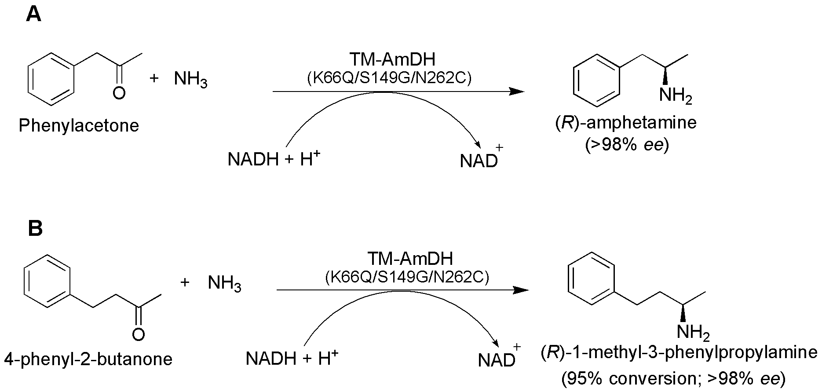
Figure 9. Synthesis of A) (R)-amphetamine and B) (R)-1-methyl-3-phenylpropylamine by AmDH generated from Rhodococcus PheDH [Adapted with permission from Reference 96, Copyright 2015, American Chemical Society]

Also, the newly generated TM-AmDH was successfully coupled to glucose/glucose dehydrogenase system for the recycling of cofactors. This resulted in the TM-AmDH-mediated conversion of 15 mM 4-phenyl-2-butanone to (R)-1-methyl-3-phenylpropylamine with 95% conversion. In further advances, Li’s group directly immobilized AmDH on Ni-NTA magnetic nanoparticles (MNP). The immobilized AmDH-MNP preparation retained 91% of the original productivity after three cycles of reductive amination of 4-phenyl-2-butanone to (R)-1-methyl-3-phenylpropylamine. This group successfully demonstrated the novel concept of the coupled immobilization of AmDH and cofactor recycling enzyme GDH. The coupling of immobilized AmDH and immobilized GDH on MNPs efficiently carried out the asymmetric reductive amination of 4-phenyl-2-butanone to (R)-1-methyl-3-phenylpropylamine with excellent enantioselectivity (99% ee) and 74% yield, with the recycling of NADH for 2940 times.⁹⁷ Caparco et al.⁹⁸ presented a protein-based concept of immobization of AmDHs. F-AmDH with a C-terminal leucine zipper tag (ZE-tag) separated from the enzyme by a (GSP)₂GS linker was found to retain nearly complete activity in comparison with the native enzyme. However, activity significantly decreased if length, composition, and location (N- vs. C-terminal tag) were changed.
Recently, Pushpanath et al.⁹⁹ generated an AmDH from a PheDH from Caldalkalibacilus thermarum. Comparison of this newly generated AmDH with F-AmDH exhibited increased thermostability (Tm =83.5 °C) of the newly generated AmDH compared to 56.5 °C of the later. These studies reported for the first time the high-scale (400 mM) reductive amination of phenoxy-2-propanone in a biphasic reaction system (ee (R) <99 %).

3.2 Extending the amine dehydrogenase panel and the substrate scope thereof
Recently, Knaus et al.¹⁰⁰ have studied the extended substrate scope of three previously developed AmDHs: 1) F-AmDH, 2) TM-AmDH and 3) chimeric AmDH generated by domain shuffling (cFL1-AmDH). The substrate panel in these studies mainly consisted of four types i.e. i) phenylacetone derivatives; ii) alkyl methylketones iii) acetophenone derivatives and iv) bulky-bulky ketones and aliphatic aldehydes. Though F-AmDH and TM-AmDH were generated from their respective parent wild-type phenylalanine dehydrogenases by mutating similar positions in the active site, these enzymes displayed a very different substrate acceptance and thermostability. TM-AmDH afforded the best conversion of phenylacetone substituents such as (para-methyl)phenylacetone, (meta-methoxy)phenylacetone, (meta-trifluromethyl)phenylacetone and ‘bulky-bulky’ ketones such as 1-phenyl-butan-2-one to their corresponding (R)-amines with excellent enantioselectivity (>99%) and conversion rates (≥98%). F-AmDH, compared to other AmDHs, could efficiently perform the reductive amination of phenylacetaldehyde. TM-AmDH also afforded the preparative scale conversion of 208 mg of (p-methoxyphenyl)acetone to its (R)-amine with an 82% isolated yield and with >99% ee in ammonium formate buffer.^{29,100} Likewise, Abrahamson et al. had already obtained 212 mg of (R)-p-fluorophenylisopropylamine (p-FPAm) with >99% ee at a 100 mL-scale.⁹¹
Most recently, Yun’s group has demonstrated the utilization of previously generated chimeric AmDH for the production of (S)-amines through the oxidative deamination of racemic amines.⁸⁵ The kinetic resolution of amines using whole cells expressing AmDH and NADH oxidase (NOX) from Lactobacillus brevis successfully resolved 50 mM (rac)-2-aminoheptane and 20 mM (rac)-1-phenylethylamine (1-PEA) into their corresponding (S)-enantiomers with excellent stereospecificity (>99% ee).

3.3 Cascade reactions and amine dehydrogenases for redox-neutral conversions
Combining the multistep reactions in one pot renders many economic and environmental advantages to the enzymatic synthesis of industrially important products. As the need for workups and purification is curtailed, cascade reactions generally possess elevated atom efficiency and potentially lower environmental impact factors.¹⁰¹⁻¹⁰⁵ AmDH, in combination with alcohol dehydrogenase, has been used for the redox-neutral conversion (termed ‘hydrogen-borrowing’) of alcohols to their corresponding amines. The direct consumption of hydrides, generated during the oxidation of alcohol to a ketone, by the subsequent step of reductive amination of the ketone to amine, has been proposed as the basis of this interconnected reaction converting alcohols to amines¹⁰⁶ [Figure 10]. In these cascade reactions, initially alcohol dehydrogenase (ADH) nonselectively oxidizes the racemic secondary alcohols to their corresponding ketones, followed by the amination of the ketones to the chiral amines by amine dehydrogenase using ammonia as an amino donor.
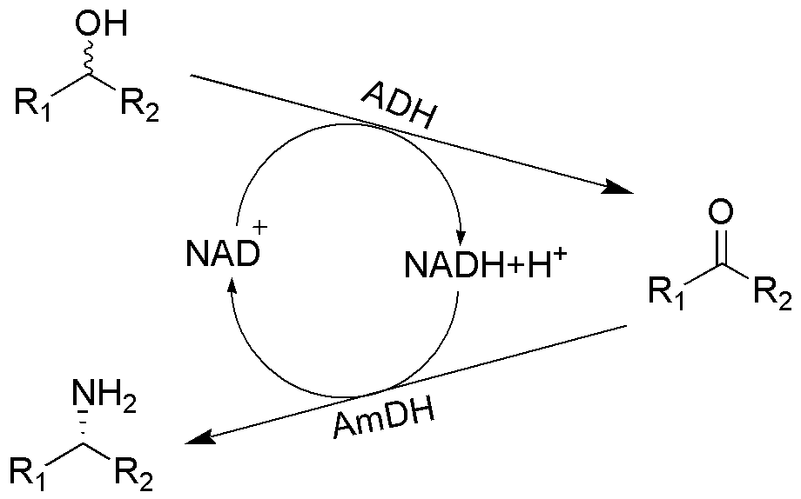
Figure 10. Conversion of alcohols to their corresponding amines by ‘hydrogen borrowing’ in a cascade reaction employing alcohol dehydrogenase and amine dehydrogenase.¹⁰⁶
Mutti et al. have recently utilized F-AmDH (AmDH generated by protein engineering of B. badius phenylalanine dehydrogenase) and NAD-dependent alcohol dehydrogenases from Aromatoleum aromaticum or Lactobacillus brevis, which exhibited matching stereoselectivities, which were reacted with 20 mM alcohol substrates and 1 mM NAD⁺ cofactor. A 24 h reaction at pH 8.7 achieved more than 85% conversion of the aromatic secondary alcohols such as 1-phenylpropan-2-ol, 1-phenylbutan-2-ol and aliphatic secondary alcohols such as octan-2-ol and heptan-2-ol to their corresponding (R)-amines with >99% ee.¹⁰⁶
The use of AmDHs in cascade reactions containing alcohol dehydrogenases was later reported by Chen et al.¹⁰⁷ This group constructed a redox-neutral two-enzyme cascade process for the preparation of chiral amines from racemic secondary alcohols. Initially, NADH-dependent LeuDH from Exiguobacterium sibiricum (Es-LeuDH) was engineered and two-site mutation (K77S/N270L), equivalent to those previously identified in L-AmDH, was introduced. Coupling of this active variant with ADH from Streptomyces coelicolor efficiently converted a range of racemic alcohols with excellent enantioselectivities up to >99% ee.¹⁰⁷
The simultaneous execution of oxidative and reductive steps in cascade reaction is a major challenge. Also, carrying out one-pot redox-neutral cascade reactions in which the electrons liberated in the first oxidative step are consumed by the subsequent reductive step is even more challenging.^{106,108,109} Though few of the AADHs have been engineered to generate AmDHs to catalyze the reductive amination reactions with ketone and amine partners [Table 3], research efforts focusing on the structural information of the catalytic mechanism and the interaction of active site residues with the substrates are highly desirable. Also, the major challenge faced by the AmDH-mediated synthesis is the scarce availability of (S)-specific enzymes; thus, the synthesis of (S)-amines by reductive amination is limited.
Table 3. Selected Examples of Substrates Utilized by Various AmDHs
Entry No. | Enzyme | Variants | Substrate | Conversion (%) | Product configuration and ee (%) | Specific activity (U/mg) | Kcat (s⁻¹), Km  (mM) | Reference
1 | L-AmDH | K68S/E114V/N261L/V291C |  | 92.5 | (R), 99.8 | 0.69 | 0.46, 15.1 | 90
2 | F-AmDH | K77S/N276L |  | 93.8 | (R), >99.8 | 11.6 | 6.85, 4.61 | 91
3 | Petrotoga mobilis sp. DSM 10674 | - |  | 90 | (S), >99.5 | 0.0519 | N.D. | 89
4 | cFL1-AmDH | - |  | N.D. | (R), 99.8 | 0.069 | 0.24, 5.2 | 92
5 | cFL1-AmDH | - |  | N.D. | (R), 99.8 | 0.301 | N.D. | 92
6 | Rs-PhAmDH | (TM-AmDH) K66Q/S149G/N262C |  | N.D. | (R), 98 | 5 | 0.7, 4 | 96
7 | Rs-PhAmDH | (TM-AmDH) K66Q/S149G/N262C |  | 95.2 | (R), 98 | 8.8 | 0.72, 1.4 | 96
8 | PheDH- Cal | K68S/N266L |  | 96 | (R), <99 | 0.62 | 0.35, 2.22 | 99
9 | cFL1-AmDH | - |  | >99 | (R), >99 | N.D. | N.D. | 100
10 | Rs-PhAmDH | (TM-AmDH) K66Q/S149G/N262C |  | 91 | (R), >99 | N.D. | N.D. | 100
11 | Rs-PhAmDH | (TM-AmDH) K66Q/S149G/N262C |  | 71 | (R), >99 | N.D. | N.D. | 100
12 | cFL1-AmDH | - |  | >99 | (R), >99 | N.D. | N.D. | 100
13 | Rs-PhAmDH | (TM-AmDH) K66Q/S149G/N262C |  | 98 | (R), >99 | N.D. | N.D. | 100
14 | Rs-PhAmDH | (TM-AmDH) K66Q/S149G/N262C |  | 98 | (R), >99 | N.D. | N.D. | 100
15 | Rs-PhAmDH | (TM-AmDH) K66Q/S149G/N262C |  | 39 | (R), >99 | N.D. | N.D. | 100
16 | Rs-PhAmDH | (TM-AmDH) K66Q/S149G/N262C |  | 87 | (R), >99 | N.D. | N.D. | 100
17 | Rs-PhAmDH | (TM-AmDH) K66Q/S149G/N262C |  | >99 | (R), >99 | N.D. | N.D. | 100
18 | cFL1-AmDH | - |  | 50# | (S), >99 | N.D. | N.D. | 85
19 | cFL1-AmDH | - |  | 50# | (S), >99 | N.D. | N.D. | 85
20 | cFL1-AmDH | - |  | 50# | (S), >99 | N.D. | N.D. | 85

L-AmDH: Amine dehydrogenase variant originated from the leucine dehydrogenase from Bacillus stearothermophilus.
F-AmDH: Amine dehydrogenase variant originated from phenylalanine dehydrogenase from Bacillus badius
cFL1-AmDH: chimeric amine dehydrogenase generated through domain shuffling of F-AmDH variant and L-AmDH variant
PheDH-Cal: Amine dehydrogenase variant originated from phenylalanine dehydrogenase from Caldalkalibacillus thermarum
Rs-PhAmDH: amine dehydrogenase variant originated from the phenylalanine dehydrogenase from Rhodoccoccus sp. M4.
#obtained by kinetic resolution
N.D. – Not determined

- Monoamine oxidases (MAOs)
Monoamine oxidase (MAO), a member of the oxidoreductase class, catalyzes oxidative deamination of aliphatic monoamines and/or aromatic amines to imines with simultaneous reduction of oxygen to hydrogen peroxide^{20,110} [Figure 11]. Principally, the reaction catalyzed by MAOs is exactly opposite to that catalyzed by IREDs.
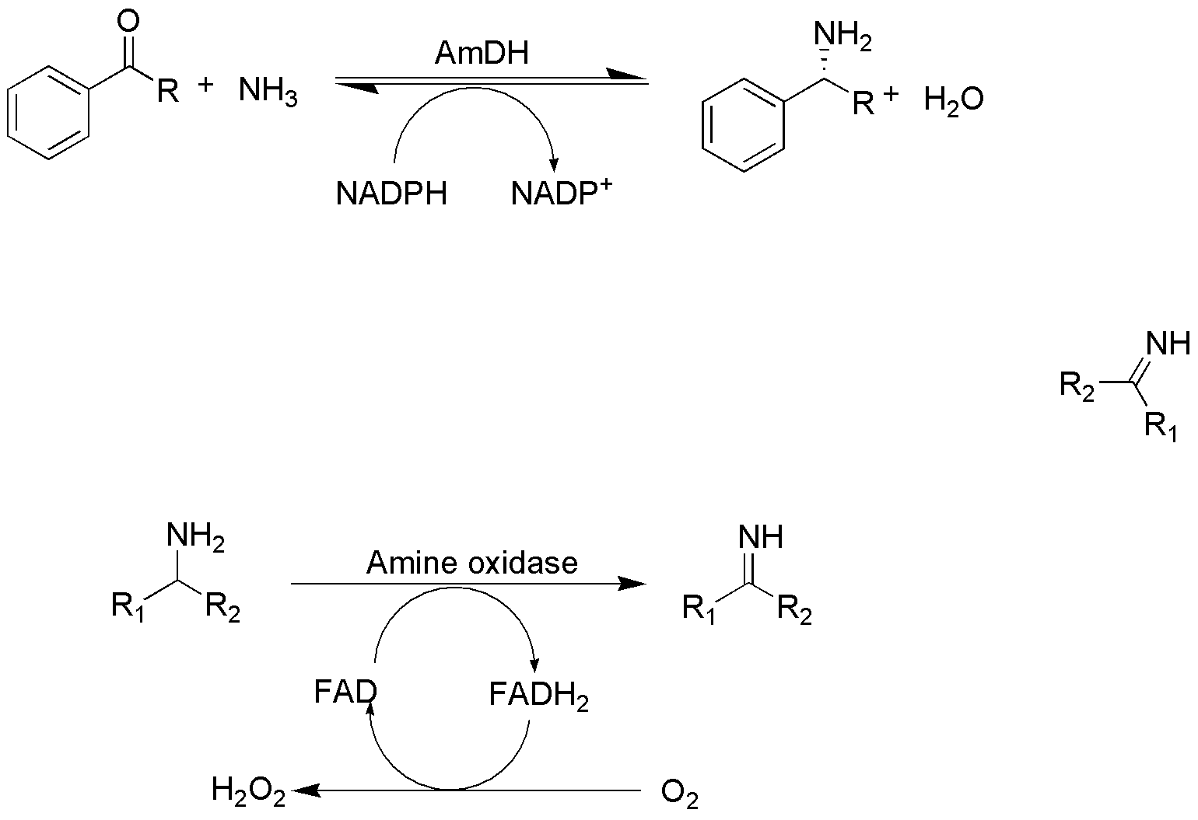
Figure 11. Oxidative deamination of amine to imine catalyzed by amine oxidases
MAOs only require molecular oxygen as the stoichiometric oxidant with no need for additional or sacrificial co-factors.¹¹¹ The reaction equilibrium of MAO-catalyzed reaction, owing to the reduction reaction of molecular oxygen to water catalyzed by the enzyme, lies so far on the product side as to appear irreversible and thus stoichiometrically forms the corresponding imines from the amine substrates.¹¹² Based on their coenzyme dependence, MAOs are classified into two groups: Type I are copper-dependent enzymes and Type II are flavin-dependent enzymes. Type I MAOs consist of enzymes containing two coenzymes, copper, and pyrroloquinolinequinone. However, an intermediate imine formed by Type I enzymes remains covalently bound to the protein, thus rendering these enzymes unsuitable for biocatalytic purposes. On the other hand, flavin-dependent AOs, primarily comprising monoamine oxidase (MAO), release free imines, thus rendering them competent biocatalysts.²⁰ Though universal acceptance has not yet been reached for a precise mechanism, the MAO-mediated catalysis has been proposed to exhibit one of three mechanisms, i.e. (1) single electron transfer; (2) direct hydride transfer; and (3) concerted polar nucleophilic mechanism.
4.1 Protein engineering of amine oxidase for the synthesis of chiral amines
Monoamine oxidase from Aspergillus niger (MAO-N) is one of the most widely reported AOs for biocatalytic applications in the last decade [Figure 12A]. Turner et al., in a series of publications, have utilized MAO-N for the deracemization of primary, secondary and tertiary amines.^{113,114}
An activity exhibited by MAO-N towards L-1-PEA served as a vehicle for the research efforts towards protein engineering approaches for the improvement in catalytic activity and enantioselectivity of MAO-mediated catalysis.¹¹⁵ Initially, a directed evolution approach was used to generate the active variant (N336S) which showed 5.8 and 47-fold improvement in the selectivity and catalytic activity, respectively towards L-1-PEA versus D-1-PEA compared to the wild-type enzyme. An effective high-throughput colorimetric plate-based screening method was developed, which captured the hydrogen peroxide produced using 3,3’-diaminobenzidine with peroxidase. This method allowed the screening of approximately 2000-3000 colonies per plate for the identification of a mutant with enhanced enantioselectivity by using a single enantiomer (L-1-PEA) substrate in the screen.¹¹⁵ The mutant identified by colorimetric screening was further applied for the deracemization of (rac)-1-PEA to generate an optically active 1-PEA with 77% yield and ee of 93% [Figure 12B].
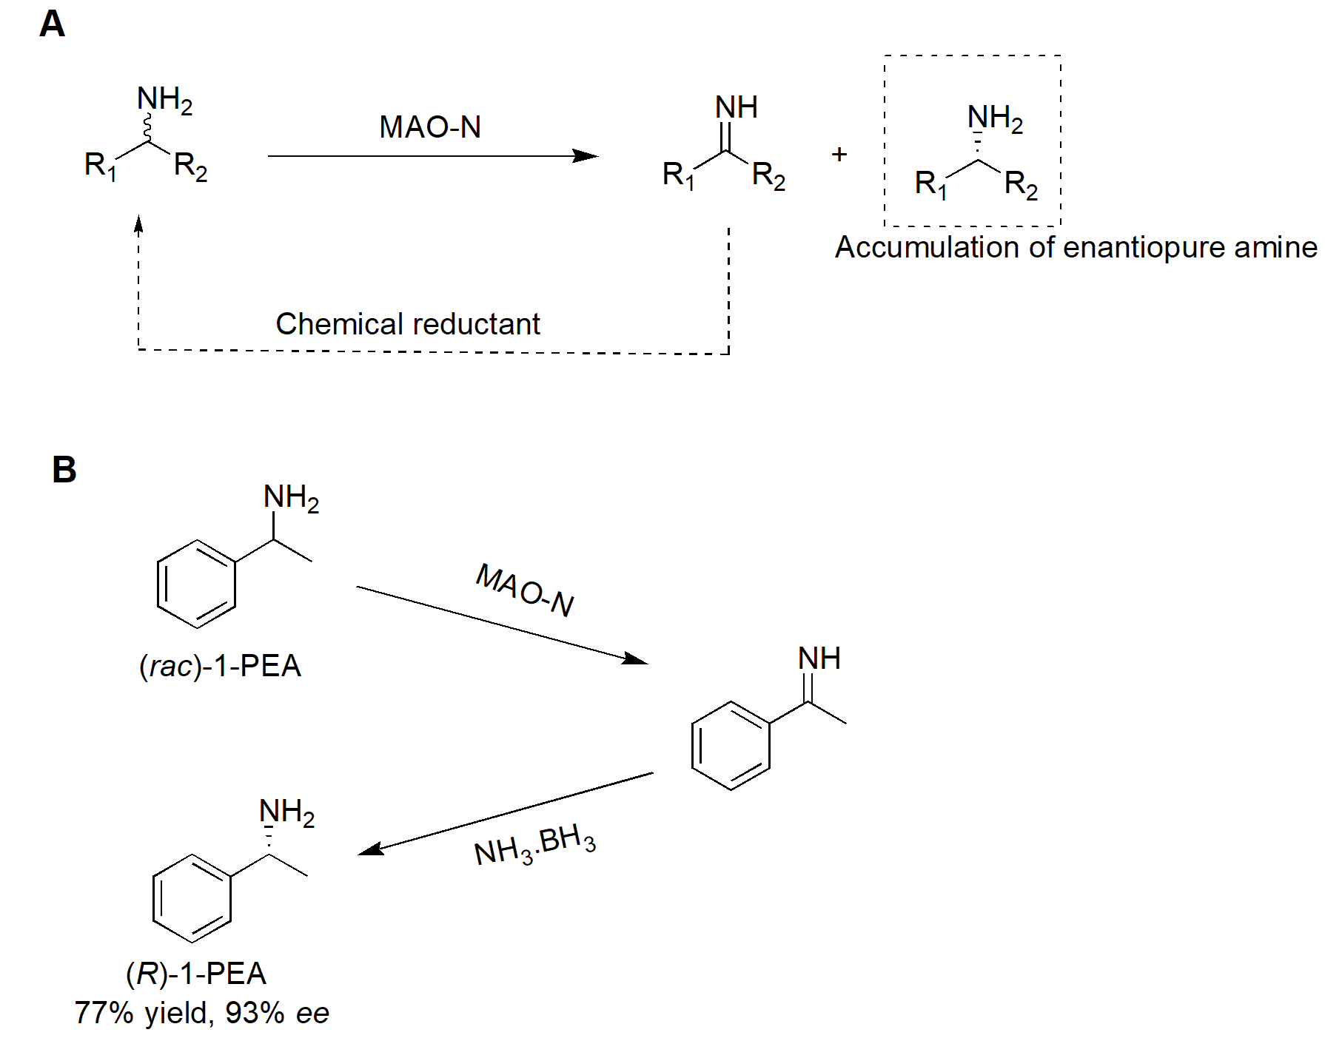
Figure 12. A) General scheme of deracemization by MAO-N and B) Deracemization of (rac)-1-PEA by MAO-N.¹¹⁵
In subsequent work, Carr et al. introduced an additional mutation (M348K) to the previously generated N336S mutant of MAO-N. The substrate classes of chiral amines such as substituted phenethylamines and 1-alkylamines were highly reactive with this variant. Also, this newly generated variant exhibited the highest activity towards the (S)-enantiomers of the substrates containing primary amine group flanked by a methyl group and bulky alkyl/aryl functional groups.¹¹³ The further scope of the MAO-N was improved by another round of directed evolution of MAO-N.¹¹⁶ The amino acid substitutions R259K and R260K improved the expression levels, while I246M was identified as a ‘hot spot’ owing to its location in the substrate entrance channel and thereby playing critical role in controlling substrate specificity. This newly generated variant (D3; N336S/I246M/M348L) exhibited enhanced activity towards chiral secondary amines. A complete deracemization of 10 mM (rac)-MTQ (1-methyl-1,2,3,4-tetrahydroisoquinoline), with 10 equivalents of ammonia borane as reducing agent, was achieved within 8 h by whole cell two-step one-pot reaction of E. coli expressing the variant¹¹⁶ [Figure 13].
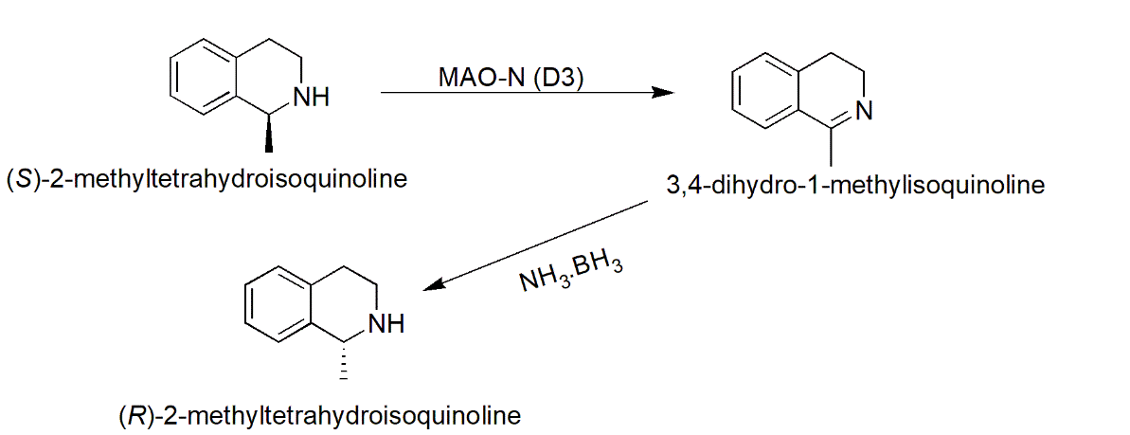
Figure 13. Use of MAO-N D3 for the deracemization of 1-methyl-1,2,3,4-THIQ to (R)-1-methyl-1,2,3,4-THIQ¹¹⁶
Furthermore, the variant generated by inserting 5 mutations (MAO-N D5; I246M/N336S/M348K/T384N/D385S) showed the highest activity towards tertiary amine substrates, particularly those containing pyrrolidine ring flanked by bulky aryl groups¹¹⁴ [Figure 14A].
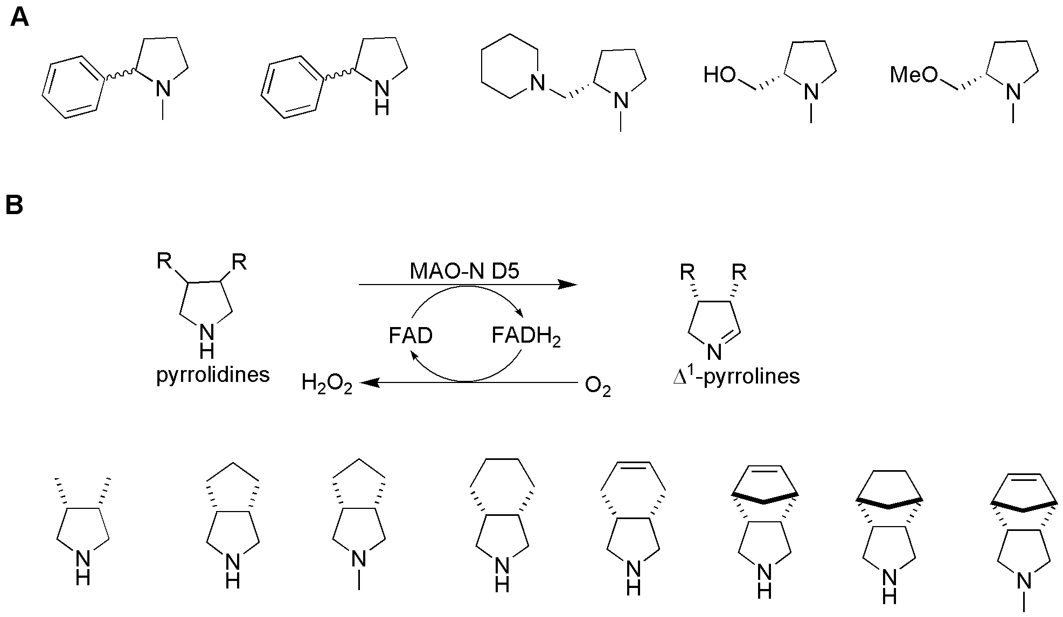
Figure 14. Substrate panel tested for the A) oxidative deamination by MAO-N D3;¹¹⁴ and B) oxidative desymmetrization of pyrrolidines by MAO-N D5 ¹¹⁸

In preparative deracemization reaction utilizing MAO-N D5, 25 mM of N-methyl-2-phenylpyrrolidine (Nicotine) yielded 75% isolated yield of (R)-nicotine with 99% ee in 24 h. Also, a complete stereoinversion of (S)-nicotine to (R)-enantiomer was achieved in 24 h using ammonia borane as a reducing agent. Similarly, deracemization reaction of 10 mM (rac)-crispine A (anticancer alkaloid from plant Carduus crispus) with 3–4 equivalents of ammonia–borane as the reducing agent and washed whole cells (Escherichia coli) expressing the MAO-N D5 variant amine oxidase yielded (+)-crispine A with very good enantioselectivity (97% ee) in 40 h.¹¹⁷ The substrate scope of MAO-N D5 [Figure 14B] was further improved for oxidative desymmetrization of unprotected pyrrolidines to the corresponding ∆¹-pyrrolines, which serve as useful building blocks for the synthesis of L-proline analogs of high enantiomeric purity.¹¹⁸
Subsequently, for further modification in MAO-N, two potential target amino acid residues were identified by Turner and co-workers with the specific aim of increasing the size of the small cavity within the active site pocket to incorporate an additional phenyl group of bulky substrates.¹¹² Site-saturation mutagenesis at W430 generated a variant MAO-N D10 (6 mutations to wild-type; I246M/N336S/M348K/T384N/D385S/W430G). This single mutation (W430G) led to the increase in the volume of the small cavity within an active site, which allowed the accommodation of bulky aminodiphenylmethane motif. Also, the newly generated variants were utilized for the asymmetric synthesis of two important drug molecules, Levocetirizine [Figure 15A] and Solefenacin [Figure 15B], which are industrially prepared using classical resolution. The deracemization of (rac)-4-chlorobenzhydrylamine on a 500-mg scale resulted in the production of (R)-4-chlorobenzhydrylamine with very good enantioselectivity (97% ee) after 48 h, which was further used in the synthesis of Levocetirizine. Similarly, further modifications in the substrate access channel (F210L, L213T, M242Q, and I246T) led to the generation of a D11 variant of MAO-N (MAO-N D11; F210L/L213T/M242Q/I246T/N336S/M348K/T384N/D385S/W430G). This variant was used for the deracemization of (rac)-1-phenyl-THIQ on a gram scale (1 g, 15 mM), leading to the formation of (S)-1-phenyl-THIQ with 98% enantiomeric excess after 48 h and subsequently for the synthesis of Solifenacin.
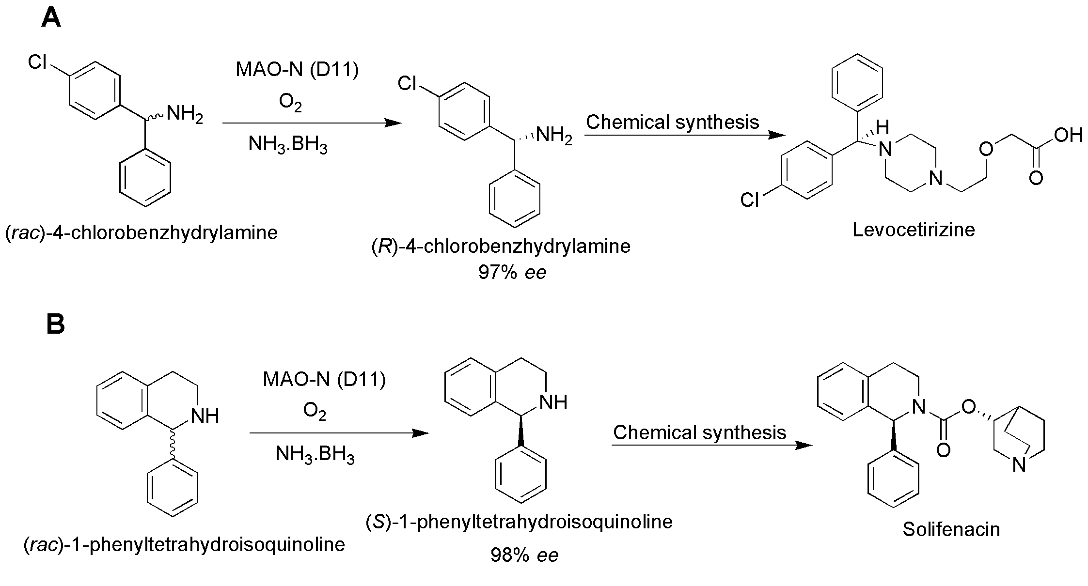
Figure 15. Use of active variant D-11 of MAO-N (MAO-N D11) for the synthesis of A) Levocetirizine and B) Solifenacin [Adapted with permission from Reference 112, Copyright 2013, American Chemical Society]
Furthermore, the engineered MAO-N variants were applied for the production of a diverse range of alkaloid natural products, such asconiine, eleagnine, and leptaflorine in their enantiomerically pure form.¹¹² Recently reported, the applicability of various mutants (MAO-N-D5, D9 and D11) was evaluated for the deracemization of various substituents belonging to substrate class such as (i) α-substituted benzylamines, (ii) α-substituted allyl-, homoallyl- and propargylamines, (iii) α-substituted aliphatic amines and (iv) 1,2,3,4-tetrahydronaphthylamine (THN) and (v) aminoindane.¹¹¹ More recently, MAO-N variants D9 (I246M/N336S/M348K/T384N/D385S/W430H) and D11, coupled with a Cu-based oxidative system (CuI/H₂O₂), were used in a one-pot two-step system for the transformation of 1,2,3,4-THIQ to 3,4-dihydroisoquinolin-1(2H)-one (DHIO)¹¹⁹ [Figure 16]. At 25 mL scale, feeding of THIQ yielded 48.2 mM of the intermediate 3,4-dihydroisoquinoline (DHIQ) with a yield of 71.3%. Subsequent addition of chemical catalysts (1 mol% CuI and 10 eq. H₂O₂) to DHIQ formed ~30 mM DHIO at 69.4% overall yield.
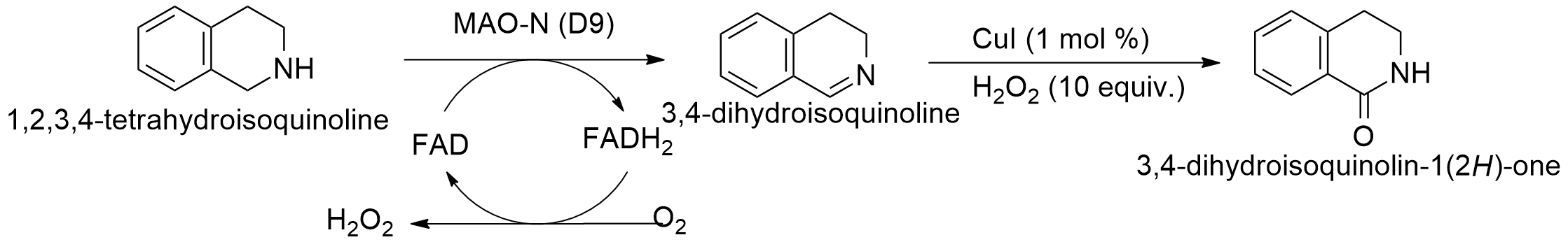
Figure 16. MAO-mediated deracemization of THIQ to 3,4-dihydroisoquinolin-1(2H)-one (DHIO) via the formation of intermediate 3,4-dihydroisoquinoline (DHIQ). [Adapted with permission from Reference 119, Copyright 2017, John Wiley and Sons]

4.2 Tailoring amino acid oxidases for the generation of amine oxidases
Though amino oxidase-mediated biocatalysis is an attractive approach for amine synthesis, (R)-selective MAO, suitable for deracemization, was not yet identified until recently. Also, all the variants of MAO-N (monoamine oxidase from Aspergillus niger) that received a significant attention in recent years, exclusively exhibited S-stereopreference and produced (R)-configured amine by the deracemization of racemic amines using chemical reductants. This was addressed by Yasukawa et al., who recently developed R-selective AO from porcine kidney D-amino acid oxidase (pkDAO) and subsequently used it for deracemization of racemic amines.¹²⁰ pkDAO is known to catalyze the oxidative deamination of α-amino acids with strict (R)-stereoselectivity to form the corresponding keto acids, ammonia, and hydrogen peroxide, but it does not act on simple amines.¹²⁰ The PDB structure of pkDAO complexed with benzoate as an inhibitor was used to identify the important amino acid residues. Two amino acid residues, Y228 and R283, were identified as important catalytic residues and serve as an initial point of mutational studies to improve the substrate specificity. Saturation mutagenesis at these residues generated the active variant Y228L/R283G which showed high, stereoselective oxidase activity towards the (R)-enantiomer of (rac)-1-PEA. Furthermore, enantiopure (S)-1-PEA was synthesized from a racemic substrate by the deracemization process using the active variant generated that selectively oxidized (R)-configured amines in the presence of a chemical reductants, such as NaBH₄.¹²⁰ Recently, it has been reported that a small energy difference of hydrophobic interaction (including π-π stacking interaction) between (R)- and (S)-1-PEA binding forms in (R)-MAO may function as an origin of high stereoselectivity of MAO towards (R)-1-PEA.¹²¹
Recent years have evidenced the significantly increased interest in the amine oxidase-mediated biocatalysis for synthetic purposes [Figure 17]. In this light, various amine oxidases have been purified from different microbial species.^{110,122,123} However, the application of these amine oxidases in synthetic applications still remains a challenge. An increasingly important challenge associated with amine oxidase-mediated biocatalysis remains the availability of enzymes and the substrate scope thereof to facilitate their use for the industrial synthesis of important amines. Although considerable work carried out on the generation of MAO-N variants to improve the substrate scope, the generation of reactive iminium ions for Pictet–Spengler reactions is still a relatively unexplored ﬁeld.²⁰
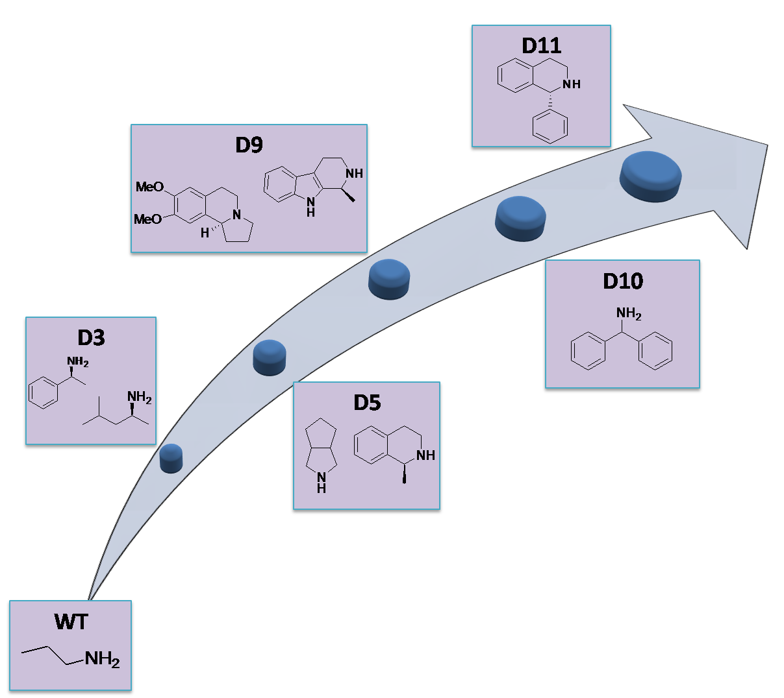
Figure 17. Development of MAO-N as a potential biocatalyst by improving its substrate scope

- Cytochrome P450s
Cytochrome P450s (P450s) are nature’s most versatile biocatalysts, and catalyze a plethora of oxidation reactions, such as the hydroxylation of aliphatic and aromatic hydrocarbons, epoxidation of alkenes and arenes, O-, N-, and S-dealkylation, oxidative deamination, dehalogenation, dehydrogenation, dehydration, denitration, and reduction of NO, N-oxides and epoxides.¹²⁴⁻¹³⁰ P450s are heme-containing monooxygenases that exhibit maximum absorbance at 450 nm when carbon monoxide binds to their ferrous heme iron, hence the name ‘Pigment 450 nm’.^{124,131}
P450s reductively activate molecular oxygen, which splits into the component atoms. While one oxygen atom is inserted into the substrate bound to the P450 active site (thus monooxygenases), the second oxygen atom is reduced to form a water molecule.¹³²
RH + O₂+ 2e⁻ +2H⁺ ROH + H₂O;
For the cleavage of an oxygen molecule during oxidation of a substrate, two electrons need to be transferred to the P450. These reducing equivalents are generally provided by NAD(P)H, via one or more redox partners, but the identities and number of those varies between P450 systems.¹³³ Depending on the redox partners, P450s are classified into two main classes. In adrenal mitochondrial enzymes, the provision of reducing equivalents requires both an iron-sulphur protein (ferrodoxin/adrenodoxin) and an NAD(P)H-dependent flavin-containing reductase (ferredoxin/adrenodoxin reductase). The liver microsomal P450 enzymes obtain electrons from an NAD(P)H-dependent cytochrome P450 reductase (CPR). However, with the increasing number of identified electron transfer systems, the classification of P450s have been extended to 10 classes.¹³⁴⁻¹³⁶ More details on structural organization and mechanism of P450s can be found in specialized reviews.^{133,134,137,138}
Although mammalian P450s have been extensively studied for their critical role in drug metabolism, their prokaryotic counterparts exhibit excellent biocatalytic potential owing to their high solubility and stability in aqueous environment.¹³⁶ P450_{BM3}, a flavocytochrome from Bacillus megaterium, is one of the most studied microbial P450s.¹³⁹ P450_{BM3} has been recognized as a preferable model system owing to the presence of both the domains, a heme domain catalyzing substrate oxidation, and NAD(P)H-dependent diflavin reductase domain responsible for electron transport, in a single polypeptide chain.^{139,140} The following sections summarize the advancements achieved in recently discovered function of P450s, i.e. amination of C-H bond, playing important role in the generation of amines.

5.1 Engineering P450s for C(sp3)-H Amination
The biocatalytic conversion of C-H to C-N can provide direct access to amine and amides, by utilizing the usual advantages of enzymes being stereoselective in nature.¹⁴¹ The amination of C-H bonds provides a streamlined route for the ubiquitously present amine bonds in biologically active molecules. Although synthetic catalyst-mediated nitrene transfer reactions are limited by the poor selectivity and/or efficiency and requirement of toxic metals, they were until recently only accessible route for the metal-catalyzed nitrene transfer reactions.¹⁴¹ Enzymes can insert oxygen atoms into unactivated C-H bonds; however, the possible sites of similar insertion of nitrogen atom are constrained. Few of the enzymes, such as TAs and AADHs, can target chemically activated carbon atoms, and enzymes catalyzing the concerted oxidative amination of C-H bonds were unknown until very recently when McIntosh et al., reported the first highly active P450-mediated catalysis for C-H amination.¹⁴² In those studies, among the 24 variants of P450_{BM3} screened for their C-H amination capability, a variant possessing a single mutation (T268A) was most active (28 TTN) for C-H amination of the substrate 2,4,6-triethylbenzene-1-sulfonylazide under anaerobic and reducing conditions [Figure 18]. Also, the screening of several serine–heme-ligated ‘P411’ enzymes (in which the axially coordinating Cys400 residue is mutated with serine, to give the maximum absorbance of the ferrous CO-bound enzyme at 411 nm rather than 450 nm for cysteine-ligated enzymes) exhibited C400S mutant P411_{BM3}-CIS (14 mutations from the wild type), which also contained the T268A mutation, as the most active enzyme for the amination of the sulfonyl azide substrate. As T268A/C400S double mutants resulted in higher activity (73% yield of C-H amination product), the authors concluded that these mutations were major contributors to the C-H amination capability of the P411_{BM3}-CIS. The authors also reported that hemin was also capable of catalyzing the reaction when reduced with dithionite; however, the sultam product formed was racemic, implying that P450_{BM3}-catalyzed amination occurs within the active site of the enzyme.¹⁴² The substrate specificity studies in the hemin and enzyme variants further explored the critical role of the enzyme in the formation of C-N bond beyond providing a chiral environment that provides the stereospecific products. Also, the diminished activity of the enzyme towards bulkier triisopropyl substituent of the substrate suggested that smaller substrates are favored by the enzyme variant, which nevertheless could be engineered to accommodate bulkier substrates. Bordeaux et al. subsequently explored the C-H amination reactivity of other hemoproteins.¹⁴³
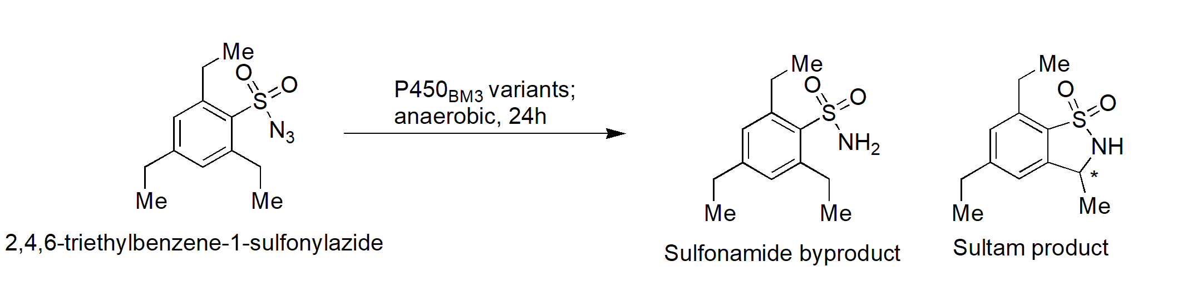Figure 18. P450-catalyzed C-H amination of sulfonyl azides to sultam products and sulfonamide byproducts. [Adapted with permission from Reference 142, Copyright 2013, John Wiley and Sons]
Subsequent research efforts by various research groups found that the cleavage of C-H bonds is also affected by the bond strength. While the amination of C-H bonds with lower bond dissociation energies (BDEs) can be easily carried out, a significant challenge is put on display by the amination of those with greater BDEs.¹⁴⁴ Furthermore, the major challenge in the amination of C-H bonds is to control the regioselectivity. It was found that amination of C-H bond is kinetically controlled, and the geometry of the substrates influences the enantioselectivity of the product formed.¹⁴³⁻¹⁴⁵ Hyster et al. postulated that enzyme-controlled selectivity would be a much better alternative, as it can generate a diverse range of products from a single starting material.¹⁴⁶ With the aim of solving these regioselectivity issues, they carried out the active site engineering of P450 to generate two active mutants catalyzing the regioselective amination of the substrates possessing two potential sites for C-H amination. For example, 2,5-di-n-propylbenzenesulfonyl azide was used as a model system because it contains two potential sites for C−H amination - the benzylic position (α-position) and the homo-benzylic position (β-position) with distinguishing C−H bond strengths (85 and 98 kcal/mol) [Figure 19A]. Among the site saturation libraries of five active site residues [F87, L181, I263, T268, and T438], variant P411_{BM3}-CIS-I263F-T438S showed an 11-fold increase in activity compared to its parent P411_{BM3}-CIS-T438S [15 mutations from wild type] and significant amination at the β-position with the ratio of 97:3 compared to the α-position. Also, another variant P411_{BM3}- F87A-T268A (three mutations from the wild-type) provided 187 TTNs and modest selectivity (30:70) for the generation of α-amination product. Furthermore, the role of these mutations in controlling the regioselectivity of the amination was tested in various substrates, wherein these two variants continued to favor their respective regioselectivity in the substrates bearing alkyl and ester substitutions on the aromatic ring [Figure 19B].
Although, the enzyme variant may show distinguishing regioselectivity, the similar KIE values in the studies by Hyster et al. suggested that the mechanism of C-H cleavage is similar. Given the fact that C-H abstraction is kinetically controlled, it has been hypothesized that the regioselectivity favored by the respective variant depends on the proximity of the C-H bond to the metal nitrenoid and the enzyme plays a critical role in situating a substrate such that a different C-H bond is accessible in each variant.¹⁴⁶
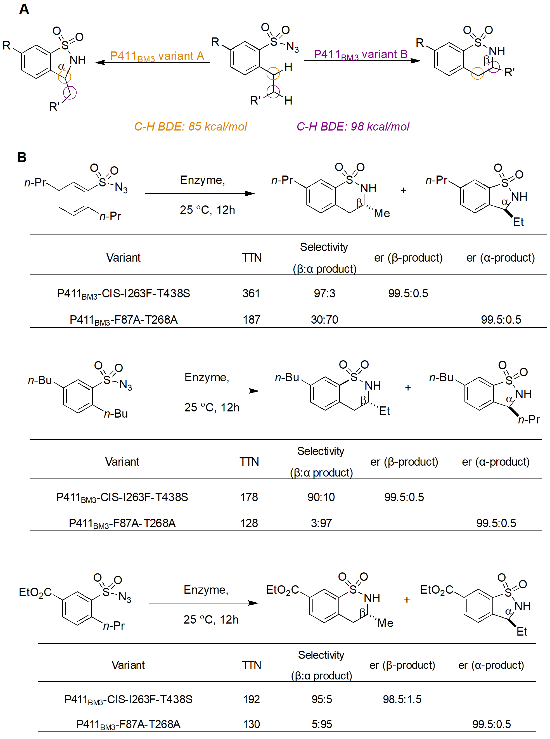
Figure 19. A) Enzyme-controlled regioselective amination of the substrates possessing two potential sites for C-H amination; B) P411 variant-controlled regioselectivity of the C-H amination in substrates bearing alkyl and ester substitutions on the aromatic ring [Adapted with permission from Reference 146, Copyright 2014, American Chemical Society].

Complementary work by Singh et al. further confirmed the critical role of the enzyme in catalyzing the progression of the reaction in a stereo- and enantioselective manner.¹⁴⁷ It is worth emphasizing that the results of these studies were in contrast to the previously reported studies by Arnold et al., who suggested that the substitution of the heme proximal cysteine with serine residue is largely necessary for effective C-H amination catalyzed by P450s.^{142,146} Singh et al.¹⁴⁷ demonstrated that not only do cysteine-heme-ligated P450s catalyze the C-H amination of 2,4,6-trisubstituted benzenesulfonyl azide substrates to their corresponding benzosultam products, but do so with equal, to or even higher efficiencies than their serine-ligated counterparts [Figure 20]. The active site variant FL#62 (containing five active site mutations; V78A, F81S, A82V, F87A and A184V) exhibited 10 and 20-fold higher TTN for the cyclization of 2,4,6-triethyl-benzenesulfonyl azide and 2,4,6-triisopropyl-benzenesulfonyl azide substrates, respectively compared to the parent enzyme P450_{BM3.}
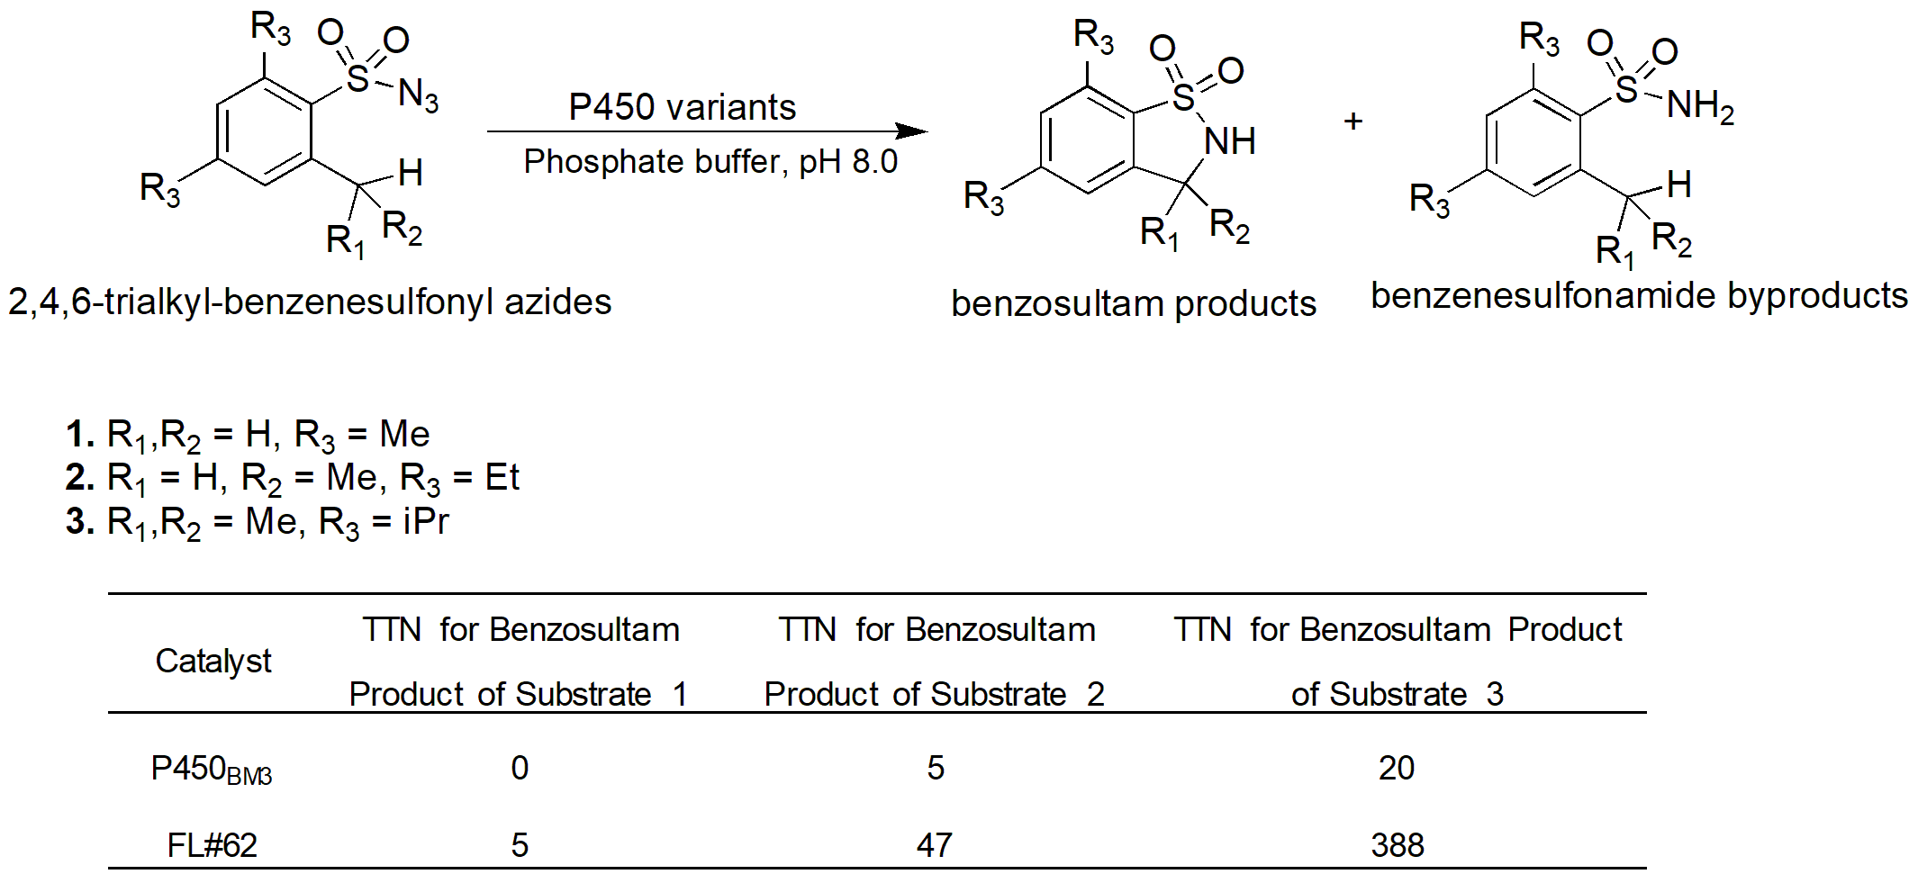
Figure 20. Intramolecular benzylic C−H amination reactions catalyzed by P450-variants. [Adapted with permission from Reference 147, Copyright 2014, American Chemical Society]
P450s have also been engineered to catalyze the amination of allylic sulfides that generate chiral allylic sufimides. These products undergo spontaneous sigmatropic rearrangement to give chiral allylic amines. In these reactions, the ferrous state of the heme cofactor of P450s reacts with a nitrene precursor sulfonyl azides that generate iron nitrenoid sulfimides, which then undergo P450-catalyzed amination to generate chiral allylic amines^{148,149} [Figure 21A]. In their initial work, Arnold and coworkers demonstrated that P411 enzymes could catalyze the intermolecular insertion of nitrogen into thioethers to form sulfimides.¹⁵⁰ In further studies, Prier and coworkers envisioned that engineered P450s could perform the enantioselective imidation of prochiral allylic sulfides to generate allylic sulfimides that undergo [2,3]-sigmatropic rearrangement to generate the allylic amines with a new chiral centre.¹⁴⁹ As sigmatropic rearrangements are known to progress with high enantioselectivity, it was presumed that the stereoselectivity in the sulfimide intermediate would be carried forward to the allylic amine products, which can serve as constituents of the important bioactive molecules and/or their intermediates. Several rounds of mutagenesis generated various active mutants from P411BM3-CIS T438S parent that catalyzed nitrene transfer to bulkier sulfides with high TTNs in whole cell reactions [Figure 21B]. It is worth noting that although the enzyme variants do not catalyze the sigmatropic rearrangements by themselves, nevertheless, the enzyme assembles the allylic sulfimide intermediates with high enantioselectivity, and thereby generates the enantiopure allylic amine products.¹⁴⁹
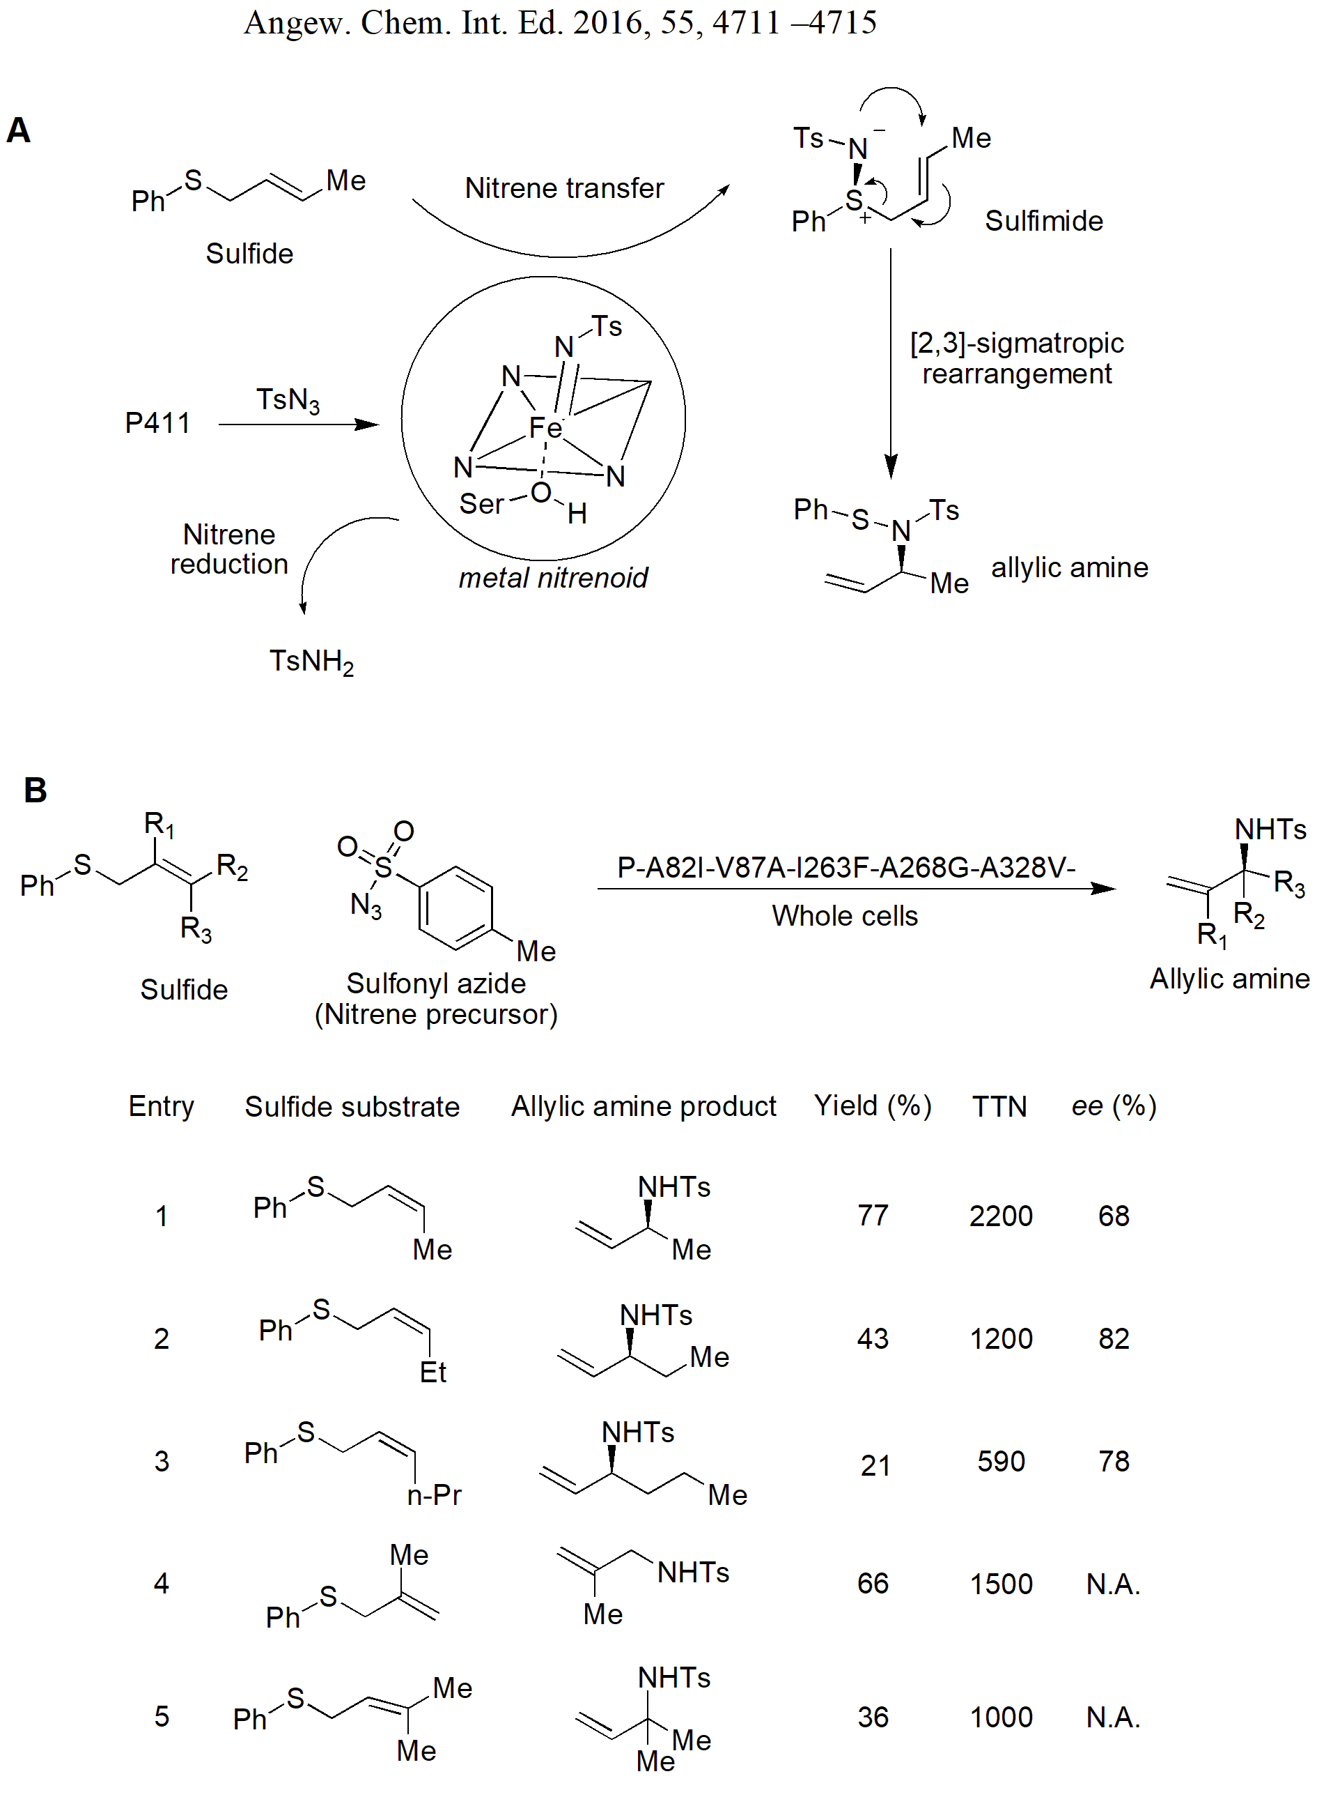
Figure 21. A) Schematics of P450-catalyzed sulfimidation and sigmatropic rearrangement and B) In vivo enantioselective imidation of various prochiral allylic sulfides to allylic amines [Reproduced with permission from Reference 149, Copyright 2016, John Wiley and Sons].
The studies on the P450-catalyzed imidation of sulfides demonstrated two potential limitations that affect the ultimate outcome of the reaction.^{149,150} The first was the dependence of reaction rates on the electron-sufficiency or electron-deficiency of the sulfide substrates. The reaction was observed to be promoted by electron-rich sulfide substrates. The second limitation was that, electron-deficient sulfide substrates resulted in a significant side reaction of enzyme-catalyzed azide reduction to sulfonamides, rather than the desired sulfimide products. Nevertheless, the ratio of sulfimide to sulfonamide side product could be improved by increasing the loading of sulfide substrates, suggesting that increase in the effective concentration of nitrene acceptors in the enzyme active sites can improve the overall sulfimidation productivity of the enzyme variants. However, in line with that of sulfides, increasing the concentration of less reactive olefin substrates for the enzyme-catalyzed aziridination is an operational limitation owing to the poor water solubility of olefins.
Farwell and co-workers demonstrated that an enzyme engineering approach would circumvent these potential limitations for the intermolecular aziridination of the olefin substrates by azide nitrene sources¹⁵¹ [Figure 22A]. Among the various enzyme variants tested, a variant of P411_{BM3}-CIS-I263F-T438S improved the aziridination of 4-methoxystyrene by 10-fold compared to the P411_{BM3}-CIS-T438S parent (TTNs of 150 compared to 15 in the parent enzyme). Also, this variant improved the productivity of aziridination of the less electron-rich substrates such as 4-methylstyrene and styrene [Figure 22B]. Further improvement in the aziridination was achieved by generating site-saturation mutagenesis libraries of several active site positions. A variant P411_{BM3}-CIS-I263F-A328V-L437V-T438S diminished the sulphonamide side product of aziridination reaction of 4-methylstyrene to 43 from 95% in the parent enzyme. Moreover, the very high enantioselectivity [99% ee (S)] of the desired aziridine product was achieved by the addition of these two mutations. Furthermore, whole cells expressing P411_{BM3}-CIS-I263F-A328V-L437V-T438S could efficiently catalyze the aziridination of various substituted styrene substrates [Figure 22C]. For instance, whole cell reactions of the evolved enzyme provided 600 TTNs for the aziridination of styrene, and yielded 70% of the desired aziridine product. It is noteworthy that, in contrast to the imidation of sulfide substrates in the earlier reported studies, the productivity of the enzyme-catalyzed aziridination was not related to the nature (electron-withdrawing or electron donating) of the aryl substituents.¹⁵¹

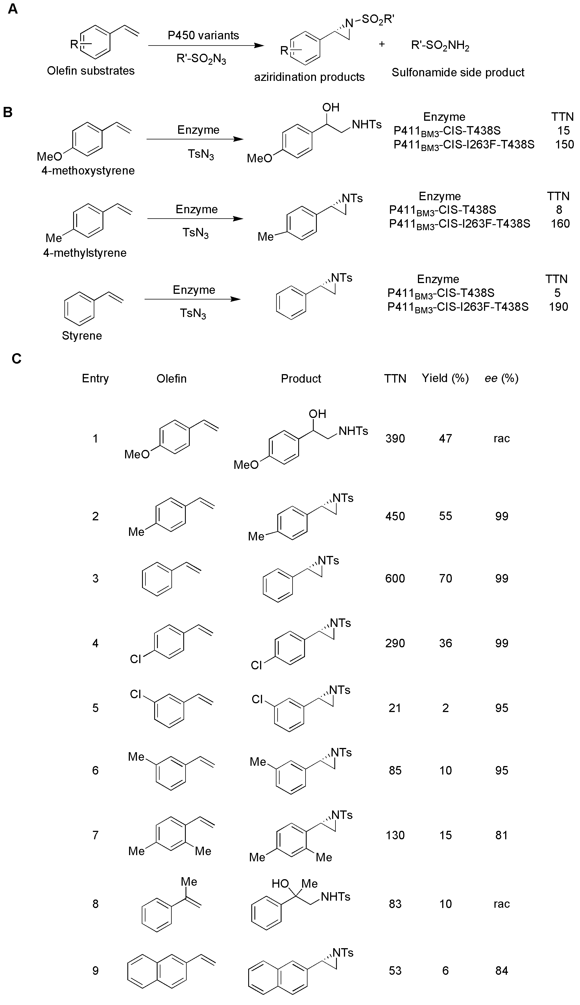
Figure 22. A) Schematics of the P450-catalyzed intermolecular aziridination of the olefin substrates B) Enzyme catalyzed intermolecular C-H amination of styrene derivatives using azide nitrene sources and C) In vivo aziridination of various substituted styrene substrates by P450 variant P411_{BM3}-CIS-I263F-A328V-L437V-T438S [Adapted with permission from Reference 151, Copyright 2015, American Chemical Society].

Singh et al.¹⁵² further extended the scope of intramolecular C−H amination and recently reported that P450s could effectively catalyze the intramolecular C−H amination of carbonazidate to generate oxazolidinones [Figure 23]. The hydrolysis products of oxazolidinones are 1,2-aminoalcohols, which are key constituents of important bioactive molecules and chiral auxiliaries.^{153,154} In a similar mode to that of serine-heme-ligated P450s, FL#62-mediated amination of C-H was also dependent on the strength of C-H bond. Also, not only could the amination of benzylic/allylic C-H bonds with lower BDEs (BDE < 90 kcal/mol) be achieved, but the amination of stronger C-H bonds was also catalyzed. The investigation of substrate scope revealed that substrates possessing substituted aromatic ring were tolerated by the best variant FL#62. While the substitution of the para-position with methyl group improved the TON, substitution with the isosteric but electron-withdrawing trifluoromethyl group diminished the C-H amination activity [Figure 23], implying that electrophilicity of the substrate affects the outcome of the C-H amination reaction.¹⁵²

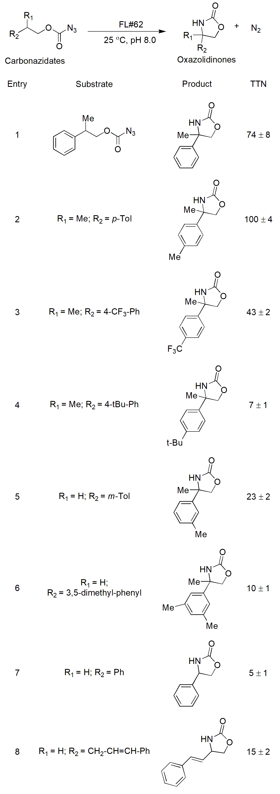
Figure 23. Cyclization of carbonazidate substrates to oxazolidinones by engineered P450-catalyzed nitrene insertion to C-H bond [Adapted with permission from Reference 152, Copyright 2015, American Chemical Society].

Most recently, Prier and coworkers demonstrated the ability of engineered P450s to intermolecularly aminate benzylic C–H bonds with high selectivity.¹⁵⁵ In the initial studies, P411_{BM3}-CIS-V87A-I263F-A268G-A328V-T438S variant (termed as P4), originally generated for the imidation of allylic sulfides,¹⁴⁹ showed promiscuous activity towards intermolecular C-H amination at the benzylic carbon of 4-ethylanisole with modest yield and enantioselectivity (11% and 14% ee, respectively). Addition of a single mutation A82L to P4 resulted in four-and five-fold improvement in yield and enantioselectivity of the benzylic amine product, respectively [77% compared to 14% ee in the parent]. The addition of two more mutations, A78V and F263L, improved the activity and selectivity towards all the three substrates tested, i.e. 4-ethylanisole, 4-ethyltoluene, and ethylbenzene yielded the corresponding benzylic amine products as single enantiomers [>99% ee] [Figure 24A]. Furthermore, addition of E267D mutation created the variant (termed P411_{CHA}; ‘cytochrome P411 C–H aminase’) which could catalyze the amination of a diverse set of arene-containing substituted hydrocarbons [Figure 24B]. It is worth mentioning that the engineered catalyst supported 1300 turnovers in vivo, far exceeding the previously reported highest ever TTN for the intermolecular C-H amination using chiral synthetic metal catalysts.¹⁵⁵

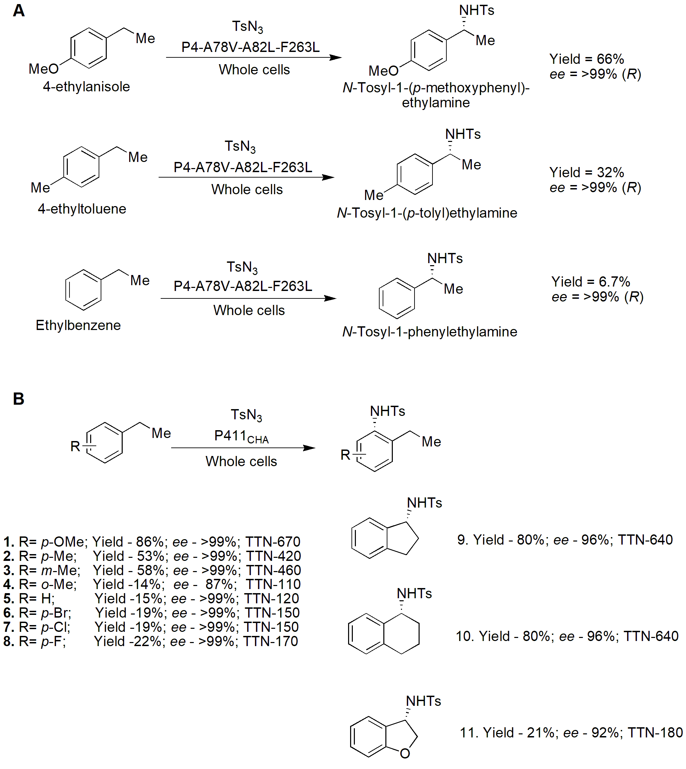
Figure 24. Enantioselective C-H amination of various arene-containing substituted hydrocarbons by whole cells expressing P450 variants A) P4-A78V-A82L-F236L; and B) P411_{CHA}. [Adapted with permission from Reference 155, Copyright 2017, Springer Nature].

5.2 Engineering P450s to incorporate unusual metal cofactors for C-H amination catalysis
Recent developments in the protein engineering and directed evolution of P450s, metalloproteins containing Fe-protoporphyrin IX (Fe-PIX) cofactors, have successfully generated variant that could catalyze the intramolecular and intermolecular amination of C-H bonds. However, the yields of these reactions, especially of intramolecular C-H amination reactions, are often limited by the poor chemoselectivity, and thereby poor enantioselectivities of the products formed. For instance, during the P450-catalyzed amination reaction of sulfonyl azide substrates, the mixture of two products i.e. desired products of the nitrene insertion into the C-H bonds, and undesired sulfonamide byproduct, are formed.^{142,146} Very often, the sulfonamide side products are formed in comparable or greater extent than the desired products of nitrene insertion. Also, despite the potential of Fe-PIX proteins to catalyze abiological reactions, such as the insertion of carbenes and nitrenes to olefins and X-H bonds,^{151,156,157} the exquisite reactivity of the Fe-centre confines the scope of the array of transformations. For instance, Fe-PIX proteins can catalyze the carbene insertion into the reactive N-H and S-H bonds, however, they cannot catalyze the insertion into the C-H bonds.^{157,158}
The stable coordination formed by PIX cofactor makes it feasible to incorporate a non-natural metal with reactivity different from that of the native complex.¹⁵⁹ Recently, many of the artificial PIX proteins incorporating metal ions, such as Mn, Cr, and Co have been generated to catalyze the inherent functions of the native enzymes containing Fe-metal ion.^{143,160} However, the performance of these artificial PIX proteins is poorer compared to the reactions catalyzed by native Fe-PIX enzymes.¹⁵⁸ Also, many of the metal porphyrin complexes have been reported to efficiently catalyze the amination of C-H bonds in sulfonyl azide substrates; however, the major limitation is related to the processing of these reactions at higher temperatures.¹⁶¹⁻¹⁶³
In this light, Dydio et al.¹⁶⁴ hypothesized that P450s can be amended to incorporate completely noble-metal complexes, rather than their native Fe-cofactors, in such a manner that the undesired azide reduction to sulfonamide would be minimized, and amination of C-H bond in sulfonyl azide substrates is preferred. CYP119, an artificial P450 containing Ir(Me)-PIX-cofactor system from the archaeon Sulfolobus solfataricus that exhibits much higher melting temperature (T_{m} of 69 °C) than the commonly used catalyst P450_{BM3} (45 °C)¹⁶⁵ was engineered to efficiently catalyze the insertion of a nitrene into C-H bonds of sulfonyl azide substrates to generate the desired sulfamates with higher enantioselectivities. In the initial experiments, Ir(Me)-PIX was found to be the best among other M-PIX complexes, as the ratio of sultam to sulfonamide was >10:1 for both model substrates, i.e. isopropylbenzenesulfonyl azide and 2-ethylbenzenesulfonyl azide. The yields of the corresponding sultam products from these substrates were 92 and 89%, respectively [Figure 25A]. The variant CYP119-Max-L155G, which contains 5 mutations (L69V, L155G, T213G, V254L, and a single mutation in the axial ligand C317G), drastically improved the chemoselectivity of the N-H insertion to the C-H bonds in substrate 2-ethylbenzenesulfonyl azide and yielded corresponding sultam product with 98% yield, while fundamentally reducing the generation of sulfonamide byproduct to < 1%. However, the stereoselectivities of the products generated was poor, with the modest enantiomeric ratio (e.r.) of 63:37. To achieve the improvements in e.r., a library of variants containing mutations at the eight different active site positions was generated, wherein, various variants, in particular T213G, V254L, F310G, and C317G catalyzed the formation of sultam to sulfonamide products of 2-ethylbenzenesulfonyl azide substrate with e.r. of 84:16 [Figure 25B]. The potential of various other variants of the artificial metalloenzyme Ir(Me)-PIX CYP119 was evaluated in the nitrene transfer to C-H bonds in sulfonyl azide substrates. Notably, the variant, Ir(Me)-CYP119- L69V, T213G, C317G synthesized a cyclized product with excellent yield and e.r. (84% and 90:10, respectively). Furthermore, the selectivity for the formation of desired product over reduction of the substrate to the sulfonamide product was >25:1.¹⁶⁴
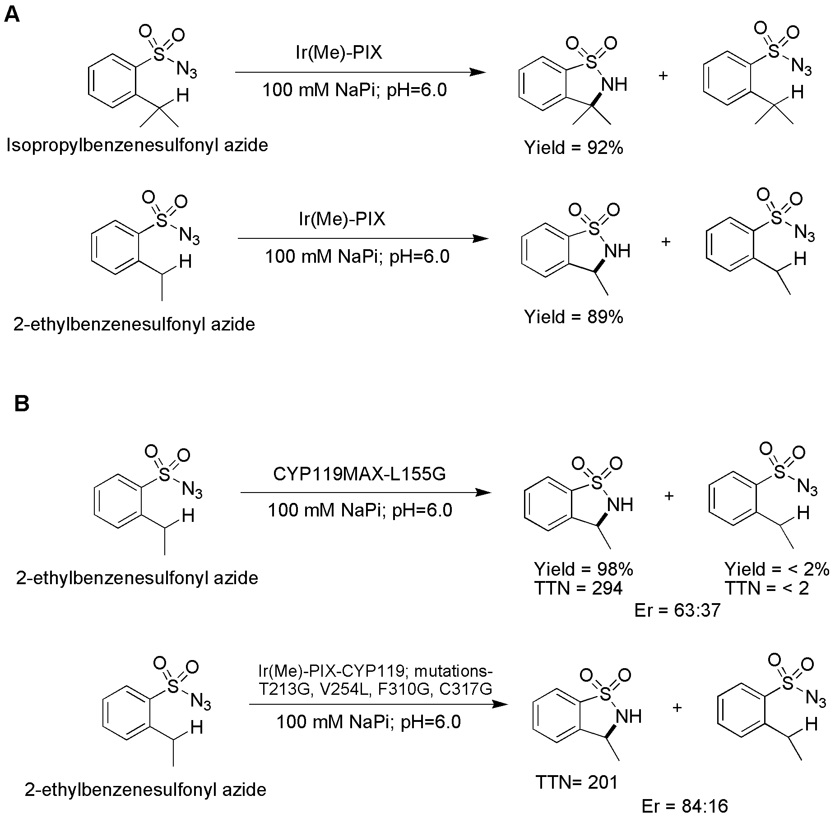
Figure 25: Enantioselective C-H amination of sulfonyl azide substrates catalyzed by A) Ir(Me)-PIX and B) by enzyme variants.¹⁶⁴

Many of the P450-catalyzed naturally occurring reactions continue to find a useful place in the chemical synthesis of various important compounds. The recent advances achieved in expanding the scope of reactions catalyzed by P450s have facilitated biocatalytic reactions that no longer depend on the natural antecedents.¹⁴² The recent experimental studies on the substrates belonging to various chemical classes have demonstrated the feasibility of the applicability of P450-mediated catalysis, especially C-H amination, for the generation of complex amine structures possessing pharmaceutical relevant activities. The studies demonstrating the catalytic mechanism of C-H amination reactions and the role of active site residues involved therein have paved a way to improve the catalytic activity towards a target substrate in question and to further improve the substrate scope of the enzymes. The recently extended substrate scope for the P450-catalyzed C-H amination reaction opens exciting opportunities for the application of these versatile biocatalysts in the installation of remote C(sp3)-H positions in organic molecules.¹⁵²
Though the typical nitrene transfer reactions as such are not reported in nature, the very recent protein engineering studies have successfully demonstrated that only few of the active site mutations in P450s can commence the inestimable reaction pathways that are not catalyzed by natural enzymes.¹⁴⁹ The judiciously designed protein engineering strategies and systematic exploration of promiscuity of the natural enzymes have overcome the well-known plasticity of the P450s such as the active site of these enzymes and can now be progressively engineered to catalyze unnatural and potentially challenging reactions.¹⁵¹
While the regioselectivity of the product formed by P450-catalyzed C-H amination still remains a considerable challenge, a step forward has already been taken by using protein engineering approaches to establish P450s as a versatile platform to solve the regioselectivity issues in the enzyme-catalyzed C-H amination.¹⁴⁶
Since the first full-length sequence of P450 in the early 1980s, much has been achieved in the subsequent decades and currently >300,000 sequences are available, which are expected to reach one million in the coming four years.¹⁶⁶ As intramolecular and intermolecular nitrene transfer has now been added to the impressive array of the natural and un-natural reactions catalyzed by P450s, the structural information gained following the availability of large number of P450s can further be used for synthetically valuable transformations.^{141,150,167-169}
6. Concluding remarks
Extensive improvement in the understanding and applications of enzymes to amine synthesis has been made in the last few years. Even though commercial-scale syntheses of enantiomerically pure amines exist, for example the lipase-catalyzed deracemization of (S)-methoxyisopropylamine [(S)-MOIPA] by BASF, or the transaminase-catalyzed synthesis of sitagliptin by Merck, much of the current scientific effort is devoted to the discovery of novel enzymes other than lipases and transaminases. Major challenges connected to lipase- and transaminase-catalyzed reactions, such as reaction equilibrium limitations, are now addressed by various strategies of reaction engineering. New enzymes catalyzing reactions to enantiomerically pure amines have been developed, notably monoamine oxidases (MAOs), amine dehydrogenases (AmDHs), imine reductases (IREDs), reductive aminases (RedAms), and variants of cytochrome P450 monooxygenases (CYP P450s), all of which are covered in this review. Those developments have been helped or even enabled by progress in both protein engineering techniques and database-associated computational methods. Protein engineering approaches have been used to tackle the uneven availability of both (R)- and (S)-selective enzymes and to improve specific rate, substrate scope, and stability of the available enzymes. Also, the availability of large sequence databases has opened a new avenue of efficient combinatorial tools to accompany highly competent protein engineering techniques. Extensive research of the catalytic mechanisms of P450s, AADHs, and IREDs has led to the establishment of these enzymes as potential biocatalysts to enantiomerically pure amines. However, there is still a long way to go to understand the detailed catalytic mechanisms of recently discovered enzymes such as IREDs and AmDHs. Moreover, the substrate specificity of these biocatalysts is complex and cannot be easily generalized from one enzyme template to another. Another important challenge associated with the use of these redox biocatalysts is regeneration of expensive nicotinamide cofactors. In situ regeneration of cofactors is essential to enable economic biotransformations on the industrial scale.¹⁷⁰ Although regeneration of NADH has been subject to intensive studies in recent years, the accessibility to enzyme systems regenerating NADPH cofactors is still limited.⁴²
As enzymes are produced in cells, keeping them there poses obvious advantages for biotransformations. Disruption of microbial cells and subsequent purification of the desired protein is a laborious and costly task.¹⁷¹⁻¹⁷⁵ Use of whole-cells for biotransformations costs ca. 10% of the purified enzymes by avoiding the need for cell lysis and protein purifications.¹⁷⁶⁻¹⁷⁹ Furthermore, implementing biocatalytic syntheses in the form of whole-cell biotransformations is advantageous in in situ regeneration of the redox cofactors.¹⁸⁰ Nevertheless, mass transfer limitations imposed by the cell membrane can also be circumvented by various strategies.¹⁸¹
The last few years have witnessed the accelerated rate of discovery of new enzymes and their engineering for the applications in chiral amine synthesis. The recent discovery of natural AmDH⁸⁹ can be seen as glimmer of hope and future of redox biocatalysis research should evidence the discovery of novel enzymes by using metagenomic approaches. The near future of redox biocatalysis should also see the judiciously designed engineering of L- and D-amino acid dehydrogenases to further improve the availability of (S)-AmDHs and (R)-MAOs, respectively. Cytochrome P450-based biocatalysts often still suffer from limited total turnover numbers, which can be circumvented by further advances in protein engineering. Nevertheless, the biocatalytic pool for the synthesis of optically active amines is substantially extended and now possesses potent enzymes such as IREDs, AmDHs, MAOs and Cytochrome P450s, which currently are serving as effective alternatives to chemical synthesis.
Conflict of Interest: The authors declare no competing financial interest.

Acknowledgments:
This work was supported in part by Basic Science Research Program through the National Research Foundation of Korea (NRF) funded by the Ministry of Science, ICT and future Planning (2016R1A2B2014794). MDP gratefully acknowledges ‘Foreign Research Professorship’ under ‘2018-KU Brain Pool program’ from Konkuk University, Seoul. ASB gratefully acknowledges support from the US National Science Foundation grants 1540017 (to the I/UCRC Center for Pharmaceutical Development (CPD)) and 1512848.

References
- Bornscheuer, U. T. The Fourth Wave of Biocatalysis is Approaching. Phil. Trans. R. Soc. A. 2018, 376, 20170063.
- Denard, C. A.; Ren, H.; Zhao, H. Improving and Repurposing Biocatalysts via Directed Evolution. Curr. Opin. Chem. Biol. 2015, 25, 55-64.
- Bommarius, A. S. Biocatalysis: A Status Report. Annu. Rev. Chem. Biomol. Eng. 2015, 6, 319-45.
- Toogood, H. S.; Scrutton, N. S. Discovery, Characterization, Engineering, and Applications of Ene-Reductases for Industrial Biocatalysis. ACS Catal. 2018, 8, 3532-49.
- Patel, R. N. Biocatalysis: Synthesis of Key Intermediates for Development of Pharmaceuticals. ACS Catal. 2011, 1, 1056-74.
- Roper, L.; Grogan, G. Biocatalysis for Organic Chemists: Hydroxylations; In Organic Synthesis Using Biocatalysis, Goswami, A.; Stewart, J., Ed.; Academic Press, Elsevier Inc., Amsterdam, the Netherlands 2015, p 213-241.
- Au, S. K.; Groover, J.; Feske, B. D.; Bommarius, A. S. Organic Synthesis with Transaminases, Amino Acid Dehydrogenases, and Amine Dehydrogenases, In Organic Synthesis Using Biocatalysis, Goswami, A.; Stewart, J., Ed.; Academic Press, Elsevier Inc., Amsterdam, the Netherlands 2015, p 187-212.
- Grogan, G. Biotransformations, Annu. Rep. Prog. Chem., Sect. B: Org. Chem. 2013, 109, 15-42.
- Zhang, D.; Chen, X.; Zhang, R.; Yao, P.; Wu, Q.; Zhu, D. Development of β-amino Acid Dehydrogenase for the Synthesis of β-amino Acids via Reductive Amination of β-Keto Acids. ACS Catal. 2015, 5, 2220-2224.
- Sun, H.; Zhang, H.; Ang, E.; Zhao, H. Biocatalysis for the Synthesis of Pharmaceuticals and Pharmaceutical Intermediates. Bioorg. Med. Chem. 2018, 26, 1275-1284.
- Simon, R. C.; Mutti, F. G.; Kroutil, W. Biocatalytic Synthesis of Enantiopure Building Blocks for Pharmaceuticals. Drug Discov Today: Technologies 2013, 10, e37-e44.
- Zheng, G. W.; Xu, J. H. New Opportunities for Biocatalysis: Driving the Synthesis of Chiral Chemicals. Curr. Opin. Biotechnol. 2011, 22, 784-792.
- Gröger, H.; Hummel, W. Combining the ‘Two Worlds’ of Chemocatalysis and Biocatalysis Towards Multi-step One-pot Processes in Aqueous Media. Curr. Opin. Chem. Biol. 2004, 19, 171-179.
- Solano, D. M.; Hoyos, P.; Hernáiz, M. J.; Alcántara, A. R.; Sánchez-Montero, J. M. Industrial Biotransformations in the Synthesis of Building Blocks Leading to Enantiopure Drugs. Bioresour. Technol. 2012, 115, 196–207.
- Truppo, M. D. Biocatalysis in the Pharmaceutical Industry – The Need for Speed, ACS Med. Chem. Lett. 2017, 8, 476–480.
- Graedel, T. E. Green Chemistry and Sustainable Development; In Handbook of Green Chemistry and Technology, Clark J.; Macquarrie, D. J., Eds.; Wiley, New York, 2002, p 56–61.
- Paul, C. E.; Rodríguez-Mata, M.; Busto, E.; Lavandera, I.; Gotor-Fernández, V.; Gotor, V.; García-Cerrada, S.; Mendiola, J.; de Frutos, Ó.; Collado, I. Transaminases Applied to the Synthesis of High Added-Value Enantiopure Amines. Org. Proc. Res. Dev. 2014, 18, 788-792.
- Höhne, M.; Bornscheuer, U. T. Biocatalytic Routes to Optically Active Amines. ChemCatChem 2009, 1, 42-51.
- Wu, D.; Cai, P.; Zhao, X.; Pan, Y. Enantioselective Precipitate of Amines, Amino Alcohols, and Amino Acids via Schiff Base Reaction in the Presence of Chiral Ionic Liquid. Org. Lett. 2017, 19, 5018-5021.
- Ghislieri, D.; Turner, N. J. Biocatalytic Approaches to the Synthesis of Enantiomerically Pure Chiral Amines, Top. Catal. 2014, 57, 284–300.
- Breuer, M.; Ditrich, K.; Habicher, T.; Hauer, B.; Kesseler, M.; Stürmer, R.; Zelinski, T. Industrial Methods for the Production of Optically Active Intermediates. Angew. Chemie. Int. Ed. 2004, 43, 788-824.
- Constable, D. J.; Dunn, P. J.; Hayler, J. D.; Humphrey, G. R.; Leazer Jr, J. L.; Linderman, R. J.; Lorenz, K.; Manley, J.; Pearlman, B. A.; Wells, A.; Zaks, A. Key Green Chemistry Research Areas—A Perspective from Pharmaceutical Manufacturers. Green Chem. 2007, 9, 411-420.
- Gomm, A., O’Reilly, E. Transaminases for Chiral Amine Synthesis. Curr. Opin. Chem. Biol. 2018, 43,106-112.
- Albarrán-Velo, J., González-Martínez, D., Gotor-Fernández, V. Stereoselective Biocatalysis: A Mature Technology for the Asymmetric Synthesis of Pharmaceutical Building Blocks. Biocatal. Biotransformation 2018, 36, 102-130.
- Kürti, L. Streamlining Amine Synthesis. Science 2015, 348, 863-864.
- Guo, F.; Berglund, P. Transaminase Biocatalysis: Optimization and Application. Green Chem. 2017, 19, 333–360.
- Koszelewski, D.; Tauber, K.; Faber, K.; Kroutil, W. ω-Transaminases for the Synthesis of Non-Racemic α-Chiral Primary Amines. Trends Biotechnol. 2010, 28, 324-332.
- Mangas-Sanchez, J.; France, S. P.; Montgomery, S. L.; Aleku, G. A.; Man, H.; Sharma, M.; Ramsden, J. I.; Grogan, G.; Turner, N. J. Imine Reductases (IREDs). Curr. Opin. Chem. Biol. 2017, 37, 19-25.
- Sharma, M.; Mangas-Sanchez, J.; Grogan, G. NAD(P)H-Dependent Dehydrogenases for the Asymmetric Reductive Amination of Ketones: Structure, Mechanism, Evolution and Application. Adv. Synth. Catal. 2017, 359, 2011-2025.
- Kohls, H.; Steffen-Munsberg, F.; Höhne, M. Recent Achievements in Developing the Biocatalytic Toolbox for Chiral Amine Synthesis. Curr. Opin. Chem. Biol. 2014, 19, 180-192.
- Slabu, I.; Galman, J. L.; Lloyd, R. C.; Turner, N. J. Discovery, Engineering, and Synthetic Application of Transaminase Biocatalysts. ACS Catal. 2017, 7, 8263–8284.
- Busto, E.; Simon, R. C.; Richter, N.; Kroutil, W. Enzymatic Synthesis of Chiral Amines using ω-Transaminases, Amine Oxidases, and the Berberine Bridge Enzyme, In Green Biocatalysis, First Edition.; Patel, R. N. Ed., John Wiley & Sons, Inc., Hoboken, New Jersey, 2016; p. 17-57
- Brundiek, H.; Höhne, M. Transaminases – A Biosynthetic Route for Chiral Amines, In Applied Biocatalysis: From Fundamental Science to Industrial Applications, Ed. Hilterhaus, L.; Liese, A.; Kettling, U.; Antranikian, G. Wiley-VCH Verlag GmbH & Co., Weinheim, Germany, 2016; p 199-218.
- Mathew, S.; Yun, H. ω-Transaminases for the Production of Optically Pure Amines and Unnatural Amino Acids. ACS Catal. 2012, 2, 993-1001.
- Patil, M. D.; Grogan, G.; Bommarius, A; Yun, H. Recent Advances in ω-Transaminase-Mediated Biocatalysis for the Enantioselective Synthesis of Chiral Amines. Catalysts 2018, 8, 254.
- Patil, M. D.; Grogan, G.; Yun, H. Biocatalyzed C‐C bond formation for the production of alkaloids. ChemCatChem 2018. In Press, https://doi.org/10.1002/cctc.201801130.
- Scheller, P. N.; Fademrecht, S.; Hofelzer, S.; Pleiss, J.; Leipold, F.; Turner, N. J.; Nestl, B. M.; Hauer, B. Enzyme Toolbox: Novel Enantiocomplementary Imine Reductases. ChemBioChem 2014, 15, 2201-2204.
- Lenz, M.; Borlinghaus, N.; Weinmann, L.; Nestl, B. M. Recent Advances in Imine Reductase-Catalyzed Reactions. World J. Microb. Biotechnol. 2017, 33, 199.
- France, S. P.; Howard, R. M.; Steflik, J.; Weise, N. J.; Mangas-Sanchez, J.; Montgomery, S. L.; Crook, R.; Kumar, R.; Turner, N. J. Identification of Novel Bacterial Members of the Imine Reductase Enzyme Family that Perform Reductive Amination. ChemCatChem 2018, 10, 510-514.
- Huang, H.; Liu, X.; Zhou, L.; Chang, M.; Zhang, X. Direct Asymmetric Reductive Amination for the Synthesis of Chiral β-Arylamines. Angew. Chem. Int. Ed. 2016, 55, 5309-5312.
- Brenna, D.; Porta, R.; Massolo, E.; Raimondi, L.; Benaglia, M. A. New Class of Low-Loading Catalysts for Highly Enantioselective, Metal-Free Imine Reduction of Wide General Applicability. ChemCatChem 2017, 9, 941-945.
- Borlinghaus, N.; Nestl, B. Switching the Cofactor Specificity of an Imine Reductase. ChemCatChem 2018, 10, 183-187.
- Sehl, T.; Hailes, H. C.; Ward, J. M.; Menyes, U.; Pohl, M.; Rother, D. Efficient 2-Step Biocatalytic Strategies for the Synthesis of All Nor (Pseudo) Ephedrine Isomers. Green Chem. 2014, 16, 3341-3348.
- Schrittwieser, J. H.; Velikogne, S.; Kroutil, W. Biocatalytic Imine Reduction and Reductive Amination of Ketones. Adv. Synth. Catal. 2015, 357, 1655-1685.
- Leipold, F.; Hussain, S.; Ghislieri, D.; Turner, N. J. Asymmetric Reduction of Cyclic Imines Catalyzed by a Whole-Cell Biocatalyst Containing an (S)-Imine Reductase. ChemCatChem 2013, 5, 3505-3508.
- Mitsukura, K.; Suzuki, M.; Tada, K.; Yoshida, T.; Nagasawa, T. Asymmetric Synthesis of Chiral Cyclic Amine from Cyclic Imine by Bacterial Whole-Cell Catalyst of Enantioselective Imine Reductase. Org. Biomol. Chem. 2010, 8, 4533-4535.
- Mitsukura, K.; Suzuki, M.; Shinoda, S.; Kuramoto, T.; Yoshida, T.; Nagasawa, T. Purification and Characterization of a Novel (R)-Imine Reductase from Streptomyces sp. GF3587. Biosci. Biotechnol. Biochem. 2011, 75, 1778-1782.
- Mitsukura, K.; Kuramoto, T.; Yoshida, T.; Kimoto, N.; Yamamoto, H.; Nagasawa, T. A NADPH-Dependent (S)-Imine Reductase (SIR) from Streptomyces sp. GF3546 for Asymmetric Synthesis of Optically Active Amines: Purification, Characterization, Gene Cloning, and Expression. Appl. Microbiol. Biotechnol. 2013, 97, 8079-8086.
- Rodríguez Mata, M.; Frank, A.; Wells, E.; Leipold, F.; Turner, N. J.; Hart, S.; Turkenburg, J. P.; Grogan, G. Structure and Activity of NADPH-Dependent Reductase Q1EQE0 from Streptomyces kanamyceticus, which Catalyses the R-Selective Reduction of an Imine Substrate. ChemBioChem 2013, 14, 1372-1379.
- Aleku, G. A.; Man, H.; France, S. P.; Leipold, F.; Hussain, S.; Toca-Gonzalez, L.; Marchington, R.; Hart, S.; Turkenburg, J. P.; Grogan, G.; Turner, N. J. Stereoselectivity and Structural Characterization of an Imine Reductase (IRED) from Amycolatopsis orientalis. ACS Catal. 2016, 6, 3880-3889.
- Li, H.; Zhang, G. X.; Li, L. M.; Ou, Y. S.; Wang, M. Y.; Li, C. X.; Zheng, G. W.; Xu, J. H. A Novel (R)-Imine Reductase from Paenibacillus lactis for Asymmetric Reduction of 3 H-Indoles. ChemCatChem 2016, 8, 724-727.
- Li, H.; Luan, Z. J.; Zheng, G. W.; Xu, J. H. Efficient Synthesis of Chiral Indolines Using an Imine Reductase from Paenibacillus lactis. Adv. Synth. Catal. 2015, 357, 1692-1696.
- Zhu, J.; Tan, H.; Yang, L.; Dai, Z.; Zhu, L.; Ma, H.; Deng, Z.; Tian, Z.; Qu, X. Enantioselective Synthesis of 1-aryl-Substituted Tetrahydroisoquinolines Employing Imine Reductase. ACS Catal. 2017, 7, 7003-7007.
- Hussain, S.; Leipold, F.; Man, H.; Wells, E.; France, S. P.; Mulholland, K. R.; Grogan, G.; Turner, N. J. An (R)-Imine Reductase Biocatalyst for the Asymmetric Reduction of Cyclic Imines. ChemCatChem 2015, 7, 579-583.
- Maugeri, Z.; Rother, D. Application of Imine Reductases (IREDs) in Micro-Aqueous Reaction Systems. Adv. Synth. Catal. 2016, 358, 2745-2750.
- Wetzl, D.; Berrera, M.; Sandon, N.; Fishlock, D.; Ebeling, M.; Müller, M.; Hanlon, S.; Wirz, B.; Iding, H. Expanding the Imine Reductase Toolbox by Exploring the Bacterial Protein-Sequence Space. ChemBioChem 2015, 16, 1749-1756.
- Li, H.; Tian, P.; Xu, J. H.; Zheng, G. W. Identification of an Imine Reductase for Asymmetric Reduction of Bulky Dihydroisoquinolines. Org. Lett. 2017, 19, 3151-3154.
- Tutkowski, B.; Kerdphon, S.; Lime, E.; Helquist, P.; Andersson, P. G.; Wiest, O.; Norrby, P. O. Revisiting the Stereodetermining Step in Enantioselective Iridium-Catalyzed Imine Hydrogenation. ACS Catal. 2017, 8, 615-623.
- Chakraborty, S., Milstein, D. Selective Hydrogenation of Nitriles to Secondary Imines Catalyzed by an Iron Pincer Complex. ACS Catal. 2017, 7, 3968-3972.
- Long, J.; Shen, K.; Li, Y. Bifunctional N-doped Co@ C Catalysts for Base-Free Transfer Hydrogenations of Nitriles: Controllable Selectivity to Primary Amines vs Imines. ACS Catal. 2016, 7, 275-284.
- Kocovsky, P.; Stoncius, S. Reductions of Imines with Trichlorosilane Catalyzed by Chiral Lewis Bases, In Chiral Amine Synthesis: Methods, Developments and Applications, Nugent, T. C.; Ed.; Wiley, Weinheim, 2010, p 131-156.
- Church, T. L.; Andersson, P. G. Chiral Amines from Transition-Metal-Mediated Hydrogenation and Transfer hydrogenation. In Chiral Amine Synthesis: Methods, Developments and Applications, Nugent, T. C.; Ed.; Wiley, Weinheim, 2010, p 179-223.
- Nugent, T. C.; ElShazly, M. Chiral Amine Synthesis–Recent Developments and Trends for Enamide Reduction, Reductive Amination, and Imine Reduction. Adv. Synth. Catal. 2010, 352, 753-819.
- Gee, Y. S.; El Kader, K. F.; Hyland, C. J. Synthetic Methods: Part (II) Oxidation and Reduction methods. Ann. Rep. Sec. B Org. Chem. 2013, 109, 103-125.
- Gand, M.; Müller, H.; Wardenga, R.; Höhne, M. Characterization of Three Novel Enzymes with Imine Reductase Activity. J. Mol. Catal. B: Enzym. 2014, 110, 126-132.
- Green, A. P.; Turner, N. J. Biocatalytic Retrosynthesis: Redesigning Synthetic Routes to High-Value Chemicals. Perspect. Sci. 2016, 9, 42-48.
- Whitlow, M.; Howard, A. J.; Stewart, D.; Hardman, K. D.; Kuyper, L. F.; Baccanari, D. P.; Fling, M. E.; Tansik, R. L. X-ray Crystallographic Studies of Candida albicans Dihydrofolate Reductase High Resolution Structures of the Holoenzyme and an Inhibited Ternary Complex. J. Biol. Chem. 1997, 272, 30289-30298.
- Goto, M.; Muramatsu, H.; Mihara, H.; Kurihara, T.; Esaki, N.; Omi, R.; Miyahara, I.; Hirotsu, K. Crystal Structures of Δ1-Piperideine-2-carboxylate/Δ1-Pyrroline-2-Carboxylate Reductase Belonging to a New Family of NAD(P)H-Dependent Oxidoreductases Conformational Change, Substrate Recognition, and Stereochemistry of the Reaction. J. Biol. Chem. 2005, 280, 40875-40884.
- Lenz, M.; Scheller, P. N.; Richter, S. M.; Hauer, B.; Nestl, B. M. Cultivation and Purification of Two Stereoselective Imine Reductases from Streptosporangium roseum and Paenibacillus elgii. Protein. Expr. Purif. 2017, 133, 199-204.
- Maugeri, Z.; Rother, D. Reductive Amination of Ketones Catalyzed by Whole Cell Biocatalysts Containing Imine Reductases (IREDs). J. Biotechnol. 2017, 258, 167–170.
- Aleku, G. A.; France, S. P.; Man, H.; Mangas-Sanchez, J.; Montgomery, S. L.; Sharma, M.; Leipold, F.; Hussain, S.; Grogan, G.; Turner, N. J. A Reductive Aminase from Aspergillus oryzae. Nat. Chem. 2017, 9, 961-969.
- Matzel P, Gand M, Höhne M. One-step asymmetric synthesis of (R)- and (S)-Rasagiline by Reductive Amination Applying Imine Reductases. Green Chem. 2017, 19, 385-389.
- Huber, T.; Schneider, L.; Präg, A.; Gerhardt, S.; Einsle, O.; Müller, M. Direct Reductive Amination of Ketones: Structure and Activity of S-Selective Imine Reductases from Streptomyces. ChemCatChem 2014, 6, 2248-2252.
- Scheller, P. N.; Lenz, M.; Hammer, S. C.; Hauer, B.; Nestl, B. M. Imine Reductase Catalyzed Intermolecular Reductive Amination of Aldehydes and Ketones. ChemCatChem 2015, 7, 3239-3242.
- Lenz, M.; Meisner, J.; Quertinmont, L.; Lutz, S.; Kaestner, J.; Nestl, B. M. Asymmetric Ketone Reduction by Imine Reductases. ChemBioChem 2017, 18, 253-256.
- Roiban, G. D.; Kern, M.; Liu, Z.; Hyslop, J.; Lyn T. P.; Levine, M. S.; Jordan, L. S.; Brown, K.; Hadi, T.; Ihnken, L. A.; Brown, M. J. Efficient Biocatalytic Reductive Aminations by Extending the Imine Reductase Toolbox. ChemCatChem 2017, 9, 4475-4479.
- Ma, G.; Xu, Z.; Zhang, P.; Liu, J.; Hao, X.; Ouyang, J.; Liang, P.; You, S.; Jia, X. A Novel Synthesis of Rasagiline via a Chemoenzymatic Dynamic Kinetic Resolution. Org. Process Res. Dev. 2014, 18, 1169-1174.
- Grogan, G.; Turner, N. J. InspIRED by Nature: NADPH-Dependent Imine Reductases (IREDs) as Catalysts for the Preparation of Chiral Amines. Chem-Eur. J. 2016, 22, 1900-1907.
- Man, H.; Wells, E.; Hussain, S.; Leipold, F.; Hart, S.; Turkenburg, J. P.; Turner, N. J.; Grogan, G. Structure, Activity and Stereoselectivity of NADPH-Dependent Oxidoreductases Catalysing the S-Selective Reduction of the Imine Substrate 2-Methylpyrroline. ChemBioChem 2015, 16, 1052-1059.
- Wetzl, D.; Gand, M.; Ross, A.; Müller, H.; Matzel, P.; Hanlon, S. P.; Müller, M.; Wirz, B.; Höhne, M.; Iding, H. Asymmetric Reductive Amination of Ketones Catalyzed by Imine Reductases. ChemCatChem 2016, 8, 2023-2026.
- Gand, M.; Thöle, C.; Müller, H.; Brundiek, H.; Bashiri, G.; Höhne, M. A NADH-Accepting Imine Reductase Variant: Immobilization and Cofactor Regeneration by Oxidative Deamination. J. Biotechnol. 2016, 230, 11-18.
- Fademrecht, S.; Scheller, P. N.; Nestl, B. M.; Hauer, B.; Pleiss, J. Identification of Imine Reductase-Specific Sequence Motifs. Proteins Struct. Funct. Bioinf. 2016, 84, 600-610.
- Cahn, J. K.; Werlang, C. A.; Baumschlager, A.; Brinkmann-Chen, S.; Mayo, S. L.; Arnold, F. H. A General Tool for Engineering the NAD/NADP Cofactor Preference of Oxidoreductases. ACS Synth. Biol. 2016, 6, 326-333.
- Grogan, G. Synthesis of Chiral Amines Using Redox Biocatalysis. Curr. Opin. Chem. Biol. 2018, 43, 15-22.
- Jeon, H.; Yoon, S.; Ahsan, M. M.; Sung, S.; Kim, G. H.; Sundaramoorthy, U.; Rhee, S. K.; Yun, H. The Kinetic Resolution of Racemic Amines Using a Whole-Cell Biocatalyst Co-Expressing Amine Dehydrogenase and NADH Oxidase. Catalysts 2017, 7, 251.
- Hummel, W.; Kula, M. R. Dehydrogenases for the Synthesis of Chiral Compounds. EJB Rev. 1989, 1989, 85-97.
- Galkin, A.; Kulakova, L.; Yoshimura, T.; Soda, K.; Esaki, N. Synthesis of Optically Active Amino Acids from Alpha-Keto Acids with Escherichia coli Cells Expressing Heterologous Genes. Appl. Environ. Microbiol. 1997, 63, 4651-4656.
- Itoh, N.; Yachi, C.; Kudome, T. Determining a Novel NAD⁺-Dependent Amine Dehydrogenase with a Broad Substrate Range from Streptomyces virginiae IFO 12827: Purification and Characterization. J. Mol. Catal. B: Enzym. 2000, 10, 281-290.
- Mayol, O.; David, S.; Darii, E.; Debard, A.; Mariage, A.; Pellouin, V.; Petit, J. L.; Salanoubat, M.; de Berardinis, V.; Zaparucha, A.; Vergne-Vaxelaire, C. Asymmetric Reductive Amination by a Wild-Type Amine Dehydrogenase from the Thermophilic Bacteria Petrotoga mobilis. Catal. Sci. Technol. 2016, 6, 7421-7428.
- Abrahamson, M. J.; Vázquez, F. E.; Woodall, N. B.; Moore, J. C.; Bommarius, A. S. Development of an Amine Dehydrogenase for Synthesis of Chiral Amines. Angew. Chem. Int. Ed. 2012, 51, 3969-3972.
- Abrahamson, M. J.; Wong, J. W.; Bommarius, A. S. The Evolution of an Amine Dehydrogenase Biocatalyst for the Asymmetric Production of Chiral Amines. Adv. Synth. Catal. 2013, 355, 1780-1786.
- Bommarius, B. R.; Schürmann, M.; Bommarius, A. S. A Novel Chimeric Amine Dehydrogenase Shows Altered Substrate Specificity Compared to its Parent Enzymes. Chem. Commun. 2014, 50, 14953-14955.
- Klibanov, A. M. Improving Enzymes by Using Them in Organic Solvents. Nature 2001, 409, 241-246.
- Stepankova, V.; Bidmanova, S.; Koudelakova, T.; Prokop, Z.; Chaloupkova, R.; Damborsky, J. Strategies for Stabilization of Enzymes in Organic Solvents. ACS Catal. 2013, 3, 2823-2836.
- Au, S. K.; Bommarius, B. R.; Bommarius, A. S. Biphasic Reaction System Allows for Conversion of Hydrophobic Substrates by Amine Dehydrogenases. ACS Catal. 2014, 4, 4021-4026.
- Ye, L. J.; Toh, H. H.; Yang, Y.; Adams, J. P.; Snajdrova, R.; Li, Z. Engineering of Amine Dehydrogenase for Asymmetric Reductive Amination of Ketone by Evolving Rhodococcus Phenylalanine Dehydrogenase. ACS Catal. 2015, 5, 1119-1122.
- Liu, J.; Pang, B. Q.; Adams, J. P.; Snajdrova, R.; Li, Z. Coupled Immobilized Amine Dehydrogenase and Glucose Dehydrogenase for Asymmetric Synthesis of Amines by Reductive Amination with Cofactor Recycling. ChemCatChem 2017, 9, 425-431.
- Caparco, A. A.; Bommarius, A. S.; Champion, J. A. Effect of Peptide Linker Length and Composition on Immobilization and Catalysis of Leucine Zipper‐Enzyme Fusion Proteins. AIChE J. 2018, 64, 2934-2946.
- Pushpanath, A.; Siirola, E.; Bornadel, A.; Woodlock, D.; Schell, U. Understanding and Overcoming the Limitations of Bacillus badius and Caldalkalibacillus thermarum Amine Dehydrogenases for Biocatalytic Reductive Amination. ACS Catal. 2017, 7, 3204-3209.
- Knaus, T.; Böhmer, W.; Mutti, F. G. Amine Dehydrogenases: Efficient Biocatalysts for the Reductive Amination of Carbonyl Compounds. Green Chem. 2017, 19, 453-463.
- Nicolaou, K. C.; Edmonds, D. J.; Bulger, P. G. Cascade Reactions in Total Synthesis. Angew. Chem. Int. Ed. 2006, 45, 7134-7186.
- Bugada, L. F.; Smith, M. R.; Wen, F. Engineering Spatially Organized Multi-enzyme Assemblies for Complex Chemical Transformation, ACS Catal. 2018, 8, 7898–7906.
- Hepworth, L. J.; France, S. P.; Hussain, S.; Both, P.; Turner, N. J.; Flitsch, S. L. Enzyme Cascades in Whole Cells for the Synthesis of Chiral Cyclic Amines. ACS Catal. 2017, 7, 2920-2925.
- Denard, C. A.; Hartwig, J. F.; Zhao, H. Multistep One-Pot Reactions Combining Biocatalysts and Chemical Catalysts for Asymmetric Synthesis. ACS Catal. 2013, 3, 2856-2864.
- Sperl, J. M.; Sieber, V. Multienzyme Cascade Reactions- Status and Recent Advances. ACS Catal. 2018, 8, 2385-2396.
- Mutti, F. G.; Knaus, T.; Scrutton, N. S.; Breuer, M.; Turner, N. J. Conversion of Alcohols to Enantiopure Amines Through Dual-Enzyme Hydrogen-Borrowing Cascades. Science 2015, 349, 1525-1529.
- Chen, F. F.; Liu, Y. Y.; Zheng, G. W.; Xu, J. H. Asymmetric Amination of Secondary Alcohols by using a Redox-Neutral Two-Enzyme Cascade. ChemCatChem 2015, 7, 3838-3841.
- France, S. P.; Hepworth, L. J.; Turner, N. J.; Flitsch, S. L. Constructing Biocatalytic Cascades: In Vitro and In Vivo Approaches to De Novo Multi-Enzyme Pathways. ACS Catal. 2017, 7, 710-724.
- Schrittwieser, J. H.; Sattler, J.; Resch, V.; Mutti, F. G.; Kroutil, W. Recent Biocatalytic Oxidation–Reduction Cascades. Curr. Opin. Chem. Biol. 2011, 15, 249-256.
- Sugawara, A.; Matsui, D.; Yamada, M.; Asano, Y.; Isobe, K. Characterization of Two Amine Oxidases from Aspergillus carbonarius AIU 205. J. Biosci. Bioeng. 2015, 119, 629-635.
- Herter, S.; Medina, F.; Wagschal, S.; Benhaïm, C.; Leipold, F.; Turner, N. J. Mapping the Substrate Scope of Monoamine Oxidase (MAO-N) as a Synthetic Tool for the Enantioselective Synthesis of Chiral Amines. Bioorg. Med. Chem. 2018, 26, 1338-1346.
- Ghislieri, D.; Green, A. P.; Pontini, M.; Willies, S. C.; Rowles, I.; Frank, A.; Grogan, G.; Turner, N. J. Engineering an Enantioselective Amine Oxidase for the Synthesis of Pharmaceutical Building Blocks and Alkaloid Natural Products. J. Am. Chem. Soc. 2013, 135, 10863-10869.
- Carr, R.; Alexeeva, M.; Enright, A.; Eve, T. S.; Dawson, M. J.; Turner, N. J. Directed Evolution of an Amine Oxidase Possessing Both Broad Substrate Specificity and High Enantioselectivity. Angew. Chem. 2003, 115, 4955-4958.
- Dunsmore, C. J.; Carr, R.; Fleming, T.; Turner, N. J. A Chemo-enzymatic Route to Enantiomerically Pure Cyclic Tertiary Amines. J. Am. Chem. Soc. 2006, 128, 2224-2225.
- Alexeeva, M.; Enright, A.; Dawson, M. J.; Mahmoudian, M.; Turner, N. J. Deracemization of α-Methylbenzylamine Using an Enzyme Obtained by In Vitro Evolution. Angew. Chem. 2002, 114, 3309-3312.
- Carr, R.; Alexeeva, M.; Dawson, M. J.; Gotor-Fernández, V.; Humphrey, C. E.; Turner, N. J. Directed Evolution of an Amine Oxidase for the Preparative Deracemization of Cyclic Secondary Amines. ChemBioChem 2005, 6, 637-639.
- Bailey, K. R.; Ellis, A. J.; Reiss, R.; Snape, T. J.; Turner, N. J. A Template-Based Mnemonic for Monoamine Oxidase (MAO-N) Catalyzed Reactions and Its Application to the Chemo-Enzymatic Deracemisation of the Alkaloid (±)-crispine A. Chem. Commun. 2007, 35, 3640-3642.
- Köhler, V.; Bailey, KR.; Znabet, A.; Raftery, J.; Helliwell, M.; Turner, N. J. Enantioselective Biocatalytic Oxidative Desymmetrization of Substituted Pyrrolidines. Angew. Chem. 2010, 122, 2228-2230.
- Zajkoska, P.; Cárdenas-Fernández, M.; Lye, G. J.; Rosenberg, M.; Turner, N. J.; Rebroš, M. Chemo-Biocatalytic One-Pot Two-Step Conversion of Cyclic Amine to Lactam Using Whole Cell Monoamine Oxidase. J. Chem. Technol. Biotechnol. 2017, 92, 1558-1565.
- Yasukawa, K.; Nakano, S.; Asano, Y. Tailoring D-Amino Acid Oxidase from the Pig Kidney to R-Stereoselective Amine Oxidase and its Use in the Deracemization of α-Methylbenzylamine. Angew. Chem. Int. Ed. 2014, 53, 4428-4431.
- Nakano, S.; Yasukawa, K.; Tokiwa, T.; Ishikawa, T.; Ishitsubo, E.; Matsuo, N.; Ito, S.; Tokiwa, H.; Asano, Y. Origin of Stereoselectivity and Substrate/Ligand Recognition in an FAD-Dependent R-Selective Amine Oxidase. J. Phys. Chem. B. 2016, 120, 10736-10743.
- Markošová, K.; Dolejš, I.; Stloukal, R.; Rios-Solis, L.; Rosenberg, M.; Micheletti, M.; Lye, G. J.; Turner, N. J.; Rebroš, M. Immobilisation and Kinetics of Monoamine Oxidase (MAO-N-D5) Enzyme in Polyvinyl Alcohol Gels. J. Mol. Catal. B: Enzym. 2016, 129, 69-74.
- Isobe, K.; Sasaki, T.; Aigami, Y.; Yamada, M.; Kishino, S.; Ogawa, J. Characterization of a New Enzyme Oxidizing ω-amino Group of Aminocarboxyric Acid, Aminoalcohols and Amines from Phialemonium sp. AIU 274. J. Mol. Catal. B: Enzym. 2013, 96, 89-95.
- Yasuda, K.; Sugimoto, H.; Hayashi, K.; Takita, T.; Yasukawa, K.; Ohta, M.; Kamakura, M.; Ikushiro, S.; Shiro, Y.; Sakaki, T. Protein Engineering of CYP105s for Their Industrial Uses. BBA-Proteins Proteom. 2018, 1866, 23–31.
- Cook, D. J.; Finnigan, J. D.; Cook, K.; Black, G.W.; Charnock, S. J. Cytochromes P450: History, Classes, Catalytic Mechanism, and Industrial Application. In Advances in Protein Chemistry and Structural Biology; Academic Press, Elsevier Inc., Cambridge, United States of America, 2016, Vol. 105, p 105-126.
- Durairaj, P.; Hur, J. S.; Yun, H. Versatile Biocatalysis of Fungal Cytochrome P450 Monooxygenases. Microb. Cell Fact. 2016, 15, 125.
- Jung, S.T.; Lauchli, R.; Arnold, F. H. Cytochrome P450: Taming a Wild Type Enzyme. Curr. Opin. Biotechnol. 2011, 22, 809-817.
- Ahsan, M. M.; Sung, S.; Jeon, H.; Patil, M. D.; Chung, T.; Yun, H. Biosynthesis of Medium-to Long-Chain α, ω-Diols from Free Fatty Acids Using CYP153A Monooxygenase, Carboxylic Acid Reductase, and E. coli Endogenous Aldehyde Reductases. Catalysts 2017, 8, 4.
- Ahsan, M. M.; Jeon, H.; Nadarajan, S. P.; Chung, T.; Yoo, H-W.; Kim, B-G.; Patil, M. D.; Yun, H. Biosynthesis of the Nylon 12 Monomer, ω‐Aminododecanoic acid with Novel CYP153A, AlkJ, and ω‐TA Enzymes. Biotechnol. J. 2018, 13, 1700562.
- Ahsan, M. M; Patil, M. D.; Jeon, H.; Sung, S.; Chung, T.; Yun, H. Biosynthesis of Nylon 12 Monomer ω-Aminododecanoic Acid Using Artificial Self-Sufficient P450, AlkJ and ω-TA. Catalysts 2018, 8, 400.
- Coelho, P. S.; Wang, Z. J.; Ener, M. E.; Baril, S. A.; Kannan, A.; Arnold, F. H.; Brustad, E. M. A Serine-Substituted P450 Catalyzes Highly Efficient Carbene Transfer to Olefins In Vivo. Nature Chem. Biol. 2013, 9, 485-487.
- Munro, A. W.; Girvan, H. M.; Mason, A. E.; Dunford, A. J.; McLean, K. J. What Makes a P450 Tick? Trends Biochem. Sci. 2013, 38, 140-150.
- Guengerich, F. P.; Waterman, M. R., Egli, M. Recent Structural Insights into Cytochrome P450 Function. Trends Pharmacol. Sci. 2016, 37, 625-640.
- Poulos, T. L.; Johnson, E. F. Structures of Cytochrome P450 Enzymes, In Cytochrome P450: Structure, Mechanism, and Biochemistry, 4th ed., De Montellano, P.R., Ed. Springer Science & Business Media; Switzerland, 2015, Vol. 1, p. 87-114.
- Hannemann, F.; Bichet, A.; Ewen, K. M.; Bernhardt, R. Cytochrome P450 Systems—Biological Variations of Electron Transport Chains. Biochim. Biophys. Acta (BBA)-Gen. Subjects 2007, 1770, 330-344.
- Ducharme, J.; Auclair, K. Use of Bioconjugation with Cytochrome P450 Enzymes. Biochim Biophys Acta (BBA) - Proteins Proteom. 2018, 1866, 32–51.
- Shalan, H.; Kato, M.; Cheruzel, L. Keeping the Spotlight on Cytochrome P450. Biochim. Biophys. Acta (BBA)-Proteins Proteom. 2018, 1866, 80–87.
- Whitehouse, C. J.; Bell, S. G.; Wong, L. L. P450 BM3 (CYP102A1): Connecting the Dots. Chem. Soc. Rev. 2012, 41, 1218-1260.
- Urlacher, V. B.; Girhard, M. Cytochrome P450 Monooxygenases: An Update on Perspectives for Synthetic Application. Trends Biotechnol. 2012, 30, 26-36.
- Munro, A. W.; Leys, D. G.; McLean, K. J.; Marshall, K. R.; Ost, T. W.; Daff, S.; Miles, C. S.; Chapman, S. K.; Lysek, D. A.; Moser, C. C.; Page, C. C. P450 BM3: The Very Model of a Modern Flavocytochrome. Trends Biochem. Sci. 2002, 27, 250-257.
- Fasan, R. New Functional Twists for P450s. Nature Chem. 2017, 9, 609-611.
- McIntosh, J. A.; Coelho, P. S.; Farwell, C. C.; Wang, Z. J.; Lewis, J. C.; Brown, T. R.; Arnold, F. H. Enantioselective Intramolecular C-H Amination Catalyzed by Engineered Cytochrome P450 Enzymes In Vitro and In Vivo. Angew. Chem. Int. Ed. 2013, 52, 9309−9312
- Bordeaux, M.; Singh, R.; Fasan, R. Intramolecular C(sp3)H Amination of Arylsulfonyl Azides with Engineered and Artificial Myoglobin-Based Catalysts. Bioorg. Med. Chem. 2014, 22, 5697-5704.
- Paradine, S. M.; White, M. C. Iron-Catalyzed Intramolecular Allylic C–H Amination. J. Am. Chem. Soc. 2012, 134, 2036-2039.
- Roizen, J. L.; Harvey, M. E.; Du Bois, J. Metal-Catalyzed Nitrogen-Atom Transfer Methods for the Oxidation of Aliphatic C–H Bonds. Acc. Chem. Res. 2012, 45, 911-922.
- Hyster, T. K.; Farwell, C. C.; Buller, A. R.; McIntosh, J. A.; Arnold, F. H. Enzyme-Controlled Nitrogen-Atom Transfer Enables Regiodivergent C–H Amination. J. Am. Chem. Soc. 2014, 136, 15505-15508.
- Singh, R.; Bordeaux, M.; Fasan, R. P450-Catalyzed Intramolecular sp3 C–H Amination with Arylsulfonyl Azide Substrates. ACS Catal. 2014, 4, 546-552.
- Wei, Y.; Ang, E.L.; Zhao, H. Recent Developments in the Application of P450 Based Biocatalysts. Curr. Opin. Chem. Biol. 2018, 43, 1-7.
- Prier, C. K.; Hyster, T. K.; Farwell, C. C.; Huang, A.; Arnold, F. H. Asymmetric Enzymatic Synthesis of Allylic Amines: A Sigmatropic Rearrangement Strategy. Angew. Chem. Int. Ed. 2016, 55, 4711 –4715.
- Farwell, C. C.; McIntosh, J. A.; Hyster, T. K.; Wang, Z. J.; Arnold, F. H. Enantioselective Imidation of Sulfides via Enzyme-Catalyzed Intermolecular Nitrogen-Atom Transfer. J. Am. Chem. Soc. 2014, 136, 8766-8771.
- Farwell, C. C.; Zhang, R. K.; McIntosh, J. A.; Hyster, T. K.; Arnold, F. H. Enantioselective Enzyme-Catalyzed Aziridination Enabled by Active-Site Evolution of a Cytochrome P450. ACS Cent. Sci. 2015, 1, 89-93.
- Singh, R.; Kolev, J. N.; Sutera, P. A.; Fasan, R. Enzymatic C(sp3)-H Amination: P450-Catalyzed Conversion of Carbonazidates into Oxazolidinones. ACS Catal. 2015, 5, 1685-1691.
- Saibabu Kotti, S. R.; Timmons, C.; Li, G. Vicinal Diamino Functionalities as Privileged Structural Elements in Biologically Active Compounds and Exploitation of Their Synthetic Chemistry. Chem. Biol. Drug Des. 2006, 67, 101-114.
- Ager, D. J.; Prakash, I.; Schaad, D. R. 1, 2-Amino Alcohols and Their Heterocyclic Derivatives as Chiral Auxiliaries in Asymmetric Synthesis. Chem. Rev. 1996, 96, 835-876
- Prier, C. K.; Zhang, R. K.; Buller, A. R.; Brinkmann-Chen, S.; Arnold, F. H. Enantioselective, Intermolecular Benzylic C–H Amination Catalysed by an Engineered Iron-Haem Enzyme. Nature Chem. 2017, 9, 629-634.
- Coelho, P. S.; Brustad, E. M.; Kannan, A.; Arnold, F. H. Olefin Cyclopropanation via Carbene Transfer Catalyzed by Engineered Cytochrome P450 Enzymes. Science 2013, 339, 307-310.
- Tyagi, V.; Bonn, R. B.; Fasan, R. Intermolecular Carbene S–H Insertion Catalysed by Engineered Myoglobin-Based Catalysts, Chem. Sci. 2015, 6, 2488-2494.
- Key, H. M.; Dydio, P.; Clark, D. S.; Hartwig, J. F. Abiological Catalysis by Artificial Haem Proteins Containing Noble Metals in Place of Iron. Nature 2016, 534, 534-537.
- Wei, Y.; Ang, E. L.; Zhao, H. Recent Developments in the Application of P450 Based Biocatalysts. Curr. Opin Chem. Biol. 2018, 43, 1-7.
- Oohora, K.; Kihira, Y.; Mizohata, E.; Inoue, T.; Hayashi, T. C(sp3)–H Bond Hydroxylation Catalyzed by Myoglobin Reconstituted with Manganese Porphycene. J. Am. Chem. Soc. 2013, 135, 17282-17285.
- Uchida, T.; Katsuki, T. Asymmetric Nitrene Transfer Reactions: Sulfimidation, Aziridination and C–H Amination Using Azide Compounds as Nitrene Precursors. Chem. Rec. 2014, 14, 117-129.
- Lu, H.; Zhang, X. P. Catalytic C–H Functionalization by Metalloporphyrins: Recent Developments and Future Directions. Chem. Soc. Rev. 2011, 40, 1899-1909.
- Chan, K. H.; Guan, X.; Lo, V. K.; Che, C. M. Elevated Catalytic Activity of Ruthenium (II)–Porphyrin‐Catalyzed Carbene/Nitrene Transfer and Insertion Reactions with N‐Heterocyclic Carbene Ligands. Angew. Chem. Int. Ed. 2014, 53, 2982-2987.
- Dydio, P.; Key, H. M.; Hayashi, H.; Clark, D. S.; Hartwig, J. F. Chemoselective, Enzymatic C–H Bond Amination Catalyzed by a Cytochrome P450 Containing an Ir (Me)-PIX Cofactor. J. Am. Chem. Soc. 2017, 139, 1750-1753.
- Dydio, P.; Key, H. M.; Nazarenko, A.; Rha, J. E.; Seyedkazemi, V.; Clark, D. S.; Hartwig, J. F. An Artificial Metalloenzyme with the Kinetics of Native Enzymes. Science 2016, 354, 102-106.
- Nelson, D. R. Cytochrome P450 Diversity in the Tree of Life. Biochim. Biophys. Acta (BBA)-Proteins Proteom. 2018, 1866, 141-154.
- Grogan, G. Cytochromes P450: Exploiting Diversity and Enabling Application as Biocatalysts. Curr. Opin. Chem. Biol. 2011, 15, 241-248.
- Brandenberg, O. F.; Fasan, R.; Arnold, F. H. Exploiting and Engineering Hemoproteins for Abiological Carbene and Nitrene Transfer Reactions. Curr. Opin. Biotechnol. 2017, 47, 102-111.
- McIntosh, J. A.; Farwell, C. C.; Arnold, F. H. Expanding P450 Catalytic Reaction Space Through Evolution and Engineering. Curr. Opin. Chem. Biol. 2014, 19, 126-134.
- Van Der Donk, W. A.; Zhao, H. Recent Developments in Pyridine Nucleotide Regeneration. Curr. Opin. Biotechnol. 2003, 14, 421-426
- Patil, M. D.; Shinde, A. S.; Dev, M. J.; Patel, G.; Bhilare, K. D.; Banerjee, U. C. Combined Effect of Attrition and Ultrasound on the Disruption of Pseudomonas putida for the Efficient Release of Arginine Deiminase. Biotechnol. Prog. 2018. https://doi.org/10.1002/btpr.2664.
- Patil, M. D.; Dev, M. J.; Tangadpalliwar, S.; Patel, G.; Garg, P.; Chisti, Y.; Banerjee, U. C. Ultrasonic Disruption of Pseudomonas putida for the Release of Arginine Deiminase: Kinetics and Predictive Models. Bioresour. Technol. 2017, 233, 74-83.
- Patil, M. D.; Rathod, V. P.; Bihade, U. R.; Banerjee, U. C. Purification and Characterization of Arginine Deiminase from Pseudomonas putida: Structural Insights of the Differential Affinities of L-arginine Analogues. J. Biosci. Bioeng. 2018. https://doi.org/10.1016/j.jbiosc.2018.07.021.
- Bhilare, K. D.; Patil, M. D.; Tangadpalliwar, S.; Dev, M. J.; Garg, P.; Banerjee, U. C. Machine Learning Modelling for the High-pressure Homogenization-mediated Disruption of Recombinant E. coli. Process Biochem. 2018, 71, 182-190
- Patil, M. D.; Patel, G.; Surywanshi, B.; Shaikh, N.; Garg, P.; Chisti, Y.; Banerjee, U.C. Disruption of Pseudomonas putida by High Pressure Homogenization: A Comparison of the Predictive Capacity of Three Process Models for the Efficient Release of Arginine Deiminase. AMB Express 2016, 6, 84.
- Sheldon, R. A.; Brady, D. The Limits to Biocatalysis: Pushing the Envelope. Chem. Commun. 2018, 54, 6088-6104.
- Wachtmeister, J.; Rother, D. Recent Advances in Whole Cell Biocatalysis Techniques Bridging from Investigative to Industrial Scale. Curr. Opin. Biotechnol. 2016, 42, 169-177.
- Lin, B.; Tao, Y. Whole-cell biocatalysts by design. Microb. Cell Fact. 2017, 16, 106.
- Sheldon, R.A.; Woodley, J.M. Role of Biocatalysis in Sustainable Chemistry. Chem. Rev. 2017, 118, 801-838.
- Sung S, Jeon H, Sarak S, Ahsan MM, Patil MD, Kroutil W, Kim BG, Yun H. Parallel Anti-Sense Two Step Cascade for Alcohol Amination Leading to ω-Amino Fatty Acids and α, ω-Diamines. Green Chem. 2018. http://dx.doi.org/10.1039/C8GC02122H.
- Patil, M. D.; Dev, M. J.; Shinde, A. S.; Bhilare, K. D.; Patel, G.; Chisti, Y.; Banerjee, U. C. Surfactant-mediated Permeabilization of Pseudomonas putida KT2440 and Use of the Immobilized Permeabilized Cells in Biotransformation. Process Biochem. 2017, 63, 113-121.
Table of Contents (TOC) graphic

