Facile and Rapid Decarboxylation of Glutamic Acid to γ-Aminobutyric Acid via Microwave-assisted Reaction: Towards Valorisation of Waste Gluten

Yann Lie,ª Thomas J. Farmer^{a*} and Duncan J. Macquarrieª

ª Green Chemistry Centre of Excellence, Department of Chemistry, University of York, Heslington, York, YO10 5DD, UK. Email: thomas.farmer@york.ac.uk, telephone: +44 (0)1904 324479.

Keywords: Renewable materials; glutamic acid; gamma-aminobutyric acid; isophorone; bio-based chemicals

Abstract
The growing trend towards the utilisation of biomass to produce fuels and chemicals has the potential to produce large quantities of protein-rich wastes that may be unsuitable for use as a feed. This protein waste could instead serve as a sustainable feedstock for the production of useful nitrogen-containing bio-based chemicals. We report herein the production of γ-aminobutyric acid from glutamic acid via a microwave-assisted decarboxylation reaction using isophorone as an inducer reagent. High yields of 63% can be achieved with only short reaction times (7 minutes) required. The influences of inducer loading, reaction time and hydrochloric acid concentration used for hydrolysis step of the work up were investigated at different scales. As a proof of concept, glutamic acid was facilely isolated from waste gluten, via microwave assisted hydrolysis, and subsequently decarboxylated with success. To the best of our knowledge this is the first organocatalytic route to γ-aminobutyric acid using glutamic acid as a reagent, and represents an alternative cleaner route to a valuable precursor for bio-based solvents, polymers and pharmaceuticals.

Introduction
The production of bio-derived platform molecules is essential for making the shift from an oil-based to a bio-based society (Gallezot, 2012; Mukherjee et al., 2015). Most of these compounds considered so far are derived from isolated (pure) components (e.g. polysaccharides) of abundant lignocellulosic materials and examples include 5-(hydroxymethyl)furfural (HMF) (Rosatella et al., 2011), levulinic acid (Bozell et al., 2000), itaconic acid (Robert and Friebel, 2016) or 5-(chloromethyl)furfural (CMF) (Mascal and Nikitin, 2008) the latter being available from raw lignocellulosic biomass (Mascal and Nikitin, 2010). These can subsequently produce a diverse range of products including polymers, solvents, fuel additives or intermediates for more complex molecules. Nevertheless, the production of bio-derived nitrogen-containing platform molecules has been little considered (Froidevaux et al., 2016; Pelckmans et al., 2017). Until now, routes to such products in industry proceed through reactions of ammonia or nitric acid with alcohols, halogenoalkanes or the hydrogenation of nitriles (Froidevaux et al., 2016).
Bio-based alternative to these processes are possible through the decarboxylation of amino acids by key routes, one oxidative that leads to the nitrile equivalent (Claes et al., 2015a; Laval and Golding, 2003; Stevenson and Luck, 1961) of the amino acid and the other thermal organocatalyzed route, producing the amine equivalent (Hashimoto et al., 1986; Omeis et al., 2009; Yaegashi and Mikami, 2007). Most amino acids are currently produced via the fermentation of sugars (sucrose, glucose etc.) by genetically engineered microorganisms. On the other hand, amino acid can also be sourced from protein-containing feedstock such as gluten from wheat, feathers from poultry industry, dried distillers grain solubles (DDGS) or microalgae (Lammens et al., 2012). The development of bio-refineries will generate a large amount of protein-rich co-product when targeting the conversion of biomass components. It has been evaluated that with 10% of biofuels replacing the petroleum fuel by 2020 almost 100 million tons of proteins will be generated as co-product (Lammens, 2011; Scott et al., 2007; Teng, 2014). Most of these proteins may not be suitable for feed or food industry due to severe pre-treatments during the biofuel process (e.g. acid/alkaline hydrolysis and toxic solvent extraction). The diversity of amino acids contained in (waste) proteins represents an exciting opportunity to source bio-derived nitrogen containing molecules. However, the different properties of the 20 naturally occurring amino acids make their isolation complex and time-consuming. In fact, to the best of our knowledge, only glutamic acid could be isolated with good purity from biomass-derived proteins thanks to its abundance when compared to other amino acid residues.
Glutamic acid (Scheme 1, 1) is one of the most produced amino acids (2 million tons/year in 2009) (Sano, 2009) and is mainly used as a flavour enhancer (MSG) giving the well-known “umami” taste. It is primarily produced by a sucrose fermentation process using genetically modified microorganisms (Hidetsugu et al., 1994; Jun et al., 2009). However, it is possible to specifically recover it from a protein hydrolysate at low pH (Sano, 2009) or by electrodialysis (Teng et al., 2012). Thus, glutamic acid is the candidate of choice among the amino acids for the production of bio-derived amines via decarboxylation.

Scheme 1. Pathways to useful products through GABA as a decarboxylation product of glutamic acid

From a green perspective, earlier methods for the decarboxylation of glutamic acid suffer from several drawbacks: use of expensive metal catalysts such as Pd or Ru (Claes et al., 2015b; De Schouwer et al., 2015a), immobilised enzymes (with expensive co-factor) (Lammens et al., 2009; Lee et al., 2013), long reaction times (Claes et al., 2015a) and /or need for halonium species (Laval and Golding, 2003; Stevenson and Luck, 1961). In addition, among those methods, only the enzyme-catalysed synthesis produces γ-aminobutyric acid (GABA Scheme 1, 2) the others leading to the nitrile equivalent or to GABA’s cyclic equivalent 2-pyrroidone (Scheme 1, 3).
GABA is a potential platform chemical containing a carboxylic acid and an amine group at the opposing end of its carbon chain (ω-amino carboxylic acid). As such, it is a precursor for Nylon 4 (Scheme 1, 4), (Park et al., 2013; Zhao et al., 2016) N-alkyl pyrrolidone (Scheme 1, 5) (Lammens et al., 2010; Sherwood et al., 2016) or pharmaceuticals (Scheme 1, 6) (Hur et al., 2017) and has been recently used for the synthesis of Racetams in a three component Ugi reaction (Cioc et al., 2016)
We describe herein an alternative organocatalyzed thermal decarboxylation of glutamic acid to GABA via acid hydrolysis of 2-pyrrolidone formed in the first step using microwave heating and isophorone as an inducer reagent. Glutamic acid isolated from gluten hydrolysate (obtained after microwave heating) has also been used to produce GABA using the decarboxylation method developed in this study.

Materials and Method

2.1 Chemicals
Isophorone (97%) was purchased from Alfa Aesar; n-propanol (≥99%) from Acros Organics; ~37% w/w HCl, NaOH pellets (≥98 %) and diethyl ether (≥99%) from Fischer Scientifics; gluten from wheat was purchased from Tokyo Chemical Industries (TCI); acetone (≥99.5%), ethyl acetate (≥99 %), γ-aminobutyric acid (≥99%), glutamic acid (Reagent plus ≥99%) and 2-pyrolidone (≥99%) from Sigma-Merck. Deionised water was obtained from internal laboratory system using Centra Elga filtration apparatus.

2.2 General decarboxylation procedure
In a typical experiment, 2 or 5 mmol of glutamic acid was mixed with 3 mL of n-propanol and 4 or 10 mmol of isophorone (600 µl or 1.5 mL respectively) in a 30 mL CEM discover glass vial. A magnetic stirrer was then added, the vial was closed with a CEM silicon seal provided by the manufacturer and placed in the microwave chamber. The target temperature was set at 190 ºC in dynamic mode, via the CEM Synergy software this temperature was typically reached within 5 min and held for the length of time as indicated in Table 1 with stirring set to “high”. After this first heating and once the reaction mixture had cooled to 55 ºC the vial was released from the microwave chamber and 4 eq. of HCl was added in a one-pot fashion (4 mL or 10 mL for the 2 M solution, 1.33 mL or 3.33 mL for the 6M solution for the 2 mmol or 5 mmol scale experiment respectively). The vial was returned to the microwave chamber and a second heating step of a ramp to 190 ºC in dynamic mode (i.e. no hold time). The reaction was then allowed to cool and washed with diethyl ether or preferably ethyl acetate (1x25 mL), the water phase collected and the organic phase washed with 2 M HCl (10 mL) followed by deionised water (10 mL). The collected aqueous phases were washed with diethyl ether or preferably ethyl acetate (2x25 mL) and evaporated at 60 ºC, 67 mbar. The resulting light yellow oil was triturated with acetone to afford the HCl salt of GABA which was filtered, dried under vacuum (72 mbar) at 80 ºC for 2 hours then weighed (isolated yield) prior to analysis.
The collected organic phases were dried over MgSO₄ (~ 5 g) and evaporated at 40 ºC, 240 mbar for ethyl acetate and 40 ºC, 850 mbar for diethyl ether prior analysis. The obtained organic phase contained mostly isophorone (assessed by GC-FID), this was reused in the recycling experiments without further purification.
The conventional heating comparison was performed at 2 mmol scale (due to limitation by reactor size) in an AntonParr monowave 50. Target temperatures and hold times were identical to the aforementioned methodology. All work-up and characterisation were carried out as described above.

2.3 Isolation of glutamic HCl from gluten.
For the microwave assisted hydrolysis gluten (1 g) and 6 M HCl (50 mL) were suspended in a EasyPrep plus reactor with a stirrer bar and heated at 150 ºC or 180 ºC in a CEM Mars microwave reactor for 30 min or 10 min respectively with a 16 min or 20 min ramping time respectively, power was set at 400 W and cooling allowed for 20 min after the reaction was complete. All these operations were programmed with the built-in software.
For the conventional heating method, a 100 mL round bottom flask was charged with 1 g of gluten and 50 mL of 6 M HCl. The suspension was heated at reflux for 24 h with vigorous magnetic bar stirring (~300 rpm). For both the microwave and conventional systems the humins residue were filtered and washed with a small amount of 6M HCl. Activated carbon (250 mg) was added to the hydrolysate and stirred for 30 minutes and subsequently filtered. The solution was reduced to a viscous liquid at 60 ºC, 60 mbar and subsequently dissolved in 3 mL of 6 M HCl, this was left in a fridge (2-4 ºC) overnight. The resulting glutamic acid precipitate was separated via vacuum filtration from the supernatant, washed with few drops of n-propanol and left to dry in air. The purity was assessed by NMR spectroscopy using methylsulfone as an internal standard and confirmed by comparing FT-IR spectra of pure glutamic acid HCl salt crystals and those obtained by the method described above.

2.4 Isolation of glutamic acid free base
A solution of glutamic acid HCl salt (784.5 mg) obtained from gluten following the method described above was dissolved in 10 mL of water. The pH of the solution (originally ~1) was adjusted to 3.2 with pure NaOH (solid) and 0.1 M NaOH solution. The solution started to crash and was left in a fridge overnight. The obtained crystals were collected via filtration and washed with few drops of n-propanol, (46% yield). Success of the procedure was assessed by CHN analysis (Theoretical: C 40.82% H 6.17% N 9.52% Obtained: C 40.49% H 6.11% N 9.43%) and NMR spectroscopy (Theoretical: ¹H-NMR (400 MHz; D2)): δ 3.78 (t, J = 6.4 Hz, 1H), 2.59-2.46 (m, 2H), 2.18-2.04 (m, 2H) Obtained: ¹H-NMR (400 MHz): δ 3.76 (t, J = 6.3 Hz, 1H), 2.56-2.43 (m, 2H), 2.17-2.03 (m, 2H)).

2.5 Analytical method and instruments
A CEM Discover microwave was used in all cases unless specified (decarboxylations) the infrared temperature sensor calibration was done using an ethylene glycol solution following the manufacturer recommendation (operation manual).
Pictures of the reaction were taken using the build-in camera in an Anton Paar Monowave 400 in which the temperature was monitored using a ruby probe calibrated by the manufacturer.
The conventional heating comparison was done using an Anton Paar Monowave 50 with the integrated temperature and pressure controllers calibrated by the manufacturer. The temperature measurement is routinely checked using an IR sensor verification that compares to the reading obtained from the Ruby temperature probe. Re-adjustment is performed if the difference between the IR sensor and Ruby temperature probe exceeds 5 °C at any point over the verification heating profile.
The gluten hydrolysis was done in a CEM Mars microwave which temperature and pressure were monitored with the built-in optic probe and pressure gauge calibrated by the manufacturer.
¹H NMR spectra were recorded on a Jeol 400 spectrometer (400 MHz) using D₂O as solvent. Quantitative NMR spectroscopy using methylsulfone as an external standard assessed the purity of the isolated products and allowed for accurate calculations of the yields as reported in Table 1. A longer relaxation time (D1= 10 s) and 32 scans were used for these experiments. Calculations are available in the supplementary information.
FT-IR spectroscopy was performed on a Perkin-Elmer spectrum 400 FT-IR spectrometer (4 scans, between 650 and 4000 cm⁻¹). ESI-MS were recorded on a Bruker micrOTOF spectrometer. CHN analysis was conducted on an Exeter Analytical, Inc. CE-440 Elemental Analyzer.
GC/MS experiments were run on a Perkin Elmer GC 500 equipped with Rxi-5HT column coupled with a Perkin Elmer mass spectrometer 560. The GC method was as followed: initial temperature 50 ºC, holding 0 min, Ramp rate 30 ºC/min, Temperature final: 300 ºC, hold 5 min, split ratio 5:1, injector temperature 300 ºC. A few drops of reaction samples were diluted in methanol prior injection in the GC-MS.
GC-FID analyses were run on an Agilent 6890 equipped with a Rxi-5HT column. The GC method was as followed: initial temperature 50 ºC, holding 0min, Ramp rate 30 ºC/min, Temperature final: 300 ºC, hold 5 min, split ratio 5:1, injector temperature 300 ºC.
Heidolph rotary evaporator and controller equipped with a water bath and a Vacuubrand CVC 2 pressure controller and pump were used to evaporate the solvents.

Results and Discussion
3.1 Initial trials and optimization of reaction time
At high temperature (>120 ºC) glutamic acid is thought to convert readily to pyroglutamic acid (Scheme 2, 7), this being the dominant reported product (De Schouwer et al., 2015b; Teng et al., 2012). Indeed, the decarboxylation at elevated temperature of glutamic acid is known to be particularly challenging relative to many of the other amino acids as a result of its preference to form 2. In addition, Weiss’s thermal decomposition study of natural amino acids (Weiss et al., 2018) ruled out the decarboxylation of pyroglutamic acid to 2-pyrrolidone during decomposition as they did not observed CO₂ emission from temperature ranging from 50 to 300 ºC.

Scheme 2. Lactamization of glutamic acid to pyroglutamic acid

The thermal organo-catalysed decarboxylation of amino-acids with carbonyls has been known since the 19th century (Strecker, 1862), but has been sparsely investigated since initial studies using different carbonyls and selected amino acids (Brandt et al., 2006; Chatelus, 1964; Dose, 1957; Obata and Ishikawa, 1966). The original paper by Hashimoto et al. was the first using a cyclic enone catalyst (2-cyclohexene-1-one, Scheme 3, 8) for the decarboxylation of several naturally occurring amino acids but did not mention glutamic acid nor pyroglutamic acid as a possible substrate (Hashimoto et al., 1986). In addition, other research articles clearly stated that glutamic acid could not react using a structurally similar carbonyl inducers (R-carvone, Scheme 3, 9) (Jackson et al., 2015).

Scheme 3. Different cyclic enone catalyst used for the decarboxylation of amino acids: isophorone (3), R-carvone (4) and 2-cyclohexene-1-one (5)

In a patent titled “Process for decarboxylation of carboxylic acids” isophorone (Scheme 3, 10) was described as a potential organocatalyst for the decarboxylation of amino acids (Marianne Omeis et al., 2009). However, the examples given solely focused on the decarboxylation of lysine with no evidence that other amino acids were suitable substrates for this method. Given the capacity of isophorone to induce decarboxylation and its potential recovery (Clark et al., 2018) the decarboxylation of glutamic acid was attempted with this cyclic enone.
Initially, a 2 mmol scale experiment was conducted at 190 ºC. Photographs were taken at regular time intervals to assess the completion of the reaction (suspension turning into clear solution, Figure 1) (Brandt et al., 2006; Hashimoto et al., 1986; Jackson et al., 2015). The reaction medium turned from an opaque suspension to a clear pale yellow solution within 7-8 minutes at 190 ºC (Figure 1, G-H). The yellow colouration was likely to be due to the formation of oxime species (Scheme 4, 11), imines (Scheme 4, 12), or isophorone related impurities (dimers Scheme 4, 13a or 13b (Gonçalves et al., 1998), trimers (Kind et al., 2014)). A prolonged reaction time led to browning of the reaction medium (Fig 1, I), this was attributed to the further formation of impurities as above. Thus, 7 minutes was later selected as the optimal reaction time for further optimisation.
Scheme 4. Possible structures of coloured compound formed during heating of the reaction

Figure 1. Photographs of reaction medium over the course of the reaction. 2 mmol of glutamic acid, 4 mmol of isophorone, 3 mL of n-propanol temperature hold at 190 ºC reached within 5 min

Characterisation of the product (isolated as an HCl salt, ESI-Figures S1-S3) was conducted with ¹H NMR spectroscopy (e.g. Figure 2) and comparison with the NMR and FT-IR spectra of the pure GABA HCl salt (ESI-Figures S4-S6) was made to ensure the product was not glutamic acid HCl salt (ESI-Figures S7-S9), 2-pyrrolidone (ESI-Figures S10-S12) or pyroglutamic acid (ESI-Figures S13-S15) (as postulated by De Schouwer et al., 2015a; Sari et al., 2014; Teng et al., 2012). Further analysis (ESI-MS, CHN is available through the accompanying dataset) confirmed the success of the procedure.

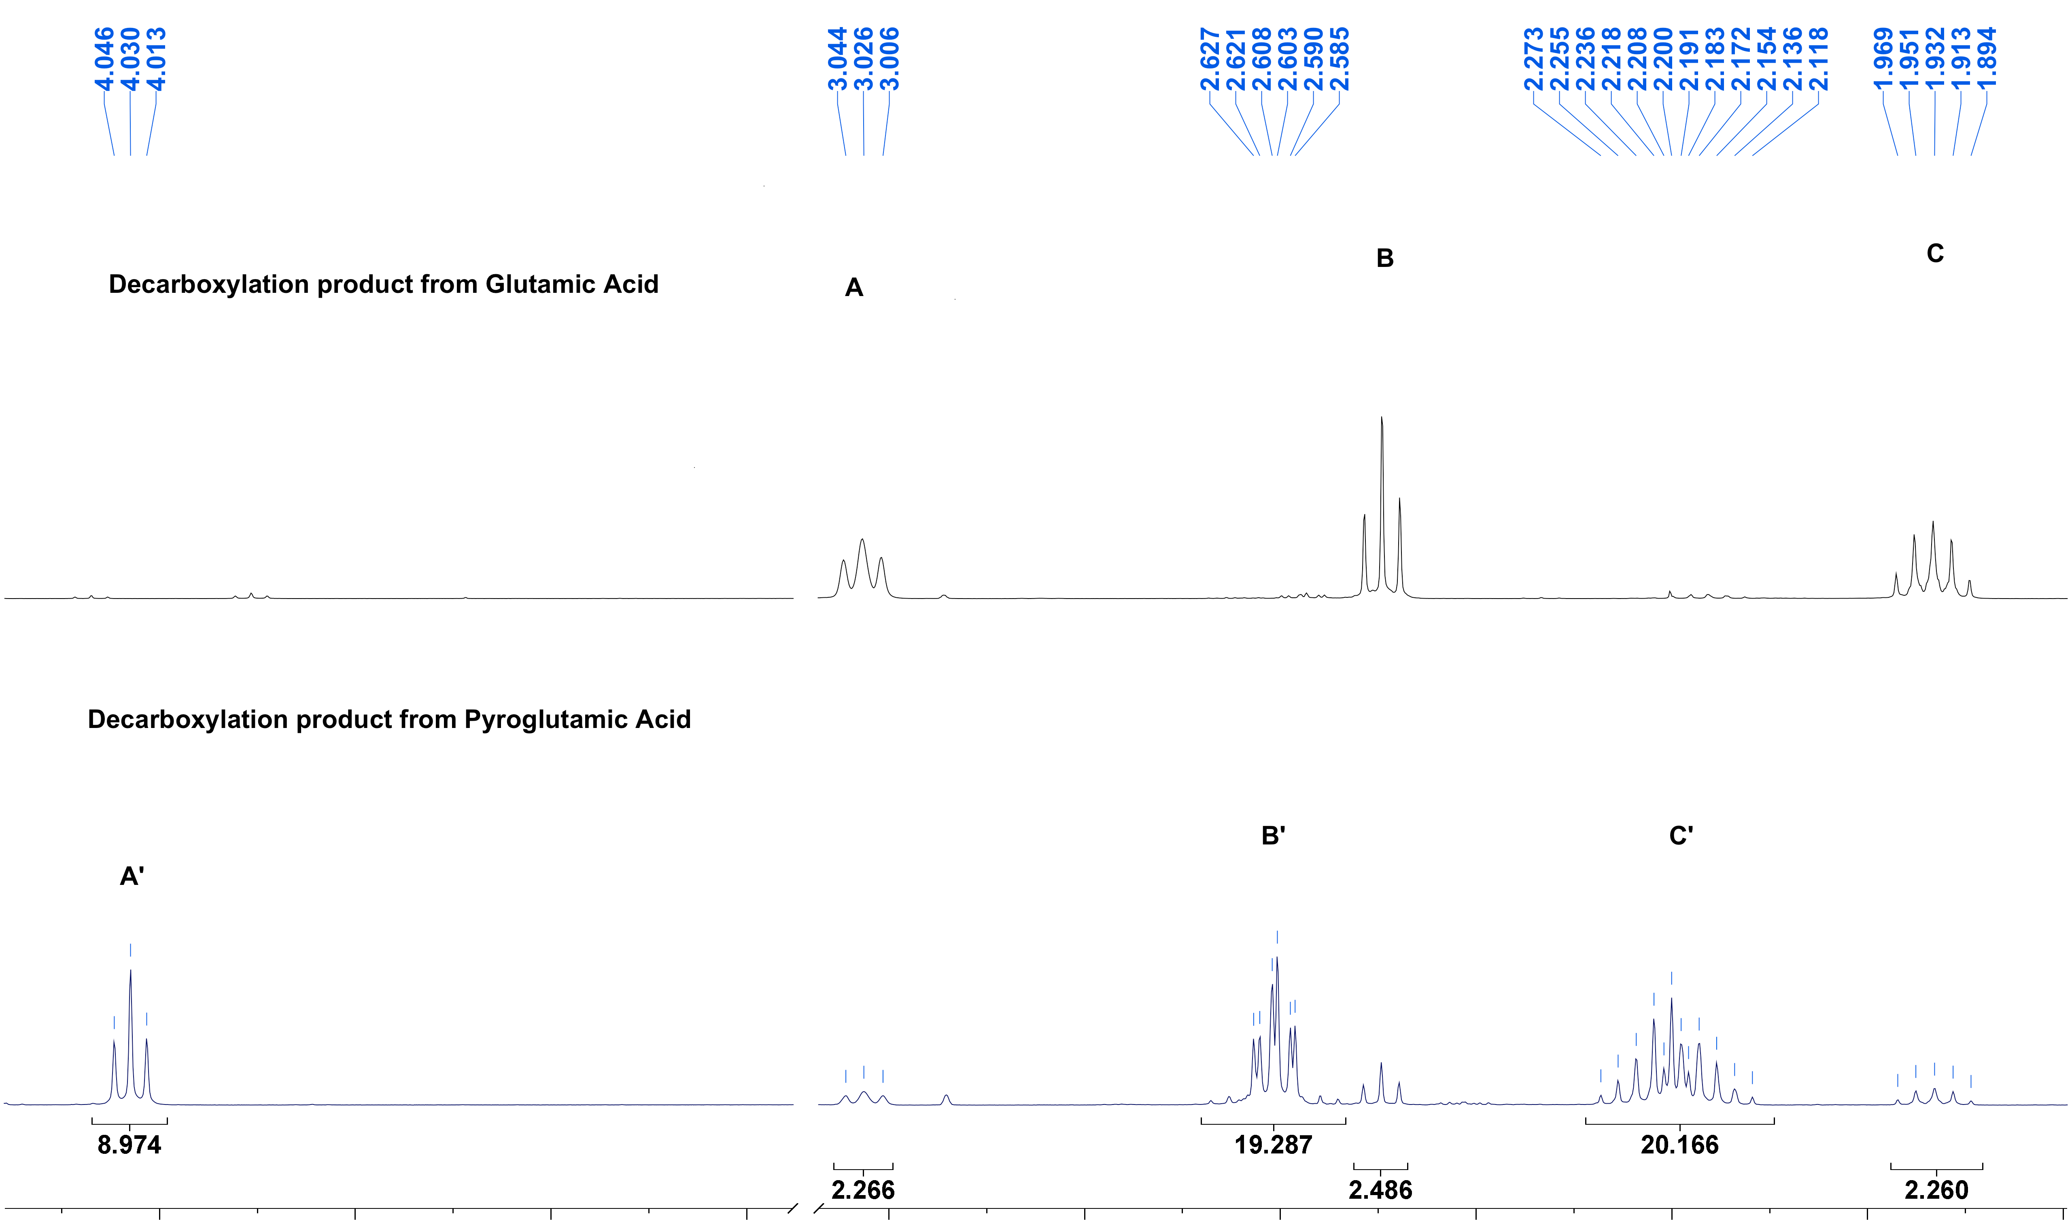
Figure 2. NMR spectra of product of the reaction using glutamic acid (Table 1, entry 4, top spectrum) or pyroglutamic (5 mmol, 2 eq. isophorone, bottom spectrum) as starting material. Methylsulfone standard peak was cut for insert 3.1-3.8 ppm, NMR solvent = D₂O

Glutamic acid decarboxylation to GABA has already been described using (immobilized) glutamic acid decarboxylase (GAD) (Lammens et al., 2009; Teng et al., 2014). However, in most cases the use of an expensive co-factor (pyridoxal phosphate) is necessary and additional costs of the enzymes and the immobilization procedure are also required. Furthermore, despite the possibility to replace PLP with the much cheaper 𝛼-ketoglutaric acid (Lammens et al., 2009), the eventual deactivation of the GAD is unavoidable. On the other hand, the decarboxylation with isophorone does not require immobilisation, is cheap and easy to handle (no pH buffers) and can be scaled up facilely.
Despite its attractiveness, it is known that carbonyl decarboxylation inducers require a higher loading (2 equivalent), than other expensive metal catalyst (Verduyckt et al., 2017). In addition, the influence of the concentration of the HCl solution used to separate impurities from the reaction medium was suspected to influence the reaction due to the amount of water added in the reaction vessel. Thus, the influence of two reaction parameters were subsequently investigated:
- The HCl concentration used for the hydrolysis of the mixture during the second heating step (6 M or 2 M HCl solution as described by Jackson et al., 2015)
- The isophorone loading (0, 0.1, 0.5, 1 or 2 equivalents)

3.2 Influence of the HCl concentration on GABA yield
First, the product obtained without a hydrolysis step after heating glutamic acid and isophorone for 7 min at 190 ºC was analysed. It only resulted in a mixture of 2-pyrrolidone, pyroglutamic acid (1:0.7 ratio) and isophorone (excess) detected in the crude product but no GABA (Figure 3). This indicated that it is indeed the HCl hydrolysis step that converts the initial 2-pyrrolidone formed in the first step to GABA.
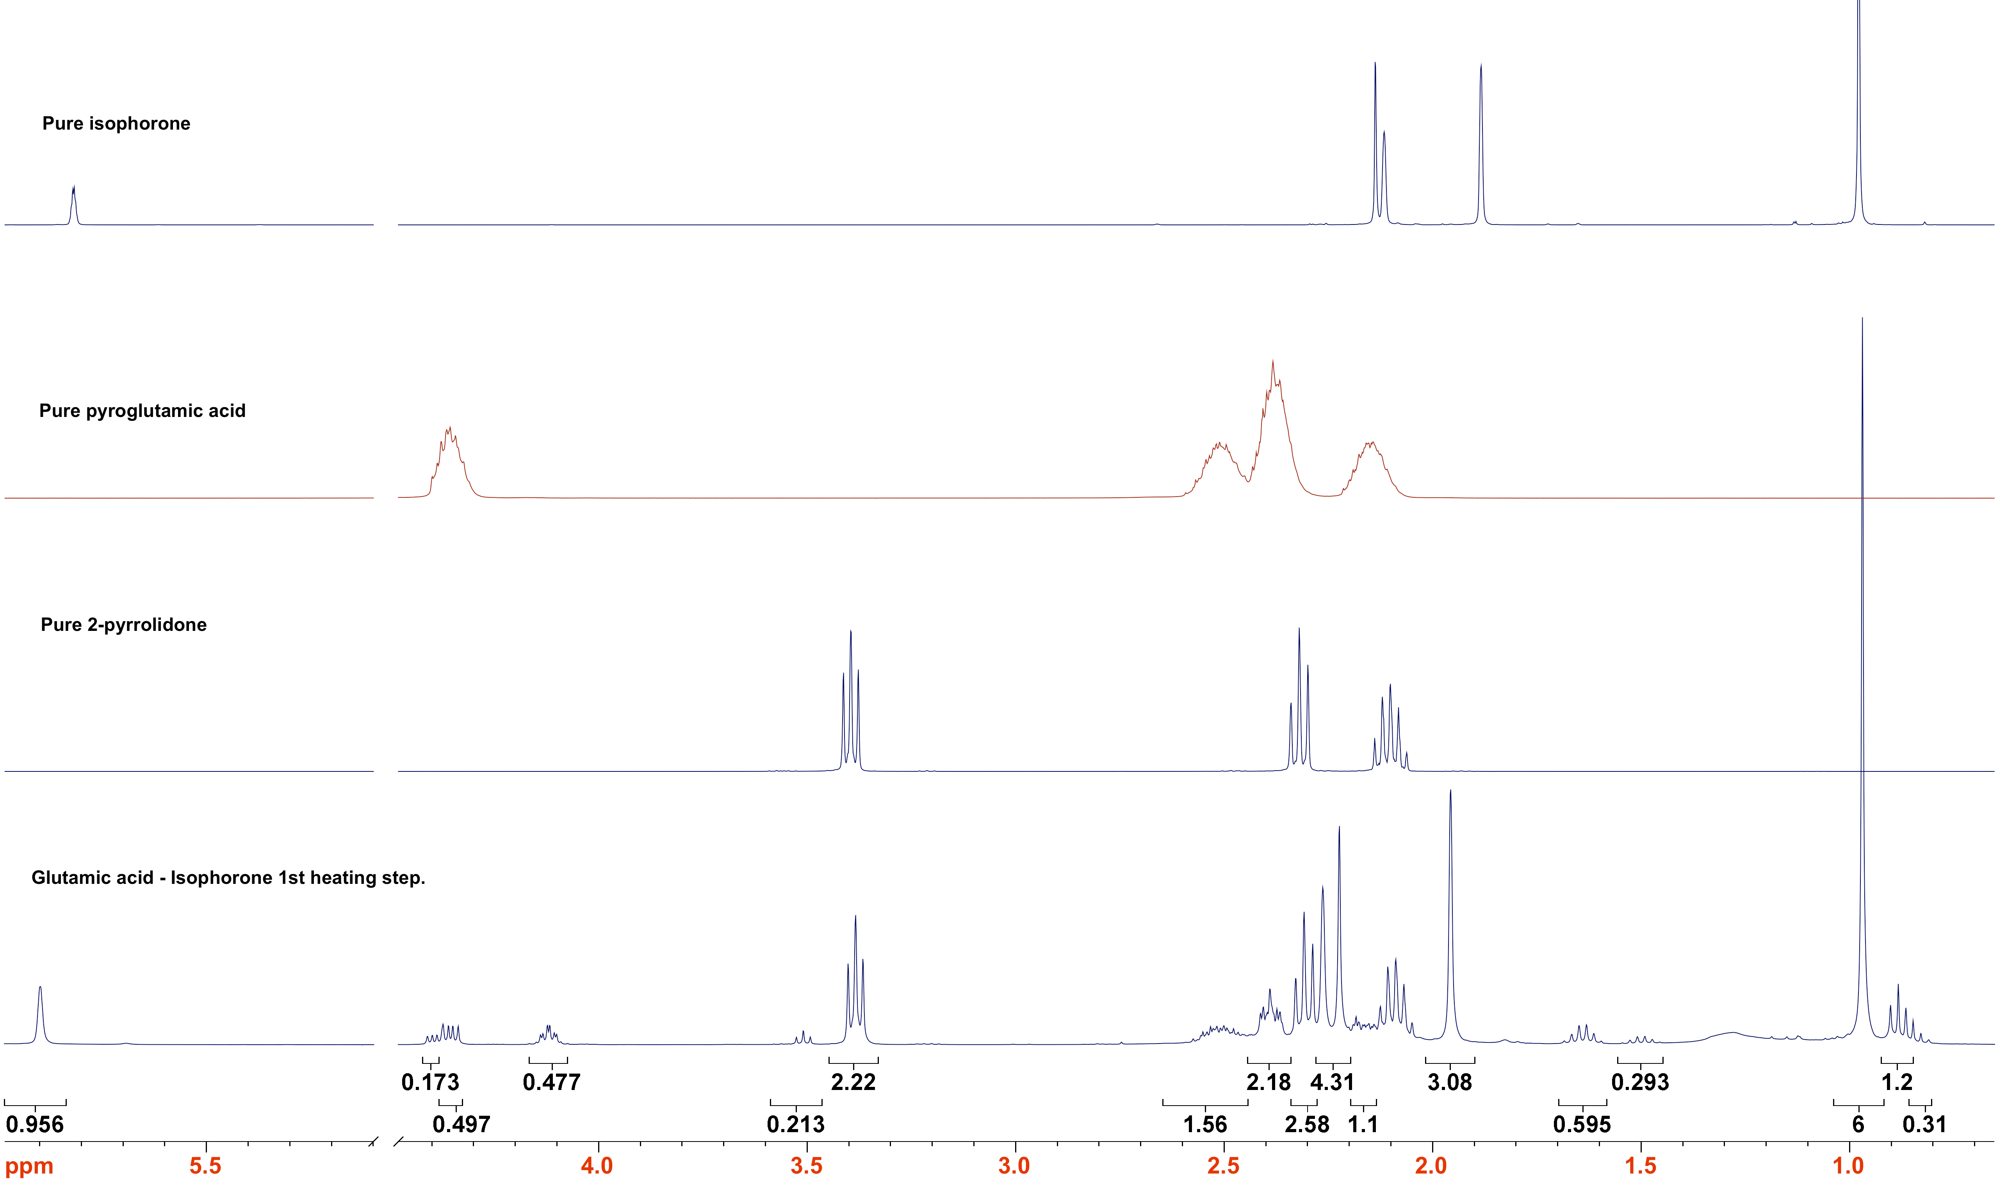
Figure 3. NMR spectrum of: the crude mixture after first reaction step at 190 ºC for 7 min (5 mmol, 2 eq. isophorone, bottom); pure 2-pyrrolidone (middle-bottom); pure pyroglutamic acid (middle-top); pure isophorone (top). Water peak was cut for insert 5-4.5 ppm, NMR solvent = D₂O

The highest yields were obtained when heating for 20 minutes at 190 ºC during the first reaction step, followed by using a 6 M HCl solution for the hydrolysis second step (entry 9, Table 1). However, an almost similar yield was obtained when heating for 7 min and using a 2 M HCl solution for hydrolysis (entry 5, Table 1). Furthermore, the ¹H NMR and FT-IR spectra (ESI-Figures S16-S18) show that residual glutamic acid (~20% by NMR spectroscopy) was present in both cases. At 5 mmol scale it was concluded that the concentration of the HCl solution did not appear to have a significant impact on the yield or the mass ratio (Table 1, entries 5-10) of the final product. Finally, the reaction time during the first heating step did not appear to change the product distribution as expected and further confirmed the suitability of choosing a 7 min holding time at 190 ºC for the first reaction step.

Table 1. Summary of the decarboxylation reaction investigating the use of 6 M or 2 M HCl solution for the hydrolysis step at different scale and holding time
Entry | Glutamic Acid | Time (min) | Isophorone loading | HCl conc. | Mass ratio (%) |  | GABA Yield (%)
1 | 2 mmol | 7 | 4 mmol | 2 M |  | 76 | 56
2 |  |  | 4 mmol | 6 M |  | 59 | 49
3 |  | 13 | 4 mmol | 2 M |  | 57 | 51
4 |  |  | 4 mmol | 6 M |  | 21 | 21
5 | 5 mmol | 7 | 10 mmol | 2 M |  | 79 | 63
6 |  |  | 10 mmol | 6 M |  | 70 | 53
7 |  | 13 | 10 mmol | 2 M |  | 61 | 48
8 |  | 20 | 10 mmol | 2 M |  | 67 | 50
9 |  |  | 10 mmol | 6 M |  | 69 | 65

Interestingly, the 2 mmol scale experiment displayed a different behaviour depending on the HCl concentration used. When the reaction was heated for 13 minutes and a 6 M HCl solution was employed for the hydrolysis, a lower yield (21%, entry 4, Table 1) was obtained. On the other hand, no glutamic acid was detected in the collected product with ¹H NMR spectroscopy (98% purity using methyl sulfone as an internal standard, Figure 2, top spectrum). However, when using the diluted 2 M HCl solutions the presence of glutamic acid was observed (purity between 70-85%, entries 1-3, Table 1). This would demonstrate that depending on the initial glutamic acid loading the water content of the acid solution used for the hydrolysis step may have an impact on the product distribution. However, for ease of separation and measurements it was decided to pursue the reaction investigation at 5 mmol (initial loading of glutamic acid) and using a 2 M HCl solution for the hydrolysis step.

3.3 Optimisation of the isophorone loading
No decarboxylation occurred in the absence of isophorone (Figure 4 and ESI-Figures S19-S20) highlighting the need for this inducer. After an aqueous work-up, the organic phase mainly contained pyroglutamic acid and n-propanol together with pyroglutamic acid propyl ester (~1:1.5:2), the latter from the reaction between former two (ESI-Figures S21-24). The collected product after evaporation of the aqueous phase was glutamic acid HCl salt (45%).
Interestingly, a catalytic amount of isophorone (0.1 mmol, 2% mol. eq) led to a drop in GABA yield, the major product being glutamic acid HCl salt. 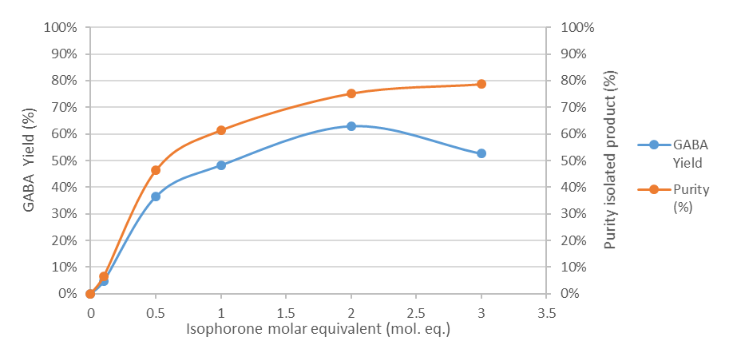
Figure 4. GABA yield and purity against molar equivalent of isophorone. Reaction conditions: 7 min holding time at 190ºC, 5 mmol glutamic acid, 10 mL of 2 M HCl for the hydrolysis step

From Figure 4 it appeared that using more than a 2 molar eq. of isophorone did not lead to a significant improvement in yield nor purity of the isolated product. In addition, using a catalytic amount of isophorone (0.1 mmol) for a prolonged reaction (15 or 30 min) time had no effect on the final isolated yield (7.5% and 4.5% respectively). From these observations, it can be concluded that using 2 molar equivalent of isophorone was necessary to obtain a good yield of GABA.
Other impurities collected after the trituration step with acetone were analysed by GC-MS (ESI-Figures S25-30) and were attributed to several side reactions. The formation of 5-propylester-2-pyrrolidone (Scheme 5, 14) from the reaction between 2-pyrrrolidone and propanol (Scheme 5, i) could explain the main impurity detected with a mass of m/z = 143. This mass could also be explained by the reaction of GABA and acetone (Scheme.5, ii) forming 7-amino-2,4-heptanedione (Scheme 5, 15) during the crystallization step. The second impurity detected is likely due to the reaction between 2-pyrrolidone and GABA (Scheme 5, iii) to form 1-(4-aminobutanoyl)-2-pyrrolidone (Scheme 5, 16) (m/z = 171) or the esterification of pyroglutamic acid with propanol (Scheme 5, iv) forming pyroglutamic n-propyl ester (Scheme 5, 17).

Scheme 5. Possible structures of by-products identified with gas chromatography mass spectrometry

The decarboxylation of glutamic acid leading to its nitrile counterpart 3-cyanopropanoic acid leads to a different product distribution. Reports of the in situ generation of halonium species for the decarboxylation of glutamic acid used hydrogen bromide and tungsten layered double hydroxide (LDH) heterogeneous catalyst with NH₄Br (Claes et al., 2015a), N-bromo succinimide (NBS) (Laval and Golding, 2003), o-iodoxybenzoic acid (IBX) (Bellale et al., 2011) and earlier chloramine T (Dakin, 1917) or sodium hypobromite (Friedman and Morgulis, 1936; Norman, 1936). In most cases the reaction product contained the amino acid aldehyde counterpart, sometimes in significant proportion (Dakin, 1917; Friedman and Morgulis, 1936; Norman, 1936).
Moreover, the use of haloperoxidases allow formation of halonium species in situ (in that case Br⁺) in the presence of hydrogen peroxide (Nieder and Hager, 1985) that is necessary for the oxidative decarboxylation of amino acids (Schönberg et al., 1951; Stevenson and Luck, 1961). Due to the specificity of enzymes for their substrate and the reaction they catalyse the selectively of the oxidative decarboxylation for the nitrile compound is much higher. But et al (But et al., 2017, 2012) used a vanadium chloroperoxidase to decarboxylate and oxidise glutamic acid to 3-cyanopropanoic acid. But’s study also highlighted the differences in reactivity between glutamic acid and the closely related aspartic acid, with the former undergoing the cyanodecarboxylation more effectively.
Recently, a solid-supported Pd/C catalysed decarboxylation of pyroglutamic acid (2), and glutamic acid via 2, to 2-pyrrolidone (4) was reported (De Schouwer et al., 2015a). This method uses water as a solvent and does not require hydrogen peroxide nor a halonium-giving species which greatly reduce the negative environmental impact. Indeed, hydrogen peroxide is a corrosive chemical that readily forms peroxide compounds with organic solvents and is very unstable when reacted with acetone (forming explosive acetone peroxides). Most of the halonium-giving species (NBS, IBX, NaOBr etc.) are corrosive and have a potential acute toxicity. Nevertheless, the conditions necessary to perform the improved decarboxylation are not ideal: 250 ºC, 6 hours under N₂ atmosphere. The condition used in the present study did not require an inert atmosphere and yields are comparable (63% yield of GABA in best conditions here and 70% yield of 2-pyrrolidone in De Schouwer’s study) despite the short reaction time and lower temperature. Furthermore, the use of expensive and critical metals such Pd or Ru (Claes et al., 2015b; Verduyckt et al., 2017) should be avoided on sustainability grounds (Hunt et al., 2013), and our protocol does this. The same group extended their protocol for the direct production of bio-based N-alkyl 2-pyrolidone solvents in a one-pot procedure, at least demonstrating the potential industrial application of this approach (De Schouwer et al., 2017).
In order to understand the thermal decarboxylation of glutamic acid a mechanistic investigation based on glutamic acid (protected) analogues as well as the reported products (pyroglutamic acid, 2-pyrrolidone and GABA) was performed.

3.5 Mechanistic investigation
Since it was stated in earlier studies that the formation of pyroglutamic acid readily occurs at elevated temperature (>120 ºC) (Teng et al., 2012) the decarboxylation was attempted with this as the starting compound. However, the main product obtained was instead glutamic acid with traces of GABA (93% mass ratio, 6% yield Figure 4). Because of the hydrolysis step, the intermediate lactam (Figure 1, 2) or Schiff base (Scheme 6, 18) are probably hydrolysed back to the aliphatic amino acid (Figure 2). The presence of GABA is therefore likely due to the glutamic acid being formed from the pyroglutamic acid during the hydrolysis step, which in turns reacts with the isophorone remaining in the solution. This could also explain the presence of glutamic acid as an impurity in the collected product from the standard reaction. It would also indicate that in earlier studies by other groups where formation of the pyroglutamic acid occurred before decarboxylation, this would indeed lead to low yields for this particular amino acid (De Schouwer et al., 2015a; Teng et al., 2014). As such, our reported protocol seemingly reduces the formation of pyroglutamic acid and represents an important step in the effective decarboxylation of glutamic acid.
Scheme 6. Proposed mechanism for the organocatalyzed decarboxylation reaction of glutamic acid to GABA via HCl hydrolysis

The same protocol was also applied using GABA as a reagent. After the first heating step the complete conversion of GABA to 2-pyrrolidone was observed by ¹H NMR spectroscopy (ESI-Figures S31-S34). The second heating with HCl allowed its hydrolysis to form GABA, this was further confirmed when 2-pyrrolidone was used in the reaction system (GABA obtained with 90% mass ratio, 55% yield ESI-Figures S35-37) for the previously indicated reason. Furthermore, using protected version of glutamic acid (N-Fmoc, 5-O^{t}Bu, OH) did not afford any crystals. Some GABA could be detected by NMR spectroscopy likely due to the instability of these protecting group at high temperature and low pH. In addition, using 5-methyl ester glutamic acid in the decarboxylation process resulted in a lower GABA yield (39 %). This observation could be due to the harder, and therefore unlikely, attack of the ester on the imine to form the intermediate 19 would require deprotection prior to the attack (this being more likely at elevated temperature).
The recovery of the excess isophorone was confirmed by GC/MS (ESI-Figures S38-39). Commonly, 65% of the isophorone could be readily recovered according to GC-FID analysis. When the reaction was run at 5% molar equivalent of isophorone, glutamic acid was the main product (4 % GABA yield by ¹H-NMR spectroscopy) but 75% of the remaining isophorone could be recovered.
Finally, it was proven possible to reuse the two organic fractions (both containing residual isophorone) obtained after an aqueous work up to run another reaction which afforded GABA at a reduced but still appreciable yield and purity (31% yield, 49.5% mass ratio).
Higher yields were difficult to obtain likely due to the low mass ratio (Table 1, entry 4). However, when the space-time yield is calculated instead the obtained value is 260 kg.m⁻³.h⁻¹ of GABA (calculated from Table 1, entry 5, detailed calculation in ESI). The value obtained is much higher than the one reported by Lammens et al. (35 kg.m⁻³.h⁻¹) using an immobilized enzymatic system (Lammens et al., 2009).
From the result presented above it appeared that two main competing reactions occurred: the formation of the Schiff base intermediate (Scheme 6, 18) and the isomerization of glutamic acid to pyroglutamic acid. Nevertheless, the hydrolysis of pyroglutamic acid could also occur during the reaction which was also promoted by the liberation of water during the imine formation. Overall, the reaction is thus driven towards the Schiff base formation. The presence of glutamic acid in the final product shows that the isomerization into pyroglutamic acid could not be avoided entirely. However, Lee et al. showed that further purification using cation exchange chromatography can afford GABA in high purity (Lee et al., 2013). We postulated that the presence of 2-pyrrolidone in the reaction medium (prior to the hydrolysis step) is due to the formation of an intermediate bicyclic species (Scheme 6, 19) which would drive the decarboxylation reaction but readily collapse to form 2-pyrrolidone and isophorone again. Ultimately, the HCl hydrolysis step permitted to separate the coloured impurities formed in the course of the reaction (supposedly phorones) whilst also forming GABA HCl salt, the latter proving easier to isolate than its lactam counterpart 2-pyrrolidone.
It has recently been shown that bubble-forming reactions were promoted by microwaves (De bruyn et al., 2017). This previous study suggests that bubbles disrupt the microwave field resulting in an over-heated zone in the vicinity of the bubbles which can further drive the reaction. Based on this recent observation decarboxylation reactions are logically also likely to be promoted by microwaves. However, when we applied conventional heating no significant difference was observed in terms of yield (38%) or mass ratio (47% at 2 mmol scale, Table.2) compared to our microwave reactions. Therefore, although benefits in being able to use microwaves exist (improved efficiency, ability to instantly stop heating / cooler surroundings) the process is not reliant on this, thus allowing versatility in the approach with conventional heating proving equally as suitable (Table 2).
Table 2. Comparison of conventional and microwave heating for the decarboxylation of glutamic acid to GABA. 2 mmol glutamic acid, 2 eq. isophorone 7 min at 190 ºC then 4 mL 2 M HCl
 | Conventional Heating | Microwave Heating
Mass ratio | 47% | 76%
GABA yield | 38% | 56%
Advantages | - Readily available  - Well-known and widespread heating method  - Easy to scale up | - Better heating efficiency,  - Safer technology  - Possible use of acid and base

Ideally, the source of glutamic acid would be protein waste from protein-rich residues issued from a biorefinery (DDGS, microalgae etc.). It was envisioned that using gluten derived glutamic acid as representative of DDGS-derived glutamic acid (Sari et al., 2014), could demonstrate a potential way to valorise protein waste.

3.4 Decarboxylation of glutamic acid obtained from gluten
Originally, glutamic acid was produced via the acid hydrolysis of protein rich biomass, for instance kombu or gluten (Ikeda and Suzuki, 1909; Sano, 2009). Indeed, glutamic acid hydrochloride has a very low solubility at low pH (<1). Furthermore, it has been postulated that the crystal system in which glutamic hydrochloride salts form prevents other amino acids to incorporate into that system:

“In addition, the (glutamic acid hydrochloride) salt crystal itself has very high selectivity against other amino acids: L-glutamic acid molecules stack along the crystal’s a-axis, linking a-amino N-H-Cl and c-carboxyl O-H-Cl hydrogen bonds (6). Structurally, it is difficult for other amino acids to insert themselves into these growing crystals […]” from (Sano, 2009; Zhang et al., 2008).

Hence, after an HCl hydrolysis glutamic acid hydrochloride preferentially precipitates from the other amino acids. However, the need for a higher production capacity and a reduction of the hazards associated with the use of HCl lead to a fermentation-based production. In the context of a green economy using gluten as a feedstock, which is a co-product from the starch production industry (Figure 5), is pertinent. It is a co-product obtained during the industrial production of starch and is currently used as cattle feed (Sari, 2015).
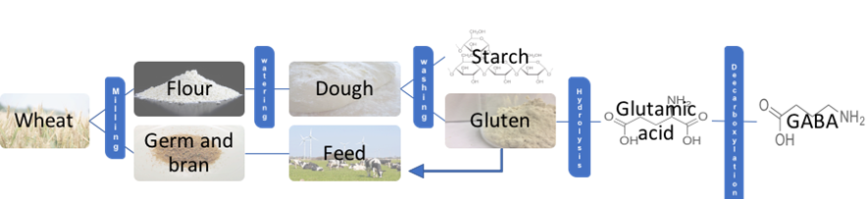
Figure 5. Valorisation of gluten from the starch production as a feedstock for GABA synthesis
Microwave heating has become a popular method for the hydrolysis of proteins, as it is possible to rapidly reach high temperatures that greatly reduces the time for reactions (conventionally 24 hours in 6 M HCl was used to completely hydrolyse proteins) (Chen et al., 2009; Fountoulakis and Lahm, 1998; Margolis et al., 1991). We envisioned that microwave heating (which can be safer and greener) could be used to isolate glutamic acid HCl from a protein hydrolysate, this would also potentially streamline with the aforementioned decarboxylation (de la Hoz et al., 2016; Galema, 1997). Two different microwave conditions for the hydrolysis of gluten were compared (Table 3) that did not show a significant difference in terms of glutamic acid yield, nor purity of the isolated product. The yields were calculated assuming a glutamic acid content of 1.81 mmol/g according to Sari et al (2015).

Table 3. Summary of the glutamic acid production from gluten
Temperature | 150 ºC | 180 ºC | 110 ºC (reflux)
Method | Microwave | Microwave | Conventional
Power | 400 W | 400 W | 630 W
Time | 30 min  (+ 16 min ramping,  20 min cooling) | 10 min  (+20 min ramping,  20 min cooling ) | 24 h
Purity | 86% | 90% | 94%
Isolated Yield | 30% | 34% | 47%
mgGlutamic acid.W⁻¹.h⁻¹ | 1.49 | 1.73 | 0.01

When comparing to a conventional method (Table 3, far right column), microwaves clearly represent an excellent alternative to drastically reduce the hydrolysis time whilst maintaining a good yield and purity of the obtained product. When only the yield is considered one may be tempted to think that conventional heating surpasses the microwave. However, when time and power is considered in the yield calculation, microwave heating clearly appears ~10 times superior. Another greener aspect of our method is the absence of a neutralization step which usually lead to a large amount of salt waste and requires further desalinization either by dialysis or by chromatography through an ion exchange resin.
Our earlier decarboxylation reaction was attempted with the glutamic acid hydrochloride salt as isolated from gluten, though only a low yield of GABA (4%) could be obtained, the main product being residual glutamic acid (Figure 6, middle spectrum). This result may indicate that the hydrochloride salts of other amino acids would not react as easily as the free base for the decarboxylation reaction, though this is yet to be verified. We postulated that the presence of HCl in the first decarboxylation step may reduce the nucleophilicity of the amino group, thus reducing the formation of the suspected imine intermediate during the decarboxylation.
To try and further improve the yield of GABA from gluten waste we first prepared the free base of glutamic acid from the gluten hydrolysate. Two commonly used methods exist to desalt amino acids. The first is to elute a solution of the amino acid hydrochloride over an anion exchange resin (e.g. Dowex50) to adsorb them. Subsequently, a second elution using a piperidine or ammonia solution allows the desorption of the amino acid free base (Buchanan, 1957; Mueller et al., 1955; Piez et al., 1952; Takano et al., 2010). The second method uses electrodialysis with ion exchange membranes (Elisseeva et al., 2002; Sandeaux et al., 1998). However, both of these methods require specific equipment and large amounts of water/salt, resulting in significant waste. Glutamic acid being a zwitterionic species, possess an isoelectric point (pI) at which its solubility in water is minimal. At this point, most of the glutamic acid present in the solution is in the form of a free base (Sano, 2009). The isolated glutamic HCl from gluten was thus converted into its free base and isolated following the procedure described in section 2.2. Success of the procedure was confirmed with NMR spectroscopy and CHN analysis (see section 2.2). The obtained crystals were used in the decarboxylation process and a much higher GABA yield could be obtained (26% Figure 6, bottom spectrum) relative to the HCl salt starting material. Under the same condition, using commercial glutamic acid free base, a GABA yield of 56% could be obtained (Figure 6, top spectrum). This difference could be explained by the possible remaining HCl in the glutamic acid free base derived from gluten hydrolysis which reduces the GABA yield. A way to further optimize the conditions would be to generate the free base in situ with the presence of a base such as NaOH, trimethylamine or piperidine and run the reaction but a substantial amount of salt may be generated.

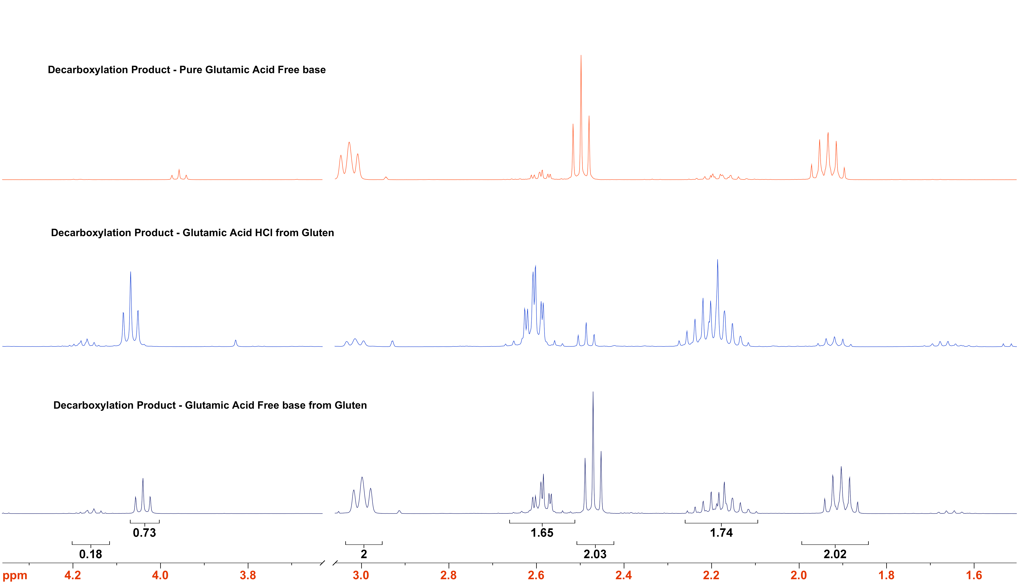
Figure 6. Overlay of ¹H NMR spectra of decarboxylation product obtained from pure glutamic acid free base (top), glutamic acid HCl from gluten (middle) and glutamic acid free base from gluten (bottom). Methylsulfone standard peak was cut for insert 3.1-3.8 ppm, NMR solvent = D₂O

This study represents an important first step in the bio-based production of a useful γ-amino carboxylic acid (GABA) via rapid and efficient microwave heating. A possible immobilisation of isophorone on solid support could make a heterogeneous catalyst for decarboxylation avoiding an aqueous workup. Gluten has been demonstrated as a viable feedstock for this reaction. We easily isolated glutamic acid HCl from the other amino acid residues following microwave-assisted hydrolysis. Subsequently, the free base of glutamic acid was isolated via use of its pI precipitation, and this decarboxylated to afford GABA. To the best of our knowledge this is the first desalting method of amino acids that does not require ion-exchange chromatography or electrodialysis.

- Conclusions
A non-enzymatic thermal decarboxylation of glutamic acid catalysed by isophorone was proven successful. The isophorone is produced on an industrial scale by the self-condensation of acetone with alkaline catalyst at high temperature with high atom economy (Arturi et al., 2018; Orschel et al., 2013; Schmitt et al., 1967). In addition, the use of isophorone presents advantages over the previously reported enzymatic or supported palladium pathways:

- Isophorone is cheap (4-6 $/kg) and can be recovered and reused
- Only 7 minutes reaction time is required to obtain GABA in high yields opposed to the 100 minutes necessary for 90% conversion with enzymes (Lee et al., 2013)
- This system prevents problems of available active sites (as in heterogeneous or enzyme catalysed reactions) and substrate concentration ratio and can be run at high concentrations (as opposed to lower concentrations typical for enzymatic reactions). This coupled with point 2 results in significant improvements in space-time yields
- It avoids of the use of precious metal catalysts (Pd) or hazardous reagents (H₂O₂, formation of halonium species)

This demonstrates the feasibility of a fully bio-based green route from gluten (and logically other protein rich waste such as DDGS, jatropha meal seeds etc.) to the useful platform molecule GABA.

Acknowledgments
This work was supported in part by the EPSRC Sustainable Polymers grant (EP/L017393/1)

Data statement
All raw data used for this study is contained within the manuscript, the electronic supplementary information or available on request from DOI: 10.15124/690a3440-19bc-4ef0-a899-613a852ef74b

References
Arturi, K.R., Sokoli, H.U., Søgaard, E.G., Vogel, F., Bjelić, S., 2018. Recovery of value-added chemicals by solvolysis of unsaturated polyester resin. J. Clean. Prod. 170, 131–136. https://doi.org/10.1016/j.jclepro.2017.08.237
Bellale, E. V., Huddar, S.N., Mahajan, U.S., Akamanchi, K.G., 2011. Oxidative decarboxylation of α-amino acids to nitriles using o-iodoxybenzoic acid in aqueous ammonia. Pure Appl. Chem. 83, 607–612. https://doi.org/10.1351/PAC-CON-10-09-15
Bozell, J.J., Moens, L., Elliott, D.C., Wang, Y., Neuenscwander, G.G., Fitzpatrick, S.W., Bilski, R.J., Jarnefeld, J.L., 2000. Production of levulinic acid and use as a platform chemical for derived products. Resour. Conserv. Recycl. 28, 227–239. https://doi.org/10.1016/S0921-3449(99)00047-6
Brandt, S.D., Mansell, D., Freeman, S., Fleet, I.A., Alder, J.F., 2006. Analytical characterisation of the routes by thermolytic decarboxylation from tryptophan to tryptamine using ketone catalysts, resulting in tetrahydro-β-carboline formation. J. Pharm. Biomed. Anal. 41, 872–882. https://doi.org/10.1016/j.jpba.2006.02.007
Buchanan, D.L., 1957. Desalting amino acid solutions by displacement with piperidine. Anal. Chem. 29, 1877–1878. https://doi.org/10.1021/ac60132a012
But, A., Le Nôtre, J., Scott, E.L., Wever, R., Sanders, J.P.M., 2012. Selective oxidative decarboxylation of amino acids to produce industrially relevant nitriles by vanadium chloroperoxidase. ChemSusChem 5, 1199–1202. https://doi.org/10.1002/cssc.201200098
But, A., Van Der Wijst, E., Le Nôtre, J., Wever, R., Sanders, J.P.M., Bitter, J.H., Scott, E.L., 2017. Unusual differences in the reactivity of glutamic and aspartic acid in oxidative decarboxylation reactions. Green Chem. 19, 5178–5186. https://doi.org/10.1039/c7gc02137b
Chatelus, G., 1964. La Decarboxylation des acides a-amines. Bull. Soc. Chim. Fr. 10, 2523-2532.
Chen, S.-T., Chiou, S.-H., Chu, Y.-H., Wang, K.-T., 2009. Rapid hydrolysis of proteins and peptides by means of microwave technology and its application to amino acid analysis. Int. J. Pept. Protein Res. 30, 572–576. https://doi.org/10.1111/j.1399-3011.1987.tb03367.x
Cioc, R., Schaepkens van Riempst, L., Schuckman, P., Ruijter, E., Orru, R., 2016. Ugi four-center three-component reaction as a direct approach to racetams. Synthesis 49, 1664–1674. https://doi.org/10.1055/s-0036-1588672
Claes, L., Matthessen, R., Rombouts, I., Stassen, I., De Baerdemaeker, T., Depla, D., Delcour, J.A., Lagrain, B., De Vos, D.E., 2015a. Bio-based nitriles from the heterogeneously catalyzed oxidative decarboxylation of amino acids. ChemSusChem 8, 345–352. https://doi.org/10.1002/cssc.201402801
Claes, L., Verduyckt, J., Stassen, I., Lagrain, B., De Vos, D.E., 2015b. Ruthenium-catalyzed aerobic oxidative decarboxylation of amino acids: a green, zero-waste route to biobased nitriles. Chem. Commun. 51, 6528–6531. https://doi.org/10.1039/C5CC00181A
Clark, J., Farmer, T., Ingram, I., Lie, Y., North, M., 2018. Renewable self-blowing non-isocyanate polyurethane foams from lysine and sorbitol. European J. Org. Chem. 2018, 4265-4271. https://doi.org/10.1002/ejoc.201800665
Dakin, H., 1917. On the oxidation of amino-acids and of related substances with chloramine-T. Biochem. J. 11, 79–95.
De bruyn, M., Budarin, V.L., Sturm, G.S.J., Stefanidis, G.D., Radoiu, M., Stankiewicz, A., Macquarrie, D.J., 2017. Subtle microwave-induced overheating effects in an industrial demethylation reaction and their direct use in the development of an innovative microwave reactor. J. Am. Chem. Soc. 139, 5431–5436. https://doi.org/10.1021/jacs.7b00689
de la Hoz, A., Díaz-Ortiz, A., Prieto, P., 2016. Chapter 1: Microwave-assisted green organic synthesis, in Stefanidis G. & Stankiewicz A. (eds.), Alternative Energy Sources for Green Chemistry. The Royal Society of Chemistry, pp. 1-33. https://doi.org/10.1039/9781782623632-00001
De Schouwer, F., Adriaansen, S., Claes, L., De Vos, D.E., 2017. Bio-based N-alkyl-2-pyrrolidones by Pd-catalyzed reductive N-alkylation and decarboxylation of glutamic acid. Green Chem. 19, 4919-4929. https://doi.org/10.1039/C7GC01829K
De Schouwer, F., Claes, L., Claes, N., Bals, S., Degrève, J., De Vos, D.E., 2015a. Pd-catalyzed decarboxylation of glutamic acid and pyroglutamic acid to bio-based 2-pyrrolidone. Green Chem. 17, 2263–2270. https://doi.org/10.1039/C4GC02194K
De Schouwer, F., Claes, L., Claes, N., Bals, S., Degrève, J., De Vos, D.E., 2015b. Pd-catalyzed decarboxylation of glutamic acid and pyroglutamic acid to bio-based 2-pyrrolidone. Green Chem. 17, 2263–2270. https://doi.org/10.1039/C4GC02194K
Dose, K., 1957. Catalytic decarboxylation of α-amino-acids. Nature 179, 734–735. https://doi.org/10.1038/179734b0
Elisseeva, T. V., Shaposhnik, V.A., Luschik, I.G., 2002. Demineralization and separation of amino acids by electrodialysis with ion-exchange membranes. Desalination 149, 405–409. https://doi.org/10.1016/S0011-9164(02)00763-4
Fountoulakis, M., Lahm, H.-W., 1998. Hydrolysis and amino acid composition analysis of proteins. J. Chromatogr. A 826, 109–134. https://doi.org/10.1016/S0021-9673(98)00721-3
Friedman, A.H., Morgulis, S., 1936. The oxidation of amino acids with sodium hypobromite. J. Am. Chem. Soc. 58, 909–913. https://doi.org/10.1021/ja01297a017
Froidevaux, V., Negrell, C., Caillol, S., Pascault, J.-P., Boutevin, B., 2016. Biobased amines: from synthesis to polymers; present and future. Chem. Rev. 116, 14181–14224. https://doi.org/10.1021/acs.chemrev.6b00486
Galema, S. a., 1997. Microwave chemistry. Chem. Soc. Rev. 26, 233-238. https://doi.org/10.1039/cs9972600233
Gallezot, P., 2012. Conversion of biomass to selected chemical products. Chem. Soc. Rev. 41, 1538–1558. https://doi.org/10.1039/c1cs15147a
Gonçalves, H., Robinet, G., Barthelat, M., Lattes, A., 1998. Supramolecularity and photodimerization of isophorone: FTIR and molecular mechanics studies. J. Phys. Chem. A 102, 1279–1287. https://doi.org/10.1021/jp9729270
Hashimoto, M., Eda, Y., Osanai, Y., Iwai, T., Aoki, S., 1986. A novel decarboxylation of α-amino acids. A facile method of decarboxylation by the use of 2-cyclohexene-1-one as a catalyst. Chem. Lett. 15, 893–896. https://doi.org/10.1246/cl.1986.893
Hidetsugu, N., Hiroki, K., Inao, O., Keiji, I., Yoshio, K., 1994. Method of producing L-glutamic acid by fermentation. US 5492818A.
Hunt, A.J., Farmer, T.J., Clark, J.H., 2013. Chapter 1: Element recovery and sustainability, in Hunt, A.J. (ed.), Element Recovery and Sustainability, The Royal Society of Chemistry, Cambridge, pp. 1-28. https://doi.org/10.1039/9781849737340
Hur, W., Rosen, H., Gray, N.S., 2017. A benzo[b]thiophene-based selective type 4 S1P receptor agonist. Bioorg. Med. Chem. Lett. 27, 1–5. https://doi.org/10.1016/j.bmcl.2016.11.050
Ikeda, K., Suzuki, S., 1909. Nutritive and flavoring substance and process of making same. US1035591A.
Jackson, D.M., Ashley, R.L., Brownfield, C.B., Morrison, D.R., Morrison, R.W., 2015. Rapid conventional and microwave-assisted decarboxylation of L-histidine and other amino acids via organocatalysis with R-carvone under superheated conditions. Synth. Commun. 45, 2691–2700. https://doi.org/10.1080/00397911.2015.1100745
Jun, N., Seiko, H., Hisao, I., 2009. L-glutamic acid-producing microorganism and a method for producing l-glutamic acid. US20100068769A1.
Kind, S., Neubauer, S., Becker, J., Yamamoto, M., Völkert, M., Abendroth, G. von, Zelder, O., Wittmann, C., 2014. From zero to hero - production of bio-based nylon from renewable resources using engineered Corynebacterium glutamicum. Metab. Eng. 25, 113–123. https://doi.org/10.1016/j.ymben.2014.05.007
Lammens, T.M., 2011. Biobased Industrial Chemicals from Glutamic Acid. Thesis, Wageningen University. library.wur.nl/WebQuery/wurpubs/413117
Lammens, T.M., De Biase, D., Franssen, M.C.R., Scott, E.L., Sanders, J.P.M., 2009. The application of glutamic acid α-decarboxylase for the valorization of glutamic acid. Green Chem. 11, 1562-1567. https://doi.org/10.1039/b913741f
Lammens, T.M., Franssen, M.C.R., Scott, E.L., Sanders, J.P.M., 2012. Availability of protein-derived amino acids as feedstock for the production of bio-based chemicals. Biomass and Bioenergy 44, 168–181. https://doi.org/10.1016/j.biombioe.2012.04.021
Lammens, T.M., Franssen, M.C.R., Scott, E.L., Sanders, J.P.M., 2010. Synthesis of biobased N-methylpyrrolidone by one-pot cyclization and methylation of aminobutyric acid. Green Chem. 12, 1430–1436. https://doi.org/10.1039/c0gc00061b
Laval, G., Golding, B.T., 2003. One-pot sequence for the decarboxylation of α-amino acids. Synlett 4, 542–546. https://doi.org/10.1055/s-2003-37512
Lee, S., Ahn, J., Kim, Y.-G., Jung, J.-K., Lee, H., Lee, E., 2013. Gamma-aminobutyric acid production using immobilized glutamate decarboxylase followed by downstream processing with cation exchange chromatography. Int. J. Mol. Sci. 14, 1728–1739. https://doi.org/10.3390/ijms14011728
Margolis, S.A., Jassie, L., Kingston, H.M., 1991. The hydrolysis of proteins by microwave energy. J. Automat. Chem. 13, 93–95. https://doi.org/10.1155/S1463924691000172
Mascal, M., Nikitin, E.B., 2010. Co-processing of carbohydrates and lipids in oil crops to produce a hybrid biodiesel. Energy and Fuels 24, 2170–2171. https://doi.org/10.1021/ef9013373
Mascal, M., Nikitin, E.B., 2008. Direct, high-yield conversion of cellulose into biofuel. Angew. Chemie - Int. Ed. 47, 7924–7926. https://doi.org/10.1002/anie.200801594
Mueller, G.C., Bowman, G., Herranen, A., 1955. Desalting amino acid solutions by ion exchange. Anal. Chem. 27, 1357–1358. https://doi.org/10.1021/ac60104a052
Mukherjee, A., Dumont, M.J., Raghavan, V., 2015. Review: Sustainable production of hydroxymethylfurfural and levulinic acid: Challenges and opportunities. Biomass and Bioenergy 72, 143–183. https://doi.org/10.1016/j.biombioe.2014.11.007
Nieder, M., Hager, L., 1985. Conversion of α-amino acids and peptides to nitriles and aldehydes by bromoperoxidase. Arch. Biochem. Biophys. 240, 121–127. https://doi.org/10.1016/0003-9861(85)90014-1
Norman, M.F., 1936. The oxidation of amino-acids by hypochlorite: Glycine. Biochem. J. 30, 484–496.
Obata, Y., Ishikawa, Y., 1966. Thermal decarboxylation of sulfur-containing amino acids in the presence of acetophenone, a preparation of 3-methylthiopropylamine hydrochloride. Agric. Biol. Chem. 30, 706–708. https://doi.org/10.1080/00021369.1966.10858669
Omeis, M., Koehler, G., Neumann, M., Kuebelbaeck, T., 2009. Continuous process for decarboxylating carboxylic acids. US7485756B2.
Orschel, M., Ansen, R., Maier, M., Schwarz, M., Nitz, J.-J., Hengstermann Axel, 2013. Method for producing isophorone. US2013/0261343A1.
Park, S.J., Kim, E.Y., Noh, W., Oh, Y.H., Kim, H.Y., Song, B.K., Cho, K.M., Hong, S.H., Lee, S.H., Jegal, J., 2013. Synthesis of nylon 4 from gamma-aminobutyrate (GABA) produced by recombinant Escherichia coli. Bioprocess Biosyst. Eng. 36, 885–892. https://doi.org/10.1007/s00449-012-0821-2
Pelckmans, M., Renders, T., Van de Vyver, S., Sels, B.F., 2017. Bio-based amines through sustainable heterogeneous catalysis. Green Chem. 19, 5303–5331. https://doi.org/10.1039/C7GC02299A
Piez, K.A., Tooper, E.B., Fosdick, L.S., 1952. Desalting of amino acid solutions by ion exchange. J. Biol. Chem. 194, 669–672.
Robert, T., Friebel, S., 2016. Itaconic acid – a versatile building block for renewable polyesters with enhanced functionality. Green Chem. 18, 2922–2934. https://doi.org/10.1039/C6GC00605A
Rosatella, A. a., Simeonov, S.P., Frade, R.F.M., Afonso, C. a. M., 2011. 5-Hydroxymethylfurfural (HMF) as a building block platform: biological properties, synthesis and synthetic applications. Green Chem. 13, 754-793. https://doi.org/10.1039/c0gc00401d
Sandeaux, J., Sandeaux, R., Gavach, C., Grib, H., Sadat, T., Belhocine, D., Mameri, N., 1998. Extraction of amino acids from protein hydrolysates by electrodialysis. J. Chem. Technol. Biotechnol. 71, 267–273. https://doi.org/10.1002/(SICI)1097-4660(199803)71:3<267::AID-JCTB835>3.0.CO;2-O
Sano, C., 2009. History of glutamate production. Am. J. Clin. Nutr. 90, 728–732. https://doi.org/10.3945/ajcn.2009.27462F
Sari, Y.W., 2015. Biomass and its potential for protein and amino acids; valorizing agricultural by-products. Thesis, Wageningen university. library.wur.nl/WebQuery/wurpubs/488210
Sari, Y.W., Alting, A.C., Floris, R., Sanders, J.P.M., Bruins, M.E., 2014. Glutamic acid production from wheat by-products using enzymatic and acid hydrolysis. Biomass and Bioenergy 67, 451–459. https://doi.org/10.1016/j.biombioe.2014.05.018
Schmitt, K., Herne, W., Josef, D., 1967. Process for recovering isophorone in high purity. US05654550.
Schönberg, A., Moubasher, R., Barakat, M.Z., Hackman, R.H., Baker, J.W., Ames, T.R., Davy, G.S., Halsall, T.G., Jones, E.R.H., Sykes, P., Illingworth, E., Peters, A.T., 1951. Action of N-bromosuccinimide and N-bromo phthalimide on α-amino-acids. J. Chem. Soc. 2504–2509. https://doi.org/10.1039/JR9510002504
Scott, E., Peter, F., Sanders, J., 2007. Biomass in the manufacture of industrial products-the use of proteins and amino acids. Appl. Microbiol. Biotechnol. 75, 751–762. https://doi.org/10.1007/s00253-007-0932-x
Sherwood, J., Parker, H.L., Moonen, K., Farmer, T.J., Hunt, A.J., 2016. N-Butylpyrrolidinone as a dipolar aprotic solvent for organic synthesis. Green Chem. 18, 3990–3996. https://doi.org/10.1039/C6GC00932H
Stevenson, G.W., Luck, J.M., 1961. The bromodecarboxylation of amino acids: formation of nitriles. J. Biol. Chem. 236, 715–717.
Strecker, A., 1862. Ueber einige neue bestandtheile der schweinegalle. Justus Liebigs Ann. Chem. 123, 353–360. https://doi.org/10.1002/jlac.18621230310
Takano, Y., Kashiyama, Y., Ogawa, N.O., Chikaraishi, Y., Ohkouchi, N., 2010. Isolation and desalting with cation-exchange chromatography for compound-specific nitrogen isotope analysis of amino acids: application to biogeochemical samples. Rapid Commun. Mass Spectrom. 24, 2317–2323. https://doi.org/10.1002/rcm.4651
Teng, Y., 2014. Specific conversion of amino acids as a means for their separation. Thesis, Wageningen University. ISBN 978-94-6257-065-8 http://edepot.wur.nl/312326
Teng, Y., Scott, E.L., Sanders, J.P.M., 2014. The selective conversion of glutamic acid in amino acid mixtures using glutamate decarboxylase - a means of separating amino acids for synthesizing biobased chemicals. Biotechnol. Prog. 30, 681–688. https://doi.org/10.1002/btpr.1895
Teng, Y., Scott, E.L., Sanders, J.P.M., 2012. Separation of L-aspartic acid and L-glutamic acid mixtures for use in the production of bio-based chemicals. J. Chem. Technol. Biotechnol. 87, 1458–1465. https://doi.org/10.1002/jctb.3769
Verduyckt, J., Coeck, R., De Vos, D.E., 2017. Ru-catalyzed hydrogenation-decarbonylation of amino acids to bio-based primary amines. ACS Sustain. Chem. Eng. 5, 3290–3295. https://doi.org/10.1021/acssuschemeng.6b03140
Weiss, I.M., Muth, C., Drumm, R., Kirchner, H.O.K., 2018. Thermal decomposition of the amino acids glycine, cysteine, aspartic acid, asparagine, glutamic acid, glutamine, arginine and histidine. BMC Biophys. 11, 1–15. https://doi.org/10.1186/s13628-018-0042-4
Yaegashi, K., Mikami, M., 2007. Process for preparing amines US20050222430A1.
Zhang, Y.J., Shu, Z., Xu, W., Chen, G., Li, Z.G., 2008. L-Glutamic acid hydro-chloride at 153 K. Acta Crystallogr. Sect. E Struct. Reports Online 64, 2514–2519. https://doi.org/10.1107/S1600536807068560
Zhao, L., Wei, J., Qian, J., MA, J., Tang, X., 2016. Method for preparing environmentally-friendly nylon polybutyrolactam. WO2016110079A1.

