English equivalent to El fuego en las altas latitudes (Open Access)

“Adding fuel to the economic/symbolic debate”: Ethnographic analogy and the symbolic use of fire in the Palaeolithic and Mesolithic.

Dr Penny Spikins, (Department of Archaeology, University of York, UK)
Ms Rebecca Kelly, (Department of Archaeology, University of York, UK)
Dr Liliana M. Manzi, (Consejo Nacional de Investigaciones Científicas y Técnicas, Argentina)

«Across leagues of wooded hills up the forty-mile length of Lake Kami, Tamileot and I gazed long and silently towards a glorious sunset. I knew that he was searching the distance for any sign of smoke from the camp-fires of friends or foes. After a while his vigilance relaced and, lying near to me, he seemed to become oblivious to my presence. Feeling the chill of evening I was on the point of suggesting a move, when he heaved a deep sigh and said to himself, as softly as an Ona could say anything: “Yak haruin” (“my country”). That sigh followed by those gentle words, so unusual for one of his kind - was it caused by a vision of the not far distant future when the Indian hunter would roam his quiet woods no more; when the light wraith from his camp fire would give place to the smoke from the saw-mills; when throbbing engines and hooting sirens would shatter for ever the age-old silence?»
(Bridges L. 1948: 336-7)

Abstract
Archaeological interpretations of the use of fire in Mesolithic societies focus almost exclusively on its practical and economic uses, such as a source of light, warmth or to cook food. Though new theoretical approaches have cast insight into many themes within studies of the Mesolithic – of which food (Miracle P. 2002; Milner N. 2006), settlement patterns (Conneller C. 2005) and gender relations (Finlay N. 2009) are perhaps the most notable – fire remains interpreted as a largely economic or practical element. In order to redress this imbalance one possibility is to draw potential new interpretations from ethnographic analogies which illustrate a much broader and more social use of fires. To this end in this paper we consider the use of fire by the Selk’nam of Tierra del Fuego, a group living in high latitude densely forested environments similar to those of much of Mesolithic Europe, as a basis for re-interpreting the use of fire at March Hill Carr and March Hill Top in the Central Pennines in the Late Mesolithic, as well as in order to generate broader insights into the potential for wider consideration of the social or symbolic use of fire in early prehistory.

Introduction
Over the past ten years new theoretical approaches have changed many of our interpretations of Upper Palaeolithic and Mesolithic sites. New insights have been cast on the potentially symbolic and social use of food and feasting (Miracle P. 2002; Milner N. 2006), the social context of settlement patterns (Spikins P. 2000; Conneller C. 2005) and the use and social/symbolic importance of apparently mundane artefacts such as microliths (Finlay N. 2002).

Despite the almost ubiquitous evidence for the use of fire on settlement sites, with the exception of an attention to the role of burning of vegetation (Law C. 1998; Moore J. 2003) there has been almost no attention to the role or social/symbolic importance of fires. Hearths are a common element of Mesolithic sites with structural remains (Whickham-Jones C. 2004), or such as Howick, East Barns or Mount Sandel, (Waddington C. 2007) and are often noted on upland Pennine Mesolithic sites (Spikins P. 2010), as well as in many varied contexts from shell middens to open air and rockshelter sites across Europe. At the Late Mesolithic sites of March Hill Carr and March Hill Top site in the Pennines, 5 clearly defined and very different hearths were recovered in only about 25m² of excavation (Spikins P. 1999, 2003). Though little attention has typically been accorded to them in their own right hearths are clearly a key element in our evidence for past activities.

Approaching a grounded understanding of the social/symbolic role of hearths and fire
A better understanding of the role of hearths and fires demands a deeper insight into how fire can be used in a real world context. Ethnographic analogy might seem an obvious source of inspiration for a more in depth understanding of the use of fire in Mesolithic contexts, yet necessarily demands being treated with caution. Not least of all ethnography and archaeology operate, for the most part, on very different timescale (Wobst H.M. 1978). Whereas ethnographic studies are short term in nature, focusing on the relationship between people and stretching to a generation at most, archaeology takes a longer view; charting change over centuries or even millennia. The issue is also further confused by the nature of archaeological sites, which often represent a numerous visits. Hearths are a clear example of this; although they tend to be restricted to a limited period of use, their surrounding contexts may be influenced by a palimpsest of activity. The use of explicitly direct ethnographic analogy can also be problematic. The use of direct analogies are often particularly criticised where there are few similarities between the ethnographic and archaeological contexts. However, in the absence of ethnographic evidence we easily fall into the trap of imposing an overtly economic and practical modern western interpretation onto activities in the past. The function of hearths and fire seem to, perhaps, most clearly reflect this latter issue. In adopting a “fall-back” economic or functionalist approach we are certainly no nearer, and potentially further, from a balanced understanding of the role of fires in Palaeolithic and Mesolithic society.
In this paper we aim to stimulate debate into the social and symbolic use of fires on Palaeolithic and Mesolithic sites by considering the use of fire by the Selk’nam of Tierra del Fuego, questioning in particular the relative social/symbolic and functional use of fire and how distinctions between different uses might be drawn archaeologically, and drawing insights for identifying potentially testable social and symbolic roles to the use of fire in particular contexts in the Mesolithic.

The Selk’nam of Tierra del Fuego:
Tierra del Fuego (Spanish for “Land of Fire”) is an archipelago at the southernmost tip of South American at similar southerly latitude to the northerly latitude of northern England. The landscape is mountainous and substantially forested by cold adapted tree species, such as the southern beech (Nothofagus).
The indigenous populations have been recorded since the earliest documented discovery of the island in 1520 by Magellan’s expedition (Pigafetta M. 1999 [1519-22]: 64, 67). The Selk’nam or Yamana were the main inland dwelling population on the island. As with societies in the northern European Mesolithic they were adapted to an island environment where the distribution of resources is heterogeneous and seasonal in nature (Borrero L. and Manzi L. 2007). In both cases, the diet was mainly composed of hunted large terrestrial mammals, red deer in the Mesolithic and the guanaco for the Selk’nam - animals that have a similar body size and behaviour and inhabit forested environments and were hunted with bows and arrows (figure 1). In both cases diets were expanded by the collection of plant and marine resources. Attention has been particularly focused in general patterns of mobility and settlement which has wider implications for studies of settlement patterns elsewhere (Manzi L. 1991, 1993, 2001, 2009).

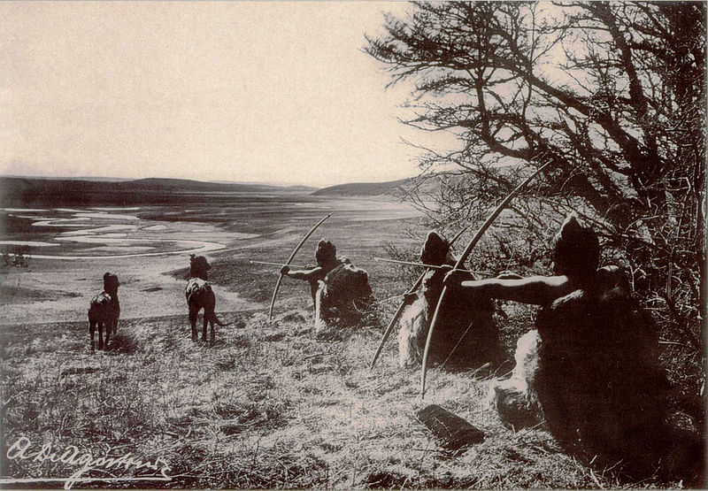
Figure 1. Hunting using bows and arrows by the Selk’nam of Tierra del Fuego.
In general terms it is only common sense that fire will have been important to both the ethnographically documented Selk’nam and societies of Mesolithic Europe. Fire will have been essential as a source of heat in cold winter months, and for cooking. Fire is also documented as an important means of reducing vegetation and encouraging the growth of fodder for game animals in many Mesolithic contexts (Jacobi R. et al. 1976; Law C. 1998). Using the ethnographic record however provides insight into the possibilities of what fire meant on a deeper level; as part of their social and spiritual lives and as a symbol to groups and individuals living in the past.

The depth of significant of fires within daily lives, from practical tasks to deeper spiritual meanings is remarkable. Without fire habitation of the island would be impossible (Gusinde M. 1982 [1931]; Gallardo C. 1910). Indeed the island was named after the ubiquitous presence of indigenous fires seen by the early colonists. Fire is a constant social, metaphorical and ideological presence in the life of the Selk’nam.

Fire was of course clearly used constantly for many practical tasks, it was essential in the processing of shellfish (Gallardo C. 1910; Gusinde M. 1982 [1931]; Lista R. 1887; Segers P. 1891) as well as for defrosting and cooking meat and to treat certain raw materials, such as wooden arrow shafts. All adult members of the Selk’nam society carried with them the materials to start a fire. Men carried flint, pyrite and tinder in a waterproof skin pouch alongside other essential objects such as arrowheads, tendons and paints (Chapman A. 1986: 53; Dabbene C. 1911: 68; Gallardo C. 1910: 286; Spegazzini 1882: 174) whilst women carried a leather pouch with mixture of down and finely ground carbon in one side and pyrite in the other within a basket in which they carried firewood (Segers P. 1891: 64, 73). The essential materials for starting fires were flint, pyrite and tinder which were found in various different locations across Tierra del Fuego and exchanged between indigenous groups. Flint was obtainable on the south coast, and was collected at low tide, pyrite was found in some places in the south and north of the island, the dried fungus and bird droppings which were used as tinder and were readily available.

The different types of fire were recorded and photographed by Martin Gusinde (1982 [1931]), hearths could be slightly concave in a shallow depression a few centimetres deep or flat, depending on the terrain. They tended to average 50 cm in diameter although this varied slightly depending on the type of shelter. Fires were always kept burning in the campsites (Coiazzi A. 1914: 32; Gusinde M.1982 [1931]: 180; Segers P. 1891: 69; Spegazzini 1882: 173) (figure 2) and fires were central in the tents or “choza” (Beauvoir 1915: 202; Coiazzi A. 1914: 32; Gallardo M. 1920: 42; Gusinde M. 1982 [1931]: 67; Payro R. 1898: 200; Vignati 1926). A large trunk of wood was laid between the hearth and the tent entrance at night, with a support designed to keep the trunk alight and burning slowly throughout the night (Gusinde M. 1982 [1931]; Beauvoir 1915: 202). The heath would be left full of ash, mollusc shells and various distinct classes of deposited objects when the campsite was abandoned (Payro R. 1898: 200).

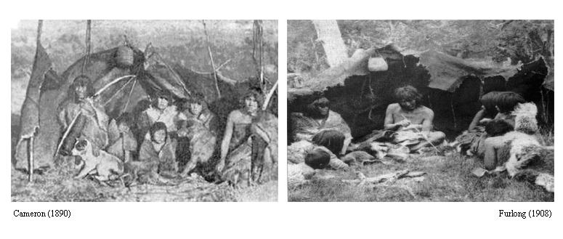
Figure 2. Campsite fires recorded ethnographically

Making fire formed connections between people. Initially such connections were most obviously made through trade for the raw materials required for fire lighting. However the construction and use of fires also formed a bond between families and group members. Collecting wood for the fire was a family affair, involving all members of the group, and either men or women might light or tend the fire. People congregated around the fires at all times of the day, sitting on beds of leaves and moss covered with hides (figure 1), such as in front of windbreaks (Bridges L. 1978 [1887-1902]: 215; Coiazzi A. 1914: 33; Dabbene C. 1911: 66; Gusinde M. 1982 [1931]: 180; Segers P. 1891: 64). The construction of a shelter was not always necessary on short trips, even in winter, however a fire was always essential. In this sense fire was more important as a symbol of a lived area than was any construction.

Fires played an important symbolic function beyond the practical one. They were always present at ceremonies and celebrations, as well as providing a focus for gatherings that occurred every day (Gusinde M. 1982 [1931]). The importance of talking together round the fire continued into the 20th c as commonly recorded by the chroniclers. The moment at which any groups, sometimes breaking into separate groups, left the camp and separated from each other was that at which the fire was put out. Conversely when people joined together they would often join windbreaks and share a single fire between them to symbolise their incorporation (Gusinde M. 1982 [1931]), though at night each family would have their own fire. The presence of fires symbolised the presence of other groups, and fires were lit to ask permission to enter other’s territories to hunt or to alert other groups to the presence of an abundance of food which could be shared (such as a beached whale).

Fire was also connected to the spirit world; one of its most important uses was in the male initiation ceremonies, where it was used to represent spirits and played a role in the enactment of the spirits appearance and performances. Spirits that were particularly associated with fire included Ksohort, who appears to emerge from the fire and Halpen or Xalpen, whose rituals took place at night with the light of a huge bonfire. Other spirits associated with fire included Koxmenki or koshmenk, and Matan, the personification of night. A lantern was used to create long mobile shadows. Fire also played an important role in the most important ritual of the Selk’nam, the Hain initiation ceremony. A hut was constructed away from the settlement exclusively for the men. Central to the hut was a fire, which divided the hut into symbolic spheres. Certain spirits were associated with fire and were meant to rise from the spirit world into the hain hut through the central fire (Chapman A. 1986). Fire was an important part of the movement between the living and spirit worlds. If an individual was seriously ill, their bow and arrows would be burnt, upon their death their hut would be burnt down around over the body.

Fire for the Selk’nam, in its role as a practical tool, yet a social uniting force and symbol of home, and yet equally heavily symbolic ritual force provides perhaps a particularly good example of how practical, social and symbolic aspects of apparently functional objects can merge within ethnographically documented society challenging our tendencies to demarcate elements of life to functional or ideological realms.

The central importance and role of fire is not unique to the Selk’nam but typical of many ethnographically documented societies. The neighbouring, largely marine based, Yamana were societies equally dependant economically, socially and symbolically on fire (Gusinde M. 1961). Fires were kept permanently alight in the Yamana canoes (Bridges L. 1948) and these canoes were the main focal point, the key focus of settlement and ideology for these people. Fires are also seen as having a particular significance in many ethnographically recorded societies such as the Andaman Islanders (Radcliffe-Brown A.R. 1922) who believed that fire was what defined being human.

An understanding of such a role and concept of fire and hearths challenges our interpretations of hearths routinely found on Mesolithic sites. In the following section we make a tentative attempt to use such insights to provide fuller interpretations of hearths found at March Hill.

Case study: The use of fires in the Mesolithic at March Hill
Excavations at March Hill in the Central Pennines in 1993-96 revealed 5 hearths in about 25 m² of excavated area. Though each might be interpreted in purely practical terms, a reflection on the insights from ethnography suggests that other explanations might also be made.
Trench A. In this part of the excavation four hearths, each distinctively different in structure, were dated to within 20 years of each other, representing potentially one single or limited episode of use with little post-depositional disturbance (Spikins P. et al. 2002, figures 3-6). The two central hearths, respected by a circular orientation of refitted artefacts, were stone lined structures. A more southerly “hearth” was actually a very small pit filled with charcoal and burnt flint – interpreted as a small pit used to preheat flint. A larger hearth to the west was egg shaped and full of substantial charcoal, potentially serving some other role. Situated in relation to each other, either deliberately at one moment as part of structure of social life, or as part of an acknowledged reoccupation and re-use of the same locale the hearths and associated finds tell a more complex story than simply that of fire used for warming and cooking, but of a complex suite of activities including heating flint and within which the fire served a central social role.

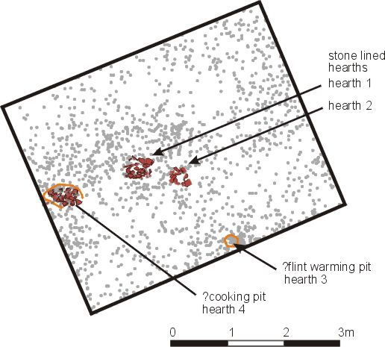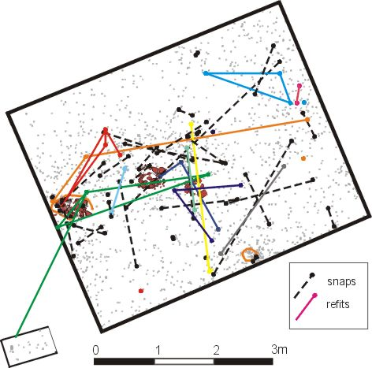
Figure 3. Trench A, March Hill, distribution of flint artefacts and features, and refitting patterns.

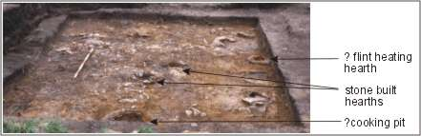
Figure 4. Four “Hearths” at Trench A, March Hill
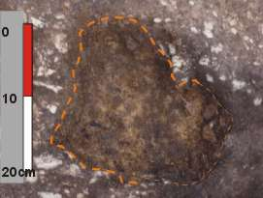
Figure 5. Small “flint-heating” pit at Trench A, March Hill

Hearth 1

5790 ± 35 (OxA 6296)  4717- 4546  0.965 | 5813 ± 22 (UB– 4050)  4721- 4596  0.910
Hearth 2

5835 ± 35 (OxA 6297)  4796- 4595  0.992 | 5824 ± 28 (UB 4051)  4732- 4589  0.850
Hearth 3

5745 ± 35 (OxA 6298)  4690- 4497  0.997 | 5796 ± 29 (UB- 4052)  4716- 4577  0.890
Hearth 4

5830 ± 35 (OxA 6299)  4783- 4584  0.982 | 5855 ± 40 (OxA 6300)  4795- 4584  0.979

Figure 6. Radio-carbon date samples for March Hill Carr Trench A hearths,
uncalibrated BP and calibrated date ranges (2 sigma)

At Trench B, a rather more unusual hearth was recovered (figures 7-9). Here, within only a few metres of excavated sediment a small hearth situated within a pit appeared to have been used on several occasions. Excavated in the lab, it showed 2-3 phases of use, with for example a piece of flint lying in the fill of the first hearth cut is burnt on one side by exposure to hearth in the second re-use. The hearth burnt using smoky wood, not found in the immediate uplands such as alder and would have given off little heat (Spikins P. 2003). The distribution of burnt flint around the hearth (and relative dearth in the vicinity) suggests that the knapped waste, perhaps on a flexible surface such as leather, was emptied into the hearth, and the contents dug out and deposited to the south before re-use. The location, almost on the top of March Hill itself and in a particularly exposed location with a view right across Yorkshire, coupled with the nature of its use has been suggested to imply that the smoke from the fire was more significant than its heat. Dated at the very end of the Mesolithic, this hearth, with a distinctive “rod microlith dominated” assemblage also found in other promontory locations, might have been part of a more explicitly symbolic use of fire contemporary with the changes taking place in the early Neolithic. Perhaps only excavation of hearths associated with other so-called “rod sites” could address this more fully.

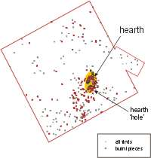

Figure 7. Trench B artefact distribution

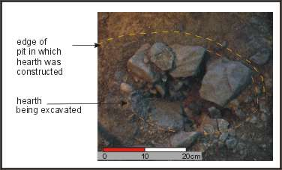

Figure 8. Trench B hearth under excavation in the lab.

1  5310 ± 45 (OxA6301)  4249- 4037  0.925 | 2  5315 ± 35 (OxA 6302)  4246- 4041  0.978 | 3  5255 ± 30 (OxA 6303)  4081- 3979  0.590 | 4  5180 ± 30 (OxA 6304)  4041- 3946  1.000
5  5270 ± 45 (OxA 6305)  4169- 3979  0.816 | 6  5190 ± 45 (OxA 6306)  4051- 3938  0.847 | 7  5271 ± 24 (UB 4053)  4111- 4036  0.306

Figure 9. Radio-carbon samples for March Hill Top Trench B hearth,
uncalibrated BP and calibrated date ranges (2 sigma)

Whilst we would be wary of making any direct analogy, insights from the use of fire within populations in Tierra del Fuego can clearly fuel new interpretations and testable suggestions for sites where hearths and fire may have been far more significant both socially and symbolically than we typically assume.

Wider considerations
The above discussion highlights a number of ways in which we as archaeologists can begin to develop an understanding of hearths beyond their functional attributes. In the ethnographic example there are examples of hearths whose use is purely ritual in nature; the hearths used in the Hain ceremony for example, and the fires used to burn the dead and dying possessions and hut. Within the archaeological record it is likely that purely ritual fires are likely to be the easiest to identify, at the Mesolithic cemetery sites such as Teviéc and Höedic in Brittany (Schulting R. 1996) there is evidence for small ritual fires being light on top of many graves, as well as evidence for cremations and ritual deposits (Collins T. and Coyne F. 2003; Brinch Petersen E. and Meiklejohn C. 2003). Ritual fires may also be easy to identify because of their separation from the main living area or the absence of finds from the surrounding area, this is a possible interpretation of the hearth at Hawkcombe Head, Somerset (Gardiner P. 2007).

However, the theme that occurs in the ethnography of the Selk’nam is the embedded nature of fire within the daily social and spiritual life. Hearths practical uses were combined with their social ones, this is likely to prove to be harder to unpick in the archaeological record. However, Spatial analysis of lithic scatters at Mesolithic sites across Europe such as, South Haw (Chatterton R. 2007), Mostmolen (Crombé P. 1998), VerreBroek (Crombé P. 1998, Crombé P. et al. 2003), and Miron Cave (Nakazawa Y. et al. 2009) as well as Upper Palaeolithic sites such as Etoilles (Pigeot N. 1990), show that much activity was centred around the hearth. In the case of Trench B, March Hill the hearth, re-used on several occasions, may have held both a practical and social/symbolic function (Spikins P. 2002).
The implications are twofold. Firstly care and attention paid to the excavation and analysis of hearths, through micro-excavation, charcoal identification and micromorphology, can yield important insights that go well beyond hearths as being purely functional structures. Secondly the hierarchy imposed by archaeologists on Mesolithic sites, where those that have structurally elements are seen as the most important may need reconsideration. Within Mesolithic contexts the paucity of evidence of structures in settlement sites is often commented upon, often it is considered that a house/hut structure makes it s “real” settlement site. This is not an attitude that the Selk’nam would understand. For them, the fire was what made a settlement a home, it was always the first thing that was done when setting up a new camp, and was far more essential to life than the temporary huts and windbreaks they built. If we consider something similar for the Mesolithic it means the absence of structures is not so remarkable and a re-assessment of site “value” in terms of hearth features may be well overdue.

Conclusions
Fires form such a persistence presence in our excavations of Palaeolithic and Mesolithic sites that unless they are particularly unique in terms of attributes such as size or intensity of burning we can almost fail to register their presence. However beneath the “grey patch” of site illustrations lie a multitude of meanings. Hearths may be a result of many different practical uses, perhaps teased apart through careful microexcavation and micromorphology and charcoal studies, or may be central socially or key spiritually and symbolically to understanding such part societies. Hearths represent deliberate acts of interacting with a life-giving and dynamic medium, not just a practical and economic use of a resource.

References
Beauvoir José María, 1915, Los Selk’nam, indígenas de Tierra del Fuego. Sus tradiciones, costumbres y lenguas (por Los Misioneros Salesianos), Librería del Colegio Pio IX, Buenos Aires.
Borrero Luis - Manzi Liliana, 2007, Arqueología supra-regional y biogeografía en la Patagonia Meridional. Levantando piedras, desenterrando huesos… y develando arcanos, Ediciones CEQUA, Punta Arenas, pp. 163-172.
Brinch Petersen Erik - Meiklejohn Chris, 2003, Three cremations and a funeral: aspects of burial practice in Mesolithic Vedbæk, in Lars Larsson, Hans Kindgren, Kjel Knutsson, David Loeffler and Agneta Åkerlund (eds.), Mesolithic on the move, papers presented at the sixth International conference on the Mesolithic in Europe, Stockholm 2000, Oxford: Oxbow books, pp. 485-493.
Bridges Lucas, 1948, Uttermost Part of the Earth, Hodder and Stoughton, London.
Chapman Anne, 1986, Los Selk’nam. La vida de los Onas, Emecé Editores, Buenos Aires.
Chatterton Richard, 2007, South Haw, Northern England. An Upland Mesolithic Site in Context, in Clive WaddingtoN and Kristian Pedersen (eds), Mesolithic Studies in the North Sea Basin and beyond. Oxbow Books, Oxford.
Coiazzi Antonio, 1904, Los indios del archiepiélago fuegino, Revista Chilena de Historia y Geografía 13, Santiago.
Collins Tracey. and Coyne, Frank. 2003. Fire and water...Early Mesolithic cremations at Castleconnell, co. Limerick. Archaeology Ireland, pp24-27.
Conneller Chantal, 2005 Moving beyond sites: Mesolithic technology in the landscape in Nicky Milner and Peter Woodman (eds) Mesolithic Studies at the Beginning of the 21st Century. Oxford: Oxbow Books. 42-55.
Conneller Chantal - Warren Graeme. 2005. Mesolithic Britain and Ireland, Tempus
Crombé P., 1998. The Mesolithic in North-western Belgium: Recent excavations and Surveys. BAR International Series 716.
Crombé Philippe, Perdaen Yves, and Sergant Jacques, 2003. The Site of Verrebroek “dok” (Flanders, Belgium): Spatial organisation of an extensive early Mesolithic settlement. In Lars Larsson, Hans Kindgren, Kjel Knutsson, David Loeffler and Agneta Åkerlund (eds), Mesolithic on the Move. Oxbow Books: Oxford.
Dabbene Carlos 1904. Viaje a la Tierra del Fuego y la isla de los Estados. Boletín del instituto geográfico Argentino XXI. Buenos Ares
Davies Paul, Robb John & Ladbrook Dave 2005. Woodland clearance in the Mesolithic: the social aspects. Antiquity 79: 280-288
Finlay Nyree. 2009. Introduction: Understanding the Social Context, in McCartan S, Schulting R., Warren, G., Woodman, P., 2009. Mesolithic Horizons, Oxbow Books
Finlay, Nyree., 2003. Microliths and multiple authorship in Lars Larsson, Hans Kindgren, Kjel Knutsson, David Loeffler and Agneta Åkerlund (eds.). 2003. The Mesolithic on the Move (Papers presented at the Sixth International Conference on the Mesolithic in Europe , Stockholm 2000). Oxbow Books. Oxford.169-176
Gallardo Carlos., 1910. Los Onas. Cabaut: Buenos Aires.
Gardiner, Paula., 2007. Mesolithic Activity at Hawkcombe Head, Somerset: An interim report on the 2002-3 excavations. In Waddington, C., and Pedersen, K. (eds), Mesolithic Studies in the North Sea Basin and beyond. Oxbow Books: Oxford.
Gusinde, Martin, 1961. The Yamana: the life and thought of the water nomads of Cape Horn. Buenos Aires: Centro Argentino de Etnologia Americana.
Gusinde, Martin, 1982 [1931]. Los indios de la Tierra Del Fuego. Los Selk’nam. Caea: Buenos Aires.
Jacobi, Roger, Tallis, John and Mellars, Paul, (1976). The Southern Pennine Mesolithic and the ecological record. Journal of Archaeological Science 3 (4),307-320.
Jordan Peter., 2006. Analogy. In Chantal Conneller & Graeme Warren (ed), Mesolithic Britain and Ireland. The History Press, Uk.
Law Chris., 1988. The uses and fire-ecology of reedswamp vegetation. In Paul Mellars and Petra Dark, Editors, 1988. Star Carr in context, new archaeological and palaeoecological in vestigations at the Early Mesolithic site of Star Carr in North Yorkshire., McDonald institute for Archaeological Research, Cambridge p. 197–206
Lista Ramón, 1887. Viaje al pais de los Onas. Tierra Del Fuego. Establecimiento Tipografico de Alberto Nunez, Piedad 17 ½. Buenos Aires.
Manzi Liliana. 1991. De cómo y dónde se movían los grupos de cazadores-recolectores pedestres de la Isla Grande de Tierra del Fuego. Shincal, 3(3): 184-190.
Manzi Liliana. 1993. Crónicas acerca de los sitios de agregación Selk’nam y de las posibles actividades allí involucra-das. ¿Hay alguna evidencia arqueológica? Cuadernos del INAPL, 14: 217-235.
Manzi Liliana. 2001. Territorialidad y movilidad en grupos cazadores-recolectores Selk’nam: un acercamiento a partir del pasado etnográfico. Simposio Movilidad y uso del espacio en cazadores-recolectores: perspectivas compara-das. Actas XIII Congreso Nacional de Arqueología Argentina, Tomo I, Córdoba: 11-31.
Manzi Liliana. 2009. Dinámica poblacional y desintegración territorial entre Los Selk’nam de Tierra del Fuego. Arqueología de la Patagonia. Una mirada desde el último confín. Monica Salemme, Francisco Santiago (eds.) Editorial Utopías. Tomo 1:159-172. Ushuaia.
Manzi Liliana - Spikins Penny. A. 2008. El fuego en las altas latitudes: Los Selk’nam de Tierra del Fuego como referente ethnográfico para el Mesolítico europeo, Complutum 19 (1): 79-96.
Milner Nicky., 2006. Subsistence. In Chantal Conneller, & Graeme Warren, (ed), Mesolithic Britain and Ireland. The History Press: Uk.
Miracle Preston., 2002. Mesolithic Meals from Mesolithic Middens. In Miracle, P & Milner, N. (eds), Consuming Patterns and Patterns of Consumption. McDonald Institute Monographs: Cambridge.
Moore Jenny., 2003. Enculturation through fire: beyond hazelnuts and into the forest. In Larsson, Hans Kindgren, Kjel Knutsson, David Loeffler and Agneta Åkerlund (eds), Mesolithic on the Move. Oxbow Books: Oxford.
Nakazawa Yuichi, Strauss Lawrence, Gonzalez-Morales, Manuel, Cuenca Solana David and Caro Suiz, Jorge, 2009. On Stone Boiling Technology in the Upper Palaeolithic: Behavioural Implications from an early Magdelanian hearth in El Miron Cave, Cantabria, Spain. Journal of Archaeological Science 36: 684-693.
Payro, Roberto. 1898. La Australia Argentina. Imprenta de la Nación, Buenos Aires.
Pigafetta Antonio. (1999 [1519-22]): Primer viaje en torno del globo. Espasa Calpe, Madrid.
Pigeot Nicolle, 1990. Technical and Social actors: Flintknapping specialists and apprentices at Magdalenian Etoilles. Archaeological Review from Cambridge 9 (1):126-141
Radcliffe-Brown Alfred , 1922. The Andaman Islanders. The Free Press of Glencoe: New York.
Schulting Rick., 1996. Antlers, Bone Pins and Flint Blades: The Mesolithic cemeteries of Téviec and Hoëdic, Brittany. Antiquity 70: 335-50.
Sergers, Polidoro. 1981. Habitos y costumbres de los indios onas. Boletin del Instituto Geografici Argentino XII. Buenos Aires.
Spegazzini, Carlos. 1882. Costumbres de los habitantes de la Tierra del Fuego. Annales de la Sociedad científica Argentina. Tomo XIV. Segundo semestre. Buenos Aires.
Spikins Penny. A. 2010. Research Agenda for Palaeolithic and Mesolithic sites in West Yorkshire, West Yorkshire Archaeology Service, Wakefied.
Spikins Penny., 2000. Ethno-facts or Ethno-fiction? Searching for the structure of Settlement patterns. In Rob Young (ed), Mesolithic Lifeways: Current research from Britain and Ireland. Leicester: university of Leicester.
Spikins Penny 2003. Nomadic People of the Pennines: Reconstructing the Lifestyles of Mesolithic People on Marsden Moor. West Yorkshire Archaeology Service and English Heritage.
Spikins Penny 1999 Mesolithic Northern England: Environment, Population and Settlement. Oxford: Archaeopress.
Spikins Penny , Conneller, Chantal , Ayestaran, Horacio and Scaife, Brett 2002 “GIS based interpolation applied to distinguishing occupation phases of hunter-gatherer sites”, Journal of Archaeological Science 29 (11):1235-1245
Vignati, Milcíades. 1926. El tipo de la habitación actual de los Indios Onas de Tierra del Fuego. Physics (revista de la Sociedad Argentina de Ciencias Naturales), Tomo VII, Buenos Aires.
Waddington, Clive, 2007. Mesolithic Settlement in the North Sea Basin, a case study from Howick, North-East England. Oxbow books: Oxford.
Wickham-Jones Caroline 2004. Structural Evidence in the Scottish Mesolithic, in Alan Saville (ed.) Mesolithic Scotland and its Neighbours: the Early Holocene Prehistory of Scotland, its British and Irish Context, and Some Northern European Perspectives. Edinburgh, Society of Antiquaries of Scotland, 229–42.
Wobst Martin. 1978. The Archaeo-Ethnology of Hunter-Gatherers or the Tyranny of the Ethnographic Record in Archaeology, American Antiquity, Vol. 43, No. 2, Contributions to Archaeological Method and Theory (Apr., 1978), pp. 303-309.

