Incipient signs of genetic differentiation among African elephant populations in fragmenting miombo ecosystems in south-western Tanzania

Alex L. Lobora

Tanzania Wildlife Research Institute (TAWIRI), Tanzania

P.O Box 661, Arusha

[alex.lobora@tawiri.or.tz](mailto:alex.lobora@tawiri.or.tz)

Cuthbert L. Nahonyo

University of Dar es Salaam (UDSM), Tanzania

P.O Box 35064, Dar es salaam

nahonyo@udsm.ac.tz

Linus K. Munishi

Nelson Mandela African Institution of Science and Technology (NM-AIST), Tanzania

P.O. Box 447, Arusha, TANZANIA

linus.munishi@nm-aist.ac.tz

Tim Caro

Department of Wildlife, Fish and Conservation Biology,

University of California, Davis, USA

[tmcaro@ucdavis.edu](mailto:tmcaro@ucdavis.edu)

Charles Foley

Wildlife Conservation Society Tanzania Program, Arusha, Tanzania

P.O Box 2703, Arusha

[cfoley@wcs.org](mailto:cfoley@wcs.org)

Jérôme G. Prunier  
Station d’Ecologie Théorique et Expérimentale, Unité Mixte de Recherche (UMR) 5321, Centre National de la Recherche Scientiﬁque

(CNRS), Université Paul Sabatier (UPS), 09200 Moulis, France [jerome.prunier@gmail.com](mailto:jerome.prunier@gmail.com)  
  
Colin M. Beale

Department of Biology

University of York, United Kingdom

Heslington, York

YO10 5DD

colin.beale@york.ac.uk

Lori S. Eggert  
University of Missouri  
Division of Biological Sciences  
226 Tucker Hall  
University of Missouri  
Columbia, MO  65211

[eggertl@missouri.edu](mailto:eggertl@missouri.edu)

*Corresponding author:

Alex L. Lobora

Address: Tanzania Wildlife Research Institute, P.O Box 661, Arusha, Tanzania

Mobile number: +255-784-301924; +255-754-301924

Fax: +255-27-2548240

[alexander.lobora@tawiri.or.tz](mailto:alexander.lobora@tawiri.or.tz)

Word count

Abstract: 180

Main text: 3908

Acknowledgements: 83

References: 2092

Number of tables: 2

Number of figures: 4

Appendices: 3

Abstract

Habitat fragmentation can play a major role in the reduction of genetic diversity among wildlife populations. The Ruaha-Rungwa and Katavi-Rukwa ecosystems in south-western Tanzania comprise one of the world’s largest remaining African savannah elephant metapopulation but are increasingly threatened by loss of connectivity and poaching for ivory. To investigate the genetic structure of populations, we compared the genotypes for nine microsatellite loci in the western, central and eastern populations. We found evidence of genetic differentiation among the three populations, but the levels were low and mostly concerned the younger cohort, suggesting recent divergence probably resulting from habitat loss between the two ecosystems. We identified weak isolation by distance, suggesting higher gene flow among individuals located less than 50km apart. In a long-lived species with overlapping generations, it takes a long time to develop genetic substructure even when there are substantial obstacles to migration. Thus, in these recently fragmented populations, inbreeding (and the loss of heterozygosity) may be less of an immediate concern than the loss of adults due to illegal hunting.

*Keywords*: African elephant, microsatellites, genetic isolation, habitat fragmentation.

**1. Introduction**

Human population growth is one of the main drivers of natural habitat loss and increased isolation of natural landscapes (Rands *et al*., 2010; Pereira *et al*., 2010; Jones *et al*., 2012). Habitat loss and fragmentation is a conservation problem not only because of the direct loss of range and increased edge effects (Hanski, 2011; Lamb *et al*., 2016), but also because of the potential for inbreeding depression through genetic drift (Hedrick & Kalinowski, 2000), making restoration and conservation of wildlife corridors increasingly important in times of unprecedented habitat fragmentation (Graham *et al*., 2009; Jones *et al*., 2012). Of particular concern is the speed and scale at which fragmentation is happening (Hansen *et al*., 2013; Haddad *et al*., 2015), because few migration routes are entirely within protected areas (Harris *et al*., 2009; Bartlam-Brooks *et al*., 2011; Tucker *et al*., 2018). A recent study conducted across five continents indicates that fragmentation of natural habitat reduces biodiversity by 13% to 75% with effects being greatest in the smallest and most isolated fragments (Haddad *et al*., 2015).

African elephant (*Loxodonta africana*) populations were historically distributed across the continent (Douglas-Hamilton, 1987), with very little or no genetic structure among populations (Georgiadis *et al*., 1994). But in recent years, fragmentation has escalated across their range largely restricting many mega-herbivores to protected areas (Graham *et al*., 2009; Jenkins & Joppa, 2009), which represent fragments of the once continuous historic ranges (Ripple *et al*., [2015](https://link.springer.com/article/10.1007/s10592-017-1005-z#CR41)). Habitat fragmentation and illegal hunting for ivory may lead to inbreeding depression (Allendorf *et al*., [2013](https://link.springer.com/article/10.1007/s10592-017-1005-z#CR1); Ishida *et al*., 2018) and loss of genetic variation (Gobush *et al*., 2009; Wasser *et al*., 2015), especially when the oldest individuals (who are often the target) are involved (Archie *et al*., 2008). This poses a question of whether populations that once ranged across the continent are becoming genetically isolated because of ongoing habitat destruction, fragmentation and illegal killings. While it is important to recognize that there is a time lag between changes to habitats and the time when the full implications of those changes are experienced by wildlife species (Bennett,1999), it is desirable to understand early signs of variation among populations using measures of genetic differentiation (Taylor *et al*., 2011; Paule *et al*., 2012). Information contained in a series of individual genotypes can quantify the extent to which isolated populations have lost genetic diversity over time, making it a relevant tool for assessing differences in structure within and among populations of the same species in fragmenting habitats (Taylor *et al*., 2011).

The past 20 years have seen widespread deforestation of the miombo woodlands in areas between Katavi-Rukwa and Ruaha-Rungwa ecosystems in southwestern Tanzania, with about 17.5% of the woodlands and forests modified or removed to make way for agricultural development, threatening connectivity between these ecosystems (Lobora *et al.*, 2017). The area has one of the world’s largest remaining African elephant populations (TAWIRI, 2014; Chase *et al*., 2016) and of high conservation priority because it i) joins two large, well-protected elephant populations, and ii) forms the principle link between the central and western African elephant populations in Tanzania. Because fragmentation in this landscape is relatively recent (Lobora *et al*., 2017), and because elephants are long-lived (generation time of 25 years; Armbruster, 1993; Blanc, 2008) and show large population sizes, previous studies carried out in this area found little genetic structure among adults (Epps *et al*., 2013). We thus expect there to be little or no genetic structure among adults. However, Wasser *et al.* (2015) show that there is sufficient differentiation across the continent to allow identification of source populations of poached ivory from genetic data. Given the potential for recent disruption of gene flow, testing for developing spatial genetic structure among individuals from the younger age classes could be informative. If adult movement has recently become restricted due to the recent fragmentation of the Katavi-Rukwa and Ruaha-Rungwa ecosystems, we expect to see incipient signs of genetic structure, particularly among the younger cohorts within these populations, and particularly given that male movement and dominance patterns are already known to drive age-related population structure in African elephants (Archie *et al*., 2008).

**2. Material and methods**

2.1 Study area

The study area covers about 109,050 km2 and lies between latitude 6015'59.38" and 8010'23.78" S and between longitude 30045'13.29" and 35028'34.44" E. The area comprises the Katavi-Rukwa ecosystem in the west, a contingent of Game Reserves (henceforth “GRs”), Game Controlled Areas (GCAs) and Open Areas (OAs) in the central part, as well as the Ruaha-Rungwa ecosystem in the east (Figure 1). About 45,961 km2 of this area is designated as Fully Protected Areas (Two National Parks-NPs, Seven GRs where no human settlements are permitted), and 34,196 km2 designated as Lesser Protected Areas (Eight GCAs and Eight OAs where human settlements are permitted alongside wildlife conservation). A further 28,893 km2 of land within the study area is unprotected and includes towns and highly populated regions north and south of Katavi National Park, and to the north-east and south of Ruaha National Park (Figure 1).

[Insert Figure 1 about here]

2.2 Methods

*Sample collection*

We collected 380 fresh dung samples between July and November 2015 in Katavi-Rukwa ecosystem (henceforth “western population”), Lukwati and Piti Game Reserves (henceforth “central population”) and Ruaha-Rungwa ecosystem (henceforth “eastern population”). An opportunistic random sampling strategy was used to obtain samples from different parts of the study area whilst avoiding samples from closely related individuals (e.g. in the event that a group of fresh samples were encountered in the same location, we only collected one sample). For each sample, we placed approximately 10 g of the external region of the dung bolus surface with genetic content (< 12 hours old) in 40 ml polypropylene tubes and boiled them for 15 min in the field to stall microbial activity, then preserved in Queens College Buffer (20% DMSO, 100 mM Tris pH 7.5, 0.25 M EDTA, saturated with NaCl; Amos *et al*., 1992). Samples were initially kept in the dark at room temperature in the field station and later moved to a lab at the Nelson Mandela African Institution for Science and Technology (NM-AIST) for post field storage and subsequently shipped to the University of Missouri-Division of Biological Sciences under USDA permit number 128686 for subsequent DNA extraction and analyses.

*DNA extraction, PCR, Sexing and microsatellite genotyping*

The QIAamp mini stool extraction kit (Qiagen, Valencia, CA) was used to extract DNA from samples following earlier published protocols (Archie *et al*., 2006). The extraction process took place in a laboratory designated exclusively for the extraction of DNA from non-invasively collected samples to minimize the possibility of contamination (Okello *et al*., 2008; Ahlering *et al*., 2011). We genotyped all samples at 11 dinucleotide microsatellite loci developed for the African elephant (FH1, LaT24, FH60, LA5, FH19, LafMS06, LA6, LaT08, LafMSO2, FH48 and FH67), using published primers (Nyakaana *et al*., 2001; Archie *et al*., 2006; 2008, Eggert *et al*., 2008; Okello *et al*., 2008; Kongrit *et al*., 2008) with fluorescent labels. Multiplex PCR reactions (Ahlering *et al*., 2011) were performed using Platinum Multiplex PCR Master Mix (Applied Biosystems, Foster City, CA) following the manufacturer protocols, but in 8 µl volumes with 0.8X BSA and GC enhancer solution added to a final concentration of 10%. The PCR profile included an initial denaturing step at 95 °C for 2 min, followed by 40 cycles of 95 °C denaturing for 30 s, annealing at locus specific temperatures for 90 s, and 72 °C extension for 60 s; and a final 30-min extension at 60 °C. A negative control was included in each PCR plate to detect contamination of the PCR reagents and a positive control sample was included to standardize scoring. We genotyped all samples on an ABI 3730XL capillary sequencer and subsequently analyzed with GeneMarker v2.6.7 (Soft Genetics LLC). To minimize the probability of genotyping error, we repeated our genotyping three times, or until were able to obtain at least three confirmations of each genotype (Frantz *et al*., 2003; Hansen *et al*., 2008; Ahlering *et al*., 2011).

We used the Excel Microsatellite Toolkit (Park, 2001) to identify potential genotyping errors, create input files for population genetic analysis programs, find genetically identical samples and calculate allele frequencies and diversity statistics. Because DNA extracts from non-invasively collected samples are dilute and contain degraded DNA, we rechecked each pair of genotypes that differed at 3 or fewer loci for possible problems with allelic dropout and considered genotypes to represent the same individual if they differed at two or fewer alleles but matched in sex and had very similar bolus circumferences (Ahlering *et al*., 2011). This conservative approach was taken to avoid scoring samples as different individuals when they are actually erroneous genotypes (Ahlering *et al*., 2011).

To determine individual sex, we followed Ahlering *et al*. (2011). The PCR was performed in 25 µl reactions containing 1 U AmpliTaq Gold DNA Polymerase (Applied Biosystems), 1X PCR Gold Buffer (Applied Biosystems), 0.2 mM dNTPs, 0.4 mM SRY1 forward primer, 0.4 mM SRY1 reverse primer, 0.4 mM AMELY2 forward primer, 0.4 mM AMELY2 reverse primer, 0.4 mM PLP1 forward primer, 0.4 mM PLP1 reverse primer, 0.4 mM MgCl2, 0.8X BSA and 1 µl DNA extract. The PCR profile consisted of an initial denaturation at 95°C for 10 min, followed by 45 cycles of 95°C denaturing for 30 sec, annealing at 59°C for 30 sec, and extension at 72°C for 45 sec, with a final extension of 10 min at 72°C. Each PCR plate contained a negative (no DNA) and positive control to detect possible contamination of the PCR reagents and consistency of the amplification respectively (Ahlering *et al*., 2011). Five µl of PCR product was subsequently electrophoresed at 80 V for 40 min on a 2% Agarose gel. Since the restriction site is on the Y-chromosome, we scored single bands (PLP1-191 bp) as females and three bands (SRY1-71 bp, AMELY2-122 bp, PLP1-191 bp) as males and repeated the process once for each sample to confirm sex (Ahlering *et al*., 2011).

1. **Genetic analysis**

We analyzed the set of unique genotypes within and among populations using GenePop 4.2 (Raymond & Rousset 1995, Rousset, 2008) to test for deviations from expected heterozygosity values under Hardy-Weinberg equilibrium (HWE), for linkage disequilibrium, and to determine the number of alleles at each locus (A), the observed (HO) and expected (HE) heterozygosity values, and the coefficient of inbreeding (Fis) as estimated by Weir & Cockerham, 1984. Because sample sizes were unequal, we used rarefaction in HP-Rare (Kalinowski, 2005) to estimate allelic richness, i.e. the mean number of alleles at a sample size of 36 (the smallest sample size of any population). We compared rarefied allelic richness among populations using a Kruskal-Wallis test with loci treated as replicates. We estimated genetic distances (fixation index- Fst) between pairs of populations in Arlequin version 3.5.1.3 (Excoffier & Lischer 2010) and evaluated the significance of these Fst values using a permutation test (1000 permutations).

We tested for genetic differentiation using pairwise Fst across all individuals in the three populations. To test for the influence of age class on genetic differentiation, we also estimated global Fst for each age and then compared Fst across groups of different age cohorts i.e. Young age 0-9, Sub-adult age 10-19 and Adult age 20+. We obtained the age structure of the three populations through dung bolus measurements following Morrison *et al*. (2005). To determine whether observed levels of genetic differentiation across age cohorts were significant, we randomly permuted age cohorts among individuals and computed a theoretical global Fst under the hypothesis of no age structure in the dataset. The permutation procedure was repeated 1000 times, and, for each age cohort, we computed the mean and the 95% quantiles of the obtained theoretical distributions. Global Fst estimates were calculated using the hierfstat (Goudet, 2005) and adegenet (Jombart, 2008) R-packages.

To investigate possible patterns of isolation-by-distance (IBD), we used an individual-based approach. We computed a pairwise matrix of inter-individual genetic distances using the Bray-Curtis percentage dissimilarity measure (function *diss.dist* from the R-package *poppr*; Kamvar *et al*., 2014) that we compared to the corresponding pairwise matrix of inter-individual Euclidean distances using a simple Mantel test with 10000 permutations (function mantel.randtest from the R-package ade4: Dray & Dufour, 2007). Additionally, based on the geographic coordinates of sample locations, we investigated spatial patterns of IBD using a spatial autocorrelogram in GenAlEx (Peakall & Smouse, 2006) using the matrix of Bray-Curtis percentage dissimilarity measures as the response variable. Euclidean distance classes were deﬁned every 50,000 m (up to 50 km). Mantel spatial autocorrelograms were also computed for each sex separately.

To test for genetic structure on an evolutionary timescale, we analyzed genotypes in STRUCTURE 2.3.4 (Pritchard *et al*., 2000), a Bayesian model-based clustering algorithm. We programmed the length of the burn-in period to 10,000 and the number of Markov Chain Monte Carlo (MCMC) reps after the burn-in to at least 100,000 steps. We further programmed STRUCTURE to run 10 times for each value of K from 1 to 10, with the use of prior information about the location (LOC_PRIOR) from which the sample was collected, under the admixture model with correlated allele frequencies among populations. We used spatial Principal Component Analysis (Jombart et *al.,* 2008) to reveal possible cryptic genetic structures, stemming from the specific life-history traits of this long-lived species. The sPCA seeks principal components that optimize the variance of individual allelic frequencies while taking spatial autocorrelation of data into account. It disentangles global structures stemming from strong genetic similarity or positive autocorrelation between neighbors, from local ones, stemming from strong genetic differences or negative autocorrelation between neighbors. Inter-individual spatial autocorrelation was modeled according to a distance-based neighborhood network with a distance threshold consistent with results from the spatial autocorrelogram: all individuals located more than 50km apart were not considered as neighbors in the spatial network (see results for details). Global and local Monte Carlo tests were carried out with 10,000 permutations to evaluate the signiﬁcance of detected global and local patterns (Jombart *et al.,* 2008).

**Results**

Of the 380 samples collected across the landscape, 376 (98.9%) were successfully genotyped and 310 individuals identified by their unique genotypes. The remaining 66 samples were recaptures within the same populations and therefore discarded from subsequent analyses. The age class distribution by sex of the three populations is presented in Table 1. We were unable to determine sexes for some individuals due to repeated failure to discriminate bands as either males or females (Table 1).

[Insert table 1 about here]

Two of the 11 loci (LafMS02 and LafMS06) did not conform to expectations under HWE in any of the three populations after applying Bonferroni correction for multiple tests (Rice, 1989). These loci had significant excesses of heterozygosity that could not be resolved through reanalysis of the genotypes and hence were removed from the analyses. Other than these loci, LA5 and FH19 deviated from expectations in the western population, FH60 deviated in the central population, and LA5 and FH48 deviated in the eastern population. Because there were no consistent patterns of deviation across populations, these loci were retained in the analyses.

*4.1 Genetic diversity within populations*

We found high levels of genetic diversity in all populations, with allelic diversity ranging from an average of 8.7 (± 1.9 StdDev) alleles per locus in the eastern population to 6.2 (± 2.3 StdDev) alleles per locus in the central population. When these values were corrected to a standard sample size of 36 (the size of the smallest sample) using rarefaction (Kalinowski, 2004), there was no significant difference among populations in the number of alleles (Kruskal-Wallis K=5.208, df=8, p=0.735) or private alleles (Kruskal-Wallis, K=5.865, df=8, p=0.662).

*4.2 Genetic differentiation among populations*

We found the three populations to be significantly different, though the level of differentiation was small, with Fst values ranging from 0.006 between the eastern and central populations to 0.011 between the western and central populations (Table 2). We identified weak (but statistically significant) isolation by distance (Mantel test, r = 0.09, p = 0.045), suggesting higher gene flow among nearer individuals. Samples within 50km of each other were more likely to be genetically similar, but beyond this distance, there was no remaining spatial autocorrelation (Figure 2). No significant spatial autocorrelation pattern could be identified when considering males and females separately (data not shown).

[Insert Table 2 about here]

Analyses in STRUCTURE detected no significant genetic clustering among populations across the study landscape (K=1), suggesting that while there is significant differentiation over a recent, ecological timescale, individuals represent a single genetic population over an evolutionary timescale. Nevertheless, we identified significant cryptic genetic structures when using sPCA. The global Monte-Carlo test performed in sPCA was signiﬁcant (max(t) = 0.007, p = 0.007), indicating the presence of a signiﬁcant global genetic structure. On the contrary, the local Monte-Carlo test did not detect any signiﬁcant local structure (max(t) = 0.013, P > 0.05). Scores of individuals along the ﬁrst sPCA axis distinguished the western population from the central and eastern populations (Figure 3). Along the second axis though, individuals showed a spatial pattern characterized by a longitudinal alternation of genetic clusters, roughly delimited every 50 km, highlighting the influence of a continuous IBD in this species (Figure 3).

[Insert Figure 3 about here]

4*.3 Genetic differentiation among age cohorts*

As expected, global Fst estimates were higher in young cohorts (Fst = 0.055) than in sub-adults and adult’s cohorts (Fst = 0.008 in both cohorts). The 95% confidence intervals around mean expected Fst values under the hypothesis of an absence of age structuration indicated that young individuals from different populations were significantly more genetically distinct than older individuals from different populations (Figure 4).

[Insert Figure 4 about here]

1. **Discussion**

We found evidence of weak but significant genetic differentiation among the three recently divided populations, particularly between younger elephants, suggesting that the recent loss of natural habitat (Lobora *et al*., 2017) may be starting to generate population level differences. Isolation was weakly but significantly associated with distance, consistent with early stages of population fragmentation. Landguth *et al*. (2010) found the lag time to barrier detection with genetic methods to be relatively short (1–15 generations) for wide ranging species but cautioned that detecting the effects of fragmentation on long-lived species (with overlapping generations) over ecological time scales may be difficult. Thus, we are not surprised that STRUCTURE did not detect significant genetic clustering. Although this program works well when population structure is relatively weak (Hubisz *et al*., 2009), it may fail to detect structure when differentiation levels are as low as those in this study (Duchesne & Turgeon, 2012). This is also consistent with our prediction that there would be no significant structure across adult individuals in these populations at evolutionary time scales because habitat fragmentation is a recent phenomenon.

Nevertheless, sPCA revealed subtle global hierarchical genetic structure, with eastern and central populations (white squares) showing higher genetic relatedness than the western population (black squares) at the higher level of the hierarchy (Figure 3). This is unsurprising because habitat loss/fragmentation due to anthropogenic activities is higher between western and central populations than between central and eastern populations (Lobora *et al*., 2017). At the lower level of the hierarchy, it appeared that genetic structuring mostly stemmed from a longitudinal IBD pattern, with a lag distance of about 50 km, suggesting that IBD is an important driver of genetic differentiation in this system.

The historical large extent of miombo woodland linking these three populations appears to have facilitated broad-scale connectivity, at least until recently (Epps *et al*., 2013). Our recent analysis on the broad area extending from the Ruaha-Rungwa ecosystem to the Katavi-Rukwa ecosystem indicates that these areas retained approximately 73% of miombo woodland cover up until 1990s and continuous connectivity may only have been impaired recently (Lobora *et al*., 2017). Despite large areas of natural woodland remaining between the two ecosystems even now habitat loss has limited movement between the two ecosystems to a very narrow region (corridor), including some areas heavily used by people and a main road that links the northern and southern regions of Tanzania traverses the area (Caro *et al*., 2009; Jones *et al.,* 2009; Riggio & Caro, 2017).

The low level of genetic differentiation among populations could partly be explained by the fact that, in absence of long-standing habitat fragmentation, the average distance between farthest populations (about 200 km) is within the dispersal capabilities of the African elephant (Blanc *et al*., 2007). The measure of population subdivision across all populations (Fst), was low suggesting many successful migrants entering each population per generation (approximately 25 years for African elephant, Blanc, 2008) assuming an island model of migration (Frankham *et al*., 2002). Nevertheless, without substantial levels of gene flow, habitat fragmentation and other anthropogenic disturbances can lead to extensive genetic differentiation among populations (Dixon *et al*., 2007), even among populations that are geographically close (Vos *et al*., 2001), as suggested by higher genetic differentiation in the young cohort.

Our genetic data did not suggest that there has been significant inbreeding in these populations, highlighting the importance of management actions (such as protection of the remaining potential habitat for connectivity) to maintain migration corridors that reinforce gene flow. This is particularly important because conservation of wide-ranging species depends not only on protected areas but also dispersal areas to provide connectivity (Western *et al*., 2009; Ahlering *et al*., 2012; Epps *et al*., 2013; Caro & Riggio, 2014). Our analysis indicates fragmentation signs to be affecting the genetic structure of young individuals born when movement became increasingly restricted after 1990 and that genetic variation observed between adults and the young age could be precursors of what can be expected in the future. These changes will persist for at least a generation (even if connectivity was completely resurrected today) but appropriate management could restore a fully panmictic population in the future.

Overall, the results obtained in our analysis are consistent with the suggestion that habitat fragmentation and loss will soon constitute a threat to African elephant populations across their range (Comstock *et al*., 2002). As demonstrated in other taxa such as large carnivores (Johnson *et al*., 2001), African elephants are also susceptible to losses in genetic variation due to habitat fragmentation, despite long generation times (Blanc, 2008). The incipient signs of genetic differentiation detected in our analysis indicate increasing conservation challenges in human dominated landscapes (Newmark, 2008), calling for deliberate efforts and political will to save remaining dispersal areas for continued gene flow.

**Management Implications**

A species’ ability to cope with the changing selective forces resulting from anthropogenic disturbance may be partially determined by the amount of genetic variability in populations as well as the way that variation is structured within and between populations (Archie *et al*., 2011; Ishida *et al*., 2016). Evidence for recent emergence of genetic structure within the three studied elephant populations suggests that habitat loss and fragmentation in the areas between Ruaha and Katavi are starting to alter population connectivity. At present, a narrow corridor of natural habitat persists between the two systems, but heavy human use likely reduces the suitability of this corridor for elephant movements. The remaining potential habitat for connectivity between the two ecosystems falls under the multiple landuse categories (Open Areas), and we call for deliberate and timely actions to upgrade the protection status of this area to ensure continued gene flow between these populations. One of these efforts may include transforming these Open Areas (Piti east & Rungwa south) to a Wildlife Management Area (WMA), a new landuse category that promotes local community driven conservation allowing greater local community buy-in (USAID, 2013; WWF, 2014), or establishing Game Reserves that restricts multiple uses on a case by case basis.

**Acknowledgements**

We would like to thank the Ministries of Livestock development and Natural Resources and Tourism for facilitating the required permits for this study. We further extend our special thanks to two anonymous reviewers for their insights and helpful comments. Funding for this project was provided by the Wildlife Conservation Society (WCS) Tanzania program, (through the Tarangire Elephant Program). At the University of Missouri, Jacob Burkhart and the entire Eggert lab team helped with laboratory work while fieldwork was assisted with Amiri Swaleh.

1. **References**

Ahlering, M. A., Eggert, L. S., Western, D., Estes, A., Munishi, L., Fleischer, R., ... & Maldonado, J. E. (2012). Identifying source populations and genetic structure for savannah elephants in human-dominated landscapes and protected areas in the Kenya-Tanzania borderlands. *PloS one*, *7*(12), e52288.

Ahlering, M. A., Hailer, F., Roberts, M. T., & Foley, C. (2011). A simple and accurate method to sex savannah, forest and asian elephants using noninvasive sampling techniques. Molecular Ecology Resources, 11(5), 831-834.

Allendorf F.W, Luikart G, Aitken S.N. (2013). Conservation and the genetics of populations, 2nd edn. Blackwell Publishing, Wiley and Sons. LTD, West Sussex

Amos, W., Whitehead, H., Ferrari, M. J., Glockner‐Ferrari, D. A., Payne, R., & Gordon, J. (1992). Restrictable DNA from sloughed cetacean skin; its potential for use in population analysis. Marine Mammal Science, 8(3), 275-283.

Archie, E. A., Maldonado, J. E., Hollister-Smith, J. A., Poole, J. H., Moss, C. J., Fleischer, R. C. and Alberts, S. C. (2008). Fine-scale population genetic structure in a fission-fusion society. Molecular Ecology 17, 2666-2679.

Archie, E. A., Moss, C. J. and Alberts, S. C. (2006). The ties that bind: genetic relatedness predicts the fission and fusion of social groups in wild African elephants. Royal Society 273, 513-522.

Archie, E.A., Fitzpatrick, C. L., Moss, C. J., and Alberts, S.C. (2011): In Moss, C. J., Croze, H., & Lee, P. C. (Ed.). The Amboseli elephants: a long-term perspective on a long-lived mammal (pp. 37–47). University of Chicago Press.

Armbruster P, Lande R. (1993). A population viability analysis for African elephant (*Loxodonta africana*): how big should reserves be? Conservation Biology 7, 602-610. DOI 10.1046/j.1523-1739.1993.07030602.x.

Bartlam-Brooks, H. L. A., Bonyongo, M. C., & Harris, S. (2011). Will reconnecting ecosystems allow long-distance mammal migrations to resume? A case study of a zebra Equus burchelli migration in Botswana. Oryx, 45(2), 210-216.

Bennett, A. F. (1999). Linkages in the landscape: the role of corridors and connectivity in wildlife conservation (No. 1). Iucn.

Blanc JJ, Barnes RFW, Craig CG, Dublin HT, Thouless CR, *et al*. (2007). African Elephant Status Report 2007: An update from the African elephant database. Glands, Switzerland: IUCN.

Blanc, J. (2008). Loxodonta africana. The IUCN Red List of Threatened Species 2008: e.T12392A3339343. <http://dx.doi.org/10.2305/IUCN.UK.2008.RLTS.T12392A3339343.en>. Downloaded on 07 February 2017

Caro, T., & Riggio, J. (2014). Conservation and behavior of Africa’s “Big Five”. Current Zoology, 60(4), 486-499.

Caro, T., Jones, T., & Davenport, T. R. (2009). Realities of documenting wildlife corridors in tropical countries. Biological conservation, 142(11), 2807-2811.

Chase MJ, Schlossberg S, Griffin CR, Bouché PJC, Djene SW, Elkan PW, Ferreira S, Grossman F, Kohi EM, Landen K, Omondi P, Peltier A, Selier SAJ, Sutcliffe R. (2016). Continent-wide survey reveals massive decline in African savannah elephants. PeerJ4:e2354 <https://doi.org/10.7717/peerj.2354>

Comstock, K. E., Georgiadis, N., Pecon‐Slattery, J., Roca, A. L., Ostrander, E. A., O'Brien, S. J., & Wasser, S. K. (2002). Patterns of molecular genetic variation among African elephant populations. Molecular Ecology, 11(12), 2489-2498.

Conservation Biology 10,1500-1508. DOI 10.1046/j.1523-1739.1996.10061500.x.

Dray, S. and Dufour, A.B. (2007). The ade4 package: implementing the duality diagram for ecologists. Journal of Statistical Software. 22(4), 1-20.

Dixon, J. D., Oli, M. K., Wooten, M. C., Eason, T. H., McCown, J. W., & Cunningham, M. W. (2007). Genetic consequences of habitat fragmentation and loss: the case of the Florida black bear (Ursus americanus floridanus). Conservation Genetics, 8(2), 455-464.

Douglas-Hamilton, I. (1987). African elephants: population trends and their causes. Oryx, 21(1), 11-24.

Duchesne, P. & Turgeon, J. (2012). FLOCK provides reliable solutions to the “number of populations” problem. Journal of Heredity, 103, 734–743.

Eggert, L. S., Patterson, G., & Maldonado, J. E. (2008). The Knysna elephants: a population study conducted using faecal DNA. African Journal of Ecology, 46(1), 19-23.

Epps, C. W., Wasser, S. K., Keim, J. L., Mutayoba, B. M., & Brashares, J. S. (2013). Quantifying past and present connectivity illuminates a rapidly changing landscape for the African elephant. Molecular ecology, 22(6), 1574-1588.

Excoffier, L. & Lischer, H.E.L. (2010). Arlequin suite ver 3.5: A new series of programs to perform population genetics analyses under Linux and Windows. Molecular Ecology Resources 10, 564-567.

Frankham R, Ballou, J.D, Briscoe D.A (2002). Introduction to Conservation Genetics. Cambridge: Cambridge University Press. 640 p.

Frantz, A.C., Pope, L.C., Carpenter, P. J., Roper, T. J., Wilson, G. J., Delahay, R. J., & Burke, T. (2003). Reliable microsatellite genotyping of the Eurasian badger (Meles meles) using faecal DNA. Molecular Ecology, 12(6), 1649-1661.

Georgiadis, N., Bischof, L., Templeton, A., Patton, J., Karesh, W., & Western, D. (1994). Structure and history of African elephant populations: I. Eastern and southern Africa. Journal of Heredity, 85(2), 100-104.

Gobush, K., Kerr, B. E. N., & Wasser, S. (2009). Genetic relatedness and disrupted social structure in a poached population of African elephants. Molecular Ecology, 18(4), 722-734.

Goudet, J. (2005). Hierfstat, a package for R to compute and test hierarchical F‐statistics. Molecular ecology resources, 5(1), 184-186.

Graham, M. D., Douglas-Hamilton, I., Adams, W. M., & Lee, P. C. (2009). The movement of African elephants in a human‐dominated land‐use mosaic. Animal Conservation, 12(5), 445-455.

Haddad, N. M., Brudvig, L. A., Clobert, J., Davies, K. F., Gonzalez, A., Holt, R. D., ... & Cook, W. M. (2015). Habitat fragmentation and its lasting impact on Earth’s ecosystems. Science Advances, 1(2), e1500052.

Hansen, H., Ben‐David, M. E. R. A. V., & Mcdonald, D. B. (2008). Technical Advances: Effects of genotyping protocols on success and errors in identifying individual river otters (Lontra canadensis) from their faeces. Molecular Ecology Resources, 8(2), 282-289.

Hansen, M. C., Potapov, P. V., Moore, R., Hancher, M., Turubanova, S. A., Tyukavina, A., ... & Kommareddy, A. (2013). High-resolution global maps of 21st-century forest cover change. Science, 342(6160), 850-853.

Hanski, I. (2011). Habitat loss, the dynamics of biodiversity, and a perspective on conservation. AMBIO: A Journal of the Human Environment, 40(3), 248-255.

Harris, G., Thirgood, S., Hopcraft, J. G. C., Cromsigt, J. P., & Berger, J. (2009). Global decline in aggregated migrations of large terrestrial mammals. Endangered Species Research, 7(1), 55-76.

Hedrick, P. W., & Kalinowski, S. T. (2000). Inbreeding depression in conservation biology. Annual review of ecology and systematics, 31(1), 139-162.

Hubisz, M. J., Falush, D., Stephens, M., & Pritchard, J. K. (2009). Inferring weak population structure with the assistance of sample group information. Molecular Ecology Resources, 9, 1322-1332.

Ishida, Y., Gugala, N. A., Georgiadis, N. J., & Roca, A. L. (2018). Evolutionary and demographic processes shaping geographic patterns of genetic diversity in a keystone species, the African forest elephant (Loxodonta cyclotis). Ecology and Evolution.

Ishida, Y., Van Coeverden de Groot, P. J., Leggett, K. E., Putnam, A. S., Fox, V. E., Lai, J., ... & Roca, A. L. (2016). Genetic connectivity across marginal habitats: the elephants of the Namib Desert. Ecology and Evolution, 6(17), 6189-6201.

Jenkins, C. N., & Joppa, L. (2009). Expansion of the global terrestrial protected area system. Biological Conservation, 142(10), 2166-2174.

Johnson, W. E., Eizirik, E. D. U. A. R. D. O., Roelke-Parker, M., & O Brien, S. J. (2001). Applications of genetic concepts and molecular methods to carnivore conservation. Conservation Biology Series-Cambridge, 335-358.

Jombart, T. (2008). adegenet: a R package for the multivariate analysis of genetic markers. Bioinformatics, 24(11), 1403-1405.

Jombart, T., Devillard, S., Dufour, A. B., & Pontier, D. (2008). Revealing cryptic spatial patterns in genetic variability by a new multivariate method. Heredity, 101(1), 92.

Jones, T., Bamford, A. J., Ferrol-Schulte, D., Hieronimo, P., McWilliam, N., & Rovero, F. (2012). Vanishing wildlife corridors and options for restoration: a case study from Tanzania. Tropical Conservation Science, 5(4), 463-474.

Jones, T., Caro, T. & Davenport, T.R.B. (Eds.). (2009). Wildlife Corridors in Tanzania. Unpublished report. Tanzania Wildlife Research Institute (TAWIRI), Arusha. 60 pp.

Kalinowski, S. T. (2004). Counting alleles with rarefaction: private alleles and hierarchical sampling designs. Conservation genetics, 5(4), 539-543.

Kalinowski, S.T. (2005). HP-Rare: a computer program for performing rarefaction on measures of allelic diversity. Molecular Ecology Notes, 5, 187-189.

Kamvar, Z. N., Tabima, J. F., & Grünwald, N. J. (2014). Poppr version 2.5.0: an R package for genetic analysis of populations with clonal, partially clonal, and/or sexual reproduction. PeerJ, 2, e281.

Kongrit, C., Siripunkaw, C., Brockelman, W. Y., Akkarapatumwong, V., Wright, T. F., & Eggert, L. S. (2008). Isolation and characterization of dinucleotide microsatellite loci in the Asian elephant (Elephas maximus). Molecular ecology resources, 8(1), 175-177.

Landguth, E. L., Cushman, S. A., Schwartz, M. K., McKelvey, K. S., Murphy, M., & Luikart, G. (2010). Quantifying the lag time to detect barriers in landscape genetics. Molecular Ecology, 19(19), 4179-4191.

Lamb, A., Balmford, A., Green, R. E., & Phalan, B. (2016). To what extent could edge effects and habitat fragmentation diminish the potential benefits of land sparing?. Biological Conservation, 195, 264-271.

Lobora A. L., Cuthbert L. Nahonyo, Linus K. Munishi, Tim Caro, Charles Foley & Colin M. Beale (2017). Modelling habitat conversion in miombo woodlands: insights from Tanzania, Journal of Land Use Science, 12:5, 391-403.

Morrison, T. A., Chiyo, P. I., Moss, C. J., & Alberts, S. C. (2005). Measures of dung bolus size for known‐age African elephants (*Loxodonta Africana*): implications for age estimation. Journal of Zoology, 266(1), 89-94.

Newmark, W. D. (2008). Isolation of African protected areas. Frontiers in Ecology and the Environment, 6(6), 321-328.

Nyakaana, S., Abe, E. L., Arctander, P. and Siegismund, H. R. (2001). DNA evidence for elephant social behaviour breakdown in Queen Elizabeth National Park, Uganda. Animal Conservation 4, 231–237.

Okello, J. B., Masembe, C., Rasmussen, H. B., Wittemyer, G., Omondi, P., Kahindi, O., ... & Siegismund, H. R (2008). Population genetic structure of savannah elephants in Kenya: conservation and management implications. Journal of heredity 99, 443-452.

Park, S. D. (2001). Trypanotolerance in West African cattle and the population genetic effects of selection. Ph.D. thesis, Trinity College, University of Dublin, Dublin.

Paule, L., Krajmerová, D., Romšáková, I., & Schlosserová, D. (2012). Conservation genetics: new tool for wildlife management and nature conservation. In International symposium on hunting, modern aspects of sustainable management of game population. Zemun-Belgrade, Serbia (pp. 22-24).

Peakall, R. O. D., & Smouse, P. E. (2006). GENALEX 6: genetic analysis in Excel. Population genetic software for teaching and research. Molecular Ecology Resources, 6(1), 288-295.

Pereira, H. M., Leadley, P. W., Proença, V., Alkemade, R., Scharlemann, J. P., Fernandez-Manjarrés, J. F., ... & Chini, L. (2010). Scenarios for global biodiversity in the 21st century. Science, 330(6010), 1496-1501.

Pritchard JK, Stephens M, Donnelly P. (2000). Inference of population structure using multilocus genotype data. Genetics 155, 945–959.

Rands, M. R., Adams, W. M., Bennun, L., Butchart, S. H., Clements, A., Coomes, D., ... & Sutherland, W. J. (2010). Biodiversity conservation: challenges beyond 2010. Science, 329(5997), 1298-1303.

Raymond M. & Rousset F, (1995). GENEPOP (version 1.2): population genetics software for exact tests and ecumenicism. J. Heredity, 86, 248-249

Rice, W. R. (1989). Analyzing tables of statistical tests. Evolution, 43(1), 223-225.

Riggio, J., & Caro, T. (2017). Structural connectivity at a national scale: Wildlife corridors in Tanzania. PloS one, 12(11), e0187407.

Ripple WJ, Newsome TM, Wolf C, Dirzo R, Everatt KT, Galetti M,Hayward MW, Kerley GIH, Levi T, Lindsey PA, Macdonald DW, Malhi Y, Painter LE, Sandom CJ, Terborgh J, Van Valkenburgh B (2015). Collapse of the world’s largest herbivores. Sci Adv.doi:10.1126/sciadv.1400103

Rousset, F., (2008). Genepop'007: a complete reimplementation of the Genepop software for Windows and Linux. Mol. Ecol. Resources 8, 103-106.

TAWIRI (2014). Population Status of African Elephant in Ruaha­‐Rungwa Ecosystem. Dry Season

Taylor, A. C., Walker, F. M., Goldingay, R. L., Ball, T., & Van Der Ree, R. (2011). Degree of landscape fragmentation influences genetic isolation among populations of a gliding mammal. PLoS One, 6(10), e26651.

Tucker, M. A., Böhning-Gaese, K., Fagan, W. F., Fryxell, J. M., Van Moorter, B., Alberts, S. C., ... & Bartlam-Brooks, H. (2018). Moving in the Anthropocene: Global reductions in terrestrial mammalian movements. Science, 359(6374), 466-469.

USAID (2013). Tanzania Wildlife Management Areas Evaluation. Final Evaluation Report. <http://www.maliasili.org/wp-content/uploads/2014/01/USAID-WMA.pdf>. Accessed on 19th November 2016

Vos, C. C., Jong, A. D., Goedhart, P. W., & Smulders, M. J. M. (2001). Genetic similarity as a measure for connectivity between fragmented populations of the moor frog (Rana arvalis). Heredity, 86(5), 598-608.

Wasser, S. K., Brown, L., Mailand, C., Mondol, S., Clark, W., Laurie, C., & Weir, B. S. (2015). Genetic assignment of large seizures of elephant ivory reveals Africa’s major poaching hotspots. Science, 349(6243), 84-87.

Weir, B.S. & Cockerham, C.C. (1984). Estimating F-statistics for the analysis of population structure. Evolution 38, 1358-1370.

Western, D., Russell, S., & Cuthill, I. (2009). The status of wildlife in protected areas compared to non-protected areas of Kenya. *PLoS One*, *4*(7), e6140.

WWF (2014). Tanzania’s Wildlife Management Areas: A 2012 Status Report. WWF, Dar es Salaam. <http://www.twma.co.tz/uploads/WMA_Status_Report_2012_Final.pdf>. Accessed on 19th November 2016

**Tables**

|  |  |  |  |  |  |
| --- | --- | --- | --- | --- | --- |
| **Table 1**: Age class distribution by sex | | | |  |  |
| **Sex** | **Adult** | **Sub adult** | **Young** | **Juvenile** | **Unknown** |
| **Female** | 68 | 41 | 11 | 0 |  |
| **Males** | 90 | 39 | 11 | 2 |  |
| **Unknown** |  |  |  |  | 48 |
|  | **158** | **80** | **22** | **2** | **48** |

|  |  |  |  |  |
| --- | --- | --- | --- | --- |
| **Table 2.** Genetic distance measures among populations. Significance levels are indicated  as *=p<0.05, **=p<0.01. | | | | |
|  | **Western** | **Central** | **Eastern** |  | |  |  |  |
| **Western** | - | 0.011* | 0.007** |  | |  |  |  |
| **Central** | 0.011* | - | 0.006** |  | |  |  |  |
| **Eastern** | 0.007** | 0.006** | - |  | |  |  |  |

**Figures**

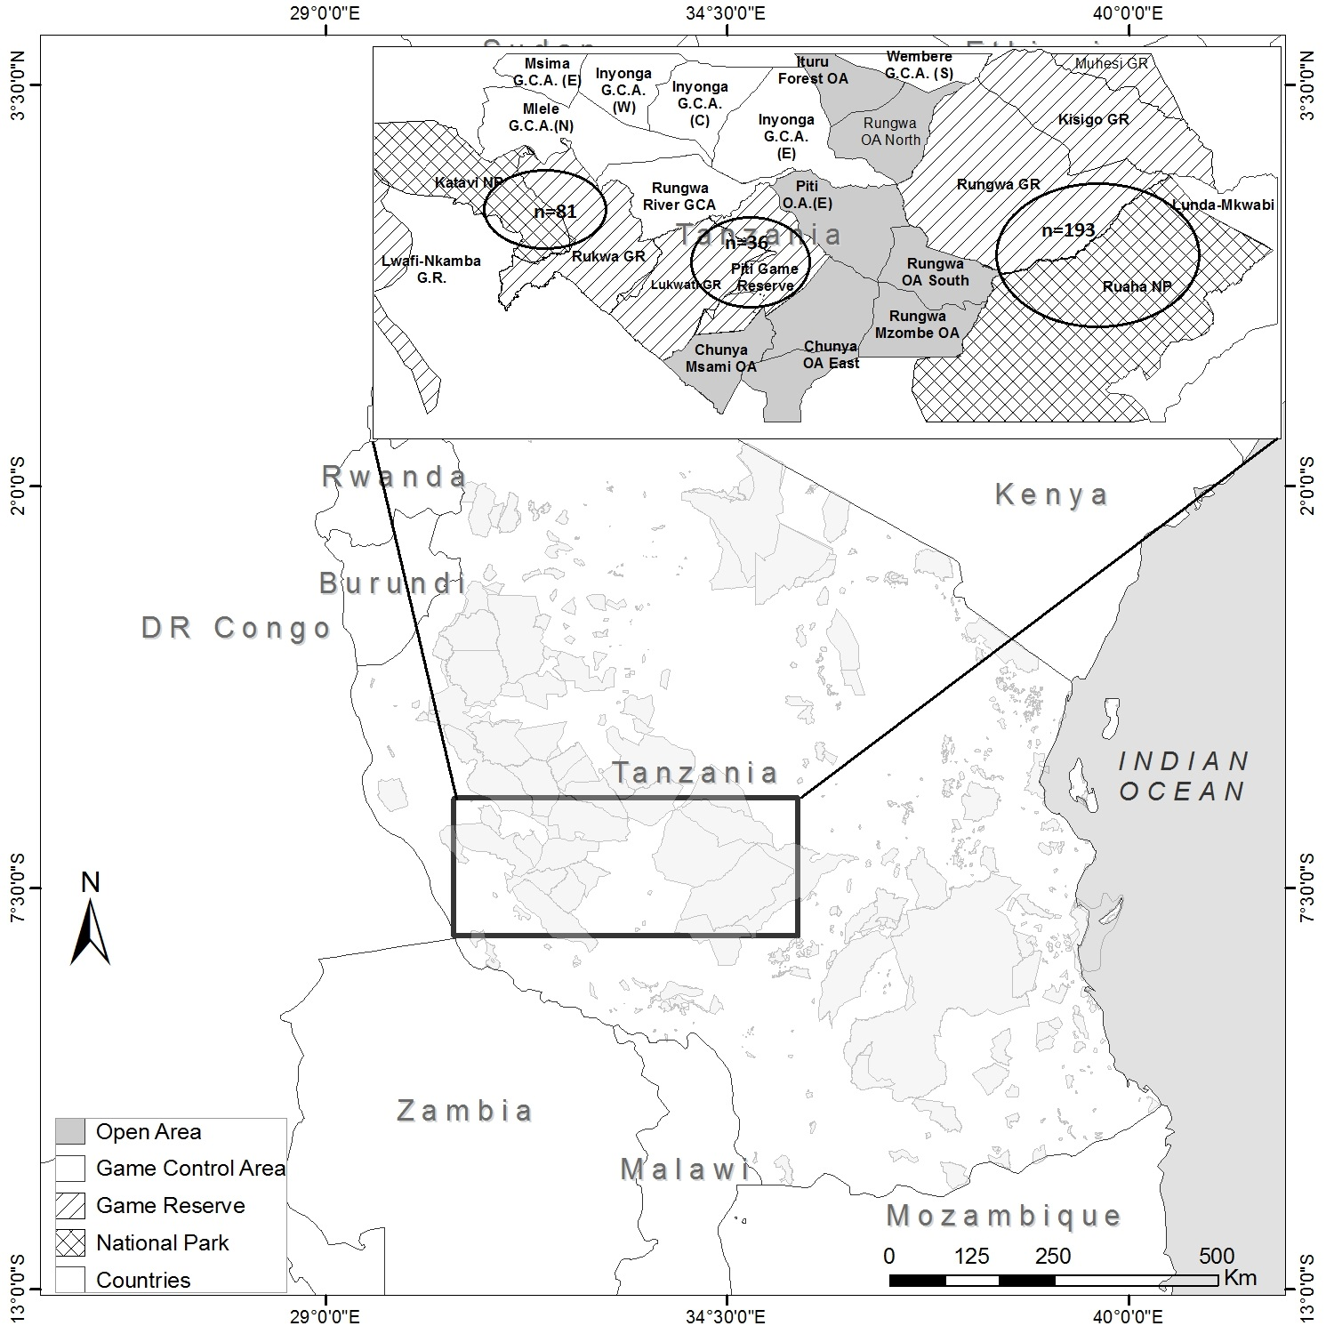

**Figure 1:** Sampling locations across the study area

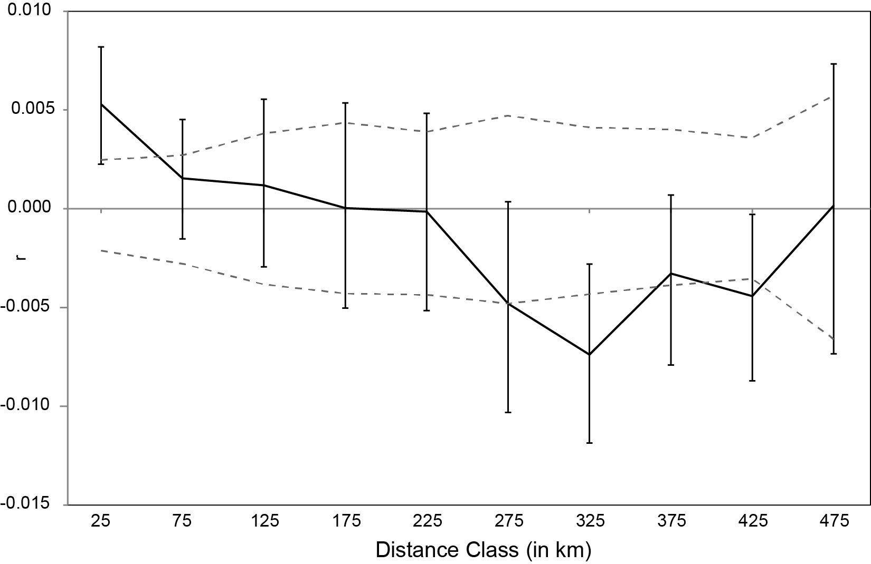

**Figure 2:** Correlogram showing spatial genetic autocorrelation (r) among individuals as a function of Euclidean distance. Distance classes were defined every 50km. Dotted lines indicate the 95% CI about the null hypothesis of no genetic structure. The error bars about r represent the 95% CI, as determined by bootstrapping (1000 iterations).



**Figure 3:** Analyses of individual genetic data using sPCA. (a) Positive and negative sPCA eigenvalues; only the two first positive (global) axes, corresponding to patterns of positive spatial autocorrelation among genotypes, were considered here. (b) Map of the ﬁrst global sPCA scores for each individual. (c) Map of the second global sPCA scores for each individual. Large white and black squares stand for highly negative and positive individual scores respectively. Small squares stand for low individual scores. White and black squares allow identifying distinct genetic clusters along each global axis, whereas the size of squares indicates how similar a genotype is from its neighbors (here located less than 50 km apart).

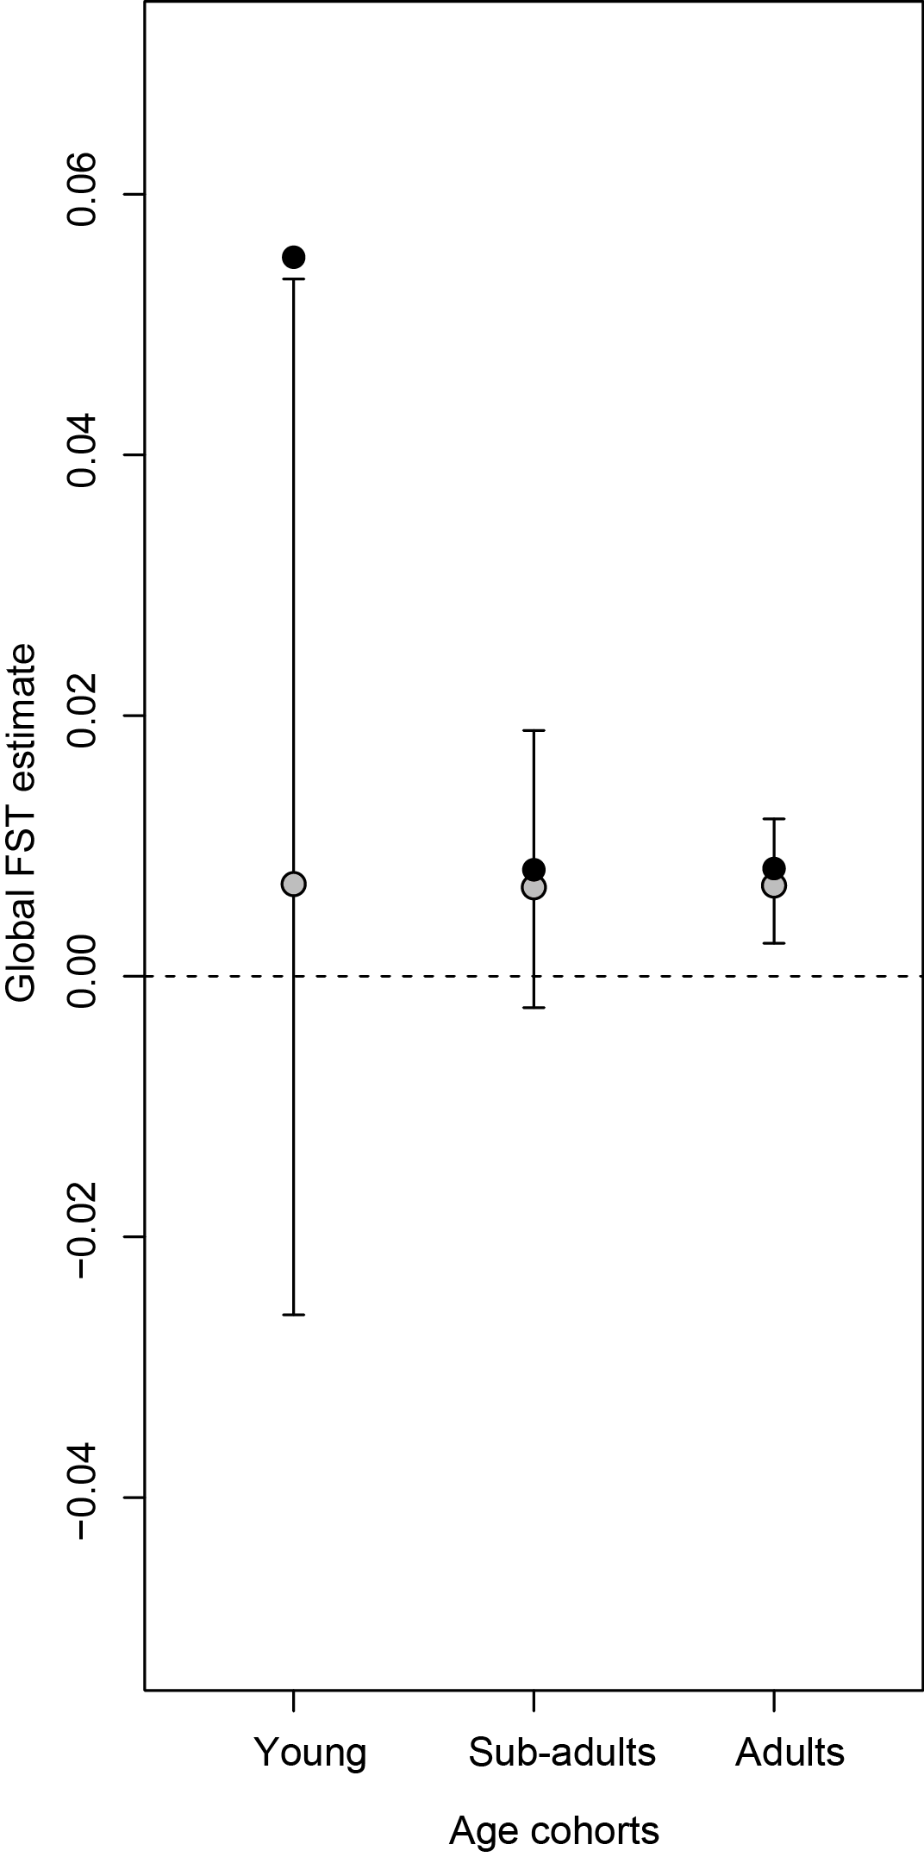

**Figure 4:** Comparison of global Fst estimates across age cohorts. For each cohort, observed Fst values are in black, whereas expected mean values under the hypothesis of an absence of age structure are in grey. Error bars indicate 95% confidence intervals around mean expected values, as computed from the random permutation of age cohorts among individuals (1000 iterations).

**Supplementary materials**

|  |  |  |  |  |  |  |  |  |  |
| --- | --- | --- | --- | --- | --- | --- | --- | --- | --- |
| **Appendix 1**. Genetic diversity measures for the populations sampled for this study. A=number of  alleles detected, AR=number of alleles adjusted for unequal sample sizes, AP=number of private  alleles, HO=observed heterozygosity, HE=expected heterozygosity, FIS=coefficient of inbreeding, *=locus does not conform to expected values under Hardy-Weinberg equilibrium | | | | | | | | | |
|  | | | | | | | | | |
| **Population** | **Locus** | **N** | **A** | **AR** | **AP** | **HO** | **HE** | **FIS** |  |
| **Western** | FH1 | 80 | 5 | 4.2 | 0.1 | 0.675 | 0.687 | 0.018 |  |
| **n=81** | LaT24 | 80 | 10 | 7.7 | 1.0 | 0.688 | 0.829 | 0.171 |  |
|  | FH60 | 81 | 5 | 3.0 | 0.1 | 0.296 | 0.330 | 0.102 |  |
|  | LA5 | 70 | 7 | 5.8 | 1.5 | 0.429* | 0.667 | 0.359 |  |
|  | FH19 | 80 | 9 | 6.6 | 1.2 | 0.513* | 0.712 | 0.282 |  |
|  | LA6 | 81 | 7 | 4.2 | 0.9 | 0.605 | 0.585 | -0.035 |  |
|  | LaT08 | 79 | 10 | 7.7 | 0.4 | 0.696 | 0.842 | 0.174 |  |
|  | FH48 | 81 | 9 | 6.8 | 0.3 | 0.802 | 0.726 | -0.106 |  |
|  | FH67 | 81 | 8 | 4.6 | 0.2 | 0.469 | 0.598 | 0.197 |  |
|  | Average |  | 7.8 | 5.6 | 0.6 | 0.605 | 0.664 | 0.129 |  |
|  | StDev |  | 1.9 | 1.7 | 0.5 | 0.170 | 0.153 | 0.150 |  |
|  |  |  |  |  |  |  |  |  |  |
|  |  |  |  |  |  |  |  |  |  |
| **Central** | FH1 | 36 | 4 | 4.0 | 0.0 | 0.750 | 0.720 | -0.042 |  |
| **n=36** | LaT24 | 36 | 7 | 6.5 | 0.1 | 0.694 | 0.812 | 0.146 |  |
|  | FH60 | 36 | 4 | 3.4 | 0.3 | 0.306* | 0.504 | 0.397 |  |
|  | LA5 | 29 | 4 | 3.6 | 0.0 | 0.345 | 0.482 | 0.288 |  |
|  | FH19 | 36 | 7 | 5.9 | 0.5 | 0.528 | 0.735 | 0.288 |  |
|  | LA6 | 36 | 4 | 3.7 | 0.6 | 0.528 | 0.570 | 0.075 |  |
|  | LaT08 | 36 | 10 | 9.1 | 1.2 | 0.750 | 0.826 | 0.094 |  |
|  | FH48 | 36 | 8 | 7.2 | 0.3 | 0.750 | 0.724 | -0.037 |  |
|  | FH67 | 36 | 8 | 6.7 | 1.0 | 0.694 | 0.730 | 0.049 |  |
|  | Average |  | 6.2 | 5.6 | 0.4 | 0.630 | 0.678 | 0.140 |  |
|  | StDev |  | 2.3 | 2.0 | 0.4 | 0.148 | 0.128 | 0.154 |  |
|  |  |  |  |  |  |  |  |  |  |
|  |  |  |  |  |  |  |  |  |  |
| **Eastern** | FH1 | 187 | 7 | 4.6 | 0.6 | 0.706 | 0.678 | -0.041 |  |
| **n=193** | LaT24 | 190 | 11 | 7.6 | 1.0 | 0.763 | 0.826 | 0.076 |  |
|  | FH60 | 193 | 5 | 4.0 | 0.9 | 0.368 | 0.422 | 0.128 |  |
|  | LA5 | 170 | 8 | 5.2 | 0.9 | 0.535* | 0.664 | 0.194 |  |
|  | FH19 | 187 | 10 | 6.8 | 1.2 | 0.642 | 0.737 | 0.130 |  |
|  | LA6 | 192 | 8 | 3.7 | 0.5 | 0.625 | 0.556 | -0.124 |  |
|  | LaT08 | 184 | 11 | 7.5 | 0.4 | 0.788 | 0.827 | 0.047 |  |
|  | FH48 | 192 | 9 | 6.8 | 0.3 | 0.922* | 0.759 | -0.215 |  |
|  | FH67 | 193 | 9 | 6.4 | 0.7 | 0.674 | 0.705 | 0.044 |  |
|  | Average |  | 8.7 | 5.9 | 0.7 | 0.652 | 0.686 | 0.027 |  |
|  | StDev |  | 1.9 | 1.5 | 0.3 | 0.139 | 0.130 | 0.131 |  |

**Appendix 2:** Results of analysis in STRUCTURE 2.3.4 (Pritchard *et al*., 2000) for values of K=1-10.

**K Mean LnP(K) StDev LnP(K) Delta K**

1 -9985.9300 0.0948 -

2 -10217.0100 95.7662 7.2013

3 -11137.7400 600.5503 2.0638

4 -10819.0000 374.6171 0.4626

5 -10326.9500 81.7760 5.6891

6 -10300.1000 46.0983 4.9698

7 -10502.4100 81.2908 1.1636

8 -10799.2800 176.4367 1.2661

9 -10872.7600 121.6361 1.7447

10 -11158.4600 237.3383 0.8142

**Appendix 3:** Script used for the analysis

*#Load libraries*

library(adegenet)

library(hierfstat)

*#Prepare data in Genind format from files “MP123.stru” (genotypes), “MP123_xy.txt” (coordinates) and “'ind_caracteristic.txt” (Age and sex for each individual)*

carac=read.table('ind_caracteristic.txt', h=TRUE)

R=read.structure("MP123.stru",n.ind = 310,n.loc = 9,onerowperind = TRUE,col.lab = 1,col.pop= 2,row.marknames = 0,col.others = 0,NA.char = "-9")

R@tab=tab(R, NA.method="mean")

Rxy=read.table("MP123_xy.txt",h=T)

R$other$xy= data.frame(cbind(Rxy$x,Rxy$y))

R$other$age=carac$Age

R@other$sex=carac$Sex

*#sPCA Analysis*

spca1=spca(R,scannf = TRUE,type = 5,d1 = 0,d2 = 100000)

loadingplot(loads, xlab = "Alleles", ylab = "Weight of the alleles",main = "Contribution of alleles \n to the sPCA axis ")

s.value(Rxy, spca1$ls[, 1], origin=c(min(Rxy$x),min(Rxy$y)), csize = 0.5)

s.value(Rxy, spca1$ls[, 2], origin=c(min(Rxy$x),min(Rxy$y)), csize = 0.5)

s.value(Rxy, spca1$ls[, 3], origin=c(min(Rxy$x),min(Rxy$y)), csize = 0.5)

*#Differences among age cohorts in terms of genetic differentiation: Permutation procedure*

Ra1=R[R@other$age==1,] *# Subset of Genind object for juveniles*

Ra2=R[R@other$age==2,] *# Subset of Genind object for subadults*

Ra3=R[R@other$age==3,] *# Subset of Genind object for adults*

Rini=R

Rini=Rini[Rini@other$age>0,] *# Removing individuals of unknown age*

output=as.data.frame(matrix(NA,nrow=1000,ncol=3)) *# Random permutation of ages*

for (i in c(1:1000)){

print(i)

Rboot=Rini

rarray=sample(1:dim(Rboot@tab)[1],dim(Rboot@tab)[1],replace = FALSE)

Rboot@other$age=Rboot@other$age[rarray]

Ra1bis=Rboot[Rboot@other$age==1,] *# Subset of Genind object for "false" juveniles*

Ra2bis=Rboot[Rboot@other$age==2,] *# Subset of Genind object for "false" subadults*

Ra3bis=Rboot[Rboot@other$age==3,] *# Subset of Genind object for "false" adults*

output[i,1]=fstat(Ra1bis,pop=Ra1bis@pop,fstonly=TRUE) *# expected global FST for "false" juveniles*

output[i,2]=fstat(Ra2bis,pop=Ra2bis@pop,fstonly=TRUE) *# expected global FST for "false" subadults*

output[i,3]=fstat(Ra3bis,pop=Ra3bis@pop,fstonly=TRUE) *# expected global FST for "false" adults*

}

colnames(output)=c('Young','Subad','Adults')

outexp=as.data.frame(matrix(NA,nrow=3,ncol=3))

for (i in c(1:3)){

outexp[,i]=quantile(output[,i],probs=c(0.025,0.5,0.975),na.rm=TRUE) *# expected range of global FST for each age class*

}

meanobs=as.data.frame(cbind(fstat(Ra1,pop=Ra1@pop,fstonly=TRUE),

fstat(Ra2,pop=Ra2@pop,fstonly=TRUE),

fstat(Ra3,pop=Ra3@pop,fstonly=TRUE))) *# observed global FST for each age class*

plot(1:3,meanobs,xlab='Age Class',ylab='Global FST estimate',ylim=c(-0.05,0.07),pch=16,cex=2,type='n',xlim=c(0.5,3.5))

arrows(1,outexp[1,1],1,outexp[3,1], length=0.05, angle=90, code=3)

arrows(2,outexp[1,2],2,outexp[3,2], length=0.05, angle=90, code=3)

arrows(3,outexp[1,3],3,outexp[3,3], length=0.05, angle=90, code=3)

points(1:3,outexp[2,],pch=21,bg='grey',cex=1.5)

abline(h=0,lty=2)

points(1:3,meanobs,pch=16,cex=1.5)