This version of the paper was accepted in May 2018 for publication in English Language and Linguistics (https://www.cambridge.org/core/journals/english-language-and-linguistics) and will appear there in its final form subsequent to editorial input by Cambridge University Press.

Transatlantic perspectives on variation in negative expressions
CLAIRE CHILDS
University of York
CHRISTOPHER HARVEY
University of Toronto
KAREN P. CORRIGAN
Newcastle University
SALI A. TAGLIAMONTE
University of Toronto

Abstract

Negation with indefinite items in English can be expressed in three ways: any-negation (I didn’t have any money), no-negation (I had no money) and negative concord (I didn’t have no money). These variants have persisted over time, with some studies suggesting that the newest variant, any-negation, is increasing at the expense of no-negation (Tottie 1991a, 1991b). Others suggest that although this variable was undergoing change in earlier centuries, it is stable in Modern English (Wallage 2017). This paper examines the current state of the variability in four communities within two distinctive English-speaking regions: Toronto and Belleville in Ontario, Canada, and Tyneside and York in Northern England. Our comparative quantitative analysis of speech corpora from these communities show that the rates of no-negation vary between Northern England and Ontario, but the variation is largely stable and primarily conditioned by verb type in a robust effect that holds cross-dialectally: functional verbs retain no-negation, while lexical verbs favour any. The social embedding of the variability varies between the communities, but they share a common variable grammar.

Keywords

Negation, indefinites, comparative sociolinguistics, morpho-syntactic variation, language variation and change

1 Introduction

English has three strategies for expressing negation with an indefinite item, which in this paper are termed any-negation, no-negation, and negative concord, respectively. Any-negation features a negative marker not on the verb (or the enclitic n’t as in (1)), which has scope over an indefinite negative polarity item with the form any(-), such as any, anything, anyone, or anybody. No-negation, illustrated in (2), lacks not and instead shows negation on the indefinite item itself, as in no, none, nothing, no one, or nobody. Negative concord features both not/n’t on the verb and a no- form, as in (3), but is interpreted as a single instance of negation.

(1) I wasn’t paying any rent here (York, M/26)
(2) There’s nothing you can do about it (Toronto, M/24)
(3) I haven’t got you nothing yet (Tyneside, F/19)

The historical development of negation in English can illuminate how any-negation, no-negation and negative concord have evolved which in turn will help explain their contemporary distribution. In Old English, the primary negator was ne. When used, ne always appeared immediately before the main verb as a proclitic (Ingham 2013: 123). In addition to ne, negative clauses sometimes featured a negative adverb with forms including nāwiht, nāht, nōht and nōwiht, as in (4) (Nevalainen 1998: 267). This became more common in the Middle English period, during which nowiht grammaticalized leading to the development of a compulsory post-verbal form not (van Kemenade 2000: 58; Iyeiri 2001: 86; Wallage 2012: 722), as shown in (5). Negative concord with indefinite items, like in (3) above, was common in Middle English (Jack 1978: 38), but no-negation could also be used once ‘n-item indefinites became able to introduce negation by themselves’ (Ingham 2013: 144–5). In Early Modern English, the co-occurrence of multiple negative markers declined in frequency, while the occurrence of not with any-items (shown in (6)) became possible in a change reportedly led by the upwardly mobile middle classes, particularly men (Nevalainen 1998: 277–8, 2006: 580; Nevalainen & Raumolin-Brunberg 2006). The choice of any-negation over negative concord at that time has been described as ‘a selective process from above in terms of the speaker-writer’s education and social status’ (Nevalainen 2006: 580).

(4) He nōwiht tō gymeleste ne forlet (Bede 206, 17)
‘He didn’t leave no whit (nothing) to neglect’
(5) thou n’art nat put out of it (Chaucer’s Boece, Book I, P5, 9–10) (14th C)
‘you [neg] are not put out of it’
(6) to enjoyne the said Baxter not to prosecute anie accion (Bacon 1590)
‘to order the said Baxter not to prosecute any action’

Any-negation had thus become a viable alternative to no-negation in Early Modern English. Did any-negation increase in frequency at the expense of no-negation? Willis et al. (2013: 38) suggest that this has been happening since the Middle English period, but Ingham (2013: 146) notes that any-negation ‘did not quickly displace no negation’, as no-negation was the favoured variant in 16th century letters. He suggests that increases in the frequency of any-negation over time may be related to the introduction of negative auxiliaries (e.g. don’t) that became used more often from the 16th century onwards (Ingham 2013: 146). Alternatively, the purported increase in any-negation ‘may well be an impression due to the disappearance of multiple negation from the standard’ (Mazzon 2004: 100).
To investigate the historical trajectory of the variation, its contemporary patterning and the constraints on use, Tottie (1991a, 1991b) undertook an extensive quantitative investigation of any-/no-negation in corpora of Standard British English. Her most contemporary data consisted of two samples from the 1960s – written prose (excluding fiction) from the Lancaster-Oslo/Bergen Corpus of British English (LOB) and spoken spontaneous conversation from the London-Lund Corpus of Spoken English (LLC) – which were analysed in Tottie (1991a) and Tottie (1991b). In these samples, no-negation was most preferred with existential BE constructions, followed by stative HAVE and copula BE, whereas lexical verbs tended to occur with not (Tottie 1991a, 1991b). Tottie (1991a: 440) suggests that these effects reflect lexical diffusion of any-negation over time, namely that ‘the more frequent a construction is, the more likely it is to be retained in its older form for a longer period of time’. When comparing this data with a sample of written texts from the Helsinki Corpus of English Texts (1640-1710), she observes an increase in the frequency of no-negation (for all verb types except copula BE) which she suggests ‘could indicate that there has been a development from no-negation to not-negation [any-negation] between the late seventeenth century and the present day’ (Tottie 1991a: 462).
While this trajectory of change seems plausible, the evidence provided in support of this conclusion is not entirely convincing. Firstly, the quantitative trend towards any-negation may have been biased by the inclusion of invariable sentences in the analysis (i.e. tokens where only one variant was possible) alongside variable ones – a decision which was taken ‘because of the problems involved in assessing variability in the historical sample’ (Tottie 1991a: 461). Secondly, the data used to establish verb frequency can likewise be critiqued. Tottie (1991a, 1991b) refers to DO, KNOW, GIVE and MAKE as the lexical verbs that are most frequent with no-negation and links this to their relatively high frequency overall, as indicated by their high ranking among c.6000 items in Francis and Kučera’s (1982) Frequency Analysis of English Usage: MAKE (rank 40); KNOW (rank 63); GIVE (rank 72). Although Francis and Kučera (1982) also rank DO, HAVE and BE as more frequent than other (lexical) verbs, which creates a parallel between frequency and rate of no-negation, Tottie (1991a) points out that this source does not distinguish between main and auxiliary functions of verbs. It is also not clear what the frequency rank was for the other lexical verbs in the sample and whether this correlates with their rate of no-negation. The rates of no-negation for DO, MAKE, KNOW and GIVE are calculated based on relatively few tokens and the trends in use fluctuate between speech and writing (Tottie 1991a, 1991b), suggesting that there may not be enough data to interpret the proposed trends unequivocally.
Regardless of whether the frequency-based account is supported, the contemporary variation could indeed reflect ‘a process of transition’ from no-negation to any-negation (Tottie 1991b: 235). However, a more recent corpus-based investigation by Wallage (2017), who investigated the evidence for change both historically and in modern Standard English, found no evidence of ongoing change. In his comparison of the variation in the Penn-Helsinki Parsed Corpus of Early Modern English (PPCEME) and the British National Corpus (BNC), the frequency of variants was consistent, as were the verb type constraints, leading him to conclude that the results ‘suggest historical persistence of variation rather than ongoing change’ (Wallage 2017: 197). Childs’ (2017) quantitative analysis of this variable in contemporary regional varieties of English spoken in Glasgow (Scotland), Tyneside (North East England) and Salford (Greater Manchester) similarly found no evidence of a change in progress towards no-negation, corroborating Wallage’s findings. As summarized in section 3 of this paper, Childs (2017) also highlights some methodological issues concerning Tottie’s (1991a, 1991b) definition of the variable and the variable context.
Our aim in this paper is to investigate the potential competition between any-negation, no-negation and negative concord, to establish whether the variation in contemporary Englishes reflects an ongoing diachronic change from no-negation to any-negation or is instead more indicative of a change which has now become stable. To this end, we examine the phenomena in two sets of vernacular speech corpora, from Northern England and Ontario, Canada, to see whether attending to geographic, linguistic and social factors can offer insights into the current state of the variation.

2 Corpora and samples

The corpora comprise vernacular sociolinguistic interviews with native English speakers, conducted in Northern England and Ontario, Canada. A preliminary study of negation in Ontario was made based on the Canadian corpora analyzed here (Harvey 2013). In the present paper, we aim to determine whether similar language internal and external tendencies exist in geographically distinct varieties of English, through a comparison of two varieties on either side of the Atlantic: Ontario English and Northern British English. These dialects share historical links in the sense that the vast majority of the early founder populations (Mufwene 2001: 27–9) to Ontario hailed from the British Isles. Southern Ontario was predominately settled by migrants of British descent from the United States (Loyalists), whereas more northern climes had significantly more migrants from Northern England, Scotland and Ulster (see Cowan 1961: 288; Elliott 2004: 65; Boberg 2010: 77). We therefore adopt a comparative approach, analyzing the distribution of any-negation, no-negation and negative concord across our target locales to (i) establish how variation is conditioned within the grammar(s) of English; (ii) identify how the variation is socially conditioned; and (iii) assess the evidence for linguistic change in progress and the state of the variation in the different varieties (Tagliamonte 2013: 186).
The Canadian recordings (Tagliamonte 2003–2006) are from Toronto, a major urban area with over five million inhabitants, and Belleville, a town of approximately 50,000 residents situated two hours east of Toronto. The two locales have distinctive demographic profiles: Toronto is a diverse multicultural urban centre while Belleville is more homogenous with a strong history of Loyalist settlement.
The British recordings are from four Northern English locales, three of which are herein combined as the ‘North East of England’ since the varieties spoken there share similar dialectal features (Beal et al. 2012). These three locales are the urban Tyneside region and two nearby smaller urban areas, Wheatley Hill and Durham, in County Durham. The Tyneside data consists of a sample of recordings from the Diachronic Electronic Corpus of Tyneside English (DECTE, Corrigan et al. 2010–12) while the data from Wheatley Hill and Durham is from Tagliamonte (1998, 2003). We compare the results from North East England with those from York (Tagliamonte 1996-1998, 1998, 2003), a major city in North Yorkshire, where the native dialect is distinct from that spoken in the North East but they share certain pan-Northern English linguistic features (Trousdale 2012; Buchstaller & Corrigan 2015).
The conversations within these sociolinguistic interviews, which were designed to elicit vernacular speech, are informal. They contain many narratives of personal experience about childhood, hobbies and interests, as well as local history. The interviewees’ speech is representative of the dialect of their local area, having all been born and raised in their respective locales. The corpora have different sizes and the distribution of speakers by age varies across the datasets. In total, there are 305 speakers in our sample and their ages range from 14 to 80+, as Table 1 shows.

Table 1
Speaker sample
Community | 14–19 | 20–29 | 30–39 | 40–49 | 50–59 | 60–69 | 70–79 | 80+ | TOTAL
North East England | 26 | 19 | 4 | 7 | 10 | 7 | 6 | 0 | 79
York, North Yorkshire | 6 | 15 | 9 | 10 | 11 | 16 | 20 | 8 | 95
Toronto, Ontario | 5 | 20 | 12 | 18 | 12 | 8 | 11 | 8 | 94
Belleville, Ontario | 5 | 3 | 4 | 4 | 4 | 5 | 7 | 5 | 37

The recordings provide ample tokens of the variable under study, and rich intra-speaker variation, as shown in (7) and (8). In (7), the clause construction is the same each time, featuring existential there were and the complement jobs, but the speaker alternates between any-negation for the first sentence and no-negation for the second. Similar optionality is shown in (8): negation can be expressed within the verb phrase (8a) or on the indefinite (8b).

(7) a. There weren’t any jobs.
b. There were no jobs to be had (Toronto, F/43)
(8) a. I don’t have any information.
b. you had no option (Belleville, M/33)

3 The variable context

All instances of any-negation, no-negation and negative concord were extracted from our sample. Any-negation tokens feature the indefinite items any, anybody, anyone, anything, owt (found exclusively in the British data, meaning ‘anything’) or anywhere in the predicate. These are prototypically licensed by a negative marker (not/n’t) on the preceding verb in the clause, which has scope over the indefinite. Within prepositional phrases (henceforth PPs), indefinite any- items are often licensed in this same way (9a), but they can also appear alongside elements such as without (10a). No- indefinites can also occur in these environments with no change in referential meaning, as (9b) and (10b) illustrate.

(9) a. We’re not under any obligation
b. We’re under no obligation (Toronto, F/29)
(10) a. […] someone else was appointed without any reference
b. […] someone else was appointed with no reference (York, F/24)

Tokens of no-negation feature the negative counterparts to the indefinite any- items, namely no/none, nobody, no one, nothing, nowt (‘nothing’ – exclusively British) and nowhere. Negative concord tokens were also captured using this latter set of search terms, since they feature these no-forms (in addition to a negatively marked verb). Instances of never and n’t/not…ever were not extracted because never is near-categorically used in this environment, so including those tokens in our analysis would bias the results (Tottie 1991b: 109; Childs 2017).
The variable context excludes tokens with a negatively marked verb that has scope over the articles a/an or zero determiner, i.e., sentences of the type in (11a).

(11) a. well she said # that doesn’t make sense # that’s the cheapest of the lot
b. well she said # that makes no sense # that’s the cheapest of the lot
(Tottie 1991b: 178, 211)

Although some previous studies of any-negation and no-negation interpret sentences like (11a) and (11b) to be semantically equivalent and include them in their analysis (Tottie 1991a, 1991b), we consider the underlying form of makes no sense in (11b) to be doesn’t make any sense, rather than doesn’t make sense like in (11a). Our rationale is as follows.
Childs (2016, 2017) argues that a/an/ø are not equivalent to any because they have distinct semantic and syntactic properties. Firstly, unlike the a/an/ø items, any is a negative polarity item which expresses ‘a kind of extreme non-specificity’ (Lyons 1999: 37) that the former do not – i.e., they are ‘less exception-tolerant’ (Chierchia 2013: 27).
Secondly, several investigations of negative concord in different varieties of English find that a and an either do not undergo negative concord at all, or do so very rarely (Labov 1972a: 806; Cheshire 1982: 66; Smith 2001: 131). Although Howe (2005) finds examples of this kind in African American Vernacular English (AAVE), Labov (1972a: 810–1) had argued (also based on AAVE) that such instances arise because any is inserted prior to negative concord taking place. This can explain why (12b) and (12c) are equivalent in emphatic force while (12a) is much weaker.

(12) a. He didn’t have a car.
b. He didn’t have any car.
c. He didn’t have no car.

Thirdly, Tottie (1991b: 205) reports that her informant judged he is not/isn’t a moralist as semantically equivalent to he is no moralist, but not semantically equivalent to he is not/isn’t any moralist. This judgement is contrary to the overwhelming consensus that no is equivalent to not any (Quirk et al. 1985: 782; Tieken-Boon van Ostade 1997: 188; Anderwald 2002, 2005; Peters 2008; Peters & Funk 2009; Wallage 2017). Tottie (1991b: 130) rightly argues elsewhere that Bill is not a doctor and Bill is no doctor do not have the same meaning since the former is a denial while the latter expresses the view that Bill ‘lacks the essential qualities’ to be a good doctor. This same explanation can be extended to he is no moralist, yet that sentence was included and Bill is no doctor was not.
Fourthly, although Tottie includes indefinite articles/zero determiners in her variable context, she acknowledges that instances of indefinites with not-negation that do permit no-negation tend to have any (or potentially allow it), and that no-negation similarly tends to correspond to an underlying any rather than a/an or zero determiners (Tottie 1991b: 263).
We therefore argue based on the discussion in Childs (2016, 2017) as summarized above that no-negation is semantically equivalent to n’t/not…any- constructions, rather than n’t/not…a/an/ø. We thus exclude the latter token types and use the term any-negation to refer to the former.
The extracted tokens were rigorously sorted to remove those that fall outside the precise variable context described above. Several other contexts appear to be candidates for any/no-negation and negative concord, but there are cases where either variation is not possible or any-negation is not semantically equivalent to no-negation, which we outline below.

3.1 Indefinites in subject position

As our variable context requires any-/no-forms to be in the predicate, we excluded indefinites in subject position. No is categorical in this context (13a) and alternatives with any-negation as in (13b) did not appear in any of the corpora. Indeed, these are rare even in other varieties such as those spoken in Ireland in which the failure of negative attraction is possible for some speakers (Harris 1984: 305; Filppula 1999: 179–81; Filppula 2008: 338). These tokens are therefore not considered further in the investigation.

(13) a. Nobody would sit in that seat (Toronto, M/36)
b. *Anybody wouldn’t sit in that seat

3.2 Presence of adverbs

The presence of an adverb in the clause restricts the choice of variant. For example, when actually is in the immediate scope of a negative marker, as in (14a), the sentence is interpreted as ‘a hedged statement’ (Paradis 2003: 202). In contrast, (14b) has ‘the function of emphasizing the subjective judgement of the importance of the situation involved in the proposition in question’ (Paradis 2003: 194). Other adverbs such as absolutely cannot occur after negation (15b), only before it (15a). Therefore, tokens containing adverbs were excluded from the sample given the lack of semantic equivalence between variants.

(14) a. I didn’t actually need anything (York, F/52)
b. I actually needed nothing

(15) a. There’s absolutely no flights out of Victoria (Toronto, M/49)
b. *There’s not absolutely any flights out of Victoria

3.3 Negative raising or cross-clausal negation

In cross-clausal or negative raising contexts, the movement of the negative marker changes the meaning or force of the sentence, as demonstrated by the subtle differences in (16). Furthermore, certain negative raising constructions such as I don’t think are formulaic and have become grammaticalized (Scheibman 2000; Pichler 2013), which leads to use of the any-negation variant. Cross-clausal negation was thus also excluded from our sample.

(16) a. I don’t think I would change anything (Tyneside, F/18)
b. I think I wouldn’t change anything
c. I think I would change nothing

3.4 Adjectival complements

As Tottie (1991b: 131) notes, any- and no-negation often differ in meaning when there is an adjectival complement. Examples like (17a) had already been excluded for having no determiner and it is clear that (17b) has a much stronger, more emphatic reading. Pairs like this are therefore not semantically equivalent and likewise do not form part of the variable context.

(17) a. It doesn’t look good for a Christian woman (M/SG/121, Tyneside)
b. It looks no good for a Christian woman

3.5 Unclear tokens

Tokens that were unclear in the audio/transcripts, occurred in unfinished clauses or were ambiguous in any respect were similarly excluded from our sample as in these cases we could not be certain as to their classification.
Observing all of these procedures produced 1821 tokens where any-negation, no-negation, and negative concord were all viable with semantically equivalent meanings.

4 Coding

We coded for both grammatical and social factors. The grammatical factor is verb/construction type, which has been found to be a major factor governing the variation in previous research (Tottie 1991a, 1991b; Childs 2017; Wallage 2017).
Verb/construction type was coded according to the categories in (18). Existential there+BE constructions consistently have the highest rates of no-negation, while lexical verbs have the lowest and tend to have any-negation. The percentages of no-negation for BE, HAVE and HAVE GOT differ between previous studies but consistently rank between the existentials and lexical verbs in this regard.
Variation within PPs has drawn considerably less attention in the literature. Although Tottie (1991b: 265–6) examines PPs and notes that no-negation is infrequent in this environment, her results are based on her overall sample of both invariable and variable structures, in speech and writing. Tottie’s findings for the variable spoken sample, most comparable to the nature of our data (in that it is spoken and comprises only tokens where both any- and no-negation are possible, in contrast to her ‘written’ and ‘invariable’ samples) are inconclusive due to low Ns (N=4). Although PPs do not feature negative marking on a verb, any/no do alternate in this environment, e.g. without any versus with no, as in (18f). We therefore decided to include PPs as part of our investigation as a point of comparison to examine whether they pattern like the examples of verbal negation.

(18) a. Existentials (there + BE) There was no canteen (Belleville, M/52)
b. BE It wasn’t any particular amount (Tyneside, M/25)
c. HAVE We had nothing (Toronto, F/19)
d. HAVE GOT I haven’t got any (Wheatley Hill, F/72)
e. Lexical verbs He’s not heard anything (York, M/55)
f. In PP We’ll end up with no Santa’s grotto
(Tyneside, M/ 21)

Our decision to implement binary social variables in our analysis may mask self-imposed social categories that can be pertinent in the analysis of language variation (Eckert 1989, 2000). However, our data emanates from pre-existing large-scale corpora, which precludes taking a more ethnographic approach. Our aim is to analyze the linguistic variable’s distribution quantitatively in conjunction with the classic sociolinguistic variables of sex (male/female), age (birth year, ranging from 1906 to 1993) and education (with/without post-secondary education), which will allow us to assess the evidence for change in progress.

5 Distributional Analysis

5.1 Locality

Figure 1 shows the overall distribution of negative constructions for the four areas under study.

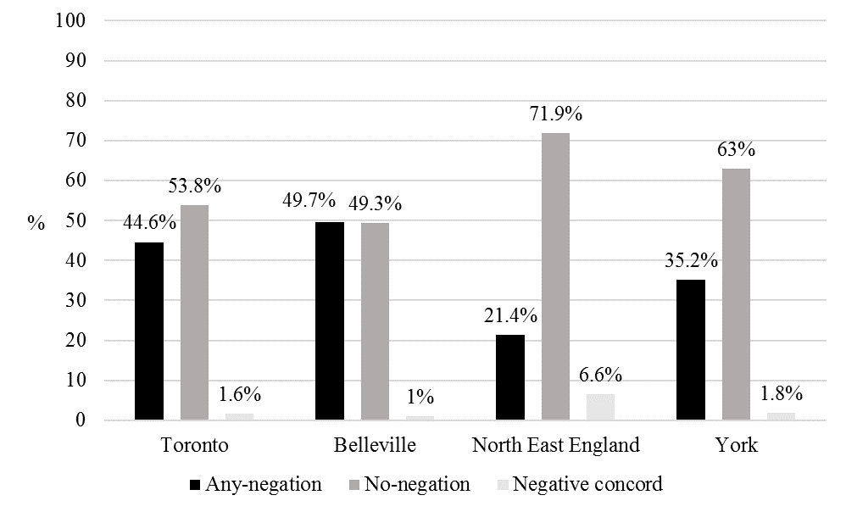
Figure 1
Distribution of any-negation, no-negation and negative concord in each community
Negative concord is virtually absent in Toronto, Belleville and York, and occurs rarely (6.6% of the time) in the North East of England. Because of its low frequency, negative concord is henceforth excluded from our quantitative analysis. In contrast, variation between no- and any-negation is present in all varieties, but the distribution is markedly different for both countries. In Canada, the two constructions have near-equal frequency, with a slight preference for no-negation in Toronto. In England, no-negation dominates at 63% in York and 71.9% in the North East. Given that any-negation is the newcomer variant historically, these figures indicate that any-negation has made greater inroads into Canadian English dialects, while in Northern British English varieties the older no-negation variant endures.
5.2 Verb/Construction type

Table 2 shows the distribution of no-negation according to verb/construction type in each community, in terms of the categories presented in section 4. The greyed out percentages for HAVE GOT in Toronto and HAVE GOT/BE in Belleville indicate that there are less than 10 tokens in these cells.

Table 2
Distribution of no-negation per verb/construction type in each community
 | Toronto |  | Belleville |  | North East England |  | York
 | % | N | % | N | % | N | % | N
Existentials | 93 | 327 | 84 | 107 | 98 | 160 | 95 | 285
BE | 78 | 50 | 100 | 8 | 94 | 36 | 88 | 57
HAVE GOT | 88 | 8 | 50 | 2 | 87 | 79 | 66 | 32
HAVE | 66 | 272 | 59 | 61 | 77 | 79 | 64 | 188
PPs | 40 | 63 | 46 | 13 | 64 | 14 | 63 | 27
Lexical | 13 | 390 | 7 | 108 | 36 | 111 | 19 | 223

Despite the different overall frequencies between the dialects, the patterning of no-negation by verb/construction types is remarkably similar in each community. Existentials (there+BE) consistently have the highest frequency of no-negation, with near-categorical rates in England. Constructions with BE, HAVE and HAVE GOT also have high rates of no-negation, ranging from (excluding the two tokens of HAVE GOT in Belleville) 59% in Belleville for HAVE up to 94% in North East England for BE. In contrast, the lexical verbs have a strong tendency to co-occur with any-negation. This pattern is consistent across all four communities, ranging between 7% in Belleville and 36% in North East England. Furthermore, these tendencies are generally in keeping with those observed for this variable in Standard British English (Tottie 1991a, 1991b; Wallage 2017) and varieties of English spoken in Glasgow, Scotland and Salford, Greater Manchester (Childs 2017). The consistency in these trends emphasizes the robustness of the verb type constraint on this variation in grammars of English globally.
PPs are positioned between lexical and functional verbs in terms of their propensity to take no-negation, but display different tendencies on each side of the Atlantic: in Ontario, Canada, PPs most often occur with any-negation, while in Northern England they tend to occur with no. The PP environment is therefore one in which the choice of any-negation versus no-negation appears to be subject to cross-dialectal differentiation. The over-arching pattern, however, is a marked division between functional verbs (BE, HAVE, HAVE GOT) versus lexical verbs (see also Wallage 2017).
Bybee & Hopper (2001) argue that constructions such as existentials are highly frequent and therefore processed and produced as a whole, which could account for their high propensity to occur with no-negation. As discussed in section 1, Tottie (1991a, 1991b) argues that BE and HAVE are also high frequency, making them resistant to change and therefore more likely to retain the variant that is oldest historically, no-negation. In contrast, individual lexical verbs are less frequent which Tottie (1991a, 1991b: 232) argues makes them more likely to undergo change, i.e. take any-negation. Tottie (1991b) does note that verbs which have more tokens within her any-/no-negation variable context do exhibit more no-negation, e.g. existentials were higher frequency (N=38) and had more no-negation than copula BE (N=20), but the evidence for this frequency-based account can be questioned, as discussed in section 3.
In his analysis of any-negation and no-negation in Ontario, Canada, Harvey (2013) appeals to Tottie’s (1991a, 1991b) frequency account to explain collocational tendencies in his data, but suggests that syntactic factors may also be relevant to better understand the verb type effects in speakers’ choice of variant. Harvey’s (2013) proposal, based on Smith’s (2000) account of DO-absence, appeals to the fact that functional and lexical verbs have different movement properties and positions in the syntactic structure relative to the negative operator. Under this account, since BE (obligatorily) and HAVE (optionally) raise for tense and agreement (Pollock 1989) and thus reside in a position that is syntactically close to the negative operator in the functional projection NegP, they are more likely to take no-negation. Lexical verbs, on the other hand, obligatorily remain low in the VP with much greater structural distance between them and the operator, making no-negation more difficult to derive.
Childs (2017) proposes that this effect could be explained in one of two ways: (i) no-forms have an uninterpretable negative feature that must agree with an interpretable negative operator in NegP (Zeijlstra 2004), in which case lexical verbs favour any-negation because they remain in a position between the negative operator and the post-verbal indefinite item and thus can disrupt the Agree relation required for no-negation/negative concord; or (ii) no-negation is distinct from the other two variants in being marked for negation within the post-verbal NP and moving to NegP to receive sentential scope (see Kayne 1998; Svenonius 2002; Zeijlstra 2011; Tubau 2016), which would be dispreferred with lexical verbs since they constitute additional material that the no-negation must move across. While the former account predicts that both no-negation and negative concord would be dispreferred with lexical verbs, the latter predicts that this is true only of no-negation (Childs 2017). Childs (2017) finds in her data from three Northern British communities that the latter account is more strongly supported since any-negation and negative concord behaved in tandem with respect to verb type and overall frequency, while no-negation was distinct.

5.3 Sex

Labov’s (2001) principles of linguistic change emphasize the role of women as leaders of change, whether it is from above (Principle 3: a conscious change whereby women favour a variant with more prestige) or below (Principle 2: an unconscious change in which women use innovative variants more than men). When we consider the historical context of the variation that we are investigating, we see that the inception and rise in the frequency of any-negation over negative concord in Early Modern English has been characterized as a change from above. At that time, any-negation certainly fit the definition of a prestige form that is associated with groups of higher status (e.g. Labov 1972b: 138; Van Herk 2012: 48). It was used by people who were more educated and of a higher social standing (Nevalainen 1998: 277–8, 2006; Nevalainen & Raumolin-Brunberg 2006) and was associated with legal, administrative and professional language (Rissanen 2000: 125; Nevalainen & Raumolin-Brunberg 2006: 150). Contrary to what one would typically expect for a change from above, the increasing use of any-negation as opposed to negative concord in Early Modern English was led by men (Nevalainen 1998: 277–8, 2006), because at that time women ‘did not promote language changes that emanated from the world of learning and professional use, which lay outside their own spheres of ‘being’’ (Nevalainen & Raumolin-Brunberg 2006: 131). That said, while women ‘did not prove to be the leading influence in this change, […] neither did they lag behind in adopting the innovation’ (Nevalainen 1998: 284).
In Present-Day English, it is not clear whether any-negation holds any particular prestige over no-negation (which the above accounts did not investigate), though this remains a question for future research. We examine the contemporary frequency of no-negation (versus any-negation) in Figure 2. In this distributional analysis, and others pertaining to social variables, we remove existentials given their near-categorical tendency to take no-negation.
In Figure 2, we see a reversal of the historical association between any-negation and men. Male speakers now use no-negation more than women in Belleville, North East England and York. In Toronto, on the other hand, there is barely any distinction between the sexes in their use of this variable and this is the only community in which the distribution is not significant.

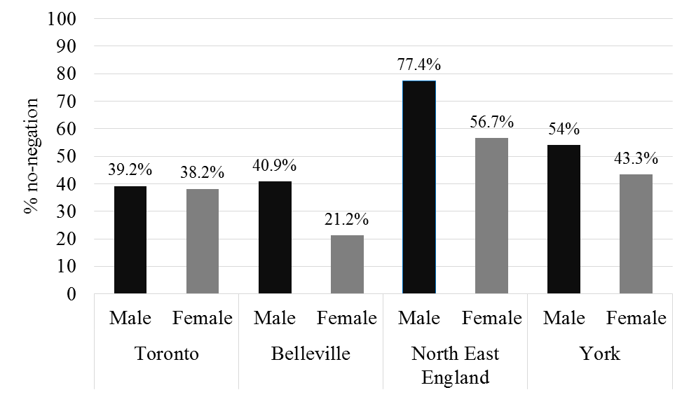
Figure 2
Distribution of no-negation in each community according to speaker sex

If these patterns do reflect modern-day competition between variants, the fact that women use any-negation more than men in three out of our four communities may not necessarily represent change from above, but change from below (Labov 1966: 207, 1972b: 133). This interpretation would capture women’s propensity to lead in unconscious changes towards greater use of an innovative variant without recourse to prestige. While any-negation is not a ‘recent’ innovation, it is historically the newest variant of our negation sub-types. Alternatively, what we may be witnessing here is stable linguistic variation with social patterning between men and women in three of our four communities. Examining how the variation patterns according to speakers’ birth year, as we do in section 5.4, offers us a way of further assessing the evidence for present-day change or stability.

5.4 Birth year

To explore whether there is evidence for change or stability in British and Canadian vernaculars, we categorized the data according to speakers’ birth year as a proxy for real time. Although there were no speakers born in 1906–20 in the North East England and Belleville samples, and no speakers born in 1981–93 in the York sample, the timespan is nevertheless expansive and allows us to observe diachronic trends in the frequency of no-negation (versus any-negation), as shown in Figure 3.

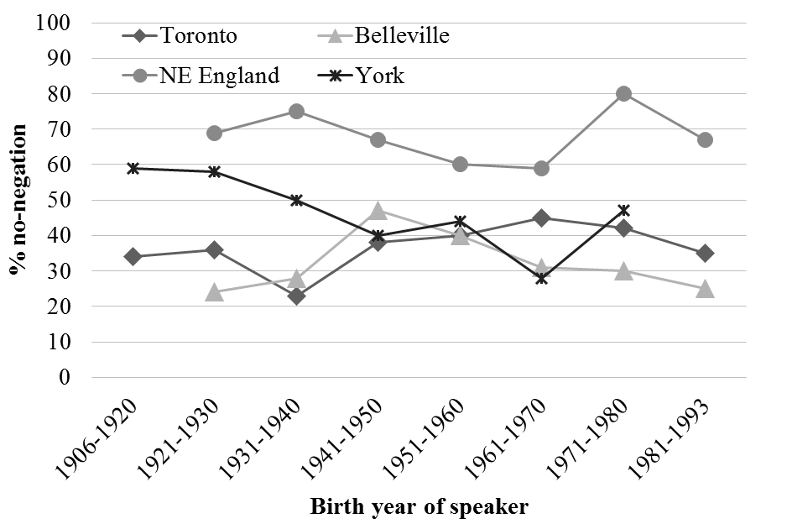
Figure 3
Distribution of no-negation in each community according to speakers’ birth year

The distribution of variants according to birth year is significant in York, but not in any other locale. In York, there is an upswing among the speakers born in 1971-1980 compared to speakers born in the previous few decades. In all communities, even York, there is not a steady increase or decline in the use of no-negation. Therefore, taken as a whole, the results more strongly support the third of our three possible interpretations set out in section 5.3, i.e. that the current variation between any- and no-negation is relatively stable, as opposed to undergoing change from above or below. The nature of these trends is explored further in section 6, where birth year is considered alongside other predictors in a mixed-effects logistic regression analysis to confirm which factors have a significant impact on variant choice while holding the effect of the individual constant.

5.5 Education

The final social factor considered here is education, specifically whether a speaker has completed post-secondary education or not. As D’Arcy & Tagliamonte (2010) discovered in their analysis of relative who, linguistic items that were once introduced by change from above can retain their distributional association with higher levels of education and professional status several centuries later in corpus-based analysis. Thus, in this section we investigate the possibility that any-negation, which had prestige and was introduced in a change from above in Early Modern English (Nevalainen 1998: 277–8, 2006; Nevalainen & Raumolin-Brunberg 2006), may be used at higher frequencies amongst more educated speakers.
Figure 4 shows the relationship between the percentage of no-negation and education. Although the distribution is more socially-stratified according to education in the two British communities as opposed to the two Canadian ones, the effect is not statistically significant in any locale. The direction of the pattern is the same in both the North East of England and in York: speakers without post-secondary education use no-negation more than those who have been educated beyond secondary school, i.e. those who are more highly educated use any-negation at higher rates. Although no-negation has been considered ‘more literary’ (Biber 1988: 245) and is more frequent in writing than speech (Tottie 1991a, 1991b; Biber et al. 1999), our data shows that this does not equate to a higher use of no-negation among more educated speakers.

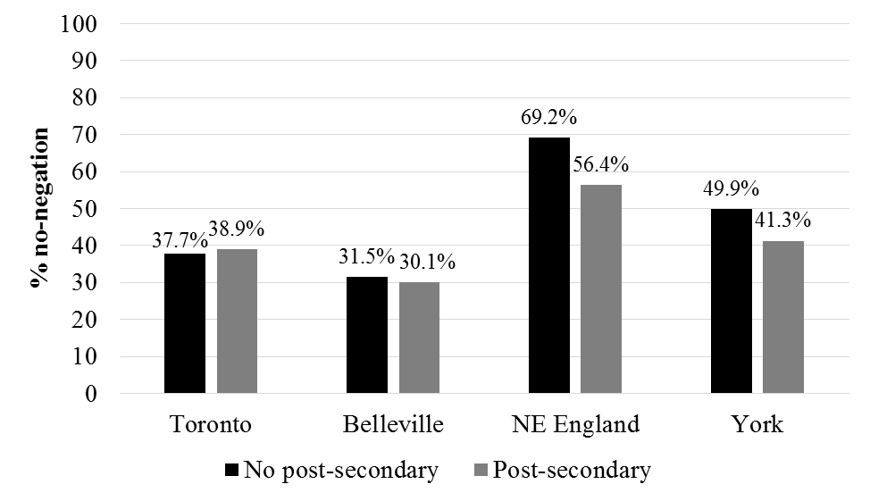
Figure 4
Percentage of no-negation in each community according to speaker education

The distributional results have revealed that both internal and external factors impact upon speakers’ choice between any- and no-negation in British and Canadian English. The following section presents the results of statistical modelling to establish which effects are significant when all are considered simultaneously and to investigate whether they operate consistently on each side of the Atlantic.

6 Statistical modelling

We now undertake mixed-effects logistic regression analysis of the variation using the lme4 package (Bates et al. 2015) in R (R Core Team 2014), with one model per locale: Toronto, Belleville, North East England, and York. The four predictors analyzed independently in section 5 were included in the models for each variety: ‘verb/construction type’, ‘sex’, ‘education’ and ‘birth year’ as fixed effects, plus ‘speaker’ as a random effect. As the results from section 5.2 revealed that BE, HAVE and HAVE GOT all tend to occur with no-negation, these were combined as ‘functional verbs’, as opposed to ‘PPs’ and ‘lexical verbs’. ‘Existentials’ were excluded given their near-categorical tendency to take no-negation. ‘Sex’ was coded as ‘male’ versus ‘female’, and ‘education’ as ‘secondary’ versus ‘post-secondary’. ‘Birth year’ was collapsed from the original eight categories to four larger groups (‘1906–30’, ‘1931–50’, ‘1951–70’, ‘1971–93’), to overcome the fact already mentioned that some of the corpora did not have speakers born in 1906–20 or 1981–93 (see Figure 3).
Table 3 shows the results of the regression of the factors affecting the choice of no-negation over any-negation in the four locales.
Table 3
Mixed effects logistic regression of factors affecting the choice of no-negation (over any-negation) per locale

 | Toronto |  |  |  | Belleville |  |  |  | North East England |  |  |  | York
Total N | 783 |  |  |  | 192 |  |  |  | 319 |  |  |  | 527
 | Est. | Std error | p | Sig. | Est. | Std error | p | Sig. | Est. | Std error | p | Sig. | Est. | Std error | p | Sig.
Verb/construction
Functional verbs
PPs | -1.312 | 0.314 | 2.92e⁻⁵ | *** | -0.687 | 0.725 | 0.343 |  | -1.093 | 0.659 | 0.097 |  | -0.297 | 0.442 | 0.502
Lexical verbs | -2.973 | 0.227 | < 2e⁻¹⁶ | *** | -3.547 | 0.585 | 1.3e⁻⁹ | *** | -2.580 | 0.349 | 1.48e⁻¹³ | *** | -2.384 | 0.241 | < 2e⁻¹⁶ | ***
Sex
Female
Male | 0.060 | 0.266 | 0.820 |  | 1.304 | 0.589 | 0.027 | * | 1.036 | 0.392 | 0.008 | ** | 0.646 | 0.227 | 0.004 | **
Education
No post-secondary
Post-secondary | -0.328 | 0.311 | 0.293 |  | 0.218 | 0.572 | 0.702 |  | -0.578 | 0.469 | 0.217 |  | -0.214 | 0.272 | 0.432
Birth year
1971–93
1906–30 | -0.369 | 0.379 | 0.330 |  | 0.389 | 0.768 | 0.613 |  | -0.588 | 0.678 | 0.386 |  | 0.772 | 0.353 | 0.029 | *
1931–50 | -0.285 | 0.412 | 0.489 |  | 1.036 | 0.733 | 0.157 |  | 0.182 | 0.538 | 0.735 |  | -0.014 | 0.346 | 0.967
1951–70 | 0.057 | 0.300 | 0.850 |  | -0.113 | 0.738 | 0.878 |  | -0.475 | 0.454 | 0.295 |  | -0.308 | 0.353 | 0.384
Speaker (random)  Standard deviation | 0.662 |  |  |  | 0.836 |  |  |  | 0.605 |  |  |  | 0.149

The results in Table 3 reveal that ‘verb/construction type’ is the major constraint affecting any- and no-negation, with all four locales displaying a statistically significant effect whereby functional verbs (BE, HAVE, HAVE GOT) strongly favour no-negation and lexical verbs disfavour it. The overall frequency of no-negation with PPs was earlier found to differ between Canadian English and British English (see section 5.2), but in Table 3, the distinction between functional verbs and PPs is significant only in Toronto. Nevertheless, the same propensity holds across the board: in every community, PPs slightly disfavor no-negation compared to functional verbs. The fact that this effect is significant only in Toronto and not Belleville may simply be because there are fewer tokens of PPs in Belleville (N=13).
Consideration of the social factors shows that men use more no-negation than women across all four communities, at statistically significant levels in the UK locales and in Belleville, which corresponds with the distributional analysis in section 5.3. Education, on the other hand, has no significance in the variation. Birth year meanwhile shows small deviations between the groups but is significant only in York and only between the speakers born earliest (1906-1930) and born latest (1971-1993).
The statistical analysis therefore confirms that the most significant constraint on the variation between any- and no-negation is linguistic, i.e. verb/construction type. The social effects are secondary: there is an additional association between no-negation and male speakers, but no education-based effects. The evidence for ongoing change in progress is slim overall, as age is not significant in three out of four locales. The only community where a change in progress is plausible is York, given the direction of the effect and the significant distinction between the very oldest and very youngest cohorts.

7 Discussion

Our quantitative comparative sociolinguistic investigation of any-negation and no-negation in Northern England and Ontario, Canada has demonstrated how the variation is structured, both linguistically and socially. It has situated the variation in these distinctive Englishes in the context of whether there is a continuing longitudinal change from no-negation to any-negation, or relative stability in the modern day.
Our first major finding is that regardless of locality, the underlying linguistic constraints are parallel. The choice of variant is conditioned by the same internal factor, verb/construction type, which operates consistently in all four communities: functional verbs favour no-negation and lexical verbs disfavour this variant. PPs pattern in-between, with the distributions suggesting a Canadian vs. UK English distinction, though this is significant only in Toronto. The verb type contrast is the major constraint and corroborates previous findings (Tottie 1991a, 1991b: 232; Childs 2017; Wallage 2017). Tottie (1991a, 1991b) had argued that the high frequency of functional verbs makes them more resistant to change and more likely to retain the older no-negation variant than lexical verbs, which are lower in frequency. However, structural explanations, either with an appeal to the different syntactic positions of functional and lexical verbs (see Childs 2017; Harvey 2013) or to a consideration of typologically consistent soft versus hard contrasts (Burnett et al. 2018), can also account for the same facts. Such analyses are similarly in line with other investigations that have identified the relevance of underlying syntactic mechanisms for other English verb-related phenomena, such as DO-absence (Smith 2000). This does not preclude the possibility that frequency may still have some role to play in this variation, e.g. in maintaining the use of idiomatic expressions with no outside our variable context, such as no way! (see Peters 2008; Peters & Funk 2009). High frequency verbs can indeed be slower to succumb to a syntactic change (see Lieberman et al. 2007 on verb regularization; Grieve-Smith 2009 on negation in French). However, even when studies are designed to replicate each other, there can be conflicting conclusions about the role of frequency. For example, Erker & Guy’s (2012) investigation of personal pronoun variation in Spanish found no independent frequency effects on the distribution (only interactions), whereas Bayley et al. (2013) did find such effects in their study which was specifically designed to replicate the former. Further research is therefore required into the role of frequency in morpho-syntactic variation and change more generally.
Some previous synchronic corpus-based analyses of Standard English had suggested that any-negation is increasing at the expense of no-negation (Tottie 1991a; 1991b), but our data from a range of English vernaculars provide little evidence that such a change is ongoing. The exception to this is in York, where we see a significant difference between the variation for speakers born in 1906-1930 versus 1971-1993, but the distinction between speakers born in 1906-1930 and those born in the intermediate decades (1931-1950, 1950-1971) is not significant. This could therefore reflect slow change in this community which is only observable after several decades. The apparent lack of change in progress in Toronto, Belleville and North East England is consistent with conclusions drawn from other recent investigations of this variation in dialects of English spoken in Glasgow and Salford in the UK (Childs 2017) and in the comparison of the variation between PPCEME and BNC (Wallage 2017).
The distinction between York and North East England with respect to change in progress for this variable could reflect the latter’s more conservative profile. The stronger persistence of no-negation in the North East may be a reflex of local societal norms – it is a region which has not been subject to much socio-demographic change in its recent history, largely on account of its disadvantaged status relative to the rest of the UK (Robinson 2002: 322). In York, a city that has, in contrast, undergone substantial social reorganization over the last 50 years (Huby et al. 1999), we see some indication of movement towards any-negation, though further research with a longer diachronic time-depth would allow us to confirm this trajectory.
The variation remains significantly affected by sex in all communities except Toronto, though the trend is the same: men use no-negation more than women. The prestige once associated with any-negation in Early Modern English (Nevalainen 1998: 277–8, 2006: 580; Nevalainen & Raumolin-Brunberg 2006) may therefore manifest itself in its modern-day distribution where it is favoured by women. However, as noted previously, we did not observe any effect of education on the variation. Whether speakers actually perceive the variant as more prestigious than no-negation remains a question for further investigation, since both variants are Standard English alternatives. Based on our results, we would not expect any corresponding prestige-based stylistic variation between the variants. However, the variants have become specialized to achieve different discoursal effects, with no-negation favoured when introducing discourse-new information and any-negation more likely to relate back to discourse-old propositions (Wallage 2015, 2017; Childs 2017; see also Tottie 1991b on discourse effects on the variation).
We therefore conclude that the correlates between no-negation and male speech are characteristic of the difference between a conservative variant and a historically newer variant (Labov 1966 et seq). The fact that significant social effects are not found in Toronto whereas the other communities show at least some social stratification may reflect differences in the socio-historical context, beginning with the divergent input of the founders to different parts of Ontario (who hailed from diverse dialect regions of the British Isles, the United States and elsewhere) as well as the social conditions that led to the subsequent levelling of their varieties (Chambers 1991; Dolinger 2006: 10; Tagliamonte & Denis 2014).
Our investigation demonstrates the advantages of cross-varietal comparison in the analysis of morpho-syntactic variation, both for establishing the robustness of linguistic constraints on usage and identifying how the variation is embedded socially in different communities. The social patterns in the variation reflect a distinction between an older variant (no-negation) and a newer variant (any-negation), but in largely stable variation. Even in diverse global spaces such as Ontario and Northern England, we see the consistency and primacy of internal constraints on morpho-syntactic variation.
Authors’ addresses:

Department of Language and Linguistic Science
University of York
Heslington, York
YO10 5DD
UK
Email: claire.childs@york.ac.uk

Department of Linguistics
University of Toronto
Sidney Smith Hall, 4th Floor
100 St. George Street
Toronto, Ontario
M5S 3G3
Canada
Email: c.harvey@mail.utoronto.ca

School of English Literature, Language and Linguistics
Percy Building
Newcastle University
Newcastle upon Tyne
NE1 7RU
UK
Email: k.p.corrigan@ncl.ac.uk

Department of Linguistics
University of Toronto
Sidney Smith Hall, 4th Floor
100 St. George Street
Toronto, Ontario
M5S 3G3
Canada
Email: sali.tagliamonte@utoronto.ca

REFERENCES

Anderwald, Lieselotte. 2002. Negation in non-standard British English: Gaps, regularizations and asymmetries. London: Routledge.
Anderwald, Lieselotte. 2005. Negative concord in British English dialects. In Yoko Iyeiri (ed.), 113–37.
Bates, Douglas, Martin Mächler, Ben Bolker & Steve Walker. 2015. Fitting linear mixed-effects models using lme4. Journal of Statistical Software 67, 1-48.
Bayley, Robert, Kirsten Greer & Cory Holland. 2013. Lexical frequency and syntactic variation: A test of a linguistic hypothesis. University of Pennsylvania Working Papers in Linguistics 19, 21–30.
Beal, Joan C., Lourdes Burbano-Elizondo & Carmen Llamas. 2012. Urban North-Eastern English: Tyneside to Teesside. Edinburgh: Edinburgh University Press.
Berdan, Robert. 1980. Have/Got in the speech of Anglo and Black children. In Joey L. Dillard (ed.), Perspectives on American English, 377–92. The Hague: Mouton.
Biber, Douglas. 1988. Variation across speech and writing. Cambridge: Cambridge University Press.
Biber, Douglas, Stig Johansson, Geoffrey Leech, Susan Conrad & Edward Finegan. 1999. Longman grammar of spoken and written English. London: Longman.
Boberg, Charles. 2010. The English language in Canada: Status, history and comparative analysis. Cambridge: Cambridge University Press.
Buchstaller, Isabelle & Karen P. Corrigan. 2015. Morphosyntactic features of Northern English. In Raymond Hickey (ed.), Researching Northern English, 71–98. Amsterdam: John Benjamins.
Burnett, Heather, Hilda Koopman & Sali A. Tagliamonte. 2018. Structural explanations in syntactic variation: The evolution of English negative and polarity indefinites. Language Variation and Change 30: 83-107.
Bybee, Joan & Paul Hopper. 2001. Introduction to frequency and the emergence of linguistic structure. In Joan Bybee & Paul Hopper (eds.), Frequency and the emergence of linguistic structure, 1–24. Amsterdam: John Benjamins.
Chambers, J.K. 1991. Canada. In Jenny Cheshire (ed.), English around the world: Sociolinguistic perspectives, 89–107. Cambridge: Cambridge University Press.
Cheshire, Jenny. 1982. Variation in an English dialect: A sociolinguistic study. Cambridge: Cambridge University Press.
Chierchia, Gennaro. 2013. Logic in grammar: Polarity, free choice, and intervention. Oxford: Oxford University Press.
Childs, Claire. 2016. Variation and change in English negation: A cross-dialectal perspective. Ph.D dissertation, Newcastle University.
Childs, Claire. 2017. Integrating syntactic theory and variationist analysis: The structure of negative indefinites in regional dialects of British English. Glossa: A Journal of General Linguistics 2(1): Article 106. 1–31.
Corrigan, Karen P., Isabelle Buchstaller, Adam J. Mearns & Hermann L. Moisl. 2010–12. A linguistic ‘time-capsule’ for the Google generation: The Diachronic Electronic Corpus of Tyneside English. http://research.ncl.ac.uk/decte/ [accessed 2 May 2017]
Cowan, Helen I. 1961. British emigration to British North America: The first hundred years. Revised and enlarged edition. Toronto: University of Toronto Press.
D’Arcy, Alexandra & Sali A. Tagliamonte. 2010. Prestige, accommodation, and the legacy of relative who. Language in Society 39, 383–410.
Dolinger, Stefan. 2006. ‘Oh Canada! Towards the Corpus of Early Ontario English’. In Antoinette Renouf & Andrew Kehoe (eds.), The changing face of corpus linguistics, 7–26. Amsterdam/New York: Rodopi.
Eckert, Penelope. 1989. Jocks and burnouts: Social categories and identity in the high school. New York: Teachers College Press.
Eckert, Penelope. 2000. Linguistic variation as social practice. Oxford: Blackwell.
Elliott, Bruce S. 2004. ‘Regional patterns of English immigration and settlement in Upper Canada’. In Barbara J. Messamore (ed.), Canadian migration patterns from Britain and North America, 51–90. Ottawa: University of Ottawa Press.
Erker, Daniel & Gregory R. Guy. 2012. The role of lexical frequency in syntactic variability: Variable subject personal pronoun expression in Spanish. Language 88, 526–57.
Filppula. Markku. 1999. The grammar of Irish English: Language in Hibernian style. London: Routledge.
Filppula, Markku. 2008. Irish English: Morphology and syntax. In Bernd Kortmann & Clive Upton (eds.), Varieties of English: The British Isles, 328–59. Berlin: de Gruyter.
Francis, Winthrop N. & Henry Kučera. 1982. Frequency Analysis of English Usage: Lexicon and Grammar. Boston, Mass.: Houghton Mifflin.
Grieve-Smith, Angus B. 2009. The spread of change in French negation. Ph.D dissertation, University of New Mexico.
Harris, John. 1984. Syntactic variation and dialect divergence. Journal of Linguistics 20, 303–27.
Harvey, Chris. 2013. “Any” and “no” negation in Southern Ontario English. Oral presentation at New Ways of Analyzing Variation 42 (NWAV42), Pittsburgh.
Howe, Darin. 2005. Negation in African American Vernacular English. In Yoko Iyeiri (ed.), 173–203.
Huby, Meg, Jonathan Bradshaw & Anne Corden (eds.). 1999. A study of town life: Living standards in the city of York 100 years after Rowntree. York: Joseph Rowntree Foundation.
Ingham, Richard. 2013. Negation in the history of English. In David Willis, Christopher Lucas & Anne Breitbarth (eds.), 119–50.
Iyeiri, Yoko. 2001. Negative constructions in Middle English. Fukuoka: Kyushu University Press.
Iyeiri, Yoko (ed.). 2005. Aspects of English negation. Amsterdam: John Benjamins.
Jack, George B. 1978. Negative concord in Early Middle English. Studia Neophilologica 50, 29–39.
Johnson, Daniel E. 2009. Getting off the GoldVarb standard: Introducing Rbrul for mixed-effects variable rule analysis. Language and Linguistics Compass 3, 359–83.
Kayne, Richard. 1998. Overt vs. covert movement. Syntax 1, 128–91.
Labov, William. 1966. The social stratification of English in New York City. Washington, D.C.: Center for Applied Linguistics.
Labov, William. 1972a. Negative attraction and negative concord in English grammar. Language 48, 773–818.
Labov, William. 1972b. Sociolinguistic patterns. Philadelphia: University of Pennsylvania Press.
Labov, William. 2001. Principles of linguistic change, volume 2: Social factors. Oxford: Blackwell.
Lieberman, Erez, Jean-Baptiste Michel, Joe Jackson, Tina Tang & Martin A. Nowak. 2007. Quantifying the evolutionary dynamics of language. Nature 449, 713–16.
Lyons, Christopher. 1999. Definiteness. Cambridge: Cambridge University Press.
Mazzon, Gabriella. 2004. A history of English negation. London: Pearson.
Mufwene, Salikoko S. 2001. The ecology of language evolution. Cambridge: Cambridge University Press.
Nevalainen, Terttu. 1998. Social mobility and the decline of multiple negation in Early Modern English. In Jacek Fisiak & Marcin Krygier (eds.), Advances in historical linguistics, 263–91. Berlin: de Gruyter.
Nevalainen, Terttu. 2006. Historical sociolinguistics and language change. In Ans van Kemenade & Bettelou Los (eds.), The handbook of the history of English, 558–88. Malden, MA: Blackwell.
Nevalainen, Terttu & Helena Raumolin-Brunberg. 2006. Historical sociolinguistics: Language change in Tudor and Stuart England. 2nd ed. London: Routledge.
Paradis, Carita. 2003. Between epistemic modality and degree: The case of really. In Roberta Facchinetti, Manfred Krug & Frank R. Palmer (eds.), Modality in contemporary English, 191–220. Berlin: de Gruyter.
Peters, Pam. 2008. Patterns of negation: The relationship between NO and NOT in regional varieties of English. In Terttu Nevalainen, Irma Taavitsainen, Päivi Pahta & Minna Korhonen (eds.), The dynamics of linguistic variation: Corpus evidence on English past and present, 147–62. Amsterdam: John Benjamins.
Peters, Pam & Yasmin Funk. 2009. NO in the lexicogrammar of English. In Pam Peters, Peter Collins & Adam Smith (eds.), Comparative studies in Australian and New Zealand English: Grammar and beyond, 225–41. Amsterdam: John Benjamins.
Pichler, Heike. 2013. The structure of discourse-pragmatic variation. Amsterdam: John Benjamins.
Pollock, Jean-Yves. 1989. Verb movement, Universal Grammar and the structure of IP. Linguistic Inquiry 20, 365–424.
Quirk, Randolph, Sidney Greenbaum, Geoffrey Leech & Jan Svartvik. 1985. A comprehensive grammar of the English language. London: Longman.
R Core Team. 2014. R: A Language and Environment for Statistical Computing. Vienna: R Foundation for Statistical Computing.
Rissanen, Matti. 1999. Isn’t it? or is it not? On the order of postverbal subject and negative particle in the history of English. In Ingrid Tieken-Boon van Ostade, Gunnel Tottie & Wim van der Wurff (eds.), Negation in the history of English, 189–205. Berlin: de Gruyter.
Rissanen, Matti. 2000. Standardisation and the language of early statutes. In Laura Wright (ed.), The development of Standard English, 1300-1800: Theories, descriptions, conflicts, 117–130. Cambridge: Cambridge University Press.
Robinson, Fred. 2002. The North East: A journey through time. City 6: 317–34.
Scheibman, Joanne. 2000. I dunno: A usage-based account of the phonological reduction of don’t in American English conversation. Journal of Pragmatics 32, 105–24.
Smith, Jennifer. 2000. ‘You ø na hear o’ that kind o’ things’: Negative DO in Buckie Scots. English World-Wide 21, 231–59.
Smith, Jennifer. 2001. Negative concord in the Old and New World: Evidence from Scotland. Language Variation and Change 13, 109–34.
Svenonius, Peter. 2002. Strains of negation in Norwegian. Working Papers in Scandinavian Syntax 69, 121–46.
Tagliamonte, Sali A. 1996–1998. Roots of identity: Variation and grammaticization in contemporary British English. Research Grant. Economic and Social Research Council (ESRC) of Great Britain. Reference #000221842. URL http://individual.utoronto.ca/tagliamonte/
Tagliamonte, Sali A. 1998. Was/were variation across the generations: View from the city of York. Language Variation and Change 10: 153–91.
Tagliamonte, Sali A. 2003. ‘Every place has a different toll’: Determinants of grammatical variation in cross-variety perspective. In Günter Rohdenburg & Britta Mondorf (eds.), Determinants of Grammatical Variation in English, 531–554. Berlin: de Gruyter.
Tagliamonte, Sali A. 2003–2006. Linguistic changes in Canada entering the 21st century. Research Grant. Social Sciences and Humanities Research Council of Canada (SSHRC). Reference #410-2003-0005. URL http://individual.utoronto.ca/tagliamonte/
Tagliamonte, Sali A. 2013. Roots of English: Exploring the history of dialects. Cambridge: Cambridge University Press.
Tagliamonte, Sali A. & Derek Denis. 2014. Expanding the transmission/diffusion dichotomy: Evidence from Canada. Language 90, 90–136.
Tieken-Boon van Ostade, Ingrid. 1997. Negation in Sarah Fielding’s letters. In Udo Fries, Viviane Müller & Peter Schneider (eds.), From Ælfric to the New York Times: Studies in English corpus linguistics, 183–95. Amsterdam: Rodopi.
Tottie, Gunnel. 1991a. Lexical diffusion in syntactic change: Frequency as a determinant of linguistic conservatism in the development of negation in English. In Dieter Kastovsky (ed.) Historical English syntax, 439–68. Berlin: de Gruyter.
Tottie, Gunnel. 1991b. Negation in English speech and writing: A study in variation. London: Academic Press.
Trousdale, Graeme. 2012. English dialects in the north of England. In Bernd Kortmann & Kerstin Lunkenheimer (eds.), The Mouton world atlas of variation in English, 70–7. Berlin: de Gruyter.
Tubau, Susagna. 2016. Lexical variation and negative concord in traditional dialects of British English. Journal of Comparative Germanic Linguistics 19, 143–77.
Van Herk, Gerard. 2012. What is Sociolinguistics? Malden: Blackwell.
van Kemenade, Ans. 2000. Jespersen’s cycle revisited. In Susan Pintzuk, George Tsoulas & Anthony Warner (eds.), Diachronic syntax: Models and mechanisms, 51–74. Oxford: Oxford University Press.
Wallage, Phillip. 2012. Quantitative evidence for a feature-based account of grammaticalisation in English: Jespersen’s cycle. In Terttu Nevalainen & Elizabeth C. Traugott (eds.), The Oxford handbook of the history of English, 721–34. Oxford: Oxford University Press.
Wallage, Phillip. 2015. Identifying the role of pragmatic activation in changes to the expression of English negation. In Pierre Larrivée & Chungmin Lee (eds.), Negation and polarity: Experimental perspectives, 199–227. London: Springer.
Wallage, Phillip. 2017. Negation in early English: Grammatical and functional change. Cambridge: Cambridge University Press.
White, Randall. 1996. Ontario 1610–1985: A political and economic history. Toronto: Dundurn Press.
Willis, David, Christopher Lucas & Anne Breitbarth. 2013. Comparing diachronies of negation. In David Willis, Christopher Lucas & Anne Breitbarth (eds.), 1–50.
Willis, David, Christopher Lucas & Anne Breitbarth (eds.). 2013. The history of negation in the languages of Europe and the Mediterranean. Oxford: Oxford University Press.
Zeijlstra, Hedde. 2004. Sentential negation and negative concord. Utrecht: LOT.
Zeijlstra, Hedde. 2011. On the syntactically complex status of negative indefinites. Journal of Comparative German Linguistics 14, 111–38.

This paper is a thoroughly revised and redeveloped version of our earlier working paper published in the University of Pennsylvania Working Papers in Linguistics 21.2, 2015. We gratefully acknowledge the financial support from the Economic and Social Research Council’s North East Doctoral Training Centre (for an award granted to the first author), the Arts and Humanities Research Council (for awards granted to the second author) and the Economic and Social Research Council of the UK and the Social Science and Humanities Council of Canada (for awards granted to the fourth author). We would also like to thank Jack Chambers, Elizabeth Cowper, Anders Holmberg, Heike Pichler, Jennifer Smith, Jennifer Thorburn, Joel Wallenberg and Hedde Zeijlstra for comments and discussion on this variable over the past few years, as well as audiences at NWAV43 (Chicago), ICLaVE8 (Leipzig) and ICAME36 (Trier). Many thanks also go to the DECTE project team for access to the Tyneside data.
Many examples of negative concord can have a double negation interpretation, especially when the indefinite is stressed (e.g. I haven’t got you NOTHING = ‘I’ve got you something’). Double negation is rare and is not semantically equivalent to any-negation, no-negation and negative concord, so tokens of this type fall outside the variable context.
The information in parentheses refers to the location, sex and age of the individual.
The path of development was therefore as follows (with the possibility of additional orthographic variation): nōwiht > nauht > not (Rissanen 1999).
Loyalists were American colonists, of different ethnic backgrounds, who supported the British cause during the American Revolution (1775–83). They migrated to British North America during and after the revolutionary war, boosting and diversifying the population as well as heavily influencing the culture and politics of what would eventually become Canada (White 1996).
However, the number of speakers in a given cell is not necessarily proportional to the number of tokens they produce.
Though see the proviso regarding negative concord tokens in our discussion of the distribution of variants in section 5.
As Childs (2017) explains, no-negation is expected to be disfavoured under both Account 1 and 2 if got in have got is a main verb. Our finding here that have got favours no-negation is consistent with Childs’ (2017) results, from which she suggested that got (in have got) may be more transparent to the Agree relation (Account 1) or the movement (Account 2) required for no-negation than ordinary lexical verbs are, e.g. since got in have got is ‘semantically void’ (Berdan 1980: 388).
Toronto (N=783): χ² = 0.077, d.f. = 1, p > 0.05; Belleville (N=192): χ² = 8.697, d.f. = 1, p < 0.01; North East England (N=319): χ² = 15.41, d.f. = 1, p < 0.001; York (N=527): χ² = 5.802, d.f. = 1, p < 0.05.
The number of speakers represented in these data points ranges from 17 (Belleville male speakers) to 51 (Toronto female speakers).
Toronto (N=783): χ2 = 7.878, d.f. = 7, p > 0.05; Belleville (N=192): χ2 = 4.361, d.f. = 6, p > 0.05; North East England (N=319): χ2 = 7.104, d.f. = 6, p > 0.05; York (N=527): χ2 = 21.711, d.f. = 6, p < 0.01.
Toronto (N=783): χ² = 0.094, d.f. = 1, p > 0.05; Belleville (N=192): χ² = 0.042, d.f. = 1, p > 0.05; North East England (N=319): χ² = 3.694, d.f. = 1, p > 0.05; York (N=527): χ² = 2.997, d.f. = 1, p > 0.05.
In most sociolinguistic studies, speakers typically provide multiple tokens of the same variable, which means that the individual tokens are not independent observations. Including speaker as a random effect accounts for this, resulting in more accurate estimates and p-values for the fixed factors than if speaker had not been included as a random effect (Johnson 2009).

