Supplementary Information 1

Keeler Crowded LogMAR Test

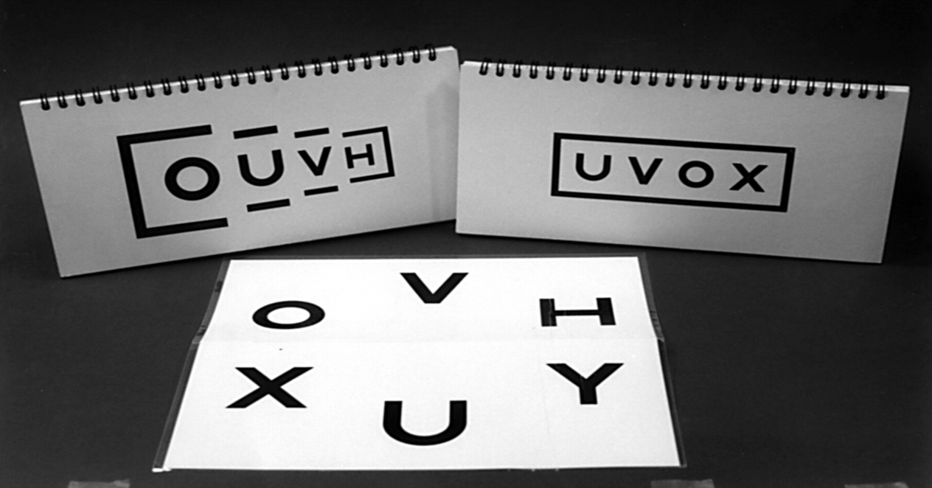

Bailie Lovie Near Vision Test

