Infusion device standardisation and the use of dose error reduction software: a UK survey

Ioanna Iacovides¹, Ann Blandford¹, Anna Cox¹, Bryony Dean Franklin², Paul Lee³ and Chris J. Vincent¹.

¹UCL Interaction Centre, University College London, London
²Centre for Medication Safety and Service Quality, Pharmacy Department, Charing Cross Hospital, Imperial College Healthcare NHS Trust and UCL School of Pharmacy, London
³ Abertawe Bro Morgannwg University Local Health Board, Medical Physics and Clinical Engineering Department, Morriston Hospital, Swansea, Wales

Ioanna Iacovides (corresponding author)
Address: UCL Interaction Centre, MPEB 8th floor, University College London, Gower Street, London, WC1E 6BT
Tel: 02076792769 (internal ext. 32769)
Email: i.iacovides@ucl.ac.uk

Ioanna Iacovides, is a postdoctoral research associate at the UCL Interaction Centre (UCLIC).
Ann Blandford is Professor of Human–Computer Interaction at UCLIC.
Anna Cox is Reader in Human-Computer Interaction and Deputy Director at UCLIC.
Bryony Dean Franklin is Director of the Centre for Medication Safety and Service Quality (CMSSQ), a joint research unit between Imperial College Healthcare NHS Trust and UCL School of Pharmacy, where she is Professor of Medication Safety.
Paul Lee is the Medical Devices Training Manager for ABM University Local Health Board and is also Chairman of NAMDET UK (National Association of Medical Device Educators and Trainers).
Christopher J. Vincent is a postdoctoral research associate working on the CHI+MED project at UCLIC.

Acknowledgments
This article represents independent research supported by EPSRC (reference EP/G059063/1) and the National Institute for Health Research (NIHR) Imperial Patient Safety Translational Research Centre. The views expressed are those of the author(s) and not necessarily those of EPSRC, the NHS, the NIHR or the Department of Health.
Abstract
In 2004, the National Patient Safety Agency (NSPA) released a safety alert relating to the management and use of infusion devices in England and Wales. The alert called for the standardisation of infusion devices and a consideration of using centralised equipment systems to manage device storage. There has also been growing interest in smart pump technology, such as dose error reduction software (DERS) as a way to reduce IV medication errors. However, questions remain about the progress that has been made towards infusion device standardisation and the adoption of DERS.

We report on the results of a survey investigating the extent to which the standardisation of infusion devices has occurred in the last 10 years; how far centralised equipment libraries are being used in practice; and about the prevalence of DERS use within the UK.

The findings indicate that while reported standardisation levels are high, the use of centralised equipment libraries remains low, as does DERS usage.

Key phrases
- Infusion device standardisation, the use of centralised equipment libraries and DERS have all been suggested as ways to improve patient safety but there has been little research on establishing the prevalence of all three on a national level.
- Progress has been made towards infusion device standardisation, however “standardisation” does not always mean that only one type of device is being used, and there is still some variability in the devices used across whole organisations.
- Due to specific clinical areas requiring different devices or alternative configurations of the same device centralised equipment libraries are not the most common method of device storage management across entire hospitals.
- Due to the significant practical and organisational challenges that face institutions wishing to implement DERS, only a small number of hospitals are using this technology, especially across entire trusts and health boards.
- Obstacles to the implementation of DERS include existing device contracts, the significant time and resources required, not being convinced of the technology, and complications related to a lack of standardisation.
Introduction
Ten years ago, the National Patient Safety Agency released a safety alert relating to the management and use of infusion devices in England and Wales (NPSA, 2004). The alert noted that 19% of 700 annual incidents involving intravenous infusions were attributed to user error. In order to reduce the chances of error occurring, it was argued that NHS organisations should review the way in which they purchase, manage and use infusion devices. On the basis of a pilot study in six acute trusts, it was also recommended that organisations providing acute care reduce the range of device types available (where each type has agreed default configurations) and that centralised equipment libraries should be considered a more effective way of managing devices that can also improve patient safety. A toolkit was provided by the NPSA, as well as an audit tool to help organisations make the changes suggested in order to improve patient safety (Quinn, Stevenson & Glenister, 2004).

As a result, organisations have made changes to purchasing policy (NPSA, 2006) and standardisation has been shown to be effective (Lee, 2010), where a strategic approach to the ongoing management of infusion devices with board level responsibility is recommended to help maintain the high profile that these high risk devices and therapy demand (MHRA, 2013). However, since 2004, it is unclear the extent to which the standardisation of infusion devices has occurred and how far centralised equipment libraries are being used in practice.

In addition, despite design improvements, user error is still blamed for a large proportion of incidents involving medical infusion devices, up to 21% according to the Medicines and Healthcare Products Regulatory Agency (MHRA, 2013). Nurses are primary users of infusion devices (Iacovides et al., 2013), and “smart pump” technology such as Drug Error Reduction Software (DERS) has been presented as beneficial to both nurses and patients (Upton and Quinn, 2013). While the definition of “smart pump” technology can vary, for the purposes of this review, the term is used to describe infusion devices which require additional information about the patient (e.g. weight) and medication (e.g. drug name, dose, concentration) to be entered and also performs checks to detect possible prescribing and programming errors. In this way, the software performs an “electronic double check” for nurses (Cousins et al, 2013). Limits for maximum and minimum dosages and infusion rates can be programmed into the associated software which can also be used to form the basis of a risk management plan. Hard limits are fixed and cannot be overridden by the user, whereas soft limits can be temporarily overridden depending on therapy and individual circumstances.

It has been suggested that DERS can help to improve patient safety, particularly in intensive care (Murdoch and Cameron, 2008), and there are examples of successful implementation within particular hospitals (Cousins et al, 2013). Furthermore, Keohane et al (2005) highlight the role of the nurse as critical within the selection, implementation and continuing evaluation of smart pump technology. However, it has also been argued that the evidence base for DERS use in practice is currently limited, particularly within the UK (Hertzel and Souza 2009; Taxis and Franklin, 2011, Lee 2013). Upton and Quinn (2013) also note that the uptake of DERS within Europe and the UK appears much lower when compared to the USA. The reasons they suggest for this include:

- A lack of standardisation of equipment.
- Low investment in new technology.
- Resistance to change.
- Lack of robust evidence of effectiveness.
- Lack of promotion by manufacturers.
- The need for greater hospital pharmacy involvement.

While 68% of hospitals in the USA were found to be using DERS in 2011 (Pedersen et al, 2012), there has not been a similar survey to explore the prevalence of use within UK hospitals is (Cousins et al, 2013). Understanding current usage would help inform future studies of IV infusion safety and DERS usage.

We aimed to address this gap by investigating the following questions in relation to UK hospitals:

- To what extent are volumetric infusion devices and syringe pumps currently standardised?
- How are infusion devices currently stored and management?
- How is DERS being used and to what extent?

Method
An online survey was sent to infusion device managers and trainers within NHS organisations across the UK between April – July 2013. Respondents were recruited from a previous interview study (Iacovides et al., 2013), various mailing lists and websites (e.g. the Institute of Physics and Engineering in Medicine mailing list and the National Association of Medical Device Educators and Trainers website) and through attempting to directly contact departments within a list of 162 acute trusts in England (NHS, 2013). A researcher first contacted each trust’s switchboard in order to be put through to the relevant department e.g. Medical Physics, before asking for the contact details of someone responsible for infusion device management. As a result of this process, the survey link was sent to individuals within 83 trusts (in the other cases, the appropriate individual could not be reached). To encourage participation, respondents were given the option to be included in a prize draw where they could win one of three £50 vouchers.

The survey was hosted online and included questions on standardisation, the pumps in use, how they were stored and accessed, and details of any DERS use.

Results
In total, forty five respondents participated in the study. These included NHS staff who were involved in medical device management, maintenance and/or training within 49 UK organisations (44 trusts in England, 3 health boards in Scotland, and 2 health boards in Wales), representing 120 hospitals (64 acute, 37 community and 19 specialist: e.g. urgent care, cardio-thoracic). These responses have been included in the analysis. The replies to the survey were collated and tabulated for further analysis.

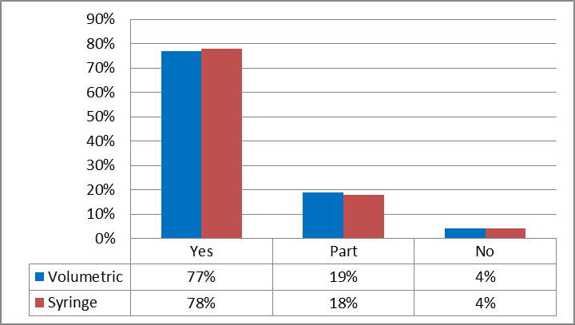
Figure 1: Standardisation of infusion devices (n = 120)
Standardisation
Participants were asked whether standardisation had occurred across an entire hospital site, within only some clinical areas, or had not taken place at all. Figure 1 indicates that, across 120 hospitals, a high level of standardisation was reported, in relation to both volumetric infusion pumps (n = 92) and syringe pumps (n = 93). Fewer than 20% of hospitals had not standardised across all clinical areas for volumetric pumps (n=23) and syringe pumps (n=22); only 4% reported there was no standardisation at all (n=5).

To further investigate the extent of standardisation, respondents were asked to list which volumetric and syringe pumps were being used within their trusts. Table 1 indicates the different brands of devices that were mentioned in relation to this question (where n refers to the total number of brand mentions). The figures do not indicate individual makes or models of devices in use or variations between device types as detailed information was not always provided by respondents.

Table 1: Brands of volumetric and syringe devices (where n = number of mentions)
Brand | Volumetric (n = 103) | Syringe (n = 134)
Alaris/Carefusion | 37% | 46%
Arcomedical | 7% | 3%
Baxter | 12% | N/A
BBraun | 15% | 11%
CME | N/A | 12%
Fresenius | 9% | 6%
Hospira | 10% | N/A
Smiths/Graseby | 10% | 22%

Of the 39 organisations who reported standardising their devices and where more detailed information about models was provided, the average number of types of volumetric devices listed per trust was 1.3 (range = 1-5). The average number of types of syringe devices was 2.8 per trust (range = 1-9).

Device storage
Table 2 summarises the reported storage and management arrangements of infusion devices in terms of local storage and the use of central libraries across four clinical areas. While some areas use both centralised libraries and local storage systems, the most common approach was to store pumps in local areas only: critical care (62%, n = 50); general medicine (46%, n = 49); general surgery (41%, n = 38) and paediatrics (68%, n = 50). The use of centralised libraries alone does not appear to be very common, particularly within critical care (16%, n = 13) and paediatrics (7%, n = 5).

Table 2: Device storage (rounded to the nearest percentage)
 | Centralised library | Mixed approaches | Storage in local clinical areas | Number of hospital sites
Critical Care | 16% | 22% | 62% | 81
General Medicine | 34% | 20% | 46% | 108
General Surgery | 34% | 25% | 41% | 92
Paediatrics | 7% | 26% | 67% | 74

Use of DERS

Of the 49 respondents, 39 % (n = 19) reported using some form of DERS on at least one site within each organisation. However, the majority (55%, n = 27) were not, and 6% (n = 3) did not know whether DERS had been implemented. Within the 19 organisations using DERS, 74% (n = 14) had DERS implemented on both volumetric and syringe devices, 11% (n = 4) had it enabled only on syringe devices) and the remaining organisation only on volumetric pumps. These figures do not mean that DERS is being used across entire inventories, only that an organisation is using DERS on at least one type of volumetric and/or syringe device.

In terms of how DERS was used at an organisational level (i.e. across whole trusts or health boards), Table 3 indicates that most areas use a mixture of both hard and soft limits: critical care (72%, n = 13); general medicine (70%, n = 7); general surgery (60%, n = 6); paediatrics (63%, n = 5). Out of the respondents, the most common area to utilise DERS was critical care (18 organisations) and the least common was paediatrics (8 organisations). Other specialist areas reported to use DERS include oncology and neonatal intensive care.

Table 3: DERS use across 19 organisations (rounded to nearest percentage)
 | Only drug library | Soft limits | Hard limits | Mix of limits | Number of sites
Critical Care | 11% | 6% | 11% | 72% | 18
General Medicine | 0% | 10% | 20% | 70% | 10
General Surgery | 10% | 10% | 20% | 60% | 10
Paediatrics | 10% | 14% | 13% | 63% | 8
Other areas | 14% | 0% | 14% | 72% | 14

On a site level, across 24 hospitals implementing DERS, almost all respondents reported updating drug libraries manually, (96%, n = 23), with only one hospital using wireless updates (4%, n = 1).
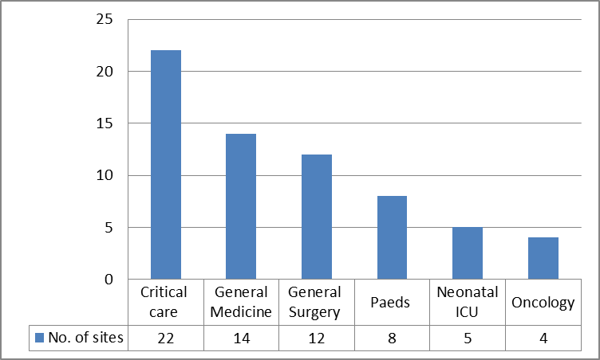
Figure 2: DERS use across 24 hospital sites
Figure 2 illustrates that within specific hospitals, Critical Care is the most common area for DERS to be used (92%, n = 22). These results also suggest that DERS is not necessarily implemented across all areas within the same hospital. Some respondents also selected “Other areas” of DERS use, with the most popular areas later specified as Neo-natal ICU (22%, n = 5) and Oncology (17%, n = 4).
Reasons for not using DERS

Of the 30 organisations who said they were not using DERS, 43% (n = 13) reported that there were no plans to introduce this technology within the next 12 months. Only 20% (n = 6) stated that there was a plan to do so, with a further high proportion of respondents not knowing about future plans (37%, n = 11).

Respondents were asked to explain their choice of answer regarding the future plans for DERS and several reasons were provided for their being no plans to introduce this technology within the next 12 months. For some, this was due to practical issues, such as being tied to an existing device contract e.g. “Existing devices do not have DERS capability and are provided under contract from the OEM [Original Equipment Manufacturer]. This contract has 18-24 months [to run]”, (Respondent 43).

In addition, there were concerns about the lack of resources available e.g. “The Trust does not have the resources or infrastructure to implement DERS”, (Respondent 7); and the time required to implement DERS and train staff e.g. “Risks of 1) incorrect use of drug error reduction software due to lack of training and high staff turnover and 2) the time and effort required to maintain drug libraries were felt to be significant enough to at least equal the benefits if not outweigh them”, (Respondent 36).

Furthermore, there were some issues around not being able to standardise across an entire site e.g. “There is nothing in the pipeline to my knowledge, the key here is every pump has its own software which talks to its own pump. Problem is each of the softwares will not talk to each other, and standardisation is difficult when certain pumps are purchased for different criteria and application”,
(Respondent 41). This particular response also suggests there is an issue concerning lack of interoperability between multiple brands of device.

Discussion
The survey results suggest that in the last 10 years (since the NPSA alert in 2004), progress has been made towards the standardisation of infusion devices. Standardisation is particularly important to achieve before implementing DERS and is likely to aid nurses in their day to day tasks (Cousins et al, 2013). There is room for improvement however, especially since Lee (2010) has shown that using a multidisciplinary group to help manage and achieve standardisation can reduce clinical risks effectively. There is also an indication that the term “standardisation” may not always mean that one type of pump is being used across the whole hospital as there is still variability in the type of devices used. This is most likely due to specific areas, e.g. critical care and paediatrics, requiring different devices or alternative configurations of the same device. The fact that certain clinical areas require a different set up may be the main reason why centralised equipment libraries are not the most commonly used method of device storage management across entire hospitals.

In addition, this survey provides empirical support regarding the use of DERS in the UK that was previously lacking (Cousins et al, 2013). The findings indicate that while there are a small number of hospitals and trusts who are starting to implement DERS, but it is less common for this form of technology to be used across an entire site or organisation. The most common usage of DERS appears to be in specialised areas such as Critical Care, with a mixture of hard and soft limits being the most frequent implementation across all areas.

Furthermore, it seems that organisations who wish to implement this type of technology need to overcome several challenges before being able to proceed. Similar to those noted by Upton and Quinn (2013), these challenges involve practical and organisational issues such as existing device contracts; the infrastructure and resources available; not being convinced that implementing the technology is worth the time and financial investment required, and complications related to a lack of standardisation and communication between devices. The survey findings indicate that many organisations are responsible for multiple sites, which can be at different stages of standardisation and use different types of infusion pumps; this is likely to further complicate the introduction of DERS across entire trusts and health boards.

However, in terms of gathering the data, it was a real challenge to identify individuals who could answer all the questions included for each hospital within a single organisation. Multiple people, including manufacturers, are often involved in the procurement, management and setting up of infusion devices while job titles and departments are not always consistent. This difficulty means that response rates were lower than initially anticipated and also serves to highlight the complexity of working in the area of device management.

This study was the first step in identifying the prevalence of DERS and considering related issues such as standardisation and effective infusion device management. The findings have established a foundation upon which to proceed with further research which is able to consider the effectiveness of DERS and possible recommendations for interventions relating to infusion devices that have greatest potential for aiding nurses in their day to day tasks and increasing patient safety.

References
Cousins D, Keyser T, Catrwright E (2013) Implementing and evaluating the patient safety benefits of dose error reduction software in electronic infusion devices in one NHS Hospital Trust. Br J Nurs CareFusion supplement 22(14):9-14

Hertzel C, Souza VD (2009) The use of smart pumps for preventing medication errors. J Infusion Nurs 32(5):257-67

Iacovides I, Cox AL, Blandford A (2013) Supporting learning within the workplace: Device training in healthcare. Proceedings of the European Conference on Cognitive Ergonomics (ECCE 2013), article no. 30. New York: ACM

Keohane CA, Hayes J, Saniuk C, Rothschild JM, Bates DW (2005) Intravenous Medication Safety and Smart Infusion Systems Lessons Learned and Future Opportunities. J Int Nurs 28(5):321-8

Lee PT (2013) Foreword: Safer systems for IV therapy: what role does drug error reduction software play? Br J Nurs CareFusion supplement 22(14):3

Lee PT (2010) A team approach to identify and manage risk in infusion therapy. Br J Nurs Intravenous Supplement 19(5):12-8

Medicines and Healthcare Products Regulatory Agency (2013). Infusion Systems v2.1 December 2013

Murdoch LJ, Cameron VL (2008) Smart infusion technology: a minimum safety standard for intensive care? Br J Nurs 17(10):630–6

National Health Service (2013) Authorities and Trusts. Available: http://www.nhs.uk/servicedirectories/pages/acutetrustlisting.aspx. Accessed 13th May 2013

National Patient Safety Agency (2004). Safer practice notice 01: improving infusion device safety. Available: http://www.nrls.npsa.nhs.uk/resources/?EntryId45=59788 Accessed 26th April 2014

National Patient Safety Agency (2006). Evaluating safer practice notice 1. Available:
http://www.npsa.nhs.uk/EasysiteWeb/getresource.axd?AssetID=1605&type=Full&servicetype=Attachment Accessed 26th April 2014.

Pedersen CA, Schneider PJ, Scheckelhoff DJ (2012) ASHP national survey of pharmacy practice in hospital settings: dispensing administration - 2011. Am J Health Syst Pharm 69(9):768-85

Quinn C, Stevenson E, Glenister H (2004). NPSA infusion device toolkit: a cost-saving way to improve patient safety, Clinical Governance: An International Journal 9(3):195-9

Taxis K, Franklin BD (2011). Smart infusion pumps in safe drug administration. Hospital Healthcare Europe

Upton D, Quinn C (2013). Smart pumps-good for nurses as well as patients. Br J Nurs Carefusion supplement 22(14):4-8

