**The Influence of Density on Microwave Pyrolysis of Cellulose**

Jiajun Fan,a Peter S. Shuttleworth,b Mark Gronnow,a Simon W. Breeden,a James H. Clark,a Duncan J. Macquarrie,a and Vitaliy L. Budarina*

aGreen Chemistry Centre of Excellence, Department of Chemistry, University of York, Heslington, York, North Yorkshire, YO10 5DD, U.K.

bDepartamento de Física de Polímeros, Elastómeros y Aplicaciones Energéticas, Instituto de Ciencia y Tecnología de Polímeros, CSIC, c/Juan de la Cierva, 3, 28006 Madrid, Spain.

*vitaliy.budarin@york.ac.uk (Vitaliy Budarin)

**Keywords:** Microwave; Pyrolysis; Cellulose; Sample density; Heating rate; Biorefinery

**ABSTRACT**

Herein we present the influence of sample density on the microwave induced pyrolysis of crystalline cellulose, with heating rate, bio-char and bio-oil yields investigated. The article demonstrates that sample density is a fundamental parameter influencing microwave-assisted biomass pyrolysis, with a direct impact on heating rate, the speed of volatiles diffusion through the sample matrix and distribution of products. Of significant interest was that the maximum heating rate and bio-oil yield corresponded to an optimum sample density as a result of heat and mass transfer effects. Increase in density above this value stimulated a rise in bio-char yield. The increased understanding of the mechanisms influenced by sample density in a microwave field give increased ability for users to produce bio-oil or bio-char, giving rise to improved microwave-based biorefineries for future energy and chemical needs.

INTRODUCTION

Biorefineries are most commonly based on two mechanisms: hydrolytic or pyrolytic treatment, where the principle aims are to either hydrolytically liberate monosaccharides 1, 2, 3 or to thermochemically degrade lignocellulosic biomass into useful organic decomposition products4. However, these technologies are yet to be demonstrated commercially5-7 due to the high price of reﬁnery-scale infrastructure, commercially unviable operating costs and complex compositions of bio-oil, making biorefineries to date economically unfeasible 8-10.

Hydrolysis in some cases can lead to a more specific product distribution, but the large quantities of water needed, longer plant times and the limited variety of biomasses that can be processed, makes pyrolysis a potentially more attractive route, especially when dealing with lignocellulosic material.

It has been previously found that increases in bio-oil yield and product specificity can be achieved if pyrolysis is carried out within specific temperature ranges, with volumetric/uniform heating and high heating rates 11-13 These improvements to the pyrolysis process help its industrial viability, with further fine tuning of the process reducing energy consumption and increasing the potential to make high value chemicals. Diversifying from the typical route of attempting to produce products with comparable properties to crude or fuel oils and treating them as products in their own right will also help towards commercialisation. A significant advancement in this technology has come over the last 10-15 years from the use of low temperature microwave processing of biomass.14-17This technology provides potential increases in efficiencies of energy,18 greater degrees of feedback/control and superior uniformity of sample heating.19,20

Nonetheless, the design of a microwave reactor presents its own challenges when attempting to scale up from the laboratory to industrial scale,21 with a distinct lack of fundamental experimental testing examining the variables that influence the mechanism of microwave pyrolysis. From conventional pyrolysis investigations it is already known that heating rate is a key parameter of bio-oil yield optimisation, with higher heating rates giving much greater yields of oil.22 As such, the influence of microwave pyrolysis conditions on heating rate is a logical place to target research in the area of microwave pyrolysis.23,24 The rate of a sample’s heating within a microwave cavity can be generally described through the dielectric loss factor (ε’’), which is a function of sample density (ρ) (ε’’=aρ2 +bρ),25. Microwave heating rate could be represented as a function of permittivity (ε), specific heat capacity Cρ, the electrical field strength (E) and the sample density according to equation (1) below.26

According to equation 1, the rate of microwave heating of a gram of material can be increased by only changing either microwave power or sample density, as all other factors are a constant. The first approach, increasing power input, would not only be limited by the ability of the sample to interact with microwave radiation, but also the propensity of pyrolysis decomposition products to interact with the radiation as well, leading to secondary reactions and reducing the bio-oil yield and the process selectivity.

However, changes in the sample density have the potential to regulate sample heating rate without altering the mechanism of pyrolysis or the required microwave energy input. Herein we report the results of microwave pyrolysis of cellulose (a major biomass component; available in high purity)27 as a model compound for the investigation into the influence of the sample density on microwave heating rate profiles and bio-oil yield.

EXPERIMENTAL SECTION

Microwave experiments were carried out using a “SRL Milestone RotoSYNTH” multimode batch microwave at 1200W (see Fig. 1A). The sample was heated at a rate of 17 oC/min to a maximum temperature of 200 oC; process pressure was monitored at all times. Liquid fractions were collected via the vacuum unit, which condensed vapours produced during the process. Microcrystalline cellulose tablets with different densities (ranging from 0.67 to 1.24 g cm-3) and with a fixed diameter of 4cm (Fig. 1B) were prepared by applying a 6.3 to 50kN pressure to 7g of cellulose.

For GC-MS analysis, samples were prepared at a concentration of 20mg/mL of pyrolysis oil in methanol. A sample of 0.5μL was injected on to a Perkin Elmer Clarus 500 Gas chromatography and Clarus 560S Mass spectrometer at an injector temperature of 350oC and a column flow rate of 1.0ml/min with a 1:10 split ratio applied. The oils were passed onto a Phenomenex Zebron DB5-HT column (30m × 0.25m × 0.25μm) at a temperature of 60oC. The column was held for 1 minute at this temperature and then ramped to 360oC at 8oC/min. It was then held for further 10 minutes.

For each experiment 14 pellets (98 g ±1.5 g of cellulose) were used. In preliminary experiments it was found that the pyrolysis process was complete within 10 minutes, with no further bio-oil observed after this time. Microwave experiments for each density were therefore varied in duration, from 2.5 to 10 minutes in 2.5 minute increments. After each run, bio-oil and bio-char yield was measured, with bio-gas yield calculated by difference. Temperature was measured using a Calex IR pyroprobe (Fig. 1A). As heating rate is a key parameter, temperature is crucial to the microwave pyrolysis process. It has been proved that the precision of the IR detector is accurate to ±5°C during the microwave pyrolysis of biomass.28

Macroporosity of the samples was investigated using both a scanning electron microscope Hitachi S-2400 (samples were Au coated on a high resolution sputter SC7640 at a sputtering rate of 1500 Vmin-1, up to a 7 nm thickness) and a Pascal 140 mercury porosimeter.

RESULTS AND DISCUSSION

An increase in density of the cellulose tablets from 0.67 to 1.04gcm-3 was found to lead to a linear improvement in the yield of bio-oil during microwave pyrolysis, from 18±1% to 28±1.5% respectively. However, the linear relationship of density with bio-oil does not continue past a density of 1.04 gcm-3, and decreases to 22±1% at a density of 1.24 gcm-3. Therefore, it can be seen that the relationship between cellulose density and bio-oil yield has non-linear character with a maximum bio-oil and minimum bio-char yield observed at a density of ~1 g cm-3 (see Figure 1C), with yields of bio-oil or char either falling away or increasing respectively either side of this. Despite the change in the yield of char or oil with change in density, the yield of bio-gas remains constant.

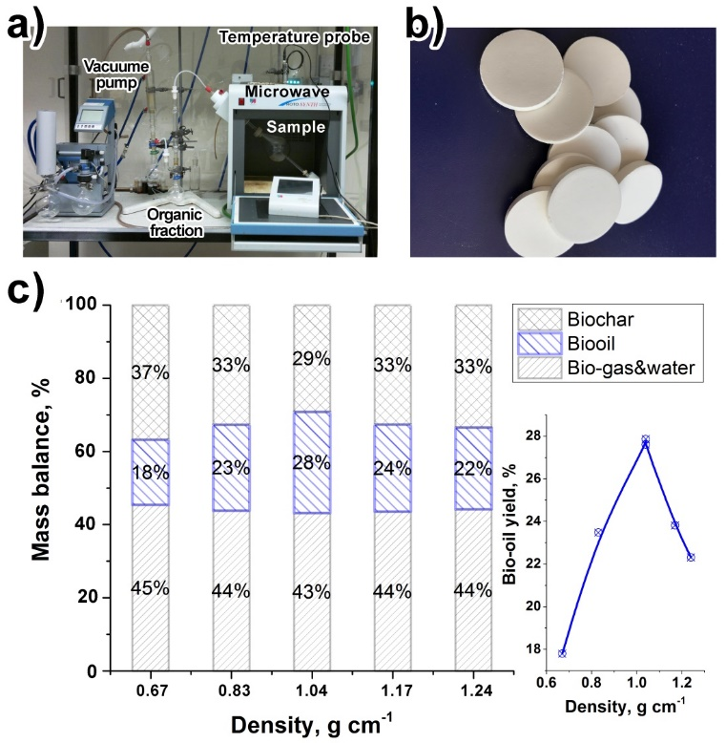**Figure 1:** A) Microwave setup with vacuum pump and vapour collection vessels; B) cellulose tablets; C) bio-char, bio-oil and bio-gas yields for different density prepared cellulose tablets after microwaving for 10 minutes. The mass balance measurement experimental error was found to be around of one percent.

To find if there is a correlation between bio-oil yield and rate of heating (ROH), the heating profiles of cellulose were studied (see Figure 2A). Derivatives of these traces that represent the heating rate profile of cellulose pyrolysis, consist of two rapid periods of heating (ca. 40s and 200s), which are in good agreement with previously reported data.29,30 The first peak demonstrates the heating rate from ambient temperature to 100°C and is attributed to the heating of residual moisture contained within the tablets, with no discernible relationship observed with sample density. The second peak intensity and time to reach the maximum intensity are strongly dependent on the sample density and is associated with cellulose decomposition.

The influence of the sample density on MW-assisted pyrolysis of cellulose is further verified from investigation of bio-oil production rate, measured as the derivative of the bio-oil yield with time. To visualise the process of the microwave cellulose pyrolysis in more details, the rate of the bio-oil production was represented as a 2D graph of the function of the sample

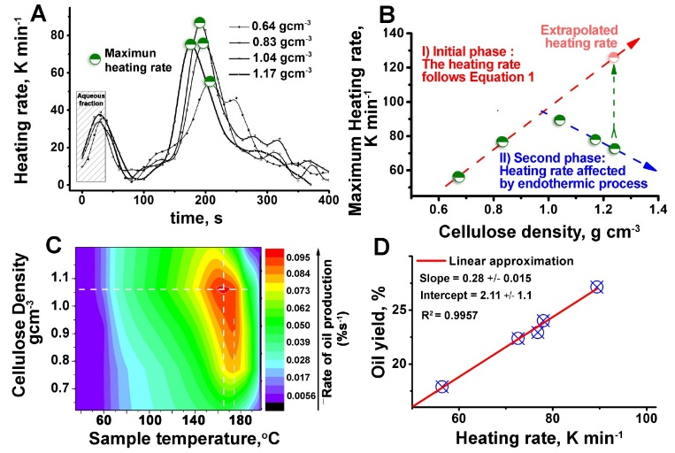

**Figure 2:** A) Stacked kinetic profile traces showing the influence of initial density of cellulose on the heating rate of cellulose; B) maximum heating rate as a function of density; C) 2D plot of oil production rate with sample density and temperature; and D) total oil yield vs maximum heating rate.

density and temperature (Figure 2D). It can be seen that a maximum rate of oil production is achieved at approximately 170oC and a density of around 1.05gcm-3 (Figure 2C). The optimum temperature is in a good correlation with the temperature of cellulose activation under microwave conditions, reported previously31 while the optimum density for bio-oil production is close to that found for the maximum cellulose heating rate (Figure 2B).

The latter observation points to a strong correlation between bio-oil production and the sample heating rate which, is verified in Figure 2D. The linear trend between oil yield and heating rate with an R2 value of 0.9957, demonstrates clearly that the efficiency of the microwave-assisted pyrolysis is mainly controlled by the heating rate. However, the heating rate was restricted by other processes when the densities of the cellulose samples were above approximately 1 gcm-3. For example, in the case of pyrolysis of the prepared 1.24 gcm-3 cellulose sample, following Equation 1, a rate of 130 Kmin-1 would be expected to produce the maximum yield of the bio-oil, nearly double the experimental value (see Figure 2B).

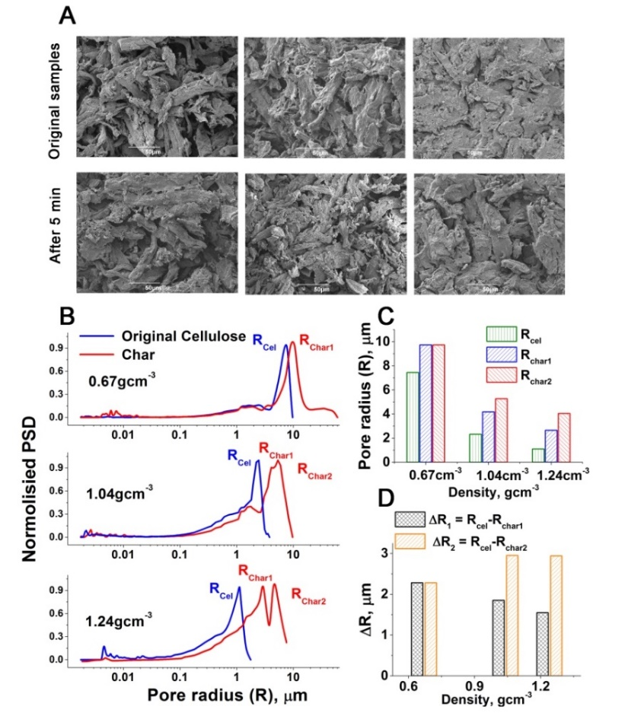**Figure 3:** Influence of the samples density on their porosity before and after pyrolysis: A) SEM images; B) Mercury porosimeter traces; C) Pore radius of the original cellulose and obtained chars; D) Change in pore radius of the samples after microwave pyrolysis.

This reduction in rate reduces significantly the bio oil yield from 35 to 27 wt% accordingly to the extrapolation shown on the Figure 2D. It can be seen from both the scanning electron microscopy images and the mercury porosimeter traces that the macropore radius of the original cellulose samples is larger after pyrolysis (Figures 3A, B &C). Moreover, the pore distribution of the solid char residues changes from mono to bimodal for the highest density sample. This could be a result of micro-level non-homogeneous packing of the cellulose powder under high pressure. For example, the cellulose is compressed in the direction of the applied force but the table diameter does not change (perpendicular direction), leading to a possible explanation of the bimodal trend at high pressure. The increase in macropore radius of the sample after pyrolysis is evidence of substantial gas and volatile compound production, resulting in sample volume expansion. This adiabatic expansion process is endothermic, with the intensity of the process being proportional to the mass of the produced bio-oil.

Therefore, in case of high sample density, greater yields of bio-oil will result in higher heating rate suppression. This becomes even more pronounced due to the Joule–Thomson (JT) effect of gas expansion that describes the temperature change of a real gas when it is forced through a capillary. As such, it is established that the temperature change is proportional to the difference of the pressures before and after the gas is forced through the capillary with the proportional coefficient μJT represented in equation 2:

$$μ_JT=(∂T/∂P)_H= V/C_P (αT-1) (2)$$

where, T is the gas temperature, V the gas volume, CP [heat capacity at constant pressure](https://en.wikipedia.org/wiki/Specific_heat_capacity#Heat_capacity_of_compressible_bodies), and α its [coefficient of thermal expansion](https://en.wikipedia.org/wiki/Coefficient_of_thermal_expansion). According to the equation 2, the cooling effect is much more pronounced in the case of the high density samples due to both the larger volumes of gases and volatiles produced and the smaller radius of pores, resulting in higher internal pressure of these gases trapped within the cellulose particles. From Figure 3D the intensity of this cooling mechanism has a non-linear dependency on the cellulose density mainly due to the exponential reduction in the pore radius, leading to a pronounced increase in the heat adsorbed via the Joule-Thomson process. For a sample above a certain density the impact of cooling induced by expansion and diffusion will become significant enough to decrease the total sample heating rate. In addition, the produced molecules in the vapour or gas phase are not microwave active, and therefore receive no energy from the microwave. The combination of these two processes, but principally the first, results in a vapour or gas that is cooler than the capillary/ pore walls, which subsequently reduces the local temperature and rate of oil production (see Figure 2C) facilitating condensation, oligomerization and charring of the organics produced. Though, this endothermic process of gas vaporisation, expansion and diffusion could play an important role in the protection of the biomass active centres from overheating during microwave activation and significantly improve its uniformity, with density increasing its efficiency. Therefore, based on the obtained results it could be concluded that the optimum sample density for large scale microwave pyrolysis of biomass is around 1 gcm-3 under constant power and ambient conditions, achieving at this point both the maximum bio-oil yield and the best process uniformity.

The liquids produced during experimentation were examined for their composition by GC-MS, the results of which are found in Table 1. The major products of pyrolysis for all samples are high value chemicals such as levoglucosan32 and levoglucosenone.33 This makes the proposed approach very promising for a future biorefinery technology. Furthermore, from this, it is

**Table 1:** Major products of bio-oils produced during the microwave pyrolysis of cellulose samples of differing density.

|  |  |  |  |
| --- | --- | --- | --- |
| **Retention Time** | **Peak Area (TiC)** | **Compound Name** | **Empirical Formula** |
| 7.68 | 1532668 | 2-Ethoxyethyl acetate | C6H12O3 |
| 8.40 | 2186374 | Levoglucosenone | C6H6O3 |
| 10.13 | 3740659 | 1,4:3,6-Dianhydro-α-d-glucopyranose | C6H8O4 |
| 11.65 | 1398398 | 4,5-Dimethyl-3-heptanol | C9H18O |
| 12.40 | 1130043 | 4-Oxotetrahydropyran-2-carboxylic acid | C6H8O4 |
| 13.90 | 1297223 | D-Allose | C6H12O6 |
| 14.70 | 26971562 | Levoglucosan | C6H10O5 |
| 16.18 | 3656490 | 1,6-Anhydro-β-D-glucofuranose | C6H10O5 |

possible to determine that the mechanism of cellulose depolymerisation is essentially independent from the sample density emphasising that high biomass density increases bio-oil yield without any compromise to the product mixture quality. It is evident that little variation in bio-oi calorific values (CV) are observed in any one experiment (see Table 2). In contrast to the bio-oil, bio-char CVs were significantly changed (>than 14%) with sample density achieving values (27 kjmol-1) close to the typical CV of charcoal34 for high density samples.

**Table 2:** Calorific values of solid and bio oils produced at 10 minutes microwave exposure.

|  |  |  |
| --- | --- | --- |
| **Sample density**  **g/cm3** | **Bio-Oil CV**  **MJ/Kg** | **Solid CV**  **MJ/Kg** |
| 0.67 | 21.7 | 25.3 |
| 0.83 | 21.9 | 23.6 |
| 1.04 | 20.0 | 23.4 |
| 1.17 | 22.2 | 26.7 |
| 1.24 | 21.2 | 27.2 |

CONCLUSIONS

In summary, the experimental results demonstrated that the rate of heating is fundamental for microwave-assisted bio-oil production, showing a strong linear correlation between heating rate and bio-oil yield, which is in good agreement with conventional fast pyrolysis theory.35 However, microwave pyrolysis of bio-mass is a complex process which involves the production of non-ideal gases, (e.g. carbon dioxide, carbon monoxide) and volatiles with a high heat of vaporisation. Vaporisation and expansion of these molecules is highly endothermic as well as their diffusion through the capillaries/porous channels leads to cooling of the system both on micro and macro level. This causes a maximum heating rate around 1 gcm-3 and consequently an optimum pellet density for maximum oil yield. The optimum pellet density corresponds to the maximum heating rate, coupled with rapid removal of liquids from the pellet, minimising further reaction to produce chars. The major components of bio-oil are high value anhydrosugars such as levoglucosan and levoglucenone. The understanding of the optimum conditions for obtaining of maximum yield of high value chemicals makes proposed approach very promising for a future biorefinery technology. Moreover, the optimum conditions for production high calorific value char with maximum yield have been found. Altogether, the obtained data demonstrates that biomass density is a very efficient parameter of control, enabling a very green, inexpensive method of producing MW-assisted pyrolysis products with a high quality.

AUTHOR INFORMATION

Corresponding Author

*vitaliy.budarin@york.ac.uk (Vitaliy Budarin) **Notes**

The authors declare no competing financial interest.

**ACKNOWLEDGEMENTS**

This work is financially supported by EPSRC for research grant no. EP/K014773/1, the Industrial Biotechnology Catalyst (Innovate UK, BBSRC, EPSRC) to support the translation, development and commercialisation of innovative industrial Biotechnology processes (EP/N013522/1). PSS also gratefully acknowledges the Spanish Ministry Economy and Competitivity (MINECO) for a Ramón y Cajal senior research fellowship (RYC-2014-16759) and a proyecto de I+D+I para jóvenes investigadores (MAT2014-59674-JIN).

REFERENCES

1. Kumar, R.; Singh, S.; Singh, O. V., Bioconversion of lignocellulosic biomass: biochemical and molecular perspectives. *Journal of Industrial Microbiology & Biotechnology* **2008,** *35* (5), 377-391. DOI: 10.1007/s10295-008-0327-8

2. Fitzpatrick, M.; Champagne, P.; Cunningham, M. F.; Whitney, R. A., A biorefinery processing perspective: Treatment of lignocellulosic materials for the production of value-added products. *Bioresource Technology* **2010,** *101* (23), 8915-8922. DOI: 10.1016/j.biortech.2010.06.125

3. Maki-Arvela, P.; Salmi, T.; Holmbom, B.; Willfor, S.; Murzin, D. Y., Synthesis of Sugars by Hydrolysis of Hemicelluloses-A Review. *Chemical Reviews* **2011,** *111* (9), 5638-5666. DOI: 10.1021/cr2000042

4. Mohan, D.; Pittman, C. U.; Steele, P. H., Pyrolysis of wood/biomass for bio-oil: A critical review. *Energy & Fuels* **2006,** *20* (3), 848-889. DOI: 10.1021/ef0502397

5. Balat, M.; Balat, H.; Oz, C., Progress in bioethanol processing. *Progress in Energy and Combustion Science* **2008,** *34* (5), 551-573. DOI: org/10.1016/j.pecs.2007.11.001

6. Dessbesell, L.; Xu, C.; Pulkki, R.; Leitch, M.; Mahmood, N., Forest biomass supply chain optimization for a biorefinery aiming to produce high-value bio-based materials and chemicals from lignin and forestry residues: a review of literature. *Canadian Journal of Forest Research* **2017,** *47* (3), 277-288. DOI: org/10.1139/cjfr-2016-0336

7. Aguilar-Reynosa, A.; Romani, A.; Rodriguez-Jasso, R. M.; Aguilar, C. N.; Garrote, G.; Ruiz, H. A., Microwave heating processing as alternative of pretreatment in second-generation biorefinery: An overview. *Energy Conversion and Management* **2017,** *136*, 50-65. DOI: 10.1016/j.enconman.2017.01.004

8. Matson, T. D.; Barta, K.; Iretskii, A. V.; Ford, P. C., One-Pot Catalytic Conversion of Cellulose and of Woody Biomass Solids to Liquid Fuels. *Journal of the American Chemical Society* **2011,** *133* (35), 14090-14097. DOI: 10.1021/ja205436c

9. Gray, K. A.; Zhao, L. S.; Emptage, M., Bioethanol. *Current Opinion in Chemical Biology* **2006,** *10* (2), 141-146. DOI: 10.1016/j.cbpa.2006.02.035

10. Zheng, A.; Chen, T.; Sun, J.; Jiang, L.; Wu, J.; Zhao, Z.; Huang, Z.; Zhao, K.; Wei, G.; He, F.; Li, H., Toward Fast Pyrolysis-Based Biorefinery: Selective Production of Platform Chemicals from Biomass by Organosolv Fractionation Coupled with Fast Pyrolysis. *Acs Sustainable Chemistry & Engineering* **2017,** *5* (8), 6507-6516. DOI: 10.1021/acssuschemeng.7b00622

11. Miao, X. L.; Wu, Q. Y.; Yang, C. Y., Fast pyrolysis of microalgae to produce renewable fuels. *Journal of Analytical and Applied Pyrolysis* **2004,** *71* (2), 855-863. DOI: org/10.1016/j.jaap.2003.11.004

12. Gronnow, M. J.; Budarin, V. L.; Mašek, O.; Crombie, K. N.; Brownsort, P. A.; Shuttleworth, P. S.; Hurst, P. R.; Clark, J. H., Torrefaction/biochar production by microwave and conventional slow pyrolysis – comparison of energy properties. *GCB Bioenergy* **2013,** *5* (2), 144-152. DOI: 10.1111/gcbb.12021

13. Li, T.; Remón, J.; Shuttleworth, P. S.; Jiang, Z.; Fan, J.; Clark, J. H.; Budarin, V. L., Controllable production of liquid and solid biofuels by doping-free, microwave-assisted, pressurised pyrolysis of hemicellulose. *Energy Conversion and Management* **2017,** *144* (Supplement C), 104-113. DOI: org/10.1016/j.enconman.2017.04.055

14. Dominguez, A.; Menendez, J. A.; Inguanzo, M.; Pis, J. J., Investigations into the characteristics of oils produced from microwave pyrolysis of sewage sludge. *Fuel Processing Technology* **2005,** *86* (9), 1007-1020. DOI: org/10.1016/j.fuproc.2004.11.009

15. Bu, Q.; Lei, H. W.; Ren, S. J.; Wang, L.; Zhang, Q.; Tang, J.; Ruan, R. G., Production of phenols and biofuels by catalytic microwave pyrolysis of lignocellulosic biomass. *Bioresource Technology* **2012,** *108*, 274-279. DOI: 10.1016/j.biortech.2011.12.125

16. Lam, S. S.; Russell, A. D.; Lee, C. L.; Lam, S. K.; Chase, H. A., Production of hydrogen and light hydrocarbons as a potential gaseous fuel from microwave-heated pyrolysis of waste automotive engine oil. *International Journal of Hydrogen Energy* **2012,** *37* (6), 5011-5021. DOI: org/10.1016/j.ijhydene.2011.12.016

17. [Zhang, R](https://apps.webofknowledge.com/DaisyOneClickSearch.do?product=WOS&search_mode=DaisyOneClickSearch&colName=WOS&SID=C5FT1tXpFEkOMZl7Gw9&author_name=Zhang,%20R&dais_id=39287949&excludeEventConfig=ExcludeIfFromFullRecPage).; [Li, LL](https://apps.webofknowledge.com/DaisyOneClickSearch.do?product=WOS&search_mode=DaisyOneClickSearch&colName=WOS&SID=C5FT1tXpFEkOMZl7Gw9&author_name=Li,%20LL&dais_id=15668049&excludeEventConfig=ExcludeIfFromFullRecPage).; [Tong, D.M](https://apps.webofknowledge.com/DaisyOneClickSearch.do?product=WOS&search_mode=DaisyOneClickSearch&colName=WOS&SID=C5FT1tXpFEkOMZl7Gw9&author_name=Tong,%20DM&dais_id=37902681&excludeEventConfig=ExcludeIfFromFullRecPage).; Hu,C.,Microwave-enhanced pyrolysis of natural algae from water blooms**.**  *Bioresource Technology* **2016,**  212, 311-317. DOI: 10.1016/j.biortech.2016.04.053

18. Ludlow-Palafox, C.; Chase, H. A., Microwave-induced pyrolysis of plastic wastes. *Industrial & Engineering Chemistry Research* **2001,** *40* (22), 4749-4756. DOI: 10.1021/ie010202j

19. Miura, M.; Kaga, H.; Sakurai, A.; Kakuchi, T.; Takahashi, K., Rapid pyrolysis of wood block by microwave heating. *Journal of Analytical and Applied Pyrolysis* **2004,** *71* (1), 187-199. DOI: org/10.1016/S0165-2370(03)00087-1

20. Yoon, B. J.; Hong, E. H.; Jee, S. E.; Yoon, D. M.; Shim, D. S.; Son, G. Y.; Lee, Y. J.; Lee, K. H.; Kim, H. S.; Park, C. G., Fabrication of flexible carbon nanotube field emitter arrays by direct microwave irradiation on organic polymer substrate. *Journal of the American Chemical Society* **2005,** *127* (23), 8234-8235. DOI: 10.1021/ja043823n

21. Bridgwater, A. V., Review of fast pyrolysis of biomass and product upgrading. *Biomass & Bioenergy* **2012,** *38*, 68-94. DOI:10.1016/j.biombioe.2011.01.048

22. Tsai, W. T.; Lee, M. K.; Chang, Y. M., Fast pyrolysis of rice straw, sugarcane bagasse and coconut shell in an induction-heating reactor. *Journal of Analytical and Applied Pyrolysis* **2006,** *76* (1-2), 230-237. DOI:10.1016/j.jaap.2005.11.007

23. Luque, R.; Menendez, J. A.; Arenillas, A.; Cot, J., Microwave-assisted pyrolysis of biomass feedstocks: the way forward? *Energy & Environmental Science* **2012,** *5* (2), 5481-5488. DOI: 10.1039/C1EE02450G

24. Stuerga, D.; Gonon, K.; Lallemant, M., Microwave-heating as a new way to induce selectivity between competitive reactions - application to isomeric ratio control in sulfonation of naphthalene. *Tetrahedron* **1993,** *49* (28), 6229-6234. DOI: org/10.1016/S0040-4020(01)87961-8

25. Nelson, S. O.; Ieee, Permittivity and density relationships for granular and powdered materials. *Ieee Antennas and Propagation Society Symposium, Vols 1-4 2004, Digest* **2004**, 229-232. DOI: 10.1109/APS.2004.1329610

26. Hua, Y. X.; Liu, C. P., Heating rate of minerals and compounds in microwave field. *Transactions of Nonferrous Metals Society of China* **1996,** *6* (1), 35-40.

27. Mascal, M.; Nikitin, E. B., Direct, High-Yield Conversion of Cellulose into Biofuel. *Angewandte Chemie International Edition* **2008,** *47* (41), 7924-7926. DOI: 10.1002/anie.200801594

28. Budarin, V. L.; Zhao, Y. Z.; Gronnow, M. J.; Shuttleworth, P. S.; Breeden, S. W.; Macquarrie, D. J.; Clark, J. H., Microwave-mediated pyrolysis of macro-algae. *Green Chemistry* **2011,** *13* (9), 2330-2333. DOI:10.1039/C1GC15560A

29. Huang, Y. F.; Kuan, W. H.; Lo, S. L.; Lin, C. F., Total recovery of resources and energy from rice straw using microwave-induced pyrolysis. *Bioresource Technology* **2008,** *99* (17), 8252-8258. DOI: 10.1016/j.biortech.2008.03.026

30. Wu, C. Y.; Benatar, A., Microwave welding of high density polyethylene using intrinsically conductive polyaniline. *Polymer Engineering and Science* **1997,** *37* (4), 738-743. DOI: 10.1002/pen.11717

31. Fan, J.; De Bruyn, M.; Budarin, V. L.; Gronnow, M. J.; Shuttleworth, P. S.; Breeden, S.; Macquarrie, D. J.; Clark, J. H., Direct Microwave-Assisted Hydrothermal Depolymerization of Cellulose. *Journal of the American Chemical Society* **2013,** *135* (32), 11728-11731. DOI: 10.1021/ja4056273

32. Galletti, P.; Moretti, F.; Samori, C.; Tagliavini, E., Enzymatic acylation of levoglucosan in acetonitrile and ionic liquids. *Green Chemistry* **2007,** *9* (9), 987-991. DOI:10.1039/B702031G

33. Sarotti, A. M.; Zanardi, M. M.; Spanevello, R. A.; Suarez, A. G., Recent Applications of Levoglucosenone as Chiral Synthon. *Current Organic Synthesis* **2012,** *9* (4), 439-459. DOI: org/10.2174/157017912802651401

34. Raveendran, K.; Ganesh, A., Heating value of biomass and biomass pyrolysis products. *Fuel* **1996,** *75* (15), 1715-1720. DOI: org/10.1016/S0016-2361(96)00158-5

35. Bridgwater, A. V.; Meier, D.; Radlein, D., An overview of fast pyrolysis of biomass. *Organic Geochemistry* **1999,** *30* (12), 1479-1493. DOI: org/10.1016/S0146-6380(99)00120-5

**For Table of Contents Use Only**

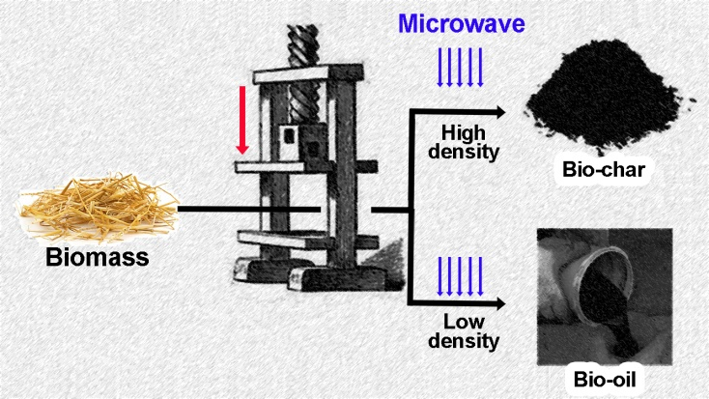

Biomass density is a very efficient parameter of control, enabling a very green, inexpensive method of producing MW-assisted pyrolysis products with a high quality