Failures in Leadership:
How and Why Wishy-Washy Politicians Equivocate
on Japanese Political Interviews

Ofer Feldman (Doshisha University, Japan)

Ken Kinoshita (Doshisha University, Japan)
Peter Bull (University of York, UK)

Ofer Feldman
Mailing address: Faculty of Policy Studies, Doshisha University,
Keisuikan 228, Kamigyo-ku, Imadegawa, Kyoto, Japan 602-8580
E-mail: ofeldman@mail.doshisha.ac.jp
Telephone: +81 (0) 75-251-3502
Fax: +81 (0) 75-251-3502

Ken Kinoshita
Mailing address: Faculty of Policy Studies, Doshisha University,
Kamigyo-ku, Imadegawa, Kyoto, Japan 602-8580
E-mail: kekinosh@mail.doshisha.ac.jp
Telephone: +81 (0) 75-251-3502
Fax: +81 (0) 75-251-3502

Peter Bull
Mailing address: Department of Psychology, University of York, Heslington,
York YO10 5DD, United Kingdom
E-mail: peter.bull@york.ac.uk
Telephone: +44 (0) 1904 433142
Fax: +44 (0) 1904 433181

Suggested Running Head: “Elite” Politicians Discourse during Televised Interviews

Abstract

This paper examines how Japanese leading politicians deal with the communicative problems posed to them during broadcast political interviews. Based on data gathered during 14-month period in 2012-2013, the paper replicates and modifies the “Theory of Equivocation” to explore the extent to which national and local level politicians endeavor to affect the content of information distributed to the public and to influence the way people perceive events that take place in the public domain. Differentiating among selected groups of politicians, i.e., ruling and opposition parties’ members, Cabinet ministers and prime ministers, and local level politicians, the paper focuses on the ways Japanese politicians (and for comparison also nonpoliticians) equivocate during televised programs and the conditions underlying this equivocation, thereby also assesses the significance of these talk shows in the broader context of political communication in Japan.

Keywords: Political interviews; Television; Media discourse; Theory of Equivocation; Political issues; Japan
Bio notes

Ofer Feldman (PhD, University of Tokyo, Japan) is a professor of political psychology and behavior at the Faculty of Policy Studies, Doshisha University, Kyoto, Japan. He is the author of more than 90 journal articles and book chapters, and more than 100 encyclopedia items, in the fields of political behavior/psychology, communication studies, and Japanese politics. He is the sole author of seven books and monographs, including Talking Politics in Japan Today (2004) and Seiji shinrigaku (Political Psychology; in Japanese, 2006), and sole and coeditor of six books, including Beyond Public Speech and Symbols (2000) and Political Leadership for the New Century (2002).

Ken Kinoshita (PhD, Doshisha University, Japan) is an assistant of Advanced Research and Education Organization at the Faculty of Policy Studies, Doshisha University.

Peter Bull (PhD, University of Exeter, United Kingdom) is a reader in psychology at the University of York, UK, a Fellow of the British Psychological Society, and Visiting Professor in Political Communication, University of Antwerp (Belgium). He has more than 100 academic publications, primarily concerned with the detailed “microanalysis” of political discourse and nonverbal communication (his principal research interests) (Personal website: http://drbull.nfshost.com; twitter: @drpeterbull; social psychology network: http://bull.socialpsychology.org/).

Acknowledgements
Financial support during this study came through a Grant-in-Aid for Scientific Research awarded to the first author by the Japanese Ministry of Education, Culture, Sports, Science, and Technology (2012-2015), and through a travel grant awarded to the third author from the Great Britain Sasakawa Foundation (May, 2015). We are grateful to Imai Masae, Ōta Monami, Takeda Yuki, Sawada Kanae, Adachihara Yui, and Hatani Iri for transcribing the interviews, and to Ishimaru Atsushi and Misumi Naoki for assistance in coding the data.
Failures in Leadership:
How and Why Wishy-Washy Politicians Equivocate
on Japanese Political Interviews

1. Introduction

To what extent do savvy politicians endeavor to affect the content of information conveyed to the public and to influence the way people perceive events that take place in the public domain? And how do they do that? We have tried to examine these questions within the context of broadcast political interviews in Japan, which have become in recent years one of the most important means of political communication in this country to follow public policy developments, distinguish between political candidates and competing groups and their stances, and evaluate the various political alternatives. In the ensuing discussion, we detail the communicative patterns and responsiveness of high-echelon members of the Japanese National Parliament (Diet) as well as local level political leaders throughout televised talk shows along a 14-month period, and compare them with those of nonpoliticians.

The Theory of Equivocation
In their Theory of Equivocation, Bavelas and her colleagues (Bavelas et al., 1990) noted politicians’ vagueness, evasiveness, or equivocation as they hedge from providing direct answers to questions they are asked. Yet, they proposed, it is the interview situation, rather than politicians’ devious, slippery personalities, that create strong pressures towards equivocation. Bavelas and her colleagues regard equivocation as a form of indirect communication, ambiguous, contradictory, and tangential, which may also be incongruent, obscure or even evasive (Bavelas et al., 1990: 28).
Bavelas et al. (1990) theorized that individuals typically equivocate when they are placed in an “avoidance-avoidance conflict” (or communicative conflict), whereby all possible responses to a question have potentially negative consequences for the respondent, but nevertheless a response is still expected by interlocutors and audience. Such conflicts are especially prevalent in interviews with politicians because of the nature of the interview situation. Thus, interviewers may have an interest in controversial, sensitive and divisive issues, and thereby put pressure on politicians to choose among undesirable alternatives, in which all potential responses may damage the image of the politicians or alienate part of the electorate (Bavelas et al., 1990: 246-49). Bavelas et al.’s fundamental proposal is that equivocation does not occur without a situational precedent. In other words, although it is individuals who equivocate, such responses must always be understood in the situational context in which they occur, known as the Situational Theory of Communicative Conflict (STCC). In relations to blame and scandal, for example, Hansson (2015) has detailed how government officeholders under conflictual situations may use discursive strategies of blame avoidance, such as emphasizing favorable and de-emphasizing unfavorable information about the self, emphasizing negative aspects about others (e.g., scapegoating, launching counter-attacks), and diverting attention or burying information, to achieve optimal self-presentation.
Bavelas et al. (1990) further proposed that equivocation can be conceptualized in terms of four dimensions, namely, sender, receiver, content, and context. Thus, the sender dimension refers to the extent to which the response is the speaker’s own opinion; a statement is considered more equivocal if the speaker fails to acknowledge it as his or her own opinion, or attributes it to another person. Receiver refers to the extent to which the message is addressed to the other person in the situation, the less so the more equivocal the message. Content refers to comprehensibility, an unclear statement being considered more equivocal. Context refers to the extent to which the response is a direct answer to the question; the less the relevance, the more equivocal the message.
This paper utilizes this framework of equivocation theory to analyze televised interviews with Japanese politicians and detail their attitudes toward responding to a wide range of questions posed to them during interviews. Differentiating among selected groups of politicians, i.e., ruling and opposition parties’ members, Cabinet ministers, prime ministers, and local level politicians, the main focus of this paper is on whether and to what extent Japanese politicians equivocate during televised programs. By comparing the attitudes of the above-mentioned politicians with nonpoliticians interviewed in the same programs, this study aims also to detail the specific circumstances under which politicians tend to equivocate most often in these talk shows in Japan.

2. Method

The interviews
The study detailed here is based on 194 live interviews (145 with politicians, 49 with nonpoliticians) broadcast over a period of 14 months (May 2012 – June 2013) on three nationally-broadcast television programs: Puraimu Nyūsu [1] (Prime News; 147 interviews), Shin Hōdō 2001(New Broadcast 2001; 25 interviews), and Gekiron Kurosufaya (Gekiron Crossfire; 22 interviews). Questions were mainly posed by prominent journalists, who also functioned as moderators of the wider discussion. Scholars or experts in areas such as public policy or economics (referred to as komenteitā or “commentators”) often participated in the interviews and contributed their own questions. Interviews were not scripted, but interviewees had a general idea of what they were going to be asked.
The sample of 194 interviews consisted of 133 interviews with national politicians from all the political parties represented in the Diet. [2] For comparison purposes, there were 12 interviews with local politicians (e.g., governors of Tōkyō and Ōsaka), and 49 with nonpoliticians (e.g., subject-matter experts and retired politicians). Interviews took place either in small groups or one-on-one, with preference for selecting the latter wherever possible, in order to focus primarily on question-response sequences between interviewer and interviewee. Only questions asked by the moderators or “commentators” were included in this study. [3]
The mean duration of the interviews was 24 minutes, 36 seconds, with a mean of 26.2 questions per interview. In total, 5,084 questions were analyzed based on the criteria detailed below.

Procedure
Interviews from the three programs were recorded using a DVD recorder. A verbatim transcript was made of each selected interview. Based on a methodology used by the first author in previous research in Japan (Feldman, 2004: 80-88), criteria for identifying questions and responses were determined. Two coding sheets were devised for analyzing the structure and verbal content of the interviews: the first for interviewer questions, the second for interviewee responses.

Questions. “Questions” were regarded as utterances made by interviewers in order to request information from interviewees. Following Jucker (1986), questions were divided into two main groups: prefaced and nonprefaced. Prefaced questions are preceded by a main clause, such as “What do you think?” “What do you feel?” “Are you saying…?” “Are you suggesting...?” “Will you explain...?” “Could you say what…?” or “Can I ask you…?”, while the main propositional content of the question appears in indirect form in a subordinate clause. In nonprefaced questions, there is no such preceding main clause. Nonprefaced questions can be further subdivided according to whether or not they take interrogative syntax. There are three principal question forms that take interrogative syntax: (1) polar questions are those “which seek a ‘yes’ or ‘no’ response in relation to the validity of (normally) an entire predication” (Quirk et al. 1972, p. 52, cited in Jucker, 1986, p. 109); (2) interrogative-word questions are those that start with the words what, why, who, when, where, or how; and, (3) disjunctive questions are those that pose a choice between two or more alternatives. Non-interrogative syntax questions include declaratives, imperatives, or moodless questions (i.e., those that lack a finite verb).
The total number of questions analyzed was 5,084. Of them, 2,938 (57.8%) were
prefaced questions and 2,146 (42.2%) were nonprefaced questions (subdivided further into polar (yes-no) questions (1,646 or 32.4% of all the questions), interrogative-word questions (264, 5.2%), disjunctive questions (183, 3.6%), and non-interrogative syntax questions (50, 1%). The questions were distributed across the television programs as follows: Puraimu Nyūsu 3,868 (76.1%); Shin Hōdō 2001957 (18.8%); Gekiron Kurosufaya259 (5.1%). The high proportion drawn from the first program reflects the fact that it is broadcast five days a week for almost two hours.

Responses. The second coding sheet comprised several questions intended to analyze interviewee responses. Four were based on the four Bavelas et al. (1990) dimensions of sender, receiver, content, and context. However, whereas in the Bavelas et al. procedure raters are asked to mark on a straight line the degree of equivocation for each dimension, in this study each dimension was assessed on a six-point Likert-type scale (a “neutral” option was not included in order to force the raters of these interviews to make a selection on the relative degree of equivocation).
Further modifications were made to Bavelas et al.’s (1990) four dimensions and to the subsequent sub-questions as follows:

1. Sender. Assessed by the question: “To what extent is the response the speaker’s own opinion (intention, observation, ideas)?” The scale consisted of six options, ranging from (1) “It is obviously his/her personal opinion/ideas, not someone else's,” to (6) “It is obviously someone else’s opinion/ideas.”
If the answer was not (1), then the raters responded to another question:
2. “Whose opinion does the speaker seem to express?” The raters indicated whom
they thought was the opinion expressed by selecting from the following list: (1) Political parties; (2) The general public/public opinion; (3) The government (the administration); (4) Mass media; (5) Economic and industrial circles (public and private sectors) and the third sections (organizations that are not for-profit and non-governmental); (6) Refer to facts/historical flow of events/common sense.
Consider the following exchange between Sorimachi Osamu and Kasai Akira, [4] of the Japan Communist Party:

Sorimachi: From the perspective of Japan Communist Party, is the size of the Japan Coast Guard today small?
Kasai: It is said that they do what is needed as a necessary police activity
(Puraimu Nyūsu, November 22, 2012).

Here Kasai does not express his own opinion: his words “It is said” is about as equivocal on the sender dimension as one can get! “It” might be the way things are perceived either in his party or the Japan Coast Guard, or anyone else, in either case this is not his own personal view. In this specific example the reply was coded as reflecting the opinion within the respondent’s political party.

2. Receiver. Assessed by the question “To what extent is the message addressed to the other person in the situation?”
Because the original Bavelas et al. (1990) scales were devised for the analysis of dyadic conversations, the intended receiver is always clear. However, when the scale is extended to broadcast interviews, there arises the issue of multiple receivers. Thus, when an interviewee responds to a question, it is not always clear whether the intended receiver is the interviewer, or possibly another interviewee. It may also be the general public, a particular segment of the public, or other politicians, all of whom can be referred to as the “overhearing audience” (Heritage, 1985).
The coding sheet in this study was intended to address this issue by posing the following questions:
(1) “To what extent is the message addressed to the person(s) who asked the question?” i.e. the interviewer (either the moderator or the commentators). Possible
recipients were assessed on a six-point scale, ranging from (1) “Obviously addressed to the moderators or the commentators” to (6) “Addressed to other people.”
If the answer was not (1), then the raters responded to another question:
2. “To whom does the message seem to be addressed?” The raters indicated whom
they thought was the intended target of the message by selecting from the following list: (1) Another interviewee politician(s) that appear(s) in the show in the studio; (2) Decision-makers (at the center of Japanese politics [Nagatachō], or government officials [Kasumigaseki]); (3) Voters in general (4) Specific prefecture/prefecture residents; (5) The public in general (6) Economic and industrial circles (public and private sectors) and the third sections (not for-profit/non-governmental organizations); (7) Other (specify).
The following exchange between Kakizawa Mito of Your Party and Suda Tetsuo, illustrates an occurrence in which Kakizawa’s reply was aimed at members of the Japan Restoration Party who were attending the interview in the studio. Hence, it was equivocal on the receiver dimension (his reply was accompanied by a nod in the head toward these members to emphasis the target of his statement).

Suda: I will ask now Kakizawa from Your Party, is it possible [for your party] to merge with the Japan Restoration Party, this [topic] has also become now the focus of the news.
Kakizawa: When appearing on this program I looked forward enormously to decide on this, well, it is up to [their] policy, policy is important (Shin Hōdō 2001, November 25, 2012).

3. Content. Assessed by the question “How clear is the message in terms of what is being said?” The six options aimed to evaluate the various degrees of equivocation range from (1) “Straightforward, easy to understand, only one interpretation is possible,” to (6) “Totally vague, impossible to understand, no meaning at all.”
If the answer was not (1), then the raters were asked to specify what made the reply unclear or difficult to comprehend by selecting from at least one of the following four options (1) It consisted of long /complex sentences that were difficult to follow; (2) It was run-around, double talk (circuitous talk); (3) It included difficult terms, or professional jargon; (4) It consisted of multiple arguments (sometimes inconsistent).
An example of an ambiguous reply is identified in the following extracts taken from the interview with Satō Yukari, Vice Minister of Economy, Trade and Industry as the discussion focused on the Japanese economy and the question as to whether deflation can be overcome. The vice-minister stressed the need to increase the number of foreign companies’ direct investment in Japan. The interviewer, Abe Hiroyuki, news commentator follows up:

Abe Hiroyuki: To this aim, to have foreign companies invest directly in Japan, corporate taxes need to be lowered, right?
Satō: When foreign investors enter Japan using the preferential tax system, the income deduction is lowered by 20% for 5 years. But [beside] the appeal of Japan itself, there are various regulations, for example, when foreign investors come in, [they have to fill out] documents such as security reports in the financial market.
These are finally allowed to be given away in English but in the past they had to be
translated into Japanese before handing it in. Or to make it easier for foreign companies to come in, various administrative procedures, like registers for companies, and “one stop services,” are possible to be done now in English, yet various other things need to be changed or else Japan will become a country which is difficult to enter.
Abe: Can you do it?
Satō: It has to be done. The situation is that with the "crocodile's mouth"(<TEXTAREA NAME=\wani
no kuchi) open, the amount of tax revenue going out is bigger (Puraimu Nyūsu,
March, 5, 2013).

Satō’s reply is unclear because of the use of a professional jargon incomprehensible to most of the public. This includes the term "the crocodile's mouth," referring to a graph used by the central government bureaucracy to show the gap between the country's tax revenue and expenditure; as the distance between them increases, it looks like a widely open mouth of a crocodile. The term ”one stop services” refers to a business or office where numerous services are offered, where consumers can receive all they need in just "one stop."

4. Context. The question used to assess this dimension was, “To what extent is this a direct answer to the question?” (Bavelas et al., 1990). The six options ranged from: (1) “This is a direct answer to the question asked,” to (6) “Totally unrelated to the question.”
If the answer was not (1), i.e., the interviewee failed to reply to the question, then the response was coded in terms of the following 12 categories of non-reply (based on Bull & Mayer, 1993): (1) Intentionally ignores the question (typically while launching into another discussion); (2) Acknowledges the question without answering on it; (3) Questions the question (reflecting a question back to the interviewer(s); (4) Attacks the question; (5) Attacks the interviewer; (6) Declines to answer a question; (7) Makes political point; (8) Incomplete answer; (9) Repeats answer to previous question; (10) States or implies that the question has already been answered; (11) Apologizes; (12) Other (specify). These 12 categories are not mutually exclusive as more than one category can be used at a time.
An example illustrating an instance in which the interviewee failed to reply to the question is taken from an interview with Matsunami Kenta of the Japan Restoration Party. He is asked about his party campaign tactics and he just refuses to answer (sub-category 6 in the above categories of non-reply):

Sorimachi: It has not become clear yet if the three members from the [nationwide list of] the proportional representation for the upper house of the Diet [who seceded] from Your Party [and joined the Japan Restoration Party] are going to run for the next House of Representatives’ election representing the Japan Restoration Party. [Is that the case?]
Matsunami: Humm, there are various circumstances regarding the constituencies, er-, now I will refrain here from answering (Puraimu Nyūsu, November 7, 2012).

Matsunami declines to reply may be related to lack of information. He could just reply then saying ‘I don’t know,’ or ‘I am not sure.’ But admitting his lack of knowledge might hurt is image as he is one of the leading figures in the party and supposed to be well informed on the strategy for the coming election. Conversely, if he answers positively, he may be criticized by his colleagues for revealing details of the election strategy. In this situation, when either reply could endanger his public standing, he prefers to hint he is knowledgeable but would not like to share his knowledge with the interviewer.
One important point is that a message can be equivocal on any of the four above dimensions. So the content may be perfectly clear (unequivocal in terms of content), but not a direct answer to the question (equivocal on the context dimension).

5 & 6. Subject of enquiry/response. In addition to the above four questions, there were two additional questions to identify those key topics at the center of the interview and the issues at stake in each question-response: Question 5 was, “What is the main content of the question about?” Question 6 was, ”What is the main content of the response about?” Each of these two questions were sub-divided (and coded) in respect to six criteria which are detailed below, all mutually exclusive, on the content of the questions and answers (Notably, there was not even one case in which the subjects of enquiry and response differed in terms of these criteria):
(1) Knowledge of a certain topic or a fact or lack of it (mainly requesting responses to interrogative-word questions - what, where, who, why, when, and how).
(2) Human affairs/significant others (i.e., others’ performance at work, impressions on their activities, evaluation of their ability, characteristics, personality, attitudes, and thoughts, and human relationship).
(3) Political and social institutions (e.g., impressions, opinion, and judgments on the activities, attitudes, views, thoughts and ideas within political parties, party factions, and the media).
(4) Political process (i.e., involving procedures of decision-making and course of action in the government, the bureaucracy, and between political parties).
(5) Political commitment (promises regarding courses of action, pledges, and public obligation).
(6) Issues (opinions, stances, and views on policy issues, on social, economic, political and other problems and topics on the public agenda). If category “(6) Issues” was selected, the research coders identified the issues at the focus of the discussion between the interviewers and the interviewees and listed them one by one. It was later clustered in related categories as detailed below.

Coding
The coding on the above six questions was conducted initially by a well-trained graduate student. Any problem that arose during the coding was resolved immediately through discussion with the main author. An inter-coder reliability study of a sample of 300 questions was conducted with an undergraduate. His analysis was performed independently of the main coder and resulted in a high level of agreement: The Pearson’s correlation coefficients were 0.72 (for the sender dimension), 0.73 (receiver), 0.85 (content) and 0.82 (context), all p<0.001; The figures for the sub-categories in the four dimensions were between 83%-99% for each of the sub-categories in the sender and receiver dimensions, and Cohen’s (1960) kappa of 0.87 and 0.85 for the content and the context dimensions, respectively. A reliability study on the issue-non-issue (the six categories listed in questions 5&6) for the 300 questions from the sample showed a Cohen’s (1960) kappa of 0.72, and a further reliability study on the 19 issues (see below) of 300 questions from the sample showed a Cohen’s (1960) kappa of 0.79 when compared with the main rater.

3. Results

Analyzing Hedging Style
The analysis is based on 194 interviews broadcast on three television channels: 145 interviews with individual politicians (133 with Diet members, 12 with local level politicians), and 49 interviews with nonpoliticians. A total of 5,084 questions were identified. Politicians were asked 3,748 questions (73.7% of the total questions): 1,978 to Diet members who (at the time of the interview) belonged to the ruling coalition, 1,364 to opposition party members, and 406 questions to local level politicians. Nonpolitician interviewees were asked 1,336 (26.3%) questions.
In an initial analysis of the 194 interviews (Feldman, Kinoshita, & Bull, 2015), two general findings were reported regarding interviewee responses to questions on the four Bavelas et al. (1990) dimensions (sender, content, receiver, and context). Firstly, the mean average scores (on a scale of 1 to 6) for all interviewees were 3.26 for the sender dimension, 3.98 for the receiver dimension, 2.09 for the content dimension, and 2.36 for the context dimension. In other words, when Japanese politicians and nonpoliticians responded to questions, they were less likely to disclose their personal thoughts and opinions, tended to address people other than the interviewers, were inclined to talk unclearly, and did not directly answer the questions they had been asked. Secondly, for the sender, receiver, and context dimensions, there were significant differences between politicians and nonpoliticians. In comparison to nonpoliticians, decision-makers (on both the national and the local levels) are less inclined to reply to questions asked and to disclose their own thoughts; they were also more likely to address other people rather than the interviewers.
To further examine the attitudes of decision-makers, that is, their endeavor to affect the content of the information they conveyed to the public within the context of televised interviews, the analysis was focused on the way politicians at various levels handle questions with which they were challenged. To do so, the sample was divided into six different groups (including the nonpoliticians, for comparison purposes) as follows: prime ministers (n=48) (n refers to the number of responses to questions asked); ministers and vice ministers (n = 989); ruling coalition party members (n = 940); opposition party members (n=1336); local level politicians (n=406); and nonpoliticians (n = 1365).[5] As the methodology used six-point scales to assess the responses patterns of the sample on each of the four dimensions (sender, receiver, content, and context), Kruskal Wallis tests were used rather than ANOVA to test whether there were differences between these six groups. All four dimensions were statistically significant: Sender: χ²=222.521, df=5, p<.001, Receiver:χ²=115.366, df=5, p<.001, Content:χ²=27.845, df=5, p<.001, Context:χ²=82.314, df=5, p<.001.
The general inclination of members of each group to reply to interview questions are detailed hereon along the four dimensions. First, with respect to the sender dimension, Figure 1 presents the proportion of replies that explicitly reflected the speakers’ views and ideas. Whereas for all groups the inclination to reveals their members’ opinions is low, local politicians tended to disclose most often their own views; top members of the administration, including vice ministers, ministers and the prime ministers, tended on the other hand to reveal their thoughts and opinions least. Instead of revealing their thoughts, each and every group’s members tended, as reflects in Figure 2, to detail the facts, the historical background, or the rationale behind a certain topic they were asked to address. Interestingly, while members of the ruling coalition parties (including members of the cabinet and the prime ministers) tended to reveal the ideas of the administration, members of the opposition tended to present the opinion prevalent in their political parties more often than any other group. Local politicians along with nonpoliticians tended to present the opinions which were prevalent in economic and industrial sectors.

Figures 1 and 2 about here

Second, with regard to the receiver dimension, Figure 3 reveals the low extent to which members of the different groups directed their replies to the interviewers: the majority of interviewee replies were aimed at other people or institutions as detailed in Figure 4. Clearly, members of all groups addressed their replies to the “overhearing audience” (Heritage, 1985): National level politicians from both the ruling and opposition parties, aimed most often at decision-makers, politicians and government officials, and at voters in general; local politicians addressed decision-makers on the national level, and to a less extent the public in general; and nonpoliticians used the interview sessions as an opportunity to pass on their rhetoric first to the general public and then to decision-makers at the center of Japanese politics. Relatively limited replies were aimed at specific prefecture residents (especially those affected by the East Japan earthquake), public and private sectors, and other interviewees that appeared in the show.

Figures 3 and 4 about here

Third, with regard to the content dimension, Figure 5 illustrates the ratio of clear replies for members of the different groups and Figure 6 shows the reasons for the non-straightforward content. The breakdown of the content dimension suggests that although large differences between the groups cannot be seen, members of the ruling coalition parties including the prime ministers, ministers and vice ministers tended to provide fuzzy and less self-explanatory replies. Members of the opposition camp and local politicians spoke in a relatively much clearer style. Figure 6 further shows that members of the different groups (excluding the prime ministers) demonstrated the same inclination as they tended to use long/complex sentences that were difficult to follow, followed by run-around talk, while often using technical terms and other terminology that were not easy to grasp.

Figures 5 and 6 about here

Finally, with regard to the context dimension, Figure 7 shows that more than any other groups’ members, nonpoliticians tended to provide more direct replies to the questions they were asked. Conversely, politicians in general and the prime ministers, ministers and vice ministers, and other members of the ruling parties in particular tended to equivocate on the context dimension. Figure 8 details that when equivocating on this dimension, members inclined over and over again to provide incomplete answers, followed by making political points, acknowledging the questions without answering on them and intentionally ignoring the questions.

Figures 7 and 8 about here

Combining the data reported in the figures above depicted a pattern consists of two opposing clusters of politicians. On one hand are members of the ruling parties (including members of the cabinet and the prime ministers) who often tended to equivocate, providing less complete and more vague replies, disclosing less their personal opinions, and addressed others rather than the interviewers. Notably, the ministers and vice ministers equivocated time and again (especially on the receiver dimension, followed by the sender and the context dimensions), and the prime ministers equivocated more than any other group members on the sender dimension, followed by the content and context dimensions. On the other hand, there are members of the opposition parties and the local politicians, who equivocated less often, providing clearer messages that reflected their own opinion, and which were addressed to the interviewers. Finally, there are the nonpoliticians. Relative to the other groups, they addressed their replies to the interviewers and provided the most complete responses to question they were asked. Thus, these results demonstrate that “elite” politicians, the high-echelon members of the administration, who are up to the last detail in political dynamics and decision-making processes in the government, and who serve most often as information sources to the media, tend to equivocate significantly more than any other politicians along the four dimensions examined here.

Non-Issues and Policy Issues

Focusing on the group of “elite” politicians, the analysis hereupon tries to identify the particular subject matter on which they tended to equivocate. A distinction was made between those questions that focused on issues (2,753 of the 5,084 questions, 54.2%), and non-issues (2,331, 45.8%). Non-issues were further subdivided into the following five categories: (1) Knowledge of a certain topic/fact or lack of it (537, 10.6%); (2) Human affairs (382, 7.5%); (3) Political and Social institutions (742, 14.6%); (4) Political process(547, 10.8%); (5) Political commitment (123, 2.4%). Issues were further subdivided into 19 categories on the following topics: 1. Government Bureaucracy (e.g., functioning of officials in the government ministries) (684 questions); 2. Foreign Policy & Diplomacy(456); 3. Economy (286); 4. Energy & Nuclear Power (261); 5. National Security (e.g., disputed islands with South Korea and China) (193); 6. Earthquake- and Tsunami-Affected Fukushima’s (and other areas) Reconstruction Efforts (165); 7. Campaign Strategies (e.g., nomination of candidates) (124); 8. TPP (Trans-Pacific Partnership) (97); 9. Constitution (e.g., revision) (88); 10. Intra-Party Politics (e.g., strategy within a political party) (70); 11. Local Autonomy (65); 12. Diet Affairs Management (65); 13. Consumption Tax & Financial Affairs (61); 14. Cabinet and Government Performance (e.g., appointment of ministers) (52); 15. Interparty Cooperation (e.g., building grand coalition) (26); 16. Parties’ Policy Beliefs & Preferences(21); 17. Public Opinion (e.g., opinion polls) (16); 18. Diet’s Dissolution (13); (19) Yasukuni Shrine [a Shintō shrine in central Tōkyō, commemorates to war dead who served the Emperor during wars from 1867–1951. Since 1975 visits by Japanese prime ministers and ministers to the shrine have been causing concerns regarding a violation of the principle of separation of church and state](10).
Our analysis indicated first that when interviewees (politician and nonpoliticians alike) are asked questions regarding non-issues, they tend to equivocate less than when they are invited to share their opinions on political issues (Feldman, Kinoshita, & Bull, 2016). In relation to issues, interviewees tended to direct their replies toward audiences other than the interviewers (receiver dimension), to offer less easy to understand and more complex replies (content dimension), and not to provide a full answers to the questions (context dimension). Based on the sample of interviews consider for example such issue as Government Bureaucracy. Inviting politicians or experts to comment on the working of the government bureaucracy is troublesome because disapproval of the officials’ working style or their decision-making processes might invite criticism from members of the ruling parties who work closely with the same officials; on the other hand, flattering bureaucrats for their skillfulness in handling issues of national concern might be considered as an attempt to gain certain personal or political goals. Or, to further illustrate, regarding Yasukuni Shrine. A prime minister who clearly states his determination to continue to visit this shrine may irritate neighboring countries such as China and Korea. Conversely, to state that such visits should be avoided might offend right-wing nationalist groups that support his political party, also might make it seem as if he puts the interests of other nations above those of Japan.
Nonpoliticians (including experts on economy and society) tended to equivocate when replying to questions on the economy (on the sender, content, and context dimensions), the reconstruction efforts, and questions involving the affected areas following the 2011 earthquake (sender and context). They also did not answer questions (context dimension) relating to foreign policy, policy beliefs & preferences, public opinion, TPP, and national security. TPP and national security related questions were the best predictors of nonpoliticians’ equivocation in answering questions. In regard to national security, revealing strong-minded stances regarding hostile attitudes of China and Korea, for example, may invite criticism against interviewees for intensifying the already tense relationship with these neighboring countries. Conversely, calling for more restraint and understanding in dealing with issues of common concern with these countries might be disapproved by those with more nationalistic views as demonstrating weak attitude.
For local level politicians, the best predictor for equivocation on the content dimension were questions regarding campaign strategy, intra-party politics, the constitution, inter-party cooperation, and reconstruction efforts in the aftermath of the great earthquake. When replying to questions on foreign policy/diplomacy, local level politicians did not address the interviewers (receiver) and did not reply directly (context) to questions regarding inter-party cooperation, policy beliefs & preferences, and the constitution. Regarding, for example, inter-party cooperation, local level politicians who will not openly express support for inter-party collaboration in coalition building run the risk of jeopardizing the image of the participating parties. Conversely, if they fully support such cooperation they might be criticized for paying insufficient heed to public opinion on the participating personnel. As for the constitution, politicians from the local level who openly support the revision of the constitution may lose the backing of those groups in their constituencies that oppose this revision. On the other hand, if they overtly express the need to further deliberate possible revision of the constitution, they may be accused of not fully supporting their parties’ basic orientation.
Finally, Diet members tended to equivocate along all four dimensions with regard to two issues: the economy, and energy and nuclear power. Concerning the first issue, for example, coalition members’ belief that the current economy policy of the administration is entirely successful might challenge contrasting views of experts. However, if the same politicians call the economic situation a total failure, it would reflect badly on the government and their own political parties that are part of the ruling coalition. As for the energy issues, Diet members’ further commitment not to use nuclear power plants in the future can be regarded as a lie, considering the fact that the government have decided to resume activities in some of the plants. Conversely, their support for resuming the construction of nuclear power plants might bring about criticism from the public and local residents; hence these politicians might be regarded as ignoring public opinion. Consequently, they hedge their replies. They equivocated to a lesser extent, on three dimensions, over issues such as the national security and the constitution (sender, receiver, and context), and consumption tax and financial affairs (sender, receiver, and content). In addition, they shunned replying to questions (context dimension) on foreign policy/diplomacy, and intra-party politics.
Table 1 details more closely this last group of politicians. Here the focus is on the issues that were at the heart of the interview sessions and the way politicians in the ranks of vice ministers, ministers, and prime ministers handle them. Considering that a six-point scale was used for each of the four dimensions, and the fact that this is regarded as a censored data, we used the Tobit model to conduct our estimation. Thus, the table presents the interaction terms between politicians in the rank of vice minister and above and their response to subject matters.

Table 1 about here

The frequent, positive significance between a large number of interaction terms and issues indicates that elite government politicians habitually equivocate to questions. The most noticeable findings are that high-ranking officials in the administration tend to equivocate primarily with regard to two issues: the economy and topics relating to energy and nuclear power. In particular, questions with regard to the effect of the economic policies of Prime Minister Abe Shinzō were often met with equivocation. In the case of energy/nuclear power, there were equivocal replies to queries related to the Great East Japan Earthquake of 2011, and the consequent tsunami, which did considerable damage in the region, and on the use of nuclear power as a major element of electricity production. Similarly, there were equivocal replies to questions on nuclear safety, nuclear waste disposal, and the reviving of nuclear power plants in Japan. Questions related to these two issues are arguably the most difficult to handle by leading politicians during political interviews.
In addition, the table reveals that elite politicians also tended to equivocate (especially on the sender, receiver, and the context dimensions) when asked on such issues as national security, foreign policy and diplomacy, TPP, and reconstruction efforts. They spoke in a confused, difficult to understand manner (content) and did not reply directly to questions (context) on political dynamics (mostly on the selection and activities of cabinet members), and Diet affairs managements. Importantly, the latter two issues along with TPP, economy and nuclear power appear as the best predictors for equivocation (on the context dimension) as they reflect the higher Beta figures in this table.
In contrast, as portrayed in the table, the same high-echelon politicians did not find any trouble in responding to non-issues questions: they revealed their own ideas, addressed the interviewers, spoke in a clear language, and directly replied to questions when asked to detail their knowledge on political events, or to share their stances on significant others and the political process.

4. Discussion

In our previous study (Feldman, Kinoshita, & Bull, 2015), a high level of equivocation was found by politicians in comparison to nonpoliticians. In this study, the whole sample was further subdivided into six groups: prime ministers; ministers and vice ministers; ruling coalition parties’ members; opposition parties’ members; local level politicians; and nonpoliticians. The results showed that the first two groups (high-echelon members of the administration--prime ministers, ministers and vice-ministers) tended to equivocate significantly more than both lower-ranking politicians and nonpoliticians along the four Bavelas et al. (1990) dimensions.
Further analysis was intended to identify the subject matter of the high-echelon politicians’ equivocation. An important distinction was made between issue and non-issue questions. High-echelon politicians tended to equivocate primarily in regard to two issues: the economy and topics relating to energy and nuclear power. They also tended to equivocate when asked on issues concerning national security, foreign policy & diplomacy, TPP, reconstruction efforts, political dynamics, and Diet affairs managements. In contrast, they did not have trouble providing answers to non-issue questions, namely, their knowledge on political events, and their stances on significant others and the political process.
Issue questions, it is proposed, are much more likely than non-issue questions to create communicative conflicts, particularly for high-echelon politicians. This is because
non-issue questions were typically more open-end, hence arguably less likely to create communicative conflicts, thereby allowing the politicians the opportunity to construct a reply according to their convenience.
Overall, the results of this study suggest that certain kinds of speech content (in this case, political issues) lead to more equivocal responses from people in certain kinds of positions (in this case, high-echelon politicians in government). These findings have important implications for the theory of equivocation, both methodologically and theoretically. Methodologically, this is the first study to include rating scales for the detailed analysis of the forms of speech content that lead to both equivocal and non-equivocal responses. Thus, in addition to the four Bavelas et al. (1990) rating scales, two additional questions were included to identify the primary focus of both the interviewer’s enquiry and the interviewee’s response. The results thereby obtained demonstrate the importance of speech content as a variable affecting equivocation, and suggest that these additional rating scales should be included in future research.
Theoretically, these results are also of significance. The role of high-echelon politicians in government might be characterized as a situational factor which makes them more susceptible to equivocation. In the original version of equivocation theory (Bavelas et al.,1990), the importance of situational factors is explicitly acknowledged through the concept of the STCC. However, the STCC is only applied to the particular linguistic and social context of specific questions. In contrast, the results of this study suggest that a much broader and deeper account of the role of situational factors is required, particularly with regard to the influence of social roles and power differentials, in this case, the important role of political leaders in government.
Furthermore, it is not just the case that high-echelon politicians are more susceptible to equivocation per se, rather it is in relation to particular issues that they tend to be more equivocal. Hence, equivocation theory also needs to be revised to include the significant role of speech content, and how this interacts with situational factors. In short, a much more sophisticated and interactive version of equivocation theory is required.
The main limitation of this study is its lack of detailed analysis of question types in relation to equivocation. Questions can be usefully distinguished into polar (yes-no), disjunctive, and wh-(interrogative word) questions. One important aspect of these distinctions is that they provide a means of analyzing how a communicative conflict is realized in the particular form of a question (Bull, 2009). So, for example, in responding to a polar/yes-no question, there are three principal options: to answer in the affirmative, to answer in the negative, or to equivocate. In a detailed analysis of question structure, the problems posed by each of these principal forms of response would be considered in relation to the problems presented by a particular question topic (e.g., the economy, energy& nuclear power). This form of question analysis presents a fruitful line of enquiry for future research.
Notably, this study was conducted at a time of government change. Hence, it was possible to follow the attitudes of politicians from different political parties as they switched following the general election from opposition to ruling coalition, and vice versa. An important finding is related to this observation: Without regard to their political party, those who rule the country and dominate political power at any given time, communicate in a similar style. That is, in comparison to members of the opposition camp, members of the ruling parties at any time, reply less directly to interview questions, and talk less clearly. This finding is of importance, indicating that those who are in control of the country are more vulnerable to communicative conflicts, that is, they face tougher questions that will lead them to equivocate when replying to questions. This is in contrast to members of the opposition parties, who face less controversial questions and have less responsibility in the decision-making process and thus, relatively speaking, “can say what they wish.” Thus, from this perspective, the position of interviewed-politicians in government may be understood to dictate their rhetorical style and content during televised interviews--hence the importance of analyzing speech content in relation to situational differences in susceptibility to equivocation.

References

Bavelas, J. B., Black, A., Chovil, N., & Mullett, J. (1990). Equivocal communication. Newbury Park, CA: Sage.
Bull, P. (2009). Techniques of political interview analysis. In Álvarez-Benito, G., Fernández-Díaz, G., & Íñigo-Mora, I. (Eds.) Discourse and Politics (pp. 215-228). Newcastle-upon-Tyne: Cambridge Scholars Publishing.
Bull, P., & Mayer, K. (1993). How not to answer questions in political interview. Political Psychology, 4, 651-666.
Cohen, J. (1960). A coefficient of agreement for nominal scales. Educational and Psychological Measurement, 20, 37-46.
Feldman, O. (2004). Talking politics in Japan today. Brighton, England: Sussex Academic Press.
Feldman, O., Kinoshita, K., & Bull, P. (2015). Culture or communicative conflict? The analysis of equivocation in broadcast Japanese political interviews. Journal of Language and Social Psychology, 34, 65-89.
Feldman, O. Kinoshita, K., & Bull, P. (2016). ‘Ducking and Diving’: How Political Issues Affect Equivocation in Japanese Political Interviews. Japanese Journal of Political Science ,17, 141–167
Hansson, S. (2015).Discursive strategies of blame avoidance in government: a framework for analysis. Discourse & Society, 26, 297-322.
Heritage, J. (1985). Analyzing news interviews: Aspects of talk for an overhearing audience. In T. A. van Dijk, (ed.), Handbook of discourse analysis, Vol. 3, 95-119, New York: Academic Press.
Jucker, J. (1986).News Interviews: A Pragmalinguistic Analysis. Amsterdam: Gieben.

Notes
1. In Japanese vowels can either be short or long; a diacritical mark, e.g. ō, ū, ē, or ā over the vowel indicates that it is a long vowel.
2. The sample consisted of Liberal Democratic Party (LDP), 61 members; the Democratic Party of Japan (DPJ), 38; Japan Restoration Party, 7; the Kōmei Party,6; Your Party,6; People's Life Party, 3; Japanese Communist Party, 3; the Social Democratic Party, 2; the People's New Party, 1; the New Renaissance Party, 1; the Sunrise Party of Japan, 1; Tax Cuts Japan, Anti-TPP, Nuclear Phaseout Realization Party, 1; New Party Daichi–True Democrats, 1; Green Wind, 1; and one unaffiliated politician. On the selection of these interviews see Feldman et. al., 2015.
3. Interviews were broadcast both before and after the general election of 16 December, 2012 for the Lower House of the National Diet. Since September 2009, majority of seats in this House had been held by the DPJ and its coalition partner, the People's New Party. However, the election resulted in a disastrous defeat for the DPJ and an overwhelming victory for the LDP and its partner the Kōmei Party; they won a majority in the House, and consequently established a new coalition administration.
4. Personal names are given in the Japanese order, i.e. family name first.
5. The sample consisted of two prime ministers, 31 ministers & vice ministers, 43 ruling coalition parties’ members, 57 opposition parties’ members, 12 local level politicians, and 49 nonpoliticians.

Figure 1 Proportion of Replies that Explicitly Reflect the Speakers’ Views and
Opinions of Members of the Different Groups (Sender Dimension)
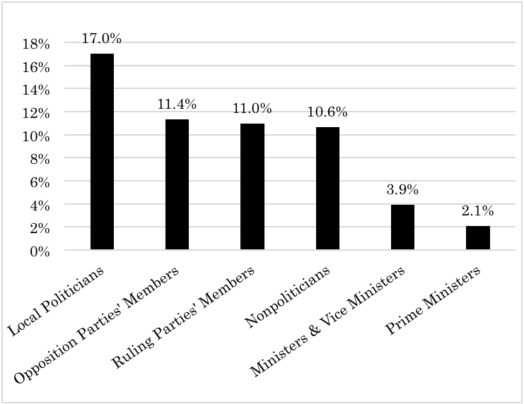
Note: Means of the Sender Dimension for the Different Groups (ranging from (1) “It is
obviously his/her personal opinion/ideas, not someone else's,” to (6) “It is obviously
someone else’s opinion/ideas”): Local politicians 2.93; Opposition parties’ member 3.30;
Ruling parties’ members 3.15; Nonpoliticians 3.06; Ministers & vice ministers: 3.74;
Prime Ministers 3.17.

Figure 2 Reasons for Equivocation on the Sender Dimesion
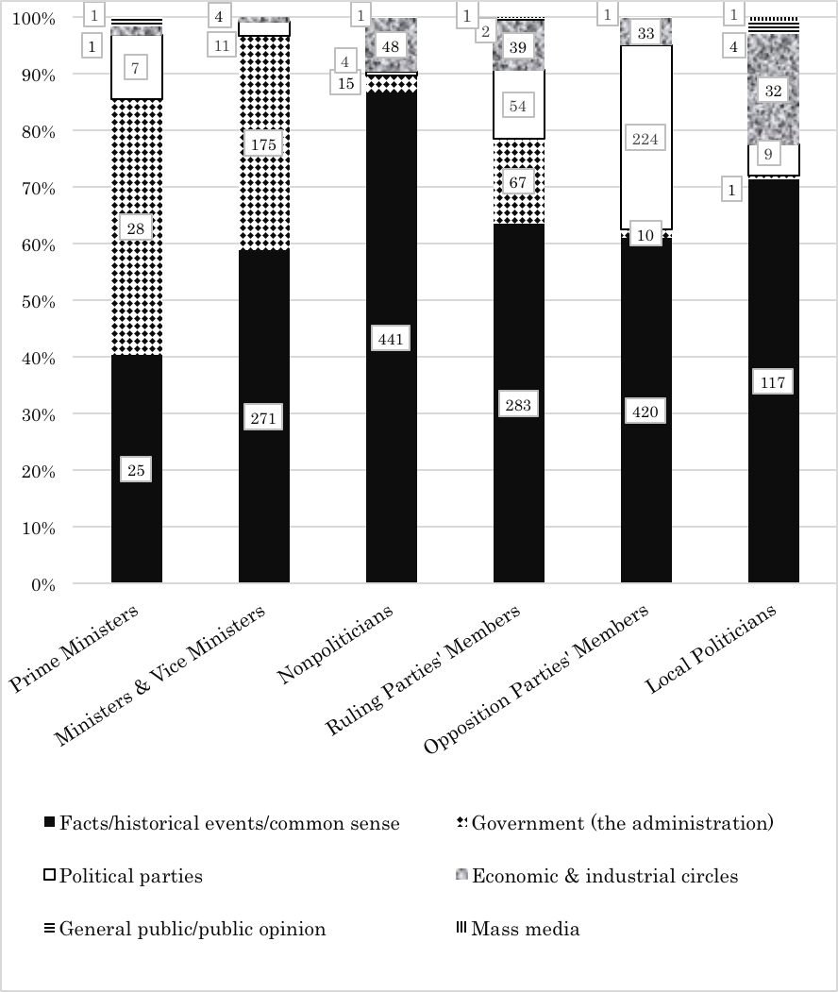

Figures in the different bars indicate the number of questions/answers.
Figure 3 Proportion of Replies Explicitly addressed to the Interviewers by
Members of the Different Groups (Receiver Dimension)
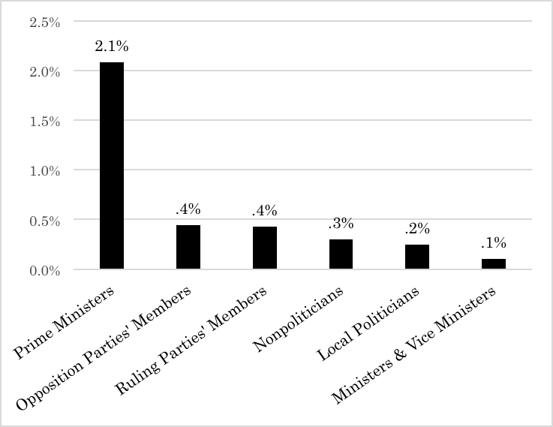

Note: Means of the Receiver Dimension for the Different Groups (ranging from
(1) “Obviously addressed to the moderators or the commentators” to (6) “Addressed
to other people.”): Prime Ministers 4.29; Opposition parties’ members 4.04; Ruling
parties’ members 3.94; Nonpoliticians 3.85; Local politicians 4.09; Ministers & vice
ministers 4.06.

Figure 4 Reasons for Equivocation for the Receiver Dimension
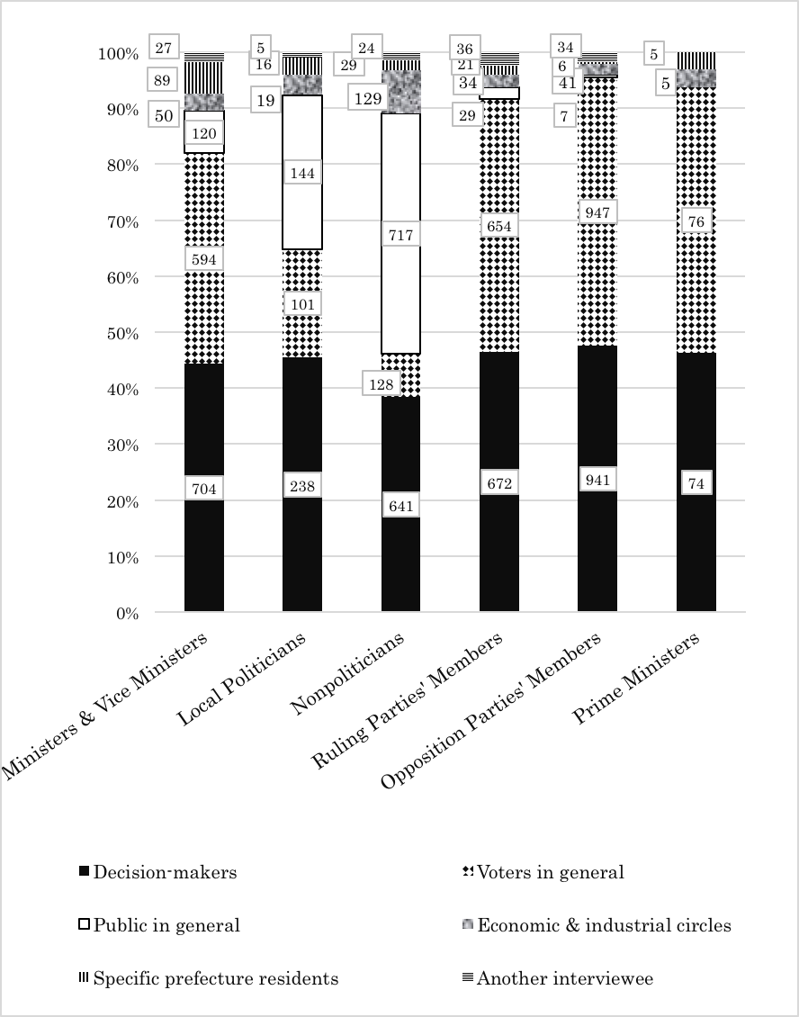

Figures in the different bars indicate the number of questions/answers.

Figure 5 Proportion of Straightforward, Clear Replies by Members of the Different Groups
(Content Dimension)
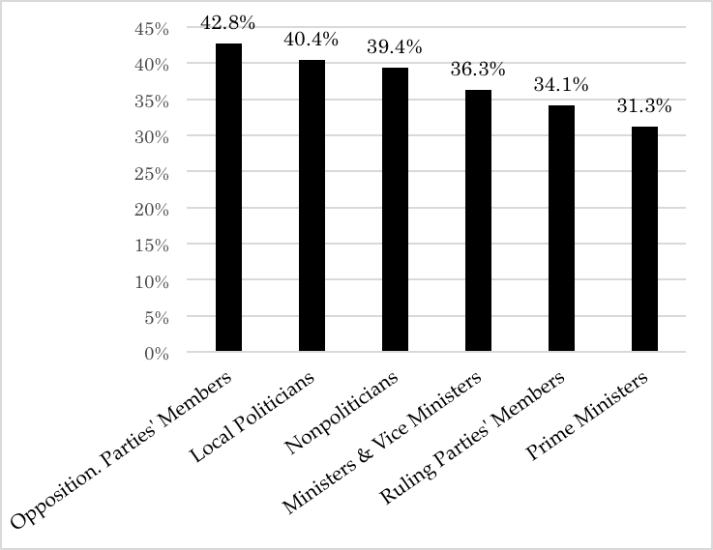

Note: Means of the Receiver Dimension for the Different Groups (ranging from
(1) “Straightforward, easy to understand, only one interpretation is possible,”
to (6) “Totally vague, impossible to understand, no meaning at all.”): Opposition
parties’ members 1.98; Local politicians 2.16; Nonpoliticians 2.04; Ministers & vice
ministers 2.16; Ruling parties’ members 2.19; Prime Ministers 2.33.
Figure 6 Reasons for Equivocation for the Content Dimension
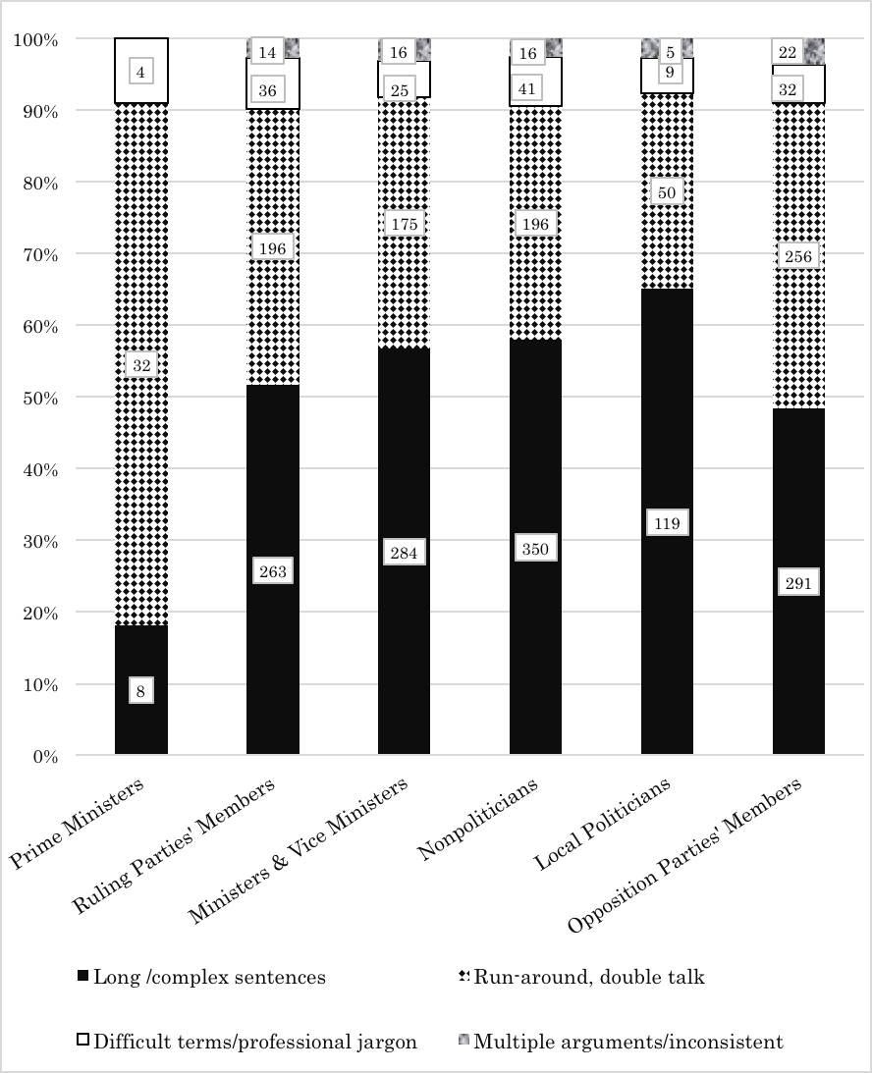

Figures in the different bars indicate the number of questions/answers.

Figure 7 Proportion of Direct Replies to Questions by members of the Different Groups
(Context Dimension)
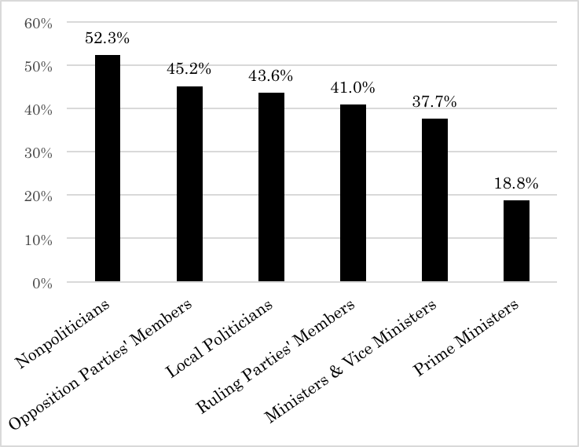

Note: Means of the Receiver Dimension for the Different Groups (ranging from

“This is a direct answer to the question asked,” through (6) “Totally unrelated to
the question”): Nonpoliticians 2.10; Opposition parties’ members 2.33; Local politicians 2.44;
Ruling parties’ members 2.45; Ministers & vice ministers 2.57; Prime Ministers 3.31.
Figure 8 Reasons for Equivocation for the Context Dimension
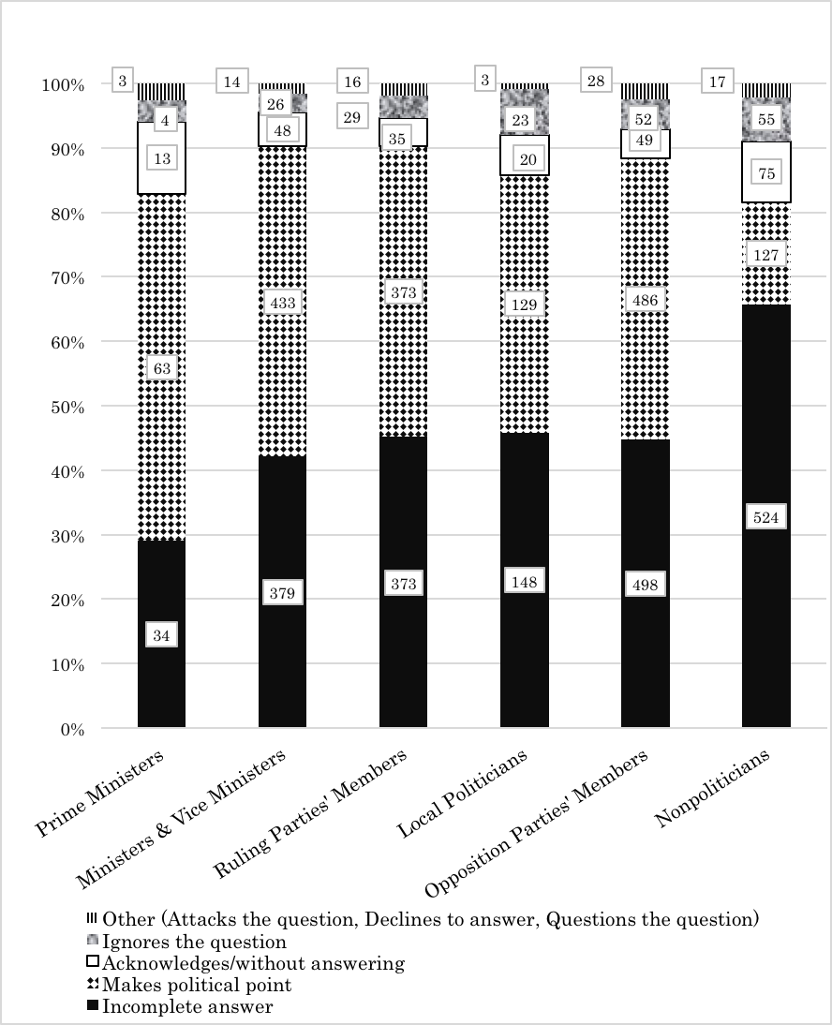

Figures in the different bars indicate the number of questions/answers.
Table 1: Explanatory Model for Addressing Issues by High-Echelon Politicians (Vice Ministers,
Ministers, and Prime Ministers) along the Four Dimensions (Tobit Model)

 | Sender |  | Receiver |  | Content |  | Context
 | beta | St. Err. | beta | St. Err. | beta | St. Err. | beta | St. Err.
(Constant) | 4.595***  (39.009) | 0.118 | 3.723***  (62.865) | 0.059 | 1.287***  (8.453) | 0.152 | 0.980***  (3.804) | 0.258
Knowledge of  Familiarity w/Issue | 0.790***  (12.342) | 0.064 | -0.326***  (-10.171) | 0.032 | -1.108***  (-12.614) | 0.088 | -1.919***  (-12.328) | 0.156
Political Process | 0.273***  (4.189) | 0.065 | -0.015  (-0.447) | 0.033 | -0.045  (-0.542) | 0.083 | 0.578***  (4.217) | 0.137
Significant Others:  Individuals | -0.732***  (-9.648) | 0.076 | -0.176***  (-4.682) | 0.038 | -0.421***  (-4.339) | 0.097 | -0.031  (-0.193) | 0.160
Significant others:  Political Groups | -0.125**  (-2.177) | 0.057 | 0.004  (0.125) | 0.029 | -0.221***  (-2.998) | 0.074 | 0.102  (0.831) | 0.122
Political  Commitment | 0.232*  (1.859) | 0.125 | -0.102  (-1.621) | 0.063 | -0.705***  (-4.208) | 0.168 | -0.263  (-0.977) | 0.269
V/Minister X  National Security | 0.720**  (5.555) | 0.130 | 0.264***  (4.019) | 0.066 | -0.025  (-0.149) | 0.169 | 0.616**  (2.217) | 0.278
V/Minister X  Foreign Policy &  Diplomacy | 0.843***  (7.241) | 0.116 | 0.147**  (2.489) | 0.059 | -0.138  (-0.921) | 0.150 | 0.951***  (3.877) | 0.245
V/Minister X  Intra-Party Politics | 0.064  (0.316) | 0.201 | -0.119  (-1.175) | 0.102 | 0.108  (0.415) | 0.261 | 0.913**  (2.169) | 0.421
V/Minister X  Energy &  Nuclear Power | 0.836***  (5.477) | 0.153 | 0.613***  (7.928) | 0.077 | 0.904***  (4.704) | 0.192 | 1.097***  (3.446) | 0.318
V/Minister X  Economy | 0.583***  (3.104) | 0.188 | 0.297***  (3.116) | 0.095 | 0.630***  (2.669) | 0.236 | 1.113***  (2.812) | 0.396
V/Minister X  TPP | 0.910*  (1.909) | 0.477 | 0.435*  (1.813) | 0.240 | 0.759  (1.298) | 0.585 | 1.959**  (2.024) | 0.968
V/Minister X  Reconstruct. Efforts | 0.251**  (2.105) | 0.119 | 0.329***  (5.461) | 0.060 | -0.096  (-0.618) | 0.155 | 0.649**  (2.537) | 0.256
V/Minister X  Diet Affairs Man. | 0.449  (1.564) | 0.287 | -0.045  (-0.311) | 0.145 | 0.790**  (2.177) | 0.363 | 2.054***  (3.486) | 0.589
V/Minister X  Tax & Fin. Affairs | 0.613*  (1.889) | 0.325 | 0.308*  (1.874) | 0.164 | 0.132  (0.320) | 0.413 | -0.467  (-0.655) | 0.713
V/Minister X  Public Opinion | 1.289***  (3.321) | 0.388 | 0.313  (1.595) | 0.196 | 0.332  (0.683) | 0.487 | 1.653**  (2.046) | 0.808
V/Minister X  Political Dynamics | 1.146  (1.220) | 0.939 | 0.110  (0.231) | 0.477 | 2.632**  (2.297) | 1.146 | 3.351*  (1.789) | 1.873
Sigma | 1.326***  (90.781) | 0.015 | 0.673***  (100.021) | 0.007 | 1.618***  (71.251) | 0.023 | 2.645***  (63.113) | 0.042
AIC | 3.296 |  | 2.072 |  | 2.976 |  | 3.220
Log likelihood | -8352.001 |  | -5238.946 |  | -7537.748 |  | -8157.164
N | 5084 |  | 5084 |  | 5084 |  | 5084
***: p<.01, **: p<.05, *: p<.10.
Note: Entries are unstandardized regression coefficients (beta’s) and standard errors (St. Err.).
Figures in parenthesis indicate the z-value.
Controlling for age gender, coalition parties’ members, opposition parties’ members, local politicians,
television programs and regime change.

