**Inequality and the NHS Hospital Crisis**

***Why hospital staff should pay more attention to social disadvantage***

24 November 2015

Submitted as an invited editorial to *British Journal of Hospital Medicine*

**Keywords (MeSH Headings):** (1) Emergencies, (2) Chronic Disease, (3) Health Equity; (4) Health Care Disparities, (5) Quality Indicators, Health Care; (6) Socioeconomic Factors

**Word count: 1189**

**Key points**

* Emergency admissions and bed-blocking are inextricably linked to social inequality
* Someone living in the most deprived fifth of neighbourhoods in England is two and a half times more likely to suffer potentially avoidable emergency hospitalisation than someone living in the least deprived fifth, after allowing for age and sex
* Hospital staff cannot eliminate social inequality, but they can do more to improve follow-up ambulatory care for socially disadvantaged patients at risk of avoidable admission
* NHS England has published new local equity assurance indicators for clinical commissioning groups that show how well or badly your local NHS area is doing in tackling health inequalities compared with similar local areas
* By prioritizing prevention of costly health emergencies linked to social deprivation, costs, quality and equity could all be addressed.

**Short introduction**

Social inequality plays a pivotal role in generating the emergency hospital admissions and bed-blocking that are paralysing NHS hospitals. To curb growth in emergency admissions, hospital staff must do more to help co-ordinate follow-up care for socially disadvantaged patients.

**The rise and rise of emergency admissions**

Emergency hospital admission rates have been rising for decades in all high income countries (Jones, 2011), leading to perennial “crises” of emergency medicine (Institute of Medicine Committee on the Future of Emergency Care in the US Health System, 2006). Current overcrowding of English “accident and emergency” (A&E) departments is generating ongoing media interest, centring around breaches of a national target for 4 hour patient waiting, as is the follow-on problem of “bed-blocking” by older patients with no appropriate care at home due to cuts in adult social care budgets. Examining the pivotal but under-appreciated role that social deprivation plays in generating emergency hospital admissions will lead to a better understanding of these twin problems and may uncover novel solutions.

Some of the pressure from increased A&E attendance is due to patients bypassing primary care services for more immediate management (Cowling et al., 2014). Less well known, however, is the greater increase in emergency admission of patients for inpatient hospital treatment (Blunt, 2013). According to the UK National Audit Office, the “conversion rate” from A&E attendance to hospital admission rose from 19% to 26% from 2002-3 to 2012-13, and emergency admissions accounted for 67% of hospital bed days in 2012-13 at a cost of £12.5 billion (Morse, 2013).

**Potentially avoidable admissions**

Some of this growth in emergency hospital admissions is an unfortunate and unavoidable side-effect of social and medical progress. The good news is that we are avoiding premature death and living longer; the bad news for the NHS is that – other things equal – older people are at greater risk of suffering acute health emergencies. However, some of the growth is potentially avoidable by improved ambulatory care outside the emergency hospital system. Research has shown that rates of emergency hospitalisation for chronic conditions such as cardiovascular and respiratory diseases, diabetes and dementia are sensitive to the quality of ambulatory care (Purdy and Huntley, 2013). Emergency admissions for these “chronic ambulatory care sensitive conditions” are now used as an indicator of the quality of ambulatory care across the world.

**The social gradient in health emergencies**

People living in the most deprived fifth of neighbourhoods in England suffer nearly two-and-a-half times as many potentially avoidable emergency admissions for chronic conditions as people living in the least deprived fifth (Asaria et al., 2016). This phenomenon is not unique to the poorest in society. The middle fifth of neighbourhoods experience 40% more emergency admissions than the richest fifth. There is a “social gradient” whereby people further down the social spectrum are more likely to suffer an emergency admission at any given age (see graph).

People at the top of the social scale are better at caring for themselves – they have access to better information, stronger informal support networks and home environments more conducive to recovery from illness; they also have the ‘sharpest elbows’ for navigating through the bureaucratic jungle to receive the best care (Cookson et al., 2016b). Proportionately, those lower down the social scale need more support to achieve the same health outcomes. As illustrated in the cartoon, equity in health care thus requires “proportional universalism”: not just making the same “one-size-fits-all” medical services freely available to all on a reactive basis, but making additional investment in the proactive co-ordination and delivery of ambulatory care in proportion to need to ensure everyone is equally able to make effective use of medical services.

**Co-ordinated care**

The paradigm of coordinated care and proactive support for self-care is an attractive way of reducing emergency admissions. Patient education, rehabilitation programs and individualised care plans have been tried as a way of encouraging people to better self-care, though the results are patchy (Purdy and Huntley, 2013). Other initiatives such as ‘safer, faster, better’, the Better Care Fund and the Vanguard sites all seek to improve care coordination though none specifically address the issues of social inequality (Shortell et al., 2015).

Local initiatives in specific disadvantaged groups could be another answer. One promising initiative, for example, is the Kings Health Partners Homeless Team which has delivered hospital-based integrated care services for homeless people in London since 2014 (Kings Health Partners Pathway Homeless Team, 2014). Affiliated with the homeless charity, Pathway, this links health care with housing advocacy services, drawing on skills from GPs, nurses, occupational therapists, social workers and mental health practitioners. Cloud-based information technology may also play a useful role in facilitating co-ordinated care. For example, Liverpool has piloted a “delivering assisted living lifestyles at scale” (DALLAS) programme that combines tele-monitoring in the home with structured case management and coaching delivered by a multi-professional support team (Devlin et al., 2016). And in 2015, London started piloting a “111 Patient Relationship Manager” system that shares patients’ care planning information with clinicians operating the non-emergency NHS telephone service.

**Mirror, mirror on the wall – whose model of care is fairest of all?**

Local experimentation of this kind is an excellent opportunity to identify cost-effective ways of reducing hospital admissions among socially disadvantaged patients. But lessons will only be learned if the impacts of initiatives are quantified rigorously, using control groups of similar local areas and paying careful attention to social gradients in hospitalisation. NHS officials responsible for planning health services have a statutory duty to consider reducing inequalities in healthcare outcomes. To discharge this duty, they need to start monitoring inequalities within local areas and evaluating the impact of local actions on local inequalities. This requires better integration of local patient information between primary, secondary and social care, with specific attention to deprivation. NHS England have now started producing local indicators of inequality in potentially avoidable emergency hospitalisation that could be used routinely to find out whether local initiatives are making a difference to local health inequalities (Cookson et al., 2016a). These indicators show how well your local NHS area is doing at tackling inequality in avoidable admissions compared with other similar NHS areas, and further information include tools for looking at your own area can be found here: <http://www.york.ac.uk/che/research/equity/monitoring/>.

**Can hospitals afford to ignore health inequality?**

During the 2000s, investment in primary care strengthening led to improved outcomes across all socio-economic groups, particularly among the poorest (Asaria et al., 2016). Although the inequality reductions in potentially avoidable hospitalisation and mortality were modest, they can be seen as an achievement against the continuing rise in income inequality during this period. Today’s austere funding climate may encourage clinicians and managers to see investment in coordinated care as unaffordable, and health inequality as a third order concern meriting lip-service only. However that perception would be a mistake: the truth is that health services cannot afford not to invest in new initiatives for reducing hospital admissions, and in so doing cannot afford to ignore the central role of inequality in driving increased pressures on health service finances. By prioritizing prevention of costly health emergencies linked to social deprivation, costs, quality and equity could all be addressed.

**Figures**

**Figure 1. Rate of potentially avoidable emergency admission to hospital by socio-economic deprivation**

The graph demonstrates a stepwise increase in emergency hospital admissions with worsening socio-economic deprivation. The general population is split into quintile groups of neighbourhood deprivation. The figures show the indirectly age-sex standardised rate per 1,000 people in 2011/2 with one or more emergency admissions for chronic ambulatory care sensitive conditions as per the NHS Outcomes Framework list; full details of analytical methods are published elsewhere (Asaria et al., 2016).

**D:\GoogleDrive\Cookson Current Work\Projects\HSR Equity\Waldo hospital editorial\Fig 1 Social gradient in potentially avoidable hospitalisation.tif**

**Figure 2: Equality versus equity**

*Source:* This figure was drawn by Angus McGuire and has been made freely available on the web by the Interaction Institute for Social Change <http://interactioninstitute.org/illustrating-equality-vs-equity/>

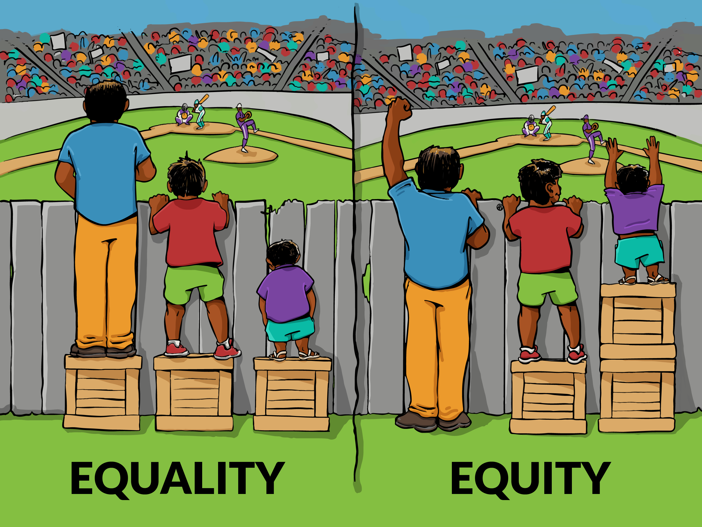

**Conflict of interest statement**

All authors have completed the Unified Competing Interest form at www.icmje.org/coi_disclosure.pdf (available on request from the corresponding author).

Richard Cookson is a member of the NHS Outcomes Framework Technical Advisory Group and is supported by the National Institute for Health Research. He is supported by the National Institute for Health Research (Senior Research Fellowship, Dr Richard Cookson, SRF-2013-06-015).

Andrew Walden declares no support from any organisation for the submitted work; no financial relationships with any organisations that might have an interest in the submitted work in the previous three years, no other relationships or activities that could appear to have influenced the submitted work.

The views expressed in this publication are those of the authors and not necessarily those of the NHS, the National Institute for Health Research or the Department of Health.

**Contributorship statement**

RC and AW had the original idea jointly; RC wrote the initial draft, AW substantially revised and manuscript, then both authors revised and approved the final version.

**References**

ASARIA, M., ALI, S., DORAN, T., FERGUSON, B., FLEETCROFT, R., GODDARD, M., GOLDBLATT, P., LAUDICELLA, M., RAINE, R. & COOKSON, R. 2016. How a universal health system reduces inequalities: lessons from England. *Journal of epidemiology and community health***,** jech-2015-206742.

BLUNT, I. 2013. Focus on preventable admissions: Trends in emergency admissions for ambulatory care sensitive conditions, 2001 to 2013. London: Nuffield Trust.

COOKSON, R., ASARIA, M., ALI, S., FERGUSON, B., FLEETCROFT, R., GODDARD, M., GOLDBLATT, P., LAUDICELLA, M. & RAINE, R. 2016a. Health Equity Indicators for the English NHS: a longitudinal whole-population study at the small-area level. *Health Services and Delivery Research,,* 4.

COOKSON, R. A., PROPPER, C., ASARIA, M. & RAINE, R. 2016b. Socioeconomic inequalities in health care in England. *Fiscal Studies,* 37**,** 371-403.

COWLING, T. E., SOLJAK, M. A., BELL, D. & MAJEED, A. 2014. Emergency hospital admissions via accident and emergency departments in England: time trend, conceptual framework and policy implications. *Journal of the Royal Society of Medicine,* 107**,** 432-438.

DEVLIN, A. M., MCGEE-LENNON, M., O’DONNELL, C. A., BOUAMRANE, M.-M., AGBAKOBA, R., O’CONNOR, S., GRIEVE, E., FINCH, T., WYKE, S. & WATSON, N. 2016. Delivering digital health and well-being at scale: lessons learned during the implementation of the dallas program in the United Kingdom. *Journal of the American Medical Informatics Association,* 23**,** 48-59.

INSTITUTE OF MEDICINE COMMITTEE ON THE FUTURE OF EMERGENCY CARE IN THE US HEALTH SYSTEM 2006. Hospital-based emergency care: at the breaking point. Washington, DC: National Academies Press.

JONES, R. 2011. Bed occupancy: the impact on hospital planning. *British Journal of Healthcare Management,* 17**,** 307-313.

KINGS HEALTH PARTNERS PATHWAY HOMELESS TEAM 2014. First year report 2014. London, England: Pathway: Healthcare for Homeless People.

MORSE, A. 2013. Emergency admissions to hospital: managing the demand. *London: The Stationery Office, National Audit Office*.

PURDY, S. & HUNTLEY, A. 2013. Predicting and preventing avoidable hospital admissions: A review. *Journal of the Royal College of Physicians of Edinburgh,* 43**,** 340-344.

SHORTELL, S. M., ADDICOTT, R., WALSH, N. & HAM, C. 2015. The NHS five year forward view: lessons from the United States in developing new care models. *BMJ,* 350**,** h2005.