Basin-scale observations of monoterpenes in the Arctic and Atlantic Oceans

Sina C. Hackenberg†, Stephen J. Andrews†, Ruth Airs‡, Steve R. Arnold§, Heather A. Bouman~, Denise Cummings‡, Alastair C. Lewis†,&, Jamie K. Minaeian†, Kristen M. Reifel⊥,^, Alison Small~, Glen A. Tarran‡, Gavin H. Tilstone‡, and Lucy J. Carpenter*,†

†Wolfson Atmospheric Chemistry Laboratories, Department of Chemistry, University of York, York YO10 5DD, UK

‡Plymouth Marine Laboratory, Prospect Place, West Hoe, Plymouth PL1 3DH, UK.

~Department of Earth Sciences, University of Oxford, South Parks Road, Oxford, OX1 3AN

§Institute for Climate and Atmospheric Science, School of Earth & Environment, University of Leeds, Leeds, LS2 9JT

⊥Department of Botany and Plant Pathology, 2082 Cordley Hall, Oregon State University, Corvallis, Oregon, 97331-2902, USA

&National Centre for Atmospheric Science, University of York, Heslington, York, YO10 5DD, UK

*Corresponding author: [lucy.carpenter@york.ac.uk](mailto:lucy.carpenter@york.ac.uk), Tel: 01904 324588, Fax: 01904 322516

ABSTRACT. We report novel *in situ* speciated observations of monoterpenes (α- and β-pinene, myrcene, δ3-carene, ocimene, limonene) in seawater and air during three cruises in the Arctic and Atlantic Oceans, in/over generally oligotrophic waters. Oceanic concentrations of the individual monoterpenes ranged from below the detection limit of <1 pmol L-1 to 5 pmol L-1, with average concentrations of between 0.5-2.9 pmol L-1. After careful filtering for contamination, atmospheric mixing ratios varied from below the detection limit (<1 pptv) to 5 pptv, with averages of 0.05 - 5 pptv; these levels are up to two orders of magnitude lower than those reported previously. This could be at least partly due to sampling over waters with much lower biological activity than in previous studies. Unlike in previous studies, no clear relationships of the monoterpenes with biological variables were found. Based on our measured seawater concentrations and a global model simulation, we estimate total global marine monoterpene emissions of 0.16 Tg C yr-1, similar to a previous bottom-up estimate based on laboratory monoculture studies, but 2 orders of magnitude lower than a previous top-down estimate of 29.5 Tg C yr-1.

Table of Contents Graphic

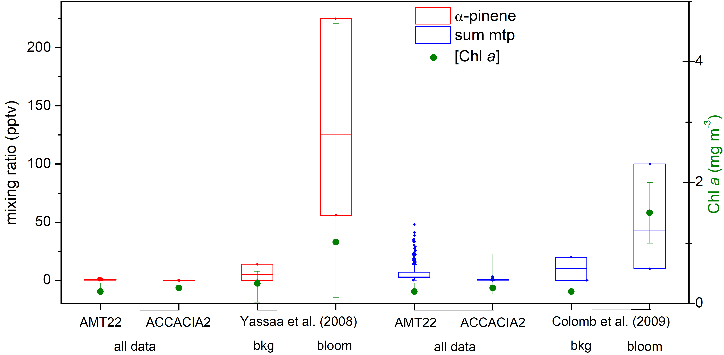

1. Introduction

Monoterpenes (C10H16) are estimated to account for 7-31% of global biogenic volatile organic compound emissions, with terrestrial emissions of 26-177 Tg yr-1. 1–3 Monoterpenes are highly reactive towards oxidation by OH and NO3 radicals and O3, with large (and variable) resultant secondary organic aerosol (SOA) yields.4 This leads to substantial impacts on air quality and climate, but with large uncertainties on the distribution and magnitude of these effects.4,5

Due in part to the difficulties of measuring monoterpenes at low concentrations and the assumption that they are of minor relevance in the marine environment, observations of monoterpenes in the marine atmosphere were not reported until 2008, when Yassaa et al.6 published evidence for the marine production of these compounds, based on laboratory monoculture studies and field data. Significant levels of monoterpenes in air during field measurements in the Southern Indian Ocean were subsequently reported.7 Both studies found, to varying extents, correlations of atmospheric monoterpene mixing ratios with oceanic Chl *a* (chlorophyll *a*) concentrations, which led the authors to conclude that monoterpenes are of biogenic origin. This was further supported by correlations of monoterpene with isoprene mixing ratios, as isoprene is generally accepted to be biogenic.8

A recent study of glyoxal and methylglyoxal in the Southern Hemisphere also measured monoterpenes in air as supporting data,9 but to our knowledge no other field measurements have been published to date. Yassaa et al.6 and Meskhidze et al.10 both observed emission of several monoterpenes in laboratory-based phytoplankton monoculture experiments, with Meskhidze et al.10 additionally exploring effects of temperature and light stress.

Results from field and laboratory studies to date clearly show a large variability within and between datasets, which in combination with the overall paucity of observational data prevents a good constraint of global monoterpene emission estimates. Different growing conditions and the use of different species from the same functional group (diatoms) in laboratory experiments could explain some of the variability. The conditions chosen by Yassaa et al.6 aimed to be representative of the species’ natural growing conditions, while the study by Meskhidze et al.10 characterised the effects of stress rather than specifically replicating natural emissions.

No seawater observations of monoterpenes have been published to date, making bottom-up emission estimates11 solely reliant on parameterisations with Chl *a* derived from the laboratory studies, without validation against field measurements. Global marine emissions have only been estimated by a single study so far,11 based on measurements from one paper.6 The calculations yielded very different results for a top-down estimate based on atmospheric mixing ratios (29.5 Tg C yr-1) compared to a bottom-up approach based on laboratory-based phytoplankton monoculture experiments (0.013 Tg C yr-1). The emerging consensus is that the global marine source of isoprene is small-to-negligible compared to terrestrial emissions and even to other ocean-derived organic reactive compounds, and likely not important for marine SOA.12–15 However, there is much less constraint on our understanding of monoterpenes and their atmospheric impacts than for isoprene.6,11

Better constraints on the global flux of monoterpenes are required to determine their importance in marine atmospheric chemistry, through seawater as well as air observations and via more spatially and temporally comprehensive datasets. This study provides a large dataset of new field measurements, investigates relationships with potential biological controls, and estimates global monoterpene fluxes based on these new data.

2. Experimental Methods

2.1 Cruise and Sampling Overview

Sampling took place during the AMT 22 cruise (Atlantic Meridional Transect, UK-South Atlantic, Oct/Nov 2012, RRS James Cook), AMT 23 cruise UK-South Atlantic, (Oct/Nov 2013, RRS James Clark Ross (JCR)) and ACCACIA 2 cruise (Aerosol-Cloud Coupling and Climate Interactions in the Arctic, JR288, Arctic, Jul/Aug 2013, JCR). Cruise tracks are shown in Figure S1 (Supplementary Information, SI).

CTD (conductivity-temperature-depth) casts were performed twice daily (pre-dawn and solar noon) during AMT 22 and 23, and once daily (morning) during ACCACIA 2. Water was sub-sampled from Niskin bottles (20 L) for further processing, described in detail for each variable. Various measurements were also made from the ships’ clean underway seawater supply inlet (nominal depth 5-6 m).

2.2 Trace Gas Measurements by (autoP&T)-TD-GC-MS and Data Processing

Trace gases were measured in water and air during all three cruises by (automated Purge & Trap)-Thermal Desorption-Gas Chromatography-Mass Spectrometry ((autoP&T)-TD-GC-MS), for details see section S1.1 (SI).

Briefly, monoterpenes in air were measured as discrete samples of 1-2 L air, from a continuously pumped air inlet. Monoterpenes in seawater were analysed from the ships’ pumped non-toxic seawater supplies as well as from CTD casts from within the photic depth, using the semi-automated P&T system described in Andrews et al.16 with modifications as detailed in S1.1.2 (SI). Analysis was performed by GC-MS. The instruments were calibrated regularly using a pre-mixed gas standard. Each water analysis was paired with an external air standard and the detection limit calculated dynamically, to allow correction for instrument sensitivity drift. The uncertainty of the analysis was typically around 15-50%, as calculated as a propagation of analytical errors using standard formulae. Further details of data processing are detailed in S1.1.3 (SI).

Air data was filtered for contamination events arising from the ship’s exhaust using a combination of visual inspection, a hydrocarbon marker threshold and a wind filter (further details in S1.1.3, SI, and also given in metadata for datasets held by the British Oceanographic Data Centre, BODC). Contamination filtering removed ca. 16 % and 30 % of the AMT 22 and ACCACIA 2 data, respectively. The AMT 23 air data contained highly elevated levels (compared to AMT 22) of hydrocarbon contamination marker concentrations across the entire cruise (as well as the monoterpenes). A large interannual variation of the monoterpenes was considered unlikely given the concurrent high background hydrocarbon data. Consequently, AMT 23 air data was disregarded for further analyses due to suspected contamination. Terrestrial influence was largely excluded due to short atmospheric lifetimes with respect to oxidation by OH, NO3 and ozone in conjunction with air mass back trajectories along the cruise tracks (see also section S2, SI). A more detailed description of the quality control process can be found in ref 17.

All AMT 23 water data for β-pinene was discarded due to a significant mismatch of underway (around 3-4 x DL) and surface CTD samples (<DL), potentially resulting from contamination/interference in the underway pathway; β-pinene air data for the second half of the cruise was also discarded due to a large interference. A smaller mismatch of underway/surface CTD of up to a factor of 2 was observed for α-pinene, carene and limonene until mid-cruise, but no obvious reason found and no correction made. The very high limonene water data for AMT 22 was attributed to contamination because of several issues with the data: High blank values, a factor of ~2-3 difference between CTDs and underway concentrations, and much higher (around 20x) concentrations than found in AMT 23 (the other monoterpenes exhibited similar water concentrations – within 60 % – in AMT 22 and AMT 23). The AMT 22 limonene seawater data were therefore excluded.

Overall, our analyses revealed that contamination (which we attribute to the ship’s exhaust, the ship itself, and – in some instances – from sampling lines) is a major issue for remote measurements of monoterpenes; we opted on the side of caution in removing data.

2.3 Biological and Supporting Data

Several biological datasets were collected and analysed during the cruises, with methods described in the supporting information (section S1.2). Data included gross biomass (Chl *a*) and integrated primary production (intPP) as well as flow cytometry and pigment data from high-performance liquid chromatography analysis (HPLC). CHEMTAX analysis was performed for ACCACIA 2 pigment data.

Meteorological data such as wind speed and sea surface temperature (SST) were obtained from the ship systems, provided by BODC.

2.4 Sea-air emission calculation

The monoterpene sea-to-air fluxes were calculated following the approach of Johnson,18 assuming air concentrations of zero due to the large degree of supersaturation of the gas in seawater (see section S1.3, SI).

2.5 Global Modelling

Global distributions of speciated monoterpene sea-air fluxes were calculated using the Community Earth System Model (CESM) version 1.1.1, which simulates the global atmosphere using the Community Atmospheric Model version 4 (CAM4).19 Single global surface ocean concentrations for the monoterpenes were specified based on seawater observations reported here, and sea-air fluxes were calculated based on model wind speed, sea surface temperatures, and assumed zero atmospheric concentrations. See S1.4 for further detail on these calculations.

3. Results and Discussion

3.1 Monoterpene air and water concentrations

The reported atmospheric mixing ratios and seawater concentrations of α-pinene, β-pinene, myrcene, δ3-carene, ocimene and limonene span around 130 degrees of latitude in the Atlantic and Arctic Oceans. Figure 1 illustrates the distribution of data (>DL only) summarised in Table S4, alongside sea surface temperature (SST) and Chl *a*. Overall, water concentrations were at the low pmol L-1 level for the two AMT cruises (within a factor of 2-3, noting that limonene water data was discarded for AMT22 because of suspected contamination), but around 3- to 10-fold higher in the Arctic (for α- and β-pinene, the only monoterpenes quantified in seawater).

Factors affecting seawater concentrations are production and consumption rates in the water column and losses to the atmosphere. Wind speeds were similar between the cruises (see Figure 3; mean of 6 m s‑1 for ACCACIA 2 and *ca.* 7.5 - 8 m s‑1 for both AMT cruises), i.e. losses by sea-air gas exchange should be of comparable magnitude. The solubility increase of the gases at lower SST based on their Henry's Law temperature dependences20 should only account for up to around 1/3 of the increase in Arctic waters, and no obvious or consistent relationship between SST and analyte concentrations was observed within each cruise dataset, despite the large ranges of SST encountered. Large differences in biological consumption or production rates in the Arctic and Atlantic are possible explanations for the differences in seawater concentrations. Very little is known about the biological consumption in marine environments (one study on bacterial consumption of terrestrial monoterpene run-off into the Gulf of Alaska exists21) and little about oceanic production. Yassaa et al.6 observed one of the highest production rates from a Southern Ocean diatom (*Fragilariopsis kerguelensis*), but another strain isolated from the Southern Ocean (*Chaetoceros debilis*) showed one of the lowest production rates. This remains the only published study that tested monoterpene production rates under natural growing conditions, making it difficult to draw general conclusions regarding emissions from polar phytoplankton compared to other biomes.

A simple estimate of expected seawater concentrations based on these total monoterpene laboratory production rates gives steady-state monoterpene concentrations of ~ 0.004 and 0.22 pmol L-1 for the two coldwater phytoplankton species above, respectively, and 1.2 pmol L-1 for the strongest emitter, *Dunaliella tertiolecta*.6 We used a mixed layer depth (MLD) of 50 m, [Chl *a*] = 0.3 μg L-1 (assumed to represent a single species) and losses only from air-sea exchange (gas transfer velocity = 12 cm hr-1). All calculated concentrations are at the low end of the range of our measured total monoterpene seawater concentrations (Figure 1), but show that phytoplankton production at the high end of these laboratory-measured rates (which are still much lower than reported rates for isoprene) could be capable of sustaining seawater abundances of monoterpenes.

Atmospheric mixing ratios were generally below a few pptv for both AMT 22 and ACCACIA 2, with levels much lower in the Arctic than the Atlantic (for all monoterpenes), despite the similar seawater source strength (see section 3.2). No diurnal trends were observed in water or air during any of the cruises, and vertical profiles in the water column did not exhibit a clear shape (Figure 2), with variations generally being in the noise. The relatively constant observed atmospheric mixing ratios, along with little variability in the water column, are inconsistent with photochemical production, which has been reported for isoprene in the surface microlayer.22

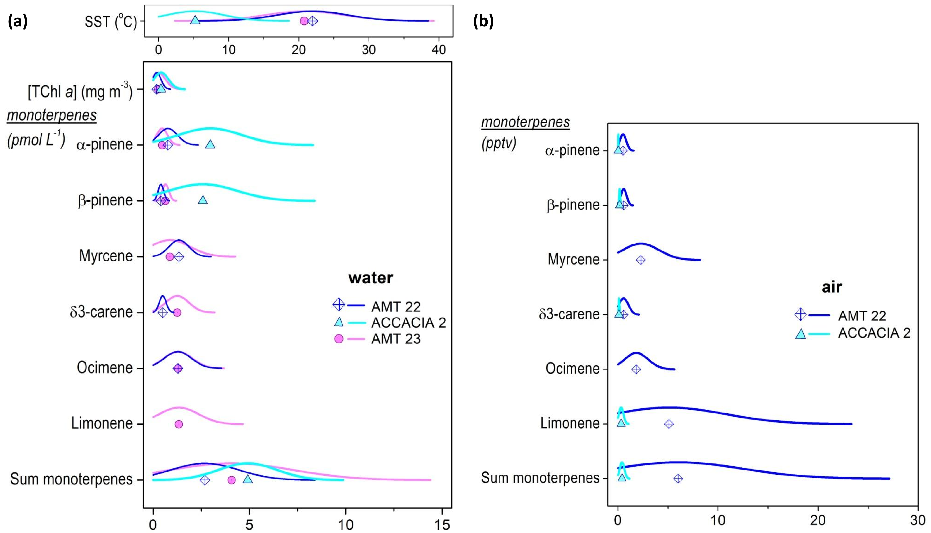**Figure 1.** Data distribution for all cruises of (a) monoterpene concentrations (pmol L-1) in water, alongside SST (°C) and Chl *a* concentrations (mg m-3) corresponding to the water measurements, and (b) monoterpene air mixing ratios (pptv). Symbols = mean; only data >DL.

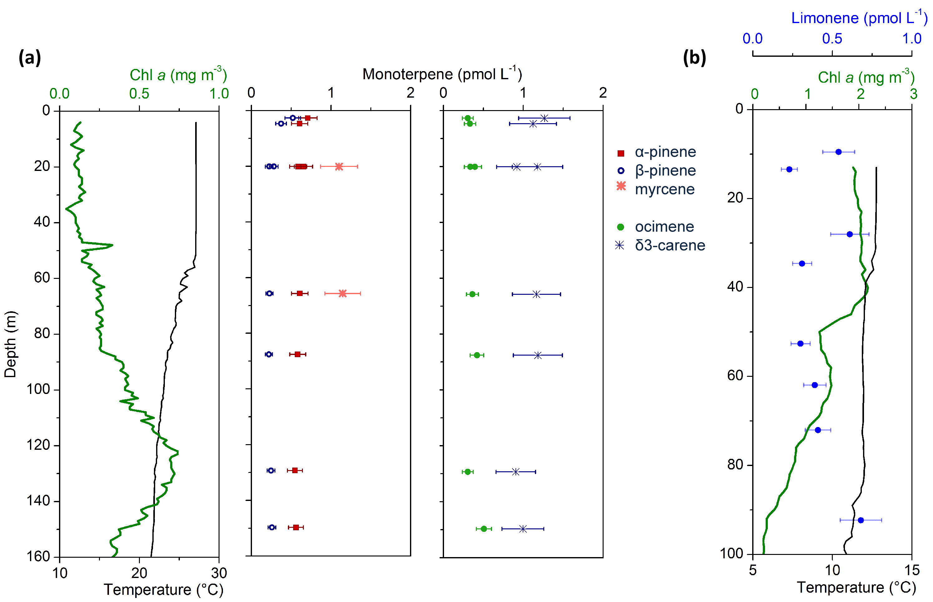

**Figure 2.** Typical CTD profiles of monoterpenes alongside the CTD sensor Chl *a* (green) and temperature (black) traces to indicate biological activity and mixed layer depth. Error bars for monoterpene data represent the measurement uncertainty. The few profiles obtained with monoterpenes >DL showed no clear trends; (a) North Atlantic Gyre, 23 °N, 41 °W (CTD 23, AMT 22); apparent β-pinene surface trend was not repeated in other profiles; no complete depth profile exists for myrcene as it was generally <DL; (b) South Atlantic, 38 °S 41 °W (CTD 58, AMT 23).

Table 1 summarises all monoterpene observations during the three cruises, with more details including median values in Table S4 (SI).

3.2 Sea-to-air fluxes

In order to assess the atmospheric impact of marine monoterpenes, the role of the ocean as a source (or sink) needs to be determined. Sea-to-air transfer is thought to be the dominant loss term from the ocean for the monoterpenes due to their low Henry’s Law solubility constants20 and also since no chemical or biological losses in the water column have been identified.10,23

Fluxes were calculated for points where water measurements above the DL existed (shown in Figure 3). Wind speeds were similar across all cruises, but the higher seawater concentrations in the Arctic (of α- and β-pinene) compensated for the lower SST, so that sea-to-air fluxes were similar for the cruises (where data was available). As a result of concentrations being below or near the detection limit and instrument issues, we note however that large sections of data are missing for most measured monoterpenes and the picture obtained from the derived fluxes is incomplete.

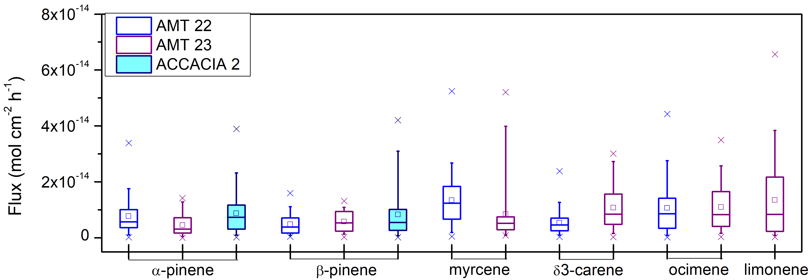

**Figure 3.**  Seawater-derived monoterpene fluxes. Mean (open square), median (line), 25th-75th percentile (box); 5th-95th percentile (whiskers), 1st-99th percentile (cross).

3.3 Potential oceanic controls on monoterpene surface water concentrations

Given the evidence of a biogenic origin in the literature,6,7,10 associations of monoterpene water concentrations with biological variables may be expected. However, although we found significant relationships between biological markers and dissolved isoprene concentrations measured during the same cruises (ref 24; also see Figure 4), we did not find any clear association of dissolved monoterpene and isoprene concentrations, nor any similarity of dissolved monoterpenes to observed biological patterns, including Chl *a* (examples shown in Figure 4). No relationships were seen with diatoms or chlorophytes, which were found to be the strongest emitters in both published laboratory studies:6,10 neither fucoxanthin (pigment found in diatoms) nor MV-Chl *b* (monovinyl-chlorophyll *b*; marker pigment for the division chlorophyta to which chlorophytes belong25) or chlorophytes as determined by CHEMTAX (ACCACIA 2 only) showed any clear patterns similar to any of the monoterpenes data. Correlations with photoprotective pigments, potentially reflecting enhanced terpene production as a response to light stress as reported by Meskhidze et al.,10 were also not observed in our data. Similarly, we found no relationships between atmospheric mixing ratios of the monoterpenes and these biological data (cf. Figures S5 and S6).

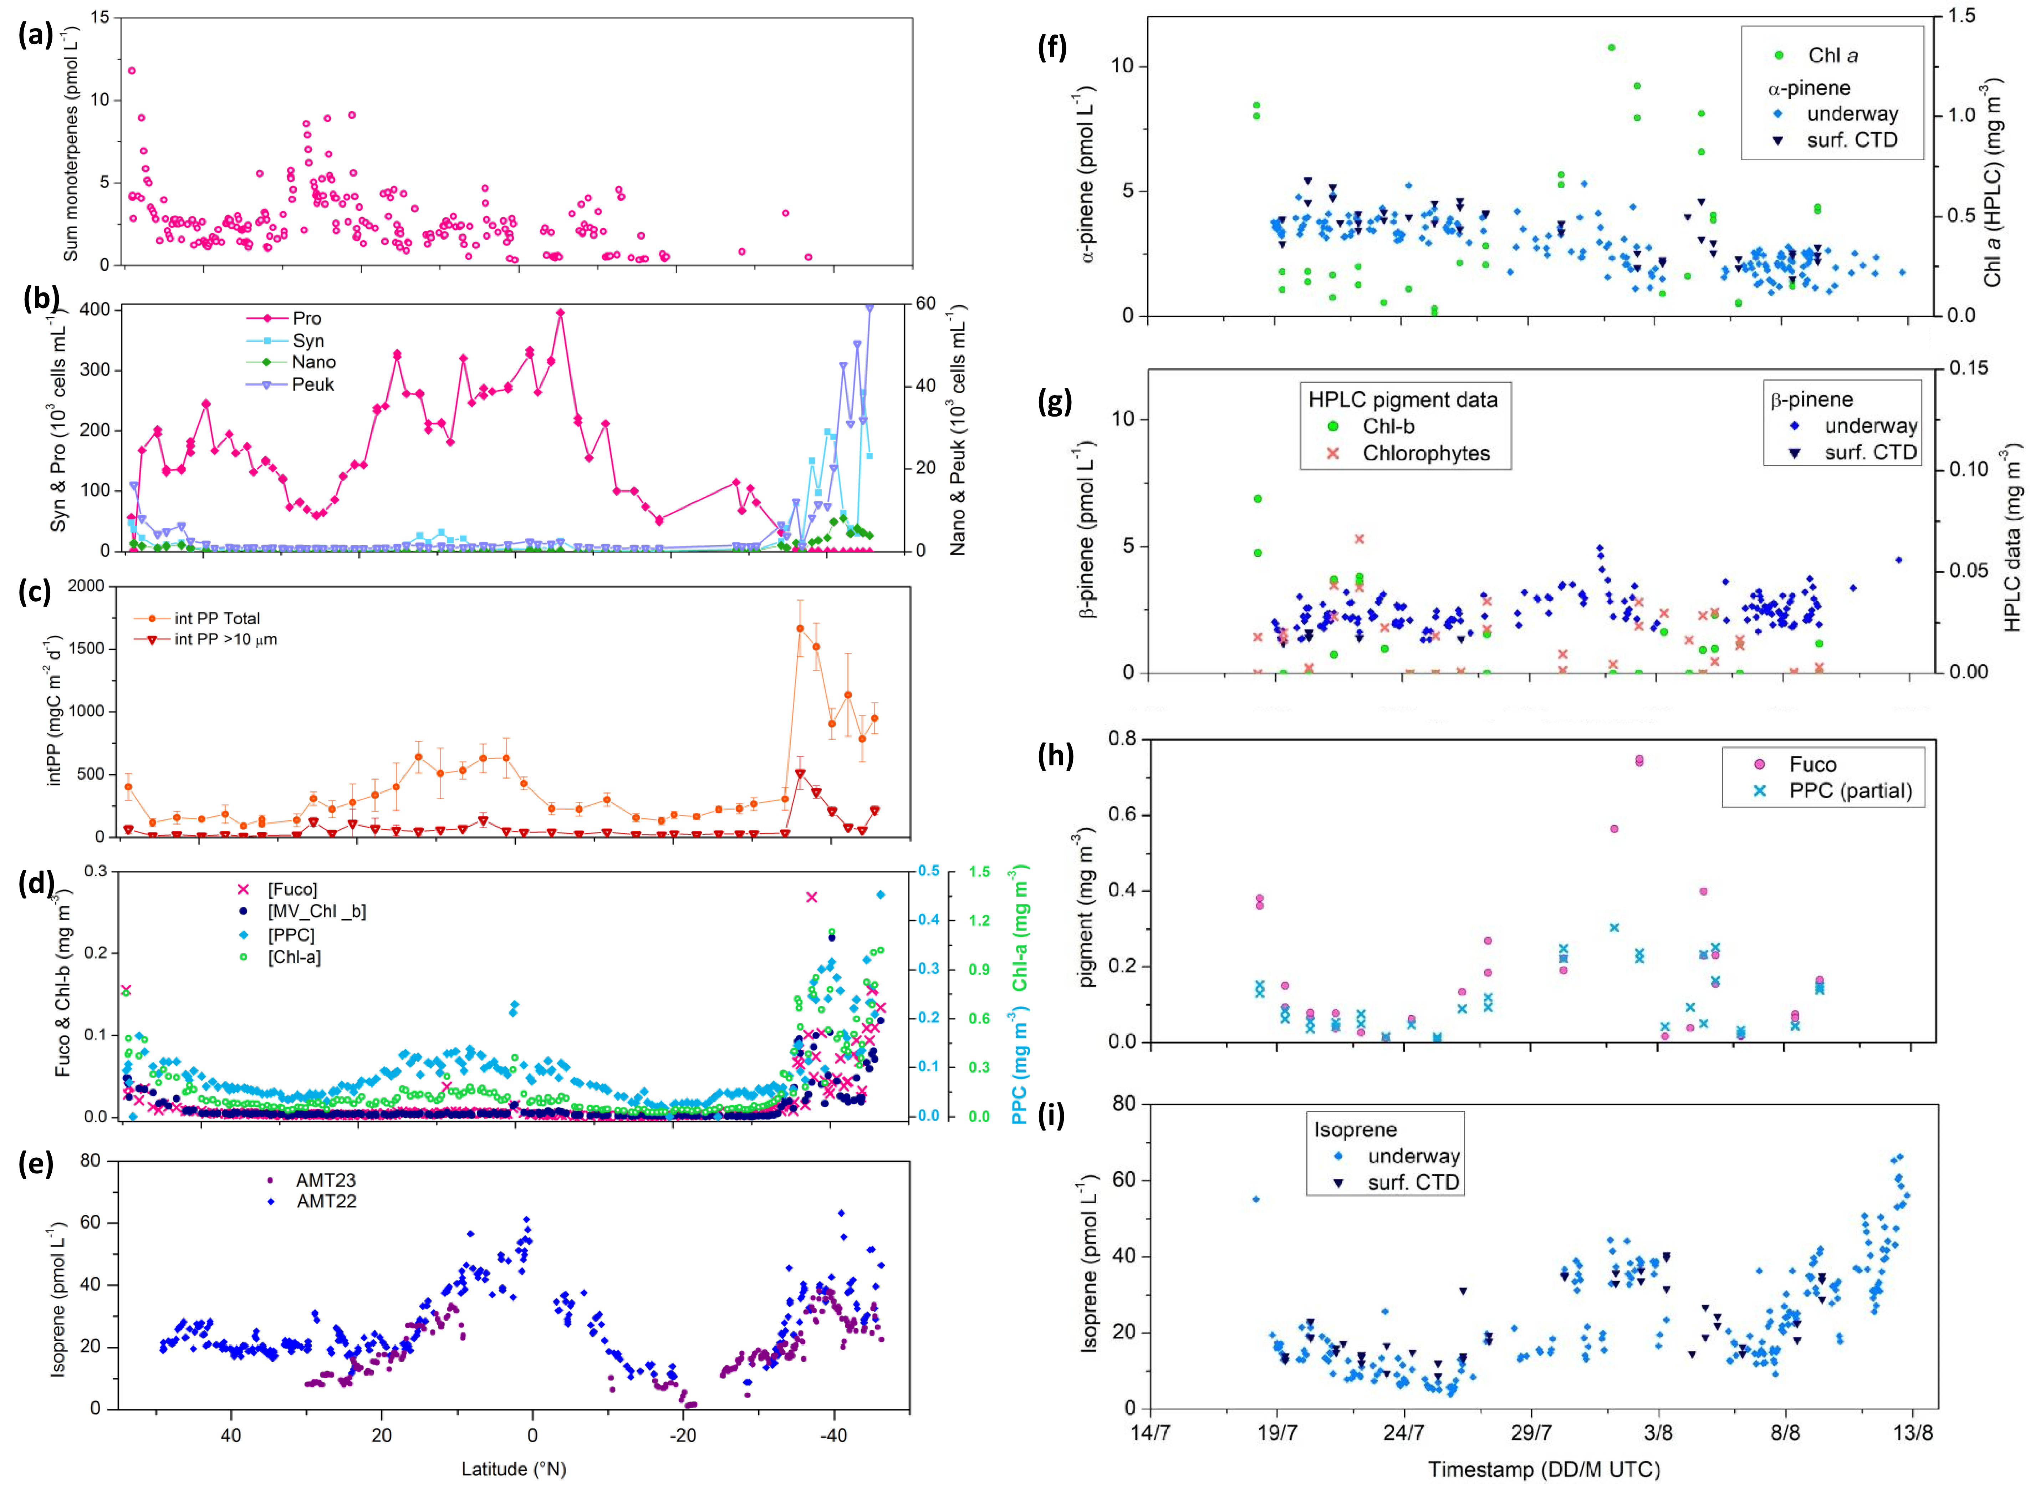

**Figure 4.** (a-d) Selected biological variables (surface (<10 m) CTD and underway) shown alongside the monoterpene underway water concentrations; sum of monoterpenes (>DL only, excluding limonene for AMT 22), as representative of trends in both AMT cruises; (f-h) selected biological variables shown alongside α- and β-pinene water concentrations for ACCACIA 2, surface (<10 m depth) CTD, also underway data for monoterpenes; (e) and (i) isoprene underway concentrations for comparison for the respective cruises (clear trends; for details see ref 24); Syn, Pro, Nano, Peuk = *Synechococcus, Prochlorococcus,* Nanoeukaryotes, Picoeukaryotes, respectively; MV-Chl *b* = monovinyl-chlorophyll *b*; intPP = integrated primary production; Fuco = fucoxanthin, PPC = photoprotective carotenoids.

3.4 Investigating associations with isoprene

As described in the introduction, both Colomb et al. and Yassaa et al. reported correlations of isoprene with monoterpenes,6,7 apparently supporting the attribution of these species to similar sinks and (biogenic) sources. Our datasets did not show a linear association of isoprene and sum of monoterpenes for air or for water (Figures S8 and S10). Some correlation appeared to be present in the AMT 23 air data (Figure S8, SI), but since this data was suspected to be contaminated, it does not necessarily indicate common biogenic sources and rather points to a common contamination source. The latter is further supported by a correlation observed for monoterpenes with the contamination markers benzene and *m*-/*p*-xylene (Figure S9, SI), despite data flagged “contaminated” already being excluded. It emphasises the benefits of concurrent measurements of hydrocarbon contamination markers for quality control purposes.

Overall, surface water concentrations of total monoterpenes (without limonene for AMT 22) were much lower than those of isoprene, though the ratio was highly variable (between >1 and 0.05 for total monoterpenes/isoprene). Monoculture studies6,10 have reported monoterpene emissions to be up to three orders of magnitude lower than isoprene emissions.

In conclusion, we find no evidence that monoterpenes are strongly linked to biological production in our data. A possible explanation both for the lack of any observed association with biological variables (Figure 4), and for the very well mixed levels of monoterpenes within the oceanic mixed layer (Figure 2), could be that they have very long lifetimes in seawater (assuming a similar reactivity to isoprene as described in ref 23), and are produced at only low rates in the oligotrophic ocean. This would also be consistent with the monoculture studies and associated calculations discussed in section 3.1.

3.5 Comparison of observations with previous studies

**Table 1.** Monoterpene measurements in air and from laboratory monoculture studies (light-acclimated conditions only), and modelled global monoterpene emissions. Sum of monoterpenes unless specified; DL = detection limit.

|  |  |  |  |  |  |  |  |
| --- | --- | --- | --- | --- | --- | --- | --- |
| Mean ± error (range) | Notes | Technique | | Locationa (month) | | Reference | |
| **air** (pptv) | | | | | | | |
| sum of (+)/(-)-α-pinene |  | |  | |  | |  |
| 5 (<DL-14)  79 (25-130)  125 (56-225) | far from bloom  distant bloom  in bloom | | GC-MS (not *in situ*)  (DL = 1-5 pptv) | | Southern Ocean (Jan) | | 6 |
| sum of monoterpenes |  | |  | |  | |  |
| 20-80  10 ± 10 | range of means  background | | PTR-MS | | Southern Indian Ocean (Dec) | | 7 |
| < DL  21 | 2006, DL = 6 pptv  2007 | | PTR-MS | | Cape Grim observatory (hourly mean, marine air) | | 26 |
| 32 |  | | PTR-MS | | Temperate South Pacific (Mar) | | 9 |
| 1.97 (0.05-9.52) b, c |  | | GC-MS | | Arctic (Jul-Aug) Oligotrophic ocean | | This work |
| 7.18 (1.97-48.19) b |  | | GC-MS | | Atlantic (Oct-Nov) Oligotrophic ocean | | This work d |
| **monoculture emissions** (nmol monoterpene (g Chl *a*)-1 d-1) | | | | | | | |
| 0.3-68.1  0.3  225.9  0.8-1.1 | Diatoms e  Coccolithoporid  Chlorophyceae  Cyanobacteria | | GC-MS | | (laboratory) | | 6 |
| 27.0-28.5  21.7  40.3-45.1  36.5 | Diatoms e  Prymnesiophytes  Dinoflagellates  Cryptophytes | | GC-MS | | (laboratory) | | 27,  also in 10 f |
| **(modelled) monoterpene emissions** (Tg yr-1) | | | | | | | |
| 0.013  29.5 | α-pinene  α-pinene | | bottom-up g  top-down g | | global model (GEOS-Chem) | | 11 |
| 0.2 |  | | top-down g, h | | global model (TM4-ECPL) | | 15 |
| 0.018  0.019 0.026 0.022 0.035 0.037 | α-pinene β-pinene myrcene δ3-carene ocimene limonene | | bottom-up; from seawater measurements in this work | | global model (CESM with CAM4) | | 19 |
| a ship unless specified; b assuming a value of 0.5 x DL for data <DL; c high upper range limit largely due to high ocimene DL; d AMT 22 only; e different diatom species and growing conditions. f Rates given are for mean production over first light cycle (12 h) under initial growing conditions (90 μmol m-2 s-1, 22 °C); rates in Meskhidze et al.10 are the same data, but different units and no total monoterpenes given; speciated measurements for α- and β-pinene, camphene and limonene available. g From data in Yassaa et al.6; h mid-range value compared to isoprene. | | | | | | | |

Our observed monoterpene abundances are consistently lower than those reported previously (Table 1; air data only), by up to two orders of magnitude. However, one important distinction between the campaigns is the extent of biological activity present, associated with the different sampling regions and seasons. The AMT and ACCACIA cruises traversed generally oligotrophic waters (median surface [Chl *a*] for AMT 0.1-0.2 μg L-1; 0.3 μg L-1 for ACCACIA 2) that are more comparable to the "far from bloom"/background conditions described by Yassaa et al. and Colomb et al.6,7 Considering only those data, our observations of total monoterpenes and total α-pinene were of the same order of magnitude as previous studies, given the large uncertainty on all measurements (Figure 5). Despite suspected persistent contamination for all monoterpenes in air, AMT 23 results (after filtering for obvious contamination events) also still fall within a similar, low range (data not shown).

Yassaa et al.6 reported only a loose relationship with Chl *a* (and no correlation parameters were given), attributing the lack of a clear result to variations in the phytoplankton speciation, physiological state and chlorophyll content. Similarly, Colomb et al.7 stated that significant monoterpene mixing ratios could only be due to a local source, and noted a diurnal cycle with mid-day maxima, but did not state a correlation with Chl *a*. Yassaa et al.6 furthermore qualitatively noted a weak correlation of α-pinene with both in-situ and averaged satellite 10-day back-trajectory-weighted Chl *a*. Although the weighting of Chl *a* along the back-trajectory is not detailed, given the high reactivity of α-pinene it is unlikely that the influence of a bloom more than a few hours away would be detectable above the detection limit. Assuming the highest observed mixing ratio of 225 pptv 6 and an atmospheric lifetime solely with respect to OH (10.4 h at the 1 x 105 molecules cm-3 mixing ratio assumed by the authors; low compared to other literature28), the remaining α-pinene levels at the point of sampling would fall below 1 pptv after less than 60 h. Using a total daytime atmospheric lifetime of 1.6 h (further details and calculations in section S2, SI), the mixing ratio would have decreased to less than 0.2 pptv after only 12 h, which is below the study's reported detection limit of 1-5 pptv and partially below that of the present work (dynamic DL between 0.01-0.85 pptv). Thus, the reported correlation with distant Chl *a* is unlikely to indicate causation.

Analysis in the current work was restricted to in situ Chl *a*. The lack of correlations of monoterpenes with biological measurements in our dataset (see section 3.4) could be due to the much lower biological productivity encountered, or lower contrast in biological productivity, as well as different phytoplankton speciation compared to these prior studies, but in any case should be put into context with the weak or qualitative correlations reported previously. In addition, any potential diurnal cycles would have been less visible due to the lower temporal resolution of our data compared to Colomb et al.7 and a constantly changing background due to a moving measurement platform.

In addition to biological activity, another contributing factor to differences between studies may be the different sampling methods (see Table 1). We obtained in-situ speciated monoterpene measurements by GC-MS throughout all campaigns, while Yassaa et al.6 collected cartridge samples that were analysed by GC-MS in the laboratory later (also speciated), and Colomb et al.7 deployed a PTR-MS instrument (in situ), determining the sum of all monoterpenes.



**Figure 5.** Monoterpene atmospheric mixing ratios for AMT22 and ACCACIA2 compared to published data alongside relevant mean (literature) or median (AMT/ACCACIA) Chl *a* concentrations [Chl *a*] and ranges (error bars represent 25th and 75th percentile for this work; literature errors/ranges as given); bkg = background. Yassaa et al.6 boxes represent the range of measured values and the mean (line); Colomb et al.7 boxes and Chl *a* show the mean, maximum calculated from [mean + standard deviation] and minimum from [mean - std. dev.] given in their Table 1 (asymmetrical for “bloom” conditions as they spanned several sections with different means and standard deviations).

Our (speciated) measurements suggest that limonene contributed between 50-90 % to the total monoterpenes in air for AMT 22, with α-pinene accounting for around 3 and 10 % in water and air, respectively. ACCACIA air data similarly showed a dominant limonene contribution (50-70 %). In contrast, Yassaa et al.6 found α–pinene and limonene contributions in the laboratory of ca. 9 and 35 %, respectively (data only given for one algal species; 8 monoterpenes monitored), but quantified exclusively α-pinene in the field, as other monoterpenes identified in the culture studies were only detected at much lower levels. Apparently consistent with the latter, Meskhidze et al.10 observed a 70 % contribution from α-pinene and 20 % from limonene to the sum of monoterpenes in their laboratory experiments (4 monoterpenes monitored overall). At present, it is not possible to determine whether these discrepancies are caused by biological differences between studies, between monoculture and field measurements, or potentially by contamination.

It is recommended that further fieldwork should be focused on measurements in seawater, to improve our understanding of the causes of the substantial variability of these compounds and to constrain global oceanic emission estimates, which has been previously attempted11 based on only a single (atmospheric) dataset. Nevertheless, based on the large variability in atmospheric concentrations observed in different AMT cruises sampling similar waters, we conclude that relatively low-level and hence less obvious contamination is a major issue for remote measurements of monoterpenes, especially limonene, which can apparently add several ppt to the atmospheric abundance and tens of pmol L-1 to apparent seawater concentrations (20-600 % and around 200 % of the mean uncontaminated background values, respectively). Careful performance validation and comparisons of different analytical or sampling procedures prior to (and during) deployment is recommended to minimise effects of analytical artefacts from even small differences in set-up and conditions (e.g. underway/CTD). A technique that is capable of speciating monoterpenes and concurrently measuring hydrocarbon contamination markers can greatly improve the reliability of a dataset compared to acquisition without such quality control measures.

3.6 Global extrapolation of fluxes

Although limited to the Atlantic and Arctic, we consider that it is beneficial to use our seawater data for a global bottom up ocean monoterpene emission estimate – despite the large uncertainties involved – because no such estimates currently exist. Our global model simulation of sea-air fluxes, based on seawater data presented here, produces a total monoterpene emission of 0.16 Tg C yr-1 (see S1.4 for further details). Individual emission totals for each of the 6 monoterpene species simulated are (in Tg C yr-1): -pinene - 0.018; -pinene - 0.019; myrcene - 0.026; carene - 0.022; ocimene - 0.035; limonene - 0.037 (see Table 1). The total emission rate is similar to the estimated 0.2 Tg C yr-1 by Myriokefalitakis et al.,15 which was based on laboratory monoculture production rates of monoterpenes relative to isoprene production rates. 6,13,14 The modelled annual α-pinene flux of 0.018 Tg C yr-1 agrees closely with the bottom-up value of 0.013 Tg C yr-1 published by Luo and Yu.11 Seasonality of the total monoterpene flux (Figure 6) shows wind speed to be the dominant driver, with a maximum flux simulated in the winter months of each hemisphere. This dependence is not surprising, since the model neglects any seasonal variation in seawater abundances of the monoterpenes. Both Luo and Yu11 and Myriokefalitakis et al.15 concluded that a monoterpene source of the magnitude we simulate here is unlikely to be globally important for SOA production, assuming formation *via* known mechanisms of gas phase oxidation followed by gas-particle conversion.

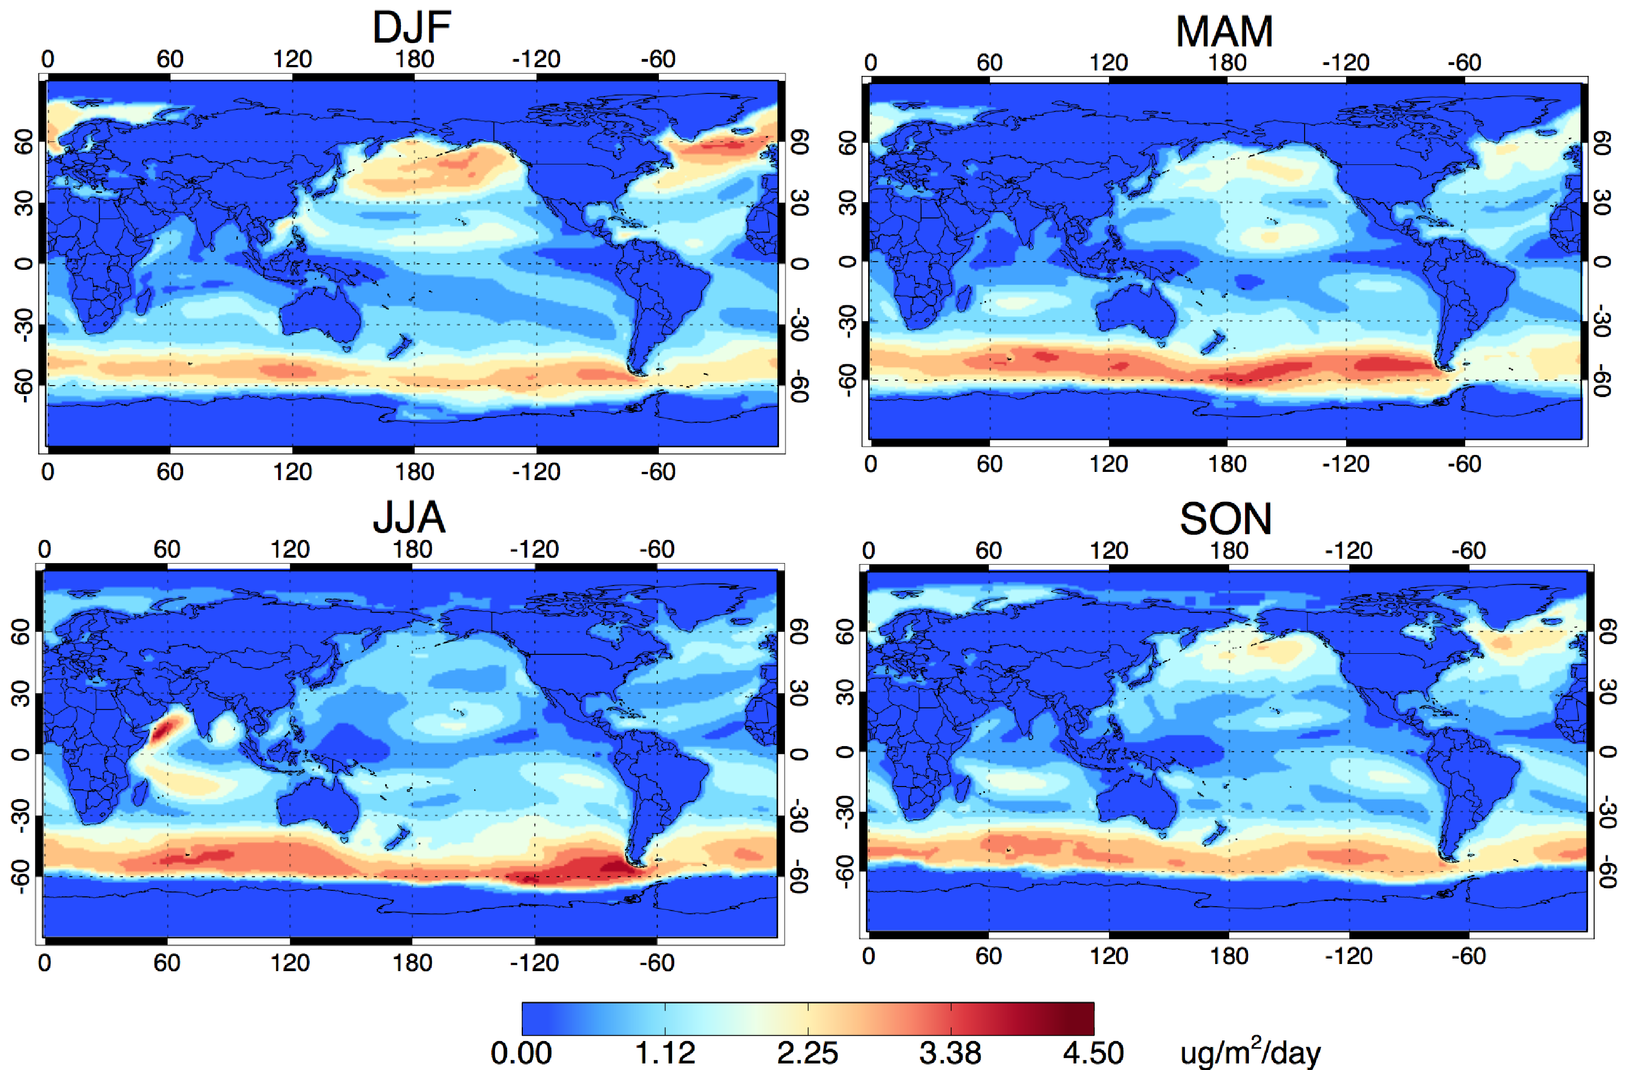

**Figure 6.** Modelled seasonal distribution of total monoterpene flux, using a fixed oceanic source based on measurements from this work. DJF = December, January, February; MAM = March, April, May; JJA = June, July, August; SON = September, October, November.

Whilst some studies have suggested increased local or regional importance of isoprene SOA, e.g. due to enhanced biological production in the tropics based on light-dependent algorithms,13,14,29 currently there is no evidence that monoterpene SOA is important on a regional basis. Hu et al.28 reported strongly increased isoprene SOA in an Antarctic bay during bloom events, but no enhancement of monoterpene SOA, which is consistent with our finding that monoterpenes are not correlated with biological activity. However, our study is unable to confirm or otherwise whether monoterpene levels are enhanced around highly bioactive regions of the ocean, and there is still insufficient constraint on seawater distributions of monoterpenes and associated drivers to improve our model estimate.

Finally, we speculate that even at low concentrations, monoterpene oxidation products could potentially play a role in the aerosol nucleation process,30–33 mediating new particle formation from DMS-sourced marine sulfur.

AUTHOR INFORMATION

Corresponding Author

* lucy.carpenter@york.ac.uk

Present Addresses

^National Biodefense Analysis and Countermeasures Center, 8300 Research Plaza, Frederick, Maryland, 21702, USA.

Author Contributions

S.C.H., S.R.A. and L.J.C wrote the manuscript and L.J.C. and S.R.A. conceived the study. All authors discussed the results and commented on the manuscript. S.C.H., S.J.A. and J.K.M. made the terpene and hydrocarbon measurements; R.A., D.C., H.B., A.S. and K.M.R. measured and processed the pigment data; G.H.T. made primary production measurements; G.A.T. provided flow cytometric measurements, and S.R.A. ran the global model. All authors have given approval to the final version of the manuscript.

Funding Sources

This study was funded by NERC (UK Natural Environment Research Council) grants NE/K004980/1 and NE/K006665/1 (ORC3 project) and NE/I028769/1 (ACCACIA project) and uses data from NMF (NERC), provided by the British Oceanographic Data Centre and funded by the Oceans 2025 programme (AMT 22), and as part of NERC's National Capability programme (AMT 23) and the NERC Arctic Research Programme (ACCACIA). SH’s PhD studentship was supported by a NERC Doctoral Training Grant (DTG) (2011-2015). GT, RA and DC were supported by the NERC National Capability Atlantic Meridional Transect programme. KMR was supported by the National Aeronautics and Space Administration through the Ocean Biology and Biogeochemistry Program (grant number NNX10AT70G). This study is a contribution to the international IMBER project and was supported by the UK Natural Environment Research Council National Capability funding to Plymouth Marine Laboratory and the National Oceanography Centre, Southampton. This is contribution number [pending] of the AMT programme.

ACKNOWLEDGMENT

The authors would like to thank the personnel of the RRS James Cook, RRS James Clark Ross and RV Lance. Data is held at the British Oceanographic Data Centre (http://www.bodc.ac.uk) and is available publicly or upon request. We declare no conflict of interest.

ABBREVIATIONS

AMT, Atlantic Meridional Transect; ACCACIA, Aerosol-Cloud Coupling and Climate Interactions in the Arctic; BODC, British Oceanographic Data Centre; CTD, conductivity-temperature-depth; DMS, Dimethyl sulfide; (autoP&T)-TD-GC-MS, automated Purge & Trap-Thermal Desorption-Gas Chromatography-Mass Spectrometry; HPLC, high performance liquid chromatography; Syn, *Synechococcus;* Pro, *Prochlorococcus;* Nano, Nanoeukaryotes; Peuk, Picoeukaryotes; MV-Chl *b,* monovinyl-chlorophyll *b*; intPP, integrated primary production; Fuco, Fucoxanthin; pptv, parts per trillion y volume; PPC, photoprotective carotenoids; SI, Supplementary Information; SOA, Secondary Organic Aerosol.

**Supporting Information**.

Text and Tables: Experimental and Modelling Details; Atmospheric Lifetime Calculations; Monoterpene Concentrations

Figures: Cruise Tracks, Observational and Derived Datasets (concentrations and fluxes); Linear relationships with isoprene/ contamination

This material is available free of charge via the Internet at http://pubs.acs.org.

REFERENCES

(1) Arneth, A.; Monson, R. K.; Schurgers, G.; Niinemets, Ü.; Palmer, P. I. Why are estimates of global terrestrial isoprene emissions so similar (and why is this not so for monoterpenes)? *Atmos. Chem. Phys.* **2008**, *8* (16), 4605–4620.

(2) Guenther, A. B.; Jiang, X.; Heald, C. L.; Sakulyanontvittaya, T.; Duhl, T.; Emmons, L. K.; Wang, X. The model of emissions of gases and aerosols from nature version 2.1 (MEGAN2.1): An extended and updated framework for modeling biogenic emissions. *Geosci. Model Dev.* **2012**, *5* (6), 1471–1492.

(3) Acosta Navarro, J. C.; Smolander, S.; Struthers, H.; Zorita, E.; Ekman, A. M. L.; Kaplan, J. O.; Guenther, A.; Arneth, A.; Riipinen, I. Global emissions of terpenoid VOCs from terrestrial vegetation in the last millennium. *J. Geophys. Res. Atmos.* **2014**, *119* (11), 6867–6885.

(4) Hallquist, M.; Wenger, J. C.; Baltensperger, U.; Rudich, Y.; Simpson, D.; Claeys, M.; Dommen, J.; Donahue, N. M.; George, C.; Goldstein, A. H.; et al. The formation, properties and impact of secondary organic aerosol: current and emerging issues. *Atmos. Chem. Phys.* **2009**, *9* (14), 5155–5236.

(5) Goldstein, A. H.; Galbally, I. E. Known and unexplored organic consistuents in the Earth’s atmosphere. *Environ. Sci. Technol.* **2007**, *41*, 1514.

(6) Yassaa, N.; Peeken, I.; Zöllner, E.; Bluhm, K.; Arnold, S.; Spracklen, D. V.; Williams, J. Evidence for marine production of monoterpenes. *Environ. Chem.* **2008**, *5* (6), 391.

(7) Colomb, A.; Gros, V.; Alvain, S.; Sarda-Esteve, R.; Bonsang, B.; Moulin, C.; Klüpfel, T.; Williams, J. Variation of atmospheric volatile organic compounds over the Southern Indian Ocean (30 - 49°S). *Environ. Chem.* **2009**, *6* (1), 70.

(8) Shaw, S. L.; Gantt, B.; Meskhidze, N. Production and Emissions of Marine Isoprene and Monoterpenes: A Review. *Adv. Meteorol.* **2010**, No. 1, 1–24.

(9) Lawson, S. J.; Selleck, P. W.; Galbally, I. E.; Keywood, M. D.; Harvey, M. J.; Lerot, C.; Helmig, D.; Ristovski, Z. Seasonal in situ observations of glyoxal and methylglyoxal over the temperate oceans of the Southern Hemisphere. *Atmos. Chem. Phys.* **2015**, *15* (1), 223–240.

(10) Meskhidze, N.; Sabolis, A.; Reed, R.; Kamykowski, D. Quantifying environmental stress-induced emissions of algal isoprene and monoterpenes using laboratory measurements. *Biogeosciences* **2015**, *12* (3), 637–651.

(11) Luo, G.; Yu, F. A numerical evaluation of global oceanic emissions of α-pinene and isoprene. *Atmos. Chem. Phys.* **2010**, *10*, 2007–2015.

(12) O’Dowd, C. D.; de Leeuw, G. Marine aerosol production: a review of the current knowledge. *Philos. Trans. A. Math. Phys. Eng. Sci.* **2007**, *365* (1856), 1753–1774.

(13) Arnold, S. R.; Spracklen, D. V.; Williams, J.; Yassaa, N.; Sciare, J.; Bonsang, B.; Gros, V.; Peeken, I.; Lewis, A. C.; Alvain, S.; et al. Evaluation of the global oceanic isoprene source and its impacts on marine organic carbon aerosol. *Atmos. Chem. Phys.* **2009**, *9* (4), 1253–1262.

(14) Gantt, B.; Meskhidze, N.; Kamykowski, D. A new physically-based quantification of marine isoprene and primary organic aerosol emissions. *Atmos. Chem. Phys.* **2009**, *9* (14), 4915–4927.

(15) Myriokefalitakis, S.; Vignati, E.; Tsigaridis, K.; Papadimas, C.; Sciare, J.; Mihalopoulos, N.; Facchini, M. C.; Rinaldi, M.; Dentener, F. J.; Ceburnis, D.; et al. Global Modeling of the Oceanic Source of Organic Aerosols. *Adv. Meteorol.* **2010**, *2010*, 1–16.

(16) Andrews, S. J.; Hackenberg, S. C.; Carpenter, L. J. Technical Note: A fully automated purge and trap GC-MS system for quantification of volatile organic compound (VOC) fluxes between the ocean and atmosphere. *Ocean Sci.* **2015**, *11* (2), 313–321.

(17) Hackenberg, S. C. Quantifying isoprene and monoterpenes in the remote marine environment, University of York, UK, 2015.

(18) Johnson, M. T. A numerical scheme to calculate temperature and salinity dependent air-water transfer velocities for any gas. *Ocean Sci.* **2010**, *6* (4), 913–932.

(19) Neale, R. B.; Richter, J.; Park, S.; Lauritzen, P. H.; Vavrus, S. J.; Rasch, P. J.; Zhang, M. The Mean Climate of the Community Atmosphere Model (CAM4) in Forced SST and Fully Coupled Experiments. *J. Clim.* **2013**, *26* (14), 5150–5168.

(20) Sander, R. Compilation of Henry’s law constants (version 4.0) for water as solvent. *Atmos. Chem. Phys.* **2015**, *15* (8), 4399–4981.

(21) Button, D. K. Evidence for a Terpene-Based Food-Chain in the Gulf of Alaska. *Appl. Environ. Microbiol.* **1984**, *48* (5), 1004–1011.

(22) Ciuraru, R.; Fine, L.; Pinxteren, M. Van; D’Anna, B.; Herrmann, H.; George, C. Unravelling New Processes at Interfaces: Photochemical Isoprene Production at the Sea Surface. *Environ. Sci. Technol.* **2015**, *49* (22), 13199–13205.

(23) Palmer, P. I.; Shaw, S. L. Quantifying global marine isoprene fluxes using MODIS chlorophyll observations. *Geophys. Res. Lett.* **2005**, *32* (9), 1–5.

(24) Hackenberg, S. C.; Andrews, S. J.; Airs, R.; Arnold, S. R.; Bouman, H. A.; Brewin, R. J. W.; Chance, R. J.; Cummings, D.; Dall’Olmo, G.; Lewis, A. C.; et al. Potential controls of isoprene in the surface ocean. *Global Biogeochem. Cycles* **2017**, *31*, 644–662.

(25) Jeffrey, S. W.; Wright, S. W.; Zapata, M. Microalgal classes and their signature pigments. In *Phytoplankton Pigments*; Roy, S., Llewellyn, C. A., Egeland, E. S., Johnsen, G., Eds.; Cambridge University Press, 2011; pp 3–77.

(26) Lawson, S. J.; Galbally, I.; Dunne, E.; Gras, J. Measurement of VOCs in marine air at Cape Grim using Proton Transfer Reaction-Mass Spectrometry (PTR-MS). In *Baseline Atmospheric Program (Australia) 2007-2008 - Cape Grim*; Derek, N., Krummel, P. B., Eds.; Australian Bureau of Meteorology and CSIRO Marine and Atmospheric Research: Melbourne, 2011; pp 23–32.

(27) Sabolis, A. W. Quantifying Marine Emissions of Biogenic Volatile Organic Compounds Using Laboratory Measurements, Field Measurements and Remote Sensing Data, North Carolina State University, 2010.

(28) Lee, A.; Goldstein, A. H.; Kroll, J. H.; Ng, N. L.; Varutbangkul, V.; Flagan, R. C.; Seinfeld, J. H. Gas-phase products and secondary aerosol yields from the photooxidation of 16 different terpenes. *J. Geophys. Res. Atmos.* **2006**, *111* (D17305), 1–25.

(29) Hu, Q.-H.; Xie, Z.-Q.; Wang, X.-M.; Kang, H.; He, Q.-F.; Zhang, P. Secondary organic aerosols over oceans via oxidation of isoprene and monoterpenes from Arctic to Antarctic. *Sci. Rep.* **2013**, *3*, 2280.

(30) Laaksonen, A.; Kulmala, M.; O’Dowd, C. D.; Joutsensaari, J.; Vaattovaara, P.; Mikkonen, S.; Lehtinen, K. E. J.; Sogacheva, L.; Dal Maso, M.; Aalto, P.; et al. The role of VOC oxidation products in continental new particle formation. *Atmos. Chem. Phys.* **2008**, *8*, 2657–2665.

(31) Metzger, A.; Verheggen, B.; Dommen, J.; Duplissy, J.; Prevot, A. S. H.; Weingartner, E.; Riipinen, I.; Kulmala, M.; Spracklen, D. V.; Carslaw, K. S.; et al. Evidence for the role of organics in aerosol particle formation under atmospheric conditions. *Proc. Natl. Acad. Sci. U. S. A.* **2010**, *107* (15), 6646–6651.

(32) Kulmala, M.; Kontkanen, J.; Junninen, H.; Lehtipalo, K.; Manninen, H. E.; Nieminen, T.; Petäjä, T.; Sipilä, M.; Schobesberger, S.; Rantala, P.; et al. Direct observations of atmospheric aerosol nucleation. *Science (80-. ).* **2013**, *339* (6122), 943–946.

(33) Riccobono, F.; Schobesberger, S.; Scott, C. E.; Dommen, J.; Ortega, I. K.; Rondo, L.; Almeida, J.; Amorim, A.; Bianchi, F.; Breitenlechner, M.; et al. Oxidation products of biogenic emissions contribute to nucleation of atmospheric particles. *Science (80-. ).* **2014**, *344* (6185), 717–721.