Siderophores as anchors in artificial metalloenzymes

Daniel J. Raines, Justin E. Clarke, Elena V. Blagova, Keith S. Wilson and
Anne-Kathrin Duhme-Klair
Department of Chemistry, University of York, Heslington, York YO10 5DD, UK
E-mail: anne.duhme-klair@york.ac.uk
Thematic Area: Medicinal Inorganic Chemistry (example)
Keywords: first, second, third (maximum of 3)
Artificial metalloenzymes that consist of a synthetic catalyst that is linked via an anchor to a protein scaffold allow the bio-orthogonal reactivity of organometallic catalysts to be combined with the selectivity of enzymes. A particular strength of this approach lies in the synthesis of enantiomerically pure compounds and the potential use of artificial enzymes in vivo, for example within the periplasm of a Gram-negative bacterial cell.¹ To complement the commonly used biotin-(streptavidin) affinity pair, we have identified ferric siderophore-binding protein pairs that allow organometallic catalysts to be anchored with suitably high affinities. Siderophores are ligands that are produced by bacteria for the uptake of essential iron and hence, ferric siderophore complexes are bound both strongly and enantioselectively by their cognate periplasmic binding proteins.^{2, 3} By linking iridium-based transfer hydrogenation catalysts to selected siderophore-binding protein systems (Figure 1) the reduction of prochiral imines to chiral amines was achieved with encouraging levels of enantioselectivity.
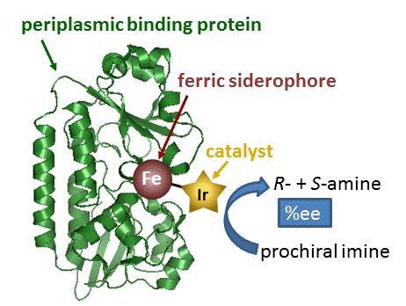
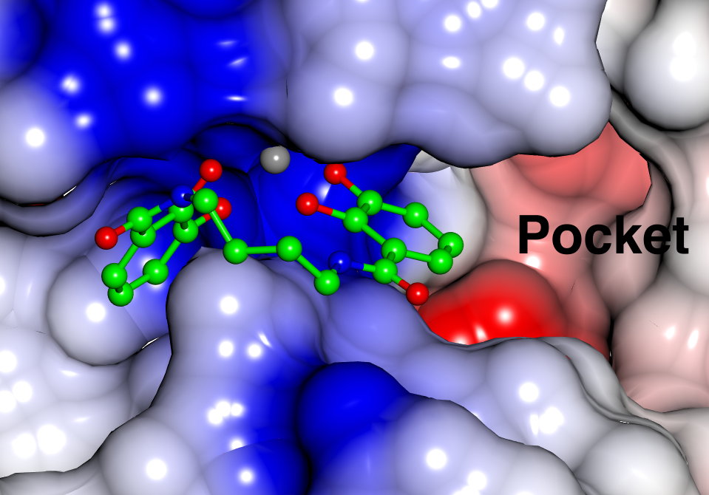
A
B

C

Figure 1: A) Schematic representation of an artificial metalloenzyme. B) [Fe(siderophore)]⊂PBP crystal structure (PBP: electrostatic surface representation; Fe grey; siderophore: C green, O red, N blue). C) Example of a catecholamide siderophore derivative.

Acknowledgments: Funding Agency
References
- M. Jeschek, R. Reuter, T. Heinisch, C. Trindler, J. Klehr, S. Panke, T. R. Ward, Nature, 537, 661 (2016)
- D. J. Raines, O. V. Moroz, K. S. Wilson and A. K. Duhme-Klair, Angew. Chem. Int. Ed., 52, 4595 (2013)
- D. J. Raines, O. V. Moroz, E. Blagova, J. P. Turkenburg, K. S. Wilson, A.-K. Duhme-Klair, PNAS, 113, 5850 (2016)

