Received 00th January 20xx,
- York Structural Biology Laboratory, Department of Chemistry, University of York, Heslington, York, YO10 5DD, United Kingdom; E-mail: seishi.shimizu@york.ac.uk
- TWI Ltd., Granta Park, Great Abington, Cambridge, CB21 6AL, United Kingdom
- Centro de Química e Bioquímica e Departamento de Química e Bioquímica, Faculdade de Ciências, Universidade de Lisboa, 1749-016 Lisboa, Portugal.; E-mail: memp@fc.ul.pt.
Electronic Supplementary Information (ESI) available: [pK_{a} values of precursor species HA and of conjugated acid [HB]⁺ and corresponding ΔpK_{a} values. Standard specific enthalpies of vaporization of amines and PILs. Standard molar enthalpies of solution of amines and PILs. Components of the ab-initio W1-F12 enthalpies. Standard molar enthalpies of atomization and gas-phase standard molar enthalpies of formation of each amine, calculated by the W1-F12 procedure. CCSD(T)-F12a/3C(FIX)/cc-pVDZ-F12 energies and enthalpies, and DF-B3LYP-D3/cc-pVTZ based standard molar entropies of HOAc, amines, and PILs in the gas phase. Standard molar enthalpies of formation of the protonated amines and proton affinities of the neutral amines in the gas phase]. See DOI: 10.1039/x0xx00000x
Accepted 00th January 20xx
DOI: 10.1039/x0xx00000x
www.rsc.org/
Structure-Property Relationships in Protic Ionic Liquids: A Thermochemical Study
Joshua E. S. J. Reid,^{a,b} Filipe Agapito,^{c} Carlos E. S. Bernardes,^{c} Filomena Martins,^{c} Adam J. Walker,^{b} Seishi Shimizu,^{a,*} and Manuel E. Minas da Piedade^{c,*}
How does cation functionality influence the strength of intermolecular interactions in protic ionic liquids (PILs)? Quantifying the energetics of PILs can be an invaluable tool to answer this fundamental question. With this in view, we have determined the standard molar enthalpy of vaporization, , and the standard molar enthalpy of formation, , of three tertiary ammonium acetate PILs with varying cation functionality, and of their corresponding precursor amines, through a combination of Calvet-drop microcalorimetry, solution calorimetry, and ab-initio calculations. The obtained results suggest that these PILs vaporize as their neutral acid and base precursors. We also found a strong correlation between of the PILs and of their corresponding amines. This suggests that, within this series of PILs, the influence of cation modification on their cohesive energies follows a group additivity rule. Finally, no correlation between the of PILs and the extent of proton transfer, as estimated from the difference in aqueous between the precursor acid and the conjugate acid of the precursor base, was observed.

1 Introduction
Protic ionic liquids (PILs) are a subclass of ionic liquids formed by proton transfer from a Brønsted acid (HA) to an appropriate base (B) to produce a salt ([HB][A]) with a melting point (conventionally) below 100 °C.^{1–4} Their straightforward preparation, typically through the direct mixing of the HA and B precursors, reduces or eliminates additional work-up stages, such as solvent separation and ion-exchange reactions.⁵ This is an appealing feature of PILs in comparison to aprotic ionic liquids (AILs), which normally require more complex synthesis and purification procedures.
The industrial application of PILs is in fact already a reality (e.g., the BASIL process)^{6,7} and they have been increasingly explored as potential solvents and materials for a variety of applications, including natural product extraction,^{8–10} biomass processing,^{11–15} biocatalysis,^{16–18} anhydrous electrolytes,^{19–21} hydrometallurgy,^{22–24} and lubrication.^{25–27} Additionally, certain PILs, particularly those with ammonium carboxylate based structures, have been suggested to be of low environmental hazard based on an initial screening of toxicity,^{28,29} biodegradability,³⁰ and mutagenicity.³¹
One important aspect that makes PILs attractive for technological applications is their capability of being distilled in an analogous fashion to conventional organic solvents.^{11–13} The vaporization mechanism of PILs under the reduced pressure distillation conditions used in practice is, however, still debated, a key question being whether they preferentially vaporize as discrete precursor molecules, ions, neutral ion pairs, pairs of hydrogen bonded neutral precursors, or as mixtures with varying proportions of different types of species:^{32–40}

Standard molar enthalpies of vaporization, , provide important information to address this question, as previously illustrated by a study on 1-methylimidazolium acetate, [Hmim][OAc].³⁶ In this case, a good agreement was found between the value directly measured by vaporization calorimetry and the enthalpy of reaction (1) calculated from the enthalpies of formation, , of [HB][A](l), B(g), and HA(g), determined from different types of calorimetric experiments, ab-initio calculations, and literature data. This gave a good indication that the vaporization of [Hmim][OAc] predominantly yields its neutral precursors, namely 1-methylimidazole and acetic acid, as had been previously demonstrated by Fourier transform ion cyclotron resonance mass spectrometry (FTICR-MS)³² and Raman spectroscopy.³³ A similar approach was also used to show that for the highly ionic PIL 1,1,3,3-tetramethylguanidinium nitrate, a vaporization channel yielding its gaseous constituent ions, eqn (2), was implausible when compared to the pathway in which the neutral precursors were produced, eqn (1).³⁷ This is consistent with the fact that ionic species, eqn (2), were never found in PIL vapors produced by reduced pressure distillation.^{32–35} It should nevertheless be stressed that the prime vaporization pathway of PILs may depend on the pressure-temperature conditions chosen for distillation. Indeed, experiments where ethylammonium nitrate vaporized into a helium or a nitrogen flow close to ambient pressure suggested that up to 419 K the vapor essentially consisted of [EtNH₃][NO₃](g) ion pairs, and above this temperature the neutral precursors (ethylamine and nitric acid) became progressively dominant.⁴⁰
Besides their importance to understand the purification of protic ionic liquids by distillation, reliable and data are also central in the investigation of molecular structure-energetics relationships in PILs. These relationships constitute, in turn, a very useful tool for the design of PILs with properties tailored for specific applications. For example, the enthalpy of vaporization of a PIL reflects its cohesive energy, which bears an obvious relation to structure and it is intimately connected to industrially relevant properties, such as vapor pressure and solvation ability.
To date, only a small selection of PILs has been characterized energetically. The findings have nonetheless been significant, as demonstrated by the following two examples: (i) Differences in between protic and aprotic ionic liquids were found to correlate exceptionally well with the strength of intermolecular interactions as determined by far-infrared spectroscopy; furthermore, contributions to from hydrogen bond and dispersion intermolecular interactions could both be inferred with the help of density fluctuation theory.⁴¹ (ii) The PIL 1,5-diazabicyclo[4.3.0]non-5-enium acetate was comprehensively characterized from a thermochemical point of view, including the determination of in the gas and condensed phases, and . The obtained data subsequently provided fundamental information for cellulose processing.⁴²

Fig. 1 Molecular structures of the materials used in this study and labelling scheme. HOAc = acetic acid; DMBuA = N,N-dimethylbutylamine; TMEDA = N,N,N’,N’-tetramethylethane-1,2-diamine; DMEtA = N,N- dimethylethanolamine; [HDMBuA][OAc] = N,N-dimethylbutylammonium acetate; [HTMEDA][OAc] = 2-(dimethylamino)-N,N-dimethylethylammonium acetate; [HDMEtA][OAc] = N,N-dimethylethanolammonium acetate.
Here we report a thermochemical study involving the determination of the enthalpies of formation and vaporization of three tertiary ammonium acetate PILs and their corresponding precursor amines (Fig. 1), by using solution calorimetry, Calvet drop-vaporization calorimetry, and ab-initio calculations (W1-F12 and CCSD(T)-F12a). The chosen PILs feature a common anion, acetate, paired with a tertiary ammonium cation with varying functionality: N,N-dimethylbutylammonium acetate, [HDMBuA][OAc]; 2-(dimethylamino)-N,N-dimethylethylammonium acetate, [HTMEDA][OAc]; and N,N-dimethylethanolammonium acetate, [HDMEtA][OAc]. The primary objectives of this work were: (i) to evaluate whether or not the vaporization of the selected PILs under reduced pressure preferentially occurs via their neutral precursors; (ii) to investigate how differences in the functionality of those PILs influence enthalpy of vaporization trends and how these trends reflect specific hydrogen bond (H-bond) differences; (iii) to assess if variations between the PILs correlate with those observed for the corresponding amines, thus implying additive contribution of functionality, as previously showcased for some molecular solvents (e.g. alkanes vs. a alcohols);⁴³ and, finally, (iv) to test if the PILs , which reflect their cohesive energies, show a clear parallel trend with the widely used measure of ionicity,⁴⁴ where represents the difference in aqueous between the HA and [HB]⁺ species.

2 Materials and methods
2.1 General
¹H and ¹³C NMR analysis of the pure PILs were performed using a Bruker 700 MHz NMR instrument.⁵ A Wilmad coaxial inset contained a solution of D₂O with 1.0 % w/w tert-butyl alcohol to be used as a reference peak of 1.24 ppm.⁴⁵
Because of the known effect of low concentrations of water on the structure of PILs and ILs in general,^{46,47} water content in each PIL was determined using one component Karl-Fischer titration. Measurements were performed with a Metrohm 890 Titrando with 803 Ti Stand apparatus. Hydranal-Composite 5 was used as the titrating agent and methanol as the baseline solvent. The instrument was calibrated with Hydranal Water Standards 10.0, 1.0, and 0.1, which correspond to weight percentage water contents of 10.0%, 1.0% and 0.1%. Approximately 1 cm³ of sample was used in the determinations.
2.2 Materials
The acetic acid (HOAc, ≥99.5%) and amines (DMBuA, 99.0%; TMEDA, ≥99.5%; DMEtA, ≥99.5%,) used in the preparation of the protic ionic liquids were supplied by Sigma Aldrich UK, and were not further purified. The water contents in the amines, given by Karl-Fischer titration, were: 230 ppm for DMBuA, 895 ppm for TMEDA, and 270 ppm for DMEtA. These same amine samples were used for enthalpy of vaporization measurements by Calvet microcalorimetry.
The three PILs in this study were prepared following the procedure outlined by Walker.¹ A flask purged with N₂ was charged with the precursor amine and placed in an ice bath. Acetic acid was added to the flask dropwise while stirring. After complete addition, the reaction was left to stir for 24 h, to ensure that proton exchange had been brought to equilibrium.
Synthesis of [HDMBuA][OAc]. Mass of DMBuA: 5.1158 g (50.6 mmol), mass acetic acid: 3.0961 g, (51.6 mmol). Molar percentages of components as determined from the above masses: 50.5% (acid), 49.5% (amine). ¹H NMR (700 MHz, D₂O) δ/ppm 2.98-2.96 (t, J = 7.8 Hz, 2H), 2.81 (s, 6H), 2.29 (s, 3H), 1.97-1.92 (p, J = 7.7 Hz, 2H), 1.78-1.72 (hx, J = 7.6, 7.4) 1.34 (t, J = 7.4). ¹³C NMR (176 MHz, D₂O) δ 174.63, 58.24, 43.62, 28.34, 22.22, 20.56, 13.88. Water content from Karl Fischer titration: 645 ppm.
Synthesis of [HTMEDA][OAc]. Mass TMEDA: 4.6541 g (40.1 mmol), mass acetic acid: 2.4377 g (40.6 mmol). Molar percentages of components as determined from the above masses: 50.3% (acid), 49.7% (amine). ¹H NMR (700 MHz, DMSO-d6) δ/ppm 2.98 (s, 4H), 2.71 (t, 12H), 2.29 (s, 3H). ¹³C NMR (176 MHz, D₂O) δ 174.47, 56.14, 44.90, 22.36. Water content from Karl Fischer titration: 1057 ppm.
Synthesis [HDMEtA][OAc]. Mass DMEtA: 4.4747 g (50.2 mmol), mass acetic acid: 3.0404 g (50.6 mmol). Molar percentages of components as determined from the above masses: 50.2% (acid), 49.8% (amine). ¹H NMR (700 MHz, D₂O) δ/ppm 4.00-3.98 (t, J = 5.0 Hz, 2H), 3.19-3.17 (t, J = 5.0 Hz, 2H), 2.88 (s, 6H), 2.11 (s, 3H). ¹³C NMR (176 MHz, DMSO) δ 176.63, 59.89, 57.10, 43.50, 23.42. Water content from Karl Fischer titration: 900 ppm.
2.3 Calvet microcalorimetry
Direct measurements of the standard molar enthalpies of vaporization of the studied PILs and their constituent amines were carried out by Calvet-drop microcalorimetry, following a procedure previously described by Vitorino et al.³⁶ A sample with a mass of 6-12 mg was inserted into a capillary under N₂ atmosphere. The capillary was sealed using Parafilm ‘‘M’’ tape and weighed in a Mettler UMT2 ultra-micro balance, with a precision of 0.1 μg. The Parafilm seal was removed and the capillary with the sample was immediately dropped into the calorimetric cell, held at 297.9±0.1 K, under a N₂ atmosphere. After the drop, the system was evacuated to 0.13 Pa. The specific enthalpy of the calorimetric process, (J⋅g⁻¹), was obtained from:

(4)

where m is the mass of the sample, is the mass of water given by Karl Fischer titration, = 18.015 g⋅mol⁻¹ is the molar mass of water, = 44.004±0.002 kJ⋅mol⁻¹ is the standard molar enthalpy of vaporization of water,⁴⁸ A is the area of the measured curve corresponding to the overall experiment, A_{b} is the area of the background contribution for the observed process due to dropping of the capillary and evacuation of the cell, and ε is the energy equivalent of the calorimeter obtained by electrical calibration.⁴⁹ Background values were determined by replicating the above described experiment using an empty capillary.
2.4 Solution calorimetry
Solution calorimetry measurements were performed with an electrically calibrated isoperibol Thermometric Precision Solution Calorimeter (model 2225) adapted to a thermostatic bath (TAM 2227) with a temperature stability better than 0.1 mK. The procedure has been previously detailed.^{36,37} In a typical experiment a thin walled glass ampule was loaded with sample, under N₂ atmosphere, and weighed with a precision of 10 µg in a Mettler Toledo XS205 balance. The dissolution process was started by breaking the ampule inside the calorimetric vessel containing 100 cm³ of the appropriate aqueous solution, under stirring. The standard molar enthalpy of the solution process, , was calculated from:

(5)
(6)

where m and M are the mass and the molar mass of the sample, respectively; is the calibration constant determined by dissipating a known amount of heat Q = VIt inside the calorimetric solution, where V is the potential difference applied to the calibration resistance, I the resulting current and t the duration of the heat input; and is the adiabatic temperature change in the calibration or main experiment calculated from the experimental temperature vs. time curves by using the Regnault-Pfaundler method⁵⁰ as implemented in the SolCal 1.2 program from Thermometric under the designation dynamics of break. The heat associated with ampule breaking was not taken into account, since it was previously found to correspond to a temperature change of less than 0.1 mK in blank experiments where empty ampules were broken in 100 cm³ of water.
2.5 Computational details
The structures of DMBuA, TMEDA, DMEtA, HOAc, [DMBuA][HOAc], [TMEDA][HOAc], and [DMEtA][HOAc] (note that proton transfer from HOAc to the amines was not observed in the computed PIL’s gas phase structures) were optimized using the B3LYP-D3 dispersion corrected⁵¹ hybrid density functional^{52,53} together with the cc-pVTZ basis set.^{54,55} Density fitting (DF)⁵⁶ was performed using the cc-pVTZ/JKFIT basis set.⁵⁷ Vibrational frequencies were obtained at the same level of theory, and scaled with 0.9889.⁵⁸ The enthalpy of each molecule at 298.15 K was determined with the W1-F12⁵⁹ composite procedure. The DF-B3LYP-D3/cc-pVTZ optimized geometries and vibrational frequencies were used in these calculations.
Given that the high computational cost of W1-F12 precludes its use for the studied PILs, the energies of all molecules were additionally obtained by single-point calculations at the CCSD(T)-F12a level,⁶⁰ using the 3C(FIX) ansatz^{60,61} and the cc-pVDZ-F12 orbital basis set.⁶² Resolutions of the identity (RI) were performed using the cc-pVDZ-F12/OptRI basis set⁶³ and the CABS approach.⁶⁴ The cc-pVDZ/JKFIT basis set⁶⁵ was used in the density fitting of Fock and exchange matrices, and the aug-cc-pVDZ/MP2FIT basis set⁶⁶ was used in the density fitting of the remaining integral quantities. A value of 0.9 was used for the exponent of the Slater-type frozen geminal correlation factor.⁶⁷ The energies thus obtained were added to the thermal enthalpy corrections calculated as described above, yielding the enthalpy for each species at 298.15 K.
The diagonal Born-Oppenheimer corrections^{68–70} for each molecule, required by the W1-F12 procedure, were determined using CFOUR.⁷¹ All other calculations were performed with the Molpro 2012.1 package.⁷²
3 Results and discussion
3.1 Energetics of DMBuA, TMEDA, and DMEtA
The standard molar enthalpies of vaporization of the three precursor amines, at 298 K, obtained by Calvet-drop microcalorimetry are summarized in Table 1 (detailed results are given as ESI). The assigned uncertainties are twice the combined standard uncertainty, u_{c},⁷³ of four determinations, which includes contributions from the main experiment and calibration. The calorimetric results for TMEDA and DMEtA in Table 1 are not significantly different from the previously reported = 42.2±0.2⁷⁴ and = 46.5±0.4⁷⁵, at 298 K, obtained from vapor pressure vs. temperature measurements.
Also listed in Table 1 are the standard molar enthalpies of formation of the amines in the gas phase calculated by the W1-F12 procedure. The computations rely on the following equations:

= a(C, g) + b(H, g) + c(O, g) +
d(N, g) - (C_{a}H_{b}O_{c}N_{d}, g) (7)

(C_{a}H_{b}O_{c}N_{d}, g) = − + a(C, g) + b(H, g) +
c(O, g) + d(N, g) (8)

where refers to the atomization reaction:

C_{a}H_{b}O_{c}N_{d}(g) = aC(g) + bH(g) + cO(g) + dN(g) (9)

and are the W1-F12 enthalpies of the compounds and their constituent atoms in the gas phase (see ESI). These ab-initio calculations allowed the determination of the enthalpies of atomization of DMBuA (8133.9 kJ⋅mol⁻¹), TMEDA (8742.6 kJ⋅mol⁻¹) and DMEtA (6194.4 kJ⋅mol⁻¹), which together with the experimental gas-phase enthalpies of formation of hydrogen (217.998±0.006 kJ⋅mol^{–1}), carbon (716.680±0.450 kJ⋅mol^{–1}), oxygen (249.18±0.10·kJ⋅mol^{–1}) and nitrogen (472.68±0.40 kJ⋅mol^{–1}),⁴⁸ led to the standard molar enthalpies of formation of the amines, shown in Table 1. Previously reported data was only found for
Table 1 Standard molar enthalpies of formation and vaporization of DMBuA, TMEDA, and DMEtA, at 298 K, obtained in this work.
Compound | /kJ⋅mol^{-1 a} | /kJ⋅mol⁻¹
 |  | (g) ^{b} | (l) ^{c}
DMBuA | 35.2±0.6 | 91.2±2.7 | 126.4±2.8
TMEDA | 43.1±0.5 | 9.2±2.8 | 52.3±2.8
DMEtA | 47.2±0.3 | 207.8±1.8 | 255.0±1.8
ª Calvet microcalorimetry. ^{b} Obtained through quantum chemistry calculations (W1-F12 procedure, see text). ^{c} Derived from the corresponding and values.
TMEDA, namely −19.7 kJ⋅mol⁻¹, estimated by Benson’s group contribution method,⁷⁶ and −22.6 kJ⋅mol⁻¹ obtained at the G3(MP2) level of theory. These values show a considerable discrepancy relative to the result in Table 1 (−9.2±2.8 kJ⋅mol⁻¹), which was obtained by the more accurate W1-F12 procedure.
Finally, the standard molar enthalpies of formation of the amines in the liquid state (Table 1), needed for the solution calorimetry studies (see below), could also be derived from the corresponding and data presented in Table 1.
3.2 Energetics and mechanism of PILs vaporization
Insights into the most likely mechanism of [HDMBuA][OAc], [HTMEDA][OAc], and [HDMEtA][OAc] vaporization were provided by a comparison of the enthalpy of the processes described by eqns (1)-(3), indirectly obtained by using results from calorimetric experiments, ion thermochemistry literature data, and ab initio calculations, with the values directly measured by Calvet microcalorimetry. Detailed results are given as ESI.
The enthalpy of vaporization of the PILs according to eqn (1), , was determined using an adaptation of the method previously described by Vitorino et al.,^{36,37} and involved the following steps: (i) The enthalpies, , , and corresponding to the solution processes (B represents the amine precursors of the PILs):

[HB][OAc](l) + nH₂O(l) → {[HB][OAc]:nH₂O}(aq) (10)
HOAc(l) + nH₂O(l) → (HOAc:nH₂O)(aq) (11)
B(l) + (HOAc:nH₂O)(aq) → {[HB][OAc]:nH₂O}(aq) (12)

were firstly measured by solution calorimetry or, in the case of , obtained from data in the NBS tables.⁷⁷ Then (ii) the enthalpy of the mixing process:

B(l) + HOAc(l) → [HB][OAc](l) (13)

was calculated as:

= + − (14)

and (iii) subsequently used to derive the enthalpy of formation of the PIL according to:

([HB][OAc], l) = + (B, l) +
(HOAc, l) (15)

where = −483.66±0.18 kJ.mol⁻¹ ⁷⁸. Finally (iv), , corresponding to the process in eqn (1), could be obtained as:

= (B, g) + (HOAc, g) −
([HB][OAc], l) (16)

with = −432.84±0.62 kJ.mol⁻¹.⁷⁸ The obtained results are compared in Table 2 with the
Table 2. Enthalpies of solution, formation, and vaporization of the PILs studied in this work (see text). All data in kJ⋅mol⁻¹.ª
 | [HDMBuA][OAc] | [HTMEDA][OAc] | [HDMEtA][OAc]
 | 46.83±0.79 (5) | 58.83±2.06 (5) | 34.07±1.62 (6)
 | 1.27±0.08 ^{b} | 1.27±0.08 ^{b} | 1.26±0.08 ^{b}
 | 62.09±2.53 (6) | 77.27±2.93 (6) | 57.53±2.01 (5)
 | 16.53±2.65 | 19.71±3.58 | 24.72±2.58
 | 626.6±3.9 | 555.7±4.5 | 763.4±3.2
^{c} | 574.1±2.8^{c} | 495.7±2.9 ^{c} | 687.2±1.9 ^{c}
 | 102.6±4.8 | 113.7±5.3 | 122.8±3.7
 | 592±12 | 559±12 | 638±18
 | 52.5±4.8 | 60.0±5.3 | 76.2±3.7
 | 108.6±1.8 (4) | 116.9±0.4 (4) | 119.1±0.7 (4)
ª Unless otherwise stated the reported uncertainties correspond to twice
the standard deviation of the mean; were appropriate, the number
of independent determinations is given in parenthesis. ^{b} Reference ⁷⁷.
^{c}·Obtained using the CCSD(T)-F12a/3C(FIX)/cc-pVDZ-F12 methodology; uncertainty calculated from the uncertainties in the enthalpies of formation of HOAc and parent amines.; proton transfer from HOAc to the amines was not observed in the computed gas phase structures.

corresponding values directly measured by Calvet microcalorimetry. As has been previously demonstrated for 1-methylimidazolium acetate,³⁶ the good agreement between these two independently determined values gives a good indication that [HDMBuA][OAc], [HTMEDA][OAc], and [HDMEtA][OAc] preferentially vaporize under reduced pressure as their neutral acid and base precursors. Nevertheless, for comparison purposes, the enthalpies of the processes where the PILs are assumed to vaporize as ionic species or neutral ion pairs, respectively, were also calculated. In the former case, represented by eqn (2), it can be written that:

= ([HB]⁺, g) + ([OAc]⁻, g) −
([HB][OAc], l) (17)

Based on the ([HB][OAc], l) values in Table 2, = −510.8±7.5 kJ⋅mol⁻¹,⁷⁹ = 475.8±8.4 kJ⋅mol⁻¹, = 514.2±8.5 kJ⋅mol⁻¹, and = 385.1±16.2 kJ⋅mol⁻¹ (see ESI for details on the calculation of the enthalpies of formation of the cations), the following values for can be derived: = 592±12 kJ⋅mol⁻¹ for [HDMBuA][OAc], = 559±12 kJ⋅mol⁻¹ for [HTMEDA][OAc], and = 638±18 kJ⋅mol⁻¹ for [HDMEtA][OAc] (Table 2). These values are significantly higher than the corresponding in Table 2, thus ruling out the formation of discrete ionic species in the gas phase upon vaporization. This is in keeping with the statement made in the Introduction that ionic species were never found in PIL vapors produced under reduced pressure distillation conditions.^{32–35}
Regarding the process described by eqn (3), the DF-B3LYP-D3/cc-pVTZ calculations indicated that if the three PILs studied in this work vaporized to neutral ion pairs, hydrogen bonded neutral species with the proton dwelling in the acid moiety would be formed in the gas phase (Fig. 2). The standard molar enthalpies of formation of those species, , were determined from the enthalpy of reaction (18)

[B][HOAc](g) → B(g) + HOAc(g) (18)

calculated as:

= (HOAc, g) + (B, g) − ([B][HOAc], g) (19)

where denotes the CCSD(T)-F12a standard molar enthalpies for each molecule (see ESI). The obtained values are given in Table 3 and allowed the computation of the values from:

= − + (HOAc, g) +
(B, g) (20)

which are summarized in Table 2.
Finally, by combining the and values in Table 2 it is possible to derive for each PIL:

= ([B][HOAc], g) − ([HB][OAc], l) (21)

where the final state is composed by the species shown in Fig. 2. The obtained results (Table 2) are smaller by more than 50 kJ⋅mol⁻¹ than the corresponding data. This unequivocally supports the above conclusion that these PILs vaporize as their neutral acid and base precursors, eqn (1).
The question then remains of why the vaporization channel with higher enthalpy, eqn (1), is preferred to that with lower enthalpy, eqn (3)? This can be explained by noting that the dissociation process in eqn (18) is entropically controlled.

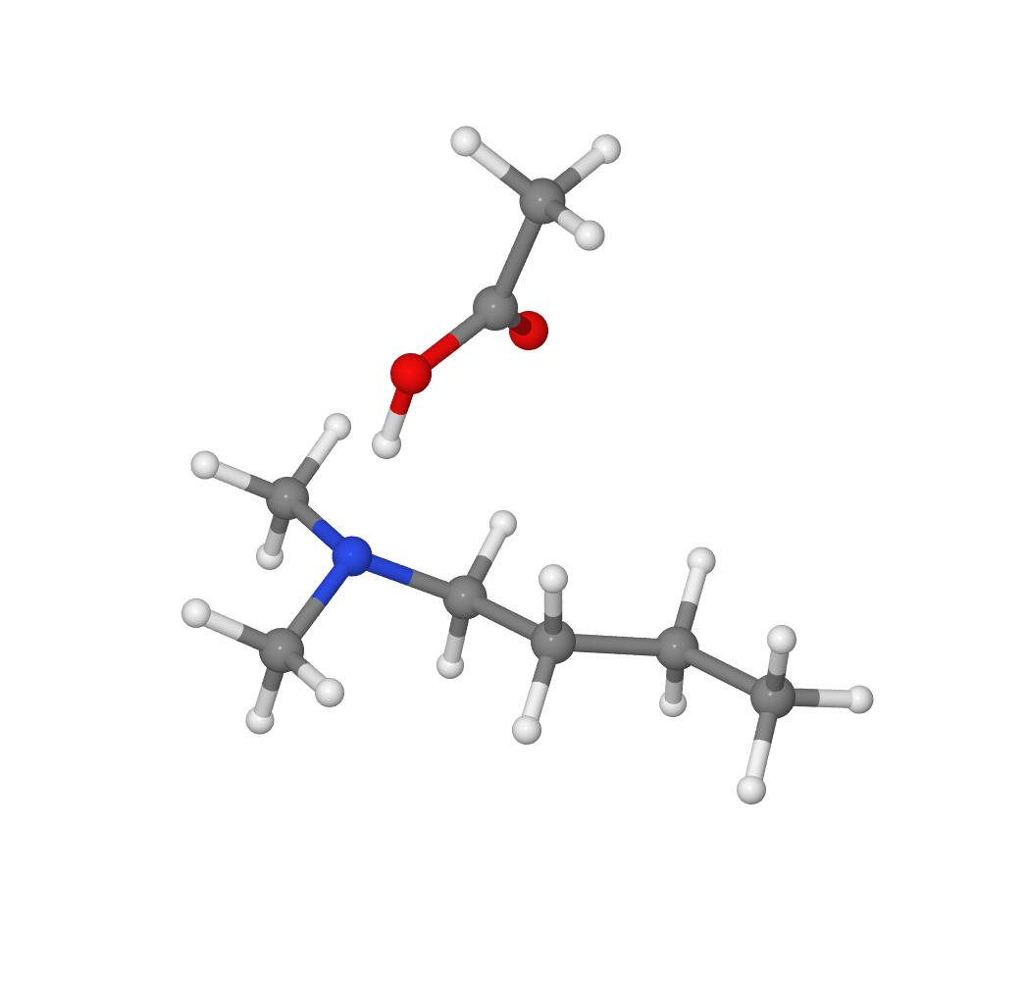 | 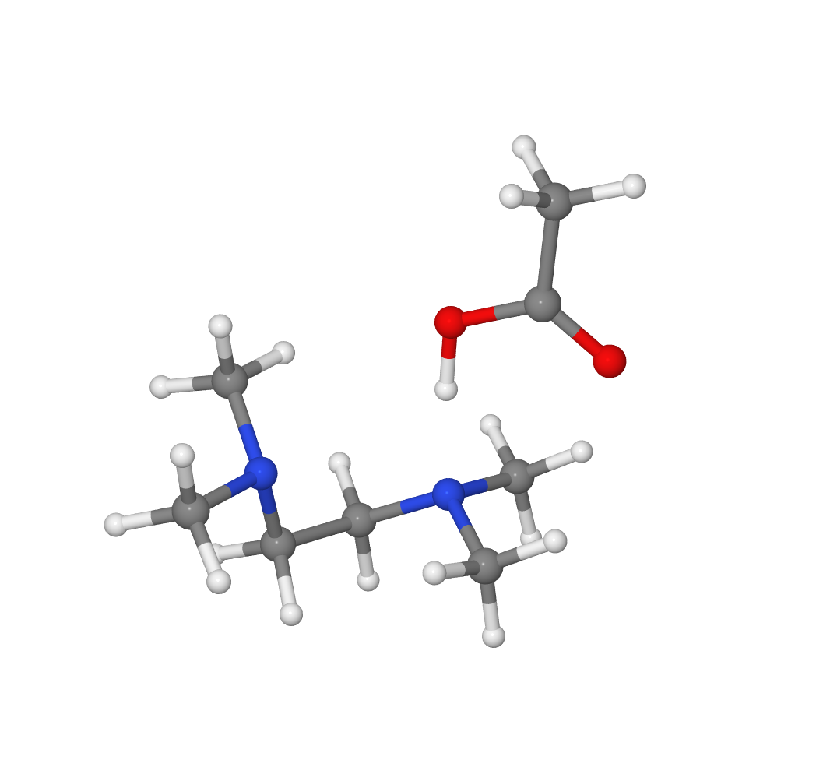 | 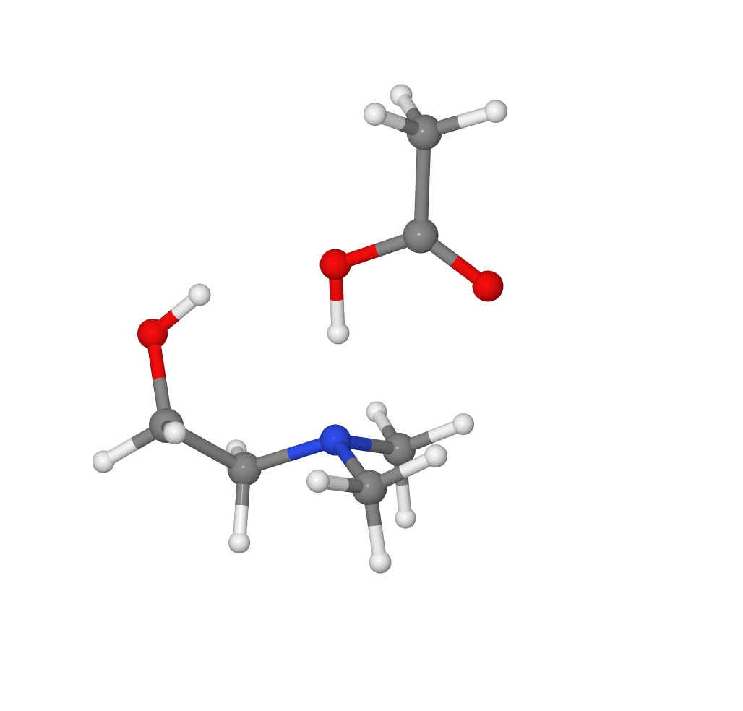
(a) | (b) | (c)
Fig. 2 Molecular structures of gaseous (a) [DMBuA][HOAc], (b) [TMEDA][HOAc], and (c) [DMEtA][HOAc], obtained by the DF-B3LYP-D3/cc-pVTZ method.
Table 3 Standard molar enthalpies and entropies of reaction (18) at 298.15 K.
B | / kJ⋅mol⁻¹ | / kJ⋅mol⁻¹
DMBuA | 50.1±3.9 | 51.6
TMEDA | 53.7±4.1 | 60.3
DMEtA | 46.6±2.7 | 57.9

Indeed entropy data for the B(g), HOAc(g), and [B][HOAc](g) species (see ESI), calculated by Statistical Mechanics,⁸⁰ using optimized geometries and harmonic vibrational frequencies (scaled by 0.9889)⁵⁸ obtained by the DF-B3LYP-D3/cc-pVTZ method, led to the results, at 298.15 K, given in Table 3. These values are larger by 2-11 kJ⋅mol⁻¹ than the corresponding enthalpy terms,, leading to a negative . The dissociation of [B][HOAc](g) into the neutral precursors B(g) and HOAc(g) is, therefore, thermodynamically favourable in all cases.

3.3 Structure-energetics relationships for [HDMBuA][OAc], [HTMEDA][OAc], and [HDMEtA][OAc]
It can be concluded from Table 2, that the substitution of the alkyl functional group with either a hydrogen bond acceptor (HBA) or donor (HBD) functional group on the cation of the studied PILs increases their . The introduction of a HBA or HBD functional group in the PIL backbone is, however, also expected to affect the proton transfer equilibrium involving the ionic ([HB]⁺, [OAc]⁻) and neutral species (B, HOAc) present in the condensed state and the number of strong directional intermolecular interactions between them.^{44,81–83} It is therefore interesting to evaluate whether or not this causes the cohesive energies of the studied PILs (measured by their values) to significantly deviate from the typical bond or group additivity behavior often observed for many families of organic molecules⁸⁴ including aprotic ionic liquids.⁸⁵
When [HTMEDA][OAc] is compared to [HDMBuA][OAc], the presence of the additional hydrogen bond acceptor dimethylamino group in the HTMEDA⁺ cation, is likely to lead to further hydrogen bonding interactions within the system. NMR analysis of the neat PIL (see Experimental Section) showed only a single peak for the -CH₃ environment and a single peak for the -CH₂- environment. This suggests that at the temperatures studied, the two nitrogen centers in [HTMEDA]⁺ are equivalent due to a low barrier for proton transfer between them,⁸⁶ an may both be engaged in intermolecular hydrogen bonding to the acetate anion or intramolecular bonds within the system.
The presence of an hydroxyl group may also have a significant influence on the cohesive energy of [HDMEtA][OAc] when compared to [HDMBuA][OAc], since additional intramolecular hydrogen bonds with the acetate anion or intermolecular interactions within the system may be formed.⁴³ An intramolecular hydrogen bond with oxygen atoms of the acetate anion has, for example, been suggested to exist in the aprotic analogue of [HDMEtA][OAc], choline acetate.⁸⁷
It is found that, despite these possible differences in hydrogen-bonding ability, the enthalpies of vaporization of the studied PILs follow, to a good approximation, a group additivity rule. Indeed, as shown in Fig. 3, a linear least squares fit to a plot of the enthalpies of vaporization of the PILs, , against the enthalpies of vaporization of the corresponding precursor amines, led to:

= (0.968±0.145) + 74.1±6.1 (22)

(correlation coefficient r² = 0.98) where the uncertainties of the slope and the intercept represent standard deviations for 95% probability. Eqn (22) can reproduce the values with deviations in the range 0.4-1.0 kJ⋅mol⁻¹. Note that the plot was built based on the values in Table 1 and on the weighed mean of the and values in Table 2, namely = 107.9±1.7 kJ⋅mol⁻¹, = 116.9±0.4 kJ⋅mol⁻¹, and = 119.2±0.7 kJ⋅mol⁻¹.
It should be stressed that the general application of relationships such as eqn (22), expressing approximate group additivity behavior, needs to be tested with larger sets of compounds. The trend observed here provides, nevertheless, a good starting point for a wider discussion on how structural changes influence the energetics of PILs.

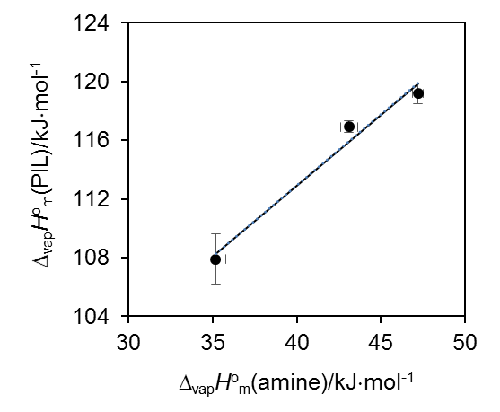
Fig. 3. Relationship between the enthalpies of vaporization of the studied PILs and of their precursor amines.

3.4 vs.
As mentioned in the Introduction, the difference between the aqueous ’s of the HA and [HB]⁺ species, , has been widely used as a measure of the proton transfer extent that is largely responsible for the ionicity of PILs. As the vaporization mechanism proceeds via the reverse proton transfer between cation and anion, the cohesive energy of PILs must also be influenced by the PIL’s ionicity. Although it has been recognized that aqueous data may not be appropriate for the nonaqueous PIL environment,^{4,44,88–91} different physical properties of PILs have shown regular trends with .^{2,4} As illustrated in Fig. 4, this does not seem to be the case for the enthalpies of vaporization of the PILs studied in this work for which = 5.30±0.04, = 3.94±0.44, and = 4.35±0.02 (see ESI).^{92–95} Although based on limited data, this finding reinforces the importance of understanding the effect
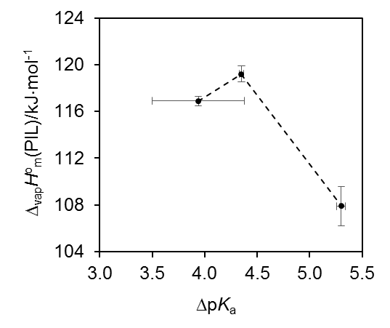
Fig. 4. Enthalpies of vaporization of the studied PILs as a function of (see text).

of functionality on the properties of PILs. A combination of both proton transfer mediated interactions and contributions from the cation functional groups clearly governs the cohesive energy in PILs.
Conclusions
The energetics of three tertiary ammonium acetate PILs of general formula [(CH₃)₂NH⁺CH₂CH₂R][CH₃COO⁻] (R = CH₂CH₃, N(CH₃)₂, OH), in which the R group confers different hydrogen bonding donor/acceptor ability, and of their precursor amines was investigated by combining and results obtained by calorimetry, ion thermochemistry literature data, and ab initio calculations (W1-F12 and CCSD(T)-F12a procedures). The analysis of the data suggests that the predominant vaporization channel for the three PILs, under reduced pressure, yields the neutral amine and acetic acid precursors. It was also concluded that additional H-bond interaction ability due to changes in functionality from R = CH₂CH₃ to R = N(CH₃)₂ or OH leads to higher and thus higher cohesive energy. The good linear correlation found between and suggests that, despite the possible differences in intermolecular interactions and speciation originated by differences in functionality, the cohesive energies of the studied PILs follow, to a good approximation, a group additivity rule. Finally, their vaporization energetics does not seem to correlate with the extent of proton transfer described by alone. As such, we postulate that cation functionality, particularly hydrogen bond donor/acceptor groups, can influence the energetics of protic ionic liquids.
Acknowledgements
J. E. S. J. Reid gratefully acknowledges financial support from the Engineering and Physical Sciences Research Council (EPSRC), through an industrial CASE award. Financial support from Fundação para a Ciência e a Tecnologia (Portugal), through project UID/MULTI/00612/2013 and post-doctoral grants awarded to F. Agapito (SFRH/BPD/74195/2010) and C. E. S. Bernardes (SFRH/BPD/101505/2014) is also greatly appreciated.
References
1 A. J. Walker, Eur. Pat. 1 805 131, 2004.
2 T. L. Greaves and C. J. Drummond, Chem. Rev., 2008, 108, 206–237.
3 C. Austen Angell, Y. Ansari and Z. Zhao, Faraday Discuss., 2012, 154, 9–27.
4 T. L. Greaves and C. J. Drummond, Chem. Rev., 2015, 115, 11379–11448.
5 G. L. Burrell, I. M. Burgar, N. F. Dunlop, F. Separovic and N. F. Dunlop, Phys. Chem. Chem. Phys., 2010, 12, 1571–7.
6 N. V Plechkova and K. R. Seddon, Chem. Soc. Rev., 2008, 37, 123–150.
7 M. Maase, K. Massonne and U. Vagt, ChemFiles, 2009, 5, 4–7.
8 M. W. Sanders, L. Wright, L. Tate, G. Fairless, L. Crowhurst, N. C. Bruce, A. J. Walker, G. A. Hembury and S. Shimizu, J. Phys. Chem. A, 2009, 113, 10143–10145.
9 Y. S. Chi, Z. D. Zhang, C. P. Li, Q. S. Liu, P. F. Yan, U. Welz-Biermann, C. Yansheng, Z. Zhida, L. Changping, L. Qingshan, Y. Peifang and U. Welz-Biermann, Green Chem., 2011, 13, 666–670.
10 N. Goujon, X. Wang, R. Rajkowa and N. Byrne, Chem. Commun., 2012, 48, 1278.
11 A. W. T. King, J. Asikkala, I. Mutikainen, P. Järvi and I. Kilpeläinen, Angew. Chemie - Int. Ed., 2011, 50, 6301–6305.
12 A. Idris, R. Vijayaraghavan, A. F. Patti and D. R. Macfarlane, ACS Sustain. Chem. Eng., 2014, 2, 1888–1894.
13 E. C. Achinivu, R. M. Howard, G. Li, H. Gracz and W. A. Henderson, Green Chem., 2014, 16, 1114–1119.
14 A. George, A. Brandt, K. Tran, S. M. S. N. S. Zahari, D. Klein-Marcuschamer, N. Sun, N. Sathitsuksanoh, J. Shi, V. Stavila, R. Parthasarathi, S. Singh, B. M. Holmes, T. Welton, B. A. Simmons and J. P. Hallett, Green Chem., 2015, 17, 1728–1734.
15 C. Chiappe, A. Mezzetta, C. S. Pomelli, B. Masciocchi, A. Gentile and G. Iaquaniello, Green Chem., 2016, 18, 4982–4989.
16 A. J. Walker and N. C. Bruce, Chem. Commun., 2004, 1, 2570–2571.
17 A. J. Walker and N. C. Bruce, Tetrahedron, 2004, 60, 561–568.
18 R. A. Sheldon, Chem. - A Eur. J., 2016, 22, 12984–12999.
19 W. Xu and C. A. Angell, Science (80-. )., 2003, 302, 422–425.
20 M. Armand, F. Endres, D. R. MacFarlane, H. Ohno and B. Scrosati, Nat. Mater., 2009, 8, 621–9.
21 D. R. Macfarlane, N. Tachikawa, M. Forsyth, J. M. Pringle, P. C. Howlett, G. D. Elliott, J. H. Davis, M. Watanabe, P. Simon and C. A. Angell, Energy Environ. Sci., 2014, 7, 232–250.
22 H. Luo, M. Yu and S. Dai, Z. Naturforsch. A, 2007, 62, 281–291.
23 S. Katsuta, Y. Yoshimoto, M. Okai, Y. Takeda and K. Bessho, Ind. Eng. Chem. Res., 2011, 50, 12735–12740.
24 J. R. Bell, H. Luo and S. Dai, Sep. Purif. Technol., 2014, 130, 147–150.
25 J. Qu, J. J. Truhan, S. Dai, H. Luo and P. J. Blau, Tribol. Lett., 2006, 22, 207–214.
26 Q. Zhao, G. Zhao, M. Zhang, X. Wang and W. Liu, Tribol. Lett., 2012, 48, 133–144.
27 T. Espinosa, M. Jimenez, J. Sanes, A. E. Jimenez, M. Iglesias and M. D. Bermudez, Tribol. Lett., 2014, 53, 1–9.
28 A. Tzani, M. Elmaloglou, C. Kyriazis, D. Aravopoulou, I. Kleidas, A. Papadopoulos, E. Ioannou, A. Kyritsis, E. Voutsas and A. Detsi, J. Mol. Liq., 2016, 224, 366–376.
29 B. Peric, J. Sierra, E. Martí, R. Cruañas and M. A. Garau, Ecotoxicol. Environ. Saf., 2015, 115, 257–262.
30 Y. Deng, I. Beadham, M. Ghavre, M. F. Costa Gomes, N. Gathergood, P. Husson, B. Legeret, B. Quilty, M. Sancelme and P. Besse-Hoggan, Green Chem., 2015, 17, 1479–1491.
31 J. E. S. J. Reid, N. Sullivan, L. Swift, G. A. Hembury, S. Shimizu and A. J. Walker, Sustain. Chem. Process., 2015, 3, 17.
32 J. P. Leal, J. M. S. S. Esperança, M. E. Minas da Piedade, J. N. Canongia Lopes, L. P. N. Rebelo and K. R. Seddon, J. Phys. Chem. A, 2007, 111, 6176–6182.
33 R. W. Berg, J. N. Canongia Lopes, R. Ferreira, L. P. N. Rebelo, K. R. Seddon and A. A. Tomaszowska, J. Phys. Chem. A, 2010, 114, 10834–41.
34 R. W. Berg, A. Riisager and R. Fehrmann, J. Phys. Chem. A, 2008, 112, 8585–8592.
35 J. Vitorino, J. P. Leal, M. E. Minas da Piedade, J. N. Canongia Lopes, J. M. S. S. Esperança and L. P. N. Rebelo, J. Phys. Chem. B, 2010, 114, 8905–8909.
36 J. Vitorino, C. E. S. Bernardes and M. E. Minas da Piedade, Phys. Chem. Chem. Phys., 2012, 14, 4440–4446.
37 J. Vitorino, F. Agapito, M. F. M. Piedade, C. E. S. Bernardes, H. P. Diogo, J. P. Leal and M. E. Minas da Piedade, J. Chem. Thermodyn., 2014, 77, 179–189.
38 V. N. Emel’yanenko, S. P. Verevkin and A. Heintz, J. Am. Chem. Soc., 2007, 129, 3930–3937.
39 X. Zhu, Y. Wang and H. R. Li, Phys. Chem. Chem. Phys., 2011, 13, 17445–17448.
40 V. N. Emel’Yanenko, G. Boeck, S. P. Verevkin and R. Ludwig, Chem. - A Eur. J., 2014, 20, 11640–11645.
41 D. H. Zaitsau, V. N. Emel’yanenko, P. Stange, C. Schick, S. P. Verevkin and R. Ludwig, Angew. Chemie - Int. Ed., 2016, 11682–11686.
42 A. Ostonen, J. Bervas, P. Uusi-Kyyny, V. Alopaeus, D. H. Zaitsau, V. N. Emel’Yanenko, C. Schick, A. W. T. King, J. Helminen, I. Kilpeläinen, A. A. Khachatrian, M. A. Varfolomeev and S. P. Verevkin, Ind. Eng. Chem. Res., 2016, 55, 10445–10454.
43 S. W. Benson, J. Am. Chem. Soc., 1996, 118, 10645–10649.
44 M. Yoshizawa, W. Xu and C. A. Angell, J. Am. Chem. Soc., 2003, 125, 15411–15419.
45 H. E. Gottlieb, V. Kotlyar and A. Nudelman, J. Org. Chem., 1997, 62, 7512–7515.
46 J. E. S. J. Reid, A. J. Walker and S. Shimizu, Phys. Chem. Chem. Phys., 2015, 17, 14710–14718.
47 J. E. S. J. Reid, R. J. Gammons, J. M. Slattery, A. J. Walker and S. Shimizu, J. Phys. Chem. B, 2017, 121, 599–609.
48 J. D. Cox, D. D. Wagman and V. A. Medvedev, CODATA Key Values for Thermodynamics, Hemisphere, New York, 1989.
49 T. Kiyobayashi and M. E. Minas da Piedade, J. Chem. Thermodyn., 2001, 33, 11–21.
50 J. A. Martinho Simões and M. E. Minas da Piedade, Molecular Energetics, Oxford University Press, New York, 2008.
51 S. Grimme, J. Antony, S. Ehrlich and H. Krieg, J. Chem. Phys., 2010, 132, 154104.
52 T. H. Dunning, J. Chem. Phys., 1989, 90, 1007–1023.
53 P. J. Stephens, F. J. Devlin, C. F. Chabalowski and M. J. Frisch, J. Phys. Chem., 1994, 98, 11623–11627.
54 T. Van Mourik, A. K. Wilson and T. H. Dunning, Mol. Phys., 1999, 96, 529–547.
55 T. H. Dunning Jr., J. Chem. Phys., 1989, 90, 1007.
56 R. Polly, H.-J. Werner, F. R. Manby and P. J. Knowles, Mol. Phys., 2004, 102, 2311–2321.
57 F. Weigend, Phys. Chem. Chem. Phys., 2002, 4, 4285–4291.
58 M. K. Kesharwani, B. Brauer and J. M. L. Martin, J. Phys. Chem. A, 2015, 119, 1701–1714.
59 A. Karton and J. M. L. Martin, J. Chem. Phys., 2012, 136, 124114.
60 G. Knizia, T. B. Adler and H. J. Werner, J. Chem. Phys., 2009, 130, 54104.
61 H.-J. Werner, T. B. Adler and F. R. Manby, J. Chem. Phys., 2007, 126, 164102.
62 K. A. Peterson, T. B. Adler and H. J. Werner, J. Chem. Phys., 2008, 128, 84102.
63 K. E. Yousaf and K. A. Peterson, J. Chem. Phys., 2008, 129, 184108.
64 E. F. Valeev, Chem. Phys. Lett., 2004, 395, 190–195.
65 F. Weigend, Phys. Chem. Chem. Phys., 2002, 4, 4285–4291.
66 F. Weigend, A. Köhn and C. Hättig, J. Chem. Phys., 2002, 116, 3175–3183.
67 J. G. Hill, K. A. Peterson, G. Knizia and H. J. Werner, J .Chem. Phys., 2009, 131, 194105.
68 A. Tajti, P. G. Szalay and J. Gauss, J. Chem. Phys., 2007, 127, 14102.
69 W. Kutzelnigg, Mol. Phys., 1997, 90, 909–916.
70 N. C. Handy, Y. Yamaguchi and H. F. Schaefer III, J. Chem. Phys., 1986, 84, 4481–4484.
71 CFOUR, a quantum chemical program package written by J.F. Stanton, J. Gauss, M.E. Harding, P.G. Szalay with contributions from A.A. Auer, R.J. Bartlett, U. Benedikt, C. Berger, D.E. Bernholdt, Y.J. Bomble, L. Cheng, O. Christiansen, M. Heckert, O. Heun, C. Huber, T.-C. Jagau, D. Jonsson, J. Jusélius, K. Klein, W.J. Lauderdale, D.A. Matthews, T. Metzroth, L.A. Mück, D.P. O'Neill, D.R. Price, E. Prochnow, C. Puzzarini, K. Ruud, F. Schiffmann, W. Schwalbach, S. Stopkowicz, A. Tajti, J. Vázquez, F. Wang, J.D. Watts and the integral packages MOLECULE (J. Almlöf and P.R. Taylor), PROPS (P.R. Taylor), ABACUS (T. Helgaker, H.J. Aa. Jensen, P. Jørgensen, and J. Olsen), and ECP routines by A. V. Mitin and C. van Wüllen. For the current version, see http://www.cfour.de.
72 H.-J. Werner, P. J. Knowles, G. Knizia, F. R. Manby, M. Schütz, P. Celani, T. Korona, R. Lindh, A. Mitrushenkov, G. Rauhut, K. R. Shamasundar, T. B. Adler, R. D. Amos, A. Bernhardsson, A. Berning, D. L. Cooper, M. J. O. Deegan, A. J. Dobbyn, F. Eckert, E. Goll, C. Hampel, A. Hesselmann, G. Hetzer, T. Hrenar, G. Jansen, C. Köppl, Y. Liu, A. W. Lloyd, R. A. Mata, A. J. May, S. J. McNicholas, W. Meyer, M. E. Mura, A. Nicklass, D. P. O’Neill, P. Palmieri, D. Peng, K. Pflüger, R. Pitzer, M. Reiher, T. Shiozaki, H. Stoll, A. J. Stone, R. Tarroni, T. Thorsteinsson and M. Wang, MOLPRO, version 2012.1, a package of ab initio programs, Cardiff, UK, 2012.
73 B. N. Taylor and C. E. Kuyatt, Guidelines for Evaluating and Expressing the Uncertainty of NIST Measurement Results (NIST Technical Note 1297), National Institute of Standards and Technology, Gaithersburg, 1994.
74 A. Razzouk, A. Hajjaji, I. Mokbel, P. Mougin and J. Jose, Fluid Phase Equilib., 2009, 282, 11–13.
75 S. Kapteina, K. Slowik, S. P. Verevkin and A. Heintz, J. Chem. Eng. Data, 2005, 50, 398–402.
76 S. G. Lias, J. E. Bartmess, J. F. Liebman, J. L. Holmes, R. D. Levin and W. G. Mallard, J. Phys. Chem. Ref. Data, Suppl. 1, 1988, 17, 1–861.
77 R. L. Wagman, D. D.; Evans, W. H.; Parker, V. B.; Schumm, R. H.; Halow, I.; Bailey, S. M.; Churney, K. L.; Nuttall, J. Phys. Chem. Ref. Data, Suppl. 2, 1982, 11, 1–392.
78 B. Ruscic, Active Thermochemical Tables (ATcT) values based on ver. 1.118 of the Thermochemical Network, available at ATcT.anl.gov, 2015.
79 A. I. Aleixo, P. H. Oliveira, H. P. Diogo and M. E. Minas Da Piedade, Thermochim. Acta, 2005, 428, 131–136.
80 K. K. Irikura and D. J. Frurip, 1998.
81 J.-P. Belieres and C. A. Angell, J. Phys. Chem. B, 2007, 111, 4926–4937.
82 K. Fumino, A. Wulf and R. Ludwig, Angew. Chem. Int. Ed. Engl., 2009, 48, 3184–6.
83 K. Fumino, V. Fossog, P. Stange, D. Paschek, R. Hempelmann and R. Ludwig, Angew. Chemie - Int. Ed., 2015, 54, 2792–2795.
84 F. Gharagheizi, P. Ilani-Kashkouli, W. E. Acree, A. H. Mohammadi and D. Ramjugernath, Fluid Phase Equilib., 2013, 360, 279–292.
85 S. P. Verevkin, D. H. Zaitsau, V. N. Emel’Yanenko, A. V. Yermalayeu, C. Schick, H. Liu, E. J. Maginn, S. Bulut, I. Krossing and R. Kalb, J. Phys. Chem. B, 2013, 117, 6473–6486.
86 H. U. Ung, A. R. Moehlig, S. Khodagholian, G. Berden, J. Oomens and T. H. Morton, J. Phys. Chem. A, 2013, 117, 1360–1369.
87 J. A. L. Willcox, H. Kim and H. J. Kim, Phys. Chem. Chem. Phys., 2016, 18, 14850–14858.
88 C. A. Angell, N. Byrne and J. P. Belieres, Acc. Chem. Res., 2007, 40, 1228–1236.
89 B. Nuthakki, T. L. Greaves, I. Krodkiewska, A. Weerawardena, M. I. Burgar, R. J. Mulder and C. J. Drummond, Aust. J. Chem., 2007, 60, 21–28.
90 J. Stoimenovski, E. I. Izgorodina and D. R. MacFarlane, Phys. Chem. Chem. Phys., 2010, 12, 10341–10347.
91 R. Kanzaki, H. Kodamatani, T. Tomiyasu, H. Watanabe and Y. Umebayashi, Angew. Chemie - Int. Ed., 2016, 55, 6266–6269.
92 M. M. Kreevoy and S.-W. Oh, J. Am. Chem. Soc., 1973, 95, 4805–4810.
93 W. M. Haynes, in CRC Handbook of Chemistry and Physics, 97th Ed., CRC Press, Boca Raton, 2017, pp. 5–96.
94 R. L. Gustafson and A. E. Martell, J. Am. Chem. Soc., 1959, 81, 525–529.
95 R. J. Littel, M. Bos and G. J. Knoop, J. Chem. Eng. Data, 1990, 35, 276–277.

