**Melodies of God: Significance of the Soundscape in Conserving the Great Zimbabwe Landscape**

*Ashton Sinamai, Archaeology Dept. University of York.*

**Abstract**

Sacred cultural landscapes require a holistic approach in terms of their conservation. They are intimate spaces which are susceptible to cultural erosion if the focus is on a few elements that heritage practitioners think are important. Mainstream conservation theories and processes, developed from western philosophies, however, emphasises on the preservation of material remains. But there intimate connections between people and place which if eroded can result in erasure of memory and ultimately the un-inheriting of the heritage place. Soundscapes, the relationship between people and the sounds around them, is a novel way to understand these intimate and emotional connections that people have in places. Using the Great Zimbabwe World Heritage site, I examine how local communities cultivate deep connections and sustain memory of place through their preservation of the intangible. A series of events at Great Zimbabwe have clearly shown that the soundscapes represent intimate connections between local communities and the cultural landscape and how the preservation of this soundscape can enhance the conservation of the tangible heritage in this sacred landscape. This paper examines how the soundscape of the Great Zimbabwe cultural landscape is used to preserve memory and sustain connections between the people and the landscape.

**Keywords:** *Great Zimbabwe, cultural landscape, soundscapes, mbira, music, voices.*

**Introduction**

Great Zimbabwe is the remains of a city of an ancient Zimbabwe state that existed between 1250 and 1500 AD. Its monumental dry stone wall walls, rising up to twelve metres in height and measuring over six metres in width in some places makes it a magnet of tourists who visit Zimbabwe. Located in rural Masvingo, the Great Zimbabwe estate is an ‘island’ rich in flora and fauna that has disappeared in the surrounding, exhausted rural farming lands. The remains of the city cover an area of 720 hectares and are composed of free standing dry stone walls some with heights above 12 metres. The site was declared a ‘national monument’ in 1937 and a World Heritage Site in 1986. Its importance to the state of Zimbabwe is rather obvious: the name Zimbabwe is derived from this site. It provides a convenient narrative for the state and was deployed in the anti-colonial struggles of the black majority. The colonial regime also used Great Zimbabwe in building settler identities buy adopting symbols from the site as its own. In fact, a colonial narrative in which the site was imagined to have been built by a disappeared white civilisation was promoted (Champion 2001). While the site has a prominent international and national profile, it is also revered by local communities that live in the surrounding areas. For the state, Great Zimbabwe is a resource for a national narrative but for local communities it is the centre of their cosmology and plays a huge part in their daily lives. For local communities the management regimes for Great Zimbabwe should involve not only scientific methods, but also cultural norms, as mistakes made through the conservation process often impact directly on their lives. As a tourist destination managed a state body, however, this cultural landscape (and its various attributes) has been devalued through access given and denied, the use of the site and the silencing of local voices in the conservation and interpretation of the landscape (Fontein 2006).

Researching on folklore and landscape at Great Zimbabwe, one of the most contentious issues that local communities raised was the use of Great Zimbabwe as a venue for live music shows sponsored by the government and meant to ‘celebrate unity’ of the people of Zimbabwe. These events which were dubbed Unity Galas or *biras* (a reference to an all-night traditional ceremony to call on ancestors) began after the land reform programme in 2000 and were aimed at bolstering waning support for a government that was getting progressively repressive and an managing an economy in a tailspin. Two shows, lasting the whole night were hosted at Great Zimbabwe at the end of 2001 and 2002, leading to complaints from traditional chiefs of the Mugabe/Murinye (Duma), Charumbira and Nemamwa clans. Their complaints were against too much noise in a consecrated, serene place and at that they were held at night when the ancestral presence was supposed to be more pronounced at Great Zimbabwe. The shows, which attracted a very youthful audience, are also said to have desecrated the sacred landscape through the behaviour of these youths. Communities mentioned alcohol, drugs and sex, all of which were reflected through the litter that was cleaned up at the site the next day, as incompatible to Great Zimbabwe

The major catastrophe for the communities, however, was that the music that was played during these ‘music galas,’ which was not consistent with the sanctity of the cultural landscape. Most of the bands played modern Zimbabwean music which, for the local communities, was not related to Great Zimbabwe as the most sacred landscapes in Zimbabwe (Sinamai 2003). In short, the Unity Galas were profane entertainment in a sanctified sacred environment.

In my interviews at Great Zimbabwe, it was emphasized that the only music that was allowed at Great Zimbabwe was mbira and *ngoma* (drum)-based sacred or ritual music. Mbira or drum-based music played for entertainment purposes was also not compatible to the sacred nature of the site. Other traditional musical instruments like the *marimba* and mouth bows, and music *genres* like Christian gospel, *sungura* and *Chimurenga (*a modern *genre* based on the mbira sound) were not appropriate sounds for the Great Zimbabwe landscape. These and other foreign sounds were regarded as *noise* while others like *mbira* and *ngoma,* were part of the landscape as soundscapes. Local people therefore have an auditory engagement with Great Zimbabwe which is totally different to that espoused by the national narrative. This papers aims to examine the emotional connections that people living around Great Zimbabwe have on the cultural landscape through an understanding of the acoustic boundaries of this landscape. This paper also explores the significance of sound in the conservation of the Great Zimbabwe World Heritage site through the concept of soundscape.

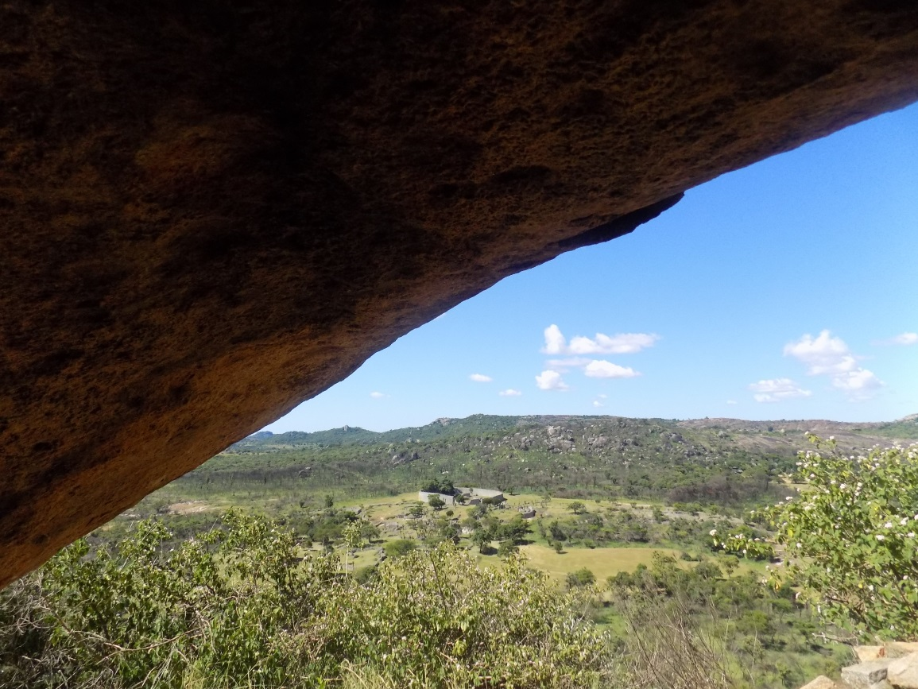

Figure 1: The Great Enclosure at Great Zimbabwe from a cave near the eastern enclosure whose acoustics projects voices to the valley below (Source: Author)**.**

**Landscape acoustics**

Every landscape has sounds that are unique to it be it natural, geographical or anthropological. Each landscape thus has an acoustic character that affects the users of that landscape positively or negatively. There are therefore ‘acoustic boundaries’ that have to be respected in conserving certain heritages, especially cultural landscapes. A cacophony of car hooters that people are used to in urban landscapes may be regarded as unusual noise in a rural landscape. Similarly, the ‘rural’ sounds (e.g. from animals, livestock) maybe incongruous to the soundscape of an urban landscape. The division between what we regard as ‘sound’ and/or ‘noise’ is determined by our culture and the perceptions we have of the landscape that we are in. Anderson et al. (1983) concluded that any positive or negative assessment of a place depends on the sounds that can be heard from it. Hence any place may be visually beautiful but as long as the sounds coming from it may signify danger, people will avoid it. There are, therefore, appropriate sounds reserved for certain landscapes which if disturbed, can influence how communities perceive them and can, ultimately affect the well-being of communities. Chiweshe (2010) who is also a *mbira* music player of note, believes that the separation of material heritage from the immaterial like sounds has not only abbreviated cultural heritage, but it has also broken the communal spirit. In other words, a cultural landscape without its preferred sounds is empty of the experiences and emotions of the people who value it. This relationship of the landscape and the sounds that are associated with it, is the soundscape (Pijanowski et al 2011:203), an aspect of cultural heritage that archaeologist and heritage practitioner often ignore.

Archaeology does not study emotional meanings of place; it studies the material culture as evidence of an experience but is wary of emotions as evidence. Material remains are associated with the visual senses; emotional meanings on the other hand are better understood through senses that express our emotions like music and sound (Carles et al 1999). Understanding soundscapes allow us a holistic conceptualisation of the cultural landscape; a conceptualisation that not only involves what we see, but also what we experience in them. In trying to understand the relationship between human beings (and other animals as well) and sound, some researchers have identified three acoustical characteristics: the biophony, geophony and anthrophony (Krause 1987). A biophony is composed of the sounds that are made by all animals; the geophony is the sound that is generated by the natural features of the landscape (e.g. wind, rain, thunder or sounds made by a fire) and lastly, the anthrophony is composed by human-made sounds from people’s activities or music and cancan also include imagined sounds that represent a sacred presence. In much of Africa, however, these sounds maybe difficult to separate in this way. Thunder maybe an encrypted cultural message and among the Shona of Zimbabwe, a roaring lion maybe an ancestral ‘lion spirit’ trying to communicate to the living. These characteristics of a soundscape are therefore all anthrophonic as the perception of the cultural landscape is much more holistic. When these acoustic characteristics are disturbed, communities may feel a loss of the sense of place. Similarly, animals may also feel threatened by the presence of new sounds or the loss of the familiar sounds. A sound from a gun, loud music usually drives most animals away from certain places and the absence of sounds from other animals may signal a loss of a food source or some form of danger. To maintain the balance, people therefore assign certain sounds to their familiar landscapes and absence of assigned sounds, or the introduction of new ones may signal changes which may upset not only the soundscape but that equilibrium that gives communities confidence about their futures. This paper does not wish to characterise the Great Zimbabwe soundscape in this way, but takes all sounds within this cultural landscape as anthrophonic. The fusion of all the sounds creates the sacred soundscape at the Great Zimbabwe.

For places that are managed by state bodies however soundscapes are, however, often determined by the prevailing power structures. Many cultural landscapes like Great Zimbabwe World Heritage ‘Site’ are also branded as tourist destinations by governments or organisations that own them. As such, determining what is ‘noise’ and sound is not usually the prerogative of communities but of organisations that manage them. In Zimbabwe, where legislation gives all power to one central organisation, the (National Museums and Monuments of Zimbabwe NMMZ), the use of Great Zimbabwe is solely determined by this organisation with little, if any consultation of local communities. In some cases, NMMZ’s conservation guidelines are set aside through purely political decisions made by senior government representatives as will be discussed in this paper. Though NMMZ can sometimes stand its ground when the monument is threatened physically, it usually cannot do the same where elements like the soundscape are threatened. It is not surprising to note that the major concerns about holding a ‘Unity *Bira*’ at Great Zimbabwe was ‘the harmful effects of high volume music out put (sic) on dry stone walls’ (Memorandum L/3:EM/gg Regional Director to Executive Director, 19 December 2002).

**The Great Zimbabwe Soundscape**

It is this heritage that people often think of in terms of interpretation and preservation. Though it is managed as a site it is actually a cultural landscape that is associated with many other natural features around it. Folklore from surrounding areas say that it is connected to all the major mountains around it through tunnels and that there was a pot (*Pfuko yaKuvanji*) which walked from Great Zimbabwe to all these mountains. For local communities the Great Zimbabwe is thus not just a ‘monument’, a tourist destination or just an important research resource, it is the most sacred centre of this wider landscape. Communities lost this centre of the cultural landscape through colonial legislation, which not only demarcated it as a tourist area but also reduced access into it through segregation laws and entrance fees. This legislation has not been replaced since independence in 1980 though the segregation laws were removed in 1980. Currently this heritage legislation is not compatible with the new constitution which states in the Bill of Rights that;

Every person has the right to use the language, and to participate in the lawful cultural life, of his or her choice (The Zimbabwe Constitution, Bill of Rights 2013).

The constitution also has incorporated culture into its national objectives. National Objective 16 states that;

1. The State and all institutions and agencies of government at every level must promote and preserve cultural values and practices which enhance the dignity, well-being and equality of Zimbabweans.

2. The State and all institutions and agencies of government at every level, and all Zimbabwean citizens, must endeavour to preserve and protect Zimbabwe's heritage.

3. The State and all institutions and agencies of government at every level must take measures to ensure due respect for the dignity of traditional institution (The Zimbabwe Constitution, National Objectives, 2013).

Further to this Zimbabwe also signed the 2003 United Nations Educational, Scientific and Cultural Organization (UNESCO)’s Convention for the Safeguarding of the Intangible Cultural Heritage in May 2006 (UNESCO 2003). However, the adoption of these objectives and the accession to convention has not prompted changes to the heritage legislation. The national heritage legislation still does allow for community ownership of heritage and does not enforce consultations with communities concerned on heritage issues. Its major weakness is the absence of any mention of intangible heritage; it focuses solely on the preservation of material heritage. Where communities have a holistic approach to cultural heritage, NMMZ focuses its efforts on preserving the material remains. At Great Zimbabwe the focus is therefore on preserving the monumental stone walls.

In interviews with members of communities around Great Zimbabwe one issue, however, stood out as it appeared in all folklore associated with the landscape. The issue of ‘voices’ which could be heard from the Hill Complex was narrated by every participant I interviewed. They narrated that voices could be heard calling from the eastern enclosure of the Hill Complex. These voices were also accompanied by whistling and sound from domestic animals like cattle. One voice shouting *Huya nehwedza iwe* (Bring me a milking container) was quoted verbatim by all participants (Interviews Participants 1-9, Great Zimbabwe). Some participants also mentioned the roar of lions which they say can still be heard from a cave to the east of the Hill Complex and the cry of sacred birds like the Fish and the Bateleur Eagles which they associated with departed ancestral spirits. Older participants reported hearing drums and *mbira* music being played on the Hill Complex before the site became a popular tourist destination.

These voices and sounds are said have since disappeared resulting in a landscape emptied of the voice that had directed life within the wider landscape. From the folklore the Great Zimbabwe landscape incorporated the mountains that surrounded it and how those mountains have been affected by man also determines the spiritual health of Great Zimbabwe (Interview Manunure Mugabe, Samuel Mugabe, F. Manwa, February, 2016). A cave near the Eastern Enclosure on the Hill Complex has acoustics that allows sound made within it to be heard in the valley below and is regarded as one of the most sacred places at Great Zimbabwe (see Figure 1 above). Some of these sacred mountains like Ruvhure, Nyuni and Sviba are said to have been desecrated by the construction of radio and phone communication towers and this has silenced the voices and the sounds that used to be heard from Great Zimbabwe. The access to every part of the site by tourists has also driven these voices away.

This however does not mean the landscape is not sacred still. It is in a dormant state in which ancestors can still communicate with those who can still read the signs in the landscape. In my interviews with local elders at Great Zimbabwe, I was told that I may not be able to see or hear the lion spirits because I try to read the signs ‘through books.’ The reading of the landscape therefore requires certain skills acquired through cultural immersion that outsiders usually don’t have. It was also emphasised that not all music can be played within the Great Zimbabwe. Traditional *mbira*, shakers and drums were the only instruments that can be played within the Great Zimbabwe landscape. The *mbira* provides the ambience for a much deeper experience of Great Zimbabwe. As an instrument that has a long association with Shona religion it takes the living to a primordial place where they can experience their authentic culture away from western influences. It is also a sound that the ancestors are familiar with: with about six tunings it preserves the music that the ancestors listened to at Great Zimbabwe. Indeed *mbira* keys have been found in archaeological deposits at Great Zimbabwe and other dry stone walled sites. In colonial Rhodesia the *mbira* was fundamental in the preservation Shona culture and was therefore also an instrument of resistance. It brought back the landscapes lost through colonial evictions and resettlements and created bridges to a world where the lost landscapes could be experienced again (Hancock-Barnett, C. 2012). As a vessel of ‘Shonahood’, the *mbira* enhances the experience of the landscape and creates an atmosphere in which some members of the community can communicate with the ancestors and pass back the message to the rest of the community.

It was the introduction of modern music events within the landscape in 2001-2 that alarmed the local community. Modern Zimbabwean music is of course a mixture of different sounds from different parts of southern Africa played with instruments from different parts of the world. The use of these instruments has been resisted in traditional religious ceremonies and their use at Great Zimbabwe has been frowned upon by local communities. One needs to understand the use of music in Shona religion to understand the resistance to new instruments and music in Shone religious ceremonies. There are very few instruments that are allowed in a Shona religious ceremony and these include the drum, the mbira and the shakers. Among the Shona when a person dies he or she becomes an ancestor who can be an intermediary between the living and God. The ancestor comes back through a selected ‘pocket’ who has to be one of his descendants. The connection between the living and this ancestor is brought about by a *bira* ceremony which is supposed to imitate past experiences of that ancestor.

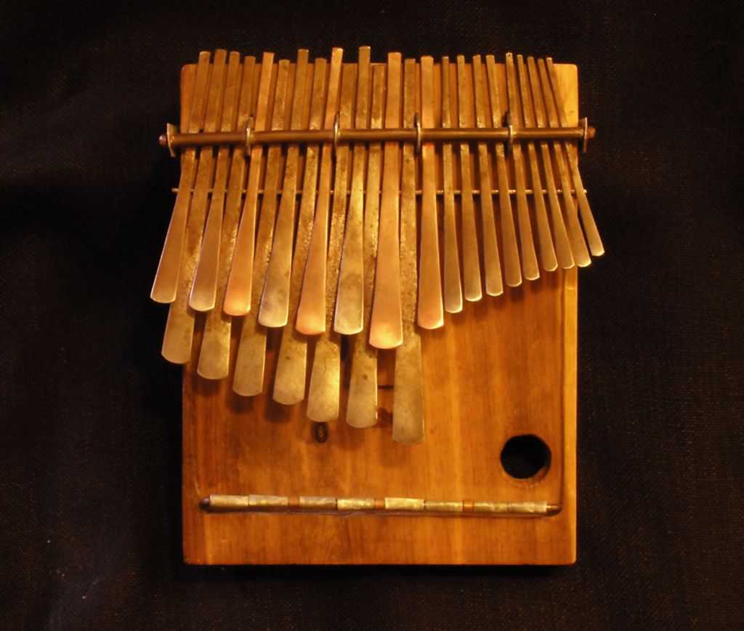

Figure 2: The traditional *mbira* instrument from Zimbabwe (Source: Wikipedia)

The *bira* therefore brings the past into the present (Matiure 2012). To enter into the realm of the ancestors the context in which the *bira* is held has to recreate an ancestral landscape complete with the material culture that they used. In other words the food, beer, the clothes, the music and instruments used have to be authentic (Matiure 2012: 31). At a territorial level this same structure is replicated with the royal ancestral spirits being the intermediaries to God for issues that affect the whole community like drought. Before embarking on these ceremonies people have to abstain from certain activities including intercourse. Without following the protocol on music and instruments, dressing and food, the ceremony is failure. Family *bira* ceremonies are usually carried out within a homestead and those that affect the whole communities are usually at sacred places like Great Zimbabwe. The music galas at Great Zimbabwe which the government dubbed *biras* were therefore a mockery to the traditional religion and to the ceremonies that locals were denied to carry out at Great Zimbabwe.

**Eroding the sacred soundscape**

In 2001, with the national morale going down and inflation rising daily, the Zimbabwe government decided to hold a Unity Gala at Great Zimbabwe as part of a project to influence people to support its policies, especially the land reform programme. Promoted by the Minister of Information, Jonathan Moyo an academic and musician, the galas were supposed to bolster support for a government that was becoming gradually unpopular. Bands from the military, the police, prisons and in some cases, bands created by Jonathan Moyo himself, played with other selected popular musicians. Attended mostly by urban youths, these galas were attended by crowds of up to 40 000 people and usually ended at sunrise. Many of the bands were forced to perform in these galas through covert threats to ban their music on local radio stations, huge monetary incentives, and sometimes bad press in the government newspapers (Bere 2012: 86). With no private radio or television stations, musicians depended on government media outlets for airplay. Bere, (2012) traces how one female musician, Sandra Ndebele, was coerced into performing at the galas through promises of more airplay on national radio and positive press coverage in government newspapers and how, when she stopped performing at galas, she was subjected to misogynistic tirades from the government press, received less airplay on radio, resulting in her popularity waning.

There a deliberate targeting of modern Zimbabwean music in generating propaganda for the state. Jonathan Moyo, the then Minister of Information, described the use of music in propaganda as ‘press releases.’ He argued that the usual press releases were ‘bureaucratic’ and ‘cryptic’ and music being a language understood by people, was better placed to convey the government’s messages (Willems, 2013: 167). The galas were thus ‘melodic press releases’ and Great Zimbabwe was just the most appropriate backdrop for a ‘press release’ that focused on African achievements, unity of purpose and independence.

The NMMZ, which manages Great Zimbabwe, also had no choice and had to agree to host these galas which were expected to be held at the site annually. The NMMZ gave the company hosting these galas (ZimArts) some conditions to be followed in protecting the ‘monument’ from the expected high numbers of revellers and the volume of the music. None of these discussed the preservation of the ambience of this sacred landscape. The conditions for hosting the galas at Great Zimbabwe mention only the protection of the material remains: ‘displacement or alteration of the physical features….and its environmental setting’ (Letter RD Great Zimbabwe to Managing Director, ZimArts, 20 December 2002). The Regional Director was of course also aware that the galas were not popular with the local communities and raised the issue with the Executive Director NMMZ in his memorandum to grant permission for the gala to go ahead:

You are well aware that the idea of a music gala is steeped in controversy and public opinion is divided on whether this is the right thing to do at a national shrine (Memorandum L/3:EM/gg Regional Director to Executive Director, 19 December 2002).

There is however no discussion on the preservation of the intangible in the exchanges between conservators at Great Zimbabwe and those who wanted to host the galas. The galas were held at Great Zimbabwe in an open space to the west of the Hill Complex outside the stone-walled areas to protect the archaeological remains. With no obligation to consult local communities their concerns about the galas were totally ignored. Complaints by local communities were met with arguments that the Great Zimbabwe was a ‘national monument’ and that local concerns had to be assessed with the site’s national character in mind. Local communities however had argued against the galas especially after the 2001 event, after which elders volunteered to clean up the site (Interview Samuel Haruzivishe February 2016). The debris of the gala which included plastics, used condoms, abandoned intimate clothing and bottles symbolised not only the polluting of hallowed ground but also represented the destruction of the soundscape.

Six months after the gala, two accidents occurred in the Masvingo Province within a space of one week in which a total of forty-eight people died. This is not unusual especially on the Harare-Beitbridge road which connects the African interior with South Africa. The local leadership however saw these accidents differently: there was a result of their failures to stop the holding of the galas at Great Zimbabwe. Chief Murinye of the Duma Clan attributed these accidents to the abuse the ‘shrine’

We knew this debacle would come one day. How could the government allow a gala to be held at the Great Zimbabwe monument? You can’t organise a function at a sacred place and have drunken youths and promiscuous elders coming to engage in sexual activities and defecate the shrine. Has anything like this happened before in our history?’ …..they have even allowed musicians to come and play their guitars. Those instruments have not been played at the shrine since the monuments were constructed. (Chief Murinye quoted in *The* *Zimbabwe Standard* 16 June 2002).

His complaints appearing in the private press was dismissed by government officials who went on to hold another gala at Great Zimbabwe on the 21st December 2002. The governor of the Masvingo Province arrogantly dismissed the chiefs’ and spirit mediums’ concern about the disturbance of the soundscape with the usual arrogance of Zimbabwean government administrators. A newspaper article reported that the governor (Josaya Hungwe) ‘dismissed the chief's criticism saying the government did not need anyone's permission to hold national celebrations’ at a national monument (*The Zimbabwe Standard* 16 June 2002).

Traditional chiefs blamed the music galas for the problems that their areas and indeed, the whole province were facing. Fontein (2006: 218) states that misfortunes blamed on music galas included inadequate rain and the spread of HIV within the community. At that time Nemamwa Growth Point, the nearest township to Great Zimbabwe, had recorded the highest incidence of HIV infections in the country (Sinamai 2004). This was seen as a punishment to the community for allowing this disturbance to the sacred soundscape. The chiefs became bolder and approached central government to stop music galas at the site.

This has not, however, stopped the use of Great Zimbabwe for political mileage. In February 2016 the President celebrated his 92nd birthday at Great Zimbabwe. The venue was in the centre of the site and considerable damage was caused to archaeological deposits as heavy trucks were allowed into the centre of the site during the rainy season. The sheer number of people who attended (estimated at 50 000) and the number of vehicles allowed into the sensitive part of the site (over 300) caused some walls in the Valley Enclosures to collapse. Again modern music was played loudly from the venue which overlooked the Eastern Enclosure of the Hill Complex, the most part of the site. In my interviews with members of the local communities, it is the continuation of the disrespect for the sacred soundscape that has caused the problems that the country was experiencing, including the debilitating drought that the area was experiencing at the time.

*Mbira* music is a component of preferred sounds at Great Zimbabwe. There are several types of mbira with the most popular among the Shona being *Njari*, (30-32 keys), *Nyunganyunga*, (18 keys) *Mbira dzevadzimu* (*mbira* of the ancestors, 22-28 keys). Though the other instruments mentioned can be used, it is the *mbira dzevadzimu* that the ancestors are quicker to respond to (Matiure, 2012). The success of a *bira* ceremony depends on how suitable context is and also on the appropriateness of the music played and the ability of the musicians. Great Zimbabwe as a sacred place provides a very suitable context for this. One does not have to imagine an ancestral landscape as they already are within place that the ancestors lived in.

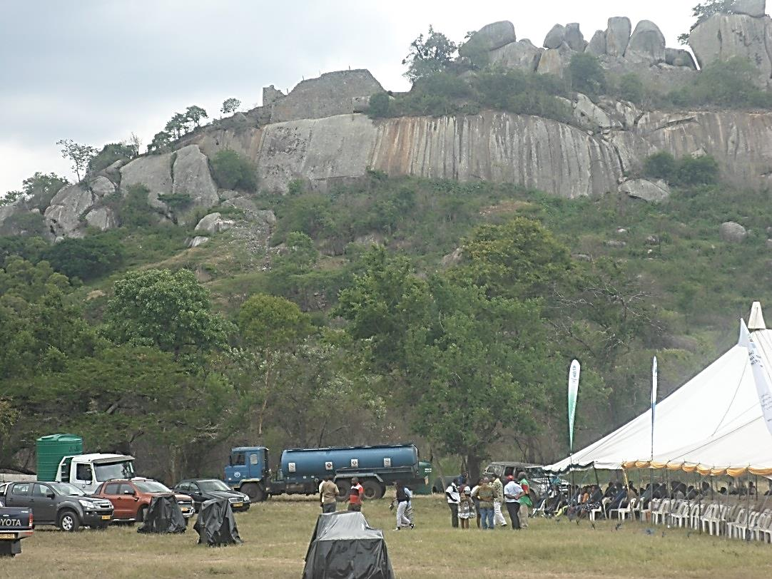

Figure 3: The venue of the President’s birthday celebrations before the arrival of guests. Note the heavy trucks and the Hill Complex in the background (Source: Elton Sagiya)

The atmosphere created by Great Zimbabwe accompanied by the sacred soundscape and mbira provides the most ideal context for a ritual ceremony. *Mbira* music is however the very sound that is hardly heard at Great Zimbabwe except at the Shona Village, a simulacrum of a traditional village that has received criticism from the community. The fact that traditional ceremonies (*bira*) where the *mbira* could be used are not allowed at Great Zimbabwe and that the music festival was called a *bira* aggravated the communities around Great Zimbabwe. For local communities, the music festival was another invasion of the sacred soundscape which the government has refused to ‘heal,’ despite several requests from traditional leaders. For local communities, the lack of authenticity in the music played, the behaviour of the audience and the disturbance of the soundscape through the introduction of ‘foreign’ instruments and sounds upset the equilibrium so much that the region began to experience misfortunes like the accidents mentioned above (Fontein 2006).

**Conclusions**

From the above it is clear that the soundscape is one of the most important cultural element of Great Zimbabwe that communities would preserved. The NMMZ however focuses on the stone walls though communities are less worried about them. In a research project to assess the attitude of communities towards the restoration of stone walls, Mabvadya (1990) established that for communities the disintegration of stone walls was not such a bad thing as it was the wish of the ancestors. It is thus intriguing that NMMZ ignores the preservation of the soundscape at Great Zimbabwe when it evokes so much emotion when communities feel it is being eroded. The visual bias that exists in contemporary Zimbabwean heritage conservation philosophy contradicts the intimate connections that are represented by the soundscape.

The reaction of communities at Great Zimbabwe to the music festivals shows that conservation sacred landscapes is not only based on action (restorations) or the performance of rituals and ceremonies but on respecting the landscape and its soundscape. One way to disrespect the landscape is to introduce unfamiliar sounds; sounds that may not be appreciated not only by the ancestors but by everything that dwells within. At the Great Zimbabwe these sounds include all music produced outside the culturally accepted boundaries (modern Shona music, gospel music) the foreign sounds from vehicles and other machinery. These are regarded as profane noise that devalues the sanctity of the landscape. The soundscape is thus a heritage resource like the stone walls and its preservation is just as important as the conservation of stone walls.

The soundscape of the Great Zimbabwe encompasses a variety of sounds including music, ‘voices’ and the natural sounds from animals and birds. Approaching conservation of for example sacred birds like the fish and Bateleur eagles as conservation of the landscape preserves not only the species but also the valuable soundscape they represent. There are social values to sounds- people construct meanings from certain sounds – the cry of a fish eagle has a different meaning to people from Zimbabwe. As a sacred bird, its cry is a voice that can be interpreted by those with abilities to translate it. Sound as a culturally constructed media thus provides a window into the intimate connections that people have with cultural landscapes. The loss of the voices that is mentioned in interviews is in fact the loss of the emotional attachment and the introduction of the music festivals at Great Zimbabwe breached the acoustic boundaries of the sacred landscape.

The soundscape at Great Zimbabwe is a fusion of sounds presents (‘natural’) but also about sounds preferred (appropriate music that can be played in ceremonies) and sounds expected (the messages from the past) .This auditory engagement with natural, human and imagined sounds in the landscape is a way to intimately engage with the cultural landscape that is the centre of their cosmology. In this wat they inherit and conserve the landscape in much more intimately than the state and its NMMZ who manage it. The voices represent the communication between people and place. It is interesting that the loss of voices was often discussed in conjunction with changes in the environment like less rain and other changes in climate. Hearing the voices is a form of listening to the environment and noting the changes that the landscape is going through. The community is much more sensitive to the changes within the landscape and their knowledge should therefore be central in the conservation of Great Zimbabwe. Without the soundscape Great Zimbabwe is a ‘site’ but with its soundscape it becomes a cultural landscape.

When conservation is guided by narrow principles with a uni-focal view it misses it loses these intimate connections Silberman 2015). Best practice in heritage management requires an understanding of these people-place relationships. Clause 8 of the Nara document states that ‘responsibility for cultural heritage management of [a site] belongs, in the first place, to the cultural community that has generated it, and subsequently to that which cares for it’ (Nara Document, 1994). Many heritage practitioners have raised issues with this statement, considering the problems that beset projects when communities are involved (Silbermann 2015: 52). But if one considers memory and landscape experience as preservation, communities around Great Zimbabwe have conserved not only the tangible but also the soundscape which mainstream conservation has ignored. Though the NMMZ can control the deterioration of the physical site they can hardly control the devaluation of the landscape. That is the within the ambit of local communities who have an intimate relationship with the landscape. With landscape experience being a whole-body encounter the responsibility to remember is not for those who care for it but those who are culturally responsible for its survival.

**References**

Anderson, L.M., Mulligan, B.E., Goodman, L.S., Regan, H.Z., 1983. Effects of sounds on preferences for outdoor settings. *Environmental Behaviour* 15(5), 539-566.

Bere, F.W. 2012. Infectious Beats: Urban Grooves Music’s Collusion with the Zimbabwean State. In F. Falola, T. Fleming. *Music Performance and African Identity*. Routledge. London

Carles, J.L. López Barrioa, I. Vicente de Luciob, J. 1999. Sound influence on landscape values. *Landscape and Urban Planning*, Volume 43 (4) 191–200 doi.org/10.1016/S0169-2046(98)00112-1.

Champion, Timothy 2001.The appropriation of the Phoenicians in British imperial ideology. *Nations and Nationalism*, 7, (4), 451-467.

Chiweshe S. R. 2010 Prologue: Intangible Musical Heritage. In Offenhäußer, D., Zimmerli, W.C. Albert, M-T. *World Heritage and Cultural Diversity.* German Commission for UNESCO. Cottbus.

Fontein J. 2006. The Silence of Great Zimbabwe: Contested Landscapes and the Power of Heritage. Weaver Press. Harare.

Hancock-Barnett, C. 2012. Colonial resettlement and cultural resistance: the mbira music of Zimbabwe. *Social & Cultural Geography*, Vol. 13, No. 1, February 2012.

Kato, K. 2009. Soundscape, Cultural Landscapes and Connectivity. *Sites: New Series* Vol 6 (2).

Krause B. 1987. Bioacoustics, habitat ambience in ecological balance. *Whole Earth Review* 57: 14–18.

Mabvadya, E. 1990. A Study of Attitudes Towards Museums and Monuments in Zimbabwe. Unpublished B.A Dissertation. History Department, University of Zimbabwe.

Matiure P. 2012. *Mbira dzavadzimu* and its space within the Shona cosmology: tracing *mbira* from *bira* to the spiritual world. *Muziki,* 8:2, 29-49. DOI:10.1080/18125980.2011.631291

Pijanowski, B.C., Villanueva-Rivera, L.J., Dumyahn, S.L.,Farina, A., Krause, B.L., Napoletano, B.M., Gage S.H., and Pieretti, N. 2011. Soundscape Ecology: The Science of Sound in the Landscape. *BioScience* 61 (3): 203-216 doi: 10.1525/bio.2011.61.3.6.

Silberman N. 2015. Remembrance of Things Past: Collective Memory, Sensory Perception, and the Emergence of New Interpretive Paradigms. In A. Castillo (ed.) *The 2nd International Conference on Best Practices in World Heritage: People and Communities.* Universidad Completeness de Madrid, Madrid. p 51-62.

Sinamai, A. 2003. Cultural Shifting-Sands: Changing Meanings of Zimbabwe sites in Zimbabwe, South Africa and Botswana. Paper presented at the ICOMOS General Assembly, Victoria Falls, Zimbabwe. 27 - 31 October 2003. <http://www.icomos.org/victoriafalls2003/papers/C3-7%20-%20Sinamai.pdf>

Sinamai, A. 2014. The Management of Cultural World Heritage Sites and their contribution to the Development of the Continent. In S. Makuvaza. The Management of Cultural World Heritage Sites and Development: History, Nomination Process and Representation on the World Heritage List. Springer. New York.

Willems W. 2013. Zimbabwe’s Cultural Revolution and ‘Melodic Press Releases:’ Mediated National Imaginaries in an Age of Neo-Liberalism. In S. Gatsheni-Ndhlovu, F. Ndhlovu, *Nationalism and National Projects in Southern Africa. New Critical Reflections*. Africa Institute of South Africa. Pretoria. p. 158-73.

**Other sources**

Letter Regional Director, Great Zimbabwe to Managing Director ZimArts, 20 December 2002. Great Zimbabwe Conservation Centre Archive.

Interviews, Participants 1-9 Great Zimbabwe National Monument, Zimbabwe. February 2016.

Memorandum (Ref L/3:EM/gg) Regional Director, Southern Region to Executive Director, NMMZ. 19 December 2002. Great Zimbabwe Conservation Centre Archive.

International Council on Monuments and Sites (ICOMOS). 1994. The Nara Document on Authenticity. Available at <http://www.icomos.org/charters/nara-e.pdf> (accessed 14 October 2016).

Standard Correspondent. 2002. Masvingo Accidents Blamed On Zanu PF. *The Zimbabwe Standard* 16 June 2002.

United Nations Educational, Scientific and Cultural Organization (UNESCO). 2003. Convention for the Safeguarding of the Intangible Cultural Heritage. UNESCO Paris. Available at <http://www.unesco.org/culture/ich/en/convention> (accessed 14 October 2016).

Government of the Republic of Zimbabwe. 2013. The Zimbabwe Constitution. Government Printers. Harare.