Article

**A comparison of upland stream invertebrates in moorland and coniferous woodland in the North York Moors National Park, UK**

Sam Jones and Peter J Mayhew*

*Department of Biology, University of York, Heslington, York, UK*

*Corresponding author: E-mail [peter.mayhew@york.ac.uk](mailto:peter.mayhew@york.ac.uk)

**Abstract:** Conversion of moorland to coniferous woodland is a common land-use change in the high latitude uplands. Conifer woodlands are known to increase detrimental acidification in upland streams, but can benefit some invertebrates by increasing allochthonous inputs. We aimed to identify the effects of conifer woodlands on benthic stream macroinvertebrate communities in the North York Moors National Park, whose streams are some of the most acidified in the UK. Benthic invertebrates from eight moorland and eight conifer woodland catchments were gathered using kick sampling in 2014. Taxonomic composition and diversity differed significantly in woodlands and moorlands, with woodland communities showing higher diversity, and species characteristic of lower levels of stressors. Moorland and woodland communities did not differ in average acid sensitivity, and taxa were typical of close-to-neutral pH, matching spot pH measurements taken during sampling that were 2-3 pH units higher than in 2005. We conclude that conversion of moorland to coniferous woodland does not necessarily detrimentally affect upland stream invertebrate communities, and that those on the North York Moors are not always highly acid-tolerant, perhaps indicating biotic recovery from previous acidification.

**Key words:** acidification, benthic macroinvertebrates, conifer plantations, forestry, land use, moorland, pH, upland streams

**Introduction**

There are currently numerous threats to natural ecosystems, ranging from climate change to pollution and land-use change (MEA 2005). These different threats carry the potential to interact in their effects on ecosystems such that the effect of one can depend on another (Tu 2009, Wu et al. 2012, García-Valdés et al. 2015). Acidification is one widespread form of ecosystem damage that may be influenced by both pollution and land-use change (Harriman and Morrison 1982, Kernan et al. 2010). Acidification is the process by which anions are added to a system via wet or dry deposition and/or cations are lost from a system (Cresser and Edwards 1987). Freshwaters are a focal point for ions within ecosystems, making them key indicators of anthropogenic acidification (Battarbee et al. 2014). In this paper we observe how the benthic macroinvertebrate stream assemblages of an upland area in the UK, known for its high acidification, have responded to land use.

Many ecosystems worldwide have naturally acidic drainage water due to the mineral composition of the bedrock and chemical and biological processes in the soil (Cresser and Edwards 1987, Curtis et al. 2014). Land use change can alter those processes and affect the degree of acidification. In the UK, some 11% of the land area is occupied by exotic softwood plantations, much in upland areas, where they can affect the chemistry of the headwaters of major rivers (Ormerod et al. 1993). Coniferous woodland generally has soils of lower pH than both deciduous woodland and moorland due to biotic interactions with the organic material and increased interception of pollutants from the atmosphere (Dunford et al. 2012, Evans et al. 2014). Coniferous woodland may exacerbate damage caused by low pH by mobilizing high quantities of Al3+ from soils (Dunford et al. 2012, Evans et al. 2014, Graham et al. 2014, Malcolm et al. 2014b). Severe acid flush events from such soils can occur when pH rapidly decreases over a short space of time in response to storm events (or more gradually with the seasons) (Cooper et al. 1987, Eimers et al. 2008).

Pollution is another major anthropogenic contributor to acidification in high latitude upland regions (Cresser and Edwards, 1987, Bouwman et al. 2002). Through diatom and sediment surveys, past fossil fuel combustion has been linked with changes in the chemical composition of surface waters (Battarbee et al. 1988, Schindler 1988). Decreases in pH, and mobilization of Al3+ from soils at low pH, can directly retard the development of fish, damage plant growth, kill aquatic invertebrates (potentially causing trophic cascades), diatoms, and algae, severely harm overall photosynthetic production, and impact on decomposition of organic detritus in the water (Delhaize and Ryan 1995, Schindler 1988, Lien et al. 1996, Clivot et al. 2014, Malcolm et al. 2014a) . This damage has led to efforts to restore upland ecosystems by curbing atmospheric sulphur emissions (RoTAP 2011). There has since been a general chemical recovery of upland surface waters in the Northern Hemisphere (Evans et al. 2001, Stoddard et al. 2003, Davies et al. 2005, Kopáček et al. 2006), although biological recovery is less pronounced (Monteith et al. 2005).

Benthic invertebrates are known to be sensitive indicators of a wide range of environmental stressors in freshwater systems (Hering et al., 2006, Murphy et al. 2013, Paisley et al. 2014), as well as being of great functional ecological importance (Covich et al. 1999). Invertebrate communities in upland streams have been severely affected by acid pollution (Monteith et al. 2005), and communities have been more degraded under conifer plantations, consistent with more intense acidification (Harriman and Morrison 1982, Friberg et al. 1998, Ormerod & Durrance 2009). However, invertebrate communities under forestry have sometimes shown more rapid recovery from acid pollution than in moorland (Feeley & Kelly-Quinn 2014, Malcolm et al. 2014b), whilst the enhanced allochthonous inputs from forestry over moorlands can sometimes boost the abundance and richness of certain invertebrate guilds (Ventura and Harper 1996, Broadmeadow and Nisbet 2002, Pretty and Dobson 2004), because acid streams can be resource-limited (Hildrew 2009). As surface water chemistry shows long term recovery from previous acidification (Evans et al. 2001, Hildrew 2009), and as conifer plantations become more sensitively managed for their stream communities (Ormerod et al. 1993, Broadmeadow and Nisbet 2002), the effect of conifer plantations on benthic invertebrate communities could potentially change.

The aim of this study was to investigate whether upland streams in conifer woodlands contain more degraded invertebrate communities compared to moorlands in the North York Moors National Park. Such an outcome would be consistent with previous water chemistry measurements (Evans et al. 2014). Alternatively, plantations may affect other aspects of upland streams (such as allochthonous inputs) that could benefit their invertebrate communities in the context of recovering surface water chemistry.

**Study site**

The North York Moors National Park contains unique biological communities, including the largest expanse of moorland in England (NYMNPA 2013a), but also contains extensive exotic conifer plantations, and is threatened by acidification (NYMNPA 2013b). It is surrounded by historic and current sources of sulphate and nitrate pollution such as the industrial centres of Manchester and Leeds, and the Tees valley and Hull. Mean estimates of sulphate deposition are 17 kgS/ha/yr through both wet and dry deposition (between 2004 and 2006) (Evans et al. 2014). Nitrate deposition was estimated at 22 kgN/ha/yr (in the same period) (Evans et al. 2014). These values predict that the Acid Neutralizing Capacity (ANC) of soils may currently be overwhelmed in this region (Bouwman et al. 2002). Uplands of the North York Moors are primarily underlain by Jurassic sandstone, siltstone, and mudstone, all of which are base-poor with a low buffering potential (Evans et al. 2014, BGS 2015). Much of the upland is also dominated by naturally acidic moorland environments.

Despite these issues, studies of surface waters in the National Park have been sparse compared with other upland UK regions. Long term pH data for the upper reach of Danby Beck (one of the most acidified streams in the area) shows an average pH of 3.81 and studies showed an average rainfall pH of 4.5 between 1990 and 2000 across multiple sites (Chadwick 2001). These pH values are exceptional, even for acidified sites, seeming to lag behind the recovery predicted from the reduction in acidifying emissions in the UK (Battarbee et al. 2014, Evans et al. 2014).

Surface waters in the North York Moors contain high quantities of aluminium, iron, and other metals, reaching 2000µg/l of Al (Evans et al. 2014), ten times that of the drinking water standard in England and Wales. Moorland and coniferous woodlands show similar pH measures, but the latter show higher aluminium and nitrate concentrations than moorland sites (Evans et al. 2014). Although fish kills within the National Park have previously been linked to acid flush events (Chadwick 2001), there is a deficit of scientific studies on the effects of acidification on local biotic communities. This deficit is partly because the park was omitted from the UK Acid Water Monitoring network of sites until 2012 when a single site (Danby Beck) was included (Battarbee et al. 2014).

Sample site selection in this study was based on a previous investigation of stream chemistry in the North York Moors (Evans et al. 2014). We selected 16 sites for invertebrate sampling: eight moorland, and eight coniferous woodland (Fig. 1). All moorland sites and four woodland sites corresponded to sites previously surveyed by Evans et al. (2014) but four novel woodland sites were selected in order to increase the sample size for that habitat whilst keeping the woodland sites within the same general region as the moorland sites (Fig. 1).

All sites are independent catchments within the east of the park, sampling a narrow range of altitudes, catchment lengths, depths, and widths (Table 1). The bedrock of each site is within the sandstone layer of uplands of the region, with its low ANC (BGS 2015).

**Material and methods**

*Invertebrate sampling and assessment*

Sites were sampled between 23 June and 10 July 2014 using the standard UK Environment Agency freshwater invertebrate 3-minute-kick sampling methodology (EA 2008). Previous water chemistry measurements of some of these sites in 2005 (reported in Evans et al. 2014) were made in March, which may have been less-representative of base-flow conditions, for which our samples provide a contrast. At the time of sampling, the location, substrate characteristics, and stream depth and width were estimated (Table 1). Conductivity was recorded on site with a Hanna HI 9033 conductivity meter (Hanna Instruments Inc), and pH was also recorded with a hand-held Eutech Cyberscan 310 pH meter (**Eutech Instruments Pte Ltd)**. Altitude and catchment length were estimated using satellite imagery from Google Earth and Ordnance Survey maps to pinpoint locations, distances and elevations. Substrate characteristics were scored on an ordinal scale where 1 represents bedrock, 2 boulders, 3 cobbles, 4 pebbles, 5 gravel, 6 sand, 7 silt, and 8 mud/clay (EA 2008). Many sites were a mix of substrates, in which case the mean substrate score was taken.

Ephemeroptera, Plecoptera, Odonata, Trichoptera, Hemiptera, Elmidae (Coleoptera), Crustacea, and Gastropoda, being highly diagnostic of environmental conditions (Moe et al. 2010, Ungermanova et al. 2014) were identified to species where specimens allowed. All other groups were identified to at least family, except for Oligochaeta and Hydracarina. Keys used included Cham (2012; Odonata), Dobson et al. (2012; all invertebrates to family); Edington and Hildrew (1995; caseless Trichoptera); Elliot et al. (1988; Ephemeroptera); Hynes (1977; Plecoptera); Macan (1960; Gastropods); Savage (1989; Hemiptera); Wallace et al. (2003; casebearing Trichoptera). Identifications were checked for potential errors against National Biodiversity Network distribution data (NBN 2015).

*Statistical analyses*

Several summary statistics of the invertebrate communities at each site were calculated. Simpsons diversity index (1-D; scale 0-1 with 1 being most diverse) was calculated across all taxa (the Shannon index is inappropriate as it assumes that 100% of taxa present were sampled (Magurran 2004)). The family level Acid Water Indicator Community (AWIC-fam) index (Davy-Bowker et al. 2005, Ormerod et al. 2006; scale 1-6 with 6 being most acid-sensitive) was also calculated for each site, as well as the Indicator Key grouping of Rutt et al. (1990; groups 1-4, with 3 & 4 being acidic streams). The species level AWIC index (Murphy et al. 2013) was also applied but was found to be inappropriate for the samples because two sites contained none of the indicator species required, whilst only one was present at a further six sites, making these scores less robust. Sites were also scored using the modified Biological Monitoring Working Party general water quality score (presence only) of Walley, Hawkes, Paisley and Trigg (WHPT) (Paisley et al. 2014) with higher scores (scale -0.8 to 12.7) indicating less degraded sites.

Non-metric Multidimensional Scaling (NMDS), using the Bray-Curtis dissimilarity measure, was performed on the invertebrate abundances across sites to summarize the community composition and to detect associations with environmental variables, using the metaMDS function in the vegan package in R (R Core Team 2015). Two separate analyses were conducted: including all taxa at their finest identification scale, and at just the family level (or order for Oligochaeta and Hydracarina). However, results from these two analyses were very similar (see below).

Abiotic and community differences between moorland and woodland sites were first tested using independent samples t-tests (having not violated test assumptions). Environmental variables were also correlated against each other to identify relationships between the conditions at each site.

To summarize the variation in abiotic variables across sites into a smaller number of independent variables, a Principal Components Analysis (PCA) was conducted using the prcomp function in R with pH, conductivity, substrate score, altitude, depth x width (D x W), and catchment length as input variables, all standardized. The components were correlated against the NMDS axes to test if the abiotic variables explain community composition.

To further test whether woodland and moorland communities differed in taxonomic composition, Permutational Multivariate Analysis of Variance (PERMANOVA) (Anderson 2001) was conducted using the adonis function in the vegan package in R, using 999 permutations. A matrix of Bray-Curtis dissimilarities across sites was the input data, produced in the vegdist function in vegan, and the PERMANOVA assumption of homogeneity of multivariate spread amongst groups was validated using the betadisper function in vegan.

**Results**

A total of 2605 individuals from 49 different taxonomic groups were collected across the 16 sites (Table S1). Twenty-two individual species were identified, whilst 27 taxa were identified only to a higher level (four to genus, 21 to family, and two to order). Only Chironomidae (Diptera) were present in all samples, with Leuctridae (Plecoptera) species present in all but two samples, and *Plectrocnemia conspera* (Trichoptera) in all but three (Table S1).

Although the number of individuals collected did not differ between woodland and moorland sites (Fig. 2a), taxonomic richness and the Simpsons diversity index were greater in woodland than moorland sites (Fig. 2b,c). The low diversity in the moorland sites was a result of the dominance of Chironomidae, with few other taxa present, which also tended to be present in lower abundance (Table S1). In woodlands, Chironomidae were still abundant, but greater numbers of other taxa were also present, sometimes reaching similar abundance (e.g. Simulidae, Baetidae, Leuctridae, Siphloneuridae, and Polycentropodidae). AWIC-fam did not differ between moorland and woodland sites (Fig. 2d). Upland site scores ranged from 3 at moorland site 8 (Bluewath Beck) to 4.67 at moorland site 4 (Brocka Beck), with a mean of 4.01. Consistent with this, all sites grouped in class 4 (acidic streams) on the Indicator Key of Rutt et al. (1990) due to insufficient key acid-sensitive families. However, some sites did contain some acid-sensitive or highly-sensitive taxa. Examples included the caddisfly *Odontocerum albicorne* found at woodland site 6 (Hipperley Beck) and woodland site 8 (Muffles Dyke), the caddis *Rhyacophila dorsalis* found at four woodland sites, the mayflies *Ecdyonurus torentis* and *Habrophlebia fusca* at Hipperley Beck, and the isopod *Asellus aquaticus* found at woodland site 3 (May Beck) and moorland site 3 (Darnholme).

The WHPT scores were significantly higher in woodland than moorland sites (Fig. 2e), indicating that the general level of environmental stressors is lower at woodland sites. Scores ranged from 4.97 at moorland site 5 (Sliving Beck) to 7.22 at woodland site 3 (May Beck), indicating an intermediate level of stressors.

The first community NMDS axis (NMDS 1) site scores were significantly different across habitats for all taxa combined (t [14] = -4.375, p = 0.0006) (Fig. 3), and for just families (t [14] = -4.838, p = 0.0003) (scores for taxa are given in Table S2). The second NMDS axis (NMDS 2) site scores however did not differ significantly across habitats either for all taxa (t [14] = 0.138, p = 0.893) (Fig. 3) or for just families (t [14] = 0.969, p = 0.349). Unsurprisingly therefore, PERMANOVA showed that habitat (moorland or woodland) significantly affected community composition (All taxa combined: F[1,14] = 4.08, p = 0.004, r2 = 0.226; families F[1,14] = 4.13, p = 0.003, r2 = 0.228)

The NMDS 1 site scores for all taxa were highly correlated with those for families (*R*s = +0.979, n = 16, p <0.0001). For all taxa, NMDS 1 values were significantly positively correlated with pH (*R*s = +0.723, n = 16, p < 0.0001), conductivity (*R*s = +0.746, n = 16, p = 0.0009), substrate score (*R*s = +0.658, n = 16, p = 0.006), D x W (*R*s = +0.810, n = 16, p = 0.0001) and negatively correlated with altitude (*R*s = -0.612, n = 16, p = 0.01), but not significantly correlated with catchment length (*R*s = +0.327, n = 16, p = 0.216). None of the NMDS 2 values were significantly correlated with any of these environmental variables. Results were similar for the NMDS analysis of families.

Across sites, many of the abiotic variables were inter-correlated (Table 2). For example, sites with higher pH also tended to have higher conductivity, higher D x W, and were at lower altitudes (for ranges see Table 1). Woodland sites differed from moorland sites in a number of these characteristics: they had finer substrates, larger cross sections, and higher conductivities, but did not differ significantly in altitude, pH, or catchment length (Table 1). A PCA on the abiotic variables resulted in a first component axis (PCA 1) summarizing 53.1% of the site variation and a second axis (PCA 2) accounting for a further 21.5% of the variation, with no other component having an eigenvalue >1. The first axis was most highly positively correlated with pH, D x W and conductivity, and negatively correlated with altitude (Table 3). The second axis was negatively correlated with substrate score and positively correlated with catchment length (Table 3). The PCA 1 scores were positively correlated with the NMDS 1 scores across sites (*R*s = +0.785, n = 16, p < 0.001; Fig. 3) but not NMDS 2 (*R*s = 0.209, n = 16, p = 0.436), and PCA 2 scores were not correlated with either NMDS axes (NMDS1: *R*s = -0.188, n = 16, p = 0.484; NMDS2: *R*s = -0.071, n = 16, p = 0.797). A regression showed that NMDS 1 was highly driven by PCA 1 (F[1,14] = 26.10, p < 0.001, *R*2 = 0.651, y = 0.00 + 0.236x; Fig. 4) but that after accounting for PCA 1 in an ANCOVA, habitat was not significant (F[1,12] = 3.45, p = 0.088) and that there was no significant interaction between PCA 1 and habitat (F[1,12] < 0.01, p = 0.976). This suggests that differences in the benthic macroinvertebrate communities are largely driven by the abiotic variables in PCA 1 acting in the same manner across habitats.

Stream pH at the time of sampling (June-July 2014) was positively correlated with pH measurements taken in March 2005 (data from Evans et al. 2014) (*R*s = +0.712, n = 12, p = 0.009) (Fig. 5a), more so if the outlying datapoint of Darnholme (pH = 7.51 in Evans et al. 2014) was omitted (Pearson’s *R* = +0.782, n = 11, p = 0.004). However, pH in 2014 was consistently less acidic than in 2005 by 2-3 pH units (Fig. 5a). Predicted pH based on the site AWIC-fam scores matched the 2014 pH measurements much better than the 2005 measurements (Fig. 5b). There was however a tendency for the communities to over-predict low pH values and under-predict high pH values (Fig. 5b).

**Discussion**

The main finding of this study is that upland streams in conifer woodlands can contain less degraded benthic invertebrate communities than those on moorland. The communities found in this study were characteristic of close-to-neutral pH, matching spot pH measurements taken during sampling. This is contrary to expectations from previous water chemistry measurements, which showed these to be some of the most highly acidified waters in the UK.

Coniferous forests are generally regarded to detrimentally affect stream invertebrates by increasing acidification as well as reducing the diversity and retention of organic inputs (e.g. Ventura and Harper 1996, Friberg et al. 1998, Pretty and Dodson 2004, Ormerod and Durance 2009). However, the AWIC-fam scores in our data do not show more acid-tolerant communities in coniferous woodlands than moorlands; whilst the WHPT scores indicate lower levels of stressors. Further, Simpson’s diversity was higher in woodlands, suggesting that woodlands may provide some benefits for stream invertebrates. The woodland sites differed in several abiotic variables, including a higher conductivity, smaller substrate grain size, and greater D $×$ W (Table 2). We do not know if these differences reflect the change to conifer woodland or existed previously. Shelter provided by trees may be beneficial to the terrestrial/aerial stages of stream insects, ameliorate the local climate, and provide a source of organic matter (Pretty and Dobson 2004), important as acid stream communities may be resource limited (Hildrew 2009). In addition, a number of measures have been taken locally within the woodlands to conserve stream habitats (Walker 2014), including creating unplanted streamside buffer zones and log dams to slow flow. These measures may improve conditions for stream invertebrates (Ormerod et al. 1993, Pretty and Dobson 2004). Consistent with our findings, previous studies have found that some components of the invertebrate community are consistently enhanced in coniferous woodlands (Riipinien et al. 2009), suggesting that conifer woodlands are not universally detrimental to stream invertebrates. The sample size of eight woodland sites is relatively small. Despite this, any detrimental effects of coniferization appear not to have been severe enough to outweigh the effects of other, perhaps positive, abiotic differences with moorland sites.

Most sites sampled in this study had a close-to-neutral pH at the time of sampling with only two upland sites lower than pH 6 (Table 1). These data diverge greatly from those in Evans et al. (2014) where the same sites had pH values mostly between 3.5 and 5 (Fig. 5a). High variability in pH is, however, a feature of upland streams in the North York Moors, with two-weekly measurements over 20 years ranging over 3-4 pH units (Evans et al. 2014). Evans et al. (2014) sampled in March 2005 whereas this study sampled in June-July 2014. During March, lower pH may be expected due to the naturally higher rainfall and potential for snowmelt causing higher leaching (Cooper et al. 1987, Eimers et al. 2008). A previous study of Brocka Beck (site M4 in this study; McNish et al. 1997) has also shown higher pH during summer baseflows, and this was also a feature of the lowland acid Broadstone stream model system (Hildrew 2009). A further consideration is that regional rainfall pH shows a weak upward trend (0.6 pH units between 1986 and 2007) consistent with efforts to reduce anthropogenic rainfall acidication (Evans et al. 2014), and there is a 10 year gap between the measurements in the two studies, during which pH may have continued to rise. Thus, the measurements here should not be taken to represent long term averages, but they probably fairly reflect differences across sites, since the measurements in the two studies are significantly correlated (Fig. 5). The higher pH measurements of this study, however, do help make sense of the invertebrate communities sampled, which were more acid sensitive than expected.

There has been little previous work on upland stream invertebrate communities in the North York Moors. Based on previous water chemistry measurements we expected a low taxonomic diversity of highly-acid-tolerant species, exacerbated in catchments that are largely coniferous woodlands. Our findings are only partially consistent with these expectations. Whilst the Indicator Index groupings (Rutt et al. 1990) were consistent with acid sites, the AWIC-fam values are typical of less acidified sites than suggested by pH measurements taken in 2005 (Davy-Bowker et al. 2005), and better reflect pH measurements taken at the time of invertebrate sampling which were closer to neutral. This suggests that acidification of these upland streams had not recently (Davy-Bowker et al. 2005 suggest a timescale of weeks to months) been so severe as to produce highly degraded invertebrate communties. Despite this, many of the acid-sensitive taxa were found in very low abundance, or individuals were small, suggesting perhaps that the populations are not well established (Table S1). Recent data from Irish streams suggest that general recovery of invertebrate communities from acidification may be hindered by episodic acidification during storm flows, although this has not prevented some acid-sensitive taxa establishing (Feely and Kelly-Quinn 2014). This has also been observed in the Broadstone acid stream model system in lowland Britain where acid-sensitive taxa are continually attempting to colonize but do not easily establish (Hildrew 2009). It may be that similar changes are presently in operation on the North York Moors. There was a continuum of community composition across sites (Figs. 3, 4) matching the changes in abiotic variables (Fig. 4, Table 1).

There is little local data with which to compare our findings. Danby Beck however, one of the most acidified sites in Evans et al. (2014), was added to the UK Acid Water Monitoring network in 2012 (Battarbee et al. 2014). The samples so far show a low-diversity community dominated by taxa with moderate-to-high acid tolerant taxa, but some acid sensitive taxa (Shilland et al. 2014). AWIC-fam scores were 3.25 in 2012 and 3.00 in 2013, at the lower end of values obtained in the current study, but still predicting site pH values higher than those actually observed at the site (Davy-Bowker et al. 2005). Our data therefore suggest that the broader picture over moorland and conifer woodland sites, at least in the central-east of the National Park is better than suggested by this one site and by water chemistry alone. Future samples will be needed to test whether our data reflect a general recovery of biotic communities as a result of ongoing improvment of surface water chemistry (Evans et al. 2014).

That the benthic invertebrate community composition was significantly correlated with a number of different physico-chemical stream characteristics is consistent with a large body of work showing that such taxa are sensitive indicators of several abiotic gradients (Hering et al. 2006). Substrate score, D x W, conductivity and pH all showed similar strengths and direction of association with community composition, whilst altitude operated in the opposite direction. This reflects strong intercorrelations between these variables across sites (Table 2) which makes their independent roles difficult to tease apart in observational data. Nonetheless, pH was most highly weighted in the first PCA axis of environmental variables (PCA 1, Table 3), which correlated well with the first NMDS axis of community composition (NMDS 1, Fig. 3), suggesting that acidification has played a role in altering community composition in predictable ways across sites. The association between pH and altitude we found mirrors typical findings for UK streams (Davy-Bowker et al. 2005), which, at a national scale, is due to the interactions of geology, climate, vegetation and acid pollution (Cresser & Edwards 1987).

The stream pH predicted from AWIC-fam scores was mostly within 1 pH unit of actual measures, as found by Ormerod et al. (2006) (Fig. 5b). However, predicted pH is consistently overestimated at low values and underestimated at high values (Fig. 5b), This reflects findings by Murphy et al. (2013) across a much larger number of sites, showing that the AWIC-fam index was less sensitive to pH than the species level, AWIC-sp index. Whilst the family level index brings practical advantages in that a lower level of taxonomic expertise is required to generate the data, our study shows that even where these resources are available, the species level index may not be applicable in some studies where few of the identified species have been assigned an AWIC-sp score. Only a subsample of the species that may be encountered in upland Britain have as yet been included in the index, and none of the sites used to train the index came from the North York Moors (Murphy et al. 2013). In contrast, the family level index is more inclusive of the taxa likely to be encountered, meaning that more of the data contribute to each site score. Our study also shows the limitations of the Indicator Index of Rutt et al. (1990), which does not distinguish between any of the individual locations, and indeed does not predict the neutral pH measures which AWIC-fam does quite well (Fig. 5b).

In conclusion, our data suggest that the invertebrate communities of upland conifer woodlands are not always more degraded than those of moorland. Additionally, moorland and especially conifer-woodland streams in the North York Moors can, at least temporarily, hold moderately acid-sensitive communities. This suggests some potential for colonization by acid-sensitive species, and also that the degree of ecological degradation caused by acidification is not always as severe as supposed. These findings should stimulate future researchers to reassess the effects of upland land-use change on invertebrates and to continue to monitor changes to the communities of surface waters in this relatively undersampled part of upland Britain, and more broadly.

**Acknowledgements**

We thank Rebecca Sutton and the Environment Department at the University of York for loan of equipment, Simon Hirst and the North York Moors National Park for assistance with sampling resources, the numerous landowners, the UK Forestry Commission, and the UK Ministry of Defence for providing access to sampling sites, and Dean Jacobsen and three anonymous referees for comments on a previous version of the manuscript.

**References**

Anderson MJ. 2001. A new method for non-parametric multivariate analysis of variance. Austral Ecol. 26:32-46.

Battarbee RW, Anderson NJ, Appleby PG, Flower RJ, Fritz SC, Haworth EY, Higgitt S, Jones VJ, Kreiser A, Munro MAR, Natkanski J, Oldfield F, Patrick ST, Richardson NG, Rippey B, Stevenson ACLE. 1988. Lake acidification in the United Kingdom 1800–1986: evidence from analysis of lake sediments. London: ENSIS Ltd.

Battarbee RW, Shilland EM, Kernan M, Monteith DT, Curtis CJ. 2014. Recovery of acidified surface waters from acidification in the United Kingdom after twenty years of chemical and biological monitoring (1988-2008). Ecol Indic. 37:267-273.

Benjamini Y, Hochberg Y. 1995. Controlling the false discovery rate: a practical and powerful approach to multiple testing. J R Stat Soc Ser B. 57:289–300.

[BGS] British Geological Survey [Internet]. 2015. Geology of Britain viewer. [cited 2 October 2015] http://www.bgs.ac.uk/discoveringGeology/geologyOfBritain/viewer.html

Bouwman AF, Van Vuuren DP, Derwent RG, Posch M. 2002. A global analysis of acidification and eutrophication of terrestrial ecosystems. Water Air Soil Pollut. 141:349-382.

Broadmeadow S, Nisbet T. 2002. The Effect of Riparian Forest Management on the Freshwater Environment. SNIFFER (Scotland and Northern Ireland Forum for Environmental Research) Report SR(02)06F. Marlow: Foundation for Water Research.

Chadwick T. 2001. Monitoring acid rain on the North York Moors: summary report of a ten year programme of monitoring from 1990 to 2000. Whitby (UK): Environet Environmental Monitoring.

Cham SA. 2012. Field guide to the larvae and exuviae of British dragonflies : dragonflies (Anisoptera) and damselflies (Zygoptera). Peterborough (UK): British Dragonfly Society Publications.

Clivot H, Cornut J, Chauvet E, Elger A, Poupin P, Guerold F, Pagnout C. 2014. Leaf-associated fungal diversity in acidified streams: insights from combining traditional and molecular approaches. Environ Microbiol. 16:2145-2156.

Cooper DM, Morris EM, Smith CJ. 1987. Precipitation and streamwater chemistry in a sub-arctic Scottish catchment. J Hydrol. 93:221-240.

Covich AP, Palmer MA, Crowl TA. 1999. The role of benthic invertebrate species in freshwater ecosystems: zoobenthic species influence energy flows and nutrient cycling. Bioscience. 49:119-127.

Cresser M, Edwards A. 1987. Acidification of freshwaters. Cambridge (UK): Cambridge University Press.

Curtis CJ, Battarbee RW, Monteith DT, Shilland EM. 2014. The future of upland water ecosystems of the UK in the 21st century: a synthesis. Ecol Indic. 37:412-430.

Davies JJL, Jenkins A, Monteith DT, C.D. Evans CD, Cooper DM. 2005. Trends in surface water chemistry of acidified UK freshwaters 1988–2002. Environ Pollut. 137:27–39.

Davy-Bowker J, Murphy JF, Rutt GP, Steel JEC, Furse MT. 2005. The development and testing of a macroinvertebrate biotic index for detecting the impact of acidity on streams. Arch Hydrobiol. 163:383-403.

Delhaize E, Ryan PR. 1995. Aluminum toxicity and tolerance in plants. Plant Physiol. 107:315-321.

Dobson M, Pawley S, Fletcher M, Powell, A. 2012. Guide to freshwater invertebrates. Ambleside (UK): The Freshwater Biological Association, Scientific Publication 68.

Dunford RW, Donoghue DNM, Burt TP. 2012. Forest land cover continues to exacerbate freshwater acidification despite decline in sulphate emissions. Environ Pollut. 167:58-69.

[EA] Environment Agency. 2008. Freshwater macro-invertebrate sampling in rivers. Environment Agency operational instruction document No. 018_08, version 1.

Edington JM, Hildrew AG. 1995. A revised key to the caseless caddis larvae of the British Isles : with notes on their ecology. Ambleside (UK): The Freshwater Biological Association, Scientific Publication 53.

Eimers MC, Buttle J, Watmough SA. 2008. Influence of seasonal changes in runoff and extreme events on dissolved organic carbon trends in wetland- and upland-draining streams. Can J Fish Aquat Sci 65:796-808.

Elliot JM, Humpesch UH, Macan TT. 1988. Larvae of the British Ephemeroptera: a key with ecological notes.  Ambleside (UK): The Freshwater Biological Association, Scientific Publication 49.

Evans, C.D., Chadwick, T., Norris, D., Rowe, E.C., Heaton, T.H.E., Brown, P., Battarbee, R.W., 2014. Persistent surface water acidification in an organic soil-dominated upland region subject to high atmospheric deposition: The North York Moors, UK. Ecol Indic. 37:304-316.

Evans CD, Cullen JM, Alewell C, Kopáček J, Marchetto A, Moldan F, Prechtel A, Rogora M, Veselý J, Wright R. 2001. Recovery from acidification in European surface waters Hydrol Earth Syst Sci. 5:283–298.

Feeley HB, Kelly-Quinn M. 2014. Re-examining the effects of episodic acidity on macroinvertebrates in small conifer-forested streams in Ireland and empirical evidence for biological recovery. Biol Environ: Proc R Ir Acad. 114B:205-218.

Friberg N, Rebsdorf A, Larsen SE. 1998. Effects of afforestation on acidity and invertebrates in Danish streams and implications for freshwater communities in Denmark. Water Air Soil Pollut. 101:235–256.

García-Valdés R, Svenning J-C, Zavala MA, Purves DW, Araújo MB. 2015. Evaluating the combined effects of climate and land-use change on tree species distributions. J Appl Ecol. 52:902–912.

Graham CT, Drinan TJ, Harrison SSC, O'Halloran J. 2014. Relationship between plantation forest and brown trout growth, energetics and population structure in peatland lakes in western Ireland. For Ecol Manage. 321:71-80.

Harriman, R, Morrison BRS. 1982. Ecology of streams draining forested and non-forested catchments in an area of central Scotland subject to acid precipitation. Hydrobiol. 88:251–63.

Hering D, Johnson RK, Kramm S, Schmutz S, Szoszkiewicz K, Verdonschot PFM. 2006. Assessment of European streams with diatoms, macrophytes, macroinvertebrates and fish: a comparative metric-based analysis of organism response to stress. Freshwater Biol. 51:1757-1785.

Hildrew AG. 2009. Sustained research on stream communities: a model system and the comparative approach. Adv Ecol Res. 41:175-312.

Hynes HBN. 1977. A Key to the Adults and Nymphs of British Stoneflies (Plecoptera) with Notes on their Ecology and Distribution. Ambleside (UK): The Freshwater Biological Association, Scientific Publication 17.

IBM Corp. 2012. IBM SPSS Statistics for Windows, Version 21.0. Armonk, NY (USA): IBM Corp.

Kernan M, Battarbee RW, Curtis CJ, Monteith DT, Shilland EM, editors. 2010. Recovery of lakes and streams in the UK from the effects of acid rain. UK Acid Waters Monitoring Network 20-year interpretative report. London (UK): Environmental Change Research Centre, University College London.

Kopáček J, Stuchlík E, Hardekopf D. 2006. Chemical composition of the Tatra Mountains lakes: recovery from acidification. Biologia 61(Suppl. 18):21–33.

Lamers LPM, Van Roozendaal SME, Roelofs JGM. 1998. Acidification of freshwater wetlands: Combined effects of non-airborne sulfur pollution and desiccation. Water Air Soil Pollut: 105:95-106.

Lepori F, Keck F. 2012. Effects of atmospheric nitrogen deposition on remote freshwater ecosystems. Ambio 41:235-246.

Lien L, Raddum GG, Fjellheim A, Henriksen A. 1996. A critical limit for acid neutralizing capacity in Norwegian surface waters, based on new analyses of fish and invertebrate responses. Sci Total Environ. 177:173-193.

Macan TT. 1960. A key to the British Gastropods, with notes on their ecology. Ambleside (UK): The Freshwater Biological Association, Scientific Publication 13.

Malcolm IA, Bacon PJ, Middlemas SJ, Fryer RJ, Shilland EM, Collen P. 2014a. Relationships between hydrochemistry and the presence of juvenile brown trout (*Salmo trutta*) in headwater streams recovering from acidification. Ecol Indic. 37:351-364.

Malcolm IA, Gibbins CN, Fryer RJ, Keay J, Tetzlaff D, Soulsby C. 2014b. The influence of forestry on acidification and recovery: Insights from long-term hydrochemical and invertebrate data. Ecol Indic. 37:317-329.

McNish JH, Labadz JC, Butcher DP. 1997. Assessing variability of acidity in Yorkshire rivers, with special reference to the acid sensitive headwaters of the Esk catchment. In: British Hydrological Society 6th National Hydrology Symposium, Salford: 2.1-2.7.

[MEA] Millennium Ecosystem Assessment. 2005. Ecosystems and human well-being: synthesis*.* Washington: World Resources Institute.

Moe SJ, Schartau AK, Baekken T, McFarland B. 2010. Assessing macroinvertebrate metrics for classifying acidified rivers across northern Europe. Freshwater Biol. 55:1382-1404.

Monteith DT, Hildrew AG, Flower RJ, Raven PJ, Beaumont WRB, Collen P, Kreiser AM, Shilland EM, Winterbottom JH. 2005. Biological responses to the chemical recovery of acidified fresh waters in the UK. Environ Pollut. 137:83–101

Murphy JF, Davy-Bowker J, McFarland B, Ormerod SJ. 2013. A diagnostic biotic index for assessing acidity in sensitive streams in Britain. Ecol Indic. 24:562-572.

[NBN] National Biodiversity Network [internet]. 2015. National Biodiversity Network Gateway [cited 1 Mar 2015]. Available from https://data.nbn.org.uk

[NYMNPA] North York Moors National Park Authority. 2013a, North York Moors biodiversity action plan. Moorland habitat action plan 2013-2017. Helmsley (UK): North York Moors National Park Authority.

[NYMNPA] North York Moors National Park Authority. 2013b. North York Moors biodiversity action plan. Rivers and streams habitat action plan 2013-2017. Helmsley (UK): North York Moors National Park Authority.

Ormerod SJ, Durance I. 2009. Restoration and recovery from acidification in upland Welsh streams over 25 years. J Appl Ecol. 46:164-174.

Ormerod SJ, Lewis BR, Kowalik RA, Murphy JF, Davy-Bowker J. 2006. Field testing the AWIC index for detecting acidification in British streams. Arch Hyrobiol. 166:99-115.

Ormerod SJ, Rundle SD, Lloyd EC, Douglas AA. 1993. The influence of riparian management on the habitat structure and macroinvertebrate communities of upland streams draining plantation forests. J Appl Ecol. 30:13-24.

Paisley MF, Trigg DJ, Walley WJ. 2014. Revision of the Biological Monitoring Working Party (BMWP) score system: derivation of present-only and abundance-related scores from field data. River Res Appl. 30:887-904.

Pretty JL, Dobson M. 2004. The response of macroinvertebrates to artificially enhanced detritus levels in plantation streams. Hydrol Earth Syst Sci. 8:550–559.

R Core Team (2015). R: A language and environment for statistical computing. Vienna (Austria): R Foundation for Statistical Computing.

Riipinen MP, Davy-Bowker J, Dobson M. 2009. Comparison of structural and functional stream assessment methods to detect changes in riparian vegetation and water pH. Freshwater Biol. 54:2127–2138.

[RoTAP]. Review of Transboundary Air Pollution. 2011. Report to the Department of Environment, Food and Rural Affairs. Edinburgh: Centre for Ecology and Hydrology.

Rutt GP, Weatherley NS, Ormerod SJ. 1990. Relationships between the physiochemistry and macroinvertebrates of British upland streams: the development of modelling and indicator systems for predicting fauna and detecting acidity. Freshwater Biol. 24:463-480.

Savage AA. 1989. Adults of the British aquatic Hemiptera Heteroptera: a key with ecological notes. Ambleside (UK): The Freshwater Biological Assoication, Scientific Publication 50.

Schindler DW. 1988. Effects of acid-rain on freshwater systems. Science 239:149-157.

Shilland EM, Monteith DT, Millidine K, Malcolm IA. 2014. The United Kingdom Upland Waters Monitoring Network data report for 2013-2014 (Year 26). Report to the Department for Environment, Food and Rural Affairs.

Stoddard JL, Kahl JS, Deviney FA, De Walle DR, Driscoll CT, Herlihy AT, Kellogg JH, Murdoch PS, Webb JR, Webster KE. 2003. Response of surface water chemistry to the Clean Air Act amendments of 1990. North Carolina: United States Environmental Protection Agency, Report EPA 620/R-03/001.

Tu J. 2009. Combined impact of climate and land use changes on stream flow and water quality in eastern Massachusetts, USA. J Hydrol. 379:268–283.

Ventura M, Harper D. 1996. The impacts of acid precipitation mediated by geology and foresty upon upland invertebrate communities. Arch Hydrobiol. 138:161-173.

Wallace ID, Wallace B, Philipson GN. 2003. Keys to the case-bearing caddis larvae of Britain and Ireland. Ambleside (UK): The Freshwater Biological Association, Scientific Publication 61.

Walker B. 2014. Langdale forest: a case of mistaken identity? York (UK): Place Publications.

Wu Y, Liu S, Gallant AL. 2012. Predicting impacts of increased CO2 and climate change on the water cycle and water quality in the semiarid James River Basin of the Midwestern USA. Sci Total Environ. 430:150–160.

**Figure legends**

**Fig. 1.** Locations (closed circles) of the woodland (W) and moorland (M) study sites (see Table 1). Watercourses sampled are shown (single black lines), with areas of coniferous plantation (tree symbols enclosed in single back lines), and major roads (double lines). Squares show settlements within the region. OS grid refs (SE) are given at 5km intervals. Insert shows location within UK.

**Fig. 2.** Comparison of the invertebrate communities of upland streams of moorland (n = 8) and coniferous woodland sites (n = 8) in the North York Moors National Park, UK, obtained by 3 minute kick samples. Plots show the median (horizontal line), interquartile range (box), and the range (whiskers) for a. number of individuals sampled, b. number of taxa sampled, c. Simpson’s diversity, d. the AWIC-fam scores, and e. the WHPT scores (see text for explanations). * p < 0.01, ** p < 0.001, independent-samples t.

**Fig. 3.** Non-metric Multi-Dimensional Scaling (all taxa combined) site plot. Moorland sites are closed circles, woodland sites open circles. Labels correspond to sites in Table 1 and Fig. 1. The Bray-Curtis dissimilarity measure was used, with square root transformation, stress =0.157.

**Fig. 4.** The first NMDS axis (all taxa combined) summarizing invertebrate community composition across sites, against the first Principle Component axis, summarizing abiotic differences across sites. Moorland sites are closed circles, and woodland sites are open circles. Site labels correspond to Table 1 and Fig. 1. For the NMDS, the Bray-Curtis dissimilarity measure was used, with square root transformation, stress =0.157. The PCA was based on the correlation matrix using standardized data.

**Fig. 5.** Stream pH across sites in June-July 2014 (x-axes) compared with a. pH at 12 of the same sites in March 2005 and b. pH predicted from the AWIC-fam scores (Davy-Bowker et al. 2005) of 2014 invertebrate communities. The solid lines are *y* = *x*.

**Table 1.** Site information for the 8 moorland sites (M) and 8 woodland sites (W). Differences between woodland and moorland sites are assessed by independent samples t-tests (**p < 0.001). Predicted pH is the median for that AWIC-fam class in Davy-Bowker et al. (2005).

|  |  |  |  |  |  |  |  |  |  |
| --- | --- | --- | --- | --- | --- | --- | --- | --- | --- |
| Site | Site name | OS Grid  Reference | Site in Evans et al. (2014) | pH (predicted) | Conductivity  (μSm-1) | Mean Substrate  Score | DW (cm2) | Sample Altitude (m) | Catchment length (m) |
| M1 | Rutmoor Beck | SE 8024 9697 | 45 | 6.7 (7.63) | 45 | 3 | 500 | 173 | 1400 |
| M2 | Collier Gill | SE 8004 9920 | 41 | 6.8 (6.36) | 55 | 4 | 1500 | 157 | 1700 |
| M3 | Darnholme | NZ 8359 0203 | 19 | 6.8 (6.36) | 80 | 4 | 1200 | 122 | 450 |
| M4 | Brocka Beck | NZ 8595 0095 | 16 | 6.6 (7.63) | 76 | 2 | 1000 | 204 | 1100 |
| M5 | Sliving Beck | SE 8622 9856 | 17 | 6.9 (7.63) | 50 | 1 | 1500 | 186 | 2200 |
| M6 | Little Eller Beck | SE 8663 9840 | 46 | 6.3 (7.25) | 49 | 1 | 1500 | 194 | 2000 |
| M7 | Hunt House  Nt House | SE 8160 9872 | 21 | 6.3 (6.65) | 48 | 3 | 500 | 167 | 1000 |
| M8 | Bluewath Beck | NZ 7453 0005 | 47 | 5.1 (5.91) | 45 | 2 | 1000 | 323 | 900 |
| W1 | Keys Beck | SE 7977 9527 | 37 | 5.2 (6.65) | 64 | 8 | 1000 | 225 | 950 |
| W2 | Brown Head | SE 8087 9690 | - | 7.2 (7.25) | 77 | 6 | 3000 | 183 | 1000 |
| W3 | May Beck | NZ 8908 0219 | 42 | 7.7 (6.65) | 125 | 5 | 3000 | 169 | 1500 |
| W4 | Blea Hill Beck | NZ 8933 0237 | - | 7.5 (6.65) | 98 | 5 | 6000 | 156 | 3800 |
| W5 | Stockland Beck | SE 9215 9280 | 34 | 7.3 (6.65) | 79 | 4 | 2400 | 98 | 3100 |
| W6 | Hipperley Beck | SE 9283 9264 | 28 | 8.1 (7.63) | 88 | 4 | 3000 | 96 | 2350 |
| W7 | Little Beck | SE 7618 9175 | - | 6.6 (6.36) | 69 | 7 | 1500 | 149 | 750 |
| W8 | Muffles Dyke | SE 7611 9408 | - | 7.7 (7.25) | 144 | 5 | 4000 | 143 | 1100 |
| Mean |  |  |  | 6.8 (6.91) | 74.5 | 4 | 2038 | 171.6 | 1581 |
| Mean M |  |  |  | 6.44 (6.92) | 56 | 2.5 | 1088 | 190.8 | 1344 |
| Mean W |  |  |  | 7.16 (6.88) | 93 | 5.5 | 2988 | 152.4 | 1819 |
| t (M-W) |  |  |  | -1.90 | **-3.33**\*\* | **-4.58\*\*** | **-3.37\*\*** | 1.49 | -1.05 |

**Table 2.** Spearman’s correlation matrix between site attributes (n = 16). Numbers above the diagonal are correlation coefficients, and numbers below the diagonal are associated probabilities. Correlations in bold are significant after accounting for multiple comparisons using the false discovery rate (Benjamini and Hochberg 1995).

|  |  |  |  |  |  |  |
| --- | --- | --- | --- | --- | --- | --- |
| **Variable** | **pH** | **Conductivity** | **Substrate** | **DxW** | **Altitude** | **Catchment Length** |
| pH | - | **+0.804** | +0.298 | **+0.824** | **-0.677** | +0.561 |
| Conductivity | **0.0002** | - | +0.560 | **+0.798** | **-0.600** | +0.227 |
| Substrate | 0.2623 | 0.0240 | - | +0.431 | -0.319 | -0.240 |
| DxW | **<0.0001** | **0.0002** | 0.0953 | - | -0.494 | +0.507 |
| Altitude | **0.0040** | **0.0139** | 0.2289 | 0.0520 | - | -0.255 |
| Catchment length | 0.0239 | 0.3979 | 0.3703 | 0.0450 | 0.3409 | - |

**Table 3.** Principle Component Analysis of site characteristics (standardized). Numbers for site variables are component weights based on the correlation matrix.

|  |  |  |
| --- | --- | --- |
| **Variable** | **Component 1** | **Component 2** |
| pH | 0.507 | 0.136 |
| Conductivity | 0.447 | -0.340 |
| Substrate score | 0.187 | -0.721 |
| Depth $×$ width | 0.484 | 0.013 |
| Altitude | -0.414 | -0.060 |
| Catchment length | 0.320 | 0.585 |
| Initial eigenvalue | 3.183 | 1.290 |
| % variance | 53.05 | 21.50 |

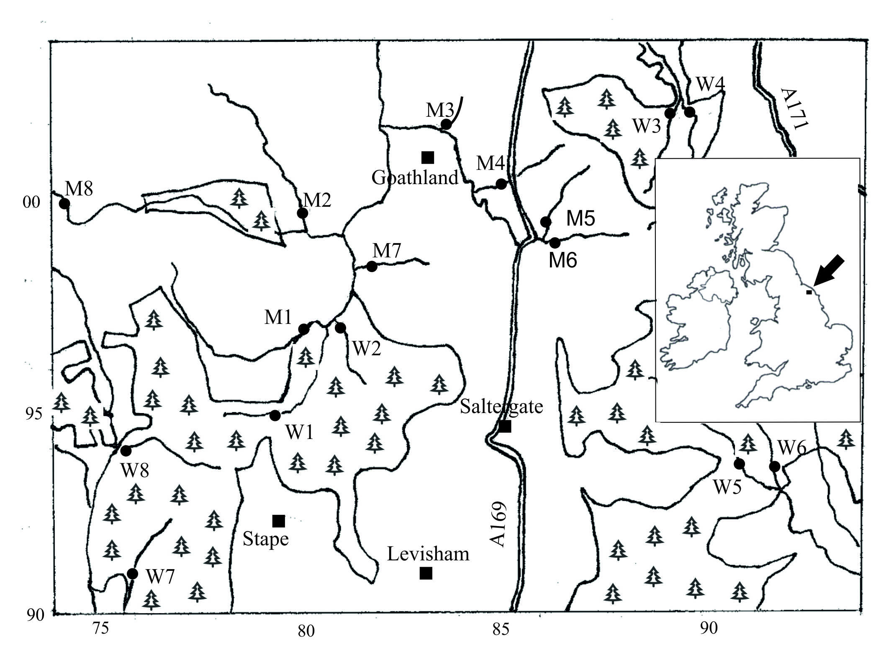

**Fig. 1.** Locations (closed circles) of the woodland (W) and moorland (M) study sites (see Table 1). Watercourses sampled are shown (single black lines), with areas of coniferous plantation (tree symbols enclosed in single back lines), and major roads (double lines). Squares show settlements within the region. OS grid refs (SE) are given at 5km intervals. Insert shows location within UK.

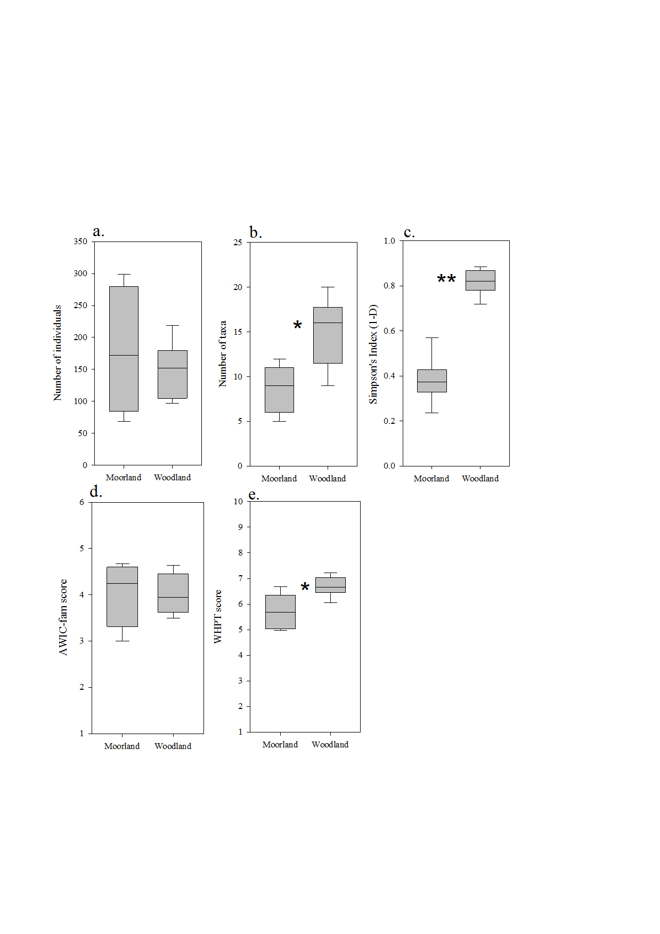

**Fig. 2.** Comparison of the invertebrate communities of upland streams of moorland (n = 8) and coniferous woodland sites (n = 8) in the North York Moors National Park, UK, obtained by 3 minute kick samples. Plots show the median (horizontal line), interquartile range (box), and the range (whiskers) for a. number of individuals sampled, b. number of taxa sampled, c. Simpson’s diversity, d. the AWIC-fam scores, and e. the WHPT scores (see text for explanations). * p < 0.01, ** p < 0.001, independent-samples t.

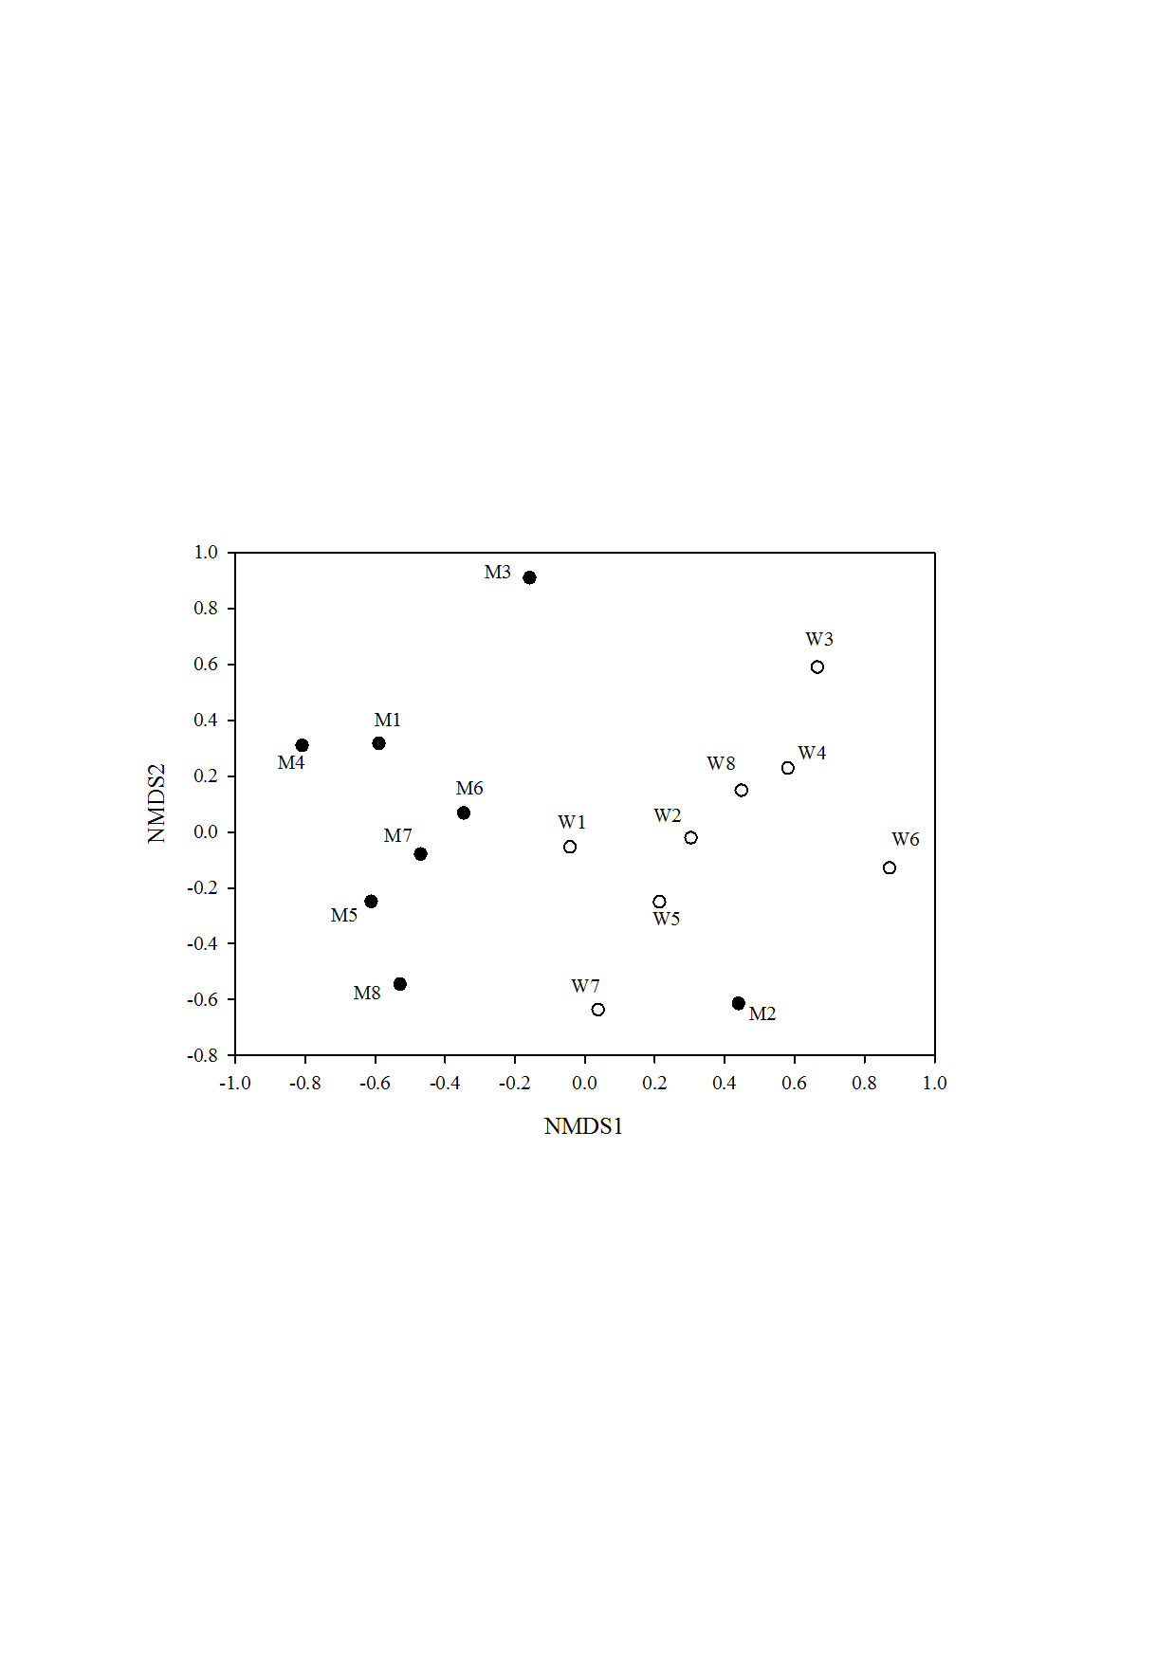

**Fig. 3.** Non-metric Multi-Dimensional Scaling (all taxa combined) site plot. Moorland sites are closed circles, woodland sites open circles. Labels correspond to sites in Table 1 and Fig. 1. The Bray-Curtis dissimilarity measure was used, with square root transformation, stress =0.157.

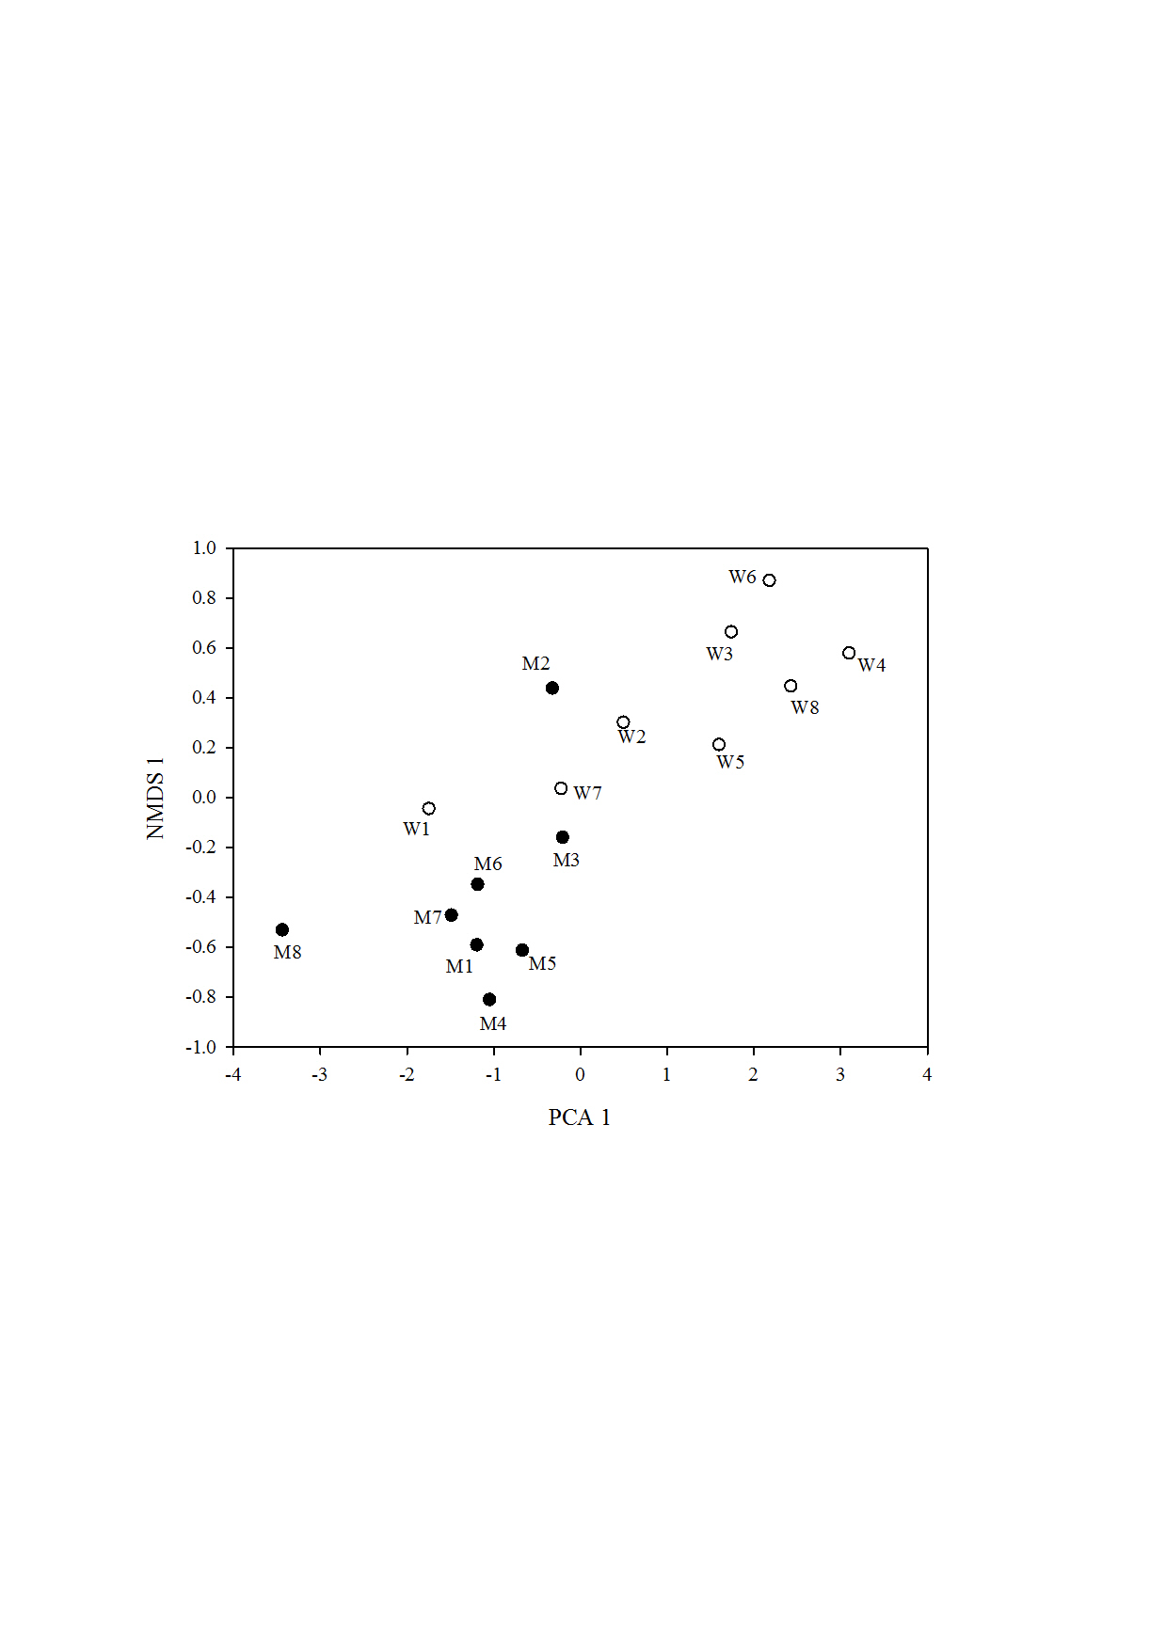

**Fig. 4.** The first NMDS axis (all taxa combined) summarizing invertebrate community composition across sites, against the first Principle Component axis, summarizing abiotic differences across sites. Moorland sites are closed circles, and woodland sites are open circles. Site labels correspond to Table 1 and Fig. 1. For the NMDS, the Bray-Curtis dissimilarity measure was used, with square root transformation, stress =0.157. The PCA was based on the correlation matrix using standardized data.

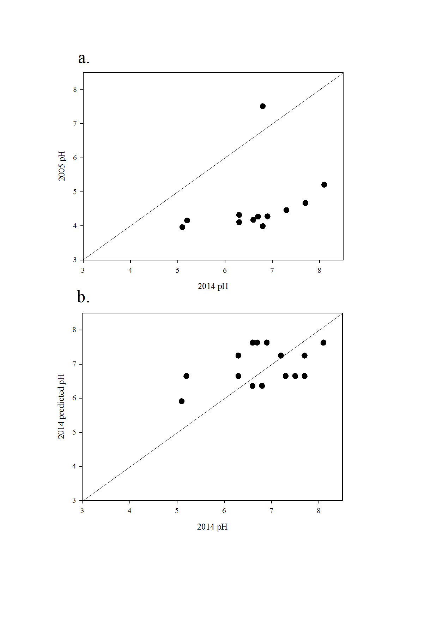

**Fig. 5.** Stream pH across sites in June-July 2014 (x-axes) compared with a. pH at 12 of the same sites in March 2005 and b. pH predicted from the AWIC-fam scores (Davy-Bowker et al. 2005) of 2014 invertebrate communities. The solid line is *y* = *x*.