Figure 1: Search process
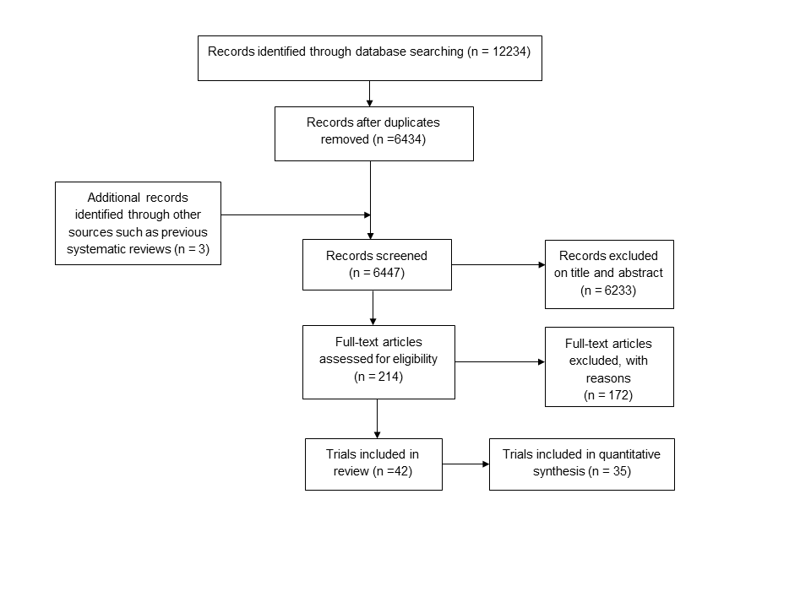
Figure 2: Forest plots for treatment comparisons and perinatal outcomes
2a: Packages of care (starting with dietary modification) versus routine care: dichotomous and continuous outcomes
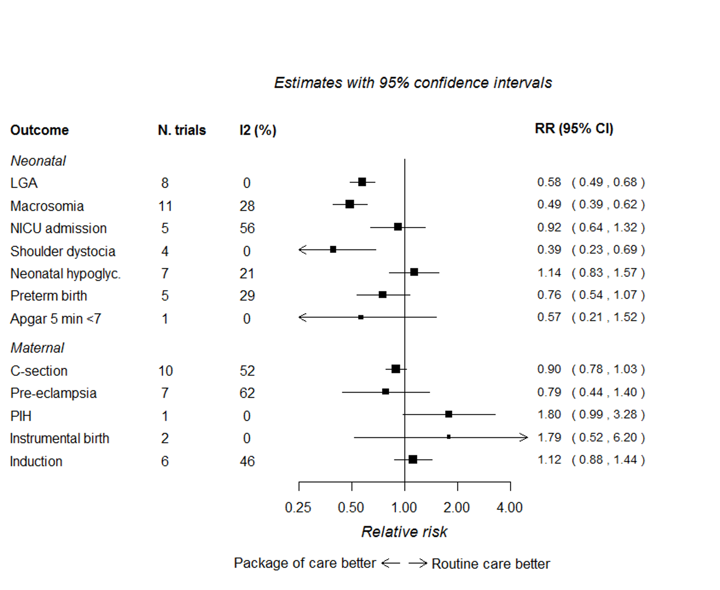
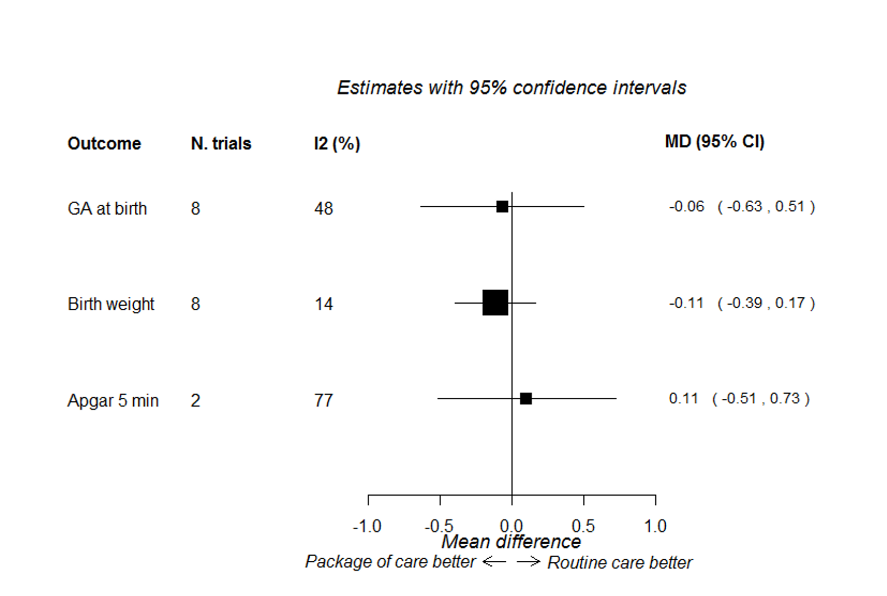

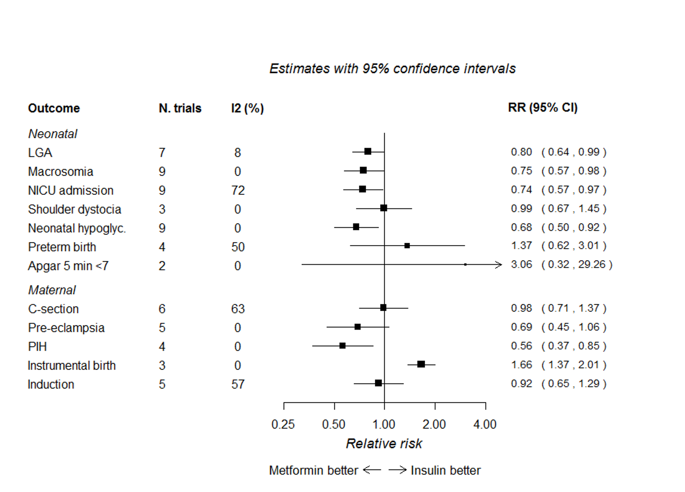
Figure 2b: Metformin versus insulin: dichotomous and continuous outcomes
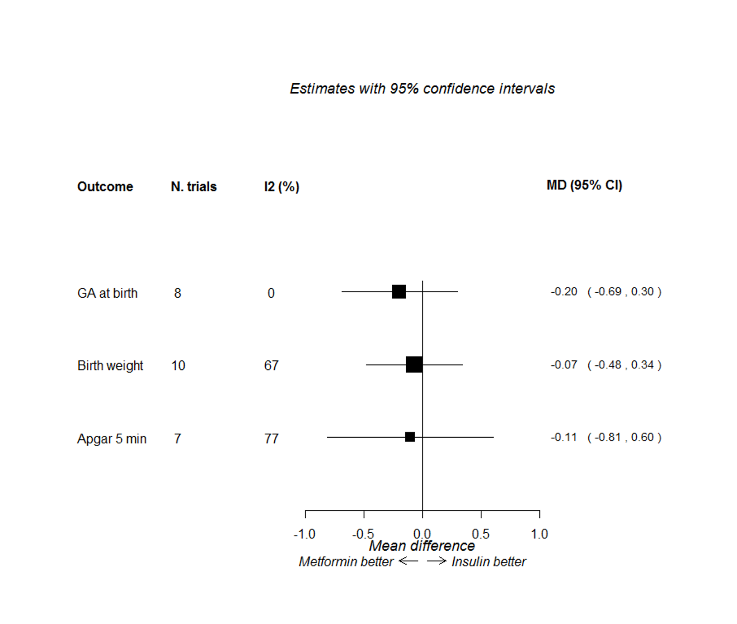

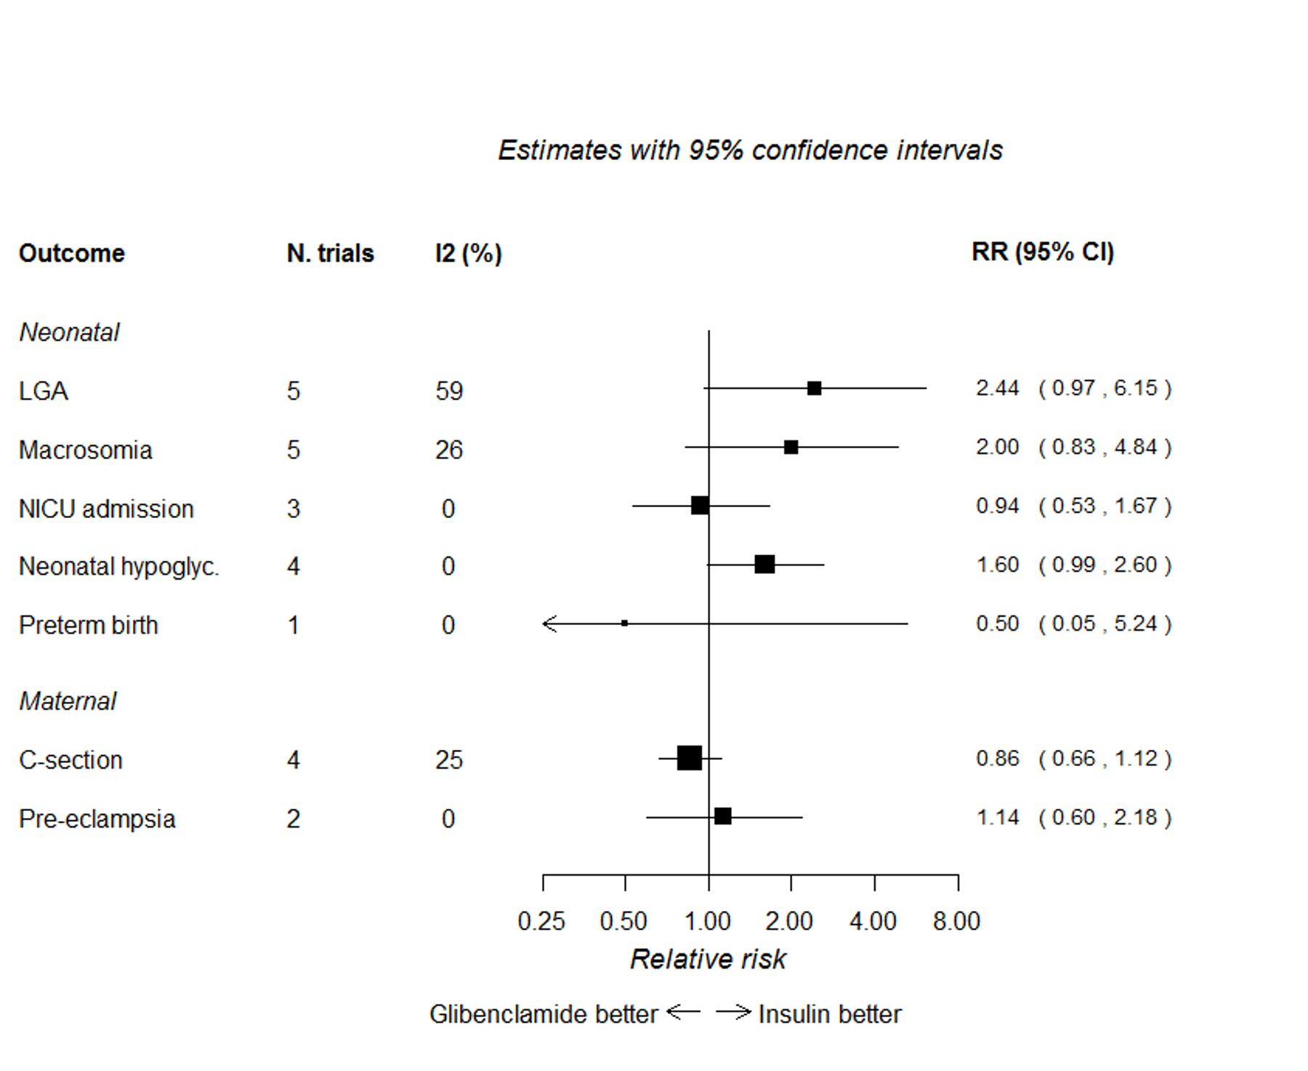
Figure 2c: Glibenclamide versus insulin: dichotomous and continuous outcomes

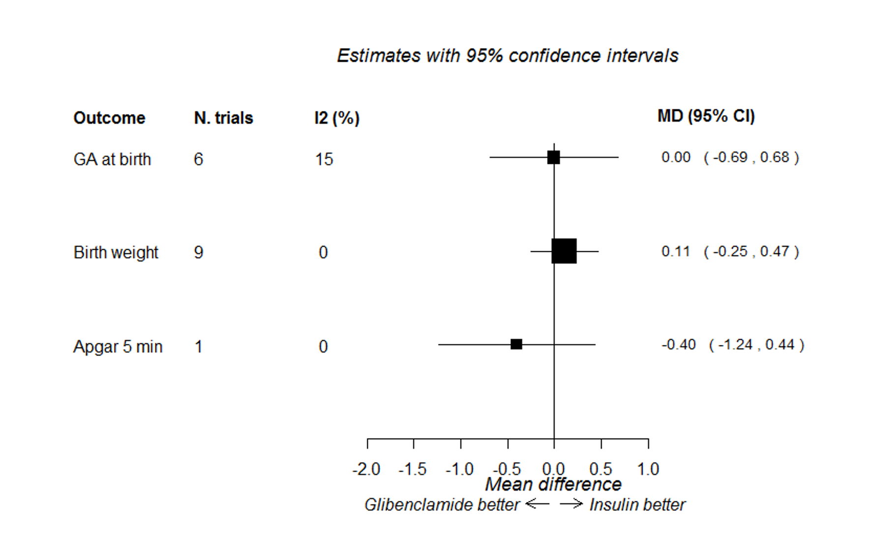

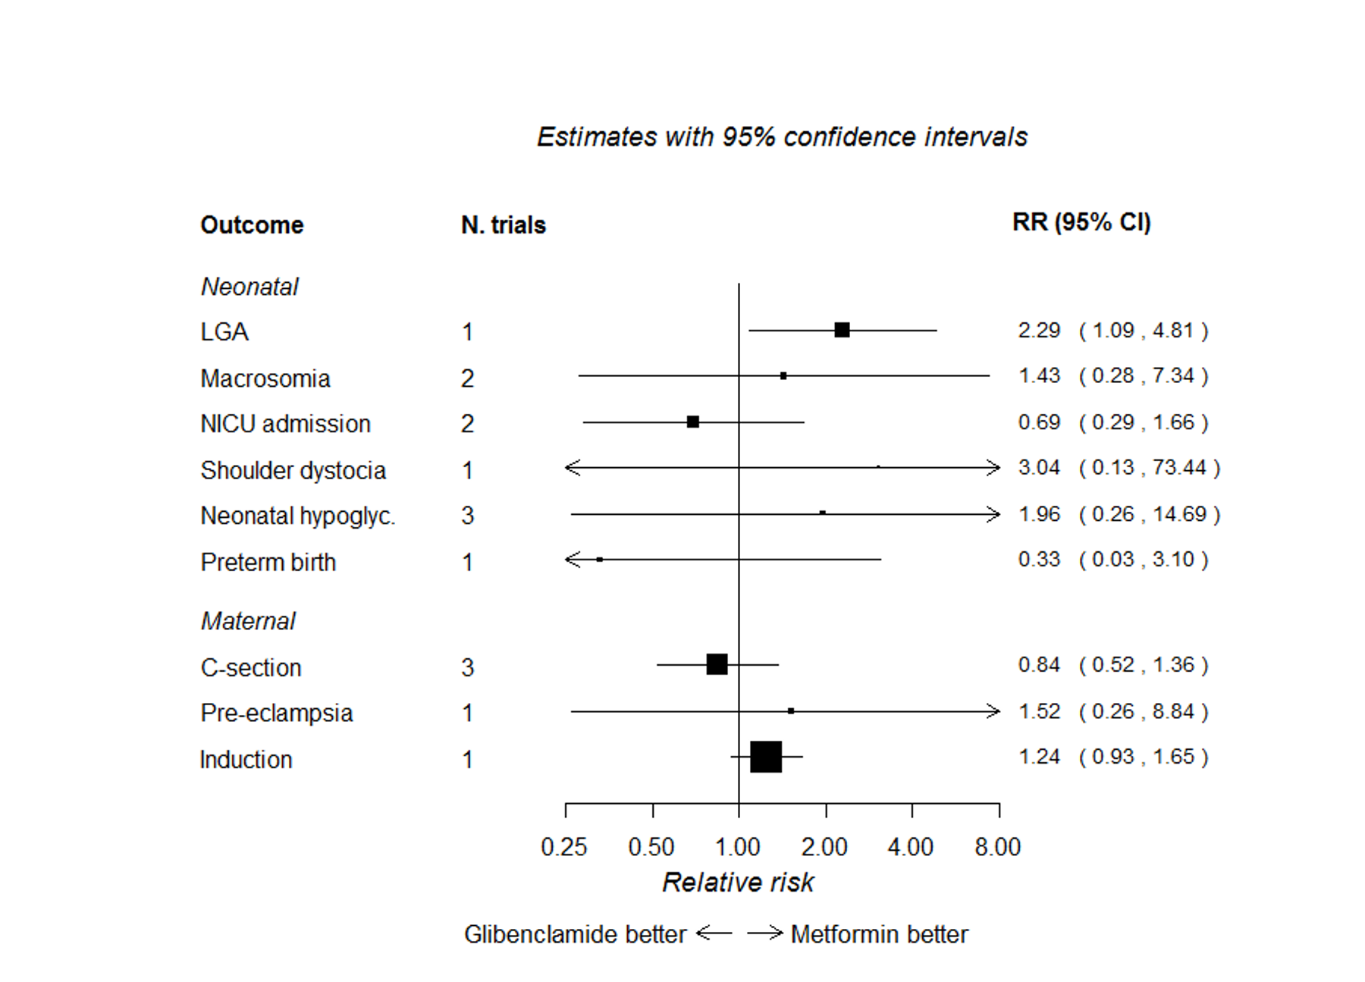
Figure 2d: Glibenclamide versus metformin: dichotomous and continuous outcomes
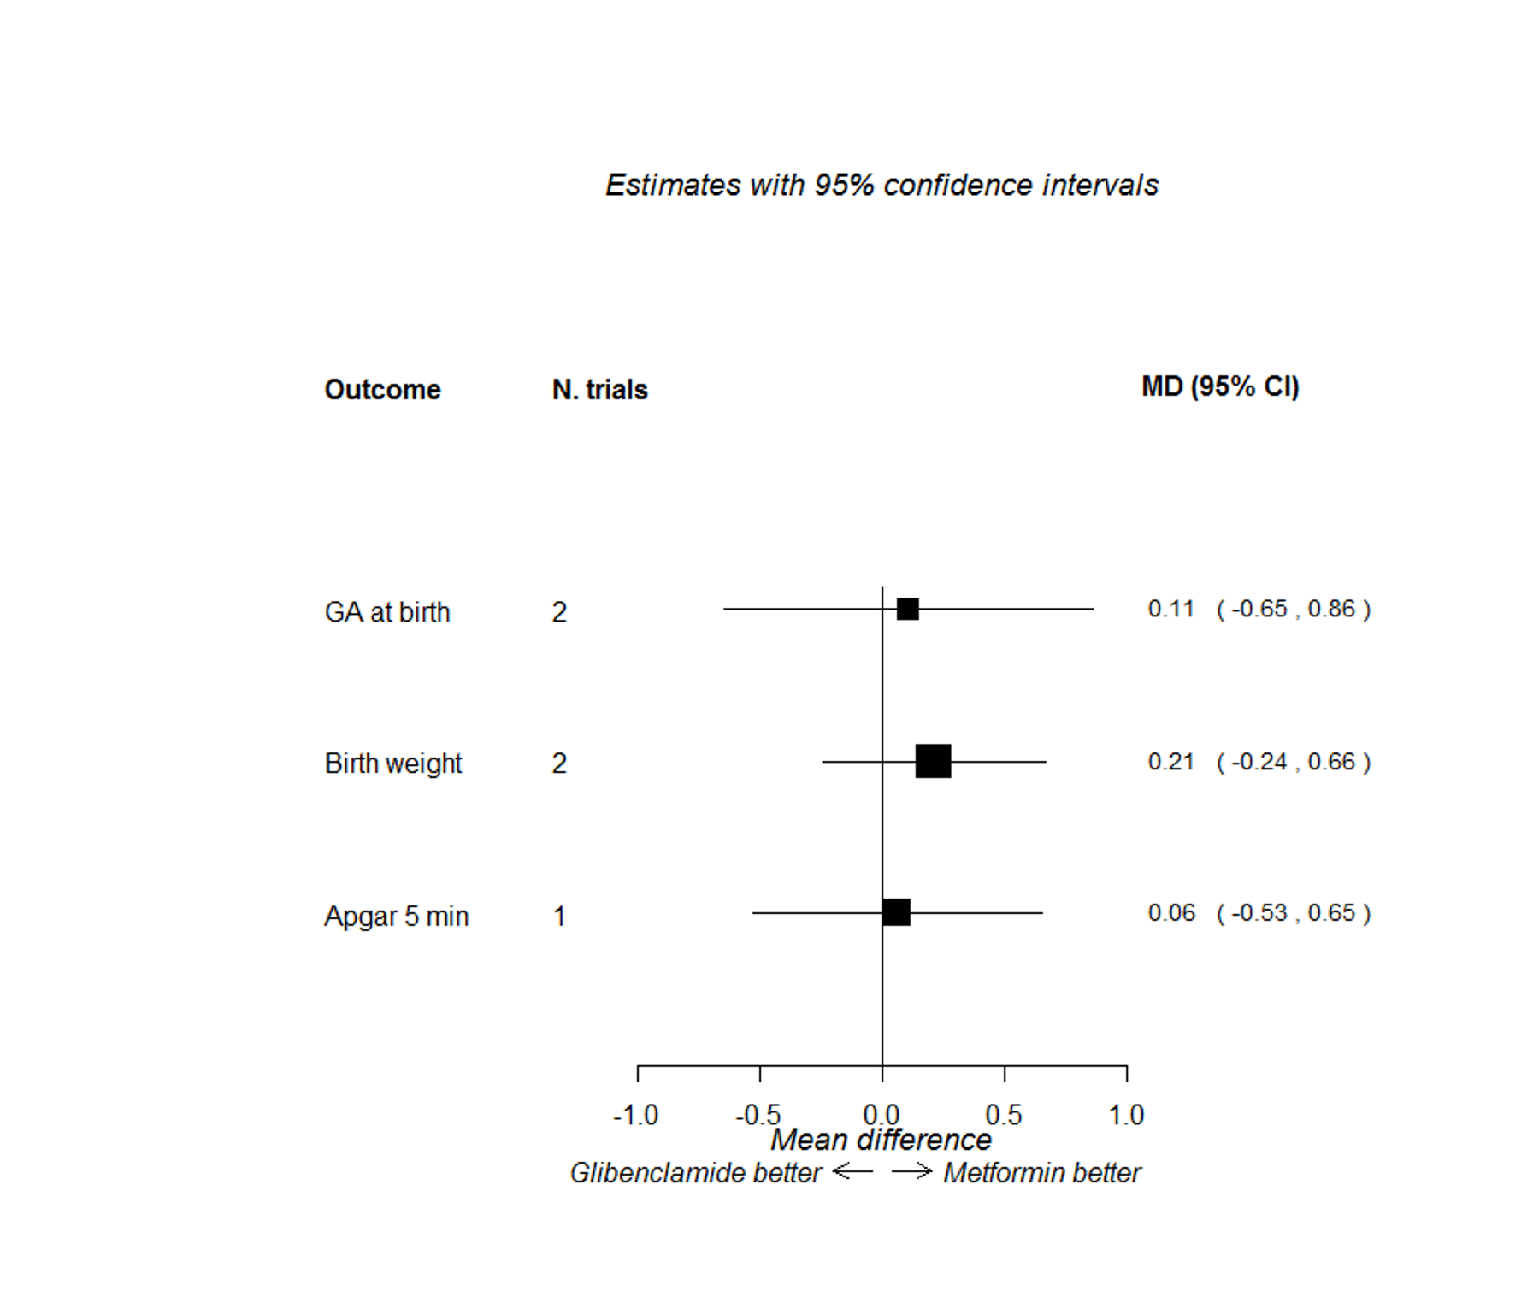

Figure 3: Network meta-analysis, relationship of treatment comparisons
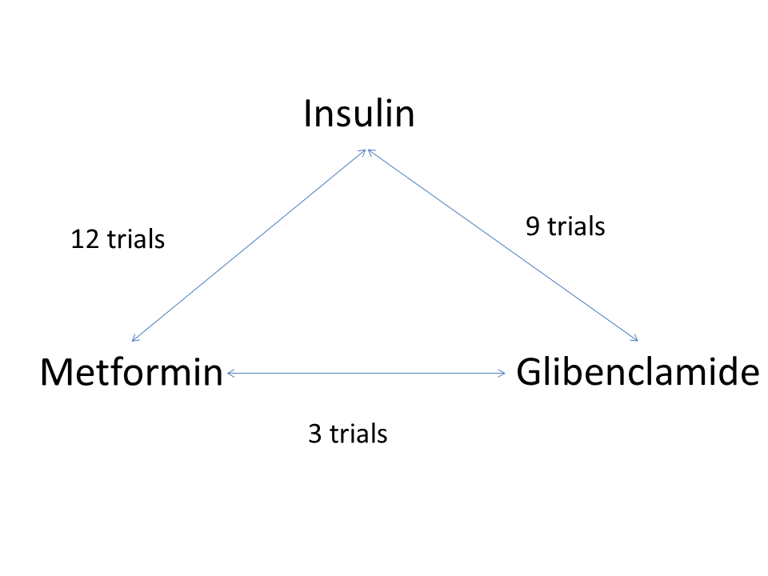

Figure 4: Network meta-analysis comparing metformin, glibenclamide and insulin. First better – treatment listed first in the outcome column is superior; second better – treatment listed second in the outcome column is superior.
