**UNIVERSITY OF YORK**

**Social Policy Research Unit**

**TEENAGE CONCEPTIONS AND DEPRIVATION**

[Jonathan Bradshaw](https://pure.york.ac.uk/portal/en/researchers/jonathan-richard-bradshaw(905fa104-a977-4863-83ff-cf28283fe3a2)/profile.html) and [Karen Bloor](https://www.york.ac.uk/healthsciences/our-staff/karen-bloor/)

31 March 2017

**Background**

Between 2000 and 2015 the rate of conceptions per 1000 women under 18 has fallen by 52% in England and Wales. Most of the reduction has occurred since 2007 and the trend is still on a steep downward trajectory (see Figure 1).

**Figure 1: Conceptions per 1000 women under 18. England and Wales**

The Office for National Statistics has a [*Conceptions-Deprivation Analysis Toolkit*](http://webarchive.nationalarchives.gov.uk/20160105160709/http:/www.ons.gov.uk/ons/rel/regional-trends/area-based-analysis/conceptions-deprivation-analysis-toolkit/conceptions-deprivation-measures--2009-11.html) which is designed to enable the analysis of teenage conceptions by the deprivation of the area. At the moment this is only available for the period 2009-11. In this note we have analysed the conception data up 2015 and related it to the latest [Index of Deprivation](https://www.gov.uk/government/statistics/english-indices-of-deprivation-2015) (ID) for 2015 at upper tier local authority level.

**Findings**

It is already well known[1],[2] that there is a strong association between the rate of teenage conceptions and the level of deprivation of an area. Figures 2 and 3 show the conception rate in 2000 and 2015 compared with the ID rank. The association between teenage conceptions and deprivation has weakened slightly as the conception rate has fallen. This is because there has been a slight tendency for the more deprived LAs to have had larger reductions in their conceptions rates (see Figure 4).

**Figure 2: LA under 18 conception 2000 rate by ID rank**

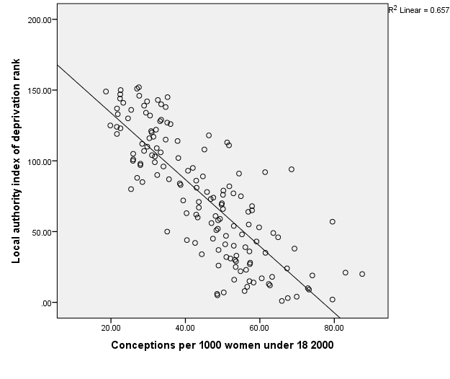

**Figure 3: LA under 18 conception 2015 rate by ID ranks**

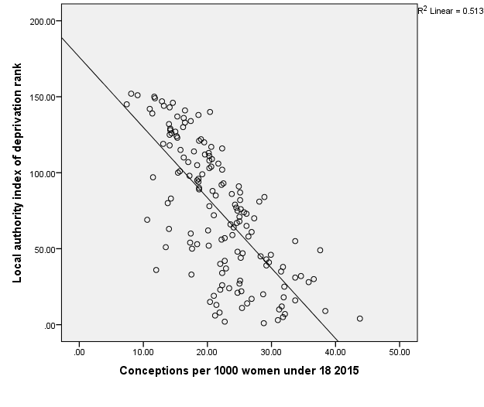

**Figure 3: % change in LA under 18 conception rates 2000-2015 by ID ranks**

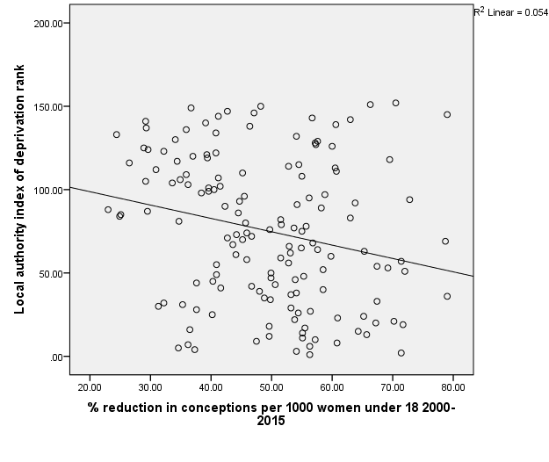

There are some quite deprived LAs among the 20 LAs with the largest reduction in their conception rates 2000-2015, including Hackney (see Table 1). Generally London Boroughs have had the largest reductions in teenage conceptions.

**Table 1: The 20 LAs with the largest % reduction in teenage conceptions 2000-2015 by their ID rank**

|  |  |  |  |  |
| --- | --- | --- | --- | --- |
| Deprivation rank | Local authority | Teenage conception rate 2000 | Teenage conception rate 2015 | % reduction in teenage conceptions 2000-2015 |
| 36 | Westminster | 57.2 | 12.0 | 79.0 |
| 145 | Bracknell Forest | 35.2 | 7.4 | 79.0 |
| 69 | Kensington and Chelsea | 49.7 | 10.6 | 78.7 |
| 94 | Wandsworth | 68.5 | 18.6 | 72.8 |
| 51 | Camden | 48.3 | 13.5 | 72.0 |
| 19 | Haringey | 74.1 | 21.0 | 71.7 |
| 2 | Hackney | 79.5 | 22.7 | 71.4 |
| 57 | City of London | 79.5 | 22.7 | 71.4 |
| 152 | Wokingham | 27.5 | 8.1 | 70.5 |
| 21 | Southwark | 83.0 | 24.7 | 70.2 |
| 118 | Merton | 46.3 | 14.1 | 69.5 |
| 53 | Hammersmith and Fulham | 59.8 | 18.4 | 69.2 |
| 33 | Brent | 53.7 | 17.5 | 67.4 |
| 54 | Bristol, City of | 53.0 | 17.3 | 67.4 |
| 20 | Lambeth | 87.5 | 28.7 | 67.2 |
| 151 | Windsor and Maidenhead | 27.0 | 9.1 | 66.3 |
| 13 | Islington | 62.4 | 21.4 | 65.7 |
| 63 | Ealing | 40.3 | 14.0 | 65.3 |
| 24 | Lewisham | 67.3 | 23.4 | 65.2 |
| 15 | Waltham Forest | 57.2 | 20.4 | 64.3 |

Over the period since 2000 some large deprived LAs have achieved very large reductions in teenage conceptions (Table 2). Manchester, the most deprived local authority, has achieved a reduction of 56.3% (295 teenage births) and Birmingham has 55.1% (588) fewer teenage births.

**Table 2: Most deprived 20 LAs in ID 2015 by % reduction in the rate of teenage conceptions**

|  |  |  |  |  |
| --- | --- | --- | --- | --- |
| Deprivation rank | Local Authority | Teenage conception rate 2000 | Teenage conception rate 2015 | % reduction in teenage conceptions 2000-2015 |
| 1 | Manchester | 65.9 | 28.8 | 56.3 |
| 2 | Hackney | 79.5 | 22.7 | 71.4 |
| 3 | Barking and Dagenham | 67.5 | 31.0 | 54.1 |
| 4 | Blackpool | 69.9 | 43.8 | 37.3 |
| 5 | Knowsley | 48.6 | 31.8 | 34.6 |
| 6 | Tower Hamlets | 48.5 | 21.2 | 56.3 |
| 7 | Liverpool | 50.3 | 32.1 | 36.2 |
| 8 | Newham | 55.9 | 21.9 | 60.8 |
| 9 | Kingston upon Hull, City of | 73.2 | 38.4 | 47.5 |
| 10 | Nottingham | 72.9 | 31.2 | 57.2 |
| 11 | Birmingham | 56.6 | 25.4 | 55.1 |
| 12 | Sandwell | 62.7 | 31.6 | 49.6 |
| 13 | Islington | 62.4 | 21.4 | 65.7 |
| 14 | Leicester | 58.3 | 26.2 | 55.1 |
| 15 | Waltham Forest | 57.2 | 20.4 | 64.3 |
| 16 | Middlesbrough | 53.1 | 33.7 | 36.5 |
| 17 | Stoke-on-Trent | 60.5 | 26.9 | 55.5 |
| 18 | Wolverhampton | 63.3 | 31.9 | 49.6 |
| 19 | Haringey | 74.1 | 21.0 | 71.7 |
| 20 | Lambeth | 87.5 | 28.7 | 67.2 |

But there are also some very deprived local authorities that have achieved some of the lowest reductions in teenage pregnancy including Knowsley, Halton and Sunderland (see Table 3).

**Table 3: The 20 LAs with the smallest % reduction in the rate of teenage conceptions by deprivation rank**

|  |  |  |  |  |
| --- | --- | --- | --- | --- |
| Deprivation rank | LA | Teenage conception rate 2000 | Teenage conception rate 2015 | % reduction in teenage conceptions 2000-2015 |
| 88 | Cumbria | 27.0 | 20.8 | 23.0 |
| 133 | Cambridge | 21.8 | 16.5 | 24.4 |
| 84 | Stockton-on-Tees | 38.5 | 28.9 | 24.9 |
| 85 | Norfolk | 28.5 | 21.3 | 25.1 |
| 116 | Stafford | 30.3 | 22.3 | 26.5 |
| 125 | North Yorks | 19.8 | 14.1 | 28.9 |
| 105 | Devon | 26.0 | 18.4 | 29.2 |
| 141 | Hampshire | 23.3 | 16.5 | 29.2 |
| 137 | Hertford | 21.6 | 15.3 | 29.3 |
| 87 | Lancashire | 35.6 | 25.1 | 29.5 |
| 124 | Gloucester | 21.6 | 15.2 | 29.6 |
| 112 | Essex | 28.4 | 19.6 | 30.9 |
| 30 | Halton | 53.3 | 36.6 | 31.3 |
| 123 | Dorset | 22.6 | 15.3 | 32.2 |
| 32 | Sunderland | 51.0 | 34.6 | 32.2 |
| 104 | Kent | 31.0 | 20.6 | 33.6 |
| 130 | West Sus | 24.6 | 16.2 | 34.1 |
| 117 | Poole | 31.4 | 20.6 | 34.4 |
| 5 | Knowsley | 48.6 | 31.8 | 34.6 |
| 81 | Medway | 43.0 | 28.1 | 34.7 |

Finally Table 4 lists the 20 LAs still with the highest teenage conception rates in 2015. Blackpool has reduced its teenage conception rate by less than average and now has the highest rate. Hull has reduced its conception rate by more than average but still has the second highest rate of all English LAs.

**Table 4: The 20 LAs with the highest rate of teenage conceptions in 2015**

|  |  |  |  |  |
| --- | --- | --- | --- | --- |
| Deprivation rank | LA | Teenage conception rate 2000 | Teenage conception rate 2015 | % reduction in teenage conceptions 2000-2015 |
| 4 | Blackpool | 69.9 | 43.8 | 37.3 |
| 9 | Kingston upon Hull, City of | 73.2 | 38.4 | 47.5 |
| 49 | North East Lincolnshire | 63.6 | 37.6 | 40.9 |
| 30 | Halton | 53.3 | 36.6 | 31.3 |
| 28 | Hartlepool | 57.4 | 35.8 | 37.6 |
| 32 | Sunderland | 51.0 | 34.6 | 32.2 |
| 31 | Barnsley | 52.1 | 33.7 | 35.3 |
| 16 | Middlesbrough | 53.1 | 33.7 | 36.5 |
| 55 | Redcar and Cleveland | 57.0 | 33.7 | 40.9 |
| 7 | Liverpool | 50.3 | 32.1 | 36.2 |
| 25 | Salford | 53.5 | 32.0 | 40.2 |
| 18 | Wolverhampton | 63.3 | 31.9 | 49.6 |
| 5 | Knowsley | 48.6 | 31.8 | 34.6 |
| 38 | Doncaster | 69.3 | 31.8 | 54.1 |
| 12 | Sandwell | 62.7 | 31.6 | 49.6 |
| 35 | Walsall | 61.5 | 31.5 | 48.8 |
| 10 | Nottingham | 72.9 | 31.2 | 57.2 |
| 3 | Barking and Dagenham | 67.5 | 31.0 | 54.1 |
| 46 | Coventry | 64.9 | 29.9 | 53.9 |
| 41 | St. Helens | 50.7 | 29.6 | 41.6 |

The background data for this analysis including the results for other LAs can be obtained by emailing [jonathan.bradshaw@york.ac.uk](mailto:jonathan.bradshaw@york.ac.uk).

1. Bradshaw, J. Finch, N, and Miles JNV (2005) Deprivation and variations in teenage conceptions and abortions in England, *J Fam Plann Reprod Health Care* 2005: 31 (1) 15-19.
2. Wellings, C. et al (2016) Changes in conceptions in women younger than 18 years and the circumstances of young mothers in England in 2000-2012: an observational study, *Lancet* 388, 586-595