**Mechanistic Insights into the Bleaching of Melanin by Alkaline Hydrogen Peroxide**

R. A. W. Smith,1a B. Garrett,1a K. R. Naqvi,1 A. Fülöp,1 S. Godfrey,2 J. Marsh,3 & V. Chechik1*

1Department of Chemistry, University of York, Heslington, York, YO10 5DD.

2Procter & Gamble Service GmbH, Sulzbacher Str. 40, 65824 Schwalbach am Taunus, Germany

3The Procter & Gamble Company, Mason Business Center, 8700 Mason Montgomery Road, Mason, Ohio, 45040

aThese authors contributed equally

Corresponding author: Victor Chechik, Department of Chemistry, University of York, Heslington, York YO10 5DD; phone +44-1904-324185; email: [victor.chechik@york.ac.uk](mailto:victor.chechik@york.ac.uk)

**Abstract**

This work aims to determine the roles of reactive oxygen species HO∙ and HO2- in the bleaching of melanins by alkaline hydrogen peroxide. Experiments using melanosomes isolated from human hair indicated that the HO∙ radical generated in the outside solution does not contribute significantly to bleaching. However, studies using soluble *Sepia* melanin demonstrated that both HO2- and HO∙ will individually bleach melanin. Additionally, when both oxidants are present, bleaching is increased dramatically in both rate and extent. Careful experimental design enabled the separation of the roles and effects of these key reactive species, HO∙ and HO2-. Rationalisation of the results presented, and review of previous literature, allowed the postulation of a simplified general scheme whereby the strong oxidant HO∙ is able to pre-oxidise melanin units to *o*-quinones enabling more facile ring opening by the more nucleophilic HO2-. In this manner the efficiency of the roles of both species is maximised.

**Keywords**: melanin bleaching; hydrogen peroxide; reactive oxygen species; superoxide; hydroxyl radical; Fenton chemistry.

**Introduction**

Human hair colour is due to the presence of melanin granules (melanosomes) within hair. These melanosomes contain melanin pigments that are believed to have antioxidant and photo protective roles [1, 2]. The precise structure of this highly insoluble class of compounds has not been elucidated. However, in the case of eumelanins (responsible for brown/black hair colours) they are proposed to consist of oligomeric 5,6-dihydroxyindole (DHI) derivatives. These derivatives are aggregated into nanoparticles and further encapsulated into melanosomes (Fig.1). These DHI derivatives are synthesised in the body from tyrosine in a process known as melanogenesis [3].

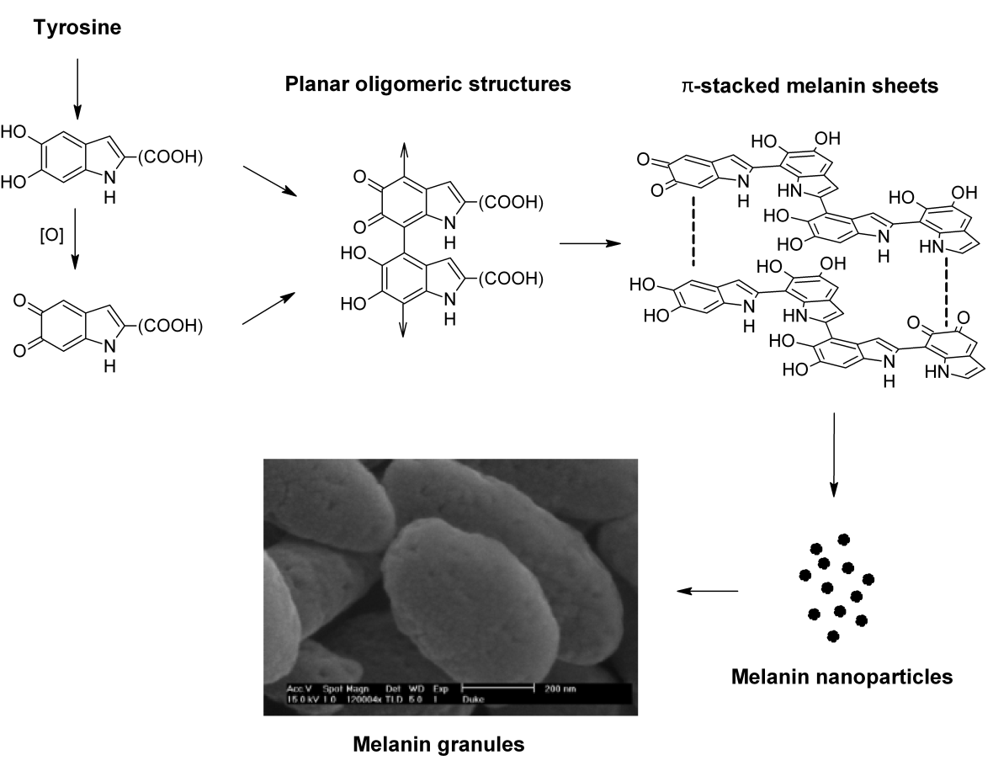

*Figure 1: Schematic overview of eumelanin formation, including the structures of the monomeric units 5,6-dihydroxyindole (DHI) and 5,6-dihydroxyindole carboxylic acid (DHICA) and the hierarchical aggregation of melanin sheets into nanoparticles and granules.*

Cosmetic hair bleaching relies on destructive oxidation of melanin pigments, usually as a result of treatment by hydrogen peroxide under alkaline conditions (ammonia or monoethanolamine). Currently the roles of the base and reactive oxygen species (ROS) in the bleaching of melanin by hydrogen peroxide are not well understood. Mechanistic insights into this melanin oxidation are of interest to the cosmetic industry and may inform the development of hair bleaching and colouring products.

Conceptually there are at least three distinct steps that need to take place for the bleaching of melanin within the hair to occur: 1) Diffusion of oxidants/base into the hair to access the melanosomes. 2) Rupture of the melanosomal membrane and the solubilisation of the released melanin nanoparticles and 3) Action of the oxidant/oxidants on the melanin pigments.

A body of literature exists which investigate the processes involved in bleaching/decolourisation of melanin within hair [4-6], isolated melanosomes [4, 6-8], or synthetic melanin pigments [9-12]. Elucidating precise mechanisms is complicated by the fact that several processes are happening at once and that the reaction constituents may also play different roles at different stages.

*Bleaching of melanin*

Metal ions in the hair fibre, such as Fe3+ and Cu2+, may lead to Fenton [14] or Fenton-like reactions, which decompose hydrogen peroxide during bleaching. This decomposition results in the production of reactive oxygen species (ROS), such as hydroxyl radicals (HO∙), perhydroxyl radicals (HO2∙) and superoxide anions (O2∙-).

There has been considerable debate in the literature over the precise mechanism of the deceptively simple Fenton reaction, predominantly as to whether the reactive intermediate is a hydroxyl radical or a hypervalent iron complex (such as ferryl ion LxFe=O) [15, 16]. For this work the distinction between the reactive intermediates was not made, as the reactivity of these two intermediates is likely to be similar. Instead HO· is used to represent a reactive intermediate.

Despite the fact that the precise structural details of melanin are unknown, there is evidence that the main substructure is based upon 5,6-dihydroxyindole (DHI) derivatives. This evidence comes from studies of the breakdown of various melanins to pyrrolic acids *via* bleaching processes [9, 10, 17-19]. Several complex mechanisms for this process have been proposed [9-11]. A general consensus is that a melanin subunit must first be oxidised from its *o*-hydroquinone form through a semiquinone radical to the *o*-quinone form. This step is a reversible equilibrium that occurs naturally in melanin and is proposed to be the origin of its antioxidant activity [1]. The *o*-quinone can then be irreversibly oxidised ultimately to a pyrrolic acid. A simplified mechanism to represent this is shown in Fig 2.

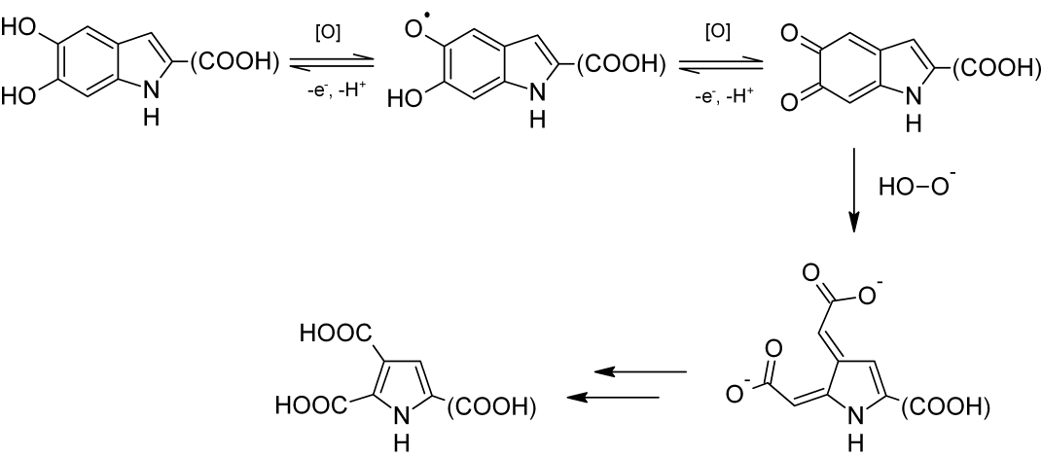

*Figure 2: A generalised and simplified melanin bleaching scheme showing how a monomeric 5,6-dihydroxyindole (DHI) unit that comprises melanin can be oxidised ultimately to a pyrrolic acid [11].*

The identities of the oxidising species for the reversible and irreversible oxidation stages are difficult to determine. HO∙ radicals have been suggested to be involved in the breakdown of melanin, though the stages at which they are involved have not been postulated. These radicals are presumed to be produced *via* site-specific Fenton (-like) reactions between melanin bound metals and hydrogen peroxide [11]. It has also been shown that radiolytically generated hydroxyl radicals can lead to both reversible and irreversible oxidation of melanin [20].

In addition, it is likely that the perhydroxyl anion (present at high pH from the deprotonation of hydrogen peroxide) is responsible for at least some of the bleaching [11]. It has also been shown that superoxide anion (O2·-) can accept electrons from melanin [21, 22], and that singlet oxygen (1O2) can lead to visible bleaching of melanin [22].

*Role of base*

Current literature suggests that the ammonia used in hair bleaching can play several roles. Firstly, it has the effect of swelling the hair fibres allowing oxidants into the cortex, where melanin is found [13]. Secondly, an alkaline pH is necessary for deprotonation of H2O2 (pKa = 11.65) [23] and generation of the perhydroxyl anion, believed to be an important oxidant of melanin [11]. Finally, during melanin bleaching, it appears that the key role of the ammonia (and particular to ammonia over other bases) is to rupture the melanosomal membrane leading to release of melanin nanoparticles [4]. However, it is not known if the base plays a further role in melanin oxidation after this solubilisation.

This work set out to provide further insights into the mechanism of melanin bleaching in the context of understanding the chemistry of commercial hair bleaching formulations. The focus is placed on separating the role of hydroxyl radical from that of the perhydroxyl anion. A further aim was to provide evidence that the identity of the base is an important mechanistic consideration.

**Experimental**

Materials and chemicals

Intact eumelanin melanosomes were obtained by enzymatic extraction[24] from Asian black hair and provided by Proctor and Gamble.

*Sepia* melanin was isolated from the ink of the cuttlefish (Nortindal Sea Products, S.L) [25], this was then converted into *Sepia* melanin free acid (MFA) using 1 % hydrogen peroxide in aqueous ammonia [25].

Metal-reduced and metal-enriched melanins were produced following reported methods [27] from samples of isolated melanosomes.

30 % v/v (9.79 M) hydrogen peroxide and 25 % aqueous ammonia were from Fisher Scientific and used as received.

The N,N’-(5-nitro-1,3-phenylene)bisglutaramide (NPGA) was synthesized according to the procedure published in the literature [28].

All other reagents were obtained from Sigma-Aldrich and used as received. All experiments were performed at room temperature and pressure.

All pH measurements were obtained using a Jenway 3505 pH meter, which had been calibrated using buffers from Fisher (4.0, 7.0 and 9.2) on the day of use.

All solutions were prepared using deionised water.

Preparation of bleaching solutions

Isolated melanosome bleaching experiments:

pH 10.0 and 9.2 ammonia solutions were prepared fresh to final concentrations of 264 mM NH3, 756 mM H2O2 and 0.2 mM TEMPO (where required) in deionised water from stock solutions. pH was adjusted to the desired value by the addition of acetic acid.

Commercial formulations add hydrogen peroxide to their compositions and then buffer to the appropriate pH. However, these commercial formulations also contain chelants and stabilisers to prevent the hydrogen peroxide from decomposing prematurely. As some of the experiments in this study were performed under chelant-free conditions, these preservatives and chelants could not be added directly to the buffers. For this reason, hydrogen peroxide was added last to the pre-buffered formulations in order to initiate reactions immediately and any potential pH drop was recorded. In this way it was ensured that hydrogen peroxide was not decomposing within the buffers and the concentration was consistent across experiments.

Soluble melanin bleaching experiments:

pH 7.7 ammonia solution: The pH of a stock solution of 20 mM ammonia was adjusted to 7.7 by the addition of 1 M NH4Cl solution. CuSO4·5H2O, tetrasodium EDTA as a chelant, and NPGA as a hydroxyl radical probe were added, where appropriate, to final concentrations of 0.18 mM, 1.3 mM and 1.0 mM from stock solutions of 5.5 mM, 50 mM, and 10 mM, respectively. Finally, H2O2 was added to a final concentration of 0.979 M. Addition of the other reactants led to no change in the pH of the solutions.

pH 9.9 ammonia solution: The pH of a stock solution of 400 mM ammonia was adjusted to 10.0 by the addition of 400 mM NH4Cl solution. CuSO4·5H2O, tetrasodium EDTA as a chelant, and NPGA as a hydroxyl radical probe were added, where appropriate, to final concentrations of 0.18 mM , 1.3 mM and 1.0 mM from stock solutions of 5.5 mM, 50 mM, and 10 mM respectively. Finally, addition of H2O2 to a final concentration of 0.979 M gave a solution with a pH of 9.9

pH 9.4 ammonia solution: The pH of a stock solution of 20 mM ammonia was adjusted to 10.0 by the addition of stock 20 mM NH4Cl solution. CuSO4·5H2O and tetrasodium EDTA as a chelant, were added, where appropriate, to final concentrations of 0.18 mM and 1.3 mM from stock solutions of 5.5 mM and 50 mM respectively. Finally, addition of H2O2 to a final concentration of 0.979 M gave a solution with a pH of 9.4. The pH did not change appreciably (< 0.1 pH unit) during bleaching.

pH 9.4 sodium hydroxide solution: The pH of a stock solution of 20 mM NaOH solution was adjusted to 11.63 using dilute HCl. Addition of CuSO4·5H2O and tetrasodium EDTA to final concentrations of 0.18 mM and 1.3 mM, from stock solutions of 5.5 mM and 50 mM respectively. Finally, H2O2 was added to a final concentration of 0.979 M which gave a solution with a pH of 9.4. The pH did not change appreciably (> 0.1 pH unit) during bleaching.

Measuring radical production

The total amounts of radicals produced in the bleaching experiments using intact melanosomes were monitored using Electron Paramagnetic Resonance (EPR) to observe the decay of the radical signal of (2,2,6,6-tetramethylpiperidin-1-yl)oxyl (TEMPO) (See Fig. 4). Bleaching experiments were performed by adding 5 mg melanosomes to 1 ml of a freshly prepared pH 10.0 or 9.2 ammonia solution. The radical signal intensity was monitored as a function of time. EPR signal intensities were determined by double integrals. The signal due to TEMPO was found to decay over time in the presence of melanin. TEMPO signal decay was also observed in the presence of bleaching solution. Therefore, the TEMPO signal at t=0, plotted in Fig. 4, was normalised to a value of 100 and the data was adjusted to take into account the latter decay. Thus, these data can be seen as an indication of the additional radical production due to the bleaching process itself. A control experiment of Fenton reaction (H2O2 + Fe3+) in the presence of melanin and TEMPO showed that the TEMPO radical signal was rapidly lost.

EPR spectroscopy: A Bruker EMX-Micro EPR spectrometer operating at X-band was used to measure the TEMPO radical signal. A quartz capillary was used and the measurements were performed at a microwave power of 1 mW, using a time constant of 82.92 ms, a modulation frequency of 100 KHz, a modulation amplitude of 1 G, a receiver gain of 4 x 104, a centre field of 3485 G and a field sweep width of 120 G.

The radical production in soluble melanin bleaching compositions was monitored using an Hitachi U-3000 UV-vis spectrophotometer and the colorimetric probe N,N'-(5-nitro-1,3-phenylene)bisglutaramide (NPGA) [28]. pH 7.7 or 9.9 ammonia solutions containing 0.18 mM Cu2+, 0.979 M H2O2, 1 mM NPGA and 1.3 mM EDTA as chelant (where it was used) were monitored at room temperature. H2O2 was added last to initiate the reaction. These reagents and concentrations were chosen to represent possible environments inside the hair fibre during hair bleaching. A characteristic peak at 430 nm can be detected by UV-vis spectroscopy when NPGA is hydroxylated by hydroxyl radicals [28]. The structure of NPGA and the mechanism for its reaction with hydroxyl radical is shown in Fig. S1. Hydroxyl radical production was then quantitatively estimated and compared between chelant-containing and chelant-free formulations. *Sepia* melanin was omitted from these solutions, so that the absorbance due to melanin did not convolute spectra. However, the effect on chelant-containing compositions should be negligible.

Measuring the rate of bleaching

The rate of intact melanosome bleaching was measured by reflectance spectrophotometry. Bleaching experiments were performed by adding 5 mg melanosomes to 1 ml of a freshly prepared pH 10.0 or 9.2 ammonia solution in a small glass vial. At regular intervals the vial was shaken before the reflectance spectrum of the whole solution was measured from below. Reflectance spectra were measured using a MINOLTA CM-2600d spectrophotometer running SpectraMagic software. To ameliorate a potential source of error due to initial effervescence in these reactions, the spectra of the bleaching solutions at 2 minutes was taken as a reference. The change in overall colour, ΔE*ab (using SCI/100 and the CIE L*a*b* colour space) over the course of the reaction was then determined relative to this reference. When metal-doped melanin was studied, too much effervescence occurred to accurately monitor the extent of bleaching using this method.

Soluble melanin bleaching was studied by UV-vis spectroscopy. Formulations were set up that contained the same reagents as those used to detect hydroxyl radicals in soluble formulations. Conditions were identical, including concentrations and pH. However, the 1 mM NPGA was replaced by 0.06 mg ml-1 of Sepia MFA. The decrease in broadband absorbance, due to MFA, was monitored over the course of 2 hours, to give a kinetic plot of melanin bleaching. Due to the broadband absorbance of melanin, no wavelength maximum exists in the visible region (see Fig. S2). Hydrogen peroxide absorbs strongly in the UV region, so to monitor bleaching, a wavelength in the visible region was chosen to avoid convolution of the results. An arbitrary wavelength of 532 nm was used.

Concentrations of perhydroxyl anion / free ammonia concentrations

The perhydroxyl anion concentrations and free ammonia concentrations were determined for given experimental conditions using the free software CurTiPot v. 4.2.3 available online [29] and a pKa for H2O2 of 11.65 [23].

Attempted bleaching of melanosomes by superoxide radical

KO2 (71 mg, 1 mmol) was added to a suspension consisting of 5 mg isolated melanosomes, 1 mL deionised (DI) water and 35 *µ*L of 25% NH4OH solution. A large amount of effervescence could be seen but no visible bleaching effect on the melanin granules was observed.

Attempted bleaching of melanosomes by Fenton reaction

Isolated melanosomes (5 mg) were added to a freshly prepared suspension of FeSO4.7H2O (2 mg, 0.0072 mmol) in 1 mL of 30 % v/w H2O2 solution. Vigorous effervescence and gas evolution was observed which lasted for ca. 30 mins after which time the supernatant had turned a pale yellow indicating solubilisation of a small amount of melanin, however most of the melanin appeared unaffected.

**Results & Discussion**

*Bleaching of intact melanosomes*

Initially the bleaching of extracted melanosomes from human black hair was investigated. In order to simplify the experimental conditions, extracted melanosomes were studied rather than whole hair. Thus, it was possible to isolate the process of bleaching from factors such as diffusion rates of oxidants into the hair and any confounding effects from other hair constituents.

The roles of the different oxidants and the role of the base in the bleaching process are difficult to separate. The intention of the experiments outlined in this study was to pull apart these roles. A particular focus was placed on separating the roles of radical oxidants (i.e. HO·) from non-radical oxidants (i.e. HO2-).

*The effect of radicals*

It has been suggested that Fenton chemistry arises from the reaction of metals in the melanin with H2O2 [11]. This indicates that the amount of radical Fenton chemistry occurring can be modulated by changing the amount of metal present within the melanin. Therefore, enzymatically isolated human hair eumelanin melanosomes [24] were treated to prepare melanins with reduced metal and increased metal content (Fe or Cu) [27]. These were compared with untreated melanin. It was then possible to investigate whether the metal content, and hence the free radical production, correlated with bleaching efficiency. Radical production was monitored by the addition of TEMPO as a probe and EPR. Any O2-·/HO· or carbon centred radicals (from further reaction of O2-·/HO· with melanin) react with TEMPO. This led to a measureable decrease in radical signal intensity, which was detectable by EPR (see Fig. 3) [30, 31].

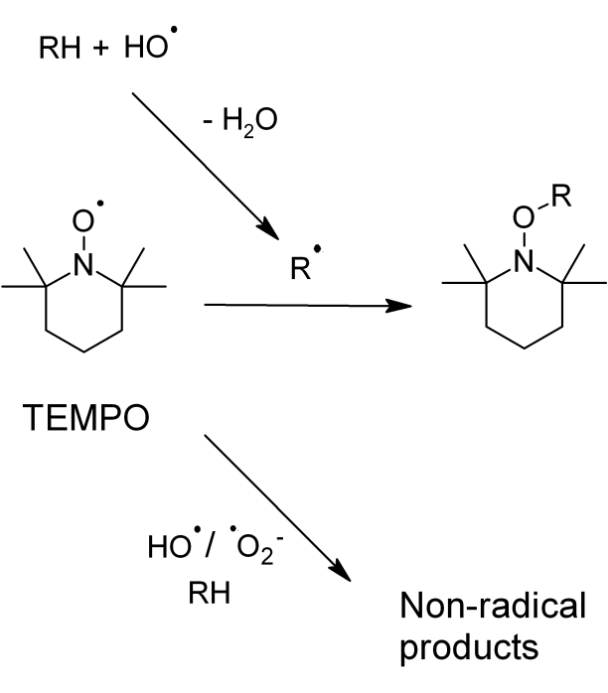

*Figure 3: TEMPO, (2,2,6,6-tetramethylpiperidin-1-yl)oxyl, can act as a radical probe [30, 31]. The loss of radical signal, measured by Electron Paramagnetic Resonance (EPR), reports on the extent of radical production occurring.*

The normalised results of bleaching different melanin samples in the presence of TEMPO are shown in Fig. 4. This shows a measure of the total extra radical production occurring during bleaching, after correcting for the (much smaller) individual effects of melanin and the H2O2/ammonia solution on the TEMPO signal over time (see experimental).

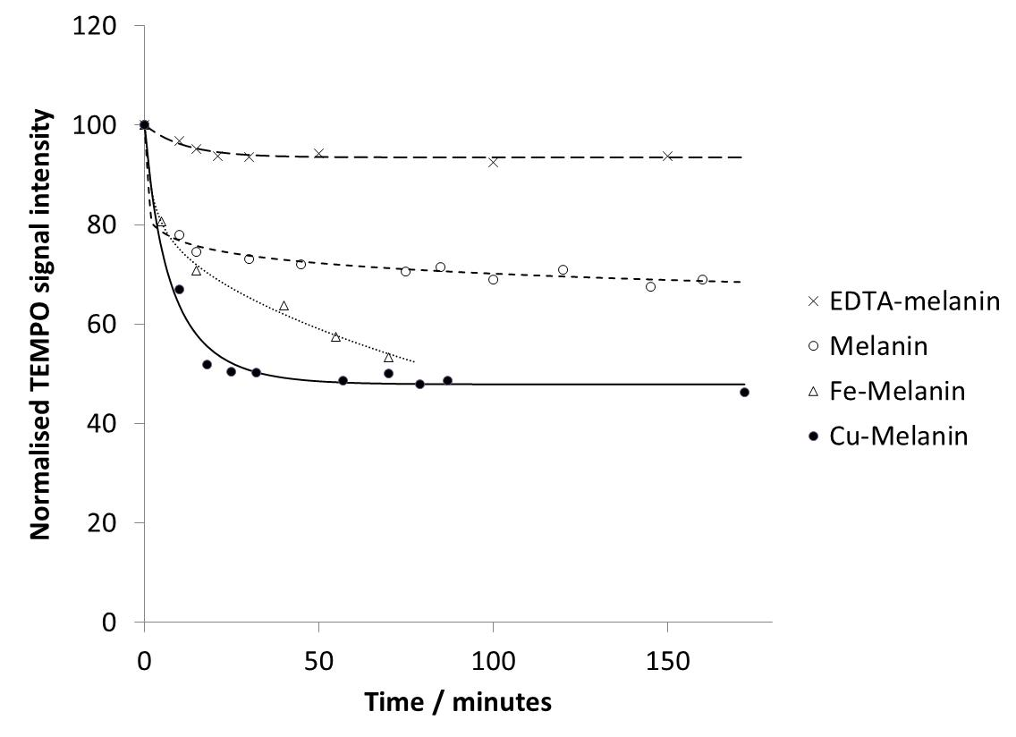

*Figure 4: Effect on TEMPO radical signal as a result of bleaching the different melanin samples by a pH 10.0 ammonia solution with 0.756 M H2O2, in the presence of TEMPO (radical probe) indicating the extent of radical production occurring.*

It is clear from Fig. 4 that the metal content in the melanin has a measurable effect on the total radical production occurring during its bleaching by H2O2/NH3 at pH 10. Washing melanin with EDTA removes >90% of Fe3+ and >70% of Cu2+ ions present [27] and it can be seen that there is very little radical production measured under bleaching conditions. In contrast, when melanins with increased metal content are placed under bleaching conditions there is a substantial increase in radical production when compared with untreated melanin. Note that the untreated melanin has a small endogenous metal content [32], which is leading to radical chemistry responsible for the 30% decrease in TEMPO concentration during bleaching.

Surprisingly, during these experiments the rates of bleaching of the different melanins appeared to be very similar by eye. Reflectance spectroscopy was used to investigate if this observation held up under a more quantitative analysis. Therefore, the bleaching of untreated and EDTA-washed melanins was investigated to confirm whether the determined radical production had any measurable effect on the rate of bleaching. Unfortunately, when these experiments were attempted using metal-enriched melanins, too much effervescence occurred to accurately monitor the extent of bleaching using this method. Reflectance spectroscopy has previously been used to compare rates of bleaching of dark hair *vs* red hair [6] but has not been used to measure bleaching of extracted melanosomes.

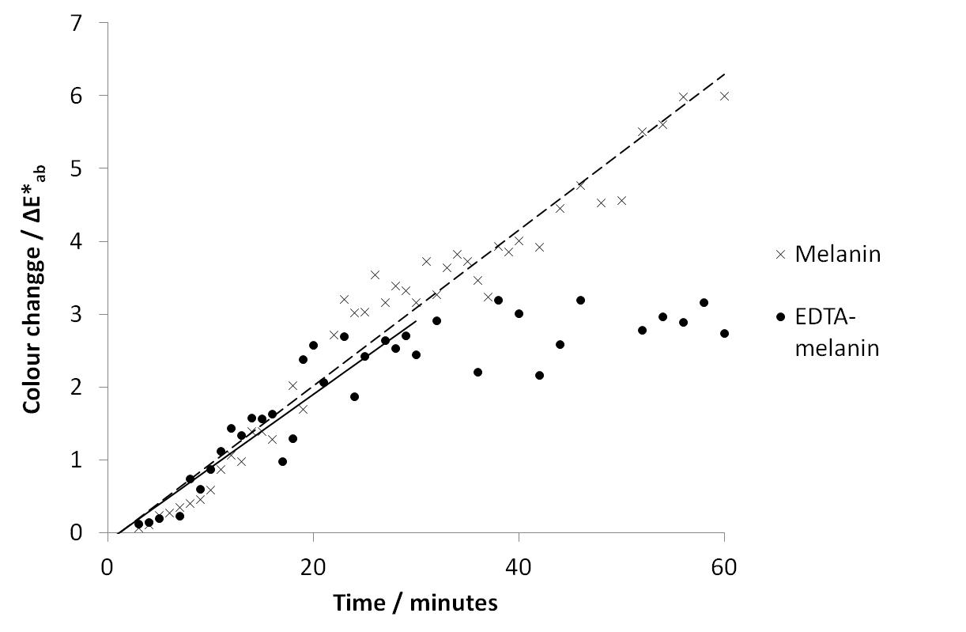

*Figure 5: Overall colour change (*ΔE*ab*) as a function of time during bleaching of untreated melanin and EDTA-melanin by a pH 10.0 ammonia solution with 0.756 M H2O2.*

It is evident from the plots in Fig. 5 that the rate of colour change (ΔE*ab / time) is comparable for both the untreated and metal-reduced melanin over the first 20-25 minutes of bleaching. This indicates that the increased radical production detected when bleaching the untreated melanin does not affect the initial rate of bleaching. Interestingly, the bleaching kinetics of the two melanin samples changes markedly after 20-25 minutes. Bleaching of the metal-reduced melanin appears to stop at this point and very little further colour change is seen. In contrast, for the untreated melanin sample it is seen that bleaching continues and ΔE*ab / time remains almost constant up to at least 60 minutes.

*The effect of pH*

The effect of pH on the rate of bleaching was also explored in an attempt to determine the extent to which perhydroxyl anions (HO2-) could play a role in bleaching. The pKa of hydrogen peroxide is 11.65 [23] and by decreasing the pH of the bleaching mixture from 10.0 to 9.2 the concentration of perhydroxyl anion is decreased from 20 mM to 3.2 mM. It should be noted that the solubilisation/dispersion of the melanosomes are also affected by the pH and are proportional to the concentration of free NH3 [8]. This is likely to be only a minor effect as the free NH3 will only decrease from 387.5 mM at pH 10.0 to 378 mM at pH 9.2 under these experimental conditions.

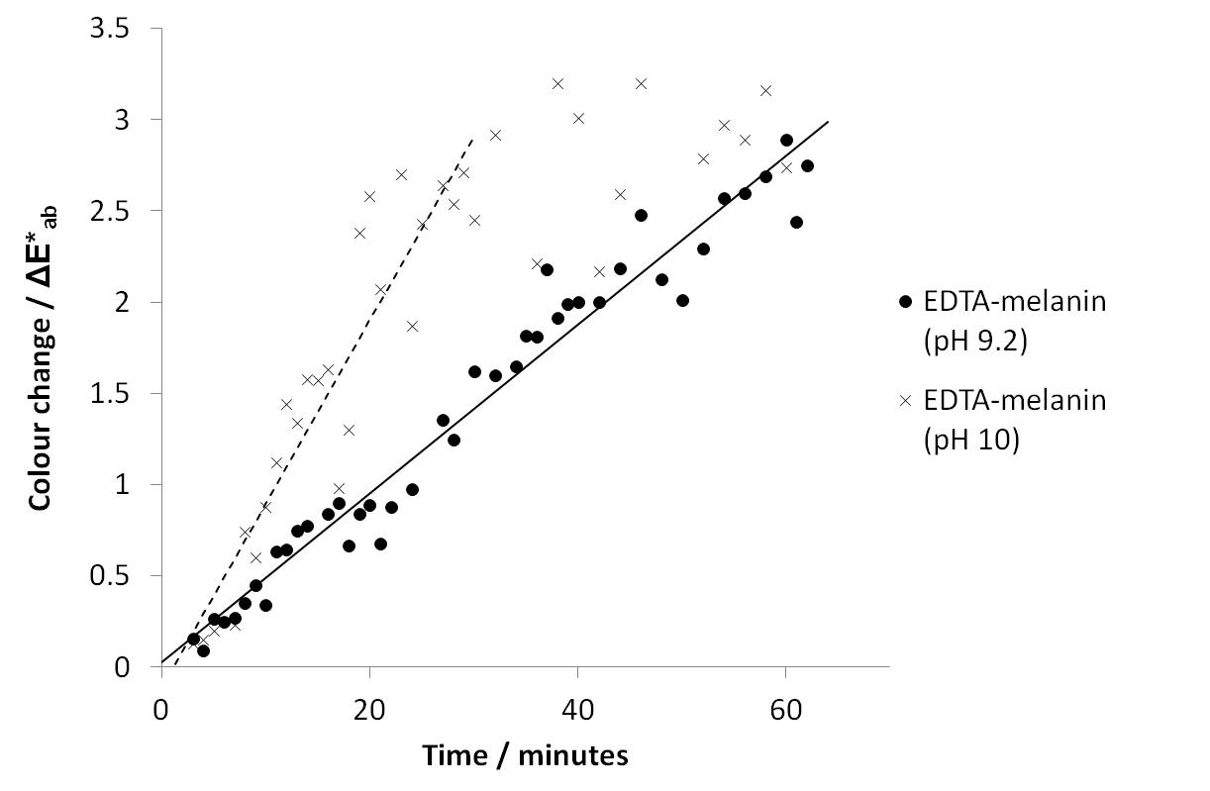

*Figure 6: Overall colour change (*ΔE*ab*) as a function of time during bleaching of EDTA-washed melanin by pH 9.2 and 10.0 ammonia solutions containing 0.756 M H2O2.*

It can be seen from Fig. 6 that for the first 30 minutes of the reaction, the rate of bleaching is significantly lower with a bleaching formulation at pH 9.2 *vs* pH 10.0. This result indicates that the perhydroxyl anion is more important in controlling the overall rate of bleaching than the degree of radical chemistry occurring (from Fig. 5).

The inefficiency of radical chemistry to solubilise intact melanosomes was further shown by attempting to bleach untreated melanin in the presence of HO∙ (from H2O2 + Fe3+, see experimental). After the H2O2 had all decomposed, only a small amount of melanin had been solubilised and bleached but the majority of the melanosomes appeared unaffected suggesting that this is not an efficient method to induce bleaching.

Furthermore, the superoxide radical (O2∙-) was also shown not to be able to bleach intact melanosomes by attempted reaction between melanin and KO2 (see experimental).

Taken in combination, these results indicate that radical chemistry initiated in the outside solution does not play a significant role in controlling the overall rate of bleaching of melanin granules. However, making definitive conclusions is complicated by the solubilisation/dispersion of melanin, which occurs in concurrence with bleaching.

*Solubilised Melanin Bleaching – hydroxyl radicals vs perhydroxyl anions*

In order to gain mechanistic insights into the oxidation of the melanin pigment after the complex dispersion/solubilisation process, the experimental conditions were further simplified. This was achieved by using pre-solubilised melanin before bleaching was measured. Water-soluble *Sepia* Melanin Free Acid (MFA) was prepared from *Sepia* melanin by a literature method [25]. *Sepia* melanin has been studied extensively and found to consist predominantly of eumelanin [27]. This makes it a good model for studying the bleaching of black hair, which also has high eumelanin content [19]. When dissolved in aqueous solution, *Sepia* MFA gives a UV-vis spectrum that exhibits broadband absorbance (see Fig. S2). This absorbance could be monitored at an arbitrary wavelength during bleaching to follow the process.

By careful control of the reaction conditions during bleaching, the relative amounts of perhydroxyl anion and hydroxyl radical in the reaction mixture can be manipulated. Controlling the concentration of perhydroxyl anionsin the reaction mixture can be achieved by varying the pH of the solution (see experimental). All experiments in this section were carried out in the presence of 0.18 mM Cu2+ ions. By adding a strong chelant such as EDTA to the compositions the production of hydroxyl radicals *via* Fenton (-like) chemistry with Cu2+ ions can be effectively switched off [33-35]. This was demonstrated by measuring hydroxyl radical production in pH 7.7 or 9.9 ammonia solutions containing 0.979 M H2O2 and 0.18 mM Cu2+ with and without added 1.3 mM EDTA as a chelant (see experimental). The formation of hydroxyl radicals was monitored by the addition of the colorimetric probe NPGA (1 mM). A characteristic peak at 430 nm can be detected by UV-vis spectroscopy when NPGA is hydroxylated by hydroxyl radicals [28].

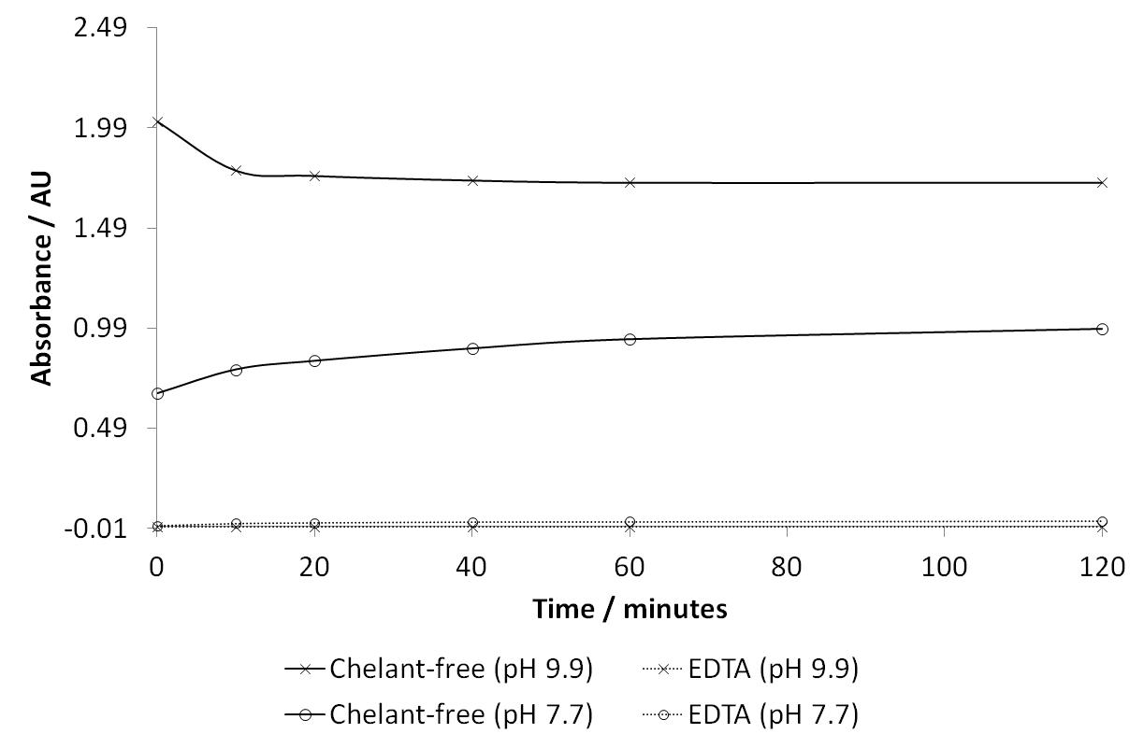

*Figure 7: Hydroxyl radical production, measured by NPGA assay at 430 nm, during bleaching of soluble Sepia melanin in pH 7.7 or 9.9 ammonia solutions containing 0.979 M H2O2 0.18 mM Cu2+ and 1 mM NPGA both with and without the addition of 1.3 mM EDTA.*

It is clear from Fig. 7 that formulations with EDTA showed negligible hydroxyl radical production, whereas the EDTA-free formulations showed significantly more radical formation. Hydroxyl radical production is much greater in chelant-free compositions at pH 9.9 than at pH 7.7 as Fenton-like chemistry displays complex pH dependence. The changing copper ion speciation in solution affects how efficiently hydrogen peroxide is decomposed to generate hydroxyl radicals. The initial production of hydroxyl radical in the pH 9.9 chelant-free formulation is so great that the degradation of the NPGA-OH adduct by the extremely high hydroxyl radical flux overcomes its formation, leading to the drop in the absorbance at the start of this reaction.

Manipulating these two experimental conditions, pH and presence of chelant, enables the effects of each oxidant to be prised apart. Thus, the effects of hydroxyl radical and perhydroxyl anion on soluble melanin bleaching can be studied separately, see Tab. 1 and Fig. 8.

|  |  |  |  |
| --- | --- | --- | --- |
| **Experimental conditions** | | | **Predominant oxidising species present** |
| ***H2O2*** | ***EDTA*** | ***pH*** |
| No | No | 9.9 | None (ammoniaonly) |
| Yes  Yes | Yes  No | 7.7  7.7 | H2O2  HO∙ |
| Yes  Yes | Yes  No | 9.9  9.9 | HO2-  HO∙ and HO2- |

*Table 1: A summary showing the predominant oxidising species present when experimental conditions are changed during the bleaching of soluble Sepia melanin by H2O2/ammonia.*

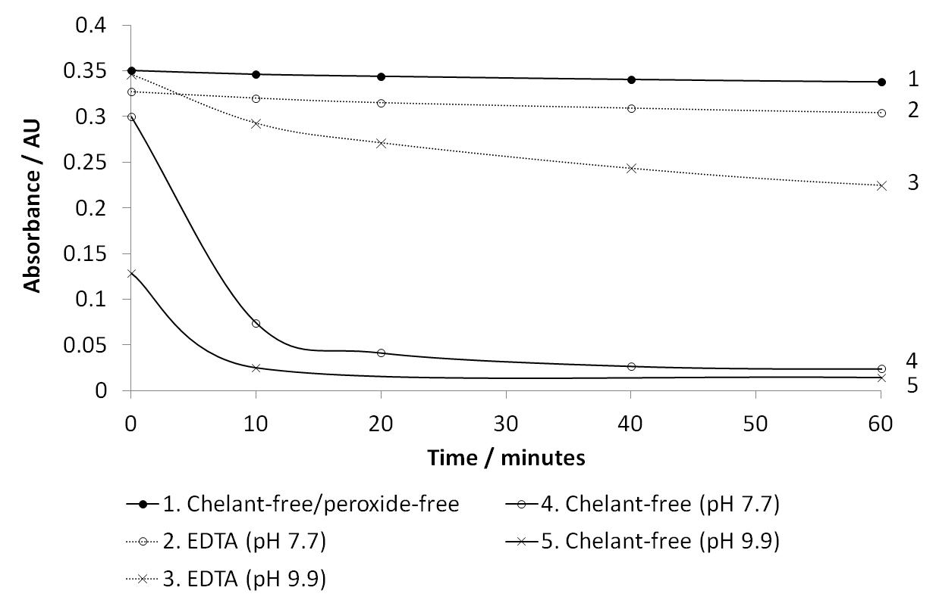

*Figure 8: Rates of bleaching of soluble Sepia melanin by pH 7.7 or 9.9 ammonia solutions containing 0.979 M H2O2, 0.18 mM Cu2+ ions both with and without the addition of 1.3 mM EDTA. Measured by UV-vis at 532 nm.*

Firstly by examining bleaching using a pH 7.7 ammonia solution containing 0.979 M H2O2, 0.18 mM Cu2+ and 1.3 mM EDTA, *i.e.* no HO· and a very low HO2- concentration (0.11 mM), it can be seen that H2O2 is not an efficient oxidant of soluble melanin. Using a pH 9.9 ammonia solution (containing H2O2 and Cu2+) with the addition of EDTA allows us to measure the process of soluble melanin bleaching by 19 mM HO2-. A significant amount of bleaching was observed over 60 minutes, confirming that HO2- can act as an oxidant of soluble melanin, independent of hydroxyl radicals. Again bleaching using a pH 9.9 ammonia solution (with H2O2 and Cu2+), but in this case with no added EDTA, the extra effect of HO∙ (in addition to that of HO2-) can clearly be seen. The rate of bleaching is so fast that the absorbance due to melanin has decreased by more than half before the first absorbance reading could be taken. Finally, when bleaching using a pH 7.7 ammonia solution (with H2O2 and Cu2+) without EDTA (i.e. predominantly HO∙ present) extensive bleaching was still observed, though at a lower rate than for the pH 10 composition. This is due to both the lower concentration of hydroxyl radical and of the perhydroxyl anion (0.11 mM) available for bleaching at this pH. A control experiment containing neither EDTA nor hydrogen peroxide showed a negligible decrease in absorbance over one hour. This confirmed that ammoniaalone will not bleach solubilised melanin at an appreciable rate.

From these results, it can be concluded that hydroxyl radicals and perhydroxyl anions are both able to act independently as efficient oxidants of soluble melanin. This confirms proposals that the perhydroxyl anion is important for bleaching melanin [7, 11, 12]. Additionally, in the presence of both HO2- and HO∙ together, melanin is both more extensively bleached and at an increased rate. However, It is not clear whether this ‘dual bleaching’ is simply an additive effect of the two species or whether a more subtle synergistic effect is occurring.

*Time-delayed addition of EDTA*

The time-delayed addition of 1.3 mM EDTA to pH 9.4 ammonia solutions containing H2O2, Cu2+ and 0.06 mg mL-1 soluble *Sepia* melanin provided more information on how perhydroxyl anions and hydroxyl radicals interacted during bleaching. This study aimed to determine whether the increase in melanin bleaching is simply an additive effect when both oxidants are present, or whether a relationship between the oxidants exists which improves bleaching efficiency. By delaying the addition of EDTA to formulations, a high concentration of hydroxyl radicals is generated initially but radical production is then rapidly ceased upon addition of chelant to the formulation. This allows the bleaching of soluble melanin by HO2- to be measured after a controlled degree of exposure to hydroxyl radicals. Note that the pH and therefore the extent of the HO· production was necessarily decreased in order to give a feasible initial rate of bleaching for these experiments.

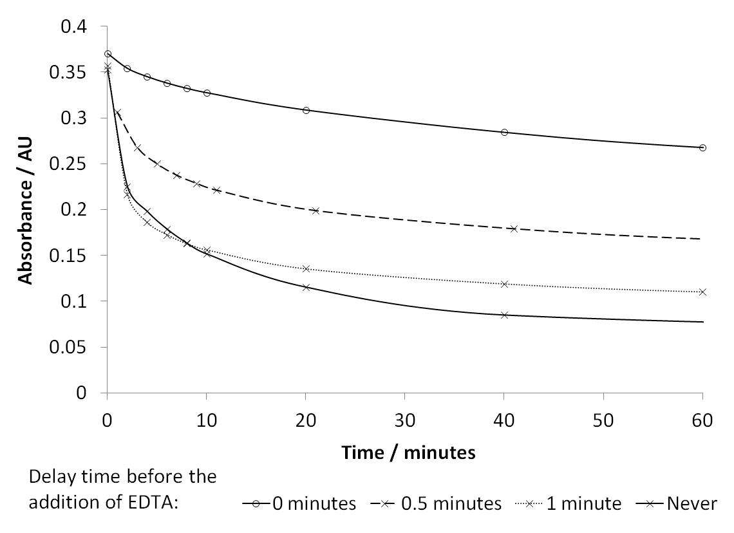

Figure 9: Rates of bleaching of soluble Sepia melanin by a pH 9.4 ammonia solution containing 0.979 M H2O2 and 0.18 mM Cu2+ showing the effect of a time-delayed addition of 1.3 mM EDTA. Measured by UV-vis at 532 nm.

As expected, the longer the delay before the addition of EDTA, the greater the initial extent of bleaching. Interestingly, it was observed that the rate of bleaching does not decrease immediately after the addition of EDTA. The high rate of bleaching lasted until a reaction time of approximately 10 minutes after addition, despite the rapid binding of metal ion centres by EDTA (see Fig. S3 and Fig S4). This indicates that hydroxyl radicals can have multiple roles in melanin bleaching dependent on the conditions. In addition to reacting efficiently with melanin (Fig. 8), hydroxyl radicals can also ‘pre-oxidise’ melanin, giving rise to an acceleration in the reaction of melanin with perhydroxyl anions.

*Role of base*

It is known that if NaOH is used instead of ammonia as base in the bleaching of hair/extracted melanosomes then no bleaching will occur (photographic demonstration of this phenomenon is available in Fig. S5). This is because ammonia has a vital but unclear role in allowing rupture of the melanosomal membrane to occur [19].

By studying soluble *Sepia* melanin bleaching by alkaline hydrogen peroxide solutions using different bases, it could be determined whether the base plays any further role after melanin solubilisation/dispersal.

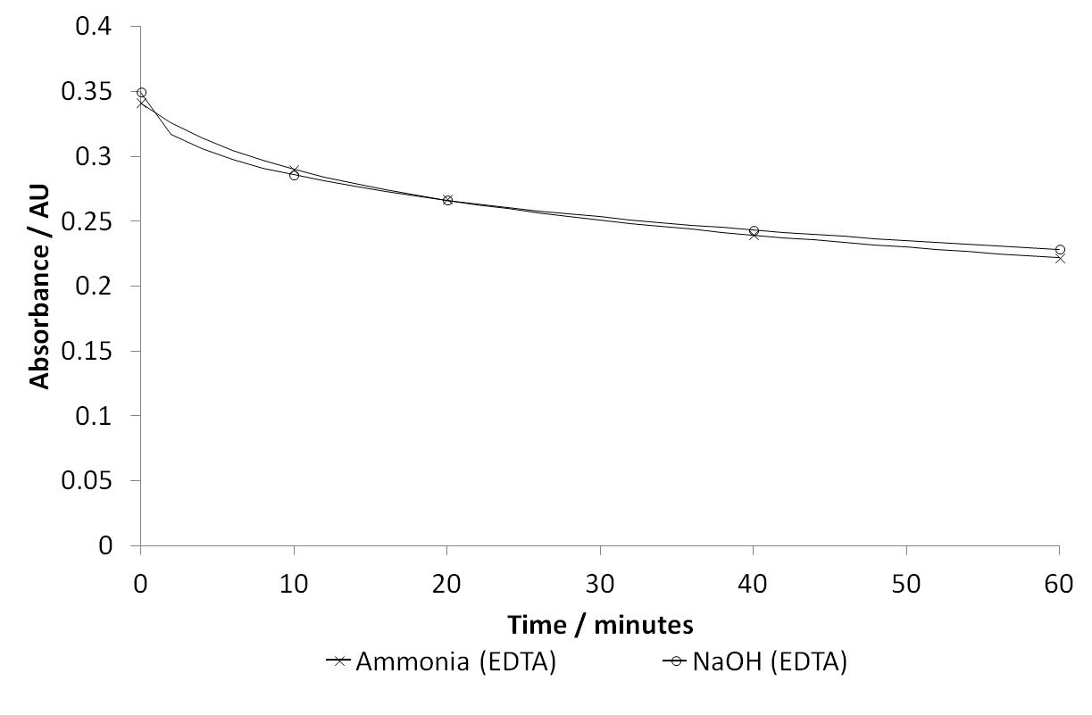

*Figure 10: Rate of soluble Sepia melanin bleaching in pH 9.4 ammonia or sodium hydroxide solutions containing 0.979 M H2O2, 0.18 mM Cu2+ and 1.3 mM EDTA.* Measured by UV-vis at 532 nm*.*

It can be seen from Fig. 10 that the bleaching profiles using pH 9.4 ammonia or sodium hydroxide bleaching solutions containing H2O2, Cu2+ and EDTA are almost identical, regardless of the base used to give an alkaline solution. It is worth noting here that the pH of the solution is determined by the concentration of OH- present, which is identical in both experiments. What we can conclude from these data is that the presence of additional free NH3 in solution leads to no detectable difference in bleaching rate. Therefore, once the melanin has been solubilised, the identity of the base used is not important and it plays no further mechanistic role beyond deprotonation of H2O2. A NPGA HO∙ assay experiment confirmed that the radical production seen when using either base was similar (Fig. S6).

**Conclusions**

The amount of Fenton (-like) chemistry occurring in the bleaching of isolated, intact melanosomes (from Asian hair) by H2O2/ammonia was modulated and the rate of bleaching was studied. The data indicates that hydroxyl radicals may not play a role in bleaching intact melanosomes and provided no measurable rate enhancement when compared to HO2-. Presumably, this is because the lifetime of the radical is too low to diffuse through the melanosomal membrane. Therefore, its role may be limited to reacting with the outer membrane surface. However, once the melanin has been completely solubilised, radical chemistry appears to enable the bleaching to proceed to a much greater extent than bleaching by perhydroxyl anions alone.

There are several processes happening concurrently in the bleaching of intact melanosomes, making definitive statements difficult. Therefore, to gain more meaningful insights, experimental conditions were further simplified by using pre-solubilised melanin in the form of *Sepia* Melanin Free Acid (MFA). This allowed for more controlled probing of the processes that occur after melanin solubilisation and dispersion. By controlling the pH and the presence of EDTA (to switch on/off Fenton (-like) chemistry) the influence of HO2- and HO∙ on the bleaching of solubilised melanin pigment could be separated. These experiments allowed us to show that both HO2- and HO∙ will act to efficiently oxidise and bleach soluble MFA when present separately. Additionally, the effect of having both oxidants present at pH 10 leads to enhanced bleaching power, both in rate and extent. This enhancement is most likely because hydroxyl radical activates the melanin towards further, more facile, irreversible oxidation by HO2-, as postulated by Korytowski [11].

These results and conclusions confirm that the previously proposed reaction scheme, presented in Fig. 2, is a likely pathway for the oxidation of melanin during hair bleaching. Re-examining this scheme in more detail allows us to put forward some tentative mechanistic explanations for the observed results.

By considering the relative nucleophilicity/oxidation potentials of the perhydroxyl anion and hydroxyl radical, some speculative chemical reasoning can be made. The perhydroxyl anion is a very strong nucleophile but a weak oxidant [36]. Conversely, the hydroxyl radical is a very strong oxidant [36] but is a surprisingly weak nucleophile [37]. In simplified terms (assuming negligible pH effects on reduction potential) it can be proposed that the oxidation of melanin by hydroxyl radicals will be much more favourable than by perhydroxyl anion. However, in the absence of hydroxyl radical, oxidation of melanin by HO2- can still occur at a reduced rate. This may be facilitated by residual metals that cannot be completely extracted from melanin by EDTA. Once the melanin molecule has been oxidised to the *o*-quinone form, the aromaticity in the 6-membered ring is lost. Thus, it becomes susceptible to nucleophilic ring opening attack. The rate of this step will be much higher with the hydroperoxyl anion acting as the nucleophile. However, the hydroxyl radical could also facilitate a similar reaction in the absence of HO2-. This simplified scheme also explains why the rate and extent of bleaching is greatly increased when both hydroxyl radicals and perhydroxyl anions are present. By overcoming the redox-buffering potential of the melanin polymer, allowing a high enough population of the *o*-quinone unit to exist, facile nucleophilic ring opening by HO2- is possible. It was therefore possible to conclude that hydroxyl radicals contribute to the initial oxidation of DHI units to *o*-quinone units (first two steps in Fig. 2). These data then confirmed that the perhydroxyl anion can act as the nucleophile that breaks down the *o*-quinone units irreversibly (third step in Fig. 2), as proposed by Korytowksi [11]. In the absence of perhydroxyl anion, the oxidation of melanin may proceed down a different mechanistic pathway, similar to that of the oxidation of indoles by hydroxyl radical [38].

That the amount of radical chemistry occurring seems to influence the degree of bleaching occurring suggests that the varying concentrations of transition metal ions (particularly Fe3+ or Cu2+) found within melanosomes in human hair could have a large influence on the extent of bleaching observed. This may explain general difficulties in controlling extents of hair bleaching from person to person. Modulating this metal-mediated radical chemistry could provide a potential route to adding further control into this process.

Finally, pre-solubilised melanin was used to show that after solubilisation the identity of the base used in bleaching is unimportant. The base serves no further mechanistic role in bleaching beyond deprotonation of H2O2 to give the perhydroxyl anion. The necessity for NH3 in the solubilisation step is presumably due to its small, non-polar and uncharged nature allowing it to rapidly diffuse through the melanosomal membrane.

The methods for studying melanin bleaching employed by this study could allow for further detailed mechanistic studies of melanin bleaching. The hope is that such studies could eventually be extended to real hair systems, greatly improving the understanding of this commercially important process.

**Acknowledgements**

The authors would like to thank Proctor and Gamble and the EPSRC (EP/F021127/1) for funding the work. B.G. would like to acknowledge the Daphne Jackson Trust for the award of a fellowship and also the University of York and Royal Society of Chemistry for funding.

**References**

1. Sarna, T. and Sealy, R.C. Free radicals from eumelanins: Quantum yields and wavelength dependence. *Arch. Biochem. Biophys.* **232,** 574–578 (1984).
2. Kollias, N., Sayre, R.M., Zeise, L. And Chedekel, M.R. New trends in photobiology: Photoprotection by melanin. *J. Photochem. Photobiol. B*. **9**, 135-160 (1991).
3. Ito, S. A chemist’s view of melanogenesis. *Pigment Cell Res*., **16,** 230–236, (2003).
4. Wolfram, L.J., Hall, K. and Hui, I. The mechanism of hair bleaching. *J. Soc. Cosmet. Chem.* **21**, 875-900 (1970).
5. Robbins, C. Chemical aspects of human hair. *J. Soc. Cosmet. Chem.* **22**, 339-348 (1971).
6. Wolfram, L.J., and Albrecht, L. Chemical and photobleaching of brown and red hair. *J. Soc. Cosmet. Chem.* **8**, 179-191 (1987).
7. Zahn, H., Hilterhaus, S. and Strübmann, A. Bleaching and permanent waving aspects of hair research. *J. Soc. Cosmet. Chem.* **3**, 159-175 (1986).
8. Prem, P., Dube, K.J., Madison, S.A., and Bartolone, J. New insights into the physicochemical effects of ammonia/peroxide bleaching of hair and *Sepia* melanins. *J. Cosmet. Sci.* **54**, 395-409 (2003).
9. Napolitano, A., Peuella, A., d’Ischia, M. and Prota, G. Oxidative degradation of melanins to pyrrole acids: A model study. *Tetrahedron*, **51**, 5913-5920 (1995).
10. Napolitano, A., Peuella, A., d’Ischia, M. and Prota, G. New pyrrole acids by oxidative degradation of eumelanins with hydrogen peroxide. Further hints to the mechanism of pigment breakdown. *Tetrahedron*. **52**, 8775-8780 (1996).
11. Korytowski, W. and Sarna, T. Bleaching of melanin pigments, role of copper ions and hydrogen peroxide in autooxidation and photooxidation of synthetic dopa-melanin. *J. Biol. Chem*. **265**, 12410-12416 (1990)
12. Littrell, K.C., Gallas, J.M., Zajac, G.W. and Thiyagarajan, P. Structural studies of bleached melanin by synchrotron small-angle X-ray scattering. *Photochem. Photobiol*. **77**, 115–120 (2003).
13. Robbins, C.R. Chemical and physical behaviour of human hair. 3rd ed. Springer-Verlag, New York; London (**1994**).
14. Fenton, H.J.H. Oxidation of tartaric acid in presence of Iron. *J. Chem. Soc. Trans.* **65**, 899 (1894).
15. Walling, C. Intermediates in the reactions of Fenton type reagents. *Acc. Chem. Res.* **31**, 155 (1998).
16. MacFaul, P.A, Wayner, D.D.M. and Ingold, K.U. A radical account of “Oxygenated Fenton Chemistry”. *Acc. Chem. Res.* **31**, 159-162 (1998).
17. Borges, C.R., Roberts, J.C., Wilkins, D.G. and Rollins, D.E. Relationship of melanin degradation products to actual melanin content: Application to human hair. *Anal. Biochem.* **290**, 116-125 (2001).
18. Ghiani, S., Baroni, S., Burgio, D., Digilio, G., Fukuhara, M., Martino, P., Monda, K., Nervi, C., Kiyominec, A. and Aime, S., Characterization of human hair melanin and its degradation products by means of magnetic resonance techniques. *Magn. Reson. Chem*. **46**, 471–479 (2008).
19. Wakamatsu, K. And Ito, S. Review: Innovative technology advanced chemical methods in melanin determination*. Pigm. Cell. Res.,* **15**, 174–183 (2002).
20. Sarna, T., Pilas, B., Land, E.J. and Truscoli, T.G. Interaction of radicals from water radiolysis with melanin. *Biochim. Biophys. Acta* **883**, 162-167 (1986).
21. Korytowski, W., Kalyanaraman, B., Menon, I.A., Sarna, T. and Sealy, R.C. Reaction of superoxide anions with melanins: Electron spin resonance and spin trapping studies. *Biochim. Biophys. Acta* **882**, 145-153 (1986).
22. Tada, M., Kohno, M. and Niwano, Y. Scavenging or quenching effect of melanin on superoxide anion and singlet oxygen. *J. Clin. Biochem. Nutr.,* **46**, 224-228 (2010).
23. Evans, M. G., and Uri, N. The dissociation constant of hydrogen peroxide and the electron affinity of the HO2 radical. *Trans. Faraday Soc*., **45**, 224-230, (1949).
24. Liu, Y., Kempf, V.R., Nofsinger, J.B., Weinert, E.E., Rudnicki, M., Wakamatsu, K., Ito, S. and Simon, J.D. Comparison of the structural and physical properties of human hair eumelanin following enzymatic or acid/base extraction. *Pigm. Cell. Res.* **16**, 355 (2003).
25. Magarelli, M. Passamonti, P. and Renieri, P. Purification, characterization and analysis of *Sepia* melanin from commercial *Sepia* ink (*Sepia* Officinalis). *C. Rev. CES Med. Vet. y Zootec.* **5**, 18 (2010)
26. Aime, S., Fasano, M., Terreno, E., and Groombridge, C.J. NMR Studies of melanins: Characterization of a soluble melanin free acid from *Sepia* Ink. *Pigm. Cell. Res*. **4**, 216 (1991).
27. Liu, Y., Hong, L., Kempf, V.R., Wakamatsu, K., Ito, S. and Simon, J.D. Ion-exchange and adsorption of Fe(III) by *Sepia* melanin. *Pigm. Cell. Res.* **17**, 262–269 (2004).
28. Singh, S. and Hider, R.C. Calorimetric detection of the hydroxyl radical: Comparison of the hydroxyl-radical-generating ability of various iron complexes. *Anal. Biochem.* **171**, 47 (1988).
29. http://www.iq.usp.br/gutz/Curtipot_.html (v.4.2.3) [accessed March 2017]
30. Samuni, A., Goldstein, S., Russo, A., Mitchell, J. B., Krishna, M. C., and Neta, P. Kinetics and mechanism of hydroxyl radical and OH-adduct radical reactions with nitroxides and their hydroxylamines. *J. Amer. Chem. Soc.*, **124**, 8719 – 8724, (2002).
31. Pattison, D. I., Lam, M., Shinde, S. S., Anderson, R. F. and Davies, M. J. The nitroxide TEMPO is an efficient scavenger of protein radicals: Cellular and kinetic studies. *Free Radic. Biol. Med*., **53**, 1664- 1674, (2012).
32. McGraw, K.J. Melanins, metals, and mate quality. *Oikos,* **102**, 402-406 (2003).
33. Griffiths, D. P. Trying to decrease the decomposition rates of peracids (and H2O2) by solution-phase metal ions. PhD [dissertation] York: University of York, **2004**, Available through: Ethos, e-theses online service.
34. Jones, C. W. Applications of hydrogen peroxide and derivatives, Cambridge: Royal Society of Chemistry, **1999**.
35. Smith, R. A. W. The Role of Monoethanolamine in hair bleaching and dyeing: Mechanistic insights from model formulations. PhD [Dissertation] York: University of York, **2014**.
36. Haynes, W. M., and Lide, D. R. (ed). CRC handbook of chemistry and physics, Boca Raton: CRC Press, 92nd edn., **2011**.
37. De Vleeschouwer,F., Van Speybroeck, V., Waroquier, M., Geerlings, P. and De Proft, F. Electrophilicity and nucleophilicity index for radicals. *Org. Lett*., **9**, 2721-2724 (2007).
38. Poeggeler, B., Saarela, S., Reiter, R. J., Tan, D. X., Manchester L. C., and Barlew-Walden, L. R. Melatonin - a highly potent endogenous radical scavenger and electron donor: New aspects of the oxidation chemistry of this indole accessed in vitro. *Ann. N. Y. Acad. Sci*., **738** (1), 419-420 (1994).