**Skin and wound care and effective water use in resource-poor countries.**

Jill Brooks PhD, MPhil, RN,, Independent Nurse Consultant, Oxfordshire, UK

Steven Ersser, PhD, RN, Department of Health Sciences, University of York, York, KK

**Abstract**

It is estimated that three billion people living in rural areas of 127 resource-poor countries do not have access to the most basic skin care consisting of washing with soapy water and drying1. Diseases caused by poor personal hygiene and skin or eye contact with contaminated water include trachoma, scabies, flea, lice and tick-borne diseases. Keeping skin clean and intact is therefore crucial. When skin breaches occur through insect bites, trauma, disease or dry cracked skin optimal treatment is required to prevent inflammation, infection, wound deterioration and delayed wound healing. This article highlights key issues faced by those in rural areas of resource poor countries in keeping skin clean and healthy and treating any wounds that may occur. The article focuses on Uganda and Ethiopia, the countries where the first author has worked as a nurse and researcher.

**Introduction**

Skin performs many vital functions including forming a barrier to physical agents and preventing loss of body fluid thus avoiding dehydration and death in a terrestrial environment. It also helps protect the body against potential pathogenic organisms.

To maintain its functions effectively the skin needs to be kept clean, excessive surface dirt and grease removed and the build-up of micro-organisms on its surface prevented. The stratum corneum (SC) relies on a delicate water balance which when altered even slightly may results in a compromised skin barrier function (SBF) 2. Dry skin loses elasticity, becoming vulnerable to cracking, and fissures in areas such as the foot can increase the risk of entry of soil and pathogens causing infections, and disease. Water, as well as helping to clean skin, also hydrates the SC. Clinical trial evidence suggest that hydration is augmented with the application of an emollient 3. Soap is often necessary for washing because it acts as an emulsifier removing oil (sebum), other lipids and organic debris- such as soil which water alone cannot remove.

**Cleaning the skin with water**

Being poor in a hot dusty environment, living in cramped poor quality housing with inadequate nutrition and no piped water is not conducive to healthy skin. In the hut pictured in Figure 1 seven people lived together with their animals. There was no piped water. It had to be collected several times a day from many kilometres away in 25 litre yellow plastic containers each weighing 25 kilos when full.

*Fig1. The inside of a typical hut in rural Ethiopia*

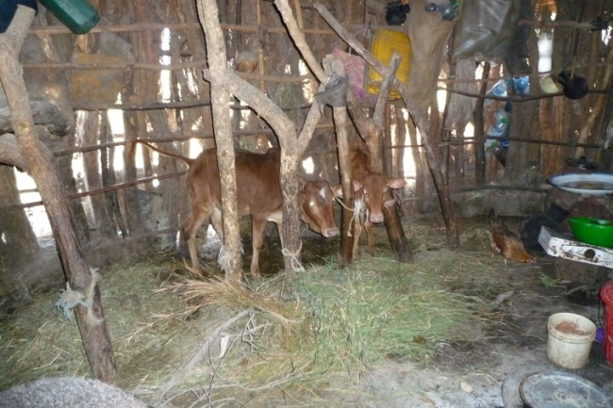

Globally, water from unprotected dug wells, rivers, lakes and ponds is used by 884 million people. Most of these are the rural inhabitants of sub-Saharan Africa4. However, a protected well does not necessarily mean it is free from all pathogens5. More than a quarter of the population (mainly women (64%)) in several sub-Saharan countries take longer than 30 minutes to make one water collection 4.

*Fig 2. Children collecting water from a standpipe in Ethiopia.*

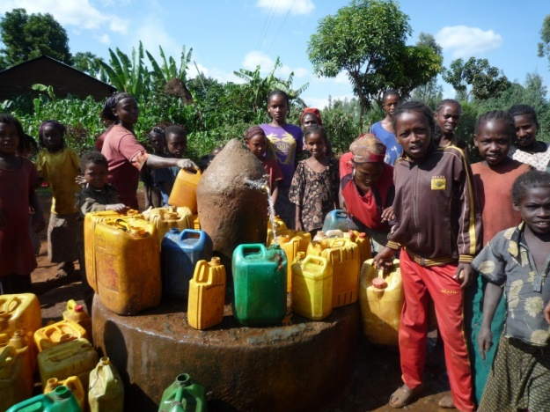

Collecting water several times a day from a distant source is hard, time consuming work. Water from ponds or lakes is often easier to access but may well be grossly polluted by animal and human waste and/or by chemicals and heavy metals. When used for cleaning, contaminated water can result in skin infections.

*Fig 3. Ethiopian children collecting water and washing from a pond.*

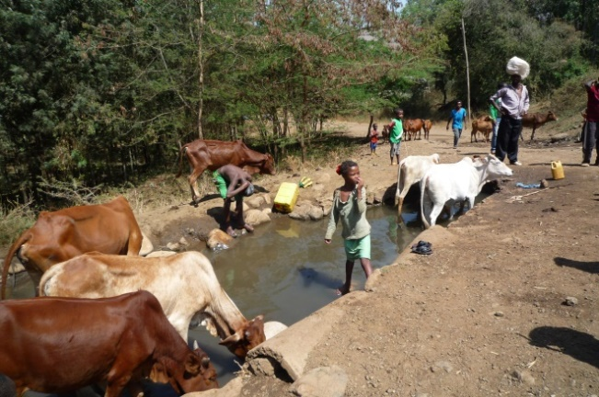

Data indicates that 42% of healthcare facilities in Africa do not have access to safe water6. A rural hospital in Uganda where the first author worked drew water from an underground source which, when analysed had ‘too many bacteria to count but no coliform bacteria’. Relatives, who provided the food, drink, clean bed linen and washing water for the patients obtained their water from a pump in the hospital grounds.

*Fig 4. Relatives drawing water in a Ugandan Hospital.*

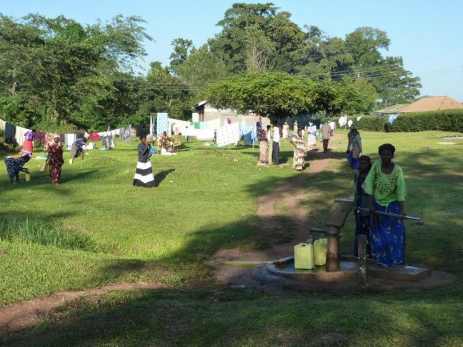

### The United Nations Millennium Development Target 7.C aimed ‘to halve by 2015 the proportion of people without sustainable access to safe drinking water and basic sanitation.’ The drinking water target has not been achieved, and 663 million people still use unimproved drinking water sources; nearly half of these live in sub-Saharan Africa 7.

### In rural areas scarce water is primarily used for drinking and cooking. Interviews with 6 Assistant Medical Officers in Tanzania on the public’s washing practices reported the relative priorities for water were drinking, cooking and washing, respectively. Among the Maasai people it was: drinking by cattle, drinking by humans then washing 8. Therefore, there is a major tension between the use of water for the drinking and survival needs over skin cleansing to either maintain a healthy skin or help manage deterioration of the skin barrier, if diseased.

**Washing skin with soap**

Water alone, however, is not sufficient for cleansing dirty skin. Soap and drying cloths are also required. There are other cleansing agents but soap is the primary cleanser used in resource poor countries. Soaps clean by acting as an emulsifier allowing oil and water to mix in order that oily substances and dirt can be removed during rinsing. The cheapest soap available in rural Ethiopia has a pH of 10 and is contaminated with silicates (minerals present in soil) 9. This high pH disrupts the protective acid mantle of skin changing it from one which is slightly acid into one more alkaline and decreasing the fat content. This may lead to an increase in surface micro-organisms, with colonisation and potential infections by pathogenic bacteria.

The findings in the first multi-country review of water, sanitation and hygiene services in health-care facilities drew on data from 54 low- and middle-income countries 6. This report concluded that 38% of countries lack access to even rudimentary levels of water, 19% lack sanitation and 35% do not have water and soap for handwashing. Indeed some hospital wards where the first author has worked in rural Uganda and Ethiopia often had no water available in the hand basins and/or soap or clean, dry towels.

An example of effective skin care practice is the podoconiosis (non-filarial elephantiasis) clinics in Ethiopia where patients are taught to wash their feet and legs daily with soap and water. This, together with a soak in water and application of an emollient such as *Vaseline®* improves their skin condition by preventing further plantar cracking and the entry of soil and pathogens and reducing leg/foot swelling 10. A randomised control trial on podoconiosis reported highly significant differences in lowered trans-epidermal water loss and increased SC hydration (improved SBF) using less soaking water with added 2% glycerine when compared to the current skin treatment; 9. In many areas, however, dry skin is often left untreated due to lack of knowledge regarding their use or the cost of emollients.

*Fig 5. Patients in a podoconiosis clinic washing their legs and feet.*

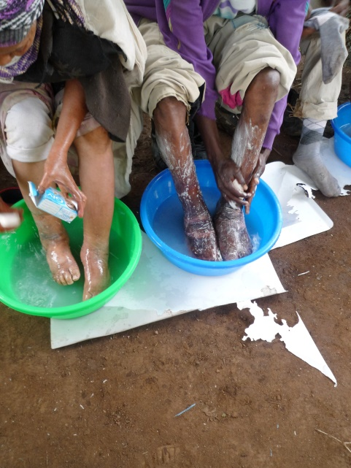

*Figs 6,7. Feet of two podoconiosis patients, one before and one after 3 months of daily washing regimen*

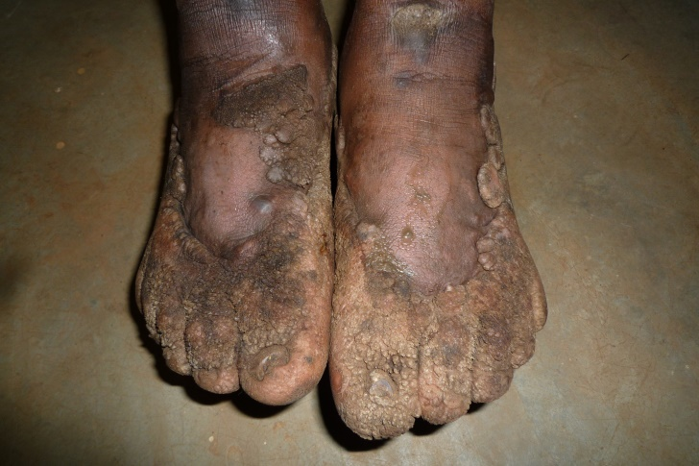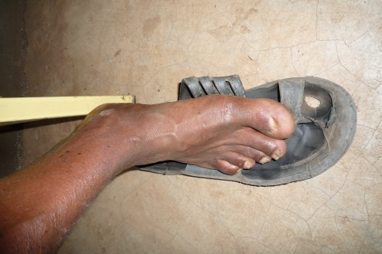

**Cleaning wounds in resource-poor countries.**

Cost effective and research based wound management is an enormous challenge for those in resource-poor countries. Wound and skin care is often undertaken with very limited resources and without up-to-date evidence-based information available to make clinical decisions. Patients often delay coming to hospital because of distance, loss of work or cost. Many patients in rural areas will seek the help of a local healer in the first instance. Their preparations may be ineffective, possibly harmful and often expensive.

*Fig 8. Neglected foot wound in a Ugandan Hospital*



There is commonly a scarcity of wound cleansing agents in many resource-poor countries. Cotton wool swabs are used for cleaning, however, they may leave fibres in wounds providing a focus for infection. Vigorous rubbing to clean a wound is sometimes undertaken but this may remove any new tissue growth, although gentle pressure is recommended to remove excess exudate and debris. For cleaning wounds and removing debris antiseptics such as chlorhexidine gluconate lotion (*Savlon*), hydrogen peroxide and bleach in various dilutions are commonly used. A Cochrane review concluded that using tap water to cleanse acute wounds in adults did not increase infection rates 11. Furthermore, the review concluded that where tap water is of drinkable quality it may be as good as other methods such as sterile water or saline and more cost-effective. Drinkable quality water should therefore be suitable for washing the skin of those with skin disease or with skin breaches or wounds. It is now extensively used in the UK for managing wounds.

There are three main methods of removing pathogens from polluted water and making it of drinkable quality. It may be boiled but in resource poor countries obtaining fuel such as wood is time and time consuming as well as environmentally detrimental. Charcoal has similar environmental effects and is expensive. Secondly, water may be placed in plastic containers in full sunlight (solar water disinfection). These are often 2 litre bottles so obtaining sufficient amounts for skin washing would be challenging. A literature review identified cold or cloudy weather, fear of leaching from the plastic, water turbidity and lack of community acceptance as barriers to use of 19 litre water dispenser containers 12. Dilute household bleach may also be used but access and expense may be a problem.

Water purification products such as PUR™ are also effective 13. This is a flocculant chemical which removes particulate microbes and pollutants from water including heavy metals such as arsenic. It is produced by Procter & Gamble who have been distributing it as a humanitarian aid for several years to provide safe drinking water. Each small 4g sachet, when added to 10 litres of filthy water, thoroughly stirred, and then filtered, produces clear clean water within 30 minutes. The water will retain microbial stability for about a day, although purified water can be maintained longer by storage in a clear plastic container and placing it in direct sunlight. The International Foundation for Dermatology and International Skin Care Nursing Group have signed a Memorandum of Understanding for supporting the use of PUR in skin care projects. PUR™ was used instead of antiseptics on 32 patients in a surgical/trauma ward in rural Uganda to clean many different types of wounds 14. Laboratory facilities for microscopy, culture and sensitivity were not available but there was no discernible rise in infection rates. Savings on wound antiseptics over a 4 month period of £139 related to £417 per annum which, in a hospital where nurses were paid £45 per month was a considerable saving14.

**Conclusion.**

Accessing and instigating evidence-based wound and skin care in resource poor countries is difficult for many reasons but mainly there is a lack of easy access to adequate amounts of drinkable quality water. There is a lack of knowledge on the importance of skin care and the financial resources to purchase the items required, although some low cost alternatives such as glycerine are under used. Third there is difficulty accessing health care facilities due to distance or financial issues. Until these issues are resolved, using drinkable quality water for cleaning skin and wounds for the poorest in society will remain an issue.

References

1. Hay RJ, Fuller LC. The assessment of dermatological needs in resource-poor regions. *International Journal of Dermatology.* 2011 **50**(5), pp. 552-557.

2. Rawlings AV, Matts PJ, Anderson CD, Roberts MS. Skin biology, xerosis, barrier repair and measurement. *Drug Discovery Today: Disease Mechanisms*, 2008. *5* 2: e127-e136. doi:10.1016/j.ddmec.2008.03.001.

3. Holden, C., English, J., Hoare, C., Jordan, A., Kownacki, S., Turnbull, R and Staughton, R Advised best practice for the use of emollients in eczema and other dry skin conditions. 2002. *Journal of Dermatological Treatment.*

4. WHO/UNICEF Progress on Sanitation and Drinking- Water 2010. http://www.who.int/water_sanitation_health/publications/9789241563956/en/

5. WHO.. *Progress on Sanitation and Drinking Water.* 2010 http://www.unwater.org/downloads/JMP_report._2010.pdf edn. Geneva.

# 6. WHO/UNICEF, Water, sanitation and hygiene in health care facilities

Status in low-and middle-income countries and way forward. 2015 http://www.who.int/water_sanitation_health/publications/wash-health-care-facilities/en/

### 7. Rose JB. Water. Sanitation and the Millennium Development Goals: A Report card on Global Progress. 2015. [*http://www.waterandhealth.org/water-sanitation-millennium-development-goals-report-card-global-progress/*](http://www.waterandhealth.org/water-sanitation-millennium-development-goals-report-card-global-progress/)

8. Matts PJ, Ryan TJ. Water and the skin: Skin carers collaborate with industry in a new initiative and humanitarian drive. 2012. *http://www.skincareforall.org/wp-content/uploads/2012/10/32.-Water-and-Skin-Revised.pdf*

9. Brooks J. A randomised control trial to determine an effective skin regime aimed at improving skin barrier function and quality of life in those with podoconiosis in Ethiopia. 2016. *Unpublished PhD Thesis*, University of Hull, UK.

10. Sikorski C, Ashine M, Zeleke Z, Davey G. Effectiveness of a simple lymphoedema treatment regime in podoconiosis management in Southern Ethiopia: one year follow-up. *Neglected Tropical Diseases,* 2010. (PLoS Neglected Tropical Diseases (electronic resource) vol./is.4/11 (e902)1035-2727;1935-2735).

11. Fernandez R, Griffiths R. Water for wound cleansing. *Cochrane Database of Systematic Reviews,* 2008 (1), pp. Art.No.:CD003861.DOI:10.1002/14651858.CD003861.pub2

12. Borde P, Elmusharaf K, McGuigan KG, Keogh MB. Community challenges when using large plastic bottles for Solar Energy Disinfection of Water. *BMC Public Health*. 2016. 16:931 DOI 10.1186/s12889-016-3535-6.

13. Centres for Disease Control and Prevention. 2013. [http://www.cdc.gov/safewater/flocculant-filtration.html.](http://www.cdc.gov/safewater/flocculant-filtration.html.%20)

14. Brooks J. Water fit for drinking is fit for washing wounds! A case study at a Ugandan Hospital. *Community Dermatology*. 2011. 7: 17-32 pp 2-4.