**Quantitative Reconstruction of Peatland Hydrological Regime with Fossil Testate Amoebae Communities**

*A. N. Tsyganova*, K. V. Babeshkoa, E. Yu. Novenkob, E. A. Malyshevaa, R. J. Paynea,b, and Yu. A. Mazeia,b*

*aPenza State University, Penza, 440026 Russia*

*bMoscow State University, Moscow, 119991 Russia*

*cUniversity of York, Heslington, York YO10 5DD, UK*

*e-mail: [andrey.tsyganov@bk.ru](mailto:andrey.tsyganov@bk.ru)

Received November 21, 2015

**Abstract—**The effect of bog water table on the species structure of sphagnobiontic testate amoebae communities has been studied in peatland ecosystems of European Russia. On this basis, a transfer function (model) for quantitative paleoreconstructions has been develped. This involved the formation of a training dataset, construction of models, and testing thier performance. As a result, the model constructed by weighted averaging regression has been adopted as optimal.

*Keywords:* transfer function, testate amoebae, paleoecological reconstruction, peatland ecosystems

Analysis of the historical dynamics of climate and ecosystems is necessary for estimating possible future climate changes and their effects on the environment and biota. A major role in this research is played by paleoreconstruction methods based on the use of indicator organisms that respond to changes in climatic or ecological characteristics and are well preserved as fossils [1]. Such biological indicators include plant remains, pollen, spores, seeds, foraminifers, diatoms, chironomid larvae, etc. Modern approaches to paleoreconstruction involve the search for new indicator species and development of methods for quantitatively reconstructing characteristics of the environment.

Testate amoebae have been widely used in recent studies on reconstructing hydrological characteristics of peatland ecosystems [2]. Testate amoebae, or testaceans, are a group of Protozoa that produce an external shell (test). These organisms are almost ubiquitous and play an important role in the detrital food webs of soil, aquatic, and peatland ecosystems [3]. They sensitively respond to changes in local hydrology and are resistant to decomposition, being preserved in peat and bottom sediments of bogs and water bodies. These properties make testate amoebae valuable for bioindication and paleoreconstruction research that can contribute to present-day knowledge of climate dynamics and ecosystem evolution.

Several approaches to quantitative paleoreconstruction are known, with all of them involving two basic stages [1]. The first stage deals with modeling the relationships between environmental parameters and the structure of communities of indicator organisms on the basis of data on the modern distribution of these species depending on known characteristics of the environment (transfer fucntion, or training dataset). Methods of regression analysis are usually used for this purpose. At the second stage, the resulting model (i.e., the dependence revealed at the first stage) is used to reconstruct characteristics of the environment based on the structure of fossil assemblages. In fact, this is a calibration task [4], and this is why the above model is referred to as a calibration model. The existing methods of reconstruction differ mainly in the type of functional dependence that they can reconstruct (linear, unimodal, or having no definite pattern).

To date, about 20 regional transfer functions based on testacean analysis have been developed for Europe [2], North America [5], and some regions of China [6]. The data on the state of peatland ecosystems obtained with these models are widely used for paleoreconstructions in combination with data based on the use of other indicator groups, which allows more accurate results to be obtained. However, since the actual ecological niches of indicator organisms depend on local conditions [3], transfer functions for a certain region are inapplicable to regions with different climatic conditions.

Testate amoebae have been used as indicator species in paleoecological studies performed in the territory of Russia [7, 8], and their hydrological preferences have been evaluated quantitatively [9]. However, their applicability to quantitative reconstructions by modern methods has not yet been evaluated comprehensively. There are only a few publications on the use of testate amoebae for quantitative paleoreconstruction of hydrological conditions in peatland ecosystems of Western Siberia [10, 11].

The purpose of this study was to analyze the effect of bog water table depth (WTD) on the species structure of testacean communities in peatland ecosystems of European Russia and, based on these data, to develope a transfer function for quantitative paleoreconstructions. To this end, we compiled a training dataset from modern surface samples of *Sphagnum* moss, with information on the corresponding WTD measurements; revealed and modeled the dependence between the species structure of testacean communities and the WTD using basic calibration methods; evaluated the quality of resulting models and selected the optimal model for paleoreconstruction.

MATERIAL AND METHODS

The material for constructing the transfer function was collected in the main distribution regions of bogs and transitional peatlands in the taiga, mixed and broadleaf forest, and forest–steppe zones of European Russia (52.9–66.5° N, 32.9–46.5° E) [12–14]. The study area mainly has a temperate continental climate with different degrees of influence by maritime air masses. According to the IWMI World Water and Climate Atlas (1961–1991), the average January and July temperatures vary from –9.7°С to –13.2°С and from 14.5°С to 20.4°С, respectively; the annual average precipitation is 500–600 mm (http://www.iwmi.org; see [15]). On the whole, 18 ecosystems were surveyed, where 80 surface sphagnum moss samples were taken and the WTD depth at sampling sites was measured (Table 1). All the ecosystems were characterized by dominance of *Sphagnum* mosses and typical bog vegetation (*Pinus sylvestris, Betula pubescens, Oxycoccus palustris, Vaccinium myrtillus*, *V. vitis-idаеа*, *Eriophorum vaginatum, Ledum palustre,* etc.).

Field sampling within each peatland was conducted in an attempt to represent the full range of microbiotopes inhabited by testaceans (hummocks, ridges, flat areas, and hollows). In each microbiotope, a visually uniform fragment of *Sphagnum* cover was selected, and an about 10-cm3 sample was carefully cut out with scissors so as to preserve its vertical structure. The samples were divided into the upper (0–6 cm) and lower portions. To construct the calibration function, only the testacean communities from the upper portions of the samples were used, because they are more responsive to the current habitat conditions [5]. The WTD was measured relative to the *Sphagnum* surface (taken as the zero level) with a centimeter tape in the hole left after taking out the sample. At sites where the *Sphagnum* cover was submerged, this parameter was measured as the distance from its surface to the water surface and recorded as a negative value.

Samples for microscopic analysis were prepared by a modified method based on filtering and concentrating water suspensions from *Sphagnum* samples [13]. Identification and counting of testate amoebae (no less than 150 ind. per sample) were performed in 1 mL of a suspension placed in a Petri dish and examined under a microscope at 200× magnification.

All calculations and statistical analysis were made using the R language [16] and R packages rioja [17] and vegan [18]. The influence of WTD on the species structure of testacean communities was evaluated by canonical correspondence analysis (CCA), which implies unimodal functional relationships between the variables. Preliminary data on the relative abundance of species were loge transformed (*x’* = loge(*x* + 1)) in order to reduce the effect of dominant species on the results of analysis. The revealed relationships were tested for statistical significance by means of Monte Carlo randomization with 999 permutations.

Transfer functions were constructed by basic calibration methods used in paleoecology: weighed averaging (WA); weighted averaging with tolerance down weighting (WA-Tol), where high-tolerance species are assigned lower weights than low-tolerance species to reduce their contribution to the model, since the former are objectively inferior to the latter as indicators; maximum likelihood (ML) method; modern analogue technique (MAT); and weighted modern analogue technique (WMAT).

In the WA method, average values are calculated twice: when the regression is constructed and when calibration is performed. As a result, the range of reconstructed variable values narrows down as the average is approached. Simple linear transformations for correcting these values can be made in two ways. The first is to use classic WA or WA-Tol regression to estimate the dependence of the initially calculated values of the environmental factor (initial *xi*) on the measured values of the factor (*xi*): initial *xi* = *b*0 +*b*1*xi* + *εi*; then, the final values of the factor are calculated by the formula final *xi* = (initial *xi* – *b*0)/*b*1 (here and below, *b*0 is truncation and *b*1 is angular coefficient of regression, and *ε* is random error of the model). The second way is to use reverse WA or WA-Tol regression to estimate the dependence of the measured values of the factor (*xi*) on the initially calculated values: *xi* = *b*0+ *b*1(initial *xi*) + *εi*; then, the final values are calculated by the formula *xi* = *b*0 + *b*1(initial *xi*) [1].

The accuracy of prediction and correctness (quality) of trasfer fucntions were tested by leave-one-out cross-validation and bootstrap analysis. On this basis, the optimal model was selected. The quality of a given model was estimated from the correlation coefficient (*R*2) between the known (standard) values of WTD and the values predicted by the model (the higher the coefficient, the better the model). The accuracy of prediction was estimated from the residual mean square error of prediction (RMSEP): the lower the RMSEP value, the more accurate the predicted value; in addition, the maximum bias of the model was calculated. The constructed transfer function was tested for the presence of outliers by analyzing the measured–predicted plots with the OX-axid showing the known (standard) values of the environmental parameter and the OY-axis showing the corresponding values predicted from the model. The outliers can be explained by an atypical taxonomic structure of communities (resulting from the influence of other environmental factors) or errors in measuring WTD. Their presence is a negative indicator of model quality and, hence, should be taken into account.

RESULTS

A total of 76 testacean species and subspecies were recorded in the test samples. Their number per sample varied from 4 to 19, averaging 12.1  0.4 (*n* = 80). The most abundant species were *Hyalosphenia papilio* (average relative abundance 19.7%), *Assulina muscorum* (10.9%), *Nebela collaris* (7.5%), *Archerella flavum* (6.5%), *Nebela tincta* (4.3%), and *Euglypha compressa* (3.9%), with the first three species occurring in more than 60% of the samples. On the other hand, 31 taxa were very rare (recorded in three samples or less ). Therefore, they were classified as nonrepresentative and excluded from further analysis. Thus, the training dataset consisted of 80 samples containing 45 taxa of testate amoebae. The WTD in the surveyed biotopes varied from 0 to 48 cm, averaging 15.3  11.8 cm (Fig. 1).

As shown by CCA (Fig. 2), the WTD explained 7.1% of the total variance in the structure of testate communities (pseudo-*F* = 5.91, *P* = 0.001). Therefore, the data obtained could be used for constructing the transfer function.

Parameters of transfer fucntions constructed by different methods are shown in Table 2. According to tests for the accuracy of prediction and correctness (quality), the model constructed by the weighted averaging method, with reverse regression used for correcting values (the reverse WA model), was found to be the best. Depending on the method of verification, the accuracy of prediction (RMSEP) varied from 7.7 to 8.0 cm, with *R*2 = 0.57. An analysis of measured–predicted plots (Fig. 3a) revealed eight samples for which the error of prediction exceeded 12 cm (in modulus). They were excluded from the training dataset in order to improve parameters of the model (Fig. 3b). As follows from Table 2, the leave-one-out cross-validation of models constructed for the reduced training dataset showed that the best parameters were characteristic of the reverse WA-Tol model (RMSEP = 5.5, *R*2 = 0.74), whereas the results of its validation by bootstrap analysis were much worse (RMSEP = 6.3, *R*2 = 0.74). At the same time, the improved reverse WA model was characterized by a prediction accuracy (RMSEP) of 5.6 to 6.0 cm, depending on validation method, at *R*2 = 0.73. These parameters only slightly differed from those of the reverse WA-Tol model and were confirmed by both validation methods. Therefore, it is the reverse WA model that could be considered as the basic one for paleoecological reconstructions. This transfer function was used to estimate the ecological optima and tolerance ranges of testacean taxa relative to WTDs. The results are presented in Fig. 4.

DISCUSSION

The results presented above confirm that testate amoebae are universal indicators of WTD in peatland ecosystems and that the can be used for paleoreconstructions in the territory of European Russia. As show by CCA, the WTD has a statistically significant effect on the species structure of testacean communities, with its strength being in agreement with the values reported previously [19]. Particular mechanisms of the WTD influence on the communities of sphagnobiontic testate amoebae are as yet unclear, but it appears that this factor acts indirectly, through changes in the moss moisture content and, hence, in the thickness of water films in which the testate amoebae live. It should be noted that a major proportion of variance in the community structure remained unexplained, which may be due to the effect of environmental factors not included in this study (acidity, nutrient supply, etc.) [20]. This, in turn, may indicate the possibility to use testate amoebae as potential indicators of these environmental parameters. The dependence of testacean community structure on several factors is evidence that paleoecological reconstructions would be more correct if a complex of such factors is taken into account. In general, a major proportion of unexplained variance in the community structure is typical of unicellular organisms: being small in size, they sensitively respond to changes in environmental conditions even within visually uniform habitats [21].

Based on validation tests, the reverse WA model was found to be optimal for paleoecological reconstructions. Its parameters generally coincide with those previously reported for other training datasets [19]. Weighted averaging is widely used for paleoecological reconstructions, because this method allows modeling of unimodal dependences, which most adequately describe the responses of biological indicators to environmental factors. Tolerance down weighting failed to considerably improve the quality of the WA model, indicating that species with a wide tolerance range had no significant effect on the results of modeling based on the training dataset used in this study.

Parameters of other models proved to be inferior to those of the reverse WA model, which could be due to specific features of the model itself and of the training dataset. According to Birks [1], the reasons for which weighed averaging (WA) usually outperforms the maximum likelihood (ML) method are as follows: first, the ML model takes into account zero values of species abundance, which are ignored in the WA model; second, the ML model is more sensitive to high variation and asymmetry on the data on relative abundance of taxa. The low quality of our models constructed using the modern analogue technique (MAT) may be explained by an insufficient size of the training dataset, because MAT is more effective when applied to large samples where the probability to find an analogue community is higher.

The hydrological optima calculated for the species recorded in our study correspond to those reported by other researchers [9, 22]. According to our results, the group of hydrophilic testate amoebae (optimum WTD <10 cm) comprises species such as *Difflugia petricola, Heleopera sphagni, Archerella flavum, Cyclopyxis arcelloides, Hyalosphenia papilio,* and *Heleopera sylvatica*. Surprisingly, *Arcella arenaria* and *Arcella arenaria compressa,* which are usually classified as xerophilic species [9], also proved to fall into the same group. This discrepancy may be explained by difficulties in taxonomic identification of these species, which are often mistaken for *Arcella catinus* or not differentiated at all [22]. The group of xerophilic species (optimum WTD >20 cm) includes *Bullinularia indica, Trigonopyxis arcula, Euglypha strigosa glabra, Trinema lineare,* and *Corythion dubium.* These results show that the ecological preferences and indicator value of testate amoebae are fairly universal, but it is necessary to take into account the existing problems in their taxonomy. Solving these problems can help to markedly improve the accuracy of reconstructions.

Thus, in this study we have compiled a training dataset and, on its basis, revealed and modeled the dependence between WTD and the structure of testacean community. According to validation tests, the model constructed by the weighted averaging method, with reverse regression used for correcting values (the reverse WA model), has been adopted as optimal for paleoecological reconstruction. Further studied on the methods of sample collection and analysis and on the taxonomy of testate amoebae will help to improve the accuracy and quality of paleoecological reconstructions based on this group of indicator organisms.

ACKNOWLEDGMENTS

The authors are grateful to E.M. Volkova for her assistance in field studies performed in Tula oblast.

This study was supported by the Russian Foundation for Basic Research (project nos. 14-04-31472-mol_a, 14-05-00568_A, and 14-05-00550), a grant from the President of the Russian Federation (no. MD-4435.2014.4), the Russian Science Foundation (project no. 14-14-00891), and the Ministry of Education and Science of the Russian Federation (project no. 1315).

REFERENCES

1. Birks, H.J.B., Quantitative palaeoenvironmental reconstructions, in *Statistical Modelling of Quaternary Science Data,* Maddy, D. and Brew, J.S., Eds., Cambridge: Quaternary Research Association, 1995, pp. 161–254.

2. Charman, D.J., Blundell, A., and Members, A., A new European testate amoebae transfer function for palaeohydrological reconstruction on ombrotrophic peatlands, *J. Quat. Sci.,* 2007, vol. 22, pp. 209–221.

3. Mitchell, E.A.D., Charman, D.J., and Warner, B.G., Testate amoebae analysis in ecological and paleoecological studies of wetlands: Past, present and future, *Biodiv. Conserv.,* 2008, vol. 17, no. 9, pp. 2115–2137.

4. Pomerantsev, A.L., *Khemometrika v Excel: Ucheb. posobie* (Chemometrics in Excel: A Textbook), Tomsk: Tomsk. Ped. Univ., 2014.

5. Booth, R.K., Testate amoebae as paleoindicators of surface-moisture changes in Michigan peatlands: Modern ecology and hydrological calibration, *J. Paleolimnol.,* 2002, vol. 28, no. 3, pp. 329–348.

6. Qin, Y., Mitchell, E.A.D., Lamentowicz, M., et al., Ecology of testate amoebae in peatlands of central China and development of a transfer function for paleohydrological reconstruction, *J. Paleolimnol.,* 2013, vol. 50, pp. 319–330.

7. Andreev, A.A., Grosse, G., Schirrmeister, L., et al., Weichselian and Holocene palaeoenvironmental history of the Bol'shoy Lyakhovsky Island, New Siberian Archipelago, Arctic Siberia, *Boreas,* 2009, vol. 38, pp. 72–110.

8. Novenko, E.Yu., Tsyganov, A.N., Volkova, E.M., Babeshko, K.V., and Mazei, Yu.A., The Holocene dynamics of landscapes and climate in the northwestern Central Russian Upland, *Vestn. Mosk. Gos. Univ., Ser. 5: Geogr.,* 2014, no. 6, pp, 24–30.

9. Bobrov, A.A., Charman, D.J., and Warner, B.G., Ecology of testate amoebae from oligotrophic peatlands: Specific features of polytypic and polymorphic species, *Biol. Bull.* (Moscow), 2002, vol. 29, no. 6, pp. 605–617.

10. Kur'ina, I.V., Ecology of testate amoebae from oligotrophic peatlands in the southern taiga of Western Siberia as indicators of hydrological regime, *Izv. Penzensk. Gos. Ped. Univ. im. V.G. Belinskogo,* 2011, no. 25, pp. 368–375.

11. Preis, Yu.I. and Kur'ina, I.V., Testacean analysis for reconstructing the hydrological regime of peatland ecotopes: Selection of optimal methodological approach, *Izv. Penzensk. Gos. Ped. Univ. im. V.G. Belinskogo,* 2011, no. 25, pp. 412–420.

12. Mazei, Yu.A., Tsyganov, A.N., and Bubnova, O.A., Species composition, distribution, and community structure of testate amoebae from a moss bog in the Middle Volga region, *Zool. Zh.,* 2007, vol. 86, no. 10, pp. 1155–1167.

13. Mazei, Yu.A., Tsyganov, A.N., and Bubnova, O.A., Community structure of testate amoebae in waterlogged biotopes in the southern taiga of European Russia, *Usp. Sovrem. Biol.,* 2009, vol. 129, no. 2, pp. 212–222.

14. Mazei, Yu.A. and Tsyganov, A.N., Species composition, spatial distribution and seasonal dynamics of testate amoebae community in sphagnum bog (Middle Volga region, Russia), *Protistology,* 2007, vol. 5, nos. 2–3, pp. 156–206.

15. New, M., Lister, D., Hulme, M., and Makin, I., A high-resolution data set of surface climate over global land areas, *Climate Res.,* 2002, vol. 21, pp. 1–25.

16. R Core Team, *R: A Language and Environment for Statistical Computing,* Vienna, Austria: R Foundation for Statistical Computing, 2012.

17. Juggins, S., *rioja: Analysis of Quaternary Science Data, R Package Version (0.8-7),* 2012. http://cran.r-project.org/package=rioja.

18. Oksanen, J., Blanchet, F.G., Kindt, R., et al., *vegan: Community Ecology Package, R Package Version 2.2-0,* 2012.

19. Payne, R.J., Telford, R.J., Blackford, J.J., et al., Testing peatland testate amoeba transfer functions: Appropriate methods for clustered training-sets, *Holocene,* 2011, vol. 22, pp. 819–825.

20. Lamentowicz, M. and Mitchell, E.A.D., The ecology of testate amoebae (protists) in sphagnum in north-western Poland in relation to peatland ecology, *Microb. Ecol.,* 2005, vol. 50, pp. 48–63.

21. Mitchell, E.A.D., Borcard, D., Buttler, A.J., and Grosvernier, P., Horizontal distribution patterns of testate amoebae (Protozoa) in a *Sphagnum magellanicum* carpet, *Microb. Ecol.,* 2000, vol. 39, pp. 290–300.

22. Charman, D.J., Hendon, D., and Woodland, W.A., *The Identification of Testate Amoebae (Protozoa: Rhizopoda) in Peats,* London: Quaternary Research Association, 2000.

TABLES

**Table 1.** General characteristics of biotopes studied (arranged in order of decreasing latitude of location)

|  |  |  |  |  |  |  |  |  |  |
| --- | --- | --- | --- | --- | --- | --- | --- | --- | --- |
| **no.** | **Peatland** | **Region** | **Latitude, degrees N** | **Longitude, degrees E** | **Sampling date** | **Peatland type** | **Natural climatic zone** | **Number of samples** | **WTD range, cm** |
| 1 | Karel'skoe 01 | Karelia | 66.52158 | 32.91901 | Aug. 2004 | Transitional | Northern taiga | 3 | 2–30 |
| 2 | Karel'skoe 02 | – // – | 66.52179 | 32.94816 | Aug. 2004 | – // – | – // – | 3 | 0–11 |
| 3 | Sysoevskoe | Yaroslavl oblast | 58.17578 | 38.21742 | July 2004 | – // – | Southern taiga | 4 | 5–19 |
| 4 | Ivantsevskoe | – // – | 58.15171 | 38.19080 | July 2004 | – // – | – // – | 4 | 9–41 |
| 5 | Khmelevka | Tver oblast | 56.50321 | 33.05604 | July 2012 | – // – | – // – | 3 | 7–30 |
| 6 | Pushta | – // – | 56.50321 | 33.05604 | July 2012 | – // – | – // – | 5 | 0–31 |
| 7 | Starosel'skoe | – // – | 56.48310 | 33.01864 | July 2012 | Bog | – // – | 20 | 0–32 |
| 8 | Sphagnum–bilberry spruce forest | – // – | 56.46195 | 33.92833 | July 2012 | Transitional | – // – | 8 | 0–35 |
| 9 | Manenkovo | Moscow oblast | 55.61744 | 38.90410 | July 2014 | Bog | Mixed forest | 2 | 15–36 |
| 10 | Beloozerskoe | Ryazan oblast | 55.18348 | 40.22179 | July 2014 | Transitional | – // – | 2 | 21–29 |
| 11 | Naumovskoe | – // – | 55.17088 | 40.21115 | July 2014 | – // – | – // – | 3 | 12–30 |
| 12 | Ozernoe | Tula oblast | 54.06194 | 37.59194 | Aug. 2011 | – // – | Broadleaf forest | 4 | 6–14 |
| 13 | Polesye 01 | Orel oblast | 53.33416 | 35.29560 | July 2012 | – // – | Forest–steppe / mixed forest / southern taiga | 5 | 20–48 |
| 14 | Polesye 02 | – // – | 53.31976 | 35.33181 | July 2012 | – // – | – // – | 2 | 14–38 |
| 15 | Bezymyannoe | Penza oblast | 53.30463 | 45.13816 | July 2004 | – // – | Broadleaf forest | 6 | 0–32 |
| 16 | Verkhozimskoe 01 | – // – | 52.98561 | 46.45928 | June 2004 | – // – | – // – | 2 | 6–13 |
| 17 | Verkhozimskoe 02 | – // – | 52.98326 | 46.46163 | June 2004 | – // – | – // – | 2 | 5–14 |
| 18 | Kuncherovskoe | – // – | 52.89233 | 46.39666 | July 2004 | – // – | Forest–steppe | 2 | 7–15 |

**Table 2.** Characteristics of transfer functions based on complete and reduced training datasets according to leave-one-out cross-validation and bootstrap analysis

|  |  |  |  |  |  |  |
| --- | --- | --- | --- | --- | --- | --- |
| **Complete training dataset** | | | | | | |
| Transfer function | Leave-one-out | | | Bootstrap | | |
| RMSEP | *R*2 | Maximum error | RMSEP | *R*2 | Maximum bias |
| WA (classic) | 8.8 | 0.58 | 25.9 | 8.8 | 0.57 | 26.3 |
| WA (reverse) | **7.7** | **0.57** | 28.2 | **8.0** | **0.57** | 28.3 |
| WA-Tol (classic) | 8.9 | 0.56 | 23.5 | 9.2 | 0.56 | 23.8 |
| WA-Tol (reverse) | 7.8 | 0.56 | 26.4 | 8.3 | 0.56 | 26.3 |
| ML | 9.8 | 0.46 | 26.9 | 9.6 | 0.50 | 27.3 |
| MAT | 8.1 | 0.53 | 22.3 | 9.1 | 0.51 | 28.7 |
| WMAT | 7.7 | 0.54 | 15.9 | 9.0 | 0.51 | 28.9 |
| **Reduced training dataset** | | | | | | |
| WA (classic) | 6.0 | 0.73 | 10.4 | 6.1 | 0.73 | 11.7 |
| WA (reverse) | **5.6** | **0.73** | 13.4 | **6.0** | **0.73** | 14.2 |
| WA-Tol (classic) | 5.7 | 0.75 | 8.5 | 6.4 | 0.74 | 11.4 |
| WA-Tol (reverse) | 5.5 | 0.74 | 11.5 | 6.3 | 0.74 | 13.7 |
| ML | 6.8 | 0.64 | 12.9 | 7.2 | 0.66 | 13.9 |
| MAT | 6.4 | 0.65 | 17.5 | 7.0 | 0.66 | 17.4 |
| WMAT | 6.3 | 0.66 | 17.3 | 7.0 | 0.66 | 17.3 |

Models with the best parameters are indicated by boldface type (for details, see Material and Methods).

FIGURE CAPTIONS

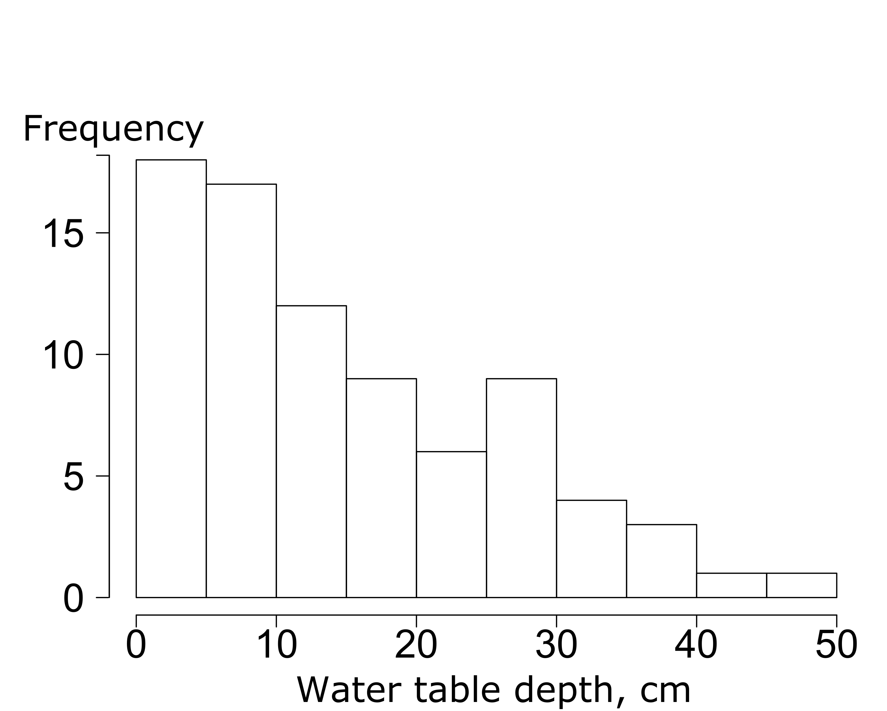

**Fig. 1.** Histogram of changes in the water table depth (WTD).

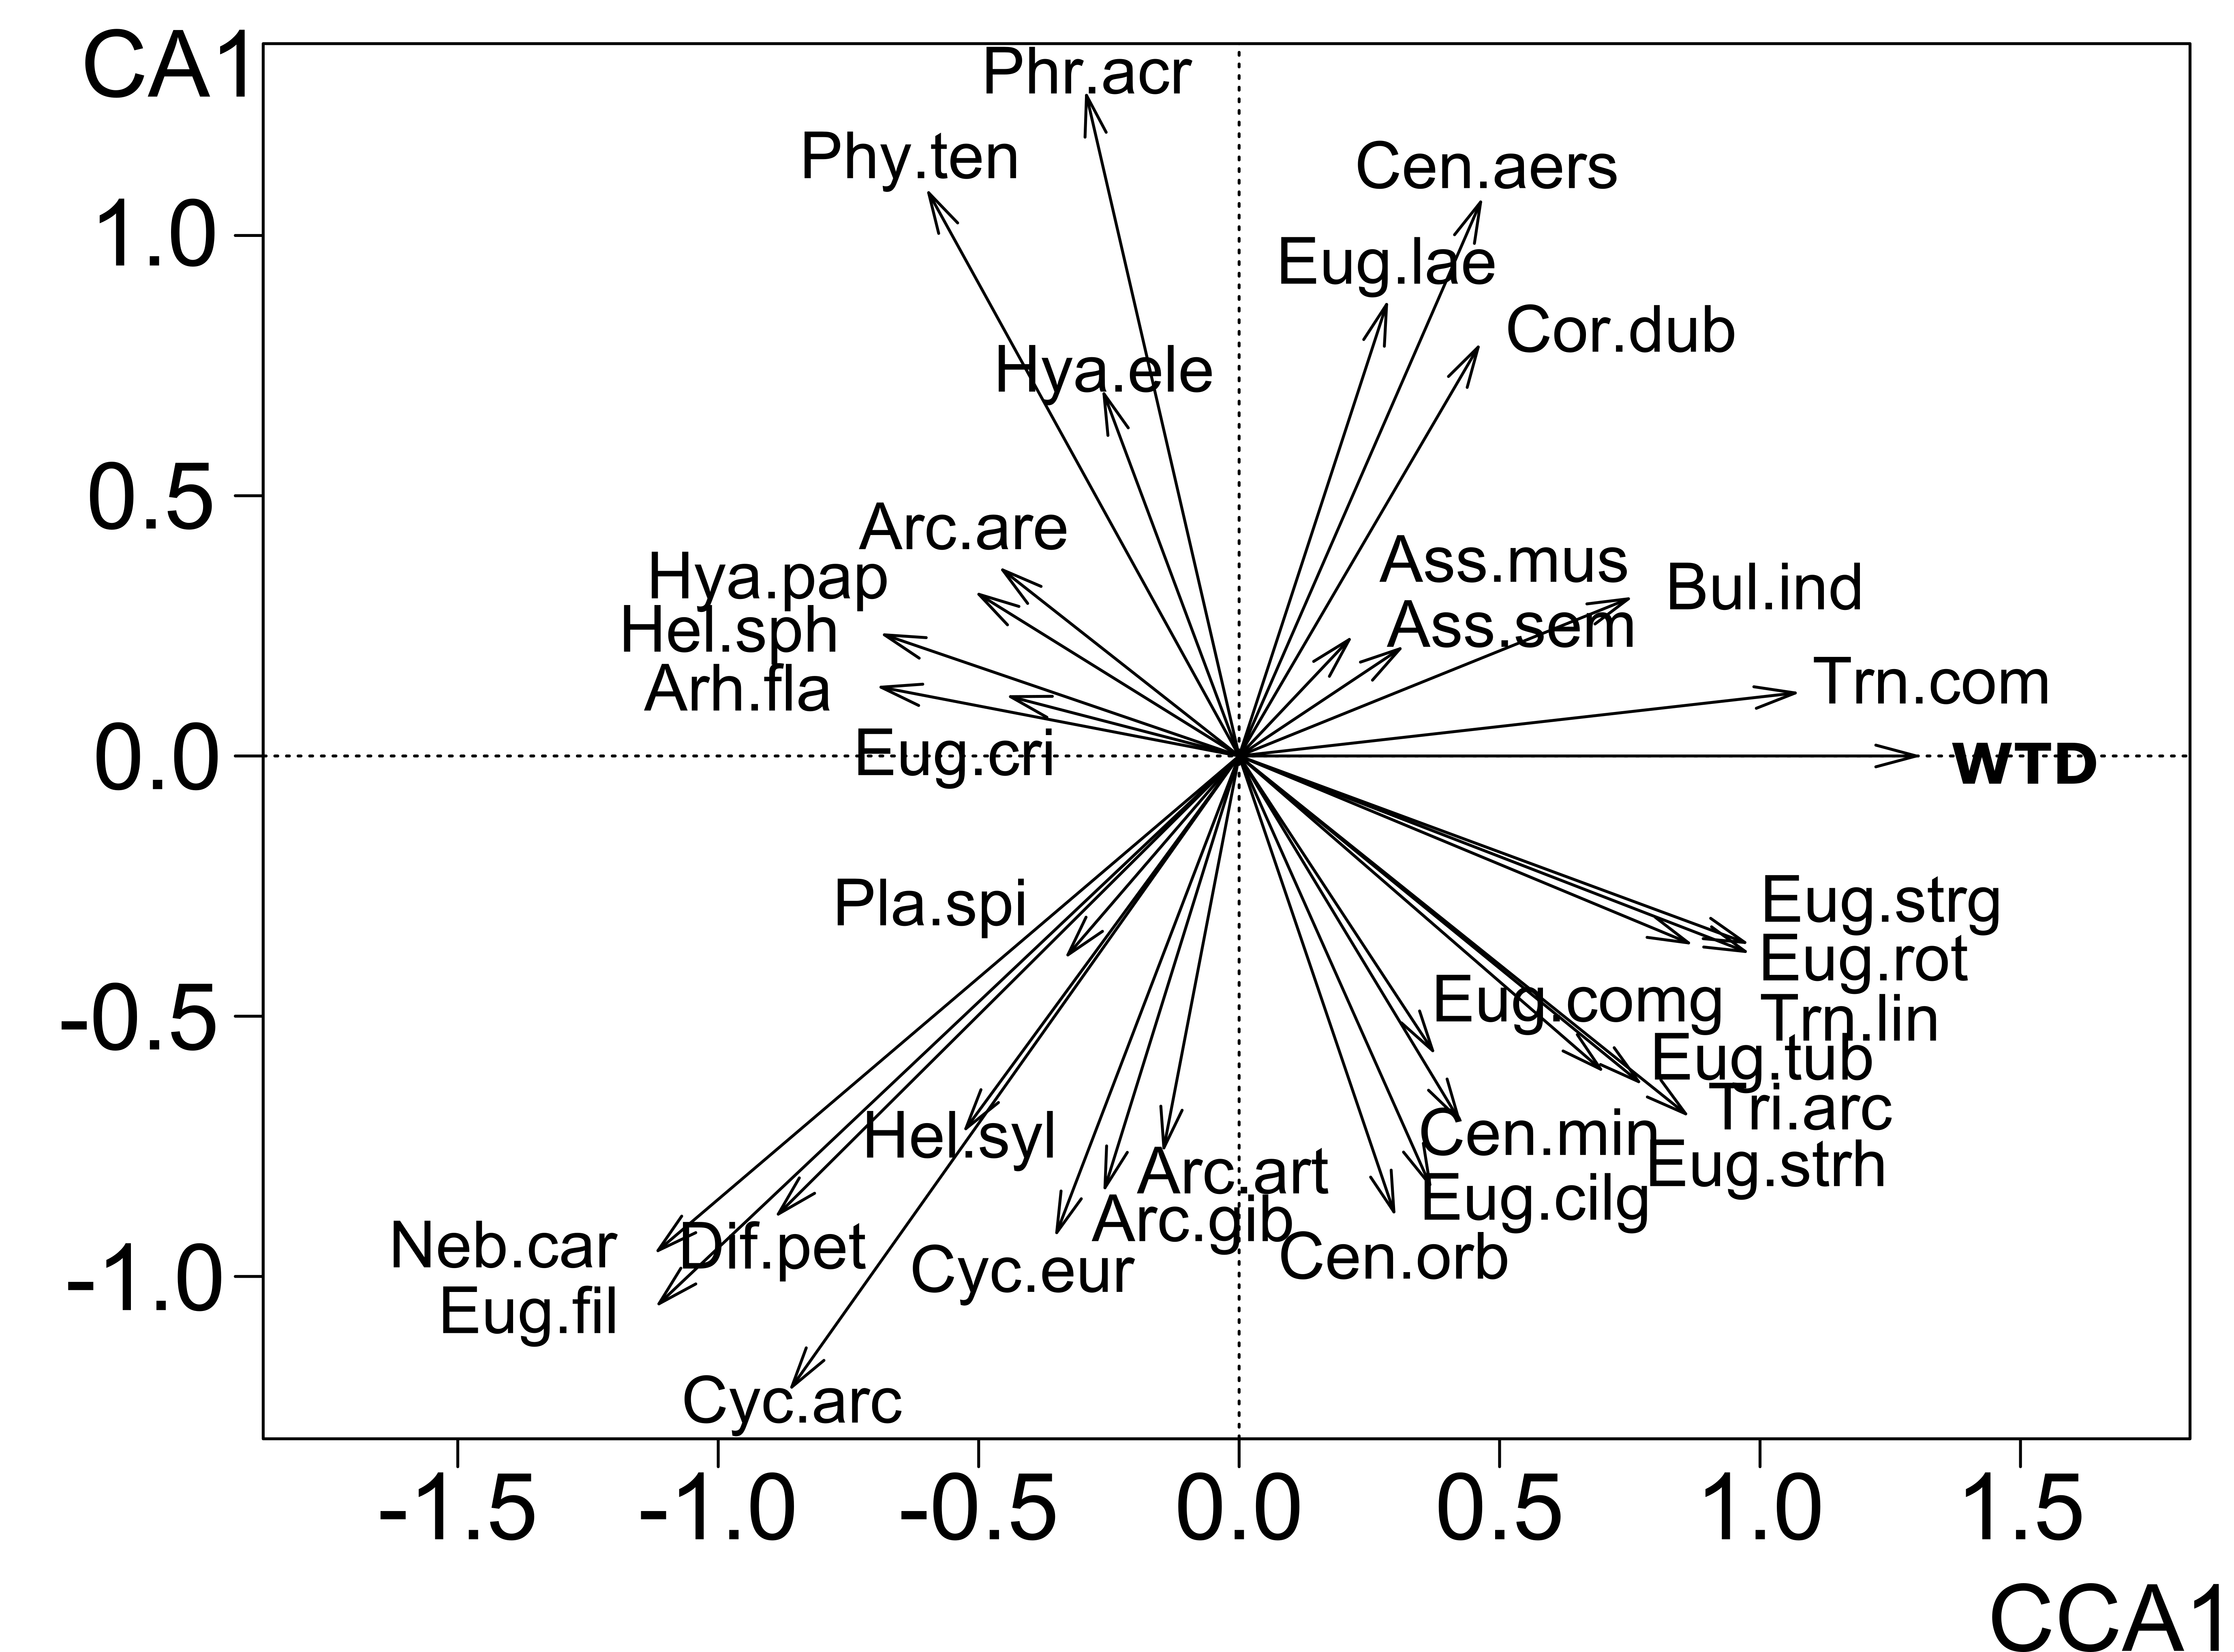

**Fig. 2.** Testacean species ordination based on canonical correspondence analysis. The species are shown that most contributed to the overall variation in the community structure. They are designated by the first three letters of the genus and species names (see Fig. 4).

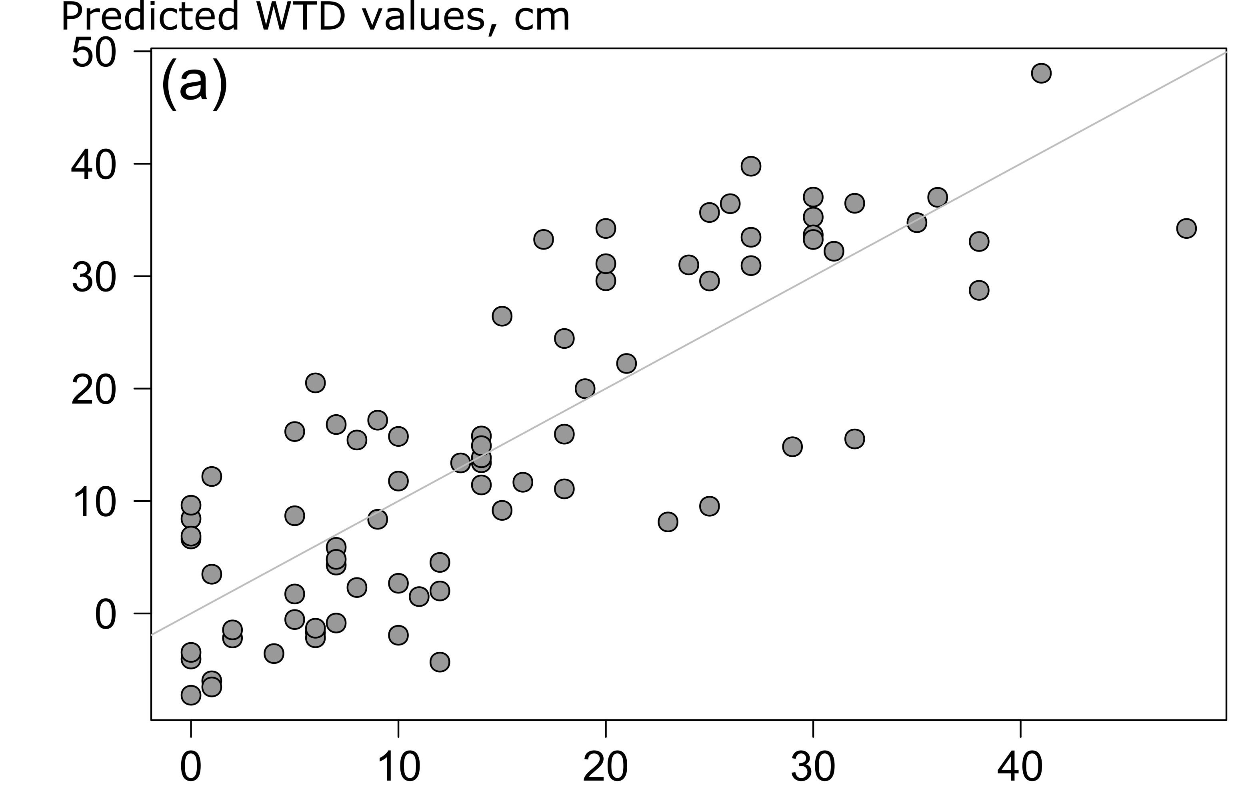

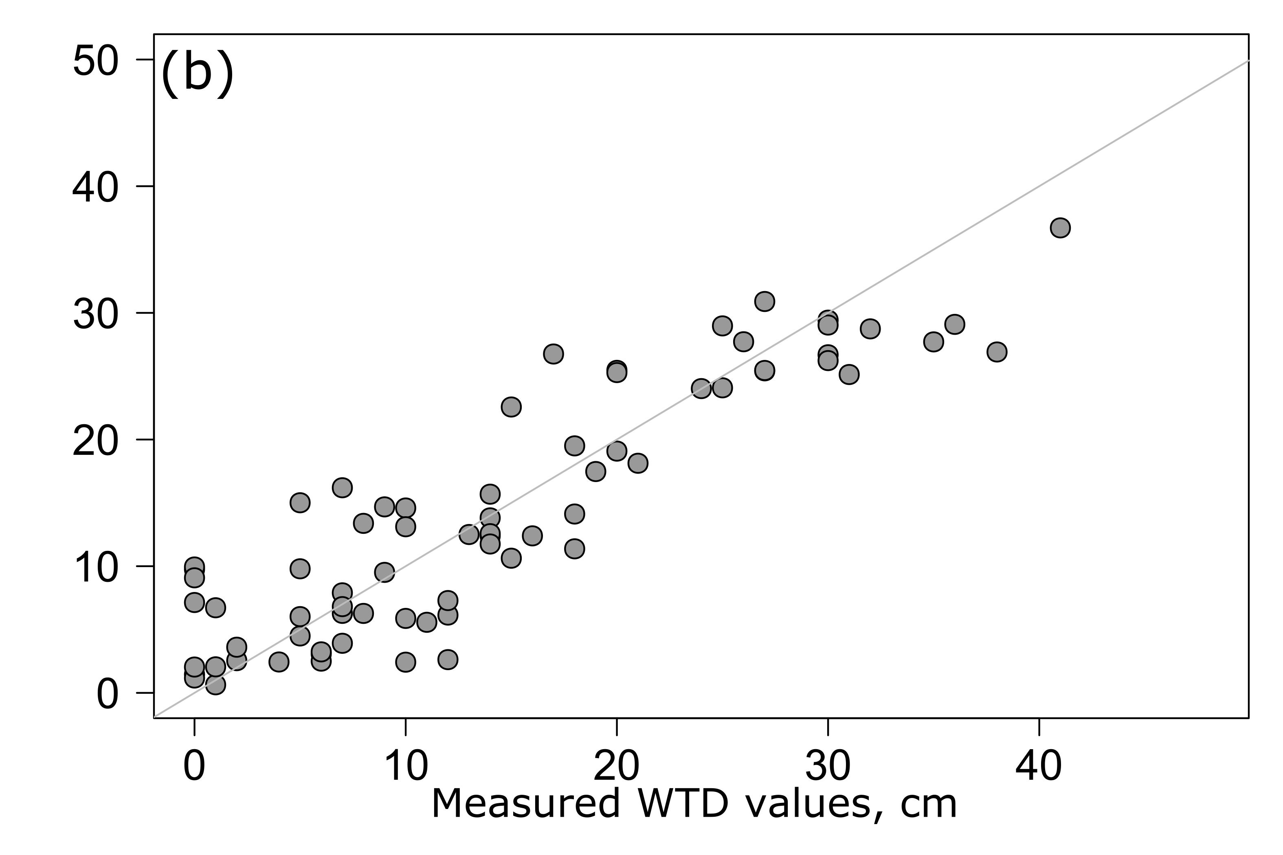

**Fig. 3.** WTD measured in the field and predicted from the weighed averaging transfer function constructed using (a) complete and (b) reduced training dataset.



**Fig. 4.** Ecological optima and tolerance ranges of testacean species relative to WTD as estimated by the weighed averaging method. Figures in parentheses show the number of samples in which the species was found.